IEEE P802.22
Wireless RANs
[Comments on 22-06-0238-03-0001_Preliminary_Draft]
Date: 2007-04-23
Author(s):
Name | Company | Address | Phone | email
David Mazzarese | Samsung Electronics | Korea | +82 10 3279 5210 | d.mazzarese@samsung.com
Jinxia Cheng | Samsung Electronics | China | +86 10 6439 0088 3133 | jinxia.cheng@samsung.com
Shan Cheng | Samsung Electronics | Korea | +82 31 279 7557 | cheng.shan@samsung.com
Euntaek Lim | Samsung Electronics | Korea | +82 31 279 5917 | et.lim@samsung.com
Abstract
[Technical and editorial comments on clauses 6 and 7 in 22-06-0238-03-0001_Preliminary_Draft. The comments are sorted according to increasing clause number.

Revision 1 includes other comments sent on the 802.22.1 email reflector and comments on other pending proposals, so that all current comments from the authors are included in this document. The changes are highlighted in text changes mode in blue colour.]
Notice: This document has been prepared to assist IEEE 802.22. It is offered as a basis for discussion and is not binding on the contributing individual(s) or organization(s). The material in this document is subject to change in form and content after further study. The contributor(s) reserve(s) the right to add, amend or withdraw material contained herein.

Release: The contributor grants a free, irrevocable license to the IEEE to incorporate material contained in this contribution, and any modifications thereof, in the creation of an IEEE Standards publication; to copyright in the IEEE’s name any IEEE Standards publication even though it may include portions of this contribution; and at the IEEE’s sole discretion to permit others to reproduce in whole or in part the resulting IEEE Standards publication. The contributor also acknowledges and accepts that this contribution may be made public by IEEE 802.22.

Patent Policy and Procedures: The contributor is familiar with the IEEE 802 Patent Policy and Procedures
<http://standards.ieee.org/guides/bylaws/sb-bylaws.pdf>, including the statement "IEEE standards may include the known use of patent(s), including patent applications, provided the IEEE receives assurance from the patent holder or applicant with respect to patents essential for compliance with both mandatory and optional portions of the standard." Early disclosure to the Working Group of patent information that might be relevant to the standard is essential to reduce the possibility for delays in the development process and increase the likelihood that the draft publication will be approved for publication. Please notify the Chair <Carl R. Stevenson> as early as possible, in written or electronic form, if patented technology (or technology under patent application) might be incorporated into a draft standard being developed within the IEEE 802.22 Working Group. If you have questions, contact the IEEE Patent Committee Administrator at <patcom@ieee.org>.

1.0 Comments and Proposed Changes

Clause 6.1.4 Table 2 lines 35-36
Wouldn't it be more accurate to specify that it is uncoded PER?

Clause 6.3 page 22 lines 53-54
How can the sync field be used to obtain chip synchronization?

Since the modulated symbols are differentially encoded, I don't see how this would be possible. The same holds true for DQPSK symbol synchronization. It is the spreading sequence that is used for that purpose, not the sync sequence.

After despreading and bit decoding of DQPSK symbols, I agree that the sync field is used to obtain synchronization with the start of the slot, and that synchronization is done at the QPSK symbol level. But chip synchronization must have been acquired before that.

Clause 6.3 page 23 line 10
"the number of synchronization bursts remaining" should be replaced by "the number of slots remaining", since some slot may contain the RTS/ANP period instead of the synchronization burst.

[Technical] Clause 6.4 page 23 line 45
Since there is one byte for padding, why not make the PHR 2 bytes? This would allow to have more reserved bits, while having repetitions for the "initialization" bit.

In any case, (PHR + coded MSF1) = 17*2+1 = 35 bytes, so the WRAN would have to schedule a quiet period of 36 symbols (9 slots) to get MSF1. Since the first sync burst (with index N) contains 1 byte of PHR + 2 bytes of MSF1, it has to be included in the quiet period. So I suggest to increase the size of PHR to 2 bytes, without impact on the minimum sensing period to detect MSF1.

Repetitions of the "initialization" bit: this is not to bring the level of protection of the "initialization" bit to the same level of protection of the PSDU and sync burst, since the "initialization" bit is only useful for inter-beacon communication (the WRAN doesn't need that bit). So the repetition doesn't need to bring a 6 dB coding gain. We just want to avoid an SPD to send an RTS when it is not allowed by the PPD. A few repetitions should be sufficient.

Proposal: Would a repetition of 5 be appropriate? That would leave 11 reserved bits, compared to 7 in the current draft.

[Technical] Clauses 6.5 and 6.6
Since FEC is now applied to the index, one slot = 32 symbols. The whole section needs revisions.

Below, we propose a possible technical change to fix this problem, which also improves upon the design in the current draft.
This proposal does not go beyond the features that are in the current draft 238r3, in the sense that it does not address collisions, so it should be considered as a fix to the current draft.

If a proposal to address collisions was accepted by the Task Group, then this contribution would no longer be valid. IF a proposal to address collisions is not accepted by the Task Group, we recommend to adopt this contribution.

Discussion and analysis

The proposed change assumes the same length of codewords for the RTS and ANP. In order to equalize the probability of error on both codewords, and given that the PPD to SPD ad SPD to PPD links are reciprocal and uncoded, it is better that the RTS and ANP codewords have the same lengths. Having different lengths for the RTS and ANP codewords as currently in the draft makes no sense.

A word of caution is in order. There are now an additional 8 symbols times in a slot. Increasing the lengths of the RTS, ACK and NACK codewords has a drawback, since it would increase the probability of codeword error at a given SNR, given the requirement that these codewords must be received without any error to be declared a valid RTS, ACK or NACK codeword. To address this problem, we propose to equalize the length of the RTS and ACK/NACK codewords to 4 symbols (or 8 bits), and the length of the three turnaround times to 8 symbol times. An alternative would be to equalize the lengths of the RTS and ACK/NACK codewords to 7 symbols, and the turnaround times to 6 symbols, but the lengths of the codewords would render their errorless detection less likely. Therefore, we chose to propose the following design.

The following design is based on the assumption that the comment to use DQPSK phase transitions with Gray mapping rather than natural mapping will be accepted.

Proposal

- decrease the size of the RTS codeword (6 to 4 symbols)
- increase the size of the ANP burst (3 to 4 symbols)
- increase the size of the 3 turnaround times (5 to 8 symbol durations)

→ Total: 32 symbols times = 1 slot.

Consider the sequences {1+j,-1-j,-1-j,1+j} and {-1-j,-1-j,1+j,1+j}. They are orthogonal with each other.
The first one is selected as the ACK codeword, and the second one is selected as the NACK codeword and RTS codeword.
The RTS codeword is chosen to be the same as the NACK codeword

Change to Figure 8

Change to Table 16 (RTS codeword)

(DQPSK) Symbol number |  | 0 | 1 | 2 | 3
Physical I channel (dI) | Name | r₀ | r₁ | r₂ | r₃
Physical I channel (dI) | Value | 1 | 0 | 1 | 0
Physical Q channel (dQ) | Name | r₄ | r₅ | r₆ | r₇
Physical Q channel (dQ) | Value | 1 | 0 | 1 | 0
DQPSK symbol |  | -1-j | -1-j | 1+j | 1+j

Assumptions:
- Gray mapping of DQPSK phase transitions (11 results in a rotation by pi of the previous symbol, while 00 results in no rotation of the previous symbol)
- DQPSK encoder is re-initialized at the beginning of an RTS codeword (including NPD acknowledgment code)
- DQPSK encoder is re-initialized at the beginning of an ANP codeword (including ACK, NACK, Go-on)
- DQPSK encoder is re-initialized at the beginning of each beacon frame

The above assumptions 2, 3 and 4 should be stated as mandatory requirements in the specifications at the appropriate place. These requirements are currently missing.

Note that bits r_{i} are no longer defined from a cyclic shifted version of the sync burst sequence.

Change to Table 17 (ACK codeword)

(DQPSK) Symbol number |  | 0 | 1 | 2 | 3
Physical I channel (dI) | Name | a₀ | a₁ | a₂ | a₃
Physical I channel (dI) | Value | 0 | 1 | 0 | 1
Physical Q channel (dQ) | Name | a₄ | a₅ | a₆ | a₇
Physical Q channel (dQ) | Value | 0 | 1 | 0 | 1
DQPSK symbol |  | 1+j | -1-j | -1-j | 1+j

Change to Table 18 (NACK codeword)

(DQPSK) Symbol number |  | 0 | 1 | 2 | 3
Physical I channel (dI) | Name | a₀ | a₁ | a₂ | a₃
Physical I channel (dI) | Value | 1 | 0 | 1 | 0
Physical Q channel (dQ) | Name | a₄ | a₅ | a₆ | a₇
Physical Q channel (dQ) | Value | 1 | 0 | 1 | 0
DQPSK symbol |  | -1-j | -1-j | 1+j | 1+j

With this simple encoding, the receiver has the choice to implement the DQPSK decoder and recover exactly all 8 bits, or to directly correlate with the DQPSK symbols sequences when receiving in the RTS/ANP burst.

Other changes in clause 6.5 to reflect these changes are editorial and straightforward, so they are left up to the editor.

Clause 6.8.1 page 26 line 38
Why is it "P802.22/D1" and not just "P802.22"?

Clause 6.8.1.2 pages 26-27
"bits of the beacon frame" and "bits of the synchronization burst" are taken at the output of the FEC. So they don't come directly from the MAC since we introduced FEC on the index and on the PSDU. This change is required all along this clause, except for the the RTS and ANP codeword bits.

[Technical] Clause 6.8.1.3 page 27 Table 21 rows 4 and 5 column 2
Swap the phase changes for "01" and "11" to obtain Gray coding of the phase transitions. This gives about a 1 dB gain in uncoded PER for the 4-byte sync burst, as shown in Figure C1.

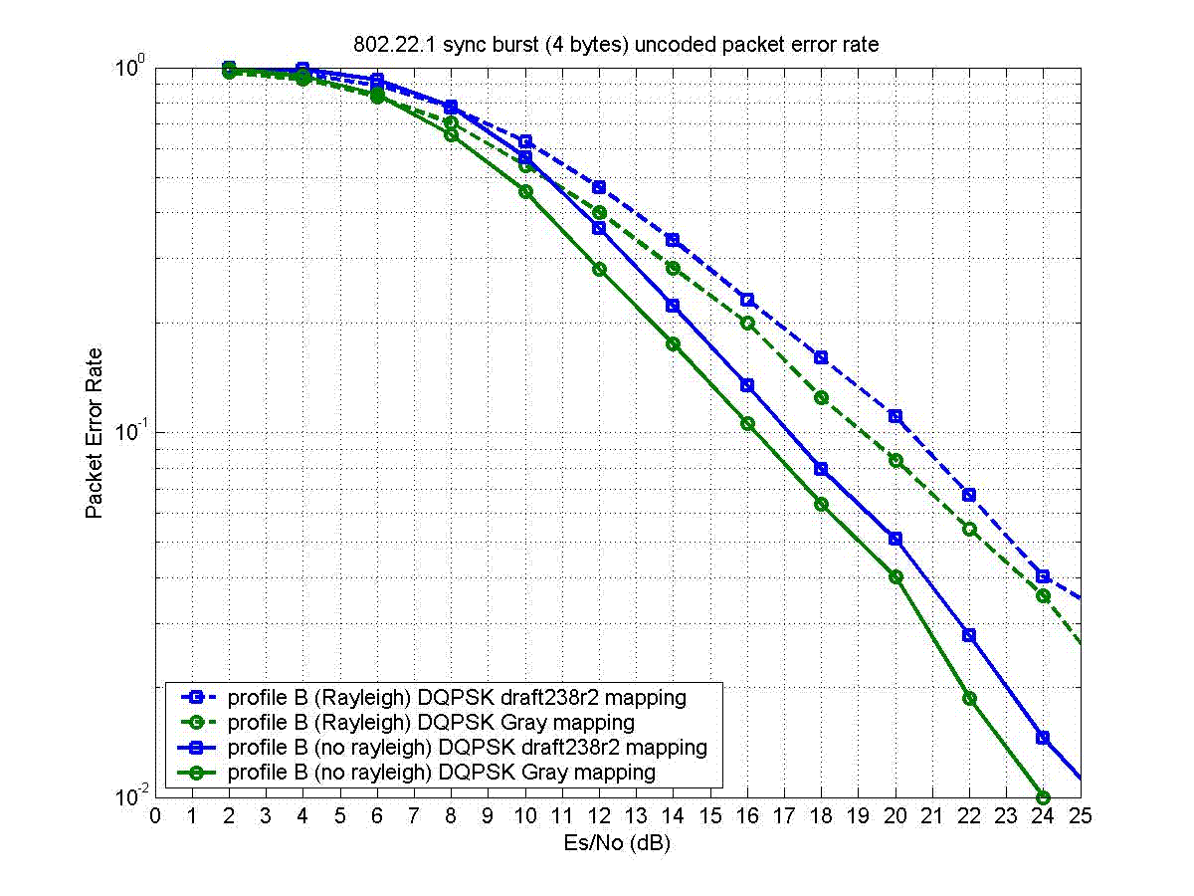
Figure C1

Change to Table 21:

Input bits (dI,dQ) | Phase change φ
00 | 0
10 | π/2
01 | 3π/2 (-π/2)
11 | π

Figure 6 illustrates the performance gain of using Gray mapping for DQPSK phase transitions.

Clause 6.8.1.3 page 29

Insert the following text at the end of clause 6.8.1.3:

The DQPSK modulator shall be initialized at the beginning of each:
- new superframe
- RTS burst
- ACK burst
- NACK burst
- Go-on burst (if this proposal is accepted)

[Technical] Clause 6.8.1.4 page 28

We propose to use a new complex spreading sequence with better correlation properties, which improve the robustness against beacon-to-beacon interference. The new sequence is: (1-i, -1-i, 1+i, 1-i, 1-i, 1-i, -1+i, -1-i).

Here is the justification of the proposed change of spreading sequence. The sequence proposed in draft238r2 was optimized using its auto-correlation property without considering the modulation of a DQPSK symbol. However in practice during synchronization, the correlation will be taken among sequences that spread random DQPSK symbols. So an orthogonal sequence without spreading a modulated symbol will no longer be orthogonal in practice during synchronization. Using this criterion, we found the better sequence shown above. That sequence offers enhanced performance in beacon-to-beacon interference situations. Without interference, the performance is the same as the sequence in draft238r2.

Figure C2 shows the correlation properties of 4 complex sequences:
- draft238r0
- draft238r2
- an orthogonal sequence
- the new sequence (the proposed sequence)

For clarification, sequence #3 wans’t found before Samsung’s submission that was accepted and incorporated in draft238r2, although it is orthogonal, because the sequence of draft238r2 was found using an optimization over a limited set of of sequences. However, sequences #3 and #4 have been found by an exhaustive search over the complete set of complex sequences with 4 levels (QPSK) of length 8.

On Figure C2, the top row shows the auto-correlation of all 4 sequences without modulation by a DQPSK symbol. The bottom row shows the auto-correlation of all 4 sequences with modulation by a DQPSK symbol, which were obtained by averaging over all possible DQPSK symbols. As can be seen, over the 4 sequences, the fourth one shows the best correlation in the practical case of synchronization with a modulated sequence, even though it is not orthogonal.

Figure C3 shows simulation results with beacon-to-beacon interference, where one beacon is interfered by another beacon. Figure C4, copied from 22-06-0171-00-0001_Beacon_PHY_Simulations, shows the same behaviour for the sequence of draft238r0 as shown in Figure C2. This behaviour should be compared with Figure C3, but the numbers cannot be compared.

Figure C5 shows that the performance without inter-beacon interference has no visible change between the proposed sequence and the sequence in draft238r2. Due to limited time to conduct this simulation, the accuracy of the points below 10% packet error rate should be taken with care. The improvement in sync burst index PER in channel B from draft238r2 to the new proposal comes from the use of Gray mapping in DQPSK phase transitions. The PER of the PSDU stays unchanged with the proposed changes.

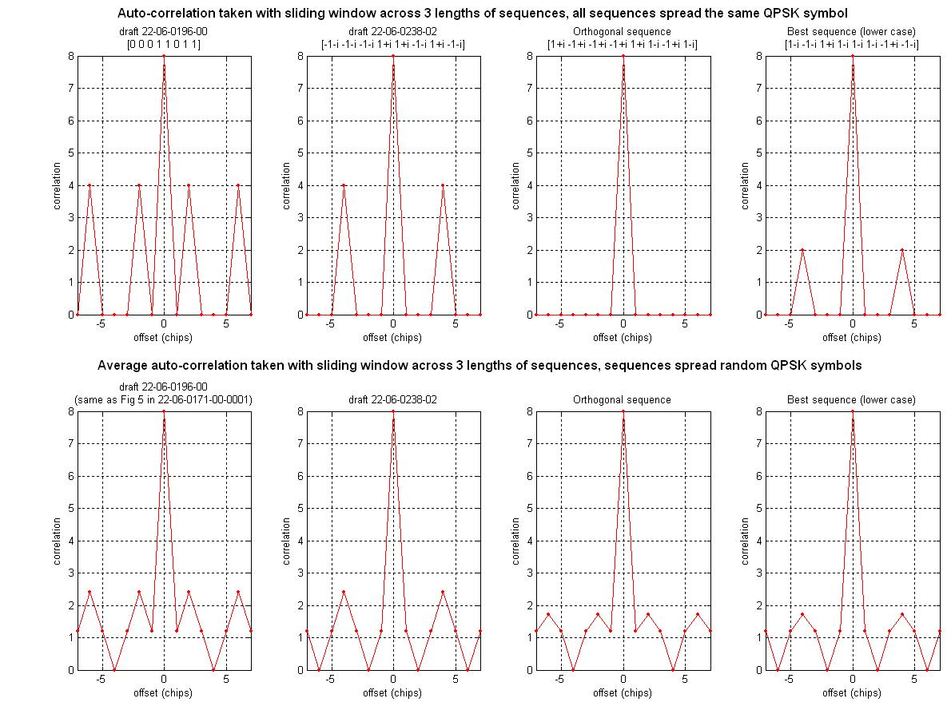
Figure C2
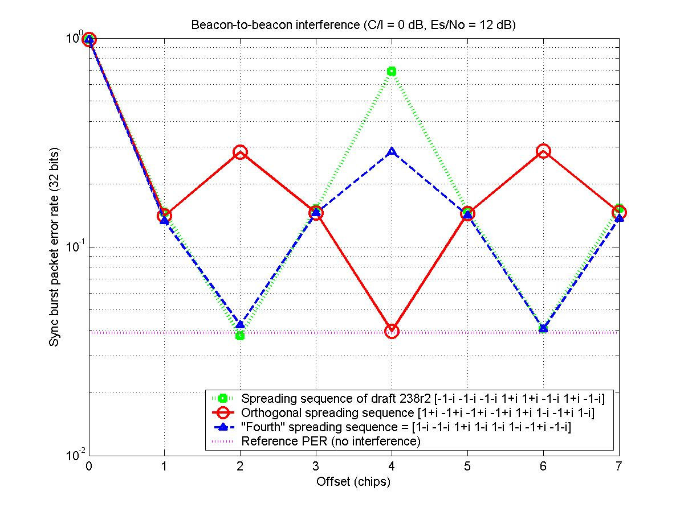
Figure C3
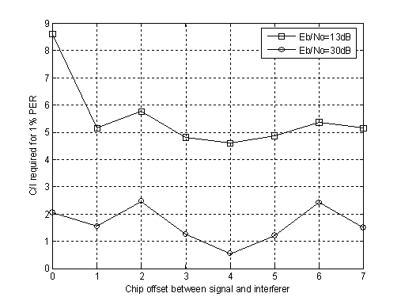
Figure C4

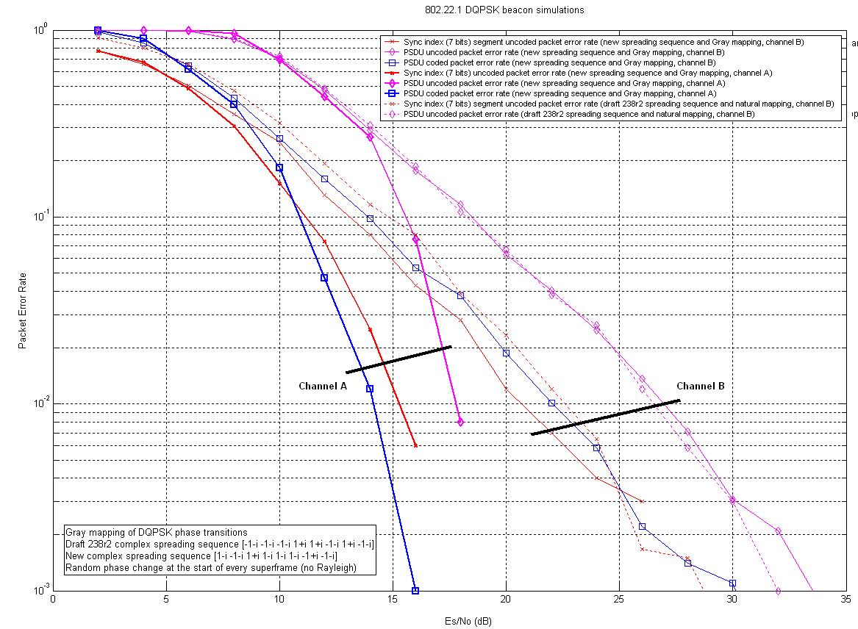
Figure C5

Proposed changes to the draft238r3 text are (in red):

Input DQPSK symbol | Input DQPSK symbol phase | c0 | c1 | c2 | c3 | c4 | c5 | c6 | c7
1+j | π/4 | 1 | -j | j | 1 | 1 | 1 | -1 | -j
-1+j | 3π/4 | j | 1 | -1 | j | j | j | -j | 1
1-j | -π/4 | -j | -1 | 1 | -j | -j | -j | j | -1
-1-j | -3π/4 | -1 | j | -j | -1 | -1 | -1 | 1 | j
Table 21 DQPSK symbol-to-chip mapping table

The DQPSK symbol-to-chip mapping operation can be equivalently viewed as the complex multiplication of the DQPSK symbol with the complex spreading sequence (1-j, -1-j, 1+j, 1-j, 1-j, 1-j, -1+j, -1-j), followed by a division by two.

Clause 6.8.2.2 page 30 paragraph 1
Since we didn't adopt the tail-biting convolutional code of 802.22, I am not sure that the reference to borrowing the code polynomials to 802.22 is relevant in these specifications. This statement is not relevant in the specifications of a standard.

Clause 6.8.2.2 page 30 lines 17-18
Is it obvious where the 12 bits come from? Or could it lead to different implementations leading to problems of inter-operability? We may want to give more details.

Clause 6.9.6 page 31 lines 36-37
The "MSF 1 1% PER" is ackward. How about rewording it to "the 1% PER static channel sensitivity of MSF 1 shall be..."

[Technical] Clause 7.4.4 page 54 paragraphs 4 and 5

Paragraph 4 reads: “During this initial transmission period, the new PPD shall set the initialization bit in the PHR to one and transmit a continuous series of superframes, which shall not include receive periods or ANPs, for a period of 30 seconds. Each superframe shall be composed of 30 synchronization bursts sent on the synchronization channel and a 120-octet length beacon frame sent on the beacon channel (7.4.1). In this case, the superframe shall have a period of (8*120) bits/9609.1 Hz = 99.905 ms.”

Paragraph 5 reads: “Following the initial transmission period, superframe transmission shall continue; however, the receive period and ANP shall be inserted immediately following the beacon frame. Since the receive period and ANP together have a duration of one slot time, the number of synchronization bursts in a superframe following the initial transmission period is 31. The superframe shall have a period of (8*121) bits/9609.1 Hz = 100.74 ms.”

Comment: it would be inconvenient to make the beacon periodicity variable form the point-of-view of the receiver, which has no knowledge of when the initialization period starts and ends.

So the proposal is to append an additional slot after a new PPD beacon frame during the initialization period.

This way, the beacon periodicity is always the same and equal to (8*31*4) = 103.2355 ms.

That slot could be one of 3 options:
- empty
- like an RTS/ANP slot with just the transmission of the NACK in the ANP period
- a synchronization burst with index 0, and zeros on the Q channel

Options 1 and 2 have the inconvenient that the WRAN may be listening at this time (since this is a new beacon coming up on an empty channel at this location) and wouldn’t be able to capture a sync burst.

Thus I recommend option 3.

Clause 7.4.5.3 pages 55-56

Make mandatory that a PPD shall transmit at least one beacon frame right after an SPD beacon frame.

Clause A.2 page 69 paragraph 3
"In general,"
These words can be removed, they don't make sense.
The following comments apply provided Soo-Young Chang’s proposals are accepted. They have been based on the revisions to draft 238r3 sent by Soo-Young Chang with purple highlights in an un-numbered document. Some of the proposed text in comment 1.17 have already been harmonized in that contribution.

Normative text for timing requirements

Insert the following sentences at the appriopriate place in the draft, possibly in a new sub-clause dedicated to timing requirements:

The NPD bit sent SHALL be sent by the PPD in superframe number n+2, and it SHALL apply to the SPD which sent its beacon in frame n.
The SPD SHALL respond with an NPD ACK in superframe n+4, when this SPD had sent its beacon in frame n.
The PPD SHALL send a NACK in the slot following any SPD beacon.
A Go-on SHALL only be valid if it is sent by the PPD in superframe n+1, where superframe n is the superframe where the SPD beacon with NST=1 was sent by the SPD.
An ACK SHALL only be valid if it is sent by the PPD in superframe n, where superframe n is the superframe where the RTS was sent by the SPD.

Clause 7.2.1.4

Comment: this clause is too descriptive.
Proposed resolution: move the description of scenarios to clause 7.5.

Clause 7.3.2 Table 45

New text has been proposed as shown below:

macNPDAddress |  | IEEE address | A valid 48-bit IEEE address | The 48-bit address of the NPD.

A PD has a MAC address that is fixed. It is independent whether it operates as a PPD, SPD or NPD. It cannot be specified in this table.

macNSTValidCount |  | Integer | 3 or 1 | 3 if a Go-on can be valid when it is sent by the PPD in superframe n+1 ,n+2 and n+3.  1 if a Go-on is only valid when it is sent by the PPD in superframe n+1.  NST is disabled when SPD can not receive Go-On message in macNSTValidCount consecutive PPD beacon frames.

An SPD has no way to know which choice the PPD would have made for this macNSTValidCount. Therefore, it should be fixed to one value. It cannot be chosen among two possible values. Therefore, as proposed in comment Error: Reference source not found, set this value to 1 all the time.

It could also be set to 3, to allow for the SPD to miss one or two NPD bits from the PPD. But in this case, it should always be 3. There is another feature that allows a PPD to monitor that the NPD is still there, which is provided by the periodic transmission of the NPD acknowledgment code. The NPD only sends that code once, once in a while. If we can accept that the performance of that single transmission of the NPD acknowledgment code is sufficient, then why would we require that the PPD sends the NPD bit more than once? So, I suggest that the value defined in the table above be fixed and equal to 1.

Clause 7.4.5.2

The mixture of normative and descriptive text is confusing. The scenarios should be described in an annex, or this section should not be normative.

New text has been proposed as shown below:

For a situation where an SPD needs to continue sending its beacon due to some reasons, the SPD will set the device rank to 0 and the NST to 1 to inform the PPD and other SPDs. Accordingly the PPD will issue the Go-On message in the ANP to assign the next SPD superframe [revise this sentence to be consistent with the last sentence in this paragraph] to the SPD to transmit its continuous beacon information. By setting the device rank to 0 and the NST to 1, the current SPD will send the continuous beacon information without issuing the RTS in the Rx period, which may decrease the RTS collision probability. After one SPD sends NST, if it can not receive Go-On message in macNSTValidCount consecutive PPD beacon superframes, this NST is disabled (i.e. the SPD can not wait for Go-On message any further.).

Clause 7.4.4.3 paragraph 1

The following statement is ambiguous: “The PPD shall continue the transmission of synchronization bursts in the following superframe; however, the PPD shall not send a beacon frame. Instead, it shall enable its receiver for a period of one slot”

Does it mean that the PPD shall transmit and receive at the same time? If this is what is implied, it is not feasible. I would believe that if a PPD receives and RTS and responds with an ACK, then it should only receive during the next frame, and not transmit anything in that frame. The next thing the PPD is allowed to transmit is an ANP burst.

Clause 7.4.6.3 paragraph 1

The following statement has been proposed: “If the NPD wants to send an RTS code, the NPD will aggregate RTS code and NPD acknowledgement code and send it to the PPD.”

What does “aggregating” RTS and NPD codes mean?

Clause 7.4.7.1

There is no procedure and associated primitive for an SPD that hears a new PPD (a PPD with a new MAC address) without its information being aggregated to it. Should this be considered as a missed PPD frame, since the MAC address of the PPD is not recognized? If this is the case, then that SPD could very well choose to promote itself as PPD irrespective of the presence of an NPD that it transmitting as PPD with a different MAC address than the original PPD.

To differentiate the behaviour of the NPD and other SPDs, the other SPDs should monitor the channel for some time for a PPD, while the NPD choose act as PPD as soon as the PPD has disappeared. Then the other SPDs will have to request to aggregate with the new PPD.

The following statement has been proposed: “The NPD will promote itself to the PPD and begin transmitting periodic beacons.”. When will the NPD begin transmitting periodic beacons? Since the PPD sets the “Cease Tx” field to 1 in its last frame, then the NPD should start transmitting in the following frame. However, due to processing delay, this won’t be possible. In this case, some revision to the definition of “Cease Tx” would be required. Otherwise, there will be at least one empty frame. This could also be acceptable.

The following statement has been proposed: “After the NPD promote itself to the new PPD, this PPD will re-choose an SPD as the new NPD.”. A similar statement appears in clause 7.4.7.3.

How can the PPD choose another NPD? The procedure to choose an NPD can only occur after a PPD receives and RTS and lets an SPD send one beacon frame. So there is no possibility to choose another NPD if all other SPDs stay quiet after the NPD has left the channel. The PPD cannot contact an SPD on its own decision. The proposed solution doesn’t work when the NPD disappears.

What will happen is that other SPDs will monitor the channel for some time (macMaxMissedBeacons), then apply a random back-off measured in integral numbers of superframes, and then one of them will start transmitting first as PPD. So in any case, we still need to have the original solution to cope with extreme cases, using random back-off and ALOHA protocol. The NPD proposal does not cover the full scope of the problem, whereas the ALOHA protocol does.

Clause 7.6 Figure 28
This is inconsistent with clause 7.4.6.3. In clause 7.4.6.3 it says that the NPD bit will be set in frame n+2, whereas on Figure 28 it is set in frame n+1.

The diagram on this figure is not accurate, since it mixes logical flows with timing. Either the boundaries of beacon frames and superframes are clearly shown on the diagram, or only the logical flows are shown. For example, it says that “NACK sent during ANP, whether RTS burst was received or not”, which implies that we have to count the number of frames in that diagram. However, the MLME-NPD.Request and MLME-NPD.Confirm primitives are shown to appear faster than could actually be processed by the PPD, even the logical succession of events is correct.

