IEEE P802.22
Wireless RANs
[Comments on 22-06-0238-03-0001_Preliminary_Draft]
Date: 2007-04-23
Author(s):
Name | Company | Address | Phone | email
David Mazzarese | Samsung Electronics | Korea | +82 10 3279 5210 | d.mazzarese@samsung.com
Jinxia Cheng | Samsung Electronics | China | +86 10 6439 0088 3133 | jinxia.cheng@samsung.com
Shan Cheng | Samsung Electronics | Korea | +82 31 279 7557 | cheng.shan@samsung.com
Euntaek Lim | Samsung Electronics | Korea | +82 31 279 5917 | et.lim@samsung.com
Abstract
[Technical and editorial comments on clauses 6 and 7 in 22-06-0238-03-0001_Preliminary_Draft. The comments are sorted according to increasing clause number.]
Notice: This document has been prepared to assist IEEE 802.22. It is offered as a basis for discussion and is not binding on the contributing individual(s) or organization(s). The material in this document is subject to change in form and content after further study. The contributor(s) reserve(s) the right to add, amend or withdraw material contained herein.

Release: The contributor grants a free, irrevocable license to the IEEE to incorporate material contained in this contribution, and any modifications thereof, in the creation of an IEEE Standards publication; to copyright in the IEEE’s name any IEEE Standards publication even though it may include portions of this contribution; and at the IEEE’s sole discretion to permit others to reproduce in whole or in part the resulting IEEE Standards publication. The contributor also acknowledges and accepts that this contribution may be made public by IEEE 802.22.

Patent Policy and Procedures: The contributor is familiar with the IEEE 802 Patent Policy and Procedures
<http://standards.ieee.org/guides/bylaws/sb-bylaws.pdf>, including the statement "IEEE standards may include the known use of patent(s), including patent applications, provided the IEEE receives assurance from the patent holder or applicant with respect to patents essential for compliance with both mandatory and optional portions of the standard." Early disclosure to the Working Group of patent information that might be relevant to the standard is essential to reduce the possibility for delays in the development process and increase the likelihood that the draft publication will be approved for publication. Please notify the Chair <Carl R. Stevenson> as early as possible, in written or electronic form, if patented technology (or technology under patent application) might be incorporated into a draft standard being developed within the IEEE 802.22 Working Group. If you have questions, contact the IEEE Patent Committee Administrator at <patcom@ieee.org>.

1.0 Comments and Proposed Changes

Clause 6.1.4 Table 2 lines 35-36
Wouldn't it be more accurate to specify that it is uncoded PER?

Clause 6.3 page 22 lines 53-54
How can the sync field be used to obtain chip synchronization?

Since the modulated symbols are differentially encoded, I don't see how this would be possible. The same holds true for DQPSK symbol synchronization. It is the spreading sequence that is used for that purpose, not the sync sequence.

After despreading and bit decoding of DQPSK symbols, I agree that the sync field is used to obtain synchronization with the start of the slot, and that synchronization is done at the QPSK symbol level. But chip synchronization must have been acquired before that.

Clause 6.3 page 23 line 10
"the number of synchronization bursts remaining" should be replaced by "the number of slots remaining", since some slot may contain the RTS/ANP period instead of the synchronization burst.

[Technical] Clause 6.4 page 23 line 45
Since there is one byte for padding, why not make the PHR 2 bytes? This would allow to have more reserved bits, while having repetitions for the "initialization" bit.

In any case, (PHR + coded MSF1) = 17*2+1 = 35 bytes, so the WRAN would have to schedule a quiet period of 36 symbols (9 slots) to get MSF1. Since the first sync burst (with index N) contains 1 byte of PHR + 2 bytes of MSF1, it has to be included in the quiet period. So I suggest to increase the size of PHR to 2 bytes, without impact on the minimum sensing period to detect MSF1.

Repetitions of the "initialization" bit: this is not to bring the level of protection of the "initialization" bit to the same level of protection of the PSDU and sync burst, since the "initialization" bit is only useful for inter-beacon communication (the WRAN doesn't need that bit). So the repetition doesn't need to bring a 6 dB coding gain. We just want to avoid an SPD to send an RTS when it is not allowed by the PPD. A few repetitions should be sufficient.

Proposal: Would a repetition of 5 be appropriate? That would leave 11 reserved bits, compared to 7 in the current draft.

[Technical] Clauses 6.5 and 6.6
Since FEC is now applied to the index, one slot = 32 symbols. The whole section needs revisions.

Below, we propose a possible technical change to fix this problem, which also improves upon the design in the current draft.
This proposal does not go beyond the features that are in the current draft 238r3, in the sense that it does not address collisions, so it should be considered as a fix to the current draft.

If a proposal to address collisions was accepted by the Task Group, then this contribution would no longer be valid. IF a proposal to address collisions is not accepted by the Task Group, we recommend to adopt this contribution.

Discussion and analysis

The proposed change assumes the same length of codewords for the RTS and ANP. In order to equalize the probability of error on both codewords, and given that the PPD to SPD ad SPD to PPD links are reciprocal and uncoded, it is better that the RTS and ANP codewords have the same lengths. Having different lengths for the RTS and ANP codewords as currently in the draft makes no sense.

A word of caution is in order. There are now an additional 8 symbols times in a slot. Increasing the lengths of the RTS, ACK and NACK codewords has a drawback, since it would increase the probability of codeword error at a given SNR, given the requirement that these codewords must be received without any error to be declared a valid RTS, ACK or NACK codeword. To address this problem, we propose to equalize the length of the RTS and ACK/NACK codewords to 4 symbols (or 8 bits), and the length of the three turnaround times to 8 symbol times. An alternative would be to equalize the lengths of the RTS and ACK/NACK codewords to 7 symbols, and the turnaround times to 6 symbols, but the lengths of the codewords would render their errorless detection less likely. Therefore, we chose to propose the following design.

The following design is based on the assumption that the comment to use DQPSK phase transitions with Gray mapping rather than natural mapping will be accepted.

Proposal

- decrease the size of the RTS codeword (6 to 4 symbols)
- increase the size of the ANP burst (3 to 4 symbols)
- increase the size of the 3 turnaround times (5 to 8 symbol durations)

→ Total: 32 symbols times = 1 slot.

Consider the sequences {1+j,-1-j,-1-j,1+j} and {-1-j,-1-j,1+j,1+j}. They are orthogonal with each other.
The first one is selected as the ACK codeword, and the second one is selected as the NACK codeword and RTS codeword.
The RTS codeword is chosen to be the same as the NACK codeword

Change to Figure 8

Change to Table 16 (RTS codeword)

(DQPSK) Symbol number |  | 0 | 1 | 2 | 3
Physical I channel (dI) | Name | r₀ | r₁ | r₂ | r₃
Physical I channel (dI) | Value | 1 | 0 | 1 | 0
Physical Q channel (dQ) | Name | r₄ | r₅ | r₆ | r₇
Physical Q channel (dQ) | Value | 1 | 0 | 1 | 0
DQPSK symbol |  | -1-j | -1-j | 1+j | 1+j

Assumptions:
- Gray mapping of DQPSK phase transitions (11 results in a rotation by pi of the previous symbol, while 00 results in no rotation of the previous symbol)
- DQPSK encoder is re-initialized at the beginning of an RTS codeword
- DQPSK encoder is re-initialized at the beginning of an ANP codeword
- DQPSK encoder is re-initialized at the beginning of each beacon frame

The above assumptions 2, 3 and 4 should be stated as mandatory requirements in the specifications at the appropriate place. These requirements are currently missing.

Note that bits r_{i} are no longer defined from a cyclic shifted version of the sync burst sequence.

Change to Table 17 (ACK codeword)

(DQPSK) Symbol number |  | 0 | 1 | 2 | 3
Physical I channel (dI) | Name | a₀ | a₁ | a₂ | a₃
Physical I channel (dI) | Value | 0 | 1 | 0 | 1
Physical Q channel (dQ) | Name | a₄ | a₅ | a₆ | a₇
Physical Q channel (dQ) | Value | 0 | 1 | 0 | 1
DQPSK symbol |  | 1+j | -1-j | -1-j | 1+j

Change to Table 18 (NACK codeword)

(DQPSK) Symbol number |  | 0 | 1 | 2 | 3
Physical I channel (dI) | Name | a₀ | a₁ | a₂ | a₃
Physical I channel (dI) | Value | 1 | 0 | 1 | 0
Physical Q channel (dQ) | Name | a₄ | a₅ | a₆ | a₇
Physical Q channel (dQ) | Value | 1 | 0 | 1 | 0
DQPSK symbol |  | -1-j | -1-j | 1+j | 1+j

With this simple encoding, the receiver has the choice to implement the DQPSK decoder and recover exactly all 8 bits, or to directly correlate with the DQPSK symbols sequences when receiving in the RTS/ANP burst.

Other changes in clause 6.5 to reflect these changes are editorial and straightforward, so they are left up to the editor.

Clause 6.8.1 page 26 line 38
Why is it "P802.22/D1" and not just "P802.22"?

Clause 6.8.1.2 pages 26-27
"bits of the beacon frame" and "bits of the synchronization burst" are taken at the output of the FEC. So they don't come directly from the MAC since we introduced FEC on the index and on the PSDU. This change is required all along this clause, except for the the RTS and ANP codeword bits.

[Technical] Clause 6.8.1.3 page 27 Table 21 rows 4 and 5 column 2
Swap the phase changes for "01" and "11" to obtain Gray coding of the phase transitions. This gives about a 1 dB gain in uncoded PER for the 4-byte sync burst, as shown in Figure C1.

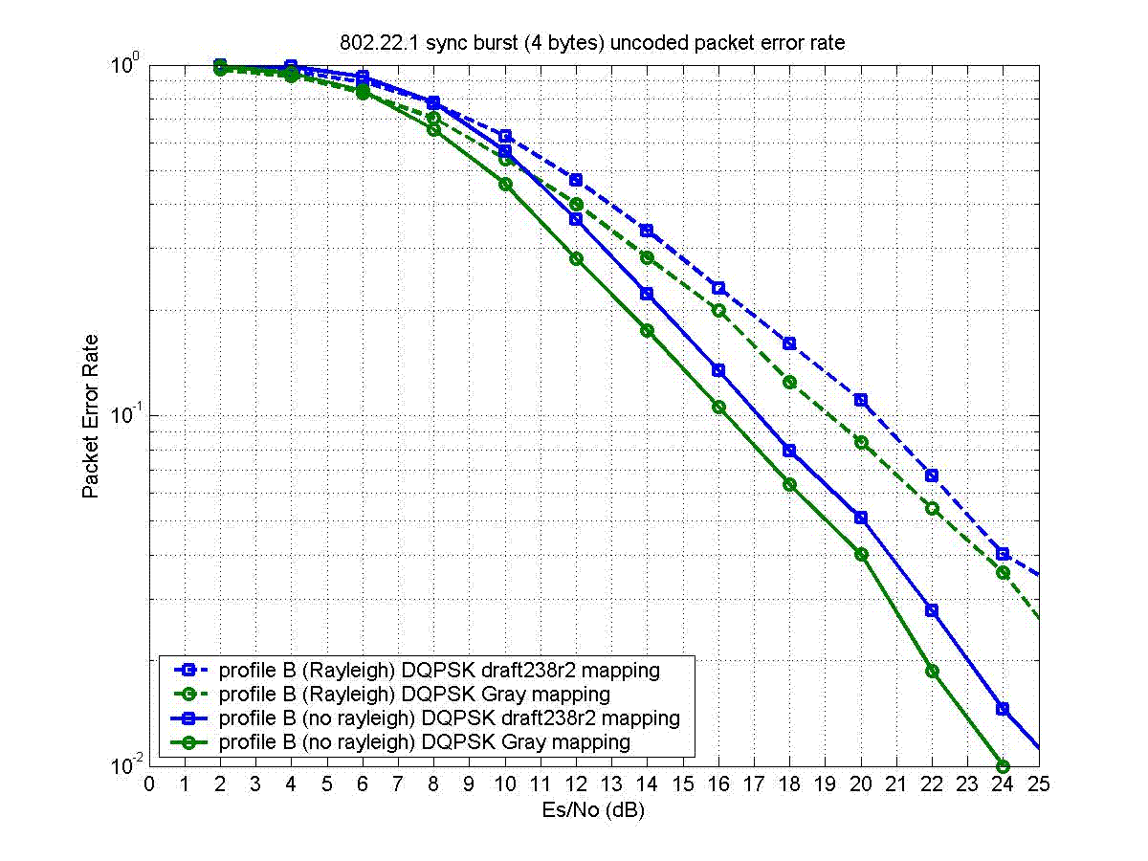
Figure C1

Change to Table 21:

Input bits (dI,dQ) | Phase change φ
00 | 0
10 | π/2
01 | 3π/2 (-π/2)
11 | π

Figure 6 illustrates the performance gain of using Gray mapping for DQPSK phase transitions.

[Technical] Clause 6.8.1.4 page 28

We propose to use a new complex spreading sequence with better correlation properties, which improve the robustness against beacon-to-beacon interference. The new sequence is: (1-i, -1-i, 1+i, 1-i, 1-i, 1-i, -1+i, -1-i).

Here is the justification of the proposed change of spreading sequence. The sequence proposed in draft238r2 was optimized using its auto-correlation property without considering the modulation of a DQPSK symbol. However in practice during synchronization, the correlation will be taken among sequences that spread random DQPSK symbols. So an orthogonal sequence without spreading a modulated symbol will no longer be orthogonal in practice during synchronization. Using this criterion, we found the better sequence shown above. That sequence offers enhanced performance in beacon-to-beacon interference situations. Without interference, the performance is the same as the sequence in draft238r2.

Figure C2 shows the correlation properties of 4 complex sequences:
- draft238r0
- draft238r2
- an orthogonal sequence
- the new sequence (the proposed sequence)

For clarification, sequence #3 wans’t found before Samsung’s submission that was accepted and incorporated in draft238r2, although it is orthogonal, because the sequence of draft238r2 was found using an optimization over a limited set of of sequences. However, sequences #3 and #4 have been found by an exhaustive search over the complete set of complex sequences with 4 levels (QPSK) of length 8.

On Figure C2, the top row shows the auto-correlation of all 4 sequences without modulation by a DQPSK symbol. The bottom row shows the auto-correlation of all 4 sequences with modulation by a DQPSK symbol, which were obtained by averaging over all possible DQPSK symbols. As can be seen, over the 4 sequences, the fourth one shows the best correlation in the practical case of synchronization with a modulated sequence, even though it is not orthogonal.

Figure C3 shows simulation results with beacon-to-beacon interference, where one beacon is interfered by another beacon. Figure C4, copied from 22-06-0171-00-0001_Beacon_PHY_Simulations, shows the same behaviour for the sequence of draft238r0 as shown in Figure C2. This behaviour should be compared with Figure C3, but the numbers cannot be compared.

Figure C5 shows that the performance without inter-beacon interference has no visible change between the proposed sequence and the sequence in draft238r2. Due to limited time to conduct this simulation, the accuracy of the points below 10% packet error rate should be taken with care. The improvement in sync burst index PER in channel B from draft238r2 to the new proposal comes from the use of Gray mapping in DQPSK phase transitions. The PER of the PSDU stays unchanged with the proposed changes.

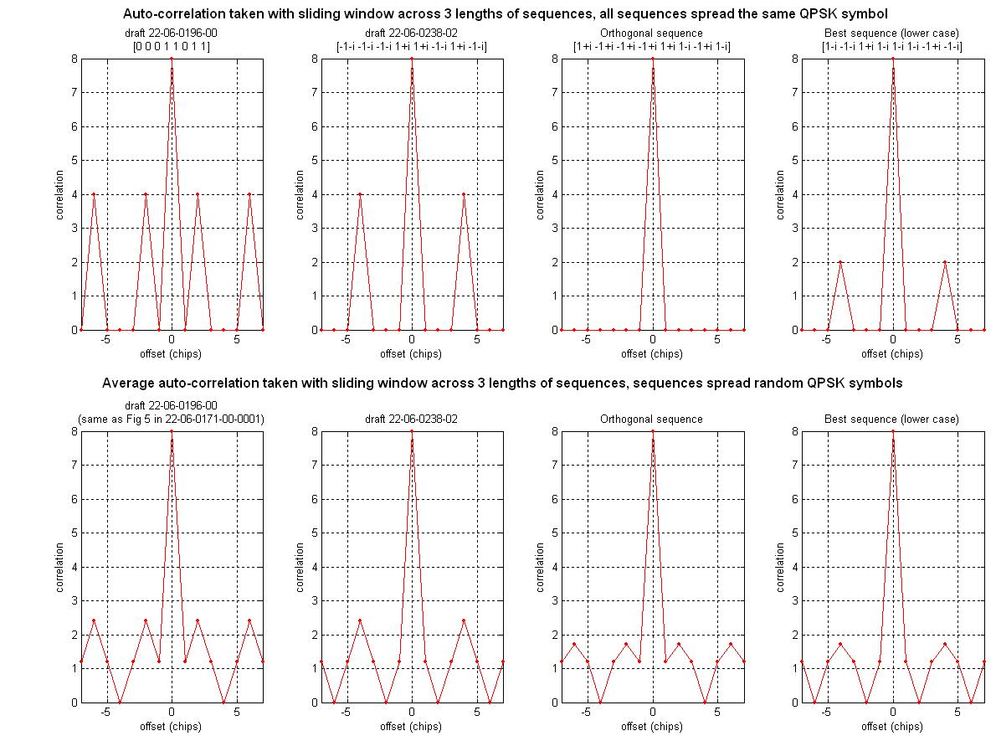
Figure C2
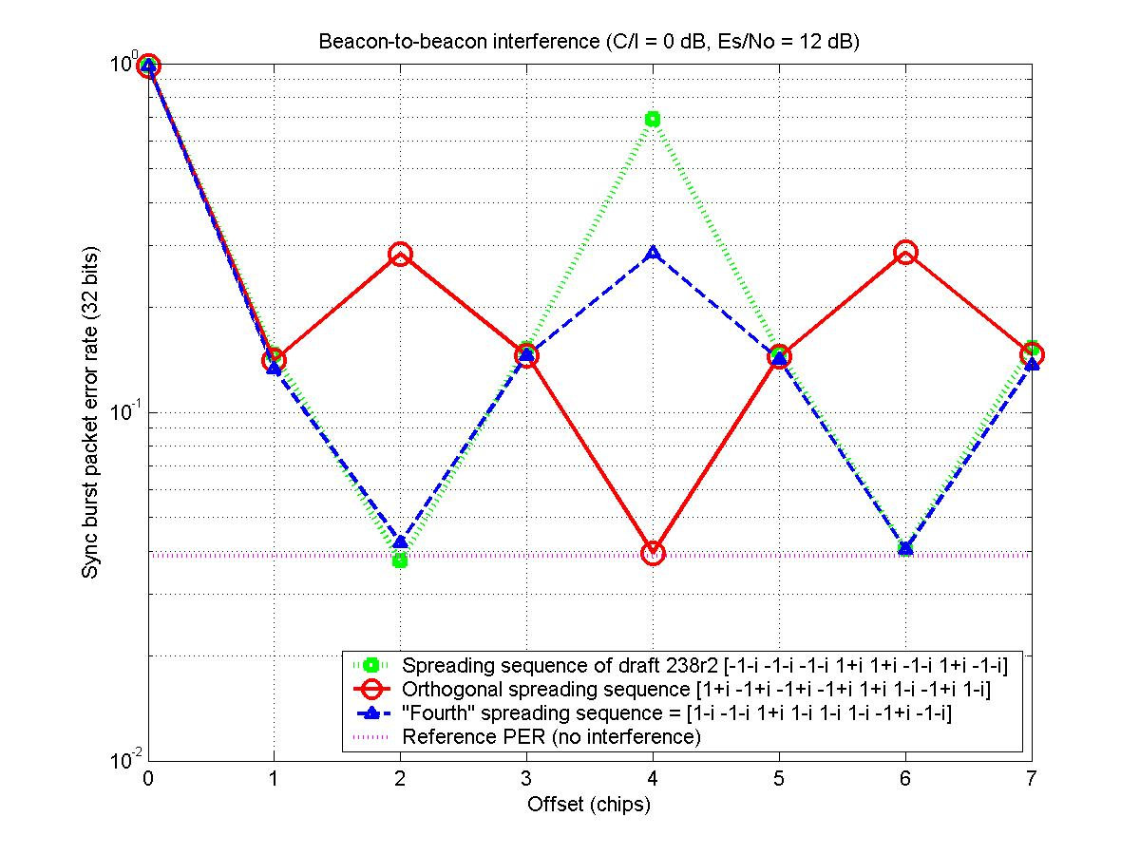
Figure C3
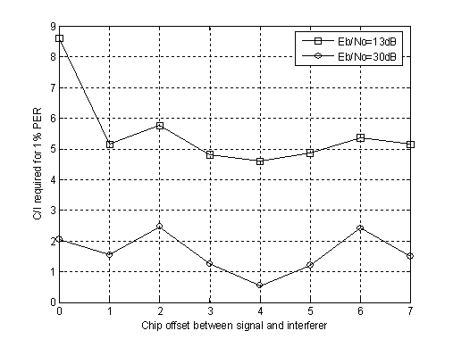
Figure C4

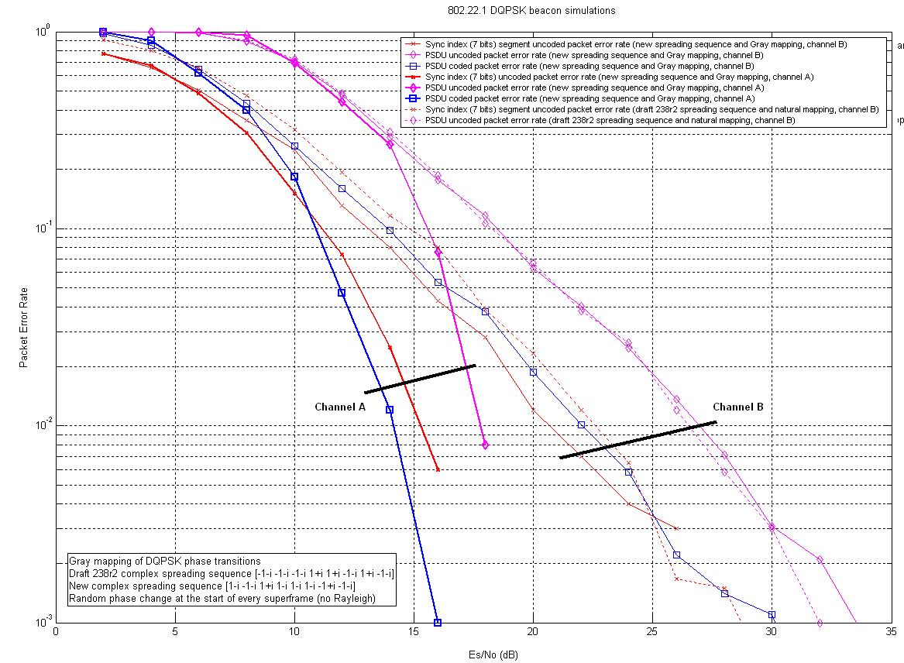
Figure C5

Proposed changes to the draft238r3 text are (in red):

Input DQPSK symbol | Input DQPSK symbol phase | c0 | c1 | c2 | c3 | c4 | c5 | c6 | c7
1+j | π/4 | 1 | -j | j | 1 | 1 | 1 | -1 | -j
-1+j | 3π/4 | j | 1 | -1 | j | j | j | -j | 1
1-j | -π/4 | -j | -1 | 1 | -j | -j | -j | j | -1
-1-j | -3π/4 | -1 | j | -j | -1 | -1 | -1 | 1 | j
Table 21 DQPSK symbol-to-chip mapping table

The DQPSK symbol-to-chip mapping operation can be equivalently viewed as the complex multiplication of the DQPSK symbol with the complex spreading sequence (1-j, -1-j, 1+j, 1-j, 1-j, 1-j, -1+j, -1-j), followed by a division by two.

Clause 6.8.2.2 page 30 paragraph 1
Since we didn't adopt the tail-biting convolutional code of 802.22, I am not sure that the reference to borrowing the code polynomials to 802.22 is relevant in these specifications. This statement is not relevant in the specifications of a standard.

Clause 6.8.2.2 page 30 lines 17-18
Is it obvious where the 12 bits come from? Or could it lead to different implementations leading to problems of inter-operability? We may want to give more details.

Clause 6.9.6 page 31 lines 36-37
The "MSF 1 1% PER" is ackward. How about rewording it to "the 1% PER static channel sensitivity of MSF 1 shall be..."

[Technical] Clause 7.4.4 page 54 paragraphs 4 and 5

Paragraph 4 reads: “During this initial transmission period, the new PPD shall set the initialization bit in the PHR to one and transmit a continuous series of superframes, which shall not include receive periods or ANPs, for a period of 30 seconds. Each superframe shall be composed of 30 synchronization bursts sent on the synchronization channel and a 120-octet length beacon frame sent on the beacon channel (7.4.1). In this case, the superframe shall have a period of (8*120) bits/9609.1 Hz = 99.905 ms.”

Paragraph 5 reads: “Following the initial transmission period, superframe transmission shall continue; however, the receive period and ANP shall be inserted immediately following the beacon frame. Since the receive period and ANP together have a duration of one slot time, the number of synchronization bursts in a superframe following the initial transmission period is 31. The superframe shall have a period of (8*121) bits/9609.1 Hz = 100.74 ms.”

Comment: it would be inconvenient to make the beacon periodicity variable form the point-of-view of the receiver, which has no knowledge of when the initialization period starts and ends.

So the proposal is to append an additional slot after a new PPD beacon frame during the initialization period.

This way, the beacon periodicity is always the same and equal to (8*31*4) = 103.2355 ms.

That slot could be one of 3 options:
- empty
- like an RTS/ANP slot with just the transmission of the NACK in the ANP period
- a synchronization burst with index 0, and zeros on the Q channel

Options 1 and 2 have the inconvenient that the WRAN may be listening at this time (since this is a new beacon coming up on an empty channel at this location) and wouldn’t be able to capture a sync burst.

Thus I recommend option 3.

Clause 7.4.5.3 pages 55-56

Make mandatory that a PPD shall transmit at least one beacon frame right after an SPD beacon frame.

Clause A.2 page 69 paragraph 3
"In general,"
These words can be removed, they don't make sense.

