IEEE P802.22
Wireless RANs
WRAN Reference Model
Date: 2007-05-10
Author(s):
Name | Company | Address | Phone | email
Gerald Chouinard | CRC | 3701 Carling Avenue, Ottawa, Ontario, Canada K2H 8S2 | 1-613-998-2500 | gerald.chouinard@crc.ca
Abstract
This document contains the proposed material for section 1.3 Reference Model of the Working Document v0.3 for review and insertion to the draft standard document during the Montreal session in May 2007.
Notice: This document has been prepared to assist IEEE 802.22. It is offered as a basis for discussion and is not binding on the contributing individual(s) or organization(s). The material in this document is subject to change in form and content after further study. The contributor(s) reserve(s) the right to add, amend or withdraw material contained herein.

Release: The contributor grants a free, irrevocable license to the IEEE to incorporate material contained in this contribution, and any modifications thereof, in the creation of an IEEE Standards publication; to copyright in the IEEE’s name any IEEE Standards publication even though it may include portions of this contribution; and at the IEEE’s sole discretion to permit others to reproduce in whole or in part the resulting IEEE Standards publication. The contributor also acknowledges and accepts that this contribution may be made public by IEEE 802.22.

Patent Policy and Procedures: The contributor is familiar with the IEEE 802 Patent Policy and Procedures
<http://standards.ieee.org/guides/bylaws/sb-bylaws.pdf>, including the statement "IEEE standards may include the known use of patent(s), including patent applications, provided the IEEE receives assurance from the patent holder or applicant with respect to patents essential for compliance with both mandatory and optional portions of the standard." Early disclosure to the Working Group of patent information that might be relevant to the standard is essential to reduce the possibility for delays in the development process and increase the likelihood that the draft publication will be approved for publication. Please notify the Chair <Carl R. Stevenson> as early as possible, in written or electronic form, if patented technology (or technology under patent application) might be incorporated into a draft standard being developed within the IEEE 802.22 Working Group. If you have questions, contact the IEEE Patent Committee Administrator at <patcom@ieee.org>.
  - 1.3 Reference Model
The Wireless Regional Networks for which this standard is developed are expected to operate in lower population density areas and provide broadband access to data networks using vacant TV channels in the VHF and UHF bands in the range of frequencies between 54 MHz and 862 MHz while avoiding interference to the broadcast incumbents in these bands. A typical application will be the coverage of the rural area around a village as illustrated in Figure 1 within a radius of 17 km to 30 km depending on the EIRP of the base station using adaptive modulation, although the MAC will accommodate user terminals located as far as 100 km when exceptional RF signal propagation conditions prevail.
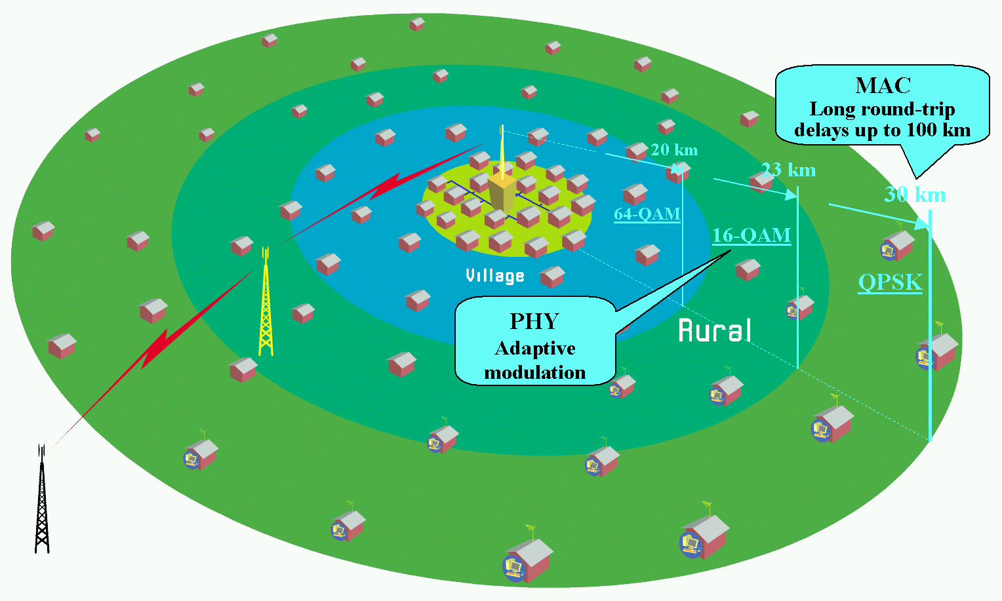
Figure 1: Typical application of the 802.22 WRAN standard

As indicated in the 802.22 Functional Requirement document, the data access capacity at the user terminal is expected to be of 1.5 Mbit/s in the downstream and 384 kbit/s in the upstream. The service availability due to RF propagation is assumed to be at 50% of locations to allow the service provider to reach subscribers in fringe areas and 99.9% of the time to provide a reliable connection where it is possible. The average spectrum efficiency over the coverage area is expected to be around 2 bit/(s*Hz) given the adaptive modulation parameters and the operating constraints described below, and assuming a 6 MHz TV channel bandwidth and a 40:1 over-subscription ratio resulting from the stochastic nature of the data network usage, this translates into a total of 255 user terminals that can be served by the base station per TV channel.

Figure 2 illustrates the main characteristics of the 802.22 WRAN standard relative to the other existing wireless network standards.
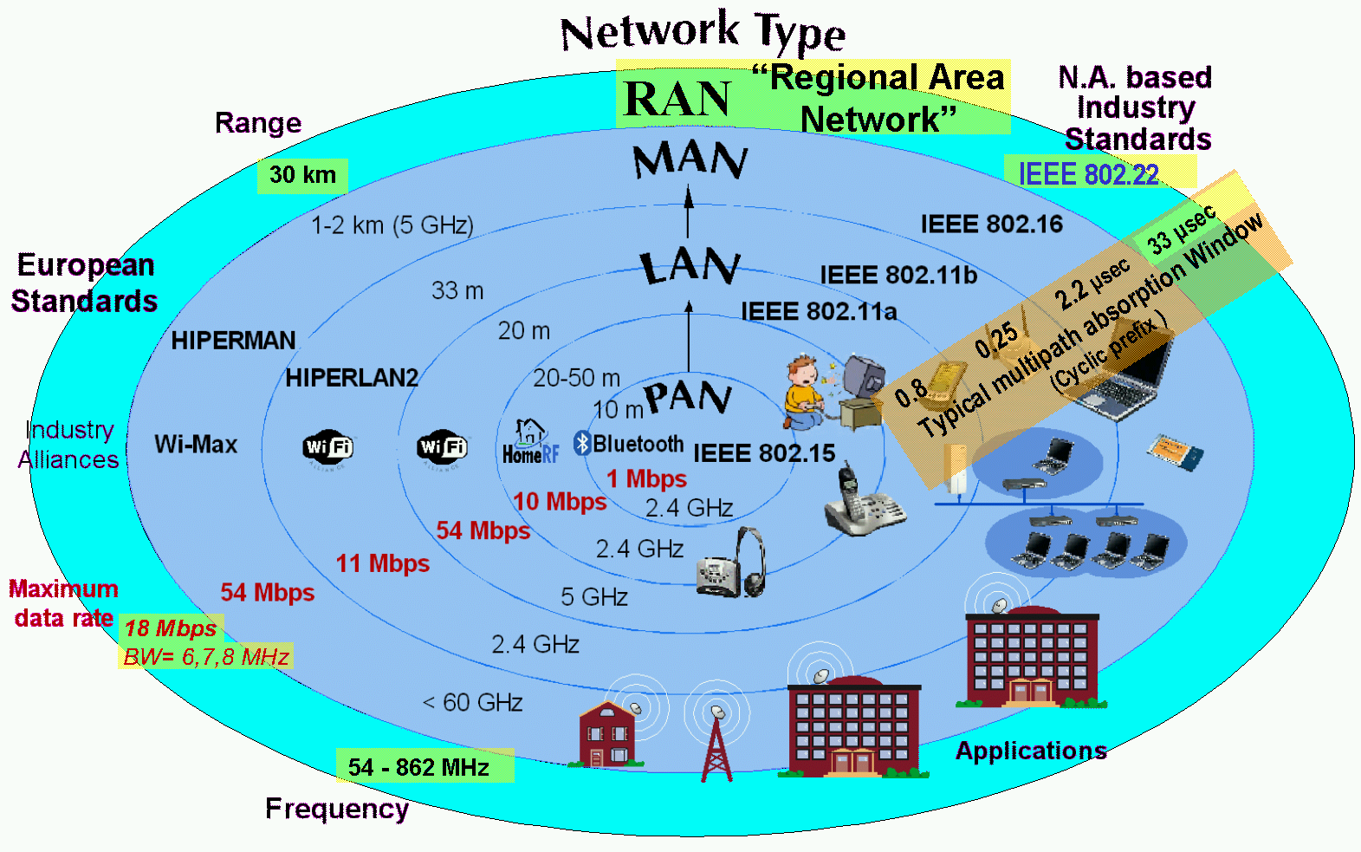
Figure 2: Characteristics of the WRAN standard relative to other wireless network standards

_______________________________________

