IEEE P802.22
Wireless RANs
Wireless Microphone Signal Simulation Method
Date: 2007-03-11
Author(s):
Name | Company | Address | Phone | email
Chris Clanton | Shure Incorporated | 5800 West Touhy Avenue  Niles, IL 60714 | 847-600-8990 | Clanton_Christopher@shure.com
Mark Kenkel | Shure Incorporated | 5800 West Touhy Avenue  Niles, IL 60714 | 847-600-8964 | Kenkel_Mark  @shure.com
Yang Tang | Shure Incorporated | 5800 West Touhy Avenue  Niles, IL 60714 | 847-600-8912 | Tang_Yang  @shure.com
Abstract
This document describes a technique for modeling wireless microphone signals and propagation characteristics using basic lab equipment and/or simulation tools. It also describes typical equipment settings to generate a representative set of test vectors which will be useful in evaluating the performance of wireless microphone sensing schemes.

Notice: This document has been prepared to assist IEEE 802.22. It is offered as a basis for discussion and is not binding on the contributing individual(s) or organization(s). The material in this document is subject to change in form and content after further study. The contributor(s) reserve(s) the right to add, amend or withdraw material contained herein.

Release: The contributor grants a free, irrevocable license to the IEEE to incorporate material contained in this contribution, and any modifications thereof, in the creation of an IEEE Standards publication; to copyright in the IEEE’s name any IEEE Standards publication even though it may include portions of this contribution; and at the IEEE’s sole discretion to permit others to reproduce in whole or in part the resulting IEEE Standards publication. The contributor also acknowledges and accepts that this contribution may be made public by IEEE 802.22.

Patent Policy and Procedures: The contributor is familiar with the IEEE 802 Patent Policy and Procedures
<http://standards.ieee.org/guides/bylaws/sb-bylaws.pdf>, including the statement "IEEE standards may include the known use of patent(s), including patent applications, provided the IEEE receives assurance from the patent holder or applicant with respect to patents essential for compliance with both mandatory and optional portions of the standard." Early disclosure to the Working Group of patent information that might be relevant to the standard is essential to reduce the possibility for delays in the development process and increase the likelihood that the draft publication will be approved for publication. Please notify the Chair <Carl R. Stevenson> as early as possible, in written or electronic form, if patented technology (or technology under patent application) might be incorporated into a draft standard being developed within the IEEE 802.22 Working Group. If you have questions, contact the IEEE Patent Committee Administrator at <patcom@ieee.org>.

Introduction

This document describes techniques for modeling wireless microphone signals and propagation characteristics in a deterministic way using lab equipment and/or simulators. In testing wireless system transmitters and receivers, we often employ the same techniques described here as a very controlled and reproducible form of receiver performance evaluation. We believe that the same basic approach should be used in generating test vectors to gauge the detection capabilities of a variety of different wireless microphone sensing schemes.
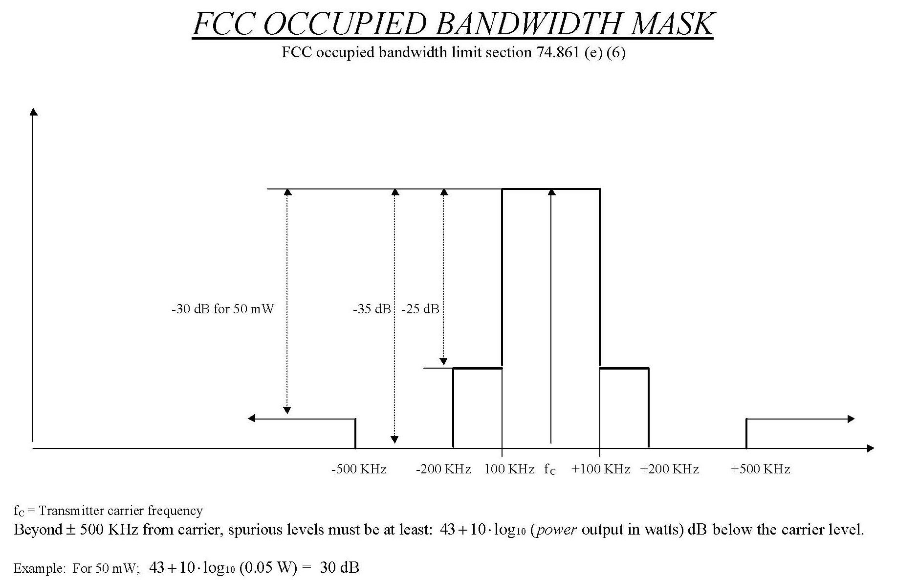
Figure 1: Wireless Microphone FCC Spectral Mask
Wireless microphones utilize simple but effective transmission concepts by today’s standards, commonly employing analog FM modulation of a UHF/VHF carrier. Some key technical characteristics [1] are
- Frequency bands: 174-216, 470-608, 614-806 MHz
- Maximum transmit power: 50 mW (VHF), 250 mW (UHF), Most units operate with 10-50 mW output
- Typical antenna gain: -2 to –6 dBi
- Body absorption: 5-15 dB
- Typical ERP: -6 to 0 dBm
- Height above ground: 1 meter
- Primarily FM modulation
- 50-15,000 Hz Frequency Response
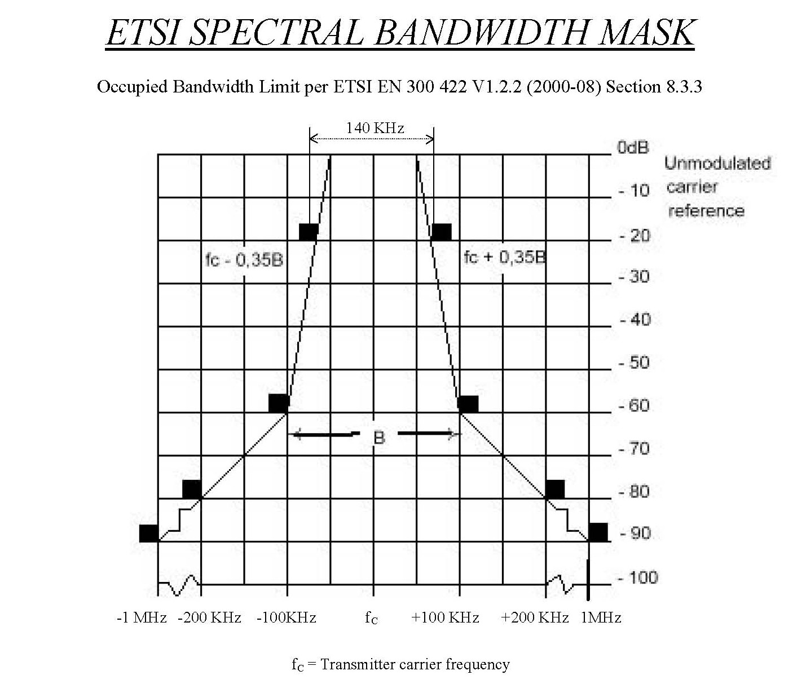
Figure 2: Wireless Microphone ETSI Spectral Mask
- Dynamic Range: 100 dB or more
- Occupied bandwidth: 200 kHz or less

Figures 1 and 2 illustrate the wireless microphone bandwidth transmission masks as specified by the FCC and ETSI, respectively.

We have found that a realistic model of the transmission channel our wireless systems typically encounter in indoor public/private venues corresponds to a flat Rayleigh faded channel (see also Figure 3). Such a channel corresponds well to typical indoor applications of wireless microphone systems, where the receiver will be subjected to reflections from walls and other obstructions present in-building. Rayleigh fading transmission channels are well understood, and can today be modeled using various types of fading simulators. One only needs to know how to set the appropriate fader parameters, in order to model the type of channel the wireless system is expected to encounter. Through testing in private/public indoor venues, we have developed realistic parameters for the fading simulator that we will provide later in this document.
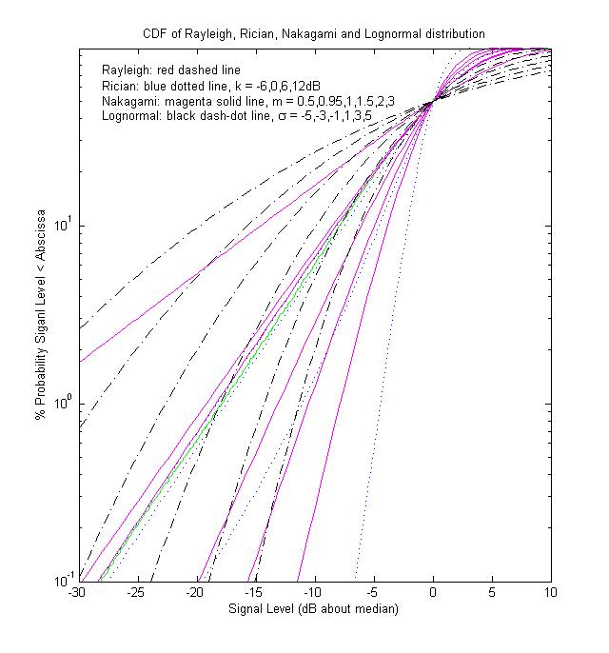
The other primary impairments encountered on the transmitter-to-receiver path include attenuation due to body absorption (a more serious problem for the popular body pack style wireless microphone transmitter, compared to hand held type wireless mics) and basic path loss due to distance between transmitter and receiver. These can be easily modeled using a variable attenuator or alternatively, by reducing the amplitude of the input signal.
Wireless
Microphone

The rest of this document is arranged as follows:
- Section 2 describes the equipment needed to create the desired signal generation environment.
- Section 3 describes the equipment configurations to generate signal test vectors.
Figure 3: Wireless Microphone Propagation Characteristics and common CDFs

2. The Signal Generation Environment

Wireless microphone signals are very easy to re-create in a simulation environment, or in the laboratory with off-the-shelf equipment. The suggested wireless microphone signal generation environment is illustrated in the figure below.

Figure 4: Wireless Microphone Signal Generation Environment

A brief description of the components is provided below:

- Signal Generator: Any RF signal generation source which has the ability to FM modulate a signal can be used. Many signal generators can generate a tone internally (a separate tone/generator can also be used if this is not the case). The device should have settings for varying the modulated signal’s amplitude, carrier frequency, and deviation. We commonly use the HP/Agilent ESG 4000A.
- Rayleigh Fading Simulation: Rayleigh fading is a well known issue for RF transmission. It is therefore common for a receiver’s performance to be measured based on its performance when the transmitted signal is subjected to such a channel. Hence, many wireless laboratories today have the capability to either model the channel in SW, or simulate it with real equipment. We have commonly used the Rohde and Schwartz SMU 200A.
- Variable Attenuator: A variable attenuator may be used for convenience (such as the Kay 829), but other approaches are also possible (e.g. fixed attenuators). The attenuator(s) will be adjusted to produce the desired RF signal level at the receiver/detector. The same effect can be achieved by appropriately adjusting the input signal’s amplitude, if preferred.

If real equipment is used, the components are connected using RF cable with adequate shielding for VHF/UHF signals.

3. Generation of Wireless Microphone Signal Test Vectors

Using the signal generation environment described above, it is recommended that at least 6 signal test vectors be considered in the evaluation of wireless microphone sensing schemes:

- Outdoor, LOS, silent: this case corresponds to the scenario of a wireless system used outside with line of sight transmission path between transmitter and receiver. The system user is silent. This means the signal transmitted is essentially the FM carrier + tone key (a supra audible tone used by the receiver to identify the desired radio signal, so that it can e.g. unmute/mute).
- Outdoor, LOS, soft speaker: this case corresponds to the scenario of a wireless system used outside with line of sight transmission path between transmitter and receiver. The system user in this case is a soft speaker. This means the signal transmitted is the FM carrier with some moderate amount of deviation.
- Outdoor, LOS, loud speaker: this case corresponds to the scenario of a wireless system used outside with line of sight transmission path between transmitter and receiver. The system user in this case is a loud speaker. This means the signal transmitted is the FM carrier with near the maximum amount of deviation.

The LOS scenarios above correspond to fairly “easy” cases for the receiver and can be used to validate some basic receiver/detector capabilities.

- Indoor, Rayleigh Faded, silent: this case corresponds to the scenario of a wireless system used indoors with fading on the transmission path between transmitter and receiver. The system user is silent. This means the signal transmitted is basically the carrier + tone key (a supra audible tone used by the receiver to identify the desired radio signal and e.g. unmute/mute).
- Indoor, Rayleigh Faded, soft speaker: this case corresponds to the scenario of a wireless system used indoors with fading on the transmission path between transmitter and receiver. The system user is a soft speaker. This means the signal transmitted is the carrier with a some moderate amount of deviation.
- Outdoor, Rayleigh Faded, loud speaker: this case corresponds to the scenario of a wireless system used indoors with fading on the transmission path between transmitter and receiver. The system user is silent, which means the signal transmitted is the carrier with near the maximum amount of deviation.

In the below, we describe the equipment/simulator settings to be used in order to reproduce the above scenarios with the signal generation environment.

Outdoor, LOS, silent
Tone Generator: 32 kHz tone
Signal Generator: tune so that signal falls within any available TV channel
FM Deviation: +/- 5 kHz
Rayleigh Fading Simulator: not used/pass through
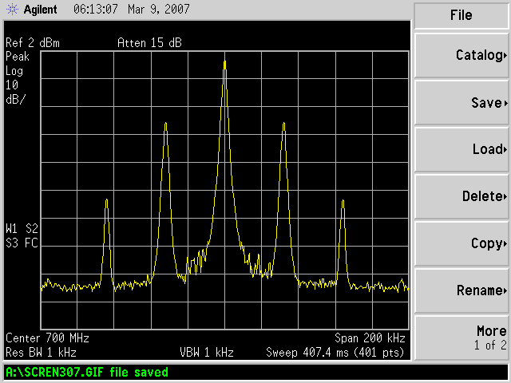
Attenuation: adjust the attenuator value in order produce the required dBm readings at the receiver (+10 dbm max, down to the–107 dBm detection threshold for wireless microphones).

Outdoor, LOS, soft speaker
Tone Generator: 3.9 kHz tone
Signal Generator: tune so that the signal falls within any available TV channel
FM Deviation: +/- 15 kHz
Rayleigh Fading Simulator: not used/pass through
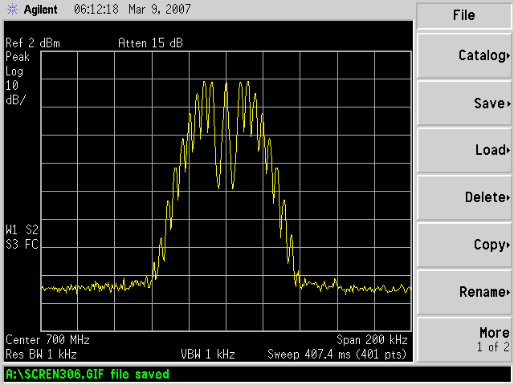
Attenuation: adjust the attenuator value in order produce the required dBm readings at the receiver (+10 dbm max, down to the–107 dBm detection threshold for wireless microphones).
Microphone Signal - Silence

Outdoor, LOS, loud speaker
Tone Generator: 13.4 kHz tone
Signal Generator: tune so that the signal falls within any available TV channel
FM Deviation: +/- 32.6 kHz
Rayleigh Fading Simulator: not used/pass through
Attenuation: adjust the attenuator value in order produce the required dBm readings at the receiver (+10 dbm max, down to the–107 dBm detection threshold for wireless microphones).

Indoor, Rayleigh Faded, silent
Microphone Signal - Soft Speaker
Tone Generator: 32 kHz tone
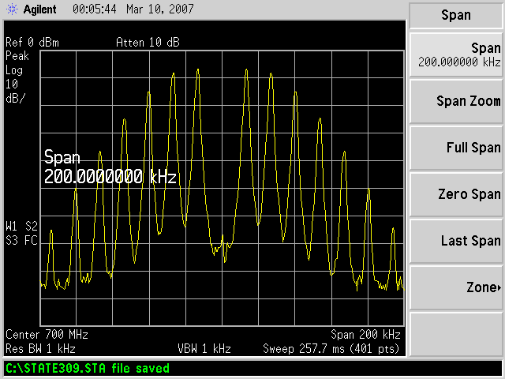
Signal Generator: tune so that the signal falls within any available TV channel
FM Deviation: +/- 5 kHz
Rayleigh Fading Simulator: flat Rayleigh Fading, one tap setting: Relative time = 0 uS, Average Relative Power = 0 dB, Equivalent Speed = 0.6 m/s
Attenuation: adjust the attenuator value in order produce the required dBm readings at the receiver (+10 dbm max, down to the–107 dBm detection threshold for wireless microphones).

Indoor, Rayleigh Faded, soft speaker
Tone Generator: 3.9 kHz tone
Microphone Signal - Loud Speaker
Signal Generator: tune so that the signal falls within any available TV channel
FM Deviation: +/- 15 kHz
Rayleigh Fading Simulator: flat Rayleigh Fading, one tap setting: Relative time = 0 uS, Average Relative Power = 0 dB, Equivalent Speed = 0.6 m/s
Attenuation: adjust the attenuator value in order produce the required dBm readings at the receiver (+10 dbm max, down to the–107 dBm detection threshold for wireless microphones).

Indoor, Rayleigh Faded, loud speaker
Tone Generator: 13.4 kHz tone
Signal Generator: tune so that signal falls within any available TV channel
FM Deviation: +/- 32.6 kHz
Rayleigh Fading Simulator: flat Rayleigh Fading, one tap setting: Relative time = 0 uS, Average Relative Power = 0 dB, Equivalent Speed = 0.6 m/s
Attenuation: adjust the attenuator value in order produce the required dBm readings at the receiver (+10 dbm max, down to the–107 dBm detection threshold for wireless microphones).

These test scenarios provide a good sampling of the types of signals that will be transmitted in typical wireless microphone use cases.

References
[1] Wireless Microphone Characteristics, IEEE 802.22-06/0070r0, May 2006, Edgar Reihl, Shure Inc.

