IEEE P802.22
Wireless RANs
802.22 Security Sublayer Proposal
Date: 2007-01-18
Author(s):
Name | Company | Address | Phone | email
David Johnston | NextWave Broadband |  | 503 380 5578 | djohnston@nextwave.com
Abstract
This document proposes a substantial amendment to the security sublayer to provide a complete link security framework including EAP, authentication, key hierarchy, cipher negotiation, link cipher and key management.

It is derived from the recent work updating the 802.16 security sublayer. However it avoids the legacy behaviour in 802.16 derived from the 802.16-2001 specification and includes changes in document structure, negotiation and options that benefit from the lessons learned during the development of the 802.16 standard.

Notice: This document has been prepared to assist IEEE 802.22. It is offered as a basis for discussion and is not binding on the contributing individual(s) or organization(s). The material in this document is subject to change in form and content after further study. The contributor(s) reserve(s) the right to add, amend or withdraw material contained herein.

Release: The contributor grants a free, irrevocable license to the IEEE to incorporate material contained in this contribution, and any modifications thereof, in the creation of an IEEE Standards publication; to copyright in the IEEE’s name any IEEE Standards publication even though it may include portions of this contribution; and at the IEEE’s sole discretion to permit others to reproduce in whole or in part the resulting IEEE Standards publication. The contributor also acknowledges and accepts that this contribution may be made public by IEEE 802.22.

Patent Policy and Procedures: The contributor is familiar with the IEEE 802 Patent Policy and Procedures
<http://standards.ieee.org/guides/bylaws/sb-bylaws.pdf>, including the statement "IEEE standards may include the known use of patent(s), including patent applications, provided the IEEE receives assurance from the patent holder or applicant with respect to patents essential for compliance with both mandatory and optional portions of the standard." Early disclosure to the Working Group of patent information that might be relevant to the standard is essential to reduce the possibility for delays in the development process and increase the likelihood that the draft publication will be approved for publication. Please notify the Chair <Carl R. Stevenson> as early as possible, in written or electronic form, if patented technology (or technology under patent application) might be incorporated into a draft standard being developed within the IEEE 802.22 Working Group. If you have questions, contact the IEEE Patent Committee Administrator at <patcom@ieee.org>.
802.22 Document Template Instructions

To properly identify your Word document as an IEEE 802.22 Submission
there are 5 steps that you must complete, and 9 data fields that you must fill in.

Step 1. Obtain a document number (has the form yy/xxxx).
Step 2. Title page (above) - fill in the document subject title text, full date (in the ISO 8601 format of YYYY-MM-DD), the full author(s) details and the abstract text (a total of 4 data fields).
Step 3. Menu select File, Properties. Fill in the 5 data fields:
Title field = document designator
example "doc.: IEEE 802.22-04/9876r0" , or
"doc.: IEEE 802.22-04/9876r2"
Author field = first author’s name
Company field = first author’s company name
Keywords field = venue date (month year, e.g. January 2005)
Comments field = first author, company
Step 4. Update the header and footer: To do this, menu select View, Normal, then menu select View, Page Layout (called View, Print Layout in some versions of Word). Switching the view of the document automatically updates all fields in the header and footer. Save the file with the final headers and footers.
Step 5. Delete this page of instructions.

MS Word Submission Preparation Summary:
Things to do: 5
Fields to fill in: 9

Recommendations:
a) Always create a new document using the template, rather than using someone else's document.
b) For quick and easy creation of new 802.22 submissions, place the 802.22 template files in the template folder area on your computer. Typical locations are:
c:\Program Files\Microsoft Office\Templates\
or,
c:\Documents and Settings\User Name\Application Data\Microsoft\Templates\
To create a new submission, menu select File, New, then select the appropriate 802.22 template file.
c) When you update or revise your document, remember to check all 5 fields in step 3 for the correct values and follow steps 3 through 4 again to ensure that the header and footer are updated with the revised field values.

rev: de2004-12-19

802.22 Security Sublayer Proposal

The following proposal is a substantial amendment to the security sublayer to provide a complete link security framework including EAP, authentication, key hierarchy, cipher negotiation, link cipher and key management.

It is derived from the recent work updating the 802.16 security sublayer. However it avoids the legacy behaviour in 802.16 derived from the 802.16-2001 specification and includes changes in document structure, negotiation and options that benefit from the lessons learned during the development of the 802.16 standard.

Issues with the 802.16 Security Sublayer

The document structure of the 802.16 specification makes poor separation of the KMAPv1 and KMAPv2 modes. This is because the specification started with only one mode and made no structural attempt to support the addition of future modes with good separation of behaviour. 802.22 can avoid this mistake, defining one mode, identified as the v1 mode, but providing clear definition as to what mode or modes any behaviour applies to and provided clear places for future modes to be added.

There are unauthenticated link cipher modes such as AES-CTR. This mode should be deprecated and can be omitted from 802.22 standard. Similarly there are historical baggage modes that are included – DES-CBC and AES-CBC. These can be omitted.

The RSA authorization mode is historical baggage imported from DOCSYS. Authentication is the domain of EAP. EAP was added to 802.16 but RSA authentication was not dropped. It can be omitted from the 802.22 specification.

802.16 has the option of using HMAC or CMAC for management message authentication. The choice is negotiated as a global switch for the SS. 802.22 need choose only one. CMAC is the more modern and NIST approvable. SHA-1 based modes such as HMAC, while currently secure are suffering from published attacks that weaken them and there is uncertainty as to whether it will survive as a secure mode for much longer.

The length of the 802.16 CMAC is questionable. length of the CMAC leads to 64 bits of integrity protection resulting from the birthday attack. This is too short for some and it would be wise to extend it to 256 bits, giving 128 bits of protection.

“During re-authentication, the EAP transfer messages are protected with an HMAC[14]/CMAC[15] xxx tuple. The BS and CPE must discard unprotected EAP transfer messages or EAP transfer messages with invalid HMAC/CMAC digests during re-authentication.
“
This means that a CPE that looses its keys can’t reauthenticate because the BS rejects its unauthenticated EAP_Request_Identity in a KMAP EAP_Transfer wrapper. The spec needs to describe the conditions under which or mechanism by which an SS can do initial authentication after loosing local authentication state.

The term privacy is misused in the 802.16 specification. 802.22 can choose to correctly appy the terms security, privacy, integrity and confidentiality.

It is reasonable to place limits on flooding of EAP initiations as a protection against DoS. Then compliant stations know how to avoid the BS discsrding their EAP packets and attackers can only place a certain maximum load on a AAA server.

Ciphersuites in 802.16 define the encryption and authentication modes. The ciphersuites need to include the KDF, the key hierarchy and the authentication tuple algorithm in the ciphersuite. NIST are introducing a KDF/Key Hierachy spec soon, and the freedom to adopt it for FIPS would be highly desierable. Including these algorithms in the negotiated ciphersuites provides the easy extensibility of these parts of the specification.

The freshness assurance of the TEK transfer is not assured if you don’t trust the BS. 802.16 relies on the SS trusting the BS to send a fresh key. Some crypto people do not like this. It is a theoretical problem that might turn real in the future. We might want a fresheness assurance built into the TEK transfer as per 802.11i/r.

802.16 has both capability negotiation and authentication policy negotiation. However capabilities are negotiated within the authentication policy negotiation. In security, a capability does not imply that policy permits its use. Correct separation of policy negotiation and capability negotiation is needed. 802.16 suffers from potential inconsistencies when authentication policy negotiation negotiates something differently to capability negotiation.

Mesh mode in 802.16 was never completed. Text supporting mesh mode can be omitted from 802.22.

The 802.16 standard uses acronyms and initials that are clumsy and/or inaccurate names, resulting from the names derived from the obsolete DOCSYS naming scheme and the incremental revision of some of the concepts. E.G. PKM (Privacy and Key Management) is an inappropriate name for an authentication and key management protocol. HMAC/CMAC authentication key (formerly HMAC key) is an algorithm specific name for an algorithm independent key. Management Message Authentication Key (MMAK) is much more appropriate and it supports the future addition of new management authentication algorithms without having to change the name.

The Generic MAC Header (GMH) includes an EC (encryption) bit to identify encrypted MPDUs. However this bit is redundant, since any received packet needs to be decrypted and authenticated according to the rules in the associated SA. The EC bit provides no further information. A packet inappropriately encrypted or not encrypted will fail integrity checks or be malformed and dropped by higher layers. The EC bit can be omitted and the valuable header bit be made available for other uses.

Key lengths in the key hierarchy in 802.16 are tuned to the length needed by the underlaying cryptographic algorithms. This inhibits the extensibility of the cryptographic algorithms used in the key hierarchy through negotiation. It would be better to leave the keys at their maximum length and have each cryptographic algorithm truncate key length to their own needs, allowing the future negotiation of algorithms that use more of the key material. The 802.16 AK length is 160 bits because this is what HMAC-SHA1 requires. However SHA1 is becoming obsoleted and insecure, so 256 for use with CMAC would be preferable.

Proposed Text Changes

[Replace Clause 7 with the following]

Security sublayer

The security sublayer provides subscribers with privacy, authentication or confidentiality across the broadband wireless network. It does this by applying cryptographic transforms to MPDUs carried across connections between SS and BS, managing keys and providing authentication through the use of EAP.
The security sublayer provides 802.22 service providers with strong protection from theft of service. The BS protects against unauthorized access to these data transport services by securing the associated service flows across the network. The Security sublayer employs an authenticated client/server key management protocol in which the BS, the server, controls distribution of keying material to client SS. If during capabilities negotiation, the SS specifies that it does not support IEEE 802.22 security, the step of authorization and key exchange shall be skipped. The BS, if provisioned to permit unauthenticated subscribers, shall consider the SS authenticated; otherwise, the SS shall not be serviced and neither key exchange nor data encryption performed.

Security Sublayer Architecture
The security sublayer has two component protocols as follows:
- An encapsulation protocol for securing packet data across 802.22 network connections. This protocol defines (1) a set of supported cryptographic suites, i.e., pairings of data encryption, authentication and key management algorithms and (2) the rules for applying those algorithms to a MAC PDU payload.
- A Key Management and Authentication Protocol (KMAPv1) providing the secure distribution of keying data from the BS to the SS. Through this key management protocol, SS and BS synchronize keying data; in addition, the BS uses the protocol to enforce conditional access to network services. The only and most recent version of the KMAP protocol is KMAPv1. As security needs change over time, the KMAPv1 protocol may need to be replaced with a new version or versions that defend against known attacks. The KMAP protocol allows for new versions to be added at a later date without breaking the previous version(s) through the use of KMAP protocol version numbers in the KMAP messages. The protocol stack for the security components of the system are shown in Figure n.
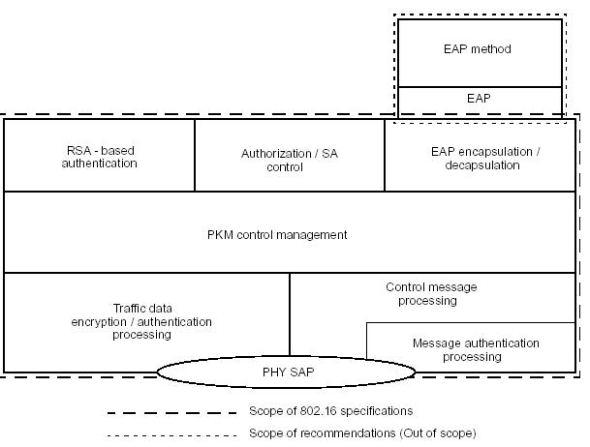
Figure 1 Security Sublayer

Negotiation of Security Behavior Overview
The capabilties negotiation determines the versions of KMAP that are available. The authentication policy negotiation determines the KMAP version and link cipher versions that are acceptable and shall be used.

Secure encapsulation of MPDUs Overview
Encryption services are defined as a set of capabilities within the MAC Security Sublayer. MAC Header information specific to encryption is allocated in the generic MAC header format. Encryption is applied to the MAC PDU payload when required by the selected ciphersuite; the generic MAC header is not encrypted. All MAC management messages shall be sent in the clear to facilitate registration, ranging, and normal operation of the MAC.
The format of MAC PDUs carrying encrypted packet data payloads is specified in 6.3.3.6.

Key management and Authentication protocol Version 1 (KMAPv1) Overview
The KMAP protocol allows for authentication methods defined as parts of the EAP protocol. This includes mutual authentication and unilateral authentication methods (e.g., where the BS authenticates SS, but not vice versa). It also supports periodic reauthentication/reauthorization and key refresh. The key management protocol uses either EAP [IETF RFC 3748]. It uses strong encryption algorithms to perform key exchanges between an SS and BS.
The KMAP’s authentication protocol establishes a shared secret (called an Authorization Key (AK)) between the SS and the BS. The shared secret is then used to secure subsequent KMAP exchanges of TEKs. This two-tiered mechanism for key distribution permits refreshing of TEKs without incurring the overhead of computation- intensive operations.
A BS authenticates a client SS during the initial authorization exchange. The SS and BS authenticate using an operator-specified EAP method. The BS may associate an SS’s authenticated identity to an authorized subscriber, and hence to the data services that subscriber is authorized to access. The subsequent AK exchange, provides the BS and SS with a shared key (the AK) with which to derive other keys such as Management Message Authentication Keys (MMAKs) and Key encryption Keys (KEKs) used to protect the management messages and traffic keys. The derivation of these keys is defined by the KMAPv1 Key Hierarchy A (KMAPv1-KHA).
The state associated with the authenticated state of the SS and BS, with the associated AK and other keys together form a Security Association (SA). The SA is identified by an SAID. For multicast groups, there is a special case of an SA called a Group Security Association (GSA). Unicast connections are secured under SAs. Multicast connections are secured under GSAs.
Since the BS authenticates the SS, these SAs may protect against an attacker employing a cloned SS, masquerading as a legitimate subscriber’s SS.
The traffic-key management portion of the KMAP protocol adheres to a client/server model, where the SS (a KMAP “client”) requests keying material, and the BS (a KMAP “server”) responds to those requests, ensuring that individual SS clients receive only keying material for which they are authorized. The KMAP protocol uses MAC management messaging, i.e., KMAP-REQ and KMAP-RSP messages defined in 6.3.2.3. The KMAPv1 protocol is defined in detail in 7.2.

Instanciation of KMAPv1 processes.
At initiation Primary and Static SAs are created by instanciating authentication state machines followed by an AK exchange. the authentication state machine for each SA remains active for the life of the SA, periodically performing reauthentication.
A TEK state machine is instanciated for each SA that is established that has active provisioned connections. Periodically this state machine is restarted to acquire fresh TEKs when the lifetime of active TEKs expires.

KMAPv1 EAP Authentication protocol Overview
An SS uses the KMAPv1 protocol to obtain authorization and traffic keying material from the BS, and to support periodic reauthorization and key refresh. KMAPv1 uses the EAP authentication framework to achieve this.
KMAP EAP Authentication uses Extensible Authentication Protocol [IETF RFC 3748] in conjunction with an operator-selected EAP Method (e.g. EAP-TLS [IETF RFC 2716]). The EAP method will use a particular kind of credential – such as an X.509 certificate in the case of EAP-TLS, or a Subscriber Identity Module in the case of EAP-SIM.
The particular credentials and EAP methods that are to be used are outside of the scope of this specification. However, the EAP method selected should fulfill the “mandatory criteria” listed in section 2.2 of RFC 4017. Use of an EAP method not meeting these criteria may lead to security vulnerabilities.
During re-authentication, the EAP transfer messages are protected with an HMAC/CMAC tuple. The BS and SS must discard unprotected EAP transfer messages, or EAP transfer messages with invalid HMAC/CMAC digests during re-authentication.

Mapping of connections to SAs
The following rules for mapping connections to SAs apply:
- All Transport Connections shall be mapped to an existing SA.
- Multicast Transport Connections may be mapped to any Static or Dynamic SA.
- The Secondary Management Connection shall be mapped to the Primary SA.
- The Basic and the Primary Management connections shall not be mapped to an SA.

In the case of dynamically created connections, the mapping is achieved by including the SAID of an existing SA in the DSA-xxx messages together with the CID. No explicit mapping of Secondary Management Connection to the Primary SA is required.

Cryptographic Suite
A Cryptographic Suite is the SA’s set of methods for data encryption, data authentication, TEK exchange, key hierarchy and Key Derivation Function (KDF). A Cryptographic Suite is specified as described in 11.9.14. The Cryptographic Suite shall be one of the ones listed in Table 378.

Security Associations
A Security Association (SA) is the set of security information a BS and one or more of its client SSs share in order to support secure communications across the IEEE Std 802.22 network. Three types of SAs are defined: Primary, Static, and Dynamic. Each SS establishes a Primary Security Association during the SS initialization process. Static SAs are provisioned within the BS. Dynamic SAs are established and eliminated, on the fly, in response to the initiation and termination of specific service flows.
An SA is shared between a single SS and BS.
A special case of SA, the Group SA or GSA, in Static and Dynamic forms may be shared by multiple SSs registered with the same BS.
An SA’s encapsulated information shall include the Cryptographic Suite employed within the SA. The information may include TEKs and Initialization Vectors. The exact content of the SA is dependent on the SA’s Cryptographic Suite.
SAs are identified using SAIDs.
Each SS shall establish an exclusive Primary SA with its BS. The SAID of any SS’s Primary SA shall be equal to the Basic CID of that SS.
Using the KMAP protocol, an SS requests from its BS an SA’s keying material. The BS shall ensure that each client SS only has access to the SAs it is authorized to access. An SA’s keying material [e.g., AES-CCM encryption key and nonce counter] has a limited lifetime. When the BS delivers SA keying material to an SS, it also provides the SS with that material’s remaining lifetime. It is the responsibility of the SS to request new keying material from the BS before the set of keying material that the SS currently holds expires at the BS. Should the current keying material expire before a new set of keying material is received, the SS shall perform network entry as described in 6.3.9.
In certain Cryptographic Suites, key lifetime may be limited by the exhaustion rate of a number space [e.g. the PN (Packet Number) in AES-CCM mode]. In this case, the key ends either at the expiry of the key lifetime or the exhaustion of the number space, which ever is earliest. Note that in this case, security is not determined by the key lifetime.

KMAPv1 protocol

KMAPv1 Authentication and AK exchange overview
Authentication, controlled by the KMAPv1 authentication state machines for the SS and BS, is the process of the BS authenticating a client SS’s identity and visa versa in the case of mutual authentication, through:
a) The BS and SS establishing a shared AK derived from the MSK resulting from an EAP exchange. From this AK a key encryption key (KEK) and Management Message Authentication Keys (MMAKs) are derived.
b) The BS providing the authenticated SS with the identities (i.e., the SAIDs) and properties of primary and static SAs that the SS is authorized to obtain keying information for.
After achieving initial authentication, an SS periodically reauthenticates with the BS; reauthentication is also managed by the SS’s and BS’s Authentication state machines. TEK state machines manage the refreshing of TEKs.

KMAPv1 Initial Authentication using EAP.
An SS or BS begins authentication by initiating an EAP state machine that transmits and receives its EAP messages over KMAP-EAP-payload MAC management messages. The EAP state machine terminates with either an indication of success or an indication of authentication failure at both ends.
In the case of a successful EAP exchange, the product of the EAP exchange which is transferred to 802.22 security sublayer in the SS from the EAP method is the Master Session Key (MSK), which is 512 bits in length. This key is known to the AAA server, to the Authenticator* (transferred from AAA server) and to the SS.
Only EAP methods that generate an MSK may be used with 802.22. EAP methods that do not generate an MSK shall not be used with 802.22.

A KMAP-EAP-Start MAC management message may be sent from one end to indicate to the other that it should initiate an EAP authentication immediately. The KMAP-EAP-Start message is not required to initiate an EAP authentication and shall not be relied upon by BS or SS to initiate an EAP authentication. Its use may serve the purpose of causing the timely initiation of EAP if neither end thinks it is its role to perform the initiation.
The Authorization Key (AK) is derived using the negotiated Key Hierarchy.
Once an AK is obtained, the BS initiates the SA-Authentication 3 way handshake as defined in xxx. This exchange involves a 3 way exhange beginning with the BS sending and SA-Authentication-Challenge, followed by the SS sending an SA-Authentication-request, followed by the BS sending the SS an SA-Authentication-Response. This exchange validates the authenticity of the AK and yields an AKID and a list of SA Identifiers (SAIDs) identifying the primary and static SAs and additional properties of the SA (e.g. type, cryptographic suite).
This sequence is controlled by the KMAPv1 authentication state machine described in [].
The initial SA-Authentication-response shall not identify any Dynamic SAs.
The BS, in responding to an SS’s Authorization Request, shall determine whether the requesting SS, whose identity can be verified, is authorized for basic unicast services, and what additional statically provisioned services (i.e., Static SAIDs) the SS’s user has subscribed for. Note that the protected services a BS makes available to a client SS can depend upon the particular cryptographic suites SS and BS share support for.

KMAPv1 Periodic Re-Authentication.
An SS shall periodically refresh its AK by re-authenticating by initiating an EAP authentication or requesting the BS to initiate an EAP authentication with KMAP-EAP-Start, followed by the KMAP-Authorization 3 way exchange with the BS.
The use of the KMAP-Authentication 3 way exchange in reauthentication is identical to the KMAP-Authorization 3 way exchange in initial authentication with the additional constaint that the BS does not change the SAIDs of the primary and static SAs shared with the SS.
To avoid service interruptions during reauthentication, successive generations of the AKs have overlapping lifetimes. Both SS and BS shall be able to support up to two simultaneously active AKs during these transition periods. The operation of the authentication state machine’s Authentication Request scheduling algorithm, combined with the BS’s regimen for updating and using a client SS’s AKs (see 7.4), ensures that the SS can refresh TEK keying information without interruption over the course of the SS's reauthentication periods.

KMAPv1 TEK exchange overview

If SS and BS decide “No authorization” as their authorization policy, SS and BS shall perform neither SATEK handshake nor Key Request/Key Reply handshake. In this case, target SAID value which may be included in DSA-REQ/RSP messages shall be Null SAID.
Upon achieving authorization, an SS starts a separate TEK state machine for each of the SAIDs identified in the Authorization Reply or KMAPv1 SA-TEK-RSP message, if data traffic encryption is provisioned for one or more service flows. Each TEK state machine operating within the SS is responsible for managing the keying material associated with its respective SAID. TEK state machines periodically send Key Request messages to the BS, requesting a refresh of keying material for their respective SAIDs.
The BS responds to a Key Request with a Key Reply message, containing the BS’s active keying material for a specific SAID.
TEKs and KEKs are 128 bits long.
Note that at all times the BS maintains two diversity sets of keying material per SAID. The lifetimes of the two generations overlap such that each generation becomes active halfway through the life of it predecessor and expires halfway through the life of its successor. A BS includes in its Key Replies both of an SAID’s active generations of keying material.
For SAs using a ciphersuite employing AES-CCM mode, the Key Reply provides the requesting SS, in addition to the TEK, the remaining lifetime of each of the two sets of keying material. The receiving SS uses these remaining lifetimes to estimate when the BS will invalidate a particular TEK, and therefore when to schedule future Key Requests such that the SS requests and receives new keying material before the BS expires the keying material the SS currently holds. For AES-CCM mode, when more than half the available PN numbers in the 31-bit PN number space are exhausted, the SS shall schedule a future Key Request in the same fashion as if the key lifetime was approaching expiry. The operation of the TEK state machine’s Key Request scheduling algorithm, combined with the BS’s regimen for updating and using an SAID’s keying material (see 7.4), ensures that the SS will be able to continually exchange encrypted traffic with the BS.
A TEK state machine remains active as long as
- The SS is authorized to operate in the BS’s security domain, i.e., it has a valid Primary SA, and
- The SS is authorized to participate in that particular SA, i.e., the BS continues to provide fresh keying material during rekey cycles.
- The SS and BS together have an established secondary management connection and/or any transport connections that are associated with an SA. Without a secondary management connection or transport connection to protect, TEKs are not required.
MAC PDUs sent on connections that belong to an SA that includes a non null ciphersuite, shall be encrypted and/or authenticated according to the rules of the ciphersuite, except for MPDUs with zero length. MPDUs of zero length shall be transmitted in cleartext and have no security cipher applied.

KMAPv1 Authentication State Machine
The KMAPv1 Authentication state machine for EAP authentication consists of six states and sixteen events (including receipt of messages and events from other fems) that may trigger state transitions. The Authentication state machine is presented in both a state flow diagram (Figure 3, “Authentication FSM”) and a state transition matrix (Table 3, “Authentication FSM state transition matrix”). The state transition matrix shall be used as the definitive specification of protocol actions associated with each state transition. The Authentication process has 2 phases: EAP phase and 3-way handshake phase (also known as SA_TEK exchange). The EAP phase is controlled by the EAP_FSM as defined in RFC3748 and RFC4173 and it is out of scope in this standard. The Auth_FSM is responsible for whole of PKM phase, except the actual EAP exchange and communicates with other FSMs in the system using events.

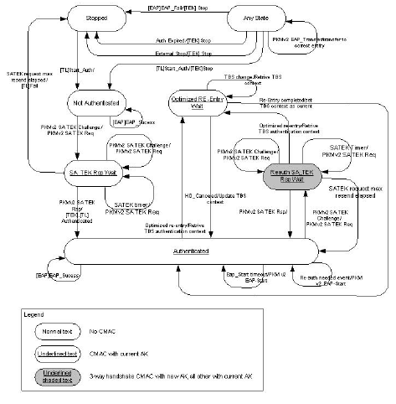

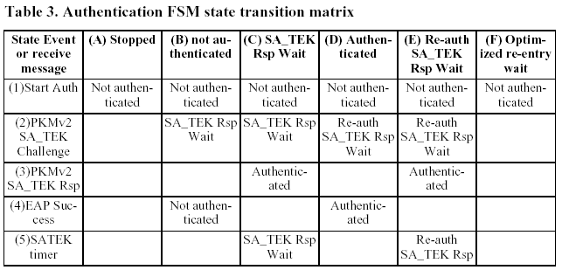
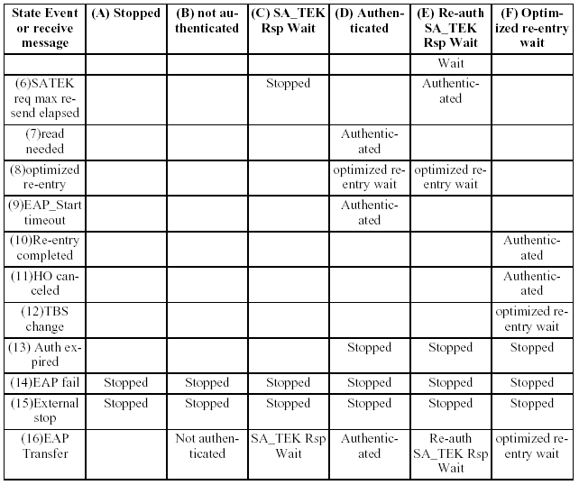

States
- Stopped: This is the initial state of the FSM, nothing is done in this state.
- Not Authenticated: The Auth FSM is not authenticated and waiting for MSK to be received from EAP FSM in order for MAC level authentication to start from BS side by SA_TEK_Challange. Upon receiving SA_TEK Challenge, it is validated by checking H/CMAC using current AK and silently discarded if not valid.
- SA TEK Rsp Wait: The Auth FSM has sent SA_TEK_Req and is waiting for SA_TEK_Rsp. It retries the message if needed as long as SATEK counter has not elapsed. Upon receiving SA_TEK Response, it is validated by checking H/CMAC using current AK and silently discarded if not valid.
- Authenticated: Successful authentication finished. The MS derives all keys from MSK, sets the valid time of authentication keys and starts timers to monitor authentication expiration. In this state, the FSM is ready to receive MSK from EAP FSM and derive keys of re-authentication and to receive MAC level re-auth from BS side (SA_TEK_Challange). In this state all management messages that are defined to be sent with H/CMAC are checked using current AK and silently discarded if MAC is not valid. In this state, the MS may hold two authentication contexts: current and next context created during re-authentication, the current context is deleted in the frame number defined in SA_TEK_RSP and the new one becomes current.
- Re-auth SA TEK Rsp Wait: The Auth FSM has sent SA_TEK_Req for reentry and is waiting for SA_TEK_Rsp. It retries the message if needed as long as SATEK counter has not elapsed. In this state there are two authentication contexts: the current which is used for MAC with all management messages (that needs MAC tuple) and temporary context created after EAP phase has finished. The temporary context is used for the re-authentication 3-way handshake exchange and upon successful reception of SA_TEK_RSP it changes from temporary to next context.
- Optimized re-entry Wait: In this state the Auth FSM is supporting Auth key derivation for Optimized reentry (for HO or Idle). It has stopped all other actions and just gives services to the HO FSM for optimized re-entry. All authentication related timers continue to tick in this state but actions are taken only upon returning to regular "authenticated" state. In this state all derived AK and context are maintained and cached for as long as they may be valid in order to protect from replay attack. Messages in this state are protected with MAC using AK of current BS, re-entry is done with. Only in this state, in case of MAC validation fail the message is discarded but an event is sent to top level FSM to notify this event.

Messages

- KMAPv1 SA TEK Challenge: first message of MAC level 3-way handshake, sent from BS to MS after EAP authentication has finished, protected by MAC digest using the key from the last EAP authentication.
- KMAPv1 SA TEK Request: Second message of MAC level 3-way handshake, sent from MS to BS as response to SA TEK Challenge, protected by MAC digest using the key from the last EAP authentication.
- KMAPv1 SA TEK Response: Last message of MAC level 3-way handshake, sent from BS to MS as response to SA TEK request, protected by MAC digest using the key from the last EAP authentication. Receiving this message validates the authentication and orders the MS to start using the key at the frame number as included in the message (if frame number TLC is missing, it must be used immediately)
- KMAPv1 EAP Start: Message used by MS to ask BS to initiate EAP Authentication. The message should be used by MS if it realizes re-authentication is needed. The Auth FSM does not receive any acknowledgement for this message. The only acknowledgement is that of successful finish of reauthentication (reception of SA_TEK_RSP).
- EAP Transfer: This message is bidirectional and is used as transport for EAP packets sent to and received from EAP FSM. Auth FSM does not use this message and just transfers them to and from EAP_FSM. These messages are sent/received unprotected in "not authenticated" state and protected with H/CMAC in any other states. The messages are not really part of Auth FSM but since they are part of security protocol, they are emphasized here. They can be processed in any state except "STOP" and are not part of Auth FSM itself.

These messages are not really part of Auth FSM but since they are part of security protocol, they are emphasized here. They can be processed in any state except "STOP" and are not part of Auth FSM itself.

Events
- Start Auth: sent from higher level FSM (NW entry for example) to start the authentication state machine and have it waiting for authentication. This event can be sent anytime. (For any reason some other FSM decides full NW-entry is needed and therefore Auth FSM should start from initial authentication state.)
- EAP Success: Sent from EAP FSM to notify Auth FSM that EAP was finished successfully. This event may not arrive if the EAP level message is lost in the air link.
- SATEK timer: timer event that signals FSM to retry sending the SA_TEK_Request message because the SA_TEK_Response was not received.
- SATEK req max resend elapsed: counter event that signal the FSM that max retry of SA_TEK_Request resend finished and another action should be taken.
- read needed: An internal event of state that can be derived from several sources such as authentication grace time, ON space grace value or other reason that makes authentication close to expiration.
- HO re-entry: Send from HO FSM to inform Auth FSM that MS is in HO re-entry phase and FSM should support AK derivation for re-entry and not normal usage of AK
- EAP_Start timeout: Timer event that courses the MS to re-send EAP start in order to ask the BS to start EAP Authentication. This event is used for EAP_Start retry in case re-authentication did not finished successfully after last EAP_Start. This timer is active only after read needed event occurred.
- Re-entry completed: Event from HO FSM to signal Auth FSM that re-entry was finished successfully and Auth can continue it's normal course with AK of new BS
- HO canceled: Event from HO FSM to signal Auth FSM that HO was canceled and should continue normal course with original AK.
- TBS change: Event from HO FSM to signal that need to switch context to new TBS.
- Auth expired: Event that signal Auth expired due to timer and need to terminate authentication and connection to BS.
- External stop: Event from other FSM to stop Auth FSM and terminate connection with BS.

Parameters
- SATEK timer: timeout value between sending SA_TEK_Request messages
- SATEK max resend counter: Counter of number of SA_TEK_Request retries allowed.
- EAP_Start timeout: Timer between sending EAP_Start messages, since the only meaningful result of EAP_Start is successful re-authentication complete by receiving SA_TEK_RSP, the value of the timer should be larger than the max re-oath time including EAP phase and SA_TEK exchange.
- Authentication grace time: period before authentication will be expired when re-authentication attempts should begin to ensure successful re-oath before actual authentication expiration. This value should be larger that large number of EAP_Start timeout.
- ON grace value: A value of ON space that when reached re-oath is needed, this value should be large enough to support message exchange during several re-oath attempts

Actions
1- A..F: Any State (Start Auth) -> not authenticated
a) Enable EAP_Transfer message transfer.
b) Stop all TEK fems
2-B: Not Authenticated (SA_TEK_Challange) -> SA TEK Rsp wait
a) Send SA TEK re.
b) Start SATEK Timer.
c) Initiate SATEK counter
1- A..F: Any State (Start Auth) -> not authenticated
a) Enable EAP_Transfer message transfer.
b) Stop all TEK fems
2-B: Not Authenticated (SA_TEK_Challange) -> SA TEK Rsp wait
a) Send SA TEK re.
b) Start SATEK Timer.
c) Initiate SATEK counter
2-C: SA TEK Rsp wait (SA_TEK_Challange) -> SA TEK Rsp wait
a) Send SA TEK req.
b) Start SATEK Timer.
2-D: SA Authenticated (SA_TEK_Challange) -> Re-auth SA TEK Rsp wait
a) Send SA TEK req.
b) Start SATEK Timer.
c) Initiate SATEK counter
2-E: Re-auth SA TEK Rsp wait (SA_TEK_Challange) -> Re-auth SA TEK Rsp wait
a) Send SA TEK re.
b) Start SATEK Timer.
3-C: SA TEK Rsp wait (PKMv2 SA_TEK_Rsp) -> Authenticated
a) Start TEK FSM
b) Start Authentication grace timer
c) Set Authentication keys as valid
3-E: Re-auth SA TEK Rsp wait (PKMv2 SA_TEK_Rsp) -> Authenticated
a) start Authentication grace timer
c) Set frame number for Authentication keys to become valid.
d) Clear old authentication keys upon arrival of the "frame number".
4-B: not Authenticated (EAP success) -> not Authenticated
a) Obtain MSK
b) Derive Authentication keys (AK, KEK, CMAC/HMAC etc..)
4-D: Authenticated (EAP success) -> Authenticated
a) Obtain MSK
b) Derive Authentication keys (AK, KEK, CMAC/HMAC etc..)
5-C: SA TEK Rsp wait (SATEK timer) -> SA TEK Rsp wait
a) Send SA TEK req.
b) Start SATEK Timer
c) SATEK counter--
5-E: Re-auth SA TEK Rsp wait (SATEK timer) -> Re-auth SA TEK Rsp wait
a) Send SA TEK req.
b) Start SATEK Timer
c) SATEK counter--
6-C: SA TEK Rsp wait (SATEK counter elapsed) -> Stopped
a) Stop Auth FSM
b) Signal fail to top level FSM
6-E: Re-auth SA TEK Rsp wait (SATEK counter elapsed) -> Authenticated
a) do nothing
7-D: Authenticated (Re-auth needed) -> Authenticated
a) Send EAP_Start
b) Start EAP_Start timer
8-D: Authenticated (optimized re-entry) -> optimized reentry wait
a) Retrieve AK and context for TBS
b) Delete re-authentication 3-way handshake temporal context is exists (MS must maintain the PMK and
AK context because 3-way HS may re-start after re-entry is finished).
8-E: Re-auth SA TEK Rsp wait (optimized re-entry) -> optimized reentry wait
a) Terminate re-auth context
b) Retrieve AK and context for TBS
9-D: Authenticated (EAP Start Timer) -> Authenticated
a) Send EAP_Start
b) Start EAP_Start timer
10-F: optimized reentry wait (Re-entry completed) -> Authenticated
a) Set chosen BS context as current
11-F: optimized reentry wait (HO canceled) -> Authenticated
a) Continue using current BS context
12-F: optimized reentry wait (TBS changed) -> optimized reentry wait
a) Retrieve context of new TBS
b) Cache context of former TBS for as long as needed.
13-D,E,F: Any state (Auth Expired) -> Stopped
a) Stop TEK FSMs
b) Stop Auth FSM
c) Disconnect from NW
14-A..F: Any state (EAP FAIL) -> Stopped
a) Stop TEK FSMs
b) Stop Auth FSM
c) Disconnect from NW
15-A..F: Any state (External Stop) -> Stopped
a) Stop TEK FSMs
b) Stop Auth FSM
c) Disconnect from NW

KMAPv1 TEK State Machine
The TEK state machine consists of seven states and eleven events (including receipt of messages) that may trigger the state transitions. The TEK state machine is presented in both a state flow diagram (Figure 4, “TEK state machine flow diagram”) and a state transition matrix (Table 4, “TEK FSM state transition matrix”). The state transition matrix defines the transition between states when.
Shaded states in Table 4, “TEK FSM state transition matrix”(.viz. Operational, Rekey Wait, Rekey Reauthorize Wait, and M&B Rekey Interim Wait) have valid keying material and encrypted traffic may be sent.
TEK state machine for each of its authorized SAIDs are started by the Auth State Machine. Note: BS maintains two active TEKs per SAID.
The BS includes in its Key Replies both of these TEKs, along with their remaining lifetimes. The BS encrypts downlink traffic with the older of its two TEKs and decrypts uplink traffic with either the older or newer TEK, depending upon which of the two keys the SS was using at the time. The SS encrypts uplink traffic with the newer of its two TEKs and decrypts downlink traffic with either the older or newer TEK, depending upon which of the two keys the BS was using at the time.
Through operation of a TEK state machine, the SS attempts to keep its copies of an SAID's TEKs synchronized with those of its BS. A TEK state machine issues Key Requests to refresh copies of its SAID's keying material soon after the scheduled expiration time of the older of its two TEKs and before the expiration of its newer TEK. To accommodate for SS/BS clock skew and other system processing and transmission delays, the SS schedules its Key Requests a configurable number of seconds before the newer TEK's estimated expiration in the BS. With the receipt of the Key Reply, the SS shall always update its records with the TEK Parameters from both TEKs contained in the Key Reply message. TEK Parameters contained in the two Key Update Command messages for the multicast service or the broadcast service.

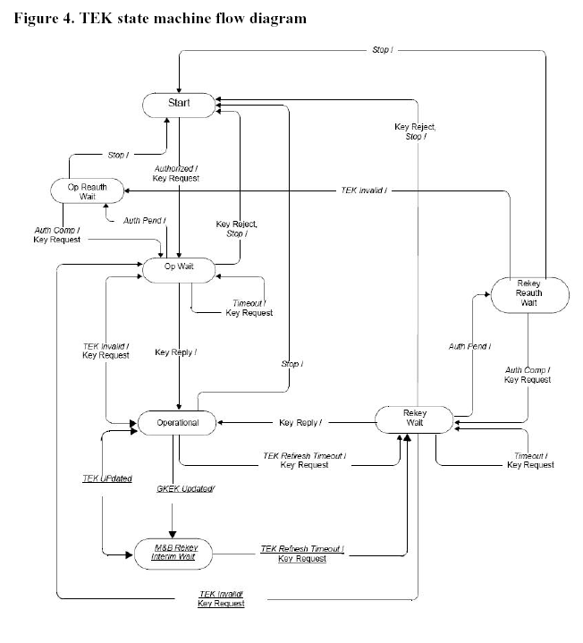

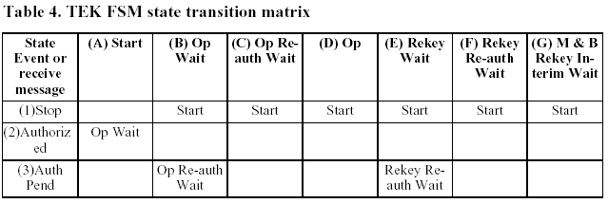
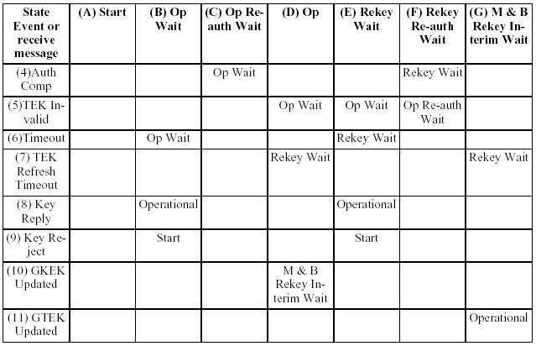

States
- Start: This is the initial state of the FSM. No resources are assigned to or used by the FSM in this state e.g. All timers are off, and no processing is scheduled.
- Operational Wait (Op Wait): The TEK state machine has sent its initial request (Key Request) for its SAID's keying material (TEK and CBC initialization vector), and is waiting for a reply from the BS.
- Operational Reauthorize Wait (Op Re-auth Wait): The wait state the TEK state machine is placed in if it does not have valid keying material while the Authorization state machine is in the middle of a reauthorization cycle.
- Operational: The SS has valid keying material for the associated SAID.
- Rekey Wait: The TEK Refresh Timer has expired and the SS has requested a key update for this SAID. Note that the newer of its two TEKs has not expired and may still be used for both encrypting and decrypting traffic.
- Rekey Reauthorize Wait (Rekey Re-auth Wait): The wait state the TEK state machine is placed in if the state machine has valid traffic keying material, has an outstanding request for the latest keying material, the Authorization state machine initiates a reauthorization cycle.

Messages

- Key Request: Request a TEK for this SAID. Sent by the SS to the BS and authenticated with keyed message digest. The message authentication key is derived from the AK.
- Key Reply: Response from the BS carrying the two diversity sets of traffic keying material for this SAID. Sent by the BS to the SS, it includes the SAID's TEKs, encrypted with a KEK derived from the AK, randomly generated from the BS or the ASA server. The Key Reply message is authenticated with a keyed message digest; the authentication key is derived from the AK.
- Key Reject: Response from the BS to the SS to indicate this SAID is no longer valid and no key will be sent. The Key Reject message is authenticated with a keyed message digest; the authentication key is derived from the AK.
- TEK Invalid: The BS sends an SS this message if it determines that the SS encrypted an uplink PDU with invalid TEK, i.e., an SAID's TEK key sequence number, contained within the received PDU's MAC Header, is out of the BS's range of known, valid sequence numbers for that SAID.
- Key Update Command: Push a GTEK for this GSAID for the multicast service or the broadcast service. Sent by the BS to the SS and authenticate with keyed message digest. The message authentication key is derived from the AK in the Key Update Command message for the GKEK update mode. The message authentication key is derived from the GKEK in the Key Update Command message for the GTEK update mode.

Events
- Stop: Sent by the Authorization FSM to an active (non-START state) TEK FSM to terminate TEK FSM and remove the corresponding SAID's keying material from the SS's key table.
- Authorized: Sent by the Authorization FSM to a non-active (START state) TEK FSM to notify TEK FSM of successful authorization.
- Authorization Pending (Auth Pend): Sent by the Authorization FSM to TEK FSM to place TEK FSM in a wait state while Authorization FSM completes reauthorization.
- Authorization Complete (Auth Comp): Sent by the Authorization FSM to a TEK FSM in the Operational Reauthorize Wait or Rekey Reauthorize Wait states to clear the wait state begun by the prior Authorization Pending event.
- TEK Invalid: This event is triggered by either an SS's data packet decryption logic or by the receipt of a TEK Invalid message from the BS. An SS's data packet decryption logic triggers a TEK Invalid event if it recognizes a loss of TEK key synchronization between itself and the encrypting BS. For example, an SAID's TEK key sequence number, contained within the received downlink MAC PDU header, is out of the SS's range of known sequence numbers for that SAID. A BS sends an SS a TEK Invalid message, triggering a TEK Invalid event within the SS, if the BS's decryption logic recognizes a loss of TEK key synchronization between itself and the SS.
- Timeout: A retry timer timeout. Generally, the particular request is retransmitted.
- TEK Refresh Timeout: The TEK refresh timer timed out. This timer event signals the TEK state machine to issue a new Key Request in order to refresh its keying material. The refresh timer is set to fire a configurable duration of time (TEK Grace Time) before the expiration of the newer TEK the SS currently holds. This is configured via the BS to occur after the scheduled expiration of the older of the two TEKs.
- GKEK Updated: This event is triggered when the SS receives the new GKEK through the Key Update Command message for the GKEK update mode.
- GTEK Updated: This event is triggered when the SS receives the new GTEK and traffic keying material through the Key Update Command message for the GTEK update mode.

Parameters
- Operational Wait Timeout: Timeout period between sending of Key Request messages from the Op Wait state.
- Rekey Wait Timeout: Timeout period between sending of Key Request messages from the Rekey Wait state.
- TEK Grace Time: Time interval, in seconds, before the estimated expiration of a TEK that the SS starts re keying for a new TEK.

Actions

Actions taken in association with state transitions are listed by <event> (<raved message>) --> <state>:
1-B Op Wait (Stop) -> Start
a) Clear Key Request retry timer
b) Terminate TEK FSM
1-C Op Re-auth Wait (Stop) -> Start
a) Terminate TEK FSM
1-D Operational (Stop) -> Start
a) Clear TEK refresh timer, which is timer set to go off "TEK Grace Time" seconds prior to the TEK's
scheduled expiration time
b) Terminate TEK FSM
c) Remove SAID keying material from key table.
1-E Rekey Wait (Stop) -> Start
a) Clear Key Request retry timer.
b) Terminate TEK FSM.
c) Remove SAID keying material from key table
1-F Rekey Re-auth Wait (Stop) -> Start
a) Terminate TEK FSM.
b) Remove SAID keying material from key table.
2-A Start (Authorized) -> Op Wait
a) Send Key Request message to BS.
b) Set Key Request retry timer to Operational Wait Timeout.
3-B Op Wait (Auth Pend) -> Op Re-auth Wait
a) Clear Key Request retry timer.
3-E Rekey Wait (Auth Pend) -> Rekey Re-auth Wait
a) Clear Key Request retry timer
4-C Op Re-auth Wait (Auth Comp) -> Op Wait
a) Send Key Request message to BS
b) Set Key Request retry timer to Operational Wait Timeout.
4-F Rekey Re-auth Wait (Auth Comp) -> Rekey Wait
a) Send Key Request message to BS
b) Set Key Request retry timer to Rekey Wait Timeout
5-D Operational (TEK Invalid) -> Op Wait
a) Clear TEK refresh timer
b) Send Key Request message to BS
c) Set Key Request retry timer to Operational Wait Timeout
d) Remove SAID keying material from key table
5-E Rekey Wait (TEK Invalid) -> Op Wait
a) Clear TEK refresh timer
b) Send Key Request message to BS
c) Set Key Request retry timer to Operational Wait Timeout
d) Remove SAID keying material from key table.
5-F Rekey Re-auth Wait (TEK Invalid) -> Op Re-auth Wait
a) Remove SAID keying material from key table.
6-B Op Wait (Timeout) -> Op Wait
a) Send Key Request message to BS.
b) Set Key Request retry timer to Operational Wait Timeout.
6-E Rekey Wait (Timeout) -> Rekey Wait
a) Send Key Request message to BS
b) Set Key Request retry timer to Rekey Wait Timeout
7-D Operational (TEK Refresh Timeout) -> Rekey Wait
a) Send Key Request message to BS.
b) Set Key Request retry timer to Rekey Wait Timeout.
7-G M&B Rekey Interim Wait (TEK Refresh Timeout) -> Rekey Wait
a) Send Key Request message to BS.
b) Set Key Request retry timer to Rekey Wait Timeout.
8-B Op Wait (Key Reply) -> Operational
a) Clear Key Request retry timer.
b) Process contents of Key Reply message and incorporate new keying material into key database.
c) Set the TEK refresh timer to go off 'TEK Grace Time' seconds prior to the newer key's scheduled expiration.
8-E Rekey Wait (Key Reply) -> Operational
a) Clear Key Request retry timer.
b) Process contents of Key Reply message and incorporate new keying material into key database.
c) Set the TEK refresh timer to go off 'TEK Grace Time' seconds prior to the newer key's scheduled expiration.
9-B Op Wait (Key Reject) -> Start
a) Clear Key Request retry timer
b) Terminate TEK FSM.
9-E Rekey Wait (Key Reject) -> Start
a) Clear Key Request retry timer.
b) Terminate TEK FSM.
c) Remove SAID keying material from key table.
10-D Operational (GKEK Updated) -> M&B Rekey Interim Wait
a) Process contents of Key Update Command message for the GKEK update mode and incorporate new GKEK into key database.
11-G M&B Rekey Interim Wait (GTEK Updated) -> Operational
a) Clear Key Request retry timer
b) Process contents of Key Update Command message for the GTEK update mode and incorporate new traffic keying material into key database
c) Set the TEK refresh timer to go off "TEK Grace Time" seconds prior to the key's scheduled expiration.

KMAPv1 Key Hierarchy A (KHA)
There is one key hierarchy defined in KMAPv1. This is named KMAPv1 Key Hierarchy A (KMAPv1-KHA).
The Master Session Key (MSK) is the 512 bit key supplied by the EAP method after EAP authentication.
The Authentication Key (AK) is the primary shared secret between the SS and BS. It is used to derive authentication and key encryption keys. It is 512 bits.
The Key Encryption Key (KEK) is used to protect the establishment of TEKs between the SS and BS. It is 128 bits.

KMAPv1-KHA Authorization Key (AK) derivation
The AK will be derived by the BS and the SS from the MSK from EAP-based authorization procedure.
AK = Dot22NegotiatedKDF(PMK, SS MAC Address | BSID | “AK”, 512)

Figure 2 AK From PMK from EAP Authentication

KMAPv1-KHA Message authentication keys (MMAKs) and KEK derivation
The Key Encryption Key or KEK is used to secure the establishment of TEKs, GKEKs and all other keys established between the BS and SS. It is 128 bits in size.
MMAK (Management Message Authentication Keys) are used with a message authentication code algorithm to sign management messages in order to validate the authenticity of these messages. The message authentication code algorithm to be used is defined by the negotiated ciphersuite. Each MMAK is 256 bits in size. If the negotiated management message authentication algorithm uses a shorter key, it is responsible for defining the reducing of the size of the 256 bit KEK suitable for its needs.
There is a different key for UL and DL messages. Also, different message authentication keys are generated for downlink multicasted management messages and for a unicast messages. The MMAKs are derived from the AK.
MMAK_KEY_U | MMAK_KEY_D | KEK = Dot22NegotiatedKDF(AK, SS MAC Address | BSID | “MMAK_KEYS+KEK”, 640)
MMAK_KEY_GD = Dot22NegotiatedKDF (GKEK, "GROUP MMAK",256) (Used for multicast MAC messages such as a KMAPv1 Group-Key-Update-Command message)
Figure 3 MMAKs and KEK from AK

KMAPv1 Group Key Encryption Key (GKEK)
GKEK is generated as a cryptographic strength random number at the BS and transmitted to the SS encrypted with the KEK. There is one GKEK per Group Security Association. GKEK is used to encrypt the GTEKs sent in multicast messages by the BS to the SSs in the same multicast group.

KMAPv1 Traffic Encryption Key (TEK)
The TEK is established between the SS and BS during a TEK key exchange, protected using the KEK.

KMAPv1 Group Traffic Encryption Key (GTEK)
The GTEK is used to encrypt multicast data packets and it is shared among all SSs that belongs to a common multicast group. There are 2 GTEKs per GSA.The GTEK is randomly generated at the BS or at certain network node and is encrypted using the negotiated GTEK encryption algorithm and transmitted to the SS in multicast or unicast messages. The GTEK in a KMAPv1 Key-Request and KMAPv1 Key-Reply messages will be encrypted by the KEK. And, the GTEK in a KMAPv1 Group Key Update Command message will be encrypted by the GKEK.

Security Associations
Keying material is held within security associations. There are two types of association: The security associations (SA) that maintain keying material for unicast connections and group security associations (GSA) that hold keying material for multicast groups.
If the SS and BS decide “No authorization” as their authorization policy, they don't have any security association. In this case, a null SAID (0x0000) shall be used as the target SAID field in DSA-REQ/RSP messages. No encryption method will be applied to connections that are established, authentication and TEK state machines will not be started.

Unicast Security associations
A security association contains keying material that is used to protect unicast connections. The contents of an SA are:

The SAID, a 16-bit identifier for the SA. The SAID shall uniquely identify the SA within the scope of a BS.
The KEK, a 128-bit key encryption key, derived from the AK.
TEK0 and TEK1, 128-bit traffic encryption keys, generated within the BS and establisged between the BS and the SS using a secure key establishment protocol.
The TEK Lifetimes TEK0 and TEK1, a key aging lifetime value.
PN0 and PN1, 32-bit packet numbers for use by the link cipher
RxPN0 and RxPN1, 32-bit receive sequence counters, for use by the link cipher.

A security association is shared between a SS and a BS. Posession of a valid and non expired SA by both a BS and SS represent a secured state between them and the capability to protect data and management traffic.

Group Security Association
The Group Security Association (GSA) contains keying material used to secure multicast groups. These are defined separately from SAs since GSA offer a lower security bound than unicast security associations, since keying material is shared between all members of the group, allowing any member of the group to forge traffic as if it came from any other member of the group.
The contents of a GSA are:
The Group Key Encryption Key (GKEK). Serves the same function as an SA KEK but for a GSA
The Group Traffic Encryption Key (GTEK). Served the same function as an SA TEK but for a GSA.

Security context
The security context is a set of parameters linked to a key in each hierarchy that defines the scope while the key usage is considered to be secure.
Examples of these parameters are key lifetime and counters ensuring the same encryption will not be used more than once. When the context of the key expires, a new key should be obtained to continue working.
The purpose of this section is to define the context that belongs to each key, how it is obtained and the scope of its usage.

AK context
The AK is the primary security context. It includes the AK (Authentication Key), its identifier the AKID, the AK key lifetime and the AK sequence number.
SAs and GSAs are established under the AK context.
Table 1 AK Context in KMAPv1
Parameter | Size (bits) | Usage
AK | 160 | The authorization key defined by the KHA-1 [].
AKID | 64 | AKID = Dot22KDF(AK, AK SN|SS MAC Address|BSID|"AK", 64)  The AK_SN in the Dot22KDF function is an 8-bit number which consists of leading 4 zero bits and appending the 4-bit AK sequence number in most significant bit first order.
AK Sequence Number | 4 | Sequence number for the AK. It is incremented modulo 16 each time the AK is updated.
AK Lifetime | - | The AK lifetime. It is equal to the lifetime of the MSK from which it was derived.
MSK sequence number | 4 | The sequence number of the MSK that the AK is derived from.
MMAK_KEY_U | 256 | The key which is used for signing UL management messages
MMAK_PN_U | 32 | Used to avoid UL replay attackson the management connection. When this expires re-authentication is needed
MMAK_KEY_D | 256 | The key which is used for signing DL management messages
MMAK_PN_D | 256 | Used to avoid DL replay attacks on the management connection. When this expires re-authentication is needed
KEK | 128 | Key Encryption Key used to protect the establishment of TEKs between the BS and SS.

Security capabilities selection
As part of their authorization exchange, the SS provides the BS with a list of all the cryptographic suites (pairing of data encryption and data authentication algorithms) the SS supports. The BS selects from this list a single cryptographic suite to employ with the requesting SS’s primary SA. The Authorization Reply the BS sends back to the SS includes a primary SA-Descriptor that, among other things, identifies the cryptographic suite the BS selected to use for the SS’s primary SA. A BS shall reject the authorization request if it determines that none of the offered cryptographic suites are satisfactory.
The Authorization Reply also contains an optional list of static SA-Descriptors; each static SA-Descriptor identifies the cryptographic suite employed within the SA. The selection of a static SA’s cryptographic suite is typically made independent of the requesting SS’s cryptographic capabilities. A BS may include in its Authorization Reply static SA-Descriptors identifying cryptographic suites the requesting SS does not support; if this is the case, the SS shall not start TEK state machines for static SAs whose cryptographic suites the SS does not support.

Dynamic SA creation and mapping
Dynamic Security Associations are SAs that a BS establishes and eliminates dynamically in response to the enabling or disabling of specific downlink service flows. SSs learn the mapping of a particular privacy-enabled service flow to that flow’s dynamically assigned SA through the exchange of DSx messages.

Dynamic SA creation
The BS may dynamically establish SAs by issuing an SA Add message. Upon receiving an SA Add message, the SS shall start a TEK state machine for each SA listed in the message.

Dynamic mapping of SA
When creating a new service flow, an SS may request an existing SA be used by passing the SAID of the SA in a DSA-REQ or DSC-REQ message. The BS checks the SS’s authorization for the requested SA and generates appropriate response using a DSA-RSP or DSC-RSP message correspondingly. With BS-initiated dynamic service creations, a BS may also map a new service flow to an existing SA that is supported by a specific SS. The SAID of the SA shall be communicated to the SS in a DSA-REQ or DSC-REQ message.

BS key usage
The BS is responsible for maintaining keying information for all SAs. The KMAP protocol defined in this specification describes a mechanism for synchronizing this keying information between a BS and its client SS.

AK key lifetime
After an SS completes basic capabilities negotiation, it shall initiate an authorization exchange with its BS. The BS’s first receipt of an Auth Request message from the unauthorized SS shall initiate the activation of a new AK, which the BS sends back to the requesting SS in an Auth Reply message. This AK shall remain active until it expires according to its predefined AK Lifetime, a BS system configuration parameter.
The AK’s active lifetime a BS reports in an Authorization Reply message shall reflect, as accurately as an implementation permits, the remaining lifetimes of AK at the time the Authorization Reply message is sent. If an SS fails to reauthorize before the expiration of its current AK, the BS shall hold no active AKs for the SS and shall consider the SS unauthorized. A BS shall remove from its keying tables all TEKs associated with an unauthorized SS’s Primary SA.

AK transition period on BS side
The BS shall always be prepared to send an AK to an SS upon request. The BS shall be able to support two simultaneously active AKs for each client SS. The BS has two active AKs during an AK transition period; the two active keys have overlapping lifetimes.
An AK transition period begins when the BS receives an Auth Request message from an SS and the BS has a single active AK for that SS. In response to this Auth Request, the BS activates a second AK [see point (a) and (d) in Figure 134], which shall have a key sequence number one greater (modulo 16) than that of the existing AK and shall be sent back to the requesting SS in an Auth Reply message. The BS shall set the active lifetime of this second AK to be the remaining lifetime of the first AK [between points (a) and (c) in Figure 134], plus the predefined AK Lifetime; thus, the second, “newer” key shall remain active for one AK Lifetime beyond the expiration of the first, “older” key. The key transition period shall end with the expiration of the older key. This is depicted on the right-hand side of Figure 134.
As long as the BS is in the midst of an SS’s AK transition period, and thus is holding two active AKs for that SS, it shall respond to Auth Request messages with the newer of the two active keys. Once the older key expires, an Auth Request shall trigger the activation of a new AK, and the start of a new key transition period.
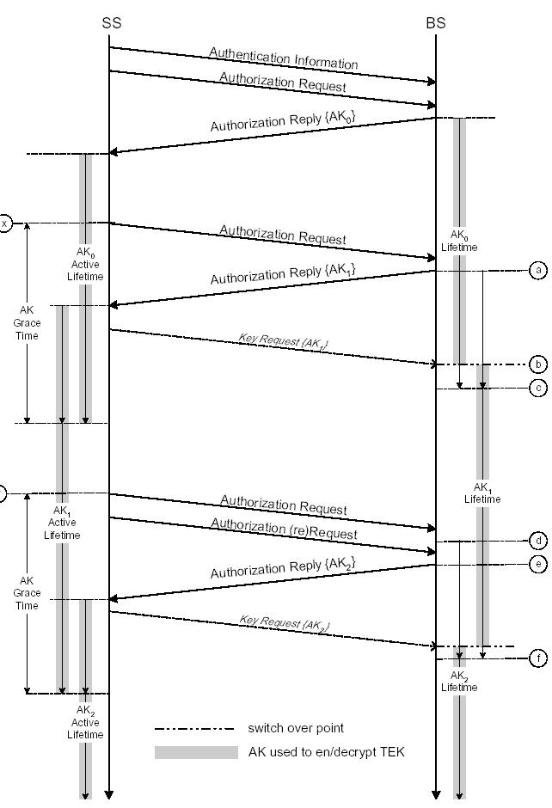
Figure 4AK Management in BS and SS

BS usage of AK
The BS shall use keying material derived from the SS’s AK for the following:
a) Verifying the HMAC-Digests in Key Request messages received from that SS,
b) Calculating the HMAC-Digests it writes into Key Reply, Key Reject, and TEK Invalid messages sent to that SS, and
c) Encrypting the TEK in the Key Reply messages it sends to that SS.
A BS shall use an MMAK_KEY_U (see 7.5.4.3) derived from one of the SS’s active AKs to verify the HMAC-Digest in Key Request messages received from the SS. The AK Key Sequence Number accompanying each Key Request message allows the BS to determine which MMAK_KEY_U was used to authenticate the message. If the AK Key Sequence Number indicates the newer of the two AKs, the BS shall identify this as an implicit acknowledgment that the SS has obtained the newer of the SS’s two active AKs [see points (b) in Figure 134].
A BS shall use an MMAK_KEY_D derived from the active AK selected above (see also 7.5.4.3) when calculating HMAC-Digests in Key Reply, Key Reject, and TEK Invalid message. When sending Key Reply, Key Reject, or TEK Invalid messages within a key transition period (i.e., when two active AKs are available), if the newer key has been implicitly acknowledged, the BS shall use the newer of the two active AKs. If the newer key has not been implicitly acknowledged, the BS shall use the older of the two active AKs to derive the KEK and the MMAK_KEY_D.
The BS shall use a KEK derived from an active AK when encrypting the TEK in the Key Reply messages. The right-hand side of Figure 134 illustrates the BS’s policy regarding its use of AKs, where the shaded portion of an AK’s lifetime indicates the time period during which that AK shall be used to derive the MMAK_KEY_U, MMAK_KEY_D, and KEK. For calculating the HMAC-Digest in the HMAC Tuple attribute, the BS shall use the MMAK_KEY_U and MMAK_KEY_D derived from one of the active AKs. For signing messages, if the newer AK has been implicitly acknowledged, the BS shall use the newer of the two active AKs to derive the MMAK_KEY_D. If the newer key has not been implicitly acknowledged, the BS shall use the older of the two active AKs to derive the MMAK_KEY_D. The HMAC Key Sequence Number in the HMAC Tuple, equal to the AK’s sequence number from which the MMAK_KEY_D was derived, enables the SS to correctly determine which MMAK_KEY_D was used for message authentication.
When receiving messages containing the HMAC Tuple attribute, the BS shall use the MMAK_KEY_U indicated by the HMAC Key Sequence Number to authenticate the messages.

TEK lifetime
The BS shall maintain two sets of active TEKs (and their associated Initialization Vectors, or IVs) per SAID, corresponding to two successive generations of keying material. The two generations of TEKs shall have overlapping lifetimes determined by TEK Lifetime, a predefined BS system configuration parameter. The newer TEK shall have a key sequence number one greater (modulo 4) than that of the older TEK. Each TEK becomes active halfway through the lifetime of its predecessor and expires halfway through the lifetime of its successor. Once a TEK’s lifetime expires, the TEK becomes inactive and shall no longer be used.
The Key Reply messages sent by a BS contain TEK parameters for the two active TEKs. The TEKs’ active lifetimes a BS reports in a Key Reply message shall reflect, as accurately as an implementation permits, the remaining lifetimes of these TEKs at the time the Key Reply message is sent.

BS usage of TEK
The BS transitions between the two active TEKs differently, depending on whether the TEK is used for downlink or uplink traffic. For each of its SAIDs, the BS shall transition between active TEKs according to the following rules:
a) At expiration of the older TEK, the BS shall immediately transition to using the newer TEK for encryption.
b) The uplink transition period begins from the time the BS sends the newer TEK in a Key Reply message and concludes once the older TEK expires.
It is the responsibility of the SS to update its keys in a timely fashion; the BS shall transition to a new downlink encryption key regardless of whether a client SS has retrieved a copy of that TEK.
The BS uses the two active TEKs differently, depending on whether the TEK is used for downlink or uplink traffic. For each of its SAIDs, the BS shall use the two active TEKs according to the following rules:
a) The BS shall use the older of the two active TEKs for encrypting downlink traffic.
b) The BS shall be able to decrypt uplink traffic using either the older or newer TEK.
Note that the BS encrypts with a given TEK for only the second half of that TEK’s total lifetime. The BS is able, however, to decrypt with a TEK for the TEK’s entire lifetime.
The right-hand side of Figure 133 illustrates the BS’s management of an SA’s TEKs, where the shaded portion of a TEK’s lifetime indicates the time period during which that TEK shall be used to encrypt MAC PDU payloads.

SS key usage
The SS is responsible for sustaining authorization with its BS and maintaining an active AK. An SS shall be prepared to use its two most recently obtained AKs according to the following manner.

SS reauthorization
AKs have a limited lifetime and shall be periodically refreshed. An SS refreshes its AK by reissuing an Auth Request to the BS. The Authorization State Machine (7.2.4) manages the scheduling of Auth Requests for refreshing AKs.
An SS’s Authorization state machine schedules the beginning of reauthorization a configurable duration of time, the Authorization Grace Time, [see points (x) and (y) in Figure 134], before the SS’s latest AK is scheduled to expire. The Authorization Grace Time is configured to provide an SS with an authorization retry period that is sufficiently long to allow for system delays and provide adequate time for the SS to successfully complete an Authorization exchange before the expiration of its most current AK.
Note that the BS does not require knowledge of the Authorization Grace Time. The BS, however, shall track the lifetimes of its AKs and shall deactivate a key once it has expired.
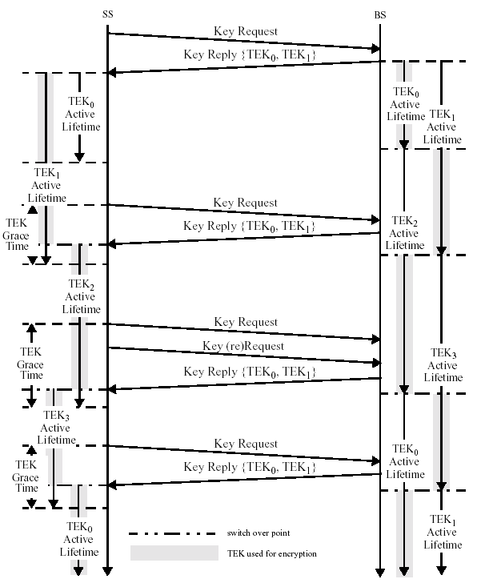
Figure 5 TEK Management in BS and SS

SS usage of AK
An SS shall use the MMAK_KEY_U derived from the newer of its two most recent AKs when calculating the Digests it attaches to Key Request messages.
The SS shall be able to use the MMAK_KEY_D derived from either of its two most recent AKs to authenticate Key Reply, Key Reject, and TEK Reject messages. The SS shall be able to decrypt an encrypted TEK used for encryption
TEK in a Key Reply message with the KEK derived from either of its two most recent AKs. The SS shall use the accompanying AK Key Sequence Number to determine which set of keying material to use.
The left-hand side of Figure 134 illustrates an SS’s maintenance and usage of its AKs, where the shaded portion of an AK’s lifetime indicates the time period during which that AK shall be used to decrypt TEKs. Even though it is not part of the message exchange, Figure 134 also shows the implicit acknowledgment of the reception of a new AK via the transmission of a Key Request message using the key sequence of the new AK.
An SS shall use the MMAK_KEY_U derived from the newer of its two most recent AKs when calculating the Digests of the Digest Tuple attribute.

SS usage of TEK
An SS shall be capable of maintaining two successive sets of traffic keying material per authorized SAID. Through operation of its TEK state machines, an SS shall request a new set of traffic keying material a configurable amount of time, the TEK Grace Time [see points (x) and (y) in Figure 133], before the SS’s latest TEK is scheduled to expire.
For each of its authorized SAIDs, the SS
a) Shall use the newer of its two TEKs to encrypt uplink traffic, and
b) Shall be able to decrypt downlink traffic encrypted with either of the TEKs.
The left-hand side of Figure 133 illustrates the SS’s maintenance and usage of an SA’s TEKs, where the shaded portion of a TEK’s lifetime indicates the time period during which that TEK shall be used to encrypt MAC PDU payloads.

Cryptographic methods
This subclause specifies the cryptographic algorithms and key sizes used by the KMAP protocol. All SS and
BS implementations shall support the method of packet data encryption defined in 7.7.1, calculation of the
TEK as specified in [], and message digest calculation as specified in [].

MPDU Encryption and Authentication with AES in CCM mode
If the data encryption algorithm identifier in the cryptographic suite of an SA equals 0x02, data on connections associated with that SA shall use the CCM mode of the 128 bit US Advanced Encryption Standard (AES) algorithm (NIST Special Publication 800-38C, FIPS-197) to encrypt the MAC PDU payloads.

MPDU payload format
The PDU payload shall be prepended with a 4-byte PN (Packet Number). The PN shall be transmitted LSB first. The PN shall not be encrypted. The plaintext PDU shall be encrypted and authenticated using the active TEK, according to the CCM specification. This includes appending an 8-byte ICV (Integrity Check Value) to the end of the payload and encrypting both the plaintext payload and the appended ICV.
The ciphertext Message Authentication Code is transmitted such that byte index 0 (as enumerated in the NIST AES Specification) is transmitted first and byte index 7 is transmitted last (i.e. LSB First). The processing yields a payload that is 12 bytes longer than the plaintext payload.
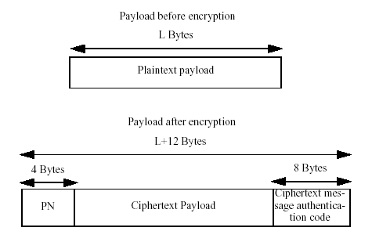
Figure 6 MPDU Payload Format

PN (Packet Number)
The PN associated with an SA shall be set to 1 when the SA is established and when a new TEK is installed. After each PDU transmission, the PN shall be incremented by 1. On uplink connections, the PN shall be XORed with 0x80000000 prior to encryption and transmission. On downlink connections, the PN shall be used without such modification
.
Any tuple value of {PN, KEY} shall not be used more than once for the purposes of transmitting data. The SS shall ensure that a new TEK is requested and transferred before the PN on either the SS or BS reaches 0x7FFFFFFF. If the PN in either the SS or BS reaches 0x7FFFFFFF without new keys being installed, transport communications on that SA shall be halted until new TEKs are installed.

CCM algorithm
The NIST CCM specification defines a number of algorithm parameters. These parameters shall be fixed to specific values when used in SAs with a data encryption algorithm identifier of 0x02. 'Tlen' shall equal 64 and t shall equal 8, meaning, the number of bytes in the Message Authentication field shall be set to 8. Consistent with the CCM specification the 3 bit binary encoding [(t-2)/2)]3 of bits 5, 4 and 3 of the 'Flags' byte in B0 shall be 011.
The size of q the length field Q shall be set to 2. Consistent with the CCM specification, the 3-bit binary encoding [q-1]3 of the q field in bits 2, 1 and 0 of the 'Flags' byte in B0 shall be 001.
The length a of the associated data string A shall be set to 0.

Figure 135—CCM

The nonce shall be 13 bytes long as shown in Figure 135a. Bytes 0 through 4 shall be set to the first five bytes of the Generic MAC Header (thus excluding the HCS). The HCS of the Generic MAC header is not included in the nonce since it is redundant. Bytes 9 through 12 are reserved and shall be set to 0x00000000. Bytes 10 through 13 shall be set to the value of the PN. The PN Bytes shall be ordered such that Byte 9 shall take the least significant byte and byte 12 shall take the most significant byte.
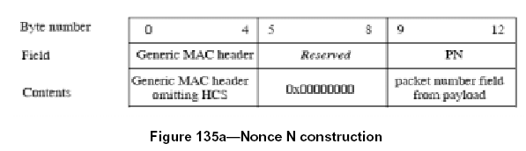
Consistent with the CCM specification, the initial block B0 is formatted as shown in Figure [].
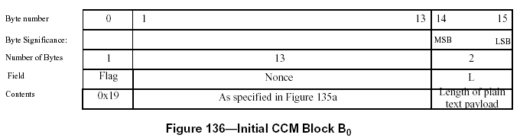
Note the ordering of the DLEN value is MSB first, consistent with the NIST CCM specification. Consistent with the NIST CCM specification the counter blocks Ctri are formatted as shown in Figure [].
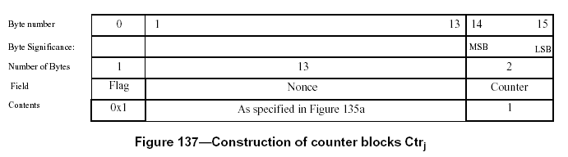

Receive Processing Rules
On receipt of a PDU the receiving SS or BS shall decrypt and authenticate the PDU consistent with the NIST CCM specification configured as specified in 7.7.1.3.
Figure 135a—Nonce N construction
Figure 136—Initial CCM Block B0

Packets that are found to be not authentic shall be discarded.
Receiving BS or SSs shall maintain a record of the highest value PN receive for each SA. If a packet is received with a PN that is equal to or less than the recorded maximum for the SA is protected under, then the packet shall be discarded as a replay attempt.
The receiver shall maintain a PN window whose size is specified by the PN_WINDOW_SIZE parameter for SAs and management connections as defined in 11.9.36. Any received PDU with a PN lower than the beginning of the PN window shall be discarded as a replay attempt. The receiver shall track PNs within the PN window. Any PN that is received more than once shall be discarded as a replay attempt. Upon reception of a PN which is greater than the end of the PN window, the PN window shall be advanced to cover this PN.

AES-CCM Mode example encrypted MPDUs
The following two examples show MPDUs in both plaintext and enciphered form in transmission order. In addition, the post-decryption plaintext of the Message Authentication Code is shown.
Example AES-CCM PDU #1 (Hex)
Plaintext PDU
Generic MAC header = 00 40 0A 06 C4 30
Payload = 00 01 02 03
Enciphered PDU where TEK = 0xD50E18A844AC5BF38E4CD72D9B0942E5 and PN=0x2157F6BC
Generic MAC header = 40 40 1A 06 C4 5A (EC bit has been set and length increased)
PN field = BC F6 57 21
Encrypted payload = E7 55 36 C8
Encrypted message authentication code =27 A8 D7 1B 43 2C A5 48
CRC32 = 1B D1 BA 21
After decryption
Plaintext message authentication code = 01 59 09 A0 ED CC 21 D3

Example AES-CCM PDU #2 (Hex)
Plaintext PDU
Generic MAC header = 00 40 27 7E B2 AD
Payload = 00 01 02 03 04 05 06 07 08 09 0A 0B 0C 0D 0E 0F
10 11 12 13 14 15 16 17 18 19 1A 1B 1C 1D 1E 1F 20
Ciphertext PDU where TEK = 0xB74EB0E4F81AD63D121B7E9AECCD268F and PN=0x78D07D08
Generic MAC header = 40 40 37 7E B2 C7 (EC bit has been set and length increased)
PN field = 08 7D D0 78
Encrypted payload = 71 3F B1 22 B9 73 4F DB FD 68 2E AD 9D CA 9F 44
1F 62 FE 0F 4A 2C 45 B5 53 17 3D 66 5B 2D 53 C1 B3
Encrypted message authentication code = E7 E4 8D 2D B7 61 CF 94
CRC32 = FD 03 7B 1D
After decryption
Plaintext message authentication code = 0B DB 85 3C 0A CA E6 5F

Encryption of 128 bit key with AES Key Wrap

This field is encrypted using the AES Key Wrap Algorithm.
encryption: C,I = Ek[P]
decryption: P,I = Dk[C]
Where:
P = Plaintext 128-bit Key
C = Ciphertext 128-bit Key
I = Integrity Check Value
k = the 128-bit KEK
Ek[ ] = AES Key Wrap encryption with key k
Dk[ ] = AES Key Wrap decryption with key k
The AES key wrap encryption algorithm accepts both a ciphertext and an integrity check value. The decryption algorithm returns a plaintext key and the integrity check value. The default integrity check value in the NIST AES Key Wrap algorithm shall be used.

Cipher-based Message authentication Code (CMAC)
The Cipher-based Message Authentication Code (CMAC) provides management message integrity protection based on Cipher-based MAC – together with the AES block cipher. The CMAC construction as specified in Special Publication 800-38B – Recommendation for Block Cipher Modes of Operation: the CMAC Mode for Authentication: May 2005 shall be used.
The downlink authentication key MMAK_D shall be used for authenticating messages in the downlink direction. The uplink authentication key MMAK_U shall be used for authenticating messages in the uplink direction. Uplink and downlink message authentication keys are derived from the AK (7.2.7.2).
For authentication multicast messages (in the DL only) a MMAK_GD shall be used (one for each multicast group). The group authentication key is derived from GKEK (7.2.7.2).
In the KMAPv1 protocol, the AKID used in the computation of the CMAC value shall be the 64 bit AKID of the AK from which the MMAK_x was derived. See [] for the SA-TEK-Challenge message attributes in which the mapping between the AK Sequence number and the AKID is communicated and see [] for a description of the AK context that contains the AK and AKID.
The CMAC Packet Number Counter (CMAC_PN_*) is a 4 byte sequential counter that is incremented in the context of UL messages by the SS, and in the context of DL messages by the BS,. The BS will also maintain a separate CMAC_PN_* for multicast packets per each GSA and increment that counter in the context of each multicast packet from the group. For MAC messages that have no CID e.g. RNG-REQ message, the CMAC_PN_* context will be the same as used on the basic CID. If basic CID is unknown (e.g. in network reentry situation) then CID 0 should be used.
The CMAC Packet Number Counter, CMAC_PN_*, is part of the CMAC security context and must be unique for each MAC management message with the CMAC tuple or digest. Any tuple value of {CMAC_PN_*, AK} shall not be used more than once. The reauthentication process should be initiated (by BS or SS) to establish a new AK before the CMAC_PN_* reaches the end of its number space.
The digest shall be calculated over a field consisting of the AKID followed by the CMAC Packet Number Counter, expressed as an unsigned 32-bit number, followed by the 16-bit Connection ID on which the message is sent, followed by 16-bit of zero padding (for the header to be aligned with AES block size) and followed by the entire MAC management message with the exception of the CMAC-TLV.
The least significant bits of the digest shall be truncated to yield a 64-bit length digest. i.e.:
CMAC value <= Truncate64 (CMAC (CMAC_KEY_*, AKID | CMAC_PN | CID |16-bit zero padding | MAC_Management_Message))
If the digest is included in an MPDU that has no CID, e.g. A RNG-REQ message, the CID used shall take the value of the basic CID. If basic CID is unknown (e.g. in network reentry situation) then CID 0 should be used.

Encryption of GKEK in KMAPv1
The BS encrypts the value fields of the GKEK in the Key Update Command message for the GKEK update mode and sends the encrypted GKEK to each SS served with the specific multicast service or the broadcast service. The key encryption encryption algorithm is determined according to the negotiated cryptographic suite.

Dot22KDF for KMAPv1
The Dot22KDF algorithm is a CTR mode construction that may be used to derive an arbitrary amount of keying material from source keying material.
In the case that the HMAC/CMAC setting in the MAC (Message Authentication Code) mode is set to CMAC, the algorithm is defined as:
Dot22KDF(key, astring, keylength)
{
result = null;
Kin = Truncate (key, 128);
for (i = 0;i <= int((keylength-1)/128); i++) {
result = result | CMAC-AES128(Kin, i | astring | keylength);
}
return Truncate (result, keylength);
}

The parameter ‘key’ is a cryptographic key that is used by the underlying digest algorithm (currently only CMAC-AES128).
'astring' is an octet string used to alter the output of the algorithm.
'keylength' is used to determine the length of key material to generate and is used in the digest input data to prevent extension attacks. Truncate(x,y) is the rightmost y bits of a value x only if y < x.

Certificate profile

Certificate format
This subclause describes the X.509 (IETF RFC 2459) Version 3 certificate format and certificate extensions used in IEEE 802.16-compliant SSs. Table 137 summarizes the basic fields of an X.509 Version 3 certificate.
Table 2 Basic fields of an X.509 Version 3 certificate
X.509 v3 field | Description
tbsCertificate.version | Indicates the X.509 certificate version. Always set to v3 (value of 2).
tbsCertificate.serialNumber | Unique integer the issuing CA assigns to the certificate
tbsCertificate.signature | Object identifier (OID) and optional parameters defining algorithm used to sign the certificate. This field shall contain the same algorithm identifier as the signatureAlgorithm field
tbsCertificate.issuer | Distinguished Name of the CA that issued the certificate
tbsCertificate.validity | Specifies when the certificate becomes active and when it expires.
tbsCertificate.subject | Distinguished Name identifying the entity whose public key is certified in the subjectpublic key information field.
tbsCertificate.subjectPublicKeyInfo | Field contains the public key material (public key and parameters) and the identifier of the algorithm with which the key is used.
tbsCertificate.issuerUniqueID | Optional field to allow reuse of issuer names over time.
tbsCertificate.subjectUniqueID | Optional field to allow reuse of subject names over time.
tbsCertificate.extentions | The extension data
signatureAlgorithm | OID and optional parameters defining algorithm used to sign the certificate. This field shall contain the same algorithm identifier as the signature field in tbsCertificate.
signatureValue | Digital signature computed upon the ASN.1 DER encoded tbsCertificate

All certificates described in this specification shall be signed with the RSA signature algorithm using SHA-1 as the one-way hash function. The RSA signature algorithm is described in PKCS #1; SHA-1 is described in FIPS 180-1. Restrictions posed on the certificate values are described in the following subclauses:

tbsCertificate.validity.notBefore and tbsCertificate.validity.notAfter
SS certificates shall not be renewable and shall thus have a validity period greater than the operational lifetime of the SS. A Manufacturer CA certificate’s validity period should exceed that of the SS certificates it issues. The validity period of an SS certificate shall begin with the date of generation of the device’s certificate; the validity period should extend out to at least 10 years after that manufacturing date. Validity periods shall be encoded as UTCTime. UTCTime values shall be expressed Greenwich Mean Time (Zulu) and shall include seconds (i.e., times are YYMMDDHHMMSSZ), even where the number of seconds is zero.

tbsCertificate.serialNumber
Serial numbers for SS certificates signed by a particular issuer shall be assigned by the manufacturer in increasing order. Thus, if the tbsCertificate.validity.notBefore field of one certificate is greater than the tbsCertificate.validity.notBefore field of another certificate, then the serial number of the first certificate shall be greater than the serial number of the second certificate.

tbsCertificate.signature and signatureAlgorithm
All certificates described in this specification shall be signed with the RSA signature algorithm, using SHA-1 as the one-way hash function. The RSA signature algorithm is described in PKCS #1; SHA-1 is described in FIPS 180-1. The ASN.1 OID used to identify the “SHA-1 with RSA” signature algorithm is
sha-1WithRSAEncryption OBJECT IDENTIFIER ::=
{ iso(1) member-body(2) us(840) rsadsi(113549) pkcs(1) pkcs-1(1) 5}

When the sha-1WithRSAEncryption OID appears within the ASN.1 type AlgorithmIdentifier, as is the case with both tbsCertificate.signature and signatureAlgorithm, the parameters component of that type is the ASN.1 type NULL.

tbsCertificate.issuer and tbsCertificate.subject
X.509 Names are SEQUENCES of RelativeDistinguishedNames, which are in turn SETs of AttributeTypeAndValue. AttributeTypeAndValue is a SEQUENCE of an AttributeType (an OBJECT IDENTIFIER) and an AttributeValue. The value of the countryName attribute shall be a two-character PrintableString, chosen from ISO 3166; all other AttributeValues shall be encoded as either T.61/TeletexString or PrintableString character strings. The PrintableString encoding shall be used if the character string contains only characters from the PrintableString set. Specifically:
abcdefghijklmnopqrstuvwxyz
ABCDEFGHIJKLMNOPQRSTUVWXYZ
0123456789
’()+,–./:=? and space

The T.61/TeletexString shall be used if the character string contains other characters. The following OIDs are needed for defining issuer and subject Names in KMAP certificates:

abcdefghijklmnopqrstuvwxyz
ABCDEFGHIJKLMNOPQRSTUVWXYZ
0123456789
’()+,–./:=? and space

The T.61/TeletexString shall be used if the character string contains other characters. The following OIDs are needed for defining issuer and subject Names in KMAP certificates:
id-at OBJECT IDENTIFIER ::= {joint-iso-ccitt(2) ds(5) 4}
id-at-commonName OBJECT IDENTIFIER ::= {id-at 3}
id-at-countryName OBJECT IDENTIFIER ::= {id-at 6}
id-at-localityName OBJECT IDENTIFIER ::= {id-at 7}
id-at-stateOrProvinceName OBJECT IDENTIFIER ::= {id-at 8}
id-at-organizationName OBJECT IDENTIFIER ::= {id-at 10}
id-at-organizationalUnitName OBJECT IDENTIFIER ::= {id-at 11}

The following subclauses describe the attributes that comprise the subject Name forms for each type of KMAP certificate. Note that the issuer name form is the same as the subject of the issuing certificate. Additional attribute values that are present but unspecified in the following forms should not cause a device to reject the certificate.

Manufacturer certificate
countryName=<Country of Manufacturer>
[stateOrProvinceName=<state/province>]
[localityName=<City>]
organizationName=<Company Name>
organizationalUnitName=WirelessMAN
[organizationalUnitName=<Manufacturing Location>]
commonName=<Company Name> <Certification Authority>

The countryName, organizationName, and commonName attributes shall be included and shall have the values shown. The organizationalUnitName having the value “WirelessMAN” shall be included. The organizationalUnitName representing manufacturing location should be included. If included, it shall be preceded by the organizationalUnitName having value “WirelessMAN.” The stateOrProvinceName and localityName may be included. Other attributes are not allowed and shall not be included.

SS certificate
countryName=<Country of Manufacturer>
organizationName=<Company Name>
organizationalUnitName=<manufacturing location>
commonName=<Serial Number>
commonName=<MAC Address>

The MAC address shall be the SS’s MAC address. It is expressed as six pairs of hexadecimal digits separated by colons (:), e.g., “00:60:21:A5:0A:23.” The Alpha HEX characters (A–F) shall be expressed as uppercase letters.
The organizationalUnitName in an SS certificate, which describes the modem’s manufacturing location, should be the same as the organizationalUnitName in the issuer Name describing a manufacturing location.
The countryName, organizationName, organizationalUnitName, and commonName attributes shall be included. Other attributes are not allowed and shall not be included.

BS certificate
countryName=<Country of Operation>
organizationName=< Name of Infrastructure Operator>
organizationalUnitName=<WirelessMAN>
commonName=<Serial Number>
commonName=<BS Id>

The BS Id field shall contain the operator-defined BSId.e It is expressed as six pairs of hexadecimal digits separated by colons (:), e.g., "00:60:21:A5:0A:23." The Alpha HEX characters (A-F) shall be expressed as uppercase letters.
The attributes listed above shall be included.

tbsCertificate.issuerUniqueID and tbsCertificate.subjectUniqueID
The issuerUniqueID and subjectUniqueID fields shall be omitted for all of the KMAP’s certificate types.

tbsCertificate.extensions

SS certificates
SS certificates may contain noncritical extensions; they shall not contain critical extensions. If the KeyUsage extension is present, the keyAgreement and keyEncipherment bits shall be turned on, keyCertSign and cRLSign bits shall be turned off, and all other bits should be turned off.

Manufacturer certificates
Manufacturer certificates may contain the Basic Constraints extension. If included, the Basic Constraints extension may appear as a critical extension or as a noncritical extension. Manufacturer certificates may contain noncritical extensions; they shall not contain critical extensions other than, possibly, the Basic Constraints extension. If the KeyUsage extension is present in a Manufacturer certificate, the keyCertSign bit shall be turned on and all other bits should be turned off.

signatureValue
In all three KMAP certificate types, the signatureValue contains the RSA (with SHA-1) signature computed over the ASN.1 DER encoded tbsCertificate. The ASN.1 DER encoded tbsCertificate is used as input to the RSA signature function. The resulting signature value is ASN.1 encoded as a bit string and included in the Certificate’s signatureValue field.

SS certificate storage and management in the SS
Manufacturer-issued SS certificates shall be stored in SS permanent, write-once memory. SSs that have factory-installed RSA private/public key pairs shall also have factory-installed SS certificates. SSs that rely on internal algorithms to generate an RSA key pair shall support a mechanism for installing a manufacturereThe BSId is an operator-defined value, consequently the BS certificate is typically issued by the Operator, who must ensure that the BSID is unique within the operator’s network. issued SS certificate following key generation. The CA certificate of the Manufacturer CA that signed the SS certificate shall be embedded into the SS software. If a manufacturer issues SS certificates with multiple Manufacturer CA certificates, the SS software shall include ALL of that manufacturer’s CA certificates. The specific Manufacturer CA certificate installed by the SS [i.e., advertised in Authentication Information messages and returned by the management information base (MIB) object] shall be that identifying the issuer of that modem’s SS certificate.

Certificate processing and management in the BS
KMAP employs digital certificates to allow BSs to verify the binding between an SS’s identity (encoded in an X.509 digital certificate’s subject names) and its public key. The BS does this by validating the SS certificate’s certification path or chain. Validating the chain means verifying the Manufacturer CA Certificate through some means.

[Insert Elsewhere in the specification]

Digest Tuple
Security Policy Negotiation
Security Capabilities Negotiation
KMAP-REQ/RSP Management Messages
KMAP TLV Encodings

In security parlance, confidentiality = privacy + authenticity
This achieves the splitting of the PN space. 0x00000001 – 0x7FFFFFFF for the downlink and 0x80000001 – 0xFFFFFFFF on the uplink, preventing a PN collision between the uplink and downlink
Sending two packets encoded with the same key and PN will eliminate all security guarantees of CCM mode

