IEEE P802.22
Wireless RANs
Random Access Mechanism for WRAN System with Adaptive Antennas
Last Revised - Date: 2007-01-03
Author(s):
Name | Company | Address | Phone | email
Vincent K. N. Lau | HKUST | Hong Kong, China | 852-2358-7066 | eeknlau@ece.ust.hk
Wai Ho Mow | HKUST | Hong Kong, China | 852-2358-7070 | eewhmow@ece.ust.hk
Roger S. Cheng | HKUST | Hong Kong, China | 852-2358-7072 | eecheng@ece.ust.hk
Ross D. Murch | HKUST | Hong Kong, China | 852-2358-7044 | eermurch@ece.ust.hk
Khaled Ben Letaief | HKUST | Hong Kong, China | 852-2358-7064 | eekhaled@ece.ust.hk
Linjun Lu | Huawei Technologies | Shenzhen, China | 0086-755-28973119 | lvlinjun@huawei.com
Soo-Young Chang | Huawei Technologies | Davis, CA, U.S. | 1-916 278 6568 | sychang@ecs.csus.edu
Jianwei Zhang | Huawei Technologies | Shenzhen, China | 86-21-68644808 | zhangjianwei@huawei.com
Lai Qian | Huawei Technologies | Shenzhen, China | 86-755-28973118 | qlai@huawei.com
Jianhuan Wen | Huawei Technologies | Shenzhen, China | 86-755-28973121 | wenjh@huawei.com
Abstract
We propose a random access mechanism for adaptive antenna system. We show that under reasonable traffic loading, our approach has smaller access delay than the existing polling mechanism.
Notice: This document has been prepared to assist IEEE 802.22. It is offered as a basis for discussion and is not binding on the contributing individual(s) or organization(s). The material in this document is subject to change in form and content after further study. The contributor(s) reserve(s) the right to add, amend or withdraw material contained herein.

Release: The contributor grants a free, irrevocable license to the IEEE to incorporate material contained in this contribution, and any modifications thereof, in the creation of an IEEE Standards publication; to copyright in the IEEE’s name any IEEE Standards publication even though it may include portions of this contribution; and at the IEEE’s sole discretion to permit others to reproduce in whole or in part the resulting IEEE Standards publication. The contributor also acknowledges and accepts that this contribution may be made public by IEEE 802.22.

Patent Policy and Procedures: The contributor is familiar with the IEEE 802 Patent Policy and Procedures
<http://standards.ieee.org/guides/bylaws/sb-bylaws.pdf>, including the statement "IEEE standards may include the known use of patent(s), including patent applications, provided the IEEE receives assurance from the patent holder or applicant with respect to patents essential for compliance with both mandatory and optional portions of the standard." Early disclosure to the Working Group of patent information that might be relevant to the standard is essential to reduce the possibility for delays in the development process and increase the likelihood that the draft publication will be approved for publication. Please notify the Chair <Carl R. Stevenson> as early as possible, in written or electronic form, if patented technology (or technology under patent application) might be incorporated into a draft standard being developed within the IEEE 802.22 Working Group. If you have questions, contact the IEEE Patent Committee Administrator at <patcom@ieee.org>.

Co-Author(s):
Name | Company | Address | Phone | email
Edward S. Zhang | HKUST | Hong Kong, China | 852-2358-7086 | eezsq@ust.hk
Ray R. Wang | HKUST | Hong Kong, China | 852-2358-7086 | wray@ece.ust.hk
Edward K. S. Au | HKUST | Hong Kong, China | 852-2358-7086 | eeedward@ece.ust.hk
Tianyu Wu | HKUST | Hong Kong, China | 852-2358-7086 | wuty@ece.ust.hk
Zhou Wu | Huawei Technologies | Shenzhen, China | 86-755-28979499 | wuzhou@huawei.com
Jun Rong | Huawei Technologies | Shenzhen, China | 86-755-28979499 | rongjun@huawei.com
Jian Jiao | Huawei Technologies | Beijing, China | 86-10-82882751 | Jiao_jian@huawei.com
Meiwei Jie | Huawei Technologies | Shenzhen, China | 86-755-28972660 | jiemingwei@huawei.com
A Random Access Mechanism for Adaptive Antenna System

1. Introduction
For those non-adaptive-antenna-system (AAS) CPEs in the current IEEE 802.22 specification [1], both contention-based and polling mechanisms can be used for US (upstream) bandwidth request; however, only polling mechanism is available for AAS CPEs. When AAS CPEs are out of the service range of the BS without any beam, they cannot request US bandwidth until being polled. This may result in large access delay, because the BS should poll each AAS CPE one by one before it gets to know which AAS CPEs request upstream bandwidth. In this proposal, we propose a random access mechanism for AAS. In particular, with parallel beam processing capability at the BS, this random access mechanism is similar to that of non-AAS CPEs. Since this mechanism is contention-based, the efficiency of bandwidth request of AAS CPEs can be increased when the traffic loading is not heavy; and hence, the access delay can be reduced.

As a remark notices that we do not propose to replace the current polling scheme for AAS CPEs in the specification. Our proposal can work together with the polling mechanism. The BS should be able to manage both of the two mechanisms as what it does for non-AAS CPEs.

2. Existing Mechanism
Through the use of more than one antenna elements, AAS can improve range and system capacity by adapting the antenna pattern and concentrating its radiation to each individual CPE as shown in Figure 1. The spectral efficiency can be increased linearly with the number of antenna elements. This is achieved by steering beams to multiple users simultaneously so as to realize an inter-cell frequency reuse of one and an in-cell reuse factor proportional to the number of antenna elements. An additional benefit is the signal-to-noise ratio (SNR) gain realized by coherently combining multiple signals, and the ability to direct this gain to particular users. Another possible benefit is the reduction in interference achieved by steering nulls in the direction of co-channel interference. For the upstream direction, the same principle can be applied in a reciprocal fashion.

To start with, the BS and the CPEs should interchange their information at the beginning. The interchange of their information should be divided into two steps, namely AAS Downstream Synchronization and AAS Upstream Bandwidth Request.
Extended coverage based on AAS
AAS CPE1
AAS CPE2
Regular coverage
Figure 1. Extended the coverage based on the AAS system.

2. 1. AAS Downstream Synchronization
When the CPE first attempts to synchronize to downstream transmission, the BS is unaware of its presence, and therefore it is not aiming the adaptive array at its direction. Nevertheless, the superframe and the frame start preamble is a repetitive well-known pattern, and CPEs may utilize the inherent processing gain associated with it in order to synchronize timing and frequency parameters with the BS. In a non-AAS system, after synchronizing to the downstream, a CPE attempts to obtain the downstream parameters by decoding the SCH, DS-MAP and DCD messages. In an AAS system, a CPE may be able to obtain the downstream parameters if it receives the broadcast channel with enough energy so as to decode the SCH, DS-MAP and DCD messages. If this is the case, the CPE can continue with the network entry process just like the non-AAS case, and the BS will get the chance to tune the adaptive array to it during the ranging process.

Alternatively, an AAS CPE shall use the following procedure to alert the BS to its presence, so that the BS can adapt its antenna array to the CPE position. An AAS BS shall periodically reserve a fixed and pre-defined part of the superframe as initial-ranging contention slots for this alert procedure. The size of contention slots is decided by the BS and their location is immediately after the SCH as depicted in Figure 2. These contention slots shall be called Alert-Window (AW).
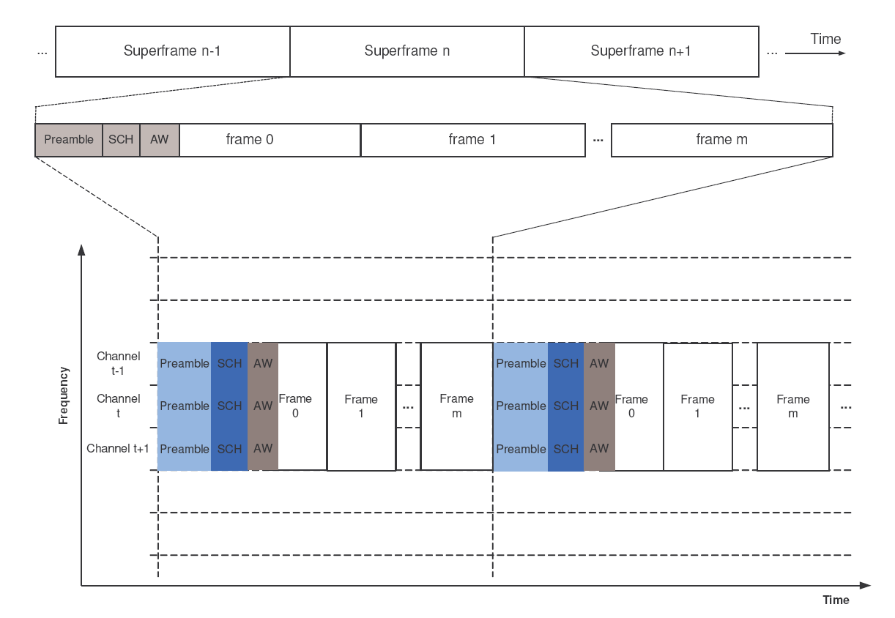
Figure 2. Alerting the BS about the presence of an AAS CPE.
When an AAS CPE has synchronized to the downstream through the superframe preamble but yet to obtain the downstream parameters because it cannot decode the SCH, DS-MAP and DCD messages, it shall attempt initial ranging on the AW. Unlike usual initial ranging, the CPE shall use all available contention slots in order to allow the BS adaptive array enough time and processing gain to shape the beam for it. After such an attempt, the CPE shall wait for a transmission containing DS-MAP and DCD messages from the BS, and shall continue the network entry process like a non-AAS CPE. If the DS-MAP and DCD messages fail to arrive, the CPE shall use an exponential backoff algorithm for selecting the next superframe in which to attempt alerting the BS to its presence. This algorithm shall be the same as that used for initial ranging by non-AAS stations.

2. 2. AAS Upstream Bandwidth Request
For bandwidth request/allocation, AAS enabled CPEs may use dedicated private DS-MAP/US-MAP messages as well as tools specific for AAS (see specific PHY sections), which can be used to facilitate avoidance of collisions with non-AAS traffic.

AAS CPEs might not be able to request bandwidth using the usual contention mechanism. This happens because the adaptive array may not have a beam directed at the CPE when it is requesting bandwidth, and the Bandwidth Request will be lost. In order to avoid this situation, an AAS CPE is directed by the BS as to whether or not it may use broadcast allocations for requesting bandwidth. The BS may change its direction dynamically using the AAS broadcast permission field, which is carried by the RNG-RSP message. The CPE shall signify by using the AAS broadcast capability field in the RNG-REQ message whether or not it can receive the broadcast messages. When a CPE is directed not to use the broadcast CID to request bandwidth, it is the responsibility of the BS to provide a polling mechanism to learn about the CPE bandwidth requirements.

Mechanism Design

3.1. Random Access Mechanism
To facilitate our proposed random access mechanism, the BS should be able to process multiple beams parallely. Before the mechanism can work, the BS should design a number of fixed beams, say M. Each of which has its mainlobe directed to one particular direction as illustrated in Figure 3. The beams should be well designed such that when an AAS CPE transmits a bandwidth request, there should be at least one beam good enough to receive this request if no collision happens.
Figure 3. Multiple beamformers at the BS.

The BS should allocate a contention window in the frame. The location of this window should be announced to all the AAS CPEs. This contention window can be in the AAS zone of a frame (Figure 10, [1]). In this way, this contention window is particular for AAS CPEs. This contention window can also be the normal contention window for non-AAS CPEs. In this way, it is shared by AAS CPEs and non-AAS CPEs.
AAS CPEs can transmit bandwidth request subheader (Table 10, [1]) in the contention window mentioned above. Since this window is open to all AAS CPEs, there may be collisions. After transmitting a bandwidth request, the AAS CPEs should start a timer. If the CPE cannot get the UL bandwidth grants or if the granted UL bandwidth is less than expected, the CPE may decide to perform backoff and request again or to discard the SDU after the timer expired. Figure 4 illustrates this procedure.
Figure 4. The contention procedure of the AAS CPE and the respective message flow.
The BS should be able to detect the bandwidth requests in the contention window. Since multiple beams are equipped at the BS, the weights of these beams should be applied onto the received signal respectively to detect the bandwidth. Hence, parallel beam processing capability is required at the BS. Figure 5 gives an example of the bandwidth contention. In the first frame, the AAS CPE1 and AAS CPE2 transmit UL bandwidth request simultaneously. As a consequence, the two requests collide. Then, according to the backoff algorithm of each other, the AAS CPE1 and AAS CPE2 determine to retransmit their bandwidth requests in the second frame and the third frame, respectively. At this time, there is no collision. Hence, both two CPEs get their bandwidth grants.
Figure 5. An example of bandwidth contention.

3.2. Receiving Structure at the BS
To facilitate our random access mechanism, let us first introduce the receiving structure at the BS. Figure 6 illustates the proposed receiving structure. There are N baseband processors at the BS, each of which is controlled by one SA module. The SA module assigns the weight of a particular beam to the baseband processor. In this way, each pair of SA module and baseband processor is able to detect the bandwidth request by steering one beam to one particular direction.

Due to the limitation of hardware complexity or cost, the number of processing units (which means the pair of SA module and baseband processor) N may be smaller than the number of beams the BS has, say M. In this situation, the BS is not able to process all the beams. Instead, the BS will select N beams from the total M beams for processing. How to select the favorite beams is controlled by the SA controller.

3.3. Selection Algorithm
When the number of beams M is larger than the number of processing units N, a selection algorithm is used to choose N appropriate beams from the total M beams. For illustration convenience, we give an example on the algorithm design:
- Initially, each beam is given a coefficient, namely C₁ C₂… C_{M}. These coefficients are equal at the very beginning.
- The BS randomly picks up N beams from these M beams for processing.
- After running for a while, the BS updates the coefficients. Let D₁ D₂… D_{M} be the number of bandwidth requests the BS detected during this while. For the beams being processed, the BS update their coefficients in this way: Ci = a * log(Ci) + b * Di, where a and b are certain constants. For the beams not being processed, their coefficients remain the same.
- The BS picks up the N beams with the largest coefficients and jumps to step 3.
Figure 6. Receiving structure of the BS.

4. Simulations

4.1. Settings
In the simulation, the distance between the CPE and BS is generated by a uniform distribution between 33km and 50km. The angle between CPE and BS is generated by a uniform distribution between 0 and 360 degrees. We compare our proposed scheme with the polling scheme. We assume that for polling, there is no collision and interference from other CPEs. For our proposed scheme, we assume there are 4 antennas. Both collision and interference are considered. For simplicity, we assume there are 4 predetermined beams and the BS can process these 4 beams simultaneously.

4.2. Simulation Results
The simulation results are shown in Figures 8 - 11. The x-axis is the probability an AAS CPE generating a bandwidth request and the y-axis is the average delay, which is defined as the average duration between generating the bandwidth requests and finally detected by the BS. As it can be observed from these figures, with the backoff window being equal to 16 and 32, our proposed scheme achieves better average access delay even for large traffic loading.
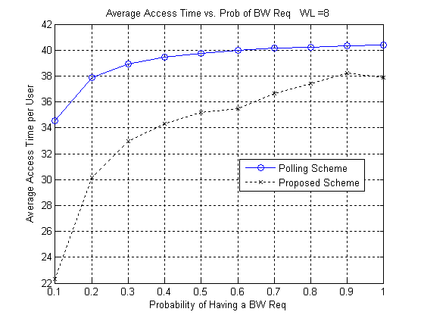
Figure 8. Simulation Result (WL = 8, # of CPEs = 40).

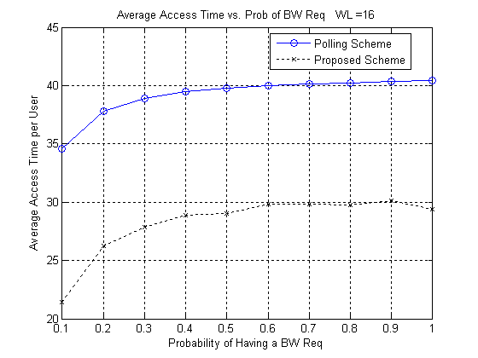
Figure 9. Simulation result (WL = 16, # of CPEs = 40).
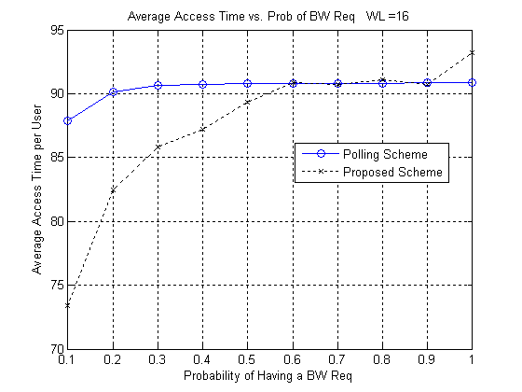
Figure 10. Simulation Result (WL = 16, # of CPEs = 90).
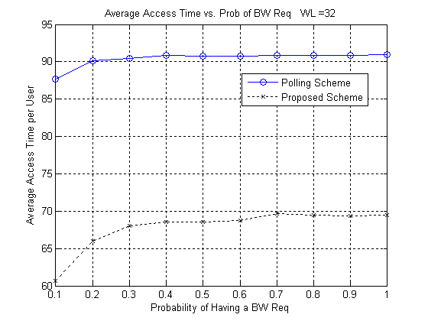
Figure 11. Simulation Result (WL = 32, # of CPEs = 90).

5. Reference
[1] IEEE 802.22/D0.1, “Draft Standard for Wireless Regional Area Networks Part22: Cognitive Wireless RAN Medium Access Control (MAC) and Physical Layer (PHY) specifications: Policies and procedures for operation in the TV Bands”, IEEE Standard, May 2006.
[2] William C. Y. Lee, Mobile Communications Engineering: Theory and Applications, second edition. McGraw-Hill, 1997
[3] H. L. Van Trees, Detection, Estimation, and Modulation Theory, Part IV. Wiley, New York, 2002

