IEEE P802.22 Wireless RANs
Contribution for IEEE 802.22 WRAN Systems
Sensing Scheme for DVB-T
Date: 2006-11-10
Author(s):
Name | Company | Address | Phone | email
Linjun Lv | Huawei Technologies | Shenzhen, China | 86-755-28973119 | lvlinjun@huawei.com
Zhou Wu | Huawei Technologies | Shenzhen, China | 86-755-28979499 | wuzhou@huawei.com
Mingwei Jie | Huawei Technologies | Shenzhen, China | 86-755-28972660 | jiemingwei@hauwei.com
Soo-Young Chang | Huawei Technologies | Davis, CA, U.S. | 1-916 278 6568 | sychang@ecs.csus.edu
Jianwei Zhang | Huawei Technologies | Shanghai, China | 86-21-68644808 | zhangjianwei@huawei.com
Jun Wang | UESTC | Chengdu, China | 86-28-83206693 | junwang@uestc.edu.cn
Shaoqian Li | UESTC | Chengdu, China | 86-28-83202174 | lsq@uestc.edu.cn
Qihang Peng | UESTC | Chengdu, China | 86-13096307946 | honey_puma@sina.com
Lei Chen | UESTC | Chengdu, China | 86-13880765377 | ocean_chl@163.com
Meng Zeng | UESTC | Chengdu, China | 86-13568886741 | truedream82321@sina.com
Abstract
In this contribution, some schemes to detect the existence of DVB-T signals are proposed. Simulation results are provided to show the performances of all these schemes. From these results, it is proved that the DVB-T signals can be effectively detected by utilizing the characteristics of the pilots inserted in the OFDM symbols.

Contents

Notice: This document has been prepared to assist IEEE 802.22. It is offered as a basis for discussion and is not binding on the contributing individual(s) or organization(s). The material in this document is subject to change in form and content after further study. The contributor(s) reserve(s) the right to add, amend or withdraw material contained herein.

Release: The contributor grants a free, irrevocable license to the IEEE to incorporate material contained in this contribution, and any modifications thereof, in the creation of an IEEE Standards publication; to copyright in the IEEE’s name any IEEE Standards publication even though it may include portions of this contribution; and at the IEEE’s sole discretion to permit others to reproduce in whole or in part the resulting IEEE Standards publication. The contributor also acknowledges and accepts that this contribution may be made public by IEEE 802.22.

Document Policy and Procedures: The contributor is familiar with the IEEE 802 Document Policy and Procedures
<http://standards.ieee.org/guides/bylaws/sb-bylaws.pdf>, including the statement "IEEE standards may include the known use of document(s), including document applications, provided the IEEE receives assurance from the document holder or applicant with respect to documents essential for compliance with both mandatory and optional portions of the standard." Early disclosure to the Working Group of document information that might be relevant to the standard is essential to reduce the possibility for delays in the development process and increase the likelihood that the draft publication will be approved for publication. Please notify the Chair <Carl R. Stevenson> as early as possible, in written or electronic form, if documented technology (or technology under document application) might be incorporated into a draft standard being developed within the IEEE 802.22 Working Group. If you have questions, contact the IEEE Document Committee Administrator at <patcom@ieee.org>.

List of Figures
Figure 1 The generation of PRBS sequence 7
Figure 2 OFDM Structure 8
Figure 3 Sliding Correlation Based on CP 8
Figure 4 Sliding Correlation Based on time domain of Pilot in CP 9
Figure 5 Simulation Result (sensing time is 17.92ms, false alarm rate is 0.1) 10
Figure 6 Simulation Result (sensing time is 17.92ms, false alarm rate is 0.01) 11

List of Tables
Table 1 The duration of CP for 8MHz channel 5
Table 2 Location of continual pilot carriers 6

- Reference
[1] ETSI EN 300 744, “Digital Video Broadcasting (DVB): Framing structure, channel coding and modulation for digital terrestrial television”.
[2] J.–J. Van de Beek, M. Sandell, and P. O. Borjesson, “ML estimation of time and frequency offset in OFDM systems”, IEEE trans. Signal Processing, vol. 45, pp. 1800-1805, July 1997.
[3] D. Landstrom, S. K. Wilson, J. – J. Van de Beek, Per Odling, and P. O. Borjesson, “Symbol time offset estimation in coherent OFDM systems”, IEEE trans. On communications, vol. 50, No. 4, April, 2002.
[4] M. D. Duncan, and A. S. Robert, “Acquisition of spread spectrum signals by an adaptive array”, IEEE trans. On acoustics, speech, and signal processing, vol. 37, No. 8, Aug. 1989.
[5] D. Landstrom, S. K. Wilson, J. – J. Van de Beek, Per Odling, and P. O. Borjesson, “Synchronization for a DVB-T receiver in presence of co-channel interference”, PIMRC, IEEE, vol. 5, pp. 2307-2311, Sept. 2002.

- Introduction to DVB-T Signal
Digital Video Broadcasting-Terrestrial (DVB-T), the European Standard on digital TV radio, has already been adopted by more than 30 countries, so it is reasonable to develop DVB-T sensing algorithms for IEEE 802.22 WRAN system. There are some distinct characteristics of DVB-T signal, such as OFDM, Cyclic Prefix (CP), Pilot symbols etc, several sensing algorithms based on these characteristics are proposed in this document. They are cyclic prefix based sliding correlation detection,, time domain pilot signals ,based sliding correlation, time domain pilot signals in cyclic prefix based sliding correlation and multi-antennas detection. In this document, all of these algorithms are described corresponding simulation results are presented.
DVB-T adopts Coded Orthogonal Frequency Division Modulation (COFDM) scheme. The number of OFDM subcarriers is as large as 2K or 8K. Each OFDM symbol contains 6817 data subcarriers in the 8K mode and 1705 data subcarriers in the 2K mode respectively. Also, the OFDM symbol is composed of two parts: the data subcarriers and the pilot subcarriers. According to the locations of the pilot subcarriers, the pilot is divided to two parts: continual pilot and scattered pilot. The location of continual pilot subcarriers within each OFDM symbol is fixed, whereas the location of scattered pilot carriers within each OFDM symbol is changed regularly. Meanwhile, in order to eliminate inter-symbol interference caused by multipath propagation, a cyclic prefix is inserted at the beginning of each OFDM symbol.

  - The Cyclic Prefix
To protect DVB-T signal against inter-symbol interference (ISI), a cyclic prefix which copy the last part of the symbol is added at the beginning of each OFDM symbol. The duration of CP for the 2K and 8K mode is listed in Error: Reference source not found respectively, where is the elementary period, which equal to for 8MHz channel.

- The duration of CP for 8MHz channel
Mode | 8K mode |  |  |  | 2K mode
CP | 1/4 | 1/8 | 1/16 | 1/32 | 1/4 |  | 1/8 |  | 1/16 |  | 1/32
Duration of symbol part
Duration of cyclic prefix
Symbol duration

  - Location of scattered pilot carriers
There are 68 OFDM symbols in one frame, for the symbol of index (ranging from 0 to 67), the scattered pilot carriers for which index belongs to the subset
where is the frequency index of the OFMD subcarriers and is an integer that takes all possible values greater than or equal to zero, provided that the resulting value for does not exceed the valid range .
  - Location of continual pilot carriers
In addition to the scattered pilots described above, 177 continual pilots in the 8K mode and 45 in the 2K mode are inserted according to Error: Reference source not found. Where “continual” means that they occur on every symbol.
- Location of continual pilot carriers
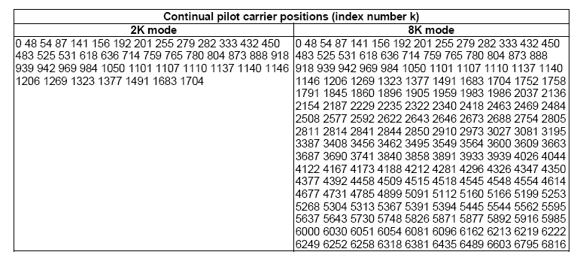

  - The generation and modulation of pilot
The continual and scattered pilot are generated by a Pseudo Random Binary Sequence (PRBS),, corresponding to their respective carrier index . The PRBS sequence is generated according to Error: Reference source not foundThe PRBS is initialized so that the first output bit from the PRBS coincides with the first active carrier. A new value is generated by the PRBS on every used subcarrier (whether or not it is a pilot).
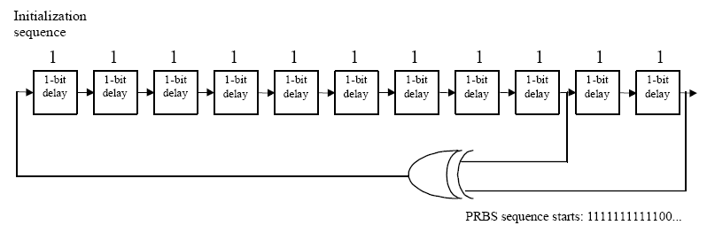

- The generation of PRBS sequence
The polynomial for the PRBS generator shall be:
The pilot cells are always transmitted at the “boosted” power level. Thus the corresponding modulation is given by:
where is the frame index, is the frequency index of the subcarriers and is the time index of the OFDM symbols.

- Detection of DVB-T Signals
  - Single Antenna Scenario
The problem of determining whether there is a DVB-T signal or not on the specific spectrum band can be categorized into the following binary hypothesis test with the null hypothesis H0 corresponding to DVB-T signal absent and the alternative hypothesis H1 corresponding to DVB-T signal existing, that is
where represents the kth sample of received signal, and are transmitted signal and the lth path fading coefficient of the channel respectively, and the additive white Gaussian noise (AWGN) is modeled as independent complex Gaussian random variables.
Based on this detection model and the characteristics of DVB-T signal described above, we proposed the following effective schemes to detect the existence of DVB-T signals.
    - CP Based Sliding Correlation
Let’s assume that there are carriers in a OFDM symbol and the length of CP is . Therefore, in time domain, the length of a OFDM symbol is . As shown in Error: Reference source not found, the first samples are the same to the last samples in the same OFDM symbol. Consequently, there exits correlation between these two parts for this construction.
- OFDM Structure
From the description and analysis above, the following detection statistics is derived for DVB-T signal detection:
where ranges from o to . The corresponding implementation diagram for this scheme is illustrated in Error: Reference source not found。
- Sliding Correlation Based on CP
    - Detection Based on IFFT of Pilot
As described in the previous section, there are a number of pilots (including both continuous ones and scattered ones). This significant characteristic can be utilized for its existence detection.
There are totally carriers in an OFDM symbol in the frequency domain. Let represent the number of the pilot subcarriers. The transmitted DVB-T Signal can be divided into two parts: the first part is made up of data carriers and it can be expressed as
in time domain , the second part is made up of pilot subcarrier and the corresponding representation in time domain is given as
Therefore the binary hypothesis test in can be transformed into the following equations:
      - Time Domain Pilot Based Sliding Correlation
is the time delay between the transmitter and the receiver, is the conjunction of receiving signal . In this algorithm, it is similar to the situation in Section 3.1.1, the value of is unknown, so the sliding correlation between and is necessary. The implementation diagram is very similar to Error: Reference source not found
      - Time domain Pilot in Cyclic Prefixes Based Sliding Correlation
It is obvious that the length of summation in is . In order to reduce the length of this operation, thus reducing the complexity of the whole detection process, and considering the CP inherited in DVB-T signals, we propose another DVB-T signal detection algorithm, as illustrated in , where is the conjunction of , is the time delay between the transmitter and the receiver, the implementation diagram of this scheme is depicted in Error: Reference source not found.
- Sliding Correlation Based on time domain of Pilot in CP
    - Simulation results
For our simulations, we choose 2K mode of 8MHz bandwidth DVB-T signal, A cyclic prefix with length is added at the beginning of each OFDM symbol, and the resulted total OFDM symbol duration is . The channel parameters is set according to the annex B of the DVB-T standard document “ETSI EN 300 744” , which is a 20 paths Rayleigh fading channel. The sensing time for all the simulations is , that means the duration of 64 OFDM symbols. The simulation results are shown in Error: Reference source not found and Error: Reference source not found in terms of ROC curves.
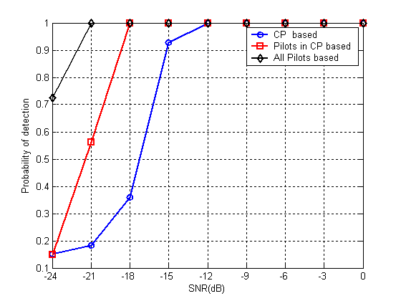
- Simulation Result (sensing time is 17.92ms, false alarm rate is 0.1)
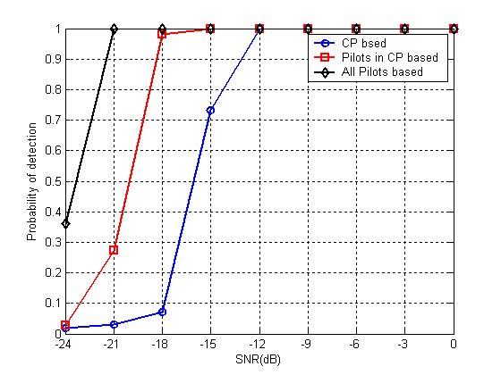
- Simulation Result (sensing time is 17.92ms, false alarm rate is 0.01)
  - Multi-Antenna Scenario
As multiple antennas utilized at Base Station (BS) is one possible solution, thus making multi-antenna detection scenario available.
The detection model in multi-antenna scenario is
where vector is the received signal vector from receiver antennas and , and are transmitted signal, channel fading coefficients vector and noise vector respectively. Here ( is the length of received signal) and ().
The detection statistics is
where denotes conjunction transpose operation and
    - Simulation Results
The simulation setup is same as before except that the sensing time is set to be , that means 4 times OFDM symbol duration and the number of receiver antennas is two.
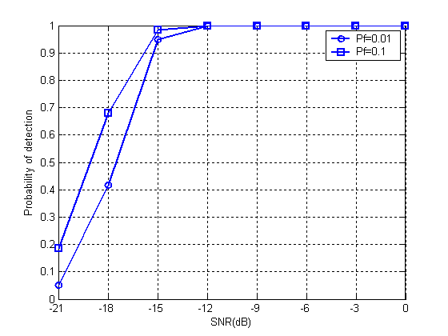
Figure 1 Simulation Result for 2 antenna detection (sensing time is 1.12ms)
- Conclusion
In this document, several algorithms are proposed to detect the existence of DVB-T signals. Simulation results are also provided to shown the performances of all these schemes. From these results, it can be concluded that the DVB-T signals can be effectively detected by utilizing the characteristics of the pilots inserted in the OFDM symbols.

