IEEE P802.22
Wireless RANs
PHY Minutes from Nov 2, 2006 Conference Call
Date: 2006-11-02
Author(s):
Name | Company | Address | Phone | email
Zander Zhongding Lei | Institute for Infocomm Research Singapore | 21 Heng Mui Keng Terrace Singapore 119613 | 65-6874-5686 | leizd@i2r.a-star..edu.sg
Abstract
This document contains the minutes from the PHY conference call on Nov. 2, 2006.
Notice: This document has been prepared to assist IEEE 802.22. It is offered as a basis for discussion and is not binding on the contributing individual(s) or organization(s). The material in this document is subject to change in form and content after further study. The contributor(s) reserve(s) the right to add, amend or withdraw material contained herein.

Release: The contributor grants a free, irrevocable license to the IEEE to incorporate material contained in this contribution, and any modifications thereof, in the creation of an IEEE Standards publication; to copyright in the IEEE’s name any IEEE Standards publication even though it may include portions of this contribution; and at the IEEE’s sole discretion to permit others to reproduce in whole or in part the resulting IEEE Standards publication. The contributor also acknowledges and accepts that this contribution may be made public by IEEE 802.22.

Patent Policy and Procedures: The contributor is familiar with the IEEE 802 Patent Policy and Procedures
<http://standards.ieee.org/guides/bylaws/sb-bylaws.pdf>, including the statement "IEEE standards may include the known use of patent(s), including patent applications, provided the IEEE receives assurance from the patent holder or applicant with respect to patents essential for compliance with both mandatory and optional portions of the standard." Early disclosure to the Working Group of patent information that might be relevant to the standard is essential to reduce the possibility for delays in the development process and increase the likelihood that the draft publication will be approved for publication. Please notify the Chair <Carl R. Stevenson> as early as possible, in written or electronic form, if patented technology (or technology under patent application) might be incorporated into a draft standard being developed within the IEEE 802.22 Working Group. If you have questions, contact the IEEE Patent Committee Administrator at <patcom@ieee.org>.
The PHY call started at 7PM PT on Nov 2. The attendance table is given at the end of the minutes (Thanks Ramon).

Eli (Runcom) explained the simulation results below that comparing the Peak-to-Average Power Ratio (PAPR) of the preamble sequences in the current draft vs. that for the 802.16 preamble sequences. In short, the 802.16 preamble sequence has much less PAPR as compared to that in the draft.

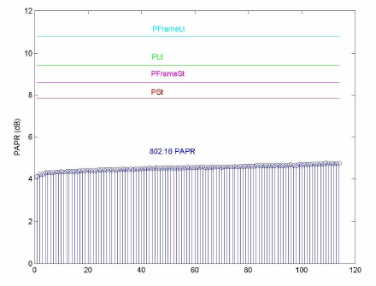

Ramon (Nextwave) asked Eli to comment on the question that Carl had asked: how often a degraded PAPR was observed and could it possible to provide a cumulative distribution function of PAPR?

Eli agreed to look into that and took an action item to address the question.

John (France Telecom) asked whether there were any simulation results provided by other parties, such as Philips.

Eli replied none.

Sung Hyun (ETRI) confirmed that they would complete the simulation results for OFDM parameters/pilot pattern/preambles soon and present in the coming Nov. Dallas meeting. More specifically, the simulations for downlink were just finished. They continued with uplink simulations and trying to optimize spectrum efficiency for different pilot patterns.

The meeting adjourned after half an hour discussion.

Action item:

Eli Sofer to address additional issues the cumulative distribution function of PAPR

Attendance for PHY conference call between Oct - Nov meeting, 2006:

 | Oct 26 | Nov 2
Myungsun Song | X | X
Kwangzin Go
Sung Hyun Hwang | X | X
Jung Sun Um
Patrick Pirat | X
John Benko |  | X
Soo-Young Chang | X | X
Edward Au
Yuchun Wu
Ying-Chang Liang
Zander Zhongding Lei | X | X
Weng Seng Leon
Chang Long Xu
Anh Tuan Hoang
Yonghong Zeng
Steve Kuffner | X
Ramon Khalona | X | X
Monisha Ghosh | X
Carlos Cordeiro
Eli Sofer |  | X
Doron Ezri
David Mazzarese
Baowei Ji
Wendong Hu
Wen Gao
Carl Stevenson | X
Gerald Chouinard | X

