IEEE P802.22
Wireless RANs
Performance of eigenvalue based sensing algorithms for detection of DTV and wireless microphone signals
Last Updated - Date: 2006-09-18
Author(s):
Name | Company | Address | Phone | email
Yonghong Zeng | Institute for Infocomm Research | 21 Heng Mui Keng Terrace, Singapore 119613 | 65-68748211 | yhzeng@i2r.a-star.edu.sg
Ying-Chang Liang | Institute for Infocomm Research | 21 Heng Mui Keng Terrace, Singapore 119613 | 65-68748211 | ycliang@i2r.a-star.edu.sg

Abstract

This document presents the eigenvalue based sensing algorithms and their performances for the IEEE 802.22 WRANs. Simulation results based on the captured DTV signals and randomly generated wireless microphone signals are given.
Notice: This document has been prepared to assist IEEE 802.22. It is offered as a basis for discussion and is not binding on the contributing individual(s) or organization(s). The material in this document is subject to change in form and content after further study. The contributor(s) reserve(s) the right to add, amend or withdraw material contained herein.

Release: The contributor grants a free, irrevocable license to the IEEE to incorporate material contained in this contribution, and any modifications thereof, in the creation of an IEEE Standards publication; to copyright in the IEEE’s name any IEEE Standards publication even though it may include portions of this contribution; and at the IEEE’s sole discretion to permit others to reproduce in whole or in part the resulting IEEE Standards publication. The contributor also acknowledges and accepts that this contribution may be made public by IEEE 802.22.

Document Policy and Procedures: The contributor is familiar with the IEEE 802 Document Policy and Procedures
<http://standards.ieee.org/guides/bylaws/sb-bylaws.pdf>, including the statement "IEEE standards may include the known use of document(s), including document applications, provided the IEEE receives assurance from the document holder or applicant with respect to documents essential for compliance with both mandatory and optional portions of the standard." Early disclosure to the Working Group of document information that might be relevant to the standard is essential to reduce the possibility for delays in the development process and increase the likelihood that the draft publication will be approved for publication. Please notify the Chair <Carl R. Stevenson> as early as possible, in written or electronic form, if documented technology (or technology under document application) might be incorporated into a draft standard being developed within the IEEE 802.22 Working Group. If you have questions, contact the IEEE Document Committee Administrator at <patcom@ieee.org>.

- Eigenvalue based sensing algorithms

Let $y(t)$ be the continuous time received signal. Assume that we are interested in the frequency band with central frequency $f_{c}$and bandwidth$W$. We sample the received signal $y(t)$ at a sampling rate$f_{s}$, where$f_{s}≥W$. Let $T_{s}=1/{f_{s}}$be the sampling period. The received discrete signal is then$x(n)=y({\text{nT}}_{s})$. There are two hypothesises:$H_{0}$: signal not exists; and $H_{1}$: signal exists. The received signal samples under the two hypothesises are therefore respectively as follows:
$$H_{0}:x(n)=η(n)$$
$H_{1}:x(n)=s(n)+η(n)$,
where$s(n)$ is the transmitted signal passed through a wireless channel (including fading and multipath effect), and$η(n)$ is the white noise samples. Note that$s(n)$can be the superposition of multiple signals. The received signal is generally passed through a bandpass filter. Let $f(k),k=0,1,\text{.}\text{.}\text{.},K$be the bandpass filter. After filtering, the received signal is turned to
$$\tilde{x}(n)=\sum_{k=0}^{K}{f(k)x(n−k),n=0,1,\text{.}\text{.}\text{.}}$$
Let
$$\tilde{s}(n)=\sum_{k=0}^{K}{f(k)s(n−k),n=0,1,\text{.}\text{.}\text{.}}$$
$$\tilde{η}(n)=\sum_{k=0}^{K}{f(k)η(n−k),n=0,1,\text{.}\text{.}\text{.}}$$
Then
$$H_{0}:\tilde{x}(n)=\tilde{η}(n)$$
$$H_{1}:\tilde{x}(n)=\tilde{s}(n)+\tilde{η}(n)$$
Choose a smoothing factor $L$ and define
$$x(n)=\begin{matrix}[\tilde{x}(n) & \tilde{x}(n−1) & \text{.}\text{.}\text{.} & \tilde{x}(n−L+1)\end{matrix}]^{T},n=0,1,\text{.}\text{.}\text{.},N_{s}−1$$
Define a $L×(L+K)$matrix as
$$H=\left[\begin{matrix}f(0) & f(1) & \text{.}\text{.}\text{.} & f(K) & 0 & \text{.}\text{.}\text{.} & 0 \\ 0 & f(0) & \text{.}\text{.}\text{.} & f(K−1) & f(K) & \text{.}\text{.}\text{.} & 0 \\ & & \text{.}\text{.}\text{.} & & \text{.}\text{.}\text{.} & & \\ 0 & 0 & \text{.}\text{.}\text{.} & f(0) & f(1) & \text{.}\text{.}\text{.} & f(K)\end{matrix}\right]$$

Let$G={\text{HH}}^{H}$. Decompose the matrix into$G={\text{QQ}}^{H}$, where $Q$ is a $L×L$Hermitian matrix.

Maximum-minimum eigenvalue (MME) detection

Step 1. Sample and filter the received signal as described above.

Step 2. Choose a smoothing factor $L$ and compute the threshold $γ$ to meet the requirement for the probability of false alarm. (can be done by Table lookup)

Step 3. Compute the sample covariance matrix
$$R(N_{s})=\frac{1}{N_{s}}\sum_{n=0}^{N_{s}−1}{x(n)x^{H}(n)}$$

Step 4. Transform the sample covariance matrix to obtain
$$\tilde{R}(N_{s})=Q^{−1}R(N_{s})Q^{−H}$$

Step 5. Compute the maximum eigenvalue and minimum eigenvalue of the matrix $\tilde{R}(N_{s})$ and denote them as $λ_{\text{max}}$ and $λ_{\text{min}}$, respectively.

Step 6. Determine the presence of the signal based on the eigenvalues and the threshold: if $λ_{\text{max}}>{\text{γλ}}_{\text{min}}$, signal exists; otherwise, signal not exists

The flow-chart of the algorithm is given in Figure 1.

Compute the sample covariance matrix using the collected sample
Choose a smoothing factor and the threshold $γ$
Sample and filter the received signal
Transform the sample covariance matrix

Decision: if $λ_{\text{max}}>{\text{γλ}}_{\text{min}}$,
signal exists;
Otherwise, signal not exists.
Compute the maximum eigenvalue, $λ_{\text{max}}$, and minimum eigenvalue, $λ_{\text{min}}$ , of the transformed covariance matrix

Figure 1. Flow-chart of the MME detection

Energy with minimum eigenvalue (EME) detection

Step 1. Sample and filter the received signal as described above.

Step 2. Choose a smoothing factor $L$ and compute the threshold $γ$ to meet the requirement for the probability of false alarm. (can be done by Table lookup)

Step 3. Compute the sample covariance matrix
$$R(N_{s})=\frac{1}{N_{s}}\sum_{n=0}^{N_{s}−1}{x(n)x^{H}(n)}$$

Step 4. Transform the sample covariance matrix to obtain
$$\tilde{R}(N_{s})=Q^{−1}R(N_{s})Q^{−H}$$

Step 5. Compute the average energy of the received signal $ρ$, and the minimum eigenvalue of the matrix $\tilde{R}(N_{s})$,$λ_{\text{min}}$.

Step 6. Determine the presence of the signal: if $ρ>{\text{γλ}}_{\text{min}}$, signal exists; otherwise, signal not exists.

The flow-chart of the algorithm is given in Figure 2.

Compute the sample covariance matrix using the collected samples
Decision: if $ρ>{\text{γλ}}_{\text{min}}$,
signal exists;
Otherwise, signal not exists.
Choose a smoothing factor and the threshold $γ$
Compute the energy $ρ$, and minimum eigenvalue $λ_{\text{min}}$ of the transformed covariance matrix

Sample and filter the received signal
Transform the sample covariance matrix

Figure 2. Flow-chart of the EME detection

- Simulations for wireless microphone signals

The FM modulated wireless microphone signal is

$$w(t)=\text{cos}\left(2π\int{(f_{c}+f_{Δ}w_{m}(τ))dτ}\right)$$
where $f_{c}$ is the central frequency, $f_{Δ}$ is the frequency deviation, and $w_{m}(τ)$ is the source signal.

We choose the frequency deviation to be 100 KHZ. We assume that the signal has been down converted to the IF with central frequency $f_{\text{IF}}$=5.381119 MHz (the same as the captured DTV signal). The sampling rate is 21.524476 MHz (the same as the captured DTV signal). The passband filter with bandwidth 6 MHz is the raised cosine filter with 89 tapes. $w_{m}(τ)$ is generated as evenly distributed real number in (-1,1). The signal and white noise are passed through the same filter. Sensing time is 9.30 mili seconds (ms). The smoothing factor is chosen as L=10. The threshold is set based on the required Pfa=0.1 (using random matrix theory) and fixed for signals. The threshold is not related to noise power.

Table 1 gives the probability of false alarm. Figure 3 shows the probability of detection.
Notations used in the following: EG: energy detection, EG-xdB: energy detection with xdB noise uncertainty.

EG-2dB | EG-1.5dB | EG-1dB | EG-0.5dB | EG-0dB  (no uncertainty) | EME | MME
0.497 | 0.497 | 0.496 | 0.483 | 0.108 | 0.081 | 0.086

Table 1. Probability of false alarm (filtered noise, sensing time 9.30 ms)

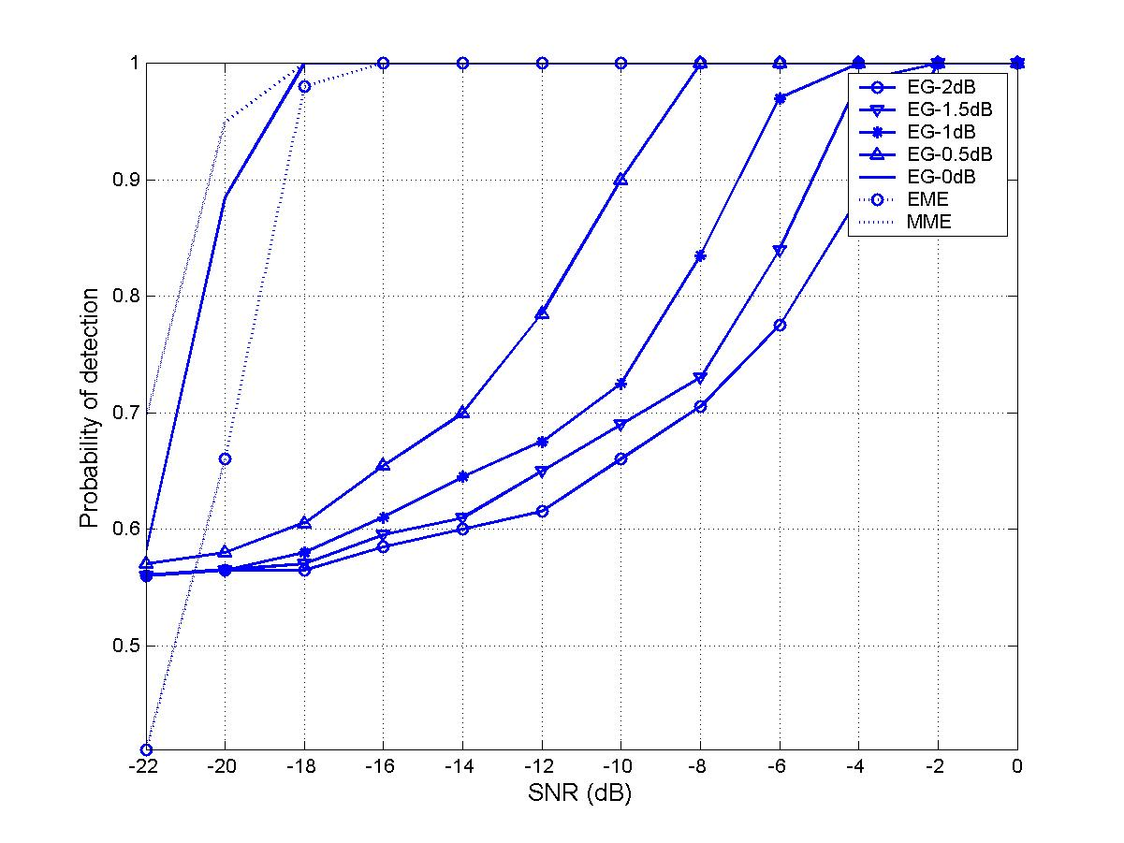

Figure 3. Probability of detection of wireless microphone signal (sensing time 9.30 ms)

- Simulations for captured DTV signals

The simulations are based on the “Spectrum sensing simulation model”.

The captured DTV signal is passed through a raised cosine filter (bandwidth 6 MHz, rolling factor ½, 89 tapes). White noises are added to obtain the various SNR levels. The number of samples used is 400000 (corresponding to 18.60 ms). The smoothing factor is chosen as L=10. The threshold is set based on the required Pfa=0.1 (using random matrix theory) and fixed for signals. The threshold is not related to noise power.

Table 2 gives the probability of false alarm. Figure 4-9 give the probability of detections for different DTV signals.

EG-2dB | EG-1.5dB | EG-1dB | EG-0.5dB | EG-0dB  (no uncertainty) | EME | MME
0.496 | 0.496 | 0.491 | 0.481 | 0.095 | 0.029 | 0.077

Table 2. Probability of false alarm (white noise, sensing time 18.60 ms)

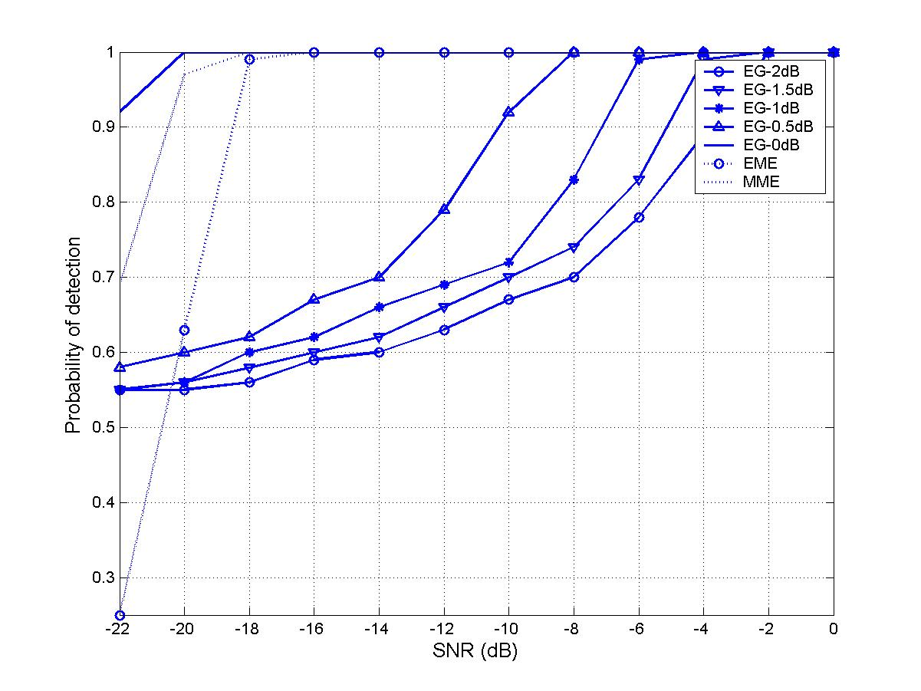

Figure 4. Probability of detection (WAS-311/48/01)

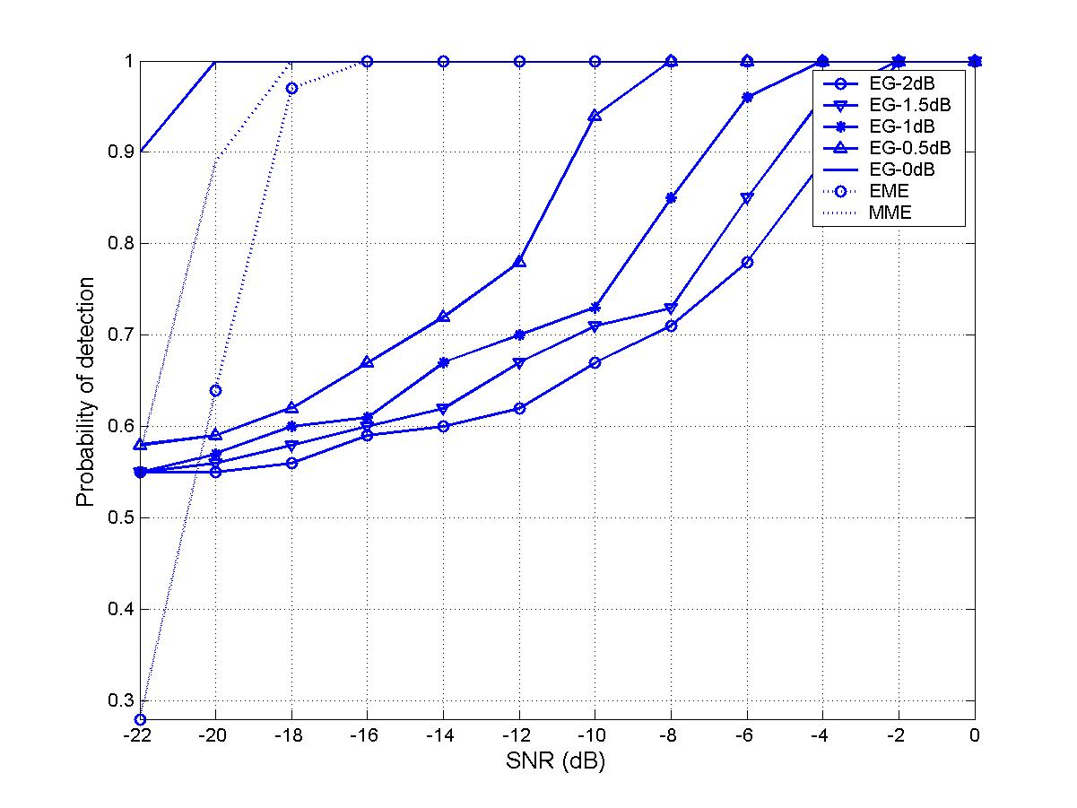

Figure 5. Probability of detection (WAS-311/36/01)

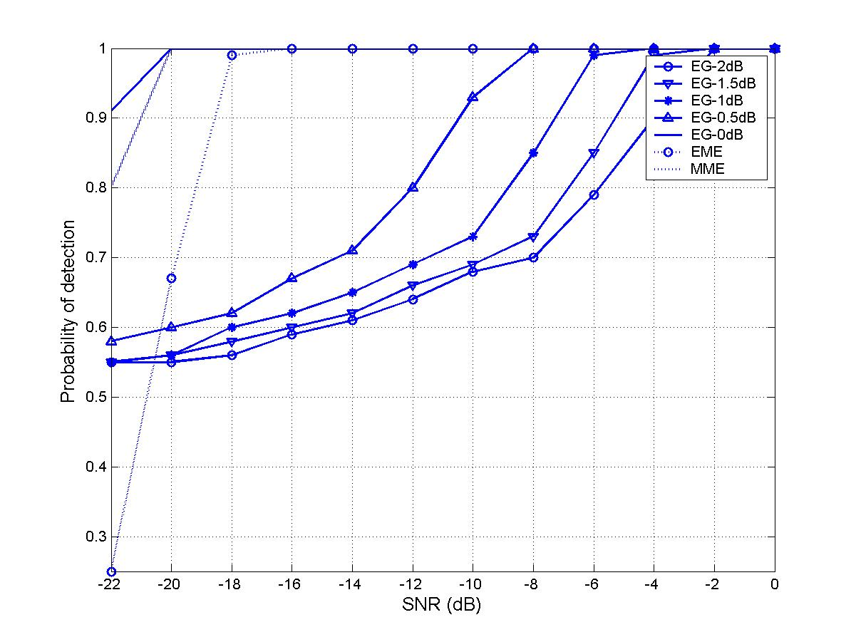

Figure 6. Probability of detection (WAS-006/34/01)

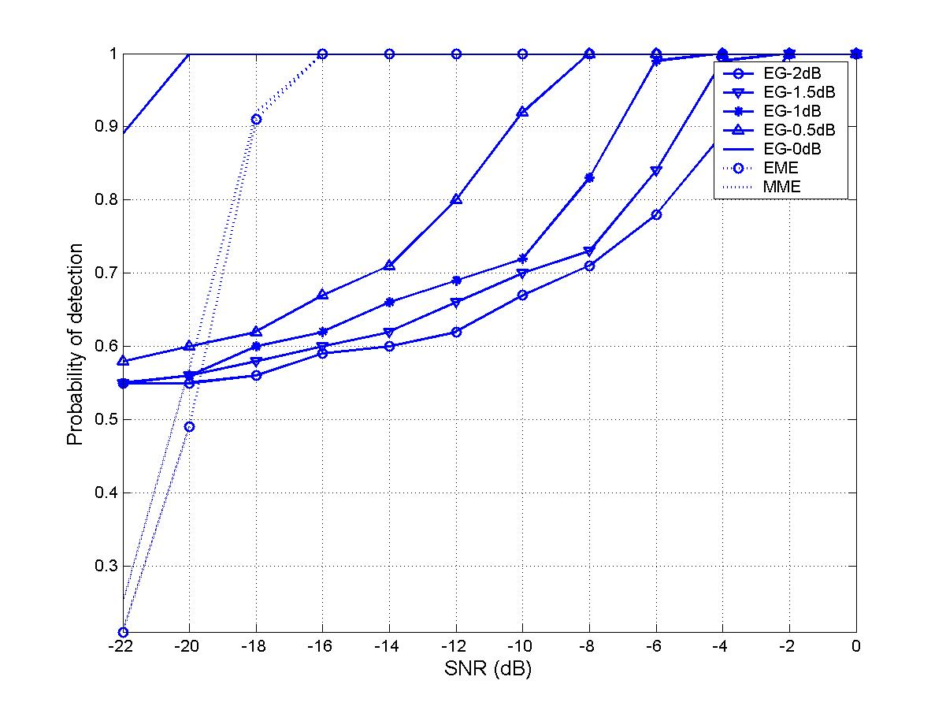

Figure 7. Probability of detection (WAS-051/35/01)

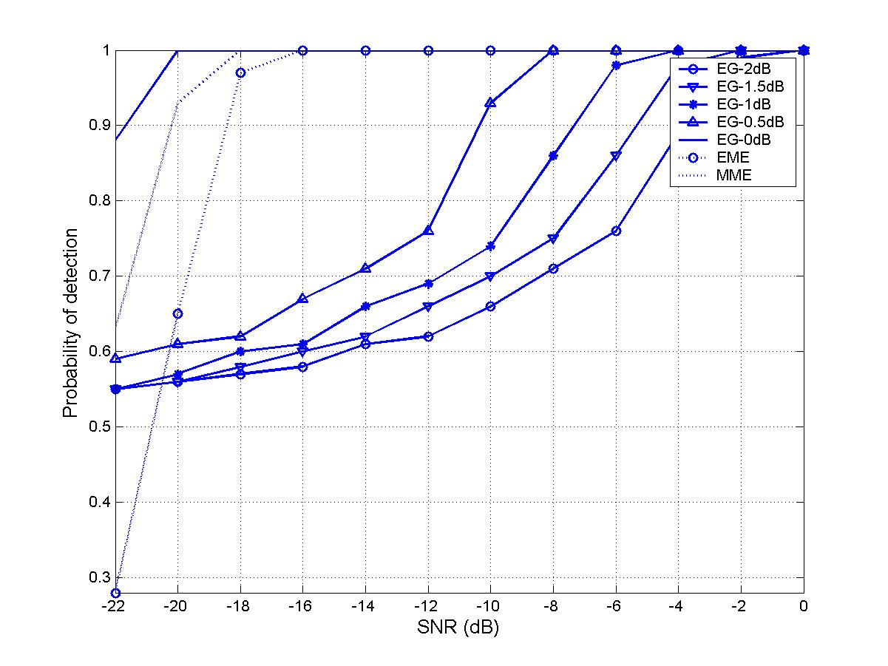

Figure 8. Probability of detection (WAS-032/48/01)

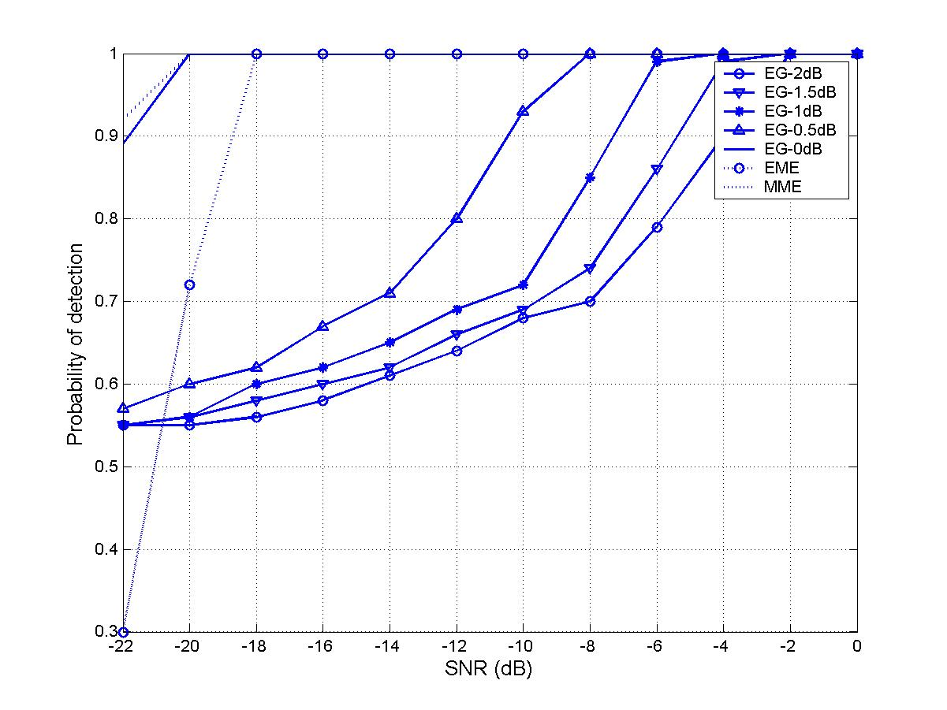

Figure 9. Probability of detection (WAS-049/34/01)

- Conclusions

- The eigenvalue based detections do not need any information on signal, the channel, the noise level and SNR.
- Same detection method for all signals (DTV, wireless microphone, …);
- Same threshold for all signals (the thresholds is independent on the signal and noise power).
- Performance is comparable to ideal energy detection (can be better than if over-sampled)

References

- A. Sahai and D. Cabric, “Spectrum sensing: fundamental limits and practical challenges,” in Dyspan 2005 (available at: www.eecs.berkeley.edu/∼sahai), 2005.
- Steve Shellhammer et al., “Spectrum sensing simulation model”, http://grouper.ieee.org/groups/802/22/Meeting_documents/2006_July/22-06-0028-07-0000-Spectrum-Sensing-Simulation-Model.doc, July 2006.
- Steve Shellhammer, “Numerical spectrum sensing requirements”, http://grouper.ieee.org/groups/802/22/Meeting_documents/2006_July/22-06-0088-00-0000-Numerical-Spectrum-Sensing-Requirements.doc, July 2006.
- I.M. Johnstone, “On the distribution of the largest eigenvalue in principle components analysis,” The Annals of Statistics, vol. 29, no. 2, pp. 295—327, 2001.
- Victor Tawil, “51 captured DTV signal”, http://grouper.ieee.org/groups/802/22/Meeting_documents/2006_May/Informal_Documents, May 2006.
- Yonghong Zeng and Ying-Chang Liang, “Eigenvalue based sensing algorithms”, http://grouper.ieee.org/groups/802/22/Meeting_documents/2006_July/22-06-0118-00-0000_I2R-sensing.doc

