IEEE P802.22
Wireless RANs
Preamble design and frequency offsets estimation for OFDMA uplink
Last Updated - Date: 2006-07-21
Author(s):
Name | Company | Address | Phone | email
Yonghong Zeng | Institute for Infocomm Research | 21 Heng Mui Keng Terrace, Singapore 119613 | 65-68748211 | yhzeng@i2r.a-star.edu.sg
A. Rahim Leyman | Institute for Infocomm Research | 21 Heng Mui Keng Terrace, Singapore 119613 | 65-68748211 | larahim@i2r.a-star.edu.sg

Abstract

Dedicated preambles are designed to estimate the carrier frequency offset (CFO) in orthogonal frequency division multiple access (OFDMA) uplink. Based on the preambles, algorithms are proposed for the CFO estimations. It is theoretically proved that the CFOs are identifiable by using the algorithms. Simulations results are given.
.
Notice: This document has been prepared to assist IEEE 802.22. It is offered as a basis for discussion and is not binding on the contributing individual(s) or organization(s). The material in this document is subject to change in form and content after further study. The contributor(s) reserve(s) the right to add, amend or withdraw material contained herein.

Release: The contributor grants a free, irrevocable license to the IEEE to incorporate material contained in this contribution, and any modifications thereof, in the creation of an IEEE Standards publication; to copyright in the IEEE’s name any IEEE Standards publication even though it may include portions of this contribution; and at the IEEE’s sole discretion to permit others to reproduce in whole or in part the resulting IEEE Standards publication. The contributor also acknowledges and accepts that this contribution may be made public by IEEE 802.22.

Document Policy and Procedures: The contributor is familiar with the IEEE 802 Document Policy and Procedures
<http://standards.ieee.org/guides/bylaws/sb-bylaws.pdf>, including the statement "IEEE standards may include the known use of document(s), including document applications, provided the IEEE receives assurance from the document holder or applicant with respect to documents essential for compliance with both mandatory and optional portions of the standard." Early disclosure to the Working Group of document information that might be relevant to the standard is essential to reduce the possibility for delays in the development process and increase the likelihood that the draft publication will be approved for publication. Please notify the Chair <Carl R. Stevenson> as early as possible, in written or electronic form, if documented technology (or technology under document application) might be incorporated into a draft standard being developed within the IEEE 802.22 Working Group. If you have questions, contact the IEEE Document Committee Administrator at <patcom@ieee.org>.

1. Introduction

Due to oscillator instabilities and/or Doppler shifts, there exists carrier frequency offsets (CFOs) between the transmitters and the receivers. When there are CFOs, the orthogonality among the subcarriers of OFDMA is destroyed and the received signals are contaminated by the inter carrier interference (ICI) and multi-access interference (MAI). For OFDMA uplink, each user may have a different CFO, which further worsens the problem. To combat the ICI and MAI, first of all the CFOs must be estimated. CFO estimation for the OFDMA uplink is a crucial and challenging task. Known CFO estimation methods for single-user OFDM cannot be directly used here because there are multiple CFOs in OFDMA.

2. Preamble design

Use one OFDM symbol as the preamble in OFDMA uplink.

Preamble design: The N subcarriers are divided into KQ consecutive subbands, where each subband has P=N/(KQ) subcarriers. Each user is allocated with Q subands, which are interleaved in the KQ subbands. In each subband, there is only one active subcarrier at the end of the subband. The minimum distance between any two active subcarriers is Δ1
.

For example, for N=16, K=2, Δ1=4, Q=2, the preamble structure in shown in Figure 1, where K is the number of users.

0 | 1 | 2 | 3 | 4 | 5 | 6 | 7 | 8 | 9 | 10 | 11 | 12 | 13 | 14 | 15

Blue: user 1; Red: user 2

Figure 1. Preamble structure (N=16, K=2, Δ1=4, Q=2)

3. Frequency offsets estimation algorithms

Algorithm 1. Simplified ML estimation

The algorithm is shown in Figure 2.
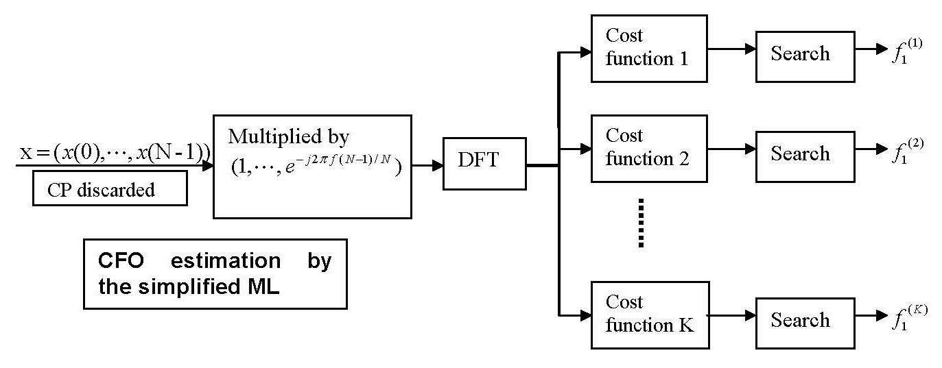

Figure 2. Simplified ML estimation

Algorithm 2. Fast algorithm

The algorithm is shown in Figure 3.

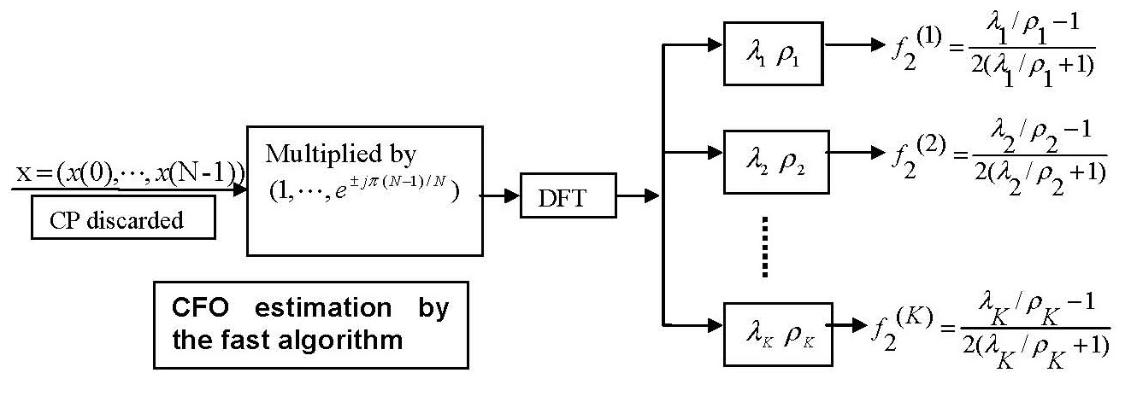

Figure 3. Fast algorithm

where

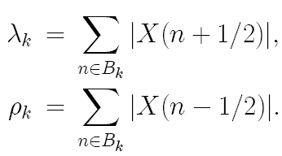

4. Simulations and conclusions

System settings

The length of OFDM block N=2048
The length of the CP is 64
Random channels with no more than 65 taps
Random CFOs in (-0.5, 0.5)

Preamble design: The N subcarriers are divided into KQ consecutive subbands, where each subband has P=N/(KQ) subcarriers. Each user is allocated with Q subands, which are interleaved in the KQ subbands. In each subband, there is only one active subcarrier at the end of the subband. The minimum distance between any two active subcarriers is$Δ_{1}$.

Simualtion results are given in Figure 4 to 6 when only one receiver antenna is used at the base-station. Figure 7 and 8 give the simualtion results when multiple receiver antennas are used at the base-station, where J is the number of antenna.

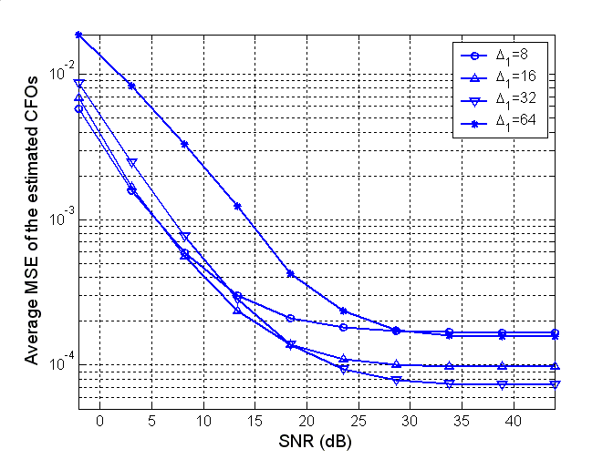

Figure 4.1 MSE for the simplified ML (number of users is K=32)

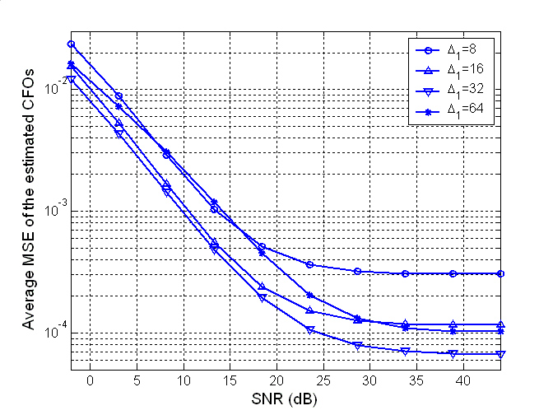

Figure 4.2 MSE for the fast algorithm (number of users is K=32)

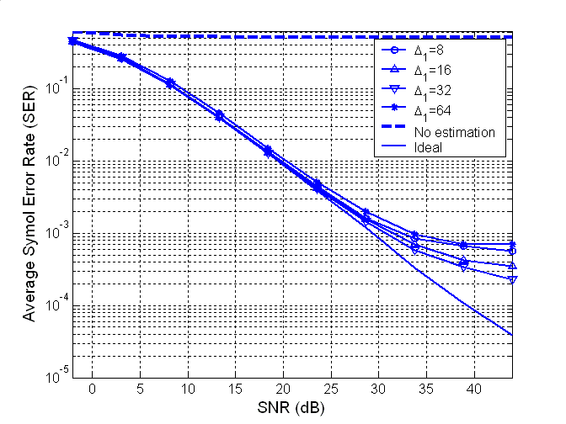
Figure 5.1 SER for the simplified ML (number of users is K=32)

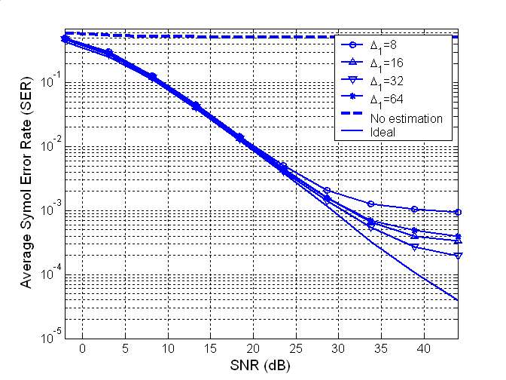

Figure 5.2 SER for fast algorithm (number of users is K=32)

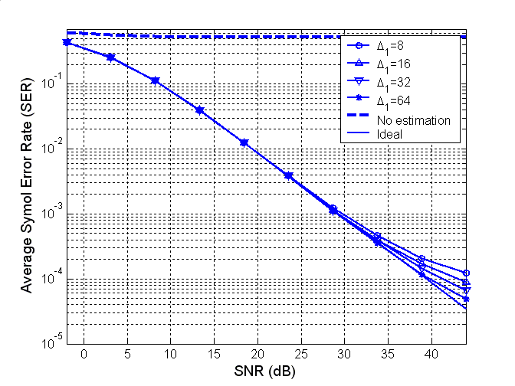
Figure 6.1 SER for the simplified ML (number of users is K=8)

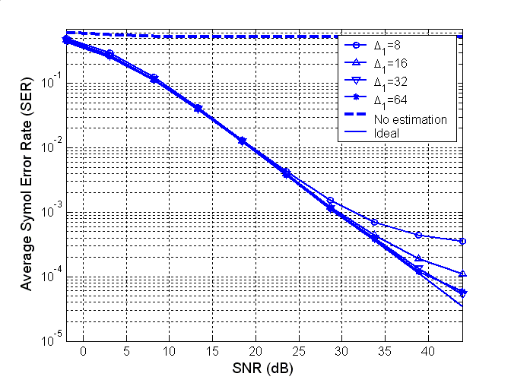
Figure 6.2 SER for the fast algorithm (number of users is K=8)
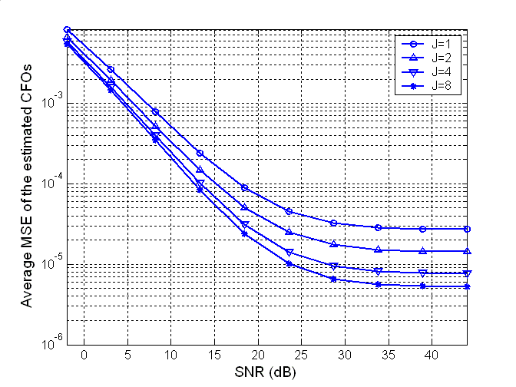

Figure 7. MSE for the fast algorithm (number of users is K=16)
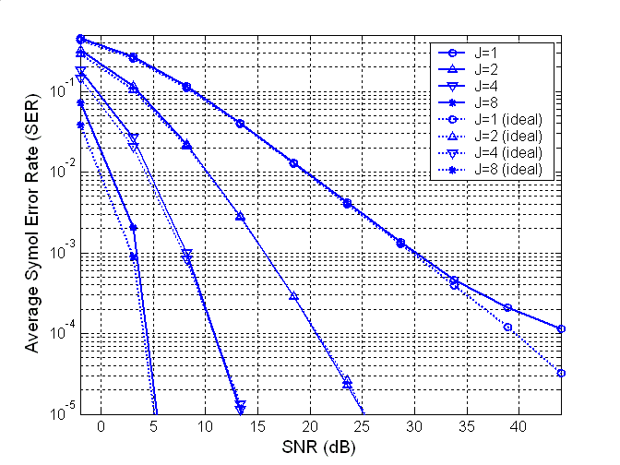

Figure 8. SER for the fast algorithm (number of users is K=16)

Conclusions

Dedicated preambles are designed to estimate the carrier frequency offset (CFO) in orthogonal frequency division multiple access (OFDMA) uplink. Based on the preambles, algorithms are proposed for the CFO estimations. It is theoretically proved that the CFOs are identifiable by using the algorithms. Simulations results have been given to show the performance of the preamble design and the estimation algorithms.

