IEEE P802.22
Wireless RANs
Eigenvalue based sensing algorithms
Last Updated - Date: 2006-07-14
Author(s):
Name | Company | Address | Phone | email
Yonghong Zeng | Institute for Infocomm Research | 21 Heng Mui Keng Terrace, Singapore 119613 | 65-68748211 | yhzeng@i2r.a-star.edu.sg
Ying-Chang Liang | Institute for Infocomm Research | 21 Heng Mui Keng Terrace, Singapore 119613 | 65-68748211 | ycliang@i2r.a-star.edu.sg

Abstract

This document presents a sensing algorithm for the IEEE 802.22 WRANs. With oversampling or multiple receivers, the maximum and minimum eigenvalue of the sample covariance matrix of the received signal contain the signal and noise information, respectively. Based on random matrix theories (RMT), the information is quantized and then used for signal detection. The threshold and the probability of false alarm are also found by using the RMT. The proposed method overcomes the noise uncertainty difficulty while keeps the advantages of the energy detection. The method can be used without knowledge of the signal, the channel and noise power.
.
Notice: This document has been prepared to assist IEEE 802.22. It is offered as a basis for discussion and is not binding on the contributing individual(s) or organization(s). The material in this document is subject to change in form and content after further study. The contributor(s) reserve(s) the right to add, amend or withdraw material contained herein.

Release: The contributor grants a free, irrevocable license to the IEEE to incorporate material contained in this contribution, and any modifications thereof, in the creation of an IEEE Standards publication; to copyright in the IEEE’s name any IEEE Standards publication even though it may include portions of this contribution; and at the IEEE’s sole discretion to permit others to reproduce in whole or in part the resulting IEEE Standards publication. The contributor also acknowledges and accepts that this contribution may be made public by IEEE 802.22.

Document Policy and Procedures: The contributor is familiar with the IEEE 802 Document Policy and Procedures
<http://standards.ieee.org/guides/bylaws/sb-bylaws.pdf>, including the statement "IEEE standards may include the known use of document(s), including document applications, provided the IEEE receives assurance from the document holder or applicant with respect to documents essential for compliance with both mandatory and optional portions of the standard." Early disclosure to the Working Group of document information that might be relevant to the standard is essential to reduce the possibility for delays in the development process and increase the likelihood that the draft publication will be approved for publication. Please notify the Chair <Carl R. Stevenson> as early as possible, in written or electronic form, if documented technology (or technology under document application) might be incorporated into a draft standard being developed within the IEEE 802.22 Working Group. If you have questions, contact the IEEE Document Committee Administrator at <patcom@ieee.org>.

1. Introduction

Energy (EG) detection is a major and basic signal detection method (sensing algorithm). Unlike coherent detection, energy detection does not need any information of the signal to be detected and is robust to unknown multipath fading. However, energy detection is vulnerable to the noise uncertainty [1-3], because the method relies on the knowledge of accurate noise power. There are several sources of uncertainty [1-3]: (1) non-linearity of components; (2) thermal noise in components (non-uniform, time-varying); (3) noise due to transmissions by other users (unintentional (close-by) or intentional (far-away)). Hence, in practice, it is very difficult (virtually impossible) to obtain the accurate noise power. The proposed algorithm overcomes this shortage. With oversampling or multiple receivers, the maximum and minimum eigenvalue of the sample covariance matrix of the received signal contain the signal and noise information, respectively. Based on random matrix theories (RMT), the information is quantized and then used it for signal detection. The threshold and the probability of false alarm are also found by using the RMT. The proposed method overcomes the noise uncertainty difficulty while keeps the advantages of the energy detection. The method can be used for various signal detection without knowledge of the signal, the channel and noise power.

2. Maximum-minimum eigenvalue (MME) detection

Let $x(n),n=0,1,\text{.}\text{.}\text{.},{\text{MN}}_{s}−1,$be the received signal samples, which is oversampled with oversampling factor $M$. Define
$$x_{i}(n)=x(\text{nM}+i−1),i=1,2,\text{.}\text{.}\text{.},M;n=0,1,\text{.}\text{.}\text{.},N_{s}−1$$
Let
$$x(n)=\begin{matrix}[x_{1}(n) & x_{2}(n) & \text{.}\text{.}\text{.} & x_{M}(n)\end{matrix}]^{T},n=0,1,\text{.}\text{.}\text{.}$$
Choose a smoothing factor $L$ and define
$$y(n)=\begin{matrix}[x(n)^{T} & x(n−1)^{T} & \text{.}\text{.}\text{.} & x(n−L+1)^{T}\end{matrix}]^{T},n=0,1,\text{.}\text{.}\text{.}$$

The procedure of the MME detection is as follows.

Step 1. Compute the sample covariance matrix
$$R(N_{s})=\frac{1}{N_{s}}\sum_{n=0}^{N_{s}−1}{y(n)y^{H}(n)}$$

Step 2. Compute the threshold:

$$γ=\frac{(\sqrt{N_{s}}+\sqrt{\text{ML}})^{2}}{(\sqrt{N_{s}}−\sqrt{\text{ML}})^{2}}\left(1+\frac{(\sqrt{N_{s}}+\sqrt{\text{ML}})^{{−2}/3}}{(N_{s}\text{ML})^{1/6}}F_{1^{−1}}(1−P_{0})\right)$$

where $F_{1}$ is the Tracy-Wisdom distribution of order 1 [4] and $P_{0}$ is the required probability of false alarm. The values of the Tracy-Wisdom distribution is given in Table 1.

$$t$$ | -3.90 | -3.18 | -2.78 | -1.91 | -1.27 | -0.59 | 0.45 | 0.98 | 2.02
$$F_{1}(t)$$ | 0.01 | 0.05 | 0.10 | 0.30 | 0.50 | 0.70 | 0.90 | 0.95 | 0.99

Table 1: Numerical table for the Tracy-Wisdom distribution of order 1 [4]

Step 3. Compute the maximum eigenvalue and minimum eigenvalue of the matrix $R(N_{s})$ and denote them as $λ_{\text{max}}$ and $λ_{\text{min}}$, respectively.

Step 4. Determine the presence of the signal based on the eigenvalues and the threshold: if $λ_{\text{max}}>{\text{γλ}}_{\text{min}}$, signal exists; otherwise, signal not exists

The flow-chart of the algorithm is given in Figure 1.

Compute the sample covariance matrix using the collected samples

Decision: if
,
signal exists;
Otherwise, signal not exists.
Compute the threshold
Compute the maximum eigenvalue,
, and minimum eigenvalue,
, of the covariance matrix

Collect signal samples
Figure 1. Flow-chart of the maximum-minimum eigenvalue (MME) detection

3. Simulations and conclusions

The simulations are based on the captured DTV signals [5]. The oversampling factor is$M=2$. The smoothing factor is chosen as $L=8\text{.}$ White noises are added to obtain the various SNR levels. The number of samples used is$2N_{s}=\text{20000}$(corresponding to 0.93ms). Figure 2 gives the probability of detection results based on the DTV signal WAS-003/27/01 (at Washington D.C., the receiver is outside and 48.41 miles from the DTV station). Figure 3 gives the results based on the DTV signal NYC/200/44/01 (at New York, the receiver is indoor and 2 miles from the DTV station).

Table 2 gives the probability of false alarm of the methods.

Notations used:

EG: energy detection.
EG-xdB: energy detection with xdB noise uncertainty.
MME: maximum-minimum eigenvalue detection

Conclusions

- Energy detection with noise uncertainty will result in high probability of false alarm and low probability of detection at low SNR;
- The MME detection does not need any information on the noise level and SNR. It overcomes the noise uncertainty difficulty while keeps the advantages of the energy detection. The method can be used for signal detection without knowledge of the signal, the channel and noise power.

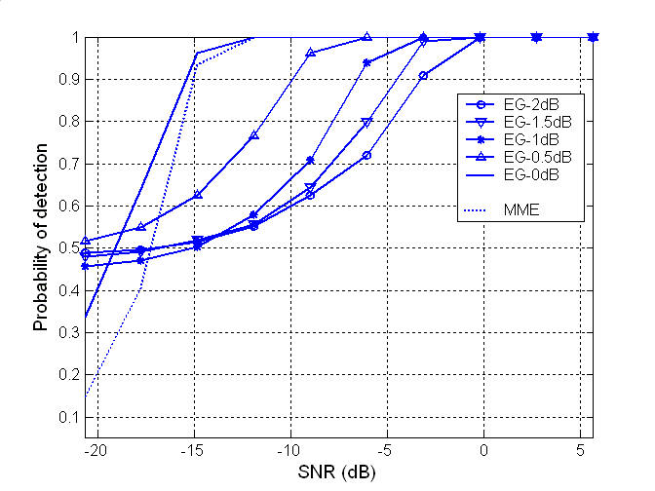
Figure 2. Probability of detection based on the DTV signal WAS-003/27/01
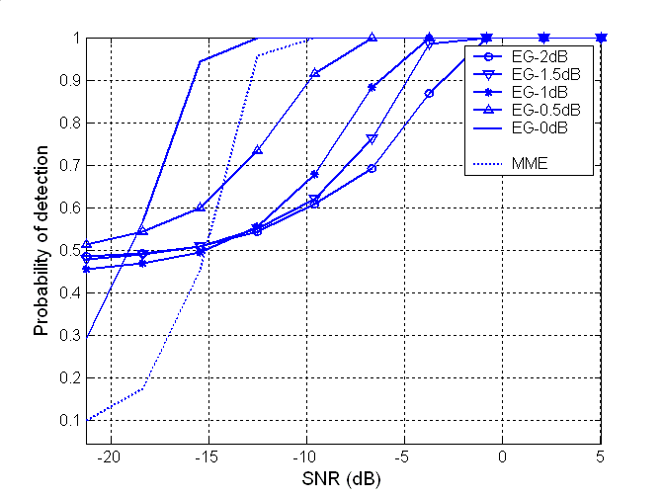

Figure 3. Probability of detection based on the DTV signal NYC/200/44/01

EG-2dB | EG-1.5dB | EG-1dB | EG-0.5dB | EG-0dB  (no uncertainty) | MME
0.479 | 0.474 | 0.441 | 0.473 | 0.094 | 0.089

Table 2: Probability of false alarm
References

- A. Sahai and D. Cabric, “Spectrum sensing: fundamental limits and practical challenges,” in Dyspan 2005 (available at: www.eecs.berkeley.edu/∼sahai), 2005.
- Steve Shellhammer et al., “Spectrum sensing simulation model”, http://grouper.ieee.org/groups/802/22/Meeting_documents/2006_July/22-06-0028-07-0000-Spectrum-Sensing-Simulation-Model.doc, July 2006.
- Steve Shellhammer, “Numerical spectrum sensing requirements”, http://grouper.ieee.org/groups/802/22/Meeting_documents/2006_July/22-06-0088-00-0000-Numerical-Spectrum-Sensing-Requirements.doc, July 2006.
- I.M. Johnstone, “On the distribution of the largest eigenvalue in principle components analysis,” The Annals of Statistics, vol. 29, no. 2, pp. 295—327, 2001.
- Victor Tawil, “51 captured DTV signal”, http://grouper.ieee.org/groups/802/22/Meeting_documents/2006_May/Informal_Documents, May 2006.

