IEEE P802.22
Wireless RANs
WRAN Sensing Receiver Characteristics
Date: 2006-07-03
Author(s):
Name | Company | Address | Phone | email
Gerald Chouinard | CRC | 3701 Carling Avenue, Ottawa, Ontario, Canada | +613-998-2500 | gerald.chouinard@crc.ca
Abstract
This document proposes a detailed text explaining the overall sensing requirements for the various incumbent signals, the mathematical treatment to link the variability of the signal to be sensed and the performance of the sensor and the resulting sensing thresholds as a function of the required probability of detection and the number of statistically independent devices involved in a collaborative sensing effort.

This text is for inclusion in section 2 of the 22-06-0089-00-0000-Spectrum-Sensing-Requirements-Summary.doc being discussed by the Sensing Tiger Team.

Notice: This document has been prepared to assist IEEE 802.22. It is offered as a basis for discussion and is not binding on the contributing individual(s) or organization(s). The material in this document is subject to change in form and content after further study. The contributor(s) reserve(s) the right to add, amend or withdraw material contained herein.

Release: The contributor grants a free, irrevocable license to the IEEE to incorporate material contained in this contribution, and any modifications thereof, in the creation of an IEEE Standards publication; to copyright in the IEEE’s name any IEEE Standards publication even though it may include portions of this contribution; and at the IEEE’s sole discretion to permit others to reproduce in whole or in part the resulting IEEE Standards publication. The contributor also acknowledges and accepts that this contribution may be made public by IEEE 802.22.

Patent Policy and Procedures: The contributor is familiar with the IEEE 802 Patent Policy and Procedures
<http://standards.ieee.org/guides/bylaws/sb-bylaws.pdf>, including the statement "IEEE standards may include the known use of patent(s), including patent applications, provided the IEEE receives assurance from the patent holder or applicant with respect to patents essential for compliance with both mandatory and optional portions of the standard." Early disclosure to the Working Group of patent information that might be relevant to the standard is essential to reduce the possibility for delays in the development process and increase the likelihood that the draft publication will be approved for publication. Please notify the Chair <Carl R. Stevenson> as early as possible, in written or electronic form, if patented technology (or technology under patent application) might be incorporated into a draft standard being developed within the IEEE 802.22 Working Group. If you have questions, contact the IEEE Patent Committee Administrator at <patcom@ieee.org>.

2- Overall sensing requirements
The WRAN sensing system must be able to detect the DTV, NTSC and wireless microphones signals at the specified power levels where they need to be protected and for a specified sensing reliability (probability of detection). These requirements which are given in Table 1 represent an evolution from those specified in Section 15.1.1.7 of the WRAN Functional Requirements Document.

Signal Type | Signal level to be protected ¹ | Protection Ratio (D/U) | Measurement Bandwidth | Location ² | Probability of detection (Pd) ³
ATSC | -92.1 dBm  (41 dBμV/m) | 23 dB | 6 MHz | Up to the edge of the DTV noise-limited contour | 99% (TBD) ⁴
NTSC | -69.1 dBm  (64 dBμV/m) | 34 dB | 6 MHz | Up to the edge of the NTSC Grade B contour | 99% (TBD) ⁵
Part 74 Wireless Microphone | –95 dBm | 20 dB | 200 kHz | At the location of the wireless microphone receiver | 99% (TBD) ⁶
Part 74 Wireless Microphone beacon | -120 dBm | N/A | 10 kHz | At the location of the CPE | 99% (TBD) ⁷
Table 1: WRAN sensing requirements
Notes:
- The signal levels to be sensed are defined in terms signal power at the input of the sensing detector assuming a 0 dBi sensing antenna gain which also includes any RF loss.
- The signal power to be sensed is specified for any location within the DTV and NTSC protected contours. It is the signal power to be sensed for CPEs and base stations located inside the contour. If they are located outside the contour and still need to sense the presence of DTV or NTSC operation (for co-channel and adjacent channel operation), this signal power needs to be decreased by the extra loss that the DTV or NTSC signal would normally suffer to reach their location.
- The probability of detection consists in the cumulative probability required for all WRAN systems in the same area to detect an incumbent. In other words, if there are 2 WRAN systems trying to use a same frequency in an area, the probability of misdetection of 1 % will need to be distributed to each system such that each WRAN system will be allowed to misdetect DTV or NTSC for only 0.5%.
- Since the probability that the DTV signal will exceed the specified signal power at the edge of the noise-limited contour is for 50% location and 90% time, F(50, 90), measures will have to be taken by the WRAN operator to reach the required probability of detection and compensate for the cases where the actual signal level will be below the specified level (i.e., F(50, 10)). The location and time probability of the signal to be sensed will need to be collapsed into one signal level probability. The standard deviation for the location variability is assumed to be 5.5 dB whereas the standard deviation for the time variability depends on the distance from the TV transmitter and can be generated from the prediction model (ITU-R P.1546). Meeting the resulting higher detection probability can be done by: a) using collaborating sensing with multiple CPE’s, b) reducing the signal threshold for which detection has to take place, and/or c) tightening the probability of detection at each CPE. WRAN operators may decide to use different means to achieve the stated probability of detection.
- Same as note 4 in the case of NTSC detection except that the signal availability to be compensated for is F(50,50) and the location standard deviation is 7 dB.
- Unless there are close-in CPEs, the –95 dBm signal level to be protected for Part 74 wireless microphones will not be met in all cases by practical sensing methods (sensing threshold at -107 dBm). The detection will be based on a ‘best effort’ basis.
- The power and the location of the microphone beacon should be such that the –120 dBm sensing signal level at the CPE should be sufficient for any CPE close enough to create interference to the wireless microphone operation to be able to sense the presence of the beacon for the given probability of detection.

Impact of multiple sensors

If a number of statistically independent sensors (i.e., sufficiently separated so that the local environment is different at each sensor) are used to measure the presence of incumbent signals and report it to the base station, the combination of these results will increase the overall probability of detection. As a corollary, for a specified probability of detection for the system, using a number of independent sensors will relax the probability of detection required at each sensor. This is described by the following equation and illustrated in Table 2.

Pd_{sensor} = 1-(1-Pd_{system})^{(1/n)}
where:
Pd_{system} : specified probability of detection for the system
Pd_{sensor} : required probability of detection at each sensor
n : number of statistically independent sensors

Number of sensing devices: | 1 | 2 | 3 | 4 | 5 | 6 | 7 | 8
Required probability of detection at each sensing device | 99% | 90.0% | 78.5% | 68.4% | 60.2% | 53.6% | 48.2% | 43.8%
Required probability of detection at each sensing device | 99.9% | 96.84% | 90.0% | 82.2% | 74.9% | 68.4% | 62.7% | 57.8%
Required probability of detection at each sensing device | 99.99% | 99.00% | 95.36% | 90.0% | 84.2% | 78.5% | 73.2% | 68.4%
Required probability of detection at each sensing device | 99.999% | 99.684% | 97.85% | 94.38% | 90.0% | 85.3% | 80.7% | 76.3%
Table 2: Required probability of detection as a function of number of sensors

Signal level composite variabilityProbability of detection
In the case of DTV reception, the signal is to be provided out to the noise-limited contour with a field strength of 41 dB(μV/m) for a probability of 50% location and 90% time, F(50, 90) as specified in Table 1. For a reference RF sensor (0 dBi, no RF loss) located inside or at this noise-limited contour, this corresponds to an input signal level of –92.1 dBm met for F(50, 90). The signal level variation that the sensor will see can be translated into a single variable probability as follows:
  - let us assume that the probability for which the signal level is to be exceeded is 99% of the cases
  - knowing the mean (-92.1 dBm) and the standard deviation (5.5 dB from ITU-R Rec. P.1546) for the location variability, the signal level exceeded for 99.1% of locations is found: -105.1 dBm
  - this signal level will therefore not be met for 0.9% of the locations. Since the time availability (90%) accounts for another 1/10th of the cases where the signal will be faded below the specified signal level, this will bring the 0.9% location unavailability to a total of 0.9+0.1= 1% total unavailability for the given signal level, resulting in a composite signal availability of 99%
  - In other words, the signal level exceeded for a 99% composite probability is determined from a somewhat over-restrictive signal level from the location availability specification that compensates for the reduced time availability.
This process was repeated for a few indicative system composite signal availabilities and for a number of independent sensing devices to determine the signal levels to be met at the corresponding signal availability indicated in Table 2 at each sensing device for which this system composite probability will be met. Table 3 gives the results for DTV for the –92.1 dBm level (41 dBμV/m) for F(50,90).

Composite signal availability | Number of statistically independent sensing devices
Composite signal availability | 1 | 2 | 3 | 4 | 5 | 6 | 7 | 8
99% | -105.1 | -99.3 | -96.5 | -94.8 | -93.6 | -92.7 | -91.9 | -91.3
99.9% | -109.2 | -102.4 | -99.2 | -97.2 | -95.8 | -94.8 | -93.9 | -93.2
99.99% | -112.7 | -105.0 | -101.4 | -99.2 | -97.6 | -96.5 | -95.5 | -94.8
99.999% | -115.6 | -107.2 | -103.3 | -100.9 | -99.2 | -97.9 | -96.9 | -96.0
Table 3: Required signal level at each sensor as a function of composite signal availability and number of independent sensors for DTV detection
(Note: values indicated in blue are beyond the validity range of the prediction model, i.e., 1% to 99%)
In the case of NTSC reception, the signal is to be provided up to the grade B contour with a field strength of 64 dBμV/m for a probability of 50% location and 50% time, F(50, 50) as specified in Table 1. For a reference RF sensor (0 dBi, no RF loss) located inside or at this grade B contour, this corresponds to an input signal level of –69.1 dBm met for F(50, 50). The same process as described above was repeated except that in this case, the time variability accounted for ½ of the cases where the signal would fall below the specified level and the location availability had to be over-specified accordingly. Table 4 gives the signal levels required at each sensing device for the NTSC case for a few indicative system composite signal availabilities and for a number of independent sensing devices.

Composite signal availability | Number of statistically independent sensing devices
Composite signal availability | 1 | 2 | 3 | 4 | 5 | 6 | 7 | 8
99% | -87.1 | -79.3 | -75.7 | -73.4 | -71.8 | -70.6 | -69.6 | -68.8
99.9% | -92.1 | -83.1 | -78.9 | -76.3 | -74.5 | -73.1 | -72.0 | -71.1
99.99% | -96.3 | -86.2 | -81.6 | -78.7 | -76.7 | -75.2 | -73.9 | -72.9
99.999% | -100.0 | -89.0 | -83.9 | -80.8 | -78.6 | -76.9 | -75.6 | -74.5
Table 3: Required signal level at each sensor as a function of composite signal availability and number of independent sensors for NTSC detection
(Note: values indicated in blue are beyond the validity range of the prediction model, i.e., 1% to 99%)
In the case of an ideal sensing scheme that can detect the presence of broadcast signals with a probability of detection of 100% when it appear at or above the stated signal level and 0% when it is below the stated level (step sensing transfer function), the levels indicated in Tables 3 and 4 correspond to the sensing thresholds required at each sensing device to meet the specified overall probability of detection for the given number of statistically independent sensing devices working in parallel.

However, the performance of the sensing schemes is unlikely to reproduce such a ‘step function’ but will rather be related to the signal level to be sensed according to a more progressive transition function. The probability of detection will be very high for high levels of signal level but will start to reduce when it gets close to the threshold. Furthermore, this reduction will continue when the signal falls below the threshold but will not suddenly come to zero.

In such case, there will be a need for an integration of the product of the probability density function of the signal level variability with the probability of detection characteristics of the various sensing schemes as a function of SNR (the sensing transfer function) so that an adjustment in the threshold can be made for each sensing scheme to compensate for the difference between the sensing step function as assumed above and the practical and more progressive performance characteristic of the sensing schemes. This is described in the following sections.

Incumbent signal variability composite statistical model

The variability of the signal at the edge of its coverage area comes from three statistically independent processes:

  - location variability which is mainly caused by signal blockage. This variability is assumed to follow a log-normal model. The amount of variability is known as the standard deviation of the log-normal function (5.5 dB for DTV and 7 dB for analog TV) and is assumed to be constant independent of the actual location of the receiver to a first approximation and is described in the ITU-R P.1546 propagation model. (Note that consideration of actual topographic and land coverage data in more accurate propagation models make this variability location dependent.)

  - time variability which is caused by varying conditions in the transmission channel such as change in refractivity and ducting. Such time variability tends to increase when the path length increases. This variability is assumed to follow a log-normal model. The standard deviation for this variability can be deduced from the difference in predictions between F(50, 50) and F(50, 10) at a given distance from a transmitter using the ITU-R P.1546 propagation model.

  - multipath variability which is caused by frequency selective fading inside the active channel resulting from signal reflections arriving out-of-phase at the receiver. Field measurement results were reported in document (22-06-0058-00-0000_Channel_Bandwidth_and_Fading.doc) and were fitted according to a log-normal model. The ITU-R P.1546 model indicates that the location variability includes the effect of multipath for signals occupying the full channel bandwidth. However, the signal variability caused by multipath will tend to increase for narrower bandwidth signals. This is what was observed from field measurements and this extra variability is summarized in Table 4.

Environment \ Bandwidth | 30 kHz | 1.47 MHz | 3 MHz
Suburban | 3.6 dB | 1.7 dB | 1.4 dB
Rural | 3.4 dB | 1.3 dB | 1.3 dB
Table 4: Multipath variability standard deviation for various signal bandwidths
measured in small areas

Since these three components of the signal variability are statistically independent and follow a log-normal model, a composite probability density function can be developed as follows to integrate all these variations into one composite probability model:

$$\text{pdf}(μ,σ)$$
$$μ=μ_{l}+μ_{t}+μ_{m}$$
$$σ^{2}=σ_{l}^{2}+σ_{t}^{2}+σ_{m}^{2}$$

This new composite log-normal pdf can be used to determine the signal level exceeded for a given percentage of cases for specific types of signals, bandwidths and for given distances from the broadcast transmitter.

For example, the difference in the DTV signal level at the noise-limited contour of a 1 MW, 500m high transmitter at 135 km (see 22-06-0052-03-0000_WRAN_Keep-out_Region.xls) for F(50,90) and F(50,50) is found to be 5.91 dB. The standard deviation is therefore 4.61 dB. Since we assume that the DTV signal will occupy the entire 6 MHz bandwidth, the multipath variability is assumed to be fully included in the location variability.

The composite log-normal pdf of the DTV signal variation at 135 km from the transmitter will therefore have the following characteristics:
μ = (-92.1 + 5.8) + 0 + 0 = -86.3 dBm

σ = sqrt(5.5² + 4.61² + 0²) = 7.18 dB

The composite log-normal pdf of the NTSC signal variation at 70.5 km from a 1 MW, 300 m high transmitter will have the following characteristics:
μ = -69.1 + 0 + 0 = -69.1 dBm

σ = sqrt(7² + 1.85² + 0²) = 7.24 dB

The multipath variability will need to be added in the cases where the signal to be observed or te sensor has a smaller bandwidth than the full DTV or NTSC signal bandwidth. For example, if the DTV pilot signal, NTSC video or audio carriers are used for sensing, extrapolation from the sigma values given in Table 4 will need to be made and applied to the appropriate composite statistical model.

Furthermore, if the sensing device is located outside the noise-limited contour, the extra attenuation that the incumbent signal will suffer beyond the protected contour will need to be considered in specifying the mean of this composite pdf model as being the signal mean at this outside location rather than at the protected contour by applying the prediction model for the given DTV transmitter parameters and for the distance to the sensing device. The standard deviation for the time variability will also need to be re-calculated from the difference between F(50,90) and F(50,50) calculated at the new distance as seen above.

Translation from received signal composite variability to SNR variability

The composite log-normal pdf developed to describe the incumbent signal variability at the input of the sensing device needs to be transformed into a pdf model that will include the effect of the sensor RF front-end. Annex B describes the performance of the sensor RF front-end as a function of its characteristics and establishes the relation that links the input signal level to the signal-to-noise ratio (SNR) presented to the sensing detector as follows:
$\text{SNR}=\text{Signal} \text{Level}+G/T−k−\text{10}\text{log}(\text{BW})$ dB
where:
Signal level: Input signal level in dBm which is the independent variable defining the composite log-normal pdf defined in the previous section
G/T: “Figure of Merit” of the sensor RF front-end as defined in Annex B
k: Boltzman constant = -138.6 dBm/(MHz*ºK)
BW: Equivalent noise bandwidth of the sensor, in MHz

The translation from the received signal composite variability pdf function to the SNR variability pdf function is done as follows:
$μ_{\text{SNR}}=μ+G/T−k−\text{10}\text{log}(\text{BW})$ dB

The new SNR variability pdf is therefore a log-normal function with the following parameters:

$${\text{pdf}}_{\text{SNR}}(μ_{\text{SNTR}},σ)$$

Sensor transfer function

The performance of the sensing scheme (i.e., probability of detection, Pd(SNR)) will need to be characterized as a function of the signal-to-noise (SNR) presented at its input for the various types of schemes (energy sensor, correlator, cyclo-stationary, etc.), the number of samples (time used for sensing) and the probability of false alarm. This sensor transfer function will be developed either analytically or empirically through laboratory measurements for the various types of sensing schemes. This should result in sensing transfer functions similar to the one illustrated in Figure 1.

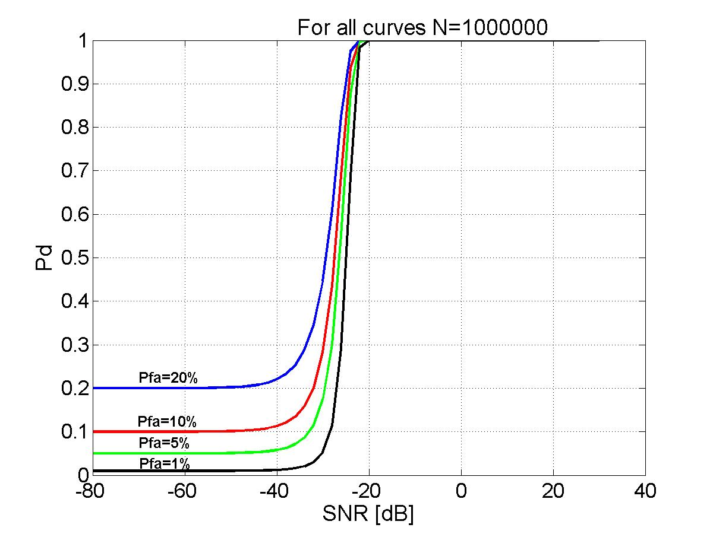
Figure 1: Example of a sensing transfer function
(Energy detector with perfect noise level reference)

Confirmation of this sensor transfer function will need to be done and will, on one hand, prove the potential performance of incumbent sensing for the purpose of advancing the development of the 802.22 WRAN standard, and on the other hand, allow comparison of the relative performance of the various proposed sensing techniques.

Integration of the SNR variability pdf function of the input signal and the sensor transfer function

In order to fing the actual overall performance of the sensing device as applied to a real signal that fluctuates, the actual sensing scheme performance (Pd(SNR)) at a specific SNR will need to be multiplied by the probability of this SNR to occur at the input of the sensor. An integration of this product for all possible SNR’s will give the overall performance of the sensing device for the specific sensing scheme, RF front-end performance (G/T) and SNR variability.

$${\text{Overall P}}_{\text{detection}}=\int{\text{Pd}(\text{SNR})∗{\text{pdf}}_{\text{SNR}}(\text{SNR})∗\text{dSNR}}$$
This is this overall probability of detection that will need to be compared to the required probability given in Table 2 for the given system probability of detection and the number of sensing devices used. Given that the pdf of the incumbent signal variability will be defined by the geometry of the receiving situation, the required probability of detection will be met by either varying the performance of the sensor RF front-end (sensing antenna gain, RF losses and amplifier noise figure) or varying the type of sensing scheme and/or its parameters (probability of false alarm, sensing time, etc.).

Probability of false alarm
With respect to the probability of false alarm for the RF sensing system, this may be left to the WRAN operators to decide since it is an internal WRAN operation question. To meet the stated probability of detection of incumbents, it may be decided to use a relatively high level of false alarm to speed-up the detection process (e.g., 5%) but this may result in a rather frequency agile WRAN system since frequency changes would tend to be initiated by false alarms wrongly indicating the presence of incumbent systems using the channel. On the other hand, a tight false alarm probability (e.g., 0.1%) would likely result in slower detection process but fewer unnecessary channel changes. The WRAN operator would likely tend to lean towards the first case when there are many available channels in an area and few WRAN systems operating; whereas the tighter false alarm setting would be used where few TV channels are available and many WRAN systems are trying to have access to it. Whatever the setting chosen by the WRAN operators, the overall probability of detection of the incumbents will need to be met.
__________________________

Carl R. Stevenson, Carlos Cordeiro, Eli Sofer and Gerald Chouinard, Functional Requirements for the 802.22 WRAN Standard, IEEE 802.22-05/0007r46, September 2005

