IEEE P802.22
Wireless RANs
Reply to Comments on Beamforming with EIRP limits in OFDMA
Joint Proposal Group
Date: 2006-05-15
Author(s):
Name | Company | Address | Phone | email
David Mazzarese | Samsung Electronics Co. Ltd. | Korea | +82 10 3279 5210 | d.mazzarese@samsung.com
Joint Proposal Group
Abstract
The present contribution shows that beamforming in an OFDMA system is beneficial even in the presence of an EIRP limit, such as the FCC EIRP limit for Part 15 devices operating in unlicensed spectrum. Not only beamforming gains can be achieved, which allows to increase range, coverage or throughput, but power savings can be realized, which offers enhanced protection for the primary users of the spectrum.
Notice: This document has been prepared to assist IEEE 802.22. It is offered as a basis for discussion and is not binding on the contributing individual(s) or organization(s). The material in this document is subject to change in form and content after further study. The contributor(s) reserve(s) the right to add, amend or withdraw material contained herein.

Release: The contributor grants a free, irrevocable license to the IEEE to incorporate material contained in this contribution, and any modifications thereof, in the creation of an IEEE Standards publication; to copyright in the IEEE’s name any IEEE Standards publication even though it may include portions of this contribution; and at the IEEE’s sole discretion to permit others to reproduce in whole or in part the resulting IEEE Standards publication. The contributor also acknowledges and accepts that this contribution may be made public by IEEE 802.22.

Patent Policy and Procedures: The contributor is familiar with the IEEE 802 Patent Policy and Procedures
<http://standards.ieee.org/guides/bylaws/sb-bylaws.pdf>, including the statement "IEEE standards may include the known use of patent(s), including patent applications, provided the IEEE receives assurance from the patent holder or applicant with respect to patents essential for compliance with both mandatory and optional portions of the standard." Early disclosure to the Working Group of patent information that might be relevant to the standard is essential to reduce the possibility for delays in the development process and increase the likelihood that the draft publication will be approved for publication. Please notify the Chair <Carl R. Stevenson> as early as possible, in written or electronic form, if patented technology (or technology under patent application) might be incorporated into a draft standard being developed within the IEEE 802.22 Working Group. If you have questions, contact the IEEE Patent Committee Administrator at <patcom@ieee.org>.

Introduction
The IEEE 802.22 functional requirements document [1] specifies that the maximum EIRP of an 802.22 device is 4W. It was emphasized again in Denver [2] that this supposes for example that the maximum conducted output power is 1W + up to 6dBi antenna gain, resulting in a maximum of 4W out of the antenna.

A question was raised following the joint proposal group presentation of multiple antenna techniques: is it possible to achieve beamforming gain with a max EIRP limit? The underlying assumption was that the transmitter conducted output power (COP) had to be decreased when an antenna gain over 6 dBi was achieved by beamforming, in order not to exceed 6W of max EIRP.

This document replies to a request to produce further analysis and a demonstration that beamforming, and similarly SDMA, can effectively provide performance gains in the WRAN. The discussion is driven by the application in the proposed OFDMA system for the WRAN. A preliminary overview of proposed regulations on max EIRP in unlicensed spectrum for multiple antenna systems is first provided. A discussion of beamforming in OFDMA system is then presented, supported by simulations results.

FCC Part 15 EIRP regulations and NPRM
The FCC current rules for Part 15 radio frequency devices does not have specific rules for smart antennas. The NPRM ET Docket No. 03-201 [3] brings some elements of thoughts on future rules for smart antennas. Some excerpts are copied below. Note that the Part 15 rules apply to the 2.4 GHz band.

- “the Commission proposed to allow sectorized and phased array systems to operate at the same power levels permitted for point-to-point directional antennas by limiting the total power that may be applied to each individual beam to the level specified in Section 15.247(b), i.e., 0.125 Watt or 1 watt, depending upon the type of modulation used”

- “we proposed, therefore, to limit the aggregate power transmitted simultaneously on all beams to 8 dB above the limit for an individual beam. This added restriction will allow a maximum of six individual beams to operate simultaneously at the maximum permitted power”

- “the Commission proposed that the transmitter output power be reduced by 1 dB for each 3 dB that the directional antenna gain of the complete system exceeds 6 dBi”

- “we are allowing advanced antenna systems, including sectorized and adaptive array systems, to operate with an aggregate transmit output power transmitted simultaneously on all beams of up to 8 dB above the limit for an individual beam”

- “we are adopting a requirement that the total EIRP on any beam may not exceed the EIRP limits for conventional point-to-point operation”

- “we will require that the aggregate power transmitted simultaneously on overlapping beams be reduced to ensure that EIRP in the area of overlap does not exceed the limit for a single beam. Applications for equipment authorization must include the algorithm that will produce the maximum gain to ensure that the requirement will be met”

- “we are not adopting a rule to restrict advanced antenna systems to 120º beamwidth”

- “systems using technologies such as MIMO, space-time coding, and switched beam devices will be accommodated under the new rules”

Comments were received, in particular concerning how the bandwidth is defined, and if the limit should apply to each channel or frequency used by the system.

With respect to the maximum conducted output power and the system bandwidth, the following existing rules can be found [4]:

In 5GHz band, the FCC regulatory requirements for power limits are as follows:

Frequency Band  (GHz) | Maximum Conducted Output Power | Maximum Antenna Gain w/o Reduction in Output power
5.150 – 5.250 | Min(50mW,  4dBm+10log10(BW_MHz) | 6dBi
5.250 – 5.350  5.470 – 5.725 | Min(250mW, 11dBm+10log10(BW_MHz) | 6dBi
5.725-5.850 | Min(1000mW, 17dBm+10log10(BW_MHz) | 6dBi

This gives the following rule for the maximum conducted output power in the 5.150 – 5.250 GHz band, illustrated in Fig. 1.

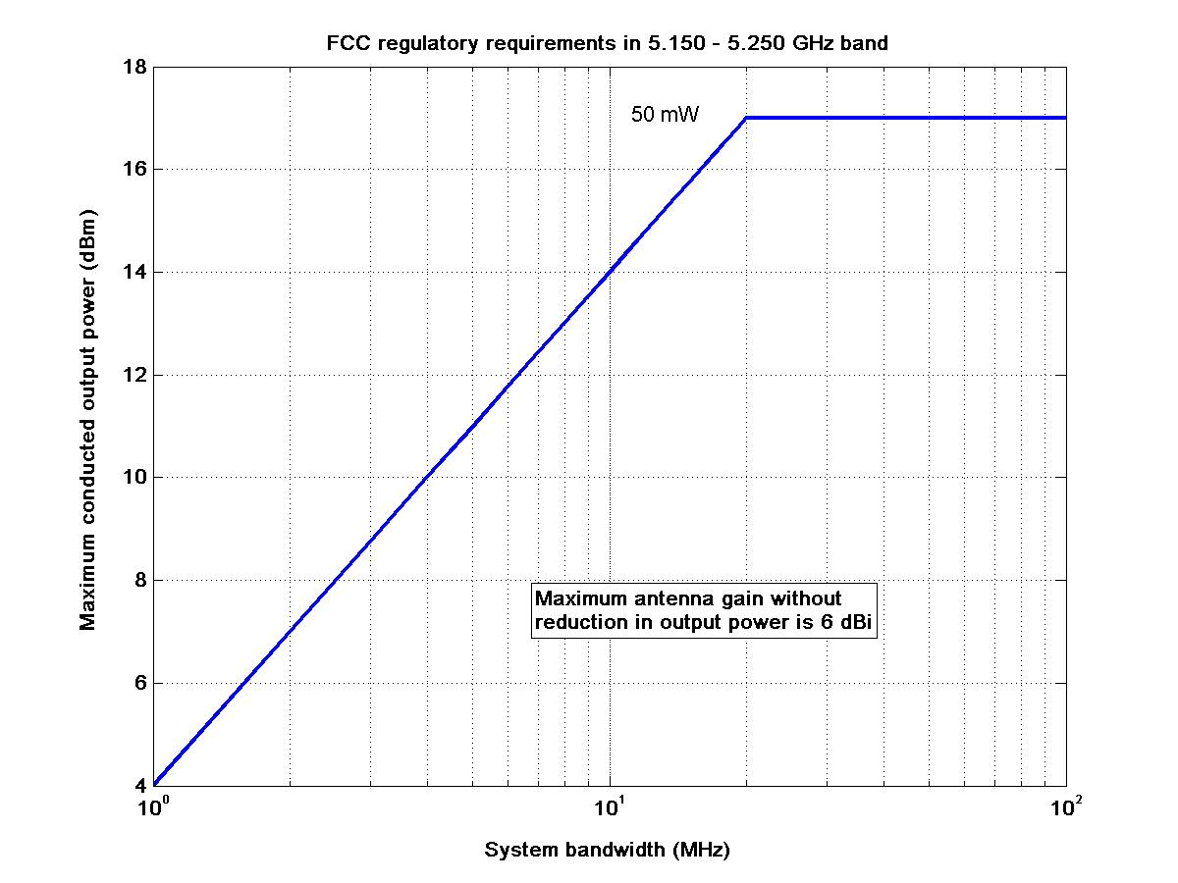
Fig. 1. maximum conducted output power in the 5.150 – 5.250 Ghz band

Antenna gain testing
Antenna testing for smart antenna systems would most likely differ from existing tests. Would individual antenna elements be tested, or the complete array? In a point-to-multipoint system, how can the actual behavior of the antenna be tested? It would be difficult to test the SDMA or adaptive antenna arrays outside normal operation conditions. It is not possible either to rotate the adaptive antenna array to measure its pattern if the users remain fixed.

Beamforming in OFDMA
Single carrier systems
In a single user single carrier system, beamforming with a single beam across the whole frequency band would induce a preferred direction where most of the power would be radiated according to the gain and radiation pattern of the antenna array. With an antenna gain G in dBi and COP in dBW:

Max EIRP = COP + G in dBW

According to regulations, the COP would need to be reduced such that the maximum EIRP does not exceed 4W if the gain exceeds 6 dBi. In this case, the received SNR cannot be increased as compared to transmitting 4W with an omnidirectional antenna (0 dBi gain). In fact, in case of multipath propagation, less power would be received by beamforming with a maximum gain of 6 dBi, since some of the paths that conduct power in the omnidirectional radiation case would not conduct any power with a directional antenna. However, when the signal propagates along preferred directions, beamforming is still more power efficient, since it allows to radiate close to the same power in the preferred radiation with reduced COP.

Multicarrier systems
In a multiuser multicarrier system, multiple users share the bandwidth by using separate subchannels, where a subchannel is composed of several subcarriers. Let us consider the case of adjacent subcarriers, which is the preferred scenario for transmission schemes that rely on closed-loop operation with multiple antennas, requiring channel state information at the transmitter.

Downlink with multiple transmit antennas at the base station

The users that are simultaneously scheduled to receive signals during a downlink OFDMA symbol are likely spatially uncorrelated. The following properties of OFDMA beamforming apply:
- The COP per subcarrier is scaled according to the number of used subcarriers
- Beamforming directions for several users are likely different
- One user is scheduled per subchannel, and uses the same beamformer for all subcarriers in one subchannel.

The total EIRP is the sum of the EIRP per subcarrier. It will be compared to the EIRP of a single omnidirectional antenna. Note that the maximum COP applies as a sum-constraint to the antenna array, not to each element, so that the total COP is the same in the single and multiple antenna cases.

Therefore in an OFDMA system, the total EIRP contributed in a given spatial direction comes from the main beam directed towards desired users on some subchannels, and the sidelobes of the beamformers on other subcarriers. It can be expected that the total over all subcarriers will be much lower than the sum of the maximum EIRP on each subcarrier, which would be the actual situation on every subcarrier with an omnidirectional antenna.

Uplink with multiple transmit antennas at the CPE

On the uplink, a single CPE would typically transmit using only one subchannel in a given OFDMA symbol. Depending on whether the EIRP limit is a maximum EIRP limit or a maximum EIRP density limit, the CPE is allowed to transmit 4W in a subchannel or not. The behavior of transmit beamforming on the uplink would therefore be of a similar nature than the single-user single carrier system. In the current joint proposal, multiple antenna techniques do not rely on uplink transmit beamforming, but rather on uplink receive beamforming at the base station.

Simulation environment
The antenna array used in the simulations is a linear uniform array with 4 omnidirectional elements. The array elements are separated by half the wavelength of the carrier frequency. We consider a system with multiple antennas at the base station and single antenna receivers at the CPEs. We consider an FFT size of 2048, and a certain number of subchannels composed of adjacent subcarriers. All subchannels are of equal length (number of subcarriers). We assume that there are more users than subchannels, and that each active user is scheduled on at most one subchannel per OFDMA symbol. Scheduling of the users is done randomly. The beamforming vector is obtained from the channel vector of the user on one subcarrier in a given subchannel, and it is used for every subcarrier in the subchannel.

We consider 2 channel models:

- Model 1: completely correlated. Each user’s signal propagate along a single direction from the transmitter to the receiver. This direction is completely determined by an angle of arrival (AoA) and an angle of departure (AoD). The channel vector is a perfect array response vector. The AoDs are randomly generated according to a uniform distribution with angle spread 360 degrees.

- Model 2: completely uncorrelated. Each user’s channel vector is composed of i.i.d. complex Gaussian random variables with mean 0 and variance ½ per real dimension.

Beamforming to one user is performed by matched filtering the channel vector. At the transmitter side, this means that the weights applied to the array elements are complex conjugates of the elements of the channel vector. For the channel model 1, this is equivalent to operating a steering array where only phase differences are applied to the array elements. For the channel model 2, different magnitudes and phases are applied to the array elements. In both cases, the beamforming weight vector has unit norm. In both cases, the SNR is maximized. For the channel model 2, the maximization of the SNR comes from maximum ratio combining of the multipaths. We will therefore refer to this type of beamforming as maximum ratio combining transmission (MRC).

Simulation results

Correlated channel model
Beamforming is performed by a steering array that applies difference phases to the array elements. The radiation pattern of the array forming a beam in the directions at -10 degrees or 60 degrees is shown on the right plot of Fig. 2. The left plot shows the radiation pattern obtained by beamforming using maximum ratio combining transmission, when the channel vector is the sum of the array response vectors at -10 and 60 degrees.

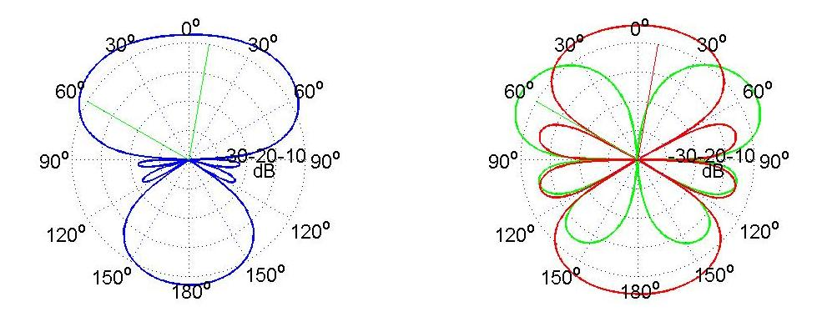
Fig. 2. radiation patterns of the matched-filter array (left) and of the steering array (right)

We now turn to the OFDMA channel. Fig. 3 and 4 show the radiation patterns on each subchannel (blue patterns) as well as the AoDs of the scheduled users (green lines). The COP on each subchannel is scaled by the number of subchannels. The thick red pattern is the overall radiation pattern. The outermost dotted circle represents the limit of 0 dBi. Dotted circles are spaced by 10 dB. The array factor gain of 6 dB can be seen as the maximum of the blue curves.

It appears that the overall pattern has a gain below 6 dBi, compared to the gain of the steering antenna array as if it was used in a single carrier single user system. The actual gain depends on the granularity of the sub-channelization. With this example, we can increase the SNR of the users while meeting the FCC requirements with a margin. Note that this has an impact on the reduction of interference created to primary users and other secondary users.

This provides a demonstration that the use of an antenna array with 6 dBi gain on any given subcarrier results in an effective OFDMA antenna with less than 6 dBi gain.

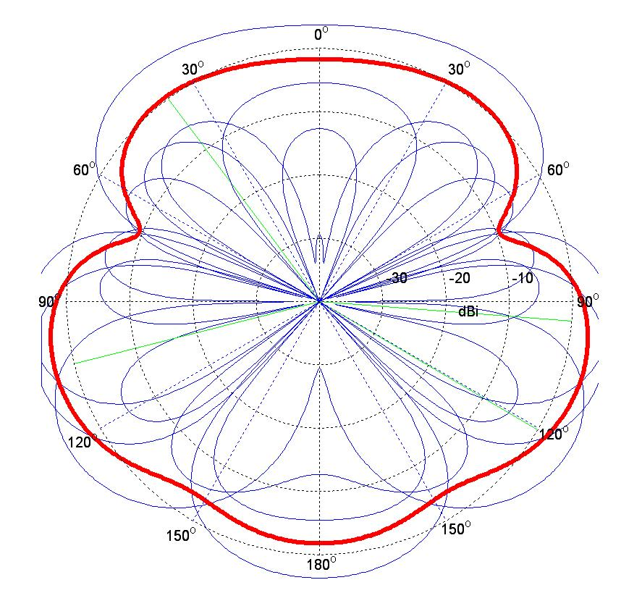
Fig. 3. Example of an OFDMA radiation pattern of the steering array with 4 subchannels

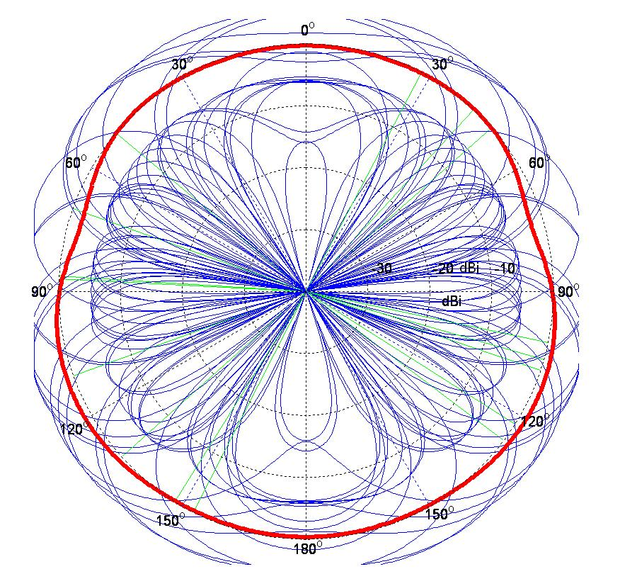
Fig. 4. Example of an OFDMA radiation pattern of the steering array with 16 subchannels

Fig. 5 shows the radiation patterns for random channel realizations with 2, 4, 8, 16, 32 and 64 subchannels.

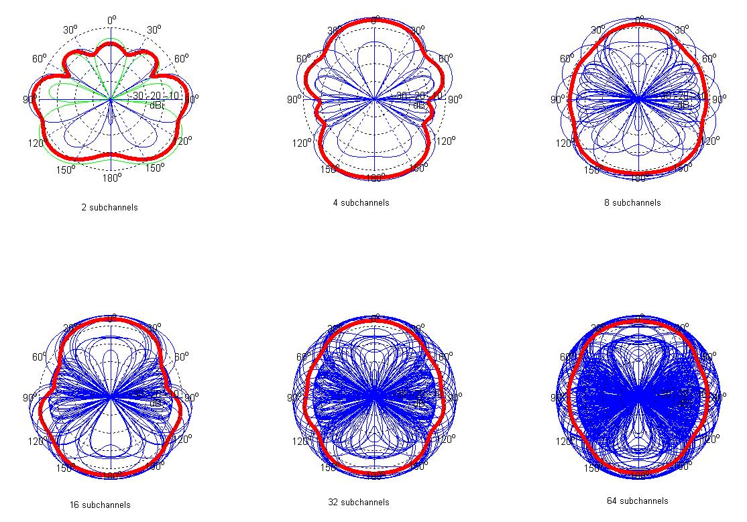

Fig. 5. OFDMA radiation pattern of the steering array with 2, 4, 8, 16, 32 and 64 subchannels
Fig. 6 shows the average effective antenna gain as a function of the number of subchannels. Remember that the typical number of simultaneously serviced users in the WRAN is 12. With 12 subchannels, the mean effective antenna array gain is below 3 dBi.

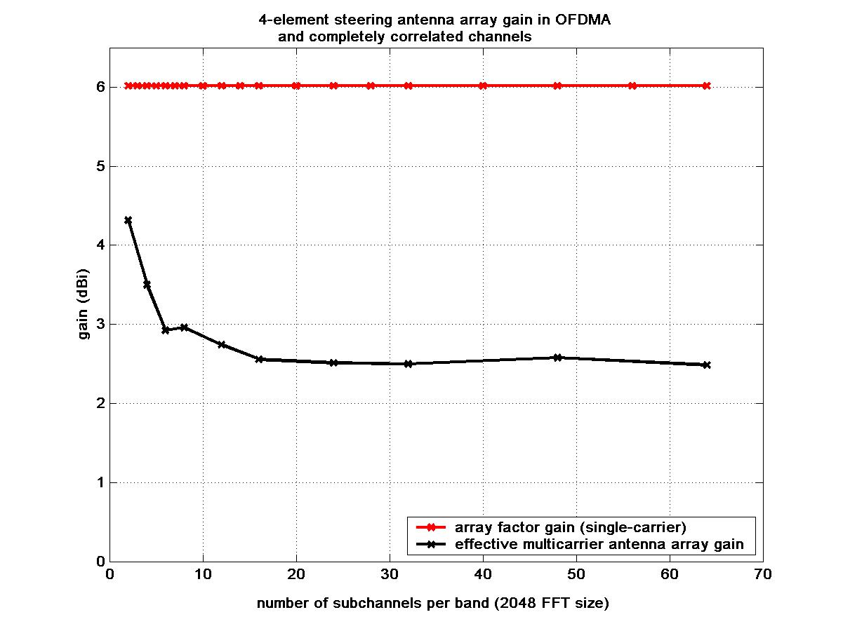

Fig. 6. Average antenna gain with a steering array in OFDMA as a function of the number of subchannels

Uncorrelated channel model
The channel is now uncorrelated Rayleigh fading, and the beamforming is maximum ratio combining transmit beamforming. Fig. 7 shows the average effective antenna gain as a function of the number of subchannels. Due to the non-directional nature of the channel, wider beams are necessary to combine the multipaths, resulting in a reduced array factor gain on any subcarrier. As a result, the mean effective antenna array gain in OFDMA is lower than in the correlated channel model 1.

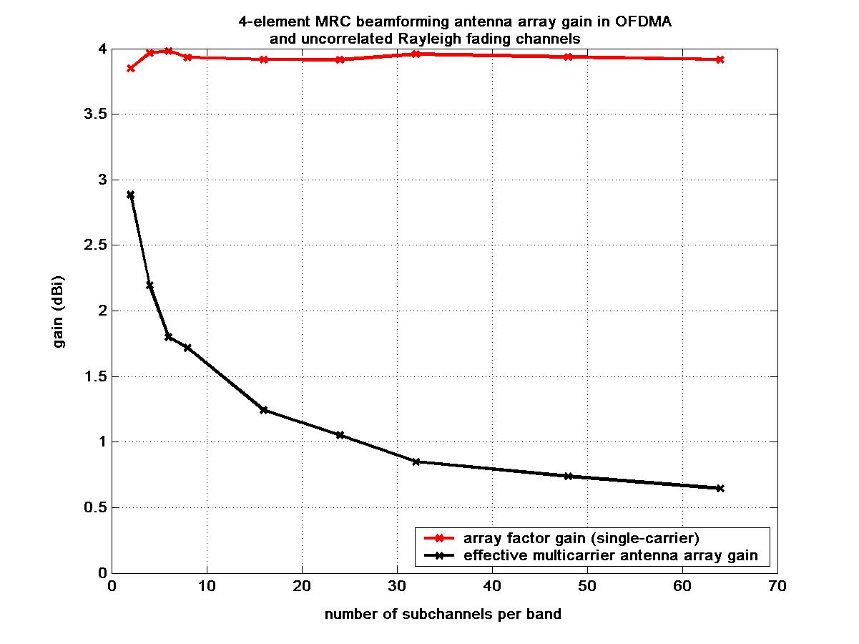
Fig. 7. Average antenna gain with a maximum ratio combining transmit beamforming array in OFDMA as a function of the number of subchannels

Fig. 8 shows the radiation patterns for random channel realizations with 2, 4, 8, 16, 32 and 64 subchannels.

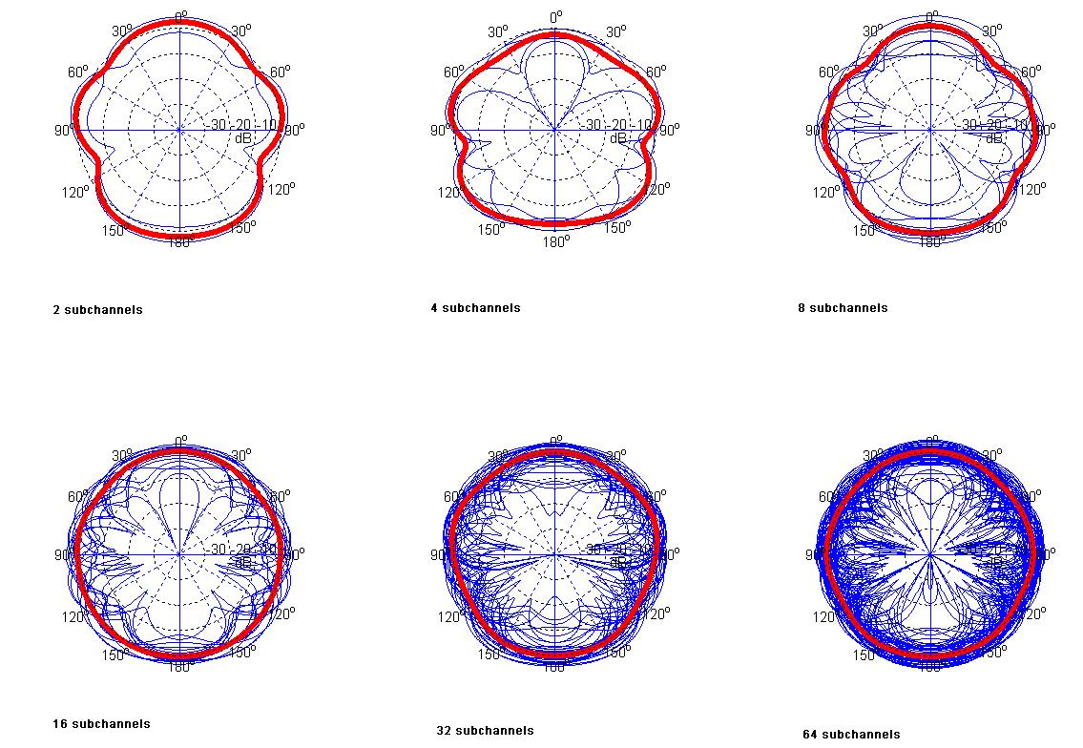
Fig. 8. OFDMA radiation pattern of theMRC beamforming array with 2, 4, 8, 16, 32 and 64 subchannels
Fig. 9 shows the distribution of the effective antenna array gain for different channel models and numbers of subchannels.

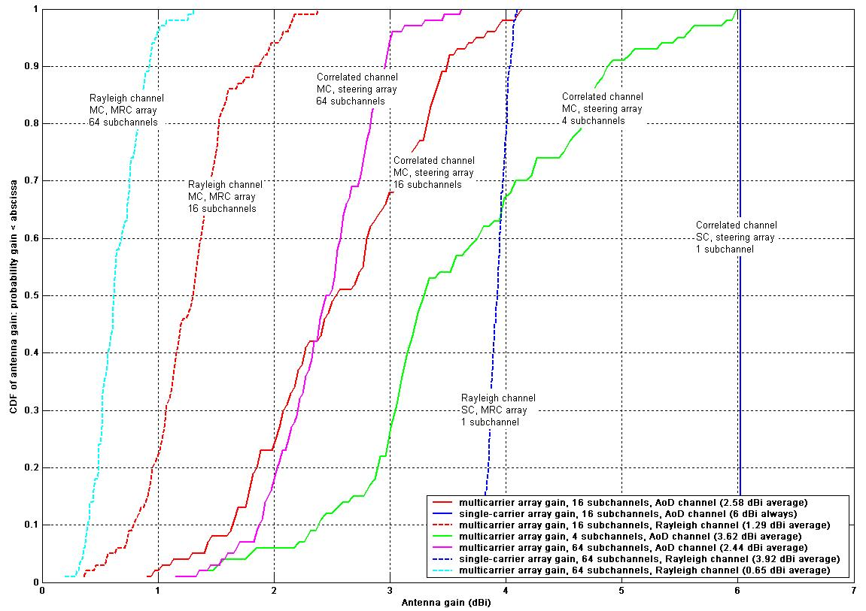

Fig. 9. Cumulative distribution function of the effective antenna array gain in multicarrier (MC) OFDMA and single carrier (SC) systems.

Sectorized cells
If a directional antenna element is used, such as a sector antenna, then the mean effective antenna array gain must not be larger than the difference between 6 dBi and the gain of the antenna element, under the current FCC rules. However, since there is a margin in OFDMA between the array factor gain and the effective antenna array gain, it is still possible to achieve the benefits of beamforming and meet the FCC rules.

Space division multiple access
In SDMA, multiple users share the same subchannel, but the total transmitted power per subchannel is shared among these users. One beam is sent to one user. As a consequence, there will an even larger amount of spatial diversity, comparable to having a larger number of subchannels. Thus it is expected that the mean effective antenna array gain in SDMA will be lower than with beamforming.

Conclusions
- The future FCC rules for smart antennas are not known, and they might be adapted to allow more power per beam.
- Testing procedures of the equipment for operation with smart antennas are not known.
- Definition of system bandwidth over which the rules apply is not clear.
- It is nevertheless possible to use beamforming in OFDMA systems and achieve an effective antenna gain lower than the array factor gain, without decreasing the SNR of the scheduled users.
- However this is not a classic way of looking at smart antennas, which traditionally assumed fixed beams or switched beams.
- Beamforming and SDMA offer multiple advantages in terms of range and coverage increase, power savings, enhanced data rates, and decreased interference to other systems.

References

[1] Functional Requirements for the 802.22 WRAN Standard, doc.: IEEE 802.22-05/0007r46.
[2] Draft Minutes of the Denver Plenary Session of 802.22, March 2006, doc.: IEEE 802.22-06/0043r0.
[3] NPRM, ET Docket No. 03-201, Modification of Parts 2 and 15 of the Commission’s Rules for unlicensed devices and equipment approval, released September 17, 2003.
[4] p802.11n Coexistence Assurance Document, Date: 2005-03-06, doc.: IEEE 802.11-06/0338r03.

