IEEE P802.22
Wireless RANs
Spectrum Sensing Simulation Model
Date: 2006-03-20
Author(s):
Name | Company | Address | Phone | email
Steve Shellhammer | Qualcomm | 5775 Morehouse Drive  San Diego, CA 92121 | (858) 658-1874 | Shellhammer@ieee.org
Victor Tawil | MSTV |  | (202) 966-1956 | vtawil@mstv.org
Gerald Chouinard | Communication Research Centre, Canada | 3701 Carling Ave. Ottawa, Ontario Canada K2H 8S2 | (613) 998-2500 | gerald.chouinard@crc.ca
Max Muterspaugh | Thomson Inc. | 101 W. 103rd St.  Indianapolis, IN 46290 | (317) 587-3711 | Max.muterspaugh@thomson.net
Monisha Ghosh | Philips Research USA | 345 Scarborough Road  Briarcliff Manor, NY 10510 | (914) 945-6415 | monisha.ghosh@philips.com
Abstract
This is a description of a simulation model that can be used to compare various spectrum sensing techniques used to identify occupied and vacant TV channels.
Notice: This document has been prepared to assist IEEE 802.22. It is offered as a basis for discussion and is not binding on the contributing individual(s) or organization(s). The material in this document is subject to change in form and content after further study. The contributor(s) reserve(s) the right to add, amend or withdraw material contained herein.

Release: The contributor grants a free, irrevocable license to the IEEE to incorporate material contained in this contribution, and any modifications thereof, in the creation of an IEEE Standards publication; to copyright in the IEEE’s name any IEEE Standards publication even though it may include portions of this contribution; and at the IEEE’s sole discretion to permit others to reproduce in whole or in part the resulting IEEE Standards publication. The contributor also acknowledges and accepts that this contribution may be made public by IEEE 802.22.

Patent Policy and Procedures: The contributor is familiar with the IEEE 802 Patent Policy and Procedures
<http://standards.ieee.org/guides/bylaws/sb-bylaws.pdf>, including the statement "IEEE standards may include the known use of patent(s), including patent applications, provided the IEEE receives assurance from the patent holder or applicant with respect to patents essential for compliance with both mandatory and optional portions of the standard." Early disclosure to the Working Group of patent information that might be relevant to the standard is essential to reduce the possibility for delays in the development process and increase the likelihood that the draft publication will be approved for publication. Please notify the Chair <Carl R. Stevenson> as early as possible, in written or electronic form, if patented technology (or technology under patent application) might be incorporated into a draft standard being developed within the IEEE 802.22 Working Group. If you have questions, contact the IEEE Patent Committee Administrator at <patcom@ieee.org>.

Revision History
Rev | Date | Description
R0 | February 8, 2006 | Initial document, including general description and one simulation scenario.
R1 | February 14, 2006 | Made some edits based on feedback during conference call. Added a simulation scenario based on receiver operating characteristics (ROC) suggested by Monisha Ghosh. Added Monisha as an author.
R2 | February 22, 2006 | Included simulation of baseline using laboratory signals. In Simulation Scenario 1 (SS1) added text to segment the 50 collected signals into four segments. Added Simulation Scenario 2 (SS2) including calculation of keep-out regions for both operation in the United States and outside the United States.
R3 | February 28, 2006 | Made some modifications based on feedback during the conference call. Some text was added on the collected DTV signals.
R4 | March 6, 2006 | Added Simulation Scenario 3 (SS3) for multisensor detection
R5 | March 20, 2006 | Reworked the calculations for the Keep-out regions in terms of receive power instead of field strength. Fixed some plots.

Table of Contents
1 Introduction 4
2 Acronyms 4
3 DTV Signal Files 5
4 General Description 5
5 Simulation Scenario 1 – Receiver Operating Characteristics 7
5.1 Description of the Two Hypotheses 7
5.2 Description of the Simulation 8
5.3 Steps of the Simulation 9
6 Simulation Scenario 2 – Single WRAN Spectrum Sensor 10
6.1 Base Station Keep-out Region (FCC Rules) 11
6.2 Base Station Keep-out Region (International) 13
6.3 Description of the Simulation 14
7 Simulation Scenario 3 – Multiple WRAN Spectrum Sensors 15
7.1 CPE Keep-out Region 15
7.2 Description of the Simulation 16
8 References 18

List of Figures
Figure 1: DTV Field Strength versus Distance 6
Figure 2: DTV Receive Power versus Distance for a 0dBi RX Antenna 6
Figure 3: Geometry of DTV station and a single WRAN sensor 10
Figure 4: WRAN Base Station Field Strength (United States) 12
Figure 5: WRAN Base station Field Strength (International) 13
Figure 6: WRAN Base station at the Edge of the Keep-out Region 14
Figure 7: WRAN CPE Field Strength 16
Figure 8: Simulation Scenario 3 Geometry 17
Figure 9: Blow-up of WRAN Cell in Simulation Scenario 2 17

List of Tables
Table 1: Two Hypotheses for Simulation Scenario 1 7
Table 2: Two Decisions for Simulation Scenario 1 7
Table 3: Summary of Probabilities for Simulation Scenario 1 8
Table 4: Parameters affecting the probability of misdetection 8
Table 5: Fixed values of probability of false alarm 8
Table 6: Summary of Keep-out Distances 16

Introduction

The purpose of this document is to supply a simulation methodology for evaluating spectrum sensing technologies. This is necessary so as to be able to evaluate spectrum sensing proposals within IEEE 802.22. The functional requirements document [1] states that spectrum sensing is required and many of the proposals to 802.22 have included techniques to performing spectrum sensing. However, there is currently no standard method of evaluating these proposals. The purpose of this document is to provide such an evaluation methodology.

The primary goal of spectrum sensing is to determine which TV channels are occupied by a DTV station and which are vacant. That allows the WRAN to utilize the unused TV channels and avoid using the occupied TV channels and/or reduce the limit on its transmit EIRP if needed as a function of the proximity of TV channels (adjacent and alternate) used for DTV broadcasting and/or Part 74 wireless microphones. Of course, identification of which TV channels are occupied and which are unoccupied is complicated by many factors: noise in the receiver, shadow fading, multipath fading, wireless transmissions other than DTV, transmission of DTV signals in adjunct channels, etc. This document will describe several simulation scenarios that can be used to evaluate spectrum sensing techniques.

Though this document initially discusses spectrum sensing of DTV signals it will be extending to include sensing of Part 74 wireless microphone signals, which may be made easier by the new 802.22.1 Task Group.

There are several different simulation scenarios that need to be considered.

The first simulation scenario involves calculating the receiver operating characteristics (ROC) of the spectrum sensing technique. This simulation gives the probability of misdetection as a function of signal-to-noise ratio (SNR). The simulation also averages over various multipath channel realizations. The results are given for various sensing times.

The second simulation scenario evaluates the spectrum sensing of a single sensor located beyond the DTV protection contour. This simulation takes into consideration not only the signal path loss and multipath but also the effects of shadow fading. This represents a single sensor located at the base station.

The third simulation scenario extends the previous scenario to include the use of multiple spectrum sensors with independent shadow fading. This represents sensor at both the base station and the CPEs.

The fourth simulation scenario involves transmission of a DTV signal (or possibly a WRAN signal) on an adjunct channel, and is intended to determine if the spectrum sensing technique improperly classifies the channel as occupied when it is actually the adjunct channel that is occupied.

The fifth simulation scenario involves transmission of a WRAN signal in the channel being evaluated and is intended to determine if the spectrum sensing technique miss-classifies a channel as occupied by a DTV signal, when in fact it is occupied by another WRAN.

Acronyms

TBD | To be determined
TBR | To be reviewed

DTV Signal Files

As part of the simulation DTV signals must be provided. These signals can be produced by a simulation or can be supplied from laboratory or field measurements. Since collected signal files are available there is no need to produce a DTV transmitter simulator.

For the past decade, the broadcast industry has conducted numerous field measurement programs to evaluate the performance of digital receivers under “real world” conditions. These programs have proven to be valuable in gaining knowledge about a wide range of varying multipath and noise conditions television receivers have to operate under, and have helped DTV consumer manufacturers improve the RF performance of their products.

Attempts by both the broadcast and the TV consumer manufacturer community to develop an adequate and reliable model to represent the diversity of signal conditions encountered in the field have so far not been successful. Both industries had to rely on a “quasi-empirical” model that includes a combination of RF captured DTV signals in the field and selected laboratory tests to approximate the propagation conditions encountered in the television bands [7]. This model could also be useful in evaluating the performance of the various sensing technologies under “real world” conditions in the same fashion as the broadcast industry used to evaluate the performance of DTV receivers.

The RF capture DTV signals proposed for evaluating the various sensing algorithms were recorded in the Washington, D.C urban area and in New York City. The captures includes data collected in different type of environments, such as urban, suburban, residential and rural, and included indoor and outdoor locations. The captures depict conditions where reception was generally difficult. The captures have a maximum length of 25 seconds and were coded into a unique data format chosen for its compatibility with standard RF playback equipment. A more detailed description of the data format is included in the document referenced in [7].

General Description

There is a DTV station which is transmitting at 1 MW (90 dBm) ERP. The DTV antenna height is 500m. The DTV operates at 615 MHz in the UHF band.

Figure 1 shows the field strength versus distance for the F(50,90) curve based on these DTV transmission parameters. The actual field strength will exceed the value specified by the F(50,90) at 50% of the locations for 90% of the time.

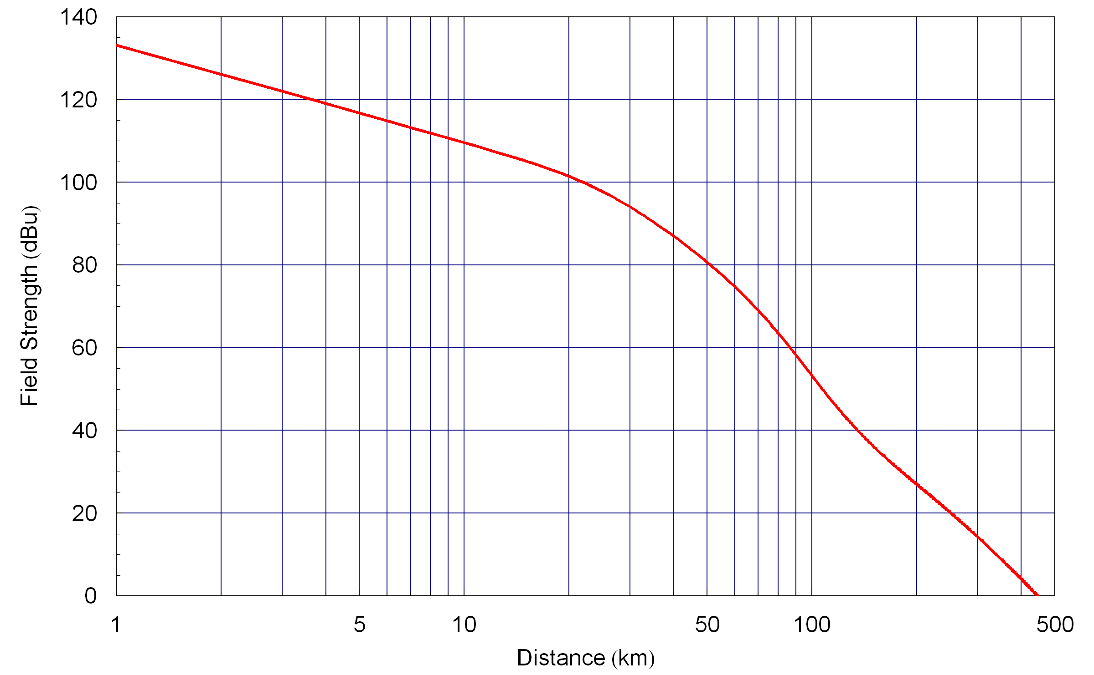
Figure 1: DTV Field Strength versus Distance

The WRAN sensor is assumed to have an isotropic receive antenna gain. The receive power, based on the F(50,90) curve, for such a sensor is plotted in Figure 2. At 615 MHz the conversion from field strength to receive power is -133 dB.

The ITU-R document describes not only the average field strength but the standard deviation of the shadow fading. This shadow fading models variations in field strength based spatial variation.

Each sensor is subject to the typical lognormal shadow fading with a 5.5 dB standard deviation [2].

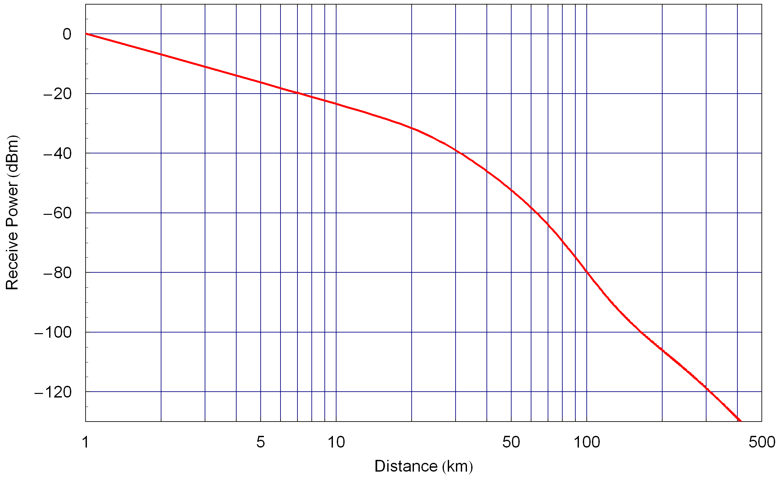
Figure 2: DTV Receive Power versus Distance for a 0dBi RX Antenna

Simulation Scenario 1 – Receiver Operating Characteristics

This simulation scenario involves calculating the receiver operating characteristics (ROC) [4] of a single spectrum sensor.

Description of the Two Hypotheses

The spectrum sensing mechanism is attempting to classify the given TV channel as either occupied by a DTV signal or vacant. This is a binary hypothesis testing problem [5]. The two hypotheses are summarized in Table 1.

H₀ | TV Channel Vacant
H₁ | TV Channel Occupied
Table 1: Two Hypotheses for Simulation Scenario 1

The detector can make one of two decisions. The two possible decisions are listed in Table 2.

D₀ | TV Channel Vacant
D₁ | TV Channel Occupied
Table 2: Two Decisions for Simulation Scenario 1

In this scenario there are two types of errors that the spectrum sensor can have. When the TV channel is vacant (H₀) the spectrum sensor can declare that the channel is occupied. This is referred to as a false alarm. The probability of this event is referred to as the probability of false alarm, $P_{\text{FA}}$ and is the probability of deciding the channel is occupied when in fact it is vacant.

$P_{\text{FA}}=P(D_{1}|H_{0})$ ()

When the TV channel is occupied (H₁) the spectrum sensor can declare that the channel is vacant. This is referred to as a misdetection. The probability of this event is referred to as the probability of misdetection, $P_{\text{MD}}$ and is the probability of deciding the channel is vacant when in fact it is occupied.

$P_{\text{MD}}=P(D_{0}|H_{1})$ ()

One minus the probability of misdetection is the probability of detection, $P_{D}=1−P_{\text{MD}}$. These probabilities are summarised in Table 3.

$$P_{\text{FA}}$$ | Probability of False Alarm
$$P_{\text{MD}}$$ | Probability of Misdetection
$$P_{D}$$ | Probability of Detection
Table 3: Summary of Probabilities for Simulation Scenario 1

Description of the Simulation

There is always a trade-off between having a high probability of detection and having a low probability of false alarm. This trade-off can be made by changing the detection threshold. In order to allow evaluation of various spectrum sensing techniques, we will select the threshold so as to get a fixed probability of false alarm and then calculate the probability of misdetection. The simulation will be run at several fixed values for the probability of false alarm.

There are several other factors that effect sensing performance. These include sensing duration, mutipath channel characteristics and signal to noise ratio.

The simulation estimates the conditional probability of misdetection as a function of these various parameters. These parameters are listed in Table 4. The conditional probability of misdetection is,

$P(D_{0}|H_{1}, P_{\text{FA}} ,T , γ)$ ()

T | Sensing duration
$$P_{\text{FA}}$$ | Probability of false alarm. For a fixed noise level this is determined by the detection threshold
MP | Multipath channel characteristics
$$γ$$ | Signal-to-noise ratio (SNR)
Table 4: Parameters affecting the probability of misdetection

The sensing duration will be varied by the person running the simulation to demonstrate the effect of sensing time on performance.

The noise value will be fixed and the signal power will be varied to accommodate different values of SNR.

The sensing threshold will be set so as to obtain a know probability of false alarm. The fixed values of the probability of false alarm are given in Table 5.

10%
1%
Table 5: Fixed values of probability of false alarm

The simulation will average over all multipath channel realizations by using all 50 (TBR) ATSC signals collected in the field.

The signal-to-noise ratio is varied, by varying the signal power, and then for each value of SNR the probability of misdetection is calculated.

Details of each step are given in the following section.

Steps of the Simulation

Step 1
Set the sensing duration. The duration should be varied over the range of values required by the spectrum sensing detector.

Step 2
Set the noise value. This is fixed and is based on the bandwidth of the collected ATSC DTV waveforms. The BW = TBD MHz. The noise figure and other losses are combined into a total noise figure of 11 dB. The noise power is given by,

$P_{N}=−\text{174}+\text{10}\text{Log}(\text{BW})+\text{11}=−\text{163}+\text{10}\text{Log}(\text{BW}) \text{dBm}$ ()

The noise should be scaled so that the power of the in-band additive white Gaussian noise (AWGN) is set according to Equation (4).

Step 3
Set the detector threshold so as to obtain a false alarm rate for a value listed in Table 5. On subsequent simulations select another value from Table 5.

Step 4
Select a value of signal-to-noise. This needs to be varied over a range of values which result in probability of misdetection near one to below ${\text{10}}^{−5}$(TBR). The SNR in dB is then,

$γ=P_{S}−P_{N} \text{dB}$ ()

Step 5

Baseline Signals
First we will run the simulations using laboratory signals. Segment the two laboratory signals into four sections resulting in eight signals. Then scale the signal so that the SNR is the value specified in the previous step.

For each of these eight signals generate many realizations of the noise. Combine the signal and the noise and process the combination with the detector. The number of simulations that needs to be run varies based on the SNR. It is reasonable to run sufficient simulations so as to obtain at least 100 misdetections. This typically gives a reasonable estimate of the probability of misdetection. The person running the simulation may choose to run more simulation if they like.

Let $N_{0}$be the number of times the signal was not detected (i.e. $D_{0}$). Then the conditional probability of misdetection is,

$P(D_{0}|H_{1}, P_{\text{FA}} ,T , γ)=\frac{N_{0}}{N}$ ()

The result of this simulation will be a family of curves giving the probability of misdetection versus SNR, parameterized by probability of false alarm and sensing time. There curves will be reused in subsequent simulations.

Field Collected Signals
Repeat the same process that was done for the baseline signals using the 50 signals collected from the field. First segment the signals into four segments resulting in 200 signals. Then scale the signal so that the SNR is the value specified in the previous step. Run the simulations as was done for the baseline signals and calculate the probability of misdetection.

Simulation Scenario 2 – Single WRAN Spectrum Sensor

This simulation scenario involves only a single WRAN sensor located outside the DTV protection contour. This intended to model sensing at the WRAN the base station. Subsequent simulation scenarios will involve multiple sensors.

Figure 3 illustrates the geometry of the single WRAN sensor detecting a DTV transmission. The distance d is the separation between the DTV transmitter and the WRAN sensor.

Figure 3: Geometry of DTV station and a single WRAN sensor

The DTV transmitter radiating at 90 dBm ERP with an antenna height of 500 m operating at 615 MHz, as described in Section 4.

The location of the WRAN sensor is based on the keep-out region. For US operation the calculation of the size of the keep-out region is given in Section 6.1. With the assumption that higher power would be permitted outside the US the calculation of the size of the keep-out region for internatonal operation is given in Section 6.2.

Base Station Keep-out Region (FCC Rules)

The DTV Protection contour, also referred to as the noise-limited contour, is located where the field strength is 41 dBu using the F(50,90) propagation curve. In this scenario this curve occurs at 132 km from the DTV transmitter.

According to the FCC NPRM for DTV the D/U ratio is 23 dB. This assumes the interferer (i.e. the undesired signal) is another DTV transmitter. For now we will assume this D/U ratio also applies when the interferer is a WRAN signal.

The D/U ratio is measured in terms of receive power and not field strength. We will use the conversion formula between field strength and receive power to convert the D/U constraint into a limit on the undesired field strength. From that field strength we can determine how far away the WRAN transmitter must be.

The D/U ratio is defined to be,

$$D/U=P_{D}−P_{U}$$

Where $P_{D}$is the receive power of the desired signal in dB and $P_{U}$is the receive power of the undesired signal in dB. The desired receive power is dependent on the field strength, the antenna gain and a constant.

$$P_{D}={\text{FS}}_{D}+G_{D}+c$$

Where ${\text{FS}}_{D}$ is the field strength of the desired signal in dB and $G_{D}$ is the antenna gain of the receive antenna is the direction of the DTV transmitter. Similarly the undesired receive signal power is given by,

$$P_{U}={\text{FS}}_{U}+G_{U}+c$$

We can now related the D/U ratio to the undesired field strength,

$$D/U=P_{D}−P_{U}=({\text{FS}}_{D}+G_{D}+c)−({\text{FS}}_{U}+G_{U}+c)$$

$$D/U={\text{FS}}_{D}−{\text{FS}}_{U}+G_{D}−G_{U}$$

Thus we have,

$${\text{FS}}_{U}={\text{FS}}_{D}−D/U+G_{D}−G_{U}$$

Notice that the term $(G_{D}−G_{U})$is the DTV receive antenna front-to-back ratio. The desired F(50,90) field strength at this point is 41 dBu, which is the signal that needs to be protected. The D/U ratio must exceed 23 dB. If we use a front-to-back ratio of 14 dB for the DTV receive antenna [1] of we get the following limit on the undesired field strength at the DTV receiver.

$${\text{FS}}_{U}≤\text{41}−\text{23}+\text{14}=\text{32} \text{dBu}$$

Given this upper limit on the undesired field strength we can put limits on the distance between the WRAN transmitter and the DTV receiver.

We use the F(50,10) propagation curve to obtain the value at which the field strength exceeds that value 50% of the locations and 10% of the time. Since we need to ensure we meet the D/U not only in 50% of the locations, but in the majority of the locations, we need to consider effects of shadow fading. To ensure high confidence we will require that the F(50,90) value be three standard deviations below the limit of 32 dBu. With a lognormal shadowing standard deviation of 5.5 dB, this requires that the F(50,90) value be less than $\text{32}−3×5\text{.}5=\text{15}\text{.}5 \text{dBu}\text{.}$ (TBR).

In the United States the transmission of a WRAN station is limited to 36 dBm EIRP. Intending to use the ITU propagation curves we convert from EIRP to ERP giving,

$$\text{ERP}=\text{EIRP}−2\text{.}2=\text{33}\text{.}8 \text{dBm}$$

If we apply this to the F(50,10), where the actual field strength only exceeds this value 10% of the time, then we get the following field strength versus distance curve. We assume the 75 m (TBR) antenna height, which is representative of a base station antenna height. Figure 4 shows the field strength of the undesired signals (WRAN) at the DTV receiver located at the DTV protection contour.

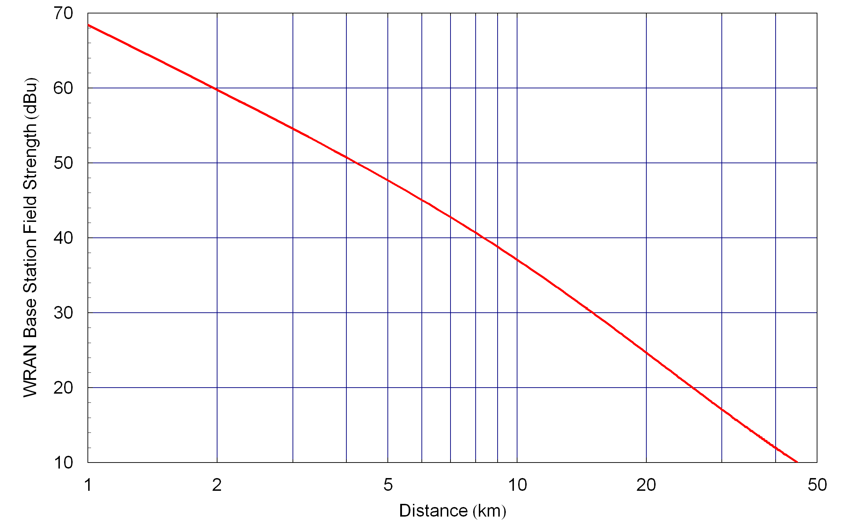

Figure 4: WRAN Base Station Field Strength (United States)

The distance at which the field strength of the undesired signal reaches 15.5 dBu is approximately 33 km. Adding 33 km to the DTV protection contour of 132 km we obtain a keep-out region of 165 km from the DTV transmitter.

At the edge of the keep-out region, 165 km from the DTV transmitter, the DTV field strength using the F(50,90) curve, is 33 dBu. And the receive power assuming isotropic sensing antenna is -100 dBm.

Base Station Keep-out Region (International)

Outside the United States the WRAN transmit power may be higher. This analysis is based on the assumption that higher power would be allowed outside the US. If such higher power is not permitted then the analysis in the previous section can be applied.

The WRAN base station transmit power used in the WRAN Reference Model Spreadsheet [6] was 100 Watts (50 dBm).

The 23 dB D/U ratio used by in the FCC documents may not be the proper value to be used for international operation. This method can still be applied, but the actual D/U value would need to be modified.

Based on the analysis in the previous section the undesired field strength based on the F(50,10) propagation curve should be less than $\text{15}\text{.}5 \text{dBu}\text{.}$ (TBR).

We assume a WRAN base station is transmitting at 50 dBm EIRP. Intending to use the ITU propagation curves we convert from EIRP to ERP giving,

$$\text{ERP}=\text{EIRP}−2\text{.}2=\text{47}\text{.}8 \text{dBm}$$

If we apply this to the F(50,10), where the actual field strength only exceeds this value 10% of the time, then we get the following field strength versus distance curve. We assume the 75 m (TBR) antenna height, which is representative of a base station antenna height. Figure 5 shows the field strength of the undesired signals (WRAN) at the DTV receiver located at the DTV protection contour.

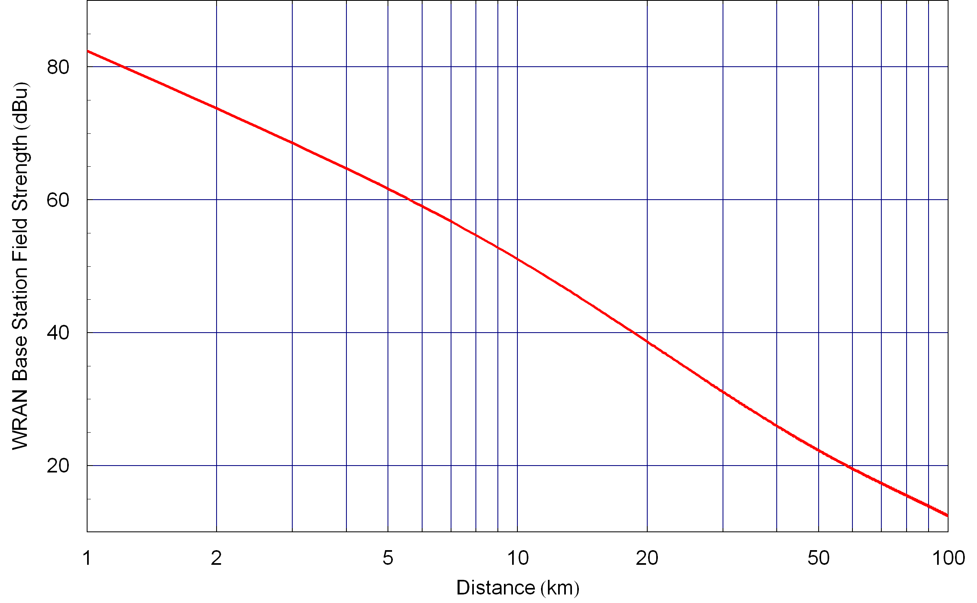
Figure 5: WRAN Base station Field Strength (International)

The distance at which the field strength of the undesired signal reaches 15.5 dBu is approximately 80 km. Adding 80 km to the DTV protection contour of 132 km we obtain a keep-out region of 212 km around the DTV transmitter.

At the edge of the keep-out region, 212 km from the DTV transmitter, the DTV field strength using the F(50,90) curve, is 25 dBu. And the receive power assuming isotropic sensing antenna is -108 dBm.

Description of the Simulation

The objective of this simulation is to calculate the probability of misdetection for the geometry described in Figure 3 based on the propagation model in [2], including both mean path loss and shadow fading.

The simulation relies on the receiver operating characteristics curves from Simulation Scenario 1 in Section 5.

Figure 6: WRAN Base station at the Edge of the Keep-out Region

Figure 6 illustrates the WRAN base station at the edge of the keep-out region. The simulation is intended to demonstrate that the spectrum sensing operated effectively at that location, and of course it would work more effectively closer to the DTV transmitter.

In the United States the mean signal power, using F(50,90) curve, is -100 dBm at a distance $d=\text{165} \text{km}$from the DTV transmitter. The signal power fluctuates about the mean value according to a lognormal distribution. Hence the signal-to-ratio is a lognormal random variable [3]. This means that the SNR in dB is a Normal random variable,

$f_{γ}(γ)=\frac{1}{\sqrt{2{\text{πσ}}^{2}}}\text{exp}\left(\frac{−(γ−m)^{2}}{2σ^{2}}\right)$ ()

With mean and standard deviation given by,

$\begin{matrix}m=−\text{100} \text{dB} \\ σ=5\text{.}5 \text{dB}\end{matrix}$ ()

The probability of misdetection including the effects of shadow fading can be obtained by integrating the conditional probability of misdetection over the density function for the shadow fading,

$P(D_{0}|H_{1}, P_{\text{FA}} ,T)=\int{P(D_{0}|H_{1}, P_{\text{FA}} ,T , γ)f_{γ}(γ)dγ}$ ()

This integration can easily be computed numerically.

After completing the simulation for the distance for the edge of the keep-out zone in the United States the simulation should be repeated for the distance for the edge of the keep-out zone for International Operation.

Outside the United States the mean signal power, using F(50,90) curve, is –108 dBm at a distance $d=\text{212} \text{km}$from the DTV transmitter. The signal power fluctuates about the mean value according to a lognormal distribution. Hence the signal-to-ratio is a lognormal random variable [3]. For this simulation the following mean and standard deviation for the receive power,

$\begin{matrix}m=−\text{108} \text{dB} \\ σ=5\text{.}5 \text{dB}\end{matrix}$ ()

Simulation Scenario 3 – Multiple WRAN Spectrum Sensors

This simulation scenario consists of multiple WRAN spectrum sensors, located at both the base station and the CPEs. Section XX describes the keep-out area for the CPEs, since up till now we have only calculated the keep-out are for the base station. Section YY describes the simulation.

CPE Keep-out Region

This analysis is similar to what was done for the base station keep-out region. The primary differences are the antenna height and that the CPE is assumed to have a directional antenna pointing toward the base station and away from the DTV receiver.

Bases on the previous analysis the undesired field strength using the F(50,90) curve should be less than 15.5 dBu.

The CPE is assumed to be transmitting at 36 dBm EIRP with a directional antenna pointed toward the base station and away from the DTV receiver. If we assume a back-to-front ratio of 14 dB then the EIRP in the direction of the DTV receiver is,

$$\text{EIRP}=\text{36}−\text{14}=\text{22} \text{dBm}$$

Intending to use the ITU propagation curves we convert from EIRP to ERP giving,

$$\text{ERP}=\text{EIRP}−2\text{.}2=\text{19}\text{.}8 \text{dBm}$$

If we apply this to the F(50,10), where the actual field strength only exceeds this value 10% of the time, then we get the following field strength versus distance curve. We assume the 10 m CPE antenna height [1]. Figure 7 shows the field strength of the undesired signals (WRAN) at the DTV receiver located at the DTV protection contour.

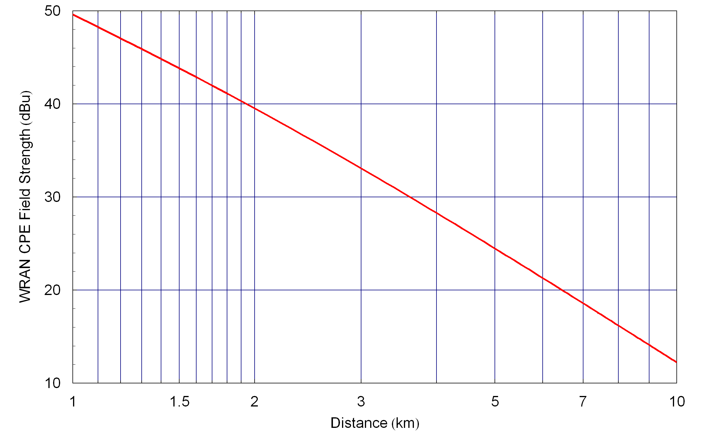
Figure 7: WRAN CPE Field Strength

The distance at which the field strength of the undesired signal reaches 15.5 dBu is approximately 8 km. Adding 8 km to the DTV protection contour of 132 km we obtain a keep-out region of 140 km around the DTV transmitter.

Given that the CPE on the opposite side of the WRAN cell has higher EIRP in the direction of the DTV receiver it is worth calculating the distance that CPE must be from the DTV receiver. Its EIRP is 36 dBm, which corresponds to a distance of 18 km from the DTV receiver. Typically the cell diameter is larger than 10 km and CPEs that are not at the edge of the cell use transmit power control, so even though they are somewhat closer then transmit at a lower power. So the basic rule of keeping the CPE at least 8 km from the DTV receiver seems to work.

Description of the Simulation

This simulation assumes there are multiple spectrum sensors; one located at the base station and the others located at the CPEs. As a reminder some of the keep-out distances are summarized in Table 6.

DTV Protection Contour | 132 km
CPE Keep-out Region | 140 km
Base station Keep-out Region | 165 km
Table 6: Summary of Keep-out Distances

Assuming a base station transmit power of 36 dBm EIRP and antenna height of 75 km the typical WRAN cell size is 10 km (TBR). Figure 8 shows the geometry of this simulation scenario. It shows a WRAN base station located $d=\text{155}\text{km}$from the DTV transmitter and a WRAN cell of 10 km. Figure 9 shows a blow-up of the WRAN cell showing the base station and several CPEs within the cell.

Figure 8: Simulation Scenario 3 Geometry

Figure 9: Blow-up of WRAN Cell in Simulation Scenario 2

The following description describes the steps of the simulation.

Step 1
Adjust the detection algorithm that uses the measurements from $N=\text{10}$ CPEs (TBR) so that the false alarm rate is 1% (TBR).

Step 2
Place the base station $d=\text{155}\text{km}$from the DTV transmitter. The WRAN cell is represented as a circle of radius $r=\text{10}\text{km}$(TBR) cantered at the base station.

Step 3
For each simulation randomly place $N=\text{10}$ CPEs in the WRAN cell. For each CPE calculate the distance between the CPE and the DTV transmitter. Then for the base station and the CPEs calculate the mean DTV signal power using F(50,90) curve, assuming a DTV transmitter at 1 MW (90 dBm) ERP, with an antenna height is 500m, operating at 615 MHz in the UHF band. Then calculate the actual receiver power of the DTV signal at the base station and each of the CPEs, assuming lognormal shadowing with a standard deviation of $σ=5\text{.}5 \text{dB}$.

Step 5
For various different sensing times (to be determined by the proposer) calculate the global probability of misdetection. This global decision is made at the base station and utilizes information sent to be by all the CPEs.

References

- Functional Requirements for IEEE 802.22 WRAN Standard, 802.22/05-0007r46, September 2005
- Method for point-to-area prediction for terrestrial services in the frequency range 30 MHz to 3000 MHz, ITU-R P.1546-1, October 11, 2005
- A. Papoulis, Probability, Random Variables, and Stochastic Processes, Third Edition, McGraw Hill, 1991
- H. L. Van Trees, Detection, Estimation, and Modulation Theory: Part 1, Wiley, 1968
- S. Kay, Fundamentals of Statistical Signal Processing: Detection Theory, Prentice Hall, 1998
- Gerald Chouinard, WRAN Reference Model Spreadsheet, IEEE 802.22-04-0002r12
- ATSC A/74 Recommended Practice Guideline Document entitled: “ATSC Recommended Practice: Receiver Performance guidelines”, Sections 4.5.2 & 4.5.3

