IEEE P802.22
Wireless RANs
Spectrum Sensing Simulation Model
Date: 2006-02-08
Author(s):
Name | Company | Address | Phone | email
Steve Shellhammer | Qualcomm | 5775 Morehouse Drive  San Diego, CA 92121 | (858) 658-1874 | Shellhammer@ieee.org
Victor Tawil | MSTV |  | (202) 966-1956 | vtawil@mstv.org
Gerald Chouinard | Communication Research Centre, Canada | 3701 Carling Ave. Ottawa, Ontario Canada K2H 8S2 | (613) 998-2500 | gerald.chouinard@crc.ca
Max Muterspaugh | Thomson Inc. | 101 W. 103rd St.  Indianapolis, IN 46290 | (317) 587-3711 | Max.muterspaugh@thomson.net
Abstract
This is a description of a simulation model that can be used to compare various spectrum sensing techniques used to identify occupied and vacant TV channels.
Notice: This document has been prepared to assist IEEE 802.22. It is offered as a basis for discussion and is not binding on the contributing individual(s) or organization(s). The material in this document is subject to change in form and content after further study. The contributor(s) reserve(s) the right to add, amend or withdraw material contained herein.

Release: The contributor grants a free, irrevocable license to the IEEE to incorporate material contained in this contribution, and any modifications thereof, in the creation of an IEEE Standards publication; to copyright in the IEEE’s name any IEEE Standards publication even though it may include portions of this contribution; and at the IEEE’s sole discretion to permit others to reproduce in whole or in part the resulting IEEE Standards publication. The contributor also acknowledges and accepts that this contribution may be made public by IEEE 802.22.

Patent Policy and Procedures: The contributor is familiar with the IEEE 802 Patent Policy and Procedures
<http://standards.ieee.org/guides/bylaws/sb-bylaws.pdf>, including the statement "IEEE standards may include the known use of patent(s), including patent applications, provided the IEEE receives assurance from the patent holder or applicant with respect to patents essential for compliance with both mandatory and optional portions of the standard." Early disclosure to the Working Group of patent information that might be relevant to the standard is essential to reduce the possibility for delays in the development process and increase the likelihood that the draft publication will be approved for publication. Please notify the Chair <Carl R. Stevenson> as early as possible, in written or electronic form, if patented technology (or technology under patent application) might be incorporated into a draft standard being developed within the IEEE 802.22 Working Group. If you have questions, contact the IEEE Patent Committee Administrator at <patcom@ieee.org>.

Introduction

The purpose of this document is to supply a simulation methodology for evaluating spectrum sensing technologies. This is necessary so as to be able to evaluate spectrum sensing proposals within IEEE 802.22. The functional requirements document [1] states that spectrum sensing is required and many of the proposals to 802.22 have included techniques to performing spectrum sensing. However, there is currently no standard method of evaluating these proposals. The purpose of this document is to provide such an evaluation methodology.

The primary goal of spectrum sensing is to determine which TV channels are occupied by a DTV station and which are vacant. That allows the WRAN to utilize the unused TV channels and avoid using the occupied TV channels and/or reduce the limit on its transmit EIRP if needed as a function of the proximity of TV channels (adjacent and alternate) used for DTV broadcasting and/or Part 74 wireless microphones. Of course, identification of which TV channels are occupied and which are unoccupied is complicated by many factors: noise in the receiver, shadow fading, multipath fading, wireless transmissions other than DTV, transmission of DTV signals in adjunct channels, etc. This document will describe several simulation scenarios that can be used to evaluate spectrum sensing techniques.

Though this document initially discusses spectrum sensing of DTV signals it will be extending to include sensing of Part 74 wireless microphone signals, which may be made easier by the new 802.22.1 Task Group.

There are several different simulation scenarios that need to be considered. The document will begin with the case of determining if a given signal TV channel is occupied with a DTV transmission. In this scenario, there will be a signal spectrum sensor, located at the base station. In this first case, the following will be included in the model: receiver noise, shadow fading, and multipath fading.

The second simulation scenario will extend the first simulation scenario to include multiple spectrum sensors, located at the base station and at each of the CPEs. In this simulation the same DTV signal is received, but the shadow and multipath fading is different at each sensor. Since the decision is ultimately made at the base station, this simulation assumes that some information is transmitted from the CPEs to the base station.

The third simulation scenario involves transmission of a WRAN signal in the channel being evaluated and is intended to determine if the spectrum sensing technique miss-classifies a channel as occupied by a DTV signal, when in fact it is occupied by another WRAN.

The fourth simulation scenario involves transmission of a DTV signal (or possibly a WRAN signal) on an adjunct channel, and is intended to determine if the spectrum sensing technique improperly classifies the channel as occupied when it is actually the adjunct channel that is occupied.

Section X describes xxx …

Acronyms

TBD | To be determined
TBR | To be reviewed

DTV Signal Files

As part of the simulation DTV signals must be provided. These signals can be produced by a simulation or can be supplied from laboratory or field measurements. Since collected signal files are available there is no need to produce a DTV transmitter simulator.

Here we put in a description of the files provided by Victor.

General Description

There is a DTV station which is transmitting at 1 MW (90 dBm) ERP. The DTV antenna height is 500m. The DTV operates at 615 MHz in the UHF band. Based on ITU-R propagation models [2] this results in a Grade B contour of approximately 86 km. Figure 1 shows the average field strength versus distance for the F(50,50) curve based on these DTV transmission parameters.

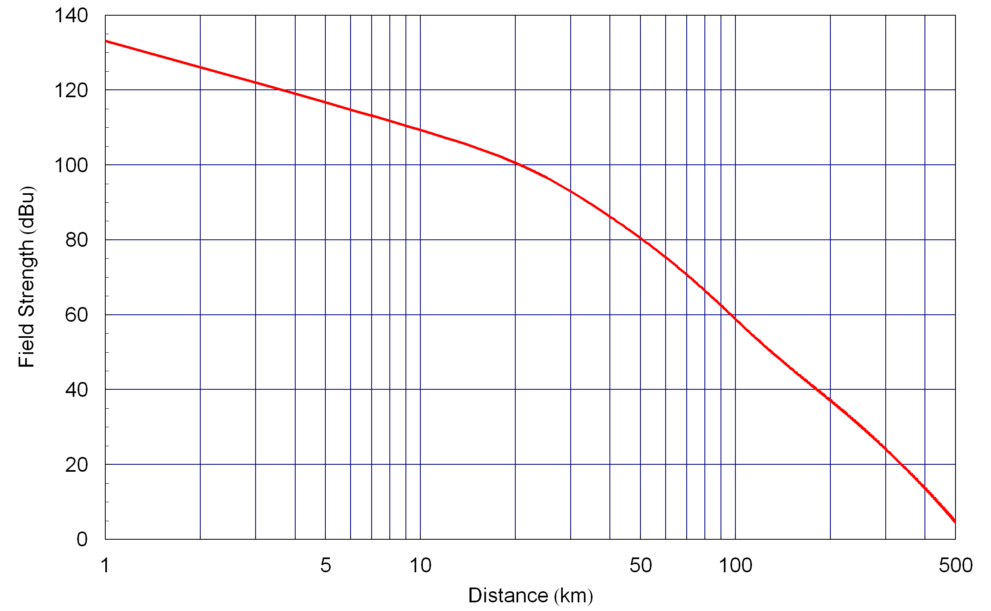
Figure 1: DTV Field Strength versus Distance

The WRAN sensor is located well outside the Grade B contour to avoid harmful interference. The WRAN sensor has a 0 dBi receive antenna gain. The receive power for such a sensor is plotted in Figure 2. The requirements document [1] states that the spectrum sensor must be able to detect the DTV signal at a receive signal power of –116 dBm. This corresponds to distance of approximately 366 km.

The ITU-R document describes not only the mean path loss but the standard deviation of the shadow fading. Each sensor should be subject to the typical lognormal shadow fading with a 5.5 dB standard deviation [2].

Let us describe some of this mathematically. Let $P_{\text{RX}}$ be the receive power (in dB) and the average receive power be indicated by ${\bar{P}}_{\text{RX}}$ be the average of mean received power (in dB). The average receive power is given by the ITU-R recommended practice. Then the receive power (in dB) is the sum of the average power and the shadow fading which is a zero-mean normal random variable [3] with standard deviation of 5.5 dB.

$P_{\text{RX}}={\bar{P}}_{\text{RX}}+F_{S} \text{dBm}$ ()

NOTE: We need to include some multipath fading model.

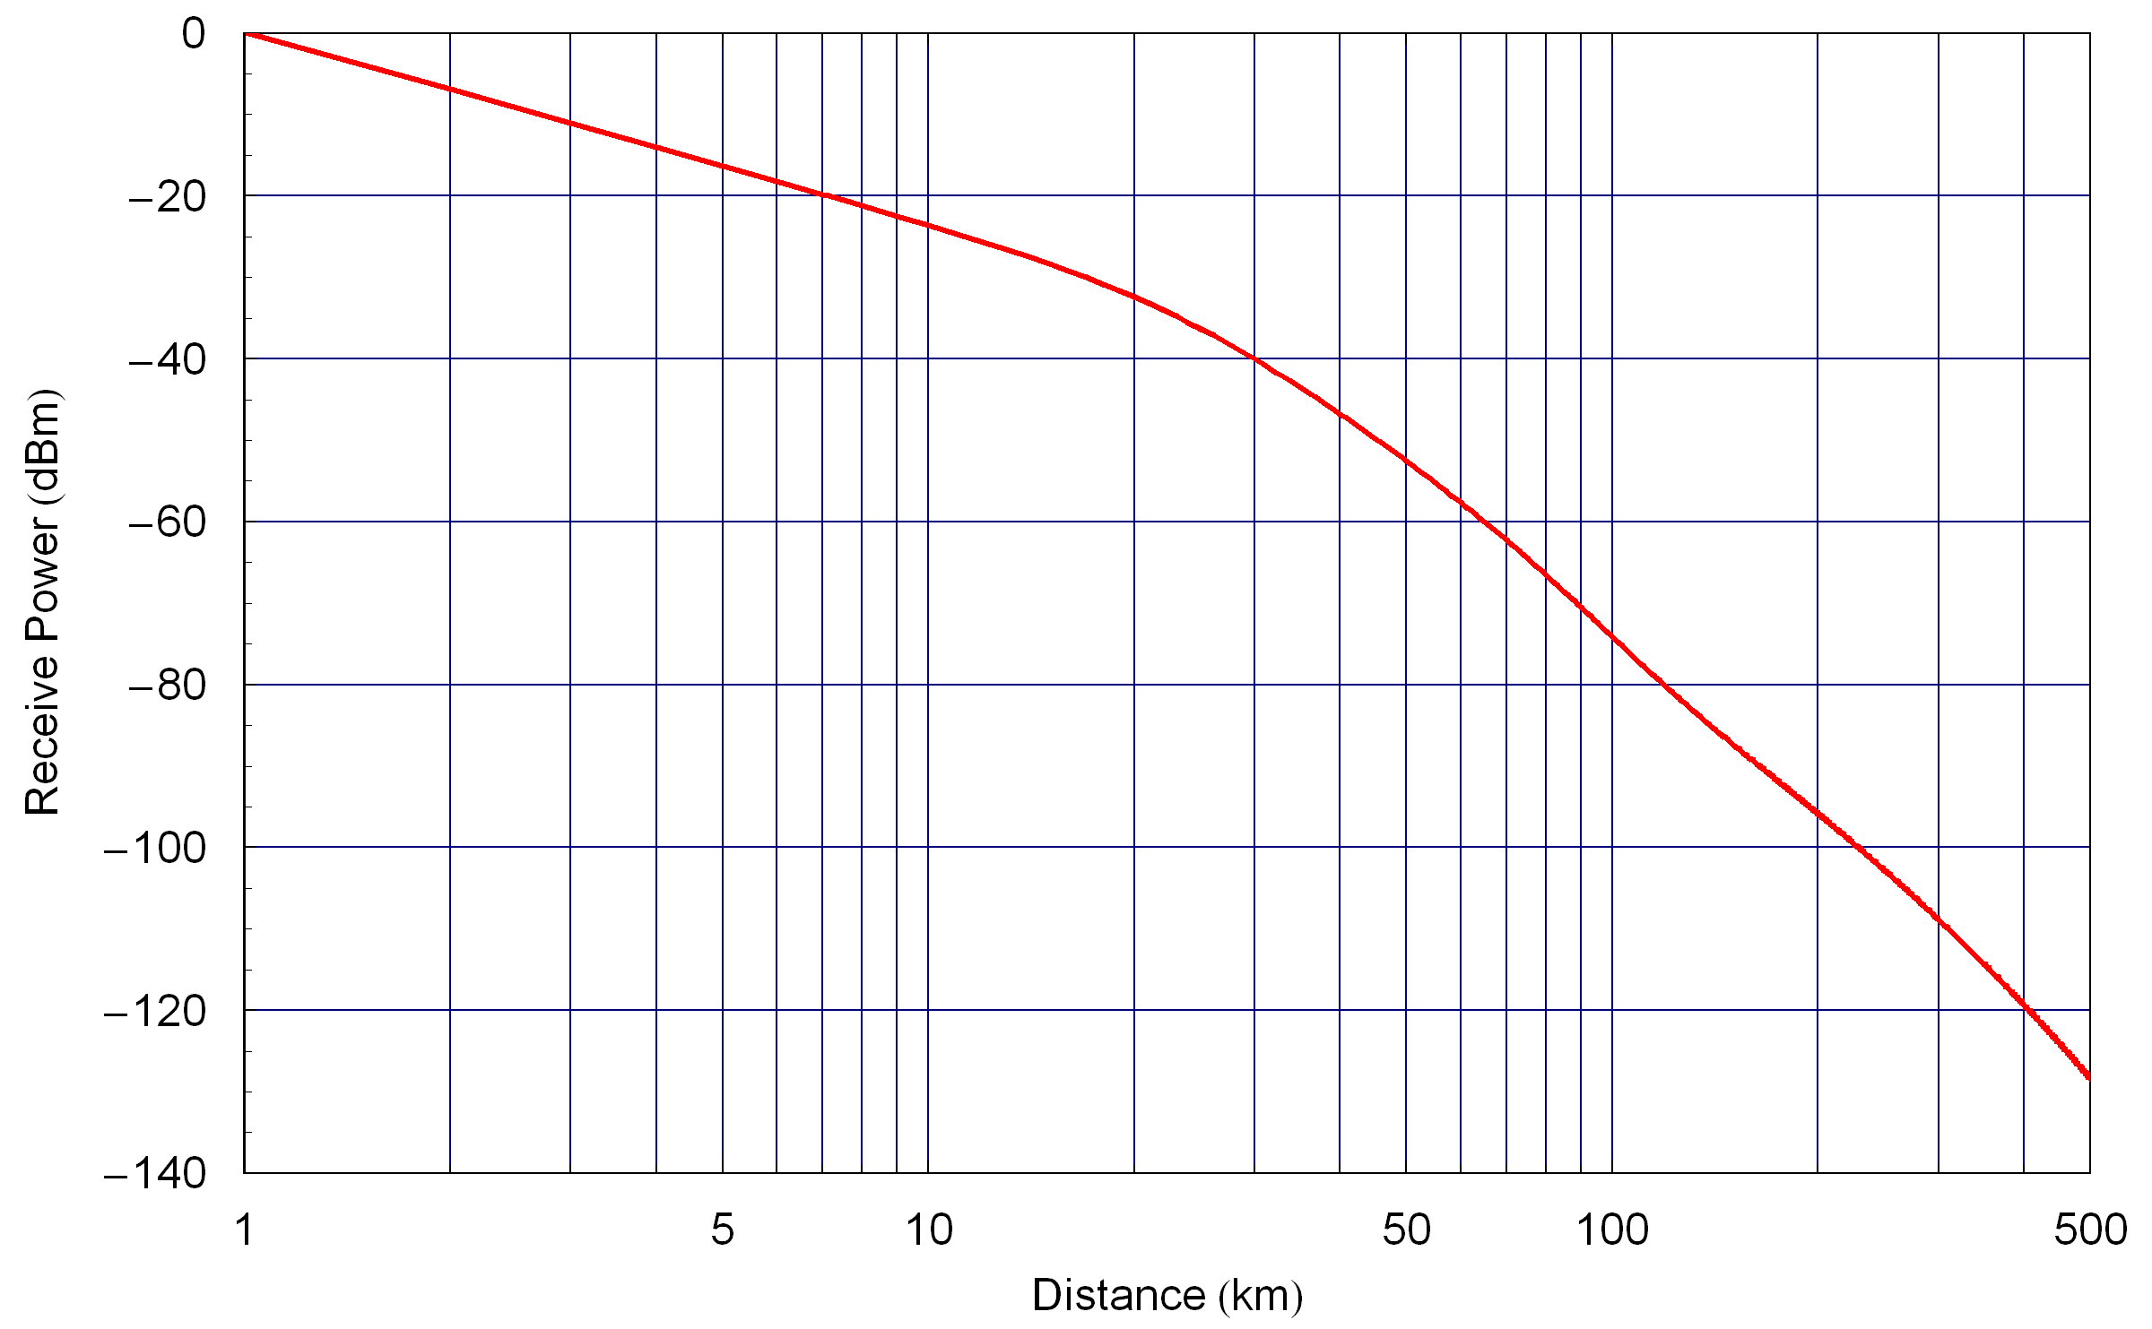
Figure 2: DTV Receive Power versus Distance for a 0dBi RX Antenna

Simulation Scenario 1 – Single WRAN Spectrum Sensor

This simulation scenario involves only a single WRAN sensor. Subsequent simulation scenarios will involve multiple sensors.

Description of the Two Hypothesises

The spectrum sensing mechanism is attempting to classify the given TV channel as either occupied by a DTV signal or vacant. This is a binary hypothesis testing problem [4]. The two hypotheses are summarized in Table 1.

H₀ | TV Channel Vacant
H₁ | TV Channel Occupied
Table 1: Two Hypothesises for Simulation Scenario 1

In this scenario there are two types of errors that the spectrum sensor can have. When the TV channel is vacant (H₀) the spectrum sensor can declare that the channel is occupied. This is referred to as a false alarm. The probability of this event is referred to as the probability of false alarm, $P_{\text{FA}}$. When the TV channel is occupied (H₁) the spectrum sensor can declare that the channel is vacant. This is referred to as a misdetection. The probability of this event is referred to as the probability of misdetection, $P_{\text{MD}}$. One minus the probability of misdetection is the probability of detection, $P_{D}=1−P_{\text{MD}}$. These probabilities are summarised in Table 2.

$$P_{\text{FA}}$$ | Probability of False Alarm
$$P_{\text{MD}}$$ | Probability of Misdetection
$$P_{D}$$ | Probability of Detection
Table 2: Summary of Probabilities for Simulation Scenario 1

Figure 3 illustrates the topology of the single WRAN sensor detecting a DTV transmission. The distance d is the separation between the DTV transmitter and the WRAN sensor.

Figure 3: Topology of DTV station and a single WRAN sensor

The DTV transmitter radiating at 90 dBm ERP with an antenna height of 500 m operating at 615 MHz, as described in the previous section. The WRAN sensor is located 366 km (TBR) from the DTV transmitter. The simulation should use signal XYZ (to be described by Victor).

The signal should be scaled so that the average signal power is set according to Equation (1).

Assuming that there is no other wireless system in operation nearby, the noise is based on thermal additive white Gaussian noise (AWGN). The receiver bandwidth is 6 MHz and a receiver noise figure of 10 dB (TBR) is assumed. This value of receiver noise figure is sufficient to include not only the noise figure and also several dB of cable losses, etc.

The noise power is then given by,

$P_{N}=−\text{174}+\text{10}\text{Log}(6×{\text{10}}^{6})+\text{10}=−\text{96}\text{.}\text{2185} \text{dBm}$ ()

The noise should be scaled so that the power of the in-band additive white Gaussian noise (AWGN) is set according to Equation (2).
The signal to noise ratio is then just the ratio of the signal power to the noise power.

Description of How to Run Simulation and What to Report

There is always a trade-off between probability of having a high probability of detection and having a low probability of false alarm. This trade-off can be made by changing the detection threshold. To allow evaluation of the spectrum sensing technique, the threshold should be set so that the false alarm probability is equal to 1% (TBR). This should be validated by running the simulation several thousand times with no DTV signal present just with noise present (H₀).

Once the detection threshold has been set so that the false alarm rate is 1%, the simulation with the signal present (H₁) should be run. They should be run for different value of sensing time, so as to demonstrate the reduction of probability of misdetection with increased sensing time.

For a given value of sensing time, the simulation with both signal and noise (H₁) should be run for 100 (TBR) different values of the shadow fading. For each simulation the receive signal power shall be calculated using Equation (1). For each realization of the channel fading random variable, the simulation should be run for 100 (TBR) different realizations of the receiver noise, with the in-band noise power set according to Equation (2). Hence, there are 10,000 total simulations. The probability of misdetection is the number of times the spectrum sensor declared that the channel was occupied while in fact it was vacant, divided by the number of simulation that were run.

The probability of misdetection should then be plotted as a function of sensing time. Values of $P_{\text{MD}}$ should be below ${\text{10}}^{−4}$(TBR).

Gerald’s Comments
[In the case of the single detector at the base station, the probability of detection will be close to the 5.5 dB standard deviation of the propagation model. This is probably why a positive margin was included in setting the sensing threshold. If we assume that the 41 dB(uV/m) level is to be provided for 90% of the locations at the noise-limited contour. A detector able to sense (41 - 23.9)= 17.1 dB(uV/m) at the DTV noise limited should have a probability of missing the presence of the DTV signal (i.e., false-negative or misdetection) of only 0.0007% according to the lognormal model and σ= 5.5 dB. 1% misdetection would correspond to a margin of 12.8 dB.]

[In the case of distributed sensing, the CPE’s should report the actual sensed RF level to the base station (say, in half dB over a range of 128 dB, 8bits) rather than the one-bit (H0/H1) information unless the threshold is set at 41 dB(uV/m) otherwise the protection would include the sensing margin since the standard deviation of the sensed level will tend to 0 with the increase in the number of CPEs reporting their sensing.]

References

- Functional Requirements for IEEE 802.22 WRAN Standard, 802.22/05-0007r46, September 2005
- Method for point-to-area prediction for terrestrial services in the frequency range 30 MHz to 3000 MHz, ITU-R P.1546-1, October 11, 2005
- A. Papoulis, Probability, Random Variables, and Stochastic Processes, Third Edition, McGraw Hill, 1991
- S. Kay, Fundamentals of Statistical Signal Processing: Detection Theory, Prentice Hall, 1998

