IEEE P802.22
Wireless RANs
Updated MIMO Proposal for IEEE 802.22 WRAN Systems
Date: 2006-01-11
Author(s):
Name | Company | Address | Phone | email
David Mazzarese | Samsung Electronics Co. Ltd. | Korea | +82 10 3279 5210 | d.mazzarese@samsung.com
Baowei Ji | Samsung Telecommunications America | US | +1 972-761-7167 | Baowei.ji@samsung.com
Abstract
Multiple antennas can offer for coverage extension, link reliability and throughput enhancement. This contribution presents an analysis of the use of multiple antennas in the 802.22 WRAN, and envisioned solutions to reach these benefits. The use of closed-loop multiuser MIMO, or downlink space division multiple access (SDMA) in particular in advocated.
Notice: This document has been prepared to assist IEEE 802.22. It is offered as a basis for discussion and is not binding on the contributing individual(s) or organization(s). The material in this document is subject to change in form and content after further study. The contributor(s) reserve(s) the right to add, amend or withdraw material contained herein.

Release: The contributor grants a free, irrevocable license to the IEEE to incorporate material contained in this contribution, and any modifications thereof, in the creation of an IEEE Standards publication; to copyright in the IEEE’s name any IEEE Standards publication even though it may include portions of this contribution; and at the IEEE’s sole discretion to permit others to reproduce in whole or in part the resulting IEEE Standards publication. The contributor also acknowledges and accepts that this contribution may be made public by IEEE 802.22.

Patent Policy and Procedures: The contributor is familiar with the IEEE 802 Patent Policy and Procedures
<http://standards.ieee.org/guides/bylaws/sb-bylaws.pdf>, including the statement "IEEE standards may include the known use of patent(s), including patent applications, provided the IEEE receives assurance from the patent holder or applicant with respect to patents essential for compliance with both mandatory and optional portions of the standard." Early disclosure to the Working Group of patent information that might be relevant to the standard is essential to reduce the possibility for delays in the development process and increase the likelihood that the draft publication will be approved for publication. Please notify the Chair <Carl R. Stevenson> as early as possible, in written or electronic form, if patented technology (or technology under patent application) might be incorporated into a draft standard being developed within the IEEE 802.22 Working Group. If you have questions, contact the IEEE Patent Committee Administrator at <patcom@ieee.org>.

Co-Author(s):
Name | Company | Address | Phone | email
Myung-Sun Song | ETRI | Korea | +82-42-860-5046 | mssong@etri.re.kr

Relevant sections of the Functional Requirements Document [1]

- 5. WRAN System Model/Requirements
- 5.3. Service Capacity
- 5.6.2. Flexible Asymmetry
- 8.10.1. Peak Data Rates

WRAN scenario
The WRAN targets wide area networks in the TV bands. Although these bands enjoy very favorable propagation conditions, signal levels at the edge of the coverage area of a cell will be very low. Multiple antenna techniques based on diversity provide enhancement of the link reliability by reducing the BER, and multiple antenna techniques based on beamforming provide SNR enhancement, resulting in decreased BER or increased coverage. It is noteworthy to note that the coverage of the WRAN cell will be highly variable depending on the TV band used by the WRAN. In order to provide a more uniform cell size in all TV bands, multiple antenna techniques are a natural candidate.

Since CPEs are fixed and the environment is only slowly changing due to mobile objects, it is very easy in the WRAN to acquire perfect channel state information about the channel fading states at the base station and at the CPEs. Moreover, if TDD is the adopted solution, the forward link can be estimated from the reverse link, and vice-versa. Therefore, beamforming at the receiver and at the transmitter is possible, providing the maximum benefits of multiple antenna channels. Moreover, advanced multiuser MIMO spatial multiplexing techniques are also allowed in these channel conditions, allowing to reach close to the maximum spectral efficiencies of multiple antenna multiuser broadcast and multiple access channels, using only simple linear precoding and beamforming techniques. The impact of these techniques on the OFDMA frame structure and MAC protocols and messages is known, and several such solutions are available, which can easily be adapted to the final 802.22 standard technical specifications.

The benefits of the proposed multiple antenna techniques are summarized below:

- Link reliability improvement (diversity or beamforming).

- Range extension (diversity or beamforming).

- Uniformization of WRAN cell coverage across the TV spectrum due to the scalability with frequency. MIMO becomes more feasible as the frequency increases due to the smaller antenna spacings required. This occurs while the range decreases due to increased path loss. MIMO can compensate for that effect and provide a more uniform coverage in any TV band. Remember that the same coverage area should be serviced in any available TV band given the customer base and spectrum opportunities.

- Multiple access (closed-loop multiuser MIMO) by Space Division Multiple Access (SDMA), which results in data rate improvement in good SNR conditions. CPEs located close to the base station can be served more rapidly, leaving more time slots to serve cell edge users, in fact increasing the range and coverage of the base station. For delay-sensitive applications, this type of multiuser spatial multiplexing decreases the average delay per user.

- In general, better spectral efficiency is achieved with MIMO.

- Possible interference cancellation or nulling of interferers, as well as creating nulls towards incumbents (e.g. Part 74 devices) to protect them while maintaining a connection with the WRAN base station.

- Enhanced coexistence by reducing required over-the-air time allowed by higher peak rates.

- Possible soft-combining at one CPE at the edge of the cell of the signals received from multiple base station.

Feasibility discussion
It has been argued that multiple antenna techniques are not feasible at the frequencies of TV bands, from 54 MHz to 862 MHz. We argue that we can use 1 to 5 antenna elements at these frequencies. They can be installed at the CPEs as well as at the base station. They are simple thus cheap solutions, and do not require professional installation. Adaptive algorithms to control the beam patterns are implemented in software in the baseband.

In some scenarios, it is likely that the terrain around a terminal will be rather flat with only in a few obstacles, leading to poor scattering. In this case, fading processes at antenna elements separated even by a wavelength will likely be correlated. In this case multiple antennas can be used for beamforming. This situation is more likely to occur with highly positioned base station antennas. In this case there will be no multiplexing gain. However whenever possible in uncorrelated scenarios, spatial multiplexing should be used for the advantages described earlier. It is expected that in some rural areas, and in particularly in suburban areas and urban areas, there will be no doubt that the full benefits of MIMO could be expected.

There are also some discussion about the use of multiple antennas and OFDMA with respect to the maximum allowed EIRP. It is possible have 4W EIRP for each antenna in MIMO case, like MIMO in WiFi? Could it be possible that the definition of EIRP in WRAN would not allow that? In this case, does 4W total EIRP restrict our beamforming proposal? From past experience, FCC only tests the omni directional case even though the antenna array intends to perform beamforming or some other similar functions. Moreover, it is understood that MIMO increases the spectral efficiency without increase of transmitted power. The total transmitted power does not depend on the number of antenna elements in the transmitting array. Furthermore, when a beam if formed towards the base station, it is obviously directed away from TV receivers in operating TV bands that are located some distance away within the TV noise-protected contour. From the base station transmission perspective, it is not a problem since the base station will typically be located very far away from the noise-protected contour of the TV operation, thus its radiated power will be insignificant in TV receivers with or without transmitter beamforming.

Physical antenna design
When we deal with signals whose frequencies are in the UHF and VHF bands, the size of the antennas has to be bigger than those used for wireless communications in the GHz range. By proper design and placement, the inconvenience of the big antenna can be greatly reduced. The Yagi-Uda antenna used for TV reception is large because the longest reflector is lambda long and the lambda is determined by the center of the frequency range the antenna is to operate. We propose a smart antenna that could be smaller than a Yagi-Uda antenna.

The proposed antenna structure is depicted in Fig. SEC8. The overall stride of the array will not exceed 1.5 m. The antenna array is composed of small dipoles with non-uniform spacings. Depending on the frequency of operation, one or several of these elements will form an array. Each one of the elements in a given array will experience independent fading processes at the given frequency of operation.

It is sometimes argued with increasing frequency, the length of the dipoles will largely exceed a half-wavelength, which could dramatically change the radiation pattern of the dipole. We argue that the dipole length is typically between and . If we choose the length to be 30 cm, it would cover the frequency range from 100 MHz to 1 GHz. As long as the above constraint is met, the radiation pattern will not change significantly.

(typically
or
)
1.5 m
0.25 m
A1
A3
A2
A4
A5
Fig. SEC8. Physical antenna array concept.

The selection of antenna array elements is performed as follows:

Frequency of operation | Elements in the array | Min element spacing () | Max element spacing ()
Below 100 MHz | A1 | N/A | N/A
100 MHz | A1, A5
200 MHz | A1, A3, A5
300 MHz | A1, A2, A4, A5
Above 600 MHz | A1, A2, A3, A4, A5 | and
Table SEC3. Selection of antenna elements with the operation frequency.

Note that even in the low frequency ranges, multiple dipoles could be used, although they would see correlated fading processes, in order to obtain a desirable radiation pattern.

Coverage extension
We assume the following propagation model for now:
- Tolerable median path loss of 119 dB [4]
- BS to CPE channel
- BS 100 m above ground
- CPE 10 m above ground
- Rural area
Thus L_hata=-17.67 and mu_hata=11.80, and mu_excess=6. Define , the frequency f in Hz and the distance d in meters. Assume that the path loss exponent is 2 up to 500 m, then beyond. The path loss is given by
Assume receive beamforming (maximal ratio combining) at the CPE, with a base station transmit power of 36 dBm. The following achievable range extension is shown in Table SEC4, with a single antenna at the base station, and an antenna array at the CPE.

 | Number of antenna elements (M) at CPE | MRC Gain (dB)  10*log10(M) | Coverage extension  (km)
Below 100 MHz  (ex 54 MHz) | 1 | 0 | 0 km  (207 km)
100 MHz | 2 | 3 dB | 31 km  (125 km → 256 km)
200 MHz | 3 | 4.8 dB | 29 km  (71 km →100 km)
300 MHz | 4 | 6 dB | 28 km  (51 km → 79 km)
600 MHz | 5 | 7 dB | 20 km  (30 km → 50 km)
Above 600 MHz  (ex 862 MHz) | 5 | 7 dB | 16 km < x < 20 km  (27 km → 43 km)
Table SEC4. Coverage extension with multiple antennas at the CPE.

Note that we cannot meet the 33 km of minimum coverage of the functional requirements above 509 MHz without multiple antennas, with the above assumption of tolerable median path loss and the path loss model used here, which is in fact more optimistic than using the same path loss exponent closer to 500 m from the base station.

Link reliability enhancement
It is well know that diversity techniques increase the slope of the BER curve vs. SNR. The BER is given as , where d is the diversity order equal to the product of the number of transmit by the number of receive antennas. Diversity can be easily achieved using spatial diversity allowed by multiple antennas. It is achieved by combining, for example maximum-ratio combining at the receiver, effectively performing receiver beamforming using a channel estimate. Transmitter beamforming can also be performed using a channel estimate, which is possible to obtain easily in a slow-varying channel and a TDD scheme. Without channel state information at the transmitter, transmit diversity can be implemented, with or without combined channel coding. Combined transmit diversity with channel coding is not mandatory, since error-control coding can already be relied upon, and since it is designed to cope with a worst channel that does not rely on transmit or receive diversity in the lowest frequencies of operation.

Link throughput enhancement
Transmit and receive diversity and beamforming can also be used for limited throughput enhancement. We propose to use more advanced techniques based on MIMO, i.e. relying on multiple antennas at the transmitter and at the receiver.

Single-user techniques are now very well-known, and allow to achieve very large spectral efficiency gains. Some techniques such as spatial multiplexing (also called V-BLAST) perform well but could require prohibitive computational complexity at the receiver side to implement multiuser detection techniques for demultiplexing. On the other hand, when channel state information is available at both the transmitter and the receiver, linear pre-processing and post-processing can be used with very low complexity and achieve even higher spectral efficiencies.

However, multiuser MIMO techniques can offer even higher spectral efficiencies also with very low complexity. We propose to use such a technique, which also relies on simple linear pre-processing and post-processing, and achieves a spectral efficiency close to the sum-capacity of the MIMO broadcast channel. This scheme is called closed-loop multiuser MIMO (CL MU MIMO). It allows to transmit independent data streams to multiple users simultaneously in a non-interfering way, by the coordinated use of multiple beams at the base station and at the CPEs. It can be used for the downlink and for the uplink, although the downlink is the preferred solution, and simplest in terms of synchronization. Fig. SEC9 illustrates the spectral efficiencies achievable with several MIMO techniques.

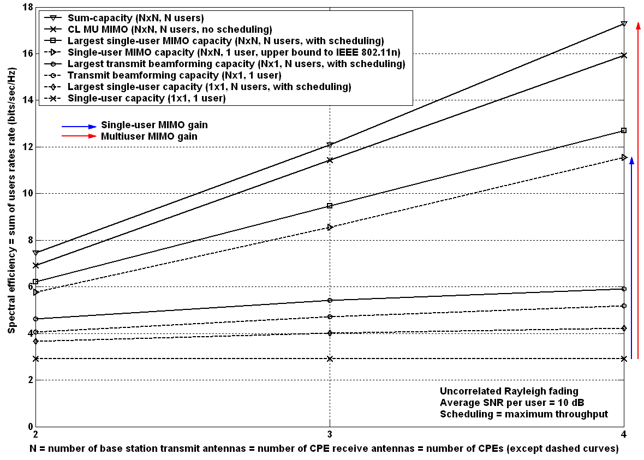
Fig. SEC9. Spectral efficiency enhancement by MIMO techniques at the link level.

Note using MIMO limits the throughput to the bottom curve, or the one above if scheduling is employed with a maximum-throughput strategy. The use of multiple antennas at one side of the transmission link only already allows to double the throughput with 4 antenna elements. The use of N antennas at both sides of the link allows to multiply the throughput by N. The use of multiuser transmission allows to gain more than another 4 bits/sec/Hz with 4 antenna elements at the base station and at each CPE. All the curves shown above rely solely on linear processing, except for the sum-capacity curve.

We propose to use only linear-complexity processing schemes that rely on channel knowledge at the transmitter and at the receivers:
- Beamforming (transmitter and/or receiver)
- Single-user SVD
- CL MU MIMO

The pilots and control signals that support CL MU MIMO do not require additional resources as compared to single-user MIMO techniques. However, due to the variable number of antenna elements, these resources should be made adaptive. The MAP information to support CL MU MIMO requires minimal changes. At this point, we can only list the requirements for the operation of CL MU MIMO, without specifying the actual structure of the supporting MAC, which will depend on other choices for the MAC. However, the design of the supporting MAC is quite flexible for CL MU MIMO.

Supporting MAC resources and functions:
- Downlink pilots for the estimation of the downlink channel matrix at the CPEs (one per base station transmit antenna).
- Uplink pilots for estimation of the uplink channel matrices at the base station (one per CPE transmit antenna), and for estimation of the downlink channel matrices by calibration in TDD operation.
- The same pilots are used for downlink channel sounding to enable CL MU MIMO.
- MAP fields for the operation of multiple users on the same sub-channel (time-frequency resource in OFDMA).
- MAC fields to inform CPEs to use CL MU MIMO mode (or other MIMO modes).

Performance evaluation
Using the multipath power-delay profiles of [5], the coherence time and bandwidth are shown to be large with respect to the typical WRAN frame (and super-frame) duration and to the subcarrier spacing, respectively. This justifies our assumption that the sub-channel matrices can be known at the transmitter with high reliability, as shown in Fig. SEC10 and SEC11.

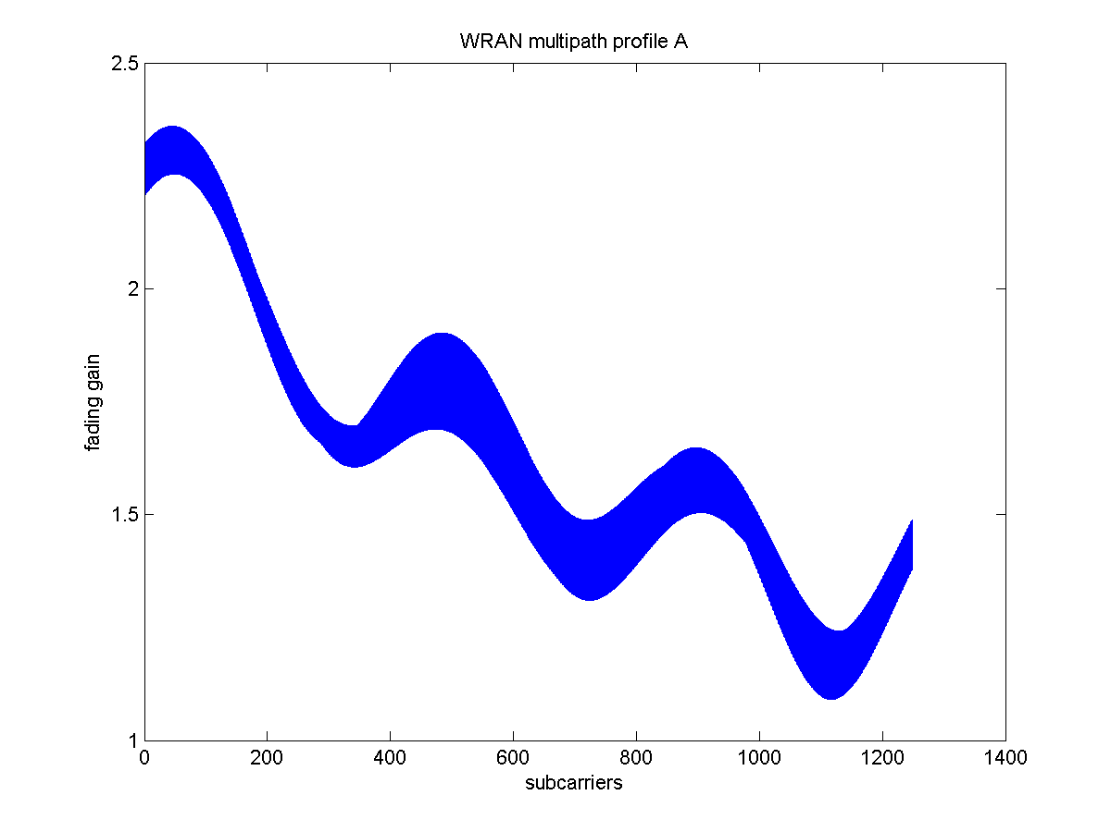
Fig. SEC10. Fading gains across subcarriers (vertical stripe shows time variations across 3400 OFDM symbols = 100 frames)
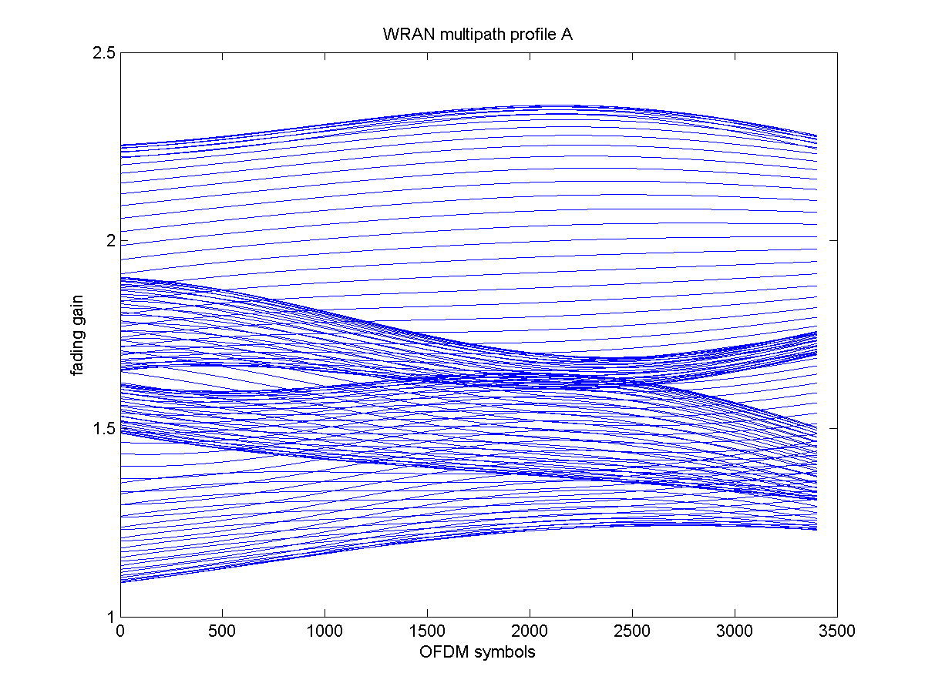
Fig. SEC11. Fading gains across OFDM symbols (each line shows a different subcarrier)

Simulations parameters:
Number of frames: 100
Number of OFDM symbols per frame (DL + UL): 34
Nfft: 2048
Cyclic prefix: 512 samples
Number of users subcarriers: 1248 (208k, with k=6 in 6 MHz TV band)
Carrier frequency: 600 MHz
Sampling frequency: 64/7 MHz

The current 802.22 channel model does not include a spatial model. In particular, antenna correlations are not modeled. Our proposal is robust to antenna correlations at the base station. Where single-user MIMO techniques fail to achieve spatial multiplexing gain in correlated environments at the base station, multiuser MIMO still provides the maximum spatial multiplexing gain, provided that we serve users that are not co-located.

The performance with correlated fading at the transmitter in the 3GPP LTE suburban-macro channel model is presented in Fig. SEC12. In that channel, the channel matrix of any given user has only one dominant eigenvalue. Therefore any single-user MIMO strategy fails to achieve a capacity larger than receiver beamforming (SIMO).

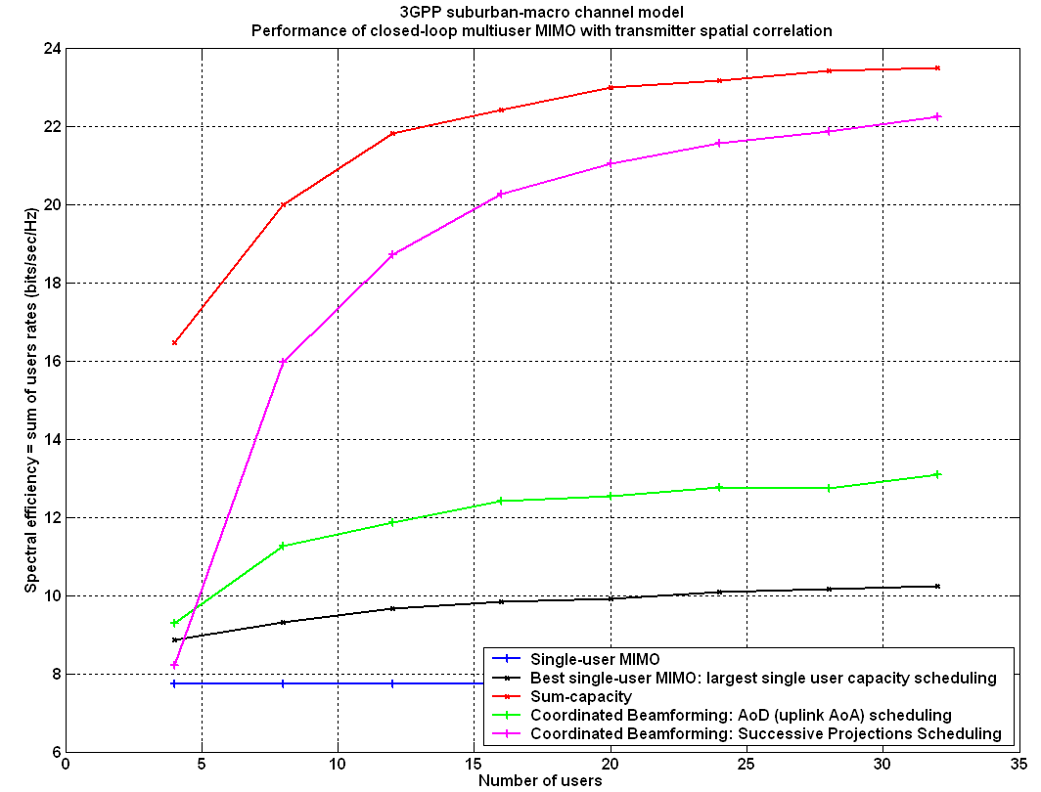
Fig. SEC12. Performance of CL MU MIMO in correlated channels.

Even a small amount of multiuser diversity (8 users) is sufficient to achieve spatial multiplexing gain. The proposed closed-loop multiuser MIMO technique achieves spatial multiplexing gain in correlated and uncorrelated channels, and it can do so with or without multiple antennas at the CPEs.

References
[1] Functional Requirements for the 802.22 WRAN Standard, doc.: IEEE 802.22-05/0007r46 .
[2] WRAN Reference Model, doc.: IEEE 802.22-04/0002r12.
[3] Niels Hoven and Anant Sahai, “Power Scaling for Cognitive Radio,” in proceedings of IEEE WirelessCom 05 Symposium on Emerging Networks, Technologies and Standards, Hawaii, USA, June 13-16, 2005.
[4] 22-05-0105-01-0000_Philips-FT_PHY-MAC_Proposal_Presentation.ppt
[5] 22-05-0055-07-0000_WRAN_channel _Modeling.doc: IEEE802.22-05/0055r7.

