IEEE P802.22
Wireless RANs
Deployment of OFDMA Based Solution in 802.22 Scenarios

Date: 2006-01-09
Author(s):
Name | Company | Address | Phone | email
Eli Sofer | Runcom | 2 Hachoma St , 75655  Rishon Lezion, Israel | +972 3 9528440 | elisofer@runcom.co.il
Yossi Segal | Runcom | 2 Hachoma St , 75655  Rishon Lezion, Israel | +972 3 9528440 | yossis@runcom.co.il
Yigal Leiba | Runcom | 2 Hachoma St , 75655  Rishon Lezion, Israel | +972 3 9528440 | yigal@runcom.co.il
Abstract
This contribution provides an example of WRAN deployment in a real rural area. Its purpose is mainly to demonstrate the capability of OFDMA, as a WRAN solution, in a large area, which has diverse geographical features. Additionally, we analyze in the contribution the effect of the synchronization and coordination on the frequency plans, and the ability to re-use the available frequencies as much as possible.

Notice: This document has been prepared to assist IEEE 802.22. It is offered as a basis for discussion and is not binding on the contributing individual(s) or organization(s). The material in this document is subject to change in form and content after further study. The contributor(s) reserve(s) the right to add, amend or withdraw material contained herein.

Release: The contributor grants a free, irrevocable license to the IEEE to incorporate material contained in this contribution, and any modifications thereof, in the creation of an IEEE Standards publication; to copyright in the IEEE’s name any IEEE Standards publication even though it may include portions of this contribution; and at the IEEE’s sole discretion to permit others to reproduce in whole or in part the resulting IEEE Standards publication. The contributor also acknowledges and accepts that this contribution may be made public by IEEE 802.22.

Patent Policy and Procedures: The contributor is familiar with the IEEE 802 Patent Policy and Procedures
<http://standards.ieee.org/guides/bylaws/sb-bylaws.pdf>, including the statement "IEEE standards may include the known use of patent(s), including patent applications, provided the IEEE receives assurance from the patent holder or applicant with respect to patents essential for compliance with both mandatory and optional portions of the standard." Early disclosure to the Working Group of patent information that might be relevant to the standard is essential to reduce the possibility for delays in the development process and increase the likelihood that the draft publication will be approved for publication. Please notify the Chair <Carl R. Stevenson> as early as possible, in written or electronic form, if patented technology (or technology under patent application) might be incorporated into a draft standard being developed within the IEEE 802.22 Working Group. If you have questions, contact the IEEE Patent Committee Administrator at <patcom@ieee.org>.
Deployment of OFDMA Based Solution in 802.22 Scenarios

Introduction
OFDMA was proposed as the basis for the PHY in all of the proposals submitted for 802.22 in the Nov. 2005 Vancouver plenary. OFDMA, as demonstrated in the STM-Runcom proposal [1], offers a high degree of flexibility, which makes it possible to provide coverage for large areas, in stringent spectrum allocation conditions.
This contribution provides an example of WRAN deployment in a real rural area. Its purpose is mainly to demonstrate the capability of OFDMA, as a WRAN solution, in a large area, which has diverse geographical features. Additionally, we analyze in the contribution the effect of the synchronization and coordination on the frequency plans, and the ability to re-use the available frequencies as much as possible.

Deployment Scenario

Terrain
The area chosen for the analysis is a 50km x 50km area, which includes valleys and mountainous areas. The terrain map of the area is depicted in Figure 1.

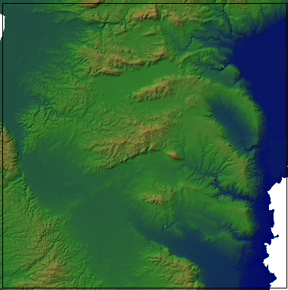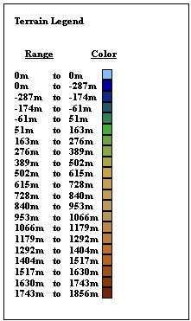
Figure 1: WRAN Deployment Terrain

User Density
Assuming an average population spread of 1.25 persons/km², as specified in the WRAN requirement document [2], with 20% penetration, there are 625 users in the area. As generally the population density is not uniform (the valleys are more
crowded than the mountains), 5 regions were defined, according to the geographical features of the terrain, and a different density was assigned to each. The regions are depicted in Figure 2 and the total number of customers in each region is indicated.
All the users' links are of 1.5Mbps peak data rate. It is assumed that a user uses the line about 10% of the time, and the ratio between the peak rate and the average rate during a session is 5.

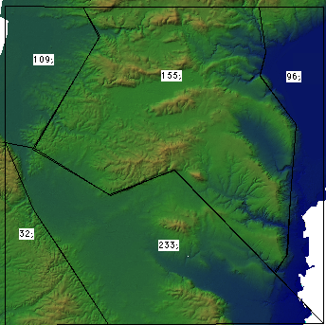
Figure 2: Number of customers in each area

System Parameters
The system parameters are as defined [1] and [2]. However, it should be noted that some of the parameters are not final and should be fine-tuned. The main parameters are listed in Table 1:

Table 1
Parameter | Value
Center frequency | 470 MHz
Channel Bandwidth | 6 MHz
Number of sub-channels | 32
Transmission power – BS* | 24.2 dBm
Transmission power – CPE* | 35.5 dBm
Receiver noise figure | 5 dB
Guard interval | 1/4 T_{s}
*To provide 4W CPE, taking into account the antenna gains introduced below

The system used adaptive modulation. Furthermore, thanks to sub-channelization, the system is capable of operating over a large dynamic range of C/I levels and signal strengths. Table 2 shows 6 levels, which are only a sample of the possible combinations.
Table 2
Modulation | Code Rate | Number of sub-channels | Required CINR* | Sensitivity | Net Throughput
QPSK | 1/2 | 1 | -10 dB | -111 dBm | 125 kbps
QPSK | 1/2 | 4 | -4 dB | -95 dBm | 500 kbps
QPSK | 1/2 | 12 | 2 dB | -91 dBm | 1.5 Mbps
16QAM | 1/2 | 12 | 8 dB | -85 dBm | 3 Mbps
64QAM | 1/2 | 20 | 14 dB | -81 dBm | 10 Mbps
64QAM | 3/4 | 32 | 19 dB | -76 dBm | 18 Mbps
* Note: The CINR refers to the CINR of a full channel. While the interference and noise are reduced with sub-channelization, the wanted carrier level is concentrated in the selected sub-channel and hence provide better CINR and sensitivity.

For the base station we use a commercial antenna, available for this frequency band. The antenna has 11.5 dBi gain in the frequency of operation, and its pattern is depicted in Figure 3.

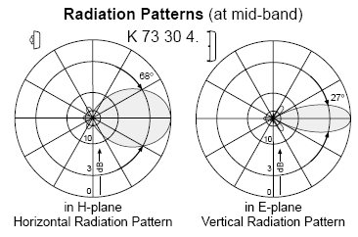
Figure 3: Antenna Radiation Pattern

As this is a 68º antenna, the basic site configuration would be of 6 sectors.

For the CPE, an omni directional antenna is used with 1.5 dBi gain.

The antenna height taken for the base stations is 100m, while for the CPE – 10m.
As a reference please note the following:

Maximum range for the most robust modulation using a single sub-channel, with a clear line-of sight (free space) is:
- Downlink: 1358 km
- Uplink: 4988 km

Horizon range (not communication range):
- flat ground: 33 km
- Typical ground height at the area: 40 km

Propagation Model
The models specified in the Channel Model document, [3], do not take into account the information provided by a digital terrain map, as presented in section 2.1. They are aimed to analyses which are statistical in nature and are very good for comparison between systems and for obtaining a system performance envelope.
However, in this contribution we are interested to see the application of the OFDMA system in a specific environment, where a digital terrain map is available. Because of this reason we used the "multiple knife-edge model (Deygout method)" as described in [4] and [5].

This is a physical model according to which a profile between the transmitter and receiver is created, and the 2 major obstacles obstructing the 1st Fresnel zone are considered. The diffraction losses between the transmitter and the second obstacle resulting from the 1st obstacle are added to the diffraction losses resulting from the second obstacle (the losses between the 1st obstacle and the receiver).

For fade margin, we used the Rice statistics with 99.9% time availability, as specified in [2]. The Ricean K- factor was K=0 for non-line of site propagation and K=10 for line-of-sight profiles.

Coverage
In order to achieve coverage, 11 base stations are needed, as depicted in Figure 4. The sites were selected out of a list of 392 high points in the area (approximately a single point every 4 sq. km). The sites are indicated by a blue dot on the map.

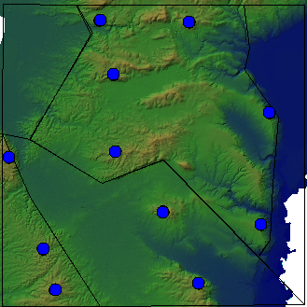
Figure 4: Site Location

The Received Signal Strength, including fade margins, in the area is depicted in Fig. 5. Fig. 5A shows the downlink results. The various signal level are shown in colors. The red color indicates a received signal strength below the level of -111 dBm, which is the level needed for the most robust modulation and coding state transmitted over a
single sub-channel. It can be seen that the site location was made to provide approximately 95% area coverage.

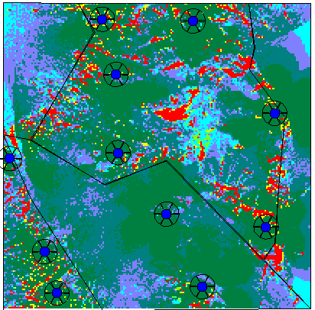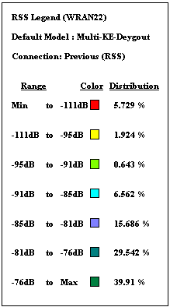
Figure 5A: Coverage map – Downlink

In the uplink the situation is as depicted in Figure 5B. As we choose the CPE antenna to be omni-directional, the uplink enjoys a better link budget than the downlink, due to the fact that higher transmission power can be used. However, in case the CPE antenna is more directional than that of the BS (a very common case in fixed wireless access systems) then the uplink would be the limiting case.

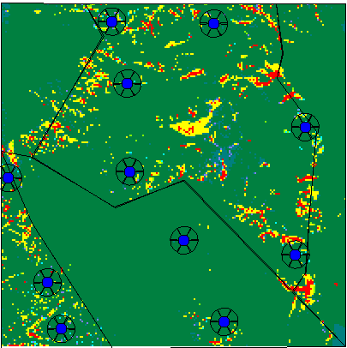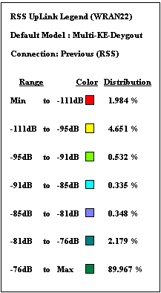
Figure 5B: Coverage map – uplink

It can be observed the in this case only 1.98% of the area is covered below the minimal level ("red zone"). Note also that while the uplink is the true capability map, namely, a signal level indicated in the map is the level a CPE is received at the base station, in the downlink there is also a constraint on the transmission power that, in case of fully loaded system, may reduce the power allocated to a given customer. For this reason it is recommended to use directional antenna at the CPE thus assure an extra margin of power in the downlink.

Capacity
The capacity, in Mbps, carried by each sector, according to the areas associated with it, is depicted in figure 6.

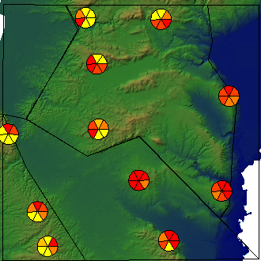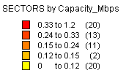
Figure 6: Capacity per Sector

It can be observed the maximum capacity required by a sector is of 1.2 Mbps in average, which requires about 10 sub-channels in QPSK modulation, code rate 1/2. However, in order to carry the peak rate of 1.5 Mbps, 12 sub-channels are needed (with QPSK 1/2). If a less robust modulation scheme is used, fewer sub-channels are needed, but the required CINR is higher. In the next section we will investigate this possibility.

Carrier to Interference Ratio

Coordinated Synchronous Configuration

As the total capacity requirement is not large, Partial usage of sub-channels (PUSC) deployment is chosen and each sector is accommodated with 10 sub-channels. In this configuration the average capacity per sector is well covered, while the peak can be covered by using a rate 3/4 code. This implies a target level of CINR of 1.45 dB (compared to the 0.4 dB CINR required for 12 subchannels with QPSK 1/2 MCS.
A CINR map is shown in Figure 7. This map shows the different levels of carrier to interference ratio experienced by the CPE's. It is assumed that system operates in a coordinated and synchronous mode, with identical permutation base. Thus the interference experienced by the CPE's is only co-channel interference. According to the legend attached to the map, about 10% of the area experiences CINR lower than
1.4 dB, which means that the peak rate is not covered in the area. 0.2% of the area is not covered at all. Better frequency planning is required to achieve better results.

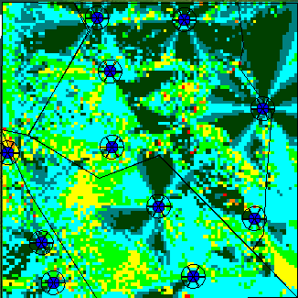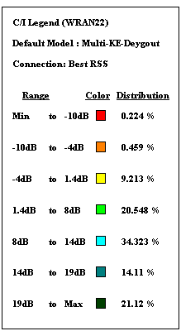
Figure 7: CINR Levels – Coordinated Configuration

Synchronous Configuration
In this case each sector uses a different permutation base. As a result, all the subchannels (including "co-channel") introduce the same level of interference, which can be approximated as a single sub carrier coinciding between any two sub-channels. In our case, the average number of sub-channels operating in each sector is 2, this would mean an average of 15dB attenuation between any two sub-channels. The results are shown in Figure 8 and are better than the previous section. However, it should be noted that this is true mainly due to the sparse deployment. In a denser environment, more interference will be experienced by the CPE's, as more sub-carriers coincide.

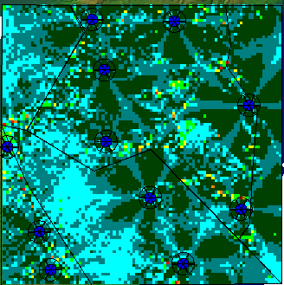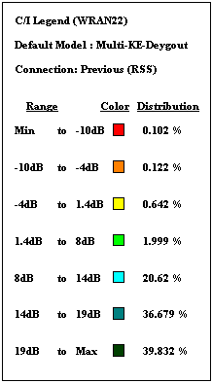
Figure 8: Synchronous Configuration

Asynchronous Configuration
In this case the time frames between the base stations are not synchronized, hence, in TDD mode, CPE to CPE as well as base station to base station interference can be experienced in addition to the interference analyzed above. Thus, in general inferior performance should be expected form this scenario.

Conclusion
This contribution has shown an example of WRAN deployment in a real life area, which included different geographical features. The main conclusion is that the OFDMA flexibility allows for improved coverage, as adaptive modulation and coding as well as sub-channellization can be used to provide service to remote areas. In the scenario presented there was no need for more than a few sub channels per sector and consequently the synchronous mode was shown to be superior to the coordinated mode.
This is definitely only the first step in the analysis of WRAN deployment, and was aimed only to demonstrate a possible procedure for deployment and analysis. The effect of other deployment environments, other levels of user density and other deployment configurations should also be studied.

References
[1] IEEE 802.22-05/0098r0 : STM Runcom PHY and MAC outline, IEEE 802.22 Wireless RAN Standard PHY and MAC Proposal. November 2005.

[2] IEEE 802.22-05/0007r46 : Functional Requirements for the 802.22 WRAN Standard. September 2005

[3] IEEE 802.22-05/0055r7 :WRAN Channel Modeling. August 2005

[4] JD Parsons, The Mobile Radio Propagation Channel. New York: Wiley, 1992

[5] ITU-R Rec. P.526-9: Propagation by Diffraction. August 2005

