IEEE P802.22
Wireless RANs
Waveform Modulated WRAN System
Date: 2005-11-07
Author(s):
Name | Company | Address | Phone | email
Soo-Young Chang | Huawei Technologies | 6000 J Street, Dept EEE, Sacramento, CA 95819-6019 | 916 278 6568 | sychang@ecs.csus.edu
Jianwei Zhang | Huawei Technologies | No. 98, Lane 91, Eshan Road, Pudong, Pudong Lujiazui Software Park, Shanghai, China 200127 | 86-21-68644808-24638 | zhangjianwei@huawei.com
Abstract
In this proposal, a set of waveforms are suggested for WRAN systems. In this system, one TV channel frequency band is divided into subbands and each subband has its own waveform. In the time domain, these waveforms are added and transmitted. Various modulation schemes are suggested. Multiple access schemes are suggested by applying orthogonal codes in the frequency domain.

These waveforms are generated by utilizing full digital processing in this proposal.

These schemes are evaluated by simulation.

Notice: This document has been prepared to assist IEEE 802.22. It is offered as a basis for discussion and is not binding on the contributing individual(s) or organization(s). The material in this document is subject to change in form and content after further study. The contributor(s) reserve(s) the right to add, amend or withdraw material contained herein.

Release: The contributor grants a free, irrevocable license to the IEEE to incorporate material contained in this contribution, and any modifications thereof, in the creation of an IEEE Standards publication; to copyright in the IEEE’s name any IEEE Standards publication even though it may include portions of this contribution; and at the IEEE’s sole discretion to permit others to reproduce in whole or in part the resulting IEEE Standards publication. The contributor also acknowledges and accepts that this contribution may be made public by IEEE 802.22.

Patent Policy and Procedures: The contributor is familiar with the IEEE 802 Patent Policy and Procedures
<http://standards.ieee.org/guides/bylaws/sb-bylaws.pdf>, including the statement "IEEE standards may include the known use of patent(s), including patent applications, provided the IEEE receives assurance from the patent holder or applicant with respect to patents essential for compliance with both mandatory and optional portions of the standard." Early disclosure to the Working Group of patent information that might be relevant to the standard is essential to reduce the possibility for delays in the development process and increase the likelihood that the draft publication will be approved for publication. Please notify the Chair <Carl R. Stevenson> as early as possible, in written or electronic form, if patented technology (or technology under patent application) might be incorporated into a draft standard being developed within the IEEE 802.22 Working Group. If you have questions, contact the IEEE Patent Committee Administrator at <patcom@ieee.org>.

- INTRODUCTION/BACKGROUND

In this proposal two key considerations are undertaken as following:

- Use short duration waveforms: purely processed in time domain, not in frequency domain
  - Simple concept: only a few components in TX and RX
  - Simple digital processing è Low complexity è Low cost
  - No components for processing frequency information (e.g. filter, osc., etc.)
  - Excellent co-existence capability due to adaptive frequency band usage – flexible to eliminate forbidden bands (e.g. active incumbent TV user bands, active microphone bands)
    - Dynamically frequency bands can be assigned to CPEs
- New waveforms have stiff out-of-band rejection around the edges of the band.

In this proposal, the work was motivated with the following miths:

- Myth 1
  - ‘Digital implementation needs more complexity and is not easily realizable with the state-of-the art technologies.’
  - Digital implementation can be realized with less complexity and simple hardware and provide full flexibility and adaptivity.
  - As the processing power increases and technologies advance, full digital processing is the trend.
- Myth 2
  - ‘Lower frequency is not easy to manage or implement.’
è Unless high transmit power is not considered, digital processing method can be easily applied for lower frequency band without using more complex algorithms.
- Myth 3
  - ‘Since this technology was not realizable yesterday, today also it is not easy to realize.’
  - Since technologies advance rapidly, more sophisticated and conceptual ideas should be realized in the near future and considered for future applications.
  - Moore’s law says that processing power increases double every 18 months: cost and complexity can be decreased with the same rate.

We have to consider the following issues for the WRAN systems:

- Modulation
- Source coding
- Channel coding/error control
  - FEC and ARQ
- Interleaving
- Pulse generation
- Antenna
- Multiple access
- Synchronization
- LNA
- Message relaying: repeaters
- Sensing of incumbent user signals
- Dynamic frequency selection (DFS)
- Transmit only device
- Detection

- Waveforms used in this proposal

The waveforms used in this proposal have the following:

- Pulse waveform shape
  - From mathematical derivation/expression
  - Shape: duration: 9 us
  - Spectrum: almost flat throughout the whole band
- How can pulses be generated
  - Digital way? à Overlapped with various delays
à can be generated with relatively lower sampling rate DACs
    - 90 samples/waveform:
    - 16 waveforms/group for binary representation
81 waveforms/group for ternary representation
    - 1440 or 7290 sample information stored in ROM per group
à 1.44 or 7.29 Kbytes ROM needed to store waveform information if 8 bits/sample is adopted
    - Waveforms are generated using DACs which have a sampling rate of 1 Msamples/sec.
  - Analog way?
    - No idea

One example wavform and its spectrum are as following:

- The base waveform below for bandwidth of 0.469 MHz, 10 samples/us
- For each subband, there is one waveform which has flat spectrum as shown below.
- Group i has four base waveforms: wi1, wi2 , wi3 , and wi4
- Group i has 16 waveforms: mi1, mi2, mi3, . . . , mi16
mij,=a* wi1 +b* wi2 +c* wi3 +d* wi4
where a, b, c, and d are determined by modulation method applied

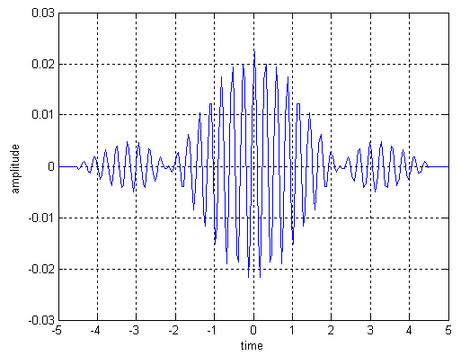

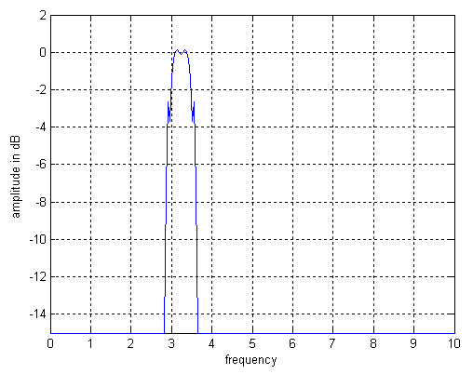

- With the same waveform, spectral flatness depends on the number of samples for each waveform
  - More samples makes the spectrum flatter: flatter inside the band and more suppression outside the band
  - Power ratio=power with perfectly flat spectrum / power with less perfectly flat spectrum
  - For the cases
    - Bandwidth = 0.469 MHz
    - Pulse width = 9 us
    - No. bits/sample = 8
    - No. samples/waveform = 50, 90, 140, 180, 280, 400

The first figure is the spectrum with less number of samples per waveform while the second is on with more samples per waveform. It can be known that the spectrum with more samples per waveform has more suppression.

- Frequency Plan

One TV channel band is divided into some subbands.

In this proposal, the following concepts are applied to have the optimum design.

- Flexible enough to satisfy any frequency band given and to avoid any forbidden bands
è pulse waveforms can be adaptively tailored to any frequency mask or band applied with any forbidden bands
- With any given frequency band, the whole frequency band can be used to enjoy more transmitted power
è 3.8 dB more power used than Gaussian pulse’s case with the same frequency band
è 3.8 dB more margin for link budget

Frequency subbands in one TV channel band is assigned as following:

- One TV channel frequency band is divided into 4 groups
- Each group has 4 subbands
  - BW of a subband = 6 MHz /16 = 0.375 MHz
  - Each subband has its own waveform: base waveform
  - If a part of a given band should be abandoned – e.g., due to active microphone operation, one of corresponding subbamd can be eliminated.

A typical frequency plan is shown in the following figure.
f
subband 1
subband 2
subband 3
subband 4
f
group 1
group 2
group 3
group 4
X MHz
X+6 MHz
w₂₁
w₂₂
w₂₃
w₂₄
base waveform

Base waveforms of a group consists of four base waveforms as follows:

- For four subbands – assuming each subband has 1 MHz BW
  - If smaller BW, larger pulse width

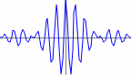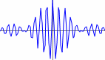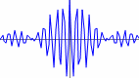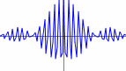
t (us)
0
4
+
+
+

Another example base waveforms of a group is as follows:

For four subbands - for smaller BW, larger pulse width
For BW of a subbnad in Group 1=0.469 MHz

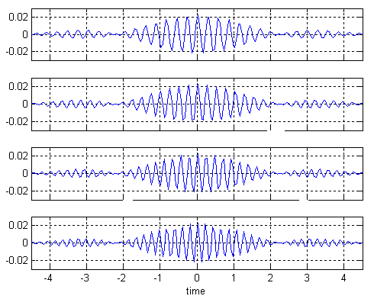
subband 1
subband 2
subband 3
subband 4

Their spectrum is shown in the following figure.

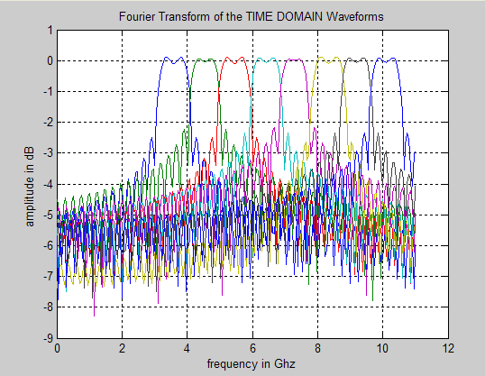

- Waveform Orthogonality

Each waveform is orthogonal to other waveforms.

Orthogonality of waveforms is described as follows:

- For each subband, one base waveform exists
  - 16 base waveforms throughout whole band (four groups):
w11(t), w12(t), w13(t), w14(t), w21(t), . . . . , w43(t), w44(t)
  - Each waveform is almost orthogonal to each other or perfectly orthogonal after de-emphasis at RX
- Each group has
  - 16 waveforms for binary base waveform modulation (OOK or BPSK) or
  - 81 waveforms for ternary base waveform modulation (OOK+BPSK) or
  - 256 waveforms for ternary base waveform modulation (QPSK)
  - These waveforms are orthogonal to each other after de-emphasis at RX
    - m1,1=0, m1,2= w1, m1,3= w2, . . . . , m4,16= w13+ w14+ w15+ w16 with OOK
    - m1,1= -w1 - w2 – w3 – w4, . . . . , m4,16= w13+ w14+ w15+ w16 with BPSK

Correlation of waveforms is defined as following:

- Correlation

where : kth sample of ith base waveform of a group for N samples/waveform

- Ratio of correlations = autocorrel/crosscorrel for various N values
- Orthogonality holds for sinusoidal waveforms with some conditions (Orthogonality condition, refer to next slide), but the waveforms used here are not sinusoidal with some envelope
  - At receiver, de-emphasis can be used to make pure sinusoidal for a period
    - mij*mij=(a* wi1 +b* wi2 +c* wi3 +d* wi4 )(a* wi1 +b* wi2 +c* wi3 +d* wi4) where mij is the waveform transmitted and mij is the waveform generated at RX after de-emphasis
    - After integration for a one waveform duration, only autocorrelation terms remain
    - Orthogonality can hold at receiver during detection for matched waveforms
  - What is the best sampling frequency such that orthogonality can be achievable?
- Less than 8 bits/sample will be enough for orthogonality evaluation? – need to verify
  - “Power consumption of ADCs goes up exponentially with resolution”, EE times, Jan 17, 2005, pp 49

Correlations between waveforms are calculated and shown in the following table.

correlation  correlation ratio | w11 | w12 | w13 | w14
w11 | 0.020984  1/1 | 0.0012155  17.264/9.7396 | 2.2562×10-5 930.05/3957.3 | 3.4173×10-6  6140.6/9681.8
w12 | 0.0012155  17.264/9.7396 | 0.020984  1/1 | 6.8651×10-6  305.66/106.69 | 2.2562×10-5  930.05/3957.3
w13 | 2.2562×10-5  930.05/3957.3 | 6.8651×10-6  305.66/106.69 | 0.020984  1/1 | 0.0012155  17.264/9.7396
w14 | 3.4173×10-6  6140.6/9681.8 | 2.2562×10-5  930.05/3957.3 | 0.0012155  17.264/9.7396 | 0.020984  1/1

In this table the following values are used:

  - # of samples = 180 # of samples = 90
  - Correlation ratio = autocorrelation/crosscorrelation
  - Correlations totally depend on the number of samples used.

- Modulation

Modulation and multiple access efficiency can be determined by the following parameters:

- Energy or power efficient? joule/sec
  - Energy=power*time
  - Power limited by spectral mask
    - Pmax=PSD/MHz*BW
è to use more energy, more time needed to be transmitted è totally related to transmit time
  - for WRAN, BW~6MHz è short duration pulses can be used for higher data rates
  - one possibility to increase energy by using multiple pulses for one bit (or symbol)
  - need to use more power under frequency mask to have higher power
  - power constrained with frequency mask for WRAN case
  - new waveform needed to fit the frequency mask to have more transmitted power

- Spectrally efficient? bit/Hz
  - limited bandwidth given
  - More complex modulation schemes have to be applied à entails higher system complexity

- Time efficient? bit/sec
  - For higher rate, more important : needs a short duration waveform for one symbol è needs to put more information in a symbol duration

Possible modulations for each waveform are as following:

Each waveform can be modulated by using the following modulation schemes depending on required data rates, system complexity, detection method, etc.

mod | No. of levels | complexity | Data rate | Detection method
OOK | 2 (+1, 0) | lowest | low | Non-coherent/coherent
Anti-podal:BPSK | 2 (+1, -1) | low | low | Coherent/differential
OOK+anti-podal | 3 (+1, 0, -1) | moderate | moderate | Coherent/differential
n level mod | n | high | high | Coherent/differential
nQAM | n | high | high | Coherent/differential

Spectrum of base waveform is shown at the figures below.

Signal for randomly generated 10000 bits is shown in the below figure.

Its spectrum is shown below.

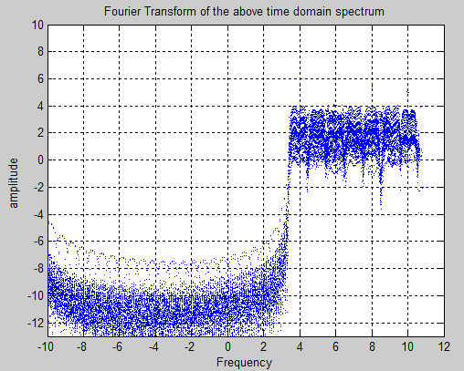

- Multiple access

Possible multiple access schemes are described as following:

- Possible MAs considered
  - Frequency hopping (FH) among subbands/groups
    - Not efficient because of higher system complexity and less usage of power
  - TDMA
    - Less time efficient
    - More difficult to synchronize
  - Direct-sequence (DS) CDMA
    - Less time efficient and more complex to process
  - FDMA/OFDMA
    - More complex
- New MA needed?

In this proposal, frequency domain bins are considered as well as time domain bins as shown in the following figure.
f
t
Group 1
Group 2
Group 3
Group 4
16 frequency bins
time domain bins
t4
t2
t3
t1
t5

Each frequency bin is mapped to one of Walsh encoded symbols shown in the following figure.

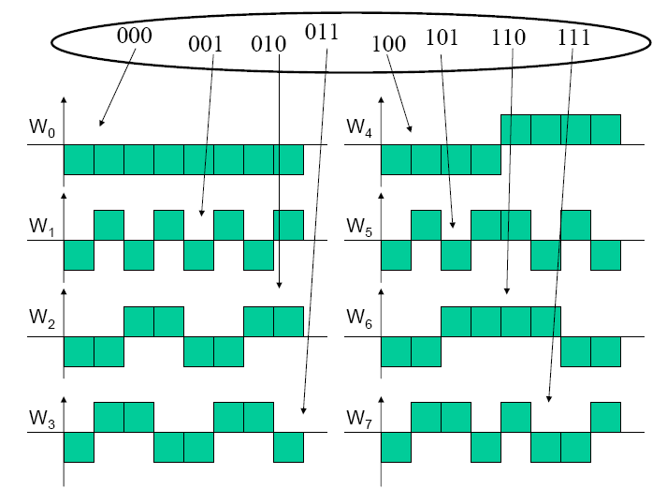

Proposed multiple access scheme is as follows:

- An orthogonal set of 8 8-bit Walsh codes is used
  - Max autocorrelation, min (or zero) crosscorrelation each other
  - One code consists of 8 frequency domain bins
  - Minimal Hamming distance of this code set is 4
    - One frequency bin error can be corrected while three bin errors can be detected; works as an ECC code; increases robustness
- 64 simultaneously operated users
  - For one user, two Walsh codes (16 bits) are assigned
  - One time domain bin is occupied by two codes
    - two codes represent one bit; one time domain bin represents one bit; one time domain bit deliver one bit
    - Hamming distances between two user codes are 4 and 8.
- For each frequency bin waveform, BPSK, QPSK, or 64QAM is applied according to signal environments – or according to the distance between and a CPE and the base station.

Various data rates can be considered in this proposal:

- Assume that 64 simultaneously operated CPEs
- Aggregated data rates estimated per TV channel
  - BPSK applied for a waveform
    - 1 bit/waveform x 1.1waveform/us = 1.1 Mbps
  - QPSK applied for a waveform
    - 2 bit/waveform x 1.1waveform/us = 2.2 Mbps
  - 64 QAM applied for a waveform
    - 6 bit/waveform x 1.1waveform/us = 6.6 Mbps

- Conclusions

The reasons why this proposal has advantages over other concepts are as follows:

- More transmit power used under frequency mask
  - More margin: at least 3.8 dB more by using full power under any frequency-power constraints with waveforms adaptive to frequency mask
è Spectrally efficient / more received signal power
è More chance to intercept signals

- Very simple architecture
  - Directly generated pulse waveforms using ROM
  - Processing in digital methods
    - No need to have analog devices (e.g., mixer, LO, integrator, etc)
è low cost / low power consumption

- High out-of-band rejection
  - More transmit power and effective bandwidth used
è high data rates can be achieved

- High adaptability to frequency, data rate, transmit power requirements
è high scalability in frequency, data rate, system configuration, waveform, etc.

References:

- “Power consumption of ADCs goes up exponentially with resolution”, EE times, Jan 17, 2005, pp 49
- http://ccrma.stanford.edu/~jos/r320/Orthogonality_Sinusoids.html

