IEEE P802.22 Wireless RANs
Technology Proposal Package for IEEE 802.22
Date: 2026-07-30
Author(s):
Name | Company | Address | Phone | email
Ashish Pandharipande | Samsung Advanced Institute of Technology | SAIT, P.O. Box 111, Suwon 440-600, Korea | +82 10-6335-7784 | p.ashish@samsung.com
Jae-Myung Kim | Inha University | SAIT, P.O. Box 111, Suwon 440-600, Korea | +82 10-9963-0676 | jaekim@inha.ac.kr
David Mazzarese | Samsung Electronics Co. Ltd. | Dong Suwon P.O. BOX 105,  416, Maetan-3dong, Yeongtong-gu, Suwon-si, Gyeonggi-do  Korea 442-600 | +82 10-3279-5210 | d.mazzarese@samsung.com
Baowei Ji | Samsung Telecommunications America | 1301 E. Lookout Dr. Richardson, TX 75082 | +1 972-761-7167 | baowei.ji@samsung.com
Abstract

This document provides technology solutions to meet functional requirements of an IEEE 802.22 based WRAN system. Keeping in view the unique requirements imposed on WRANs to operate while avoiding interference to licensed incumbents and coexistence among WRANs, we propose an OFDM(A) solution in conjunction with a set of MAC protocols, and provide distributed sensing and interference management solutions.

Notice: This document has been prepared to assist IEEE 802.22. It is offered as a basis for discussion and is not binding on the contributing individual(s) or organization(s). The material in this document is subject to change in form and content after further study. The contributor(s) reserve(s) the right to add, amend or withdraw material contained herein.

Release: The contributor grants a free, irrevocable license to the IEEE to incorporate material contained in this contribution, and any modifications thereof, in the creation of an IEEE Standards publication; to copyright in the IEEE’s name any IEEE Standards publication even though it may include portions of this contribution; and at the IEEE’s sole discretion to permit others to reproduce in whole or in part the resulting IEEE Standards publication. The contributor also acknowledges and accepts that this contribution may be made public by IEEE 802.22.

Patent Policy and Procedures: The contributor is familiar with the IEEE 802 Patent Policy and Procedures
<http://standards.ieee.org/guides/bylaws/sb-bylaws.pdf>, including the statement "IEEE standards may include the known use of patent(s), including patent applications, provided the IEEE receives assurance from the patent holder or applicant with respect to patents essential for compliance with both mandatory and optional portions of the standard." Early disclosure to the Working Group of patent information that might be relevant to the standard is essential to reduce the possibility for delays in the development process and increase the likelihood that the draft publication will be approved for publication. Please notify the Chair <Carl R. Stevenson> as early as possible, in written or electronic form, if patented technology (or technology under patent application) might be incorporated into a draft standard being developed within the IEEE 802.22 Working Group. If you have questions, contact the IEEE Patent Committee Administrator at <patcom@ieee.org>.

Table of Contents

1 Summary Classification Statement 5
2 Technology Overview 5
2.1 Overview 5
2.1.1 Sensing and associated (MAC) protocols 5
2.1.2 Physical layer design 7
2.2 Distributed sensing architectures 7
2.2.1 Data fusion 7
2.2.2 Decision fusion 7
2.3 Detection and signal classification mechanisms at individual sensing 8
2.3.1 Energy detection at CPEs, measurement feedback and data fusion 9
2.3.2 Energy detection at CPEs, decision feedback and decision fusion 10
2.3.3 Cyclostationary detection at CPEs, decision feedback and decision fusion 11
2.3.4 Energy detection mode of cyclostationary detection 13
2.3.5 Advantages of cyclostationary detection 14
2.3.6 Comments on cyclostationary detection times 14
2.3.7 Determination of noise-protected contours for interference avoidance/management 15
2.4 Sensing results from the CPEs to the BS 15
2.5 Dynamic map of spectrum usage 15
2.6 Regional WRAN information base 16
2.7 Local WRAN information base 17
2.8 BS-CPE communication channel for sensing information exchange 17
2.9 MAC frame structure 18
2.10 Sensing protocols 19
2.10.1 WRAN initialization 19
2.10.2 WRAN in-service sensing 21
2.11 Dynamic frequency change 22
2.12 Inter-WRAN resource sharing module 26
2.12.1 Resource portioning requests among WRANs 26
2.12.2 Dynamic resource renting among WRANs 27
2.13 WRAN Physical layer 31
2.13.1 Duplexing modes and supported FFT sizes 31
2.13.2 OFDMA subcarrier allocation 37
2.13.3 Synchronization 40
2.13.4 Symbol clock frequency tolerance 40
2.13.5 Ranging 41
2.13.6 Power control 42
2.14 WRAN coexistence spectrum etiquette 43
2.15 Maximum transmit power constraint for interference management and coexistence of WRANs 45
2.16 WRAN pilot and CPE association 52
2.17 Smart antenna for sensing, cell searching, packet transmitting and receiving, and soft combining 53
2.18 Spectrum classification 54
2.19 Coexistence with other LE systems 56
2.20 Soft combining 57
2.21 Flexible CPE modes 58
3 References 60
List of contributors 61
List of Figures
Figure 1. Sensing-associated functional blocks. 6
Figure 2. Energy detection device. 10
Figure 3. WRAN initialization (Option 1). 20
Figure 4. WRAN initialization (Option 2). 21
Figure 5. WRAN in-service sensing. 22
Figure 6. State transition diagram of sudden death resolution. 25
Figure 7. CPE reinitialization diagram. 25
Figure 8. Resource partitioning request. 27
Figure 9. State transition diagram of resource renting (Offeror BS). 28
Figure 10. State transition diagram of resource renting (Renter BS). 29
Figure 11. State transition diagram of resource collecting (Offeror BS). 29
Figure 12. State transition diagram of resource collecting (Renter BS). 30
Figure 13. State transition diagram of resource returning (Offeror BS). 30
Figure 14. State transition diagram of resource returning (Renter BS). 31
Figure 15. FDD frame structure. 36
Figure 16. OFDMA subcarrier allocation. 37
Figure 17. Initial ranging (2 symbols). 41
Figure 18. Periodic-ranging or bandwidth-request transmission for OFDMA using one symbol. 41
Figure 19. An example. 44
Figure 20. Role of interference management module in WRAN. 46
Figure 21. Steps in calculating maximum power constraint on CPEs. 47
Figure 22. Table listing the first layer of individual CPE maximum transmit power constraint. 48
Figure 23. Table showing the computation of the second layer of individual CPE maximum transmit power constraint from the table in Figure 22. 48
Figure 24. Table listing the second layer of individual CPE maximum transmit power constraint and joint constraint area information. 49
Figure 25. Flowchart of the decision on the first layer on individual transmit power constraint for each CPE from a possible TV operation on channel N. 50
Figure 26. Illustration of transmit power boundary constraints and constraint area in the case of NTSC TV co-channel operation. 51
Figure 27. Association (call flow). 53
Figure 28. Smart antenna suitable for advanced WRAN. 54
Figure 29. Example of smart antenna design. 54
Figure 30. Spectrum classification. 55
Figure 31. DL contention-based coexistence with LE devices. 56
Figure 32. UL contention-based coexistence with LE devices. 57
Figure 33. Soft-combining call flow (FL). 58
Figure 34. Soft-combining call flow (FL). 58
Figure 35. Flexible CPE operation. 59
List of Tables
Table 1. Spectrum sensing results 15
Table 2. Map of spectrum usage 16
Table 3. Regional WRAN information base 16
Table 4. Local WRAN information base 17
Table 5. TDD parameters 32
Table 6. TDD parameters 33
Table 7. TDD parameters 34
Table 8. FDD parameters 35
Table 9. System capacity 37
Table 10. OFDM uplink subcarrier allocation 38
Table 11. Datarate per subchannel- tile, bin case (48 data subcarriers, 3 symbol) 39
Table 12. Datarate per subchannel- cluster case (48 data subcarriers, 2 symbol) 39
Table 13. Datarate per frame (48 subcarriers) 39
Table 14. Spectral efficiency (bin case) 40
Table 15. Number of users per frame 40
Table 16. Normalized C/N per modulation 42

Technology Proposal Package for IEEE 802.22

Summary Classification Statement

This document provides a summary of a set of technologies for meeting the functional requirements for developing an inter-operable IEEE 802.22 air interface. The proposed set of PHY, MAC and associated air-interface solutions proposed here aid in enabling a point-to-multipoint (P-MP) Wireless Regional Area Network (WRAN) for use in parts of VHF-UHF spectrum without causing interference to existing services such as TV broadcasting. The proposed solutions herein constitute a partial system proposal, while meeting the corresponding requirements in [1] that are relevant to the mechanisms proposed herein.

Technology Overview
This section presents a high level description of proposed technology solutions to be used as a framework for developing the IEEE 802.22 standard. The focus of this proposal is on sensing methodologies and associated MAC protocols needed to facilitate detection and avoidance of licensed incumbents and coexistence and resource sharing among WRANs. We also advocate an OFDM(A) approach based on adaptive modulation and coding, subcarrier allocation and transmit power control to address the adaptive system performance requirements.

Overview

Sensing and associated (MAC) protocols
A WRAN comprises of a BS and a number of associated CPEs. The BS and CPEs have the capability to sense RF channel occupancy for purposes of detecting and avoiding interference (the term avoiding interference is used in the sense of operating at interference levels below those specified as tolerable by licensed incumbents) to licensed incumbents and co-existence with other WRAN systems. Sensing information from the CPEs is sent and collated at the BS where mapping of the interference situation is made by taking into account the CPE geographic coordinates. Solutions such as channel change or power reduction are deduced at the BS and signaled to the CPEs.

TV usage
database
Sensing
information
module
SG for
Part 74
devices
Dynamic map of
Spectrum usage
Interference
management
module
WRAN radio
resource
allocation module
WRAN
coexistence
Licensed device
protection
Regional WRAN
information
base
Inter-WRAN
resource sharing
module
Local WRAN
information base

Figure 1. Sensing-associated functional blocks.

Shown in Figure 1 is the functional diagram of the various blocks that facilitate WRAN sensing. Sensing of licensed incumbents is carried out through localized detection by individual CPEs, with a fusion of this information at a centralized sensing decision unit (CSDU) that may be located at the WRAN BS. Each CPE (and the BS) has the following components. With the aid of the sensing antenna, each CPE (and BS) monitors spectrum usage in the neighborhood (as defined by sensing range) and produces periodic sensing reports. This spectrum monitoring process involves RF environmental sampling over the system bandwidth. The spectral content of the environmental snapshot is then estimated using one of many possible techniques, e.g. periodogram, cyclic power spectral density, etc. An analysis of the spectral content is then performed to determine whether or not a signal is present, and possibly, which signals are present. The results of this sensing are then signaled back to the CSDU, where the sensing reports are fused in order to identify existence of users and available spectrum based on local configurations. This sensing process itself is aided by a publicly available FCC database that contains TV channel usage information in a particular geographical area (see [6]) and inputs from the Study Group created to provide solutions for enhancing the reliable detection of Part 74 devices. The WRAN BS creates a dynamic map of spectrum usage through this sensing process that constitutes the sensing information module as shown in Figure 1. The dynamic map itself has two complementing information bases: a regional WRAN information base and a local WRAN information base. The regional WRAN information base has information related to operating WRANs. This information can be accessed and shared by authorized WRANs to facilitate WRAN coexistence and resource sharing. The local WRAN information base has information pertaining to local resource characteristics, and is used to enable licensed incumbent protection. Both information bases ultimately facilitate interference management and radio resource allocation. Reaction mechanisms subsequent to signal sensing would typically be in the form of a reconfigurable RF module switching to selected frequencies and using appropriate transmission protocols on each frequency. In the following sections, we describe these functional blocks in more detail.

Physical layer design
We present a physical layer design based on a scalable, dynamic and flexible version of an OFDM(A) system to meet the functional requirements of WRAN systems. The key features of the proposed air-interface can be summarized as: Flexible multi-access, scalable FFT sizes (with additional receiver signal processing) to accommodate the WRAN channel models in [2], support for both TDD and FDD modes, multiple antennas at WRAN BS, provision for multiple TV channel access transmission and also sub-channelization of a single TV channel, adaptive modulation and coding depending on CPE topologies and transmit power control for interference management.

Distributed sensing architectures
IEEE 802.22 systems employ distributed sensing, i.e. both the WRAN BS and CPEs have the capability to sense RF channel occupancy. Information is sent and collated at the BS where a global sensing decision is made at a central sensing decision unit (CSDU) based on the sensing information from the CPEs (and the BS) and according to their respective geographic coordinates. Based on what type of information is sent from the sensing elements, and the subsequent processing at the CSDU, we can have different sensing architectures.
The WRAN system follows a master-slave relationship where the BS is the master and the CPEs the slaves. The WRAN BS controls the CPEs to conduct measurement activities and obtains sensing results. Sensing measurements may take place over scheduled quiet periods of the WRAN. The BS instructs the CPEs when to sense, which channels to sense and the duration of the sensing activity.
Two fusion schemes are considered.

Data fusion
In this scheme, each sensing element makes raw observations but does not make a decision as to whether a signal is present or not. It possibly processes the raw observations and sends the processed information to the CSDU. At the CSDU, the processed information is fused into a final decision.

Decision fusion
In this scheme, each sensing element makes raw observations, processes these observations and makes a detection decision as to whether a signal is present or not. It then sends the decision bit to the CSDU. At the CSDU, the individual decisions are fused into a final decision.
Although we describe two fusion schemes, one can envision other combination architectures. We however do not describe them here since they involve more involved interactions. Note that both data fusion and decision fusion architectures are fairly independent of the detection algorithm employed at each individual sensing element.

Detection and signal classification mechanisms at individual sensing
We present different solutions for WRAN sensing depending on the sensing at individual CPEs, feedback from CPEs to the CSDU, and the processing at the CSDU. The solutions present varying degrees of trade-offs in terms of system complexity and detection performance. We also omit geographical location information from the formulations for notational simplicity.
Consider a BS with associated CPEs. The problem of sensing licensed incumbent signals (and/or other unlicensed WRAN signals) is a problem of choosing among two hypotheses – the “signal absent” hypothesis denoted by and the “signal present” hypothesis denoted by. WRAN sensing thus involves a binary hypothesis test.
Each sensing element collects information about its RF environment by collecting RF signal samples. In order to facilitate classification along with detection, we shall exploit the fact that the signals we are attempting to identify have unique signatures (although the cyclostationary detection that we present in the next section also has classification capabilities). This is indeed true in the case of TV signals, for example, where a pilot is embedded in the TV signal [1]. In the case of WRAN systems, we propose that each WRAN system employ a unique identifying pilot signature that aids in detecting and identifying a WRAN BS. A possible approach would be to embed different spread spectrum sequences into the OFDM signals that are used by different WRAN BS transmitters. WRAN detection and identification is then based on conducting cross-correlations over the sequence set. Given the existence of such pilot signals with a structure known a priori to the sensing elements these pilots act as training sequences. We can then substantially reduce the number of samples required for detection in the low SNR regime by designing a detector that searches for these pilots.

Note that since we cannot make any assumptions on the configuration of CPEs within a WRAN, we assume that sensing elements are randomly deployed over the area of interest. If the location of the CPEs was known (along with that of the TV transmitter) the information would be embedded as another “feature.” That is, we would be looking in the information class that belonged to a certain geographical region. The signal detection problem would remain the same with the minor change of the underlying distribution functions capturing the location information.

Assume that at the -th element, the received samples be. These samples are obtained through appropriate band-pass filtering in regions where the pilots are embedded, and subsequent sampling. The number is determined by the sampling duration. Note that for clarity, we have dropped the subscript; we shall use the subscripts whenever necessary. We assume that these samples are statistically independent. Let be the transmitted signal sequence (which may be a signal sequence composed of a number of signals such as TV signals, other WRAN signals, etc.), be the signal power level that may be fluctuating due to the random nature of the channel(s) between the transmitter(s) and the sensing element, and be the sequence of noise samples assumed to be zero-mean, white Gaussian with two-sided power of.

Energy detection at CPEs, measurement feedback and data fusion

Assume that at the -th element, the received samples be. These samples are obtained through appropriate band-pass filtering in regions where the pilots are embedded, and subsequent sampling. The observation window duration and sampling rate are determined by characteristics of the signal(s) we are attempting to detect, such as the signature bandwidth and the expected signature duration. The number is determined by the sampling rate given a fixed observation window duration. Note that for clarity, we have dropped the subscript; we shall use the subscripts whenever necessary. We assume that the observations samples are uncorrelated. Note that the correlated case, for known signal correlation matrix , is easily dealt with. For symmetric , we apply a decorrelation matrix to the correlated vector, where is a matrix with columns the eigenvectors of . Let be the transmitted signal sequence (which may be a signal sequence composed of a number of signals such as TV signals, other WRAN signals, etc.), be the signal power level that may be fluctuating due to the random nature of the channel(s) between the transmitter(s) and the sensing element, and be the sequence of noise samples assumed to be zero-mean, white Gaussian with two-sided power of.
Energy detection, also known as radiometry, relies on discriminating between the binary hypotheses based on the difference in energy levels of the signal of interest and noise. In particular, the signal absent and signal present hypotheses are given by
Energy detection uses minimal a priori information about the target signal(s) to be detected. The detector essentially computes a running average of the signal power over the window of pre-specified length. Figure 2 depicts block-diagram of an energy detector. The input band-pass filter selects the center frequency and bandwidth of interest. For eg., this could be set around the frequency range known to be occupied by the pilot signal in case of TV signals. This filter is followed by a squaring device to measure the received energy and a summer which determines the observation interval. The output is given by
We note here that energy detection is an optimum detection scheme for uncorrelated Gaussian time samples in additive white Gaussian noise. In practice, however, the samples may be correlated. However, it has been shown that for sufficiently large data sizes, the energy detector performs very close to an optimum detector designed for the correlation case.
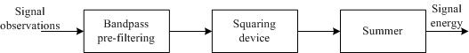
Figure 2. Energy detection device.
At this point, we provide some broad details on noise and signal power measurements. We first find a clean part of the spectrum, preferably not too far from the digitally modulated carrier, and measure the system noise floor amplitude. For digitally modulated carriers, the noise floor measurement is corrected using a noise power bandwidth equal to the digitally modulated carrier’s symbol rate.
For the purposes of deriving analytical expressions for detection and false-alarm probabilities, we can consider the problem for a low-pass process. In this case, the decision statistic can be written in the form
where is the time-bandwidth product. It is easy to show that has a central chi-square () distribution with degrees of freedom under hypothesis, and a non-central chi-square () distribution with degrees of freedom with non-centrality parameter under hypothesis , where is the SNR.
We consider the following data fusion rule: Sum of energy rule
In this rule, each of the reporting CPEs sends values of its measured signal and noise to the CSDU. Let the energy measurement of the th CPE be. A signal is said to be detected if the sum of the values is greater than a threshold, i.e.
Declare if ; else, declare .
The parameter is set so that the system achieves a certain pre-specified probability of false alarm . Although analytical expressions can be obtained for parameters, we use these only as initial conditions when testing our algorithms, and dynamically modify thresholds as needed.

Energy detection at CPEs, decision feedback and decision fusion
We consider the following fusion rule: Sum of decision rule
Each sensing element makes a local decision based on energy detection. Let the energy measurement of the th CPE be. This energy detector output is compared with a threshold. If, the CPE decides that a signal is present and sends a 1 to the CSDU; in the case the reverse inequality holds, the CPE sends a 0 value to indicate the absence of a signal. Note that the threshold can be set so as to achieve a specified probability of false alarm, independent of the signal structure. The CSDU collects these decision values from the reporting CPEs, and if the sum count is greater than or equal to the threshold, the global decision of the signal being present is made, i.e.
Note that this rule encompasses the AND, OR and majority voting rules by setting appropriate values for. The AND rule is based on deciding in favor of detection if all CPEs report so. The OR rule decides in favor if at least one CPE reports so. The majority voting rule is based on the idea of deciding in favor of a decision if a majority of the CPEs report positive signal detection results. The global probability of detection and probability of false-alarm in this case depend on the average probabilities of detection and probabilities of false-alarm at individual CPEs. Analytical expressions of these probabilities can be readily derived for a number of channel fading scenarios (eg., Rayleigh, Ricean, Nakagami) as functions of SNR and threshold .

Cyclostationary detection at CPEs, decision feedback and decision fusion
Communication signals have traditionally being modeled as stationary. A large class of signals like AM, FM, VSB, PSK, QAM, OFDM, CDMA in fact exhibit underlying periodicities in their signal structure. The scheme described herein aims to exploit these signal properties to detect and classify signals, and is based on the theory of cyclostationarity.
Consider a zero-mean discrete-time signal. We say that is cyclostationary with period if its autocorrelation function is -periodic, i.e.
We define the cyclic autocorrelation function (CAF) as
with the discrete time Fourier transform giving the cyclic spectrum density (CSD), also known as the spectral correlation function (SCF), defined as
The parameter is called the cycle frequency; each cyclic frequency is an integer multiple of the fundamental time period of the signal. Note that for , the CAF and CSD reduce to the conventional autocorrelation and power spectral density functions. Also, due to the symmetry and periodicity in , the entire function is completely specified over . Further we note that a cyclostationary signal passed through a linear time-invariant channel, which the channels in [2] are modeled by, remains cyclostationary. Also, if the signal is composed of signals , i.e.
where signal has cycle frequency , we can extract the CSD from by considering the particular cycle frequency , i.e.
.
Different signals exhibit different underlying signal periodicities, i.e. exhibit distinct spectral characteristics at their cycle frequencies. For a large class of signals, we can determine what the cycle frequency is. We now consider a simple example of a BPSK signal and specify its cycle frequency. Consider the BPSK signal
where is the average power, the IF carrier frequency, the bit duration and a random message sequence. One can easily derive the expression for the CSD to show that it has spectral components at , for integer . Thus to detect a BPSK signal with known characteristics, one only has to analyze the CSD at .
To gain an intuition into how cyclostationarity based detection works, let us revisit the problem of binary hypothesis testing. We want to determine whether the signal of interest to be detected , that is transmitted over a channel with channel impulse response in the presence of additive white Gaussian noise (AWGN) , is present or not on the basis of the measured received signal . That is, we want to determine which of the following hypothesis is true:
It is easy to show that we have the following relation
The conventional energy detector corresponds to testing the energy levels obtained from at for the signal absent and signal present cases. When the signal is heavily attenuated and/or is in the presence of a strong noise component, it becomes difficult to discriminate between the energy levels of signal+noise and noise. However a cyclostationary detector is not faced with this problem since detection can theoretically be done irrespective of the noise power level.
Different forms of detection statistics are possible, each derived from . Some examples are
  - Single-cycle magnitude detector:
where is the sliding cyclic auto-periodogram and the observation window length.
  - Multi-cycle magnitude detector:
This is simply a detector, , that is evaluated over all or a set of cycle frequencies.
In fact, we can also consider one-dimensional processing to alleviate some of the computational burden that arises from two-dimensional processing by projecting on the cycle frequency axis to obtain the projection .

Energy detection mode of cyclostationary detection
Cyclostationary feature detection is a particularly attractive detection technique due its robustness to noise power and resulting improved performance in low SNR regimes. In particular, consider a situation where the WRAN system has very few active CPEs that observe a TV signal at low SNRs. An energy detector would not perform very well with respect to the local detection probability. As such, even with information fusion, a sensing scheme operating on energy detection might not perform well. In such situations, a cyclostationary detector is a better option to increase detection reliability. However in cases where CPEs report high detection SNRs and rely on other means for signal classification, an energy detector might be sufficient for achieving the high detection probabilities expected for WRAN systems. A cyclostationary detector can be made to operate flexibly in an energy detector mode by simply operating in the mode, and either reporting the power computed from in the case of data fusion, or reporting a decision bit in the case of decision fusion.

Advantages of cyclostationary detection
Cyclostationary based detection offers a number of advantages over conventional energy detectors. One, the cyclic spectrum is a richer domain for signal analysis as compared to conventional power spectrum. As such the cyclic power spectrum density is a more comprehensive tool for signal analysis. This argument holds in light of the fact that the signals that are of interest are VSB, OFDM, and digital modulation like QAM, all of which exhibit cyclostationarity. Two, this method provides a tool for both signal detection and classification. Suppose the RF environment is composed of several superimposed signals, an energy detector would be overwhelmed due to their inability to measure or exploit fundamental signal properties. On the other hand, a cyclic power spectrum would completely reveal features of different signals (as long as signals do not have precisely the same cycle frequencies). Thus, for example, if we were trying to detect a signal composed of a TV signal, BPSK signal and a QAM-OFDM signal, the cyclic spectrum would reveal spikes at different cycle frequencies. Three, the cyclic spectral density function of noise (modeled as wide-sense stationary) is zero at cycle frequencies. Thus the cyclic spectral density function of a cyclostationary signal embedded in stationary noise when evaluated at non-zero cycle frequencies would reveal properties only of the signal. Based on this property, one can theoretically design a detector that can discriminate signal from noise, independent of the noise variance. This property makes a cyclostationary feature detector an attractive alternative to an energy detector given its robustness to noise with unknown variance. Four, an advantage of using a cyclostationary feature detector is related to the fact that the detection and sensing methods in IEEE 802.22 are expected to evolve with regulations and as the unlicensed operational domain becomes clearer. Since we cannot predict what other kind of unlicensed systems may operate in addition to WRAN in this spectrum, the proposed feature detector offers the advantage that it can be function and evolve independent of the other WRAN functionalities. Five, the cyclostationary detector can be made to operate in an energy detector mode by computing the “zero cycle frequency” which renders this detector more flexibility.

Comments on cyclostationary detection times
Here we provide comments on the detection time involved in the proposed cyclo-stationary feature detector. Consider the problem of obtaining the cyclic spectrum density of a real-valued bandpass signal with a 6 MHz bandwidth, sampled at 50 MHz. The requirement to achieve a reasonable detection output SNR is given in terms of a parameter called the time-bandwidth product which we chose as . Assume that we collect samples with the collection time being 0.2 milliseconds. Assume we use an 1024-point FFT size for computation of the cyclic power spectrum at 10 cycle frequencies. Roughly this would constitute floating point operations (FLOPS) which would take about 0.125 milliseconds on a 10 MFLOPS processor.

Determination of noise-protected contours for interference avoidance/management

As detailed earlier, all active CPEs send in their detection information to the CSDU. The CSDU processes information of all CPEs that report that they detect a particular signal that may be a TV signal from a particular TV transmitter or another WRAN. For simplicity, consider the case of determining whether or not a licensed incumbent in the form of a TV signal is present. In order to do this, the CSDU first collects information from all CPEs that report detection of the particular TV signal type. The next step is based on CPE locations and the noise-protected contours of the TV signal. The noise-protected contour itself is obtained depending on what kind of information might be available to the WRAN information base. One situation is when the noise-protected contour is explicitly specified by some database made available to the WRAN information base. The second situation is that the WRAN has information about the TV transmitter location (this location can be obtained through the TV usage database [6]). Based on the transmitter location and the TV transmitter power, the WRAN information base obtains a conservative estimate of the noise-protected contour by estimating the region while accounting for propagation losses and other RF compensation loss. Now, given the noise-protected contour, the WRAN BS simply checks whether or not the location coordinates of a given CPE correspond to a region that is inside or outside the noise-protected contour. Based on this determination and applicable EIRP profiles, the WRAN radio resource allocation module computes optimum resource allocation parameters, whereupon the local WRAN information base is subsequently updated.

Sensing results from the CPEs to the BS
Based on the detection results of the CPEs, the WRAN BS constructs a sensing map as shown below on each channel. The information is then mapped along with the noise-protected contour regions of licensed incumbents to construct a dynamic spectrum map of spectrum usage.

CPE IDs | CPE location | CPE sensing and classification and classification report  [Characteristics of signals detected]
CPE IDs | CPE location | Power of signal type 1 | Spectrum occupancy of signal type 1 | Power of signal type 2 | Spectrum occupancy of signal type 2 | …
Table 1. Spectrum sensing results

Dynamic map of spectrum usage
The map basically shows how spectrum is being used and where spectrum opportunities exist.
Sensing measurements
TV usage database
Information fusion of distributed sensing results

.
.
.

.
.
.

.
.
.
Channel N+1
BS ID
spatial footprint
spectral footprint

BS ID
spatial footprint
spectral footprint

type of incumbent
spatial footprint
spectral footprint
Channel N
Other Licensed exempt
Other WRANs

Licensed incumbents

Table 2. Map of spectrum usage

Regional WRAN information base
This information base is used to facilitate WRAN coexistence and inter-WRAN resource sharing. It contains information such as: BS identification, BS location information, Channels in use, and possibly other information required for spectrum and channel management. Dynamic information here is for instance in the form of channels in use information which is updated by WRANs periodically. Issues pertaining to ensuring only authorized access of the information base occurs, data integrity etc are part of security solutions. Further, coordination issues such as synchronization between different information bases are primarily beyond the scope of IEEE. Note that a WRAN system does not necessarily have to detect a WRAN signal through sensing means given the availability of channel in use information of neighboring WRANs in this information base. However in case there are situations wherein such information is not available, our proposal supports determining such information through detection of WRAN signals.

Operator ID | WRAN BS ID | WRAN BS location | Currently occupied spectrum occupancy | Spectrum resources available for sharing | Other parameters to facilitate inter-WRAN resource sharing
Table 3. Regional WRAN information base

Local WRAN information base

This information base is local to the WRAN and is a facilitator for resource allocation within the WRAN system. This information base takes into account information from components such as the local WRAN spectrum map and WRAN resource allocation module. Such a local information base ensures that the BS has a clear and direct picture of the resources being used by CPEs (such as modulation and coding scheme (MCS), uplink transmit power etc.) with a “genie-like” control with the ability to perform sanity checks to ensure any abnormalities of CPE operation do not occur.

WRAN BS ID | BS location | CPE IDs | CPE location | CPE DL | CPE UL | QoS and resource allocation information
 |  |  |  |  |  | SNR | Service requirement | CPE MCS | CPE Tx power | …

Table 4. Local WRAN information base

BS-CPE communication channel for sensing information exchange
The WRAN system operates in spectrum that is licensed. As such, using a pre-defined control channel for exchange of sensing information among BS and CPEs is not a feasible approach (unless actions of a regulatory nature are taken). There are different approaches to solve this problem. One approach involves defining one or more narrowband control communication channels in a channel, or channels, known a priori not to provide TV services and where wireless microphones do not operate. (Note that TV channel occupancy is indeed “publicly available” via published databases by the FCC in the US, and as such it is not unreasonable to assume that such information is obtained during a WRAN setup.) These channels of course would vary across geographical regions due to different licensed incumbent operation across TV channels. Situations may of course occur where no channel that is never used by a TV station, and in which Part 74 devices are not allowed to operate, is found. Even in this case, the WRAN BS could use procedures that reduce the search space over which CPEs have to scan to find BS control information channel(s). We believe this is a simple solution to communicating control information. Another approach involves defining underlay channels using techniques such as multi-access spread-spectrum. Either way, rules of a regulatory nature might be required pertaining to such control channels. We also note that when sensing information and controls are exchanged between the WRAN BS and CPEs, the exchange has to be reliable. We ensure this by incorporating highly robust coding. At this stage of the proposal submission, we do not consider further detailed information of the specifics of the control channel since it does not impact the detection process itself or other associated mechanisms in a major way. In the following, we describe the MAC frame formats, part of which contains sensing management information as well.

MAC frame structure
The SystemInfo (in every MAC frame) portion in BS downlink frame is used to carry some sensing related information to CPEs/other WRANs. It is also used by BS to send sensing management messages to CPEs or other BSs. Shown below are some fields present in the SystemInfo portion.
The BS communication sub-channel portion is used for BS to set BS communication sub-channel periodically, and need not appear in every MAC frame. BS communication sub-channel is used for inter-base station communication. A BS that wants to share some frequency bands must send a request message without collision.

Sensing protocols
Herein we describe issues pertaining to various protocols pertaining to sensing. We consider two cases. One is when the WRAN begins operation on initialization and two is when the WRAN is in operation.

WRAN initialization
WRAN systems may have to reinitialize for example if there is a situation that no TV channel is found empty during WRAN operation due to which it has to shut down. The process of initialization is not straightforward in the case of WRANs due to their unlicensed nature. We present two solutions to address this.
One solution involves the following steps. The WRAN BS starts by consulting the TV usage database and the regional WRAN information base to find potentially empty channels. To ensure these channels are indeed empty, it performs sensing to find one or more empty channels. Note that at this point the BS has no choice but to make the decision as to whether or not a channel is empty based only on its observations. Hence we propose that the BS adopt intensive detection processing (in the form of increased signal collection time and integration time along with detection that yields very high detection probabilities ever at low SNRs). The case of not finding any empty channels is composed of two cases. One, there is no empty channel for unlicensed operation in which case the WRAN BS has no option but to remain silent. Two, there are channels in which licensed devices do not operate but other WRAN(s) operate. In this case, it consults the regional WRAN information base, makes resource requests to appropriate WRANs and procures channel(s) for usage. Now, we have a situation where the WRAN BS has procured channel(s) for operation. There still remains the problem of ensuring that operation can occur without causing interference to incumbents. We now address this issue. The BS sends information about the channel set(s) potentially available for operation and requests the CPEs to send in their environment sensing reports regarding these channels. The CPEs on their part have to scan channels to listen to this message. Several cases may occur with respect to CPEs receiving the BS message. One, all CPEs that desire to be associated with the WRAN do receive the message in which case they carry out sensing in channels as instructed by the BS. Two, only some CPEs receive the BS message. In this case the WRAN sets up transmission only if there is sufficient (in the sense of meeting the requirements required in [1]) reliability of sensing from reporting CPEs. Based on the sensing reports from the CPEs, the BS uses information fusion to determine if a given channel is actually empty. It also determines in which channel(s) it should operate on. It further determines a set of “secondary usage channels” which are channels that could be potentially used if a primary user comes up in the channel of operation or if another WRAN user makes an inter-WRAN resource sharing request. This information is sent to the CPEs along with resource allocation information (transmit power, modulation and coding etc.) whereupon data transmission can begin. The local WRAN information base is updated with the CPE resource allocation information and the regional WRAN information base with the WRAN channel usage information.
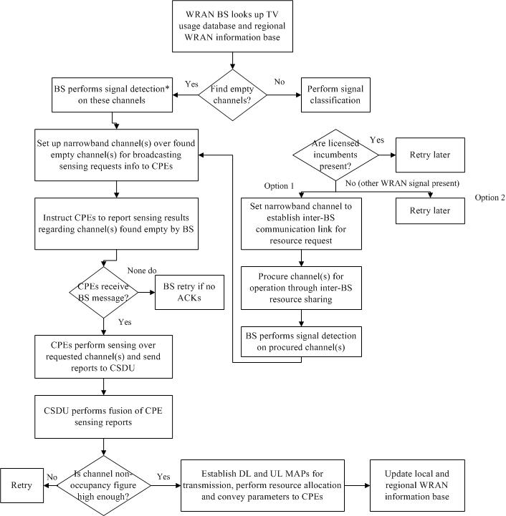
Figure 3. WRAN initialization (Option 1).
The alternative solution involves the following steps. The WRAN BS starts by consulting the TV usage database and the regional WRAN information base to find potentially empty channels. To ensure these channels are indeed empty, it performs sensing to find one or more empty channels. It then broadcasts a pre-defined sensing request signal on channels it found empty. Receiving CPEs then perform sensing on these channels and report by either sensing a pre-defined channel report signal if the channel is found empty.

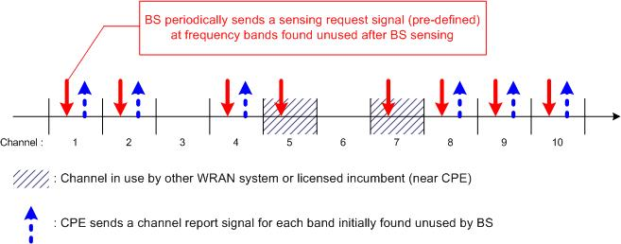
Figure 4. WRAN initialization (Option 2).

WRAN in-service sensing
Now consider what happens in the situation when sensing needs to take place during WRAN operation. In this case, the CPEs perform sensing in regular time intervals as specified by the BS. Sensing has to be performed in channels in which data transmission is occurring (referred as in-band measurements) as well as in channels in which data transmission is not currently occurring (referred as out-of-band measurements). While the latter case is straightforward, the case of in-band measurements might require quiet periods, i.e. data transmission might have to cease for a period equal to that required to perform sensing. We however note here that in the case of TDD, it is not absolutely necessary to have such quiet periods since CPE sensing can be coordinated in such a way that it occurs in time intervals of downlink transmission. Based on the sensing reports from the CPEs, the BS uses information fusion to determine if a given channel is actually empty. It also determines in which channel(s) it should operate via an optimization process performed by the WRAN resource allocation module. It also determines a set of “secondary usage channels” which are channels that could be potentially used if a primary user comes up in the channel of operation or if another WRAN user makes an inter-WRAN resource sharing request (such secondary channels are used only after distributed sensing confirms they are indeed empty; their use is primarily for reducing the search space in the sensing process which has a direct impact on the time involved in dynamic channel selection). This information is sent to the CPEs along with resource allocation information (transmit power, modulation and coding etc.) whereupon data transmission can begin. The local WRAN information base is updated with the CPE resource allocation information and the regional WRAN information base with the WRAN channel usage information.
In the Figure below, we show the above described process for a simple case where the WRAN is operating on a single channel k. Extension to the multiple channel operation case is simple.
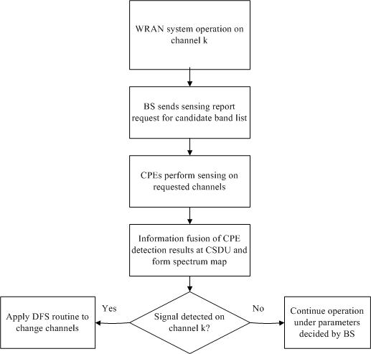
Figure 5. WRAN in-service sensing.

Dynamic frequency change
Herein we describe procedures required when a licensed device is detected in the channel(s) of operation.
If a primary system appears and after sensing BS detects that there appears licensed service signal like television or wireless microphone above the specific threshold and there exists bandwidth collisions between the WRAN system and the licensed incumbent service, BS should move to new empty band to avoid interference, which is called dynamic frequency changing. The frequency changing procedure is as follows: First BS starts frequency sensing to find a new empty band to move to. Once the empty band is found, BS should broadcast the frequency changing to CPE through SystemInfo portionusing the BandChange message which includes up and/or down frequency changing, new frequency info. Consequently CPE senses whether the new frequency band is empty or not. Then it sends Sensing Report to BS (with the current up-link band) to inform the status of the new band and if the new band was already occupied then to inform the available band list (if it has). Sensing report is sent after CPE obtained a channel using CDMA code to avoid collisions among CPEs and piggybacked on the uplink data burst. So BS should wait a sufficient time before it moves.
However, frequency changing failure happens when CPE did not receive BandChange message or BS did not receive Sensing Report message during the frequency changing procedure. Frequency changing failure events may occur under the following circumstances. In the case that CPE did not receive BandChange Message. The reason could be
1. State of downlink channel is bad.
2. Secondary BS’s power (signal strength) is weaker than primary BS.
3. Synchronization is wrong.
In the case that BS did not receive Sensing Report message the reason could be
1. State of uplink channel is bad.
2. Secondary BS’s power (signal strength) is weaker then primaryBS.
3. Synchronization is wrong.
4. Collisions of CPE’s CDMA code in ranging sub-channel.
Under both circumstances, we should refer to the sudden death procedure.
Also if the signal strength of the primary system that suddenly appeared is quite strong, it may be impossible for some CPEs to decode the WRAN BS’s message. Sudden death procedure solves just such problems. There are two cases to be considered. The first one is that BS could not recognize the primary system and continuously uses the current bands when the primary system signal with strong power suddenly appears or BS couldn’t receive the sensing report from CPE during frequency changing procedure. Second, BS recognizes the primary system appearance and will move to new bands but the CPE could not hear BandChange message from BS. For both cases, CPEs should search other frequency bands to find out the BS. If BS is serving with several bands and the CPE is served with one of the bands of BS (FDD case for instance is shown as below).

frequency
up1
up2
down1
down2
down3
CPE
Uplink band problem can be easily detected by BS. BS handles this (e.g., BandChange).
CPE={up1, down1}
CPE={up2, down2}
BS maintains a service table for each CPE’s band={uplink band, downlink band}.When the CPE cannot hear BS signal with the current downlink band down1, itmoves to one of the other downlink band down2 and tries to connect to BS. After the CPE got a synch with the new band, it sends BandMove message to BS to request for the frequency change to down2 with the up link band up2, which is indicated in DL-MAP. Then BandMoveACK message is sent by BS with the new downlink band (down2). If CPE cannot receive the BandMoveACK within the given time, it will try to use different downlink band. To do that, BS should broadcast its CurrentBandList in SystemInfo of all its downlink bands. If CPE fails to synchronize to BS with all current down link bands in the previous CurrentBandList, it may mean that BS changed its service bands into entirely new bands. Then CPE should search all frequency bands until it finds out the BS.

frequency
up2

up1
down1
down2
down3
CPE
up1
CurrentBandList={down1,down2,
down3, up1, up2, up3}

DL-
MAP

Info
System
FCH
DL-BurstBurst
DL – Burst
DL – Burst
DL-Burst
DL- Burst
DL-Burst
DL – Burst
UL-MAP
Preamble

MAC frame of down1

To reduce this searching effort by CPEs, BS periodically broadcasts some candidate bands to move after BS periodically performs spectrum sensing. Candidate bands are not used now, but if BS cannot use the current bands, then it will try to move to the candidate bands first. CandidateBandList message is also included in SystemInfo portion. When CPE entirely lost the connection with the BS, it first searches the BS from the candidate bands. Fig 6 gives the state State transition diagram of sudden death resolution for the CPE. During all these processes, CPE initialization is needed. The state diagram for CPE reinitialization is shown in Fig.7.

Figure 6. State transition diagram of sudden death resolution.

Figure 7. CPE reinitialization diagram.

Inter-WRAN resource sharing module

An important issue in WRAN systems is efficient spectrum management across WRAN systems that are making secondary usage of the spectrum. Our goal would be to maximize spectrum utility while maintaining minimal interference and providing a degree of equity across users of the WRAN systems. Algorithms and related information exchange management fall under the scope of the inter-WRAN resource sharing module and associated protocols. This also facilitates detection and identification of other WRAN systems that may be operating co-channel or on adjacent channels to facilitate sharing, coexistence, and interference mitigation amongst such neighbors.
To facilititate WRAN coexistence, we make the provision of the regional WRAN information base that is accessible to WRAN BSs. The information base includes information such as WRAN Operator Identification, Base station ID, Base station location coordinates, and Channels in use.
We now describe procedures for resource sharing among multiple BSs. Before proceeding, we mention that these parts either can be executed via explicit communication among BSs, or via implementing a module within the inter-WRAN resource sharing module. For specificity, we describe the former case.

Resource portioning requests among WRANs
Let the prior station be the one assumed by the neighbouring base station to have available resource and the secondary station the neighbour base station in need of spectrum. The secondary station initiates the resource request through the BS Communication sub-channel in the up-link of prior station. In this proposal, we don’t specify the partition ratio, though we assume it is defined a priori by other means.
Note that the BS communication sub-channel, defined in UL_MAP, appears in every periodic number of frames. To avoid collision among the resource requests, we propose a CDMA based contention in the BS communication sub-channels. The requests from the neighboring stations should be given a higher priority than the ones from the CPEs of the prior base station.
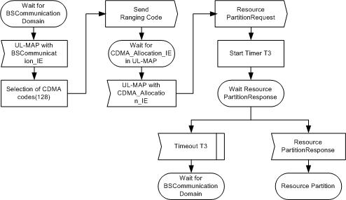
Figure 8. Resource partitioning request.

Fig. illustrates the state changes in the secondary station requesting the resource partition. The secondary station waits for the UL_MAP with BS communication field. After the acquisition of information on BS communication channel, the station selects a CDMA code and begins ranging in BS communication channel with the CDMA code. The prior station reserves a field in a up-link PDU and informs this to the secondary station through CDMA_Allocation_IE in UL_MAP. The secondary station sends the resource partition request in this up-link PDU of the prior station and waits for the resource partition response message, which ends the whole resource partition process. If Timeout period T3 elapses without the response from the prior station, the whole process should be restarted.

Dynamic resource renting among WRANs
Resource renting is necessitated for example due to disproportions in subscribers or traffic volume across servicing BSs. Hence protocols are required to facilitate sharing resources on temporary basis. To communicate such resource requests across WRANs, consider that a BS2 (renter) wants to perform a resource request to BS1 (offeror). To send a message on BS1’s uplink channel, BS2 first has to request use of this uplink. As an example case, BS1 may periodically (not in every frame) broadcast the appearance of a BS communication subchannel and its position in UL-MAP with BS1’s downlink. If BS2 wants to send a message to BS1, BS2 hears BS1’s UL-MAP and determines whether the BS communication subchannel is available on the next uplink channel of BS1. BS2 then sends a CDMA code over the BS communication subchannel of BS1’s uplink. BS1 subsequently allocates uplink resources to BS2 with UL-MAP. BS2 then sends a message for the dynamic resource renting procedure.
Figures below show the state transition diagrams of offeror and renter stations for renting, collecting and returning procedures.

Figure 9. State transition diagram of resource renting (Offeror BS).
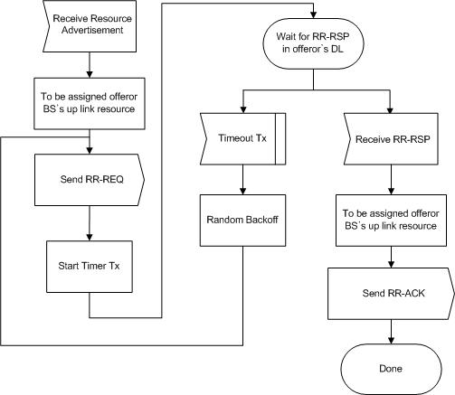

Figure 10. State transition diagram of resource renting (Renter BS).

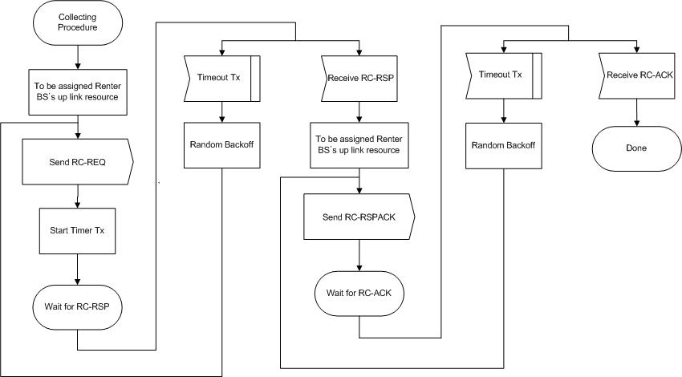
Figure 11. State transition diagram of resource collecting (Offeror BS).
Figure 12. State transition diagram of resource collecting (Renter BS).
Figure 13. State transition diagram of resource returning (Offeror BS).
Figure 14. State transition diagram of resource returning (Renter BS).

WRAN Physical layer

Duplexing modes and supported FFT sizes
In TDD mode, the duplex transmission is carried in alternate time slots in the same frequency channel. A TDD frame which consists of one downlink and one uplink subframe has a fixed duration. The up- and downlink subframe within one TDD frame can have different length. Transmit/receive transition gap (TTG) is a gap between the downlink burst and the subsequent uplink burst. This gap is used to switch the BSs from transmit mode to receive mode and to switch the CPEs from receive mode to transmit mode. During this gap, modulated data are transmitted by neither the BS nor the CPE. Instead, the BS transmitter carrier ramps down, the transmit/receive (Tx/Rx) antenna switches to actuate, and the BS receiver sections to activate. After this gap, the BS receiver shall look for the first symbol of uplink burst. The TTG starts on a PS boundary with an integer number of PS durations. (Here, PS means Physical Slot.)

Receive/transmit transition gap (RTG) is a gap between the uplink burst and the subsequent downlink burst. This gap is used to switch the BSs from receive mode to transmit mode and to switch the CPEs from transmit mode to receive mode. During this gap, modulated data are transmitted by neither the BS nor the CPE. Instead, the BS transmitter carrier ramps up, Tx/Rx antenna switches to actuate, and the CPE receiver sections to activate. After this gap, the CPE receiver shall look for the first symbol of QPSK modulated data of the downlink burst. The RTG starts on a PS boundary with an integer number of PS durations.
Parameter | Value
Duplex | TDD
Multiple Access | OFDMA
System bandwidth | 6 MHz
Sampling frequency | 6 MHz
 | 1K mode |  |  |  |  | 2K mode |  |  |  |  | 4K mode
Number of used tones | 864 out of 1,024 |  |  |  |  | 1728 out of 2,048 |  |  |  |  | 3,456 out of 4,096
Number of data tones | 768 |  |  |  |  | 1536 |  |  |  |  | 3,072
Number of pilot tones | 96 |  |  |  |  | 192 |  |  |  |  | 384
Tone spacing | 5.859375 kHz |  |  |  |  | 2.9296875 kHz |  |  |  |  | 1.46484375 kHz
Signal bandwidth | 5.0625 MHz |  |  |  |  | 5.0654 MHz |  |  |  |  | 4.9921875 MHz
FFT duration | 170.67 μs |  |  |  |  | 341.33 μs |  |  |  |  | 682.66 μs
Cyclic prefix time | 35.165 μs |  | 60.1642 μs |  |  | 35.165 μs |  | 60.1642 μs |  |  | 35.165 μs |  | 60.1642 μs
OFDMA symbol time | 204.792 μs |  |  | 230.67 μs |  | 375.463 μs |  |  | 401.33 μs |  | 716.793 μs |  |  | 742.66 μs
TDD frame length | 4ms | 5ms |  |  | 6 ms | 4ms | 5ms |  |  | 6 ms | 4ms | 5ms |  |  | 6 ms
Number of symbols in a frame | 19 | 24 |  |  | 29 | 10 | 13 |  |  | 15 | 5 | 6 |  |  | 8
Table 5. TDD parameters
Frame structure  (ref: duty ratio 1:1 / 2:1 / 3:1) |  |  | 1K mode |  | 2K mode |  | 4K mode
 |  |  | DL | UL | DL | UL | DL | UL
Tx duration (TTrans) | 4ms | 1.843  /2.253  /2.662 ms | 1.638/  1.228/  0.819 ms
Tx duration (TTrans) | 5ms | 2.252  /3.072  /3.481 ms | 2.252  /3.891  /4.301ms | 2.252  /-  /- | 2.252.778  /-  /-
Tx duration (TTrans) | 6ms | 2.867  /3.891  /4.301  ms | 2.662  /1.638  /1.229  ms | 3.003  /3.755  /4.130  ms | 2.628  /1.877  /1.502  ms | 2.867  /3.584  ms | 2.150  /1.434  Ms
TDD Gap time (Tguard) | 4ms | 518.536 μs  (288.90+129.63)
TDD Gap time (Tguard) | 5ms | 494.58 μs  (370.9+123.64) |  | 494.44 μs  (370.83+123.61)
TDD Gap time (Tguard) | 6ms | 470.616μs  (TTG + RTG =  353.025μs + 117.675 μs) |  | 368.055μs  (TTG + RTG =  273.000μs + 92.000 μs) |  | 982.449 μs  (TTG + RTG =  736.500μs + 245.500 μs)
Table 6. TDD parameters
The frame interval contains transmissions (PHY PDUs) of BS and CPEs, gaps and guard intervals.

The OFDM PHY supports a frame-based transmission. A frame consists of a downlink subframe and an uplink subframe. A downlink subframe consists of only one downlink PHY PDU. An uplink subframe consists of contention intervals scheduled for initial ranging and bandwidth request purposes and one or multiple uplink PHY PDUs, each transmitted from a different CPE.

In each TDD frame, the TTG is inserted between the downlink and uplink subframe while the RTG is inserted at the end of each frame to allow the BS to turn around. Figure 4 shows the TDD frame structure.

The OFDM symbol duration consists of two parts: Guard interval and FFT integration time. To eliminate intersymbol interference, guard interval is introduced for OFDM symbol. Moreover, it is chosen to be larger than the expected delay spread, such that the delayed multipath components from previous symbol cannot interfere with the current one. Obviously, it seems that larger guard interval means stronger capability to cancel ISI, but it cannot be arbitrarily large because of the SNR loss and more sensitivity to phase noise.

The transmitted signal is mapped to each subcarrier, and the conversion from carrier modulation values to time domain waveform is typically implemented by an IFFT algorithm on blocks of size 2^{n}. The subcarrier spacing is

The whole FFT subcarriers are divided into transmitted data subcarriers and guard bands. In this document, we use roughly 80% effective subcarriers. The FFT integration time is related to carrier spacing by

The numerical value of OFDMA parameters for 6MHz channel, including subcarrier spacing, effective subcarrier number, and symbol duration based on different FFT size and guard interval length, are given in the following table.
# of subcarrier |  | 1 K mode |  | 2 K mode |  | 4 K mode
Subcarrier spacing  (KHz) | 6MHz | 5.860 |  | 2.930 |  | 1.464
Subcarrier spacing  (KHz) | 7MHz | 6.863 |  | 3.418 |  | 1.7090
Subcarrier spacing  (KHz) | 8MHz | 7.813 |  | 3.906 |  | 1.9531
Effective Subcarrier |  | 864  (null carrier : left 80, right 79,  DC 1) |  | 1728  (null carrier : left 160,right 159,  DC 1) |  | 3408  (null carrier : left 343, right 344,  DC 1)
FFT duration (μs) | 6MHz | 170.66 |  | 341.33 |  | 682.66
FFT duration (μs) | 7MHz | 145.71 |  | 292.57 |  | 585.14
FFT duration (μs) | 8MHz | 127.99 |  | 256.01 |  | 512.00
Duration of GI (μs) | 6Mhz | 35.165 | 60.164 | 35.165 | 60.164 | 35.165 | 60.164
Duration of GI (μs) | 7Mhz | 35.145 | 60.04 | 35.145 | 60.04 | 35.145 | 60.04
Duration of GI (μs) | 8Mhz | 35.122 | 60.245 | 35.122 | 60.245 | 35.122 | 60.245
Symbol Duration (μs) | 6MHz | 204.792 | 230.67 | 375.463 | 401.33 | 716.793 | 742.66
Symbol Duration (μs) | 7MHz | 180.86 | 205.75 | 327.71 | 352.61 | 620.285 | 645.18
Symbol Duration (μs) | 8MHz | 163.11 | 188.235 | 291.13 | 316.255 | 547.122 | 572.245
Table 7. TDD parameters

In FDD mode, the uplink and downlink transmissions are carried on separate frequency bands. The capability of the downlink to be transmitted in bursts facilitates the use of different modulation types and allows the system to simultaneously support full-duplex CPEs (which can transmit and receive simultaneously) and half-duplex CPEs (which do not).

Parameter | 1K | 2K | 4K
Duplex | FDD
Multiple Access | OFDMA
System Bandwidth | 6MHz
Sampling frequency | 6MHz
Number of used tones | 864 of 1,024 | 1728 out of 2,048 | 3408 out of 4,096
Number of data tones | 768 | 1536 | 3024
Number of pilot tones | 96 | 192 | 384
Tone spacing | 5.859375KHz | 2.9296875 kHz | 1.46484375 kHz
Signal bandwidth | 5.0625MHz | 5.0654 MHz | 4.9921875 MHz
Basic OFDMA symbol time | 170.67 μs | 341.33 μs | 682.66 μs
Cyclic prefix time | 34.134 μs | 34.133 μs | 34.133 μs
OFDMA symbol time | 202.804 μs | 375.463 μs | 716.793μs
TDD frame length | 3 / 4 / 5 / 6 ms | 3 / 4 / 5 / 6 ms | 3 / 4 / 5 / 6 ms
Number of symbols  in a frame | 14 / 19 / 24 / 29 | 7 / 10 / 13 / 15 | 4 / 5 / 6 / 8
Table 8. FDD parameters
In TDD and FDD system, CPE allowances must be made by a transmit-receive turnaround gap (TTG) and by a receive-transmit turnaround gap (RTG). The BS shall not transmit downlink information to a station later than (RTG+RTD) before its scheduled uplink allocation, and shall not transmit downlink information to it earlier than (TTG-RTD) after the end of scheduled uplink allocation, where RTD denotes Round-Trip Delay. FDD frame structure is shown by Figure below.
Figure 15. FDD frame structure.

For very large cell sizes, TDD suffers from the requirement to wait for the most distant CPE to respond. This turn-around time corresponds to the system capacity loss. For example, in WRAN, the coverage of cell distance is 33-100Km. We assume the maximum cell distance is 33Km and the packet duration is 5ms, so the turn-around time is 217.8μs, and the capacity loss due to turn around time is 217.8/(5ms*2+217.8μs)=1.79%
FFT size |  | 1K |  |  |  | 2K
Modulation |  | DL |  | UL |  | DL |  | UL
 |  | TDD | FDD | TDD | FDD | TDD | FDD | TDD | FDD
QPSK | 1/2 | 3.242077 | 3.750146 | 3.525086 | 3.750146 | 3.461697 | 4.090949 | 3.854812 | 4.090949
QPSK | 2/3 | 4.322769 | 5.000195 | 4.700115 | 5.000195 | 4.615596 | 5.454599 | 5.139749 | 5.454599
QPSK | 3/4 | 4.863116 | 5.62522 | 5.28763 | 5.62522 | 5.192546 | 6.136424 | 5.782218 | 6.136424
QPSK | 7/8 | 5.673635 | 6.562756 | 6.168901 | 6.562756 | 6.05797 | 7.159161 | 6.745921 | 7.159161
16QAM | 1/2 | 6.484154 | 7.500293 | 7.050173 | 7.500293 | 6.923394 | 8.181898 | 7.709624 | 8.181898
16QAM | 2/3 | 8.645539 | 10.00039 | 9.40023 | 10.00039 | 9.231192 | 10.9092 | 10.2795 | 10.9092
16QAM | 3/4 | 9.726231 | 11.25044 | 10.57526 | 11.25044 | 10.38509 | 12.27285 | 11.56444 | 12.27285
16QAM | 7/8 | 11.34727 | 13.12551 | 12.3378 | 13.12551 | 12.11594 | 14.31832 | 13.49184 | 14.31832
64QAM | 1/2 | 9.726231 | 11.25044 | 10.57526 | 11.25044 | 10.38509 | 12.27285 | 11.56444 | 12.27285
64QAM | 2/3 | 12.96831 | 15.00059 | 14.10035 | 15.00059 | 13.84679 | 16.3638 | 15.41925 | 16.3638
64QAM | 3/4 | 14.58935 | 16.87566 | 15.86289 | 16.87566 | 15.57764 | 18.40927 | 17.34665 | 18.40927
64QAM | 7/8 | 17.0209 | 19.68827 | 18.5067 | 19.68827 | 18.17391 | 21.47748 | 20.23776 | 21.47748
- TDD/FDD capacity comparison
- 1 frame duration-TDD: 6ms/FDD: 3ms, SST mode case

Table 9. System capacity

OFDMA subcarrier allocation
In OFDMA, the whole data subcarriers are divided into subchannels, this part gives the methods of subcarrier subchannelization. Figure 6 shows a general sense of subchannelization.
Figure 16. OFDMA subcarrier allocation.

To allocate the diversity subchannels in the dowlink, the whole data tones in a slot are partitioned into groups of coutiguous data subcarriers. Each subchannel consists of one subcarrier from each of these groups. The number of groups is therefore equal to the number of data subcarriers per subchannel, and the number of the subcarriers in a group is equal to the number of subchannels. With the adjacent subcarrier permutation, symbol data within a subchannel is assigned to adjacent subcarriers and the pilot and data subcarriers are assigned fixed positions in the frequency domain within an OFDMA symbol. This permutation is the same for both uplink and downlink. To define adjacent subcarrier permutation, a bin, which is the set of nine contiguous subcarriers within an OFDMA symbol, is a basic allocation unit both in downlink and uplink. The following section defines the uplink transmission and symbol structure. The uplink follows the down-link model, therefore it also supports up to 3 segments. The uplink supports 70 subchannels where each transmission uses 48 data carriers as the minimal block of processing. Each new transmission for the uplink commences with the parameters as given in Table below.
Parameter | Value
Number of DC subcarriers | 1
N_{used} | 1681
Guard subcarriers: Left, Right | 184,183
TilePermutation | 6, 48, 58, 57, 50, 1, 13, 26, 46, 44, 30, 3, 27, 53, 22, 18, 61, 7, 55, 36, 45, 37, 52, 15, 40, 2, 20, 4, 34, 31, 10, 5, 41, 9, 69, 63, 21, 11, 12, 19, 68, 56, 43, 23, 25, 39, 66, 42, 16, 47, 51, 8, 62, 14, 33, 24, 32, 17, 54, 29, 67, 49, 65, 35, 38, 59, 64, 28, 60, 0
N_{subchannels} | 70
N_{subcarriers} | 48
N_{tiles} | 420
Tiles per subchannel | 6

Table 10. OFDM uplink subcarrier allocation
Some comparisons between tile and bin structure are given in the tables below, such as data rate per subchannel, data rate per frame and spectral efficiency, etc.
Modulation |  | 1K | 2K | 4K
Q P S K | 1 / 2 | 78.128 | 42.614 | 22.322
Q P S K | 2 / 3 | 104.171 | 56.819 | 29.762
Q P S K | 3 / 4 | 117.192 | 63.921 | 33.482
Q P S K | 5 / 6 | 130.213 | 71.023 | 37.203
Q P S K | 7 / 8 | 136.724 | 74.575 | 39.063
16QAM | 1 / 2 | 156.256 | 85.228 | 44.643
16QAM | 2 / 3 | 208.341 | 113.637 | 59.524
16QAM | 3 / 4 | 234.384 | 127.842 | 66.965
16QAM | 5 / 6 | 260.427 | 142.047 | 74.405
16QAM | 7 / 8 | 273.448 | 149.149 | 78.126
64QAM | 1 / 2 | 234.384 | 127.842 | 66.965
64QAM | 2 / 3 | 312.512 | 170.456 | 89.287
64QAM | 3 / 4 | 351.576 | 191.763 | 100.447
64QAM | 5 / 6 | 390.640 | 213.070 | 111.608
64QAM | 7 / 8 | 410.172 | 223.724 | 117.189

Expression:
Table 11. Datarate per subchannel- tile, bin case (48 data subcarriers, 3 symbol)
Modulation |  | 1K | 2K | 4K
Q P S K | 1 / 2 | 117.192 | 63.921 | 33.482
Q P S K | 2 / 3 | 156.256 | 85.228 | 44.643
Q P S K | 3 / 4 | 175.788 | 95.882 | 50.224
Q P S K | 5 / 6 | 195.320 | 106.535 | 55.804
Q P S K | 7 / 8 | 205.086 | 111.862 | 58.594
16QAM | 1 / 2 | 234.384 | 127.842 | 66.965
16QAM | 2 / 3 | 312.512 | 170.456 | 89.287
16QAM | 3 / 4 | 351.576 | 191.763 | 100.447
16QAM | 5 / 6 | 390.640 | 213.070 | 111.608
16QAM | 7 / 8 | 410.172 | 223.724 | 117.189
64QAM | 1 / 2 | 351.576 | 191.763 | 100.447
64QAM | 2 / 3 | 468.768 | 255.684 | 133.930
64QAM | 3 / 4 | 527.364 | 287.645 | 150.671
64QAM | 5 / 6 | 585.960 | 319.605 | 167.412
64QAM | 7 / 8 | 615.258 | 335.586 | 175.783
Expression:
Table 12. Datarate per subchannel- cluster case (48 data subcarriers, 2 symbol)
Modulation |  | 6 ms | 5 ms | 4 ms | 3 ms
Q P S K | 1 / 2 | 8.000 | 9.600 | 12.000 | 16.000
Q P S K | 2 / 3 | 10.667 | 12.800 | 16.000 | 21.333
Q P S K | 3 / 4 | 12.000 | 14.400 | 18.000 | 24.000
Q P S K | 5 / 6 | 13.333 | 16.000 | 20.000 | 26.667
Q P S K | 7 / 8 | 14.000 | 16.800 | 21.000 | 28.000
16QAM | 1 / 2 | 16.000 | 19.200 | 24.000 | 32.000
16QAM | 2 / 3 | 21.333 | 25.600 | 32.000 | 42.667
16QAM | 3 / 4 | 24.000 | 28.800 | 36.000 | 48.000
16QAM | 5 / 6 | 26.667 | 32.000 | 40.000 | 53.333
16QAM | 7 / 8 | 28.000 | 33.600 | 42.000 | 56.000
64QAM | 1 / 2 | 24.000 | 28.800 | 36.000 | 48.000
64QAM | 2 / 3 | 32.000 | 38.400 | 12.000 | 64.000
64QAM | 3 / 4 | 36.000 | 43.200 | 54.000 | 72.000
64QAM | 5 / 6 | 40.000 | 48.000 | 60.000 | 80.000
64QAM | 7 / 8 | 42.000 | 50.400 | 63.000 | 84.000
Expression:
Table 13. Datarate per frame (48 subcarriers)

Modulation |  | 1K | 2K | 4K
Q P S K | 1 / 2 | 0.625 | 0.682 | 0.703
Q P S K | 2 / 3 | 0.833 | 0.909 | 0.938
Q P S K | 3 / 4 | 0.938 | 1.023 | 1.055
Q P S K | 5 / 6 | 1.042 | 1.136 | 1.172
Q P S K | 7 / 8 | 1.094 | 1.193 | 1.230
16QAM | 1 / 2 | 1.250 | 1.364 | 1.406
16QAM | 2 / 3 | 1.667 | 1.818 | 1.875
16QAM | 3 / 4 | 1.875 | 2.045 | 2.109
16QAM | 5 / 6 | 2.083 | 2.273 | 2.344
16QAM | 7 / 8 | 2.188 | 2.386 | 2.461
64QAM | 1 / 2 | 1.875 | 2.045 | 2.109
64QAM | 2 / 3 | 2.500 | 2.727 | 2.813
64QAM | 3 / 4 | 2.813 | 3.068 | 3.164
64QAM | 5 / 6 | 3.125 | 3.409 | 3.516
64QAM | 7 / 8 | 3.281 | 3.580 | 3.691
Expression:
Table 14. Spectral efficiency (bin case)
Cluster | Cluster(DL) | Tile(UL) | BIN(DL) | BIN(UL)
1K | 240 | 70 | 256 | 80
2K | 210 | 56 | 224 | 64
4K | 120 | 56 | 128 | 64
Expression:
Table 15. Number of users per frame

Synchronization
For TDD and FDD realizations, it is recommended (but not required) that all BSs be time synchronized to a common timing signal. In the event of the loss of the network timing signal, BSs shall continue to operate and shall automatically resynchronize to the network timing signal when it is recovered. For both FDD and TDD realizations, frequency references derived from the timing reference may be used to control the frequency accuracy of Base-Stations provided that they meet the frequency accuracy requirements of 6.1.3. This applies during normal operation and during loss of timing reference. For any duplexing, all CPEs shall acquire and adjust their timing such that all uplink OFDMA symbols arrive time coincident at the BS to a accuracy of ±25% of the minimum guard-interval or better.

Symbol clock frequency tolerance
At the BS, the transmitted center frequency, receive center frequency, and the symbol clock frequency shall be derived from the same reference oscillator. At the BS, the reference frequency accuracy shall be better than ±2*10⁻⁶. At the CPE, both the transmitted center frequency and the symbol clock frequency shall be synchronized to the BS with a tolerance of maximum 2% of the subcarrier spacing. During the synchronization, period, the CPE shall acquire frequency synchronization within the specified tolerance before attempting any uplink transmission. During normal operation, the CPE shall track the frequency changes and shall defer any transmission if synchronization is lost.

Ranging
Ranging for time (coarse synchronization) and power is performed during two phases of operation: initial ranging and periodic ranging. The initial ranging transmission shall be used by any CPE that wants to synchronize to the system channel for the first time. An initial-ranging transmission shall be performed during two consecutive symbols. The same ranging code is transmitted on the ranging channel during each symbol, with no phase discontinuity between the two symbols. A time-domain illustration of the initial-ranging transmission is shown is in Figure below.
CP
CP
CP
CP
First Ranging Symbol
OFDMA Symbol
Second Ranging Symbol
CP copy
CP copy
Figure 17. Initial ranging (2 symbols).
Periodic-ranging transmissions are sent periodically for system periodic ranging. Bandwidth-requests transmissions are for requesting uplink allocations from the BS. These transmissions shall be sent only by CPE that have already synchronized to the system. To perform either a periodic-ranging or bandwidth-request transmission, the CPE can send a transmission in one of the following ways:
- Modulates one ranging code on the ranging subchannel for a period of one OFDMA symbol. Ranging subchannels are dynamically allocated by the MAC layer and indicated in the UL-MAP. A time-domain illustration of the periodic-ranging or bandwidth-request transmission is shown in Figure below.

CP
CP
Ranging Symbol
OFDMA Symbol
CP copy
Time
Figure 18. Periodic-ranging or bandwidth-request transmission for OFDMA using one symbol.

- Modulating three consecutive ranging codes (starting code shall always be a multiple of 3) on the ranging subchannel for a period of three OFDMA symbols (one code per symbol). Ranging subchannels are dynamically allocated by the MAC layer and indicated in the UL-MAP.

Power control
To maintain at the BS a power density consistent with the modulation and FEC rate used by each CPE, the BS may change the CPE TX power as well as the CPE assigned modulation and FEC rate. There are, however, situations where the CPE should automatically update its TX power, without being explicitly instructed by the BS. This happens when the CPE transmits in region marked by UIUC=0, UIUC=12, or UIUC=14. In all these situations, the CPE shall use a temporary TX power value set accordingly (in dB).

where,

P_{new} is the temporary TX power,
P_{last} is the last used TX power,
C/N_{new} is the normalized C/N of new modulation/FEC rate instructed by the UIUC.
C/N_{last} is the normalized C/N of the last used modulation/FEC rate,
R_{new} is the number of repetitions for the new modulation/FEC rate instructed by UIUC,
R_{last} is the number of repetitions on the last used modulation/FEC rate.

The default normalized C/N values per modulation are given by Table below. These values may be overridden by BS by using a dedicated UCD message TLV.
Modulation/  FEC rate | Normalized C/N
Fast_feedback IE | 0
CDMA code | 3
QPSK 1/2 | 6
QPSK 3/4 | 9
16-QAM 1/2 | 12
16-QAM 3/4 | 15
64-QAM 1/2 | 18
64-QAM 2/3 | 20
64-QAM 3/4 | 21
64-QAM 5/6 | 23
Table 16. Normalized C/N per modulation
To maintain at the BS a power density consistent with the modulation used by each CPE, the BS may change the CPE TX power as well as the CPE assigned modulation and FEC rate. There are, however, situations where the CPE should automatically update its TX power, without being explicitly instructed by the BS. This happens when the CPE transmits in region marked by UIUC=0, UIUC=12, or UIUC=14. In all these situations, the CPE shall use a temporary TX power value set according to the formula Temporary TX Power=Last_TX_Power_Normalized_C/N_of_last_modulation+Normalized_C/N_of_QPSK_1/2_modulation.

The CPE shall report the maximum available power and the normalized transmitted power. These parameters may be used by the base station for optimal assignment of coding schemes and modulations and also for optimal allocation of subchannels. The algorithm is vendor-specific. These parameters are reported in the REG-RSP message. The current transmitted power shall also be reported in the RNG-RSP message if the relevant flag in the REP-REQ message has been set.

The current transmitted power is the power of the burst that carries the message. The maximum available power is reported for QPSK QAM16 and QAM64 constellations. The current transmitted power and the maximum power parameters are reported in dBm. The parameters are quantized in 0.5dBm steps ranging from -64dBm (encoded 0x00) to 63.5dBm (encoded 0xFF). Value outside this range shall be assigned the closet extreme. CPEs that do not support QAM64 shall report the value of 0x00 in the maximum QAM64 power field.

WRAN coexistence spectrum etiquette
To avoid inter-cell interference, neighbor cells/sectors should cooperate when deciding what frequency bands to use. This is extremely important for WRAN because, unlike cellular system, each WRAN cell picks up frequency band dynamically and frequency planning cannot be done in advance. Neighbor cell should cooperate to avoid inter-cell interference. Without cooperation, the frequency selection in a cell may prohibit neighbor cells to function. For example, the available channels at BS1 and BS2 are {1, 3}, and {1, 2, 3} respectively. If BS2 decides to use {1, 3}, BS1 would have no channel to use. The cooperation is also necessary for load balancing. Say BS1 is heavy loaded while BS2 is not. BS2 could use {2}, then BS1 can use {1, 3}.

A distributed interference-management scheme is proposed here. The terms of central sector/cell and neighbor sectors/cells are relative concept. If there is no sectorization, one central cell has 6 neighbor cells. The scheme is illustrated using a 6-sector per cell scenario, in which case a central sector has 3 neighbor sectors. The following entities are defined and used in describing the mechanism for WRAN coexistence.

- F_{usable, ID} := the frequencies that do not interfere incumbent uses.
- F_{used, ID} := the frequencies that the central sector has picked up. This could include some backup bands.
- F_{pool} := the frequencies that are usable in the central sector and are not used by neighbor sectors := F_{usable, ID} \ (F_{used,n1} U F_{used,n2} U F_{used,n3})
- F_{local} := F_{pool} \ {F_{usable,n1} U F_{usable}, n2 U F_{usable, n3}}

Note that:
- symbols U, ∩, and \ are set operation of union, intersection, and exclude, respectively.
- ID means sector ID. In this example, it is the ID of the central sector, whereas neighbor sectors are further denoted as n1, n2, and n3.

The procedure of WRAN spectrum etiquette is as follows.
- The central sector decides its F_{usable}, and F_{pool}.
- The central sector picks up frequencies from the F_{pool} according to the following etiquette principles.
  - Try to use the frequencies that cannot be used by neighbor cells at all. In other words, use first the frequencies in F_{local}
  - If the central sector has got enough frequencies, go to Step 3. Otherwise, try to pick up frequencies from the rest of F_{pool} with the consideration of avoid using those that will affect a single neighbor cell most. For example, Use first the frequencies that are not shared by more than one neighbor cells, then other frequencies that may affect more and more neighbor cells.
  - If the central sector has got enough frequencies, go to Step 3. Otherwise, go back to Step 1 and try later. (An optional step can be taken here is trying to ask help from neighbor cells so they could release some frequencies.)
- If needed, update neighbor cells of its F_{usable}, and F_{used}. Go back to Step 1.

Note that the procedure can be done periodically, or can be triggered by a certain predefined events.

Figure 19. An example.

Maximum transmit power constraint for interference management and coexistence of WRANs
The maximum transmit power for each CPE must be controlled by the base station in order to protect incumbents in the designated areas where they must be protected. This maximum transmit power constraint is independent of the adaptation performed by the WRAN base station to meet the service requirements of its customers. This power constraint comes prior to any other control over the transmit power of the CPEs. The envisioned module is meant to protect incumbents services in the protected areas in the case of simultaneous transmissions of multiple CPEs located in an area close to the boundary of the protected contour of the incumbent. We will designate this area as a constraint area. For the time being, we will only concern ourselves with TV operations. However the same principles could be applied for other incumbents. The simultaneous CPE transmissions occur in the following scenarios:

- Uplink sharing of space-time-frequency resource (for instance that would be the case if CDMA was chosen as possible multiple access scheme)
- WRAN cells sharing of a space-time-frequency resource (same WRAN or coexistence with another WRAN)
- Contention-based access to a WRAN base station. This is not envisioned to be a traffic channel access but a control channel access, which could nevertheless cause an incumbent signal to suffer excessive interference whenever a contention occurs.
- Coexistence with other license-exempt users whose transmissions are modeled as another CPE transmitting simultaneously with one CPE of the WRAN.

This interference-management module takes inputs from the radio-scene analysis, which provides a map of the incumbent services over frequency and space at the current time. In principle, it is assumed that CPEs location information, as well as noise-protected/Grade B contour limits, are known to the WRAN base station, which can then get an estimate of the distance of each CPE to the noise-protected/Grade B contour of each operating TV station. This module could also take as input constraints from the coexistence negotiation module, which negotiates spectrum sharing between overlapping WRAN cells. This interference-management module will then output a set of minimal constraints or rules, as a set of constraint areas and maximum transmit power rules for each CPE in each constraint area. The role of this module in the WRAN system is illustrated in Fig. 20.
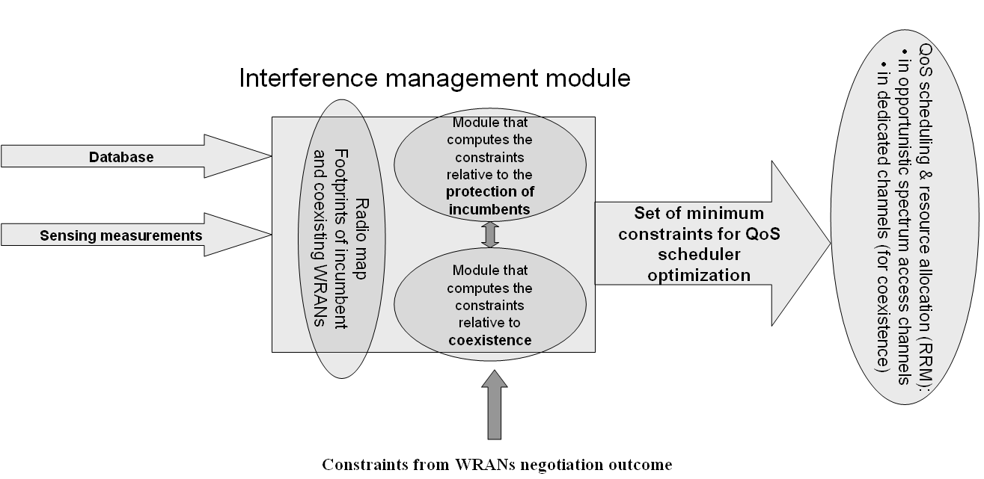
Figure 20. Role of interference management module in WRAN.

The determination of the maximum transmit power control is performed sequentially by the following steps, also illustrated in Fig. 21:

- Determine the maximum transmit power for each CPE on each TV band from the constraint of a single TV band: fill in Table in Fig 22.
- Determine the maximum transmit power for each CPE on each TV band from the constraints of all TV bands: fill in Table in Fig 23.
- Determine constraint areas for each dedicated frequency band. Some of these areas might already be provided by the WRAN coexistence negotiations. Dedicated frequency bands are operating and back-up frequency bands determined by the WRAN coexistence negotiations or by a single WRAN base station.
- Determine the maximum power constraint rule for each CPE in each constraint area, given possible prior constraints on spectrum sharing from WRAN coexistence negotiations.
- This module could also determine constraint on sharing frequency bands in cases where the maximum transmit power would not be a satisfying solution, for example in cases where too many CPEs would be allowed to share the same time-frequency-space resource, in which case the power rule would fail. This scenario will be described later below.

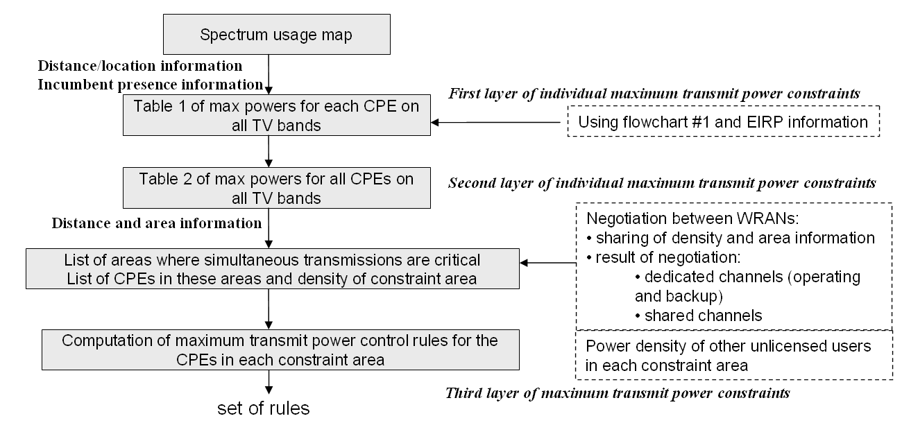
Figure 21. Steps in calculating maximum power constraint on CPEs.

The table in Error: Reference source not found shows an example of how the individual maximum transmit power constraint for a single CPE is computed from the knowledge of TV operations at the WRAN base station. Each column is filled in turn. Given NTSC operation on the 6 MHZ TV band 2 for example, and given that the CPE is located within the Grade B contour plus a margin area, it is determined that TV bands 2 and 3 are not allowed, and the maximum transmit power of that CPE if it was transmitting alone in 6 MHz is determined by the EIRP profile at +2 to +5 on TV bands 3 to 6. It is assumed that the out-of-band emission mask meets the constraints on adjacent TV bands when a CPE is transmitting in a given TV band, so this constraint does not have to be addressed in this table [1. section 15.1.7]. The table in Fig 22 shows how the individual maximum transmit power constraint for a single CPE is computed from constraints on all TV bands, by taking the minimum of all constraints on each row. The table in Fig 23 summarizes the outcome of this calculation. This table also lists the constraint area for each CPE. Two CPEs that lie in the same constraint area might have to have a joint maximum transmit power rule.

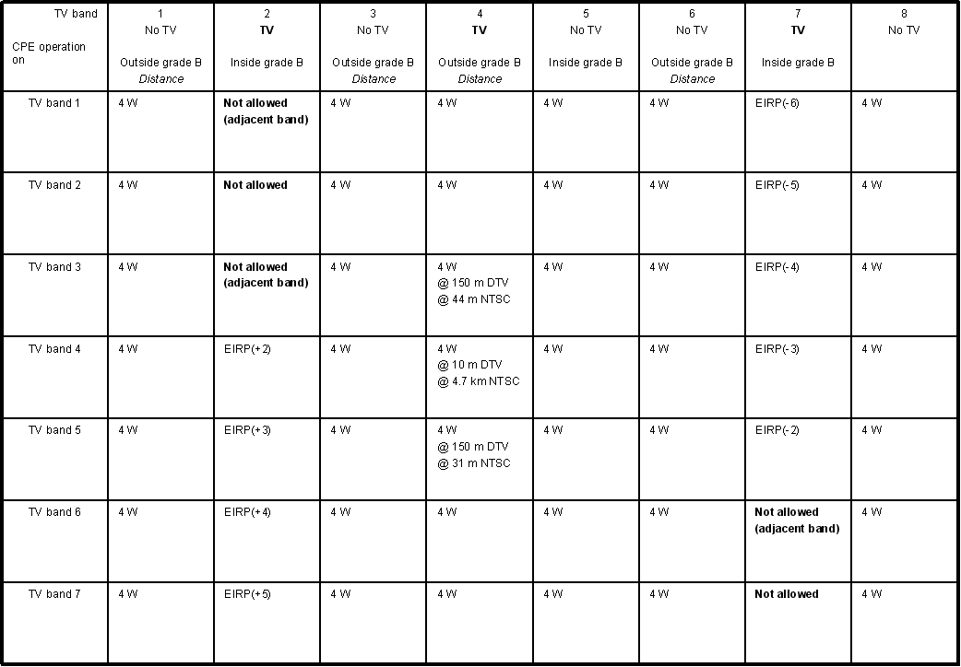
Figure 22. Table listing the first layer of individual CPE maximum transmit power constraint.

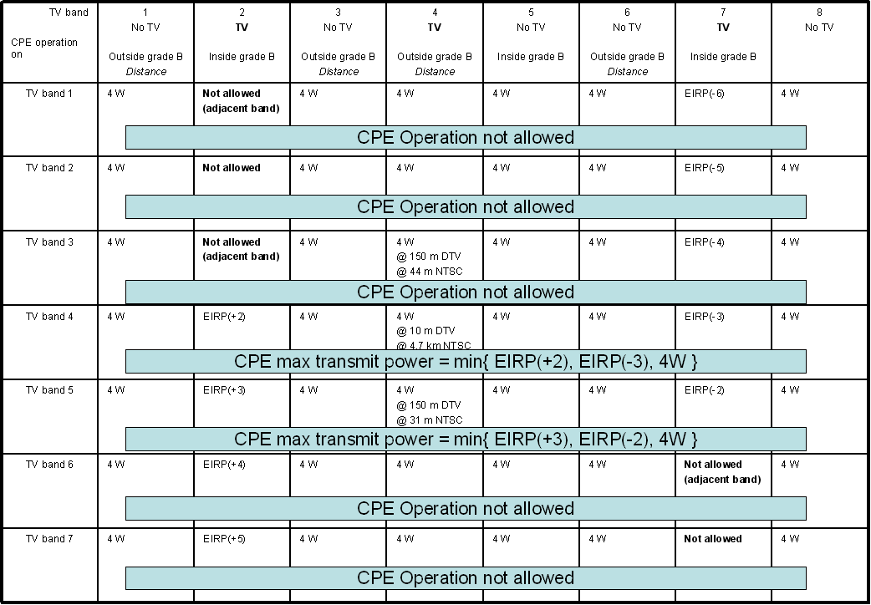

Figure 23. Table showing the computation of the second layer of individual CPE maximum transmit power constraint from the table in Figure 22.
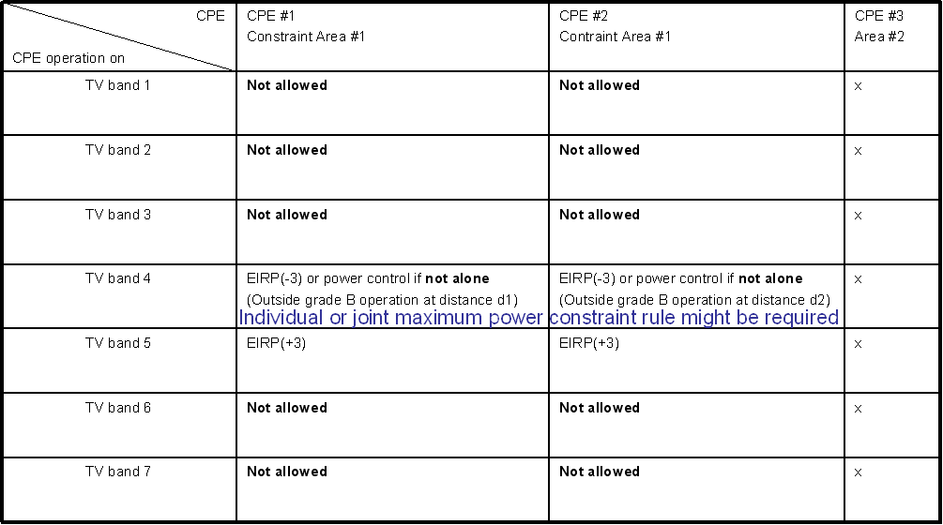

Figure 24. Table listing the second layer of individual CPE maximum transmit power constraint and joint constraint area information.

The flowchart of the decisions made to fill in one cell of the table in Fig 22 is shown in Fig. 25. In [4], calculations show that a CPE transmitting at 4W with TV operation on channel N should be:
- At least 10 m away from noise-protected contour co-channel to DTV operation
- At least 150 m away from noise-protected contour on N-1 of DTV operation
- At least 44 m away from noise-protected contour on N+1 of DTV operation
- At least 4.7 km away from Grade B contour co-channel to NTSC operation
- At least 44 m away from Grade B contour on N-1 of NTSC operation
- At least 31 m away from Grade B contour on N+1 of NTSC operation

In particular, this means that no co-channel and first adjacent channel operation is allowed within the noise-protected/Grade B contours by any CPE. But operation outside the noise-protected/Grade B contours is allowed with a constraint on the minimum distance between the CPE and the contour.

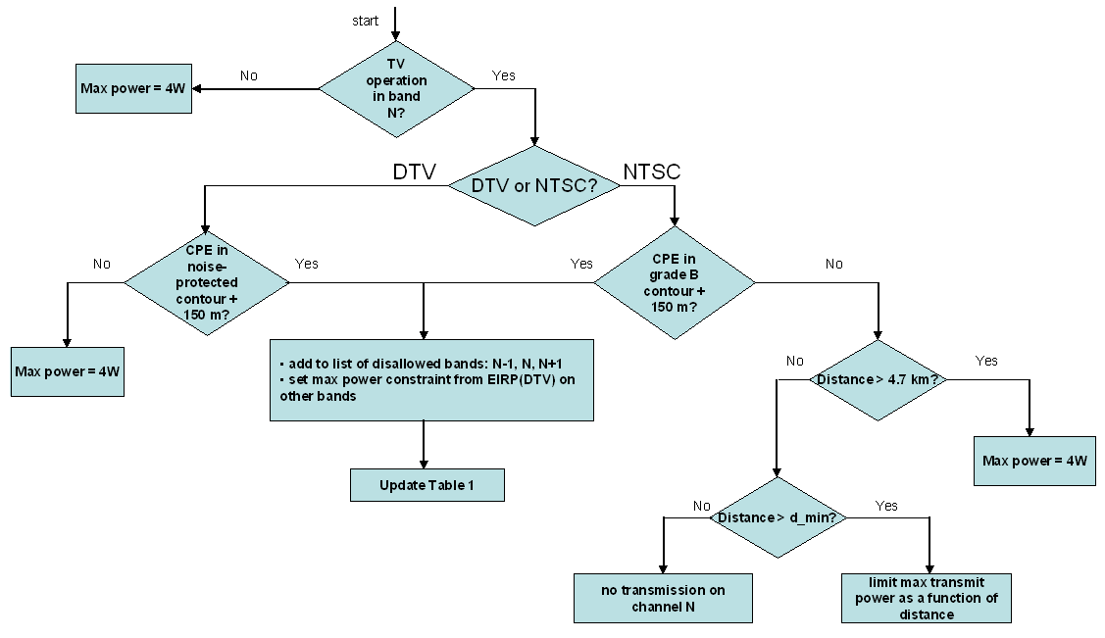
Figure 25. Flowchart of the decision on the first layer on individual transmit power constraint for each CPE from a possible TV operation on channel N.

Although the exact figures might be subject to change, it is remarkable that only in the case of NTSC co-channel operation the constraint is drastic. In all other cases, a CPE can operate at full transmit power of 4W provided that it is at least 150 m away from the boundary of the noise-protected/Grade B contour. In the operating scenarios of the WRAN with low population density, excluding operation in a disk of 150 m radius around the noise-protected/Grade B contour is the simplest solution to address 5 out of the 6 above listed constraints, without impairing the market area of the WRAN. The concept of constraint area is illustrated in Fig. 21 in the case of NTSC TV operation. Note that the same figure would apply in all other cases, by superposing the 150 m (blue) and the d_{min} km (red) boundaries.

These boundaries are explained as follows by taking the example of NTSC co-channel operation.
The Tables in Fig 22-24 list the maximum transmit power constraint in the case of the operation of a single CPE at full transmit power of 4W over a 6 MHz band. That CPE could still meet the interference requirements into NTSC TV receivers located at the edge of the Grade B contour by transmitting with less power or less bandwidth if it operates closer to 4.7 km away from the contour. However, in order to meet the WRAN services requirements, there will be a minimum distance of d_{min} km that guarantees that the CPE transmit power is large enough to achieve any useful communication with the WRAN base station. In the case of DTV operation, and NTSC operation on first adjacent channels, since we already have a 150 m margin, there will be no d_{min}. In the case of simultaneous transmission of CPEs in the same time-frequency-space resource, their radiated powers will add at the nearest TV receiver. Therefore, even outside the 4.7 km radius, if more than one CPE transmits at full power, the interference requirements into TV receivers will not be met at the Grade B contour. In this case, a joint transmit power rule is needed for CPEs that belong to the same constraint area. This constraint area in the case of NTSC operation would be limited to a few km². CPEs outside a constraint area contribute marginal power at the grade B contour relative to the CPEs transmitting from within the constraint area.

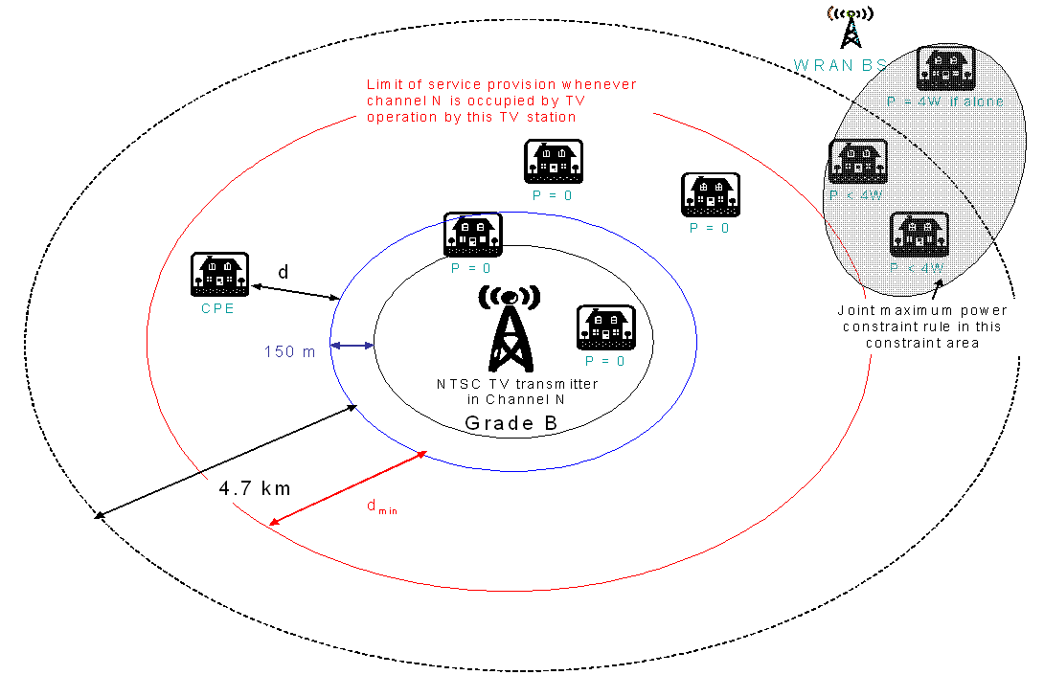
Figure 26. Illustration of transmit power boundary constraints and constraint area in the case of NTSC TV co-channel operation.

The proposed power rule will be based on the spatial densities of CPEs within a constraint area. Assuming a distribution of CPEs close to uniform, or if it is not true by clustering CPEs so that the distribution of the clusters is uniform, the power rule can be designed, such that the maximum transmit power of each CPE (respectively each cluster) will be a function of the spatial density and the distance of each CPE to the Grade B contour. In the case of a power rule allocated to a cluster, it is possible to share the total power among CPEs within the same cluster, or to output a constraint that CPEs within the same cluster are not allowed to access the same time-frequency-space resource. In the limiting cases, if only one CPE is present then this rule converges to the individual power constraint, and in cases where the density is above some threshold CPEs are not allowed to transmit unless they do not share the same time-frequency-space resource. This is a decision that will be output by the interference-management module, and it will serve as a constraint for the QoS scheduling module.

We next briefly justify the proposed operation. In the case of a single CPE transmitting at full power P_{t} over a 6 MHz bandwidth at 4.7 km away from the Grade B contour, co-channel to a NTSC TV operation, the signal radiated by that CPE number k is received by a TV receiver at the Grade B contour with power:
.

d is the distance of the CPE to the Grade B contour, and a is the path loss exponent. Fading is not included in this model, and could only decrease the power received at the TV receiver. Thus the actual path loss exponent can be chosen after analysis of the fading statistics to meet some performance target with some outage probability.

Let n be the density of CPEs in the constraint area A. These are the CPEs that share the same time-frequency-space resource, which is known as an outcome of coexistence negotiations. Otherwise this density could be the actual density of all CPEs multiplied by the probably that they transmit simultaneously in a contention-based protocol in the case the power rule is used to determine maximum CPE transmit power in access to control channels. In the case of coexistence with other license-exempt users, these users should be included in that density. Then the power received from multiple transmitting CPEs is given by:

It was shown theoretically [5] that a sea of CPEs transmitting at maximum power results in a decrease of effective path loss by 2. As a consequence, the interference requirements at the Grade B contour cannot be met anymore.

We propose the power rule for CPE number k as:
.

Then the total power received from all CPEs at the TV receiver is:

The power rule should make sure that:
- With the goal that for all in order to provide CPEs with enough transmit power to meet the WRAN services requirements.

The determination of the exact expression of that power rule is ongoing work.

WRAN pilot and CPE association
To avoid potential interference to incumbent users, a CPE cannot use any frequency no matter what is to be transmitted unless directed by a BS. For a fresh-started CPE to be able to associate with a BS, the BS must continuously broadcast the channel ID of the reverse access channel (RACH). Therefore, besides carrying conventional synchronization message, WRAN pilot must carry the ID of the RACH.

WRAN Pilot should consist of the following functionality.
- Frequency synchronization (sync LO)
- Cell timing synchronization (sync timing)
- WRAN ID and BS ID (cell identification)
- RACH ID (UL transmission, mandatory for FDD, optional for TDD)

Given this WRAN pilot definition, CPE can associate with a BS following the procedures:
- Having been powered on, CPE searches BS pilot.
- Having found a pilot and finished synchronization, CPE obtains the RACH ID.
- CPE tries to associate with the BS using the contention-based RACH (e.g., Slotted-ALOHA).
- BS directs CPE to sense and report a certain set of candidate TV channels.
- Having received the sensing report from the CPE, BS picks up a channel and directs CPE to use it. If no channel can be used for this CPE, go back to Step 4, and BS asks CPE to sense another set of candidate channels.
- CPE start to use the designated channel(s) (both uplink and downlink). Association is done.
Figure 27. Association (call flow).

Smart antenna for sensing, cell searching, packet transmitting and receiving, and soft combining
We propose a WRAN antenna subsystem using an array of small dipoles as shown in the following plot. By carefully choose the number and the locations of the dipoles we can make sure at each channel, there are at least two antennas (dipoles) that can form an array for that channel. The overall stride of the array will not exceed 1.5 m if the lowest frequency (channel) is about 100 MHz. For example, for the channel of frequency 600 MHz, we can use antennas A2, A3, A4 for form the antenna array, and using antennas A1, A2, A4 and A5 we can form an array for the channel of frequency 300 MHz. Of course, the forming of these different arrays for different channels is done by control software.

Both BS and CPE should have mechanism for switching among the 4 stages: sensing, cell searching, packet transmitting and receiving, and soft combining.
Figure 28. Smart antenna suitable for advanced WRAN.

Figure 29. Example of smart antenna design.

Spectrum classification
For a WRAN to start to operate, some absolutely reliable frequencies must be available for pilot transmission, and reverse access channel if FDD is used. To facilitate channel moving when incumbent devices are detected in the current frequency, some backup frequencies are preferred.
Moreover, the classification is necessary for the cell to effectively managing channel sensing and interference avoidance.

We propose to classify frequencies as four sets:
- Active set: frequencies being used in this cell
- Candidate set: frequencies could be used in this cell
- Observation set: further sensing reports are needed
- Disallowed set: frequencies cannot be used in this cell
The procedure of spectrum Classification is described as follows.
- Starting from spectrum database, the BS classifies spectrum into disallowed, candidate, and observing.
- BS itself does sensing, and verifies the classification, especially of the frequencies in the candidate set. If interference from incumbent users is detected, remove the corresponding frequencies from the candidate set.
- BS kicks off the cell operation using frequencies in the candidate set.
- BS directs CPE to do and report sensing, then combine its sensing result and update the classification results.
- BS may update the spectrum database if possible.
- Repeat Step 4.

The following figure describes the state transitions among the four frequency sets, where parameters S₁ and S₂ are determined according to the WRAN FRD.
As discussed in this document, BS SHALL maintain the table with the following entities for each frequency, where classification means one of the following options: active set, candidate set, disallowed set, and observing set.

CPE ID | CPE signal level | TV channel ID | Occupant  Signal level | Occupied  Bandwidth | classification | …

Active Set
C/I < S₁
Needed
C/I > S₁
C/I > S₂
C/I > S₁
C/I > S₁
Frequency Changing
Observing Set
Candidate Set
Disallowed Set
C/I < S₂
Figure 30. Spectrum classification.

Coexistence with other LE systems
In downlink (DL), only the BS needs to contend with other LE devices. If it is detected and identified that LE devices are contending in a certain frequency, the BS first try to find another frequency by resorting to WRAN Spectrum Etiquette procedure (Refer to Section 2.14). To avoid making WRAN an inferior system compared to other LE systems, a substitute frequency is used only when no undue limitation is incurred to neighbor WRAN cells. If no substitute frequency can be found, BS decides to launch a suitable contention protocol (e.g., CSMA/CA, ABTMA, or AWCD) to compete with LE devices.

In uplink (UL), a CPE or several CPEs needs to contend with other LE devices. If it is detected and identified that LE devices are contending in a certain frequency, the BS first try to find another frequency by resorting to WRAN Spectrum Etiquette procedure (Refer to Section 2.14). Again, to be fair with all LE systems, a substitute frequency is used only when no undue limitation is incurred to neighbor WRAN cells. If no substitute frequency can be found, BS directs the affected CPEs to launch a suitable contention protocol to compete with LE devices. During the assigned transmission opportunity (TXOP), the CPE contends with LE devices using protocols such as CSMA/CA, ABTMA, or AWCD. Those affected CPEs could be compensated by the BS in some manners, e.g., being scheduling more TXOP.

Figure 31. DL contention-based coexistence with LE devices.

Figure 32. UL contention-based coexistence with LE devices.

Soft combining
While it is not required in the WRAN FRD [1], Soft Combing does have the following advantages:
- Extend coverage: Multiple BSs work together and support edge CPEs
- Reduce interference: Neither the BS nor the CPE needs to increase power in order to support a certain data rate.
While soft combing is challenging for general OFDM systems, it is very possible for an OFDM-based WRAN system given the fixed P-MP topology. Similar to soft/softer handoff in cdma2000, the proposed soft combining can have multiple BSs serve the same CPE at the same time. This is highly desirable for the CPE at the cell edges. Otherwise, both the CPE and its primary BS have to raise power in order to support packet transmission, which incurs interference level to other users. The detailed call flow of soft combining for both DL and UL are shown in the following figures respectively.
Figure 33. Soft-combining call flow (FL).

Figure 34. Soft-combining call flow (FL).

Flexible CPE modes

This is not a scheduling issue, rather an issue on system flexibility. We propose the procedure for supporting various categories of CPEs. For example, CPEs with various bandwidth: 1.25 MHz, 2.5 MHz, 5 MHz, 6 MHz or 20 MHz. CPEs with different service level agreements. From BS perspective, there are several groups of CPEs, each with a certain bandwidth. Form CPE perspective, multiple channels are available from BS.

The procedure for flexible CPE operation as described as follows, and illustrated in the flow chart.
- Initial acquisition
  - CPE sends the request of bandwidth and service level agreement.
  - BS assigns the CPE a bandwidth based on the SLA and the availability of system resources.
- CPE scans other spectrum under the direction of BS, reports back channel condition information (CQI) and the request for channel change.
- If it is beneficial for the CPE and other users, BS confirms the center frequency that user should tune into, based on the CQI feedback, user profile, and SLA.
- CPE may repeat Steps 2 and 3 occasionally, e.g., when the link conditions in the current channel deteriorates.
- Besides the request from CPE, BS may inform CPE to tune into a different channel for load balancing or other purposes (e.g., strategic sensing).
- Dependent on other users’ profile and the SLAs, BS may reserve a certain frequencies for higher priorities applications and for users with higher privilege.
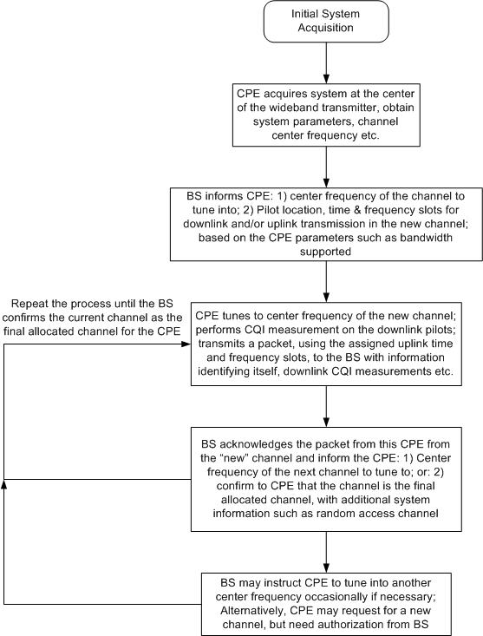

Figure 35. Flexible CPE operation.

References

- C. Stevenson et al, Functional Requirements for the 802.22 WRAN Standard, doc.: IEEE 802.22-05/0007r46, Sept 2005.
- E. Sofer and G. Chouinard, WRAN Channel Modeling, IEEE802.22-05/0055r7, Sept 2005.
- Federal Communications Commission, Notice of Proposed Rule Making and Order, FCC 03-322, Dec 2003.
- G. Chouinard, WRAN Reference Model, IEEE 802.22-04/0002r12, Sept 2005.
- Niels Hoven and Anant Sahai, “Power Scaling for Cognitive Radio,” in proceedings of IEEE WirelessCom 05 Symposium on Emerging Networks, Technologies and Standards, Hawaii, USA, June 13-16, 2005.
- FCC General Menu Reports version 2.1.20, http://svartifoss2.fcc.gov/reports/index.cfm.
List of contributors

Sections | Name | Organization | Email
1, 2.1-2.8 | Ashish Pandharipande | Samsung Advanced Institute of Technology | pashish@ieee.org
2.9-2.12 | Sang-Jo Yoo, Ashish Pandharipande, Duck-dong Hwang, | Inha University/Samsung Advanced Institute of Technology | sjyoo@inha.ac.kr
2.13 | Jaehak Chung, JaeMyung Kim, Duck-dong Hwang | Inha University/Samsung Advanced Institute of Technology | jchung@inha.ac.kr, jaekim@inha.ac.kr
2.15 | David Mazzarese | Samsung Electronics Co. Ltd. | d.mazzarese@samsung.com
2.14, 2.16-2.21 | Baowei Ji | Samsung Telecommunication America | Baowei.ji@samsung.com

