IEEE P802.22
Wireless RANs
On the Implementation of ATSC-DTV forward channel and a Terrestrial Return Channel incorporating Cognitive Radio (Unlicensed Devices)
Date: 2005-07-11
Author(s):
Name | Company | Address | Phone | email
Douglas Prendergast | Communications Research Center  Broadcast Technology Research | 3701 Carling Avenue, Ottawa, Ontario, Canada, K2H 8S2 | +1 613-998-2384 | douglas.prendergast@crc.ca
Abstract

This contribution recommends the use of ATSD-DTVfor the WRAN forward channel allowing for up to 20 Mbps/channel capacity out to a 90-km radius of the Base Station (BS). Its use will reduce system complexity, simplify interference mitigation issues, decrease the standard development time, decrease the time to market etc. Adoption of this contribution would allow for the development of an Unlicenced Device (UD) capable of operating in conjunction with an existing DTV facility should the broadcaster be willing to designate up to 15 Mbps of forward channel capacity to WRAN, or with a privately owned low power, ATSC BS made to work within and meet the cognitive radio UD requirements. One of the advatages of using ATSC-DTV in the cognitive radio UD configuration is that all of the DTV broadcast location, power, interference parameters etc. may be availabe to the UD through TxID watermark information on the DTV downlink. The return channel may use any suitable technology such as CDMA, TDMA, OFDMA etc. Any of theses technologies may be made compatible with the ATSC-DTV through the development of a new return channel PHY and MAC/Radio Resource Management etc. protocol linking ATSC-DTV to the new multiple access return channel. Thus, the development of a modified version of the ATSC-DTV standard and a new complementary return channel standard should provide a synergistic advantage towards the development of a final 802.22 WRAN standard in a more timely and cost efficient manner.
Notice: This document has been prepared to assist IEEE 802.22. It is offered as a basis for discussion and is not binding on the contributing individual(s) or organization(s). The material in this document is subject to change in form and content after further study. The contributor(s) reserve(s) the right to add, amend or withdraw material contained herein.

Release: The contributor grants a free, irrevocable license to the IEEE to incorporate material contained in this contribution, and any modifications thereof, in the creation of an IEEE Standards publication; to copyright in the IEEE’s name any IEEE Standards publication even though it may include portions of this contribution; and at the IEEE’s sole discretion to permit others to reproduce in whole or in part the resulting IEEE Standards publication. The contributor also acknowledges and accepts that this contribution may be made public by IEEE 802.22.

Patent Policy and Procedures: The contributor is familiar with the IEEE 802 Patent Policy and Procedures
<http://standards.ieee.org/guides/bylaws/sb-bylaws.pdf>, including the statement "IEEE standards may include the known use of patent(s), including patent applications, provided the IEEE receives assurance from the patent holder or applicant with respect to patents essential for compliance with both mandatory and optional portions of the standard." Early disclosure to the Working Group of patent information that might be relevant to the standard is essential to reduce the possibility for delays in the development process and increase the likelihood that the draft publication will be approved for publication. Please notify the Chair <Carl R. Stevenson> as early as possible, in written or electronic form, if patented technology (or technology under patent application) might be incorporated into a draft standard being developed within the IEEE 802.22 Working Group. If you have questions, contact the IEEE Patent Committee Administrator at <patcom@ieee.org>.
On the Implementation of an ATSC-DTV forward channel and a Terrestrial Return Channel system incorporating the Cognitive Radio (Unlicensed Devices)

- Introduction
The ATSC standard has been developed as a standard for the North American Terrestrial DTV system. This standard has been adopted by the U.S., Canada, Korea, Mexico, Argentina and is currently being promoted (ATSC Forum) throughout the world, and in particular developing countries such as South America (Brazil, Chile, etc), Asia, the Caribbean, and other 6 MHz TV regions. One of the most pressing problems in most of those countries is the ability to provide interactive Internet multimedia access and VoIP type services to their local population. This is particularly problematic in countries that have gone straight to cellular as the main means of voice communications. In those countries, copper plant is virtually non existent. We postulate that the intrinsic value of the ATSC system worldwide will be enhanced by adding a wireless R.F. return channel using a suitable multiple access technology. This enhancement will satisfy a real need in the countries that are most likely to purchase new ATSC equipment and if adopted by 802.22, create a significant demand for the deployment of UD’s worldwide. With this system approach, the resulting synergy should create a demand-pull effect for Wireless Regional Area Networks (WRAN) implementation worldwide. For the case of North America, Urban, Sub-Urban, and particularly Rural and Remote areas will benefit from the additional broadband access capacity provided by such a system.

2.0 Background
Through the NPRN 04-186, the FCC has requested information for the implementation of a system that uses Unlicensed Devices (UD) to provide wireless Internet connectivity using frequencies within the TV band. At the moment broadcasters operate the prime incumbent services in these TV bands (NTSC-TV and ATSC-DTV as well as Part 74 wireless microphones). It is, therefore, normal to assume that the broadcast industry will be concerned about the potiential interference into DTV if such Unlicenced Devices (UD) are allowed to operate in the TV bands. Using ATSC DTV for the forward channel in the development of a new standard for Internet access within the TV band to be used by WRAN, will reduce system complexity, development effort and also help to allay the broadcasters concerns about potiential interference from WRAN into the TV broadcast system.

The DTV standard already provides for a digital downlink/forward channel capability using current DTV technology and equipment that can be upgraded to provide an Internet forward connection to the user. This technology already has the inherent capability of providing a high-speed data connection that may be used for Internet Multimedia Service (IMS) and VoIP services delivery to the end user with or without the DTV component via upgraded DTV Set Top Box (STB) or IMS data only UD’s respectively. The issue of an RF return channel for such STB’s or UD’s has yet to be resolved. A new standard for the Physical Layer (PHY) and the Medium Access Control (MAC) Layer hopefully forth coming from IEEE 802.22 would allow for a complete bi-directional service offering using an ATSD-DTV forward channel, and a suitable return channel.

3.0 System Description
The current drive to introduce IMS services through the use of UD’s in the TV band will be greatly simplified if these devices meet a standard that requires them to use the DTV system as a forward channel. Hardware complexity and cost will be greatly reduced resulting in faster and larger customer uptake especially in third world countries. These UD subscriber terminals would receive the DTV broadcast data form a DTV station in the area and seek out, with the assistance of DTV (operating parameters broadcast to UD over DTV based on the base station’s knowledge of the TV channels used in the area), unused spectrum for a return channel on a non-interfering basis. The interference mitigation issue associated with a transmitting UD would also be simplified by using Transmitter Identification (TxID) / Watermark information embedded in DTV signal to communicate transmitter information (transmitter power, location etc) to the UD. The UD would then use that information to determine a suitable return channel frequency and bandwidth. Implementing the same TxID Watermark technology for the UD transmissions may also be an asset to the system implementation, for example, the TxID watermark in the UD could be used for locating the UD in an indoor environment, determining its Tx power level etc. To ease the burden on the UD in determining the latter two parameters, the DTV Base Station (BS) could broadcast information about available channel and bandwidth capacity on special broadcast sub-channel. For this case all UD operating in the BS footprint would first scan for the broadcast channel and listen to it for initial system parameters on power up. The DTV station may assist even further by supplying course Adaptive Power Control (APC) and Dynamic Frequency Selection (DFS) information to assist the UD in determining suitable power level and frequency assignment further helping to reduce the interference problem. This proposed WRAN implementation does not preclude the coexistence of multiple WRAN operators within the same DTV footprint. This deployment mode is possible by the segmentation of the downstream data on a per WRAN operator basis.

From a system capacity stand point, increase demand may be satisfied from the initial single cell Omni deployment which provides full duplex coverage out to 90 km in a Point to Multi-point configuration in at least two ways. First, by dividing the coverage area into sectors with each sector having the same capacity of the equivalent Omni coverage. Secondly, provided that the sectorized deployment has run out of capacity a cellular type deployment is also possible with each cell creating a capacity multiple of a single non-sectorized or sectorized capacity. The attached paper on “The Convergence of Digital Television and the Internet for Broadband Wide Area IT and IMS Services “ provides a concept for the single super cell with one On Channel Repeater (OCR) site deployment. By extrapolation, the system capacity and topology presented in the paper may be changed to satisfy the previous discussion and also, the return channel modified to complement ATSC-DTV system.

In the above context, we suggest that this system concept be consireded by 802.22 for the integration of the Internet access services using UD’s into the terrestrial DTV system. The final UD technology would include a new DTV receiver using 2/8 VSB (existing) and a transmitter using a suitable return channel technology such as OFDMA etc. Similarly, at the DTV Transmitter BS, a suitable receiver would have to be integrated. This approach should not deter the development of a vibrant UD market for WRAN but would also bring additional value to the DTV system for domestic and international purposes thus making the TV band use more spectrum efficient and flexible.

That the implementation of such an approach would make the ATSC DTV system much more attractive in rural, remote areas in North America and in developing countries goes without saying. In the urban and suburban areas where the WRAN/UD is aggressively pursuing TV spectrum use, such a standard implemented may be attractive to broadcasters. For the case of office complexes, Pico cells using On Channel Repeaters (OCR) may be deployed to enhance in building connectivity in these areas. Thus the broadcasters may be inclined to provide a portion of their DTV spectrum to accommodate UD activity in the urban and sub-urban areas.

The development of a Cognitive Radio UD will be greatly simplified by, using ATSC-DTV with a suitable (to be determined by 802.22) multiple access return channel. As a result, system complexity is expected to be greatly reduced. Also, considering the recent 802.22 Functional Requirements specification, this contribution proposes the use of technologies that conform to most of the requirements of that specification. Modifications may have to be performed to allow operation also in 7 MHz and 8 MHz bandwidth licenced regions.

If 802.22 MAC and PHY in the downlink is based on the ATSC-DTV standard, a BS may be realized for worldwide use using the same chain as in a full power DTV station. A low power version able to operate in an unlicensed stand-alone system mode where DTV facilities are absent will also be required. However, within North America and other 6 MHz licensed regions of the world where DTV broadcast facilities exist, UD’s should work in conjunction with those facilities if the broadcaster so chooses. In these areas, if DTV facilities do not exist or if the designated broadcaster has no interest in providing an IMS/VoIP etc. service within the footprint of his station, the same low power BS technology could be deployed in a stand alone cognitive radio UD configuration.

4.0 Conclusion
With ATSC-DTV on the downlink and a suitable multiple access technology on the uplink, a significant part of the work will have already been completed for a WRAN system. Modification to the existing MAC and PHY layer to comply with 802.22 specifications may be all that is needed to realize a working system. The issue of interference sensing and UD response would also be significantly reduced with the use of TxID / Watermark technology in DTV, which may also be implemented in the UD. We encourage the Working Group 802.22 to consider this contribution as the basis for going forward with the development of a Cognitive Radio System employing Unlicensed Devices based on the ATSD-DTV standard for deployment in the TV or other bands.

The Convergence of Digital Television and the Internet for Broadband Wide Area IT and IMS Services.

Douglas Prendergast Bernard Caron Yiyan Wu Gilles Gagnon
douglas.prendergast@crc.ca bernard.caron@crc.ca yiyan.wu@crc.ca gilles.gagnon@crc.ca

Communications Research Center, Ottawa, Ontario, Canada K2H 8S2

Abstract
In this paper, we describe how telecom and transmission technologies could be used to offer Interactive Television (ITV) and Internet Multimedia Service (IMS). We propose to use the ATSC-DTV system for the downlink and DVB-RCT standard to implement the wireless return channel. However, we first use the DVB-T forward channel in a proof of concept phase. This paper will also present some technical aspects of the system implementation

1.0 Introduction
There exists a need to provide a broadband digital access capability to sparsely populated regions, wherever they may be. A cost-effective way of achieving this objective is to build on the existing Digital Television (DTV) infrastructure, where the forward channel is already operational. In this paper, we focus on the DTV technologies that have been developed and implemented. In North America, the DTV system is based on the Advanced Television Systems Committee (ATSC) family of Standards [1], while in Europe, the Digital Video Broadcast – Terrestrial (DVB-T) system [2] has been standardized.

DTV systems are classified as broadcast systems where the objective is to reach many end users from one broadcast facility (one to many) featuring transmission in only one direction. On the other hand, conventional telecommunications systems are designed for bi-directional transmission mostly on a one to one basis. In order to provide Interactive Television and Broadband Internet Access, the broadcast system must be enhanced by providing a “many to one” channel for high-speed access. This channel should be provided on a Frequency Division Duplex (FDD) basis to allow for simultaneous bi-directional transmission. One such channel for which a standard has been developed is the Digital Video Broadcast Return Channel Terrestrial (DVB-RCT) [3]

CRC plans to conduct experiments that will evaluate the performance of this DVB-RCT system. This research will focus on the possible throughput and bit error rate under static and portable conditions for ITV and IMS services.

Further investigation of any gains that may accrue by initiating an On Channel repeater (OCR) [4] on the return
link in areas of hostile propagation conditions is also planned. Section 2 presents the implementation concepts for a return channel, Section 3 describes the overview of the system considering both the forward channel and the reverse channel while Section 4 presents the concept verification scenario for the use of DVB-RCT as a return channel. Section 5 looks at the proposed laboratory evaluation and field trial phase. Section 6 presents conclusions while Section 7 provides the references for this paper.

2.0 Implementation Concept.
The main beneficiary of this research will be the residents of the areas found some distance away from the urban centers. These rural areas in general lack the communications infrastructure required to provide DSL and Cable based Internet access services. However, in most cases, these small villages and towns of sparse population are located within the footprint of one or more terrestrial television broadcasters. These broadcasters are moving rapidly to convert their NTSC analog television facilities to the new digital format. This change allows for new value added services associated with the digital revolution to be offered possibly on subscription basis.

Figure 2.1 provides one view of a possible implementation of a terrestrial IMS service. Such an implementation can provide in addition to a Standard Digital Television (SDTV) channel, ITV and IMS access to a rural and remote area. This implementation shows the system configuration for the case where the forward channel is using the ATSC digital format in conjunction with a return channel utilizing DVB-RCT. Two coverage zones may be observed. One zone providing services to an area of large population while the other, about 80 km away, services a small village that is out of range with respect to the base station. The base station repeater here may be considered as part of a Single Frequency Network (SFN). Within each zone, there is a primary and secondary service area. The primary service area features

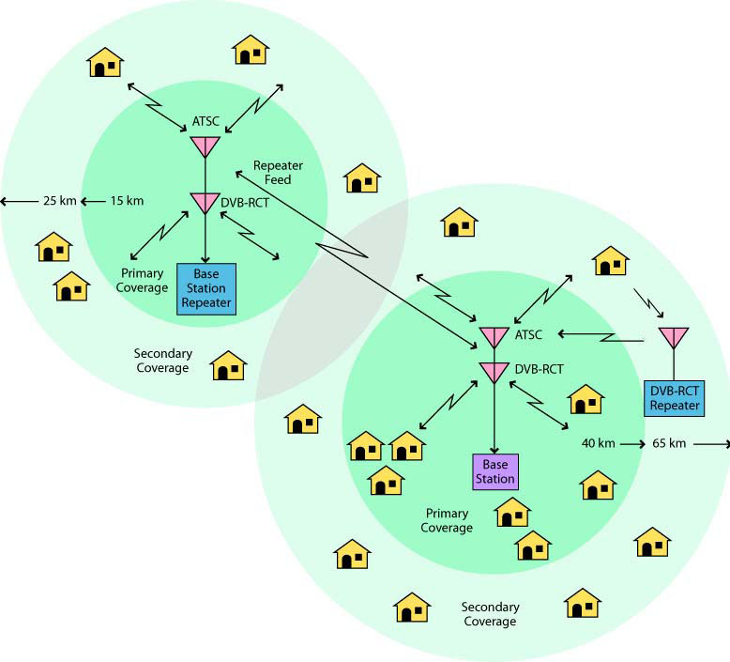

Figure 2.1 IT and IMS access using ATSC with a DVB-RCT Return Channel

a higher user terminal data capacity because a higher level of modulation may be employed on both the uplink and the downlink. The secondary service area requires a more robust modulation scheme such as the ATSC E-VSB [5] and coding scheme because of propagation impairments created by an increased distance from the main base station transmitter. Although the base station by virtue of its high transmit capability is able to reach the area of secondary coverage, the power limited user terminal in the secondary coverage area may need a return channel repeater in order to meet the system gain requirements.

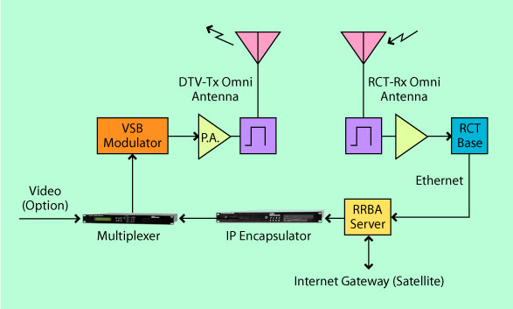

Figure 2.2 ATSC and DVB-RCT - IMS Base Station Configuration

Figure 2.2 shows a possible implementation for the base
station which consists of an IP encapsulator, a transport stream multiplexer, a VSB modulator, a power amplifier and an antenna. The receive side consists of a separate receive antenna, a preamplifier and a DVB-RCT receiver. For Internet access purposes, both the transmitter and receiver are linked through a Rural and Remote Broadband Access (RRBA) server and an Internet gateway. The transmitter and receiver frequencies are separated by at least 48 MHz to avoid interference and reduce duplexer complexity. The multiplexer can be used for ITV or IMS only or by reducing the data capacity available for Intranet/Internet by about 5 Mbps, support a SDTV channel in addition.

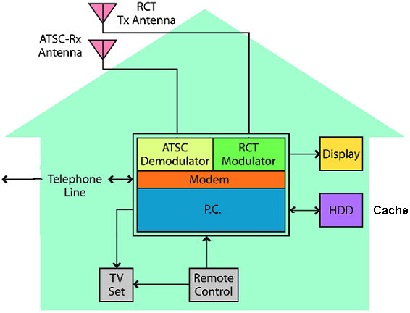
Figure 2.3 shows a possible implementation for the user terminal site. A similar discussion is valid for the

Figure 2.3 Customer Premise Implementation for ATSC-IMS service

end user configuration. However, using duplexing, and sufficient frequency separation it may be more desirable to use a single antenna to perform both the transmitting and receiving functions.

Regarding system operation, when the system is first powered up, the base station and user terminal go through a hand shaking procedure to establish the link. At that point, the user terminal will have access to the Internet and if applicable be provided with a SDTV channel as well. The data rate per user will be determined from the distance of the user terminal to the base station and the number of IMS users requesting services.. In the primary coverage area, a minimum rate of 100 kbps per user is expected for the return channel. The forward channel will deliver a much higher data rate to the user terminal since it is able to transmit more power and use a higher level of modulation. The user terminal transmitter power will be in the order of + 27 dBm. Additional gain may be realized by using a rooftop mounted external antenna.

3.0 System Overview

3.1 Forward Channel Considerations.
In order to support High Definition Television (HDTV), digital television systems have been specified to provide a downlink capacity in the order of 20 Mbps. This capacity although primarily designed for television, may also be used for ITV and IMS data applications. If television programming is not being transmitted then all the downlink capacity may be available for data applications. If television programming is to be transmitted though, the capacity available to data services will be reduced by 3 to 6 Mbps for SDTV programming or 12 to 18 Mbps for HDTV programming. The remaining capacity can then be made available for Internet/Intranet services.

The integration of television programming and data on the downlink is made possible by the Transport Stream (TS) multiplexer. The multiplexer is used to replace available TS null packets not used by television programming with the TS data packets associated with ITV and IMS applications. The output of this multiplexer is a mixture of video, audio and data destined for the end user terminal via the transmitter. Figure 3.1 shows a block

Figure 3.1 Base Station Multiplexing Scheme

diagram of the multiplexing scheme within the base station. The figure also shows that the output of the multiplexer is coded, interleaved, and that a pilot is inserted followed by VSB modulation. The modulated signal is then amplified, combined with signals from other channels and then transmitted.

The ATSC signal has the following characteristics that make it especially suitable for use as a forward channel to deliver ITV and IMS applications to under served areas:

- Large Data capacity: up to 20 Mbps in one 6 MHz channel
- Flexible coverage: Typically 85 km for a DTV station
- Developed for VHF-UHF operation: Frequency Agile, better propagation compared to WLAN
- Non-LOS operation: Provides good Multipath and Interference performance
- Provides for Flexible trade-off between data capacity and robustness
- Low Implementation Cost: DTV Consumers Products
- UHF channels are available, Particularly in Remote areas.
- Sustain long delay spread required by SFN operation

Theses characteristics give the system designer a lot of flexibility to make trade-offs in coverage area size and data rate and more flexibility in SFN network design. They also provide good propagation conditions over a large number of channels for services implementation. Thus using the ATSC infrastructure as a forward channel for downstream delivery of ITV and IMS content to a user terminal is quite feasible.

3.2 Return Channel Considerations.
The DTV system has been developed as a replacement for the analog NTSC system. The NTSC system was originally designed as a system to deliver video content on a one to many basis. The move to digital technology allows new and modern services to be contemplated. The scope of these service possibilities is drastically increased by making the DTV system a bi-directional full duplex digital system. This new feature for DTV is only achievable by the implementation of a digital return or uplink channel.

A number of candidate systems were evaluated for possible use as a DTV return channel. The evaluation lead to the conclusion that the Digital Video Broadcast – Return Channel Terrestrial (DVB-RCT) was the most suitable technology. Some attractive characteristics of this technology are as follows:

- Has already been specified as a return channel system for DVB-T to provide Interactive TV
- Spectrum efficient - User defined bandwidth
- Use Orthogonal Frequency Division Multiple Access
- Channel divided in Time and Frequency to enhance multiple access capability
- Adaptive modulation: QPSK, 16 QAM and 64 QAM
- 1 MHz segmentation over 6-7-8 MHz channel
- Power control (To a Maximum of 1 watt)
- Flexible network implementation: various cell size and degree of robustness
- MAC Security functions included

The above feature set makes this technology attractive given the flexibility and number of parameters available for manipulation. These parameters allow for the bandwidth, user terminal power, data rates, number of users, channel robustness, and spectrum efficiency to be dynamically adjusted for best data throughput performance.

One of the main features allowing such flexibility is the use of an Orthogonal Frequency Division Multiplex Multiple Access (OFDMA) scheme. It uses modulation ranging from QPSK to 64 QAM allowing for efficient use of the spectrum. Robustness against multipath interference makes it attractive for potential mobile use and embedded error corrections schemes enhance the robustness of the channel performance.

The standard for DVB-RCT [3] calls for a secure data channel to be implemented and by virtue of its time and frequency diversity allows several modes of operation to be implementable. Six modes of operation are possible using three burst structures with two sets of carriers i.e. 1K and 2K carrier sets. Burst Structure 1 used in scenarios such as televoting allows for one carrier per sub-channel to contain one data burst (188 bytes) making possible a large number of short duration transactions. Similarly, in Burst Structure 2, the data burst is divided evenly over four carriers making for a new a sub-channel. Likewise Burst Structure 3 provides for the data burst to be divided over 29 carriers to create a sub-channel. The burst structures using 1K or 2 K carriers provide for great flexibility in system implementation and allow the system engineer to tailor the system for applications requiring short bursts transactions as well as longer burst data intensive applications such as those required for IMS. Thus, the IMS applications would most likely be satisfied by the use of Burst Structure 3.

Under the control of the base station, users may be assigned one or more sub-channels based on a request from the user and the availability of sub-channels. The availability of sub-channels depend on the number of simultaneous users that are on line at any given time.

Thus, the number of active users will be reduced as the requirement for higher per user data rates is increased.
However, by reducing the size of the coverage area, higher data rates may be more easily be accommodated for the users. It is expected that at about 50 km from the

base station, the aggregate capacity on the uplink will be about 5 Mbps as compared to 22.5 Mbps, 15 km from the base station. Clearly higher per user data rates may be achieved for users residing closer to the base station. The higher aggregate data rates result from a change to higher modulation level which ranges from QPSK to 16 QAM, to 64 QAM as the user resides closer to the base. This change in modulation is implemented by the base station through a downlink MAC message to the user terminal. The base station also controls the user terminal output power, which may change as the modulation level is changed, using an Adaptive Power Control (APC) loop.

The channel is made more robust to errors by the use of coding of different rates and types Turbo or Concatenated (Convolutional - Reed Solomon). The use of OFDMA technology on the uplink with different guard intervals between symbol transmission improves the multipath performance and is expected to provide added advantage in a mobile environment. Mobility may become a requirement with the use of Personal Data Assistant (PDA) and other hand held computing devices. The DVB-RCT return channel has been specified to allow it to be used in various channel bandwidth assignment of 6 MHz, 7 MHz or 8 MHz. This allows for use in North America where the 6 MHz channel assignment is applicable. The data rate of the individual carriers in an OFDM symbol is determined by which one of the 6 modes are selected and this choice is determined by parameters such as range from the base station, code rate, guard interval etc. However, the expected per carrier bit rate varies between 600 bps to 15 kbps depending on the choice made for the above parameters.

Table 3.1 Physical Layer Parameters for DVB-RCT

DVB-RCT Physical Layer Summary
Return Channel | Multiple Access OFDM
OFDM Carrier set | 1024 (1K), 2048 (2K)
OFDM Carrier spacing | 1 kHz, 2 kHz, 4kHz,
Transmission modes | 6 modes, (3 carrier spacing) x 2 (carrier sets)
Carrier shaping | Nyquist, Rectangular
Guard interval | 1/4, 1/8, 1/16, 1/32, for rectangular shaping only
Transmission frames | TF1, TF2
Modulation | QPSK, 16 QAM, 64 QAM
Encoding rates | ½, ¾.
Channel codes | Turbo or concatenated (RS+C)
Burst structure | BS1, BS2, BS3
Net bit rate per carrier | 0.6 Kbps to 15 Kbps (depending on mode selected)
Service range | 65 km.
Channel raster | 6, 7, or 8 MHz.

Table 3.1 [6] summarizes the physical layer parameters for the return channel as described in this section. They provide the operator with flexibility in tailoring the uplink to meet the requirements of the user. Additional flexibility is provided in the number of service providers having access to the coverage area. This is done through the partitioning of the uplink bandwidth in 1 MHz slots allowing for six different service providers to offer service to the end user in the 6 MHz bandwidth available.
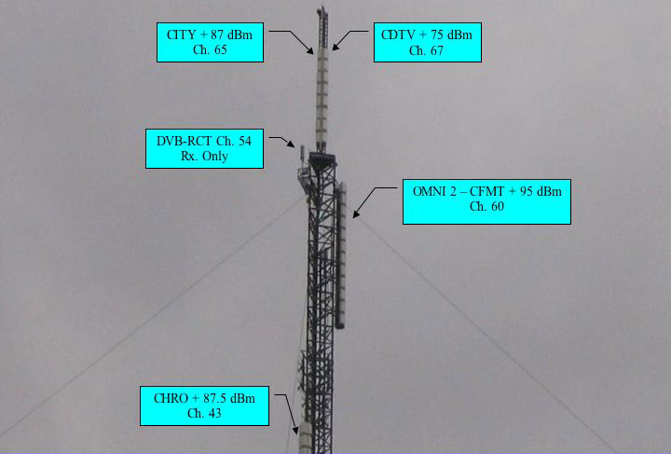
- Verification of Concept
The ATSC system has been adopted in North America as the new digital television standard for terrestrial broadcasting. There has been significant achievement on the forward channel with respect to performance in the presence of multipath interference etc, and on the implementation of the associated Single Frequency Networks (SFN) [7,8]. Further work is required, however, in the creation of a broadband wireless return channel in support of ATSC. A candidate standard has been proposed for return channel use with the ATSC system but no physical level specification or implementation has been proposed. In the absence of such specifications, it is proposed here to tailor the DVB-RCT equipment [9] to satisfy the ATSC requirement. Before determining the modifications to the ATSC in order to support DVB-RCT, a system is being designed and implemented at the Communications Research Center (CRC) to verify the suitability of DVB-RCT for return channel application in North America.

- Laboratory Evaluation and Field Trial
Field trials using the DVB-T forward channel will help verify the performance of the DVB-RCT return channel. Some of the performance parameters of interest are the capacity and range shown in figure 3.2. Test will first be conducted in the laboratory in order to get some baseline parameters. Following this, an extensive field trial will commence. Further performance research using SFN On Channel Repeaters (OCR) on the return channel will be conducted once the primary field trial is completed.
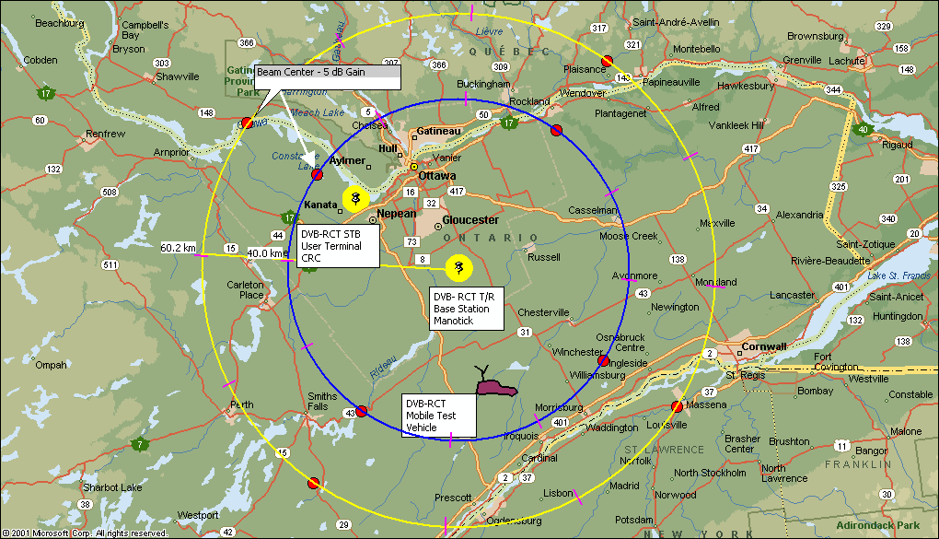
A base station has been purchased and preliminary laboratory testing shows promise. Figure 5.1 shows the base station site transmitter antenna using DTV channel 67. This antenna radiates at + 75 dBm (33 kW) and is 215 m above ground. Located under this Antenna is the DVB-RCT receive only antenna which provides about 5 dB of omni-directional gain.

Figure 5.1 Base Station Ch. 67 Tx. and Ch 54 Rx. Antennas

The user terminal transmitter will transmit between + 26 dBm (indoor antenna) and + 39 dBm (outdoor rooftop mounted antenna). This makes for a hostile environment for the received signal at the base station receiver. These issues need to be considered in the system analysis and the system designed accordingly.

The figure also shows a number of other transmitter antennas for other TV stations originating at the same site. The return channel receive antennas is here possibly in a typical environment and so care must be taken in the design to protect the receiver front end from high energy signal around the desired channel.

Figure 5.2 shows the field trial test area in the vicinity of Ottawa, Ontario, Canada.

Figure 5.2 Field Trial Test Area near Ottawa

The dark circle represents the area of primary coverage within a range of 40 km from the base station while the lighter circle extends the coverage to about 65-km. The 4 dots on the circle represents the direction of maximum receive antenna gain. The test area provides for testing under Line of Sight (LOS) and Non-Line of Sight (N-LOS) conditions due to trees buildings etc. OCR implementation will investigate the scenario of total signal blockage due to buildings. The test area also is well suited to research on the return channel performance in an urban, sub-urban and rural environment making it easier to compare results.

Testing to date has verified the performance of the return channel antenna subsystem with respect to noise and spurious interference and found the receive chain to have excellent and clean noise floor. Transmitter tone testing has verified the ability of receiving a signal at our research facility 30-km away from the base station. Preliminary static testing will be completed in the CRC laboratory using this link. On completion of static testing, in the laboratory, static testing in the coverage area will be conducted in order to understand more the effects of the propagation environment on performance. Following this a series of experiments relating to portability and

mobility will be concluded. An OCR return channel implementation will show the value of using SFN in a challenging propagation environment.

- Conclusions.
Preliminary testing of return channel equipment shows promise although more development work needs to be performed on it to make it field worthy. Subsystem implementation of equipment in support of extensive research into providing a return channel for DTV is progressing on schedule. It is expected that the results of this research will provide valuable input to the provision of a wireless terrestrial standard for an ATSC return channel. The implementation of such a system will provide for broadband services to be delivered to under served rural and remote areas thus helping to bridge the digital divide. This system will also provide another point of access for computer communications networks.

- References.
[1] ATSC, “ATSC Digital Television standard”, ATSC Standard A/53, September 16, 1995.
[2] DVB-T, ETSI EN 300 744 V1.4.1 (2001-01) “Digital Video Broadcasting (DVB); Framing structure, channel coding and modulation for digital terrestrial television”
[3]Digital Video Broadcasting (DVB); Interactive Channel for Digital Terrestrial Television (RCT) Incorporating Multiple Access OFDM. ETSI EN 301 958
[4] K. Salehian, M. Guillet, and B. Caron, “On-Channel Repeater for Digital Television Broadcasting Service” IEEE Transactions on Broadcasting, June 2003, vol 48, No. 2, pp 97-102.
[5] ATSC, “ATSC Digital Television standard”, ATSC Standard A/53C with, Amendment No.1 and Corrigendum No.1 July 2004. (www.atsc.org)
[6] DVB-RCT: The Missing Link for Digital Terrestrial TV, Gerard Faria, Broadcast Asia International Conference, Singapore, June 17-21 2004.
[7] K. Salehian, Y. Wu, and B. Caron, “ An Experimental ATSC-DTV Distributed-Transmission Network” IEEE 54 Annual Broadcast Symposium, 13-15 October, 2005
[ 8] K. Salehian, Y. Wu, and B. Caron, “Design Procedures and Field Test Results of a Distributed-Translator Network, and a Case Study for an Application of Distributed-Transmission” BEC Proceedings NAB, Las Vegas, April 2005
[19] DVB-RCT: A Standard for Interactive DVB-T, Gerard Faria, and Fabio Scalise, Proceedings of IBC Amsterdam, September 2001.

