IEEE P802.22
Wireless RANs
WRAN Channel Modeling
Date: 2005-07-04
Author(s):
Name | Company | Address | Phone | email
Eli Sofer | Runcom | 2 Hachoma St. Rishon Lezion  Israel | +972 544 997 996 | elisofer@runcom.co.il
Abstract
This contribution should be considered as a working document providing a base line approach for deriving Channel Model appropriate to the specific environment where WRAN radio link is operating. More effort is needed to achieve a reliable and representative channel model near to actual channel behaviour.
The development of appropriate models for the signal distortion in WRAN radio channel, the antenna subsystems and the non-ideal RF unit components is a crucial step in the design process. These models, when agreed upon, should support the algorithms design by providing a means for validation

Notice: This document has been prepared to assist IEEE 802.22. It is offered as a basis for discussion and is not binding on the contributing individual(s) or organization(s). The material in this document is subject to change in form and content after further study. The contributor(s) reserve(s) the right to add, amend or withdraw material contained herein.

Release: The contributor grants a free, irrevocable license to the IEEE to incorporate material contained in this contribution, and any modifications thereof, in the creation of an IEEE Standards publication; to copyright in the IEEE’s name any IEEE Standards publication even though it may include portions of this contribution; and at the IEEE’s sole discretion to permit others to reproduce in whole or in part the resulting IEEE Standards publication. The contributor also acknowledges and accepts that this contribution may be made public by IEEE 802.22.

Patent Policy and Procedures: The contributor is familiar with the IEEE 802 Patent Policy and Procedures
<http://standards.ieee.org/guides/bylaws/sb-bylaws.pdf>, including the statement "IEEE standards may include the known use of patent(s), including patent applications, provided the IEEE receives assurance from the patent holder or applicant with respect to patents essential for compliance with both mandatory and optional portions of the standard." Early disclosure to the Working Group of patent information that might be relevant to the standard is essential to reduce the possibility for delays in the development process and increase the likelihood that the draft publication will be approved for publication. Please notify the Chair <Carl R. Stevenson> as early as possible, in written or electronic form, if patented technology (or technology under patent application) might be incorporated into a draft standard being developed within the IEEE 802.22 Working Group. If you have questions, contact the IEEE Patent Committee Administrator at <patcom@ieee.org>.

Table of Contents
1 Introduction 10
2 RADIO CHANNEL MODELS 11
2.1 Environment and Propagation Types 11
2.2 Path Loss Calculation 11
2.2.1 LOS Propagation Model 11
2.2.2
2.2.3 NLOS Excess Path Loss 12
2.2.3.1 Hata’s Model 13
2.2.3.2 Frequency Dependency of the Excess Path Loss 13
2.2.4 Location Variability 13
2.3 Wideband Channel Models 13
2.3.1 Power Delay Profile 14
2.3.2 Delay Spread and K-Factor 14
2.3.3 Antenna Directivity Gain Degradation 15
2.4 Additive Noise Model 15
2.5 Non-Licensed Band Interferer Modelling 16
2.5.1 Narrow Band Jamming 16
2.5.2 Partial Band Jamming 17
2.5.3 Pulse Jamming 17
2.6 Discrete Time Channel Model 17
2.6.1 Channel Model Configuration 17
3 Non-ideal RF DEVICES MODELS 19
3.1 Non-Linear Signal Amplification 19
3.1.1 General Non-Linear System Models 19
3.1.2 Parametric RF Amplification Model 20
3.1.3 Total Power Degradation 21
3.2 Phase Noise 22
3.2.1 Phase Noise and Power-Law Model 22
3.2.2 Wiener Statistical Phase Noise Model 23
3.3 Non-Ideal Modulator/Demodulator 25
3.3.1 Introduction 25
3.3.2 Quadrature Modulator 25
3.3.2.1 Derivation of Model 25
3.3.2.2 Performance of Model 27
3.3.3 Quadrature Demodulator 29
Derivation of Model 30
3.3.4 Digital Modulation 31
3.3.5 Digital Demodulation 31
3.3.5.1 Derivation of Model 31
4 APPENDIX A 33

1

References & Standards

[1] “Fixed wireless routes for internet access”, IEEE Spectrum, September 1999.

[2] T. S. Rappaport, “Wireless communications”, Prentice-Hall, 1996.

[3] P. Karlsson, N. Löwendahl, J. Jordana, “Narrowband and wideband propagation measurements and models in the 27-29 GHz band”, COST 259 TD(98)17, COST 259 Workshop, Berne, Switzerland, February 1998.

[4] T.-S. Chu, L. J. Greenstein, “A Quantification of Link Budget Differences Between the Cellular and PCS Bands”, IEEE Trans. Veh. Tech., vol.48, no. 1, January 1998.

[5] A. Bohdanowicz et al., “Wideband Indoor and Outdoor Channel Measurements at 17 GHz”, VTC 1999.

[6] M. Mitsuhiko et al., “Measurement of Spatiotemporal Propagation Characteristics in Urban Microcellular Environment”, VTC 1999.

[7] V. Erceg et al., “A Model for the Multipath Delay Profile of Fixed Wireless Channels”, IEEE JSAC, vol. 17, no. 3, March 1999.

[8] D. Falconer, “Multipath Measurements and Modelling for Fixed Broadband Wireless Systems in a Residential Environment”, IEEE 802.16.1pc-00/01, IEEE 802.16 Broadband Wireless Access Working Group, 21/12/1999.

[9] P. Karlsson et al., “Outdoor Spatio-Temporal Propagation Measurements for Evaluation of Smart Antennas”, 3TRS091A.doc, ETSI EP BRAN #9, July 1998.

[10] AC085 – The Magic WAND, “Deliverable 2D8: Evaluation of the WAND System for Outdoor Point-to-Multipoint Configurations”, Aug. 1998.

[11] AC085 – The Magic WAND, “Deliverable 2D9: Results of outdoor measurements and experiments for the WAND system at 5 GHz”, Dec. 1998.

[12] N. Patwari, G. D. Durgin, T. S. Rappaport, R. J. Boyle, “Peer-to-peer low antenna outdoor radio wave propagation at 1.8 GHz” Proc. of the IEEE Vehicular Technology Conference (VTC '99 Spring), Houston, TX, vol. I, pp. 371-375, May 1999.

[13] M. Pettersen, P. H. Lehne, J. Noll, O. Rostbakken, E. Antonsen, R. Eckhoff, “Characterisation of the directional wideband radio channel in urban and suburban areas”, Proc. of the IEEE Vehicular Technology Conference (VTC '99 Fall), Amsterdam, The Netherlands, vol. I, pp. 1454-1459, September 1999.

[14] A. Plattner, N. Prediger, W. Herzig, “Indoor and outdoor propagation measurements at 5 and 60 GHz for radio LAN applications”, IEEE MTT-S International Microwave Symposium Digest, vol. 2, pp. 853-856, 1993.

[15] M. P. M. Hall, L. W. Barclay, M. T. Hewitt, “Propagation of Radiowaves”, The Institution of Electrical Engineers, London, UK, 1996.

[16] S. R. Saunders, “Antennas and Propagation for Wireless Communication Systems”, John Wiley & Sons, Chichester, UK, 1999.

[17] L. J. Greenstein, V. Erceg, Y. S. Yeh, M. V. Clark, “A New Path-Gain/Delay-Spread propagation model for Digital Cellular Channels”, IEEE Trans. Veh. Tech., vol. 48, no. 2, May 1997.

[18] L. J. Greenstein, V. Erceg, “Gain Reductions Due to Scatter on Wireless Paths with Directional Antennas”, IEEE Comm. Letters, vol. 3, no. 6, June 1999.

[19] ITT, “Reference Data for Radio Engineers”, Sixth Edition, 1975. Howard W. Sams and Co., Indianapolis.

[20] J. Rutman, “Characterization of phase and frequency instabilities in precision frequency sources: Fifteen years of progress”, IEEE Proc., vol. 66, no. 9, pp. 1048-1076, Sep. 1978.

[21] T. H. Lee, A Hajimiri, “Oscillator Phase Noise: A Tutorial”, IEEE J. Solid-State Circuits, vol. 35, no. 3, pp. 326-336, Mar. 2000.

[22] A. Demir, A. Mehrotra, and J. Roychowdhury, “Phase noise in oscillators: A unifying theory and numerical methods for characterization”, IEEE Trans. on Circuits and Systems-I, vol. 47, no. 5, pp. 655-674, May 2000.

[23] L. Tomba, “On the effect of wiener phase noise in OFDM systems”, IEEE Trans. Commun., vol. 46, pp. 580–583, May 1998.

[24] T. Pollet, M. van Bladel, and M. Moeneclaey, “BER sensitivity of OFDM systems to carrier frequency offset and Wiener phase noise”, IEEE Trans. Commun., vol. 43, pp. 191–193, Feb./March./April 1995.

[25] G. Foschini, “Characterizing filtered light waves corrupted by phase noise”, IEEE Trans. Inform. Theory, vol. 34, Nov. 1988.

[26] I. T. Monroy and G. Hooghiemstra, “On a recursive formula for the moments of phase noise”, IEEE Trans Commum., vol. 48, no. 6, June 2000.

[27] WRAN_2crln006a.doc, “Effects of Climate on WRAN system performance”, WRAN
Design note, Aug. 2000.

[28] R.L. Freeman, “Telecommunication Transmission Handbook”, New York: J. Wiley & Sons,
1991.

[29] H. Xu, T. Rappaport et al, “Measurements and Models for 38-GHz Point-to-Multipoint
Radiowave Propagation”, IEEE J. Selected Areas Commun., SAC-18, No. 3, March 2000, pp.
310-321.

[30] IEEE802.16.1.pc-00/12r1, “Multipath Measurements and Modeling for Fixed Broadband
Point-to-Multipoint Radiowave Propagation Links under different Weather Conditions”,
Contribution in IEEE 802.16.1, 25-02-2000.

[31] T. Pratt, C.H. Bostan, “Satellite Communications”, New York: J.Wiley, 1986.

[32] H. Masui et al, “Difference of Path Loss Characteristics due to Mobile Antenna Heights in
Microwave Urban Propagation”, IEICE Trans. Fundamentals, Vol. E82-A, No. 7, July 1999,
pp. 1144-1150.

[33] G. Durgin, T. Rappaport and H. Xu, “Measurements and Models for Radio Path Loss and
Penetration Loss In and Around Homes and Trees at 5.85 GHz”, IEEE Trans. on Commun.,
COM-46, No. 11, Nov. 1998, pp. 1484-1496.
[34]

[35]

[36]

[37]

[38]

[39]

[40]

[41]

List of abbreviations & symbols

OFDM | Orthogonal Frequency-Division Multiplexing
RF | Radio Frequency
LOS | Line-of-Sight
NLOS | Non-Line-of-Sight
PDP | Power Delay Profile
RMS | Root Mean Square
MAN | Metropolitan Area network
FFT | Fast Fourier Transform
ECC | Error Correction Codes
SNR | Signal-to-Noise Ratio
AM | Amplitude Modulation
PM | Phase Modulation
BER | Bit Error Rate
OBO | Output Back-Off
QPSK | Quadrature Phase-Shift Keying
TPD | Total Power Degradation
ICI | Inter-Channel Interference
PN | Phase Noise
LO | Local Oscillator
DAC | Digital-to-Analog Converter
DDS | Direct Digital Synthesizer
SFDR | Spurious-Free Dynamic Range
CIC | Cascaded Integrator-Comb
IF | Intermediate Frequency

List of Figures

Figure 1: (
Figure 2: Total (manmade and receiver) noise level vs. frequency in urban & suburban areas (1MHz BW).
Figure 3: Parametric non-linear amplification model.
Figure 4: SNR degradation NLIN as a function of the OBO.
Figure 5: Total power degradation as a function of the OBO.
Figure 6: Quadrature modulator.
Figure 7: Phase imbalance effects.
Figure 8: Amplitude imbalance effects.
Figure 9: DC offset effects.
Figure 10: Quadrature demodulator.
List of Tables

Table 1: Predicted ranges for τ1 and K0 for d = 1000m based on measurement data in the literature.
Table 2: Summary of channel model configuration parameters.
Table 3: Optimum OBO and corresponding TPD values.
Table 4: Hata's model excess path loss coefficients for small/medium cities at f0 = 1 GHz.
Table 5: Hata's model excess path loss coefficients for large cities at f0 = 1 GHz.
Table 6: Hata's model excess path loss for suburban and open areas at f0 = 1 GHz.

Introduction

The development of appropriate models for the signal distortion in the radio channel, the antenna subsystems and the non-ideal RF unit components is a crucial step in the design process. These models support the algorithms design by providing a means for validation. Furthermore, the results obtained by computer simulations employing realistic models support the choice of the suitable transmission schemes as well as the selection of the appropriate RF technologies. Finally, they enable a forecast of the achievable coverage of the WRAN system.

The rest of this document is organised as follows. In Sect. the WRAN radio channel models are defined. Sect. contains the various models for the non-ideal RF parts.

RADIO CHANNEL MODELS
The following channel models target wave propagation scenarios in the context of the WRAN system, i.e., outdoor broadband wireless transmission using fixed transmitter and receiver stations. A stochastic channel model is defined generating random impulse responses, which is suitable for employment in the WRAN system simulation chain. It has been an objective to develop radio channel models covering all frequency bands within 2-40 GHz, not only the WRAN frequencies 5.8 and 10.5. The base and terminal stations are assumed separated by a few hundred meters up to a few tens of kilometres. Sect. describes the different environment and propagation types that are distinguished. In Sect. the path loss is calculated both for situations where the direct path between transmitter and receiver is unobstructed and for obstructed propagation situations. The wide-band behaviour of the channel is addressed in Sect. , and Sect. contains a study of the additive noise in the receiver. Sect. deals with the modelling of the interference in non-licensed bands. The discrete time realisation of the channel model is discussed in Sect. .

Environment and Propagation Types
A classification into urban, suburban and rural environments is adopted within this document. Following Hata’s model, urban environments are further divided into large and small/medium cities while rural environments are assumed as flat.

Additionally, line-of-sight (LOS) and non-line-of-sight (NLOS) propagation scenarios are distinguished. In LOS situations there is no attenuation of the direct signal due to obstructing objects. This requires the direct transmitter-receiver path including the space within 0.6 times the radius of the first order Fresnel zone to be free [1]. All other propagation scenarios are attributed NLOS.

Path Loss Calculation
In the following section, two approaches are presented concerning the NLOS conditions As per the NLOS, the first method is based on the extrapolation of Hata’s model in the frequencies where WRAN is interested, while the second one is referring to path loss equation taking into account the path loss coefficient and the operating frequency.

LOS Propagation Model
The loss in the direct signal propagation path under LOS condition including the loss in the antennas is given by the Friis free space equation [2]
$L_{\text{LOS}}=L_{0}+\text{20}\text{log}d+\text{20}\text{log}f−\text{10}\text{log}G_{B}−\text{10}\text{log}G_{T}$ [dB],
In the above formula $L_{0}=\text{20}\text{log}\frac{4π}{c}$, where c is the speed of light. Additionally, d, f, G_{B} and G_{T} specify the transmitter-receiver-distance in meters, the frequency in Hertz and the base and terminal station antenna gain values, respectively. This model does not take the contributions from additional reflected and scattered signal paths into account.

Figure 1: (Left blank)

NLOS Excess Path Loss
In NLOS scenarios an additional path loss results from scattering, diffraction and reflection effects. This is modelled by the term L_{excess}, i.e.,
$L_{\text{NLOS}}=L_{\text{LOS}}+L_{\text{excess}}(f,d,h_{B},h_{T})$ [dB]. (2.2.1)
Besides of the frequency and the transmitter-receiver separation the excess path loss depends on the base and terminal station antenna heights denoted by h_{B} and h_{T}, respectively, in meters.

Another approach for the path loss calculation in poor LOS and NLOS environments is presented in the appendix B.

Hata’s Model
For frequencies within 150-1500 MHz and distances from one up to 20 kilometres, Hata’s model [2,16] may be employed for the excess path loss prediction. The model is based on extensive measurements in Tokyo and makes a distinction between small/medium and large cities as well as between urban, suburban and open rural areas. For f₀ = 1 GHz, the excess path loss according to Hata’s model can be expressed by
$L_{\text{HATA}}(h_{B},h_{T})+μ_{\text{HATA}}(h_{B},h_{T})\text{log}d$.
The applicable coefficients L_{HATA} and μ_{HATA} for different h_{B} and h_{T} are summarised in Appendix A in Table 4 for small/medium cities, Table 5 for large cities and Table 6 for suburban and open areas.

Frequency Dependency of the Excess Path Loss
As the above calculations are based on a radio frequency of 1 GHz they are not directly applicable to the WRAN system. Clearly, the excess path loss is frequency dependent as at least the diffraction losses increase with f. Reliable investigations on the frequency dependency of the path loss based on measurements are rare since most channel sounders operate within a very limited band only. In [4], a model was proposed based on experiments at 0.45, 0.9, and 3.7 GHz. An excess path loss exponent of 0.6 was found appropriate for the modelling of the frequency dependency. With this extrapolation, the excess path loss in (2.2.1) can be predicted according to
$L_{\text{excess}}(f,d,h_{B},h_{T})=L_{\text{HATA}}(h_{B},h_{T})+μ_{\text{HATA}}(h_{B},h_{T})\text{log}d+μ_{\text{excess}}\text{log}(f/{f_{0}})$,
where μ_{excess} = 6.

Location Variability
The large-scale path loss values depend on a great number of environmental factors. When the terminal or base stations move around in space, the received signal strength varies since the situation changes in terms of shadowing, number of reflected paths etc.. It has turned out that the signal strength variations are quite well described by a lognormal distribution. Hence, L_{excess} provides the mean excess path loss in dB while σ_{L} is the standard deviation of the normal distributed signal strength in dB, known as the location variability [16]. In fact, σ_{L} depends on the frequency and the environment. In [16], σ_{L} is modelled according to
$$σ_{L}=0\text{.}\text{65}(\text{log}(f/{{\text{10}}^{6}}))^{2}−1\text{.}3\text{log}(f/{{\text{10}}^{6}})+S_{E}$$
with S_{E} = 5.2 for urban and S_{E} = 6.6 for suburban environments, respectively.

Wideband Channel Models
Multipath wave propagation leads to additional variations of the signal attenuation, called small-scale fading, with rapid changes when moving the antenna positions locally. Moreover, for broadband transmission multipath leads to dispersion in the time domain and in the same time a frequency selectivity of the channel. The dispersion of the transmitted signal induced by the channel is modelled by a convolution with the channel impulse response, for which in this section statistical models are defined.

Power Delay Profile
The power delay profile (PDP) provides statistical second-order a-priori information about the impulse response. Specifically, the PDP provides the expected signal energy arriving at a specific delay from the transmission of a Dirac impulse. The earliest arriving contribution is assigned delay zero and normally originates from the signal part travelling in a direct transmitter-receiver path, resulting in a peak in the PDP. The energies in the indirect, reflected or scattered signal parts typically decay exponentially in the mean. This leads to the common spike-plus-exponential shape of the PDP, given by
$ϕ_{C}(τ)=c_{0}δ(τ)+({c_{1}}/{τ_{1}})\text{exp}(τ/{τ_{1}})$, τ ≥ 0, (2.3.1)
where δ(·) is the Dirac delta function. In the above formula, c₀ and c₁ determine the mean energies in the direct and indirect signal parts, respectively, and τ₁ specifies the exponential decay in the indirect components. The mean total signal energy returning from a transmitted unit energy pulse equals c₀+c₁. For LOS scenarios
$c_{0}={\text{10}}^{{L_{\text{LOS}}}/{\text{10}}}$,
whereas for NLOS scenarios and wide angle terminal station antennas
$c_{0}+c_{1}={\text{10}}^{{L_{\text{NLOS}}}/{\text{10}}}$.
The ratio c₀/c₁ is referred to as the K-factor K₀, providing information about the presence and strength of the direct propagation path. The root mean square (RMS) delay spread τ_{RMS} [2] of the PDP defined in (2.3.1) is given by
$τ_{\text{RMS}}=\sqrt{1−{\left(\frac{c_{0}}{c_{0}+c_{1}}\right)}^{2}}τ_{1}$. (2.3.2)

Delay Spread and K-Factor
Both the delay spread and the K-factor heavily depend on the environment and the antenna types. In LOS scenarios the K-factor is much larger than for NLOS scenarios even with omnidirectional antennas. In NLOS scenarios, K₀ is determined by the presence and strength of a dominant signal path. If the area between the transmitter and the receiver is totally obstructed, K₀ is close to zero.

The delay spread is normally much smaller in open rural areas than in urban and suburban areas due to the lack of distant objects at which the signal can be reflected. For urban and suburban scenarios, the results from measurement campaigns that can be found in the literature sometimes completely diverge since the boundary conditions are almost never identical. Most of the delay spread and K-factor measurement results target the frequency bands up to 2 GHz. It is thus very difficult to predict the delay spread reliably without prior measuring out the channel in exactly the scenario where the system is deployed. Therefore, the two parameters τ₁ and K₀ are in the following assumed to reside within certain ranges depending on the environment type, rather than defining exact values. Table 1 defines the predicted ranges for τ₁ and K₀, based on the measurement results published in [3], [5]-[14], and the summary in Table 1 in [17].
 | Range of τ₁ [μs]  at d = 1000 m | Range of K₀ [dB]
LOS | 0 - 0.8 | 10 – 20
Urban NLOS | 0.1 - 0.8 | -∞ - 8.0
Suburban NLOS | 0.1 - 0.5 | -∞ - 8.0
Rural NLOS | 0 - 0.1 | -∞ - 8.0
Table 1: Predicted ranges for τ₁ and K₀ for d = 1000m based on measurement data in the literature.
The two parameters τ_{RMS} and K₀ were found quite uncorrelated with the distance in [7] for 1.9 GHz links, whereas a number of experimental results cited in [17] give evidence for a slight delay spread increase with the distance with an exponent around 0.5, i.e.,
$τ_{1}(d)=τ_{1}(d_{0}){\left(\frac{d}{d_{0}}\right)}^{0\text{.}5}$ (2.3.3).
In the following, the formula (2.3.3) is adopted to model the increase of τ₁ with the distance.

Antenna Directivity Gain Degradation
Clearly, the K-factor also increases when narrowing the terminal station antenna beamwidth and in the same time fading out reflected signal parts arriving from “blind” angles. When the centre of the antenna beam is oriented towards the impinging direct signal, the gain degradation concerns only the power in the indirect signal parts. Hence, the PDP in (2.3.1) is replaced by
$ϕ_{C}^{(D)}(τ)=c_{0}δ(τ)+{\text{10}}^{{−μ_{D}}/{\text{10}}}(c_{1}τ_{1})\text{exp}(τ/{τ_{1}})$, τ ≥ 0.
Here, μ_{D} represents the antenna directivity gain degradation factor in dB. In [18], the model
$$μ_{D}(β_{T},I_{S})=−(0\text{.}\text{35}+0\text{.}1I_{S})\text{ln}({β_{T}}/{\text{360}})+(0\text{.}\text{50}+0\text{.}\text{04}I_{S})(\text{ln}({β_{T}}/{\text{360}}))^{2}$$
was proposed for μ_{D} based on measurements in the 1.9 GHz band in suburban downlinks. The gain degradations have actually turned out to depend on the half-power-beamwidth β_{T} of the terminal station antenna and on the season I_{S} (I_{S} = +1 for winter, I_{S} = -1 for summer), while being relatively independent of d. For a 60 degree antenna for instance, 2.5 dB and 1.9 dB reductions result for winter and summer, respectively, whereas for a 17 degree antenna the degradations are 6.4 dB and 5.1 dB, respectively. The model is formulated for β_{T} between 17˚ and 65˚, while extrapolations below 17˚ and beyond 65˚ are plausible.The above formula is adopted as the general model for lower frequency bands

Additive Noise Model
The total effective input receiving noise consists of two parts, namely manmade noise and receiver noise, i.e.,
10 log (P_{trn} / kT_{o}) = 10 log [(P_{mm} + P_{rn}) / kT_{o}]. (2.4.1)
Man-made noise, in dB above kT_{o} (-174 dBm), is reported in [19] versus frequency, for both urban and suburban environments. A good function fit to the suburban result is
10 log (P_{mm} / kT_{o}) = 24-23.1 log (f / 100), (2.4.2)
where f is in MHz. The result shown in [19] for urban environments is 16 dB greater at all f, but this appears to be an extreme, worst case result. We assume, instead, that the urban man-made noise density is 8 dB higher than in (2.4.2), i.e., the number 24 is replaced by 32. The commercial terminal receiver noise from 0.1 to 40 GHz can be approximately represented by a simple relation
$\text{10}\text{log}\left({P_{\text{rn}}}/{{\text{kT}}_{0}}\right)=\text{10}\text{log}\left[3\text{.}\text{16}{\left(\frac{f}{\text{1000}}\right)}^{1/4}\right]$. (2.4.3)
For l-2 GHz, adding cable loss to the base station receiver, which has a better noise figure, brings it close to (2.4.3). Using (2.4.1) to (2.4.3), the total receiving noise versus frequency for 1 MHz bandwidth have been plotted in Figure 2 for urban and suburban areas respectively. The noise levels decrease with frequency until the receiver noise becomes dominant, and then rise slowly with frequency.
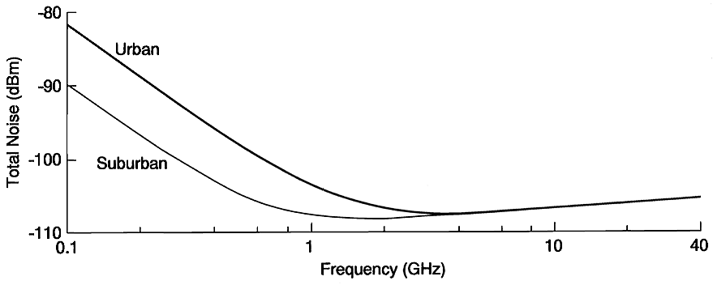
Figure 2: Total (manmade and receiver) noise level vs. frequency in urban & suburban areas (1MHz BW).
It can be concluded from the above figure that for radio frequencies above a few GHz a reasonable receiver noise figure assumption is 6 dB.

Non-Licensed Band Interferer Modelling
The interference in the MAN environment can be categorised into:
- Coexistence with DTV broadcast and Land Mobile Systems operating in upper UHF band.
- Narrow band jamming
- Partial band jamming
- Pulse jamming

Narrow Band Jamming
Narrow band jamming can be treated by:
- Using time shaping on the symbol and then equalisation (the more FFT points used the better the shape is)
- Using jamming detection and then a smart ECC, which can erase bad symbols.
In any case when using large FFT sizes, jammers at the base station are more effectively suppressed (due to the FFT filtering) and destroy fewer carriers (in percentage sense) than for small FFT size.

Partial Band Jamming
Detecting bad symbol can treat partial band jamming, which allow the usage of smart ECC, which can erase bad symbols.

Pulse Jamming
Short time interference can be sold by time interleaving the data. The usage of the sub-channel notion enables time interleaving of the sub-channel over time, the small packet length enables easy time interleaving and better statistical multiplexing.

Discrete Time Channel Model
The discrete-time impulse response model suitable for baseband Monte Carlo simulations is given by
$h(τ)=\sum_{k=0,1,\text{.}\text{.}\text{.}}{h_{k}δ(τ−{\text{kt}}_{Δ})}$,
where t_{Δ} is the sampling interval. The complex-valued coefficients h₀, h₁, … for the tapped-delay-line model are randomly generated. It is reasonable to assume uncorrelated scattering, i.e., E[h_{k} (h_{l})*] = 0 for k ≠ l. Also, a zero-mean complex Gaussian distribution is assumed for each coefficient with the variance given by
$Ε[{\left|h_{0}\right|}^{2}]=c_{0}+c_{1}(1−\text{exp}(−{t_{Δ}}/{τ_{1}}))$,
$Ε[{\left|h_{k}\right|}^{2}]=c_{1}(1−\text{exp}(−{t_{Δ}}/{τ_{1}}))\text{exp}(−{{\text{kt}}_{Δ}}/{τ_{1}})$, k = 1,2,….
The complex Gaussian distribution of all tap coefficients leads to a Rayleigh fading characteristic in the absence of a direct path (i.e. c₀ = 0), whereas otherwise a rician fading results. Taking the location variability into account, the parameters c₀ and c₁ are also random variables having a log-normal distribution.

Channel Model Configuration
The configuration parameters for the WRAN discrete time channel model and their possible values respectively ranges are summarised in Table 2.
Parameter | Values/range
transmitter-receiver separation d | a few hundred metres up to a several tens of kilometres
radio frequency f | UHF frequency band
base station antenna gain G_{B} | as specified
terminal station antenna gain G_{T} | as specified
terminal station half power beamwidth β_{T} | a few degrees up to 360 degrees
LOS condition | LOS, NLOS
environment type | urban small/medium cities; urban large cities; suburban; flat open
base station height h_{T} | 30–100 m
terminal station height h_{B} | 10 m
RMS delay spread τ_{RMS} | according to equation (2.3.2) and Table 1
K-factor K₀ | according to Table 1
season | summer; winter
Table 2: Summary of channel model configuration parameters.

Non-ideal RF DEVICES MODELS
In this section the impairments from various non-ideal RF components are addressed. Sect. contains the models for the non-linear signal amplification in the transmitter, together with some results from corresponding simulations. Models for the phase noise process are addressed in Sect. . In Sect. , models for quadrature modulation and demodulation are derived.

Non-Linear Signal Amplification
It is well known that the power envelope of an OFDM signal is time-variant and may exhibit high peaks, depending on the number of subcarriers and the modulation scheme employed. The non-constant envelope has a profound influence on the practical realisations of OFDM receiver and transmitter circuits. The power amplifier is usually the most critical device as it exhibits non-linear characteristics, which distort the transmitted signal and hence degrade the error performance. In the following, an analysis of the expected performance loss is given for a non-linear input-output-system, based on appropriate parametric models which determine the deviation from an ideal linear device. Additionally, the necessary back-off for the signal amplification in the transmitter and the total signal-to-noise ratio (SNR) degradation due to the non-linearity is found, facilitating the RF components design process.

General Non-Linear System Models
The general model for a memory-less, non-linear system is the simple functional relationship between the input and output signal given by
$y\left(t\right)=F\left[x\left(t\right)\right]$.
In communication systems, amplifiers and transducers are the devices that contribute most significantly to the non-linear characteristics. These devices are commonly modelled as memory-less non-linear systems, exhibiting non-linear gain (AM/AM) as well as amplitude-to-phase conversion (AM/PM). In the baseband representation, the AM/AM distortion only concerns the magnitude of the complex signal, whereas AM/PM converts the amplitude variations of the input signal into a phase modulation.
From the input bandpass signal
$$x\left(t\right)=A\left(t\right)\text{cos}\left[2{πf}_{0}t+φ\left(t\right)\right]$$
and after making the substitution
$$α=2{πf}_{0}t+φ\left(t\right)$$
the output signal can be expressed as
$$y\left(α\right)=F\left[A\text{cos}α\right]$$
in the neighbourhood of t. It is periodic in α and can hence be expanded in the Fourier series
$y\left(α\right)=a_{0}+\sum_{k=1}^{∞}{\left(a_{k}\text{cos}kα+b_{k}\text{sin}kα\right)}$.
Only the first-zone output, i.e. the k=1 terms in the above formula, are of interest. The bandpass signal at the output of the device can therefore be expressed as

$y\left(t\right)=a_{1}\text{cos}\left[2{πf}_{0}t+φ\left(t\right)\right]+b_{1}\text{sin}\left[2{πf}_{0}t+φ\left(t\right)\right]$ (3.1.1)
with
$a_{1}=\frac{1}{π}\int_{0}^{2π}{F\left(A\text{cos}α\right)\text{cos}α} dα$ (3.1.2)
and
$b_{1}=\frac{1}{π}\int_{0}^{2π}{F\left(A\text{cos}α\right)\text{sin}α} dα$.

It follows from the symmetry F(x) = F(-x) that the b₁-term vanishes. The baseband equivalent model follows from (3.1.1) and (3.1.2), i.e.,

$y_{l}(t)=\frac{x_{l}(t)}{\left|x_{l}\left(t\right)\right|}f\left(\left|x_{l}\left(t\right)\right|\right)$,
where f(A) is defined as
$f\left(A\right)=\frac{1}{π}\int_{0}^{2π}{F\left[A\text{cos}α\right]\text{cos}α} dα$.
Here, x_{l}(t) and y_{l}(t) denote the complex envelopes of the input and the output signal, respectively.

Parametric RF Amplification Model
For the characterisation of the non-ideal amplification in the transmitter devices the common model
$$F\left(x\right)={\left(1+x^{{−1}/s}\right)}^{−s}$$
is adopted, in which the extent of the non-linear behaviour is determined by the value of the parameter s ≥ 0. Figure 3 depicts the mapping F(·) for different values of s.
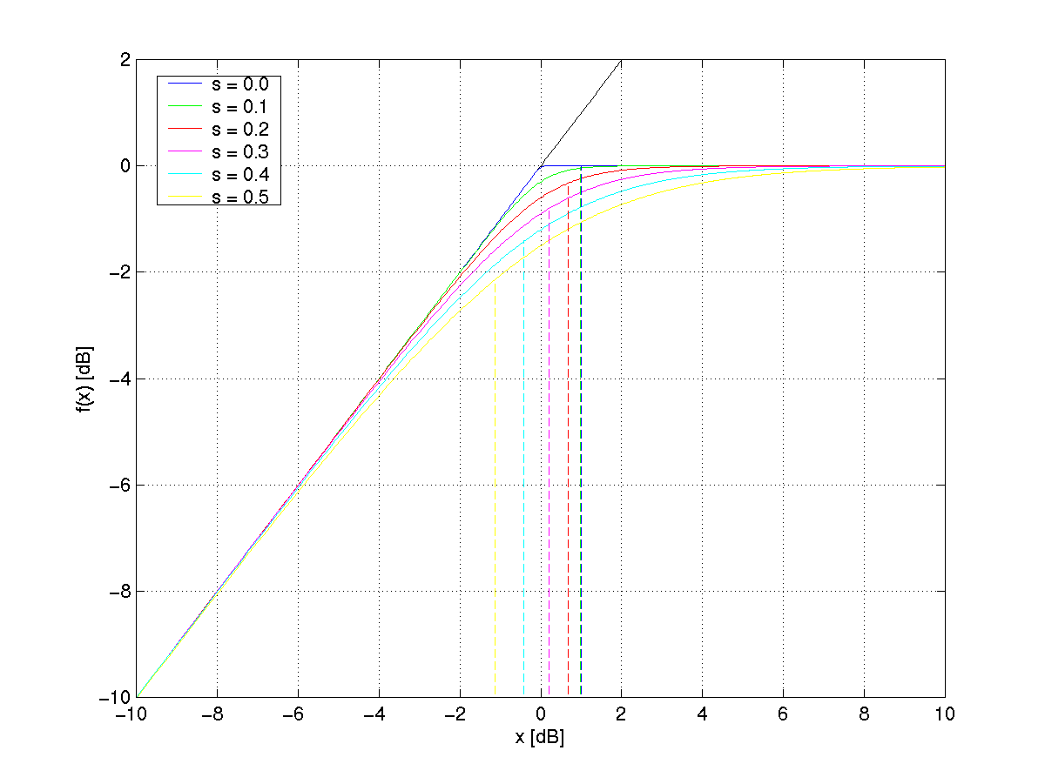
1dB compression point: P_{1dB}
Figure 3: Parametric non-linear amplification model.
The 1 dB compression point determines the power level at which the output power deviation equals 1 dB.
In the following, the SNR loss L_{NLIN} is studied, determining the difference in the SNR which is required to maintain a bit error rate (BER) of 10⁻³ under linear respectively non-linear conditions. Clearly, L_{NLIN} is a function of s and the output back-off (OBO). The OBO defines the ratio of the maximum (saturation) output power P_{sat} and the mean power output P_{o} of the device, i.e.,
$\text{OBO}=\text{10}\text{log}\frac{P_{\text{sat}}}{P_{o}}$.
For the case of an uncoded transmission employing quadrature phase-shift keying (QPSK) modulation and assuming an ideal channel, the resulting L_{NLIN} are depicted in Figure 4 for various s as a function of the OBO. The results are based on computer simulations.
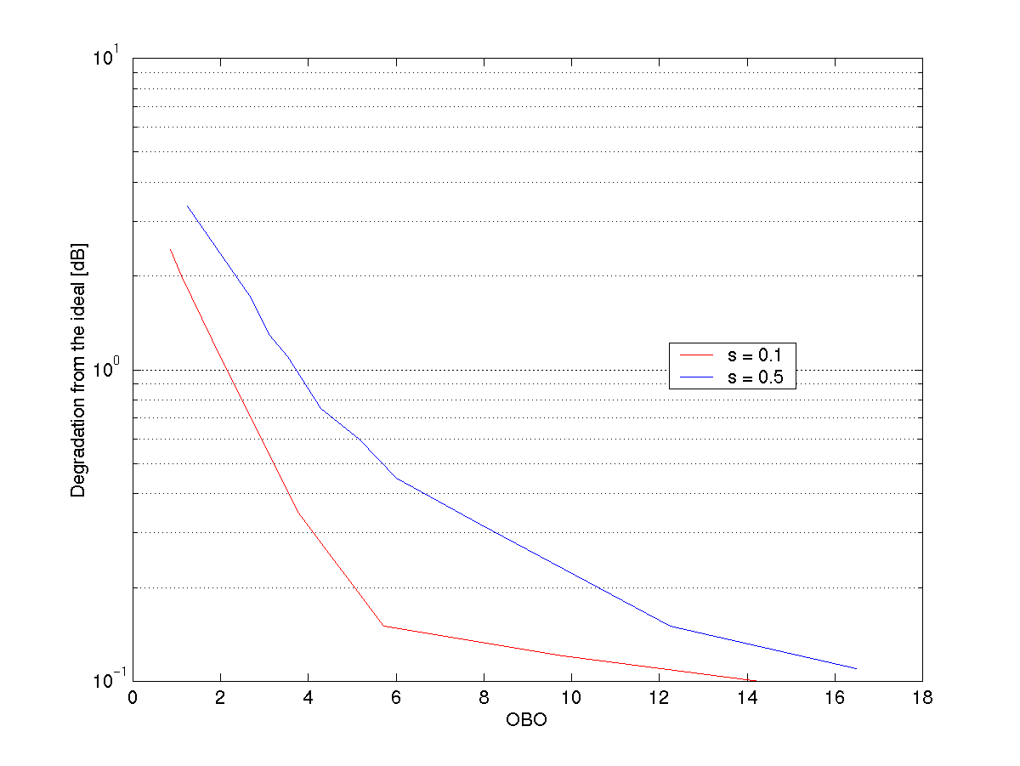
Figure 4: SNR degradation N_{LIN} as a function of the OBO.

Total Power Degradation
On the one hand it is desirable to have the smallest possible OBO in order to utilise as much of the available power of the amplifier as possible. On the other hand, operating the amplifier with a small back-off will tend to generate a relatively high L_{NLIN}. It is therefore desirable to operate the power amplifier at an optimum output back-off level, which minimises the combination of the power loss due to amplifier backing off and the SNR degradation L_{NLIN} resulting from the non-linear amplification of the signal.
The total power degradation (TPD) is defined as
$\text{TPD}=\text{OBO}+L_{\text{NLIN}}$.
Its minimum value characterises the impact of the non-linearity as it represents the best case SNR degradation that has to be taken into account.
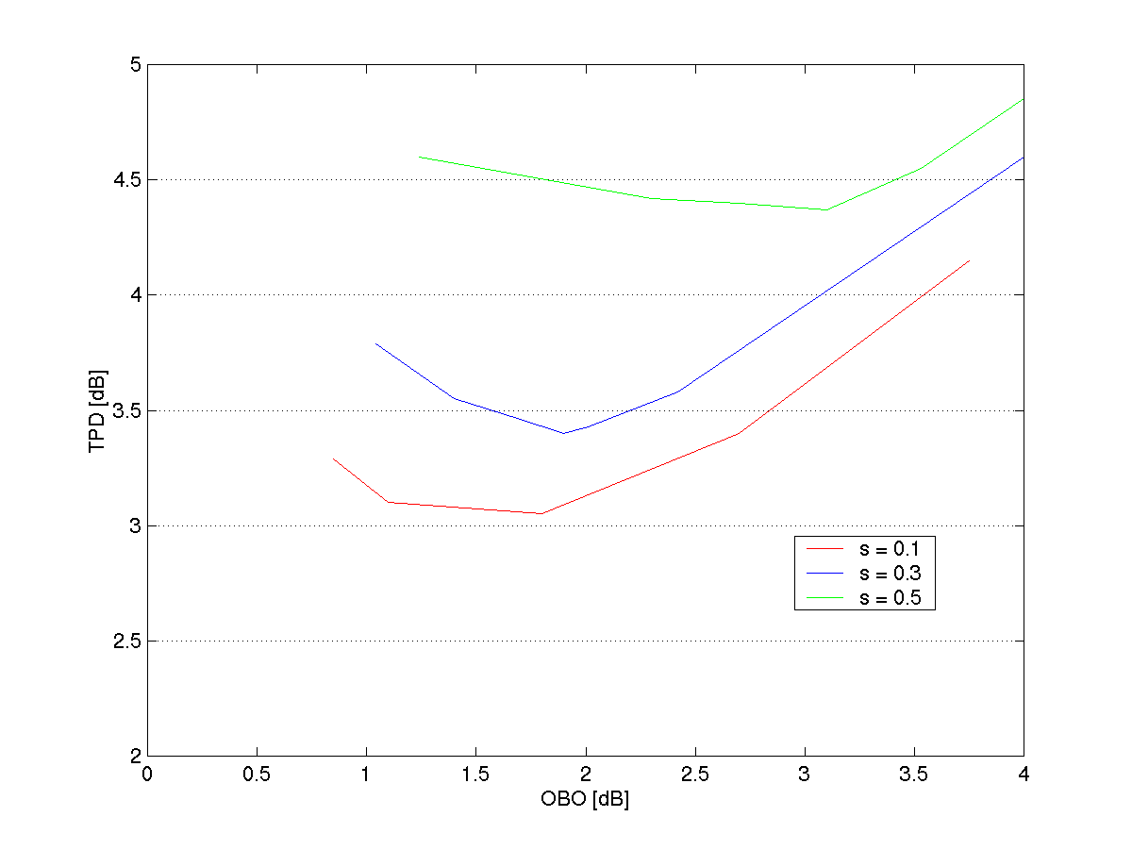
Figure 5: Total power degradation as a function of the OBO.
Figure 5 illustrates the resulting TPD values for different s. A summary of the optimum choices for the OBO and the corresponding minimum TPD values is given in Table 3.
Model parameter s | Optimised OBO | TPD
0.5 | 3.1 dB | 4.35 dB
0.3 | 1.9 dB | 3.4 dB
0.1 | 1.8 dB | 3.05 dB
Table 3: Optimum OBO and corresponding TPD values.

Phase Noise
OFDM systems are sensitive to various impairments that can affect the fundamental orthogonality between the carriers. One of these impairments is the phase noise of the oscillators, which are used for signal up and down conversion. This non-ideal oscillator characteristic induces inter-channel interference (ICI) which degrades the overall system performance.
This section focuses on some characteristics of the phase noise process, presents in brief the Power-Law Spectral Density Model, and proposes a statistical model and a simulation model, which is based on current bibliography.

Phase Noise and Power-Law Model
The phase noise topic is of great theoretical and practical interest. Although many studies have been made about it, phase noise (PN) remains a crucial issue in communication system design. Phase instabilities are phenomena that characterise any practical non-ideal oscillator. These fluctuations are strongly related to several physical mechanisms. There are systematic variations (drifts) that are called “long-term instabilities” and are due to ageing of the resonator material or due to frequency modulation by periodic signals. These are deterministic processes, which don’t afford any statistical treatment. Random short-term instabilities are caused due to thermal and flicker noise or by the oscillator’s environment. These are instabilities that need statistical treatment and respective models in order to be described.
The power spectral density S(f) of oscillator instabilities can be described from the Power-Law model, according to which
$$S(f)=h_{α}f^{a}$$
where a typically takes integer values, but also non-integer values may be encountered. The constant $h_{α}$ is a measure of the noise level. The factor $f^{0}$(i.e., independent of f) represents the white noise, which originates from the additive white noise sources that reside in the oscillator’s loop. The factor $f^{−1}$represents the flicker noise and the factor $f^{−2}$ the effect of the environment on the oscillator (temperature, vibration, and shocks) which can be modelled as Random Walk noise [20].
Experimental data are usually plotted using log-log scaling, where the power law appears as straight lines. In practice the power-law model often used is [21]

$$S(f)=\left\{\begin{matrix}\sum_{a=−3}^{3}{h_{a}f^{a},} & 0≤f≤f_{\text{co}} \\ 0, & f>f_{\text{co}}\end{matrix}\right.$$

where a cut-off frequency $f_{\text{co}}$is introduced in order to avoid mathematical difficulties as infinite power.

Wiener Statistical Phase Noise Model
In [20] it is justified that the oscillator’s environment (temperature, vibration shocks, etc.) can produce phase instabilities that can be modelled as a random walk (Brownian motion). From another point of view it has been proven [22] that the phase noise in an oscillator, regardless of its operating mechanism, has stochastic characteristics that can be very much like Brownian motion. So, the oscillators’ phase noise can be described by a Wiener process, with the zero-mean probability density function
$$f(θ,τ)=\frac{1}{\sqrt{8π^{2}\text{βτ}}}e^{{−θ^{2}}/8\text{πβτ}}$$
and variance
$$E[θ(τ+τ_{0})−θ(τ_{0})]^{2}=4\text{πβτ}$$
where $β$ is the two-sided 3-dB linewidth of the Lorenzian power density spectrum of the oscillator.
This is a good model for phase noise, whenever the main impact upon the oscillator is the environment (as opposed to the flicker noise).

The impact of Wiener phase noise on OFDM systems performance has been under investigation by several authors [23], [24]. The great sensitivity that arises leads to the need for more extensive research of phase noise statistics. Several authors have tried to explore them, some using simulation techniques [25], and others through analytical methods. In [26] an analytical recursive method is presented which accounts for moments of the phase noise for any integral of a function of the Brownian motion:
$$I(t)=\int_{0}^{t}{f(B_{θ_{0}}(τ))}dτ=\int_{0}^{t}{f(θ_{0}+B(τ))}dτ$$
where
$$\left\{B(t),t≥0\right\}$$
is the Brownian motion staring from $θ_{0}=0$ and
$$\left\{B_{θ_{ο}}(t),t≥0\right\}$$
is the Brownian with an arbitrary starting value $θ_{0}$, in case that it is measurable, bounded from below and satisfies
$\int_{−∞}^{∞}{f(y)e^{−|y|\sqrt{λ}}\text{dy}<∞}$ with $λ>0$.
It is proved that
$E_{θ_{0}}{\left(I(t)\right)}^{n}=n\int_{−∞}^{∞}{f(y)\int_{0}^{t}{E_{y}{\left(I(t)\right)}^{n−1}p(t−τ}};θ_{0},y)dτ\text{dy}$ (3.2.1)
where $E_{x}$is the expectation of a Brownian motion starting from $x$and
$p(τ;θ_{0},y)=(4π^{2}\text{βτ})^{{−1}/2}\text{exp}\left\{−(y−θ_{0}{)^{2}}/4π^{2}\text{βτ}\right\}$. (3.2.2)
In case that the process is
$$I(t)=\int_{0}^{t}{e^{j(θ_{0}+θ(τ))}}dτ$$
it can be decomposed into real and imaginary parts
$I(t)=\int_{0}^{t}{\text{cos}(θ_{0}+θ(τ))}dτ+j\int_{0}^{t}{\text{sin}(θ_{0}+θ(τ))}dτ=X_{θ_{0}}(t)+{\text{jY}}_{θ_{0}}(t)$.
Following (3.2.1-2), it is computed that

$$E_{θ_{ο}}(I(t))=E_{θ_{ο}}(X_{θ_{0}}(t))+{\text{jE}}_{θ_{ο}}(Y_{θ_{0}}(t))$$
or
$E_{θ_{ο}}(I(t))=2(\text{cos}θ_{0}+j\text{sin}θ_{0})\frac{1−e^{−2\text{πβτ}}}{4\text{πβτ}}$.
Higher order moments can be found in the same fashion. Approximate pdf’s can be estimated by use of orthogonal series expansion or through a maximum entropy approach [26].

In order to simulate the effect of phase noise on OFDM, we can use the corresponding discrete-time Wiener process, where the phase noise term affecting the n-th sample of the m-th OFDM symbol can be modelled
$φ_{m}(n)=φ_{m−1}(N−1)+\sum_{l=0}^{n}{θ_{l},}\begin{matrix} & & \end{matrix}0≤n≤N−1$, with $φ_{0}(n)=\sum_{l=0}^{n}{θ_{l}}$
where $θ_{l}$ are stationary, zero-mean Gaussian samples with variance $σ_{θ}^{2}=4\text{πβ}$.
It must be noted that in order to estimate or simulate the phase noise effect, both oscillators (at the base station and the receiver) should be accounted for. However, in most of the cases, the oscillator of the base station is stable enough to disregard its effect [23].

Non-Ideal Modulator/Demodulator

Introduction
This section derives models for quadrature modulation and demodulation. It discusses the performance of digital modulation and provides a simple model for digital demodulation.
Quantisation noise is not discussed within the following sections, but should be taken in to account when implementing the models within a system simulation.

Quadrature Modulator
Quadrature modulation is a technique to modulate a carrier using the quadrature components of the signal. This technique has the advantage of being able to directly modulate to relatively high frequencies (up to 3GHz and above). Its disadvantages include inband distortions. These are caused by local oscillator (LO) leakage, imperfect amplitude/phase balance, and DC offsets. Generally these detrimental effects become harder to contain as the carrier frequency and/or pass bandwidth is increased.

LO leakage at the output of the modulator will be generated from the internal mixers’ finite LO isolation, as well as DC offsets in the signal and/or in the mixers’ biasing. Finite phase imbalance will always be present due to the fact that it is impossible to achieve a perfect 90 degree phase shift. The tolerance of this specification will depend on the pass bandwidth within which the modulator is designed to operate. Amplitude imbalance will be caused by the finite differences in the two quadrature paths of the modulator. For instance differences in the phase splitter balance, mixer gain, combiner gain, and interstage matching will always contribute to amplitude imbalance. Both amplitude and phase imbalance will generate a negative frequency component at the output of the modulator.

Generally quadrature modulator specifications state for their bandwidth of operation, LO leakage (dBc), amplitude imbalance (dB), and phase imbalance (max or RMS degrees). Typical values for a good device would be –35dBc, 0.2dB, and 2 degrees max respectively. However many devices state limits as poor as –25dBc, 0.5dB, and 5 degrees respectively.

Derivation of Model
An equation for a modulated signal:
$$s(t)=a(t)⋅\text{cos}(ωct+θ(t))$$
can be represented by its quadrature component parts:
$s(t)=x(t)⋅\text{cos}(ωct)−y(t)⋅\text{sin}(ωct)$ (3.3.1)
where
$$\begin{aligned}x(t)=a(t)⋅\text{cos}(θ(t)) \\ y(t)=a(t)⋅\text{sin}(θ(t))\end{aligned}$$
Equation (3.3.1) can be visualised in the diagram of a quadrature modulator:

Figure 6: Quadrature modulator.

To simplify the following algebra, let $a=θ(t)$, $b=ωct$, and leave out the amplitude component $a(t)$ until later on in the derivation.
In an ideal situation the output from the modulator can be derived thus:
$$\begin{aligned}s(t)=\text{cos}(a)⋅\text{cos}(b)−\text{cos}(a+\frac{π}{2})⋅\text{cos}(b+\frac{π}{2}) \\ \text{cos}(a)⋅\text{cos}(b)−\text{sin}(a)⋅\text{sin}(b) \\ \frac{\text{cos}(a+b)}{2}+\frac{\text{cos}(a−b)}{2}−\frac{\text{cos}(a−b)}{2}+\frac{\text{cos}(a+b)}{2} \\ =\text{cos}(a+b)\end{aligned}$$
However by introducing amplitude imbalance, phase imbalance, LO leakage, and DC offset into the equation, we get:
$$\begin{aligned}s(t)=(\text{cos}(a)+m)⋅\text{cos}(b)−(x⋅\text{sin}(a)+n)⋅\text{sin}(b+c) \\ =\frac{\text{cos}(a+b)}{2}+\frac{\text{cos}(a−b)}{2}+m⋅\text{cos}(b)−\frac{x⋅\text{cos}(a−b−c)}{2}+\frac{x⋅\text{cos}(a+b+c)}{2}−n⋅\text{sin}(b+c)\end{aligned}$$
where ‘m’ and ‘n’ are the dc offsets (which are identical to LO leakage), ‘c’ is the phase imbalance, and $\text{20}⋅\text{log}\text{10}(x)$ represents amplitude imbalance in dB’s.
If we remove the LO leakage terms until later and use the following identities:
$$\begin{aligned}\text{cos}(a−b−c)=\text{cos}(a−b)⋅\text{cos}(c)+\text{sin}(a−b)⋅\text{sin}(c) \\ \text{cos}(a+b+c)=\text{cos}(a+b)⋅\text{cos}(c)−\text{sin}(a+b)⋅\text{sin}(c)\end{aligned}$$
we get:
$$\begin{aligned}s(t)=\text{cos}(a+b)⋅(\frac{1}{2}+\frac{x⋅\text{cos}(c)}{2})+\text{sin}(a+b)⋅(\frac{−x⋅\text{sin}(c)}{2})+\text{cos}(a−b)⋅(\frac{1}{2}−\frac{x⋅\text{cos}(c)}{2})+\text{sin}(a−b)⋅(\frac{−x⋅\text{sin}(c)}{2}) \\ \text{sign}(x⋅\text{cos}(c)−1)⋅\sqrt{{\left(\frac{1}{2}+\frac{x⋅\text{cos}(c)}{2}\right)}^{2}+{\left(\frac{−x⋅\text{sin}(c)}{2}\right)}^{2}}\text{cos}\left[a+b+a\text{tan}\left[\frac{\frac{x⋅\text{sin}(c)}{2}}{(\frac{1}{2}+\frac{x⋅\text{cos}(c)}{2})}\right]\right] \\ +\text{sign}(1−x⋅\text{cos}(c))⋅\sqrt{{\left(\frac{1}{2}−\frac{x⋅\text{cos}(c)}{2}\right)}^{2}+{\left(\frac{−x⋅\text{sin}(c)}{2}\right)}^{2}}\text{cos}\left[a−b+a\text{tan}\left[\frac{\frac{x⋅\text{sin}(c)}{2}}{(\frac{1}{2}−\frac{x⋅\text{cos}(c)}{2})}\right]\right] \\ \text{sign}(x⋅\text{cos}(c)−1)⋅\frac{1}{2}⋅\sqrt{1+2⋅x⋅\text{cos}(c)+x^{2}}⋅\text{cos}\left[b+a+a\text{tan}\left[x⋅\frac{\text{sin}(c)}{\left(1+x⋅\text{cos}(c)\right)}\right]\right] \\ +\text{sign}(1−x⋅\text{cos}(c))⋅\frac{1}{2}⋅\sqrt{1−2⋅x⋅\text{cos}(c)+x^{2}}⋅\text{cos}\left[b−a+a\text{tan}\left[x⋅\frac{\text{sin}(c)}{\left(x⋅\text{cos}(c)−1\right)}\right]\right]\end{aligned}$$
(3.3.2)
The term for LO leakage can be derived as follows:
$$\begin{aligned}m⋅\text{cos}(b)−n⋅\text{sin}(b+c)=m⋅\text{cos}(b)−n⋅\text{sin}(b)⋅\text{cos}(c)−n⋅\text{sin}(c)⋅\text{cos}(b) \\ =\text{cos}(b)⋅\left(m−n⋅\text{sin}(c)\right)−\text{sin}(b)⋅n⋅\text{cos}(c)\end{aligned}$$
$=\text{sign}(m−n⋅\text{cos}(c))⋅\sqrt{{\left(m−n⋅\text{sin}(c)\right)}^{2}+{\left(n⋅\text{cos}(c)\right)}^{2}}\text{cos}\left[b+a\text{tan}\left[\frac{n⋅\text{cos}(c)}{m−n⋅\text{sin}(c)}\right]\right]$ (3.3.3)

The formula for a quadrature modulator is given by (3.3.2) and (3.3.3) after multiplying them by the amplitude component $a(t)$ and replacing variables ‘a’, ‘b’, and ‘c’. However, a more convenient form for equation (3.3.3) can be used:
$$\text{mean}(a(t))⋅{\text{10}}^{\frac{\text{LO}}{\text{20}}}⋅\text{cos}(ωct)$$
where LO is the LO leakage in dBc.

Performance of Model
The graphs in Figure 7, Figure 8 and Figure 9 show the effects of phase and amplitude imbalance and DC offsets.
Figure 7: Phase imbalance effects.
Note: The amplitude of the wanted or positive frequency term cos(b+a), will not be effected significantly by phase imbalance.
For negative phase offsets, the –ve frequency phase has a 180 degrees phase shift and is therefore not shown in the graph.

Figure 8: Amplitude imbalance effects.

Note: Amplitude imbalance does not cause phase shifts in the signal.

Figure 9: DC offset effects.
Note: DC offset is relative to signal at 1 unit peak.
Depending on the level of the DC offset on each path, the phase of the LO leakage will range between +/-90 degrees relative to the Local Oscillator phase.

Quadrature Demodulator
Quadrature demodulation is a technique to demodulate a modulated signal from its carrier to its quadrature components.
Generally quadrature demodulator specifications state for their bandwidth of operation, amplitude imbalance (dB), and phase imbalance (max degrees). Typical values for a good device would be 0.2dB, and 2 degrees max respectively. However many devices state limits as poor as 0.5dB, and 5 degrees respectively.

Derivation of Model
90

Phase
Splitter

0
.y(t)
.x(t)

Figure 10: Quadrature demodulator.
Referring to the quadrature demodulator sketched in Figure 10. If we let $a=θ(t)$, $b=ωct$, and leave out the amplitude component $a(t)$ until later on in the derivation, the equations for the quadrature outputs can be given as:
$\begin{aligned}X=\text{cos}(b)⋅(\text{cos}(a+b)+L) \\ =\frac{\text{cos}(2⋅b+a)}{2}+\frac{\text{cos}(a)}{2}+L⋅\text{cos}(b)\end{aligned}$,$\begin{aligned}Y=x⋅\text{cos}(b+\frac{π}{2}+c)⋅\left(\text{cos}(a+b)+L\right) \\ =\left(\frac{−x⋅\text{sin}(2⋅b+a+c)}{2}−\frac{x⋅\text{sin}(c−a)}{2}\right)+x⋅L⋅\text{cos}(b+\frac{π}{2}+c) \\ =−\frac{1}{2}⋅x⋅\text{sin}(2⋅b+a+c)+\frac{1}{2}⋅x⋅\text{sin}(a−c)−x⋅L⋅\text{sin}(b+c)\end{aligned}$
where as before, ‘x’ represents amplitude imbalance, and ‘c’ represents phase imbalance. For convenience LO leakage (or DC offset) on both sides is represented by ‘L’.

To evaluate the distortion of the demodulation process, the quadrature components are re-modulated:
$$\begin{aligned}s(t)=\text{cos}(b)⋅\left(\frac{\text{cos}(2⋅b+a)}{2}+\frac{\text{cos}(a)}{2}+L⋅\text{cos}(b)\right)−\text{sin}(b)⋅\left(−\frac{1}{2}⋅x⋅\text{sin}(2⋅b+a+c)+\frac{1}{2}⋅x⋅\text{sin}(a−c)−x⋅L⋅\text{sin}(b+c)\right) \\ =\frac{1}{4}⋅\left(\text{cos}(3⋅b+a)+\text{cos}(b+a)\right)+\frac{1}{4}⋅\left(\text{cos}(b+a)+\text{cos}(b−a)\right) \\ +\frac{x}{4}⋅\left(\text{cos}(b+a+c)+\text{cos}(3⋅b+a+c)\right)−\frac{x}{4}⋅\left(\text{cos}(b−a+c)−\text{cos}(b+a−c)\right) \\ +L⋅\left(\frac{\text{cos}(2⋅b)}{2}+\frac{1}{2}+\frac{\text{cos}(c)}{2}−\frac{\text{cos}(2⋅b+c)}{2}\right) \\ =\text{cos}(a+b)⋅\left(\frac{1}{2}+\frac{x}{2}⋅\text{cos}(c)\right)+\text{cos}(b−a)⋅\left(\frac{1}{4}−\frac{x}{4}⋅\text{cos}(c)\right)−\text{sin}(b−a)⋅\left(\frac{x}{4}⋅\text{sin}(−c)\right) \\ +\frac{1}{4}⋅\text{cos}(3⋅b+a)−\frac{1}{4}⋅\text{cos}(3⋅b+a+c)+L⋅\left(\frac{\text{cos}(2⋅b)}{2}+\frac{1}{2}+\frac{\text{cos}(c)}{2}−\frac{\text{cos}(2⋅b+c)}{2}\right)\end{aligned}$$
The LO leakage generates components at DC and twice carrier frequency. These can be ignored along with the third order components. Re-introducing the amplitude component a(t) and leaving variables ‘a’, ‘b’, and ‘c’ in place for simplicity, we finally get:
$$\begin{aligned}s(t)=a(t)⋅\left(\frac{1}{2}+\frac{x}{2}⋅\text{cos}(c)\right)⋅\text{cos}(b+a) \\ +a(t)⋅\text{sign}(1−x⋅\text{cos}(c))⋅\frac{1}{4}⋅\sqrt{1−2⋅x⋅\text{cos}(c)+x^{2}}⋅\text{cos}\left[b−a+a\text{tan}\left[x⋅\frac{\text{sin}(c)}{\left(x⋅\text{cos}(c)−1\right)}\right]\right]\end{aligned}$$

Digital Modulation
It is possible to modulate directly to a low IF frequency with a high-speed digital-to-analog converter (DAC). A typical performance of 70dBc spurious free dynamic range can be expected by modulating to a carrier at a tenth of the sampling update rate.
The digital signal processing required to drive the DAC can be simplified by using a purpose built CMOS device. For instance, analogue devices produce a digital quadrature modulator, which incorporates quadrature DDS and DAC. The particular device is capable of offering 70dBc SFDR at 60MHz carrier frequency. It incorporates interpolation, inv SINC and inv CIC filters, DDS, and a 14bit 200MSPS DAC.
In this type of modulation, apart from quantisation noise, other deficiencies are difficult to model.

Digital Demodulation
This type of modulation involves the technique of undersampling. The analogue signal is sampled at a rate high enough to include all the information in the baseband signal. Since the aperture time is very fast compared to the sampling rate, the process downconverts the signal from the carrier to baseband.
The current RF design for WRAN uses a 415MHz IF, which is probably too high for a cost effective undersampling solution. However, a 2nd IF at 30MHz to 50MHz can be used without too much additional cost and complexity.
Undersampling offers improved performance over quadrature demodulation, and less resolution is required on the A-D converter. In simulations aperture jitter could be increased as high as 50pS rms, whereas typically 1pS rms is usually specified.

Derivation of Model
Apart from quantisation noise the main source of distortion is aperture jitter. A formula for aperture jitter at baseband can be represented by:
$$s(t)=a(t)⋅\text{cos}(θ(t)+ω\text{if}⋅J(t))$$
where $ω\text{if}$is the 2nd IF carrier frequency, and $J(t)$ represents normally distributed noise with an rms value equal to the aperture jitter of the device to be modelled.

4 . APPENDIX A

This appendix provides the coefficients L_{HATA} and μ_{HATA} for the excess path loss calculation based on f₀ = 1 GHz. for different h_{B} and h_{T} according to Hata’s model.
 | h_{T} = 1 m | h_{T} = 4 m | h_{T} = 7 m | h_{T} = 10 m
h_{B} = 30 m | L_{HATA} = -9.22  μ_{HATA} = 15.22 | L_{HATA} = -17.02  μ_{HATA} = 15.22 | L_{HATA} = -24.82  μ_{HATA} = 15.22 | L_{HATA} = -32.62  μ_{HATA} = 15.22
h_{B} = 50 m | L_{HATA} = -7.93  μ_{HATA} = 13.77 | L_{HATA} = -15.73  μ_{HATA} = 13.77 | L_{HATA} = -23.53  μ_{HATA} = 13.77 | L_{HATA} = -31.33  μ_{HATA} = 13.77
h_{B} = 100 m | L_{HATA} = -6.17  μ_{HATA} = 11.80 | L_{HATA} = -13.97  μ_{HATA} = 11.80 | L_{HATA} = -21.77  μ_{HATA} = 11.80 | L_{HATA} = -29.57  μ_{HATA} = 11.80
h_{B} = 200 m | L_{HATA} = -4.42  μ_{HATA} = 9.83 | L_{HATA} = -12.22  μ_{HATA} = 9.83 | L_{HATA} = -20.02  μ_{HATA} = 9.83 | L_{HATA} = -27.82  μ_{HATA} = 9.83
Table 4: Hata's model excess path loss coefficients for small/medium cities at f₀ = 1 GHz.
 | h_{T} = 1 m | h_{T} = 4 m | h_{T} = 7 m | h_{T} = 10 m
h_{B} = 30 m | L_{HATA} = -9.19  μ_{HATA} = 15.22 | L_{HATA} = -14.48  μ_{HATA} = 15.22 | L_{HATA} = -17.27  μ_{HATA} = 15.22 | L_{HATA} = -19.24  μ_{HATA} = 15.22
h_{B} = 50 m | L_{HATA} = -7.90  μ_{HATA} = 13.77 | L_{HATA} = -13.18  μ_{HATA} = 13.77 | L_{HATA} = -15.97  μ_{HATA} = 13.77 | L_{HATA} = -17.95  μ_{HATA} = 13.77
h_{B} = 100 m | L_{HATA} = -6.15  μ_{HATA} = 11.80 | L_{HATA} = -11.43  μ_{HATA} = 11.80 | L_{HATA} = -14.22  μ_{HATA} = 11.80 | L_{HATA} = -16.19  μ_{HATA} = 11.80
h_{B} = 200 m | L_{HATA} = -4.39  μ_{HATA} = 9.83 | L_{HATA} = -9.67  μ_{HATA} = 9.83 | L_{HATA} = -12.46  μ_{HATA} = 9.83 | L_{HATA} = -14.44  μ_{HATA} = 9.83
Table 5: Hata's model excess path loss coefficients for large cities at f₀ = 1 GHz.
 | Suburban areas | Open areas
h_{B} = 30 m | L_{HATA} = -20.72  μ_{HATA} = 15.22 | L_{HATA} = -39.47  μ_{HATA} = 15.22
h_{B} = 50 m | L_{HATA} = -19.43  μ_{HATA} = 13.77 | L_{HATA} = -38.18  μ_{HATA} = 13.77
h_{B} = 100 m | L_{HATA} = -17.67  μ_{HATA} = 11.80 | L_{HATA} = -36.42  μ_{HATA} = 11.80
h_{B} = 200 m | L_{HATA} = -15.92  μ_{HATA} = 9.83 | L_{HATA} = -34.67  μ_{HATA} = 9.83
Table 6: Hata's model excess path loss for suburban and open areas at f₀ = 1 GHz.

References:

In the entire document, log denotes the logarithm to the basis 10, i.e., log₁₀(·).

