IEEE P802.22
Wireless RANs
Impact of Adjacent Channels D/U’s on WRAN Operation
Date: 2005-06-15
Author(s):
Name | Company | Address | Phone | email
Gerald Chouinard | CRC | 3701 Carling Avenue, Ottawa, Ontario, Canada, K2H 8S2 | +1 613-998-2500 | gerald.chouinard@crc.ca

Abstract
The ATSC A-74 DTV Receiver Performance Guidelines include adjacent channels D/U’s for strong, medium and weak desired signals. However no values exist for protecting DTV reception down to the Grade B signal level. Five possible scalings of the current values to Grade B level are investigated along with the resulting impact on the WRAN operation.
Notice: This document has been prepared to assist IEEE 802.22. It is offered as a basis for discussion and is not binding on the contributing individual(s) or organization(s). The material in this document is subject to change in form and content after further study. The contributor(s) reserve(s) the right to add, amend or withdraw material contained herein.

Release: The contributor grants a free, irrevocable license to the IEEE to incorporate material contained in this contribution, and any modifications thereof, in the creation of an IEEE Standards publication; to copyright in the IEEE’s name any IEEE Standards publication even though it may include portions of this contribution; and at the IEEE’s sole discretion to permit others to reproduce in whole or in part the resulting IEEE Standards publication. The contributor also acknowledges and accepts that this contribution may be made public by IEEE 802.22.

Patent Policy and Procedures: The contributor is familiar with the IEEE 802 Patent Policy and Procedures
<http://standards.ieee.org/guides/bylaws/sb-bylaws.pdf>, including the statement "IEEE standards may include the known use of patent(s), including patent applications, provided the IEEE receives assurance from the patent holder or applicant with respect to patents essential for compliance with both mandatory and optional portions of the standard." Early disclosure to the Working Group of patent information that might be relevant to the standard is essential to reduce the possibility for delays in the development process and increase the likelihood that the draft publication will be approved for publication. Please notify the Chair <Carl R. Stevenson> as early as possible, in written or electronic form, if patented technology (or technology under patent application) might be incorporated into a draft standard being developed within the IEEE 802.22 Working Group. If you have questions, contact the IEEE Patent Committee Administrator at <patcom@ieee.org>.
Impact of Adjacent Channels D/U’s on WRAN Operation

Introduction
The ATSC A-74 DTV Receiver Performance Guidelines include adjacent channels D/U’s for strong, medium and weak desired signal levels. If the WRAN systems are to protect DTV reception out to the Grade B contours, the corresponding D/U values for the the Grade B signal level need to be used. Since such values have not been specified, this document suggests 5 possible sets of D/U’s scaled from those contained in the A-74 Recommended Practice The impact of these 5 sets of D/U’s on the potential operation of WRAN systems is analyzed.
Adjacent channel D/U scaling
Five possible scalings of the current values to Grade B level have been investigated. These are:
Saturation: The assumption used for the scaling is that the level of intermod impacting the desired signal is independent of its level and only depends on the proximity of the interfering high power carrier from the saturation point of the DTV receiver RF front-end. This is also equivalent to protecting DTV reception down to the weak desired level.
Third order intermodulation, 1/3: The usual ratio of 3 dB intermodulation level reduction for each 1 dB carrier decrease is assumed (re: IP3 level definition and the polynomial expression of the distorted waveform: F(x)=ax+bx³+cx⁵+…).
Third order intermodulation, 1/2: This relates to the two-tone test where the ‘2a-b’ intermod product increases twice as fast as the total power appearing at the input of the receiver FR front-end. Also, Charlie W. Rhodes indicated: "A 3 dB increase in power input results in a 6 dB increase in distortion (noise). Theory suggests this increase would be 9 dB for a two-tone test signal, but it's not so with DTV signals because of spectrum spreading." "The Plotting Thickens", TVTechnology - Digital TV 16 Feb05, http://www.tvtechnology.com/features/digital_tv/02-16-05.shtml
Linear extrapolation: The D/U’s at Grade B desired signal level are obtained on the basis of a linear extrapolation from the D/U's at medium and weak desired signal levels. The same trends are assumed for the D/U’s when the desired signal level is reduced. This linear extrapolation has the merit of preserving the same mix of linear and non-linear interference mechanisms for the given channel separation such as the presence of image interference which is more linear in channels N+-14 1nd 15.
Linear interference: This represents the most conservative case where the same D/U’s would apply at weak signal level and Grade B signal level. This implies that adjacent channel interference beyond N+-1 would also be due to linear mechanisms such as filtering. Hence, the D/U's are assumed to be independent of the desired signal level.
Table 1 summarizes the 5 scalings investigated.

Table 1: DTV D/U ratios as a function of the desured signal level
Impact of the different sets of D/U ratios
For the purpose of comparing the effect of the different sets of D/U ratios on the EIRP Profile and the RF Mask to be applied to the transmissions from the WRAN CPE’s in order to avoid interference to DTV reception, the maximum 4 Watt CPE transmission level is assumed and the minimum distance to the closest DTV receive antenna is 10 m. Following are the figures resulting from each assumed adjacent channel D/U scaling.
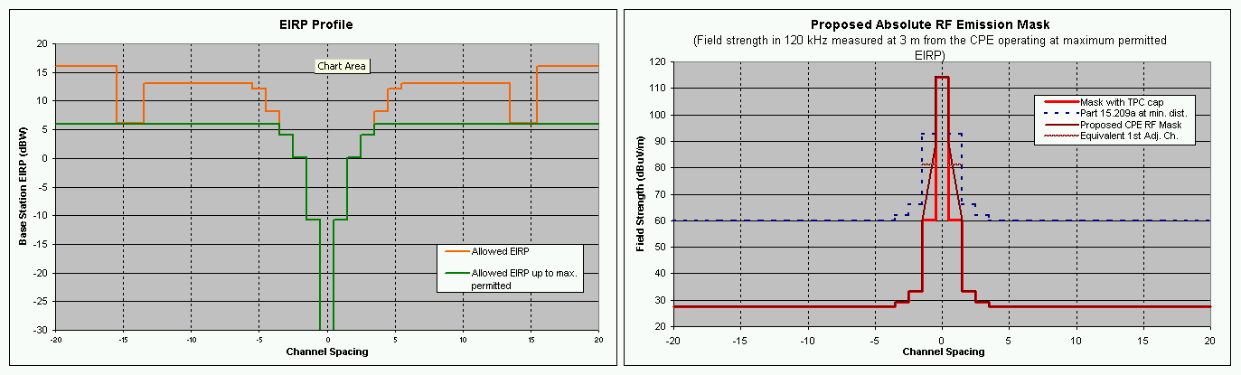
Figure 1: CPE EIRP Profile and RF Mask for the Saturation case
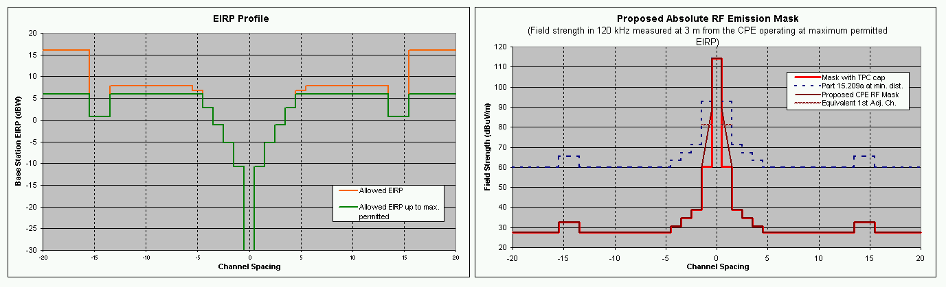
Figure 2: CPE EIRP Profile and RF Mask for the Intermod 1/3 case
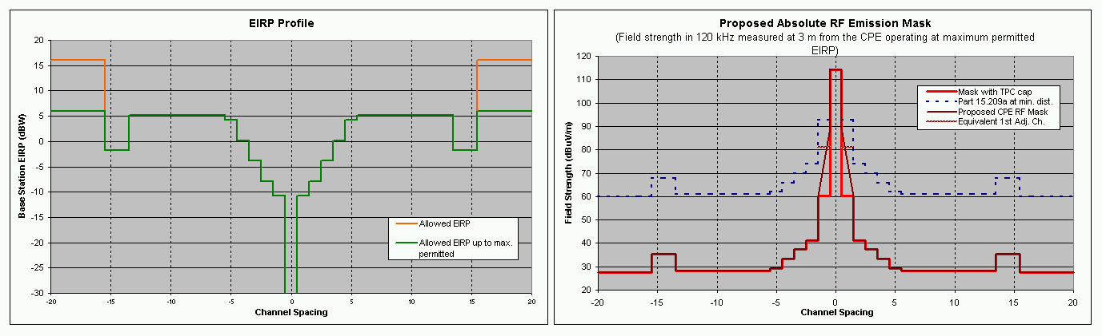
Figure 3: CPE EIRP Profile and RF Mask for the Intermod 1/2 case
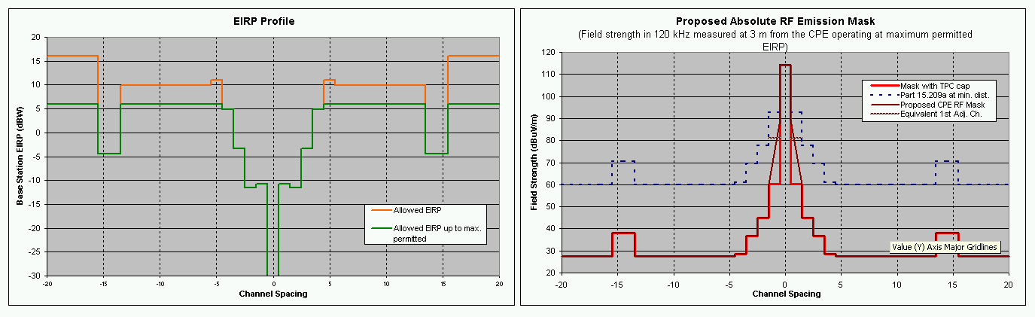
Figure 4: CPE EIRP Profile and RF Mask for the Linear Extrapolation case
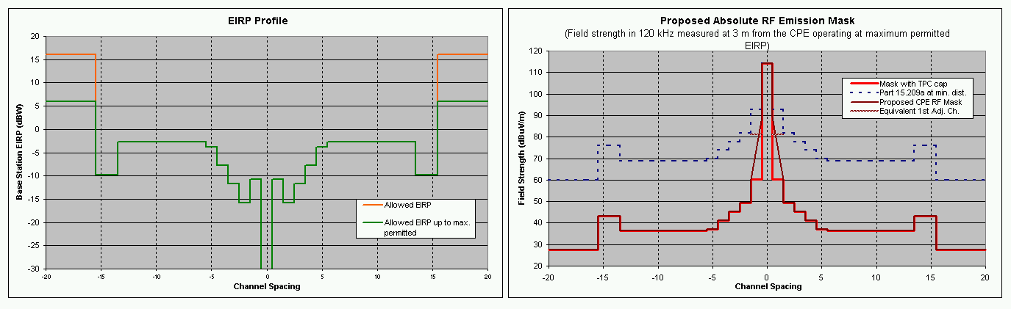
Figure 5: CPE EIRP Profile and RF Mask for the Linear Interference case

Observations
As can be seen from the figures, the impact on the WRAN operation can be important, depending on the set of D/U ratios assumed. In the “Saturation” case, operation of the CPE is possible at full power (4 watts) for all channels except N-3 to N+3. This means that the CPE will need to sense over a window of 7 channels to make sure that its transmission does not desensitize DTV receivers in the surrounding. If presence of DTV transmission is detected on one of these adjacent channels, the transmit EIRP will have to be reduced to the level indicated by the EIRP profile. This will be programmed from the WRAN Base Station but some local intelligence in the CPE could secure the level initially.
In the second case, the CPE will also have to sense the N-15 and 14, N-4, N+4 and N+14 and 15 if full power is to be used. An alternative would be to limit the CPE EIRP to +1 dBW. Then it would only need to sense a range of 7 channels at a cost of 5 dB loss in range.
In the third case, the CPE would have to add N-5 and N+5 to the channels to be sensed unless the maximum EIRP is reduced to –2 dBW where in such case, the same 7 channel window as in the first case would need to be sensed at the cost of a 8 dB loss in range.
In the case of the “Linear Extrapolation”, the channels to be sensed are the same as in the second case except that the required reduction in allowable EIRP is more pronounced.
Finally, in the case of the “Linear Interference”, the CPE would have to sense the full range from N-15 to N+15 and the practical EIRP allowed in the range is between –16 dBW to –3 dBW, reducing further the potential reach of the system.
In general, tighter is the EIRP profile, looser is the corresponding RF Mask since it does not have to protect for power levels that will not be allowed for the specific channel separations. In all these RF masks, it is shown that the required maximum field strength is some 33 dB lower than that specified by the Part 15.209(a).

