Project | IEEE 802.21d  <http://www.ieee802.org/21/>
Title | Remedy for Cmt#55 in LB7b
DCN | 21-14-0059-02-MuGM
Date Submitted | Mar, 20, 2014
Source(s) | Yoshikazu Hanatani, Yoshihiro Ohba (Toshiba)
Re: | IEEE 802.21 Session #61 in Beijing
Abstract
Purpose
Notice | This document has been prepared to assist the IEEE 802.21 Working Group. It is offered as a basis for discussion and is not binding on the contributing individual(s) or organization(s). The material in this document is subject to change in form and content after further study. The contributor(s) reserve(s) the right to add, amend or withdraw material contained herein.
Release | The contributor grants a free, irrevocable license to the IEEE to incorporate material contained in this contribution, and any modifications thereof, in the creation of an IEEE Standards publication; to copyright in the IEEE’s name any IEEE Standards publication even though it may include portions of this contribution; and at the IEEE’s sole discretion to permit others to reproduce in whole or in part the resulting IEEE Standards publication. The contributor also acknowledges and accepts that IEEE 802.21 may make this contribution public.
Patent Policy | The contributor is familiar with IEEE patent policy, as stated in Section 6 of the IEEE-SA Standards Board bylaws <http://standards.ieee.org/guides/bylaws/sect6-7.html#6> and in Understanding Patent Issues During IEEE Standards Development http://standards.ieee.org/board/pat/faq.pdf

Remedy for Cmt#55 in LB7b.
Change the original text to following new text.

Add new texts and remove original text.

New text1:

      - MIH PDU protected through Group key generated MIH SA
When a GKB is used to distribute a MGK, the keys derived from MGK shall be used for a group MIH SA created for a group of MIHFs to encrypt Service Specific TLVs of an MIH PDU. The group MIH SA is identified by a security association identifier assigned the PoS and carried in a SAID TLV. For integrity protection, a Signature TLV is carried in the MIH PDU. Figure 26 shows a protected MIH PDU for GKB-generated MIH SA. The protection procedure is specified in section Error: Reference source not found.2.

Insert the following figure at the end of Clause :

- —MIH PDU protected by a GKB-generated MIH SA

      - MIH PDU protected by digital signature only

When an MIH PDU sent by a PoS is not encrypted, it may be integrity protected by a digital signature. Figure 261 shows an MIH PDU protected by a digital signature only. The protection procedure is specified in section Error: Reference source not found.

Insert the following figure at the end of Clause 4:
MIH Service Specific TLVs
MIH header
(
S
=
1
)
Source MIHF
Identifier TLV
Destination MIHF
Identifier TLV
Service Specific
TLV
Signature TLV

- —MIH PDU protected by digital signature only

Original text1:

8.4.2.4MIH PDU protected through Group key generated MIH SA
When a GKB is used to distribute a MGK, the keys derived from MGK must be used for the SA to protect the data. A group MIH SA is established among a group of MIHF peers. It includes a ciphersuite used for the protection. A security association identifier is assigned by the PoS as a result of successful GKPM. Figure 26 shows a protected MIH PDU for GKB-generated MIH SA with a Signature TLV. The protection procedure is specified in section Error: Reference source not found.

Insert the following figure at the end of Clause :

- —MIH PDU protected by a GKB-generated MIH SA with a signature TLV

8.4.2.3.1Sending
When a PoS issues an MIH Service Specific TLV, the MIHF of the PoA generates a signature of the TLV using the signing key of the PoS and creates a Signature TLV from the generated signature.

8.4.2.3.2 Receiving
When an MN receives an MIH service specific TLV, the MIHF of the MN behaves as follows:
- The MIHF verifies the signature in the Signature TLV using the verification key corresponding to the Source Identifier extracted from the received Source MIHF ID TLV. If the verification fails, it cancels the following steps and stops processing.
- The Destination Identifier is extracted from the received Destination MIHF ID TLV. The MIHF checks if the Destination Identifier is registered as an MIH Group ID in the Group Information Base. If it is not, it cancels the following steps and stops processing.
- If a Security TLV is found in the MIH Specific TLV, the MIHF decrypts the Security TLV using the MIGMEK derived from the MKG. The MGK is the group key corresponding to the Destination Identifier extracted in the previous step. The group key is found in the Group Information Base.
New text:2

The data protection procedure with confidentiality is illustrated in and Figure 28 and Figure 29.
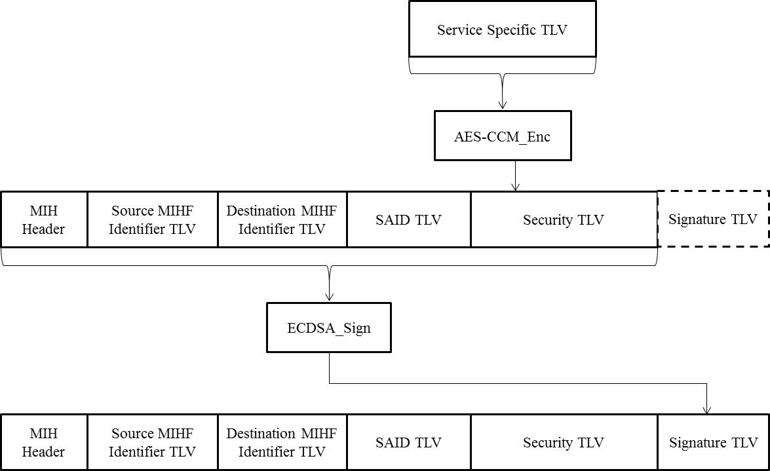
Figure 44—Signing (with confidentiality)

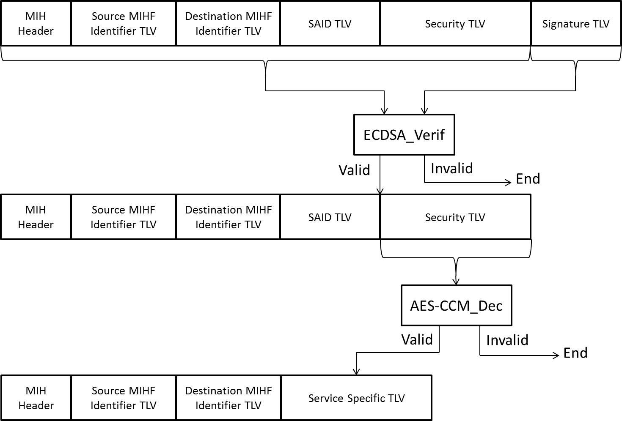
Figure 45—Sigature verification (with confidentality)

The data protection procedure without confidentiality is illustrated in and Figure 46 and Figure 47.
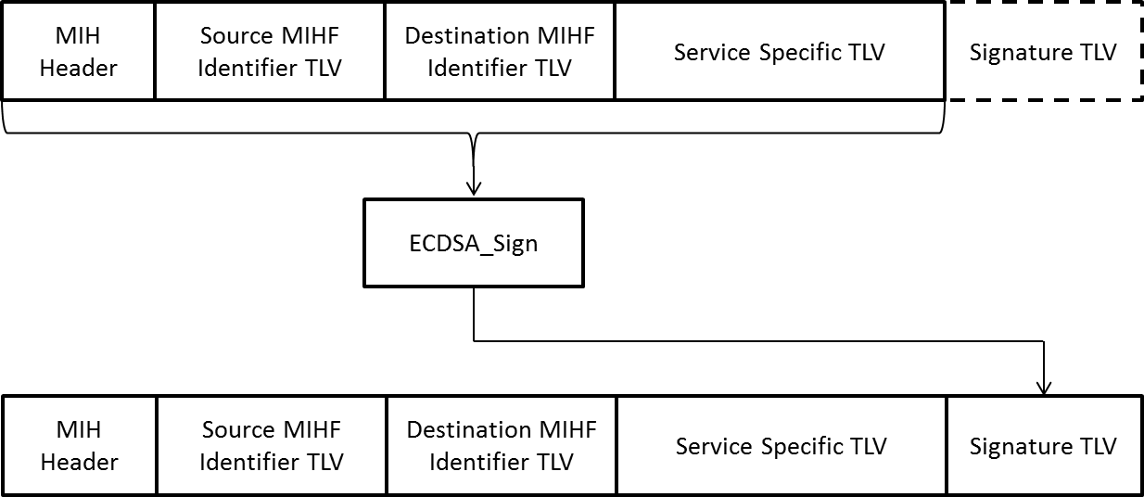
Figure 46 Signing (without confidentiality)

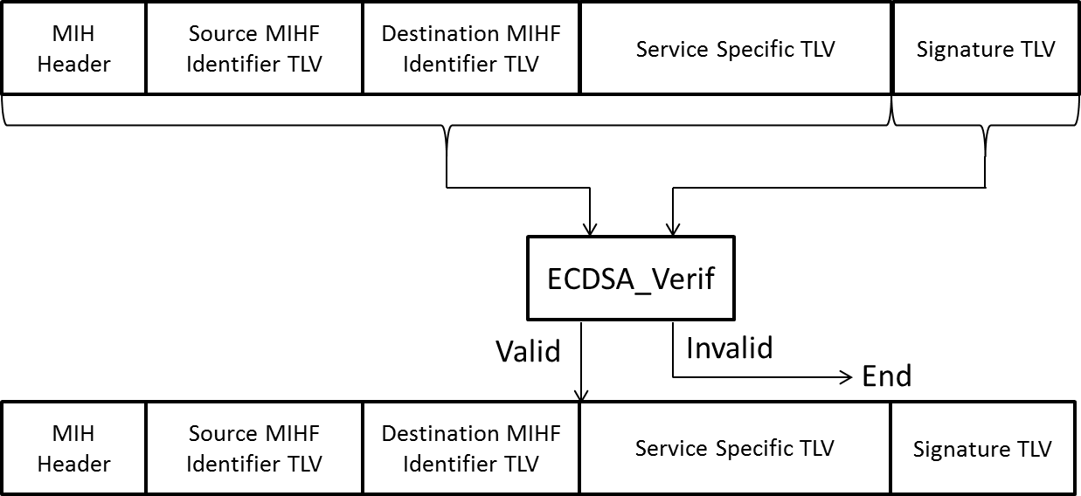
- —Signature verification (without confidentiality)

Original text2:

p.73, l.17
The data protection procedure is illustrated in and Figure 28 and Figure 29.
- —Encapsulation

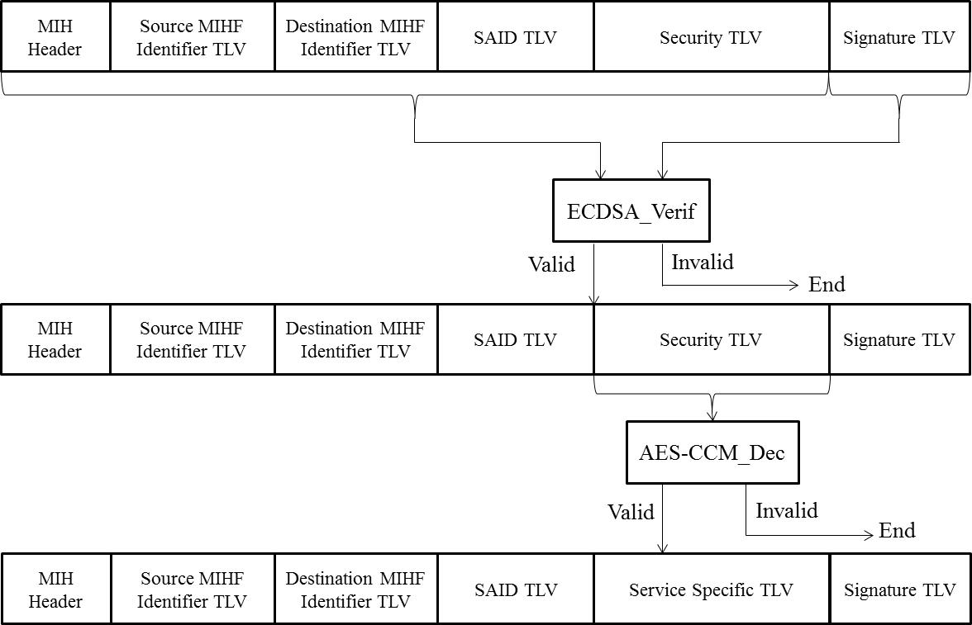
- —Decapsulation

