IEEE P802.21m
Media Independent Handover Services Revision Project
21-13-0211-01-REVP: 802.21-2008 text to be excluded
Date: 2014-1-21
Author(s):
Name | Affiliation | Address | Phone | Email
Charlie Perkins | Futurewei | Santa Clara, CA 95050 |  | charliep@computer.org
Abstract
This document contains text extracted from 802.21-2008 and 802.21a which is proposed to be excluded in the document developed within 802.21m (REVP project).

P802.21™/DvarDraftNumber
Draft Standard for Local and metropolitan area networks
Part 21: Media Independent Handover Services
Sponsor

LAN/MAN Standards Committee
of the
IEEE Computer Society

Approved varApprovedDate

IEEE-SA Standards Board

Copyright © 2013 by the Institute of Electrical and Electronics Engineers, Inc.
Three Park Avenue
New York, New York 10016-5997, USA
All rights reserved.
This document is an unapproved draft of a proposed IEEE Standard. As such, this document is subject to change. USE AT YOUR OWN RISK! Because this is an unapproved draft, this document must not be utilized for any conformance/compliance purposes. Permission is hereby granted for IEEE Standards Committee participants to reproduce this document for purposes of standardization consideration. Prior to adoption of this document, in whole or in part, by another standards development organization, permission must first be obtained from the IEEE Standards Activities Department (stds.ipr@ieee.org). Other entities seeking permission to reproduce this document, in whole or in part, must also obtain permission from the IEEE Standards Activities Department.
IEEE Standards Activities Department
445 Hoes Lane
Piscataway, NJ 08854, USA

Abstract: This standard specifies IEEE 802® media access-independent mechanisms that
optimize handovers between heterogeneous IEEE 802 systems and between IEEE 802 systems
and cellular systems.
Keywords: management, media independent handover, mobile node, mobility, seamless, point of attachment, point of service

•Notice and Disclaimer of Liability Concerning the Use of IEEE Documents: IEEE Standards documents are developed within the IEEE Societies and the Standards Coordinating Committees of the IEEE Standards Association (IEEE-SA) Standards Board. IEEE develops its standards through a consensus development process, approved by the American National Standards Institute, which brings together volunteers representing varied viewpoints and interests to achieve the final product. Volunteers are not necessarily members of the Institute and serve without compensation. While IEEE administers the process and establishes rules to promote fairness in the consensus development process, IEEE does not independently evaluate, test, or verify the accuracy of any of the information or the soundness of any judgments contained in its standards.
Use of an IEEE Standard is wholly voluntary. IEEE disclaims liability for any personal injury, property or other damage, of any nature whatsoever, whether special, indirect, consequential, or compensatory, directly or indirectly resulting from the publication, use of, or reliance upon any IEEE Standard document.
IEEE does not warrant or represent the accuracy or content of the material contained in its standards, and expressly disclaims any express or implied warranty, including any implied warranty of merchantability or fitness for a specific purpose, or that the use of the material contained in its standards is free from patent infringement. IEEE Standards documents are supplied "AS IS."
The existence of an IEEE Standard does not imply that there are no other ways to produce, test, measure, purchase, market, or provide other goods and services related to the scope of the IEEE standard. Furthermore, the viewpoint expressed at the time a standard is approved and issued is subject to change brought about through developments in the state of the art and comments received from users of the standard. Every IEEE standard is subjected to review at least every ten years. When a document is more than ten years old and has not undergone a revision process, it is reasonable to conclude that its contents, although still of some value, do not wholly reflect the present state of the art. Users are cautioned to check to determine that they have the latest edition of any IEEE standard.
In publishing and making its standards available, IEEE is not suggesting or rendering professional or other services for, or on behalf of, any person or entity. Nor is IEEE undertaking to perform any duty owed by any other person or entity to another. Any person utilizing any IEEE Standards document, should rely upon his or her own independent judgment in the exercise of reasonable care in any given circumstances or, as appropriate, seek the advice of a competent professional in determining the appropriateness of a given IEEE standard.
Translations: The IEEE consensus development process involves the review of documents in English only. In the event that an IEEE standard is translated, only the English version published by IEEE should be considered the approved IEEE standard.
Official Statements: A statement, written or oral, that is not processed in accordance with the IEEE-SA Standards Board Operations Manual shall not be considered the official position of IEEE or any of its committees and shall not be considered to be, nor be relied upon as, a formal position of IEEE. At lectures, symposia, seminars, or educational courses, an individual presenting information on IEEE standards shall make it clear that his or her views should be considered the personal views of that individual rather than the formal position of IEEE.
Comments on Standards: Comments for revision of IEEE Standards documents are welcome from any interested party, regardless of membership affiliation with IEEE. However, IEEE does not provide consulting information or advice pertaining to IEEE Standards documents. Suggestions for changes in documents should be in the form of a proposed change of text, together with appropriate supporting comments. Since IEEE standards represent a consensus of concerned interests, it is important to ensure that any responses to comments and questions also receive the concurrence of a balance of interests. For this reason, IEEE and the members of its societies and Standards Coordinating Committees are not able to provide an instant response to comments or questions except in those cases where the matter has previously been addressed. Any person who would like to participate in evaluating comments or revisions to an IEEE standard is welcome to join the relevant IEEE working group at http://standards.ieee.org/develop/wg/.
Comments on standards should be submitted to the following address:
Secretary, IEEE-SA Standards Board
445 Hoes Lane
Piscataway, NJ 08854
USA
Photocopies: Authorization to photocopy portions of any individual standard for internal or personal use is granted by The Institute of Electrical and Electronics Engineers, Inc., provided that the appropriate fee is paid to Copyright Clearance Center. To arrange for payment of licensing fee, please contact Copyright Clearance Center, Customer Service, 222 Rosewood Drive, Danvers, MA 01923 USA; +1 978 750 8400. Permission to photocopy portions of any individual standard for educational classroom use can also be obtained through the Copyright Clearance Center.
Notice to users
Laws and regulations
Users of IEEE Standards documents should consult all applicable laws and regulations. Compliance with the provisions of any IEEE Standards document does not imply compliance to any applicable regulatory requirements. Implementers of the standard are responsible for observing or referring to the applicable regulatory requirements. IEEE does not, by the publication of its standards, intend to urge action that is not in compliance with applicable laws, and these documents may not be construed as doing so.
Copyrights
This document is copyrighted by the IEEE. It is made available for a wide variety of both public and private uses. These include both use, by reference, in laws and regulations, and use in private self-regulation, standardization, and the promotion of engineering practices and methods. By making this document available for use and adoption by public authorities and private users, the IEEE does not waive any rights in copyright to this document.
Updating of IEEE documents
Users of IEEE Standards documents should be aware that these documents may be superseded at any time by the issuance of new editions or may be amended from time to time through the issuance of amendments, corrigenda, or errata. An official IEEE document at any point in time consists of the current edition of the document together with any amendments, corrigenda, or errata then in effect. In order to determine whether a given document is the current edition and whether it has been amended through the issuance of amendments, corrigenda, or errata, visit the IEEE-SA Website at http://standards.ieee.org/index.html or contact the IEEE at the address listed previously. For more information about the IEEE Standards Association or the IEEE standards development process, visit IEEE-SA Website at http://standards.ieee.org/index.html.
Errata
Errata, if any, for this and all other standards can be accessed at the following URL: http://standards.ieee.org/findstds/errata/index.html. Users are encouraged to check this URL for errata periodically.
Patents
Attention is called to the possibility that implementation of this standard may require use of subject matter covered by patent rights. By publication of this standard, no position is taken by the IEEE with respect to the existence or validity of any patent rights in connection therewith. If a patent holder or patent applicant has filed a statement of assurance via an Accepted Letter of Assurance, then the statement is listed on the IEEE-SA Website at http://standards.ieee.org/about/sasb/patcom/patents.html. Letters of Assurance may indicate whether the Submitter is willing or unwilling to grant licenses under patent rights without compensation or under reasonable rates, with reasonable terms and conditions that are demonstrably free of any unfair discrimination to applicants desiring to obtain such licenses.
Essential Patent Claims may exist for which a Letter of Assurance has not been received. The IEEE is not responsible for identifying Essential Patent Claims for which a license may be required, for conducting inquiries into the legal validity or scope of Patents Claims, or determining whether any licensing terms or conditions provided in connection with submission of a Letter of Assurance, if any, or in any licensing agreements are reasonable or non-discriminatory. Users of this standard are expressly advised that determination of the validity of any patent rights, and the risk of infringement of such rights, is entirely their own responsibility. Further information may be obtained from the IEEE Standards Association.

Participants
At the time this draft standard was completed, the 802.21 Working Group had the following membership:
Subir Das, Chair
varWkGrpViceChair, Vice Chair

Participant1
Participant2
Participant3
Participant4
Participant5
Participant6
Participant7
Participant8
Participant9

The following members of the <individual/entity> balloting committee voted on this standard. Balloters may have voted for approval, disapproval, or abstention.
[To be supplied by IEEE]

Balloter1
Balloter2
Balloter3
Balloter4
Balloter5
Balloter6
Balloter7
Balloter8
Balloter9

When the IEEE-SA Standards Board approved thistxtTrialUsetxtGorRPorSTD on varApprovedDate, it had the following membership:
[To be supplied by IEEE]
<Name>, Chair
<Name>, Vice Chair
<Name>, Past Chair
<Name>, Secretary

SBMember1
SBMember2
SBMember3
SBMember4
SBMember5
SBMember6
SBMember7
SBMember8
SBMember9

*Member Emeritus

Also included are the following nonvoting IEEE-SA Standards Board liaisons:
<Name>, DOE Representative
<Name>, NIST Representative

<Name>
IEEE Standards Program Manager, Document Development

<Name>
IEEE Standards Program Manager, Technical Program Development

Introduction
This introduction is not part of P802.21/DvarDraftNumber, Draft Standard for Local and metropolitan area networks—Part 21: Media Independent Handover Services.
This standard defines extensible media access independent mechanisms that enable the optimization of handovers between heterogeneous IEEE 802 systems and may facilitate handovers between IEEE 802 systems and cellular systems.

Contents
1. Overview 14
2. Normative references 14
3. Definitions 14
4. Abbreviations and acronyms 15
5. General architecture 16
5.1 Introduction (the existing text in this section will be deleted) 16
5.2 General design principles (to be included) 18
5.3 MIHF service overview (to be included) 18
5.4 Media independent handover reference framework (to be included) 18
5.5 MIHF reference models for link-layer technologies (to be included) 18
5.6 Service access points (SAPs) (to be included) 18
5.7 MIH protocol (to be included) 18
6. MIHF services (to be included) 19
6.1 General (to be included) 19
6.2 Service management (to be included) 19
6.3 Media independent event service (to be included) 19
6.4 Media independent command service 19
6.5 Media independent information service (to be included) 20
7. Service access points (SAPs) and primitives 21
7.1 Introduction (to be included) 21
7.2 SAPs (to be included) 21
7.3 MIH_LINK_SAP primitives 22
7.4 MIH_SAP primitives 24
7.5 MIH_NET_SAP primitives 58
8. Media independent handover protocol 59
8.1 Introduction 59
8.2 MIH protocol description 59
8.3 MIH protocol identifiers 59
8.4 MIH protocol frame format 59
8.5 Message parameter TLV encoding 59
8.6 MIH protocol messages 59
Annex A (informative) Bibliography 70
Annex B (normative) Quality of service mapping 72
Annex C (informative) Handover procedures 73
C.1 Mobile-initiated handover procedure 73
C.2 Network-initiated handover procedure 78
C.3 Example handover flow chart between IEEE 802.11 and IEEE 802.16 83
C.4 Example handover flow chart for Proxy Mobile IPv6 88
C.5 Network selection in IEEE 802.11 (WLAN) using IEEE 802.21 97
C.6 Abnormal case at the stage of resource availability check 98
Annex D (normative) Mapping MIH messages to reference points 100
Annex E (normative) Media specific mapping for SAPs 101
Annex F (normative) Data type definition 102
Annex G (normative) Information element identifiers 103
Annex H (normative) MIIS basic schema 104
Annex I (informative) Making user extensions to MIIS schema 105
Annex J (normative) IEEE 802.21 MIB 106
J.1 Parameters requiring MIB definition 106
J.2 IEEE 802.21 MIB definition 106
Annex K (informative) Example MIH message fragmentation 107
Annex L (normative) MIH protocol message code assignments 108
Annex M (normative) Protocol implementation conformance statement (PICS) proforma 112
M.1 Introduction 112
M.2 Scope 112
M.3 Conformance 112
M.4 Instructions 112
M.5 Identification of the implementation 112
M.6 Identification of the protocol 113
M.7 Identification of corrigenda to the protocol 113
M.8 PICS proforma tables 113

List of Figures
Figure 1 —MIH services and their initiation 20
Figure 2 —MIHF communication model 37
Figure 3 —Example of network model with MIH services 39
Figure 4 —General MIHF reference model and SAPs 41
Figure 5 —Types of MIHF relationship 42
Figure 6 —MIH reference model for IEEE 802.3 43
Figure 7 —MIH reference model for IEEE 802.11 44
Figure 8 —MIH reference model for IEEE 802.16 45
Figure 9 —MIH reference model for 3GPP systems 46
Figure 10 —MIH reference model for 3GPP2 systems 46
Figure 11 —Relationship between different MIHF SAPs 48
Figure 12 —Link events and MIH events 53
Figure 13 —Remote MIH events 54
Figure 14 —MIH events subscription and flow 55
Figure 15 —Link commands and MIH commands 58
Figure 16 —Remote MIH command 59
Figure 17 —Command service flow 60
Figure 18 —Depicting a list of neighboring networks with information elements 68
Figure 19 —TLV representation of information elements 70

List of Tables
Table 1 —Summary of reference points 38
Table 2 —MIH protocol Ethernet type 50
Table 3 —Service management primitives 51
Table 4 —Link events 56
Table 5 —MIH events 57
Table 6 —Link commands 61
Table 7 —MIH commands 61
Table 8 —Naming convention for MIH handover command primitives 62
Table 9 —Information element containers 65
Table 10 —Information elements 65
Table 11 —Information element namespace 69
Table 12 —IE_CONTAINER_LIST_OF_NETWORKS definition 70
Table 13 —IE_CONTAIN ER_NETWORK definition 71
Table 14 —IE_CONTAINER_POA definition 71
Table 15 —MIH_LINK_SAP primitives 75
Table 16 —MIH_NET_SAP primitive 76
Table 17 —MIH_SAP primitives 76

Draft Standard for
Local and metropolitan area networks
Part 21: Media Independent Handover Services
- Overview
Section 1 is included.
- Normative references
Section 2 is included, but service-specific references will be deleted.
- Definitions
Section 3 is included, but service-specific terminology will be deleted.
- Abbreviations and acronyms
Section 4 is included, but service-specific abbreviations and acronyms will be deleted.
- General architecture
  - Introduction (the existing text in this section will be deleted)
    - General
This standard supports different handover methods. Such methods are generally classified as “hard” or “soft,” depending on whether the handover procedure is “break-before-make” or “make-before-break” with respect to the data transport facilities that support the exchange of data packets between the MN and the network.
Handover decision making involves cooperative use of both MN and network infrastructure. Handover control, handover policies, and other algorithms involved in handover decision making are generally handled by communication system elements that do not fall within the scope of this standard. However, it is beneficial to describe certain aspects of the overall handover procedure so that the role and purpose of the MIH services in the handover process are clear. The following subclauses give an overview of how the different factors that affect handovers are addressed within this standard.
    - Service continuity
Service continuity is defined as the continuation of the service during and after the handover while minimizing aspects such as data loss and duration of loss of connectivity during the handover without requiring any user intervention. The change of access network need not be noticeable to the end user. However, irrespective of that, there should be no need for the user to re-establish the service. There can be a change in service quality as a consequence of the transition between different networks due to the varying capabilities and characteristics of the access networks. For example, if the quality of service (QoS) supported by the new access network is unacceptable, higher layer entities can decide not to handover or terminate the current session after the handover based on applicable policies. This standard specifies essential elements that enable service continuity.
    - Application class
Various applications have different tolerance characteristics for delay and data loss. Application-aware handover decisions can be possible by making a provision for such characteristics. For example, when a network transition due to impending handover is made during the pause phase of a conversation in an active voice call, the perceptible interruption in the service is minimized.
    - Quality of service
The quality of the service (QoS) experienced by an application depends on the accuracy, speed, and availability of the information transfer in the communication channel. This standard provides support for fulfilling application QoS requirements during handover.
There are two aspects of QoS to consider in the context of IEEE 802.21. First, there is the QoS experienced by an application during a handover. Secondly, there is the QoS considered as part of a handover decision. This standard includes mechanisms that support both aspects of QoS towards enabling seamless mobility; however the MIHF alone cannot guarantee seamless mobility. Depending on the QoS requirements of the end-to-end application, seamless mobility implies minimizing the handover latency and packet loss so as to minimize the end-to-end delay and the loss of transmitted information. Seamless mobility also implies the timely assessment of network conditions, such as the monitoring of packet loss on the current link and signal strength from both current and target networks, in order to optimize the handover decision and its execution.
The MIH QoS model (see Annex B) defines parameters that are used to set the requirements and assess the performance of packet transfers between a source and its destinations. When used in threshold-setting commands (such as MIH_Link_Configure_Thresholds), these parameters describe the QoS requirements of the MIH user. On the other hand, when used in parameter-reporting events (such as MIH_Link_Parameters_Report) and parameter-extraction commands (such as MIH_Link_Get_Parameters), they characterize current network conditions. Therefore, depending on their usage these parameters can represent either static QoS requirements or dynamic network measurements.
    - Network discovery
This standard defines the information that helps in network discovery and specifies the means by which such information can be obtained and be made available to the MIH users. The network information includes information about link type, link identifier, link availability, link quality, etc.
    - Network selection
Network selection is the process by which an MN or a network entity selects a network (possibly out of many available) to establish network-layer connectivity. The selection is based on various criteria such as required QoS, cost, user preferences, or the network operator’s policies. This standard specifies means by which such information can be made available to the MIH users to enable effective network selection.
    - Power management
This standard allows the MN to discover different types of wireless networks (e.g., IEEE 802.11, IEEE 802.16, and 3GPP networks), avoiding powering-up of multiple radios and/or excessive scanning at the radios. Thus, this standard minimizes power consumed by mobile devices in the discovery of potential handover candidates. Specific power management mechanisms deployed are dependent on individual link- layer technologies and the potential power management benefits from this standard only extend to the discovery of wireless networks.
    - Handover policy
The primary role of the MIHF is to facilitate handovers and provide intelligence to the network selector entity. The MIHF aids the network selector entity with the help of the event service, command service, and information service. The network selector entity and the handover policies that control handovers are outside the scope of this standard.
5.1.9 Proactive authentication and key establishment

This standard provides mechanisms for a mobile node to conduct a proactive authentication and key establishment with the candidate authenticator(s) and PoA(s). The proactive authentication is conducted through media specific network access authentication where authentication messages are exchanged between authentication end-points via a PoS. The MIH protocol is used for encapsulating the authentication messages between the MN and the PoS. A successful proactive authentication and key establishment allow a PoA in the target network to obtain a key(s) to protect the communication link between the mobile node and the PoA after the handover.
  - General design principles (to be included)
  - MIHF service overview (to be included)
  - Media independent handover reference framework (to be included)
  - MIHF reference models for link-layer technologies (to be included)
  - Service access points (SAPs) (to be included)
  - MIH protocol (to be included)
- MIHF services (to be included)
  - General (to be included)
  - Service management (to be included)
  - Media independent event service (to be included)
  - Media independent command service
    - Introduction (to be included)
    - Command service flow model (to be included)
    - Command list (to be included)
      - Link commands (to be included)
      - MIH commands
        - General (to be included)
        - Naming convention for MIH handover commands
Generally, there are three types of MIH handover command primitives based on the functionality specified for the following scenarios:
- MN to Network
- Network to MN
- Network to Network
This classification helps to ensure the specification of the proper protocol functionality and the relevant parameters for specific use as determined by the origination and the destination points.
Accordingly, these commands have a naming convention that identifies the origination point in the primitive name, as shown in Table 8. This convention is followed by the MIHF to ensure that these commands are utilized for the intended purpose. The destination point applies for remote commands only.
- —Naming convention for MIH handover command primitives
Primitive name prefix | Originating point | Destination point
MIH_MN_HO_*** | MN | Network
MIH_Net_HO_*** | Network | MN
MIH_N2N_HO_*** | Network | Network

        - Mobile initiated handovers
In this case, the MN initiates the handovers. The network selection policy function in this case resides on the mobile node. The MN directly uses the set of MIH_MN_HO_*** commands and may indirectly cause some MIH_N2N_HO_*** commands to be used when initiating handovers. The MN can use these commands to query the list of available candidate networks, reserve any required resources at the candidate target network, and indicate the status of handover operation to the MIHF in the network.
        - Network initiated handovers
In this case, the network initiates the handovers. The network selection policy function in this case resides on the network. The network uses the set of MIH_Net_HO_*** in conjunction with any MIH_N2N_HO_*** commands for initiating handovers. The network can use these commands to query the list of resources currently being used by the MN, the serving network can reserve any required resources at the candidate target network, and the network can command the MN to commit to performing a handover to a specific network.
  - Media independent information service (to be included)
- Service access points (SAPs) and primitives
  - Introduction (to be included)
  - SAPs (to be included)
    - General (to be included)
    - Media dependent SAPs
      - MIH_LINK_SAP (to be included)
      - MIH_NET_SAP (to be included)
    - Media independent SAP: MIH_SAP (mostly included)
The primitives defined as part of MIH_SAP are described in Table 17.
- —MIH_SAP primitives
Primitives | Service  category | Description | Defined  in

Primitives | Service  category | Description | Defined  in
MIH_Link_Handover_Imminent | Event | L2 handover is imminent | 7.4.11
MIH_Link_Handover_Complete | Event | L2 handover has been completed | 7.4.12
… | … | … | …
MIH_Net_HO_Candidate_Query | Command | Initiate handover | 7.4.17
MIH_MN_HO_Candidate_Query | Command | Initiate MN query request for candidate network | 7.4.18
MIH_N2N_HO_Query_Resources | Command | Query available network resources | 7.4.19
MIH_MN_HO_Commit | Command | Notify the serving network of the decided target network information | 7.4.20
MIH_Net_HO_Commit | Command | Network has committed to handover | 7.4.2 1
MIH_N2N_HO_Commit | Command | Notify target network that the serving network has committed to handover | 7.4.22
MIH_MN_HO_Complete | Command | Initiate MN handover complete notification | 7.4.23
MIH_N2N_HO_Complete | Command | Handover has been completed | 7.4.24
MIH_Get_Information | Information | Request to get information from repository | 7.4.25
MIH_Push_Information | Information | Notify the mobile node of operator policies or other information | 7.4.26

  - MIH_LINK_SAP primitives
    - Link_Detected .ind ication
    - Link_Up.indication
    - Link_Down.indication
    - Link_Parameters_Report.indication
    - Link_Going_Down.indication
    - Link_Handover_Imminent.indication
      - Function
Link_Handover_Imminent is generated when a native link-layer handover or switch decision has been made and its execution is imminent (as opposed to Link_Going_Down that only indicates that a link is losing connectivity due to a change in a certain link condition such as signal strength, but does not guarantee that a link switch-over has been decided by the link layer itself). It contains information about the new point of attachment of the MN (the LinkIdentifier parameter contains information about the new PoA). This is a Link Handover event as discussed in 6.3.4.
      - Semantics of service primitive
Link_Handover_Imminent.indication (
Old Link Identifier,
New Link Identifier,
OldAccessRouter,
NewAccessRouter
)

Parameters:
Name | Data type | Description
OldLinkIdentifier | LINK_TUPLE_ID | Identifier of the old link.
NewLinkIdentifier | LINK_TUPLE_ID | Identifier of the new link.
OldAccessRouter | LINK_ADDR | (Optional) Link address of old Access Router.
NewAccessRouter | LINK_ADDR | (Optional) Link address of new Access Router.

      - When generated
Depending on whether it is the MN or the network, it is generated when a native link-layer handover or switch decision has been made and its execution is imminent.
      - Effect on receipt
The MIHF receives this event from the link layer. The MIHF then passes this notification to the MIH user(s) that has subscribed for this notification. The MIH user(s) takes necessary actions to minimize the effect of the pending native link-layer handover or switch on user data transfer. This event is also used as an indication to start buffering packets.
    - Link_Handover_Complete.indication
      - Function
Link_Handover_Complete event is generated whenever a native link-layer handover/switch has just been completed (as opposed to Link_Up that only indicates that a link has been brought up for L2 connectivity, but does not indicate that a native link handover/switch-over has just been completed by the link layer). Notifying the upper layer of this event improves transport, session, and application layer responsiveness to the link changes. They can better adapt their data flows by resuming flows upon receiving this indication. The upper layers also use this event to check whether their IP configuration needs to be updated. This is a link-layer event that exists for intra-technology handovers defined in many media types. This event is applicable for the MN only and is valid only for intra-technology handovers. This is a Link Handover event as discussed in 6.3.4.
      - Semantics of service primitive
Link_Handover_Complete.indication (
OldLinkIdentifier,
NewLinkIdentifier,
OldAccessRouter,
NewAccessRouter,
LinkHandoverStatus
)

Parameters:
Name | Data type | Description
OldLinkIdentifier | LINK_TUPLE_ID | Identifier of the old link.
NewLinkIdentifier | LINK_TUPLE_ID | Identifier of the new link.
OldAccessRouter | LINK_ADDR | (Optional) Link address of old Access Router.
NewAccessRouter | LINK_ADDR | (Optional) Link address of new Access Router.
LinkHandoverStatus | STATUS | Status of the link handover.

      - When generated
This is generated whenever an L2 link-layer handover or switch has just been completed.
      - Effect on receipt
The MIHF receives this event from the link layer. The MIHF then passes this notification to the MIH user(s) that has subscribed for this notification. Upon reception of this event, an upper layer stops any handover adaptation that it has engaged to cope with the just completed native link-layer handover/switch and resume normal data transfer. This event is also used as an indication that a re-verification of the IP parameter should be considered.
    - Link_PDU_Transmit_Status.indication
    - Link_Capability_Discover
    - Link_Event_Subscribe
    - Link_Event_Unsubscribe
    - Link_Get_Parameters
    - Link_Configure_Thresholds
    - Link_Action
  - MIH_SAP primitives
The primitives defined as part of MIH_SAP are described in the following subclauses.
    - MIH_Capability_Discover
    - MIH_Register
    - MIH_DeRegister
    - MIH_Event_Subscribe
    - MIH_Event_Unsubscribe
    - MIH_Link_Detected.indication
    - MIH_Link_Up.indication
    - MI H_Link_Down .ind ication
    - MIH_Link_Parameters_Report. indication
    - MIH_Link_Going_Down.indication
    - MIH_Link_Handover_Imminent.indication
      - Function
This primitive is issued by the MIHF to report the imminent occurrence of an intra-technology link handover. This MIH event is either local or remote. This indication directly corresponds to the link-layer event Link_Handover_Imminent.indication defined in 7.3.6.
      - Semantics of service primitive
MIH_Link_Handover_Imminent.indication (
SourceIdentifier,
OldLinkIdentifier,
NewLinkIdentifier,
OldAccessRouter,
NewAccessRouter
)

Parameters:
Name | Data type | Description
SourceIdentifier | MIHF_ID | This identifies the invoker of this primitive, which can be either the local MIHF or a remote MIHF.
OldLinkIdentifier | LINK_TUPLE_ID | Identifier of the old link.
NewLinkIdentifier | LINK_TUPLE_ID | Identifier of the new link.
OldAccessRouter | LINK_ADDR | (Optional) Link address of old Access Router.
NewAccessRouter | LINK_ADDR | (Optional) Link address of new Access Router.

      - When generated
This notification is generated by the MIHF when a link-layer intra-technology handover is about to occur. The event could be triggered by the reception of a Link_Handover_Imminent.indication from a link or on receipt of an MIH_Link_Handover_Imminent indication message.
      - Effect on receipt
Upper layer entities take different actions upon notification.
    - MI H_Link_Handover_Complete.indication
      - Function
This primitive is issued by the MIHF to report the completion of an intra-technology link handover. This MIH event is either local or remote. MIH_Link_Handover_Complete indication is a result of a Link_Handover_Complete indication from the link layer.
      - Semantics of service primitive
MIH_Link_Handover_Complete.indication (
SourceIdentifier,
OldLinkIdentifier,
NewLinkIdentifier,
OldAccessRouter,
NewAccessRouter,
)

Parameters:
Name | Data type | Description
SourceIdentifier | MIHF_ID | This identifies the invoker of this primitive, which can be either the local MIHF or a remote MIHF.
OldLinkIdentifier | LINK_TUPLE_ID | Identifier of the old link.
NewLinkIdentifier | LINK_TUPLE_ID | Identifier of the new link.
OldAccessRouter | LINK_ADDR | (Optional) Link address of old Access Router.
NewAccessRouter | LINK_ADDR | (Optional) Link address of new Access Router.

      - When generated
This notification is generated by the MIHF when a link-layer intra-technology handover is completed. The event could be triggered by the reception of a Link_Handover_Complete. indication from a link or on receipt of an MIH_Link_Handover_Complete indication message.
      - Effect on receipt
Upper layer entities take different actions on this notification. An MIH user makes use of this notification to configure other layers (IP, Mobile IP) for various upper layer handovers that are needed. Transport layers (e.g., TCP) also make use of this primitive to fine tune their flow control and flow congestion mechanisms.
    - MI H_Link_PD U_Transmit_Status.ind ication
    - MIH_Link_Get_Parameters
    - MIH_Link_Configure_Thresholds
    - MIH_Link_Actions
    - MIH_Net_HO_Candidate_Query
      - General
For network initiated handovers, the network controller provides a list of candidate network choices to the MN (via MIH_Net_HO_Candidate_Query request message). The MN indicates resources required on each of these candidate networks in the MIH_Net_HO_Candidate_Query response message. The network controller then queries each of the candidate networks for available resources (using MIH_N2N_HO_Query_Resources primitive). Once the target network has been selected, the network controller sends an MIH_Net_HO_Commit message. An example of this operation is illustrated in C.2.
      - MIH_Net_HO_Cand idate_Query.request
        - Function
The primitive is invoked by an MIH user on a network node to communicate to a peer MIH user about its intent of handover initiation.
        - Semantics of service primitive
MIH_Net_HO_Candidate_Query.request (
DestinationIdentifier,
SuggestedNewLinkList,
SuggestedCandidateAuthenticatorList,
QueryResourceReportFlag
)

Parameters:
Name | Data type | Description
DestinationIdentifier | MIHF_ID | This identifies a remote MIHF that will be the destination of this request.
SuggestedNewLinkList | LIST(LINK_POA_LIST) | A list of PoAs for each link, suggesting the new access networks to which handover initiation should be considered. The access networks towards the top of the list are more preferable than those towards the bottom of the list.
SuggestedCandidateAuthenticator- List | LIST(LINK_AUTHENTICATOR  _LIST) | List of media specific authenticator’s addresses for the suggested candidate PoAs.
QueryResourceReportFlag | BOOLEAN | Flag to specify if resources need to be reported by MN:  TRUE: Required to report resource list  FALSE: Not required to report resource list.

        - When generated
This primitive is invoked by an MIH user to communicate with a remote MIH user about its intent of handover initiation. Serving PoS requests MN to provide information about resources required to initiate a handover by setting the QueryResourceReportFlag parameter.
        - Effect on receipt
Upon receipt of this primitive, the local MIHF generates and sends an MIH_Net_HO_Candidate_Query request message to the remote MIHF identified by the Destination Identifier. The remote MIHF forwards the request as an indication to the MIH user.
      - MIH_Net_HO_Candidate_Query. indication
        - Function
This primitive is used by an MIHF to indicate to an MIH user that an MIH_Net_HO_Candidate_Query request message was received from a remote MIHF.
        - Semantics of service primitive
MIH_Net_HO_Candidate_Query.indication (
SourceIdentifier,
SuggestedNewLinkList,
SuggestedCandidateAuthenticatorList,
QueryResourceReportFlag
)

Parameters:
Name | Data type | Description
SourceIdentifier | MIHF_ID | This identifies the invoker of this primitive, which is a remote MIHF.
SuggestedNewLinkList | LIST(LINK_POA_LIST) | A list of PoAs for each link, suggesting the new access networks to which handover initiation should be considered. The access networks towards the top of the list are more preferable than those towards the bottom of the list.
SuggestedCandidateAuthenticator- List | LIST(LINK_AUTHENTICATOR  _LIST) | List of media specific authenticator’s addresses for the suggested candidate PoAs.
QueryResourceReportFlag | BOOLEAN | Flag to specify if resources need to be reported by MN:  TRUE: Required to report resource list  FALSE: Not required to report resource list.

        - When generated
This primitive is generated by an MIHF on receiving an MIH_Net_HO_Candidate_Query request message from a peer MIHF.
        - Effect on receipt
An MIH user receiving this indication shall invoke an MIH_Net_HO_Candidate_Query.response primitive towards the remote MIHF indicated by the Source Identifier in the request message.
      - MIH_Net_HO_Cand idate_Query.response
        - Function
This primitive is used by the MIHF on an MN to respond to an MIH_Net_HO_Candidate_Query request message from a remote MIHF in the network.
        - Semantics of service primitive
MIH_Net_HO_Candidate_Query.response (
DestinationIdentifier,
Status,
SourceLinkIdentifier,
HandoverStatus,
PreferredLinkList,
PreferredCandidateAuthenticatorList
)

Parameters:
Name | Data type | Description
DestinationIdentifier | MIHF_ID | This identifies a remote MIHF that will be the destination of this response.
Status | STATUS | Status of operation.
SourceLinkIdentifier | LINK_TUPLE_ID | This identifies the current link.
HandoverStatusª | HO_STATUS | Lists the acceptance status (permit/decline) of the handover request.
PreferredLinkList^{b} | LIST(RQ_RESULT) | A list of RQ_RESULT suggesting new access networks to which handover initiation should be considered. This can be different than the networks that were suggested in the handover request. The list is sorted from most preferred first to least preferred last.
PreferredCandidateAuthenticator- List | LIST(LINK_AUTHENTICATOR  _LIST) | List of the corresponding media specific authenticator’s addresses for the preferred candidate PoAs.
ªThis parameter is not included if Status does not indicate “Success.”
^{b}This parameter is not included if Status does not indicate “Success” or Handover Status indicates “decline.”

        - When generated
The remote MIH user invokes this primitive in response to an MIH_Net_HO_Candidate_Query.indication from its MIHF.
        - Effect on receipt
The MIHF sends an MIH_Net_HO_Candidate_Query response message to the peer MIHF as indicated in the Destination Identifier.
      - MI H_Net_HO_Cand idate_Query.confirm
        - Function
This primitive is used by the MIHF to confirm that an MIH_Net_HO_Candidate_Query response message was received from a peer MIHF.
        - Semantics of service primitive
MIH_Net_HO_Candidate_Query.confirm (
SourceIdentifier,
Status,
SourceLinkIdentifier,
HandoverStatus,
PreferredLinkList,
PreferredCandidateAuthenticatorList
)

Parameters:
Name | Data type | Description
SourceIdentifier | MIHF_ID | Contains the MIHF ID of the MN that sent the MIH_Net_HO_Candidate_Query response message.
Status | STATUS | Status of operation.
SourceLinkIdentifier | LINK_TUPLE_ID | This identifies the current link.
HandoverStatusª | HO_STATUS | Lists the acceptance status (permit/decline) of the handover request.
PreferredLinkList^{b} | LIST(RQ_RESULT) | A list of RQ_RESULT suggesting new access networks to which handover initiation should be considered. This can be different than the networks that were suggested in the handover request. The list is sorted from most preferred first to least preferred last.
PreferredCandidateAuthenticator- List | LIST(LINK_AUTHENTICATOR  _LIST) | List of the corresponding media specific authenticator’s addresses for the preferred candidate PoAs.
ªThis parameter is not included if Status does not indicate “Success.”
^{b}This parameter is not included if Status does not indicate “Success” or Handover Status indicates “decline.”

        - When generated
This primitive is generated by the MIHF on receiving an MIH_Net_HO_Candidate_Query response message from a peer MIHF.
        - Effect on receipt
On receiving the primitive the entity that originally initiated the handover request decides to carry out the handover or abort it based on the primitive. However, if Status does not indicate “Success,” the recipient ignores any other returned values and, instead, performs appropriate error handling.
    - MI H_MN_HO_Candidate_Query
      - MIH_MN_HO_Candidate_Query.request
        - Function
This primitive is used by MIH users on an MN to inform MIHF to query candidates for possible handover initiation. The request includes queries on QoS resources and/or whether IP address configuration method of the ongoing data sessions can be supported in the candidate network. This primitive also includes the current IP configuration server address [e.g., DHCP server, foreign agent (FA) IP address, AR IP address] when the current IP configuration method is included.
        - Semantics of service primitive
MIH_MN_HO_Candidate_Query.request (
DestinationIdentifier,
SourceLinkIdentifier,
CandidateLinkList,
QoSResourceRequirements,
IPConfigurationMethods,
DHCPServerAddress,
FAAddress,
AccessRouterAddress,
CandidateAuthenticatorList
)
Parameters:
Name | Data type | Description
DestinationIdentifier | MIHF_ID | This identifies a remote MIHF that will be the destination of this request.
SourceLinkIdentifier | LINK_TUPLE_ID | This identifies the source link for handover.
CandidateLinkList | LIST(LINK_POA_LIST) | A list of PoAs, identifying candidate networks to which handover needs to be initiated. The list is sorted from most preferred first to least preferred last.
QoSResourceRequirements | QOS_LIST | Minimal QoS resources required at the candidate network.
IPConfigurationMethods | IP_CFG_MTHDS | (Optional) Current IP configuration methods.
DHCPServerAddress | IP_ADDR | (Optional) IP address of current DHCP Server. It is only included when MN is using dynamic address configuration.
FAAddress | IP_ADDR | (Optional) IP address of current Foreign Agent. It is only included when MN is using Mobile IPv4.
AccessRouterAddress | IP_ADDR | (Optional) IP address of current Access Router. It is only included when MN is using IPv6.
CandidateAuthenticatorList | LIST(LINK_AUTHENTICATOR  _LIST) | List of the corresponding media specific authenticator’s addresses for the candidate PoAs.

        - When generated
This primitive is generated by an MIH user in the MN that wants to query other candidate networks for a possible handover. MN uses the QueryResourceList parameter to notify the serving PoS of the minimal resource requirement at the candidate networks in order for the handover to be successful. An MIH user on MN generates this primitive when it wants to query IP address related information from the candidate networks before handover.
        - Effect on receipt
Upon receipt of this primitive, the local MIHF generates and sends an MIH_MN_HO_Candidate_Query request message to the remote MIHF identified by the Destination Identifier.
      - MIH_M N_HO_Candidate_Query.indication
        - Function
This primitive is used by MIHF to indicate the receipt of MIH_MN_HO_Candidate_Query request message from an MN.
        - Semantics of service primitive
MIH_MN_HO_Candidate_Query.indication (
SourceIdentifier,
SourceLinkIdentifier,
CandidateLinkList,
QoSResourceRequirements,
IPConfigurationMethods,
DHCPServerAddress,
FAAddress,
AccessRouterAddress,
CandidateAuthenticatorList
)
Parameters:
Name | Data type | Description
SourceIdentifier | MIHF_ID | This identifies the invoker of this primitive, which is a remote MIHF.
SourceLinkIdentifier | LINK_TUPLE_ID | This identifies the source link for handover.
CandidateLinkList | LIST(LINK_POA_LIST) | A list of PoAs, identifying candidate networks to which handover needs to be initiated. The list is sorted from most preferred first to least preferred last.
QoSResourceRequirements | QOS_LIST | Minimal QoS resources required at the candidate network.
IPConfigurationMethods | IP_CFG_MTHDS | (Optional) Current IP configuration methods.
DHCPServerAddress | IP_ADDR | (Optional) IP address of current DHCP Server. It is only included when MN is using dynamic address configuration.
FAAddress | IP_ADDR | (Optional) IP address of current Foreign Agent. It is only included when MN is using Mobile IPv4.
AccessRouterAddress | IP_ADDR | (Optional) IP address of current Access Router. It is only included when MN is using IPv6.
CandidateAuthenticatorList | LIST(LINK_AUTHENTICATOR  _LIST) | List of the corresponding media specific authenticator’s addresses for the candidate PoAs.

        - When generated
This primitive is generated by MIHF on receiving MIH_MN_HO_Candidate_Query request message from a peer MIHF in an MN.
        - Effect on receipt
The MIH user invokes MIH_N2N_HO_Query_Resources.request primitive to exchange MIH_N2N_HO_Query_Resource messages with MIHF in one or more candidate networks under consideration before invoking the MIH_MN_HO_Candidate_Query.response primitive.
      - MIH_MN_HO_Candidate_Query.response
        - Function
This primitive is used by MIH users to inform MIHF of the result of the candidate query request.
        - Semantics of service primitive
MIH_MN_HO_Candidate_Query.response (
DestinationIdentifier,
Status,
SourceLinkIdentifier,
PreferredCandidateLinkList,
PreferredCandidateAuthenticatorList
)

Parameters:
Name | Data type | Description
DestinationIdentifier | MIHF_ID | This identifies a remote MIHF that will be the destination of this response.
Status | STATUS | Status of operation.
SourceLinkIdentifier | LINK_TUPLE_ID | This identifies the source link.
PreferredCandidateLinkListª | LIST(RQ_RESULT) | A list of RQ_RESULT suggesting new access networks to which handover initiation should be considered. This can be different than the networks that were suggested in the handover request. The list is sorted from most preferred first to least preferred last.
PreferredCandidateAuthenticator- List | LIST(LINK_AUTHENTICATOR  _LIST) | List of the corresponding media specific authenticator’s addresses for the preferred candidate PoAs.
ªThis parameter is not included if Status does not indicate “Success.”

        - When generated
The MIH user invokes this primitive in response to an MIH_MN_HO_Candidate_Query request message from a peer MIHF entity in MN and possibly after the exchange of MIH_N2N_HO_Query_Resources messages with the MIHF in the candidate networks.
        - Effect on receipt
Upon receipt of this primitive MIHF sends a response message to the destination.
      - MIH_MN_HO_Candidate_Query.confirm
        - Function
This primitive is used by MIHF to inform MIH users of the receipt of candidate query and IP address related information response.
        - Semantics of service primitive
MIH_MN_HO_Candidate_Query.confirm (
SourceIdentifier,
Status,
SourceLinkIdentifier,
PreferredCandidateLinkList,
PreferredCandidateAuthenticatorList
)

Parameters:
Name | Data type | Description
SourceIdentifier | MIHF_ID | This identifies the invoker of this primitive, which is a remote MIHF.
Status | STATUS | Status of operation.
SourceLinkIdentifier | LINK_TUPLE_ID | This identifies the source link.
PreferredCandidateLinkListª | LIST(RQ_RESULT) | A list of RQ_RESULT suggesting new access networks to which handover initiation should be considered. This can be different than the networks that were suggested in the handover request. The list is sorted from most preferred first to least preferred last.
PreferredCandidateAuthenticator- List | LIST(LINK_AUTHENTICATOR  _LIST) | List of the corresponding media specific authenticator’s addresses for the preferred candidate PoAs.
ªThis parameter is not included if Status does not indicate “Success.”

        - When generated
This primitive is generated by MIHF on receiving MIH_MN_HO_Candidate_Query response message from a peer MIHF in the network.
        - Effect on receipt
On receiving the primitive the MIH user entity that originally initiated the candidate query request can decide to choose the candidate network for handover or abort it based on the list of PoA, available resources, and the IP address related information. However, if Status does not indicate “Success,” the recipient ignores any other returned values and, instead, performs appropriate error handling.
    - MIH_N2N_HO_Query_Resources
      - MI H_N2N_HO_Query_Resources.request
        - Function
This primitive is used by an MIHF on the serving network to communicate with its peer MIHF on the candidate network. This is used to query the available link resource and IP address related information of the candidate network.
        - Semantics of service primitive
MIH_N2N_HO_Query_Resources.request (
DestinationIdentifier,
QoSResourceRequirements,
IPConfigurationMethods,
DHCPServerAddress,
FAAddress,
AccessRouterAddress,
CandidateLinkList
)

Parameters:
Name | Data type | Description
DestinationIdentifier | MIHF_ID | This identifies a remote MIHF that will be the destination of this request.
QoSResourceRequirements | QOS_LIST | Minimal QoS resources required at the candidate network.
IPConfigurationMethods | IP_CFG_MTHDS | (Optional) Current IP configuration methods.
DHCPServerAddress | IP_ADDR | (Optional) IP address of current DHCP Server. It is only included when MN is using dynamic address configuration.
FAAddress | IP_ADDR | (Optional) IP address of current Foreign Agent. It is only included when MN is using Mobile IPv4.
AccessRouterAddress | IP_ADDR | (Optional) IP address of current Access Router. It is only included when MN is using IPv6.
CandidateLinkList | LIST(LINK_ID) | (Optional) A list of candidate links (i.e., APs or BSs) on a specific candidate network. In this list, each link is indicated by its link type and a PoA link address.

        - When generated
In the case of mobile-initiated handover, this primitive is generated after receiving the MIH_MN_HO_Candidate_Query request message from the MIHF on the MN. In the case of network- initiated handover, this primitive is generated after receiving the MIH_Net_HO_Candidate_Query response message from the MN.
        - Effect on receipt
Upon receipt of this primitive, MIHF shall send an MIH_N2N_HO_Query_Resources request message to the destination.
      - MIH_N2N_HO_Query_Resources.indication
        - Function
The MIHF on the candidate network indicates that an MIH_N2N_HO_Query_Resources request message is received from a remote MIHF on the serving network so that the upper layer entity can identify the link resource usage and provide IP address related information for the impending handover.
        - Semantics of service primitive
MIH_N2N_HO_Query_Resources.indication (
SourceIdentifier,
QoSResourceRequirements,
IPConfigurationMethods,
DHCPServerAddress,
FAAddress,
AccessRouterAddress,
CandidateLinkList
)

Parameters:
Name | Data type | Description
SourceIdentifier | MIHF_ID | Contains the MIHF ID of the node that sent the MIH_N2N_HO_Candidate_Query request message.
QoSResourceRequirements | QOS_LIST | Minimal QoS resources required at the candidate network.
IPConfigurationMethods | IP_CFG_MTHDS | (Optional) Current IP configuration methods.
DHCPServerAddress | IP_ADDR | (Optional) IP address of current DHCP Server. It is only included when MN is using dynamic address configuration.
FAAddress | IP_ADDR | (Optional) IP address of current Foreign Agent. It is only included when MN is using Mobile IPv4.
AccessRouterAddress | IP_ADDR | (Optional) IP address of current Access Router. It is only included when MN is using IPv6.
CandidateLinkList | LIST(LINK_ID) | (Optional) A list of candidate links (i.e., APs or BSs) on a specific candidate network. In this list, each link is indicated by its link type and a PoA link address.

        - When generated
This primitive is generated by MIHF when the MIHF on the candidate network receives MIH_N2N_HO_Query_Resources request message from a peer MIHF on the serving network.
        - Effect on receipt
The MIH user on the candidate network identifies the link resource usage for the impending handover. It also replies with MIH_N2N_HO_Query_Resources.response primitive.
      - MI H_N2N_HO_Query_Resources.response
        - Function
This primitive is used by an MIHF on the candidate network to communicate with its peer MIHF on the serving network that sent out an MIH_N2N_HO_Query_Resources request message. This is used to notify the MIHF on the serving network of the link resource status of the candidate network. It is also used to provide IP address related information of the candidate networks.
        - Semantics of service primitive
MIH_N2N_HO_Query_Resources.response (
DestinationIdentifier,
Status,
ResourceStatus,
CandidateLinkList,
)

Parameters:
Name | Data type | Description
DestinationIdentifier | MIHF_ID | Specifies the MIHF ID of the node that sent the MIH_N2N_HO_Query_Resources request message.
Status | STATUS | Status of operation.
ResourceStatusª | LINK_RES_STATUS | Specifies whether requested resources are available or not at the new PoA.
CandidateLinkList^{b} | LIST(RQ_RESULT) | A list of RQ_RESULT of the candidate links (i.e., APs or BSs).
ªThis parameter is not included if Status does not indicate “Success.”
^{b}This parameter is not included if Status does not indicate “Success” or Resource Status indicates “Not Available.”

        - When generated
The MIHF on the candidate network invokes this primitive in response to an MIH_N2N_HO_Query_Resources request message from a peer MIHF entity on the serving network.
        - Effect on receipt
Upon receipt of this primitive MIHF sends an MIH_N2N_HO_Query_Resources response message to the destination.
      - MI H_N2N_HO_Query_Resources.confirm
        - Function
This primitive is used by the MIHF on the serving network to respond with the result of any resource preparation for the impending handover and to notify the link resource status of the candidate network. It also carries IP address related information on the candidate networks to MIH users on the serving network.
        - Semantics of service primitive
MIH_N2N_HO_Query_Resources.confirm (
SourceIdentifier,
Status,
ResourceStatus,
CandidateLinkList,
)

Parameters:
Name | Data type | Description
SourceIdentifier | MIHF_ID | Specifies the MIHF ID of the node that sent the MIH_N2N_HO_Candidate_Query response message.
Status | STATUS | Status of operation.
ResourceStatusª | LINK_RES_STATUS | Specifies whether requested resources are available or not at the new PoA.
CandidateLinkList^{b} | LIST(RQ_RESULT) | A list of RQ_RESULT of the candidate links (i.e., APs or BSs).
ªThis parameter is not included if Status does not indicate “Success.”
^{b}This parameter is not included if Status does not indicate “Success” or Resource Status indicates “Not Available.”

        - When generated
This primitive is generated by the MIHF when the MIHF on the serving network receives an MIH_N2N_HO_Query_Resources response message from a peer MIHF on the candidate network.
        - Effect on receipt
In the case when the MIH_N2N_HO_Query_Resources.request primitive was initiated by receiving an MIH_MN_HO_Candidate_Query. indication, the MIH user sends an MIH_MN_HO_Candidate_Query.response primitive with the information obtained from this primitive. However, if Status does not indicate “Success,” the recipient ignores any other returned values and, instead, performs appropriate error handling.
    - MIH_MN_HO_Commit
      - MIH_MN_HO_Commit.request
        - Function
This primitive is used by MIH users on an MN to notify the serving network of the decided target network information.
        - Semantics of service primitive
MIH_MN_HO_Commit.request (
DestinationIdentifier,
LinkType,
TargetNetworkInfo
)

Parameters:
Name | Data type | Description
DestinationIdentifier | MIHF_ID | This specifies the MIHF ID of the serving network that is the target of this primitive.
LinkType | LINK_TYPE | This contains the target link type.
TargetNetworkInfo | TGT_NET_INFO | This contains the target network information.

        - When generated
The MIH user generates this primitive to notify the serving network of the target network information.
        - Effect on receipt
Upon receipt of this primitive, MIHF on the mobile node sends the corresponding MIH_MN_HO_Commit request message to the serving network.
      - MIH_MN_HO_Commit.indication
        - 7.4.20.2.1 Function
This primitive is generated by an MIHF on the serving network to indicate that an MIH_MN_HO_Commit request message has been received from a peer MIHF on the mobile node.
        - Semantics of service primitive
MIH_MN_HO_Commit.indication (
SourceIdentifier,
LinkType,
TargetNetworkInfo
)

Parameters:
Name | Data type | Description
SourceIdentifier | MIHF_ID | This specifies the MIHF ID of the mobile node that sent the MIH_MN_HO_Commit request message.
LinkType | LINK_TYPE | This contains the target link type.
TargetNetworkInfo | TGT_NET_INFO | This contains the target network information.

        - When generated
This primitive is generated by an MIHF on the serving network when receiving an MIH_MN_HO_Commit request message from a peer MIHF on the mobile node.
        - Effect on receipt
Upon receipt of this primitive an MIH user on the serving network replies with an MIH_MN_HO_Commit.response primitive. MIH user may invoke the MIH_N2N_HO_Commit.request primitive to reserve the resource at the target network.
      - MIH_MN_HO_Commit.response
        - Function
This primitive is used by an MIH user on the serving network to communicate with a peer MIH user on the mobile node from which an MIH_MN_HO_Commit request message is received.
MIH_MN_HO_Commit.response (
DestinationIdentifier,
Status,
LinkType,
TargetNetworkInfo
)

Parameters:
Name | Data type | Description
DestinationIdentifier | MIHF_ID | This specifies the MIHF ID of the mobile node that sent the MIH_MN_HO_Commit request message.
Status | STATUS | Status of operation.
LinkType | LINK_TYPE | This contains the target link type.
TargetNetworkInfo | TGT_NET_INFO | This contains the target network information.

        - When generated
This primitive is generated in response to an MIH_MN_HO_Commit. indication primitive.
        - Effect on receipt
When receiving this primitive from the MIH user, the MIHF on the Serving PoS sends the corresponding MIH_MN_HO_Commit response message to its peer MIHF on the mobile node.
      - MIH_MN_HO_Commit.confirm
        - Function
This primitive is generated by the MIHF on the mobile node to confirm that an MIH_MN_HO_Commit response message is received from a peer MIHF on the serving network.
MIH_MN_HO_Commit.confirm (
SourceIdentifier,
Status,
LinkType,
TargetNetworkInfo
)

Parameters:
Name | Data type | Description
SourceIdentifier | MIHF_ID | This specifies the MIHF ID of the Serving PoS that sent the MIH_MN_HO_Commit response message.
Status | STATUS | Status of operation.
LinkType | LINK_TYPE | This contains the target link type.
TargetNetworkInfo | TGT_NET_INFO | This contains the target network information.

        - When generated
This primitive is generated by the MIHF on the mobile node when it receives an MIH_MN_HO_Commit response message from a peer MIHF on the serving network.
        - Effect on receipt
Upon receipt, the MIH user on the mobile node is informed about the status of the previously issued target notification request.
    - MIH_Net_HO_Commit
      - MIH_Net_HO_Commit.request
        - Function
This primitive is used by an MIH user on the network to communicate with the remote MIH user on the MN. The primitive is used to request the peer MIH user the commitment to perform a network-controlled or network-assisted link handover based on selected choices for candidate networks and PoA.
        - Semantics of service primitive
MIH_Net_HO_Commit.request (
DestinationIdentifier,
LinkType,
TargetNetworkInfoList,
AssignedResourceSet,
LinkActionExecutionDelay,
LinkActionsList
)

Parameters:
Name | Data type | Description
DestinationIdentifier | MIHF_ID | Specifies the MIHF ID of the MN MIHF that is to be committed.
LinkType | LINK_TYPE | Contains target link type.
TargetNetworkInfoList | LIST(TGT_NET_INFO) | This list contains target network information for assisting the mobile node to perform a handover.
AssignedResourceSet | ASGN_RES_SET | This includes the set of resource parameters assigned to the MN for performing the handover.
LinkActionExecutionDelay | UNSIGNED_INT(2) | Time (in ms) to elapse before an action needs to be taken. A value of 0 indicates that the action is taken immediately. Time elapsed is calculated from the instance the command arrives until the time when the execution of the action is carried out.
LinkActionsList | LIST(LINK_ACTION_REQ) | (Optional) A list of network controlled handover actions for the links.

        - When generated
The MIH user generates this primitive to order specific handover actions on one or more links.
        - Effect on receipt
Upon receipt of this primitive an MIHF shall send an MIH_NET_HO_Commit request message to the destination.
      - MIH_Net_HO_Commit.indication
        - Function
This primitive is used by an MIHF to indicate that an MIH_Net_HO_Commit request message has been received from a peer MIHF.
        - Semantics of service primitive
MIH_Net_HO_Commit.indication (
SourceIdentifier,
LinkType,
TargetNetworkInfoList,
AssignedResourceSet,
LinkActionExecutionDelay,
LinkActionsList
)

Parameters:
Name | Data type | Description
SourceIdentifier | MIHF_ID | Specifies the MIHF ID of the node that sent the MIH_Net_HO_Commit request message.
LinkType | LINK_TYPE | Contains target link type.
TargetNetworkInfoList | LIST(TGT_NET_INFO) | This list contains target network information for  assisting the mobile node to perform a handover.
AssignedResourceSet | ASGN_RES_SET | This includes the set of resource parameters assigned to the MN for performing the handover.
LinkActionExecutionDelay | UNSIGNED_INT(2) | Time (in ms) to elapse before an action needs to be taken. A value of 0 indicates that the action is taken immediately. Time elapsed is calculated from the instance the command arrives until the time when the execution of the action is carried out.
LinkActionsList | LIST(LINK_ACTION_REQ) | (Optional) A list of network controlled handover actions for the links.

        - When generated
This primitive is generated by an MIHF on receiving an MIH_Net_HO_Commit request message from a peer MIHF.
        - Effect on receipt
The MIH user receiving this primitive replies with an MIH_Net_HO_Commit.response primitive. Only the applicable actions in the Link Actions List are executed. The non-applicable link actions indicate failed actions when preparing the response.
      - MIH_Net_HO_Commit.response
        - Function
This primitive is used by an MIHF to communicate with a peer MIHF from which an MIH_Net_HO_Commit request message is received. The primitive is used to communicate the response of a handover commit request.
        - Semantics of service primitive
MIH_Net_HO_Commit.response (
DestinationIdentifier,
Status,
LinkType,
TargetNetworkInfo,
LinkActionsResultList
)
Parameters:
Name | Data type | Description
DestinationIdentifier | MIHF_ID | Specifies the MIHF ID of the node that sent the MIH_Net_HO_Commit request message.
Status | STATUS | Status of operation.
LinkTypea | LINK_TYPE | Contains target link type.
TargetNetworkInfoª | TGT_NET_INFO | Contains target network information for handover.
LinkActionsResultListª | LIST(LINK_ACTION_RSP) | (Optional) A list of link actions result. This parameter is present if and only if LinkActionsList parameter is present in MIH_Net_HO_Commit.indication.
ªThis parameter is not included if Status does not indicate “Success.”

        - When generated
This primitive is generated in response to an MIH_Net_HO_Commit.indication primitive.
        - Effect on receipt
Upon receipt of this primitive MIHF shall send an MIH_Net_HO_Commit response message to the destination.
      - MI H_Net_HO_Commit.confirm
        - Function
This primitive is used by the MIHF to confirm that an MIH_Net_HO_Commit response message is received from a peer MIHF.
        - Semantics of service primitive
MIH_Net_HO_Commit.confirm (
SourceIdentifier,
Status,
LinkType,
TargetNetworkInfo,
LinkActionsResultList
)

Parameters:
Name | Data type | Description
SourceIdentifier | MIHF_ID | Specifies the MIHF ID of the node that sent the MIH_Net_HO_Commit response message.
Status | STATUS | Status of operation.
LinkTypea | LINK_TYPE | Contains target link type.

TargetNetworkInfoa | TGT_NET_INFO | Contains target network information for handover.
LinkActionsResultLista | LIST(LINK_ACTION_RSP) | (Optional) A list of link actions result. This parameter is present if and only if LinkActionsList parameter was present in MIH_Net_HO_Commit.request.
ªThis parameter is not included if Status does not indicate “Success.”
        - When generated
This primitive is generated by the MIHF on receiving an MIH_Net_HO_Commit response message from a peer MIHF.
        - Effect on receipt
Upon receipt, the old serving PoS is informed about the status of the previously issued command request.
Since the MIH_Net_HO_Commit request message contains actions to effect the handover, the link between the old PoS and the MN may not be accessible (e.g., break before make) for the old PoS to receive the MIH_Net_HO_Commit response message from the MN. In this case the MIH_Net_HO_Commit response message will not be received by the old PoS, unless the MN knows the old PoS L3 address and sends the message after establishing L3 connectivity.
    - MIH_N2N_HO_Commit
      - MIH_N2N_HO_Commit.request
        - Function
This primitive is used by an MIH user on the serving network to inform a selected target network that an MN is about to move to the target network.
        - Semantics of service primitive
The parameters of the primitive are as follows:
MIH_N2N_HO_Commit.request (
DestinationIdentifier,
MNIdentifier,
TargetMNLinkIdentifier,
TargetPoA,
RequestedResourceSet
)

Parameters:
Name | Data type | Description
DestinationIdentifier | MIHF_ID | This identifies a remote MIHF that will be the destination of this request.
MNIdentifier | MIHF_ID | This identifies the MIHF of the MN that commits to perform handover action.
TargetMNLinkIdentifier | LINK_ID | This is the identifier of the MN’s target link for which resources are requested.
TargetPoA | LINK_ADDR | This is the link address of the target point of attachment (AP/BS).
RequestedResourceSet | REQ_RES_SET | This includes the set of parameters required for performing MN admission control and resource reservation at the target network.

        - When generated
The MIH user on the serving network invokes this primitive when a single target network has been decided.
        - Effect on receipt
Upon receipt of this primitive, the local MIHF generates and sends an MIH_N2N_HO_Commit request message to the remote MIHF on the selected target network identified by the Destination Identifier.
      - MIH_N2N_HO_Commit.ind ication
        - Function
This primitive is used by an MIHF to indicate that an MIH_N2N_HO_Commit request message has been received from a peer MIHF on the serving network.
        - Semantics of service primitive
The parameters of the primitive are as follows:
MIH_N2N_HO_Commit.indication(
SourceIdentifier,
MNIdentifier,
TargetMNLinkIdentifier,
TargetPoA,
RequestedResourceSet
)

Parameters:
Name | Data type | Description
SourceIdentifier | MIHF_ID | This identifies the invoker of this primitive, which is a remote MIHF.
MNIdentifier | MIHF_ID | This identifies the MIHF of the MN that commits to perform handover action.
TargetMNLinkIdentifier | LINK_ID | This is the identifier of the MN’s target link for which resources are requested.
TargetPoA | LINK_ADDR | This is the link address of the target point of attachment (AP/BS).
RequestedResourceSet | REQ_RES_SET | This includes the set of parameters required for performing MN admission control and resource reservation at the target network.

        - When generated
This primitive is generated by an MIHF on receiving an MIH_N2N_HO_Commit request message from a peer MIHF on the serving network.
        - Effect on receipt
Upon receipt of this primitive, MIH user generates an MIH_N2N_HO_Commit.response primitive.
      - MIH_N2N_HO_Commit.response
        - Function
This primitive is used by an MIH user to respond to an MIH_N2N_HO_Commit.indication primitive.
        - Semantics of service primitive
The parameters of the primitive are as follows:
MIH_N2N_HO_Commit.response (
DestinationIdentifier, Status,
MNIdentifier,
TargetLinkIdentifier,
AssignedResourceSet
)

Parameters:
Name | Data type | Description
DestinationIdentifier | MIHF_ID | This identifies a remote MIHF that will be the destination of this request.
Status | STATUS | Status of operation.
MNIdentifier | MIHF_ID | This identifies the MIHF of the MN that commits to perform handover action.
TargetLinkIdentifierª | LINK_TUPLE_ID | This contains the identifier of the target point of attachment (AP/ BS) for the MN.
AssignedResourceSetª | ASGN_RES_SET | This includes the set of resource parameters assigned by the target network to the MN.
ªThis parameter is not included if Status does not indicate “Success.”

        - When generated
This primitive is generated by an MIHF User in response to a received MIH_N2N_HO_Commit.indication primitive.
        - Effect on receipt
Upon receipt, the MIHF generates and sends an MIH_N2N_HO_Commit response message to the peer MIHF on the serving network that sent an MIH_N2N_HO_Commit request message.
      - MIH_N2N_HO_Commit.confirm
        - Function
This primitive is used by the MIHF to confirm that an MIH_N2N_HO_Commit response message is received from a peer MIHF on the selected target network.
        - Semantics of service primitive
The parameters of the primitive are as follows:
MIH_N2N_HO_Commit.confirm (
SourceIdentifier,
Status,
MNIdentifier,
TargetLinkIdentifier,
AssignedResourceSet
)

Parameters:
Name | Data type | Description
SourceIdentifier | MIHF_ID | Specifies the MIHF ID of the node that sent the MIH_N2N_HO_Commit response message.
Status | STATUS | Status of operation.
MNIdentifier | MIHF_ID | This identifies the MIHF of the MN that commits to perform handover action.
TargetLinkIdentifierª | LINK_TUPLE_ID | This contains the identifier of the target point of attachment (AP/ BS) for the MN.
AssignedResourceSetª | ASGN_RES_SET | This includes the set of resource parameters assigned by the target network to the MN.
ªThis parameter is not included if Status does not indicate “Success.”

        - When generated
This primitive is generated by the MIHF on receiving an MIH_N2N_HO_Commit response message from a peer MIHF on the selected target network.
        - Effect on receipt
Upon receipt, the serving network is informed about the status of the previously issued command request so that it can react accordingly. For instance, the serving network determines that the handover procedure is acknowledged by the target network and it can notify the MN to perform handover. However, if Status does not indicate “Success,” the recipient ignores any other returned values and, instead, performs appropriate error handling.
    - MIH_MN_HO_Complete
      - MIH_MN_HO_Complete.request
        - Function
This primitive is optionally used by MIH users to indicate the completion of MIH level handover aiding procedure.
        - Semantics of service primitive
MIH_MN_HO_Complete.request (
DestinationIdentifier,
SourceLinkIdentifier,
TargetLinkIdentifier,
HandoverResult
)

Parameters:
Name | Data type | Description
DestinationIdentifier | MIHF_ID | This identifies a remote MIHF that will be the destination of this request.
SourceLinkIdentifier | LINK_TUPLE_ID | This identifies the source link of the handover.
TargetLinkIdentifier | LINK_TUPLE_ID | This identifies the target link.
HandoverResult | HO_RESULT | Handover result.

        - When generated
This primitive is generated when MIH level handover procedure is complete.
        - Effect on receipt
Upon receipt of this primitive, the local MIHF generates and sends an MIH_MN_HO_Complete request message to the remote MIHF identified by the Destination Identifier.
      - MIH_MN_HO_Complete.indication
        - Function
This primitive is used by MIHF to inform MIH users locally that an MIH_MN_HO_Complete request message is received.
        - Semantics of service primitive
MIH_MN_HO_Complete.indication (
SourceIdentifier,
SourceLinkIdentifier,
TargetLinkIdentifier,
HandoverResult
)
Parameters:
Name | Data type | Description
SourceIdentifier | MIHF_ID | Specifies the MIHF ID of the node that sent the MIH_MN_HO_Complete request message.
SourceLinkIdentifier | LINK_TUPLE_ID | This identifies the source link of the handover.
TargetLinkIdentifier | LINK_TUPLE_ID | This identifies the target link.
HandoverResult | HO_RESULT | Handover result.

        - When generated
This primitive is generated when an MIH_MN_HO_Complete request message is received.
        - Effect on receipt
This indicates the completion of the handover. A corresponding response is generated.
      - MIH_MN_HO_Complete.response
        - Function
This primitive is used by MIH users to send a response to the MIH_MN_HO_Complete request.
        - Semantics of service primitive
MIH_MN_HO_Complete.response (
DestinationIdentifier,
Status,
SourceLinkIdentifier,
TargetLinkIdentifier
)

Parameters:
Name | Data type | Description
DestinationIdentifier | MIHF_ID | Specifies the MIHF ID of the node that sent the MIH_MN_HO_Complete request message.
Status | STATUS | Status of operation.
SourceLinkIdentifier | LINK_TUPLE_ID | This identifies the source link of the handover.
TargetLinkIdentifier | LINK_TUPLE_ID | This identifies the target link.

        - When generated
This primitive is generated when the MIH user wants to respond to the MIH_MN_HO_Complete.indication.
        - Effect on receipt
This indicates the completion of the MIH level handover aiding procedure.
      - MIH_MN_HO_Complete.confirm
        - Function
This primitive is used by MIHF to inform MIH users locally that an MIH_MN_HO_Complete response message is received.
        - Semantics of service primitive
MIH_MN_HO_Complete.confirm (
SourceIdentifier,
Status,
SourceLinkIdentifier,
TargetLinkIdentifier
)

Parameters:
Name | Data type | Description
SourceIdentifier | MIHF_ID | Specifies the MIHF ID of the node that sent the MIH_MN_HO_Complete response message.
Status | STATUS | Status of operation.
SourceLinkIdentifier | LINK_TUPLE_ID | This identifies the source link of the handover.
TargetLinkIdentifier | LINK_TUPLE_ID | This identifies the target link.

        - When generated
MIHF generates this primitive when an MIH_MN_HO_Complete response message is received.
        - Effect on receipt
This indicates the completion of the MIH level handover aiding procedure.
    - MIH_N2N_HO_Complete
      - MIH_N2N_HO_Complete.request
        - Function
This primitive is used by an MIH user in the network to communicate with a peer network MIH entity about the completion of handover operation.
        - Semantics of service primitive
MIH_N2N_HO_Complete.request (
DestinationIdentifier,
MNIdentifier,
SourceLinkIdentifier,
TargetLinkIdentifier,
HandoverResult
)
Parameters:
Name | Data type | Description
DestinationIdentifier | MIHF_ID | Identify the MIHF ID of the destination node.
MNIdentifier | MIHF_ID | This identifies the MIHF on MN.
SourceLinkIdentifier | LINK_TUPLE_ID | Specifies the source link of the handover.
TargetLinkIdentifier | LINK_TUPLE_ID | Specifies the target link of the handover.
HandoverResult | HO_RESULT | Handover result.

        - When generated
The MIH user invokes this primitive when handover operations have been completed.
        - Effect on receipt
Upon receipt of this primitive, the local MIHF generates and sends an MIH_N2N_HO_Complete request message to the remote MIHF identified by the Destination Identifier.
      - MIH_N2N_HO_Complete.indication
        - Function
This primitive is used by the MIHF to indicate the status of the handover operation.
        - Semantics of service primitive
MIH_N2N_HO_Complete.indication(
SourceIdentifier,
MNIdentifier,
SourceLinkIdentifier,
TargetLinkIdentifier,
HandoverResult
)

Parameters:
Name | Data type | Description
SourceIdentifier | MIHF_ID | Specifies the MIHF ID of the node that sent the MIH_N2N_HO_Complete request message.
MNIdentifier | MIHF_ID | This identifies the MIHF on MN.
SourceLinkIdentifier | LINK_TUPLE_ID | Specifies the source link of the handover.
TargetLinkIdentifier | LINK_TUPLE_ID | Specifies the target link of the handover.
HandoverResult | HO_RESULT | Handover result.

        - When generated
This primitive is generated by the MIHF on receiving an MIH_N2N_HO_Complete request message from a peer MIHF.
        - Effect on receipt
The MIH user receiving this primitive replies with an MIH_N2N_HO_Complete.response primitive.
      - MIH_N2N_HO_Complete.response
        - Function
This primitive is used to send a response to a handover complete request.
        - Semantics of service primitive
MIH_N2N_HO_Complete.response (
DestinationIdentifier,
Status,
MNIdentifier,
SourceLinkIdentifier,
TargetLinkIdentifier,
ResourceRetentionStatus
)

Parameters:
Name | Data type | Description
DestinationIdentifier | MIHF_ID | Specifies the MIHF ID of the node that sent the MIH_N2N_HO_Complete request message.
Status | STATUS | Status of operation.
MNIdentifier | MIHF_ID | This identifies the MIHF of MN.
SourceLinkIdentifier | LINK_TUPLE_ID | Specifies the source link of the handover.
TargetLinkIdentifier | LINK_TUPLE_ID | Specifies the target link of the handover.
ResourceRetention- Statusª | BOOLEAN | Status of local resource at the invoker of this primitive, which can be either the source network or the target network depending on the handover flow.  TRUE: Retain resource.  FALSE: Release resource.
ªThis parameter is not included if Status does not indicate “Success.”

        - When generated
The MIH user responds with this primitive after processing the handover complete request.
        - Effect on receipt
Upon receipt, the local MIHF sends an MIH_N2N_HO_Complete response message to the destination MIHF.
      - MIH_N2N_HO_Complete.confirm
        - Function
This primitive is used by the MIHF to confirm that an MIH_N2N_HO_Complete response message is received from a peer MIHF.
        - Semantics of service primitive
MIH_N2N_HO_Complete.confirm (
SourceIdentifier,
Status,
MNIdentifier
SourceLinkIdentifier,
TargetLinkIdentifier,
ResourceRetentionStatus
)

Parameters:
Name | Data type | Description
SourceIdentifier | MIHF_ID | Specifies the MIHF ID of the node that sent the MIH_N2N_HO_Complete response message.
Status | STATUS | Status of operation.
MNIdentifier | MIHF_ID | This identifies the MIHF of MN.
SourceLinkIdentifier | LINK_TUPLE_ID | Specifies the source link of the handover.
TargetLinkIdentifier | LINK_TUPLE_ID | Specifies the target link of the handover.
ResourceRetention- Statusª | BOOLEAN | Status of local resource at the invoker of MIH_N2N_HO_Complete.resonse primitive, which can be either the source network or the target network depending on the handover flow.  TRUE: Retain resource.  FALSE: Release resource.
ªThis parameter is not included if Status does not indicate “Success.”
        - When generated
This primitive is generated by MIHF on receiving MIH_N2N_HO_Complete response message from a peer MIHF.
        - Effect on receipt
Upon receipt, the MIH user determines that the handover complete request was processed successfully. However, if Status does not indicate “Success,” the recipient ignores any other returned values and, instead, performs appropriate error handling.
    - MIH_Get_Information
    - MIH_Push_Information
  - MIH_NET_SAP primitives
- Media independent handover protocol
  - Introduction
  - MIH protocol description
  - MIH protocol identifiers
  - MIH protocol frame format
  - Message parameter TLV encoding
  - MIH protocol messages
    - MIH messages for service management
    - MIH messages for event service
      - MIH_Link_Detected indication
      - MIH_Link_Up indication
      - MIH_Link_Parameters_Report indication
      - MIH_Link_Going_Down indication
      - MIH_Link_Handover_Imminent indication
The corresponding MIH primitive of this message is defined in 7.4.11.
This message indicates that a link-layer handover decision has been made and its execution is imminent.
MIH Header Fields (SID=2, Opcode=3, AID=7)
Source Identifier = sending MIHF ID
(Source MIHF ID TLV)
Destination Identifier = receiving MIHF ID
(Destination MIHF ID TLV)
OldLinkIdentifier
(Link identifier TLV)
NewLinkIdentifier
(New link identifier TLV)
OldAccessRouter (optional)
(Old access router TLV)
NewAccessRouter (optional)
(New access router TLV)

      - MIH_Link_Handover_Complete indication
The corresponding MIH primitive of this message is defined in 7.4.12.
This message indicates that a link-layer handover has been completed.
11IH Header Fields (SID=2, Opcode=3, AID=8)
Source Identifier = sending MIHF ID
(Source MIHF ID TLV)
Destination Identifier = receiving MIHF ID
(Destination MIHF ID TLV)
OldLinkIdentifier
(Link identifier TLV)
NewLinkIdentifier
(New link identifier TLV)
OldAccessRouter (optional)
(Old access router TLV)
NewAccessRouter (optional)
(New access router TLV)
LinkHandoverStatus
(Status TLV)

    - MIH messages for command service
      - MIH_Link_Get_Parameters request
      - MIH_Link_Get_Parameters response
      - MIH_Link_Configure_Thresholds request
      - MIH_Link_Configure_Thresholds response
      - MIH_Link_Actions request
      - MIH_Link_Actions response
      - MIH_Net_HO_Candidate_Query request
The corresponding MIH primitive of this message is defined in 7.4.17.2.
This message is used for communication between the MIHF on an MN and the MIHF on a network. The function is used to communicate an intent of network initiated handover.
11IH Header Fields (SID=3, Opcode=1, AID=4)
Source Identifier = sending MIHF ID
(Source MIHF ID TLV)
Destination Identifier = receiving MIHF ID
(Destination MIHF ID TLV)
SuggestedNewLinkList
(List of link PoA list TLV)
SuggestedCandidateAuthenticatorList (the list is empty if no authenticator is suggested.)
(Authenticator List TLV)
QueryResourceReportFlag
(Query resource report flag TLV)

      - MIH_Net_HO_Candidate_Query response
The corresponding MIH primitive of this message is defined in 7.4.17.4.
This message is used for communication between the MIHF on an MN and the MIHF on a network. The function is used to respond to an intent of network initiated handover.
11IH Header Fields (SID=3, Opcode=2, AID=4)
Source Identifier = sending MIHF ID
(Source MIHF ID TLV)
Destination Identifier = receiving MIHF ID
(Destination MIHF ID TLV)
Status
(Status TLV)
SourceLinkIdentifier
(Link identifier TLV)
HandoverStatus (not included if Status does not indicate “Success”)
(Handover status TLV)
PreferredLinkList (not included if Status does not indicate “Success”)
(Preferred link list TLV)
PreferredCandidateAuthenticatorList (not included if Status does not indicate “Success”) (Authenticator List TLV)

      - MIH_MN_HO_Candidate_Query request
The corresponding MIH primitive of this message is defined in 7.4.18.1.
This message is used by an MIHF on the MN to communicate to a network MIHF, an intent to initiate a handover.

MIH Header Fields (SID=3, Opcode=1, AID=5)
Source Identifier = sending MIHF ID
(Source MIHF ID TLV)
Destination Identifier = receiving MIHF ID
(Destination MIHF ID TLV)
SourceLinkIdentifier
(Link identifier TLV)
CandidateLinkList
(List of link PoA list TLV)
QoSResourceRequirements
(Handover resource query list TLV)
IPConfigurationMethods (optional)
(IP address configuration methods TLV)
DHCPServerAddress (optional)
(DHCP server address TLV)
FAAddress (optional)
(FA address TLV)
AccessRouterAddress (optional)
(Access router address TLV)
CandidateAuthenticatorList
(Authenticator List TLV)

      - MIH_MN_HO_Candidate_Query response
The corresponding MIH primitive of this message is defined in 7.4.18.3.
This message is used by an MIHF in the network to respond to an MIH_MN_HO_Candidate_Query request message from a remote MIHF on the MN.
MIH Header Fields (SID=3, Opcode=2, AID=5)
Source Identifier = sending MIHF ID
(Source MIHF ID TLV)
Destination Identifier = receiving MIHF ID
(Destination MIHF ID TLV)
Status
(Status TLV)
SourceLinkIdentifier
(Link identifier TLV)
PreferredCandidateLinkList (not included if Status does not indicate “Success”)
(Preferred link list TLV)
PreferredCandidateAuthenticatorList
(Authenticator List TLV)

      - MIH_N2N_HO_Query_Resources request
The corresponding MIH primitive of this message is defined in 7.4.19.1.
This message is used by an MIHF on the serving network to communicate to an MIHF on the candidate network an intent to initiate a handover. This message is also used to retrieve IP address related information from the candidate network.
MIH Header Fields (SID=3, Opcode=1, AID=6)
Source Identifier = sending MIHF ID
(Source MIHF ID TLV)
Destination Identifier = receiving MIHF ID
(Destination MIHF ID TLV)
QoSResourceRequirements
(Handover resource query list TLV)
IPConfigurationMethods (optional)
(IP address configuration methods TLV)
DHCPServerAddress (optional)
(DHCP server address TLV)
FAAddress (optional)
(FA address TLV)
AccessRouterAddress (optional)
(Access router address TLV)
CandidateLinkList (optional)
(Link identifier list TLV)

      - MI H_N2N_HO_Query_Resources response
The corresponding MIH primitive of this message is defined in 7.4.19.3.
This message is used by an MIHF in the candidate network to respond to an MIH_N2N_HO_Query_Resources request message from an MIHF on the serving network. This is used to return the result of resource preparation of the impending handover and to notify the MIHF on the serving network of the link resource status and IP address related information of the candidate network.
MIH Header Fields (SID=3, Opcode=2, AID=6)
Source Identifier = sending MIHF ID
(Source MIHF ID TLV)
Destination Identifier = receiving MIHF ID
(Destination MIHF ID TLV)
Status
(Status TLV)
ResourceStatus (not included if Status does not indicate “Success”)
(Resource status TLV)
CandidateLinkList (optional) (not included if Status does not indicate “Success”)
(Preferred link list TLV)

      - MIH_MN_HO_Commit request
The corresponding MIH primitive of this message is defined in 7.4.20.1.
This message is used by the MIHF on the mobile node to notify the Serving PoS of the decided target network information.
MIH Header Fields (SID=3, Opcode=1, AID=7)
Source Identifier = sending MIHF ID
(Source MIHF ID TLV)
Destination Identifier = receiving MIHF ID
(Destination MIHF ID TLV)
LinkType
(Link type TLV)
TargetNetworkInfo
(Target network info TLV)

      - MIH_MN_HO_Commit response
The corresponding MIH primitive of this message is defined in 7.4.20.3.
This message is used by the MIHF on the Serving PoS to respond to an MIH_MN_HO_Commit request message.
MIH Header Fields (SID=3, Opcode=2, AID=7)
Source Identifier = sending MIHF ID
(Source MIHF ID TLV)
Destination Identifier = receiving MIHF ID
(Destination MIHF ID TLV)
Status
(Status TLV)
LinkType
(Link type TLV)
TargetNetworkInfo
(Target network info TLV)

      - MIH_Net_HO_Commit request
The corresponding MIH primitive of this message is defined in 7.4.21.1.
This message is used by the MIHF to communicate the intent to commit to a handover request to a specific link and PoA.
11IH Header Fields (SID=3, Opcode=1, AID=8)
Source Identifier = sending MIHF ID
(Source MIHF ID TLV)
Destination Identifier = receiving MIHF ID
(Destination MIHF ID TLV)
LinkType
(Link type TLV)
TargetNetworkInfoList
(List of target network info TLV)
AssignedResourceSet
(Assigned resource set TLV)
Link Action Execution Delay
(Time interval TLV)
LinkActionsList (Optional)
(Link actions list TLV)

      - MIH_Net_HO_Commit response
The corresponding MIH primitive of this message is defined in 7.4.21.3.
This message is used by the MIHF to respond to a request to commit to a handover request to a specific link and PoA.
11IH Header Fields (SID=3, Opcode=2, AID=8)
Source Identifier = sending MIHF ID
(Source MIHF ID TLV)
Destination Identifier = receiving MIHF ID
(Destination MIHF ID TLV)
Status
(Status TLV)
LinkType (not included if Status does not indicate “Success”)
(Link type TLV)
TargetNetworkInfo (not included if Status does not indicate “Success”)
(Target network info TLV)
LinkActionsResultList (Optional) (not included if Status does not indicate “Success”)
(Link actions result list TLV)

      - MIH_N2N_HO_Commit request
The corresponding MIH primitive of this message is defined in 7.4.22.1.
This message is used by the MIHF on the serving network to communicate with its peer MIHF on the selected target network. This is used to request the target network to allocate resources to an MN that is about to attach to that network link and PoA.
11IH Header Fields (SID=3, Opcode=1, AID=9)
Source Identifier = sending MIHF ID
(Source MIHF ID TLV)
Destination Identifier = receiving MIHF ID
(Destination MIHF ID TLV)
MNIdentifier
(Mobile node MIHF ID TLV)
TargetMobileNodeLinkIdentifier
(MN link ID TLV)
TargetPoA (PoA TLV)
RequestedResourceSet
(Requested resource set TLV)

      - MIH_N2N_HO_Commit response
The corresponding MIH primitive of this message is defined in 7.4.22.3.
This message is used by the MIHF on the selected target network to communicate with its peer MIHF on the serving network. This is used to respond to the MIH_N2N_HO_Commit request message.
11IH Header Fields (SID=3, Opcode=2, AID=9)
Source Identifier = sending MIHF ID
(Source MIHF ID TLV)
Destination Identifier = receiving MIHF ID
(Destination MIHF ID TLV)
Status
(Status TLV)
MNIdentifier
(Mobile node MIHF ID TLV)
TargetLinkIdentifier (not included if Status does not indicate “Success”)
(Link identifier TLV)
AssignedResourceSet (not included if Status does not indicate “Success”)
(Assigned resource set TLV)

      - MIH_MN_HO_Complete request
The corresponding MIH primitive of this message is defined in 7.4.23.1.
This message is used by the MIHF on the MN to communicate the status of handover operation to the MIHF on the target network.
MIH Header Fields (SID=3, Opcode=1, AID=10)
Source Identifier = sending MIHF ID
(Source MIHF ID TLV)
Destination Identifier = receiving MIHF ID
(Destination MIHF ID TLV)
SourceLinkIdentifier
(Link identifier TLV)
TargetLinkIdentifier
(New link identifier TLV)
HandoverResult
(Handover result TLV)

      - MIH_MN_HO_Complete response
The corresponding MIH primitive of this message is defined in 7.4.23.3.
This message is used by the MIHF on the target network to communicate the response following the completion of handover operation to the MN.
MIH Header Fields (SID=3, Opcode=2, AID=10)
Source Identifier = sending MIHF ID
(Source MIHF ID TLV)
Destination Identifier = receiving MIHF ID
(Destination MIHF ID TLV)
Status
(Status TLV)
SourceLinkIdentifier
(Link identifier TLV)
TargetLinkIdentifier
(New link identifier TLV)

      - MIH_N2N_HO_Complete request
The corresponding MIH primitive of this message is defined in 7.4.24.1.
This message is used by the MIHF to communicate the status of handover operation.
11IH Header Fields (SID=3, Opcode=1, AID=11)
Source Identifier = sending MIHF ID
(Source MIHF ID TLV)
Destination Identifier = receiving MIHF ID
(Destination MIHF ID TLV)
MNIdentifier
(Mobile node MIHF ID TLV)
SourceLinkIdentifier
(Link identifier TLV)
TargetLinkIdentifier
(New link identifier TLV)
HandoverResult
(Handover result TLV)

      - MIH_N2N_HO_Complete response
The corresponding MIH primitive of this message is defined in 7.4.24.3.
This message is used by the MIHF to communicate the response following the completion of the handover operation. The message is used to communicate the preferred action to be taken with respect to resources associated with the previous connection. If the handover is successful, the resources are released.
11IH Header Fields (SID=3, Opcode=2, AID=11)
Source Identifier = sending MIHF ID
(Source MIHF ID TLV)
Destination Identifier = receiving MIHF ID
(Destination MIHF ID TLV)
Status
(Status TLV)
MNIdentifier
(Mobile node MIHF ID TLV)
SourceLinkIdentifier
(Link identifier TLV)
TargetLinkIdentifier
(New link identifier TLV)
ResourceRetention Status (not included if Status does not indicate “Success”)
(Resource retention status TLV)

    - MIH messages for information service

(informative)
Bibliography
- 3GPP TR 43.901, Feasibility Study on Generic Access to A/Gb Interface.
- 3GPP TS 23.002, Network Architecture.
- 3GPP TS 23.060, General Packet Radio Service (GPRS); Service Description; Stage 2.
- 3GPP TS 23.234, 3GPP system to Wireless Local Area Network (WLAN) inter-working; System description.
- 3GPP TS 24.007, Mobile Radio Interface Signaling, Layer 3, General Aspects.
- 3GPP TS 25.331, Radio Resource Control Specification.
- 3GPP2 C.S0001-D (2004-02), Introduction to cdma2000 Standards for Spread Spectrum Systems.
- 3GPP2 C.S0002-D (2004-02), Physical Layer Standard for cdma2000 Spread Spectrum Systems.
- 3GPP2 C.S0003-D (2004-02), Medium Access Control (MAC) Standard for cdma2000 Spread Spectrum Systems.
- 3GPP2 C.S0005-D (2004-02), Upper Layer (Layer 3) Signaling Standard for cdma2000 Spread Spectrum Systems.
- 3GPP2 C.S0006-D (2004-02), Analog Signaling Standard for cdma2000 Spread Spectrum Systems.
- 3GPP2 C.S0024-A (V. 2.0, 2005-07), cdma2000 High Rate Packet Data Air Interface Specification.
- 3GPP2 C.S0063-A (V. 1.0, 2006-04), cdma2000 High Rate Packet Data Supplemental Services.
- 3GPP2 S.R0087, cdma2000 – WLAN Interworking.
- 3GPP2 X.S0028-1 00 (V. 1.0, 2006-08), Wireless Local Area Network (WLAN) Interworking, Access to internet.
- 3GPP2 X.S0028-200 (V. 1.0), Wireless Local Area Network (WLAN) Interworking, Access to Operator Services and Mobility.
- IEEE 100, The Authoritative Dictionary of IEEE Standards Terms, Seventh Edition.
- IEEE Std 802.1AB™-2005, IEEE Standard for Local and Metropolitan Area Networks—Station and Media Access Control Connectivity Discovery.
- IEEE 802.1ag™-2007, IEEE Standard for Local and Metropolitan Area Networks—Virtual Bridged Local Area Networks—Amendment 5: Connectivity Fault Management.
- IEEE P802.21™ (Document 21-04-0087-12-0000, 2004-09), Media Independent Handover Service—Draft Technical Requirements.
- IEEE P802.16g™-2007, IEEE Standard for Local and metropolitan area networks—Part 16: Air Interface for Fixed and Mobile Broadband Wireless Access Systems—Amendment 3: Management Plane Procedures and Services.
- IETF RFC 791 (198 1-09), DARPA Internet Program Protocol.
- IETF RFC 3629 (2003-11), UTF-8, a transformation format of ISO 10646.
- IETF RFC 3753 (2004-06), Mobility Related Terminology.
- IETF RFC 4291 (2006-02), IP Version 6 Addressing Architecture.
- IETF RFC 4443 (2006-03), Internet Control Message Protocol (ICMPv6) for the Internet Protocol Version 6 (IPv6) Specification.
- IETF RFC 5184 (2008-05), Unified L2 Abstractions for L3-Driven Fast Handover.
- IETF Internet Draft (draft-ietf-geopriv-radius-lo-19.txt, 2008-01), Carrying Location Objects in RADIUS and Diameter.
- IETF Internet Draft (draft-ietf-mipshop-mos-dhcp-options-03.txt, 2008-06), Dynamic Host Configuration Protocol (DHCPv4 and DHCPv6) Options for Mobility Server (MoS) discovery.
- IETF Internet Draft (draft-ietf-mipshop-mos-dns-discovery-01 .txt, 2008-05), Locating Mobility Servers using DNS.
- IETF Internet Draft (draft-ietf-mipshop-mstp-solution-04.txt, 2008-05), Mobility Services Framework Design.
- ITU-T Recommendation X.210 (11/93), Information technology-Open systems interconnection-Basic Reference Model: Conventions for the definition of OSI services (common text with ISO/IEC 10731).
- ITU-T Recommendation X.690, Information technology—ASN.1 encoding rules: Specification of Basic Encoding Rules (BER), Canonical Encoding Rules (CER) and Distinguished Encoding Rules (DER).
- ITU-T Recommendation Y. 1541, Network performance objectives for IP-based services.
- ITU-T Recommendation Z. 120 (2004), Programming Languages-Formal Description Techniques (FDT)-Message Sequence Chart (MSC).
- W3C Recommendation, OWL Web Ontology Language Reference.
- W3C Recommendation, RDF Vocabulary Description Language 1.0: RDF Schema.
- W3C Recommendation, SPARQL Query Results XML Format.

(normative)
Quality of service mapping

(informative)
Handover procedures

Mobile-initiated handover procedure
The Mobile-initiated handover procedure operates as follows (see Figure C.1):
  - The Mobile Node is connected to the serving network via the current PoS and it has access to the MIH Information Server.
  - The Mobile Node queries information about neighboring networks by sending an MIH_Get_Information request message to the Information Server. The Information Server responds with an MIH_Get_Information response message. This information is attempted as soon as the Mobile Node is first attached to the network.
  - The Mobile Node triggers a mobile-initiated handover by sending an MIH_MN_HO_Candidate_Query request message to the Serving PoS. This request contains the information of potential candidate networks.
  - The Serving PoS queries the availability of resources at the candidate networks by sending an MIH_N2N_HO_Query_Resources request message to one or multiple Candidate PoSs.
  - The Candidate PoSs respond with an MIH_N2N_HO_Query_Resources response message and the Serving PoS notifies the Mobile Node of the resulting resource availability at the candidate networks through an MIH_MN_HO_Candidate_Query response message.
  - The Mobile Node decides on the target of the handover and notifies the Serving PoS of the decided target network information by sending the MIH_MN_HO_Commit request message. Also, the Mobile Node commits a link switch to the target network interface by invoking the MIH_Link_Actions.request primitive.
  - The Serving PoS sends the MIH_N2N_HO_Commit request message to the Target PoS to request resource preparation at the target network. The Target PoS responds with the result of the resource preparation by an MIH_N2N_HO_Commit response message.
  - The new layer 2 connection is established and certain mobility management protocol procedures are carried out between the Mobile Node and the target network.
  - The Mobile Node sends an MIH_MN_HO_Complete request message to the Target PoS. The Target PoS sends an MIH_N2N_HO_Complete request message to the previous Serving PoS to release resource, which was allocated to the Mobile Node. After identifying that the resource is successfully released, the Target PoS sends an MIH_MN_HO_Complete response message to the Mobile Node.

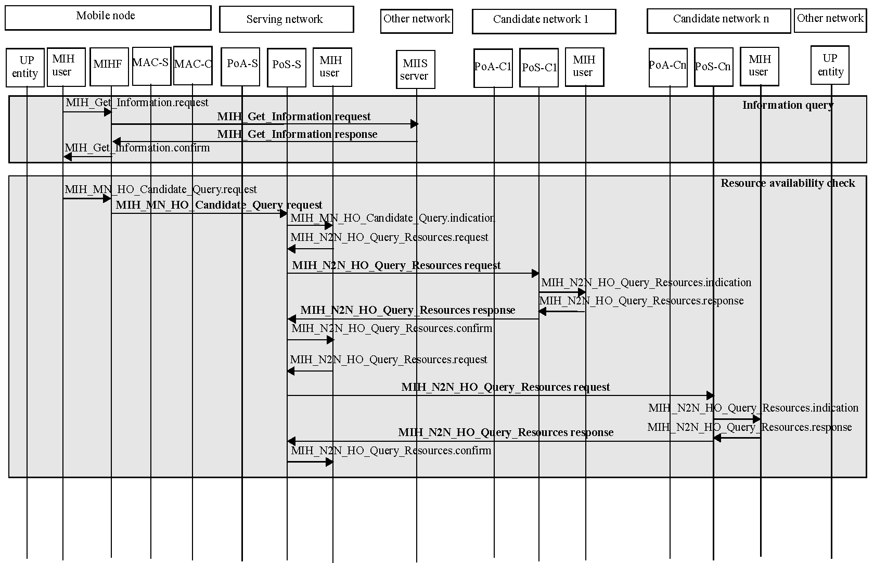
Figure C.1—Mobile-initiated handover procedure

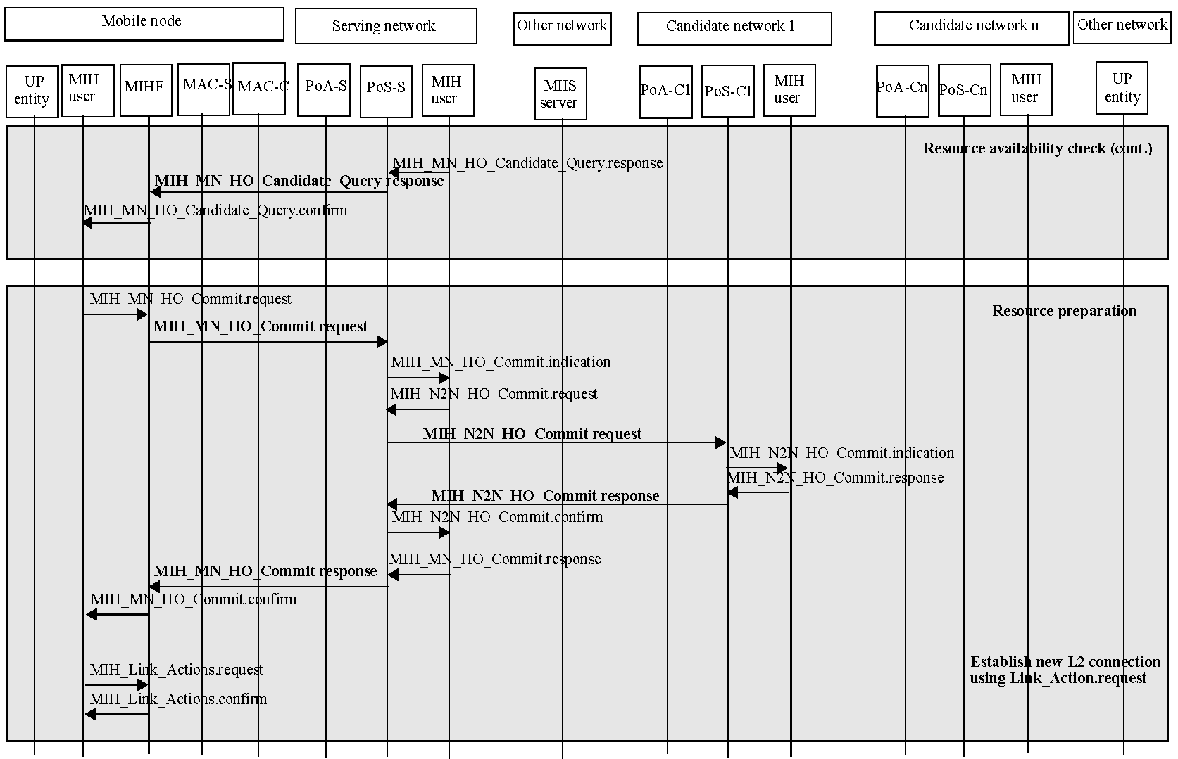
Figure C.1—Mobile-initiated handover procedure (continued)
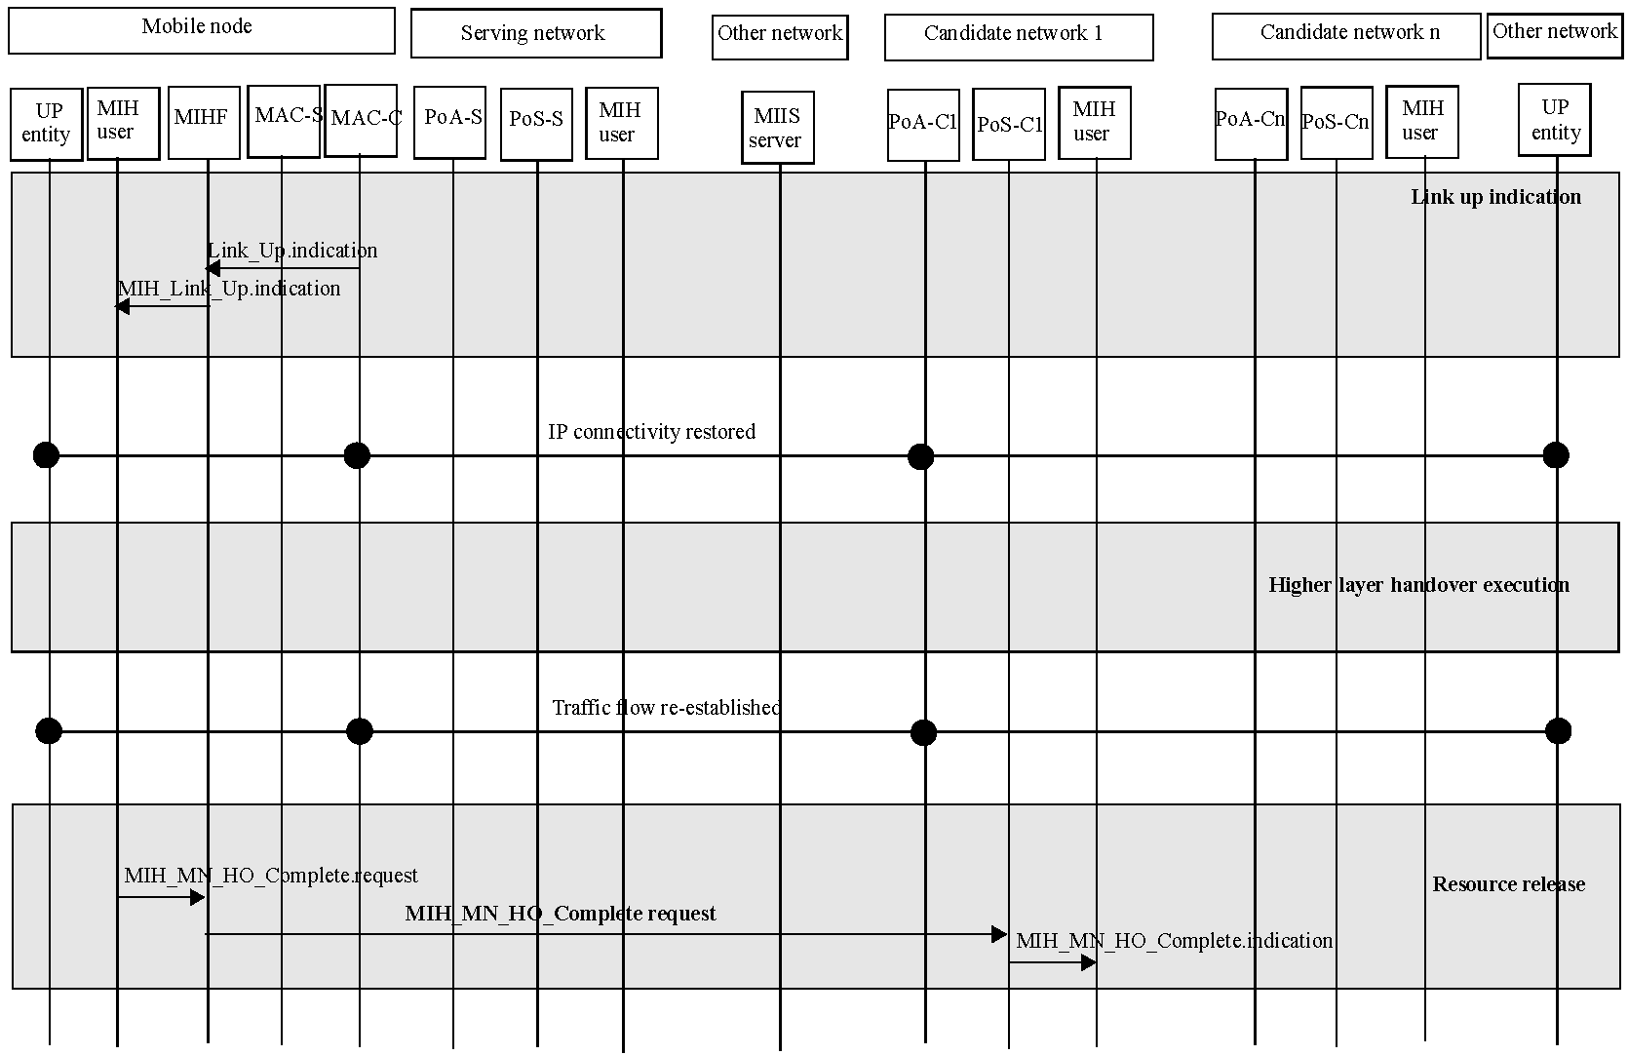
Figure C.1—Mobile-initiated handover procedure (continued)

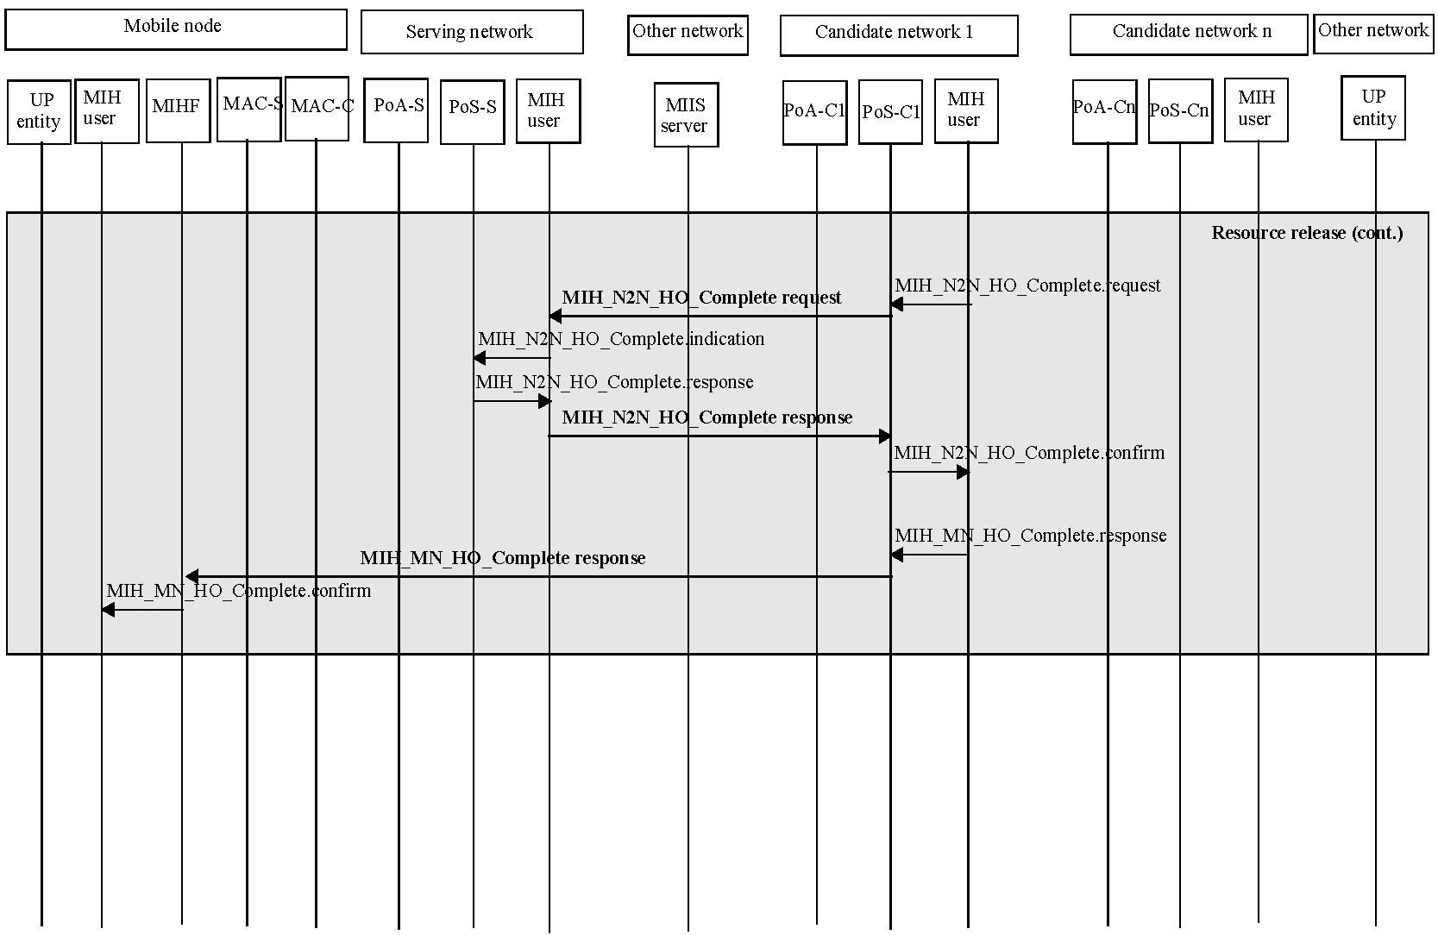
Figure C.1—Mobile-initiated handover procedure (continued)

Network-initiated handover procedure
The Network-initiated handover procedure operates as follows (see Figure C.2):
  - The Serving PoS sends an MIH_Get_Information request message to the Information Server to get neighboring network information and the Information Server responds by sending an MIH_Get_Information response message.
  - The Serving PoS triggers a network-initiated handover by sending an
MIH_Net_HO_Candidate_Query request message to the Mobile Node. The MN responds through an MIH_Net_HO_Candidate_Query response message, which contains the Mobile Node’s acknowledgement about the handover and its preferred link and PoS lists.
  - The Serving PoS sends an MIH_N2N_HO_Query_Resources request message to one or more Candidate PoSs to check the availability of the resource at candidate networks. The Candidate PoS responds by sending an MIH_N2N_HO_Query_Resources response message to the Serving PoS.
  - The Serving PoS decides the target of the handover based on the available resource status at candidate networks.
  - The Serving PoS sends an MIH_N2N_HO_Commit request message to the Target PoS to prepare resource at the target network. The Target PoS responds with the result of the resource preparation by sending an MIH_N2N_HO_Commit response message.
  - After identifying that the resource is successfully prepared, the Serving PoS commands the Mobile Node to commit handover towards the specified network type and PoA through an MIH_Net_HO_Commit request message.
  - The new layer 2 connection is established and the Mobile Node sends an MIH_Net_HO_Commit response message to the Serving PoS.
  - After higher layer handover execution, the Mobile Node sends an MIH_MN_HO_Complete request message to the Target PoS. The Target PoS sends an MIH_N2N_HO_Complete request message to the previous Serving PoS to release resource, which was allocated to the Mobile Node. After identifying that the resource is successfully released, the Target PoS sends an MIH_MN_HO_Complete response message to the Mobile Node.

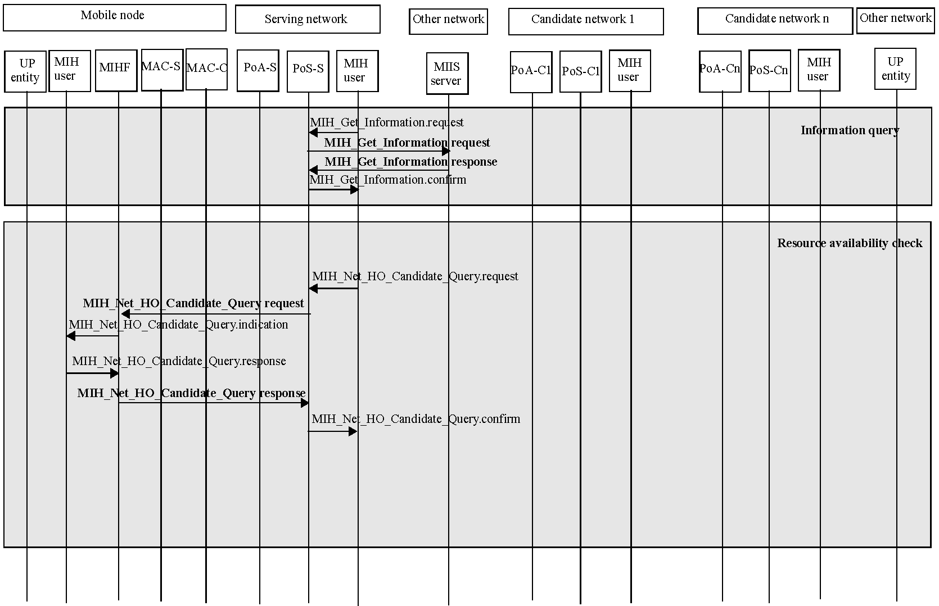
Figure C.2—Network-initiated handover procedure

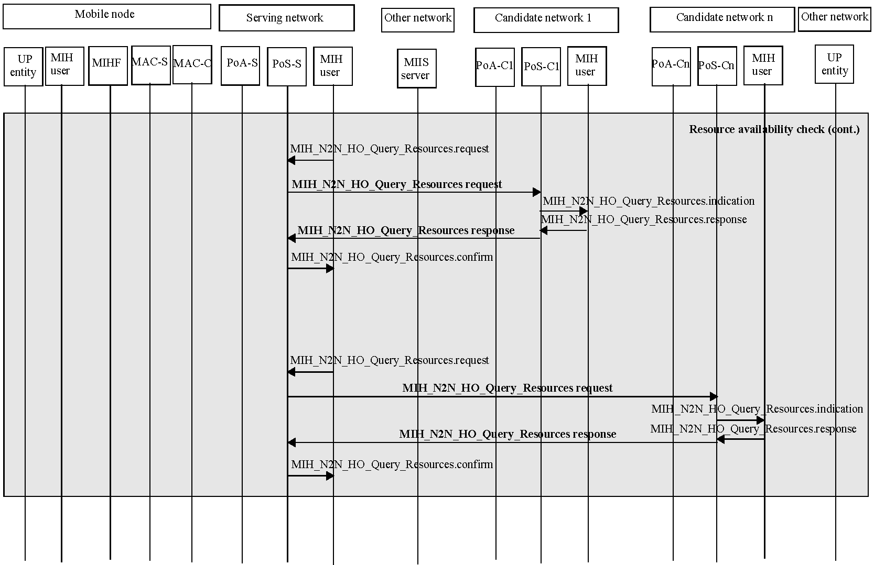
Figure C.2—Network-initiated handover procedure (continued)

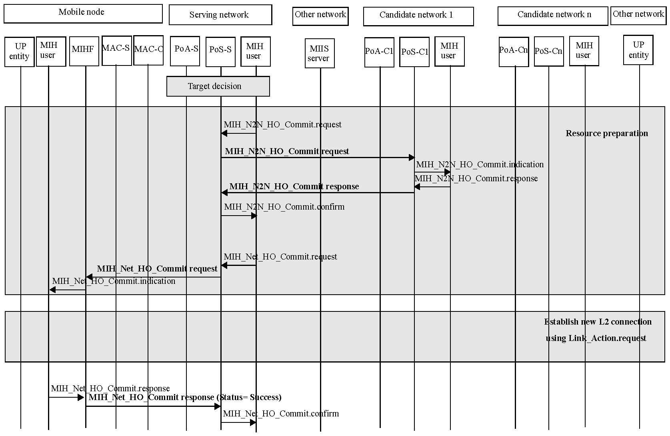
Figure C.2—Network-initiated handover procedure (continued)

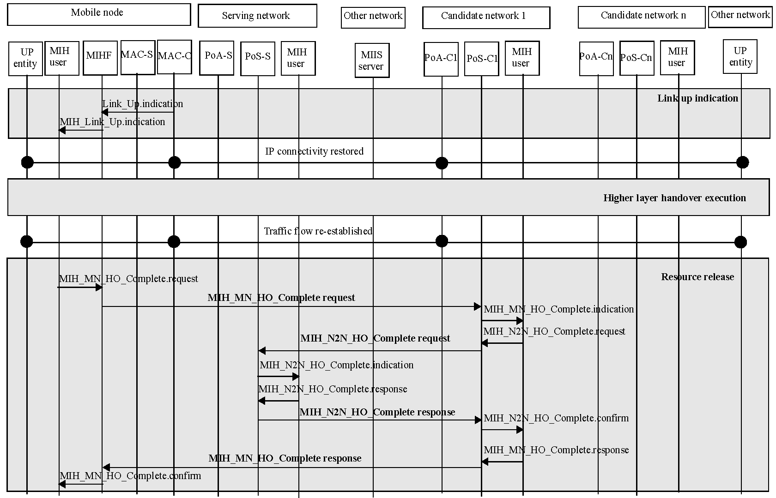
Figure C.2—Network-initiated handover procedure (continued)

Example handover flow chart between IEEE 802.11 and IEEE 802.16
Figure C.3 shows a handover flow chart between the IEEE 802.11 and the IEEE 802.16 network. This is an example of dual radio handover procedure wherein both the radios involved in handover can transmit and receive at the same time. The handover procedure operates as follows:
  - The Mobile Node is connected to the IEEE 802.11 network and receives the IEEE 802.11 link measurement report through the MIH_Link_Parameters_Report. indication and acquires the neighboring network information by the MIH_Get_Information.confirm.
  - When the Link_Going_Down event happens on the current IEEE 802.11 network, the Mobile Node performs the MIH_Link_Actions.request to scan the link status of the candidate networks. The mobile node discovers the IEEE 802.16 network and can acquire the candidate IEEE 802.16 network's DL_MAP, UL_MAP, DCD and UCD parameters.
  - The Mobile Node identifies the resource availability status of the candidate network by sending the MIH_MN_HO_Candidate_Query message to the Serving PoS. When the Serving PoS receives the MIH_MN_HO_Candidate_Query request message from the Mobile Node, it retrieves resource information from target network by sending MIH_N2N_HO_Query_Resources message to the PoSs on the candidate networks.
  - Based on resource availability and other selection criteria the IEEE 802.16 network is selected as the target of the handover and the Mobile Node sends MIH_MN_HO_Commit request message to the Serving PoS to notify the decided target network information. The Serving PoS reserves the resource at the target network through MIH_N2N_HO_Commit messages.
  - The Mobile Node commits a link switch to the IEEE 802.16 interface and the new layer 2 connection for the target IEEE 802.16 network is established. The Mobile IP procedures are carried out between the Mobile Node and the IEEE 802.16 network. As a result of that, the active sessions are now shifted over to the IEEE 802.16 network.
  - The Mobile Node sends the MIH_MN_HO_Complete request message to the Serving PoS on the IEEE 802.16 network and that Serving PoS exchanges the MIH_N2N_HO_Complete messages with the previous PoS on the IEEE 802.11 network to release the resource that was reserved for the Mobile Node on that network.

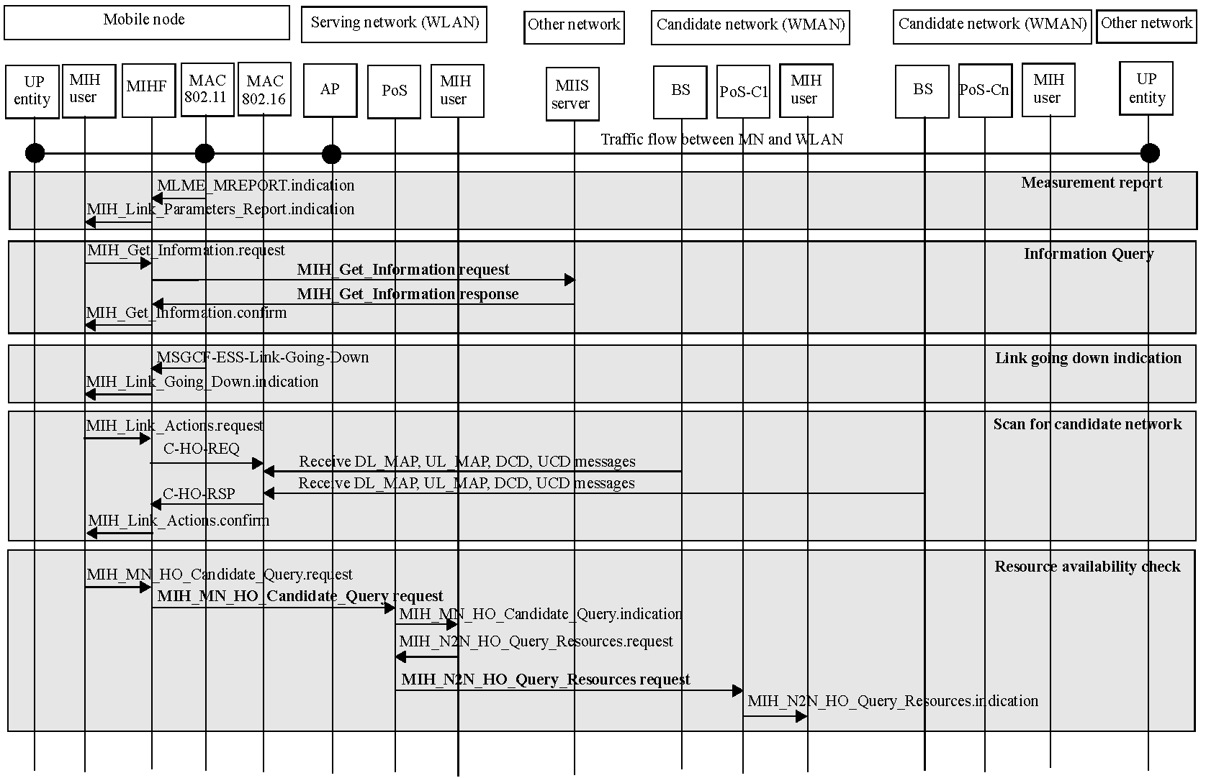
Figure C.3—Example handover flow chart between IEEE 802.11 and IEEE 802.16

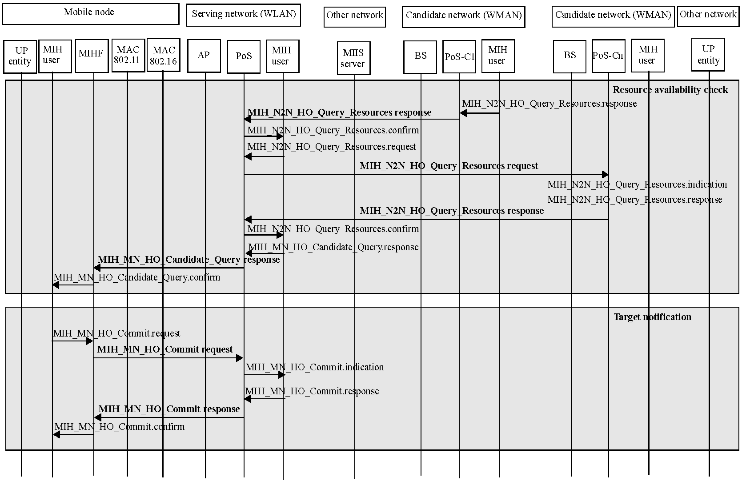
Figure C.3—Example handover flow chart between IEEE 802.11 and IEEE 802.16 (continued)

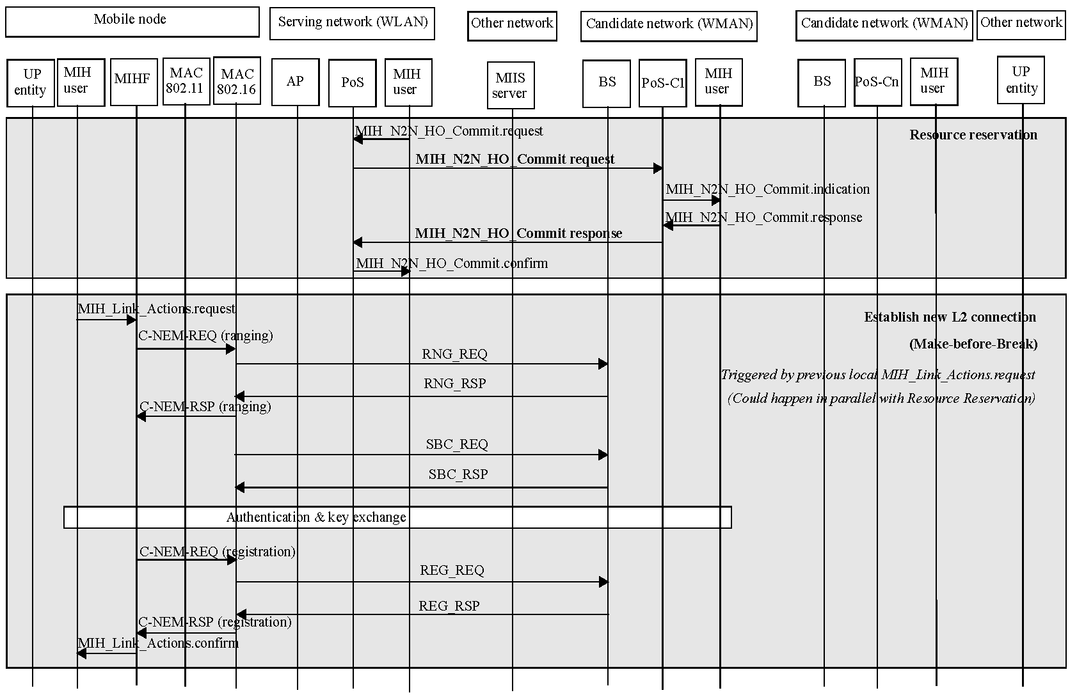
Figure C.3—Example handover flow chart between IEEE 802.11 and IEEE 802.16 (continued)

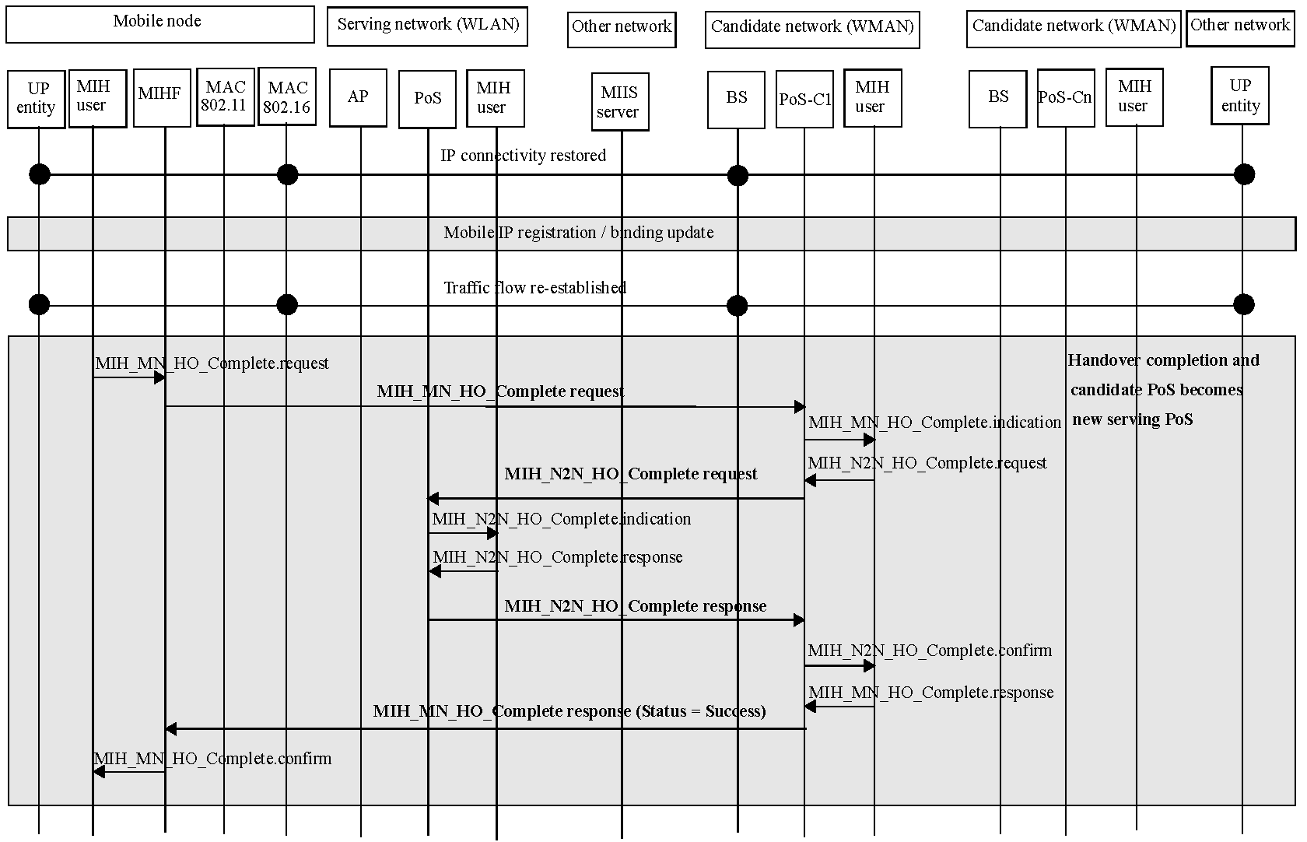
Figure C.3—Example handover flow chart between IEEE 802.11 and IEEE 802.16 (continued)

Example handover flow chart for Proxy Mobile IPv6

Network-initiated handover procedures
Figure C.4 shows a network-initiated handover flow chart for Proxy Mobile IPv6 (PMIPv6), which is currently under standardization for supporting a local mobility in IETF NetLMM Working Group (Although the Proxy Mobile IP is under standardization, its overall flow is already defined. The following handover flow refers to the overall flow.) The handover flow operates as follows:
  - The MN receives packets through both the Mobile Access Gateway (MAG) 1 located in the serving network and the Local Mobility Anchor (LMA), which are primary components of the PMIPv6.
  - The Serving PoS queries the Information Server to get information about available neighboring networks.
  - The Serving PoS triggers a network-initiated handover by sending the
MIH_Net_HO_Candidate_Query request message to the MN. The MN responds with the MIH_Net_HO_Candidate_Query response message, which contains the MN’s acknowledgement about the handover initiation and its preferred link and PoS lists.
  - The Serving PoS sends the MIH_N2N_HO_Query_Resource request messages to different Candidate PoSs (can be more than one) to query the availability of the resource at candidate networks. The Candidate PoSs respond by sending the MIH_N2N_HO_Query_Resource response message to the Serving PoS. The Serving PoS decides on the handover target based on the resource availability information of candidate networks informed by the MIH_N2N_HO_Query_Resource response message.
  - The Serving PoS informs the decided Target PoS (i.e., Candidate Network 1 in the Figure C.4, where MAG2 is located) of the handover commitment and requests the Target PoS to prepare resources for the incoming MN through sending the MIH_N2N_HO_Commit request message. The Target PoS replies to the result of the handover commitment and resource preparation by sending an MIH_N2N_HO_Commit response message. (Upon receiving the MIH_N2N_HO_Commit request message, the PMIPv6 client in the Target PoS queries the incoming MN’s profile to an AAA server and sends a Proxy Binding Update in order to register the location of the MN in advance. The PMIPv6 client in the Target PoS buffers the packets received from the LMA until the MN attaches to the Target PoS.)
  - The Serving PoS requests the MN to perform handover to the decided Target PoS by sending the MIH_Net_HO_Commit request message. The MN replies with the result of the handover commitment by sending an MIH_Net_HO_Commit response message.
  - Upon detecting the MN’s detachment, the PMIPv6 client in the Serving PoS terminates its current binding of the MN via sending a Proxy Binding Update with Lifetime set to 0 and requests the LMA to buffer packets destined for the MN.
  - Once the MN establishes Layer 2 connection to the Target PoS, the PMIPv6 client in the Target PoS registers the current MN’s location to the LMA by sending a Proxy Binding Update message. The LMA updates its Binding Cache Entry with the Proxy Binding Update message and then replies with a Proxy Binding Acknowledgement message. The LMA forwards the buffered packets.
  - After receiving the Proxy Binding Acknowledgement message, the PMIPv6 client sends a Router Advertisement message to the MN. The Router Advertisement is constructed with the MN’s information obtained from the policy server and the LMA. It can be solicited by a Router Solicitation message from the MN or periodically transmitted. The MN configures IP addresses on its interface, which is currently used to connect to the Target PoS, with the received Router Advertisement message. Once the PMIPv6 procedures are completed, the MN receives packets through both MAG 2 and LMA.
  - After the PMIPv6 execution, the Target PoS sends the MIH_N2N_HO_Complete request message to the previous Serving PoS. The previous Serving PoS responds to the message with an MIH_N2N_HO_Complete response message.
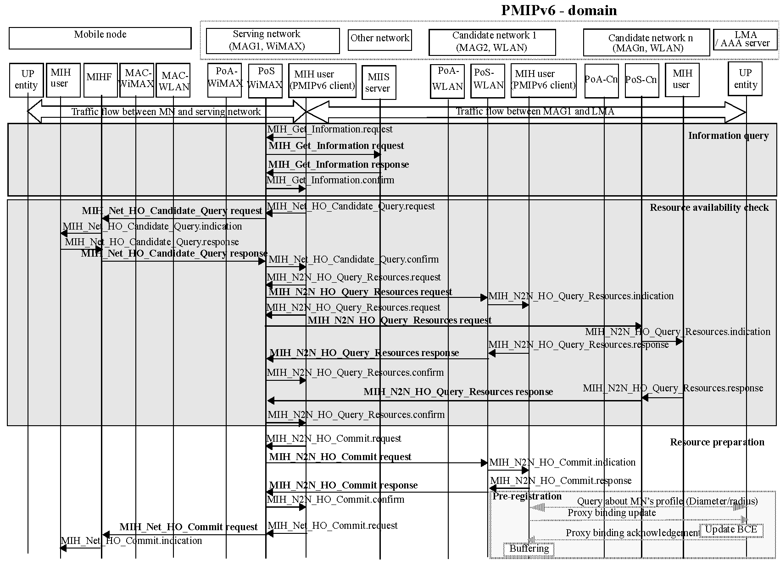
Figure C.4—Network-initiated handover procedures

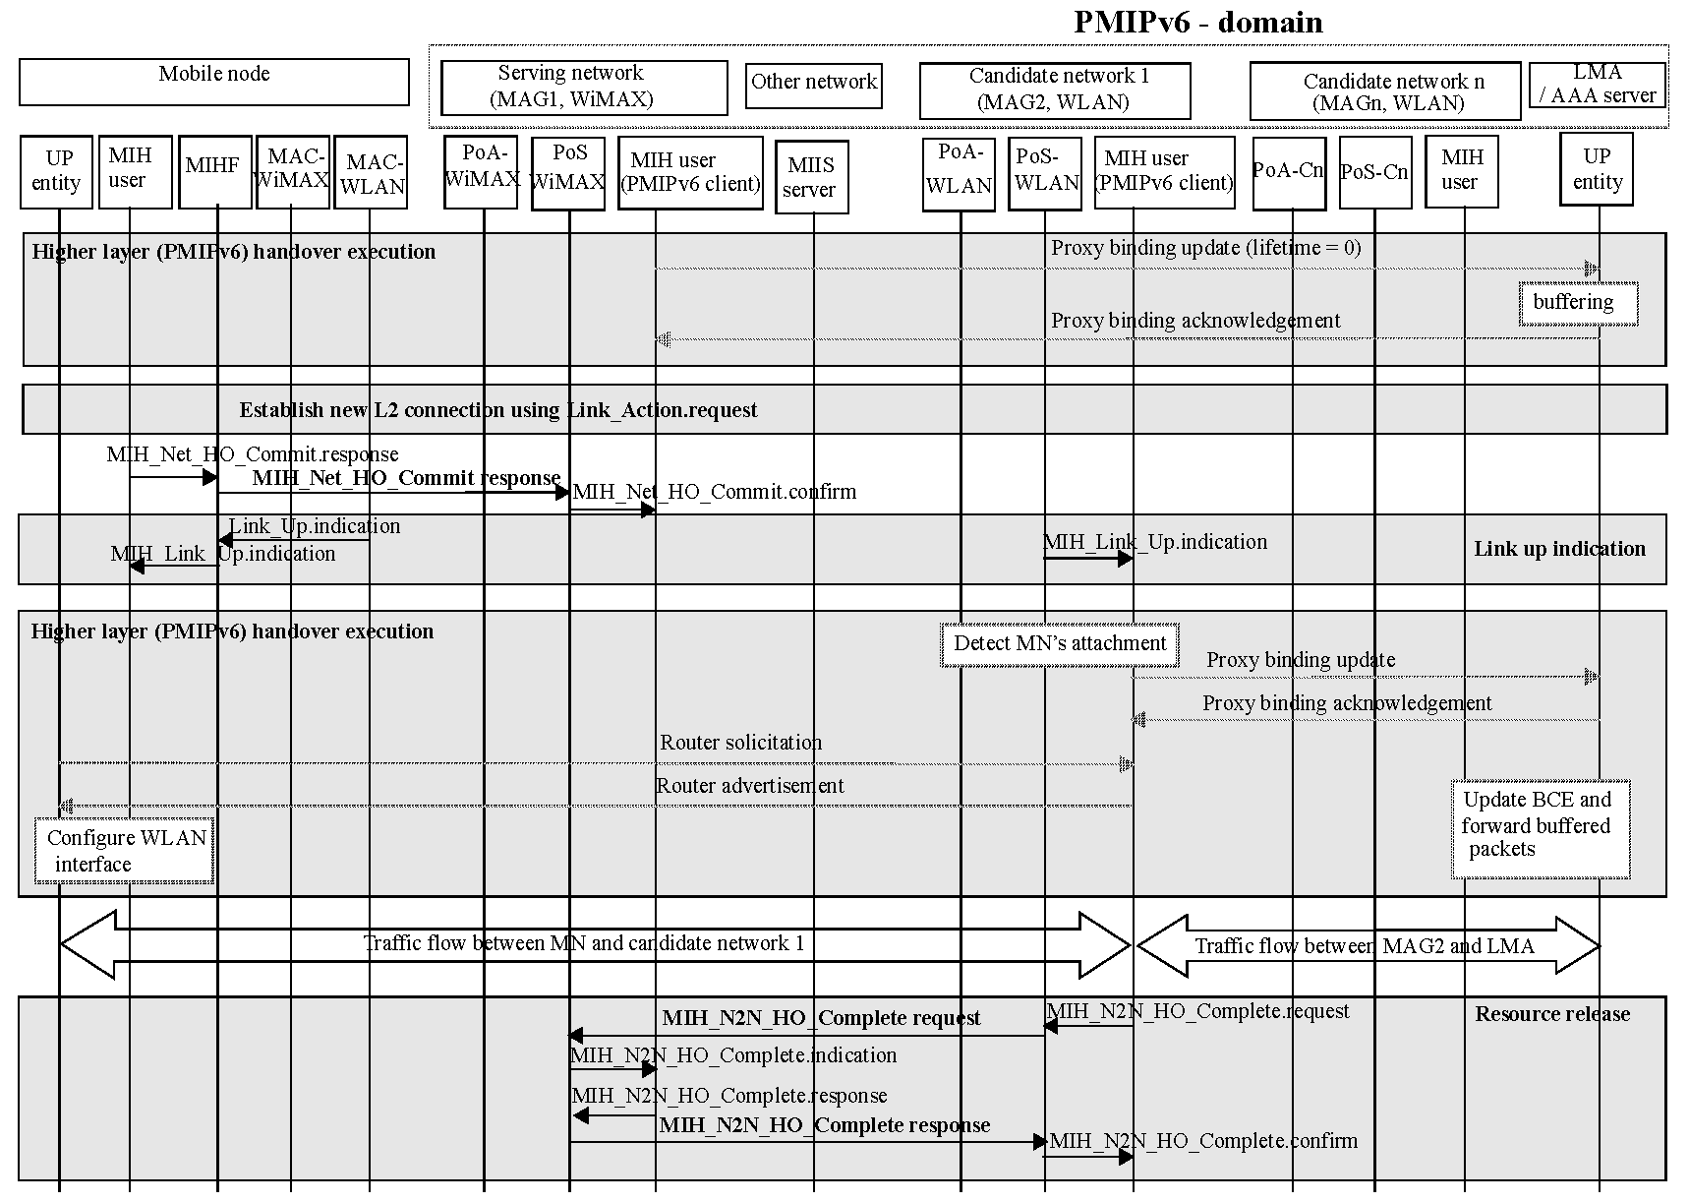
Figure C.4—Network-initiated handover procedures

Mobile-initiated handover procedures
Figure C.5 shows a mobile-initiated handover flow chart for Proxy Mobile IPv6 (PMIPv6), which is currently under standardization for supporting a local mobility in IETF NetLMM Working Group (Although the Proxy Mobile IP is under standardization, its overall flow is already defined. Following handover flow refers to the overall flow.) The handover flow operates as follows:
  - MN receives packets through both Mobile Access Gateway (MAG) 1 located in the serving network and Local Mobility Anchor (LMA), which are primary components of the PMIPv6.
  - The MN queries the Information Server to get information about available neighboring networks. This information query can be attempted as soon as the MN attaches to a new serving network or periodically for refreshing the information.
  - MN sends the MIH_MN_HO_Candidate_Query request message to the Serving PoS for triggering a mobile-initiated handover. This message contains requirements for potential candidate networks.
  - The Serving PoS sends the MIH_N2N_HO_Query_Resource request messages to the informed Candidate PoSs (can be more than one) in order to query the availability of the resource at the candidate networks. The Candidate PoS responds by sending the MIH_N2N_HO_Query_Resource response message to the Serving PoS. The Serving PoS in turn sends MIH_MN_HO_Candidate_Query response message to the MN. Finally, the MN decides the handover target based on the result of query about resource availability at the candidate networks.
  - The MN sends the MIH_MN_HO_Commit request message to notify the Serving PoS of the decided target network information. The Serving PoS reserves the resource at the target network through MIH_N2N_HO_Commit messages. Upon receiving the MIH_N2N_HO_Commit request message, PMIPv6 client as MIH user in the target PoS queries the incoming MN’s profile to a policy store such as AAA server. As a result, the Target PoS obtains the MN’s information for PMIP processes in advance. (Upon receiving the MIH_N2N_HO_Commit request message, PMIPv6 client in the Target PoS queries the incoming MN's profile to an AAA server and sends Proxy Binding Update in order to register the location of the MN in advance. The PMIPv6 client in the Target PoS also buffers the packets received from LMA until the MN attaches to the Target PoS.)
  - The Target PoS replies to the Serving PoS with the result of the resource preparation by sending MIH_N2N_HO_Commit response message.
  - The MN performs handover to the specified network type and PoA by the MIH_Link_Actions.request primitive. Upon detecting the MN’s detachment, the PMIPv6 client in the Serving PoS terminates its current binding of the MN via sending Proxy Binding Update with Lifetime set to 0 and requests the LMA to buffer packets destined for the MN.
  - Once the MN establishes the layer 2 connection to the Target PoS, the PMIPv6 client as an MIH user in the Target PoS registers the current MN’s location to the LMA by sending a Proxy Binding Update message. The LMA updates its Binding Cache Entry with the Proxy Binding Update message and then replies with Proxy Binding Acknowledgement message. The LMA also forwards the buffered packets.
  - After receiving the Proxy Binding Acknowledgement message, the PMIPv6 client sends a Router Advertisement message to the MN. The Router Advertisement is constructed with the MN’s information obtained from the policy server and LMA. It can be solicited by a Router Solicitation message from the MN or periodically transmitted. MN configures IP addresses on its interface, which is currently used to connect to the Target PoS, with the received Router Advertisement message. Once the PMIPv6 procedures are completed, the MN receives packets through both MAG 2 and LMA.
  - After the PMIPv6 execution, the Target PoS sends the MIH_N2N_HO_Complete request message to the previous Serving PoS. The previous Serving PoS responds to the message with an MIH_N2N_HO_Complete response message.

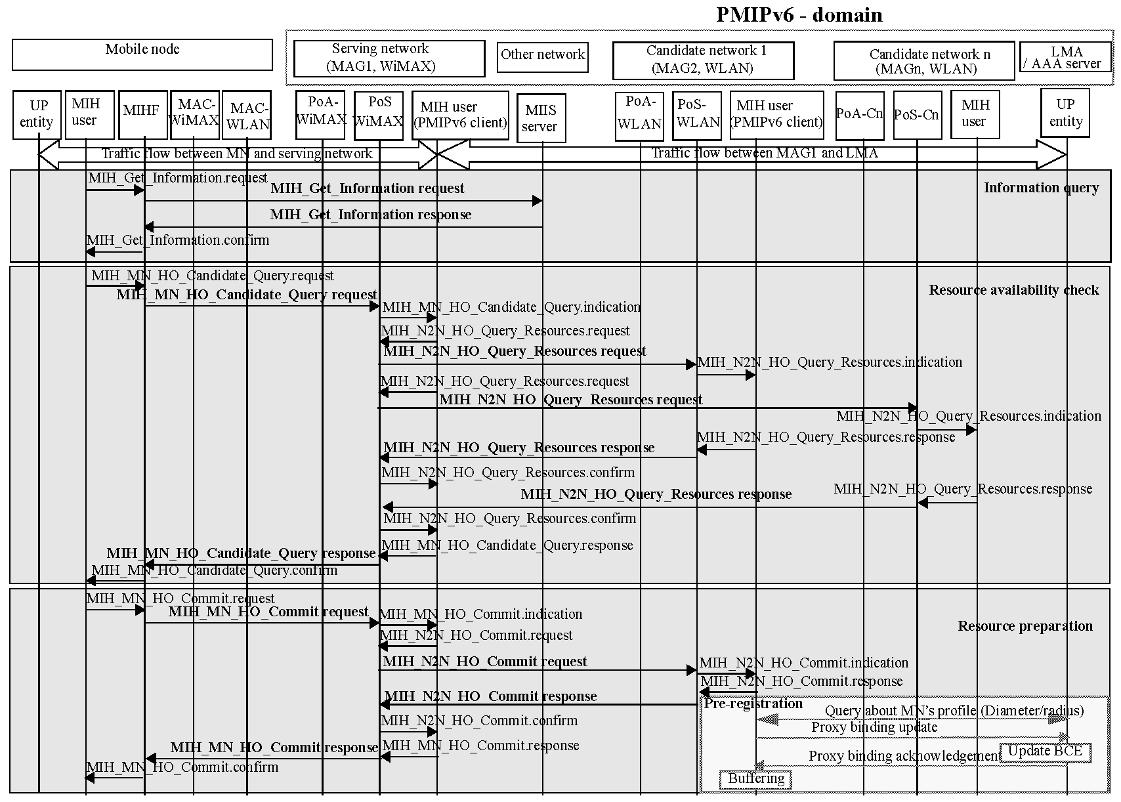
Figure C.5—Mobile-initiated handover procedures
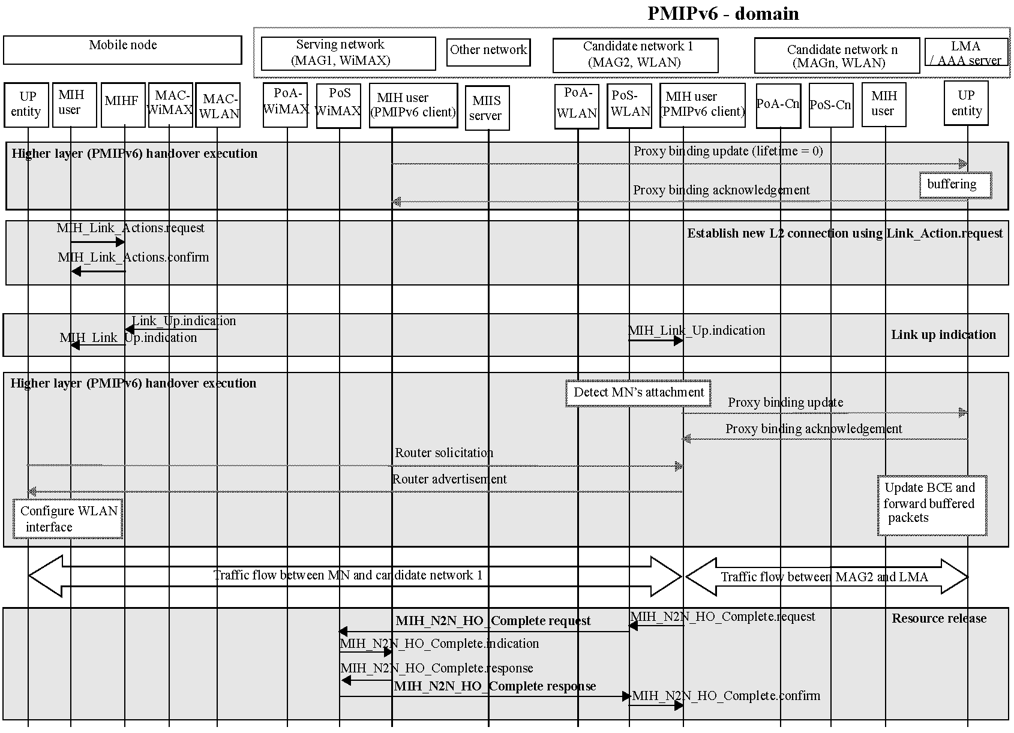
Figure C.5—Mobile-initiated handover procedures

Mobile-initiated handover for break before make case
Figure C.6 shows a mobile-initiated handover flow chart for Proxy Mobile IPv6 (PMIPv6). In this case the MN looses its connectivity with the serving PoA before the target PoA can be notified of the MN’s decision to handover. However, the MN discovers the target PoA, establishes connectivity with the target PoA and then the target PoA notifies the serving PoA of the handover completion. PMIPv6 signaling is then completed and the packets are then forwarded to the MN’s new location. The handover flow operates as follows:
  - The MN receives packets through both Mobile Access Gateway (MAG) 1 located in the serving network and Local Mobility Anchor (LMA), which are primary components of the PMIPv6.
  - The MN queries the Information Server to get information about available neighboring networks. This information query can be attempted as soon as the MN attaches to a new serving network or periodically for refreshing the information.
  - The MN sends the MIH_MN_HO_Candidate_Query request message to the Serving PoS for triggering a mobile-initiated handover. This message contains requirements for potential candidate networks.
  - The Serving PoS sends the MIH_N2N_HO_Query_Resource request messages to the informed Candidate PoSs (can be more than one) in order to query the availability of the resource at the candidate networks. The Candidate PoS responds by sending the MIH_N2N_HO_Query_Resource response message to the Serving PoS. The Serving PoS in turn sends MIH_MN_HO_Candidate_Query response message to the MN. Finally, the MN decides on the handover target based on the result of query about resource availability at the candidate networks.
  - The MN unexpectedly looses connectivity with the serving PoS. Upon detecting the MN’s detachment, the PMIPv6 client in the Serving PoS terminates a current binding of the MN via sending a Proxy Binding Update with Lifetime set to 0 and requests the LMA to buffer packets destined for the MN.
  - The loss of the link connectivity triggers an MIH_Link_Down event on the MN. Later the MN receives an MIH_Link_Up event when the WLAN L2 connection is established.
  - Once the MN establishes the layer 2 connection to the Target PoS, the PMIPv6 client as an MIH user in the Target PoS registers the current MN's location to the LMA by sending a Proxy Binding Update message. The LMA updates its Binding Cache Entry with the Proxy Binding Update message and then replies with Proxy Binding Acknowledgement message.
  - After receiving the Proxy Binding Acknowledgement message, the PMIPv6 client sends a Router Advertisement message to the MN. The Router Advertisement is constructed with the MN’s information obtained from the policy server and LMA. It can be solicited by a Router Solicitation message from the MN or periodically transmitted. The MN configures IP addresses on its interface, which is currently used to connect to the Target PoS, with the received Router Advertisement message. Once the PMIPv6 procedures are completed, the MN receives packets through both MAG 2 and LMA.
  - After the PMIPv6 execution, the Target PoS sends the MIH_N2N_HO_Complete request message to the previous Serving PoS. The previous Serving PoS responds to the message with MIH_N2N_HO_Complete response message.

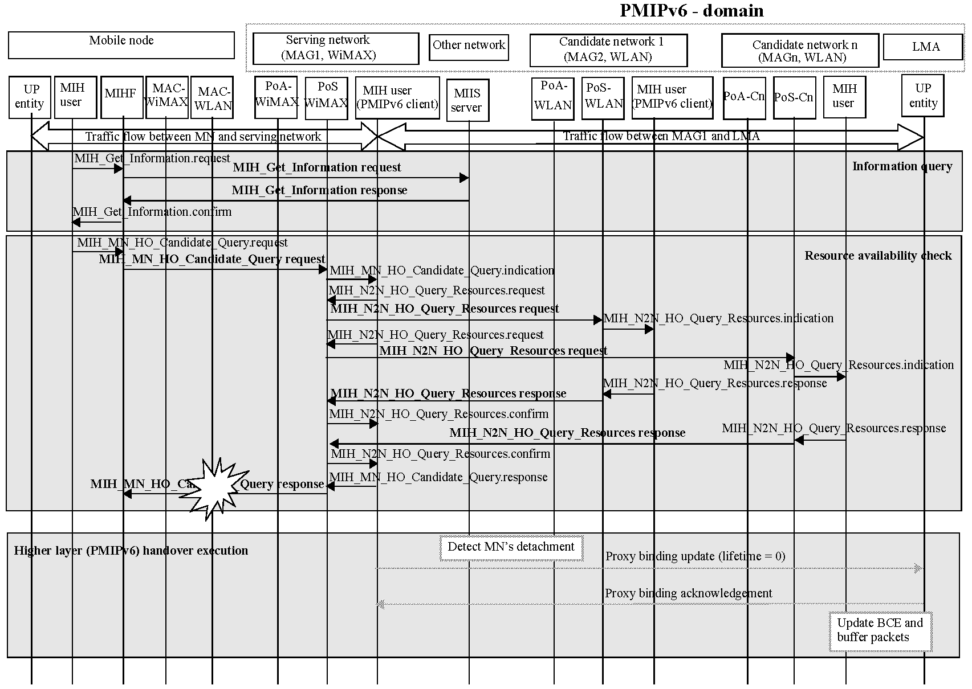
Figure C.6—Mobile-initiated handover for break before make case
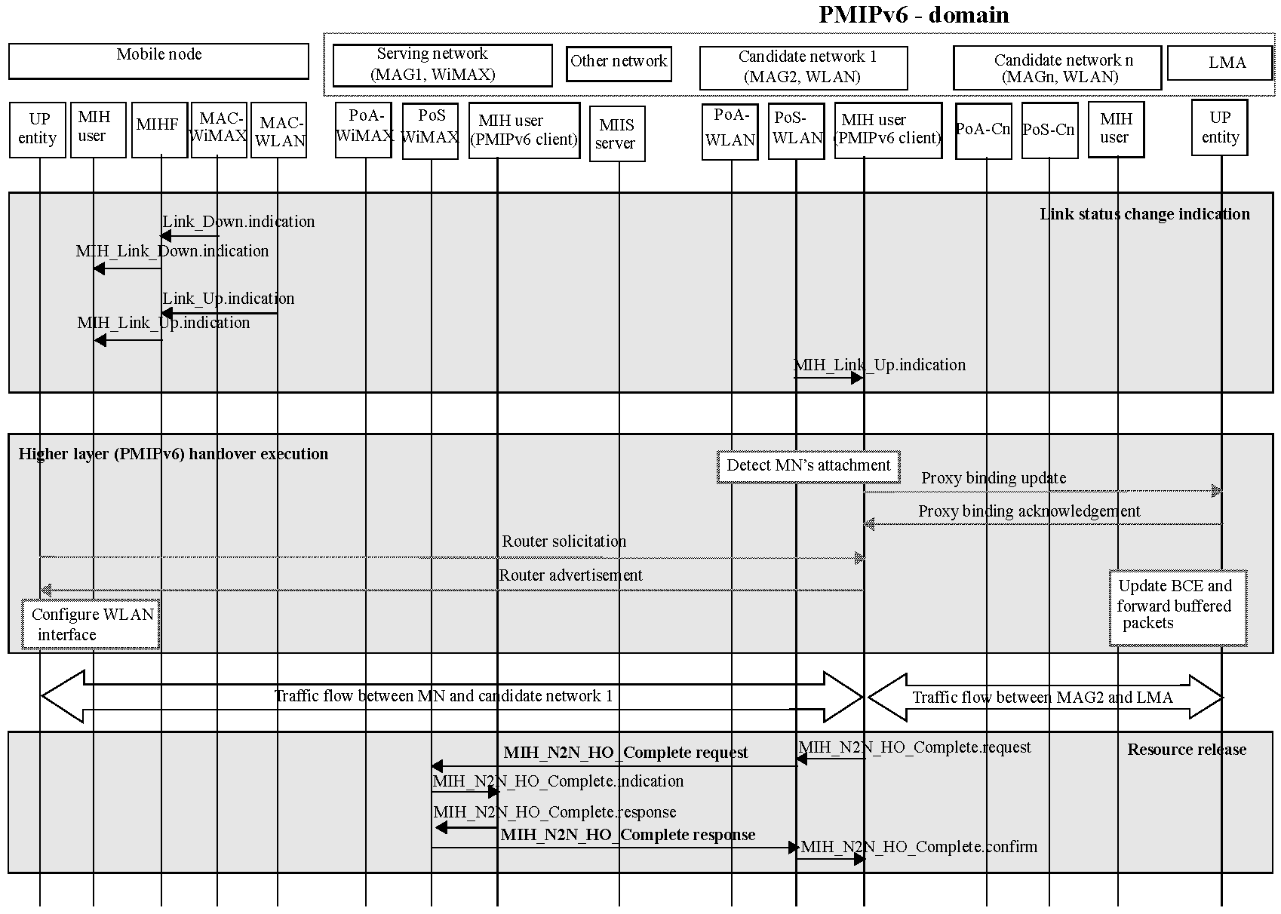
Figure C.6—Mobile-initiated handover for break before make case

Network selection in IEEE 802.11 (WLAN) using IEEE 802.21
Figure C.7 shows the general topology of an IEEE 802.11 (WLAN) network operating with an IEEE 802.21 MIIS.
The steps in network selection as shown in Figure C.8 are as follows:
  - Pre-configuration: The AP is pre-configured with advertising protocol identifier (APID) of choice and is pre-configured to use IEEE 802.21 MIIS. The AP discovers the MIIS through a variety of different mechanisms that are outside the scope of specification. The maximum length of response messages from MIIS is also set. The AP communicates with MIIS at L2 or at L3 using a protocol defined elsewhere.
  - Discover AP/Access Network Capabilities: The AP sends out a beacon with Interworking set in the extended capabilities information element and APID set to GAS (Generic Advertisement Service). The STA discovers access network capabilities by listening to beacons or it could also send a probe request and discover access network capabilities through the probe response.
  - Query list of subscription service provider networks (SSPNs): The STA sends out a query asking for a list of available SSPNs. The query is defined using an IEEE 802.21 specific MIH frame. The MIH frame is then relayed by the AP to the MIIS. Meanwhile the AP sends out the initial GAS response to the STA with initial delay (comeback delay).
  - GAS response: The MIIS interprets the query and retrieves the response either from local or remote repository. It then packs the response in an appropriate MIH frame and sends it to the AP. Subsequently when the STA sends the GAS comeback request to the AP, the AP responds with the available information in the MIH frame. The STA then retrieves the information out of the MIH frame and obtains the answer to the query.

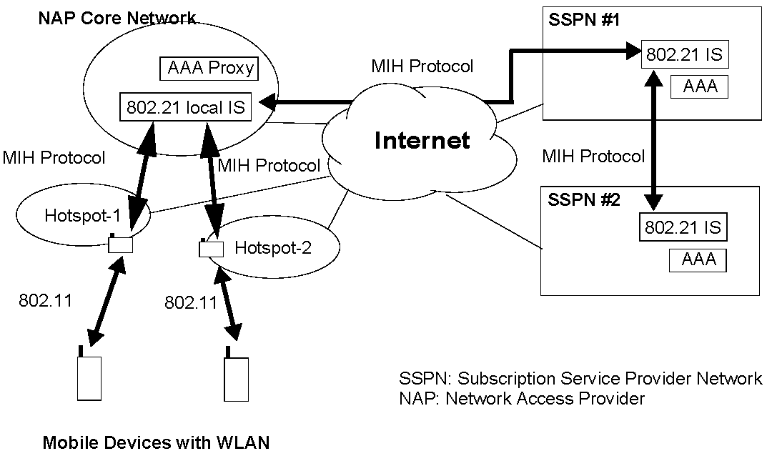

Figure C.7—Network selection in WLAN with IEEE 802.11 and IEEE 802.21
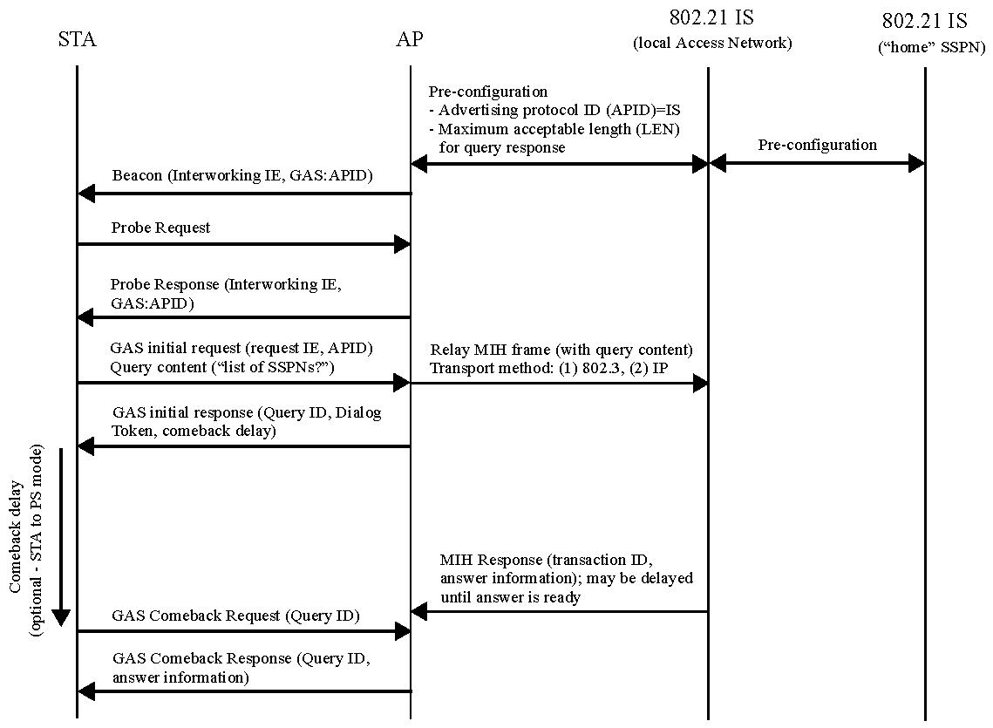
Figure C.8—Use case: query SSPN list

Abnormal case at the stage of resource availability check
When MIH_MN_HO_Candidate_Query response message indicates the handover initiator to abort handover, the MN will initiate handover process to another suitable target PoA. Figure C.9 shows the handover flow diagram for this case.

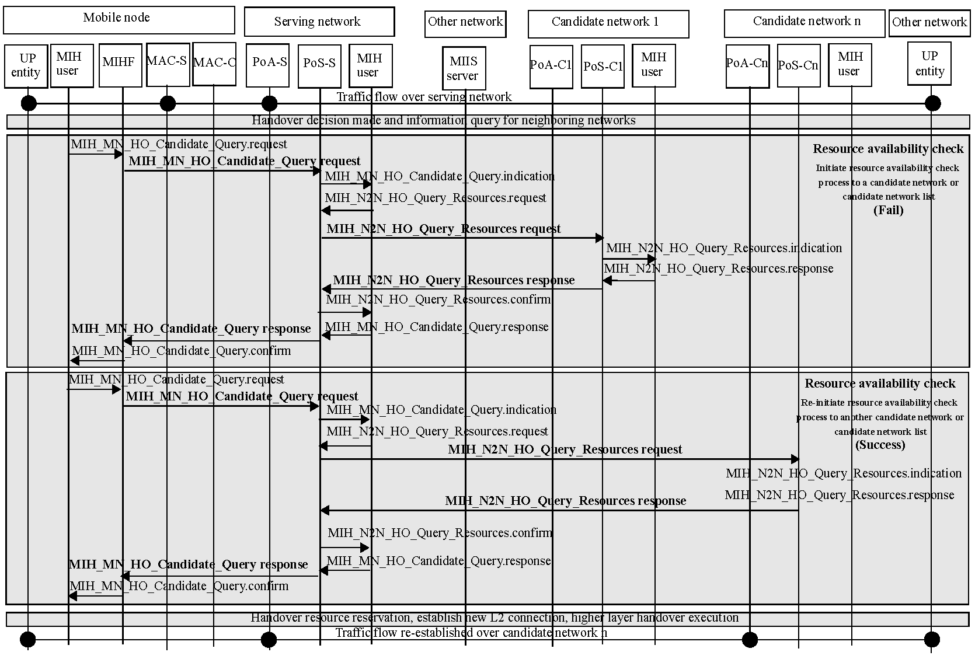
Figure C.9—Abnormal case at the stage of resource availability check

(normative)
Mapping MIH messages to reference points

(normative)
Media specific mapping for SAPs

(normative)
Data type definition

(normative)
Information element identifiers

(normative)
MIIS basic schema

(informative)
Making user extensions to MIIS schema

(normative)
IEEE 802.21 MIB

Parameters requiring MIB definition

MIH capability parameters
The following is a list of parameters that are used in the MIH capability discovery:
- …
- List of MBB Handover support (Read-only): A list of make-before-break support information for each pair of serving and target network types.

MIH protocol parameters

IEEE 802.21 MIB definition

(informative)
Example MIH message fragmentation

(normative)
MIH protocol message code assignments
Table L.1 provides the action identifier (AID) assignment for MITT messages.
Table L.1—AID assignment
MIH messages | AID
MIH messages for Service Management
MITT_Capability_Discover | 1
MITT_Register | 2
MITT_DeRegister | 3
MITT_Event_Subscribe | 4
MITT_Event_Unsubscribe | 5
MIH messages for Event Service
MITT_Link_Detected | 1
MITT_Link_Up | 2
MITT_Link_Down | 3
MITT_Link_Parameters_Report | 5
MITT_Link_Going_Down | 6
MITT_Link_TTandover_Imminent | 7
MITT_Link_TTandover_Complete | 8
MIH messages for Command Service
MITT_Link_Get_Parameters | 1
MITT_Link_Configure_Thresholds | 2
MITT_Link_Actions | 3
MITT_Net_TTO_Candidate_Query | 4
MITT_MN_TTO_Candidate_Query | 5
MITT_N2N_TTO_Query_Resources | 6
MITT_MN_TTO_Commit | 7
MITT_Net_TTO_Commit | 8
MITT_N2N_TTO_Commit | 9
MITT_MN_TTO_Complete | 10
MITT_N2N_TTO_Complete | 11

Table L.1—AID assignment (continued)
MIH messages | AID
MIH messages for Information Service
MIH_Get_Information | 1
MIH_Push_Information | 2

Table L.2 provides the TLV type value assignment for MIH messages. The type value can be extracted from the binary encoding method of the corresponding data type. TLV type value 101–255 is reserved for experimental TLVs.
Table L.2—Type values for TLV encoding
TLV type name | TLV  type value | Data type
Source MIHF ID | 1 | MIHF_ID
Destination MIHF ID | 2 | MIHF_ID
Status | 3 | STATUS
Link type | 4 | LINK_TYPE
MIH event list | 5 | MIH_EVT_LIST
MIH command list | 6 | MIH_CMD_LIST
MIIS query type list | 7 | MIH_IQ_TYPE_LST
Transport option list | 8 | MIH_TRANS_LST
Link address list | 9 | LIST(NET_TYPE_ADDR)
MBB handover support | 10 | LIST(MBB_HO_SUPP)
Register request code | 11 | REG_REQUEST_CODE
Valid time interval | 12 | UNSIGNED_INT(4)
Link identifier | 13 | LINK_TUPLE_ID
New link identifier | 14 | LINK_TUPLE_ID
Old access router | 15 | LINK_ADDR
New access router | 16 | LINK_ADDR
IP renewal flag | 17 | IP_RENEWAL_FLAG
Mobility management support | 18 | IP_MOB_MGMT
IP address configuration methods | 19 | IP_CFG_MTHDS
Link down reason code | 20 | LINK_DN_REASON
Time interval | 21 | UNSIGNED_INT(2)
Link going down reason | 22 | LINK_GD_REASON
Link parameter report list | 23 | LIST(LINK_PARAM_RPT)

Table L.2—Type values for TLV encoding (continued)
TLV type name | TLV  type value | Data type
Device states request | 24 | DEV_STATES_REQ
Link identifier list | 25 | LIST(LINK_ID)
Device states response list | 26 | LIST(DEV_STATES_RSP)
Get status request set | 27 | LINK_STATUS_REQ
Get status response list | 28 | LIST( SEQUENCE(LINK_ID,LINK_STATUS_RSP) )
Configure request list | 29 | LIST(LINK_CFG_PARAM)
Configure response list | 30 | LIST(LINK_CFG_STATUS)
List of link PoA list | 31 | LIST(LINK_POA_LIST)
Preferred link list | 32 | LIST(RQ_RESULT)
Handover resource query list | 33 | QOS_LIST
Handover status | 34 | HO_STATUS
Access router address | 35 | IP_ADDR
DHCP server address | 36 | IP_ADDR
FA address | 37 | IP_ADDR
Link actions list | 38 | LIST(LINK_ACTION_REQ)
Link actions result list | 39 | LIST(LINK_ACTION_RSP)
Handover result | 40 | HO_RESULT
Resource status | 41 | LINK_RES_STATUS
Resource retention status | 42 | BOOLEAN
Info query binary data list | 43 | LIST(IQ_BIN_DATA)
Info query RDF data list | 44 | LIST(IQ_RDF_DATA)
Info query RDF schema URL | 45 | BOOLEAN
Info query RDF schema list | 46 | LIST(IQ_RDF_SCHM)
Max response size | 47 | UNSIGNED_INT(2)
Info response binary data list | 48 | LIST(IR_BIN_DATA)
Info response RDF data list | 49 | LIST(IR_RDF_DATA)
Info response RDF schema URL list | 50 | LIST(IR_SCHM_URL)
Info response RDF schema list | 51 | LIST(IR_RDF_SCHM)
Mobile node MIHF ID | 52 | MIHF_ID
Query resource report flag | 53 | BOOLEAN
Event configuration info list | 54 | LIST(EVT_CFG_INFO)

Table L.2—Type values for TLV encoding (continued)
TLV type name | TLV  type value | Data type
Target network info | 55 | TGT_NET_INFO
List of target network info | 56 | LIST(TGT_NET_INFO)
Assigned resource set | 57 | ASGN_RES_SET
Link detected info list | 58 | LIST(LINK_DET_INFO)
MN link ID | 59 | LINK_ID
PoA | 60 | LINK_ADDR
Unauthenticated information request | 61 | BOOLEAN
Network type | 62 | NETWORK_TYPE
Requested resource set | 63 | REQ_RES_SET
(Reserved) | 64–99 | (Reserved)
Vendor specific TLV | 100 | (Vendor specific)
(Reserved for experimental TLVs) | 10 1–255 | (Used for experimental purposes)

(normative)
Protocol implementation conformance statement (PICS) proforma

Introduction

Scope

Conformance

Instructions

Identification of the implementation

Identification of the protocol

Identification of corrigenda to the protocol

PICS proforma tables

Global statement of conformance

Roles

Major capabilities
Item  number | Item description | References | Status | Support | Mnemonic
*M.8.3.1 | Is the Event Service (ES) supported? | 6.3 | O.2 | Yes [ ] No [ ] | MC1
*M.8.3.2 | Is the Command Service (CS) supported? | 6.4 | O.2 | Yes [ ] No [ ] | MC2
*M.8.3.3 | Is the Information Service | 6.5 | O.2 | Yes [ ] No [ ] | MC3
 | (IS) supported?
M.8.3.3. | Is the TLV query method | 6.5.6.1, | MC3:O.3 | Yes [ ] No [ ] N/A [ ] | MC3.1
1 | supported? | 6.5.6.2
M.8.3.3. | Is the RDF query method | 6.5.6.1, | MC3:O.3 | Yes [ ] No [ ] N/A [ ] | MC3.2
2 | supported? | 6.5.6.3
M.8.3.3. | Is the push mode supported? | 5.3.4 | O | Yes [ ] No [ ] | MC3.3
3
*M.8.3.4 | Is capability discovery supported? | 6.2.3 | M | Yes [ ] No [ ] | MC4
M.8.3.4. | Is Unsolicited Capability | 8.2.4.3.3 | O | Yes [ ] No [ ] | MC4.1
1 | Discovery supported?
M.8.3.4. | Is Solicited Capability | 8.2.4.3.4 | M | Yes [ ] No [ ] | MC4.2
2 | Discovery supported?
*M.8.3.5 | Is the Registration Service supported? | 6.2.4 | MC2 OR MC3.3: M | Yes [ ] No [ ] | MC5
M.8.3.6 | Is Mobile Initiated Handover supported? | 6.4.3.2.3 | O.4 | Yes [ ] No [ ] | MC6
M.8.3.7 | Is Network Initiated | 6.4.3.2.4 | O.4 | Yes [ ] No [ ] | MC7
 | Handover supported?
M.8.3.8 | Is MIH Acknowledgement protocol supported? | 8.2.2 | O | Yes [ ] No [ ] | MC8
M.8.3.9 | Is MIH fragmentation supported? | 8.4.2 | M | Yes [ ] No [ ] | MC9

PDUs
Item  number | Item description | References | Status | Support | Mnemonic
M.8.4. 1 | MIH_Link_Detected indication? | 8.6.2.1 | MC1 :M | Yes [ ] No [ ] N/A[ ] | PDU1
M.8.4.2 | MIH_Link_Up indication? | 8.6.2.2 | MC1:M | Yes [ ] No [ ] N/A[ ] | PDU2
M.8.4.3 | MIH_Link_Down indication? | 8.6.2.3 | MC1 :M | Yes [ ] No [ ] N/A[ ] | PDU3
M.8.4.4 | MIH_Link_Going_Down indication? | 8.6.2.5 | MC1:M | Yes [ ] No [ ] N/A[ ] | PDU4

Item  number | Item description | References | Status | Support | Mnemonic
M.8.4.5 | MIH_Link_Parameters_Report indication? | 8.6.2.4 | MC1:M | Yes [ ] No [ ] N/A[ ] | PDU5
M.8.4.6 | MIH_Link_Handover_Imminent indication? | 8.6.2.6 | MC1:O | Yes [ ] No [ ] N/A[ ] | PDU6
M.8.4.7 | MIH_Link_Handover_Complete indication? | 8.6.2.7 | MC1 :O | Yes [ ] No [ ] N/A[ ] | PDU7
M.8.4.8 | MIH_Link_Get_Parameters | 5.3.3.1, | MC2:M | Yes [ ] No [ ] N/A[ ] | PDU8
 | request? | 8.6.3.1
M.8.4.9 | MIH_Link_Get_Parameters | 5.3.3.1, | MC2:M | Yes [ ] No [ ] N/A[ ] | PDU9
 | response? | 8.6.3.2
M.8.4.10 | MIH_Link_Configure_Threshold | 5.3.3.1, | MC2:M | Yes [ ] No [ ] N/A[ ] | PDU10
 | s request? | 8.6.3.3
M.8.4.11 | MIH_Link_Configure_Threshold | 5.3.3.1, | MC2:M | Yes [ ] No [ ] N/A[ ] | PDU11
 | s response? | 8.6.3.4
M.8.4.12 | MIH_Link_Action request? | 5.3.3.1, | MC2:M | Yes [ ] No [ ] N/A[ ] | PDU12
 |  | 8.6.3.5
M.8.4.13 | MIH_Link_Action response? | 5.3.3.1, | MC2:M | Yes [ ] No [ ] N/A[ ] | PDU13
 |  | 8.6.3.6
M.8.4.14 | MIH_Net_HO_Candidate_Query | 5.3.3.1, | MC2:M | Yes [ ] No [ ] N/A[ ] | PDU14
 | request? | 8.6.3.7
M.8.4.15 | MIH_Net_HO_Candidate_Query | 5.3.3.1, | MC2:M | Yes [ ] No [ ] N/A[ ] | PDU15
 | response? | 8.6.3.8
M.8.4.16 | MIH_MN_HO_Candidate_Query | 5.3.3.1, | MC2:M | Yes [ ] No [ ] N/A[ ] | PDU16
 | request? | 8.6.3.9
M.8.4.17 | MIH_MN_HO_Candidate_Query | 5.3.3.1, | MC2:M | Yes [ ] No [ ] N/A[ ] | PDU17
 | response? | 8.6.3.10
M.8.4.18 | MIH_N2N_HO_Query_Resource | 5.3.3.1, | MC2:M | Yes [ ] No [ ] N/A[ ] | PDU18
 | s request? | 8.6.3.11
M.8.4.19 | MIH_N2N_HO_Query_Resource | 5.3.3.1, | MC2:M | Yes [ ] No [ ] N/A[ ] | PDU19
 | s response? | 8.6.3.12
M.8.4.20 | MIH_MN_HO_Commit request? | 5.3.3.1, | MC2:M | Yes [ ] No [ ] N/A[ ] | PDU20
 |  | 8.6.3.13
M.8.4.21 | MIH_MN_HO_Commit | 5.3.3.1, | MC2:M | Yes [ ] No [ ] N/A[ ] | PDU21
 | response? | 8.6.3. 14
M.8.4.22 | MIH_Net_HO_Commit request? | 5.3.3.1, | MC2:M | Yes [ ] No [ ] N/A[ ] | PDU22
 | MIH_Net_HO_Commit request? | 8.6.3.15
M.8.4.23 | MIH_Net_HO_Commit | 5.3.3.1, | MC2:M | Yes [ ] No [ ] N/A[ ] | PDU23
 | response? | 8.6.3.16
M.8.4.24 | MIH_N2N_HO_Commit request? | 5.3.3.1, | MC2:M | Yes [ ] No [ ] N/A[ ] | PDU24
 |  | 8.6.3.17
M.8.4.25 | MIH_N2N_HO_Commit | 5.3.3.1, | MC2:M | Yes [ ] No [ ] N/A[ ] | PDU25
 | response? | 8.6.3.18
M.8.4.26 | MIH_MN_HO_Complete | 5.3.3.1, | MC2:M | Yes [ ] No [ ] N/A[ ] | PDU26
 | request? | 8.6.3.19

Item  number | Item description | References | Status | Support | Mnemonic
M.8.4.27 | MIH_MN_HO_Complete | 5.3.3.1, | MC2:M | Yes [ ] No [ ] N/A[ ] | PDU27
 | response? | 8.6.3.20
M.8.4.28 | MIH_N2N_HO_Complete | 5.3.3.1, | MC2:M | Yes [ ] No [ ] N/A[ ] | PDU28
 | request? | 8.6.3.21
M.8.4.29 | MIH_N2N_HO_Complete | 5.3.3.1, | MC2:M | Yes [ ] No [ ] N/A[ ] | PDU29
 | response? | 8.6.3.22
M.8.4.30 | MIH_Get_Information request? | 8.6.4.1 | MC3 :M | Yes [ ] No [ ] N/A[ ] | PDU30
*M.8.4.31 | MIH_Get_Information response? | 8.6.4.2 | MC3 :M | Yes [ ] No [ ] N/A[ ] | PDU3 1
M.8.4.32 | MIH_Push_Information indication | 8.6.4.3 | MC3:M | Yes [ ] No [ ] N/A[ ] | PDU32
M.8.4.33 | MIH_Capability_Discover request? | 8.6.1.1 | MC4:M | Yes [ ] No [ ] N/A[ ] | PDU33
M.8.4.34 | MIH_Capability_Discover response? | 8.6.1.2 | MC4:M | Yes [ ] No [ ] N/A[ ] | PDU34
M.8.4.35 | MIH_Register request? | 8.6.1.3 | MC5:M | Yes [ ] No [ ] N/A[ ] | PDU35
M.8.4.36 | MIH_Register response? | 8.6.1.4 | MC5:M | Yes [ ] No [ ] N/A[ ] | PDU36
M.8.4.37 | MIH_DeRegister request? | 8.6.1.5 | MC5:M | Yes [ ] No [ ] N/A[ ] | PDU37
M.8.4.38 | MIH_DeRegister response? | 8.6.1.6 | MC5:M | Yes [ ] No [ ] N/A[ ] | PDU38
M.8.4.39 | MIH_Event_Subscribe request? | 8.6.1.7 | M | Yes [ ] No [ ] | PDU39
M.8.4.40 | MIH_Event_Subscribe response? | 8.6.1.8 | M | Yes [ ] No [ ] | PDU40
M.8.4.41 | MIH_Event_Unsubscribe request? | 8.6.1.9 | M | Yes [ ] No [ ] | PDU41
M.8.4.42 | MIH_Event_Unsubscribe response? | 8.6.1.10 | M | Yes [ ] No [ ] | PDU42

PDU parameters
Item  number | Item description | References | Status | Support | Supported  value
M.8.5.1 | Maximum supported MIH_Get_Information response message size (in octets)? | 8.6.4.2 | PDU31: M | Yes [ ] No [ ] N/A [ ]

Timers
Item  number | Item description | References | Status | Support | Allowed  values | Supported  values
M.8.6.1 | TransactionLifeTime Timer | 8.2.3.5 | M | Yes [ ] No [ ] | 1–255
M.8.6.2 | RetransmissionInterval Timer | 8.2.3.8.2 | M | Yes [ ] No [ ] | 1–255
M.8.6.3 | ReassemblyTimer | 8.4.2.3 | M | Yes [ ] No [ ] | 1–255

•The Institute of Electrical and Electronics Engineers, Inc. 3 Park Avenue, New York, NY 10016-5997, USA Copyright © 2013 by The Institute of Electrical and Electronics Engineers, Inc. All rights reserved. Published varPublishedDate. Printed in the United States of America. IEEE is a registered trademark in the U.S. Patent & Trademark Office, owned by The Institute of Electrical and Electronics Engineers, Incorporated. PDF: ISBN varISBNpdf varStdIDpdf Print: ISBN varISBNprint varStdIDprint IEEE prohibits discrimination, harassment, and bullying. For more information, visit http://www.ieee.org/web/aboutus/whatis/policies/p9-26.html. No part of this publication may be reproduced in any form, in an electronic retrieval system or otherwise, without the prior written permission of the publisher.

