IEEE P802.21m
Media Independent Handover Services Revision Project
DCN 21-13-0210-00-REVP: 802.21-2008 text to be included
Date: 2013-11-12
Author(s):
Name | Affiliation | Address | Phone | Email
Charlie Perkins | Futurewei | Santa Clara, CA 95050 |  | charliep@computer.org
Abstract
This document contains text extracted from 802.21-2008 which is proposed to be included in the document developed within 802.21m (REVP project).

P802.21™/DvarDraftNumber
Draft Standard for Local and metropolitan area networks
Part 21: Media Independent Handover Services
Sponsor

LAN/MAN Standards Committee
of the
IEEE Computer Society

Approved varApprovedDate

IEEE-SA Standards Board

Copyright © 2013 by the Institute of Electrical and Electronics Engineers, Inc.
Three Park Avenue
New York, New York 10016-5997, USA
All rights reserved.
This document is an unapproved draft of a proposed IEEE Standard. As such, this document is subject to change. USE AT YOUR OWN RISK! Because this is an unapproved draft, this document must not be utilized for any conformance/compliance purposes. Permission is hereby granted for IEEE Standards Committee participants to reproduce this document for purposes of standardization consideration. Prior to adoption of this document, in whole or in part, by another standards development organization, permission must first be obtained from the IEEE Standards Activities Department (stds.ipr@ieee.org). Other entities seeking permission to reproduce this document, in whole or in part, must also obtain permission from the IEEE Standards Activities Department.
IEEE Standards Activities Department
445 Hoes Lane
Piscataway, NJ 08854, USA

Abstract: This standard specifies IEEE 802® media access-independent mechanisms that
optimize handovers between heterogeneous IEEE 802 systems and between IEEE 802 systems
and cellular systems.
Keywords: management, media independent handover, mobile node, mobility, seamless, point of attachment, point of service

•Notice and Disclaimer of Liability Concerning the Use of IEEE Documents: IEEE Standards documents are developed within the IEEE Societies and the Standards Coordinating Committees of the IEEE Standards Association (IEEE-SA) Standards Board. IEEE develops its standards through a consensus development process, approved by the American National Standards Institute, which brings together volunteers representing varied viewpoints and interests to achieve the final product. Volunteers are not necessarily members of the Institute and serve without compensation. While IEEE administers the process and establishes rules to promote fairness in the consensus development process, IEEE does not independently evaluate, test, or verify the accuracy of any of the information or the soundness of any judgments contained in its standards.
Use of an IEEE Standard is wholly voluntary. IEEE disclaims liability for any personal injury, property or other damage, of any nature whatsoever, whether special, indirect, consequential, or compensatory, directly or indirectly resulting from the publication, use of, or reliance upon any IEEE Standard document.
IEEE does not warrant or represent the accuracy or content of the material contained in its standards, and expressly disclaims any express or implied warranty, including any implied warranty of merchantability or fitness for a specific purpose, or that the use of the material contained in its standards is free from patent infringement. IEEE Standards documents are supplied "AS IS."
The existence of an IEEE Standard does not imply that there are no other ways to produce, test, measure, purchase, market, or provide other goods and services related to the scope of the IEEE standard. Furthermore, the viewpoint expressed at the time a standard is approved and issued is subject to change brought about through developments in the state of the art and comments received from users of the standard. Every IEEE standard is subjected to review at least every ten years. When a document is more than ten years old and has not undergone a revision process, it is reasonable to conclude that its contents, although still of some value, do not wholly reflect the present state of the art. Users are cautioned to check to determine that they have the latest edition of any IEEE standard.
In publishing and making its standards available, IEEE is not suggesting or rendering professional or other services for, or on behalf of, any person or entity. Nor is IEEE undertaking to perform any duty owed by any other person or entity to another. Any person utilizing any IEEE Standards document, should rely upon his or her own independent judgment in the exercise of reasonable care in any given circumstances or, as appropriate, seek the advice of a competent professional in determining the appropriateness of a given IEEE standard.
Translations: The IEEE consensus development process involves the review of documents in English only. In the event that an IEEE standard is translated, only the English version published by IEEE should be considered the approved IEEE standard.
Official Statements: A statement, written or oral, that is not processed in accordance with the IEEE-SA Standards Board Operations Manual shall not be considered the official position of IEEE or any of its committees and shall not be considered to be, nor be relied upon as, a formal position of IEEE. At lectures, symposia, seminars, or educational courses, an individual presenting information on IEEE standards shall make it clear that his or her views should be considered the personal views of that individual rather than the formal position of IEEE.
Comments on Standards: Comments for revision of IEEE Standards documents are welcome from any interested party, regardless of membership affiliation with IEEE. However, IEEE does not provide consulting information or advice pertaining to IEEE Standards documents. Suggestions for changes in documents should be in the form of a proposed change of text, together with appropriate supporting comments. Since IEEE standards represent a consensus of concerned interests, it is important to ensure that any responses to comments and questions also receive the concurrence of a balance of interests. For this reason, IEEE and the members of its societies and Standards Coordinating Committees are not able to provide an instant response to comments or questions except in those cases where the matter has previously been addressed. Any person who would like to participate in evaluating comments or revisions to an IEEE standard is welcome to join the relevant IEEE working group at http://standards.ieee.org/develop/wg/.
Comments on standards should be submitted to the following address:
Secretary, IEEE-SA Standards Board
445 Hoes Lane
Piscataway, NJ 08854
USA
Photocopies: Authorization to photocopy portions of any individual standard for internal or personal use is granted by The Institute of Electrical and Electronics Engineers, Inc., provided that the appropriate fee is paid to Copyright Clearance Center. To arrange for payment of licensing fee, please contact Copyright Clearance Center, Customer Service, 222 Rosewood Drive, Danvers, MA 01923 USA; +1 978 750 8400. Permission to photocopy portions of any individual standard for educational classroom use can also be obtained through the Copyright Clearance Center.
Notice to users
Laws and regulations
Users of IEEE Standards documents should consult all applicable laws and regulations. Compliance with the provisions of any IEEE Standards document does not imply compliance to any applicable regulatory requirements. Implementers of the standard are responsible for observing or referring to the applicable regulatory requirements. IEEE does not, by the publication of its standards, intend to urge action that is not in compliance with applicable laws, and these documents may not be construed as doing so.
Copyrights
This document is copyrighted by the IEEE. It is made available for a wide variety of both public and private uses. These include both use, by reference, in laws and regulations, and use in private self-regulation, standardization, and the promotion of engineering practices and methods. By making this document available for use and adoption by public authorities and private users, the IEEE does not waive any rights in copyright to this document.
Updating of IEEE documents
Users of IEEE Standards documents should be aware that these documents may be superseded at any time by the issuance of new editions or may be amended from time to time through the issuance of amendments, corrigenda, or errata. An official IEEE document at any point in time consists of the current edition of the document together with any amendments, corrigenda, or errata then in effect. In order to determine whether a given document is the current edition and whether it has been amended through the issuance of amendments, corrigenda, or errata, visit the IEEE-SA Website at http://standards.ieee.org/index.html or contact the IEEE at the address listed previously. For more information about the IEEE Standards Association or the IEEE standards development process, visit IEEE-SA Website at http://standards.ieee.org/index.html.
Errata
Errata, if any, for this and all other standards can be accessed at the following URL: http://standards.ieee.org/findstds/errata/index.html. Users are encouraged to check this URL for errata periodically.
Patents
Attention is called to the possibility that implementation of this standard may require use of subject matter covered by patent rights. By publication of this standard, no position is taken by the IEEE with respect to the existence or validity of any patent rights in connection therewith. If a patent holder or patent applicant has filed a statement of assurance via an Accepted Letter of Assurance, then the statement is listed on the IEEE-SA Website at http://standards.ieee.org/about/sasb/patcom/patents.html. Letters of Assurance may indicate whether the Submitter is willing or unwilling to grant licenses under patent rights without compensation or under reasonable rates, with reasonable terms and conditions that are demonstrably free of any unfair discrimination to applicants desiring to obtain such licenses.
Essential Patent Claims may exist for which a Letter of Assurance has not been received. The IEEE is not responsible for identifying Essential Patent Claims for which a license may be required, for conducting inquiries into the legal validity or scope of Patents Claims, or determining whether any licensing terms or conditions provided in connection with submission of a Letter of Assurance, if any, or in any licensing agreements are reasonable or non-discriminatory. Users of this standard are expressly advised that determination of the validity of any patent rights, and the risk of infringement of such rights, is entirely their own responsibility. Further information may be obtained from the IEEE Standards Association.

Participants
At the time this draft standard was completed, the 802.21 Working Group had the following membership:
Subir Das, Chair
varWkGrpViceChair, Vice Chair

Participant1
Participant2
Participant3
Participant4
Participant5
Participant6
Participant7
Participant8
Participant9

The following members of the <individual/entity> balloting committee voted on this standard. Balloters may have voted for approval, disapproval, or abstention.
[To be supplied by IEEE]

Balloter1
Balloter2
Balloter3
Balloter4
Balloter5
Balloter6
Balloter7
Balloter8
Balloter9

When the IEEE-SA Standards Board approved thistxtTrialUsetxtGorRPorSTD on varApprovedDate, it had the following membership:
[To be supplied by IEEE]
<Name>, Chair
<Name>, Vice Chair
<Name>, Past Chair
<Name>, Secretary

SBMember1
SBMember2
SBMember3
SBMember4
SBMember5
SBMember6
SBMember7
SBMember8
SBMember9

*Member Emeritus

Also included are the following nonvoting IEEE-SA Standards Board liaisons:
<Name>, DOE Representative
<Name>, NIST Representative

<Name>
IEEE Standards Program Manager, Document Development

<Name>
IEEE Standards Program Manager, Technical Program Development

Introduction
This introduction is not part of P802.21/DvarDraftNumber, Draft Standard for Local and metropolitan area networks—Part 21: Media Independent Handover Services.
This standard defines extensible media access independent mechanisms that enable the optimization of handovers between heterogeneous IEEE 802 systems and may facilitate handovers between IEEE 802 systems and cellular systems.

Contents

1. Overview 1
1.1 Scope 1
1.2 Purpose 1
1.3 General 1
1.4 Assumptions 3
1.5 Media independence 4
2. Normative references 5
3. Definitions 8
4. Abbreviations and acronyms 12
5. General architecture 14
5.1 Introduction 14
5.2 General design principles 14
5.3 MIHF service overview 15
5.4 Media independent service reference framework[Proposal: change MIHF to MISF, etc.] 18
5.5 MIHF reference models for link-layer technologies[Proposal: change MIHF to MISF, etc.] 22
5.6 Service access points (SAPs) 29
5.7 MIH protocol 31
6. MIHF services 33
6.1 General 33
6.2 Service management 33
6.3 Media independent event service 34
6.4 Media independent command service 40
6.5 Media independent information service 45
7. Service access points (SAPs) and primitives 58
7.1 Introduction 58
7.2 SAPs 58
7.3 MIH_LINK_SAP primitives 61
7.4 MIH_SAP primitives 74
7.5 MIH_NET_SAP primitives 105
8. Media independent handover protocol 109
8.1 Introduction 109
8.2 MIH protocol description 109
8.3 MIH protocol identifiers 122
8.4 MIH protocol frame format 122
8.5 Message parameter TLV encoding 126
8.6 MIH protocol messages 127
Annex A (informative) Bibliography 147
Annex B (normative) Quality of service mapping 151
B.1 Generic IEEE 802.21 QoS flow diagram 152
B.2 Generic IEEE 802.21 QoS parameter mappings 154
B.3 Deriving generic IEEE 802.21 QoS parameters 159
Annex C (informative) Handover procedures 162
Annex D (normative) Mapping MIH messages to reference points 163
Annex E (normative) Media specific mapping for SAPs 165
E.1 MIH_LINK_SAP mapping to specific technologies 165
E.2 Mappings from MIH_LINK_SAP to media-specific SAPs 168
Annex F (normative) Data type definition 170
F.1 General 170
F.2 Basic data types 170
F.3 Derived data types 172
Annex G (normative) Information element identifiers 203
Annex H (normative) MIIS basic schema 205
Annex I (informative) Making user extensions to MIIS schema 223
Annex J (normative) IEEE 802.21 MIB 224
J.1 Parameters requiring MIB definition 224
J.2 IEEE 802.21 MIB definition 225
Annex K (informative) Example MIH message fragmentation 238
Annex L (normative) MIH protocol message code assignments 239
Annex M (normative) Protocol implementation conformance statement (PICS) proforma 243
M.1 Introduction 243
M.2 Scope 243
M.3 Conformance 243
M.4 Instructions 243
M.5 Identification of the implementation 246
M.6 Identification of the protocol 247
M.7 Identification of corrigenda to the protocol 247
M.8 PICS proforma tables 247

List of Figures
Figure 1 —MIH services and their initiation 20
Figure 2 —MIHF communication model 37
Figure 3 —Example of network model with MIH services 39
Figure 4 —General MIHF reference model and SAPs 41
Figure 5 —Types of MIHF relationship 42
Figure 6 —MIH reference model for IEEE 802.3 43
Figure 7 —MIH reference model for IEEE 802.11 44
Figure 8 —MIH reference model for IEEE 802.16 45
Figure 9 —MIH reference model for 3GPP systems 46
Figure 10 —MIH reference model for 3GPP2 systems 46
Figure 11 —Relationship between different MIHF SAPs 48
Figure 12 —Link events and MIH events 53
Figure 13 —Remote MIH events 54
Figure 14 —MIH events subscription and flow 55
Figure 15 —Link commands and MIH commands 58
Figure 16 —Remote MIH command 59
Figure 17 —Command service flow 60
Figure 18 —Depicting a list of neighboring networks with information elements 68
Figure 19 —TLV representation of information elements 70

List of Tables
Table 1 —Summary of reference points 38
Table 2 —MIH protocol Ethernet type 50
Table 3 —Service management primitives 51
Table 4 —Link events 56
Table 5 —MIH events 57
Table 6 —Link commands 61
Table 7 —MIH commands 61
Table 8 —Naming convention for MIH handover command primitives 62
Table 9 —Information element containers 65
Table 10 —Information elements 65
Table 11 —Information element namespace 69
Table 12 —IE_CONTAINER_LIST_OF_NETWORKS definition 70
Table 13 —IE_CONTAIN ER_NETWORK definition 71
Table 14 —IE_CONTAINER_POA definition 71
Table 15 —MIH_LINK_SAP primitives 75
Table 16 —MIH_NET_SAP primitive 76
Table 17 —MIH_SAP primitives 76

Draft Standard for
Local and metropolitan area networks
Part 21: Media Independent Handover Services
IMPORTANT NOTICE: IEEE Standards documents are not intended to ensure safety, health, or environmental protection, or ensure against interference with or from other devices or networks. Implementers of IEEE Standards documents are responsible for determining and complying with all appropriate safety, security, environmental, health, and interference protection practices and all applicable laws and regulations.
This IEEE document is made available for use subject to important notices and legal disclaimers.
These notices and disclaimers appear in all publications containing this document and may
be found under the heading “Important Notice” or “Important Notices and Disclaimers
Concerning IEEE Documents.” They can also be obtained on request from IEEE or viewed at http://standards.ieee.org/IPR/disclaimers.html.
- Overview
  - Scope
This standard defines extensible IEEE 802® media access independent mechanisms that enable the optimization of handover between heterogeneous IEEE 802 networks and facilitates handover between IEEE 802 networks and cellular networks.
  - Purpose
The purpose is to improve the user experience of mobile devices by facilitating handover between IEEE 802 networks whether or not they are of different media types, including both wired and wireless, where handover is not otherwise defined; and to make it possible for mobile devices to perform seamless handover where the network environment supports it. These mechanisms are also usable for handovers between IEEE 802 networks and non IEEE 802 networks.
  - General
This standard provides link-layer intelligence and other related network information to upper layers to optimize handovers between heterogeneous networks. This includes media types specified by Third Generation (3G) Partnership Project (3GPP), 3G Partnership Project 2 (3GPP2), and both wired and wireless media in the IEEE 802 family of standards. In this standard, unless otherwise noted, media refers to the method/mode of accessing a telecommunication system (e.g., cable, radio, satellite), as opposed to sensory aspects of communication (e.g., audio, video).
The following items are not within the scope of this standard:
- Intra-technology handover [except for handovers across extended service sets (ESSs) in case of IEEE 802.11]
- Handover policy
- Security mechanisms
- Enhancements specific to particular link-layer technologies that are required to support this standard (they will be carried out by those respective link-layer technology standards)
- Higher layer (layer 3 and above) enhancements that are required to support this standard
The purpose of this standard is to enhance the experience of mobile users by facilitating handovers between heterogeneous networks. The standard addresses the support of handovers for both mobile and stationary users. For mobile users, handovers can occur when wireless link conditions change due to the users' movement. For the stationary user, handovers become imminent when the surrounding network environment changes, making one network more attractive than another.
This standard supports another important aspect of optimized handover—link adaptation. A user can choose an application that requires a higher data rate than available on the current link, necessitating a link adaptation to provide the higher rate, or necessitating a handover if the higher rate is unavailable on the current link.
In all such cases, service continuity should be maintained to the extent possible during handover. As an example, when making a network transition during a phone call the handover procedures should be executed in such a way that any perceptible interruption to the conversation will be minimized.
This standard supports cooperative use of information available at the mobile node and within the network infrastructure. The mobile node is well-placed to detect available networks. The network infrastructure is well-suited to store overall network information, such as neighborhood cell lists, location of mobile nodes, and higher layer service availability. Both the mobile node and the network make decisions about connectivity. In general, both the mobile node and the network points of attachment (such as base stations and access points) can be multi-modal (i.e., capable of supporting multiple radio standards and simultaneously supporting connections on more than one radio interface).
The overall network can include a mixture of cells of drastically different sizes, such as those from IEEE 802.15, IEEE 802.11, IEEE 802.16, 3GPP, and 3GPP2, with overlapping coverage. The handover process can be initiated by measurement reports and triggers supplied by the link layers on the mobile node. The measurement reports can include metrics such as signal quality, synchronization time differences, and transmission error rates. Specifically the standard consists of the following elements:
- A framework that enables service continuity while a mobile node (MN) transitions between heterogeneous link-layer technologies. The framework relies on the presence of a mobility management protocol stack within the network elements that support the handover. The framework presents media independent handover (MIH) reference models for different link-layer technologies.
- A set of handover-enabling functions within the protocol stacks of the network elements and a new entity created therein called the MIH Function (MIHF).
- A media independent handover service access point (called the MIH_SAP) and associated primitives are defined to provide MIH users with access to the services of the MIHF. The MIHF provides the following services:
  - The media independent event service that detects changes in link-layer properties and initiates appropriate events (triggers) from both local and remote interfaces.
  - The media independent command service provides a set of commands for the MIH users to control link properties that are relevant to handover and switch between links if required.
  - The media independent information service provides the information about different networks and their services thus enabling more effective handover decision to be made across heterogeneous networks.
- The definition of new link-layer service access points (SAPs) and associated primitives for each link-layer technology. The new primitives help the MIHF collect link information and control link behavior during handovers. If applicable, the new SAPs are recommended as amendments to the standards for the respective link-layer technology.
Figure 1 shows the placement of the MIHF within the protocol stack of a multiple interfaced MN or network entity. The MIHF provides services to the MIH users through a single media independent interface (the MIH service access point) and obtains services from the lower layers through a variety of media dependent interfaces (media-specific SAPs).
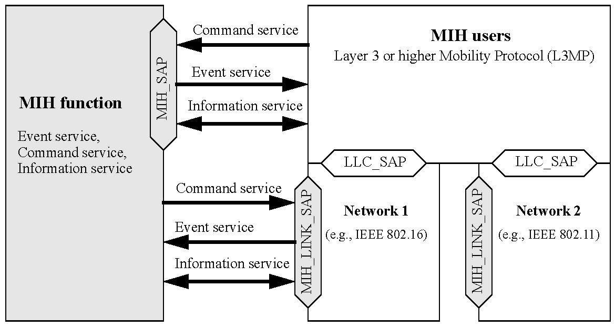
- —MIH services and their initiation
  - Assumptions
The following assumptions have been made in the development of this standard:
- The MN is capable of supporting multiple link-layer technologies, such as wireless, wired, or mixed.
- The MIHF is a logical entity, whose definition is independent of its deployment location on the MN or in the network.
- The MIHF, regardless of whether it is located on the MN or in the network, receives and transmits information about the configuration and condition of access networks around the MN. This information originates at different layers of the protocol stack within the MN or at various network elements.
  - When the information originates at a remote network element, the MIHF on the local network element obtains it through MIH message exchanges with a peer MIHF instance that resides in the remote network element.
  - When the information originates at lower layers of the protocol stack within an MN or network entity, the MIHF on that entity obtains it locally through the service primitives of the SAPs that define the interface of the MIHF with the lower layers.
  - Media independence
The intent of this standard is to provide generic link-layer intelligence independent of the specifics of mobile nodes or radio networks. As such, this standard is intended to provide a generic interface between the link- layer users in the mobility-management protocol stack and existing media-specific link layers, such as those specified by 3GPP, 3GPP2, and the IEEE 802 family of standards.
This standard defines SAPs and primitives that provide generic link-layer intelligence. Individual media- specific technologies thereafter need to enhance their media-specific SAPs and primitives to satisfy the generic abstractions of this standard. Suitable amendments are required to existing link-layer [medium access control (MAC)/ physical layer (PHY)] standards of different media-specific technologies such as IEEE Std 802.3™, IEEE Std 802.1 1™, IEEE Std 802.16™, 3GPP, and 3GPP2 to satisfy the requirements of generic link-layer intelligence identified by this standard.
- Normative references
The following referenced documents are indispensable for the application of this document (i.e., they must be understood and used, so each referenced document is cited in text and its relationship to this document is explained). For dated references, only the edition cited applies. For undated references, the latest edition of the referenced document (including any amendments or corrigenda) applies.
3GPP TS 23.003 (2007-09), Numbering, addressing and identification (Release 7).
3GPP TS 25.008, Digital cellular telecommunication system (Phase 2+); Radio subsystem link control.
3GPP TS 25.2 15 (2007-11), Physical layer - Measurements (FDD) (Release 7).
3GPP TS 25.401 (2007-09), UTRAN overall description (Release 7).
3GPP TS 25.413 (2007-09), UTRAN Iu interface RANAP signalling (Release 7).
3GPP2 C.S0004-D (2004-02), Signaling Link Access Control (LAC) Standard for cdma2000 Spread Spectrum Systems.
ANSI X3.159-1989: Programming Language C.
IEEE P802.1aj™/D2.2, (2007-10), Draft Standard for Local and Metropolitan Area Networks—Virtual Bridged Local Area Networks—Amendment 08: Two-Port Media Access Control (MAC) Relay., ,
IEEE P802.1 1u™/D3.0, (2008-05) (this version), Draft Amendment to Standard for Information Technology—Telecommunications and information exchange between systems—Local and metropolitan area networks—Specific requirements; Part 11: Wireless LAN Medium Access Control (MAC) and Physical Layer (PHY) specifications: Amendment 7: Interworking with External Networks.
IEEE P802.1 6Rev2/D5.0, (2008-06), Information Technology—Telecommunications and information exchange between system-Local and metropolitan area networks—Specific Requirements—Part 16: Air Interface for Fixed Broadband Wireless Access Systems.
IEEE Std 802.1 1™-2007, Information Technology—Telecommunications and information exchange between systems—Local and metropolitan area networks—Specific requirements—Part 11: Wireless LAN Medium Access Control (MAC) and Physical Layer (PHY) Specifications.
IEEE Std 802.1 1k™-2008, Information Technology—Telecommunications and information exchange between systems—Local and metropolitan area networks—Specific requirements; Part 11: Wireless LAN Medium Access Control (MAC) and Physical Layer (PHY) specifications; Amendment 1: Radio Resource Measurement of Wireless LANs.
IEEE Std 802.16™-2004 [ISO/IEC 8802-16: 2004], Information Technology—Telecommunications and information exchange between system—Local and metropolitan area networks—Specific Requirements—Part 16: Air Interface for Fixed Broadband Wireless Access Systems.
IEEE Std 802.16e™-2005 [ISO/IEC 8802-16: 2005], Information Technology—Telecommunications and information exchange between system—Local and metropolitan area networks—Specific Requirements—Part 16: Air Interface for Fixed and Mobile Broadband Wireless Access Systems Amendment 2: Physical and Medium Access Control Layers for Combined Fixed and Mobile Operation in Licensed Bands and Corrigendum 1.
IEEE Std 802.3™-2005, Information Technology—Telecommunications and information exchange between system—Local and metropolitan area networks—Specific Requirements—Part 3: Carrier Sense Multiple Access with Collision Detection (CSMA/CD) Access Method and Physical Layer Specifications.
IETF RFC 1661 (1994-07), The Point-to-Point Protocol (PPP).
IETF RFC 2865 (2000-06), Remote Authentication Dial In User Service (RADIUS). IETF RFC 2988 (2000-11), Computing TCP's Retransmission Timer.
IETF RFC 3344 (2002-08), IP Mobility Support for IPv4.
IETF RFC 3588 (2003-09), Diameter Base Protocol.
IETF RFC 3775 (2004-06), Mobility Support in IPv6.
IETF RFC 3825 (2004-07), Dynamic Host Configuration Protocol Option for Coordinate-based Location Configuration Information.
IETF RFC 4119 (2005-12), A Presence-based GEOPRIV Location Object Format.
IETF RFC 4140 (2005-08), Hierarchical Mobile IPv6 Mobility Management (HMIPv6).
IETF RFC 4282 (2005-12), The Network Access Identifier.
IETF RFC 4555 (2006-06), IKEv2 Mobility and Multihoming Protocol (MOBIKE).
IETF RFC 4776 (2006-11), Dynamic Host Configuration Protocol (DHCPv4 and DHCPv6) Option for Civic Addresses Configuration Information.
IETF RFC 4857 (2007-06), Mobile IPv4 Regional Registration.
IETF RFC 4881 (2007-06), Low-Latency Handoffs in Mobile IPv4.
IETF RFC 5268 (2008-06), Mobile IPv6 Fast Handovers.
ISO 3166-1 (1997), Codes for the representation of names of countries and their subdivisions—Part 1: Country codes.
ISO 4217, Codes for the Representation of Names of Countries.
ITU-T Recommendation X.290 (1995), OSI conformance testing methodology and framework for protocol Recommendations for ITU-T applications—General concepts.
ITU-T Recommendation X.296 (1995), OSI conformance testing methodology and framework for protocol Recommendations for ITU-T applications—Implementation conformance statements.
ITU-T Recommendation Y. 1540, Internet protocol data communication service—IP packet transfer and availability performance parameters.
W3C Recommendation, RDF/XML Syntax Specification.
W3C Recommendation, Resource Description Framework (RDF)—Concepts and Abstract Syntax.
W3C Recommendation, SPARQL Query Language for RDF.
- Definitions
For the purposes of this document, the following terms and definitions apply. The IEEE Standards Dictionary Online should be consulted for terms not defined in this clause.
3.1 candidate point of attachment (candidate PoA): A point of attachment (PoA) under evaluation to which the link may be switched.
3.2 dual-radio operation: In this mode a dual radio device can receive and transmit simultaneously on both the radios. Since both radios can be active simultaneously in these types of devices, the target radio connects with the target network to prepare the target network for handover. The source radio maintains connection with the source network during the handover. See also: single-radio operation.
3.3 handover: The process by which a mobile node obtains facilities and preserves traffic flows upon occurrence of a link switch event. The mechanisms and protocol layers involved in the handover can vary with the type of the link switch event (i.e., with the type of the serving and target point of attachment and the respective subnet associations). Different types of handover are defined based on the way facilities for supporting traffic flows are preserved. See also: hard handover; soft handover; seamless handover.
3.4 hard handover: Handover where facilities for supporting traffic flows are subject to complete unavailability between their disruption on the serving link and their restoration on the target link (breakbefore-make).
3.5 handover policies: A set of rules that contribute to making the handover decision for a mobile node.
3.6 home subscriber network: Network managed by an operator with whom the subscriber has a business relationship (subscription). See also: visited network; serving network.
3.7 horizontal handovers: A handover where a mobile node moves between point of attachments of the same link type (in terms of coverage, data rate and mobility), such as universal mobile telecommunications systems (UMTS) to UMTS or wireless local area network (WLAN) to WLAN. Syn: intra-technology handovers.
3.8 inter-technology handovers: See: vertical handovers.
3.9 intra-technology handovers: See: horizontal handovers.
3.10 link: A communication channel through which nodes communicate for the exchange of L2 protocol data units. Each link is associated with two endpoints and has a unique identifier.
3.11 link layer: Conceptual layer of control or processing logic that is responsible for maintaining control of the data link. The data link-layer functions provide an interface between the higher-layer logic and the data link.
3.12 link indication: Link state information provided by the link layer to higher layers.
3.13 link switch: The process by which a mobile node changes the link that connects it to the network. Changing a link implies changing the remote link endpoint and therefore the point of attachment of the mobile node.
3.14 lower layers: The layers located at OSI Level 2 and below across different link-layer technology standards supported by this standard. For example, the IEEE 802.11 Lower Layers are the MAC sublayer and the PHY, while the 3GPP Lower Layers are L1/MAC/radio link control (RLC)/packet data convergence protocol (PDCP) in the case of wideband code division multiple access (W-CDMA) frequency division duplex (FDD)/time division duplex (TDD), L1/LAPDm in the case of GSM CS, and L1/MAC/RLC in the case of general packet radio service (GPRS)/ Enhanced GPRS (EGPRS), respectively. The term “Lower Layers” also includes Logical Link Control Layers such as IEEE 802.2 Logical Link Control (LLC) or 3GPP Radio Link Control (RLC). The MIHF uses the services provided by these layers.
3.15 media independent handover (MIll) discovery protocol: A protocol for discovering media independent handover (MIH) entities.
3.16 media independent handover (MIll) network entity: Network entity with media independent handover function (MIHF) capability.
3.17 media independent handover point of service (MIll PoS): Network-side MIHF instance that exchanges MIH messages with an MN-based MIHF. The same MIH Network Entity includes an MIH PoS for each MIH-enabled mobile node with which it exchanges MIH messages. A single MIH PoS can host more than one MIH service. The same MIH Network Entity can include multiple MIH Points of Service that can provide different combinations of MIH services to the respective mobile nodes based on subscription or roaming conditions. Note that for a network entity comprising multiple interfaces, the notion of MIH PoS is associated with the network entity itself and not with just one of its interfaces.
3.18 media independent handover (MIll) node: An media independent handover function (MIHF) capable entity (mobile node or network).
3.19 media independent handover (MIll) non-PoS: An MIH network entity that can directly exchange MIH messages with other MIH network entities but cannot directly exchange MIH messages with any MIH enabled mobile node.
3.20 media independent handover (MIll) transport protocol: A protocol for transporting MIH protocol messages between a pair of MIH entities.
3.21 media independent handover (MIll) users: Entities that use the services provided by the MIHF. MIH users use the MIH_SAP to interact with the MIHF.
3.22 media independent handover function (MIllF): A function that realizes MIH services.
3.23 media independent handover function (MIllF) pairing: The communication relationship that exists between different MIHF instances when they exchange MIH messages or MIH information.
3.24 media independent handover function (MIllF) transaction: A combination of an MIH Request message and MIH Response message, MIH Indication, or MIH Response message and any associated MIH Acknowledgement messages.
3.25 mobile-controlled handover: The mobile node has the primary control over the handover process.
3.26 mobile-initiated handover: The mobile node initiates the handover process by indicating to the network that the handover is necessary or desired.
3.27 mobile node (MN): Communication node that can change its point of attachment from one link to another.
3.28 mobile node association: The connectivity state where the mobile node is ready to exchange user data [like transmission control protocol (TCP) / user datagram protocol (UDP) packets] with the network point of attachment.
3.29 network detection: The process by which a mobile node collects information on networks in its locality, identifies the different points of attachment, and ascertains the validity of link-layer configuration.
3.30 network entity: A communication node inside the network.
3.31 network-controlled handover: A handover where the network has the primary control over the handover process.
3.32 network-initiated handover: The network initiates the handover process by indicating to the mobile node that the handover is necessary or desired.
3.33 network neighborhood: The area of interest in which the network discovery and selection entity seeks to determine the available coverage of a wired/wireless network with identical or different link-layer technologies.
3.34 network point of attachment (network PoA, or PoA): The network side endpoint of a layer 2 link that includes a mobile node as the other endpoint. See also: candidate PoA; serving PoA; target PoA.
3.35 network selection: The process by which a mobile node or a network entity makes a decision to connect to a specific network (possibly out of many available) based on a policy configured in the mobile node and/or obtained from the network.
3.36 network selector: The entity that undertakes the network selection decisions that can lead to a handover.
3.37 operator identifier (operator ID): An identifier of the access or core network provider.
3.38 PICS Proforma: A normative document to express in compact form the static conformance requirements of a specification. As such, it serves as a reference to the static conformance review.
3.39 seamless handover: A handover associated with a link switch between points of attachment, where the mobile node either experiences no degradation in service quality, security, and capabilities, or experiences some degradation in service parameters that is mutually acceptable to the mobile subscriber and to the network that serves the newly connected interface.
3.40 serving network: A network that provides services to the user. The serving network can be a home subscriber network or a visited network. See also: visited network; home subscriber network.
3.41 serving point of attachment (serving PoA): The PoA of the current link being used by the mobile node.
3.42 single-radio operation: In this mode, a dual radio device can receive and transmit on only one radio at a time. This is usually the mode of operation when radio frequencies of the two radios are close to each other (e.g., in IMT 2000 bands). Since only one radio can be active at a time in these types of devices, the source radio uses the back-end connection of the source network with the target network to prepare the target network for handover while maintaining the client side connections. Once the target preparation is complete the device switches from source radio to target radio. Since all the target preparation has been completed a priori, the target radio quickly establishes connectivity with the target network and all the connections are then transferred from source network to target network. See also: dual-radio operation.
3.43 soft handover: Handover where facilities for supporting traffic flows are continuously available while the mobile node link-layer connection transfers from the serving point of attachment to the target point of attachment. The network allocates transport facilities to the target point of attachment prior to the occurrence of the link switch event (make-before-break).
3.44 static conformance requirement: One of the requirements that specify the limitations on the combinations of implemented capabilities permitted in a real open system, which is claimed to conform to the relevant specification(s).
3.45 static conformance review: A review of the extent to which the static conformance requirements are claimed to be supported by the system under test, by comparing the answers in the implementation conformance statement(s) and the system conformance statement with the static conformance requirements expressed in the relevant specifications.
3.46 target point of attachment (target PoA): A candidate PoA that has been selected to become the new serving PoA.
3.47 vertical handovers: A handover where the mobile node moves between point of attachments of different link types, such as from universal mobile telecommunications system (UMTS) to wireless area network (WLAN). Syn: inter-technology handovers.
3.48 visited network: A network managed by an operator other than the subscriber’s home operator and in which the subscriber is receiving service. See also: home subscriber network; serving network.
- Abbreviations and acronyms
The following abbreviations and acronyms are used in this standard:
3G 3rd generation
3GPP 3rd Generation Partnership Project
3GPP2 3rd Generation Partnership Project 2
AAA authentication, authorization, and accounting
ACK acknowledgement
AID action identifier
AP access point
AR access router
BCE binding cache entry
BS base station
BTS base transceiver station
CoA care-of address
CoS class of service
CS convergence sublayer / command service
DCD downlink channel descriptor
DHCP dynamic host configuration protocol
ES event service
ESS extended service set
FA foreign agent
GPRS general packet radio service
GSM global system for mobile communication
HESSID homogenous extended service set ID
IEEE Institute of Electrical and Electronics Engineers
IETF Internet Engineering Task Force
IP internet protocol
IS information service
ITU International Telecommunications Union
L1 layer 1 (PHY)
L2 layer 2 (MAC and/or LLC)
LAN local area network
LbyR location by reference
LCP location configuration protocol
LLC logical link control
LMA local mobility anchor
LSAP logical link control service access point
LTE long term evolution
MAC medium access control
MAG mobile access gateway
MICS media independent command services
MIES media independent event services
MIH media independent handover
MIHF media independent handover function
MIIS media independent information service
MIP mobile IP
MLME MAC layer management entity
MN mobile node
MPLS multi-protocol label switching
MS mobile station
MSB most significant bit
MSDU medium access control (MAC) service data unit
MSGCF MAC state generic convergence function
N/A not applicable
NAI network access identifier
NAS network access server
NCMS network control and management system
OUI organizationally unique identifier
PDU protocol data unit
PHY physical layer
PLME physical layer management entity
PLMN public land mobile network
PoA point of attachment
PoS point of service
PPP point-to-point protocol
PSAP public safety answering point
QoS quality of service
RAT radio access technology
RDF resource description framework
RFC request for comment
RLC radio link control
RNC radio network controller
RSNA robust security network association
RSSI received signal strength indication
SAP service access point
SCTP stream control transmission protocol
SDO standards development organization
SDU service data unit
SIB system information block
SID service identifier
SINR signal over interference plus noise ratio
SIP session initiation protocol
SLA service level agreement
SM session management
SME station management entity
SNR signal-to-noise ratio
SS subscriber station
STA station
TCP transmission control protocol
TLV type-length-value
UDP user datagram protocol
UE user equipment
UIR unauthenticated information request
UMTS universal mobile telecommunications system
URL uniform resource locator
WLAN wireless local area network
XML extensible mark-up language
- General architecture
  - Introduction
In the base REVP document, the subsubsections of this subsection was deleted, since they focused on specific applications. A new “Introduction” is needed, but there is some weird template requirement for heavy indentation that needs to be revisited.
  - General design principles
    - MIHF design principles
This standard is based on the following general design principles:
- MIHF is a logical entity that facilitates handover decision making. MIH users make handover decisions based on inputs from the MIHF.
- MIHF provides abstracted services to higher layers. The service primitives defined by this interface are based on the technology-specific protocol entities of the different access networks. The MIHF communicates with the lower layers of the mobility-management protocol stack through technology-specific interfaces.
- Higher layer mobility management protocols specify handover signaling mechanisms for vertical handovers. Additionally, different access network technologies have defined handover signaling mechanisms to facilitate horizontal handover. The definition of such handover signaling mechanisms is outside the scope of this standard except in the case of handovers across ESSs in IEEE Std 802.11. The role of this standard (IEEE Std 802.21) is to serve as a handover facilitating service and to maximize the efficiency of such handovers by providing appropriate link-layer intelligence and network information.
- The standard provides support for remote events. Events are advisory in nature. The decision whether to cause a handover or not based on these events is outside the scope of this standard.
- The standard supports transparent operation with legacy equipment. IEEE 802.21 standard compatible equipment should be able to co-exist with legacy equipment.
    - QoS design principles
In the context of this standard it is assumed that applications communicate via a communication channel that is considered to be composed of several connected segments, each under a possibly different but cooperative administrative authority. Examples of such channels [e.g., for internet protocol (IP) traffic] have been detailed in ITU-T Recommendation Y. 1540.
It is generally accepted that, based on the required accuracy of information transfer, applications can be grouped into a small number of behavioral sets (ITU-T Recommendation Y. 1540) called class of service (CoS). Support for differentiation via CoS is pervasive in many of the IEEE 802 based standards (IEEE Std 802.11, IEEE Std 802.1qTM, IEEE Std 802.16, etc.).
It is assumed that the classes of service definitions used within this standard conform to ITU-T Recommendation Y. 1540.
  - MIHF service overview
    - General
This standard defines services that comprise the MIHF service; these services facilitate handovers between heterogeneous access links.
- A media independent event service (MIES) that provides event classification, event filtering and event reporting corresponding to dynamic changes in link characteristics, link status, and link quality.
- A media independent command service (MICS) that enables MIH users to manage and control link behavior relevant to handovers and mobility.
- A media independent information service (MIIS) that provides details on the characteristics and services provided by the serving and neighboring networks. The information enables effective system access and effective handover decisions.
The MIHF provides asynchronous and synchronous services through well-defined SAPs for link layers and MIH users. In the case of a system with multiple network interfaces of arbitrary type, the MIH users use the event service, command service, and information service provided by MIHF to manage, determine, and control the state of the underlying interfaces.
These services provided by MIHF help the MIH users in maintaining service continuity, service adaptation to varying quality of service, battery life conservation, network discovery, and link selection. In a system containing heterogeneous network interfaces of IEEE 802 types and cellular (3GPP, 3GPP2) types, the MIHF helps the MIH users to implement effective procedures to couple services across heterogeneous network interfaces. MIH users utilize services provided by the MIHF across different entities to query resources required for a handover operation between heterogeneous networks.
MIH Services in mobile nodes facilitate seamless handovers between heterogeneous networks. MIH Services are used by MIH users such as a mobility management protocol (e.g., Mobile IP). Other mobility management protocols (in addition to Mobile IP) and even other MIH users are not precluded from making use of MIH Services.
    - Media independent event service
      - General
Events indicate changes in state and transmission behavior of the physical, data link and logical link layers, or predict state changes of these layers. The event service is also used to indicate management actions or command status on the part of the network or some management entity.
      - Event origination
Events originate from the MIHF (MIH Events) or any lower layer (Link Events) within the protocol stack of an MN or network node, as shown in Figure 12.
      - Event destination
The destination of an event is the MIHF or any upper layer entity. The recipient of the event is located within the node that originated the event or within a remote node. The destination of an event is established with a subscription mechanism that enables an MN or network node to subscribe its interest in particular event types.
      - Event service flow
In the case of local events, messages often propagate from the lower layers (e.g., PHY, MAC) to the MIHF and from MIHF to any upper layer. In case of remote events, messages propagate from the MIHF in one protocol stack to the MIHF in the peer protocol stack. One of the protocol stacks can be present in an MN while the other can be present in a fixed network entity. This network entity is the point of attachment or any node not directly connected to the other protocol stack.
      - Event service use cases and functions
The event service is used to detect the need for handovers. For example, an indication that the link will cease to carry MAC service data units (SDUs) at some point in the near future is used by MIH users to prepare a new point of attachment ahead of the current point of attachment ceasing to carry frames. This has the potential to reduce the time needed to handover between attachment points.
Events carry additional context data such as a layer 2 (MAC and/or LLC) (L2) identifier or L3 identifier. A Link_Up event can also carry a new IP address acquisition indication that informs the upper layers of the need to initiate a layer 3 handover.
    - Media independent command service
      - General
The command service enables higher layers to control the physical, data link, and logical link layers (also known as “lower layers”). The higher layers control the reconfiguration or selection of an appropriate link through a set of handover commands. If an MIHF supports the command service, all MIH commands are mandatory in nature. When an MIHF receives a command, it is always expected to execute the command.
      - Command origination
Commands are invoked by MIH users (MIH Commands), as well as by the MIHF itself (Link Commands), as shown in Figure 15.
      - Command destination
The destination of a command is the MIHF or any lower layer. The recipient of a command is located within the protocol stack that originated the command, or within a remote protocol stack.
      - Command service flow
In the case of local commands, messages often propagate from the MIH users (e.g., policy engine) to the MIHF and then from MIHF to lower layers. In the case of remote commands, messages propagate from MIH users via MIHF in one protocol stack to the MIHF in a peer protocol stack (with the use of the MIH Protocol). One of the protocol stacks can be present in an MN while the other can be present in a fixed network entity. This network entity is either a point of attachment or any node not directly connected to the other protocol stack.
      - Command service use cases and functions
The commands generally carry the upper layer decisions to the lower layers on the local device entity or at
the remote entity. For example the command service can be used by the policy engine of an entity in the
network to request an MN to switch between links (remote command to lower layers on MN protocol stack).
This standard facilitates both mobile-initiated and network-initiated handovers. Handovers are initiated by changes in the wireless environment that leads to the selection of a network that supports a different access technology other than the serving network.
During network selection, the MN and the network need to exchange information about available candidate networks and select the best network. The network selection policy engine can select a different network than the current one, which can necessitate an inter-technology handover. Network selection and handover initiation are outside the scope of mobility management protocols such as mobile IP (MIP) and session initiation protocol (SIP). Once a new network has been selected and handover has been initiated, mobility management protocols handle packet routing aspects such as address update and transfer of packet delivery to the new network.
This standard supports a set of media independent commands that help with network selection under different conditions. These commands allow both the MN and the network to initiate handovers and exchange information about available networks and negotiate the best available network under different conditions. Please refer to the flow diagrams in Annex C for more information. These commands do not affect packet routing aspects and can be used in conjunction with other mobility management protocols such as MIP and SIP to perform inter-technology handovers.
    - Media independent information service
The media independent information service (MIIS) provides a framework and corresponding mechanisms by which an MIHF entity can discover and obtain network information existing within a geographical area to facilitate the handovers.
The neighboring network information discovered and obtained by this framework and mechanisms can also be used in conjunction with user and network operator policies for optimum initial network selection and access (attachment), or network re-selection in idle mode.
MIIS primarily provides a set of information elements (IEs), the information structure and its representation, and a query/response type of mechanism (pull mode) for information transfer. The information can also include inter-technology handover policies. The definition of such policies is outside the scope of this standard. MIIS also supports a push mode wherein the information can be pushed to the MN by the operator. The information can be present in an information server from where the MIHF in the MN accesses it. The definition of the information server is outside the scope of this standard. In other cases information can be present locally in the MN, and can be learned by the MN or pre-provisioned, or both. The definition of and indexing of such a local database, as well as the regime for maintaining it or accessing it, are outside the scope of this standard.
The information is made available via both lower and higher layers. Information is made available at L2 through both a secure and a non-secure port. Information available through the non-secure port allows a network selection decision to be made before incurring the overhead of authentication and the establishment of a secure L2 connection with the network.
In certain scenarios information cannot be accessed at L2, or the information available at L2 is not sufficient to make an intelligent handover decision. In such cases information can be accessed via higher layers. Hence this standard enables both L2 and L3 transport options for information access. The selected transport option is expected to provide security, such as data integrity and data confidentiality, for the information access.
MIIS typically provides static link-layer parameters such as channel information, the MAC address and security information of a point of attachment (PoA). Information about available higher layer services in a network can also help in more effective handover decision making before the MN actually attaches to any particular network.
The information provided by MIIS conforms to the structure and semantics specified within this standard. MIIS specifies a common (or media independent) way of representing this information across different technologies by using a standardized format such as extensible mark-up language (XML) or binary encoding. A structure of information is defined as a schema.
MIIS provides the ability to access information about all networks in a geographical area from any single L2 network, depending on how the IEEE 802.21 MIIS service is implemented. MIIS either relies on existing access media specific transports and security mechanisms or L3 transport and L3 security mechanisms to provide access to the information. How this information is developed and deployed in a given network is outside the scope of the standard. Typically, in a heterogeneous network composed of multiple media types, the network selector or higher layer mobility management will collect information from different media types and assemble a consolidated view to facilitate its inter-media handover decision.
Some networks such as the cellular networks already have an existing means of detecting a list of neighborhood base stations within the vicinity of an area via the broadcast control channel. Some IEEE standards define similar means and support MNs in detecting a list of neighborhood access points within the vicinity of an area via either beaconing or via the broadcast of MAC management messages. MIIS defines a unified mechanism to the higher layer entities to provide handover candidate information in a heterogeneous network environment by a given geographical location. However, the algorithm for deciding what information to provide is out of scope. In the larger view, the objective is to help the higher layer mobility protocol to acquire a global view of the heterogeneous networks to effect seamless handover across these networks.
  - Media independent service reference framework[Proposal: change MIHF to MISF, etc.]
    - General
The following subclause describes the key points with regards to communication between different MIHF entities in the MN and the network. The reference points in this subclause (5.4) are for illustration only. This subclause does not define any specific deployed network system architecture.
    - MIHF communication model
MIH Functions communicate with each other for various purposes. The MN exchanges MIH information with its MIH point of service (PoS). The MIHF in any Network Entity becomes an MIH PoS when it communicates directly with an MN-based MIHF. When an MIHF in a Network Entity does not have a direct connection to the MN, it does not act as an MIH PoS for that particular MN. However the same MIH Network Entity can still act as MIH PoS for a different MN.
An MN can have multiple L2 interfaces. However, MIHF communication need not take place on all L2 interfaces of an MIH-capable MN. As an example, on an MIH-capable MN with three L2 interfaces, namely IEEE 802.11, IEEE 802.16, and IEEE 802.3, the IEEE 802.3 interface might be used only for system administration and maintenance operations, while the IEEE 802.11 and IEEE 802.16 interfaces might engage in the provisioning of MIHF services. The MN can use L2 transport for exchanging MIH information with an MIH PoS that resides in the same Network Entity as its Network PoA. The MN can use L3 transport for exchanging MIH information with an MIH PoS that does not reside in the same Network Entity as its Network PoA. The framework supports use of either L2 or L3 mechanisms for communication among MIH network entities.
Figure 2 shows the MIHF communication model. The model shows MIHFs in different roles and the communication relationships among them. The communication relationship shown in Figure 2 applies only to MIHFs. It is important to note that each of the communication relationships in the communication model does not imply a particular transport mechanism. Rather, a communication relationship only intends to show that passing MIHF-related information is possible between the two different MIHFs. Moreover, each communication relationship shown in the diagram encompasses different types of interfaces, different transport mechanisms used (e.g., L2, L3), and different MIHF service related content being passed (e.g., MIIS, MICS, or MIES).
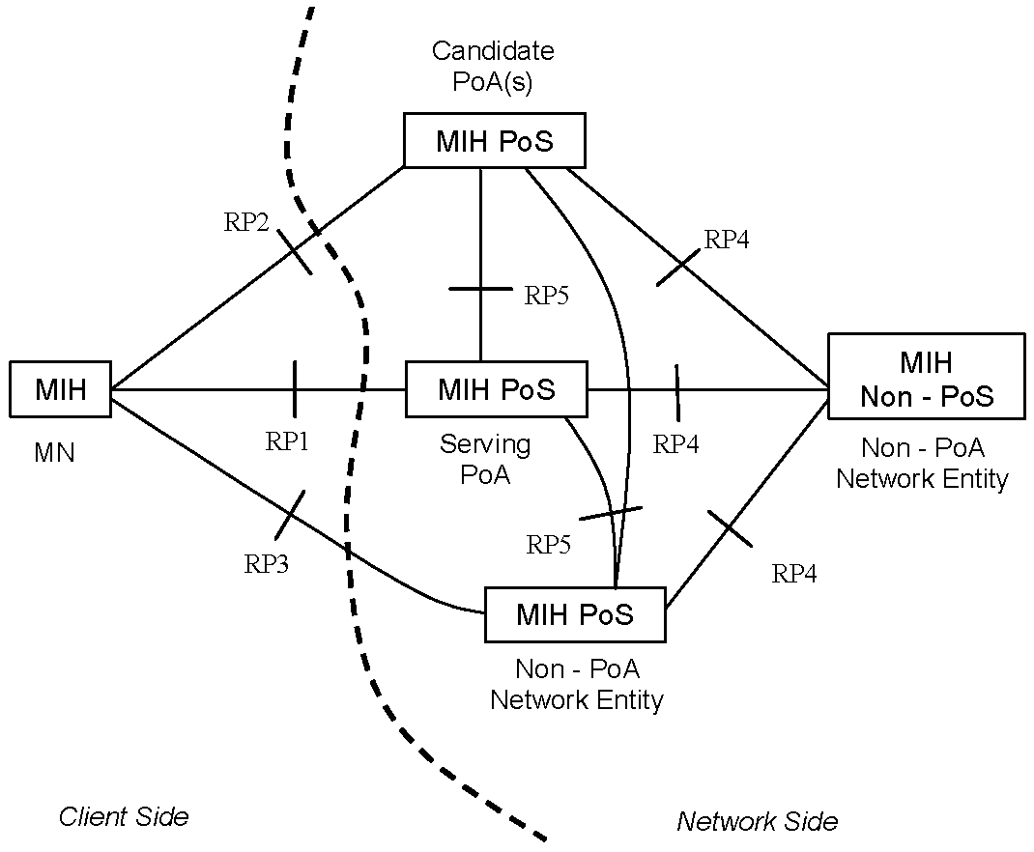
- —MIHF communication model

The communication model assigns different roles to the MIHF depending on its position in the system.
- MIHF on the MN
- MIH PoS on the Network Entity that includes the serving PoA of the MN
- MIH PoS on the Network Entity that includes a candidate PoA for the MN
- MIH PoS on a Network Entity that does not include a PoA for the MN
- MIH non-PoS on a Network Entity that does not include a PoA for the MN
The communication model also identifies the following reference points between different instances of MIHFs (see Table 1).
- Reference point RP1: Reference point RP1 refers to MIHF procedures between the MIHF on the MN and the MIH PoS on the Network Entity of its serving PoA. RP1 encompasses communication interfaces over both L2 and L3 and above. MIHF content passed over RP1 are related to MIIS, MIES, or MICS.
- Reference point RP2:Reference point RP2 refers to MIHF procedures between the MIHF on the MN and the MIH PoS on the Network Entity of a candidate PoA. RP2 encompasses communication interfaces over both L2 and L3 and above. MIHF content passed over RP2 are related to MIIS, MIES, or MICS.
- Reference point RP3: Reference point RP3 refers to MIHF procedures between the MIHF on the MN and the MIH PoS on a non-PoA Network Entity. RP3 encompasses communication interfaces over L3 and above and possibly L2 transport protocols like Ethernet bridging, or multi-protocol label switching (MPLS). MIHF content passed over RP3 are related to MIIS, MIES, or MICS.
- Reference point RP4: Reference point RP4 refers to MIHF procedures between an MIH PoS in a Network Entity and an MIH non-PoS instance in another Network Entity. RP4 encompasses communication interfaces over L3 and above. MIHF content passed over RP4 are related to MIIS, MIES, or MICS.
- Reference point RP5: Reference point RP5 refers to MIHF procedures between two MIH PoS instances in different Network Entities. RP5 encompasses communication interfaces over L3 and above. MIHF content passed over RP5 are related to MIIS, MIES, or MICS.

- —Summary of reference points
Reference point | Description
RP1 | Between the MIHF on an MN and an MIH PoS on the Network Entity of the serving PoA.
RP2 | Between the MIHF on an MN and an MIH PoS on the Network Entity of the candidate PoA.
RP3 | Between the MIHF on an MN and an MIH PoS on a non-PoA network entity.
RP4 | Between an MIHF PoS and an MIH non-PoS instance in different Network Entities.
RP5 | Between two MIH PoS instances in different Network Entities.

All reference point definitions are within the scope of this standard. Annex D provides a mapping of various MIH messages to the reference points.
    - A deployment example for the MIH services
A network model including MIH services is shown in Figure 3 to better illustrate the MIH Reference Points. Moving from left to right, the model includes an MIH-capable mobile node (MN, far left) that supports multiple wired and wireless access technologies. The model assumes that the serving network either operates multiple link-layer technologies or allows its user to roam into other networks when a service level agreement (SLA) in support of inter-working has been established.
The model illustrates access networks that are connected in some loose, serial way to a given core network (i.e., Core Operator 1, 2, or 3). Also depicted is an access network that is more tightly coupled (Access Network-3). Not depicted in Figure 3, an access network can also connect to a core network via the Internet. Each Core Operator network (1, 2, or 3) might represent a service provider, corporate intranet provider, or just another part of the visited or home access. In this depicted model, the provisioning provider is operating Access Network-3, which couples the terminal to the core (labeled Home Core Network) via RP1. At any given point in time, the subscriber’s serving network can be the home subscriber network or a visited network.
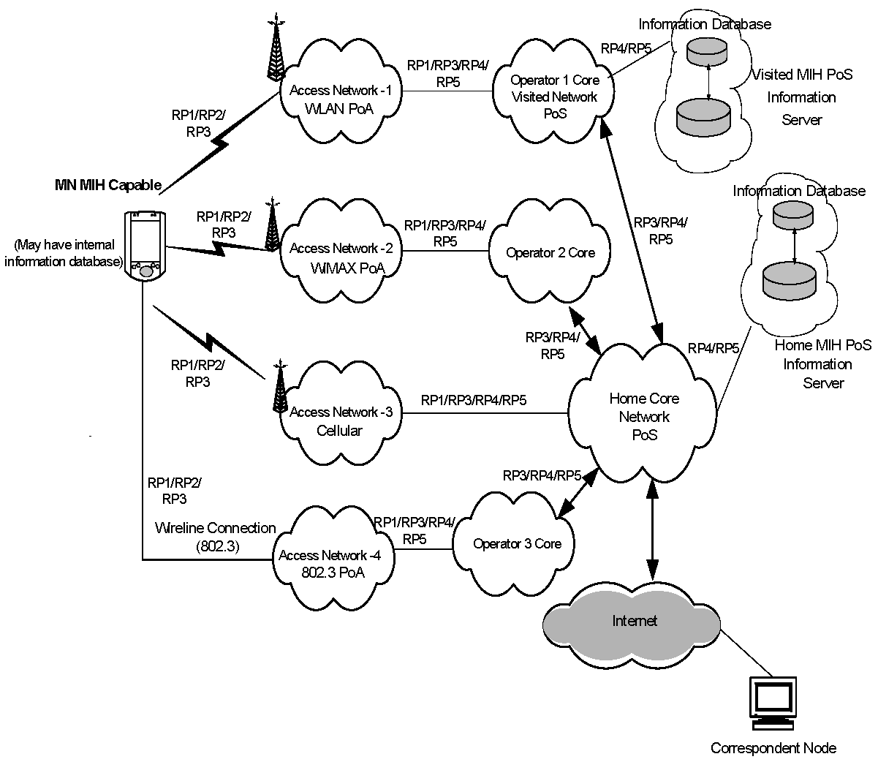
- —Example of network model with MIH services

The network providers offer MIH services in their access networks (Access Network 1 to 4) in order to facilitate heterogeneous handovers into their networks. Each access technology either advertises its MIH capability or responds to MIH service discovery. Each service provider for these access networks allows access to one or more MIH Points of Service (PoS) node(s). These PoS nodes provide some or all of the MIH services as determined during the MIH capabilities discovery. The PoS location varies based on the operator deployment scenario and the technology-specific MIH architecture.
An MIH PoS resides next to, or is co-located with, the point of attachment (PoA) node in the access network (e.g., Access Network 1, 2, 4). Alternatively the PoS can reside deeper inside the access or core networks (e.g., Access Network 3). As shown in Figure 3, the MIH entity in the MN can communicate with MIH network entities using reference points RP1, RP2, or RP3 over any of the available access networks. If the PoA in the serving access network has a co-located MIHF, the RP1 reference point terminates at the PoA that is also the PoS (MN to Access Network 1, 2, 4 of the model can all be RP1). In that case, an RP3 reference point would be terminated at any non-PoA (illustrated by MN connectivity to Access Networks 1, 2, 4). MIH events originate at both sides of an active RP1 link. The MN is typically the first node to react to these events.
The interaction of visited and home subscriber networks could be either for control and management
purposes or for data transport purposes. It is also possible that due to roaming or SLA agreements, the home subscriber network allows the MN to access the public Internet directly through a visited network. As illustrated, two MIH network entities communicate with each other via RP4 or RP5 reference points. The MIH-capable PoA communicate with other MIH network entities via RP4 and RP5 reference points. The MIH-capable MN have MIH communication with other PoA in the candidate access networks via the RP2 reference point to obtain Information Services about the candidate network.
With regard to the MIH Information Service, visited providers can offer access to their information server located in an MIH PoS node (upper far right). The operator provides the MIIS to mobile nodes so they can obtain pertinent information including, but not limited to, new roaming lists, costs, provider identification information, provider services, priorities, and any other information that would enable the selection and utilization of these services. As illustrated, it is possible for the MN to be pre-provisioned with MIIS data by its provider. It is also possible for the MN to obtain MIH Information Services from any access network of its service provider or from visited networks that maintain SLA agreements with the MN’s service provider. MIIS can also be available from another overlapping or nearby visited network, using that network’s MIIS point of service. The serving network utilizes RP4 and RP5 interfaces to access other MIH entities. As an example, in Figure 3 the home subscriber network accesses its own MIH information server or core operator 1 (visited network) MIH information server.
  - MIHF reference models for link-layer technologies[Proposal: change MIHF to MISF, etc.]
The MIHF provides asynchronous and synchronous services through well-defined service access points for MIH users. The following subclauses (5.5.1 through 5.5.7) describe the reference models for various link- layer technologies with MIH functionality.
    - IEEE 802 architectural considerations
The MIH reference models for different IEEE 802 technologies and the general MIH framework is designed to be consistent with the IEEE 802 Architecture for different link-layer technologies. The MIH Function is a management entity that obtains link-layer information from lower layers of different protocol stacks and also from other remote nodes. The MIH Function coordinates handover decision making with other peer MIH Functions in the network.
The MIH Protocol provides the capability for transferring MIH messages between peer MIH Function entities at L2 or at L3. These messages transfer information about different available networks and also provide network switching and handover capability across different networks. The MIH protocol encompasses IEEE 802 technologies such as IEEE 802.11 and IEEE 802.16 and also other non-IEEE 802 technologies such as those specified by 3GPP and 3GPP2 standards. In this sense, the MIH Protocol has different scope and functionality than the Link Layer Discovery Protocol (LLDP) as specified by IEEE Std 802.1ABTM [B18].
    - General MIHF reference model and SAPs
Figure 4 illustrates the position of the MIHF in a protocol stack and the interaction of the MIHF with other elements of the system. All exchanges between the MIHF and other functional entities occur through service primitives, grouped in service access points (SAPs).
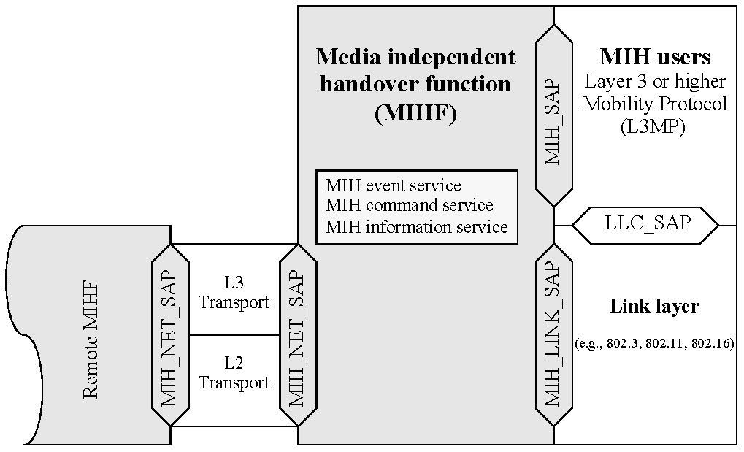
- —General MIHF reference model and SAPs

The media agnostic general MIH reference model includes the following SAPs:
- MIH_SAP: Media independent interface of MIHF with the upper layers of the protocol stack.
- MIH_LINK_SAP: Abstract media dependent interface of MIHF with the lower layers of the media- specific protocol stacks.
- MIH_NET_SAP: Abstract media dependent interface of MIHF that provides transport services over the data plane on the local node, supporting the exchange of MIH information and messages with the remote MIHF. For all transport services over L2, the MIH_NET_SAP uses the primitives specified by the MIH_LINK_SAP.
In the media-specific reference models, the media independent SAP (MIH_SAP) always maintains the same name and same set of primitives. The media dependent SAP (which is a technology-specific instantiation of the MIH_LINK_SAP), assumes media-specific names and sets of primitives, often reusing names and primitives that already exist in the respective media-specific existing lower-layer SAPs. Primitives defined in MIH_LINK_SAP result in amendments to media-specific SAPs due to additional functionality being defined for interfacing with the MIHF. All communications of the MIHF with the lower layers of media- specific protocol stacks take place through media-specific instantiations of MIH_LINK_SAP.
The message exchanges between peer MIHF instances, in particular the type of transport that they use, are sensitive to several factors, such as the nature of the network nodes that contain the peer MIHF instances (whether or not one of the two is an MN or a PoA), the nature of the access network (whether IEEE 802 or 3G cellular), and the availability of MIH capabilities at the PoA.
Figure 5 presents a summary of the types of relationships that can exist between the MIHF and other functional components in the same network node.
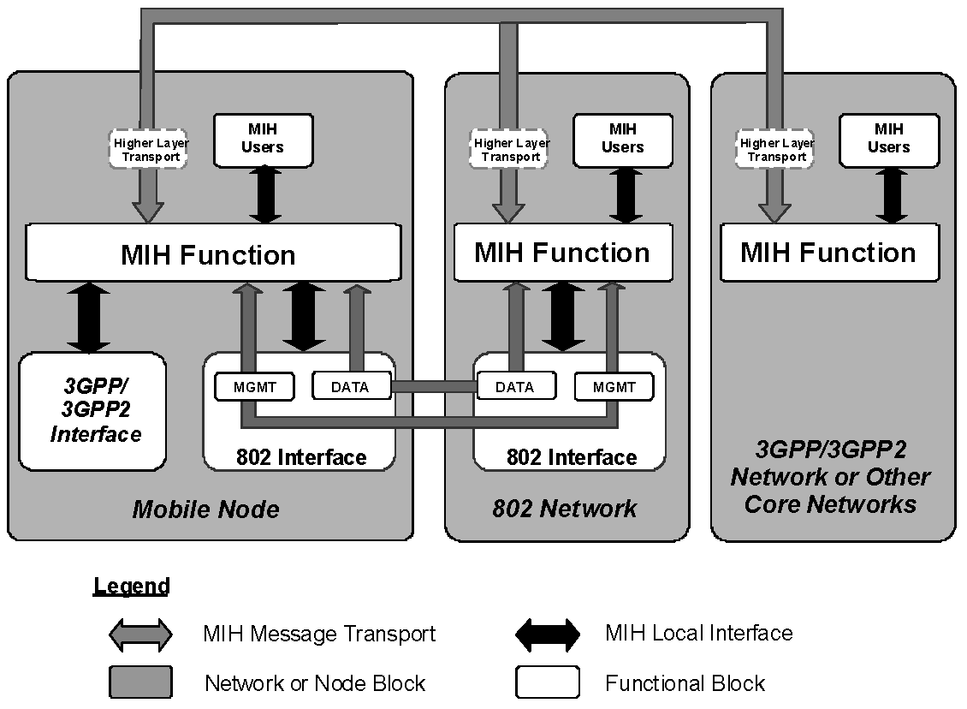
- —Types of MIHF relationship

The general MIH reference model in Figure 4 enables a simple representation of the broad variety of MIHF relationships shown in Figure 5. In the model, a mobility-management protocol stack is logically identified within each network node that includes an MIHF instance. The provided abstraction makes it easy to isolate and represent the MIH relationships with all pre-existing functional entities within the same network node. Such relationships are both internal (with functional entities that, just like the MIHF, share the logical inclusion in the mobility-management protocol) and external (with functional entities that belong to other planes).
Figure 5 shows how an MIH-enabled MN communicates with an MIH-enabled network. The gray arrows show the MIH signaling over the network, whereas the black arrows show local interactions between the MIHF and lower and higher layers in the same network or node block. For a more detailed view of local interactions, please refer to technology-specific reference models and service access point in 5.5.3 through 5.5.7.
When connected to an IEEE 802 network, an MN directly uses L2 for exchanging MIH signaling, as the peer MIHF can be embedded in a PoA. The MN does this for certain IEEE 802 networks even before being authenticated with the network. However, the MN can also use L3 for exchanging MIH signaling, for example in cases where the peer MIHF is not located in the PoA, but deeper in the network.
When connected to a 3GPP or 3GPP2 network, an MN uses L3 transport to conduct MIH signaling.
    - MIHF reference model for IEEE 802.3
The MIHF reference model for IEEE 802.3 is illustrated in Figure 6. The transport of MIHF services is supported over the data plane by use of existing primitives defined by the logical link control service access point (LSAP). There are no amendments specified in IEEE Std 802.3 to support any link services defined over the MIH_LINK_SAP in this specification.
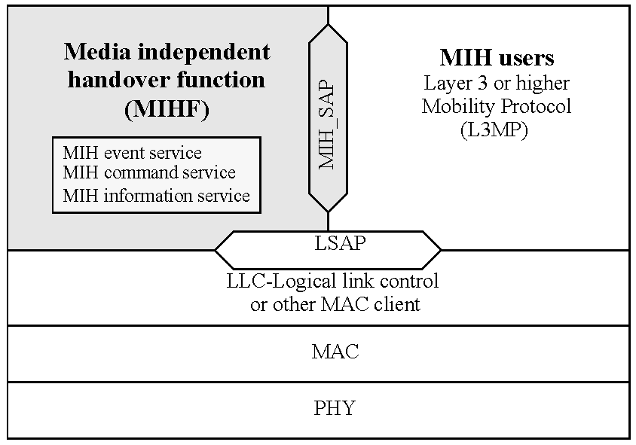
- —MIH reference model for IEEE 802.3

    - MIHF reference model for IEEE 802.11
Figure 7 shows the MIHF reference model for IEEE 802.11. The payload of MIHF services over IEEE 802.11 is carried either in the data frames by using existing primitives defined by the LSAP or by using primitives defined by the MAC State Generic Convergence Function (MSGCF) service access point (SAP) (MSGCF_SAP). The MSGCF has access to all management primitives and provides services to higher layers.
It should be noted that sending MIHF payload over the LSAP is allowed only after successful authentication and association of the station to the access point (AP). Moreover, before the station has authenticated and associated with the AP, only MIH Information Service and MIH capability discovery messages can be transported over the MSGCF_SAP.
The MIH_SAP specifies the interface of the MIHF with MIH users.
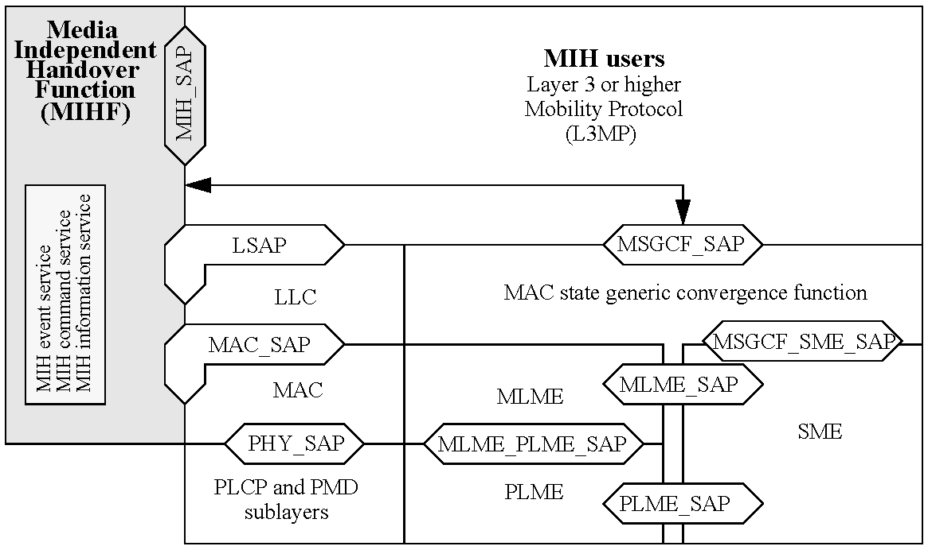
- —MIH reference model for IEEE 802.11

    - MIHF reference model for IEEE 802.16
Figure 8 shows the MIHF for IEEE 802.16 based systems. The Management SAP (M_SAP) and Control SAP (C_SAP) are common between the MIHF and Network Control and Management System (NCMS).
The M_SAP specifies the interface between the MIHF and the management plane and allows MIHF payload to be encapsulated in management messages (such as MOB_MIH-MSG defined in IEEE P802. 16g [B2 1]). The primitives specified by M_SAP are used by an MN to transfer packets to a base station (BS), both before and after it has completed the network entry procedures. The C_SAP specifies the interface between the MIHF and control plane. M_SAP and C_SAP also transport MIH messages to peer MIHF entities. The Convergence Sublayer SAP (CS_SAP) is used to transfer packets from higher layer protocol entities after appropriate connections have been established with the network.
The MIH_SAP specifies the interface of the MIHF with other higher layer entities such as transport layer, handover policy engine, and layer 3 mobility protocol.
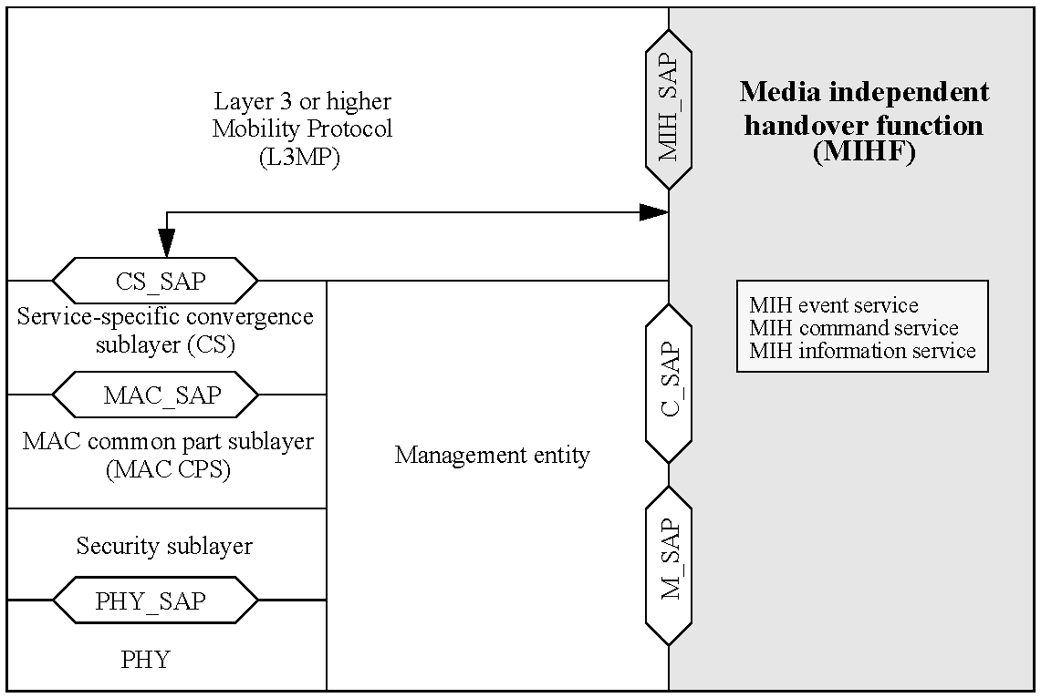
- —MIH reference model for IEEE 802.16

In this model, C_SAP and M_SAP provide link services defined by MIH_LINK_SAP, C_SAP provides services before network entry, while CS_SAP provides services over the data plane after network entry.
    - MIHF reference model for 3GPP
Figure 9 illustrates the interaction between the MIHF and the 3GPP-based systems. The MIHF services are specified by the MIH_3GLINK_SAP. However, no new primitives or protocols need to be defined in the 3GPP specification for accessing these services. The MIHF services are mapped to existing 3GPP signaling functions (see Table E.3 in Annex E). The architectural placement of the MIHF is also decided by the 3GPP standard. Figure 9 is for illustrative purposes only and should not constrain implementations.
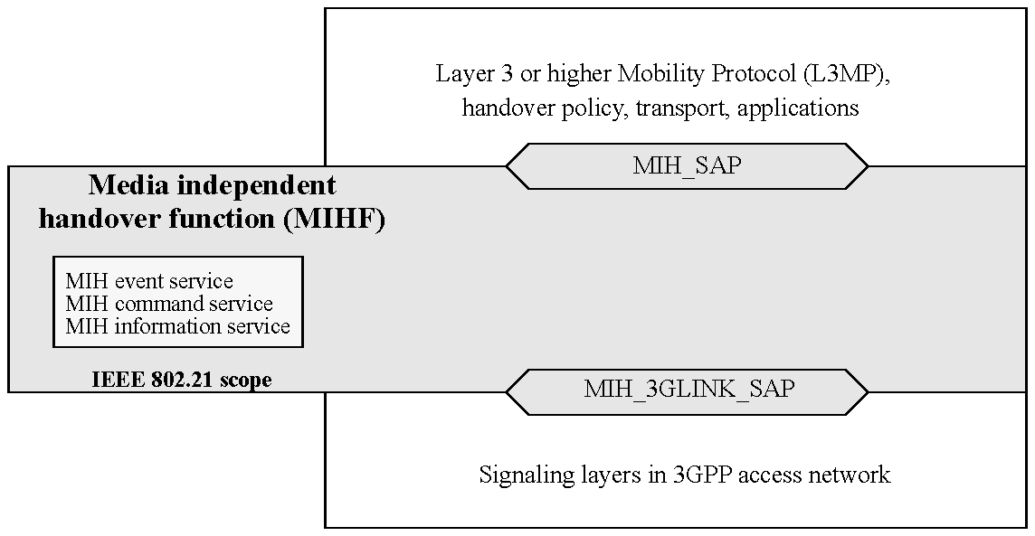
- —MIH reference model for 3GPP systems

Figure 10 illustrates the interaction between IEEE 802.21 services and 3GPP2 based systems. IEEE 802.21 services are accessed through the MIH_3GLINK_SAP. However note that no new primitives or protocols need to be defined within the 3GPP2 specification. Instead, a mapping between IEEE 802.21 link-layer primitives and 3GPP2 primitives as defined in IETF RFC 1661 and 3GPP2 C.S0004-D is already established. Primitive information available from Upper Layer Signaling and Point-to-Point Protocol (PPP) can be directly used by mapping LAC SAP and PPP SAP primitives to IEEE 802.21 service primitives in order to generate an event.
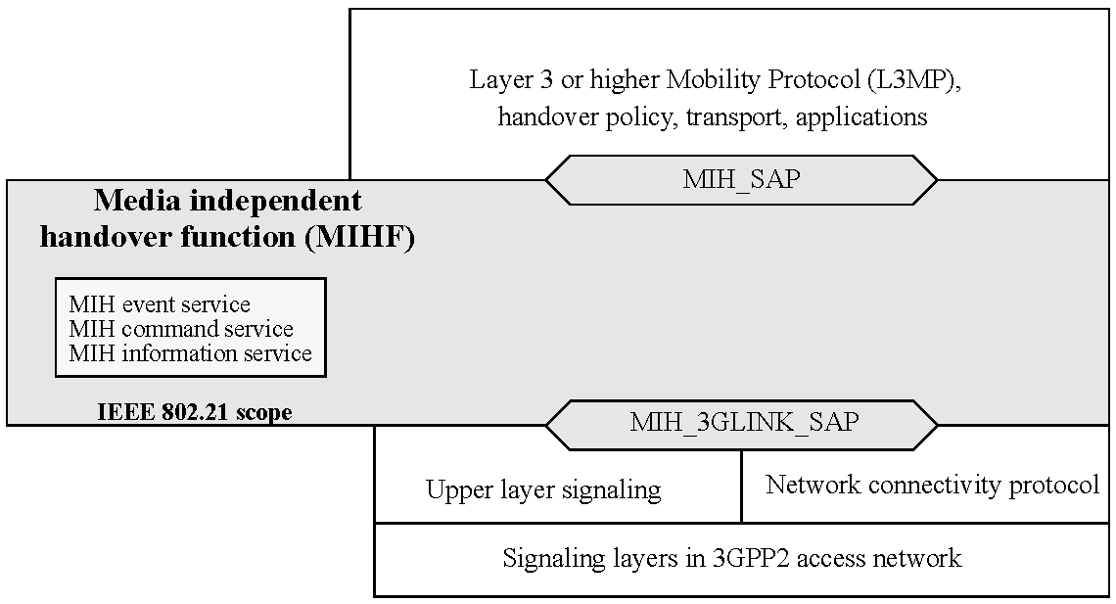
- —MIH reference model for 3GPP2 systems

This mapping is illustrated in Table E.3, which provides an example of how 3GPP and 3GPP2 primitives can be mapped to IEEE 802.21 primitives. For example, events received from the Upper Layer Signaling through the LAC layer SAP such as “L2.Condition.Notification” can be mapped and generated through the MIH_3GLINK_SAP as a Link_Up, Link_Down, or Link_Going_Down. Likewise, events generated at the PPP SAP within the PPP layer, such as LCP-Link-Up or IPCP_LINK_OPEN, could be mapped and generated through the MIH_3GLINK_SAP as a Link_Up event.
It is noteworthy that there will be no direct communication between the 3GPP2 PHY and MAC layers with the MIHF. The architectural placement of any MIHF is left to 3GPP2. Figure 10 is for illustrative purposes only and should not constrain implementations.
  - Service access points (SAPs)
    - General
The MIHF interfaces with other layers and functional planes using service access points (SAPs). Each SAP consists of a set of service primitives that specify the interactions between the service user and provider.
The specification of the MIHF includes the definition of SAPs that are media independent and recommendations to define or extend other SAPs that are media dependent. Media independent SAPs allow the MIHF to provide services to the upper layers of the mobility-management protocol stack, the network management plane, and the data bearer plane. The MIH_SAP and associated primitives provide the interface from MIHF to the upper layers of the mobility-management protocol stack. Upper layers need to subscribe with the MIHF as users to receive MIHF generated events and also for link-layer events that originate at layers below the MIHF but are passed on to MIH users through the MIHF. MIH users directly send commands to the local MIHF using the service primitives of the MIH_SAP. Communication between two MIHFs relies on MIH protocol messages.
Media dependent SAPs allow the MIHF to use services from the lower layers of the mobility management protocol stack and their management planes. All inputs (including the events) from the lower layers of the mobility-management protocol stack into the MIHF are provided through existing media-specific SAPs such as MAC SAPs, PHY SAPs, and logical link control (LLC) SAPs. Link Commands generated by the MIHF to control the PHY and MAC layers during the handover are part of the media-specific MAC/PHY SAPs and are already defined elsewhere.
Figure 11 shows the key MIHF-related SAPs for different networks, which are as follows:
- The MIH_SAP specifies a media independent interface between the MIHF and upper layers of the mobility management protocol stack. The upper layers need to subscribe with the MIHF as users to receive MIHF-generated events and also for link-layer events that originate at layers below the MIHF but are passed on to MIHF users through the MIHF. MIHF users directly send commands to the local MIHF using the service primitives of the MIH_SAP.
- The MIH_LINK_SAP specifies an abstract media dependent interface between the MIHF and lower layers media-specific protocol stacks of technologies such as IEEE 802.3, IEEE 802.11, IEEE 802.16, 3GPP, and 3GPP2. For different link-layer technologies, media-specific SAPs provide the functionality of MIH_LINK_SAP. Amendments are suggested to the respective media-specific SAPs to provide all the functionality as described by MIH_LINK_SAP.
- The MIH_NET_SAP specifies an abstract media dependent interface of the MIHF that provides transport services over the data plane on the local node, supporting the exchange of MIH information and messages with remote MIHFs.
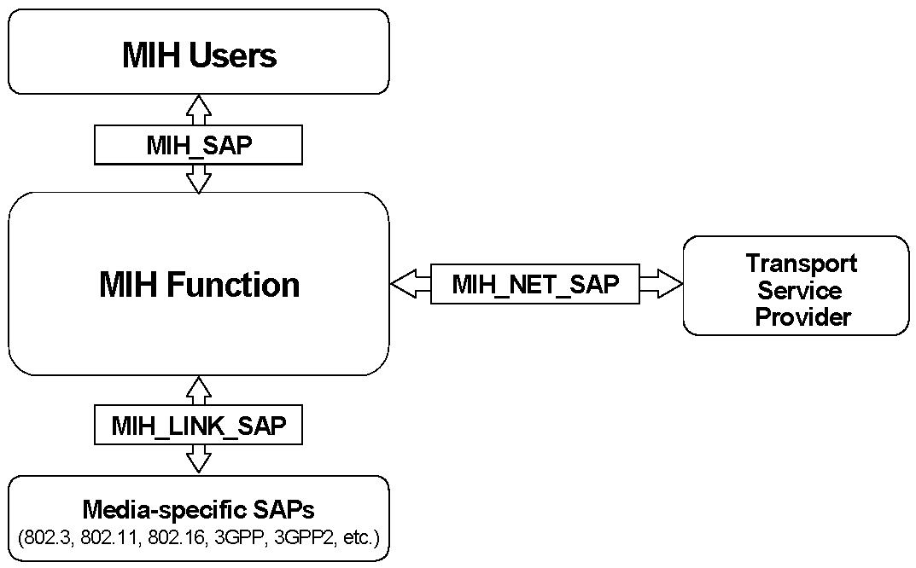
- —Relationship between different MIHF SAPs

    - Media dependent SAPs
      - General
Each link-layer technology specifies its own technology-dependent SAPs. For each link-layer technology, the MIH_LINK_SAP maps to the technology-specific SAPs.
      - MIH_LINK_SAP
This SAP defines the abstract media dependent interface between MIHF and different link-layer technologies. Amendments are suggested for different layer technology-specific SAPs based on the definition of this particular SAP.
      - MIH_NET_SAP
MIH_NET_SAP defines the abstract media dependent interface of the MIHF that provides transport services over the data plane on the local node, supporting the exchange of MIH information and messages with remote MIHFs. For L2, this SAP uses the primitives provided by MIH_LINK_SAP.
      - MLME_SAP
This SAP defines the interface between the MIHF and the management plane of an IEEE 802.11 network. This SAP is used for sending MIH messages between the MIHF and local link-layer entities, as well as between peer MIHF entities.
      - C_SAP
The C_SAP, defined in IEEE Std 802.16, provides the interface between the MIHF and the IEEE 802.16 control plane. This SAP is used for MIH exchanges between the MIHF and the lower layers of the management plane (as part of the IEEE 802.16 instantiation of the MIH_LINK_SAP).
      - M_SAP
The M_SAP, defined in IEEE Std 802.16, provides the interface between the MIHF and the IEEE 802.16 management plane functions.
      - MSGCF_SAP
This SAP, defined in IEEE P802.1 1u/D3.0, provides services to MIHF based on the IEEE 802.11 MAC state machines and interactions between the IEEE 802.11 sublayers.
      - MIH_3GLINK_SAP
This SAP works as an umbrella that defines the interface between the MIHF and the different protocol elements of the cellular systems. The existing service primitives or media-specific SAPs as defined in 3GPP and 3GPP2 specifications are directly mapped to MIHF services, and hence no new primitives need to be defined in these specifications. Table E.3 lists this mapping.
      - LSAP
The logical link control service access point (LSAP), defined in IEEE Std 802.2, provides the interface between the MIHF and the Logical Link Control sublayer in IEEE 802.3 and IEEE 802.11 networks. This SAP is used for local MIH exchanges between the MIHF and the lower layers and for the L2 transport of MIH messages across IEEE 802 access links.
      - CS_SAP
The CS_SAP, defined in IEEE Std 802.16, provides the interface between the MIHF and the service-specific Convergence Sublayer in IEEE 802.16 networks. This SAP is used for the L2 transport of MIH messages across IEEE 802.16 access links.
    - Media independent SAP: MIH_SAP
The MIH_SAP defines the media independent interface between the MIHF and MIH users such as an upper
layer mobility protocol or a handover function that might reside at higher layers or a higher layer transport
entity as well. The definition of the MIH_SAP is required to define the scope and functionality of the MIHF.
  - MIH protocol
    - General
MIH Protocol defines the format of messages (i.e., MIHF packet with header and payload) that are exchanged between remote MIHF entities and the media independent mechanisms that support the delivery of these messages.
    - Ethertype use and encoding
All MIH protocol data units (PDUs) shall be identified using the MIH protocol Ethertype specified in Table 2.
- —MIH protocol Ethernet type
Assignment | Valueª
MIH protocol Ethernet type | 89–17
ªThis Ethertype value is expressed using the hexadecimal representation defined in IEEE Std 802.

    - Transport considerations
MIH Protocol messages are sent over the data plane by use of a suitable transport mechanism at both layer 2 and layer 3. Layer 3 transport is supported using transmission control protocol (TCP) / user datagram protocol (UDP) / stream control transmission protocol (SCTP) protocols over IP. Layer 2 transport is supported with the EtherType value set to that for MIH Protocol. The data plane is available for transport after the MN has authenticated with the access network. In case of IEEE 802.11 and IEEE 802.16 networks, MIH Protocol messages can also be sent before authentication over the management plane by using respective media specific MAC management frames.
    - The generic MAC service with IEEE 802.1X
The generic MAC service in both IEEE 802.3 network and IEEE 802.11 robust security network association (RSNA) networks (which use IEEE Std 802. 1X-2004 port-based network access control), goes through the controlled port after authentication and association. The uncontrolled port is in open access mode to allow only exchange of messages to perform authentication and secure connection association, whereas the controlled port is blocked until authentication and association are successful.
The MIH messages that pass through the LSAP are distinguished from other protocols with an EtherType value of MIH protocol ethernet type in the LLC header.
When the MIH protocol is used across IEEE 802.11 networks, MIH frames may be exchanged when the STA has successfully authenticated and associated to the IEEE 802.11 access point.
      - Controlled port unblocked state: LSAP transport
After successful authentication and association, the controlled port is unblocked to the transport of authenticated messages. The MIH messages are then encapsulated into LLC protocol with EtherType value of MIH protocol to pass through the controlled port. When LSAP receives MAC frames from the LLC layer, it checks the EtherType of each frame to determine whether to send the frame to MIHF protocol or to other protocols.
      - Controlled port blocked state
Until authentication has been completed, the controlled port is in blocked state so that MIH messages cannot go through. However, in IEEE 802.11 and IEEE 802.16 networks, MIH messages (MIH_messages are limited to Information Service Query request/response, Event Service, and Command Service capability discovery only) can be transported via the management plane prior to authentication.
- MIHF services
  - General
The MIHF provides the media independent event service, the media independent command service, and the media independent information service that facilitate handovers across heterogeneous networks. Clause 6 provides a general description of these services. These services are managed and configured through service management primitives, as discussed in 6.2.
  - Service management
    - General
Prior to providing the MIH services from one MIHF to another, the MIH entities need to be configured properly. This is done through the following service management functions:
- MIH capability discovery
- MIH registration
- MIH event subscription
In order to know the services that are supported by an MIH peer, the MIH node performs MIH capability discovery. The MIH node performs MIH capability discovery with different MIH peers in order to decide which one to register with.
    - Service management primitives
Table 3 defines the set of service management primitives. A primitive is marked as local only (L), remote only (R), or local and remote (L, R), indicating whether it can be invoked by a local MIH user, a remote MIH user, or both, respectively.
- —Service management primitives
Service management  primitive | (L) ocal,  (R) emote | Defined  in | Comments
MIH_Capability_Discover | L, R | 7.4.1 | Discover the capabilities of a local or remote MIHF.
MIH_Register | R | 7.4.2 | Register with a remote MIHF.
MIH_DeRegister | R | 7.4.3 | Deregister from a remote MIHF.
MIH_Event_Subscribe | L, R | 7.4.4 | Subscribe for one or more MIH events with a local or remote MIHF.
MIH_Event_Unsubscribe | L, R | 7.4.5 | Unsubscribe for one or more MIH events from a local or remote MIHF.

    - MIH capability discovery
The MIH capability discovery procedure is used by an MIH user to discover a local or remote MIHF’s
capabilities in terms of MIH services (Event Service, Command Service, and Information Service). MIH capability discovery is performed either through the MIH protocol or through media-specific mechanisms (i.e., IEEE 802.11 Beacon frames, IEEE 802.16 downlink channel descriptor (DCD), IEEE 802.11 management frames, or IEEE 802.16 management messages).
    - MIH registration
MIH registration is defined as a means of requesting access to specific MIH services. For example, in a network controlled inter-technology handover framework, MIH registration can be used by an MN to declare its presence to a selected MIH PoS. MIH Registration is mandatory for use with the MIH Command Service and the push mode of the MIH Information Service.
    - MIH event subscription
The MIH event subscription mechanism allows an MIH user to subscribe for a particular set of events that originates from a local or remote MIHF. See 6.3.2 for a more detailed description of MIH event subscription.
    - Network communication
The network communication functions provide transport services over the data plane on the local node, supporting the exchange of MIH information and messages between the local and remote MIHF. For transport services over L2, MIH_NET_SAP utilizes the primitives specified by the MIH_LINK_SAP. For transport services over L3, the primitives are specified by MIH_NET_SAP. Please refer to 7.5 for more details on MIH_NET_SAP.
  - Media independent event service
    - Introduction
In general, handovers can be initiated either by the MN or by the network. Events relevant to handover originate from MAC, PHY, or MIHF at the MN, at the network PoA, or at the PoS. Thus, the source of these events is either local or remote entity. A transport protocol is needed for supporting remote events. Security is another important consideration in such transport protocols.
Multiple higher layer entities can be interested in these events at the same time. Thus, these events can have multiple destinations. Higher layer entities can subscribe to receive event notifications from a particular event source. The MIHF can help in dispatching these events to multiple destinations.
These events are treated as discrete events. As such there is no general event state machine. Event notifications are generated asynchronously. Thus, all MIH users and MIHFs that want to receive event notifications need to subscribe to particular events.
From the recipient’s perspective, these events are mostly “advisory” in nature and not “mandatory.” The recipient is not obligated to act on these events. Layer 3 and above entities need to deal with reliability and robustness issues associated with these events. Higher layer protocols and other entities can take a more cautious approach when events originate remotely as opposed to when they originate locally. These events can also be used for horizontal handovers.
The Event Service is broadly divided into two categories, Link Events and MIH Events. Both Link and MIH Events traverse from a lower to a higher layer. Link Events are defined as events that originate from event source entities below the MIHF and terminate at the MIHF. Entities generating Link Events include, but are not limited to, various IEEE 802-defined, 3GPP-defined, and 3GPP2-defined interfaces. Within the MIHF, Link Events propagate further, with or without additional processing, to MIH users that have subscribed for the specific events. MIH events are defined as events that originate from within the MIHF, or they are Link Events that are propagated by the MIHF to the MIH users. This relationship is shown in Figure 12.
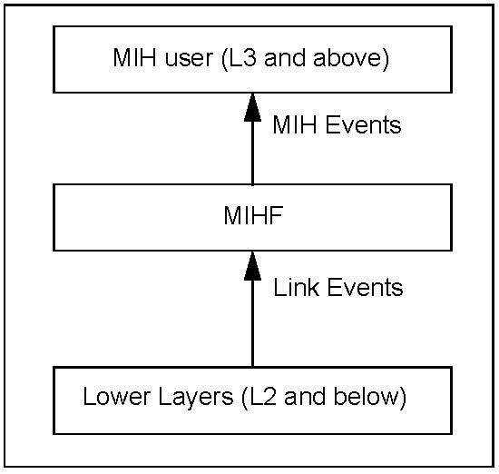
- —Link events and MIH events

An event can be local or remote; a local event is one that propagates across different layers within the local protocol stack of an MIH entity, while a remote event is one that traverses across the network medium from one MIH entity to another MIH entity.
All Link Events are local in nature and propagate from the local lower layer to the local MIHF. MIH Events are local or remote. A remote MIH Event traverses the medium from a remote MIHF to the local MIHF and is then dispatched to local MIH users that have subscribed to this remote event, as shown in Figure 13.
A Link Event that is received by the MIHF can also be sent to a remote MIH entity as a remote MIH Event.
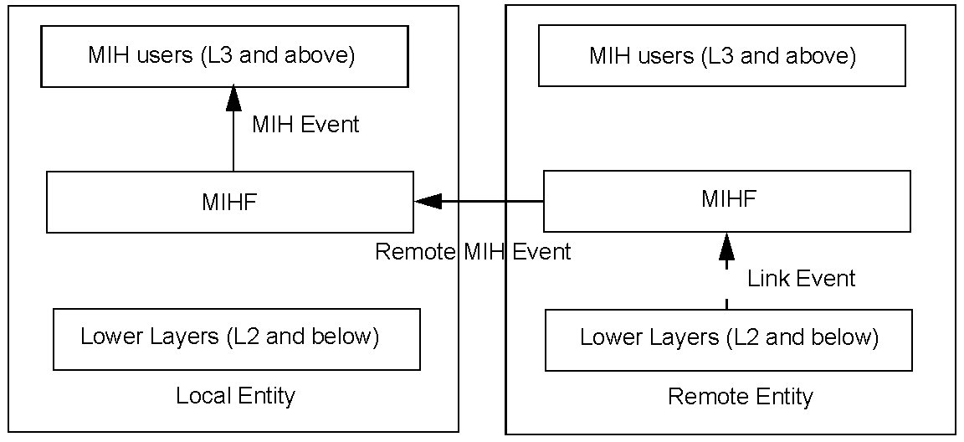
- —Remote MIH events

    - Event subscription
      - General
Event subscription provides a mechanism for upper layer entities to selectively receive events. Event subscription can be divided into link events subscription and MIH events subscription. Link events subscription is performed by the MIHF with the event source entities in order to determine the events that each event source (link) is able to provide. MIH events subscription is performed by upper layer entities with the MIHF to select the events to receive. It is possible for upper layer entities to subscribe for all existing events or notifications that are provided by the event source entity even if no additional processing of the event is done by the MIHF.
      - Link events subscription
During initialization the MIHF actively searches for pre-existing interfaces, devices, and modules that serve as link event sources in the Event service. In addition to the link event source entities that are present during the bootstrapping stage, allowances are made for devices such as hot-plugged interfaces or an external module. The exact description and implementation of such mechanisms is out of the scope of the standard. The MIHF subscribes individually with each of these link layers based on user preferences.
      - MIH events subscription
MIH users specify a list of events for which they wish to receive notifications from the MIHF. For an MIH event that can originate both locally and remotely, an MIH user specifies whether it is subscribing for the local event only, remote event only, or both (which would require two separate subscriptions). If the MIH event that an MIH user wants to subscribe to is not supported or is not available, then the MIHF rejects the subscription request and notifies the MIH user accordingly.
    - Event service flow model
Figure 14 shows the event flow model for link events and MIH events.
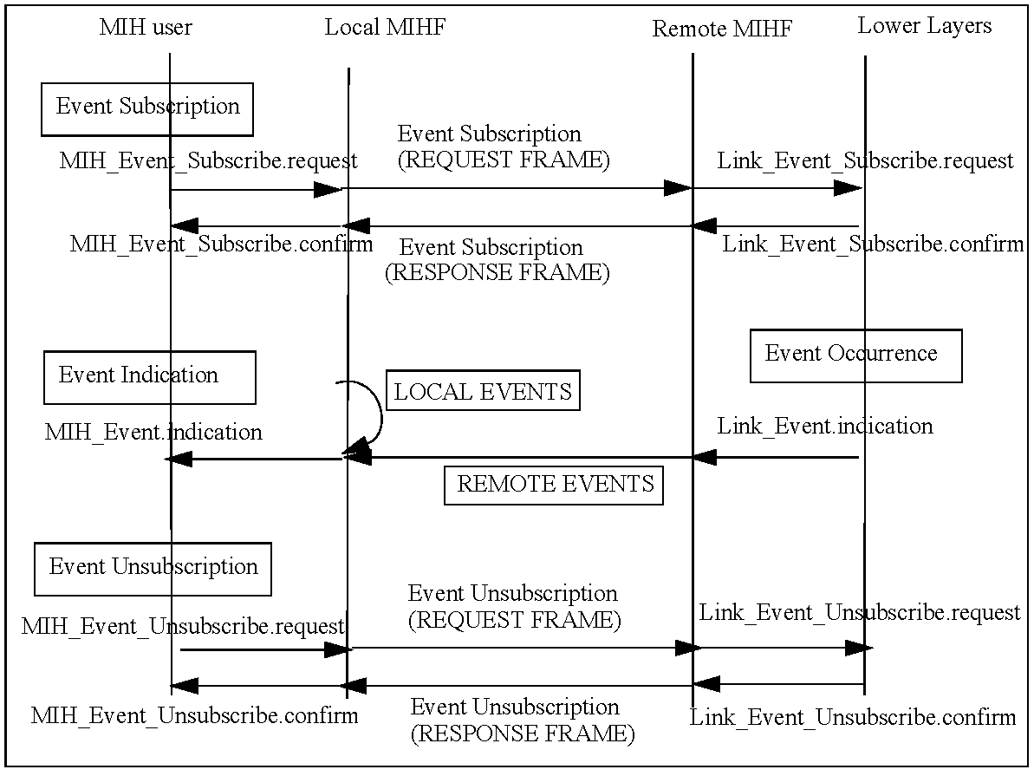
- —MIH events subscription and flow

    - Link events
The media independent event service supports the following several categories of link events:
- MAC and PHY State Change events: These events correspond to changes in MAC and PHY state. For example, Link_Up event is a state change event.
- Link Parameter events: These events are due to changes in link-layer parameters. For example, the primitive Link_Parameters_Report is a Link Parameter event.
- Predictive events: Predictive events convey the likelihood of a change in the link conditions in the near future based on past and present conditions. For example, decay in signal strength of a wireless local area network (WLAN) indicates a loss of link connectivity in the near future.
- Link Handover events: These events inform upper layers about the occurrence of L2 handovers/ link switches if supported by the given media type.
- Link Transmission events: These events indicate the link-layer transmission status (e.g., success or failure) of upper layer PDUs. This information is used by upper layers to improve buffer management for minimizing the upper layer data loss due to a handover.
For example, the occurrence of a handover of an MN from one access network to another will result in the tear-down of the old link-layer connection between the MN and the source access network and the establishment of a new link-layer connection between the MN and the target access network. When this occurs, some upper layer PDUs still remain buffered at the old link—including PDUs that had been queued at the old link but never been transmitted before the link was torn-down (i.e., unsent PDUs), and PDUs that have been transmitted over the old link but never been fully acknowledged by the upper layer receiver before the link was torn-down (i.e., unacked PDUs). These buffered PDUs will be discarded when the old link is torn-down. As a result, unless the upper layer sender attempts to retransmit them over the new link connection, these upper layer PDUs will never reach the receiver.
Table 4 defines link events.
- —Link events
Link event name | Link event  type | Description | Defined  in
Link_Detected | State change | Link of a new access network has been detected. This event is typically generated on the MN when the first PoA of an access network is detected. This event is not generated when subsequent PoAs of the same access network are discovered. | 7.3.1
Link_Up | State change | L2 connection is established and link is available for use. This event is a discrete event. | 7.3.2
Link_Down | State change | L2 connection is broken and link is not available for use. This event is a discrete event. | 7.3.3
Link_Parameters_Report | Link parameters | Link parameters have crossed pre-specified thresholds. | 7.3.4
Link_Going_Down | Predictive | Link conditions are degrading and connection loss is imminent. | 7.3.5
Link_Handover_Imminent | Link handover | L2 handover is imminent based on changes in link conditions. | 7.3.6
Link_Handover_Complete | Link handover | L2 link handover to a new PoA has been completed. | 7.3.7
Link_PDU_Transmit_Status | Link transmission | Indicate transmission status of a PDU. | 7.3.8

In general when a link event occurs due to a change in link condition it is not known at that instant if this would lead to intra-technology handover or inter-technology handover. That determination is done higher up in the protocol stack by the network selection entity based on variety of other factors. As such certain link- layer events such as Link_Going_Down leads to either intra-technology or inter-technology handovers. The network selection entity tries to maintain the current connection, by first trying intra-technology handovers and only later on resort to inter-technology handovers.
    - MIH events
Table 5 defines MIH events. An MIH event is marked as local only (L), remote only (R), or local and remote (L, R), indicating whether it can be subscribed by a local MIH user, a remote MIH user, or both, respectively.
- —MIH events
MIH event name | (L) ocal  (R) emote | Description | Defined  in
MIH_Link_Detected | L, R | Link of a new access network has been detected. This event is typically generated on the MN when the first PoA of an access network is detected. This event is not generated when subsequent PoAs of the same access network are discovered. | 7.4.6
MIH_Link_Up | L, R | L2 connection is established and link is available for use. | 7.4.7
MIH_Link_Down | L, R | L2 connection is broken and link is not available for use. | 7.4.8
MIH_Link_Parameters_Report | L, R | Link parameters have crossed a specified thresh- old and need to be reported. | 7.4.9
MIH_Link_Going_Down | L, R | Link conditions are degrading and connection loss is imminent. | 7.4.10
MIH_Link_Handover_Imminent | L, R | L2 handover is imminent based on either the changes in the link conditions or additional information available in the network. For example, the network decides that an application requires a specific QoS that can be best provided by a certain access technology. | 7.4.11
MIH_Link_Handover_Complete | L, R | L2 link handover to a new PoA has been completed. | 7.4.12
MIH_Link_PDU_Transmit_Status | L | Indicate transmission status of a PDU. | 7.4.13

    - Interaction between MIH events and access routers
Access Router (AR) is a layer 3 (L3) IP router residing in an access network and is connected to one or more PoAs. An AR is the first hop router for an MN.
During heterogeneous handovers an MN can switch from one link technology to another. This will result in a change in the PoA that the MN is connected to. The target PoA and the source PoA may or may not be on the same subnet. In cases where there is a change in subnet, IP packet delivery can be optimized if context (e.g., change in routing information) from the old AR to the target AR is transferred. In such cases, the target router can update its L2 address to IP address mapping.
Link-layer triggers such as Link Going Down and Link Up can be used to indicate departure and arrival of
MNs at AR(s) and such indications can replace L3 protocol signaling for the same and thus expedite the
handover process. Layer 3 Mobility management protocols, such as MIP can also benefit from triggers such as Link Going Down. Timely receipt of such triggers by the AR in case of network-controlled handovers can enable MIP signaling to establish the new route to take place in parallel with other handover message exchange and can thus reduce the disruption time in IP packet delivery.
  - Media independent command service
    - Introduction
media independent command service (MICS) refers to the commands sent from MIH users to the lower layers in the reference model. MIH users utilize command services to determine the status of links and/or control the multi-mode device for optimal performance. Command services also enable MIH users to facilitate optimal handover policies. For example, the network initiates and controls handovers to balance the load of two different access networks.
The link status varies with time and MN mobility. Information provided by MICS is dynamic information composed of link parameters such as signal strength and link speed; whereas, information provided by MIIS is less dynamic or static in nature and is composed of parameters such as network operators and higher layer service information. MICS and MIIS information could be used in combination by the MN/network to facilitate the handover.
A number of commands are defined in this standard to allow the MIH users to configure, control, and retrieve information from the lower layers including MAC, Radio Resource Management, and PHY. The commands are classified into two categories: MIH commands and link commands. Figure 15 shows link commands and MIH commands.
The receipt of certain MIH command requests can cause event indications to be generated. The receipt of MIH command requests indicates a future state change in one of the link layers in the local node. These indications notify subscribed MIH users of impending link state changes. This allows MIH users to be better prepared to take appropriate action.
Link commands originate from the MIHF and are directed to the lower layers. These commands mainly control the behavior of the lower layer entities. Link commands are local only. Whenever applicable, this standard encourages use of existing media-specific link commands for interaction with specific access networks. New link commands, if required, are defined as recommendations to different link-layer technology standards. It is to be noted that although Link commands originate from the MIHF, these commands are executed on behalf of the MIH users.
The MIH commands are generated by the MIH users and sent to the MIHF. MIH commands can be local or remote. Local MIH commands are sent by MIH users to the MIHF in the local protocol stack.
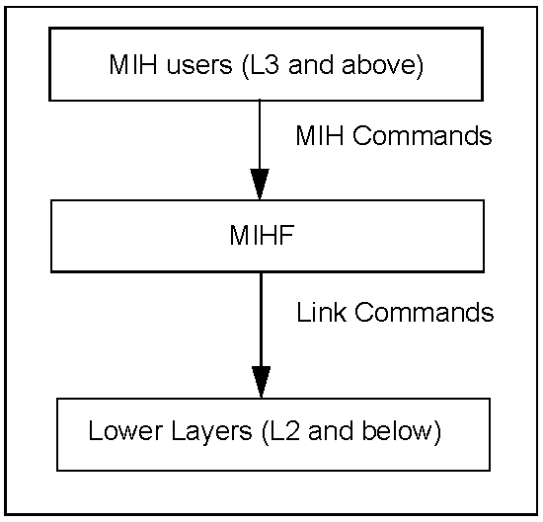
- —Link commands and MIH commands

Remote MIH commands are sent by MIH users to the MIHF in a peer protocol stack. A remote MIH command delivered to a peer MIHF is executed by the lower layers under the peer MIHF as a link command; or is executed by the peer MIHF itself as an MIH command (as if the MIH command came from an MIH user of the peer MIHF); or is executed by an MIH user of the peer MIHF in response to the corresponding indication. Often, an MIH indication to a remote MIH user results from the execution of the MIH command by the peer MIHF. Figure 16 shows remote MIH commands.
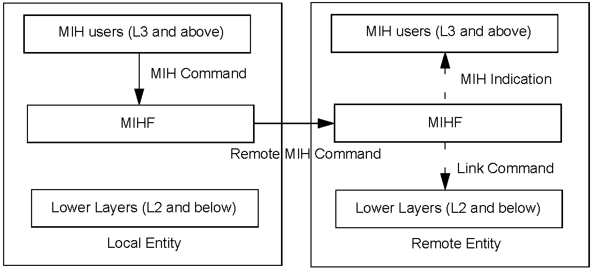
- —Remote MIH command

    - Command service flow model
Figure 17 shows the flow for a local command and an example of a remote command, respectively. Example handover procedures using the commands defined in 6.4.3 can be found in Annex C. Remote commands are transported over network layer protocols or link-layer protocols.
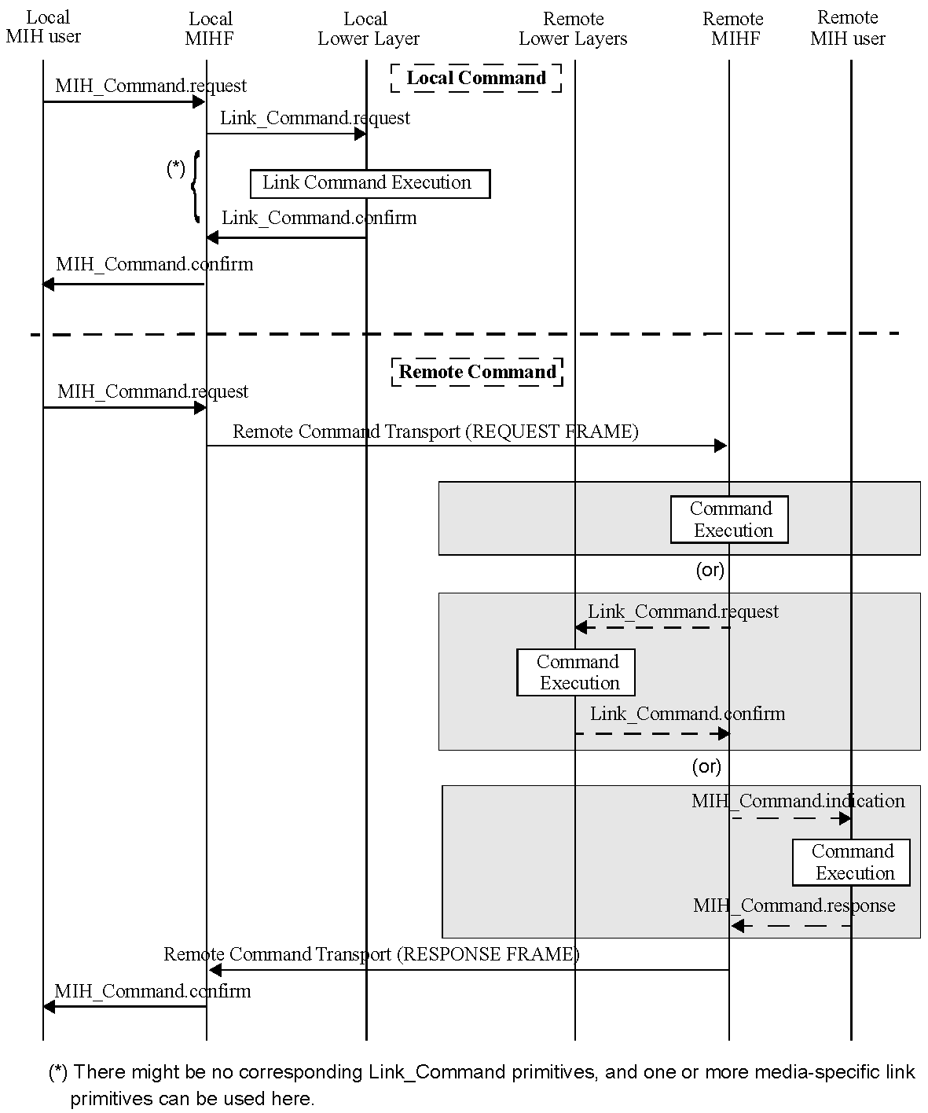
- —Command service flow

    - Command list
      - Link commands
Table 6 defines Link commands.
- —Link commands
Link command | Comments | Defined  _{in}
Link_Capability_Discover | Query and discover the list of supported link-layer events and link- layer commands. | 7.3.9
Link_Event_Subscribe | Subscribe to one or more events from a link. | 7.3.10
Link_Event_Unsubscribe | Unsubscribe from a set of link-layer events. | 7.3.11
Link_Get_Parameters | Get parameters measured by the active link, such as signal-to-noise ratio (SNR), BER, received signal strength indication (RSSI). | 7.3.12
Link_Configure_Thresholds | Configure thresholds for Link Parameters Report event. | 7.3.13
Link_Action | Request an action on a link-layer connection. | 7.3.14

      - MIH commands
        - General
Table 7 defines MIH Commands. An MIH command is marked as local only (L), remote only (R), or local and remote (L, R), indicating whether it can be issued by a local MIH user, a remote MIH user, or both, respectively.
- —MIH commands
MIH command | (L) ocal,  (R) emote | Comments | Defined  in
MIH_Link_Get_Parameters | L, R | Get the status of a link. | 7.4.14
MIH_Link_Configure_Thresholds | L, R | Configure link parameter thresholds. | 7.4.15
MIH_Link_Actions | L, R | Control the behavior of a set of links. | 7.4.16
MIH_Net_HO_Candidate_Query | R | Network initiates handover and sends a list of suggested networks and associated points of attachment. | 7.4.17
MIH_MN_HO_Candidate_Query | R | Command used by MN to query and obtain handover related information about possible candidate networks. | 7.4.18

Table 7—MIH commands (continued)
MIH command | (L) ocal,  (R) emote | Comments | Defined  in
MIH_N2N_HO_Query_Resources | R | This command is sent by the serving MIHF entity to the target MIHF entity to allow for resource query. | 7.4.19
MIH_MN_HO_Commit | R | Command used by MN to notify the serving net- work of the decided target network information. | 7.4.20
MIH_Net_HO_Commit | R | Command used by the network to notify the MN of the decided target network information. | 7.4.2 1
MIH_N2N_HO_Commit | R | Command used by a serving network to inform a target network that an MN is about to move toward that network, initiate context transfer (if applicable), and perform handover preparation. | 7.4.22
MIH_MN_HO_Complete | R | Notification from MIHF of the MN to the target or source MIHF indicating the status of handover completion. | 7.4.23
MIH_N2N_HO_Complete | R | Notification from either source or target MIHF to the other (i.e., peer) MIHF indicating the status of the handover completion. | 7.4.24

        - Naming convention for MIH handover commands (to be excluded)
        - Mobile initiated handovers (to be excluded)
        - Network initiated handovers (to be excluded)
  - Media independent information service
    - Introduction
media independent information service (MIIS) provides a framework by which an MIHF, residing in the MN or in the network, discovers and obtain network information within a geographical area to facilitate network selection and handovers. The objective is to acquire a global view of all the heterogeneous networks relevant to the MN in the area to facilitate seamless roaming across these networks.
MIIS includes support for various Information Elements (IEs). IEs provide information that is essential for a network selector to make intelligent handover decisions.
Depending on the type of mobility, support for different types of information elements is required for performing handovers. MIIS provides the capability for obtaining information about lower layers such as neighbor maps and other link-layer parameters, as well as information about available higher layer services such as internet connectivity.
MIIS provides a generic mechanism to allow a service provider and a mobile user to exchange information on different handover candidate access networks. The handover candidate information includes different access technologies such as IEEE 802 networks, 3GPP networks, and 3GPP2 networks. The MIIS also allows this collective information to be accessed from any single network. For example, by using an IEEE 802.11 access network the MN gets information not only about all other IEEE 802 based networks in a particular region but also about 3GPP and 3GPP2 networks. Similarly by using a 3GPP2 interface, the MN gets access to information about all IEEE 802 and 3GPP networks in a given region. This capability allows the MN to use its currently active access network and inquire about other available access networks in a geographical region. Thus, an MN is freed from the burden of powering up each of its individual radios and establishing network connectivity for the purpose of retrieving heterogeneous network information. MIIS enables this functionality across all available access networks by providing a uniform way to retrieve heterogeneous network information in any geographical area.
The main goal behind the Information Service is to allow MN and network entities to discover information that influences the selection of appropriate networks during handovers. This information is intended to be primarily used by a policy engine entity that can make effective handover decisions based on this information. This Information Service provides mostly static information, although network configuration changes are also accounted for. Other dynamic information about different access networks, such as current available resource levels, state parameters, and dynamic statistics should be obtained directly from the respective access networks. Some of the key motivations behind the Information Service are as follows:
- Provide information about the availability of access networks in a geographical area. Further, this information could be retrieved using any wireless network, for example, information about a nearby Wi-Fi hotspot could be obtained using a global system for mobile communication (GSM), CDMA, or any other cellular network, whether by means of request/response signaling, or by means of information that is specifically or implicitly broadcast over those cellular networks. Alternatively, this information could be maintained in an internal database on the MN.
- Provide static link-layer information parameters that helps the mobile nodes in selecting the appropriate access network. For example knowledge of whether security and QoS are supported on a particular access network influences the decision to select such an access network during handovers.
- Provide information about capabilities of different PoAs in neighbor reports to aid in configuring the radios optimally (to the extent possible) for connecting to available or selected access networks. For example knowing about supported channels by different PoAs helps in configuring the channels optimally as opposed to scanning or beaconing and then finding out this information. Dynamic link- layer parameters have to be obtained or selected based on direct interaction with the access networks.
- Provide an indication of higher layer services supported by different access networks and core networks that can aid in making handover decisions. Such information is not available directly from the MAC sublayer or PHY of specific access networks, but can be provided as part of the Information Service. For example, classification of different networks into categories, such as public, enterprise, home, and others, influences a handover decision. These higher layer services information is more vendor specific in nature.
    - Access information service before authentication
It is important to note that, with certain access networks an MN should be able to obtain IEEE 802.21 related information elements before the MN is authenticated with the PoA. These information elements are used by the handover policy function to determine if the PoA can be selected. In order to enable the information query before authentication, individual link technologies provide an L2 or media-specific transport or a protocol message exchange that makes this MIIS query exchange possible between the user equipment (MN) and a certain MIHF in the network. It should be noted that the pre-authentication query facility is provided only for MIH information query and cannot be used for carrying other MIH protocol services except MIHF capability discovery query using MIH_Capability_Discover embedded into media specific management frames. Additionally, any MIHF within the network can request for the set of information elements from a peer MIHF located in the same or a different network using the MIH protocol.
Allowing access of information service before authentication carries certain security risks such as denial-ofservice attacks and exposure of information to unauthorized MNs. In such scenarios the information service provider limits the scope of information accessible to an unauthenticated MN.
After authentication and attachment to a certain PoA, the MIH protocol is used for information retrieval by use of data frames specific to that media technology.
    - Restricting query response size
When sending an information query request, the MIIS client provides a maximum response size to limit the query response message size. A request can contain multiple queries. If the request contains multiple queries, they will be in the order of significance to the client. In case the query results exceed the maximum response size, the least significant query results will be removed from the response. The MIIS server has its own maximum response size limit configured that is smaller than the one specified by the MIIS client request. In this case, the response message returns results in the order of significance to the client up to that limit.
    - Information elements
The Information Service elements are classified into the following three groups:
- General Information and Access Network Specific Information: These information elements give a general overview of the different networks providing coverage within an area. For example, a list of available networks and their associated operators, roaming agreements between different operators, cost of connecting to the network and network security and quality of service capabilities.
- PoA Specific Information: These information elements provide information about different PoAs for each of the available access networks. These IEs include PoA addressing information, PoA location, data rates supported, the type of PHY and MAC layers and any channel parameters to optimize link-layer connectivity. This also includes higher layer services and individual capabilities of different PoAs.
- Other information that is access network specific, service specific, or vendor/network specific.
Table 9 lists information element containers (see 6.5.6.2.1 for detailed definitions). The containers are only used in the type-length-value (TLV) based query method.
- —Information element containers
Name of container | Description
IE_CONTAINER_LIST_OF_NETWORKS | List of neighboring Access Network Containers, containing information that depicts a list of heterogeneous neighboring access networks for a given geographical location.
IE_CONTAINER_NETWORK | Access Network Container, containing information that depicts an access network.
IE_CONTAINER_POA | PoA Container, containing information that depicts a PoA.

Table 10 represents the list of Information Elements and their semantics. Each Information Element has an abstract data type (see Annex F for detailed definitions). The binary and resource description framework (RDF) representation of these Information Elements are described in 6.5.6.2 and 6.5.6.3, respectively. The IEs may be retrieved using TLV or SPARQL based query methods. The standard does not recommend or mandate the choice of either method. An IEEE 802.21 implementation that implements the MIIS shall implement at least one method. Vendors or network operators define additional IEs beyond the IEs specified in Table 10. Vendors and network operators can implement new IEs using the Vendor Specific IEs. These IEs will then be available only in vendor- or operator-specific deployments.
- —Information elements
Name of information element | Description | Data type
General information elements
IE_NETWORK_TYPE | Link types of the access networks that are available in a given geographical area. | NETWORK_TYPE
IE_OPERATOR_ID | The operator identifier for the access network/core network. | OPERATOR_ID

Table 10—Information elements (continued)
Name of information element | Description | Data type
IE_SERVICE_PROVIDER_ID | Identifier for the service provider. | SP_ID
IE_COUNTRY_CODE | Indicate the country. | CNTRY_CODE
Access network specific information elements
IE_NETWORK_ID | Identifier for the access network. | NETWORK_ID
IE_NETWORK_AUX_ID | An auxiliary access network identifier. As an example for IEEE 802.11 this refers to the homogenous extended service set ID (HESSID). | NET_AUX_ID
IE_ROAMING_PARTNERS | Roaming Partners.  Network Operators with which the current network operator has direct roaming agreements. | ROAMING_PTNS
IE_COST | Cost.  Indication of cost for service or network usage. | COST
IE_NETWORK_QOS | QoS characteristics of the link layer. | QOS_LIST
IE_NETWORK_DATA_RATE | Data Rate. The maximum value of the data rate sup- ported by the link layer of the access network. | DATA_RATE
IE_NET_REGULAT_DOMAIN | Regulatory classes supported by the access network. | REGU_DOMAIN
IE_NET_FREQUENCY_BANDS | Frequency bands supported by the network. | FREQ_BANDS
IE_NET_IP_CFG_METHODS | IP Configuration Methods supported by the access network. | IP_CONFIG
IE_NET_CAPABILITIES | Bitmap of access network capabilities. | NET_CAPS
IE_NET_SUPPORTED_LCP | List of location configuration protocols supported by the access network. | SUPPORTED_LCP
IE_NET_MOB_MGMT_PROT | Type of mobility management protocol supported. | IP_MOB_MGMT
IE_NET_EMSERV_PROXY | Address of the proxy providing access to public safety answering point (PSAP). | PROXY_ADDR
IE_NET_IMS_PROXY_CSCF | Address of the proxy providing access to IMS P-CSCF. | PROXY_ADDR
IE_NET_MOBILE_NETWORK | Indicator whether the access network itself is mobile. | BOOLEAN
PoA-specific information elements
IE_POA_LINK_ADDR | Link-layer address of PoA. | LINK_ADDR
IE_POA_LOCATION | Geographical location of PoA. Multiple location types are supported including coordinate-based location information, civic address, and cell ID. | LOCATION
IE_POA_CHANNEL_RANGE | Channel Range/Parameters.  Spectrum range supported by the channel for that PoA. | CH_RANGE
IE_POA_SYSTEM_INFO | System information supported by the link layer of a given PoA. | SYSTEM_INFO
PoA-specific higher layer service information elements
Table 10—Information elements (continued)
Name of information element | Description | Data type
IE_POA_SUBNET_INFO | Information about subnets supported by a typical PoA. | IP_SUBNET_INFO
IE_POA_IP_ADDR | IP Address of PoA. | IP_ADDR
Other information elements
Vendor specific IEs | Vendor-specific services. | N/A

In certain access network deployments, some PoA properties (e.g., data rate, IP configuration methods, capabilities) are common for all PoAs within that access network. In such a case, the common PoA properties are represented as IEs as part of the access network property information.
As an example, Figure 18 shows the layout of different Information Elements and the neighbor map of different networks in a geographical area. Multiple operators can be providing support for a particular network. Thus support for IEEE 802.11 network is provided by both Operator_1 and Operator_2. A single operator can provide support for multiple networks. Thus, Operator_1 provides support for IEEE 802.11 and universal mobile telecommunications system (UMTS) networks while Operator_3 provides support for IEEE 802.16 and UMTS networks. The General Network Information Elements are specified for each network supported by an operator. Thus in the case of Operator_1, General Network Information is specified for both IEEE 802.11 and UMTS networks, while in the case of Operator_2 it is specified only for an IEEE 802.11 network.
For each network supported by an operator there is a list of supported PoAs. For each PoA the PoA Information Elements are specified. Figure 18 shows this information representation and tree hierarchy for different networks.
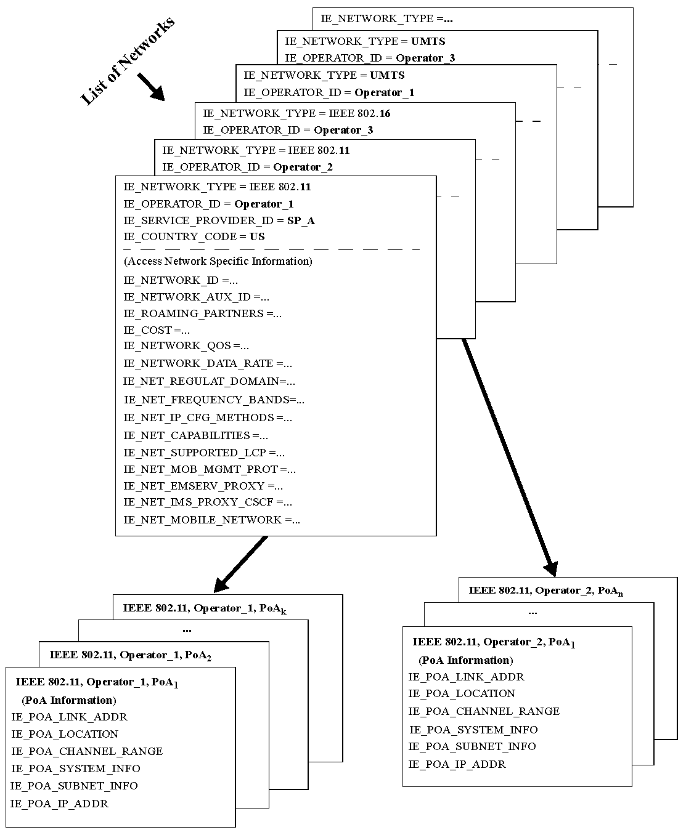
- —Depicting a list of neighboring networks with information elements

    - Definition of information element namespace
Each Information Element ID is a 32 bit value. Table 11 defines the Information Element namespace. The IEEE 802.21 specific Information Elements are assigned identifiers as per this standard. Please refer to Table G. 1 (in Annex G) for more details. Vendors specify their own IEs using the name space allocated to them. A set of IE name space ranges is also reserved for development and testing. These should not be used in released products. Allocation of additional IE namespace and any revisions to this assignment will be handled by future revisions of this standard.
- —Information element namespace
Range | Description | Comments
0x00000000 | Reserved
0x00000001–0x1FFFFFFF | IEEE 802.21 IEs | Used for IEEE 802.21 defined IEs. The currently defined IEEE 802.21 IEs are listed in Table G.1 in Annex G.
0x20000000–0x7FFFFFFF | Vendor specific IEs | Used for IEs defined by vendors.  To prevent vendor specific IE collisions, the 2nd, 3rd, and 4th octet are filled with the value of the vendor’s IEEE organizationally unique identifier (OUI). For example, if a vendor’s IEEE OUI is 00-03-3F, then its corresponding Vendor Specific IE range would be 0x2000033F–0x7F00033F.
0x80000000–0x82FFFFFF | Reserved for playpen area. | Used in development and testing. Should not be used in released products. Avoids collision during development.
0x83000000–0xFFFFFFFF | Reserved | For future use.

Functional entities should discard any received IE with an unrecognizable identifier.
    - Information element representation and query methods
      - Introduction
MIIS defines two methods for representing Information Elements: binary representation and RDF representation (see W3C Recommendation, Resource Description Framework (RDF)–Concepts and Abstract Syntax and W3C Recommendation, RDF/XML Syntax Specification). MIIS also defines two query methods. For requests using the binary representation, the TLV query method defined in 6.5.6.2 is used. For requests using the RDF representation, the SPARQL (see W3C Recommendation, SPARQL Query Language for RDF) query method is used.
      - Binary representation and TLV query
In the binary representation method, Information Elements are represented and encoded in Type-LengthValue form as shown in Figure 19.
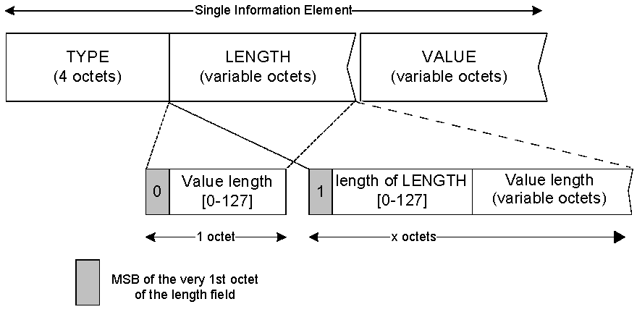
- —TLV representation of information elements

The Length field is interpreted as follows:
Case 1: If the number of octets occupied by the Value field is less than 128, the size of the Length field is always one octet and the MSB of the octet is set to the value ‘0’. The values of the other seven bits of this octet indicate the actual length of the Value field.
Case 2: If the number of octets occupied by the Value field is exactly 128, the size of the Length field is one octet. The MSB of the Length octet is set to the value ‘1’ and the other seven bits of this octet are all set to the value ‘0’.
Case 3: If the number of octets occupied by the Value field is greater than 128, then the Length field is always greater than one octet. The MSB of the first octet of the Length field is set to the value ‘1’ and the remaining seven bits of the first octet indicate the number of octets that are appended further. The number represented by the second and subsequent octets of the Length field, when added to 128, indicates the total size of the Value field, in octets.
        - IE containers
In the binary representation method, three Information Element Containers are defined, namely the IE_CONTAINER_LIST_OF_NETWORKS, the IE_CONTAINER_NETWORK, and the IE_CONTAINER_POA:
- IE_CONTAINER_LIST_OF_NETWORKS—contains a list of heterogeneous neighboring access networks for a given geographical location, as shown in Table 12.
An IE_CONTAINER_LIST_OF_NETWORKS contains at least one Access Network and optionally one or more Vendor Specific IEs. When more than one Access Network Container is provided in this IE, they should be prioritized in the order of preference from the information server’s perspective with first Access Network Container as the top priority and with decreasing priority going down the list. This would enable the receiving entity to utilize this information in the same way as provided in this list for network selection or handover decisions.

- —IE_CONTAINER_LIST_OF_NETWORKS definition
Information element ID = (see Table G.1) | Length= variable
IE_CONTAINER_NETWORK #1
IE_CONTAINER_NETWORK #2 (optional)
…
IE_CONTAINER_NETWORK #k (optional)
Vendor Specific IE (optional)

- IE_CONTAINER_NETWORK—contains all the information depicting an access network, as shown in Table 13.
When more than one PoA Container is provided in this IE, they should be prioritized in the order of preference from the information server’s perspective with first PoA Container as the top priority and with decreasing priority going down the list. This would enable the receiving entity to utilize this information in the same way as provided in this list for network selection or handover decisions.

- —IE_CONTAIN ER_NETWORK definition
Information element ID = (see Table G.1) | Length= variable
IE_NETWORK_TYPE
IE_OPERATOR_ID
IE_SERVICE_PROVIDER_ID (optional)
IE_COUNTRY_CODE (optional)
IE_NETWORK_ID (optional)
IE_NETWORK_AUX_ID (optional)
IE_ROAMING_PARTNERS (optional)
IE_COST (optional)
IE_NETWORK_QOS (optional)
IE_NETWORK_DATA_RATE (optional)
IE_NET_REGULAT_DOMAIN (optional)
IE_NET_FREQUENCY_BANDS (optional)
IE_NET_IP_CFG_METHODS (optional)
IE_NET_CAPABILITIES (optional)
IE_NET_SUPPORTED_LCP (optional)
IE_NET_MOB_MGMT_PROT (optional)
IE_NET_EMSERV_PROXY (optional)
IE_NET_IMS_PROXY_CSCF (optional)
Table 13—IE_CONTAINER_NETWORK definition (continued)
IE_NET_MOBILE_NETWORK (optional)
IE_CONTAINER_POA #1 (optional)
IE_CONTAINER_POA #2 (optional)
…
IE_CONTAINER_POA #k (optional)
Vendor Specific Network IE (optional)

- IE_CONTAINER_POA—contains all the information depicting a PoA and optionally one or more Vendor Specific PoA IEs, as shown in Table 14.

- —IE_CONTAINER_POA definition
Information element ID = (see Table G.1) | Length= variable
IE_POA_LINK_ADDR
IE_POA_LOCATION
IE_POA_CHANNEL_RANGE
IE_POA_SYSTEM_INFO
IE_POA_SUBNET_INFO #1
IE_POA_SUBNET_INFO #2 (optional)
...
IE_POA_SUBNET_INFO #k (optional)
IE_POA_IP_ADDR #1 (optional)
...
IE_POA_IP_ADDR #k (optional)
Vendor Specific PoA IE (optional)

TLVs for the component IEs contained in the Access Network Container and PoA Container are defined in Annex F.
        - TLV queries
A TLV query includes the following optional parameters to refine the query.
QUERIER_LOC parameter (defined in Table F. 15) can be useful for the Information Server to refine its response. The value field contains either the Querier's current location measurement or, when the querier does not have its current location information, an observed link-layer address (e.g., from an IEEE 802.11 Beacon frame or some broadcast mechanism for other technologies) that the Information Server will be able to use as a hint to establish an estimate of the client’s current location. Within the QUERIER_LOC parameter, the querier should not use both the LINK_ADDR value (defined in Table F.3) and LOCATION value (defined in Table F.10) in the same query. Moreover, the NGHB_RADIUS value (defined in Table F. 15), if provided, indicates the radius of the neighborhood, centered at the indicated location, within which all available access networks will be included in the list of neighboring networks. If NGHB_RADIUS value is not present, the Information Server will decide the radius for the search.
If QUERIER_LOC parameter is not included in the query, the Information Server either gets the querier location information through other means or uses the best estimate of the querier’s location to generate the neighboring network information.
NET_TYPE_INC parameter (see Table F. 15 for definition) can be used to indicate the neighboring network types the querier wants to include in the response. The querier indicates the network types it wants to include in the query response by setting the corresponding bits to “1”. If not provided, the Information Server includes information about all available network types in the query response.
NETWK_INC parameter (see Table F. 15 for definition) can be used to indicate the specific access networks the querier wants to include in the query response. If not provided, the Information Server includes information about all available access networks in the query response.
RPT_TEMPL parameter (see Table F. 15 for definition) can be used to give the information server a template of the list of IEs that is included in the information response.
The following rules shall be followed for using RPT_TEMPL parameter:
- If the RPT_TEMPL parameter is absent, the entire list of neighboring networks container is returned in the response (subject to constraints on message length, as defined in 6.5.3).
- If a container is listed without any of its component IEs, the entire container is returned in the response (subject to constraints on message length, as defined in 6.5.3). For example, inclusion of IE_CONTAINER_POA solely returns a list of PoA Containers with all their component IEs.
- If a container is listed with one or more of its component IEs, the container with only the listed component IEs is returned. For example, inclusion of IE_CONTAINER_NETWORK, IE_NETWORK_TYPE and IE_OPERATOR_ID solely returns a list of Network Containers with each containing only Network Type and Operator ID.
- If a component IE is listed without its parent container, the listed component IE is returned as an individual IE. For example, inclusion of IE_NETWORK_TYPE and IE_COST solely returns a list of Network Types and a list of Costs.
NOTE—A list of individual IEs out of their context has very limited usefulness. This is only an example to show the flexible use of RPT_TEMPL parameter.
The following rules are followed for generating returned IEs:
Upon receipt of a binary query, the information server will
- Create the list of neighboring access network information for the given location.
  - If a NET_TYPE_INC parameter is provided in the query, include only the information of the neighboring access networks of the network type(s) indicated in the NET_TYPE_INC parameter. Otherwise, include information of all available neighboring access networks for the given location.
  - If a NETWK_INC parameter is provided in the query, include only the information of the neighboring access network(s) indicated in the NETWK_INC parameter. Otherwise, include information of all available neighboring access networks for the given location.
- If no RPT_TEMPL parameter is given in the query, send the list of neighboring access network information in an IE_CONTAINER_LIST_OF_NETWORKS in an MIH_Get_Information response message.
- If an RPT_TEMPL parameter is given in the query, extract the requested IE(s)/Containers from the list of neighboring access network information using the rules described for RPT_TEMPL parameter and send them in an MIH_Get_Information response message.
      - RDF representation and SPARQL query
The RDF representation of Information Elements is represented in XML format. SPARQL is used as the query method. The RDF representation and SPARQL query method will implement the RDF schema as described in 6.5.7.2.
    - Information service schema
      - General
A schema is used in the IEEE 802.21 Information Service to define the structure of each information element, as well as the relationship among the information elements. The IEEE 802.21 Information Service schema is supported by every MIHF that implements the MIIS to support flexible and efficient information queries.
      - MIIS RDF schema
The RDF schema definition for MIIS consists of two parts; the basic and the extended schema. An MIIS client or server should be pre-provisioned with the basic schema for ease of implementation of schema- based query. In scenarios where the basic schema is not pre-provisioned, methods such as dynamic host configuration protocol (DHCP) are used to obtain the basic schema.
The MIIS RDF representation method is extensible using the extended schema. The extended schema can be pre-provisioned. The extended schema can also be updated dynamically, e.g., when a new information element about the network is introduced. When the extended schema is not pre-provisioned it is retrieved from the specified URL via the IEEE 802.21 Information Service using the schema query capability. Alternatively, methods such as DHCP provide the URL of the extended schema as well. The implementation will always use the updated version of extended schema as opposed to using the pre-provisioned version.
The basic schema is defined in Annex H. The basic schema contains the schema for information elements defined in Table 10. The extended schema is defined by individual vendors or by network operators and contain the schema for vendor-specific information elements or network operator specific information. (See Annex I for an example of a vendor-specific extension.)
    - Information service flow
Figure 20 describes an Information Service flow. The MIIS within an MIHF communicates with the remote MIHF that resides within the access network. MIH_Get_Information from the MN is carried over the appropriate transport (L2 or L3) and is delivered to the remote MIHF. The remote MIHF returns the necessary information to the MN via the appropriate response frame.
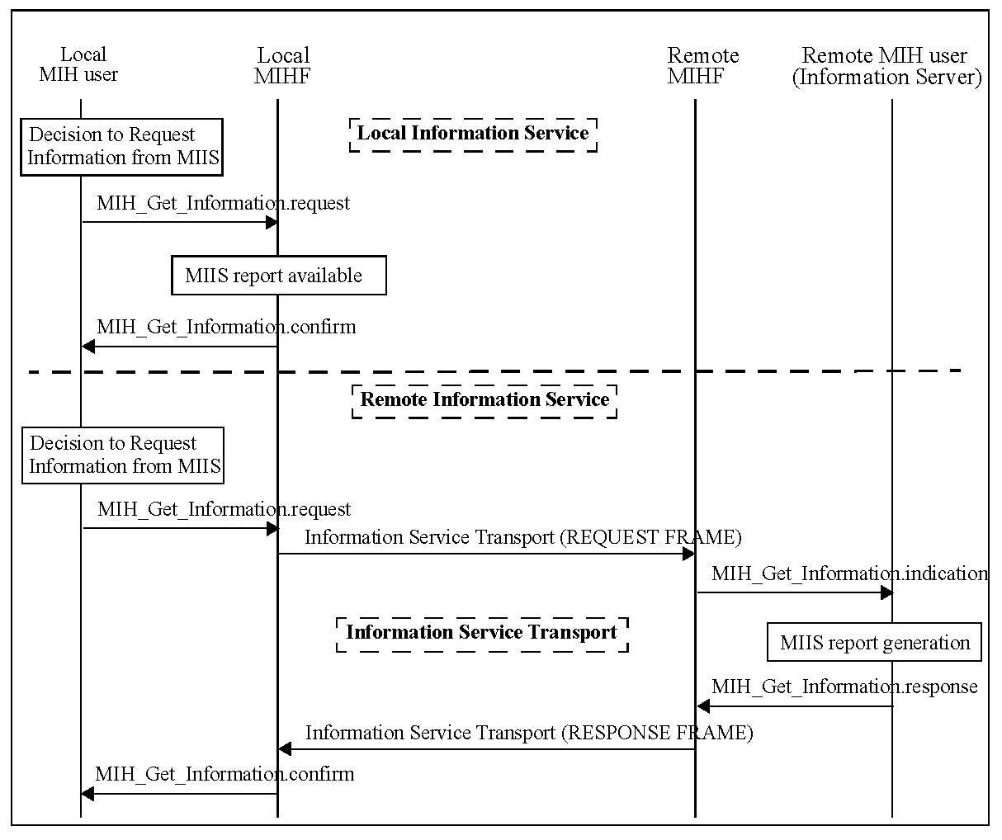
Figure 20—MIIS information flow

- Service access points (SAPs) and primitives
  - Introduction
The MIH Function uses the following SAPs for interfacing with other entities.
Media dependent SAPs:
- MIH_LINK_SAP: Abstract media dependent interface of MIHF with the lower layers of the media- specific protocol stacks. The mappings between MIH_LINK_SAP and various media-specific SAPs are described in E.2.
- MIH_NET_SAP: Abstract media dependent interface of MIHF that provides transport services over the data plane on the local node, supporting the exchange of MIH information and messages with the remote MIHF.
Media independent SAP:
- MIH_SAP: This SAP defines the media independent interface between the MIHF and MIH users.
  - SAPs
    - General
The SAPs are defined as a set of primitives. Taken together, the primitives define the services. Within the definition of each primitive there is a table of allowable parameters. Each parameter is defined using abstract data types. These types indicate the semantic value of that parameter. The parameters defined within the subclause for a particular primitive are produced or consumed by that primitive. Several of the abstract data types are used in multiple primitive definitions. In each abstract data type definition, the various names applied to this type are listed in Annex F.
    - Media dependent SAPs
      - MIH_LINK_SAP
The primitives defined as part of the MIH_LINK_SAP are described in Table 15. Annex E contains their mapping to several specific link technologies. IETF RFC 5184 [B27] specifies many of these primitives as L2 abstractions.
- —MIH_LINK_SAP primitives
Primitives | Service  category | Description | Defined  in
Link_Detected | Event | A new link is detected | 7.3.1
Link_Up | Event | L2 connectivity is established | 7.3.2
Link_Down | Event | L2 connectivity is lost | 7.3.3
Link_Parameters_Report | Event | Link parameters have crossed specified thresholds | 7.3.4
Link_Going_Down | Event | L2 connectivity loss is imminent | 7.3.5
Link_Handover_Imminent | Event | L2 handover is imminent | 7.3.6
Table 15—MIH_LIN K_SAP primitives (continued)
Primitives | Service  category | Description | Defined  in
Link_Handover_Complete | Event | L2 handover has been completed | 7.3.7
Link_PDU_Transmit_Status | Event | Indicate transmission status of a PDU | 7.3.8
Link_Capability_Discover | Command | Query and discover the list of supported link-layer events and link-layer commands | 7.3.9
Link_Event_Subscribe | Command | Subscribe for event notifications | 7.3.10
Link_Event_Unsubscribe | Command | Unsubscribe from event notifications | 7.3.11
Link_Get_Parameters | Command | Request parameters of medium | 7.3.12
Link_Configure_Thresholds | Command | Configure link thresholds for Link events | 7.3.13
Link_Action | Command | Request an action on a link-layer connection | 7.3.14

      - MIH_NET_SAP
The primitive defined for MIH_NET_SAP is described in Table 16.
- —MIH_NET_SAP primitive

Primitive | Service  category | Description | Defined  in
MIH_TP_Data | Network communication | This primitive is used for transfer of data | 7.5.1

    - Media independent SAP: MIH_SAP (some primitives deleted)
The primitives defined as part of MIH_SAP are described in Table 17.
- —MIH_SAP primitives
Primitives | Service  category | Description | Defined  in
MIH_Capability_Discover | Service management | Discover list of Events and Commands sup- ported by MIHF | 7.4.1
MIH_Register | Service management | Register with a remote MIHF | 7.4.2
MIH_DeRegister | Service management | Deregister with a remote MIHF | 7.4.3
MIH_Event_Subscribe | Service management | Subscribe for MIH event notifications | 7.4.4
MIH_Event_Unsubscribe | Service management | Unsubscribe from MIH event notifications | 7.4.5
MIH_Link_Detected | Event | A new link is detected | 7.4.6
Table 17—MIH_SAP primitives (continued)
Primitives | Service  category | Description | Defined  in
MIH_Link_Up | Event | L2 connection has been established | 7.4.7
MIH_Link_Down | Event | L2 connectivity is lost | 7.4.8
MIH_Link_Parameters_Report | Event | Link parameters have crossed specified threshold | 7.4.9
MIH_Link_Going_Down | Event | L2 connectivity is predicted to go down | 7.4.10
MIH_Link_Handover_Imminent | Event | L2 handover is imminent | 7.4.11
MIH_Link_Handover_Complete | Event | L2 handover has been completed | 7.4.12
MIH_Link_PDU_Transmit_Status | Event | Indicate transmission status of a PDU | 7.4.13
MIH_Link_Get_Parameters | Command | Get the status of link | 7.4.14
MIH_Link_Configure_Thresholds | Command | Configure link parameter thresholds | 7.4.15
MIH_Link_Actions | Command | Control the behavior of a set of links | 7.4.16
MIH_Net_HO_Candidate_Query | Command | Initiate handover | 7.4.17
MIH_MN_HO_Candidate_Query | Command | Initiate MN query request for candidate network | 7.4.18
MIH_N2N_HO_Query_Resources | Command | Query available network resources | 7.4.19
MIH_MN_HO_Commit | Command | Notify the serving network of the decided target network information | 7.4.20
MIH_Net_HO_Commit | Command | Network has committed to handover | 7.4.2 1
MIH_N2N_HO_Commit | Command | Notify target network that the serving network has committed to handover | 7.4.22
MIH_MN_HO_Complete | Command | Initiate MN handover complete notification | 7.4.23
MIH_N2N_HO_Complete | Command | Handover has been completed | 7.4.24
MIH_Get_Information | Information | Request to get information from repository | 7.4.25
MIH_Push_Information | Information | Notify the mobile node of operator policies or other information | 7.4.26

MIH command primitives defined in MIH_SAP indicates their destination as either the local MIHF or a remote MIHF. For the remote case, the local MIHF will first process the primitive to create an MIH message and then forward the message to the destination peer MIHF for execution. In those messages, there are TLV encoded parameters that implement the primitive parameter abstract data types within the protocol. The definition of the full binary encoding for each of these instantiations is in Annex F.
  - MIH_LINK_SAP primitives
    - Link_Detected .indication
      - Function
Link_Detected indicates the presence of a new PoA. This implies that the MN is in the coverage area. Link_Detected does not guarantee that the MN will be able to establish connectivity with the detected link, but just that the MN can attempt to gain connectivity. MIH users and the MIHF evaluate additional properties of the link before attempting to establish an L2 connection with the link. Moreover, Link_Detected is not generated when additional PoAs of the same link are discovered. In case of IEEE 802.11, Link_Detected is generated by MAC state generic convergence function (MSGCF).
      - Semantics of service primitive
Link_Detected.indication (
LinkDetectedInfo
)

Parameters:
Name | Data type | Description
LinkDetectedInfo | LINK_DET_INFO | Information of a detected link.

      - When generated
The Link Detected event is generated on the MN when the first PoA of an access network is detected. This event is not generated when subsequent PoAs of the same access network are discovered during the active connection on that link.
      - Effect on receipt
The MIHF receives this event from the link layer. The MIHF shall pass this notification to the MIH user(s) that has subscribed for this notification. The MIH user(s), including the MIHF itself, discovers additional properties of the link before selecting it for establishing connectivity.
    - Link_Up.indication
      - Function
This notification is delivered when a layer 2 connection is established on the specified link interface. All layer 2 activities in establishing the link connectivity are expected to be completed at this point of time.
      - Semantics of service primitive
Link_Up.indication (
LinkIdentifier,
OldAccessRouter,
NewAccessRouter,
IPRenewalFlag,
MobilityManagementSupport
)
Parameters:
Name | Data type | Description
LinkIdentifier | LINK_TUPLE_ID | Identifier of the link associated with the event.
OldAccessRouter | LINK_ADDR | (Optional) Old Access Router link address.
NewAccessRouter | LINK_ADDR | (Optional) New Access Router link address.
IPRenewalFlag | IP_RENEWAL_FLAG | (Optional) Indicates whether the MN needs to change IP Address in the new PoA.
MobilityManagementSupport | IP_MOB_MGMT | (Optional) Indicates the type of Mobility Management Protocol supported by the new PoA.

      - When generated
This notification is generated when a layer 2 connection is established for the specified link interface.
      - Effect on receipt
The MIHF shall pass this link notification to the MIH user(s) that has subscribed for this notification in an MIH_Link_Up event. The MIH user(s) takes different actions on this notification.
    - Link_Down.indication
      - Function
This notification is delivered when a layer 2 connection is no longer available for sending frames, that is, when the L2 connection with network is terminated and not during PoA to PoA transitions for the same network.
      - Semantics of service primitive
Link_Down.indication (
LinkIdentifier,
OldAccessRouter,
ReasonCode
)

Parameters:
Name | Data type | Description
LinkIdentifier | LINK_TUPLE_ID | Identifier of the link associated with the event.
OldAccessRouter | LINK_ADDR | (Optional) Old Access Router link address.
ReasonCode | LINK_DN_REASON | Reason why the link went down.

      - When generated
This notification is generated when layer 2 connectivity is lost. Layer 2 connectivity is lost explicitly in
cases where the MN initiates disassociate type procedures. In other cases, the MN can infer loss of link connectivity due to successive time-outs for acknowledgements of retransmitted packets along with loss of reception of broadcast frames.
      - Effect on receipt
The MIHF passes this link notification to the MIH user(s) that has subscribed for this notification in an MIH_Link_Down event. The MIH user(s) takes different actions on this notification. The handover policy function can eliminate this link from list of active links for routing connections and can consider handing over any potential active connections to other more suitable links.
    - Link_Parameters_Report.indication
      - Function
Link_Parameters_Report indicates changes in link conditions that have crossed specified threshold levels. Link_Parameters_Report is also generated at specified intervals for various parameters.
In the case of IEEE 802.11 network, this event is generated when higher protocol layers wish to monitor the performance parameters for a network. These higher layers can be on the network side (for network initiated handovers) and MIHF on the local MN can transfer these parameters. For local MN initiated handovers, the local station management entity (SME) and MSGCF would monitor link-layer properties and the MIHF would normally be interested only in the Link_Going_Down. indication.
NOTE—The primitive to set parameter thresholds that could trigger this event is specified in 7.3.13.
      - Semantics of service primitive
Link_Parameters_Report.indication(
LinkIdentifier,
LinkParametersReportList
)

Parameters
Name | Data type | Description
LinkIdentifier | LINK_TUPLE_ID | Identifier of the link associated with the event.
LinkParametersReportList | LIST(LINK_PARAM_RPT) | A list of Link Parameter Report.

      - When generated
For each specified parameter, this notification is generated either at a predefined regular interval determined by a user configurable timer or when it crosses a configured threshold.
      - Effect on receipt
The MIHF receives this event from the link layer. The MIHF then passes this notification to the MIH user(s) that has subscribed for this notification. The MIH user(s) takes different actions on this notification. If parameters related to link quality cross a certain threshold then that link needs to be evaluated for handing over current connections. The MIHF collectively evaluates different parameters and gives appropriate indications to higher layers regarding suitability of different links.
    - Link_Going_Down.indication
      - Function
This notification is delivered when a Layer 2 connection is expected (predicted) to go down (Link_Down) within a certain time interval. Link_Going_Down event can be the indication to initiate handover procedures.
      - Semantics of service primitive
Link_Going_Down.indication (
LinkIdentifier,
TimeInterval,
LinkGoingDownReason
)

Parameters:
Name | Data type | Description
LinkIdentifier | LINK_TUPLE_ID | Identifier of the link associated with the event.
TimeInterval | UNSIGNED_INT(2) | Time Interval (in milliseconds) specifies the time interval at which the link is expected to go down. A value of ‘0’ is specified if the time interval is unknown.
LinkGoingDownReason | LINK_GD_REASON | The reason why the link is going to be down.

      - When generated
A Link_Going_Down event implies that a Link_Down is imminent within a certain time interval. If Link_Down is NOT received within specified time interval then actions due to previous Link_Going_Down are ignored.
In the case of IEEE 802.11 networks, this notification is generated when the established IEEE 802.11 network connection is expected to go down within the specified time interval by the IEEE 802.11 MSGCF. The network is expected to go down because of an event whose timing is well understood, such as an explicit disconnection event observed on the MLME_SAP. This can also be expected as the result of a predictive algorithm that monitors link quality. The details of such a predictive algorithm used are beyond the scope of this standard. This event is not generated when the IEEE 802.11 station (STA) transitions from one AP to another in the same network.
      - Effect on receipt
The MIHF receives this event from the link layer. The MIHF then passes this notification to the MIH user(s) that has subscribed for this notification. MIH user(s) takes different actions on this notification. MIH users, then, prepare to initiate handovers.
    - Link_Handover_Imminent.indication (to be excluded)
    - Link_Handover_Complete.indication (to be excluded)
    - Link_PDU_Transmit_Status.indication
      - Function
Link_PDU_Transmit_Status indicates the transmission status of a higher layer PDU by the link layer. A success status indicates that the higher layer PDU has been successfully delivered from the link layer in the local node to the link layer in the peer node. A higher layer intermediate buffer management entity could use this indication to flush the delivered PDU from its buffer. A failure status indicates that the higher layer PDU identified in the indication was not delivered successfully from the link layer in the local node to the link layer in the peer node. During a handover, if such a failure indication is received from the link connection with the source network, the higher layer intermediate buffer management entity could attempt to retransmit the failed PDU once a connection to the target network is established.
A Packet Identifier is expected to be passed alongside when each higher layer PDU is sent from the higher layer to the link for transmission. The Packet Identifier is defined in this standard as a container structure whose syntax and semantics will be decided by the upper layer (i.e., the MIH user that subscribes to this event). The MIHF and link layer just pass and return the Packet Identifier and do not need to understand its syntax and semantics.
To avoid receiving excessive amount of link PDU transmission status indications, an MIH user, for example, chooses to subscribe to this event only after it receives a Link_Handover_Imminent.indication or when it is about to invoke an MIH_Link_Actions.request to perform a handover, and to unsubscribe from the event once it receives indication that the handover is completed.
      - Semantics of service primitive
Link_PDU_Transmit_Status.indication (
LinkIdentifier,
PacketIdentifier,
TransmissionStatus
)

Parameters:
Name | Data type | Description
LinkIdentifier | LINK_TUPLE_ID | Identifier of the link associated with the event.
PacketIdentifier | UNSIGNED_INT(2) | Identifier for higher layer PDU on which this notification is generated.
TransmissionStatus | BOOLEAN | Status of the transmitted packet. True: Success  False: Failure

      - When generated
A success notification is generated when a higher layer PDU is successfully transmitted over the link. A failure notification is generated when a higher layer PDU was not transmitted successfully.
      - Effect on receipt
The MIHF receives this event from the link layer. The MIHF then passes this notification to the MIH user(s) that has subscribed for this notification. The MIH user(s) takes different actions on this notification. A higher layer intermediate buffer management entity in MIH could use the success indication to flush higher layer packets stored in any intermediate buffers and a failure indication to retransmit higher layer packets stored in any intermediate buffers, especially if there are changes in the access network during handovers.
    - Link_Capability_Discover
      - Link_Capability_Discover.request
        - Function
This primitive is used by the MIHF to query and discover the list of supported link-layer events and link- layer commands.
        - Semantics of service primitive
No primitive parameters exist for this primitive.
Link_Capability_Discover.request ()
        - When generated
This primitive is generated by the MIHF when it needs to receive link-layer event notifications and learn about which link-layer commands the lower layer can support.
        - Effect on receipt
The recipient responds immediately with Link_Capability_Discover.confirm primitive.
      - Link_Capabi lity_Discover.confirm
        - Function
This primitive returns the result of the query to discover link-layer capability.
        - Semantics of service primitive
Link_Capability_Discover.confirm(
Status,
SupportedLinkEventList,
SupportedLinkCommandList
)

Parameters:
Name | Data type | Description
Status | STATUS | Status of operation. Code 3 (Authorization Failure) is not applicable.
SupportedLinkEventListª | LINK_EVENT_LIST | List of link-layer events supported by the link layer.
SupportedLinkCommandListª | LINK_CMD_LIST | List of link-layer commands supported by the link layer.
ªThis parameter is not included if Status does not indicate “Success.”

        - When generated
This primitive is generated in response to a Link_Capability_Discover.request primitive.
        - Effect on receipt
The recipient examines the returned event and command list and learns about link-layer capability. However, if Status does not indicate “Success,” the recipient performs appropriate error handling.
    - Link_Event_Subscribe
      - Link_Event_Subscribe.request
        - Function
This primitive is used by MIHF (the subscriber) to subscribe an interest in one or more events from a specific link-layer technology. The response indicates which of the requested events were successfully subscribed to. Events that were not successfully subscribed to will not be delivered to the subscriber.
        - Semantics of service primitive
Link_Event_Subscribe.request (
RequestedLinkEventList
)

Parameter:
Name | Data type | Description
RequestedLinkEventList | LINK_EVENT_LIST | List of link-layer events that for which the subscriber would like to receive indications.

        - When generated
This primitive is generated by a subscriber such as the MIHF that is seeking to receive event indications from different link-layer technologies.
        - Effect on receipt
The recipient responds immediately with Link_Event_Subscribe. confirm primitive.
      - Link_Event_Subscribe.confirm
        - Function
This primitive returns the result of the subscription request.
        - Semantics of service primitive
Link_Event_Subscribe.confirm (
Status,
ResponseLinkEventList
)

Parameters:
Name | Data type | Description
Status | STATUS | Status of operation. Code 3 (Authorization Failure) is not applicable.
ResponseLinkEventListª | LINK_EVENT_LIST | List of successfully subscribed link events.
ªThis parameter is not included if Status does not indicate “Success.”

        - When generated
This primitive is generated in response to a Link_Event_Subscribe.request primitive.
        - Effect on receipt
The recipient examines the ResponseLinkEventList and learns about the subscription status of different events. If Status does not indicate “Success,” the recipient performs appropriate error handling.
    - Link_Event_Unsubscribe
      - Link_Event_Unsubscribe.request
        - Function
This primitive is used by the MIHF (the subscriber) to unsubscribe from a set of previously subscribed link- layer events.
        - Semantics of service primitive
Link_Event_Unsubscribe.request (
RequestedLinkEventList
)

Parameter:
Name | Data type | Description
RequestedLinkEventList | LINK_EVENT_LIST | List of link-layer events for which indications need to be unsubscribed from the Event Source.

        - When generated
This primitive is generated by a subscriber such as the MIHF that is seeking to unsubscribe from an already subscribed set of events.
        - Effect on receipt
The recipient responds immediately with Link_Event_Unsubscribe. confirm primitive.
      - Link_Event_Unsubscribe.confirm
        - Function
This primitive returns the result of the request to unsubscribe from receiving link-layer event notifications.
        - Semantics of service primitive
Link_Event_Unsubscribe.confirm (
Status,
ResponseLinkEventList
)

Parameters:
Name | Data type | Description
Status | STATUS | Status of operation. Code 3 (Authorization Failure) is not applicable.
ResponseLinkEventListª | LINK_EVENT_LIST | List of successfully unsubscribed link events.
ªThis parameter is not included if Status does not indicate “Success.”
        - When generated
This primitive is generated in response to a Link_Event_Unsubscribe.request primitive.
        - Effect on receipt
The recipient can examine the ResponseLinkEventList and learn about the unsubscription status of different events. If Status does not indicate “Success,” the recipient performs appropriate error handling.
    - Link_Get_Parameters
      - Link_Get_Parameters.request
        - Function
This primitive is used by the MIHF to obtain the current value of a set of link parameters of a specific link.
        - Semantics of service primitive
Link_Get_Parameters.request (
LinkParametersRequest,
LinkStatesRequest,
LinkDescriptorsRequest
)

Parameter:
Name | Data type | Description
LinkParametersRequest | LIST(LINK_PARAM_TYPE) | A list of link parameters for which status is requested.
LinkStatesRequest | LINK_STATES_REQ | The link states to be requested.
LinkDescriptorsRequest | LINK_DESC_REQ | The link descriptors to be requested.

        - When generated
This primitive is generated by the MIHF to obtain the current value of a set of link parameters from a link.
        - Effect on receipt
The recipient link responds with Link_Get_Parameters.confirm primitive.
      - Link_Get_Parameters.confirm
        - Function
This primitive is sent in response to the Link_Get_Parameters.request primitive. This primitive provides current value of the requested link parameters.
NOTE—How the value is measured or calculated by the link is not specified by this standard.
        - Semantics of service primitive
Link_Get_Parameters.confirm (
Status,
LinkParametersStatusList,
LinkStatesResponse,
LinkDescriptorsResponse
)

Parameters:
Name | Data type | Description
Status | STATUS | Status of operation. Code 3 (Authorization Failure) is not applicable.
LinkParametersStatusListª | LIST(LINK_PARAM) | A list of measurable link parameters and their current values.
LinkStatesResponseª | LIST(LINK_STATES_RSP) | The current link state information.
LinkDescriptorsResponseª | LIST(LINK_DESC_RSP) | The descriptors of a link.
ªThis parameter is not included if Status does not indicate “Success.”

        - When generated
This primitive is generated in response to the Link_Get_Parameters.request operation.
        - Effect on receipt
The recipient passes the link parameter values received to the MIH users. However, if Status does not indicate “Success,” the recipient performs appropriate error handling.
    - Link_Configure_Thresholds
      - Link_Configure_Thresholds.request
        - Function
This primitive is used by the MIHF to configure thresholds and/or specify the time interval between periodic reports for the Link_Parameters_Report indication.
        - Semantics of service primitive
Link_Configure_Thresholds.request (
LinkConfigureParameterList
)

Parameter:
Name | Data type | Description
LinkConfigureParameterList | LIST(LINK_CFG_PARAM) | A list of link threshold parameters.

        - When generated
This primitive is generated by an MIHF that needs to set threshold values for different link parameters.
        - Effect on receipt
The recipient responds immediately with Link_Configure_Thresholds.confirm primitive.
      - Link_Configure_Thresholds.confirm
        - Function
This primitive is sent in response to the Link_Configure_Thresholds.request primitive. This primitive specifies the status of threshold configuration operation.
        - Semantics of service primitive
Link_Configure_Thresholds.confirm (
Status,
LinkConfigureStatusList
)
Parameters:
Name | Data type | Description
Status | STATUS | Status of operation. Code 3 (Authorization Failure) is not applicable.
LinkConfigureStatusListª | LIST(LINK_CFG_STATUS) | A list of Link Configure Status.
ªThis parameter is not included if Status does not indicate “Success.”

        - When generated
This primitive is generated in response to the Link_Configure_Thresholds.request operation.
        - Effect on receipt
The recipient prepares to receive Link_Parameters_Report indications on successful execution of this
primitive. However, if Status does not indicate “Success,” the recipient performs appropriate error handling.
    - Link_Action
      - Link_Action.request
        - Function
This primitive is used by the MIHF to request an action on a link-layer connection to enable optimal handling of link-layer resources for the purpose of handovers.
The link-layer connection can be ordered (e.g., to shut down) to remain active, to perform a scan, or to come up active and remain in stand-by mode. The command execution delay time can also be specified for cases where the link-layer technology under consideration supports the action.
        - Semantics of service primitive
Link_Action.request (
LinkAction,
ExecutionDelay,
PoALinkAddress
)
Parameters:
Name | Data type | Description
LinkAction | LINK_ACTION | Specifies the action to perform.
ExecutionDelay | UNSIGNED_INT(2) | Time (in ms) to elapse before the action needs to be taken. A value of 0 indicates that the action is taken immediately. Time elapsed is calculated from the instance the request arrives until the time when the execution of the action is carried out.
PoALinkAddress | LINK_ADDR | (Optional) The PoA link address to forward data to. This parameter is used when DATA_FWD_REQ action is requested.

        - When generated
The MIHF generates this primitive upon request from the MIH user to perform an action on a pre-defined link-layer connection.
        - Effect on receipt
Upon receipt of this primitive, the link-layer technology supporting the current link-layer connections performs the action specified by the Link Action parameter in accordance with the procedures specified by the relevant standards organization and at the time specified by the Execution Delay parameter.
      - Link_Action.confirm
        - Function
This primitive is used by link-layer technologies to provide an indication of the result of the action executed on the current link-layer connection.
        - Semantics of service primitive
Link_Action.confirm (
Status,
ScanResponseSet,
LinkActionResult
)

Parameters:
Name | Data type | Description
Status | STATUS | Status of the operation.  Code 3 (Authorization Failure) is not applicable.
ScanResponseSetª | LIST(LINK_SCAN_RSP) | (Optional) A list of discovered links and related information.
LinkActionResultª | LINK_AC_RESULT | Specifies whether the link action was successful.
ªThis parameter is not included if Status does not indicate “Success.”

        - When generated
The link-layer technology generates this primitive to communicate the result of the action executed on the link-layer connection.
        - Effect on receipt
Upon receipt of this primitive, the MIHF determines the relevant MIH command that needs to be used to provide an indication or confirmation to the MIH user of the actions performed on the current link-layer connection. If a Scan action was issued by the associated Link_Action.request, the optional ScanResponseSet field is included in the Link_Action.confirm response.
  - MIH_SAP primitives
The primitives defined as part of MIH_SAP are described in the following subclauses.
    - MIH_Capability_Discover
      - MIH_Capabi l ity_Discover.request
        - Function
This primitive is used by an MIH user to discover the capabilities of the local MIHF or a remote MIHF. When invoking this primitive to discover the capabilities of a remote MIHF, the MIH user can optionally piggyback the capability information of its local MIHF so that the two MIHFs can mutually discover each other’s capabilities with a single invocation of this primitive.
        - Semantics of service primitive
MIH_Capability_Discover.request (
DestinationIdentifier,
LinkAddressList,
SupportedMihEventList,
SupportedMihCommandList,
SupportedIsQueryTypeList,
SupportedTransportList,
MBBHandoverSupport
)

Parameters:
Name | Data type | Description
DestinationIdentifier | MIHF_ID | This identifies the local MIHF or a remote MIHF that will be the destination of this request.
LinkAddressList | LIST(NET_TYPE_ADDR) | (Optional) A list of network type and link address pair on the local MIHF.
SupportedMIHEventList | MIH_EVT_LIST | (Optional) List of supported events on the local MIHF.
SupportedMIHCommandList | MIH_CMD_LIST | (Optional) List of supported commands on the local MIHF.
SupportedISQueryTypeList | MIH_IQ_TYPE_LST | (Optional) List of supported MIIS query types on the local MIHF.
SupportedTransportList | MIH_TRANS_LST | (Optional) List of supported transport types on the local MIHF.
MBBHandoverSupport | LIST(MBB_HO_SUPP) | (Optional) This is used to indicate if a make before break handover is supported on the local MIHF. Break before make handover is always supported.

        - When generated
This primitive is generated by an MIH user to discover the capabilities of the local MIHF or a remote MIHF. In the case of remote discovery, this primitive contains the SupportedMihEventList, SupportedMihCommandList, SupportedIsQueryTypeList, SupportedTransportList, and MBBHandoverSupport parameters of the local MIHF to enable mutual discovery of each other’s capabilities.
        - Effect on receipt
If the destination of the request is the local MIHF itself, the local MIHF responds with MIH_Capability_Discover.confirm. If the destination of the request is a remote MIHF, the local MIHF shall generate a corresponding MIH_Capability_Discover request message to the remote MIHF if it does not have the capability information of the remote MIHF.
      - MI H_Capability_Discover. indication
        - Function
This primitive is used by an MIHF to notify an MIH user on the receipt of an MIH_Capability_Discover request message from a peer MIHF.
        - Semantics of service primitive
MIH_Capability_Discover.indication (
SourceIdentifier
LinkAddressList,
SupportedMihEventList,
SupportedMihCommandList,
SupportedIsQueryTypeList,
SupportedTransportList,
MBBHandoverSupport
)
Parameters:
Name | Data type | Description
SourceIdentifier | MIHF_ID | This identifies the invoker of this primitive, which is a remote MIHF.
LinkAddressList | LIST(NET_TYPE_ADDR) | (Optional) A list of network type and link address pair on the remote MIHF.
SupportedMIHEventList | MIH_EVT_LIST | (Optional) List of supported events on the remote MIHF.
SupportedMIHCommandList | MIH_CMD_LIST | (Optional) List of supported commands on the remote MIHF.
SupportedISQueryTypeList | MIH_IQ_TYPE_LST | (Optional) List of supported MIIS query types on the remote MIHF.
SupportedTransportList | MIH_TRANS_LST | (Optional) List of supported transport types on the remote MIHF.
MBBHandoverSupport | LIST(MBB_HO_SUPP) | (Optional) This is used to indicate if a make before break handover is supported on the remote MIHF. Break before make handover is always supported.

        - When generated
This primitive is used by an MIHF to notify an MIH user when an MIH_Capability_Discover request message is received. This primitive is optional since the MIHF can immediately return an MIH_Capability_Discover response message without generating this primitive to the MIH user.
        - Effect on receipt
The MIH user responds with an MIH_Capability_Discover.response primitive when an indication is received.
      - MI H_Capabil ity_Discover.response
        - Function
This primitive is used by an MIH user to convey the locally supported MIH capabilities to the MIH user that invoked the MIH_Capability_Discover request.
        - Semantics of Service primitive
MIH_Capability_Discover.response(
DestinationIdentifier,
Status,
LinkAddressList,
SupportedMihEventList,
SupportedMihCommandList,
SupportedIsQueryTypeList,
SupportedTransportList,
MBBHandoverSupport
)
Parameters:
Name | Data type | Description
DestinationIdentifier | MIHF_ID | This identifies the remote MIHF that will be the destination of this response.
Status | STATUS | Status of operation.
LinkAddressList | LIST(NET_TYPE_ADDR) | (Optional) A list of network type and link address pair on local MIHF.
SupportedMIHEventList | MIH_EVT_LIST | (Optional) List of supported events on local MIHF.
SupportedMIHCommandList | MIH_CMD_LIST | (Optional) List of supported commands on local MIHF.
SupportedISQueryTypeList | MIH_IQ_TYPE_LST | (Optional) List of supported MIIS query types on local MIHF.
SupportedTransportList | MIH_TRANS_LST | (Optional) List of supported transport types on local MIHF.
MBBHandoverSupport | LIST(MBB_HO_SUPP) | (Optional) This is used to indicate if a make before break handover is supported on local MIHF. Break before make handover is always supported.

        - When generated
This primitive is generated by an MIH user as a response to a received MIH_Capability_Discover.indication primitive.
        - Effect on receipt
Upon receiving this primitive, the MIHF shall generate and send the corresponding MIH_Capability_Discover response message to the destination MIHF.
      - MIH_Capabil ity_Discover.confirm
        - Function
This primitive is used by the MIHF to convey the supported MIH capabilities about Event Service, Command Service, and Information Service to the MIH user that invoked the MIH_Capability_Discover.request.
        - Semantics of service primitive
MIH_Capability_Discover.confirm (
SourceIdentifier,
Status,
LinkAddressList,
SupportedMihEventList,
SupportedMihCommandList,
SupportedIsQueryTypeList,
SupportedTransportList,
MBBHandoverSupport
)

Parameters:
Name | Data type | Description
SourceIdentifier | MIHF_ID | This identifies the invoker of this primitive, which can be either the local MIHF or a remote MIHF.
Status | STATUS | Status of operation.
LinkAddressList | LIST(NET_TYPE_ADDR) | (Optional) A list of network type and link address pair on the MIHF identified by Source Identifier.
SupportedMIHEventList | MIH_EVT_LIST | (Optional) List of supported events on the MIHF identified by Source Identifier.
SupportedMIHCommandList | MIH_CMD_LIST | (Optional) List of supported commands on the MIHF identified by Source Identifier.
SupportedISQueryTypeList | MIH_IQ_TYPE_LST | (Optional) List of supported MIIS query types on the MIHF identified by Source Identifier.
SupportedTransportList | MIH_TRANS_LST | (Optional) List of supported transport types on the MIHF identified by Source Identifier.
MBBHandoverSupport | LIST(MBB_HO_SUPP) | (Optional) This is used to indicate if a make before break handover is supported on the MIHF identified by Source Identifier. Break before make handover is always supported.

        - When generated
This primitive is invoked by a local MIHF to convey the results of a previous MIH_Capability_Discover.request primitive from an MIH user.
        - Effect on receipt
Upon reception of this primitive the receiving entity becomes aware of the supported MIH capabilities. However, if Status does not indicate “Success,” the recipient ignores any other returned values and, instead, performs appropriate error handling.
    - MIH_Register
      - MIH_Register.request
        - Function
This primitive is used by an MIH user to register the local MIHF with remote MIHF.
        - Semantics of service primitive
MIH_Register.request (
DestinationIdentifier,
LinkIdentifierList,
RequestCode
)

Parameters:
Name | Data type | Description
DestinationIdentifier | MIHF_ID | This identifies a remote MIHF that will be the destination of this request.
LinkIdentifierList | LIST(LINK_ID) | List of local link identifiers.
RequestCode | REG_REQUEST_CODE | Registration request code. Depending on the request code, the MIH user can choose to either register or re-register with the remote MIHF.

        - When generated
This primitive is invoked by the MIH user when it needs to register the local MIHF with a remote MIHF.
        - Effect on receipt
On receipt, the local MIHF sends an MIH_Register request message to the destination MIHF.
      - MIH_Register.indication
        - Function
This primitive is used by an MIHF to notify an MIH user that an MIH_Register request message has been received.
        - Semantics o f service primitive
MIH_Register.indication (
SourceIdentifier,
LinkIdentifierList,
RequestCode
)

Parameters:
Name | Data type | Description
SourceIdentifier | MIHF_ID | This identifies the invoker of this primitive, which is a remote MIHF.
LinkIdentifierList | LIST(LINK_ID) | List of link identifiers of the remote MIHF.
RequestCode | REG_REQUEST_CODE | Registration request code. Depending on the request code, the MIH user can choose to either register or re-register with the remote MIHF.

        - When generated
This primitive is generated by the remote MIHF when an MIH_Register request message is received.
        - Effect on receipt
The remote MIH user will perform necessary actions to process the registration request and respond with an MIH_Register.response.
      - MIH_Register.response
        - Function
This primitive is used by an MIH user to send the processing status of a received registration request.
        - Semantics of service primitive
MIH_Register.response (
DestinationIdentifier,
Status,
ValidTimeInterval
)

Parameters:
Name | Data type | Description
DestinationIdentifier | MIHF_ID | This identifies a remote MIHF, which will be the destination of this response.
Status | STATUS | Status of operation.
ValidTimeIntervalª | UNSIGNED_INT(4) | Time interval in seconds during which the registration is valid. Parameter applicable only when the status parameter indicates a successful operation. A value of 0 indicates an infinite validity period.
ªThis parameter is not included if Status does not indicate “Success.”

        - When generated
This primitive is invoked by the MIH user to report back the result after completing the processing of a registration request.
        - Effect on receipt
Upon receipt, the local MIHF sends an MIH_Register response message to the destination MIHF.
      - MIH_Register.confirm
        - Function
This primitive is used by the local MIHF to convey the result of a registration request to an MIH user.
        - Semantics of service primitive
MIH_Register.confirm (
SourceIdentifier,
Status,
ValidTimeInterval
)
Parameters:
Name | Data type | Description
SourceIdentifier | MIHF_ID | This identifies the invoker of this primitive, which is a remote MIHF.
Status | STATUS | Status of operation.
ValidTimeIntervalª | UNSIGNED_INT(4) | Time interval in seconds during which the registration is valid. Parameter applicable only when the status parameter indicates a successful operation. A value of 0 indicates an infinite validity period.
ªThis parameter is not included if Status does not indicate “Success.”

        - When generated
This primitive is used by an MIHF to notify an MIH user the result of an MIH registration request.
        - Effect on receipt
Upon receipt, the MIH user can determine the result of the registration request.
    - MIH_DeRegister
      - MIH_DeRegister.request
        - Function
This primitive is used by an MIH user to deregister the local MIHF with peer MIHF.
        - Semantics of service primitive
MIH_DeRegister.request (
DestinationIdentifier
)

Parameter:
Name | Data type | Description
DestinationIdentifier | MIHF_ID | This identifies a remote MIHF that will be the destination of this request.

        - When generated
This primitive is invoked by the MIH user when it needs to terminate an existing MIH registration with a remote MIHF.
        - Effect on receipt
Upon receipt, the local MIHF generates and sends an MIH_DeRegister request message to the destination MIHF.
      - MIH_DeRegister.indication
        - Function
This primitive is used by an MIHF to notify an MIH user that an MIH_DeRegister request message has been received.
        - Semantics of service primitive
MIH_DeRegister.indication(
SourceIdentifier )
)

Parameter:
Name | Data type | Description
SourceIdentifier | MIHF_ID | This identifies the invoker of this primitive, which is a remote MIHF.

        - When generated
This primitive is generated by an MIHF when an MIH_DeRegister request message is received.
        - Effect on receipt
The MIH user will perform necessary actions to process the deregistration request and respond with an MIH_DeRegister.response.
      - MIH_DeRegister.response
        - Function
This primitive is invoked by a remote MIH user to respond with the processing status of a received deregistration request.
        - Semantics of service primitive
MIH_DeRegister.response (
DestinationIdentifier,
Status
)

Parameters:
Name | Data type | Description
DestinationIdentifier | MIHF_ID | This identifies a remote MIHF, which will be the destination of this response.
Status | STATUS | Status of operation. Code 2 (Reject) is not used.

        - When generated
This primitive is invoked by the MIH user to report back the result after completing the processing of a deregistration request from a remote MIH user.
        - Effect on receipt
Upon receipt, the local MIHF sends an MIH_DeRegister response message to the destination MIHF.
      - MIH_DeRegister.confirm
        - Function
This primitive is used by the local MIHF to convey the result of a deregistration request to the local MIH user.
        - Semantics of service primitive
MIH_DeRegister.confirm (
SourceIdentifier,
Status
)

Parameters:
Name | Data type | Description
SourceIdentifier | MIHF_ID | This identifies the invoker of this primitive, which is a remote MIHF.
Status | STATUS | Status of operation. Code 2 (Rejected) is not used.

        - When generated
This primitive is used by an MIHF to notify the local MIH user the status of MIH deregistration request.
        - Effect on receipt
Upon receipt, the MIH user can determine the status of the deregistration request.
    - MIH_Event_Subscribe
      - MIH_Event_Subscribe.request
        - Function
This primitive is used by an MIH user (the subscriber) to subscribe an interest in one or more MIH event types from the local or a remote MIHF. Optionally, the subscriber indicates a list of specific configuration information applicable for various events being subscribed. If configured, the event must be triggered only when all the criteria set in the parameters are met.
        - Semantics of service primitive
MIH_Event_Subscribe.request (
DestinationIdentifier,
LinkIdentifier,
RequestedMihEventList,
EventConfigurationInfoList
)

Parameters:
Name | Data type | Description
DestinationIdentifier | MIHF_ID | This identifies the local MIHF or a remote MIHF that will be the destination of this request.
LinkIdentifier | LINK_TUPLE_ID | Identifier of the link for event subscription. For local event subscription, PoA link address need not be present if the link type lacks such a value.
RequestedMIHEventList | MIH_EVT_LIST | List of MIH events that the endpoint would like to receive indications for, from the Event Source.
EventConfigurationInfoList | LIST(EVT_CFG_INFO) | (Optional) List of additional configuration information for event subscription.

        - When generated
This primitive is invoked by an MIH user when it wants to receive indications on a set of specific MIH events from the local MIHF or a remote MIHF.
        - Effect on receipt
If the destination of the request is the local MIHF itself, the local MIHF responds immediately with an MIH_Event_Subscribe.confirm primitive. If the destination of the request is a remote MIHF, the local MIHF generates and sends an MIH_Event_Subscribe request message to the remote MIHF.
      - MIH_Event_Subscribe.confirm
        - Function
This primitive returns the result of an MIH event subscription request.
        - Semantics of service primitive
MIH_Event_Subscribe.confirm (
SourceIdentifier,
Status,
LinkIdentifier,
ResponseMihEventList
)

Parameters:
Name | Data type | Description
SourceIdentifier | MIHF_ID | This identifies the invoker of this primitive, which can be either the local MIHF or a remote MIHF.
Status | STATUS | Status of operation.
LinkIdentifier | LINK_TUPLE_ID | Identifier of the link for event subscription.
ResponseMIHEventListª | MIH_EVT_LIST | List of successfully subscribed MIH events.
ªThis parameter is not included if Status does not indicate “Success.”

        - When generated
This primitive is generated by the local MIHF at the completion of processing an MIH_Event_Subscribe.request primitive from a local MIH user or in response to the receiving of an MIH_Event_Subscribe response message from a peer MIHF.
        - Effect on receipt
The recipient MIH user examines the returned event list and learns about the subscription status of different events. However, if Status does not indicate “Success,” the recipient performs appropriate error handling.
    - MIH_Event_Unsubscribe
      - MIH_Event_Unsubscribe.request
        - Function
This primitive is used by an MIH user (the subscriber) to unsubscribe from a set of previous subscribed MIH events.
        - Semantics of service primitive
MIH_Event_Unsubscribe.request (
DestinationIdentifier,
LinkIdentifier,
RequestedMihEventList
)

Parameters:
Name | Data type | Description
DestinationIdentifier | MIHF_ID | This identifies the local MIHF or a remote MIHF, which will be the destination of this request.
LinkIdentifier | LINK_TUPLE_ID | Identifier of the link for event unsubscription. For local event unsubscription, PoA address in the Link Identifier need not be present if the link type lacks such a value.
RequestedMIHEventList | MIH_EVT_LIST | List of MIH events for which indications need to be unsubscribed from the Event Source.
        - When generated
This primitive is invoked by an MIH user (subscriber) that is seeking to unsubscribe from an already subscribed set of events from the local MIHF or a remote MIHF.
        - Effect on receipt
If the destination of the request is the local MIHF itself, the local MIHF responds immediately with MIH_Event_Unsubscribe.confirm primitive. If the destination of the request is a remote MIHF, the local MIHF generates and sends an MIH_Event_Unsubscribe request message to the remote MIHF.
      - MIH_Event_Unsubscribe.confirm
        - Function
This primitive returns the result of an MIH event unsubscription request.
        - Semantics of service primitive
MIH_Event_Unsubscribe.confirm (
SourceIdentifier,
Status,
LinkIdentifier,
ResponseMihEventList
)

Parameters:
Name | Data type | Description
SourceIdentifier | MIHF_ID | This identifies the invoker of this primitive, which can be either the local MIHF or a remote MIHF.
Status | STATUS | Status of operation.
LinkIdentifier | LINK_TUPLE_ID | Identifier of the link for event unsubscription.
ResponseMIHEventListª | MIH_EVT_LIST | List of successfully unsubscribed link events.
ªThis parameter is not included if Status does not indicate “Success.”

        - When generated
This primitive is generated by the local MIHF at the completion of processing an MIH_Event_Unsubscribe.request primitive from a local MIH user or in response to the receiving of an MIH_Event_Unsubscribe response message from a peer MIHF.
        - Effect on receipt
The recipient MIH user can examine the returned event list and learn about the unsubscription status of different events. However, if Status does not indicate “Success,” the recipient performs appropriate error handling.
    - MIH_Link_Detected.indication
      - Function
The MIH_Link_Detected.indication is sent to local MIHF users to notify them of a local event or of a receipt of MIH_Link_Detected indication message from a remote MIHF.
      - Semantics of the service primitive
MIH_Link_Detected.indication (
SourceIdentifier,
LinkDetectedInfoList
)

Parameters:
Name | Data type | Description
SourceIdentifier | MIHF_ID | This identifies the invoker of this primitive, which can be either the local MIHF or a remote MIHF.
LinkDetectedInfoList | LIST(LINK_DET_INFO) | List of link detection information.

      - When generated
The MIH_Link_Detected.indication is sent to local MIHF users to notify them of a local event (i.e., Link_Detected.indication), or of receipt of MIH_Link_Detected indication message from a remote MIHF (i.e., a remote Link_Detected event has occurred).
      - Effect on receipt
MIH user dependant.
    - MIH_Link_Up.indication
      - Function
The MIH_Link_Up.indication is sent to local MIHF users to notify them of a local event, or is the result of the receipt of an MIH_Link_Up indication message to indicate to the remote MIHF users who have subscribed to this remote event.
      - Semantics of the service primitive
MIH_Link_Up.indication (
SourceIdentifier,
LinkIdentifier,
OldAccessRouter,
NewAccessRouter,
IPRenewalFlag,
Mobility Management Support
)

Parameters:
Name | Data type | Description
SourceIdentifier | MIHF_ID | This identifies the invoker of this primitive, which can be either the local MIHF or a remote MIHF.
LinkIdentifier | LINK_TUPLE_ID | Identifier of the link associated with the event.
OldAccessRouter | LINK_ADDR | (Optional) Link address of old Access Router.
NewAccessRouter | LINK_ADDR | (Optional) Link address of new Access Router.
IPRenewalFlag | IP_RENEWAL_FLAG | (Optional) Indicates whether the MN needs to change IP Address in the new PoA.
MobilityManagementSupport | IP_MOB_MGMT | (Optional) Indicates the type of Mobility Management Protocol supported by the new PoA.

      - When generated
The MIH_Link_Up.indication is sent to local MIHF users to notify them of a local event (i.e., Link_Up.indication), or is the result of the receipt of an MIH_Link_Up indication message to indicate to the remote MIHF users who have subscribed to this remote event that a remote link up event occurred.
      - Effect on receipt
MIH user dependant.
    - MI H_Link_Down .ind ication
      - Function
The MIH_Link_Down.indication is sent to local MIHF users to notify them of a local event, or is the result of the receipt of an MIH_Link_Down indication message to indicate to the remote MIHF users who have subscribed to this remote event.
      - Semantics of the service primitive
MIH_Link_Down.indication (
SourceIdentifier,
LinkIdentifier,
OldAccessRouter,
ReasonCode
)

Parameters:
Name | Data type | Description
SourceIdentifier | MIHF_ID | This identifies the invoker of this primitive, which can be either the local MIHF or a remote MIHF.
LinkIdentifier | LINK_TUPLE_ID | Identifier of the link associated with the event.
OldAccessRouter | LINK_ADDR | (Optional) Link address of old Access Router.
ReasonCode | LINK_DN_REASON | Reason why the link went down.
      - When generated
The MIH_Link_Down.indication is sent to local MIHF users to notify them of a local event (i.e.,
Link_Down.indication), or is the result of the receipt of an MIH_Link_Down indication message to indicate to the remote MIHF users who have subscribed to this remote event that a remote link_down event occurred.
      - 4 Effect on receipt
MIH user dependant.
    - MIH_Link_Parameters_Report. indication
      - Function
MIH_Link_Parameters_Report indication is sent by the local MIHF to a local MIH user to report the status of a set of parameters of a local or remote link. This MIH event is either local or remote.
      - Semantics of service primitive
MIH_Link_Parameters_Report.Indication (
SourceIdentifier,
LinkIdentifier,
LinkParameterReportList
)

Parameters:
Name | Data type | Description
SourceIdentifier | MIHF_ID | This identifies the invoker of this primitive, which can be either the local MIHF or a remote MIHF.
LinkIdentifier | LINK_TUPLE_ID | Identifier of the link associated with the event.
LinkParameterReportList | LIST(LINK_PARAM_RPT) | A list of Link Parameter Reports.

      - When generated
This notification is generated by the local MIHF either
- At a predefined regular interval determined by a user configurable timer;
- When a specified parameter of a currently active local interface crosses a configured threshold. In such a case, the local MIHF most likely will first receive a Link_Parameters_Report. indication from the local link layer; or
- When an MIH_Link_Parameters_Report indication message is received from a remote MIHF.
      - Effect on receipt
Upper layer entities take different actions upon receipt of this indication.
    - MIH_Link_Going_Down.indication
      - Function
The MIH_Link_Going_Down.indication is sent to local MIHF users to notify them of a local event, or is the result of the receipt of an MIH_Link_Going_Down indication message to indicate to the remote MIHF users who have subscribed to this remote event.
      - Semantics of the service primitive
MIH_Link_Going_Down.indication (
SourceIdentifier,
LinkIdentifier,
TimeInterval,
LinkGoingDownReason
)

Parameters:
Name | Data type | Description
SourceIdentifier | MIHF_ID | This identifies the invoker of this primitive, which can be either the local MIHF or a remote MIHF.
LinkIdentifier | LINK_TUPLE_ID | Identifier of the link associated with the event.
TimeInterval | UNSIGNED_INT(2) | Time Interval (in milliseconds) specifies the time interval at which the link is expected to go down. A value of ‘0’ is specified if time interval is unknown or uncertain.
LinkGoingDownReason | LINK_GD_REASON | The reason why the link is going down.

      - When generated
The MIH_Link_Going_Down.indication is sent to local MIHF users to notify them of a local event (i.e., Link_Going_Down.indication), or is the result of the receipt of an MIH_Link_Going_Down indication message to indicate to the remote MIHF users who have subscribed to this remote event that a remote link_going_down event occurred.
      - Effect on receipt
MIH user dependant.
    - MIH_Link_Handover_Imminent.indication
      - Function
This primitive is issued by the MIHF to report the imminent occurrence of an intra-technology link handover. This MIH event is either local or remote. This indication directly corresponds to the link-layer event Link_Handover_Imminent.indication defined in 7.3.6.
      - Semantics of service primitive
MIH_Link_Handover_Imminent.indication (
SourceIdentifier,
OldLinkIdentifier,
NewLinkIdentifier,
OldAccessRouter,
NewAccessRouter
)

Parameters:
Name | Data type | Description
SourceIdentifier | MIHF_ID | This identifies the invoker of this primitive, which can be either the local MIHF or a remote MIHF.
OldLinkIdentifier | LINK_TUPLE_ID | Identifier of the old link.
NewLinkIdentifier | LINK_TUPLE_ID | Identifier of the new link.
OldAccessRouter | LINK_ADDR | (Optional) Link address of old Access Router.
NewAccessRouter | LINK_ADDR | (Optional) Link address of new Access Router.

      - When generated
This notification is generated by the MIHF when a link-layer intra-technology handover is about to occur. The event could be triggered by the reception of a Link_Handover_Imminent.indication from a link or on receipt of an MIH_Link_Handover_Imminent indication message.
      - Effect on receipt
Upper layer entities take different actions upon notification.
    - MI H_Link_Handover_Complete.indication
      - Function
This primitive is issued by the MIHF to report the completion of an intra-technology link handover. This MIH event is either local or remote. MIH_Link_Handover_Complete indication is a result of a Link_Handover_Complete indication from the link layer.
      - Semantics of service primitive
MIH_Link_Handover_Complete.indication (
SourceIdentifier,
OldLinkIdentifier,
NewLinkIdentifier,
OldAccessRouter,
NewAccessRouter,
)

Parameters:
Name | Data type | Description
SourceIdentifier | MIHF_ID | This identifies the invoker of this primitive, which can be either the local MIHF or a remote MIHF.
OldLinkIdentifier | LINK_TUPLE_ID | Identifier of the old link.
NewLinkIdentifier | LINK_TUPLE_ID | Identifier of the new link.
OldAccessRouter | LINK_ADDR | (Optional) Link address of old Access Router.
NewAccessRouter | LINK_ADDR | (Optional) Link address of new Access Router.

      - When generated
This notification is generated by the MIHF when a link-layer intra-technology handover is completed. The event could be triggered by the reception of a Link_Handover_Complete. indication from a link or on receipt of an MIH_Link_Handover_Complete indication message.
      - Effect on receipt
Upper layer entities take different actions on this notification. An MIH user makes use of this notification to configure other layers (IP, Mobile IP) for various upper layer handovers that are needed. Transport layers (e.g., TCP) also make use of this primitive to fine tune their flow control and flow congestion mechanisms.
    - MIH_Link_PD U_Transmit_Status.indication
      - Function
The MIH_Link_PDU_Transmit_Status.indication is sent to local MIHF users to notify them of a local event.
      - Semantics of the service primitive
MIH_Link_PDU_Transmit_Status.indication(
SourceIdentifier,
LinkIdentifier,
PacketIdentifier,
TransmissionStatus
)

Parameters:
Name | Data type | Description
SourceIdentifier | MIHF_ID | This identifies the local MIHF where this event occurred.
LinkIdentifier | LINK_TUPLE_ID | Identifier of the link associated with the event.
PacketIdentifier | UNSIGNED_INT(2) | Identifier for higher layer PDU on which this notification is generated.
TransmissionStatus | BOOLEAN | Status of the transmitted packet.  True: Success  False: Failure
      - When generated
The MIH_Link_PDU_Transmit_Status.indication is sent to local MIHF users to notify them of a local event (i.e., Link_PDU_Transmit_Status.indication).
      - Effect on receipt
MIH user dependant.
    - MIH_Link_Get_Parameters
      - General
An MIH_Link_Get_Parameters command is issued by upper layer entities to discover and monitor the status of the currently connected and potentially available links. This command is also used to get device state information. The destination of an MIH_Link_Get_Parameters command is local or remote. For example, an MIH_Link_Get_Parameters request issued by a local upper layer helps the policy function that resides out of the MIH to make optimal handover decisions for different applications when multiple links are available in an MN. However, a remotely initiated MIH_Link_Get_Parameters request from the network side enables the network to collect the status information on multiple links in an MN through the currently connected link.
      - MIH_Link_Get_Parameters.request
        - Function
This primitive is invoked by an MIH user to discover the status of the currently connected and potentially available links.
        - Semantics of the service primitive
MIH_Link_Get_Parameters.request (
DestinationIdentifier,
DeviceStatesRequest,
LinkIdentifierList,
GetStatusRequestSet
)

Parameters:
Name | Data type | Description
DestinationIdentifier | MIHF_ID | This identifies the local MIHF or a remote MIHF that will be the destination of this request.
DeviceStatesRequest | DEV_STATES_REQ | (Optional) List of device states being requested.
LinkIdentifierList | LIST(LINK_ID) | List of link identifiers for which status is requested. If the list is empty, return the status of all available links.
GetStatusRequestSet | LINK_STATUS_REQ | Indicate which link status(es) is being requested.

        - When generated
This primitive is invoked by an MIH user when it wants to request the status information of a set of local or remote links.
        - Effect of receipt
If the destination of the request is the local MIHF itself, the local MIHF gets the requested information on the status of the specified local links and responds with an MIH_Link_Get_Parameters.confirm. If the destination of the request is a remote MIHF, the local MIHF generates and sends an MIH_Link_Get_Parameters request message to the remote MIHF.
      - MIH_Link_Get_Parameters.confirm
        - Function
This primitive is issued by an MIHF to report the requested status of a set of specific local or remote links in response to an MIH_Link_Get_Parameters request from a local or remote MIH user.
        - Semantics of the service primitive
MIH_Link_Get_Parameters.confirm (
SourceIdentifier,
Status,
DeviceStatesResponseList,
GetStatusResponseList
)

Parameters:
Name | Data type | Description
SourceIdentifier | MIHF_ID | This identifies the invoker of this primitive, which can be either the local MIHF or a remote MIHF.
Status | STATUS | Status of operation.
DeviceStatesResponseListª | LIST(DEV_STATES_RSP) | (Optional) List of device states responses.
GetStatusResponseListª | LIST(  SEQUENCE(LINK_ID, LINK_STATUS_RSP)  ) | List of link status responses.
ªThis parameter is not included if Status does not indicate “Success.”

        - When generated
This primitive returns the results of an MIH_Link_Get_Parameters request to the requesting MIH user.
        - Effect of receipt
Upon receipt of the link status information, the MIH user makes appropriate decisions and takes suitable actions. However, if Status does not indicate “Success,” the recipient performs appropriate error handling.
    - MIH_Link_Configure_Thresholds
      - General
The MIH_Link_Configure_Thresholds is issued by an upper layer entity to configure parameter report thresholds of a lower layer. The destination of an MIH_Link_Configure_Thresholds command is local or remote. This command configures one or more thresholds on a link. When a given threshold is crossed, an MIH_Link_Parameters_Report notification shall be sent to all MIH users that are subscribed to this threshold-crossing event.
      - MIH_Link_Configure_Thresholds.request
        - Function
This primitive is issued by an MIH user to configure thresholds of a lower layer link.
        - Semantics of the service primitive
MIH_Link_Configure_Thresholds.request (
DestinationIdentifier,
LinkIdentifier,
ConfigureRequestList
)

Parameters:
Name | Data type | Description
DestinationIdentifier | MIHF_ID | This identifies the local MIHF or a remote MIHF that will be the destination of this request.
LinkIdentifier | LINK_TUPLE_ID | Identifier of the link to be configured.
ConfigureRequestList | LIST(LINK_CFG_PARAM) | A list of link threshold parameters.

        - When generated
This primitive is invoked by an MIH user when it attempts to configure thresholds of a local or remote lower layer link.
        - Effect of receipt
If the destination of the request is the local MIHF itself, the local MIHF issues a Link_Configure_Thresholds request to the lower layer link to set the thresholds for the link according to the specified configuration parameters.
If the destination of the request is a remote MIHF, the local MIHF generates and sends an MIH_Link_Configure_Thresholds request message to the remote MIHF. Upon the receipt of the message, the remote MIHF then issues a Link_Configure_Thresholds request to the lower layer link to set the thresholds for the link according to the specified configuration parameters.
      - MIH_Link_Configure_Thresholds.confirm
        - Function
This primitive is issued by an MIHF to report the result of an MIH_Link_Configure_Thresholds request.
        - Semantics of the service primitive
MIH_Link_Configure_Thresholds.confirm (
SourceIdentifier,
Status,
LinkIdentifier,
ConfigureResponseList
)

Parameters:
Name | Data type | Description
SourceIdentifier | MIHF_ID | This identifies the invoker of this primitive, which can be either the local MIHF or a remote MIHF.
Status | STATUS | Status of operation.
LinkIdentifier | LINK_TUPLE_ID | Identifier of the link configured.
ConfigureResponseListª | LIST(LINK_CFG_STATUS) | A list of the configuration status for each requested link threshold parameter.
ªThis parameter is not included if Status does not indicate “Success.”

        - When generated
This primitive returns the result of an MIH_Link_Configure_Thresholds request to the requesting MIH user.
        - Effect of receipt
Upon receipt of the result, the MIH user makes appropriate evaluations and takes any suitable actions. However, if Status does not indicate “Success,” the recipient performs appropriate error handling.
    - MIH_Link_Actions
      - MIH_Link_Actions.request
        - Function
This primitive is used by an MIH user to control the behavior of a set of local or remote lower layer links.
        - Semantics of service primitive
The parameters of the service primitive are as follows:
MIH_Link_Actions.request (
Destination Identifier,
LinkActionsList
)
Parameters:
Name | Data type | Description
DestinationIdentifier | MIHF_ID | This identifies the local MIHF or a remote MIHF that will be the destination of this request.
LinkActionsList | LIST(LINK_ACTION_REQ) | Specifies the suggested actions.

        - When generated
This primitive is invoked by an MIH user when it attempts to control the behavior of a set of local or remote lower layer links.
        - Effect on receipt
If the destination of the request is the local MIHF itself, the local MIHF issues Link_Action.request(s) to the specified lower layer link(s).
If the destination of the request is a remote MIHF, the local MIHF generates and sends an MIH_Link_Actions request message to the remote MIHF. Upon the receipt of the message, the remote MIHF then issues Link_Action.request(s) to the specified lower layer link(s).
      - MIH_Link_Actions.confirm
        - Function
This primitive is issued by an MIHF to report the result of an MIH_Link_Actions request.
        - Semantics of the service primitive
The parameters of the primitive are as follows:
MIH_Link_Actions.confirm (
SourceIdentifier,
Status,
LinkActionsResultList
)

Parameters:
Name | Data type | Description
SourceIdentifier | MIHF_ID | This identifies the invoker of this primitive, which can be either the local MIHF or a remote MIHF.
Status | STATUS | Status of operation.
LinkActionsResultListª | LIST(LINK_ACTION_RSP) | Contain the result of the request link actions.
ªThis parameter is not included if Status does not indicate “Success.”

        - When generated
This primitive returns the result of an MIH_Link_Actions.request to the requesting MIH user.
        - Effect on receipt
Upon receipt of the result, the MIH user makes appropriate evaluations and takes any suitable actions. However, if Status does not indicate “Success,” the recipient performs appropriate error handling.
    - MIH_Net_HO_Candidate_Query (to be excluded)
    - MIH_MN_HO_Candidate_Query (to be excluded)
    - MIH_N2N_HO_Query_Resources (to be excluded)
    - MIH_MN_HO_Commit (to be excluded)
    - MIH_Net_HO_Commit (to be excluded)
    - MIH_N2N_HO_Commit (to be excluded)
    - MIH_MN_HO_Complete (to be excluded)
    - MIH_N2N_HO_Complete (to be excluded)
    - MIH_Get_Information
      - MIH_Get_Information.request
        - Function
This primitive is used by an MIH user to request information from an MIH information server. The information query is related to a specific interface, attributes to the network interface, as well as the entire network capability. The service primitive has the flexibility to query either a specific data within a network interface or extended schema of a given network. It is assumed that the available information could be broadcast in access technology specific manner such as in IEEE Std 802.11 and IEEE Std 802.16.
        - Semantics of service primitive
MIH_Get_Information.request (
DestinationIdentifier,
InfoQueryBinaryDataList,
InfoQueryRDFDataList,
InfoQueryRDFSchemaURL,
InfoQueryRDFSchemaList,
MaxResponseSize,
QuerierNetworkType,
UnauthenticatedInformationRequest
)

Parameters:
Name | Data type | Description
Destination Identifier | MIHF_ID | The local MIHF or a remote MIHF that will be the destination of this request.
InfoQueryBinaryDataList | LIST(IQ_BIN_DATA) | (Optional) A list of TLV queries. The order of the queries in the list identifies the priority of the query. The first query has the highest priority to be processed by MIIS. See Table F.15 for detailed definition.
InfoQueryRDFDataList | LIST(IQ_RDF_DATA) | (Optional) A list of RDF queries. The order of the queries in the list identifies the priority of the query. The first query has the highest priority to be processed by MIIS. See Table F.16 for detailed definition.
InfoQueryRDFSchemaURL | BOOLEAN | (Optional) A RDF Schema URL query. This field is required only when the value is “TRUE,” which indicates to query a list of RDF schema URLs.
InfoQueryRDFSchemaList | LIST(IQ_RDF_SCHM) | (Optional) A list of RDF schema queries. The order of the queries in the list identifies the priority of the query. The first query has the highest priority to be processed by MIIS.
MaxResponseSize | UNSIGNED_INT(2) | (Optional) This field specifies the maximum size of Info Response parameters in MIH_Get_Information response primitive in octets. If this field is not specified, the maximum size is set to 65 535. The actual maximum size forced by the IS server can be smaller than that specified by the IS client.
QuerierNetworkType | NETWORK_TYPE | (Optional) The type of the network being used by the querier. This parameter is valid only with InfoQueryBinaryDataList and InfoQueryRDFDataList.
UnauthenticatedInformation- Request | BOOLEAN | The value of UIR bit to be set in the MIH_Get_Information request message sent to the remote MIHF.

One and only one of the following parameters is specified:
- InfoQueryBinaryDataList
- InfoQueryRDFDataList
- InfoQueryRDFSchemaURL
- InfoQueryRDFSchemaList
        - When generated
This primitive is generated by an MIH user that is seeking to retrieve information.
The order of the queries in each of InfoQueryBinaryDataList, InfoQueryRDFDataList, and InfoQueryRDF SchemaList parameters identifies the priority of the query. The first query has the highest priority to be processed by MIIS.
        - Effect on receipt
If the DestinationIdentifer contains a remote MIHF, then the recipient shall forward the query in an MIH_Get_Information request message to the designated MIIS server. If the DestinationIdentifer is for the local MIHF, then the recipient shall interpret the query request and retrieve the specified information.
      - MIH_Get_Information. indication
        - Function
This primitive is used by the MIHF to indicate that an MIH_Get_Information request message is received from a peer MIHF.
        - Semantics of service primitive
MIH_Get_Information.indication (
SourceIdentifier,
InfoQueryBinaryDataList,
InfoQueryRDFDataList,
InfoQueryRDFSchemaURL,
InfoQueryRDFSchemaList,
MaxResponseSize,
QuerierNetworkType,
UnauthenticatedInformationRequest
)

Parameters:
Name | Data type | Description
SourceIdentifier | MIHF_ID | Specifies the MIHF ID of the node that sent the MIH_GET_Information request message.
InfoQueryBinaryDataList | LIST(IQ_BIN_DATA) | (Optional) A list of TLV queries. The order of the queries in the list identifies the priority of the query. The first query has the highest priority to be processed by MIIS. See Table F. 15 for detailed definition.
InfoQueryRDFDataList | LIST(IQ_RDF_DATA) | (Optional) A list of RDF queries. The order of the queries in the list identifies the priority of the query. The first query has the highest priority to be processed by MIIS.
InfoQueryRDFSchemaURL | BOOLEAN | (Optional) A RDF Schema URL query. This field is required only when the value is “TRUE,” which indicates to query a list of RDF schema URLs.
InfoQueryRDFSchemaList | LIST(IQ_RDF_SCHM) | (Optional) A list of RDF schema queries. The order of the queries in the list identifies the priority of the query. The first query has the highest priority to be processed by MIIS.
MaxResponseSize | UNSIGNED_INT(2) | (Optional) This field specifies the maximum size of Info Response parameters in MIH_Get_Information response primitive in octets. If this field is not specified, the maximum size is set to 65 535. The actual maximum size forced by the IS server can be smaller than that specified by the IS client.
QuerierNetworkType | NETWORK_TYPE | (Optional) The type of the network being used by the querier. This parameter is valid only with InfoQueryBinaryDataList and InfoQueryRDFDataList.
UnauthenticatedInformation- Request | BOOLEAN | The value of UIR bit contained in the MIH_Get_Information request message received from the remote MIHF.

        - When generated
This primitive is generated by the MIHF on receiving an MIH_Get_Information request message from a peer MIHF. The order of the queries in each of InfoQueryBinaryDataList, InfoQueryRDFDataList, and InfoQueryRDFSchemaList parameters identifies the priority of the query. The first query has the highest priority to be processed by MIIS. Thus the order of the queries is maintained as indicated by the request message.
        - Effect on receipt
The recipient interprets the query request and retrieves the specified information. Once the information is retrieved, the recipient replies with the MIH_Get_Information.response primitive.
      - MIH_Get_Information.response
        - Function
This primitive is used by an MIH user (i.e., MIIS Server) to respond to an MIH_GET_Information.indication primitive.
        - Semantics of service primitive
MIH_Get_Information.response (
DestinationIdentifier,
Status,
InfoResponseBinaryDataList,
InfoResponseRDFDataList,
InfoResponseRDFSchemaURLList,
InfoResponseRDFSchemaList
)

Parameters:
Name | Data type | Description
DestinationIdentifier | MIHF_ID | The local MIHF or a remote MIHF that will be the destination of this response.
Status | STATUS | Status of operation.  The response lists contains meaningful data if and only if the status is ‘0’.
InfoResponseBinaryDataList | LIST(IR_BIN_DATA) | (Optional) A list of TLV query responses. The list will be sorted from most preferred first to least preferred last.
InfoResponseRDFDataList | LIST(IR_RDF_DATA) | (Optional) A list of RDF query responses. The list will be sorted from most preferred first to least preferred last.
InfoResponseRDFSchemaURLList | LIST(IR_SCHM_URL) | (Optional) A list of RDF Schema URL. The list will be sorted from most preferred first to least preferred last.
InfoResponseRDFSchemaList | LIST(IR_RDF_SCHM) | (Optional) A list of RDF schema query responses. The list will be sorted from most preferred first to least preferred last.

        - When generated
This primitive is generated by an MIH user in response to a received MIH_Get_Information.indication primitive. When the size of the Info Response parameters exceeds the maximum size specified in the MaxResponseSize parameter from MIH_Get_Information.indication primitive, one or more of the lower order list elements in Info Response parameters must be omitted.
        - Effect on receipt
The recipient will return an MIH_Get_Information response message to the designated MIIS client.
      - MIH_Get_Information.confirm
        - Function
This primitive is used by the MIHF to respond to an MIH_GET_Information.request primitive.
        - Semantics of service primitive
MIH_Get_Information.confirm (
SourceIdentifier,
Status,
InfoResponseBinaryDataList,
InfoResponseRDFDataList,
InfoResponseRDFSchemaURLList,
InfoResponseRDFSchemaList
)

Parameters:
Name | Data type | Description
SourceIdentifier | MIHF_ID | Specifies the MIHF ID of the node that invoked MIH_GET_Information.response.
Status | STATUS | Status of operation.  The response lists contains meaningful data if and only if the status is ‘0’.
InfoResponseBinaryDataList | LIST(IR_BIN_DATA) | (Optional) A list of TLV query responses. The list will be sorted from most preferred first to least preferred last.
InfoResponseRDFDataList | LIST(IR_RDF_DATA) | (Optional) A list of RDF query responses. The list will be sorted from most preferred first to least preferred last.
InfoResponseRDFSchemaU- RLList | LIST(IR_SCHM_URL) | (Optional) A list of RDF Schema URL. The list will be sorted from most preferred first to least preferred last.
InfoResponseRDFSchemaList | LIST(IR_RDF_SCHM) | (Optional) A list of RDF schema query responses. The list will be sorted from most preferred first to least preferred last.

        - When generated
This primitive is generated by the MIHF on receiving an MIH_Get_Information Response message from a peer MIHF.
        - Effect on receipt
The MIH user that requested the information utilizes the Info Response parameters and takes suitable action. However, if Status does not indicate “Success,” the recipient ignores any other returned values and, instead, performs appropriate error handling.
When the size of the Info Response parameters exceeds the maximum size specified in the MaxResponseSize parameter from MIH_Get_Information.request primitive, one or more of the lower order list elements in Info Response parameters must be omitted.
    - MIH_Push_Information
      - MIH_Push_Information.request
        - Function
This primitive is used by an MIH user (i.e., MIIS Server) to push information to the MN. MIH_Push_Information is generated by the MIIS Server to update policy information following a successful registration. This primitive can be generated at any time during the life time of the registration.
        - Semantics of service primitive
MIH_Push_Information.request (
DestinationIdentifier,
InfoResponseBinaryDataList,
InfoResponseRDFDataList,
InfoResponseRDFSchemaURLList,
InfoResponseRDFSchemaList
)

Parameters:
Name | Data type | Description
DestinationIdentifier | MIHF_ID | The remote MIHF, which is the destination of this request.
InfoResponseBinary- DataList | LIST(IR_BIN_DATA) | (Optional) A list of binary representations of Information Elements. This list will be sorted from most preferred first to least preferred last. This list can include vendor specific IE’s for representing network policies.
InfoResponseRDF- DataList | LIST(IR_RDF_DATA) | (Optional) A list of network information in RDF. The list will be sorted from most preferred first to least preferred last. This list can include operator specific RDF data that can be used to represent operator policies.
InfoResponseRDF- SchemaURLList | LIST(IR_SCHM_URL ) | (Optional) A list of RDF Schema URL supported by the network. The list will be sorted from most preferred first to least preferred last.
InfoResponseRDF- SchemaList | LIST(IR_RDF_SCHM) | (Optional) A list of RDF Schema content supported by the network. The list will be sorted from most preferred first to least preferred last.

At least one of the following parameters is specified: — InfoResponseBinaryDataList
- InfoResponseRDFDataList
- InfoResponseRDFSchemaURLList
- InfoResponseRDFSchemaList
        - When generated
This primitive is generated by the MIIS server to update any policies on the MN or to update any other IEs from the MIIS on to the MN.
        - Effect on receipt
The recipient will return an MIH_Push_Information indication message.
      - MIH_Push_Information. indication
        - Function
This primitive is used by the MIHF to notify MIH users of the information. This primitive is the result of receipt of an MIH_Push_information indication message from a remote MIHF.
        - Semantics of service primitive
MIH_Push_Information.indication (
SourceIdentifier,
InfoResponseBinaryDataList,
InfoResponseRDFDataList,
InfoResponseRDFSchemaURLList,
InfoResponseRDFSchemaList
)

Parameters:
Name | Data type | Description
SourceIdentifier | MIHF_ID | The remote MIHF, which is the source of this request.
InfoResponseBinary- DataList | LIST(IR_BIN_DATA) | (Optional) A list of binary representations of Information Elements. This list will be sorted from most preferred first to least preferred last. This list can include vendor specific IEs for representing network policies.
InfoResponseRDF- DataList | LIST(IR_RDF_DATA) | (Optional) A list of network information in RDF. The list will be sorted from most preferred first to least preferred last. This list can include operator specific RDF data that can be used to represent operator policies.
InfoResponseRDF- SchemaURLList | LIST(IR_SCHM_URL ) | (Optional) A list of RDF Schema URL supported by the network. The list will be sorted from most preferred first to least preferred last.
InfoResponseRDF- SchemaList | LIST(IR_RDF_SCHM) | (Optional) A list of RDF Schema content supported by the network. The list will be sorted from most preferred first to least preferred last.

        - When generated
This primitive is generated by the MIHF upon receiving an MIH_Push_Information indication message.
        - Effect on receipt
Upper layer entities take different actions upon notification.
  - MIH_NET_SAP primitives
    - MIH_TP_Data
The primitives associated with data transfers are as follows:
- MIH_TP_Data.request
- MIH_TP_Data.indication
- MIH_TP_Data.confirm
The MIHF uses the MIH_TP_Data.request primitive to request that an MIH PDU be transported. The transport service provider uses the MIH_TP_Data.indication primitive to indicate the arrival of an MIH PDU. MIH_TP_Data.confirm primitive is used to acknowledge the successful transfer of the MIH PDU.
      - MIH_TP_Data.request
        - Function
This primitive is the request for transfer of an MIH PDU.
        - Semantics
MIH_TP_Data.request (
TransportType,
SourceAddress,
DestinationAddress,
ReliableDeliveryFlag,
MIHProtocolPDU
)

Parameters:
Name | Data type | Description
TransportType | TRANSPORT_TYPE | Identifies the protocol layer specific transport option.
SourceAddress | TRANSPORT_ADDR | Protocol layer specific Transport Address of entity that has the Source MIHF.
DestinationAddress | TRANSPORT_ADDR | Protocol layer specific Transport Address of entity that has the Destination MIHF.
ReliableDeliveryFlag | BOOLEAN | Indicate that the data is sent reliably and an error is generated if delivery fails.  True: Reliable delivery is required.  False: Reliable delivery is not required.
MIHProtocolPDU | OCTET_STRING | MIH Protocol PDU to be transferred.

        - When generated
This primitive is used to request that an MIH PDU be transported to a remote MIHF.
        - Effect on receipt
The receipt of this primitive causes the selected transport service provider to attempt to transport the MIH PDU.
      - MIH_TP_Data.indication
        - Function
This primitive is the indication of a received MIH PDU.
        - Semantics
MIH_TP_Data.indication (
TransportType,
SourceAddress,
DestinationAddress,
ReliableDeliveryFlag,
MIHProtocolPDU
)

Parameters:
Name | Data type | Description
TransportType | TRANSPORT_TYPE | Identifies the protocol layer specific transport option.
SourceAddress | TRANSPORT_ADDR | Protocol layer specific Transport Address of entity that has the Source MIHF.
DestinationAddress | TRANSPORT_ADDR | Protocol layer specific Transport Address of entity that has the Destination MIHF.
ReliableDeliveryFlag | BOOLEAN | Indicate that the data is sent reliably and an error generated if delivery fails.  True: Reliable delivery is required.  False: Reliable delivery is not required.
MIHProtocolPDU | OCTET_STRING | MIH Protocol PDU received.

        - When generated
This primitive is used by the transport service provider to indicate that an MIH PDU has been received from a remote MIHF.
        - Effect on receipt
The receipt of this primitive causes the MIHF to receive the MIH PDU that was transported.
      - MIH_TP_Data.confirm
        - Function
This primitive is used to confirm an acknowledged transfer.
        - Semantics
MIH_TP_Data.confirm (
Status,
TransportType,
SourceAddress,
DestinationAddress
)

Parameters:
Name | Data type | Description
Status | STATUS | Status of operation.
TransportType | TRANSPORT_TYPE | Identifies the protocol layer specific transport option.

SourceAddress | TRANSPORT_ADDR | Protocol layer specific Transport Address of entity that has the Source MIHF.
DestinationAddress | TRANSPORT_ADDR | Protocol layer specific Transport Address of entity that has the Destination MIHF.

        - When generated
This primitive is passed from the transport service provider to the MIHF to confirm that a request to transfer an MIH PDU succeeded.
        - Effect on receipt
Upon receipt of this primitive, the receiving MIHF stops its retransmission timer for the corresponding request. When the MIHF does not receive this primitive for a pre-defined time after transmitting an MIH_TP_Data.request with ReliableDeliveryFlag set to TRUE, the MIHF attempts to retransmit the MIH_TP_Data.request.
- Media independent handover protocol
  - Introduction
The MIH Function entities in MN and network entities communicate with each other using the MIH protocol messages specified in this clause. The MIH protocol defines message formats for exchanging these messages between peer MIH Function entities. These messages are based on the primitives that are part of the MIH Services.
  - MIH protocol description
    - MIH protocol transaction
The media independent handover protocol defines a message exchange between two MIHF entities to support remote MIHF services. An MIH transaction is identified by a sequence of messages with the same Transaction-ID submitted to, or received from, one specific remote MIHF ID.
At any given moment, an MIH node shall have no more than one transaction pending for each direction with a certain MIH peer. In other words, the MIH node shall wait until any pending outgoing transaction is completed before it creates another outgoing transaction for the same peer. Similarly, the MIH node shall wait until any pending incoming transaction is completed before it creates another incoming transaction for the same peer.
    - MIH protocol acknowledgement service
The acknowledgement service shall be used when the MIH transport used for remote communication does not provide reliable services. When the MIH transport is reliable, the use of the acknowledgement service is not needed. The acknowledgement service is particularly useful when the underlying transport used for remote communication does not provide reliable services. When the MIH transport is reliable, the acknowledgement service is optional.
The source MIHF requests for an acknowledgement message to ensure successful receipt of an MIH protocol message. This MIH message is used to acknowledge the successful receipt of an MIH protocol message at the destination MIHF.
The MIH acknowledgement service is supported by the use of two bits of information that are defined exclusively for acknowledgement (ACK) usage in the MIH header. The ACK-Req bit is set by the source MIH node and the ACK-Rsp bit is set by the destination MIH node to utilize the acknowledgement service. It is expected that the underlying transport layer would take care of ensuring the integrity of the MIH protocol message during delivery.
When seeking acknowledgement service, the source MIH node shall start a retransmission timer after sending an MIH protocol message with the ACK-Req bit set and saves a copy of the MIH protocol message while the timer is active. The algorithm defined in IETF RFC 2988 is used to calculate the value of the retransmission timer. If the acknowledgement message is not received before the expiration of the timer, the source MIH node immediately retransmits the saved message with the same Message-ID and with the same Transaction-ID (with ACK-Req bit set). If the source MIH node receives the acknowledgement before the expiration of the timer on the first or any subsequent retransmitted attempt, then the source MIH node has ensured the receipt of the MIH packet and therefore, resets the timer and releases the saved copy of the MIH protocol message. During retransmission, if the source MIH node receives the acknowledgement for any of the previous transmission attempts then the source MIH node determines successful delivery of the message and does not have to wait for any further acknowledgements for the current message. The source MIH node retransmits an MIH protocol message with ACK-Req bit set until it receives an acknowledgment or the number of retransmissions reaches its maximum value. The maximum number of retransmissions can be configured through a parameter defined in the MIB (see Annex J). The source MIH node does not attempt to retransmit a message with same Message-ID and Transaction-ID when the ACK-Req bit was not set in the first MIH message. Implementations may consider adjusting the retransmission time-out (RTO) when operating over links with power save mobile nodes.
When a destination MIH node receives an MIH protocol message with the ACK-Req bit set, then the destination MIH node returns an MIH message with the ACK-Rsp bit set and copying the Message-ID and Transaction-ID from the received MIH protocol message. The MIH message with the ACK-Rsp bit set has only the MIH header and no other payload. In instances where the destination MIH node immediately processes the received MIH protocol message and a response is immediately available, then the ACK-Rsp bit is set in the corresponding MIH protocol response message.
The destination MIH node responds with an acknowledgement message for duplicate MIH messages (messages with same transaction-ID) that have the ACK-Req bit set. However, the destination MIH node does not process these duplicate messages if it has already done so. If a destination MIH node receives an MIH protocol message with no ACK-Req bit set, then no action is taken with respect to the acknowledgement service.
In all cases, the MIH protocol message in a transaction is processed only once at the destination MIH node, irrespective of the number of received messages with the ACK-Req bit set. The destination MIH node sets the ACK-Rsp bit in an MIH protocol response message and additionally requests acknowledgement by setting the ACK-Req bit for the same MIH protocol response message.
    - MIH protocol transaction state diagram
      - State machines
A node that has a new available message to send related to a new transaction is called transaction source and starts the transaction source state machine. In the same manner, a node that receives a message related to a new transaction is called transaction destination node and starts the destination transaction state machine.
If the ACK feature is being used by the source and/or destination transaction node, the ACK-Requestor and/ or ACK-Responder state machine is started (specific conditions specified below). The ACK related state machine is run in parallel to the transaction source/destination state machines.
Each transaction is represented in an MIHF by an instance of the transaction source or destination state machine. Optionally, each transaction can also have one instance of ACK-Requestor or one instance of ACK-Responder state machine, or both.
All instances of the state machines related to one transaction have access to inter-state-machine variables, constants and procedures, which are not accessible by the state machines related to other transactions. The inter-state-machine variables allow communications between state machines for a given transaction. There are no cases where two or more state machines for a given transaction write the same inter-state-machine variable at the same time. Intra-state-machine variables, constants, and procedures can only be accessed within a single state machine for a given transaction.
Figure 21 illustrates the interaction of transaction source/destination state machines with the ACK related state machines.
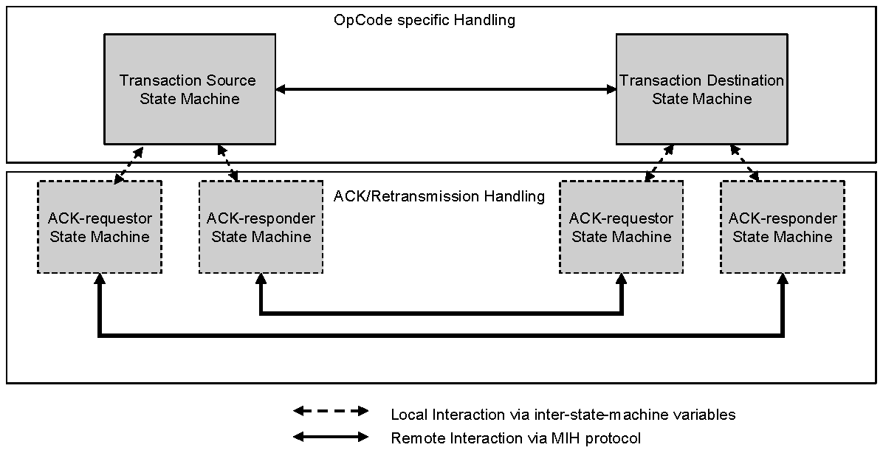
Figure 21—State machines interactions
      - Notational conventions used in state diagrams
State diagrams are used to represent the operation of an MIH transaction as a group of connected, mutually exclusive states. At any given time, only one state of each state machine can be active per transaction instance.
Each state is represented in the state diagram as a rectangular box, divided into two parts by a horizontal line. The upper part contains the state identifier, written in uppercase letters. The lower part contains any procedures that are executed on entry to the state.
All permissible transitions between states are represented by arrows, the arrowhead denoting the direction of the possible transition. Labels attached to arrows denote the condition(s) that shall be met in order for the transition to take place.
A transition that is global in nature (i.e., a transition that occurs from any of the possible states if the condition attached to the arrow is met) is denoted by an open arrow; i.e., no specific state is identified as the origin of the transition.
On entry to a state, the procedures defined for the state (if any) are executed exactly once, in the order that they appear on the page. Each action is deemed to be atomic; i.e., execution of a procedure completes before the next sequential procedure starts to execute. No procedures execute outside of a state block. On completion of all of the procedures within a state, all exit conditions for the state (including all conditions associated with global transitions) are evaluated continuously until such a time as one of the conditions is met. All exit conditions are regarded as Boolean expressions that evaluate to TRUE or FALSE; if a condition evaluates to TRUE, then the condition is met.
The label UCT denotes an unconditional transition (i.e., UCT always evaluates to TRUE).
A variable that is set to a particular value in a state block retains this value until a subsequent state block executes a procedure that modifies the value.
Should a conflict exist between the interpretation of a state diagram and either the corresponding transition tables or the textual description associated with the state machine, the state diagram takes precedence.
The interpretation of the special symbols and operators used in the state diagrams is defined in Table 18;
these symbols and operators are derived from the notation of the “C” programming language, ANSI X3.159.
Table 18—State machine symbols
Symbol | Interpretation
( ) | Used to force the precedence of operators in Boolean expressions and to delimit the argument(s) of actions within state boxes.
; | Used as a terminating delimiter for actions within state boxes. Where a state box  contains multiple actions, the order of execution follows the normal English language conventions for reading text.
= | Assignment action. The value of the expression to the right of the operator is assigned to the variable to the left of the operator. Where this operator is used to define multiple assignments, (e.g., a = b = X) the action causes the value of the expression following the right-most assignment operator to be assigned to all of the variables that appear to the left of the right-most assignment operator.
! | Logical NOT operator.
&& | Logical AND operator.
|| | Logical OR operator.
(statement1 ? statement2: statement3) | Conditional action. If statement1 evaluates to TRUE, then statement2 is executed. Otherwise statement3 is executed.
== | Equality. Evaluates to TRUE if the expression to the left of the operator is equal in value to the expression to the right.
< | Less than. Evaluates to TRUE if the value of the expression to the left of the operator is less than the value of the expression to the right.
++ | Arithmetic increment by one operator.

      - Inter-state-machine variables
Inter-state-machine variables are available for use by more than one state machine related to one transaction instance and are used to perform inter-state-machine communication and initialization functions within that transaction.
Exported variables are inter-state-machine variables that are also readable and writable from entities external to the state machines. The inter-state-machine and exported state machine variables are specified in Table 19 and Table 20, respectively.
Table 19—Inter-state-machine variables
Name | Type | Description
Opcode | OPCODE | An Opcode.
MID | MID | A message identifier.
Table 19—Inter-state-machine variables (continued)
Name | Type | Description
AckRequestorStatus | ENUMERATED | Indicates the status of the ACK requestor state machine. This variable is initialized by the transaction source state machine or transaction destination state machine and changed by the ACK requestor  state machine. The following values are valid:  1 ONGOING  2 SUCCESS  3 FAILURE
TransactionStopWhen | UNSIGNED_INT(1) | A timer to stop the transaction.
RetransmissionWhen | UNSIGNED_INT(1) | A timer to retransmit a message.

Table 20—Exported state machine variables
Name | Type | Description
TID | TID | A transaction identifier.
MyMihfID | MIHF_ID | The MIHF ID of this MIH node.
PeerMihfID | MIHF_ID | The MIHF ID of the peer MIH node.
MsgIn | MIH_MESSAGE | A valid incoming message received from a remote MIHF. An incoming message is valid in terms of state machine operation if the message has the Operation Code of the value Request (0x1), Response (0x2), or Indication (0x3).
MsgInAvail | BOOLEAN | This variable is set to TRUE by an entity external to the state machines when a valid incoming message is available for a transaction. The transaction corresponds to an instance of either Transaction Source State Machine or Transaction Destination State Machine depending on the Operation Code, Destination Identifier TLV, and ACK-Rsp bit of the message as shown in Table 21. The correspondence between an incoming message and a transaction is based on TID, MyMihfID, and PeerMihfID variables of Transaction Source or Destination State Machine against the Transaction ID field, Destination Identifier TLV, and Source Identifier TLV of the incoming message, respectively. This variable is initialized to FALSE by the external entity. This variable is set to FALSE by the state machines once the incoming message has been processed. It is the responsibility of the external entity to set this variable to TRUE such that this MIH node has no more than one transaction pending for each direction with a certain MIH peer.
MsgOut | MIH_MES SAGE | A valid outgoing message generated by the local MIHF to be sent to the remote MIHF. An outgoing message is valid in terms of state machine operation if the message has the Operation Code of the value Request (0x1), Response  (0x2), or Indication (0x3).

Table 20—Exported state machine variables (continued)
Name | Type | Description
MsgOutAvail | BOOLEAN | This variable is set to TRUE by an entity external to the state machines or by Transaction Source or Destination State Machine when a valid outgoing message is available for a transaction. The transaction corresponds to an instance of either Transaction Source State Machine or Transaction Destination State Machine depending on the Operation Code and Destination Identifier TLV of the message as shown in Table 22. The correspondence between an outgoing message and a transaction is made based on matching TID, MyMihfID, and PeerMihfID variables of Transaction Source or Destination State Machine instances against the Transaction ID field, Source Identifier TLV, and Destination Identifier TLV of the outgoing message, respectively. This variable is initialized to FALSE by the external entity. It is the responsibility of the external entity to set this variable to TRUE such that this MIH node has no more than one transaction pending for each direction with a certain MIH peer.
TransactionStatus | ENUMERATED | Indicates the status of the transaction. This variable is written by the state machine and read by the MIHF.  The following values are valid:  1 ONGOING  2 SUCCESS  3 FAILURE
StartAckRequestor | BOOLEAN | This variable is initialized to FALSE by an external entity. The instance of ACK-requestor state machine is started when this variable is set to TRUE by its associated transaction source or destination state machine.
StartAckResponder | BOOLEAN | This variable is initialized to FALSE by an external entity. The instance of ACK-responder state machine is started when this variable is set to TRUE by its associated transaction source or destination state machine.

Table 21—State Machines to be searched for incoming message
Operation code | ACK-Rsp  bit | Contains MIH  service specific  TLVs or a  fragment payload | State machine instances to be  searched:  transaction source state machine  (S) or  transaction destination state  machine (D)
Request (0x1)/Indication (0x3) | 0 | — | D
Request (0x1)/Indication (0x3) | 1 | — | S
Response (0x2) | 0 | — | S
Response (0x2) | 1 | Yes | S
Response (0x2) | 1 | No | D

Table 22—State Machines to be searched for outgoing message
Operation code | State machine instances to be searched:  transaction source state machine (S) or  transaction destination state machine (D)
Request (0x 1) / Indication (0x3) | S
Response (0x2) | D

      - Inter-state-machine procedures
- BOOLEAN Process(MIH_MESSAGE)—This procedure processes the incoming message passed as an input variable. A value of TRUE is returned if an outgoing message is available in response to the incoming message. Otherwise, a value of FALSE is returned.
- void Transmit(MIH_MESSAGE)—This procedure transmits the message passed as the input variable.
- BOOLEAN IsMulticastMsg(MIH_MESSAGE)—This procedure outputs TRUE if the input message has a multicast destination MIHF_ID. Otherwise, it outputs FALSE.
- MIHF_ID SrcMIHF_ID(MIH_MESSAGE)—This procedure obtains a Source Identifier TLV from the message passed as the input and returns the value of the TLV.
- MIHF_ID DstMIHF_ID(MIH_MESSAGE)—This procedure obtains a Destination Identifier TLV from the message passed as the input and returns the value of the TLV.
- void SetMIHF_ID(MIH_MESSAGE, MIHF_ID, MIHF_ID)—This procedure inserts a Source Identifier TLV and a Destination Identifier TLV into the MIH message. The first MIHF_ID is used as the value of the Source Identifier TLV. The second MIHF_ID is used as the value of the Destination Identifier TLV.
      - Inter-state-machine constants
- TransactionLifetime—The maximum time from the initiation of a transaction until its termination.
- Request—An OPCODE value of 0x1.
- Response—An OPCODE value of 0x2.
- Indication—An OPCODE value of 0x3.
      - Timers
The timers defined for these state machines are decremented, if their value is non-zero, by the operation of Transaction Timers state machine. All timers have a resolution of one second, i.e., the initial values used to start the timers are integer values, and they represent the timer period as an integral number of seconds.
        - Intra-state-machine variables and constants
- Tick—This variable is set in response to a regular one-second tick generated by an external system clock function. Whenever the system clock generates a one-second tick, the tick variable is set to TRUE. The variable is set to FALSE by the operation of the state machine. The operation of the system clock functions is not otherwise specified by the standard.
- void dec(Timer)—This procedure decrements the timer only if its value is greater than 0.

        - Transaction timers state machine
The transaction timers state machine (see Figure 22) for a given transaction is responsible for decrementing the timer variables for this transaction each second, in response to an external system clock function. The timer variables are used, and set to their initial values, by the operation of the individual state machines for the transaction.
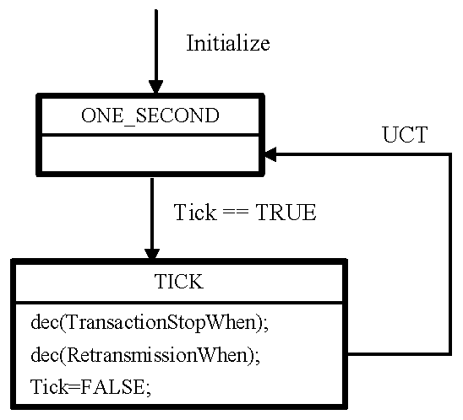
Figure 22—Transaction timers state machine
      - Transaction source and destination state machines
        - Intra-state-machine variables
- IsMulticast—This variable’s type is BOOLEAN. When its value is TRUE, it indicates that a message has a multicast destination MIHF_ID. Otherwise, its value is FALSE.
        - Intra-state-machine procedures
- ResponseReceived—This variable’s type is BOOLEAN. When its value is TRUE it indicates that a Response message has been received. Otherwise, its value is FALSE.
- TID NewTID(void)—This procedure generates a new transaction ID for the transaction generated by the new available message.
        - Transaction source state machine
The transaction source state machine (see Figure 23) is started, and related transaction initiated, when a message related to a new transaction is available to be sent (MsgOutAvail is TRUE). The transaction terminates when it transits to the SUCCESS state and any ACK related state machines if started were terminated; or if it transits to the FAILURE state. An instance of transaction source state machine can cease to exist once the value of TransactionStatus is set to either SUCCESS or FAILURE.
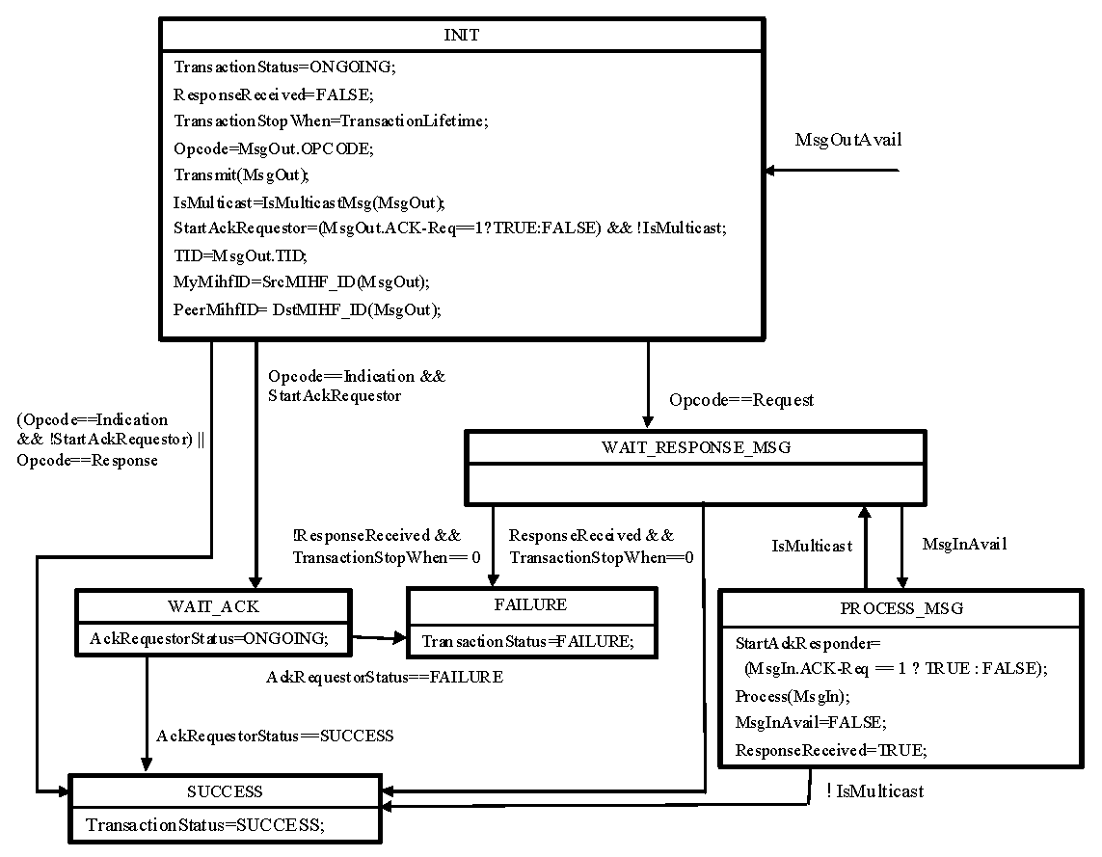
Figure 23—Transaction source state machine
        - Transaction destination state machine
The transaction destination state machine (see Figure 24) is started, and related transaction initiated, when a message related to a new transaction is received (MsgInAvail is TRUE).
The transaction terminates when it transits to the FAILURE state or SUCCESS state and any ACK related state machines, if started, were terminated. An instance of transaction destination state machine can cease to exist once the value of TransactionStatus is set to either SUCCESS or FAILURE.
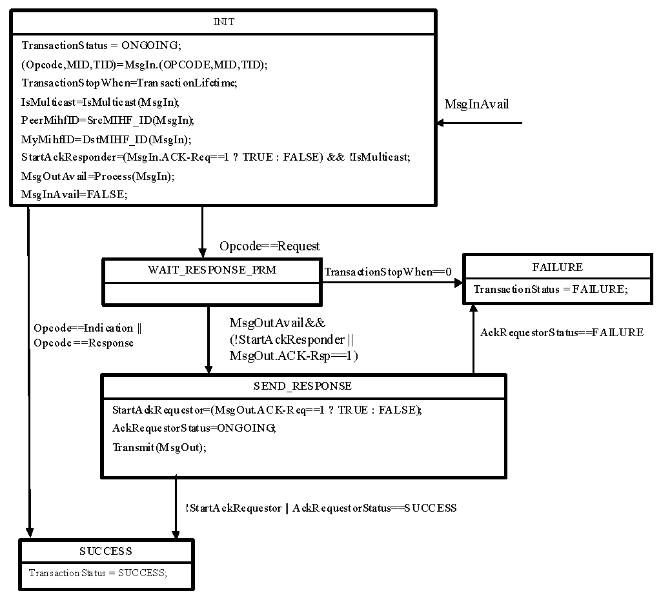
Figure 24—Transaction destination state machine
      - ACK related state machines
The ACK-requestor state machine is started when the StartAckRequest variable turns TRUE and ACKresponder state machine is started when StartAckResponder variable turns TRUE.
        - Intra-state-machine variables
- DUP—This variable is of type MIH_MES SAGE and represents an MIH message that has already been sent. This variable is used within ACK Responder state machine.
- ACK—This variable is of type MIH_MESSAGE and represents an MIH message with the ACKRsp bit set and the same message ID and transaction ID as the MIH message it acknowledges. This variable is used within ACK Responder state machine.
- RtxCtr—This variable is of type UNSIGNED_INT(1) and represents a number of retransmissions of a specific message. This variable is used within ACK Requestor state machine.
        - Intra-state-machine constants
- RetransmissionInterval—The time interval between two subsequent transmissions of a specific message.
- MaxRtxCtr—The maximum number of times that a message will be retransmitted, if retransmission conditions occur.
The maximum number of retransmissions and the retransmission interval depends on the characteristics of the underlying transport. These configuration parameters are defined in a MIB, see Annex J.
Note that the maximum number of retransmission is bounded by the transaction lifetime.
        - ACK requestor state machine
The ACK requestor state machine (see Figure 25) is started when the StartAckRequestor variable turns to TRUE in a source or destination transaction state machine. This state machine uses the inter-state-machine variables set by the originating state machine. This state machine terminates when it transits to the FAILURE state or SUCCESS state. An instance of ACK requestor state machine can cease to exist once the AckRequestorStatus is set to either SUCCESS or FAILURE state or its associated transaction source or transaction destination state machine ceases to exist.
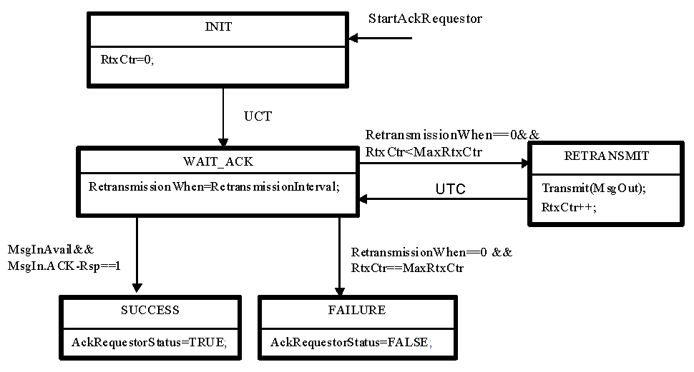
Figure 25—ACK requestor state machine

        - ACK responder state machine
The ACK responder state machine (see Figure 26) is started when the StartAckResponder variable turns to TRUE in a source or destination transaction state machine. This state machine uses the inter-state-machine variables set by the originating state machine. An instance of ACK responder state machine can cease to exist once its associated transaction source or transaction destination state machine ceases to exist.
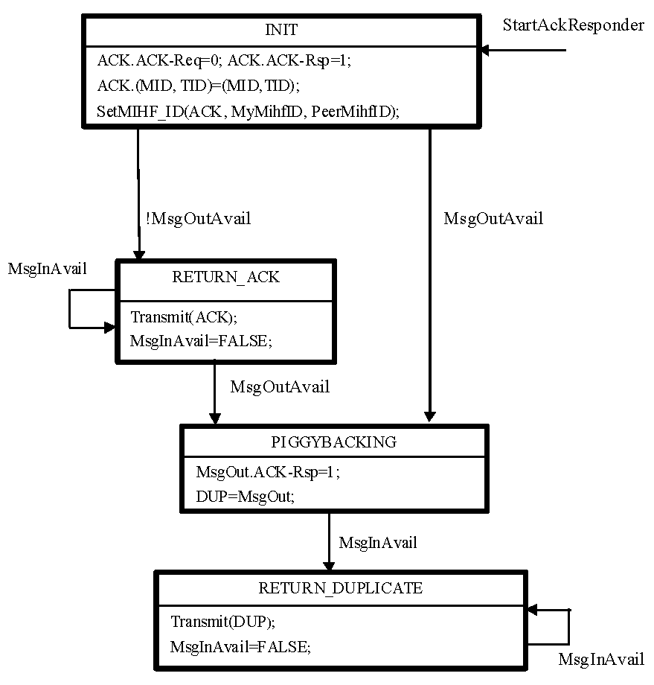
Figure 26—ACK responder state machine
    - Other considerations
      - Congestion control and load management
The MIH protocol does not provide direct support for congestion control. Therefore, it is recommended to run the MIH protocol over congestion aware transport layers.
In order to help prevent congestion, flow control mechanisms are implemented at the MIHF. A single rate limiter applies to all traffic (for all interfaces and message types). It applies to retransmissions, as well as new messages, although an implementation can choose to prioritize one over the other. When the rate limiter is in effect, MIH messages are queued until transmission is re-enabled, or an error condition is indicated back to local upper layer applications. The rate limiting mechanism is implementation specific, but it is recommended that a token bucket limiter as described in IETF RFC 4443 [B26] be used.
When an MIHF suffers from overload, it drops requests from MIH requestors. For example, messages could be dropped from a particular requestor if that requestor could be established as the origin of a denial of service attack. Any reliable delivery function indicates a flow control back to the requestor, and an MIHF invokes flow control towards a specific requestor when overloaded with reliably delivered messages.
      - Reliability
MIH protocol messages are delivered via media dependent transport. To ensure proper operation, a reliable message delivery service is required. If the media dependent transport is unreliable, then the Acknowledgement Service shall be enabled, as specified in 8.2.2. If the media dependent transport is reliable, then the Acknowledgement Service may be implemented.
A reliable media dependent transport is one that exhibits a message loss rate of less than 0.01%.
      - MIHF discovery
        - General
The MIHF discovery refers to the procedure that allows one MIHF to discover its peer MIHFs (e.g., an MN discovers available peer MIHFs in an access network). MIHF discovery can be done either at layer 2 or layer 3. MIHF discovery at L2 is performed either in media-specific manner (e.g., using IEEE 802.11 Beacon frames, IEEE 802.16 DCD) or using multicast data frames as described in 8.2.4.3.2 and 8.2.4.3.3. MIHF discovery mechanisms at layer 3 are defined in the IETF drafts [B29], [B30], and [B3 1].
        - Combined MIH function discovery and capability discovery over data plane
Combined MIH function discovery and capability discovery is performed to discover the MIHF ID, the peer MIHF transport address, and MIHF capabilities at the same time. As stated in 6.2.3, MIHF Discovery can be implicitly performed using the MIH capability discovery when both MIH nodes are residing in the same multicast domain (where an MIH node’s multicast data frame can be delivered using a group MAC address). If MIHF ID and transport address are known (e.g., pre-configured) MIHF uses MIH_Capability_Discover messages to discover MIHF capabilities only. The following subclauses refer to the MIH capability discovery both as a means to discover the MIHF and its capabilities.
        - Unsolicited MIH capability discovery
An MIHF discovers peer MIHF entities and their capabilities by listening to media-specific broadcast control messages. For example, by listening to a media-specific broadcast message such as a Beacon frame in IEEE Std 802.11 or a DCD in IEEE Std 802.16, link layers on an MN can then forward the detected MIH capabilities to its MIHF.
        - Solicited MIH capability discovery
An MIHF (the requestor) discovers its peer MIH functions and capabilities by multicasting or unicasting an MIH_Capability_Discover request message to either its multicast domain or a known MIHF ID, respectively. Only MIH network entities respond to a multicast MIH_Capability_Discover request.
When a peer MIH function (the responder) receives the MIH_Capability_Discover request message, it sends MIH_Capability_Discover response message back to the requestor. The response is sent by using the same transport type over which the request message was received. When the requestor receives the unicast MIH_Capability_Discover response message, it learns the responder’s MIHF ID by checking the source ID of MIH_Capability_Discover response.
For complete operation, the requestor sets a timer at the time of sending an MIH_Capability_Discover request during which time the requestor is in waiting state for a response from the responder. When the response message is received while the timer is running, the requestor stops the timer and finishes the MIH function and capability discovery procedure. When the timer expires without receiving a response message, the requestor tries the combined MIH function discovery and capability discovery procedure by using a different transport or terminates the MIH function and capability discovery procedure.
If the MIH capability discovery is invoked upon receiving MIH capability advertisement in unauthenticated state through media specific broadcast messages, such as beacon frames and DCD, destination MIHF ID is filled with multicast MIHF ID and this message is transmitted over the control plane using an L2 management frame, such as an IEEE 802.11 management action frame or an IEEE 802.16 MAC management message. This message contains the SupportedMihEventList, SupportedMihCommandList, SupportedISQueryTypeList, SupportedTransportList, and MBBHandoverSupport TLVs to enable the receiving MIHF to discover the sending MIHF’s capability. Therefore, peer MIHF entities can discover each other’s MIH capability by one MIH protocol message transaction. When the requestor receives the unicast MIH_Capability_Discover response message, which is embedded in the media specific control message, it retrieves the responder’s MIHF ID by checking the source of the MIH_Capability_Discover response message.
  - MIH protocol identifiers
The following identifiers are used in MIH protocol messages:
- MIHF ID
- Transaction ID
    - MIHF ID
MIHF Identifier (MIHF ID) is an identifier that is required to uniquely identify an MIHF entity for delivering the MIH services. MIHF ID is used in all MIH protocol messages. This enables the MIH protocol to be transport agnostic.
MIHF ID is assigned to the MIHF during its configuration process. The configuration process is outside the scope of the standard.
Multicast MIHF ID is defined as an MIHF ID of zero length. A multicast MIHF ID can be used when destination MIHF ID is not known to a source MIHF. The MIHF ID is of type MIHF_ID. (See F.3.11.)
    - Transaction ID
Transaction Identifier (Transaction ID) is an identifier that is used to match a request message with its corresponding response message. This identifier is also required to match each request, response or indication message and its corresponding acknowledgment. This identifier is created at the node initiating the transaction and it is carried over within the fixed header part of the MIH protocol frame.
Transaction ID is defined as a 16 bit long unsigned integer whose value is unique among all the pending transactions between a given pair of the sender and receiver. For example, this could be an integer that starts from a random initial value and incremented by one (modulo 2¹⁶) every time a new Transaction ID is generated.
  - MIH protocol frame format
    - General frame format
In MIH protocol messages, all TLV definitions are always aligned on an octet boundary and hence no padding is required. An MIH protocol payload carries a Source MIHF Identifier TLV and a Destination MIHF Identifier TLV followed by MIH Service Specific TLVs.
Figure 27 shows the components of the MIH protocol frame.
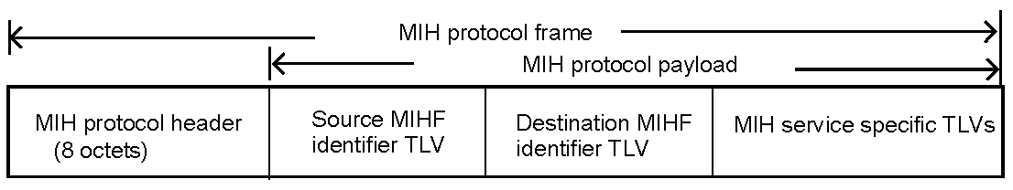
Figure 27—MIH protocol general frame format

The MIH protocol header (see Figure 28) carries the essential information that is present in every frame and is used for parsing and analyzing the MIH protocol frame.
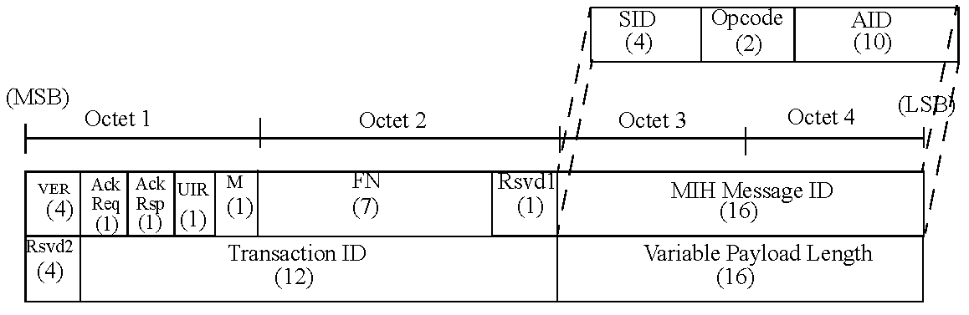
Figure 28—MIH protocol header format
Table 23 shows the description of the header fields.
Table 23—Description of MIH protocol header fields
Field name | Size (bits) | Description
Version | 4 | This field is used to specify the version of MIH protocol used.  0: Not to be used 1: First version 2–15: (Reserved)  The version number will be incremented only when a fundamental incompatibility exists between a new revision and the prior edition of the standard. An MIH node that receives an MIH message with a higher version number than it supports will discard the frame without indication to the sending MIH node.
ACK-Req | 1 | This field is used for requesting an acknowledgement for the message.
ACK-Rsp | 1 | This field is used for responding to the request for an acknowledgement for the message.

Table 23—Description of MIH protocol header fields (continued)
Field name | Size (bits) | Description
Unauthenticated information | 1 | This field is used by the MIH Information Service to indicate if the
request (UIR) |  | protocol message is sent in pre-authentication/pre-association state so that the length of the response message can be limited. The UIR bit should be set to '1' by the originator when making an MIH information service request over a certain link in the un-associated/unauthenticated or unregistered state.
 |  | In all other cases, this bit is set to '0'.
More fragment (M) | 1 | This field is used for indicating that the message is a fragment to be followed by another fragment. It is set to '0' for a message that is not fragmented and for the last fragment. The two 0 valued conditions are differentiated by the FN field. It is set to '1' for a fragment that is not the last one.
Fragment number (FN) | 7 | This field is used for representing the sequence number of a fragment. The fragment number starts from 0. The maximum fragment number is 127. This field is set to '0' for a message that is not fragmented.
Reserved1 | 1 | This field is intentionally kept reserved. When not used, this bit is set to '0'.
MIH message ID (MID) | 16 | Combination of the following 3 fields.
-- Service identifier (SID) | 4 | Identifies the different MIH services, possible values are as follows:
 |  | - Service Management
 |  | - Event Service
 |  | - Command Service
 |  | - Information Service
-- Operation code (Opcode) | 2 | Type of operation to be performed with respect to the SID, possible values are as follows:
 |  | - Request
 |  | - Response
 |  | - Indication
-- Action identifier (AID) | 10 | This indicates the action to be taken with regard to the SID (see
 |  | Table L. 1 for AID assignments).
Reserved2 | 4 | This field is intentionally kept reserved. When not used, all the bits of this field are to be set to '0'.
Transaction ID | 12 | This field is used for matching Request and Response, as well as matching Request, Response and Indication to an ACK.
Variable payload length | 16 | Indicates the total length of the variable payload embedded in this
 |  | MIH protocol frame. The length of the MIH protocol header is NOT included.

    - Fragmentation and reassembly
      - General
The MIH fragmentation mechanism is defined using 'M' (More Fragment) and 'FN' (Fragment Number) fields of the MIH protocol header.
An MIH message is fragmented only when MIH message is sent natively over an L2 medium such as Ethernet. The message is fragmented when the message size exceeds aFragmentationThreshold. The size of each of the fragments is the same except the last one, which may be smaller. The maximum fragment size is defined as the maximum value of aFragmentationThreshold, which shall be equal to the Maximum Transmission Unit (MTU) of the link layer that is on the path between two MIHF nodes. When the MTU of the link layer between two MIHF nodes is known, the maximum fragment size is set to the MTU. The method of determining such an MTU is outside the scope of this standard. When the MTU of the link layer between two MIHF nodes is unknown, the maximum fragment size is set to the minimum MTU of 1500 octets. When MIH message is sent using an L3 or higher layer transport, L3 takes care of any fragmentation issue, and the MIH protocol does not handle fragmentation in such cases.
Figure 29 shows the components of the fragmented MIH protocol frame. The MIH protocol payload carries a Source MIHF Identifier TLV and a Destination MIHF Identifier TLV followed by a fragment payload. Based on the fragment size, the fragment payload may not be aligned on a TLV boundary, i.e., TLVs other than the source MIHF identifier and destination MIHF identifier TLVs may not be complete within the fragment payload. The fragment size may be smaller than the maximum fragment size and shall be larger than the value that can generate more than 128 fragments.
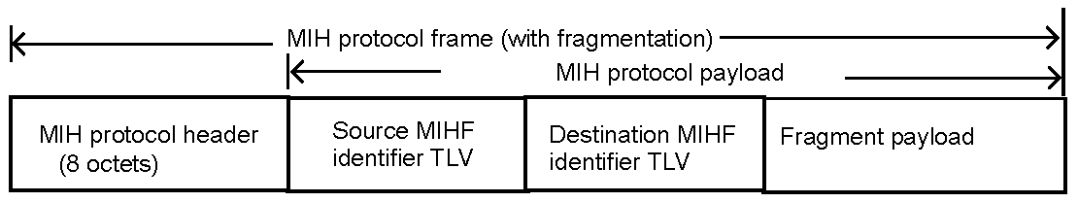
Figure 29—Fragmented MIH protocol frame format
      - Fragmentation
When an MIH message is fragmented, the fragmentation is performed within 'Transmit()' procedure in the MIH transaction protocol state machines. The MIH protocol header, the source MIHF identifier TLV and destination MIHF identifier TLV of the original message are copied to each fragment. However the 'variable payload length', 'more fragment', and 'fragment number' fields are updated accordingly for each fragment.
Variable payload length of each fragment indicates the number of octets in the MIH protocol payload of that fragment.
'More fragment' and 'fragment number' fields of each fragment are set according to the description in Table 23.
When data are to be transmitted, the number of octets in the fragment shall be determined by the fragment size and the number of octets in the multi-fragment message that have yet to be assigned to a fragment at the instant the fragment is constructed for the first time. Once a fragment is transmitted for the first time, its frame body content and length shall be fixed until it is successfully delivered to the destination MIHF.
No retransmission by the MIH protocol (defined in 8.2) is performed for any single fragment of a multi- fragment message.
      - Reassembly
The destination MIHF reassembles the received fragments into an original message. Reassembly is performed outside the MIH transaction state machines. 'MsgIn' and 'MsgInAvail' variables are set only after successful reassembly. An MIHF shall be capable of receiving fragments of arbitrary length.
The following fields are used for reassembling fragments:
- MIH message ID
- Transaction ID
- Source MIHF identifier TLV
- Destination MIHF identifier TLV
- More fragment
- Fragment number
When any fragment of a multi-fragment message has arrived first, the destination MIHF starts a timer referred to as ReassemblyTimer. If this ReassemblyTimer expires before all fragments have been received, the destination MIHF discards those fragments that it has received. A duplicate fragment is discarded.
An example of an original MIH message and fragmented MIH messages is shown in Annex K.
  - Message parameter TLV encoding
The following general TLV encoding (shown in Figure 30) shall be used for all parameters in an MIH protocol message.
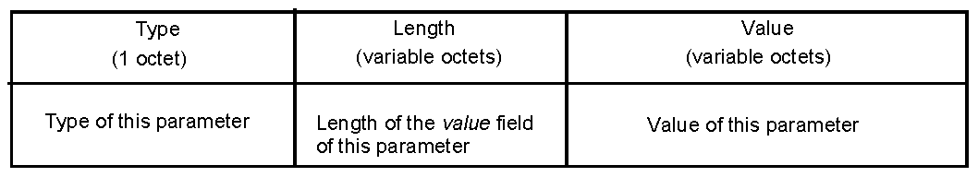
Figure 30—Message parameter TLV encoding

Specifically, the Type field is one octet¹³, and the Length shall be encoded with the rules described in 6.5.6.2.
Moreover, TLV Type values shall be unique within the MIH protocol. The TLV encoding starts at 1 and any subsequent values are assigned in ascending order (see Annex L, Table L.2).
The TLV encoding of the vendor specific TLV (type = 100) is shown in Figure 31.
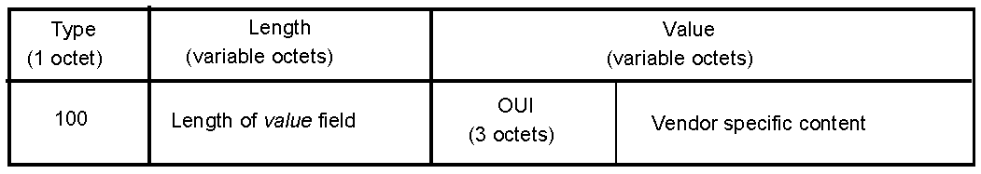
Figure 31—The TLV encoding for the vendor specific TLV (Type = 100)
¹³The TLV Type field length is different than the Information Element Type length, which is four octets.
  - MIH protocol messages
The following subclauses specify different MIH protocol messages in TLV form. The shaded areas represent the MIH protocol header, while the unshaded areas represent the MIH protocol payload. The payload consists of a set of identifiers in TLV form.
The TLV Type assignment for each TLV can be found in Annex L, Table L.2.
TLV type values ranging from 101 to 255 are reserved for experimental TLVs. These values are used by different implementations to evaluate the option of using TLVs not defined by the specification.
When a TLV type value is in the range of experimental TLVs and the data type of the TLV value is unknown or the TLV value is not in the range of valid values, the TLV should be ignored and the rest of the message should be processed. Also, experimental TLVs can be ignored, based on the MIHF information that is communicating with another MIHF with different experimental TLVs implementation.
All MIH messages carry a source MIHF ID followed by a destination MIHF ID as the first two TLVs of the MIH protocol payload part of the message. Multicast MIHF ID can be used in MIH_Capability_Discover request and response messages as its destination MIHF ID.
All “Optional” fields are optionally sent but the receiver shall properly operate on them if present, i.e., these fields are mandatory in the implementation, but optional in their use.
On receipt of an MIH request message the MIHF shall respond with a corresponding response message.
Any message received that has an invalid MIH header, or does not contain the source/destination MIHF IDs, or has an unrecognizable or invalid MIH Message ID shall be discarded without sending any indication to the source MIH node. Any undefined or unrecognizable TLVs in a received message shall be ignored by the receiver.
    - MIH messages for service management
      - MIH_Capability_Discover request
The corresponding MIH primitive of this message is defined in 7.4.1.1.
If a requesting MIHF entity knows the destination MIHF entity’s MIHF ID, the requesting MIHF entity fills its destination MIHF ID and sends this message to the peer MIHF over the data plane, either L2 or L3.
If a requesting MIHF entity does not know the destination MIHF entity’s MIHF ID, the requesting MIHF entity may fill its destination MIHF ID with a multicast MIHF ID to send this capability discover message.
11IH Header Fields (SID=1, Opcode=1, AID=1)
Source Identifier = sending MIHF ID
(Source MIHF ID TLV)
Destination Identifier = receiving MIHF ID
(Destination MIHF ID TLV)
LinkAddressList (optional)
(Link address list TLV)
SupportedMihEventList (optional)
(MIH event list TLV)
SupportedMihCommandList (optional)
(MIH command list TLV)
SupportedISQueryTypeList (optional)
(MIIS query type list TLV)
SupportedTransportList (optional)
(Transport option list TLV)
MBBHandoverSupport (optional)
(MBB handover support TLV)

      - MIH_Capabil ity_Discover response
The corresponding MIH primitive of this message is defined in 7.4.1.3. This message is sent in response to an MIH_Capability_Discover request message that was destined to a single or multicast MIHF ID.
11IH Header Fields (SID=1, Opcode=2, AID=1)
Source Identifier = sending MIHF ID
(Source MIHF ID TLV)
Destination Identifier = receiving MIHF ID
(Destination MIHF ID TLV)
Status
(Status TLV)
Link Address List (optional)
(Link address list TLV)
SupportedMihEventList (optional)
(MIH event list TLV)
SupportedMihCommandList (optional)
(MIH command list TLV)
SupportedISQueryTypeList (optional)
(MIIS query type list TLV)
SupportedTransportList (optional)
(Transport option list TLV)
MBBHandoverSupport (optional)
(MBB handover support TLV)

      - MIH_Register request
The corresponding MIH primitive of this message is defined in 7.4.2.1.
This message is transmitted to the remote MIHF to perform a registration or re-registration.
11IH Header Fields (SID=1, Opcode=1, AID=2)
Source Identifier = sending MIHF ID
(Source MIHF ID TLV)
Destination Identifier = receiving MIHF ID
(Destination MIHF ID TLV)
LinkIdentifierList
(Link identifier list TLV)
RequestCode
(Register request code TLV)

      - MIH_Register response
The corresponding MIH primitive of this message is defined in 7.4.2.3. This message is sent in response to a registration or re-registration request.
11IH Header Fields (SID=1, Opcode=2, AID=2)
Source Identifier = sending MIHF ID
(Source MIHF ID TLV)
Destination Identifier = receiving MIHF ID
(Destination MIHF ID TLV)
Status
(Status TLV)
ValidTimeInterval (not included if Status does not indicate “Success”)
(Valid time interval TLV)

      - MIH_DeRegister request
The corresponding MIH primitive of this message is defined in 7.4.3.1.
This message is transmitted to the remote MIHF to request a de-registration. There is no parameter for this message.
11IH Header Fields (SID=1, Opcode=1, AID=3)
Source Identifier = sending MIHF ID
(Source MIHF ID TLV)
Destination Identifier = receiving MIHF ID
(Destination MIHF ID TLV)
      - MIH_DeRegister response
The corresponding MIH primitive of this message is defined in 7.4.3.3.
This message is sent in response to a de-registration request.
11IH Header Fields (SID=1, Opcode=2, AID=3)
Source Identifier = sending MIHF ID
(Source MIHF ID TLV)
Destination Identifier = receiving MIHF ID
(Destination MIHF ID TLV)
Status
(Status TLV)

      - MIH_Event_Subscribe request
The corresponding MIH primitive of this message is defined in 7.4.4.1.
This message is sent by a remote MIHF (the subscriber) to subscribe to one or more event types from a particular event origination point.
11IH Header Fields (SID=1, Opcode=1, AID=4)
Source Identifier = sending MIHF ID
(Source MIHF ID TLV)
Destination Identifier = receiving MIHF ID
(Destination MIHF ID TLV)
LinkIdentifier
(Link identifier TLV)
RequestedMihEventList
(MIH event list TLV)
EventConfigurationInfoList (optional)
(Event configuration info list TLV)

      - MIH_Event_Subscribe response
The corresponding MIH primitive of this message is defined in 7.4.4.2.
The response indicates which of the event types were successfully subscribed.
11IH Header Fields (SID=1, Opcode=2, AID=4)
Source Identifier = sending MIHF ID
(Source MIHF ID TLV)
Destination Identifier = receiving MIHF ID
(Destination MIHF ID TLV)
Status
(Status TLV)
LinkIdentifier
(Link identifier TLV)
ResponseMihEventList (not included if Status does not indicate “Success”)
(MIH event list TLV)

      - MIH_Event_Unsubscribe request
The corresponding MITT primitive of this message is defined in 7.4.5.1.
This message is sent by a remote MITTF (the subscriber) to unsubscribe from a set of link-layer events.
MIH Header Fields (SID=1, Opcode=1, AID=5)
Source Identifier = sending MITTF ID
(Source MITTF ID TLV)
Destination Identifier = receiving MITTF ID
(Destination MITTF ID TLV)
LinkIdentifier
(Link identifier TLV)
RequestedMihEventList
(MITT event list TLV)

      - MIH_Event_Unsubscribe response
The corresponding MITT primitive of this message is defined in 7.4.5.2.
The response indicates which of the event types were successfully unsubscribed.
MIH Header Fields (SID=1, Opcode=2, AID=5)
Source Identifier = sending MITTF ID
(Source MITTF ID TLV)
Destination Identifier = receiving MITTF ID
(Destination MITTF ID TLV)
Status
(Status TLV)
LinkIdentifier
(Link identifier TLV)
ResponseMihEventList (not included if Status does not indicate “Success”)
(MITT event list TLV)

    - MIH messages for event service
      - MIH_Link_Detected indication
The corresponding MITT primitive of this message is defined in 7.4.6.
This message is transmitted to the remote MIHF when a new link has been detected.
11IH Header Fields (SID=2, Opcode=3, AID=1)
Source Identifier = sending MIHF ID
(Source MIHF ID TLV)
Destination Identifier = receiving MIHF ID
(Destination MIHF ID TLV)
LinkDetectedInfoList
(Link detected info list TLV)

      - MIH_Link_Up indication
The corresponding MIH primitive of this message is defined in 7.4.7.
This notification is delivered from an MIHF, when present in the PoA, to an MIHF in the network when a layer 2 connection is successfully established with an MN.
11IH Header Fields (SID=2, Opcode=3, AID=2)
Source Identifier = sending MIHF ID
(Source MIHF ID TLV)
Destination Identifier = receiving MIHF ID
(Destination MIHF ID TLV)
LinkIdentifier
(Link identifier TLV)
OldAccessRouter (optional)
(Old access router TLV)
NewAccessRouter (optional)
(New access router TLV)
IPRenewalFlag (optional)
(IP renewal flag TLV)
MobilityManagementSupport (optional)
(Mobility management support TLV)

      - MIH_Link_Down indication
The corresponding MIH primitive of this message is defined in 7.4.8.
This notification is delivered from an MIHF, when present in the PoA, to an MIHF in the network when a layer 2 connection with an MN is disconnected due to a certain reason.
MIH Header Fields (SID=2, Opcode=3, AID=3)
Source Identifier = sending MIHF ID
(Source MIHF ID TLV)
Destination Identifier = receiving MIHF ID
(Destination MIHF ID TLV)
LinkIdentifier
(Link identifier TLV)
OldAccessRouter (optional)
(Old access router TLV)
ReasonCode
(Link down reason code TLV)

      - MIH_Link_Parameters_Report indication
The corresponding MIH primitive of this message is defined in 7.4.9.
This message indicates changes in link conditions that have crossed pre-configured threshold levels. A pre- configured threshold level is set by the MIH_Link_Configure_Thresholds request message.
MIH Header Fields (SID=2, Opcode=3, AID=5)
Source Identifier = sending MIHF ID
(Source MIHF ID TLV)
Destination Identifier = receiving MIHF ID
(Destination MIHF ID TLV)
LinkIdentifier
(Link identifier TLV)
LinkParameterReportList
(Link parameter report list TLV)

      - MIH_Link_Going_Down indication
The corresponding MIH primitive of this message is defined in 7.4.10.
This message is transmitted to the remote MIHF when a layer 2 connectivity is expected (predicted) to go down within a certain time interval.
MIH Header Fields (SID=2, Opcode=3, AID=6)
Source Identifier = sending MIHF ID
(Source MIHF ID TLV)
Destination Identifier = receiving MIHF ID
(Destination MIHF ID TLV)
LinkIdentifier
(Link identifier TLV)
TimeInterval
(Time interval TLV)
LinkGoingDownReason
(Link going down reason TLV)

      - MIH_Link_Handover_Imminent indication
      - MIH_Link_Handover_Complete indication
    - MIH messages for command service
      - MIH_Link_Get_Parameters request
The corresponding MIH primitive of this message is defined in 7.4.14.2.
This message is used to discover the status of currently available links.
11IH Header Fields (SID=3, Opcode=1, AID=1)
Source Identifier = sending MIHF ID
(Source MIHF ID TLV)
Destination Identifier = receiving MIHF ID
(Destination MIHF ID TLV)
DeviceStatesRequest (optional)
(Device states request TLV)
LinkIdentifierList
(Link identifier list TLV)
GetStatusRequestSet
(Get status request set TLV)

      - MIH_Link_Get_Parameters response
The corresponding MIH primitive of this message is defined in 7.4.14.3.
This message is used by an MIHF to report the status of currently available links.
11IH Header Fields (SID=3, Opcode=2, AID=1)
Source Identifier = sending MIHF ID
(Source MIHF ID TLV)
Destination Identifier = receiving MIHF ID
(Destination MIHF ID TLV)
Status
(Status TLV)
DeviceStatesResponseList (optional) (not included if Status does not indicate “Success”)
(Device states response list TLV)
GetStatusResponseList (not included if Status does not indicate “Success”)
(Get status response list TLV)

      - MIH_Link_Configure_Thresholds request
The corresponding MIH primitive of this message is defined in 7.4.15.2. This message is used to configure thresholds of the lower layer link.
11IH Header Fields (SID=3, Opcode=1, AID=2)
Source Identifier = sending MIHF ID
(Source MIHF ID TLV)
Destination Identifier = receiving MIHF ID
(Destination MIHF ID TLV)
LinkIdentifier
(Link identifier TLV)
ConfigureRequestList
(Configure request list TLV)

      - MIH_Link_Configure_Thresholds response
The corresponding MIH primitive of this message is defined in 7.4.15.3.
This message returns the status of a thresholds configuration request. The MIHF generating this message generates MIH_Link_Parameters_Report indication message when the configured threshold is crossed.
11IH Header Fields (SID=3, Opcode=2, AID=2)
Source Identifier = sending MIHF ID
(Source MIHF ID TLV)
Destination Identifier = receiving MIHF ID
(Destination MIHF ID TLV)
Status
(Status TLV)
LinkIdentifier
(Link identifier TLV)
ConfigureResponseList (not included if Status does not indicate “Success”)
(Configure response list TLV)

      - MIH_Link_Actions request
The corresponding MIH primitive of this message is defined in 7.4.16.1. This message is used to control the behavior of a set of lower layer links.
11IH Header Fields (SID=3, Opcode=1, AID=3)
Source Identifier = sending MIHF ID
(Source MIHF ID TLV)
Destination Identifier = receiving MIHF ID
(Destination MIHF ID TLV)
LinkActionsList
(Link actions list TLV)

      - MIH_Link_Actions response
The corresponding MIH primitive of this message is defined in 7.4.16.2. This message returns the result of an MIH_Link_Actions request.
11IH Header Fields (SID=3, Opcode=2, AID=3)
Source Identifier = sending MIHF ID
(Source MIHF ID TLV)
Destination Identifier = receiving MIHF ID
(Destination MIHF ID TLV)
Status
(Status TLV)
LinkActionsResultList (not included if Status does not indicate “Success”)
(Link actions result list TLV)

      - MIH_Net_HO_Candidate_Query request (to be excluded)
      - MIH_Net_HO_Candidate_Query response (to be excluded)
      - MIH_M N_HO_Candidate_Query request (to be excluded)
      - MIH_MN_HO_Candidate_Query response (to be excluded)
      - MIH_N2N_HO_Query_Resources request (to be excluded)
      - MI H_N2N_HO_Query_Resources response (to be excluded)
      - MIH_MN_HO_Commit request (to be excluded)
      - MIH_MN_HO_Commit response (to be excluded)
      - MIH_Net_HO_Commit request (to be excluded)
      - MIH_Net_HO_Commit response (to be excluded)
      - MIH_N2N_HO_Commit request (to be excluded)
      - MIH_N2N_HO_Commit response (to be excluded)
      - MIH_MN_HO_Complete request (to be excluded)
      - MIH_MN_HO_Complete response (to be excluded)
      - MIH_N2N_HO_Complete request (to be excluded)
      - MIH_N2N_HO_Complete response (to be excluded)
    - MIH messages for information service
MIH Information service uses only the following messages—MIH_Get_Information request, MIH_Get_Information response, and MIH_Push_Information. Due to the need to support different query types and the need for flexibility to customize the query and response, the parameters and their usage in these messages are substantially different from other MIH message parameters, and are therefore separately defined in the following subclauses.
      - MIH_Get_Information request
The corresponding MIH primitive of this message is defined in 7.4.25.1.
This message is used by an MIHF to retrieve a set of Information Elements provided by the information service. A single MIH_Get_Information request message carries only one query list. However, there can be multiple queries in that list in the order of the most preferred query first.
MIH Header Fields (SID=4, Opcode=1, AID=1)
Source Identifier = sending MIHF ID
(Source MIHF ID TLV)
Destination Identifier = receiving MIHF ID
(Destination MIHF ID TLV)
InfoQueryBinaryDataList (optional)
(Info query binary data list TLV)
InfoQueryRDFDataList (optional)
(Info query RDF data list TLV)
InfoQueryRDFSchemaURL (optional)
(Info query RDF schema URL TLV)
InfoQueryRDFSchemaList (optional)
(Info query RDF schema list TLV)
MaxResponseSize (optional)
(Max response size TLV)
QuerierNetworkType (optional)
(Network type TLV)
UnauthenticatedInformationRequest
(Unauthenticated information request TLV)

      - MI H_Get_Information response
The corresponding MIH primitive of this message is defined in 7.4.25.3.
This is used as a response to the MIH_Get_Information request message. The total response message size shall not exceed the value indicated in the Max Response Size TLV of corresponding MIH_Get_Information request message. The order of the query response shall be in the same order as the query requests.
11IH Header Fields (SID=4, Opcode=2, AID=1)
Source Identifier = sending MIHF ID
(Source MIHF ID TLV)
Destination Identifier = receiving MIHF ID
(Destination MIHF ID TLV)
Status
(Status TLV)
InfoResponseBinaryDataList (optional)
(Info response binary data list TLV)
InfoResponseRDFDataList (optional)
(Info response RDF data list TLV)
InfoResponseRDFSchemaURLList (optional)
(Info response RDF schema URL list TLV)
InfoResponseRDFSchemaList (optional)
(Info response RDF schema list TLV)

      - MIH_Push_Information indication
The corresponding MIH primitive of this message is defined in 7.4.26.1.
This is an indication to push operator policies or other network information to the MN.
11IH Header Fields (SID=4, Opcode=3, AID=2)
Source Identifier = sending MIHF ID
(Source MIHF ID TLV)
Destination Identifier = receiving MIHF ID
(Destination MIHF ID TLV)
InfoResponseBinaryDataList (optional)
(Info response binary data list TLV)
InfoResponseRDFDataList (optional)
(Info response RDF data list TLV)
InfoResponseRDFSchemaURLList (optional)
(Info response RDF schema URL list TLV)
InfoResponseRDFSchemaList (optional)
(Info response RDF schema list TLV)

(informative)
Bibliography
- 3GPP TR 43.901, Feasibility Study on Generic Access to A/Gb Interface.
- 3GPP TS 23.002, Network Architecture.
- 3GPP TS 23.060, General Packet Radio Service (GPRS); Service Description; Stage 2.
- 3GPP TS 23.234, 3GPP system to Wireless Local Area Network (WLAN) inter-working; System description.
- 3GPP TS 24.007, Mobile Radio Interface Signaling, Layer 3, General Aspects.
- 3GPP TS 25.331, Radio Resource Control Specification.
- 3GPP2 C.S0001-D (2004-02), Introduction to cdma2000 Standards for Spread Spectrum Systems.
- 3GPP2 C.S0002-D (2004-02), Physical Layer Standard for cdma2000 Spread Spectrum Systems.
- 3GPP2 C.S0003-D (2004-02), Medium Access Control (MAC) Standard for cdma2000 Spread Spectrum Systems.
- 3GPP2 C.S0005-D (2004-02), Upper Layer (Layer 3) Signaling Standard for cdma2000 Spread Spectrum Systems.
- 3GPP2 C.S0006-D (2004-02), Analog Signaling Standard for cdma2000 Spread Spectrum Systems.
- 3GPP2 C.S0024-A (V. 2.0, 2005-07), cdma2000 High Rate Packet Data Air Interface Specification.
- 3GPP2 C.S0063-A (V. 1.0, 2006-04), cdma2000 High Rate Packet Data Supplemental Services.
- 3GPP2 S.R0087, cdma2000 – WLAN Interworking.
- 3GPP2 X.S0028-1 00 (V. 1.0, 2006-08), Wireless Local Area Network (WLAN) Interworking, Access to internet.
- 3GPP2 X.S0028-200 (V. 1.0), Wireless Local Area Network (WLAN) Interworking, Access to Operator Services and Mobility.
- IEEE 100, The Authoritative Dictionary of IEEE Standards Terms, Seventh Edition.
- IEEE Std 802.1AB™-2005, IEEE Standard for Local and Metropolitan Area Networks—Station and Media Access Control Connectivity Discovery.
- IEEE 802.1ag™-2007, IEEE Standard for Local and Metropolitan Area Networks—Virtual Bridged Local Area Networks—Amendment 5: Connectivity Fault Management.
- IEEE P802.21™ (Document 21-04-0087-12-0000, 2004-09), Media Independent Handover Service—Draft Technical Requirements.
- IEEE P802.16g™-2007, IEEE Standard for Local and metropolitan area networks—Part 16: Air Interface for Fixed and Mobile Broadband Wireless Access Systems—Amendment 3: Management Plane Procedures and Services.
- IETF RFC 791 (198 1-09), DARPA Internet Program Protocol.
- IETF RFC 3629 (2003-11), UTF-8, a transformation format of ISO 10646.
- IETF RFC 3753 (2004-06), Mobility Related Terminology.
- IETF RFC 4291 (2006-02), IP Version 6 Addressing Architecture.
- IETF RFC 4443 (2006-03), Internet Control Message Protocol (ICMPv6) for the Internet Protocol Version 6 (IPv6) Specification.
- IETF RFC 5184 (2008-05), Unified L2 Abstractions for L3-Driven Fast Handover.
- IETF Internet Draft (draft-ietf-geopriv-radius-lo-19.txt, 2008-01), Carrying Location Objects in RADIUS and Diameter.
- IETF Internet Draft (draft-ietf-mipshop-mos-dhcp-options-03.txt, 2008-06), Dynamic Host Configuration Protocol (DHCPv4 and DHCPv6) Options for Mobility Server (MoS) discovery.
- IETF Internet Draft (draft-ietf-mipshop-mos-dns-discovery-01 .txt, 2008-05), Locating Mobility Servers using DNS.
- IETF Internet Draft (draft-ietf-mipshop-mstp-solution-04.txt, 2008-05), Mobility Services Framework Design.
- ITU-T Recommendation X.210 (11/93), Information technology-Open systems interconnection-Basic Reference Model: Conventions for the definition of OSI services (common text with ISO/IEC 10731).
- ITU-T Recommendation X.690, Information technology—ASN.1 encoding rules: Specification of Basic Encoding Rules (BER), Canonical Encoding Rules (CER) and Distinguished Encoding Rules (DER).
- ITU-T Recommendation Y. 1541, Network performance objectives for IP-based services.
- ITU-T Recommendation Z. 120 (2004), Programming Languages-Formal Description Techniques (FDT)-Message Sequence Chart (MSC).
- W3C Recommendation, OWL Web Ontology Language Reference.
- W3C Recommendation, RDF Vocabulary Description Language 1.0: RDF Schema.
- W3C Recommendation, SPARQL Query Results XML Format.

(normative)
Quality of service mapping
This annex provides the mapping between QoS parameters with various technologies. A flow diagram is provided that shows the setting and reporting of QoS parameters using the standard IEEE 802.21 primitives. Table B. 1, Table B.2, and Table B.3 show the mapping between generic QoS parameters and those used by different technologies such as IEEE 802.11, IEEE 802.16, and 3GPP. B.3 describes how the generic QoS parameters can be derived from the access link specific parameters.
A transmitted packet over a communication medium can experience the following outcomes:
- Be received with no errors at its intended destination
- Be received with errors at its intended destination
- Not be received in which case it is said that the packet is lost
A communication medium represents one or multiple point-to-point network segments that are termed links in this standard.
The maximum attainable speed of information transfer over a given communication channel can be constant, as is usually the case with communication channels involving only wired links, or it can be time varying at different scales, as is often the case for communication channels involving wireless links. This measure will be called link throughput, for the purposes of this standard.
The ability of the link to provide accurate information transfer can be described via a statistical model characterized by the following parameters:
- Minimum Packet Transfer Delay: is defined as the minimum delay over a population of interest.
- Average Packet Transfer Delay: is defined as the arithmetic mean of the delay over a population of interest.
- Maximum Packet Transfer Delay: is defined as the maximum delay over a population of interest.
- Jitter: is defined as the standard deviation of the delay over a population of interest.
- Packet Loss Rate: is defined as the ratio between the number of frames that are transmitted but not received and the total number of frames transmitted over a population of interest.
- Packet Error Rate: is defined as the ratio between the number of packets that have been received with errors and the total number of packets present in a population of interest. Note that if the link supports re-transmission, then the Packet Error Rate includes it, otherwise it does not include it.
For a link that supports CoS differentiation, per CoS traffic accuracy parameters need to be maintained in order to provide insights on how individual traffic classes are faring.
In summary, the following set of parameters characterizes the speed and accuracy of the information transfer that a multi-CoS traffic link supports:
- Link Throughput, the number of bits successfully received divided by the time it took to transmit them over the medium.
- Link Packet Error Rate: representing the ratio between the number of frames received in error and the total number of frames transmitted in a link population of interest.
- Supported Classes of Service: represents the maximum number of differentiable classes of service supported by this link.
- Class of Service Parameters List: For each of the supported classes of service the following parameters are defined:
  - Class Minimum Packet Transfer Delay: is defined as the minimum delay over a class population of interest.
  - Class Average Packet Transfer Delay: is defined as the arithmetic mean of the delay over a class population of interest.
  - Class Maximum Packet Transfer Delay: is defined as the maximum delay over a class population of interest.
  - Class Packet Delay Jitter: is defined as the standard deviation of the delay over a class population of interest.
  - Class Packet Loss Rate: is defined as the ratio between the number of frames that are transmitted but not received and the total number of frames transmitted over a class population of interest.

Generic IEEE 802.21 QoS flow diagram
Figure B.1 represents an example flow diagram for using the QoS framework defined by the MIHF. The following terms are used in Figure B.1:
- UP Entity: An upper layer entity such as a multimedia application;
- MAC-S: The MAC layer of the interface that is currently serving the MN;
- MAC-C: The MAC layer of an interface that is not currently serving the MN;
- PoA-S: The serving PoA;
- PoS-S: The serving PoS.
The MIH_Link_Configure_Thresholds primitive is used to set the application quality of service requirements and make it available to the MIHF. These parameters are mapped into media-specific measurements at the MIH layer and then used to configure the link parameter thresholds. While this mapping is not defined by other standards, Table B.1 and Table B.2 provide such mappings. The MIH_Link_Parameters_Report primitive is used to relay link specific measurements back to the MIH user.
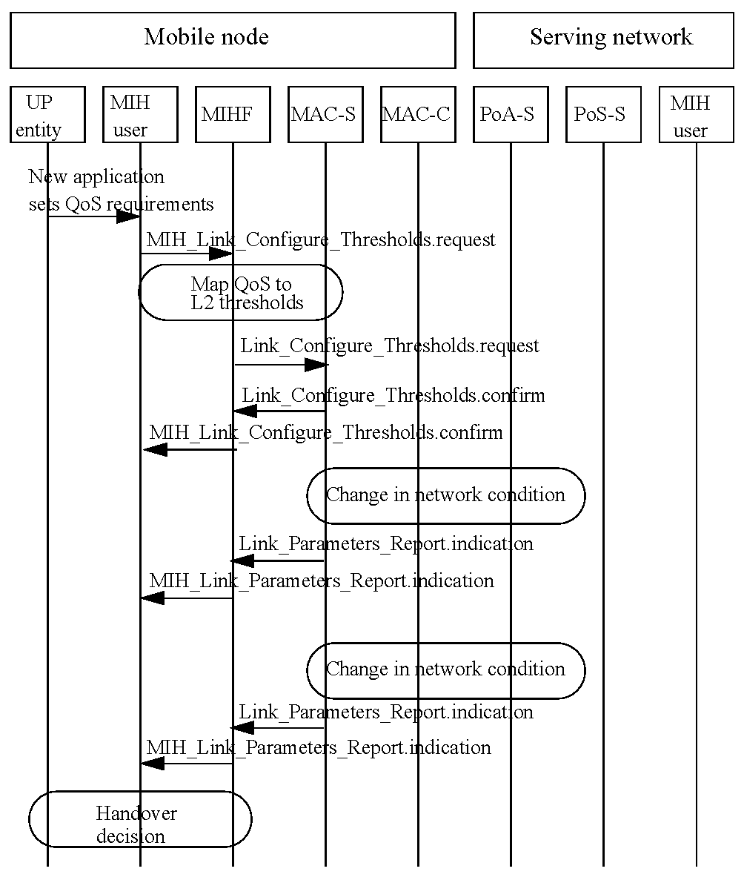
Figure B.1—An example flow for setting application QoS requirements

Generic IEEE 802.21 QoS parameter mappings
The tables provide mappings of the standard IEEE 802.21 QoS parameters to the access link technology
specific parameters. Table B. 1 is informative and list measurements defined in IEEE Std 802.11 that may be used in computing the QOS performance metrics defined in this document. For IEEE 802.11, a collection of the QoS parameters can be on an individual station measurement basis, since this is a media using a distributed (symmetric) access technology.
Table B.1—QoS parameter mapping for IEEE 802.11
IEEE 802.21 link QoS  parameters | Related IEEE 802.11 parameters | IEEE 802.11 IE  name | Note
Throughput | Not currently supported. |  | Measurement is defined as the total number of octets transmitted / Measurement duration.”
Packet error rate | TransmittedFragmentCount MulticastTransmittedFrameCount FailedCount  ReceivedFragmentCount  (See NOTE) MulticastReceivedFrameCount FCSErrorCount (See NOTE) TransmittedFrameCount  RetryCount  MultipleRetryCount FrameDuplicateCount RTSSuccessCount RTSFailureCount ACKFailureCount | STA Statistics Report
Supported number of COS | 4 for IEEE 802.11e, 8 for HCCA, 1 for non-IEEE 802.1 1e systems
CoS minimum packet transfer delay | Transmit Delay Histogram (See NOTE) | Transmit Stream/ Category Mea- surement Report | Trigger (Option) (only to specific STA)
CoS average packet trans- fer delay | Average Transmit Delay | Transmit Stream/ Category Mea- surement Report | Trigger (Option) (only to specific STA)
CoS maximum packet transfer delay | Transmit Delay Histogram (See NOTE) | Transmit Stream/ Category Mea- surement Report | Trigger (Option) (only to specific STA)
CoS packet delay jitter | Transmit Delay Histogram  (See NOTE)  Average Transmit Delay (See NOTE) | Transmit Stream/ Category Mea- surement Report | Trigger (Option) (only to specific STA)

Table B.1—QoS parameter mapping for IEEE 802.11 (continued)
IEEE 802.21 link QoS  parameters | Related IEEE 802.11 parameters | IEEE 802.11 IE  name | Note
CoS packet loss rate | QoSTransmittedFragmentCount (See NOTE)  QoSFailedCount  QoSRetryCount QoSMultipleRetryCount QoSFrameDuplicateCount QoSRTSSuccessCount QoSRTSFailureCount QoSACKFailureCount (See NOTE) QoSReceivedFragmentCount QoSTransmittedFrameCount QoSDiscardedFrameCount QoSMPDUsReceivedCount QoSRetriesReceivedCount | STA Statistics Report
CoS packet loss rate | Transmitted MSDU Count (See NOTE)  MSDU Discarded Count  MSDU Failed Count (See NOTE) MSDU Multiple Retry Count QoS CF-polls Lost Count | Transmit Stream/ Category Mea- surement Report | Trigger (Option) (only to specific STA)
NOTE—This parameter is most likely to be used to directly derive IEEE 802.21 LinkQoSParameters. See B.3 for example derivations.

Table B.2 and Table B.3 show example mappings for IEEE 802.21 QoS link parameters and other link specific parameters for IEEE 802.16, 3GPP, and 3GPP2. For these technologies control is usually by means of a base station, not an individual station, since the media is controlled using asymmetric access.
Table B.2—QoS parameter mapping for IEEE 802.16 and 3GPP2
IEEE 802.21 link QoS parameters | IEEE 802.16 | 3GPP2
Throughput | Maximum Sustained Traffic Rate | Peak_Rate
Packet loss rate |  | Max_IP_Packet_Loss_Rate
Packet error rate | Packet Error Rate
CoS minimum packet transfer delay
CoS average packet transfer delay
CoS maximum packet transfer delay | Maximum Latency | Max_Latency
CoS packet delay jitter | Tolerated Jitter | Delay_Var_Sensitive

Table B.3—QoS parameter mapping for 3GPP
IEEE 802.21 link  QoS parameters | Related 3GPP parameters
Supported number of CoS | 4
Supported number of CoS | Conversational | Streaming | Interactive | Background
Throughput | Peak throughput
Throughput | Mean throughput
Throughput | Maximum bit rate for uplink/downlink
Throughput | Guaranteed bit rate for uplink/downlink
Link packet error rate | SDU Error Ratio
Link packet error rate | Residual Bit Error Rate
CoS minimum packet transfer delay | Transfer delay
CoS average packet  transfer delay | Transfer delay
CoS maximum packet transfer delay | Maximum Transfer delay
CoS packet transfer  delay jitter |  | Delay Variation
CoS packet loss rate | Residual Bit Error Rate
CoS packet loss rate | SDU Error Ratio

Deriving generic IEEE 802.21 QoS parameters

General
The following subclauses describe how to derive generic QoS parameters from IEEE Std 802.11 link measurement parameters. This derivation relies on incremental values of counters as specified in the IEEE Std 802.11.
Note that the parameters are unicast parameters that are unrelated to multicast traffic.

Packet loss rate
To calculate the packet loss rate (PLR), one uses Equation (1).
$\text{PLR}=\frac{\text{the number of lost packets}}{\text{the number of transmitted packets }(\text{successful }+\text{ failed})}$ (1)
According to IEEE Std 802.11, a packet is a MAC user data packet or MAC service data unit (MSDU).
The PLR_{MSDU} can be derived from the Transmit Stream/Category Measurement Report using Equation (2).
$\begin{aligned}{\text{PLR}}_{\text{MSDU}}=\frac{\text{failed MSDUs}}{\text{Transmitted MSDUs }+\text{ Failed MSDUs}} \\ \frac{\text{MSDU Failed Count}}{\text{Transmitted MSDU Count }+\text{ MSDU Failed Count}}\end{aligned}$ (2)
=

Packet error rate
The packet error rate (PER) can be calculated using Equation (3).
$\text{PER}=\frac{\text{the number of packets that are received with errors}}{\text{the number of packets in a population of interest}}$ (3)
Unlike for PLR, this parameter is only defined for the IEEE 802.11 MPDU. The PER can be derived from the STA Statistics Report information element using Equation (4).
$\text{PER}=\frac{\text{FCSErrorCount}}{\text{ReceivedFragmentCount }+\text{ FCSErrorCount}}$ (4)

Average transfer delay
In IEEE Std 802.11k, the transmit delay (MSDU delay) is defined as follows:
Transmit delay (MSDU delay): The delay shall be measured from the time the MSDU is passed to the MAC sublayer until the point at which the entire MSDU has been successfully transmitted including receipt of the final ACK.
If the average MSDU transmit delay is used for the IEEE 802.21 average transfer delay, it can be derived from Transmit Stream/Category Measurement Report.
$\begin{aligned}{\text{ATD}}_{\text{MSDU}}=\text{Average MSDU Transmit Delay} \\ \text{Average Transmit Delay}\end{aligned}$

Packet transfer delay jitter
Using the IEEE 802.21 definition of “the standard deviation of the delay over a population of interest,” the IEEE 802.11 MAC sublayer provides the Transmit Stream/Category Measurement Report and measurement parameters to calculate the standard deviation of delay.
- QoS Metric information element includes:
- Transmit Delay Histogram
- Average Transmit Delay parameters
Variance calculation using discrete density function is given as
$\text{VAR}(X)=\sum_{i= 1}^{N}{P_{i}(x_{i}−\overline{X})^{2}}$
Therefore, the packet transfer delay jitter for MSDU level is
$\begin{aligned}\text{Packet Transfer Delay Jitter }=\text{ MSDU Packet Transmit Delay Jitter} \\ =\sqrt{\sum_{i= 1}^{N}{P_{i}(x_{i}−\text{ AverageTransmitDelay}})^{2}}\end{aligned}$
where,
N = the number of bins of Transmit Delay Histogram
P_{i}= the value (measured percentile) of i^{th} bin of Transmit Delay Histogram
xi = the mean value of the delay range of i^{th} bin

(to be excluded)
(informative)
Handover procedures

(normative)
Mapping MIH messages to reference points
Table D. 1 maps the MIH messages to the MIH communication model reference points.
Table D.1—Mapping MIH messages to reference points
MIH message name | Reference point
MIH_Capability_Discover | RP1, RP2, RP3, RP4, RP5
MIH_Event_Subscribe | RP1, RP3
MIH_Event_Unsubscribe | RP1, RP3
MIH_Register | RP1, RP3, RP5
MIH_DeRegister | RP1, RP3, RP5
MIH_Link_Detected | RP1, RP3
MIH_Link_Up | RP1, RP3, RP5
MIH_Link_Down | RP1, RP3, RP5
MIH_Link_Parameters_Report | RP1, RP3, RP5
MIH_Link_Going_Down | RP1, RP3, RP2
MIH_Link_Handover_Imminent | RP1, RP3, RP2
MIH_Link_Handover_Complete | RP1, RP3
MIH_Link_Get_Parameters | RP1, RP3, RP2
MIH_Link_Configure_Thresholds | RP1, RP3
MIH_Link_Actions | RP1, RP3
MIH_Net_HO_Candidate_Query | RP1, RP3
MIH_MN_HO_Candidate_Query | RP1, RP3
MIH_N2N_HO_Query_Resources | RP5
MIH_MN_HO_Commit | RP1, RP3

Table D.1—Mapping MIH messages to reference points (continued)
MIH message name | Reference point
MIH_Net_HO_Commit | RP1, RP3
MIH_N2N_HO_Commit | RP5
MIH_MN_HO_Complete | RP1, RP2, RP3
MIH_N2N_HO_Complete | RP5
MIH_Get_Information | RP1, RP2, RP3, RP4, RP5
MIH_Push_Information | RP1, RP2, RP3, RP4, RP5

(normative)
Media specific mapping for SAPs
The MIHF aggregates disparate interfaces with respective media dependent lower-layer instances (media dependent service access points) into a single interface with the MIH users (the MIH SAP), reducing the inter-media differences to the extent possible.
The MIHF features media dependent interfaces with IEEE 802 link-layer technologies (IEEE 802.2, IEEE 802.3, IEEE 802.11, and IEEE 802.16) and cellular technologies (3GPP and 3GPP2). The MIHF for the most part uses existing primitives and functionality provided by different access technology standards. Amendments to existing standards are recommended only when deemed necessary to fulfill the MIHF capabilities.
The following subclauses list general amendments recommended to different underlying access technology standards due to the enhanced heterogeneous handover capability provided by MIHF.

MIH_LINK_SAP mapping to specific technologies
Table E.2—MIH_Link_SAP/IEEE 802.16 primitives mapping
MIH_LINK_SAP primitive | IEEE Std 802.16 C_SAP | IEEE Std 802.16 M_SAP
Link_Detected | C-HO-RSP (HO-Scan) | N/A
Link_Up | C-NEM-RSP (Registration) | N/A
Link_Down | N/A | C-NEM-RSP (Deregistration)
Link_Parameters_Report | C-HO-IND (HO-Scan) C-HO-RSP (HO-Scan) C-RRM-RSP  C-SFM-RSP | N/A
Link_Going_Down | N/A | N/A
Link_Handover_Imminent | C-HO-RSP (HO-Mobile) | N/A
Link_Handover_Complete | C-NEM-RSP (Ranging) | N/A
Link_PDU_Transmit_Status | N/A | N/A
Link_Capability_Discover | N/A | N/A
Link_Event_Subscribe | N/A | N/A
Link_Event_Unsubscribe | N/A | N/A
Link_Get_Parameters | C-SFM-REQ/RSP C-HO-REQ/RSP/IND (HO-Scan)  C-RRM-REQ/RSP | N/A
Link_Configure_Thresholds | C-HO-REQ/RSP (HO-Scan) | N/A

Table E.1—MIH_Link_SAP/IEEE 802.16 primitives mapping (continued)
MIH_LINK_SAP primitive |  | IEEE Std 802.16 C_SAP | IEEE Std 802.16 M_SAP
Link_Action | LINK_DISCONNECT | C-NEM-REQ/RSP (Deregistration) | N/A
Link_Action | LINK_LOW_POWER | C-IMM-REQ/RSP  (Idle_Mobile_Initiation)
Link_Action | LINK_POWER_DOWN | N/A | M-SSM-REQ/RSP (Power down)
Link_Action | LINK_POWER_UP | N/A | M-SSM-REQ/RSP (Power on)

Table E.3—MIH_LINK_SAP/IEEE 802.11/IEEE 802.3/IEEE 802.1 ag primitives mapping
Primitives | IEEE Std 802.11 | IEEE Std 802.3 | IEEE Std  802.1ag[B19]
Link_Detected | MSGCF-ESS-Link-Detectedª | N/A | N/A
Link_Up | MSGCF-ESS-Link-Upª | Link fault | dot 1agCfgFaultAlarm^{b}
Link_Down | MSGCF-ESS-Link-Downª | Link fault | dot 1agCfgFaultAlarmª
Link_Parameters_Report | MLME-MEASURE. confirm MLME-MREPORT.indication^{c} MSGCF-ESS-Link-Thresholdreportª | N/A | N/A
Link_Going_Down | MSGCF-ESS-Link-Going-Downª | Dying Gasp | N/A
Link_Handover_Imminent | N/A | N/A | N/A
Link_Handover_Complete | N/A | N/A | N/A
Link_PDU_Transmit_Status | MA-UNIDATA-STATUS.indica- tion | N/A | N/A
Link_Capability_Discover | N/A | N/A | N/A
Link_Event_Subscribe | N/A | N/A | N/A
Link_Event_Unsubscribe | N/A | N/A | N/A
Link_Get_Parameters | MSGCF-Get-ESS-Link-Parame- tersª | N/A | N/A
Link_Configure_Thresholds | MLME-MEASURE.request MLME-MREQUEST.request^{d} MSGCF-Set-ESS-Link-Parametersª | N/A | N/A
Link_Action | MSGCF-ESS-Link-Commandª | N/A | N/A
ªSee IEEE P802.11u/3.0
^{b}The alarms (cross-connection, link failure, MACstatusDefect, and RDIdefect) are enabled and no other higher priority event has occurred.
^{c}IEEE 802.11k MLME-MEASURE.confirm and MLME-MREPORT.indication can be used. If MLME-MEASURE.request or MLME-MREQUEST.request includes Beacon Request IE or QoS Metric IE, then MLME-MEASURE.confirm or MLME-MREPORT.indication is delivered to the MIHF when one of the reporting conditions (thresholds) is satisfied. Link_Parameter_Report.indication can be also generated at a predefined regular interval determined by a user configurable time. This is also performed by MLME-MEASURE.request and MLME-MEASURE.confirm (local) or MLME-MREQUEST.request and MLME-MREPORT.indication (remote) with measurement duration setting.
^{d}It is used to configure threshold values for Link_Parameters_Report. Thresholds are used for triggering reports. IEEE 802.11k primitives, MLME-MEASURE.request(local) and MLME-MREQUEST.request(remote), can be used for that purpose. Only Beacon Request IE and QoS Metric IE can be used for setting thresholds and triggering reports. MLME-MEASURE primitive does not support confirmation to confirm the threshold setting results. It means that MLME-MEASURE primitive does not have the corresponding primitive to Link_Configure_Threshold.confirm. MLME-MEASURE.confirm is used to deliver the measurement results not to confirm the threshold setting.

Table E.4—MIH_LINK_SAP/3GPP/3GPP2 primitives mapping
Primitives | 3GPP | 3GPP2
Link_Detected | N/A | N/A
Link_Up | SMSM-ACTIVE RABMSM-ACTIVATE | L2.Condition.Notification LCP-Link-Open  LCP-Link-Up  IPCP-Link-Open
Link_Down | SMSM-DEACTIVEATE SMSM-STATUS RABMSM-DEACTIVATE RABMSM-STATUS RABMAS-RAB-RELEASE | LCP-Carrier-Failure LCP-Link-Quality-Failure LCP-Timeout  IPCP-Link-Closed  IPCP-Config-Failure  IPCP-Timeout
Link_Parameters_Report | SMSM-MODIFY RABMSM-MODIFY | N/A
Link_Going_Down | N/A | LCP-Closing
Link_Handover_Imminent | N/A | N/A
Link_Handover_Complete | RABMAS-RAB-ESTABLISH RABMSM-MODIFY | L2.Data.Confirm
Link_PDU_Transmit_Status | N/A | N/A
Link_Capability_Discover | N/A | N/A
Link_Event_Subscribe | N/A | N/A
Link_Event_Unsubscribe | N/A | N/A
Link_Get_Parameters | N/A | N/A
Link_Configure_Thresholds | SMREG-PDP-MODIFY | L2.Supervision.Request
Link_Action | N/A | N/A

Mappings from MIH_LINK_SAP to media-specific SAPs

IEEE Std 802.3
LSAP, defined in the IEEE Std 802.2, provides the interface between the MIHF and the Logical Link Control sublayer in IEEE 802.3 network. This SAP is used for local MIH exchanges between the MIHF and the lower layers of the IEEE 802.3 interface (as the IEEE 802.3 instantiation of the MIH_LINK_SAP) and for the L2 transport of MIH messages across IEEE 802.3 access links.

802.11
The MIHF uses MSGCF_SAP for interfacing with the link layer of IEEE 802.11 networks. The MIH_LINK_SAP defines additional primitives that map to MSGCF_SAP. These primitives are recommended as enhancements to IEEE 802.11 link-layer SAPs. MSGCF_SAP is defined by IEEE P802.1 1u/D3.0 and it includes, but is not limited to primitives related to the following:
- System configuration
- Link state change notifications/triggers
- MIH frame transport through control or management frames
LSAP, defined in the IEEE Std 802.2, provides the interface between the MIHF and the Logical Link Control sublayer in IEEE 802.11. This SAP is used for the L2 transport of MIH messages across IEEE 802.11 access links. The MIH messages are carried in IEEE 802.11 data frames.
Table E.2 lists this mapping.

IEEE Std 802.16
The MIHF uses C_SAP and M_SAP for interfacing with the Control and Management planes of the IEEE 802.16 network.
C_SAP is defined by IEEE Std 802.16gTM-2007 [B21] and it includes primitives related to the following:
- Handovers [e.g., notification of HO request from mobile station (MS)]
- Idle mode mobility management (e.g., Mobile entering idle mode)
- Subscriber and session management (e.g., Mobile requesting session setup)
- Radio resource management
- Authentication, Authorization, and Accounting (AAA) server signaling (e.g., EAP payloads)
- Media independent function services
M_SAP is defined by IEEE Std 802.16g-2007 [B21] and it includes primitives related to the following:
- System configuration
- Monitoring statistics
- Notifications triggers
- Multi-mode interface management
CS_SAP, defined in the IEEE Std 802.16, provides the interface between the MIHF and the service-specific Convergence Sublayer in IEEE 802.16 networks. This SAP is used for the L2 transport of MIH messages through data frames across IEEE 802.16 access links.
Table E. 1 lists this mapping.

3GPP and 3GPP2
This SAP defines MIH_3GLINK_SAP interface between the MIHF and the different protocol elements of the 3G system.
3GPP and 3GPP2 service primitives for GERAN, UMTS, long term evolution (LTE), cdma2000, cdma2000-HRPD and UMB are used to access MIH services. This is done by establishing a relationship between the 3GPP/3GPP2 primitives and MIH primitives.
Table E.3 lists this mapping. Note that a 3GPP primitive group can be mapped to more than one MIH primitive, as shown in Table E.3.

(normative)
Data type definition

General
This annex defines data types used in the IEEE 802.21 standard. Any variable-length data type in this specification contains information needed for determining the end of data.

Basic data types
The data types defined in this subclause are used as the basis for defining any other data types. All basic data types are for general purpose. The “Binary Encoding Rule” column in Table F. 1 describes the encoding rules used when the data types are carried in MIH protocol messages.
Table F.5—Basic data types
Data type name | Definition | Binary encoding rule
BITMAP(size) | A bitmap of the specified size. Usually used to represent a list of IDs.  Range: Each bit has a value of '0' or '1'. | A BITMAP(N), where N must be a multiple of 8, is made up of an N/8 octet values and encoded in network byte order.
CHOICE(  DATATYPE1, DATATYPE2[,... ]) | A data type that consists of only one of the data types listed:  DATATYPE1,DATATYPE2[,... ]. | A one-octet Selector field, followed by a variable length Value field. The Selector value determines the data type. If Selector==i, (i+1)-th data type in the list of data types DATATYPE1,DATATYPE2[,... ] is selected. The Selector value is encoded as UNSIGNED_INT(1). The Value field is encoded using the encoding rule for the selected data type.
INFO_ELEMENT | A binary encoded structure for Informa- tion Elements. | See 6.5.6.
INTEGER(size) | A signed integer of the specified size in number of octets.  Range: Each octet has a value of 0x00 to 0xff. | Each octet of an INTEGER(N) value [N=1,2,...] is encoded in network-byte order into an N-octet field.  The most significant bit of the first octet is the sign bit. If the sign bit is set, it indicates a negative integer. Otherwise, it indicates a non-negative integer.  A negative integer is encoded as 2s complement.
LIST(DATATYPE) | A list of values of DATATYPE | See F.2 for details.
NULL | A data type with empty data. | No octet is encoded for this data type. This data type is used to define an optional data type.

Table F.1—Basic data types (continued)
Data type name | Definition | Binary encoding rule
OCTET(size) | An array of octets. The size specifies the length. | The octets are encoded in network byte order.
SEQUENCE( DATATYPE1, DATATYPE2[,...]) | A data type that consists of two or more data types. | DATATYPE1,DATATYPE2[,... ] are encoded in the order of appearance. Each data type is encoded using the encoding rule for the data type.
UNSIGNED_INT(size) | An unsigned integer of the specified size in number of octets.  Range: Each octet has a value of 0x00 to 0xff. | Each octet of an UNSIGNED_INT(N) value [N=1,2,...] is encoded in network-byte order into an N-octet field.

The encoding rule for LIST(DATATYPE) is a variable length Length field followed by a variable length Value field. The Length field shall be interpreted as follows:
Case 1: If the number of list elements in the Value field is less than 128, the size of the Length field is always one octet and the MSB of the octet is set to the value ‘0’. The values of the other seven bits of this octet indicate the actual number of list elements in the Value field.
Case 2: If the number of list elements in the Value field is exactly 128, the size of the Length field is one octet. The MSB of the Length octet is set to the value '1' and the other seven bits of this octet are all set to the value ‘0’.
Case 3: If the number of list elements in the Value field is greater than 128, then the Length field is always greater than one octet. The MSB of the first octet of the Length field is set to the value ‘1’ and the remaining seven bits of the first octet indicate the number of octets that are appended further. The number represented by the 2nd and subsequent octets of the Length field, when added to 128, indicates the total number of list elements in the Value field.
For example, an attribute of type LIST(LINK_ID) with two elements is encoded as shown in Figure F. 1 (LINK_ID is defined in F.3.4):
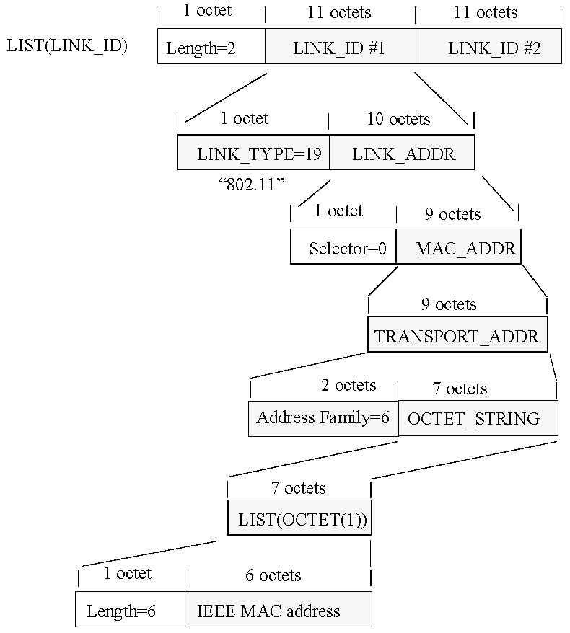
Figure F.1—Encoding example of a LIST with two LINK_ID elements

Derived data types

General
Derived data types are those that are derived from other data types or parent data types. A derived data type uses the same encoding as the parent data type.

General data types
The derived data types defined in this subclause are for general purpose only.
Table F.6—General data types
Data type name | Derived from | Definition
ENUMERATED | UNSIGNED_INT(1) | An enumerated attribute. Valid Range: 0..255
BOOLEAN | ENUMERATED | Represents a Boolean.  0: FALSE 1: TRUE
OCTET_STRING | LIST(OCTET(1)) | An array of arbitrary length octets. The default encoding format is UTF-8 [B23]. If a data type derived from OCTET_STRING uses other encoding format(s), the encoding format(s) must be specified in the definition of such a data type.
PERCENTAGE | UNSIGNED_INT(1) | Represents a percentage. Valid Range: 0..100
STATUS | ENUMERATED | The status of a primitive execution.  0: Success  - Unspecified Failure  - Rejected  - Authorization Failure  - Network Error

Data types for addresses
The data types defined in this subclause are related to addresses of network elements.
Table F.7—Data types for address
Data type name | Derived from | Definition
3GPP_2G_CELL_ID | SEQUENCE( PLMN_ID, LAC,  CI  ) | A data type to represent a 3GPP 2G cell identifier.
3GPP_3G_CELL_ID | SEQUENCE( PLMN_ID, CELL_ID  ) | A data type to represent a 3GPP 3G cell identifier.
3GPP_ADDR | OCTET_STRING | A data type to represent a 3GPP transport address.
3GPP2_ADDR | OCTET_STRING | A data type to represent a 3GPP2 transport address.

Table F.3—Data types for address (continued)
Data type name | Derived from | Definition
CELL_ID | UNSIGNED_INT(4) | This data type identifies a cell uniquely within 3GPP UTRAN and consists of radio network controller (RNC)-ID and C-ID as defined in 3GPP TS 25.401.  Valid Range: 0..268435455
CI | OCTET(2) | The BSS and cell within the BSS are identified by Cell Identity (CI). See 3GPP TS 23.003.
IP_ADDR | TRANSPORT_ADDR | Represents an IP address. The Address Type is either 1 (IPv4) or 2 (IPv6).
LAC | OCTET(2) | Location Area Code (LAC) is a fixed length code (of 2 octets) identifying a location area within a public land mobile network (PLMN). See 3GPP TS 23.003.
LINK_ADDR | CHOICE(  MAC_ADDR, 3GPP_3G_CELL_ID, 3GPP_2G_CELL_ID, 3GPP_ADDR, 3GPP2_ADDR, OTHER_L2_ADDR  ) | A data type to represent an address of any link layer.
MAC_ADDR | TRANSPORT_ADDR | Represents a MAC address. The Address Type contains the one used for a specific link layer.
OTHER_L2_ADDR | OCTET_STRING | A data type to represent a link-layer address other than the address already defined. For example, SSID.
PLMN_ID | OCTET(3) | The public land mobile network (PLMN) unique identifier. PLMN_ID consists of Mobile Country Code (MCC) and Mobile Network Code (MNC). This is to represent the access network identifier.  Coding of PLMN_ID is defined in 3GPP TS 25.4 13.
TRANSPORT_ADDR | SEQUENCE( UNSIGNED_INT(2), OCTET_STRING  ) | A type to represent a transport address. The UNSIGNED_INT(2) is the address type defined in http://www.iana.org/assignments/address-family-numbers.

Data types for link identification and manipulation
The data types defined in this subclause are used for representing attributes for identification and manipulation of links.
Table F.8—Data types for links
Data type name | Derived from | Definition
BATT_LEVEL | INTEGER(1) | Represents percentage of battery charge remaining.  Valid Range: –1..100.  –1 indicates battery level unknown.
CHANNEL_ID | UNSIGNED_INT(2) | Channel identifier as defined in the specific link technology (e.g., standards development organization (SDO)).  Valid Range: 0..65535
CONFIG_STATUS | BOOLEAN | The status of link parameter configuration.  TRUE: Success FALSE: Error
DEVICE_INFO | OCTET_STRING | A non-NULL terminated string whose length shall not exceed 253 octets, representing information on manufacturer, model number, revision number of the software/firmware and serial number in displayable text.
DEV_STATES_REQ | BITMAP(16) | A list of device status request.  Bitmap Values:  Bit 0: DEVICE_INFO Bit 1: BATT_LEVEL Bit 2–15: (Reserved)
DEV_STATES_RSP | CHOICE(  DEVICE_INFO, BATT_LEVEL ) | Represents a device status.
LINK_AC_EX_TIME | UNSIGNED_INT(2) | Time (in ms) to elapse before an action needs to be taken. A value of 0 indicates that the action will be taken immediately. Time elapsed will be calculated from the instance the command arrives until the time when the execution of the action is carried out.  Valid Range: 0..65535
LINK_AC_RESULT | ENUMERATED | Link action result.  0: Success  - Failure  - Refused  - Incapable
Table F.4—Data types for links (continued)
Data type name | Derived from | Definition
LINK_ACTION | SEQUENCE(  LINK_AC_TYPE, LINK_AC_ATTR ) | Link action.
LINK_AC_ATTR | BITMAP(8) | Link action attribute that can be executed along with a valid link action. Detail description of each attribute is in Table F.6.  Bitmap Values:  Bit 0: LINK_SCAN  Bit 1: LINK_RES_RETAIN Bit 2: DATA_FWD_REQ Bit 3–7: (Reserved)
LINK_ACTION_REQ | SEQUENCE(  LINK_ID,  CHOICE(NULL, LINK_ADDR), LINK_ACTION,  LINK_AC_EX_TIME  ) | A set of handover action request parameters. The choice of LINK_ADDR is to provide PoA address information when the LINK_ACTION contains the  attribute for DATA_FWD_REQ.
LINK_ACTION_RSP | SEQUENCE(  LINK_ID,  LINK_AC_RESULT,  CHOICE(NULL,  LIST(LINK_SCAN_RSP))  ) | A set of link action returned results.
LINK_AC_TYPE | UNSIGNED_INT(1) | An action for a link. The meaning of each link action is defined in Table F.5.  0: NONE  - LINK_DISCONNECT  - LINK_LOW_POWER  - LINK_POWER_DOWN  - LINK_POWER_UP 5–255: (Reserved)
LINK_CMD_LIST | BITMAP(32) | A list of link commands.  Bitmap Values: Bit 0: Reserved Bit 1: Link_Event_Subscribe  Bit 2: Link_Event_Unsubscribe  Bit 3: Link_Get_Parameters  Bit 4: Link_Configure_Thresholds  Bit 5: Link_Action Bit 6-31: (Reserved)

Table F.4—Data types for links (continued)
Data type name | Derived from | Definition
LINK_CFG_PARAM | SEQUENCE(  LINK_PARAM_TYPE,  CHOICE(NULL, TIMER_INTERVAL), TH_ACTION,  LIST(THRESHOLD)  ) | A link configuration parameter.  TH_ACTION indicates what action to apply to the listed thresholds.  When “Cancel threshold” is selected and no thresholds are specified, then all currently configured thresholds for the given LINK_PARAM_TYPE are cancelled.  When “Cancel threshold” is selected and thresholds are specified only those configured thresholds for the given LINK_PARAM_TYPE and whose threshold value match what was specified are cancelled.  With “Set one-shot threshold” the listed thresholds are first set and then each of the threshold is cancelled as soon as it is crossed for the first time.
LINK_CFG_STATUS | SEQUENCE(  LINK_PARAM_TYPE, THRESHOLD,  CONFIG_STATUS  ) | The status of link parameter configuration for each threshold specified in the THRESHOLD.
LINK_DESC_REQ | BITMAP(16) | A set of link descriptors.  Bitmap Values:  Bit 0: Number of Classes of Service Supported  Bit 1: Number of Queues Supported Bits 2–15: (Reserved)
LINK_DESC_RSP | CHOICE(NUM_COS, NUM_QUEUE) | Descriptors of a link.
LINK_DATA_RATE | UNSIGNED_INT(4) | A type to represent the maximum data rate in kb/s.  Valid Range: 0 – 2³²–1
LINK_DN_REASON | UNSIGNED_INT(1) | Represents the reason of a link down event.  See Table F.7 for the enumeration values.

Table F.4—Data types for links (continued)
Data type name | Derived from | Definition
LINK_EVENT_LIST | BITMAP(32) | A list of link events. The specified event is selected if the corresponding bit is set to 1.  Bitmap values:  Bit 0: Link_Detected  Bit 1: Link_Up  Bit 2: Link_Down  Bit 3: Link_Parameters_Report Bit 4: Link_Going_Down  Bit 5: Link_Handover_Imminent Bit 6: Link_Handover_Complete Bit 7: Link_PDU_Transmit_Status Bit 8–31: (Reserved)
LINK_GD_REASON | UNSIGNED_INT(1) | Represents the reason of a link going down. See Table F.8 for the enumeration values.
LINK_ID | SEQUENCE( LINK_TYPE LINK_ADDR ) | The identifier of a link that is not associated with the peer node. The LINK_ADDR contains the address of this link.
LINK_MIHCAP_FLAG | BITMAP(8) | Represents if MIH capability is supported or not. If the bit is set, it indicates that the capability is supported.  Bitmap values:  Bit 1: event service (ES) supported  Bit 2: command service (CS) supported Bit 3: information service (IS) supported Bit 0, 4–7: (Reserved)
LINK_PARAM | SEQUENCE(  LINK_PARAM_TYPE, CHOICE(LINK_PARAM_VAL,  QOS_PARAM_VAL)  ) | Represents a link parameter type and value pair.
LINK_PARAM_802_11 | UNSIGNED_INT(1) | A type to represent a link parameter for IEEE 802.11.  0: RSSI of the beacon channel, as defined in IEEE Std 802.11-2007. (This is applicable only for an MN.)  - No QoS resource available. The corresponding LINK_PARAM_VAL is BOOLEAN set to TRUE when no QoS resources available. (This applicable when the traffic stream to be transmitted is on an access category configured for mandatory admission control and the request for bandwidth was denied by the available APs in the access network).  - Multicast packet loss rate.  3–255: (Reserved)

Table F.4—Data types for links (continued)
Data type name | Derived from | Definition
LINK_PARAM_802_16 | UNSIGNED_INT(1) | A type to represent a link parameter for IEEE 802.16.  0–255: (Reserved)
LINK_PARAM_802_20 | UNSIGNED_INT(1) | A type to represent a link parameter for IEEE 802.20.  0–255: (Reserved)
LINK_PARAM_802_22 | UNSIGNED_INT(1) | A type to represent a link parameter for IEEE 802.22.  0–255: (Reserved)
LINK_PARAM_C2K | UNSIGNED_INT(1) | A type to represent a link parameter for CDMA2000.  0: PILOT_STRENGTH 1–255: (Reserved)
LINK_PARAM_HRPD | UNSIGNED_INT(1) | A type to represent a link parameter for CDMA2000 HRPD.  0: PILOT_STRENGTH 1–255: (Reserved)
LINK_PARAM_EDGE | UNSIGNED_INT(1) | A type to represent a link parameter for EDGE.  0-255: (Reserved)
LINK_PARAM_ETH | UNSIGNED_INT(1) | A type to represent a link parameter for Ethernet.  0-255: (Reserved)
LINK_PARAM_GEN | UNSIGNED_INT(1) | A type to represent a generic link parameter that is applicable to any link type.  0: Data Rate—the parameter value is represented as a DATA_RATE.  - Signal Strength—the parameter value is represented as a SIG_STRENGTH.  - Signal over interference plus noise ratio (SINR)—the parameter value is represented as an UNSIGNED_INT(2). 3:Throughput (the number of bits successfully received divided by the time it took to transmit them over the medium) —the parameter value is represented as an UNSIGNED_INT(2).  4: Packet Error Rate (representing the ratio between the number of frames received in error and the total number of frames transmitted in a link population of interest)—the parameter value is represented as a PERCENTAGE.  5–255: (Reserved)
Table F.4—Data types for links (continued)
Data type name | Derived from | Definition
LINK_PARAM_GG | UNSIGNED_INT(1) | A type to represent a link parameter for  GSM and GPRS. See 3GPP TS 25.008.  0: RxQual  - RsLev  - Mean BEP  - StDev BEP  4-255: (Reserved)
LINK_PARAM_QOS | UNSIGNED_INT(1) | A type to represent QOS_LIST parameters.  0: Maximum number of differentiable classes of service supported.  - Minimum packet transfer delay for all CoS, the minimum delay over a class population of interest.  - Average packet transfer delay for all CoS, the arithmetic mean of the delay over a class population of interest. (See B.3.4)  - Maximum packet transfer delay for all CoS, the maximum delay over a class population of interest.  - Packet transfer delay jitter for all CoS, the standard deviation of the delay over a class population of interest. (See B.3.5.)  - Packet loss rate for all CoS, the ratio between the number of frames that are transmitted but not received and the total number of frames transmitted over a class population of interest. (See B.3.2.)  6–255: (Reserved)
LINK_PARAM_RPT | SEQUENCE(  LINK_PARAM,  CHOICE(NULL, THRESHOLD)  ) | Represents a link parameter report. Includes an option of the THRESHOLD that was crossed. If no THRESHOLD is included, then this is a periodic report.
LINK_PARAM_TYPE | CHOICE(  LINK_PARAM_GEN, LINK_PARAM_QOS, LINK_PARAM_GG, LINK_PARAM_EDGE, LINK_PARAM_ETH, LINK_PARAM_802_1 1, LINK_PARAM_C2K, LINK_PARAM_FDD, LINK_PARAM_HRPD, LINK_PARAM_802_16, LINK_PARAM_802_20, LINK_PARAM_802_22 ) | Measurable link parameter for which thresholds are being set.

Table F.4—Data types for links (continued)
Data type name | Derived from | Definition
LINK_PARAM_VAL | UNSIGNED_INT(2) | The current value of the parameter. The format of the media-dependent value is defined in the respective media specification standard and the equivalent number of bits (i.e., first bits) of this data  type is used. In case that there are remaining unused bits in the data type, these are marked as all-zeros (‘0’).  Valid Range: 0..65535
LINK_PARAM_FDD | UNSIGNED_INT(1) | A type to represent a link parameter for UMTS. See 3GPP TS 25.215.  0: CPICH RSCP  - PCCPCH RSCP  - UTRA carrier RSSI  - GSM carrier RSSI  - CPICH Ec/No  - Transport channel BLER  - user equipment (UE) transmitted power  7–255: (Reserved)
LINK_POA_LIST | SEQUENCE(  LINK_ID,  LIST(LINK_ADDR)  ) | A list of PoAs for a particular link. The LIST(LINK_ADDR) is a list of PoA link addresses and is sorted from most preferred first to least preferred last.
LINK_RES_STATUS | BOOLEAN | Indicates if a resource is available or not.  TRUE: Available  FALSE: Not available.
LINK_SCAN_RSP | SEQUENCE(  LINK_ADDR,  NETWORK_ID, SIG_STRENGTH ) | Represents a scan response. The LINK_ADDR contains the PoA link address. The PoA belongs to the NETWORK_ID with the given  SIG_STRENGTH.
LINK_STATES_REQ | BITMAP(16) | Link states to be requested.  Bit 0: OP_MODE  Bit 1: CHANNEL_ID Bit 2–15: (Reserved)
LINK_STATES_RSP | CHOICE(OP_MODE,CHANNEL_ID) | The operation mode or the channel ID of the link.
LINK_STATUS_REQ | SEQUENCE(  LINK_STATES_REQ, LIST(LINK_PARAM_TYPE), LINK_DESC_REQ  ) | Represents the possible information to request from a link.
LINK_STATUS_RSP | SEQUENCE(  LIST(LINK_STATES_RSP), LIST(LINK_PARAM), LIST(LINK_DESC_RSP)  ) | A set of link status parameter values correspond to the  LINK_STATUS_REQ.

Table F.4—Data types for links (continued)
Data type name | Derived from | Definition
LINK_TUPLE_ID | SEQUENCE(  LINK_ID,  CHOICE(NULL, LINK_ADDR)  ) | The identifier of a link that is associated with a PoA. The LINK_ID contains the MN LINK_ADDR. The optional  LINK_ADDR contains a link address of PoA.
LINK_TYPE | UNSIGNED_INT(1) | Represents the link type.ª  Number assignments:  0: Reserved  - Wireless - GSM  - Wireless - GPRS  - Wireless - EDGE  15: Ethernet  - Wireless - Other  - Wireless - IEEE 802.11  - Wireless - CDMA2000  - Wireless - UMTS  - Wireless - cdma2000-HRPD  - Wireless - IEEE 802.16  - Wireless - IEEE 802.20  - Wireless - IEEE 802.22
NUM_COS | UNSIGNED_INT(1) | The maximum number of differentiable classes of service supported.  Valid Range: 0..255
NUM_QUEUE | UNSIGNED_INT(1) | The number of transmit queues supported.  Valid Range: 0..255
OP_MODE | UNSIGNED_INT(1) | The link power mode.  0: Normal Mode  - Power Saving Mode  - Powered Down  3–255: (Reserved)
SIG_STRENGTH | CHOICE(INTEGER(1), PERCENTAGE) | Represents the signal strength in dBm unit or its relative value in an arbitrary percentage scale.
TH_ACTION | ENUMERATED | 0: Set normal threshold  - Set one-shot threshold  - Cancel threshold
THRESHOLD | SEQUENCE(  THRESHOLD_VAL, THRESHOLD_X_DIR ) | A link threshold. The threshold is considered crossed when the value of the link parameter passes the threshold in the specified direction.

Table F.4—Data types for links (continued)
Data type name | Derived from | Definition
THRESHOLD_VAL | UNSIGNED_INT(2) | Threshold value. The format of the media-dependent value is defined in the respective media specification standard and the equivalent number of bits (i.e., first bits) of this data type is used. In case that there are remaining unused bits in the data type, these are marked as all- zeros (‘0’).  Valid Range: 0..65535
THRESHOLD_X_DIR | UNSIGNED_INT(1) | The direction the threshold is to be crossed.  0: ABOVE_THRESHOLD 1: BELOW_THRESHOLD 2–255: (Reserved)
TIMER_INTERVAL | UNSIGNED_INT(2) | This timer value (ms) is used to set the interval between periodic reports.  Valid Range: 0..65535
ªThe values defined are made consistent with RADIUS network access server (NAS)-Port-Type definitions as specified by Internet Assigned Numbers Authority (IANA). (See IETF RFC 2865.)

Table F.9—Link actions
Action name | Description
LINK_DISCONNECT | Disconnect the link connection directly.
LINK_LOW_POWER | Cause the link to adjust its battery power level to be low power consumption.
LINK_POWER_DOWN | Cause the link to power down and turn off the radio.
LINK_POWER_UP | Cause the link to power up and establish L2 connectivity. For UMTS link type, power up lower layers and establish PDP context.

Table F.10—Link action attributes

Action name | Description
DATA_FWD_REQ | This indication requires the buffered data at the old serving PoA entity to be forwarded to the new target PoA entity in order to avoid data loss. This action can be taken immediately after the old serving PoS receives MIH_N2N_HO_Commit response message from the new target PoS, or the old serving PoS receives MIH_Net_HO_Commit response message from the MN. This is not valid on UMTS link type.

Table F.6—Link action attributes (continued)
Action name | Description
LINK_RES_RETAIN | The link will be disconnected but the resource for the link connection still remains so reestablishing the link connection later can be more efficient.
LINK_SCAN | Cause the link to perform a scan.

Table F.11—Link down reason code
Reason  code | Reason | Description
0 | Explicit disconnect | The link is down because of explicit disconnect procedures initiated either by MN or network.
1 | Packet timeout | The link is down because no acknowledgements were received for transmitted packets within the specified time limit.
2 | No resource | The link is down because there were no resources to maintain the connection.
3 | No broadcast | The link is down because broadcast messages (such as beacons in IEEE 802.11 management frames) could not be received by MN.
4 | Authentication failure | Authentication failure.
5 | Billing failure | Billing failure.
6–127 | (Reserved) | Reserved for IEEE 802.21 future use.
128–255 | Vendor specific rea- son codes | Vendors specify their own specific reason codes in this range.

Table F.12—Link going down reason code
Reason  code | Reason | Description
0 | Explicit disconnect | The link is going to be down because explicit disconnect procedures will be initiated either by MN or network. For example, when a BS has decided to shutdown for administrative reasons or an operator of the terminal has decided to execute a handover manually, a Link_Going_Down trigger is sent to the MIHF.
1 | Link parameter degrading | The link is going to be down because broadcast messages (such as beacons in IEEE 802.11 management frames) could not be received by MN.
2 | Low power | The link is going to be down because the power level of the terminal is low and the current link will not be maintained in such a low power level. Mobile terminals usually have limited battery supply, and when the battery level of the terminal is low, a terminal can choose a link that has lower power consumption for handover according to the received Link_Going_Down triggers with this reason code. This will lengthen the usable time for the terminal.

Table F.8—Link going down reason code (continued)
Reason  code | Reason | Description
3 | No resource | The link is going to be down because there will be no resources to maintain the current connection. For example, a BS that has too many users can send Link_Going_Down indications to terminals when the links with them can not be kept because of insufficient resources. Another example is that users with higher priority can preempt the ones with lower priority when no more resources can be allocated in 3GPP, and this can also cause a Link_Going_Down indication with this reason code.
4–127 | (Reserved) | Reserved for IEEE 802.21 future use.
128–255 | Vendor specific rea- son codes | Vendors specify their own specific reason codes in this range.

Data types for QoS
The data types defined in this subclause are related to QoS.
Table F.13—Data types for QoS
Data type name | Derived from | Definition
QOS_LIST | SEQUENCE(  NUM_COS_TYPES, LIST(MIN_PK_TX_DELAY), LIST(AVG_PK_TX_DELAY), LIST(MAX_PK_TX_DELAY), LIST(PK_DELAY_JITTER), LIST(PK_LOSS_RATE)  ) | A list of Class of Service (CoS) parameters.
NUM_COS_TYPES | UNSIGNED_INT(1) | A type to represent the maximum number of differentiable classes of service supported.  Valid Range: 0..255
MIN_PK_TX_DELAY | SEQUENCE(  COS_ID,  UNSIGNED_INT(2)  ) | A type to represent the minimum packet transfer delay in ms for the specific CoS specified by the COS_ID.
AVG_PK_TX_DELAY | SEQUENCE(  COS_ID,  UNSIGNED_INT(2)  ) | A type to represent the average packet transfer delay in ms for the specific CoS specified by the COS_ID.
MAX_PK_TX_DELAY | SEQUENCE(  COS_ID,  UNSIGNED_INT(2)  ) | A type to represent the maximum packet transfer delay in ms for the specific CoS specified by the COS_ID.
PK_DELAY_JITTER | SEQUENCE(  COS_ID,  UNSIGNED_INT(2)  ) | A type to represent the packet transfer delay jitter in ms for the specific CoS specified by the COS_ID.

Table F.9—Data types for QoS (continued)
Data type name | Derived from | Definition
PK_LOS S_RATE | SEQUENCE(  COS_ID,  UNSIGNED_INT(2)  ) | A type to represent the packet loss rate for the specific CoS specified by the COS_ID. The loss rate is equal to the integer part of the result of multiplying –100 times the log10 of the ratio between the number of packets lost and the total number of packets transmitted in the class population of interest.
COS_ID | UNSIGNED_INT(1) | A type to represent a class of service identifier. Valid Range: 0–255
QOS_PARAM_VAL | CHOICE(  NUM_COS_TYPES, LIST(MIN_PK_TX_DELAY), LIST(AVG_PK_TX_DELAY), LIST(MAX_PK_TX_DELAY), LIST(PK_DELAY_JITTER), LIST(PK_LOSS_RATE)  ) | A choice of Class of Service (CoS) parameters.

Data types for location
Table F.14—Data types for location
Data type name | Derived from | Definition
LOCATION | CHOICE(  CIVIC_LOC, GEO_LOC, CELL_ID  ) | A type to represent the format and value of the location information. The location can be civic location, geospacial location, or a cellular ID value as reference location.
CIVIC_LOC | CHOICE( BIN_CIVIC_LOC, XML_CIVIC_LOC ) | A type to represent a civic address.
BIN_CIVIC_LOC | SEQUENCE( CNTRY_CODE, CIVIC_ADDR  ) | A type to represent a binary-formatted civic address.  See CNTRY_CODE and CIVIC_ADDR definitions.
XML_CIVIC_LOC | OCTET_STRING | A type to represent an XML-formatted civic location. Civic address elements, as described in IETF RFC 4119.
CIVIC_ADDR | OCTET_STRING | A type to represent civic address elements in BIN_CIVIC_LOC.  Civic address elements, as described in IETF RFC 4776.
GEO_LOC | CHOICE(  BIN_GEO_LOC, XML_GEO_LOC ) | A type to represent a geospatial location.
BIN_GEO_LOC | OCTET(16) | A type to represent a binary-formatted geospatial location. See Table F.11.

Table F.10—Data types for location (continued)
XML_GEO_LOC | OCTET_STRING | A type to represent an XML-formatted geospatial location.  Geo address elements as described in IETF RFC 4119.  For example,  <gml:location>  <gml:Point gml:id=“point1” srsName=“epsg:4326”>  <gml:coordinates>37:46:30N 122:25: 10W</gml:coordinates>  </gml:Point>  </gml:location>

Table F.15—Value field format of PoA location information (geospatial location )
Syntax | Length  (bits) | Notes  (See IETF RFC 3825 for details)
LatitudeResolution (LaRes) | 6 | Latitude resolution: six bits indicating the number of valid bits in the fixedpoint value of Latitude. Any bits entered to the right of this limit should not be considered valid and might be purposely false, or zeroed by the sender.
Latitude | 34 | A 34-bit fixed point value consisting of nine bits of integer and 25 bits of fraction. Latitude should be normalized to within ± 90 degrees. Positive numbers are north of the equator and negative numbers are south of the equator.
LongitudeResolution (LoRes) | 6 | Longitude resolution: six bits indicating the number of valid bits in the fixedpoint value of Longitude. This value is the number of high-order Longitude bits that should be considered valid. Any bits entered to the right of this limit should not be considered valid and might be purposely false, or zeroed by the sender.
Longitude | 34 | A 34 bit fixed point value consisting of nine bits of integer and 25 bits of fraction. Longitude should be normalized to within ± 180 degrees. Positive values are East of the prime meridian and negative (2s complement) numbers are West of the prime meridian.
AltitudeType (AT) | 4 | Following codes are defined:  - Meters: in 2s-complement fixed-point 22-bit integer part with 8-bit fraction. If AT = 1, an AltRes value 0.0 would indicate unknown altitude. The most precise Altitude would have an AltRes value of 30. Many values of AltRes would obscure any variation due to vertical datum differences.  - Floors: in 2s-complement fixed-point 22-bit integer part with 8-bit fraction. AT = 2 for Floors enables representing altitude in a form more relevant in buildings that have different floor-to-floor dimensions.
AltitudeResolution (AltRes) | 6 | Altitude resolution: six bits indicating the number of valid bits in the altitude. Values above 30 (decimal) are undefined and reserved.
Altitude | 30 | A 30-bit value defined by the AT field.
Datum | 8 | Following codes are defined:  - WGS  - NAD 83 (with associated vertical datum for North American vertical datum for 1998)  - NAD 83 [with associated vertical datum for Mean Lower Low Water (MLLW)]

Data types for IP configuration
Table F.16—Data types for IP configuration
Data type name | Derived from | Definition
IP_CFG_MTHDS | BITMAP(32) | A set of IP configuration methods.  Bit 0: IPv4 static configuration  Bit 1: IPv4 dynamic configuration (DHCPv4)  Bit 2: Mobile IPv4 with foreign agent (FA) care-of address (CoA) (FA-CoA)  Bit 3: Mobile IPv4 without FA (Co-located CoA) Bits 4–10: reserved for IPv4 address configurations Bit 11: IPv6 stateless address configuration  Bit 12: IPv6 stateful address configuration (DHCPv6) Bit 13: IPv6 manual configuration  Bits 14–31: (Reserved)
IP_MOB_MGMT | BITMAP(16) | Indicates the supported mobility management protocols.  Bit 0: Mobile IPv4 (IETF RFC 3344)  Bit 1: Mobile IPv4 Regional Registration (IETF RFC 4857)  Bit 2: Mobile IPv6 (IETF RFC 3775)  Bit 3: Hierarchical Mobile IPv6 (IETF RFC 4140)  Bit 4: Low Latency Handoffs (IETF RFC 4881)  Bit 5: Mobile IPv6 Fast Handovers (IETF RFC 5268)  Bit 6: IKEv2 Mobility and Multihoming Protocol (IETF RFC 4555)  Bit 7–15: (Reserved)
IP_PREFIX_LEN | UNSIGNED_INT(1) | The length of an IP subnet prefix.  Valid Range:  0..32 for IPv4 subnet.  0..64, 65.. 127 for IPv6 subnet. (IETF RFC 4291 [B25])
IP_RENEWAL_FLAG | BOOLEAN | Indicates whether MN’s IP address needs to be changed or not.  TRUE: Change required. FALSE: Change not required.
IP_SUBNET_INFO | SEQUENCE(  IP_PREFIX_LEN, IP_ADDR  ) | Represent an IP subnet. The IP_PREFIX_LEN contains the bit length of the prefix of the subnet to which the IP_ADDR belongs.

Data types for information elements
Data types defined in this subclause are used only by IEs.

Table F.17—Data types for information elements
Data type name | Derived from | Definition
NET_AUX_ID | OCTET_STRING | A type to represent an auxiliary access network identifier. This is HESSID if network type is IEEE 802.11.
NETWORK_ID | OCTET_STRING | A type to represent a network identifier.  A non-NULL terminated string whose length shall not exceed 253 octets.
BAND_CLASS | UNSIGNED_INT(1) | CDMA band class.
BANDWIDTH | UNSIGNED_INT(2) | Channel bandwidth in kb/s.
BASE_ID | UNSIGNED_INT(2) | Base station identifier.
BURST_PROF | SEQUENCE( DOWN_BP, UP_BP  ) | Burst profile
CH_RANGE | SEQUENCE(  UNSIGNED_INT(4), UNSIGNED_INT(4) ) | A type that contains two numbers. The first unsigned integer is the low range. The second unsigned integer is the high range. Both values are in kHz.  The first unsigned integer value should always be less than or equal to the second unsigned integer.
COST | SEQUENCE(  COST_UNIT, COST_VALUE, COST_CURR ) | A type to represent a cost.
COST_CURR | OCTET(3) | A type to represent the currency of a cost.  A three-letter currency code (e.g., “USD”) specified by ISO 4217.
COST_UNIT | UNSIGNED_INT(1) | A type to represent the unit of a cost.  0: second  - minute  - hours  - day  - week  - month  - year  - free  - flat rate 9–255: (Reserved)
COST_VALUE | SEQUENCE(  UNSIGNED_INT(4), UNSIGNED_INT(2) ) | A type to represent the value of a cost.  The first 4-octet contains the integer part of the cost. The last 2-octet contains the fraction part where it represents a 3-digit fraction.  Therefore, the value range of the fraction part is [0,999].  For example, for a value of “0.5”, the integer part is zero and the fraction part is 500.
CNTRY_CODE | OCTET(2) | Country code, represented as two letter ISO 3 166-1 country code in capital ASCII letters.

Table F.13—Data types for information elements (continued)
Data type name | Derived from | Definition
DATA_RATE | UNSIGNED_INT(4) | A type to represent the maximum data rate in kb/s. Valid Range: 0..2³²–1
DCD_UCD | SEQUENCE(  BASE_ID,  BANDWIDTH, DU_CTR_FREQ, EIRP,  GAP,  BURST_PROF, CDMA_CODES  ) | A type to represent the downlink channel descriptor and the uplink channel descriptor.
DOWN_BP | BITMAP(256) | A List of FEC Code Type for Downlink burst. Refer to 11.4.1 in IEEE 802.16Rev2/D5.0.
EIRP | INTEGER(1) | BS’s effective isotropic radiated power level. Signed in units of 1 dBm.
FQDN | OCTET_STRING | The fully qualified domain name of a host as described in IETF RFC 2181.
DU_CTR_FREQ | INTEGER(8) | Downlink/Uplink center frequency in kHz.
FREQ_BANDS | LIST(UNSIGNED_INT(4)) | A list of frequency bands. The values are in kHz.
FREQ_ID | INTEGER(2) | Identifier of the carrier frequency. Valid Range: 0..65535
FQ_CODE_NUM | INTEGER(2) | UMTS scrambling code, cdma2000 Walsh code. Valid Range: 0..65535
GAP | SEQUENCE(  UNSIGNED_INT(2), UNSIGNED_INT(1) ) | This gap is an integer number of physical slot durations and starts on a physical slot boundary. Used on TDD systems only.  The UNSIGNED_INT(2) is used for the TTG - transmit/receive transition gap.  The UNSIGNED_INT(1) is used for the RTG - receive/transmit transition gap.
HO_CODE | INTEGER(1) | HANDOVER_RANGING_CODE.  Refer to 11.3.1 in IEEE 802. 16Rev2/D5.0.
INIT_CODE | INTEGER(1) | INITIAL_RANGING_CODE.  Refer to 11.3.1 in IEEE 802. 16Rev2/D5.0.
IP4_ADDR | OCTET(4) | An IPv4 address as described in IETF RFC 791 [B22].
IP6_ADDR | OCTET(16) | An IPv6 address as described in IETF RFC 4291 [B25].
IP_CONFIG | SEQUENCE(  IP_CFG_MTHDS, CHOICE(NULL, DHCP_SERV), CHOICE(NULL, FN_AGNT), CHOICE(NULL, ACC_RTR)  ) | IP Configuration Methods supported by the access network.

Table F.13—Data types for information elements (continued)
Data type name | Derived from | Definition
NET_CAPS | BITMAP(32) | These bits provide high level capabilities supported on a network.  Bitmap Values:  Bit 0: Security – Indicates that some level of security is supported when set.  Bit 1: QoS Class 0 – Indicates that QoS for class 0 is supported when set.ª  Bit 2: QoS Class 1 – Indicates that QoS for class 1 is supported when set. a  Bit 3: QoS Class 2 – Indicates that QoS for class 2 is supported when set; Otherwise, no QoS for class 2 support is available.  Bit 4: QoS Class 3 – Indicates that QoS for class 3 is supported when set; Otherwise, no QoS for class 3 support is available.  Bit 5: QoS Class 4 – Indicates that QoS for class 4 is supported when set; Otherwise, no QoS for class 4 support is available.  Bit 6: QoS Class 5 – Indicates that QoS for class 5 is supported when set; Otherwise, no QoS for class 5 support is available.  Bit 7: Internet Access – Indicates that Internet access is supported when set; Otherwise, no Internet access support is available.  Bit 8: Emergency Services – Indicates that some level of emergency services is supported when set; Otherwise, no emergency service support is available.  Bit 9: MIH Capability – Indicates that MIH is supported when set; Otherwise, no MIH support is available.  Bit 10–31: (Reserved)
NETWORK_TYPE | SEQUENCE(  CHOICE(NULL, LINK_TYPE), CHOICE(NULL, SUBTYPE), CHOICE(NULL, TYPE_EXT) ) | A type to represent a network type and its subtype. See Table F.14 for details.
OPERATOR_ID | SEQUENCE(  OP_NAME,  OP_NAMESPACE  ) | A type to represent an operator identifier.
OP_NAME | OCTET_STRING | A type to represent an operator name. The value uniquely identifies the operator name within the scope of the OP_NAMESPACE.  The value is a non NULL terminated string whose length shall not exceed 253 octets.
OP_NAMESPACE | UNSIGNED_INT(1) | A type to represent a type of operator name.  0: GSM/UMTS  - CDMA  - REALM (as defined in [B28]).  - ITU-T/TSB  - General  5–255: (Reserved)

Table F.13—Data types for information elements (continued)
Data type name | Derived from | Definition
PARAMETERS | CHOICE(  DCD_UCD,  SIB,  SYS_PARAMS  ) | A data type to represent system information depending on the network type.  DCD_UCD: IEEE 802.16  SIB: UMTS  SYS_PARAMS: cdma2000
PILOT_PN | INTEGER(2) | Pilot PN sequence offset index.
PROXY_ADDR | CHOICE(  IP4_ADDR, IP6_ADDR, FQDN  ) | L3 address of a proxy server.
CDMA_CODES | SEQUENCE( INIT_CODE, HO_CODE ) | A set of CDMA ranging codes.
REGU_DOMAIN | SEQUENCE(  CNTRY_CODE,  UNSIGNED_INT(1)  ) | A type to represent a regulatory domain. A regulatory domain is identified by a country code (CNTRY_CODE) and a regulatory class  (UNSIGNED_INT(1)). The regulatory class values are defined in Annex J of IEEE Std 802.11k
SUBTYPE | BITMAP(64) | A network subtype. See Table F.14.
ROAMING_PTNS | LIST(OPERATOR_ID) | A list of roaming partners.
SP_ID | OCTET_STRING | A service provider identifier.  A non-NULL terminated string whose length shall not exceed 253 octets.
SIB | SEQUENCE(  CELL_ID,  FQ_CODE_NUM  ) | A type to represent UMTS system information block (SIB).

Table F.13—Data types for information elements (continued)
Data type name | Derived from | Definition
SUPPORTED_LCP | UNSIGNED_INT(1) | A type represent supported Location Configuration Protocol. (LCP). Location by Reference (LbyR).  Values represent LCPs: 0: NULL  - LLDP  - LbyR with LLDP 3–10: (Reserved)  - LLDP-MED  - LbyR with LLDP-MED  13–20: (Reserved)  - U-TDoA  - D-TDoA  23–30: (Reserved)  - DHCP  - LbyR with DHCP 33–40: (Reserved)  - OMA SUPL  - IEEE 802.11  - LbyR with IEEE 802.11  44–50: (Reserved)  - HELD  - LbyR with HELD 53–255: (Reserved)
SYSTEM_INFO | SEQUENCE(  NETWORK_TYPE, LINK_ADDR,  CHOICE(NULL,  PARAMETERS)  ) | A type to represent system information.
SYS_PARAMS | SEQUENCE ( BASE_ID, PILOT_PN, FREQ_ID, BAND_CLASS  ) | CDMA2000 system parameters.
TYPE_EXT | OCTET_STRING | A generic type extension contained indicating a flexible length and format field. The content is to be defined and filled by the appropriate SDO or service provider consortium, etc.  The value is a non-NULL terminated string whose length shall not exceed 253 octets.
UP_BP | BITMAP(256) | A List of FEC Code Type for Uplink burst. Refer to 11.3.1 in IEEE 802. 16Rev2/D5.0
ªThe definitions of the QOS classes are according to ITU Y. 1541 [B 34].

Table F.18—Network type and subtype representation
Network | Link type | Network subtype
(Reserved) | 0 | N/A
Wireless - GSM | 1 | N/A
Wireless - GPRS | 2 | N/A
Wireless - EDGE | 3 | N/A
(Reserved) | 4-14 | N/A
Ethernet - IEEE 802.3 | 15 | Bit 0: 10 Mb  Bit 1: 100 Mb  Bit 2: 1000 Mb  Bit 3–63: (Reserved)  The above bits represent the link speeds that Ethernet supports. The capability information of twisted pair Ethernet link can be obtained via auto-negotiation as defined in Clause 28 of IEEE Std 802.3.
(Reserved) | 16-17 | N/A
Wireless - Other | 18 | N/A
Wireless - IEEE 802.11 | 19 | Bit 0: 2.4 GHz Bit 1: 5 GHz Bit 2: 4.9 GHz Bit 3: 3.65 GHz Bit 4: 316 THz Bit 5-63 (Reserved)  The above bits represent the frequency band that IEEE 802.11  link supports. The capability information and extended capabilities information of IEEE 802.11 link can further be represented  as defined in 7.3.1.4 and 7.3.2.27, respectively, of IEEE Std  802. 11-2007.
(Reserved) | 20-2 1 | N/A
Wireless - CDMA2000 | 22 | N/A
Wireless - UMTS | 23 | Bit 0: Rel-99  Bit 1: Rel-4  Bit 2: Rel-5 (w/ HSDPA) Bit 3: Rel-6 (w/ HSUPA)  Bit 4: Rel-7 (MIMO/OFDM) Bit 5: Rel-8  Bit 6–63: (Reserved)
Wireless - cdma2000-HRPD | 24 | Bit 0: Rev-0 Bit 1: Rev-A Bit 2: Rev-B Bit 3: Rev-C Bit 4–63: (Reserved)
(Reserved) | 25-26 | N/A

Table F.14—Network type and subtype representation (continued)
Network | Link type | Network subtype
Wireless - IEEE 802.16 | 27 | Bit 0: 2.5 GHz Bit 1: 3.5 GHz Bit 2-63: (Reserved)  The above bits represent the frequency band that IEEE 802.16 link supports. The system profiles of IEEE 802.16 link can further be represented as defined in clause 12 (12.3 and 12.4) of IEEE Std 802. 16e-2005.
Wireless - IEEE 802.20 | 28 | N/A
Wireless - IEEE 802.22 | 29 | N/A
(Reserved) | 30-255 | N/A

NOTE—The Link type values in Table F.14 are deliberately made consistent with RADIUS network access server (NAS)-Port-Type definitions as specified by Internet Assigned Numbers Authority (IANA).

Data types for information service query

Binary representation
Table F.19—Data types for binary query
Data type name | Derived from | Definition
CURR_PREF | COST_CURR | A type to indicate currency preference.
IE_TYPE | UNSIGNED_INT(4) | A type to represent an IE type. See Table G. 1 for more information.
IQ_BIN_DATA | SEQUENCE(  CHOICE(NULL, QUERIER_LOC), CHOICE(NULL, NET_TYPE_INC), CHOICE(NULL, NETWK_INC), CHOICE(NULL, RPT_TEMPL), CHOICE(NULL, RPT_LIMIT), CHOICE(NULL, CURR_PREF)  ) | Represents a binary query.  There should exist at least one of the query data type QUERIER_LOC, NET_TYPE_INC, or NETWK_INC.  One CURR_PREF at most is included in an Info Query Binary TLV. If included, it indicates to the MIIS server the preferred currency the returned cost should be represented in. If the MIIS server cannot return the cost in the specified currency, it can return the cost in other currencies.
NGHB_RADIUS | UNSIGNED_INT(4) | The radius in meters from the center point of querier’s location.  Valid Range: 0..2³²–1
NETWK_INC | LIST(NETWORK_ID) | A type to represent a list of network identifiers.

Table F.15—Data types for binary query (continued)
Data type name | Derived from | Definition
NET_TYPE_INC | BITMAP(32) | A type to represent a set of link types.  The value is a four octet bitmap: Bit 0: Wireless - GSM  Bit 1: Wireless - GPRS  Bit 2: Wireless - EDGE  Bit 3: IEEE 802.3 (Ethernet) Bit 4: Wireless - Other  Bit 5: Wireless - IEEE 802.11 Bit 6: Wireless - CDMA2000 Bit 7: Wireless - UMTS  Bit 8: Wireless - cdma2000-HRPD Bit 9: Wireless - IEEE 802.16  Bit 10: Wireless - IEEE 802.20 Bit 11: Wireless - IEEE 802.22  Bit 12–31: (Reserved AND shall be always set to “0”)
QUERIER_LOC | SEQUENCE(  CHOICE(NULL, LOCATION), CHOICE(NULL, LINK_ADDR), CHOICE(NULL, NGHB_RADIUS)  ) | A type to represent a querier's location. It is not valid to use both LOCATION and LINK_ADDR at the same time.
RPT_LIMIT | SEQUENCE(  UNSIGNED_INT(2), UNSIGNED_INT(2)  ) | A type to represent a report limitation. The first UNSIGNED_INT(2) contains the maximum number of IEs in the IR_BIN_DATA. The second UNSIGNED_INT(2) contains the starting entry number (offset = 1 points to the first entry) from which a chunk of entries are to be included in the IQ_BIN_DATA. It is assumed that the IS server generates the same ordered list of entries for queries from the same IS client with the same IR_BIN_DATA content (except for RPT_LIMIT) before the limitation on the RPT_LIMIT is applied.
RPT_TEMPL | LIST(IE_TYPE) | A type to represent a list of IE types. Inclusion of any IE type is optional.

RDF representation
Table F.20—Data type for RDF query
Data type name | Derived from | Definition
IQ_RDF_SCHM | OCTET_STRING | A type to represent the URL of an RDF schema to obtain.
IQ_RDF_DATA | SEQUENCE(  CHOICE(NULL, MIME_TYPE), OCTET_STRING  ) | Represents RDF query. If MIME_TYPE is omitted, MIME type “application/sparql-query” is used. Each OCTET_STRING is formatted with the MIME type.
MIME_TYPE | OCTET_STRING | Represents MIME type.

Data types for information service response

Binary representation
Table F.21—Data type for binary information query response
Data type name | Derived from | Definition
IR_BIN_DATA | LIST(INFO_ELEMENT) | A type to represent a binary query response data.

RDF representation
Table F.22—Data type for RDF information query response
Data type name | Derived from | Definition
IR_RDF_DATA | SEQUENCE(  CHOICE(NULL, MIME_TYPE), OCTET_STRING  ) | Represents RDF data query result. If MIME_TYPE is omitted, MIME type “application/ sparql-  results+xml” is used. OCTET_STRING is formatted with the MIME type.
IR_SCHM_URL | OCTET_STRING | An URL of an RDF schema.
IR_RDF_SCHM | SEQUENCE(  CHOICE(NULL, MIME_TYPE), OCTET_STRING  ) | Represents an RDF schema. If MIME_TYPE is omitted, MIME type “application/xml” is used. OCTET_STRING is formatted with the MIME type.

Data type for MIHF identification
Table F.23—Data type for MIHF identification
Data type name | Derived from | Definition
MIHF_ID | OCTET_STRING | The MIHF Identifier: MIHF_ID is a network access identifier (NAI).
 |  | NAI shall be unique as per IETF RFC 4282. If L3 communication is used and MIHF entity resides in the network node, then MIHF_ID is the fully qualified domain name or NAI-encoded IP address
 |  | (IP4_ADDR or IP6_ADDR) of the entity that hosts the MIH Services.
 |  | If L2 communication is used then MIHF_ID is the NAI-encoded link- layer address (LINK_ADDR) of the entity that hosts the MIH services. In an NAI-encoded IP address or link-layer address, each octet of binary-encoded IP4_ADDR, IP6_ADDR and LINK_ADDR data is encoded in the username part of the NAI as “\” followed by the octet value. A multicast MIHF identifier is defined as an MIHF ID of zero length. When an MIH protocol message with multicast MIHF ID is transmitted over the L2 data plane, a group MAC address (01-80-C2-
 |  | 00-00-0E) shall be used (see IEEE P802.1aj/D2.2). The maximum length is 253 octets.

Data type for MIH capabilities
Table F.24—Data type for MIH capabilities
Data type name | Derived from | Definition
EVT_CFG_INFO | CHOICE(  LIST(LINK_DET_CFG), LIST(LINK_CFG_PARAM)  ) | Represents additional configuration information for event subscription. The list of LINK_DET_CFG contains additional filtering when subscribing to link detected events. The list of LINK_CFG_PARAM contains additional filtering when subscribing to link parameter report events.
LINK_DET_CFG | SEQUENCE(  CHOICE(NULL, NETWORK_ID), CHOICE(NULL,  SIG_STRENGTH), CHOICE(NULL, LINK_DATA_RATE)  ) | A data type for configuring link detected event trigger.
LINK_DET_INFO | SEQUENCE (  LINK_TUPLE_ID, NETWORK_ID,  NET_AUX_ID,  SIG_STRENGTH, UNSIGNED_INT(2), LINK_DATA_RATE, LINK_MIHCAP_FLAG, NET_CAPS  ) | Information of a detected link.  LINK_TUPLE_ID is the link detected. NETWORK_ID is the access network identifier. NET_AUX_ID is an auxiliary access network identifier if applicable.  SIG_STRENGTH is the signal strength of the detected link.  UNSIGNED_INT(2) is the SINR value of the link.  LINK_DATA_RATE is the maximum transmission rate on the detected link.  LINK_MIHCAP_FLAG indicates which MIH capabilities are supported on the detected link. NET_CAPS is the network capability supported by the network link.
MBB_HO_SUPP | SEQUENCE(  NETWORK_TYPE, NETWORK_TYPE, BOOLEAN  ) | Indicates if make before break is supported FROM the first network type TO the second network type.  The BOOLEAN value assignment:  True: Make before break is supported. False: Make before break is not supported.
MIH_CMD_LIST | BITMAP(32) | A list of MIH commands.  Bitmap Values:  Bit 0: MIH_Link_Get_Parameters  Bit 1: MIH_Link_Configure_Thresholds Bit 2: MIH_Link_Actions  Bit 3: MIH_Net_HO_Candidate_Query MIH_Net_HO_Commit MIH_N2N_HO_Query_Resources MIH_N2N_HO_Commit MIH_N2N_HO_Complete  Bit 4: MIH_MN_HO_Candidate_Query MIH_MN_HO_Commit MIH_MN_HO_Complete  Bit 5–31: (Reserved)

Table F.20—Data type for MIH capabilities (continued)
Data type name | Derived from | Definition
MIH_EVT_LIST | BITMAP(32) | A list of MIH events.
 |  | Bitmap Values:
 |  | Bit 0: MIH_Link_Detected
 |  | Bit 1: MIH_Link_Up
Bit 2: MIH
_Link_Down
Bit 3: MIH
_Link_Parameters_Report
 |  | Bit 4: MIH_Link_Going_Down
Bit 5: MIH
_Link_Handover_Imminent
 |  | Bit 6: MIH_Link_Handover_Complete
Bit 7: MIH
_Link_PDU_Transmit_Status
 |  | Bit 8–31: (Reserved)
MIH_IQ_TYPE_LST | BITMAP(64) | A list of IS query types.
 |  | Bitmap Values:
 |  | Bit 0: Binary data
 |  | Bit 1: RDF data
 |  | Bit 2: RDF schema URL
 |  | Bit 3: RDF schema
 |  | Bit 4: IE_NETWORK_TYPE
 |  | Bit 5: IE_OPERATOR_ID
 |  | Bit 6: IE_SERVICE_PROVIDER_ID
 |  | Bit 7: IE_COUNTRY_CODE
 |  | Bit 8: IE_NETWORK_ID
 |  | Bit 9: IE_NETWORK_AUX_ID
 |  | Bit 10: IE_ROAMING_PARTNERS
 |  | Bit 11: IE_COST
 |  | Bit 12: IE_NETWORK_QOS
Bit 13: IE
_NETWORK_DATA_RATE
 |  | Bit 14: IE_NET_REGULT_DOMAIN
 |  | Bit 15: IE_NET_FREQUENCY_BANDS
Bit 16: IE
_NET_IP_CFG_METHODS
 |  | Bit 17: IE_NET_CAPABILITIES
 |  | Bit 18: IE_NET_SUPPORTED_LCP
 |  | Bit 19: IE_NET_MOB_MGMT_PROT
 |  | Bit 20: IE_NET_EMSERV_PROXY
 |  | Bit 21: IE_NET_IMS_PROXY_CSCF
 |  | Bit 22: IE_NET_MOBILE_NETWORK
 |  | Bit 23: IE_POA_LINK_ADDR
 |  | Bit 24: IE_POA_LOCATION
Bit 25: IE
_POA_CHANNEL_RANGE
 |  | Bit 26: IE_POA_SYSTEM_INFO
 |  | Bit 27: IE_POA_SUBNET_INFO
 |  | Bit 28: IE_POA_IP_ADDR
 |  | Bit 29–63: (Reserved)

Table F.20—Data type for MIH capabilities (continued)
Data type name | Derived from | Definition
MIH_TRANS_LST | BITMAP(16) | A list of supported transports.  Bitmap Values:  Bit 0: UDP  Bit 1: TCP  Bit 2–15: (Reserved)
NET_TYPE_ADDR | SEQUENCE(  NETWORK_TYPE, LINK_ADDR  ) | Represent a link address of a specific network type.

Data type for MIH registration
Table F.25—Data type for MIH registration
Data type name | Derived from | Definition
REG_REQUEST_CODE | ENUMERATED | The registration code: 0—Registration  1—Re-Registration

Data types for handover operation
Table F.26—Data type for handover operation
Data type name | Derived from | Definition
ASGN_RES_SET | SEQUENCE (  QOS_LIST,  TSP_CONTAINER  ) | Set of resource parameters reserved and assigned by the target network to the MN for performing handover to a network PoA. The transparent container is from target to source, which includes the required configuration of the reserved resources at the target network.
HO_CAUSE | UNSIGNED_INT(1) | Represents the reason for performing a handover.  Same enumeration list as link down reason code. See Table F.7.
HO_RESULT | ENUMERATED | Handover result.  0: Success  - Failure  - Rejected
HO_STATUS | ENUMERATED | Represents the permission for handover.  0: HandoverPermitted 1: HandoverDeclined
PREDEF_CFG_ID | INTEGER(1) | Pre-defined configuration identifier. 0..255
Table F.22—Data type for handover operation (continued)
Data type name | Derived from | Definition
RQ_RESULT | SEQUENCE(  LINK_POA_LIST,  QOS_LIST, CHOICE(NULL,BOOLEAN, IP_CFG_MTHDS),  CHOICE(NULL, BOOLEAN, DHCP_SERV),  CHOICE(NULL, BOOLEAN, FN_AGNT),  CHOICE(NULL, BOOLEAN, ACC_RTR)  ) | Represents the result of network resource query. The LINK_POA_LIST is a list of potential PoAs for a given link with the same IP configuration information.  The list is sorted from most preferred first to least preferred last.  The QOS_LIST contains the available resources for this list of PoAs.  BOOLEAN value is set to TRUE when the requested value is the same as compared to the value transmitted in the request.  BOOLEAN value can only be set when the request contained the corresponding IPConfigurationMethods, DHCPServerAddress, FAAddress, or AccessRouterAddress information.
DHCP_SERV | IP_ADDR | IP address of candidate DHCP Server. It is only included when dynamic address configuration is supported.
FN_AGNT | IP_ADDR | IP address of candidate Foreign Agent. It is only included when Mobile IPv4 is supported.
ACC_RTR | IP_ADDR | IP address of candidate Access Router. It is only included when IPv6 Stateless configuration is supported.
REQ_RES_SET | SEQUENCE ( QOS_LIST, TSP_CONTAINER,  HO_CAUSE  ) | Set of resource parameters required for performing admission control and resource reservation for the MN at the target network. The transparent container is from source to target, which includes the required MN configuration for admitting the new connection at the target network and reserving resources.
TGT_NET_INFO | CHOICE ( SEQUENCE(NETWORK_ID, CHOICE(NULL, NET_AUX_ID)), LINK_ADDR  ) | Represents the handover commit information. LINK_ADDR is the target PoA link address.
TSP_CARRIER | OCTET_STRING | Transparent carrier containing link specific information whose content and format are to be specified by the link specific SDO.
TSP_CONTAINE R | CHOICE (  NULL,  PREDEF_CFG_ID, TSP_CARRIER  ) | Transparent container. If the value is null, this parameters is not available.

Data type for MIH_NET_SAP primitives
Table F.27—Data type for MIH_NET_SAP primitives
Data type name | Derived from | Definition
TRANSPORT_TYPE | ENUMERATED | The transport type supported: 0: L2  1: L3 or higher layer protocols

(normative)
Information element identifiers
Table G.1 lists the information element identifier values for different individual IEs and IE containers.
Table G.28—Information element identifier values
Name of information element or container | IE Identifier
IE_NETWORK_TYPE | 0x 10000000
IE_OPERATOR_ID | 0x10000001
IE_SERVICE_PROVIDER_ID | 0x 10000002
IE_COUNTRY_CODE | 0x10000003
IE_NETWORK_ID | 0x10000 100
IE_NETWORK_AUX_ID | 0x10000101
IE_ROAMING_PARTNERS | 0x10000102
IE_COST | 0x10000103
IE_NETWORK_QOS | 0x10000105
IE_NETWORK_DATA_RATE | 0x10000106
IE_NET_REGULAT_DOMAIN | 0x10000107
IE_NET_FREQUENCY_BANDS | 0x10000 108
IE_NET_IP_CFG_METHODS | 0x10000109
IE_NET_CAPABILITIES | 0x1000010A
IE_NET_SUPPORTED_LCP | 0x1000010B
IE_NET_MOB_MGMT_PROT | 0x1000010C
IE_NET_EMSERV_PROXY | 0x1000010D
IE_NET_IMS_PROXY_CSCF | 0x1000010E
IE_NET_MOBILE_NETWORK | 0x1000010F
IE_POA_LINK_ADDR | 0x 10000200
IE_POA_LOCATION | 0x10000201
IE_POA_CHANNEL_RANGE | 0x 10000202
IE_POA_SYSTEM_INFO | 0x10000203
IE_POA_SUBNET_INFO | 0x10000204
IE_POA_IP_ADDR | 0x10000205
IE_CONTAINER_LIST_OF_NETWORKS | 0x10000300

Table G.1—Information element identifier values (continued)
Name of information element or container | IE Identifier
IE_CONTAINER_NETWORK | 0x10000301
IE_CONTAINER_POA | 0x10000302

(normative)
MIIS basic schema
The following text defines the RDF vocabularies for MIIS.
<?xml version="1.0"?>
<!DOCTYPE rdf:RDF [
<!ENTITY rdf "http://www.w3.org/1999/02/22-rdf-syntax-ns#">
<!ENTITY rdfs "http://www.w3.org/2000/01/rdf-schema#">
<!ENTITY mihbasic "URL_TO_BE_ASSIGNED">
<!ENTITY owl "http://www.w3.org/2002/07/owl#">
<!ENTITY xsd "http://www.w3.org/2001/XMLSchema#">
]>

<rdf:RDF xmlns:rdf="&rdf;" xmlns:rdfs="&rdfs;"
xmlns:mihbasic="&mihbasic;" xml:base="&mihbasic;"
xmlns:owl="&owl;" xmlns:xsd="&xsd;">

<owl:Ontology rdf:about="">
<rdfs:label>
Basic Schema for IEEE 802.21 Information Service
</rdfs:label>
<owl:versionInfo>1.0</owl:versionInfo>
</owl:Ontology>

<owl:DatatypeProperty rdf:ID="ie_identifier">
<rdfs:subPropertyOf rdf:resource="&rdfs;label"/>
<rdfs:range rdf:resource="&xsd;hexBinary"/>
<rdfs:comment>
A type identifier values for Information Elements.
</rdfs:comment>
</owl:DatatypeProperty>

<owl:DatatypeProperty rdf:ID="bit_number">
<rdfs:range rdf:resource="&xsd;unsignedByte"/>
<rdfs:comment>
This property represents a bit number that has
the value as true.
</rdfs:comment>
</owl:DatatypeProperty>

<owl:ObjectProperty rdf:ID="ie_container_list_of_networks">
<mihbasic:ie_identifier>0x10000300</mihbasic:ie_identifier>
<rdfs:range rdf:resource="#LIST_OF_NETWORKS"/>
</owl:ObjectProperty>

<owl:Class rdf:ID="LIST_OF_NETWORKS">
<rdfs:subClassOf>
<owl:Restriction>
<owl:onProperty rdf:resource="#ie_container_network"/>
<owl:minCardinality rdf:datatype="&xsd;nonNegativeInteger">1
</owl:minCardinality>
</owl:Restriction>
</rdfs:subClassOf>
</owl:Class>

<owl:ObjectProperty rdf:ID="ie_container_network">
<mihbasic:ie_identifier>0x10000301</mihbasic:ie_identifier>
<rdfs:domain rdf:resource="#LIST_OF_NETWORKS"/>
<rdfs:range rdf:resource="#NETWORK"/>
<rdfs:comment>
This class contains General Information depicting and Access
Network Specific Information.
</rdfs:comment>
</owl:ObjectProperty>

<owl:Class rdf:ID="NETWORK">
<rdfs:subClassOf>
<owl:Restriction>
<owl:onProperty rdf:resource="#ie_network_type"/>
<owl:cardinality rdf:datatype="&xsd;nonNegativeInteger">1
</owl:cardinality>
</owl:Restriction>
</rdfs:subClassOf>
<rdfs:subClassOf>
<owl:Restriction>
<owl:onProperty rdf:resource="#ie_operator_id"/>
<owl:cardinality rdf:datatype="&xsd;nonNegativeInteger">1
</owl:cardinality>
</owl:Restriction>
</rdfs:subClassOf>
</owl:Class>

<owl:ObjectProperty rdf:ID="ie_network_type">
<mihbasic:ie_identifier>0x10000000</mihbasic:ie_identifier>
<rdfs:domain rdf:resource="#NETWORK"/>
<rdfs:range rdf:resource="#NETWORK_TYPE"/>
</owl:ObjectProperty>

<owl:Class rdf:ID="NETWORK_TYPE">
</owl:Class>

<owl:DatatypeProperty rdf:ID="link_type">
<rdfs:domain rdf:resource="#NETWORK_TYPE"/>
<rdfs:range rdf:resource="&xsd;unsignedByte"/>
<rdfs:comment>
Link type of a network. The following values are assigned:
1: Wireless - GSM
2: Wireless - GPRS
3: Wireless - EDGE
15: Ethernet
18: Wireless - Other
19: Wireless - IEEE 802.11
22: Wireless - CDMA2000
23: Wireless - UMTS
24: Wireless - cdma-2000-HRPD
27: Wireless - IEEE 802.16
28: Wireless - IEEE 802.20
29: Wireless - IEEE 802.22
</rdfs:comment>
</owl:DatatypeProperty>

<owl:ObjectProperty rdf:ID="subtype">
<rdfs:subPropertyOf rdf:resource="#bit_number"/>
<rdfs:domain rdf:resource="#NETWORK_TYPE"/>
<rdfs:comment>
The range of #bit_number is 0-63.
</rdfs:comment>
</owl:ObjectProperty>

<owl:DatatypeProperty rdf:ID="type_ext">
<rdfs:domain rdf:resource="#NETWORK_TYPE"/>
<rdfs:range rdf:resource="&xsd;string"/>
</owl:DatatypeProperty>

<owl:ObjectProperty rdf:ID="ie_operator_id">
<mihbasic:ie_identifier>0x10000001</mihbasic:ie_identifier>
<rdfs:domain rdf:resource="#NETWORK"/>
<rdfs:range rdf:resource="#OPERATOR_ID"/>
</owl:ObjectProperty>

<owl:Class rdf:ID="OPERATOR_ID">
<rdfs:subClassOf>
<owl:Restriction>
<owl:onProperty rdf:resource="#op_name"/>
<owl:cardinality rdf:datatype="&xsd;nonNegativeInteger">1
</owl:cardinality>
</owl:Restriction>
</rdfs:subClassOf>
<rdfs:subClassOf>
<owl:Restriction>
<owl:onProperty rdf:resource="#op_namespace"/>
<owl:cardinality rdf:datatype="&xsd;nonNegativeInteger">1
</owl:cardinality>
</owl:Restriction>
</rdfs:subClassOf>
</owl:Class>

<owl:DatatypeProperty rdf:ID="op_name">
<rdfs:domain rdf:resource="#OPERATOR_ID"/>
<rdfs:range rdf:resource="&xsd;string"/>
<rdfs:comment>
The value is a non NULL terminated
string whose length shall not exceed 253 octets.
</rdfs:comment>
</owl:DatatypeProperty>

<owl:DatatypeProperty rdf:ID="op_namespace">
<rdfs:domain rdf:resource="#OPERATOR_ID"/>
<rdfs:range rdf:resource="&xsd;unsignedByte"/>
<rdfs:comment>
A value of Operator Type:
0: GSM/UMTS
1: CDMA
2: REALM
3: ITU-T/TSB
4: General
</rdfs:comment>
</owl:DatatypeProperty>

<owl:DatatypeProperty rdf:ID="ie_service_provider_id">
<mihbasic:ie_identifier>0x10000002</mihbasic:ie_identifier>
<rdfs:domain rdf:resource="#NETWORK"/>
<rdfs:range rdf:resource="&xsd;string"/>
<rdfs:comment>
A non-NULL terminated string whose length shall not exceed 253 octets.
</rdfs:comment>
</owl:DatatypeProperty>

<owl:DatatypeProperty rdf:ID="ie_country_code">
<mihbasic:ie_identifier>0x10000003</mihbasic:ie_identifier>
<rdfs:domain rdf:resource="#NETWORK"/>
<rdfs:range rdf:resource="&xsd;string"/>
</owl:DatatypeProperty>

<owl:DatatypeProperty rdf:ID="ie_network_id">
<mihbasic:ie_identifier>0x10000100</mihbasic:ie_identifier>
<rdfs:domain rdf:resource="#NETWORK"/>
<rdfs:range rdf:resource="&xsd;string"/>
<rdfs:comment>
A non-NULL terminated string whose length shall not exceed 253 octets.
</rdfs:comment>
</owl:DatatypeProperty>

<owl:DatatypeProperty rdf:ID="ie_network_aux_id">
<mihbasic:ie_identifier>0x10000101</mihbasic:ie_identifier>
<rdfs:domain rdf:resource="#NETWORK"/>
<rdfs:range rdf:resource="&xsd;string"/>
<rdfs:comment>
It is HESSID if network type is IEEE 802.11.
</rdfs:comment>
</owl:DatatypeProperty>

<owl:ObjectProperty rdf:ID="ie_roaming_partners">
<mihbasic:ie_identifier>0x10000102</mihbasic:ie_identifier>
<rdfs:domain rdf:resource="#NETWORK"/>
<rdfs:range rdf:resource="#OPERATOR_ID"/>
</owl:ObjectProperty>

<owl:ObjectProperty rdf:ID="ie_cost">
<mihbasic:ie_identifier>0x10000103</mihbasic:ie_identifier>
<rdfs:domain rdf:resource="#NETWORK"/>
<rdfs:range rdf:resource="#COST"/>
</owl:ObjectProperty>

<owl:Class rdf:ID="COST">
<rdfs:subClassOf>
<owl:Restriction>
<owl:onProperty rdf:resource="#cost_unit"/>
<owl:cardinality rdf:datatype="&xsd;nonNegativeInteger">1
</owl:cardinality>
</owl:Restriction>
</rdfs:subClassOf>
<rdfs:subClassOf>
<owl:Restriction>
<owl:onProperty rdf:resource="#cost_value"/>
<owl:cardinality rdf:datatype="&xsd;nonNegativeInteger">1
</owl:cardinality>
</owl:Restriction>
</rdfs:subClassOf>
<rdfs:subClassOf>
<owl:Restriction>
<owl:onProperty rdf:resource="#cost_curr"/>
<owl:cardinality rdf:datatype="&xsd;nonNegativeInteger">1
</owl:cardinality>
</owl:Restriction>
</rdfs:subClassOf>
</owl:Class>

<owl:DatatypeProperty rdf:ID="cost_unit">
<rdfs:domain rdf:resource="#COST"/>
<rdfs:range rdf:resource="&xsd;unsignedByte"/>
<rdfs:comment>
The unit of the cost:
0: second
1: minute
2: hours
3: day
4: week
5: month
6: year
7: free
8: flat rate
9-255: Reserved
</rdfs:comment>
</owl:DatatypeProperty>

<owl:DatatypeProperty rdf:ID="cost_value">
<rdfs:domain rdf:resource="#COST"/>
<rdfs:range rdf:resource="&xsd;double"/>
<rdfs:comment>
The cost value in Currency/Unit
</rdfs:comment>
</owl:DatatypeProperty>

<owl:DatatypeProperty rdf:ID="cost_curr">
<rdfs:domain rdf:resource="#COST"/>
<rdfs:range rdf:resource="&xsd;string"/>
<rdfs:comment>
A three-letter currency code(e.g., "USD") specified by
ISO 4217.
</rdfs:comment>
</owl:DatatypeProperty>

<owl:ObjectProperty rdf:ID="ie_network_qos">
<mihbasic:ie_identifier>0x10000105</mihbasic:ie_identifier>
<rdfs:domain rdf:resource="#NETWORK"/>
<rdfs:range rdf:resource="#QOS_LIST"/>
</owl:ObjectProperty>

<owl:Class rdf:ID="QOS_LIST">
</owl:Class>

<owl:DatatypeProperty rdf:ID="num_cos_types">
<rdfs:domain rdf:resource="#QOS_LIST"/>
<rdfs:range rdf:resource="&xsd;unsignedByte"/>
</owl:DatatypeProperty>

<owl:Class rdf:ID="COS">
<rdfs:subClassOf>
<owl:Restriction>
<owl:onProperty rdf:resource="#cos_id"/>
<owl:cardinality rdf:datatype="&xsd;nonNegativeInteger">1
</owl:cardinality>
</owl:Restriction>
</rdfs:subClassOf>
<rdfs:subClassOf>
<owl:Restriction>
<owl:onProperty rdf:resource="#cos_value"/>
<owl:cardinality rdf:datatype="&xsd;nonNegativeInteger">1
</owl:cardinality>
</owl:Restriction>
</rdfs:subClassOf>
</owl:Class>

<owl:DatatypeProperty rdf:ID="cos_id">
<rdfs:domain rdf:resource="#COS"/>
<rdfs:range rdf:resource="&xsd;unsignedByte"/>
<rdfs:comment>
A type to represent a class of service identifier.
</rdfs:comment>
</owl:DatatypeProperty>

<owl:DatatypeProperty rdf:ID="cos_value">
<rdfs:domain rdf:resource="#COS"/>
<rdfs:range rdf:resource="&xsd;unsignedShort"/>
</owl:DatatypeProperty>

<owl:ObjectProperty rdf:ID="min_pk_tx_delay">
<rdfs:domain rdf:resource="#QOS_LIST"/>
<rdfs:range rdf:resource="#COS"/>
</owl:ObjectProperty>

<owl:ObjectProperty rdf:ID="avg_pk_tx_delay">
<rdfs:domain rdf:resource="#QOS_LIST"/>
<rdfs:range rdf:resource="#COS"/>
</owl:ObjectProperty>

<owl:ObjectProperty rdf:ID="max_pk_tx_delay">
<rdfs:domain rdf:resource="#QOS_LIST"/>
<rdfs:range rdf:resource="#COS"/>
</owl:ObjectProperty>

<owl:ObjectProperty rdf:ID="pk_delay_jitter">
<rdfs:domain rdf:resource="#QOS_LIST"/>
<rdfs:range rdf:resource="#COS"/>
</owl:ObjectProperty>

<owl:ObjectProperty rdf:ID="pk_loss_rate">
<rdfs:domain rdf:resource="#QOS_LIST"/>
<rdfs:range rdf:resource="#COS"/>
</owl:ObjectProperty>

<owl:DatatypeProperty rdf:ID="ie_network_data_rate">
<mihbasic:ie_identifier>0x10000106</mihbasic:ie_identifier>
<rdfs:domain rdf:resource="#NETWORK"/>
<rdfs:range rdf:resource="&xsd;unsignedInt"/>
</owl:DatatypeProperty>

<owl:ObjectProperty rdf:ID="ie_net_regulat_domain">
<mihbasic:ie_identifier>0x10000107</mihbasic:ie_identifier>
<rdfs:domain rdf:resource="#NETWORK"/>
<rdfs:range rdf:resource="#REGU_DOMAIN"/>
</owl:ObjectProperty>

<owl:Class rdf:ID="REGU_DOMAIN">
<rdfs:subClassOf>
<owl:Restriction>
<owl:onProperty rdf:resource="#regu_domain_country_code"/>
<owl:cardinality rdf:datatype="&xsd;nonNegativeInteger">1
</owl:cardinality>
</owl:Restriction>
</rdfs:subClassOf>
<rdfs:subClassOf>
<owl:Restriction>
<owl:onProperty rdf:resource="#regu_class"/>
<owl:cardinality rdf:datatype="&xsd;nonNegativeInteger">1
</owl:cardinality>
</owl:Restriction>
</rdfs:subClassOf>
</owl:Class>

<owl:DatatypeProperty rdf:ID="regu_domain_country_code">
<rdfs:domain rdf:resource="#REGU_DOMAIN"/>
<rdfs:range rdf:resource="&xsd;String"/>
</owl:DatatypeProperty>

<owl:DatatypeProperty rdf:ID="regu_class">
<rdfs:domain rdf:resource="#REGU_DOMAIN"/>
<rdfs:range rdf:resource="&xsd;unsignedByte"/>
</owl:DatatypeProperty>

<owl:DatatypeProperty rdf:ID="ie_net_frequency_bands">
<mihbasic:ie_identifier>0x10000108</mihbasic:ie_identifier>
<rdfs:domain rdf:resource="#NETWORK"/>
<rdfs:range rdf:resource="&xsd;unsignedInt"/>
</owl:DatatypeProperty>

<owl:ObjectProperty rdf:ID="ie_net_ip_cfg_methods">
<mihbasic:ie_identifier>0x10000109</mihbasic:ie_identifier>
<rdfs:domain rdf:resource="#NETWORK"/>
<rdfs:range rdf:resource="#IP_CONFIG"/>
</owl:ObjectProperty>

<owl:Class rdf:ID="IP_CONFIG">
<rdfs:subClassOf>
<owl:Restriction>
<owl:onProperty rdf:resource="#ip_cfg_mthds"/>
<owl:cardinality rdf:datatype="&xsd;nonNegativeInteger">1
</owl:cardinality>
</owl:Restriction>
</rdfs:subClassOf>
</owl:Class>

<owl:DatatypeProperty rdf:ID="ip_cfg_mthds">
<rdfs:subPropertyOf rdf:resource="#bit_number"/>
<rdfs:domain rdf:resource="#IP_CONFIG"/>
<rdfs:comment>
The range of #bit_number is 0-31.
</rdfs:comment>
</owl:DatatypeProperty>

<owl:DatatypeProperty rdf:ID="dhcp_serv">
<rdfs:domain rdf:resource="#IP_CONFIG"/>
<rdfs:range rdf:resource="#TRANSPORT_ADDR"/>
</owl:DatatypeProperty>

<owl:DatatypeProperty rdf:ID="fn_agnt">
<rdfs:domain rdf:resource="#IP_CONFIG"/>
<rdfs:range rdf:resource="#TRANSPORT_ADDR"/>
</owl:DatatypeProperty>

<owl:DatatypeProperty rdf:ID="acc_rtr">
<rdfs:domain rdf:resource="#IP_CONFIG"/>
<rdfs:range rdf:resource="#TRANSPORT_ADDR"/>
</owl:DatatypeProperty>

<owl:ObjectProperty rdf:ID="ie_net_capabilities">
<mihbasic:ie_identifier>0x1000010A</mihbasic:ie_identifier>
<rdfs:subPropertyOf rdf:resource="#bit_number"/>
<rdfs:domain rdf:resource="#NETWORK"/>
<rdfs:comment>
The range of #bit_number is 0-31.
</rdfs:comment>
</owl:ObjectProperty>

<owl:DatatypeProperty rdf:ID="ie_net_supported_lcp">
<mihbasic:ie_identifier>0x1000010B</mihbasic:ie_identifier>
<rdfs:domain rdf:resource="#NETWORK"/>
<rdfs:range rdf:resource="&xsd;unsignedByte"/>
</owl:DatatypeProperty>

<owl:ObjectProperty rdf:ID="ie_net_mob_mgmt_prot">
<mihbasic:ie_identifier>0x1000010C</mihbasic:ie_identifier>
<rdfs:subPropertyOf rdf:resource="#bit_number"/>
<rdfs:domain rdf:resource="#NETWORK"/>
<rdfs:comment>
The range of #bit_number is 0-15.
</rdfs:comment>
</owl:ObjectProperty>

<owl:ObjectProperty rdf:ID="ie_net_emserv_proxy">
<mihbasic:ie_identifier>0x1000010D</mihbasic:ie_identifier>
<rdfs:domain rdf:resource="#NETWORK"/>
<rdfs:range rdf:resource="#PROXY_ADDR"/>
</owl:ObjectProperty>

<owl:Class rdf:ID="PROXY_ADDR">
</owl:Class>

<owl:DatatypeProperty rdf:ID="proxy_addr_ip">
<rdfs:domain rdf:resource="#PROXY_ADDR"/>
<rdfs:range rdf:resource="#TRANSPORT_ADDR"/>
</owl:DatatypeProperty>

<owl:DatatypeProperty rdf:ID="proxy_addr_fqdn">
<rdfs:domain rdf:resource="#PROXY_ADDR"/>
<rdfs:range rdf:resource="&xsd;String"/>
</owl:DatatypeProperty>

<owl:ObjectProperty rdf:ID="ie_net_ims_proxy_cscf">
<mihbasic:ie_identifier>0x1000010E</mihbasic:ie_identifier>
<rdfs:domain rdf:resource="#NETWORK"/>
<rdfs:range rdf:resource="#PROXY_ADDR"/>
</owl:ObjectProperty>

<owl:DatatypeProperty rdf:ID="ie_net_mobile_network">
<mihbasic:ie_identifier>0x1000010F</mihbasic:ie_identifier>
<rdfs:domain rdf:resource="#NETWORK"/>
<rdfs:range rdf:resource="&xsd;boolean"/>
</owl:DatatypeProperty>

<owl:ObjectProperty rdf:ID="ie_container_poa">
<mihbasic:ie_identifier>0x10000302</mihbasic:ie_identifier>
<rdfs:domain rdf:resource="#NETWORK"/>
<rdfs:range rdf:resource="#POA"/>
</owl:ObjectProperty>

<owl:Class rdf:ID="POA">
<rdfs:subClassOf>
<owl:Restriction>
<owl:onProperty rdf:resource="#ie_poa_link_addr"/>
<owl:cardinality rdf:datatype="&xsd;nonNegativeInteger">1
</owl:cardinality>
</owl:Restriction>
</rdfs:subClassOf>
<rdfs:subClassOf>
<owl:Restriction>
<owl:onProperty rdf:resource="#ie_poa_location"/>
<owl:cardinality rdf:datatype="&xsd;nonNegativeInteger">1
</owl:cardinality>
</owl:Restriction>
</rdfs:subClassOf>
<rdfs:subClassOf>
<owl:Restriction>
<owl:onProperty rdf:resource="#ie_poa_channel_range"/>
<owl:cardinality rdf:datatype="&xsd;nonNegativeInteger">1
</owl:cardinality>
</owl:Restriction>
</rdfs:subClassOf>
<rdfs:subClassOf>
<owl:Restriction>
<owl:onProperty rdf:resource="#ie_poa_system_info"/>
<owl:cardinality rdf:datatype="&xsd;nonNegativeInteger">1
</owl:cardinality>
</owl:Restriction>
</rdfs:subClassOf>
<rdfs:subClassOf>
<owl:Restriction>
<owl:onProperty rdf:resource="#ie_poa_subnet_info"/>
<owl:minCardinality rdf:datatype="&xsd;nonNegativeInteger">1
</owl:minCardinality>
</owl:Restriction>
</rdfs:subClassOf>
<rdfs:comment>
This class contains all the information depicting a PoA.
</rdfs:comment>
</owl:Class>

<owl:ObjectProperty rdf:ID="ie_poa_link_addr">
<mihbasic:ie_identifier>0x10000200</mihbasic:ie_identifier>
<rdfs:domain rdf:resource="#POA"/>
<rdfs:range rdf:resource="#LINK_ADDR"/>
</owl:ObjectProperty>

<owl:Class rdf:ID="LINK_ADDR">
</owl:Class>

<owl:DatatypeProperty rdf:ID="mac_addr">
<rdfs:domain rdf:resource="#LINK_ADDR"/>
<rdfs:range rdf:resource="#TRANSPORT_ADDR"/>
</owl:DatatypeProperty>

<owl:Class rdf:ID="LINK_ADDR_3GPP_3G">
<rdfs:subClassOf rdf:resource="#LINK_ADDR"/>
</owl:Class>

<owl:DatatypeProperty rdf:ID="link_addr_3gpp_3g_cell_id_plmn_id">
<rdfs:domain rdf:resource="#LINK_ADDR_3GPP_3G"/>
<rdfs:range rdf:resource="&xsd;string"/>
</owl:DatatypeProperty>

<owl:DatatypeProperty rdf:ID="link_addr_3gpp_3g_cell_id_cell_id">
<rdfs:domain rdf:resource="#LINK_ADDR_3GPP_3G"/>
<rdfs:range rdf:resource="&xsd;unsignedInt"/>
</owl:DatatypeProperty>

<owl:Class rdf:ID="LINK_ADDR_3GPP_2G">
<rdfs:subClassOf rdf:resource="#LINK_ADDR"/>
</owl:Class>

<owl:DatatypeProperty rdf:ID="link_addr_3gpp_2g_cell_id_plmn_id">
<rdfs:domain rdf:resource="#LINK_ADDR_3GPP_2G"/>
<rdfs:range rdf:resource="&xsd;string"/>
</owl:DatatypeProperty>

<owl:DatatypeProperty rdf:ID="link_addr_3gpp_2g_cell_id_lac">
<rdfs:domain rdf:resource="#LINK_ADDR_3GPP_2G"/>
<rdfs:range rdf:resource="&xsd;string"/>
</owl:DatatypeProperty>

<owl:DatatypeProperty rdf:ID="link_addr_3gpp_2g_cell_id_ci">
<rdfs:domain rdf:resource="#LINK_ADDR_3GPP_2G"/>
<rdfs:range rdf:resource="&xsd;string"/>
</owl:DatatypeProperty>

<owl:DatatypeProperty rdf:ID="_3gpp_addr">
<rdfs:domain rdf:resource="#LINK_ADDR"/>
<rdfs:range rdf:resource="&xsd;string"/>
</owl:DatatypeProperty>

<owl:DatatypeProperty rdf:ID="_3gpp2_addr">
<rdfs:domain rdf:resource="#LINK_ADDR"/>
<rdfs:range rdf:resource="&xsd;string"/>
</owl:DatatypeProperty>

<owl:DatatypeProperty rdf:ID="link_addr_other_l2_addr">
<rdfs:domain rdf:resource="#LINK_ADDR"/>
<rdfs:range rdf:resource="&xsd;string"/>
</owl:DatatypeProperty>

<owl:ObjectProperty rdf:ID="ie_poa_location">
<mihbasic:ie_identifier>0x10000201</mihbasic:ie_identifier>
<rdfs:domain rdf:resource="#POA"/>
<rdfs:range rdf:resource="#LOCATION"/>
</owl:ObjectProperty>

<owl:Class rdf:ID="LOCATION">
</owl:Class>

<owl:Class rdf:ID="BIN_GEO_LOC">
<rdfs:subClassOf rdf:resource="#LOCATION"/>
<rdfs:comment>
This class has properties that represent geographic coordinate.
The format is based on the Location Configuration Information (LCI)
defined in RFC 3825.
</rdfs:comment>
</owl:Class>

<owl:DatatypeProperty rdf:ID="la_res">
<rdfs:domain rdf:resource="#BIN_GEO_LOC"/>
<rdfs:range rdf:resource="&xsd;unsignedByte"/>
</owl:DatatypeProperty>

<owl:DatatypeProperty rdf:ID="latitude">
<rdfs:domain rdf:resource="#BIN_GEO_LOC"/>
<rdfs:range rdf:resource="&xsd;double"/>
</owl:DatatypeProperty>

<owl:DatatypeProperty rdf:ID="lo_res">
<rdfs:domain rdf:resource="#BIN_GEO_LOC"/>
<rdfs:range rdf:resource="&xsd;unsignedByte"/>
</owl:DatatypeProperty>

<owl:DatatypeProperty rdf:ID="longitude">
<rdfs:domain rdf:resource="#BIN_GEO_LOC"/>
<rdfs:range rdf:resource="&xsd;double"/>
</owl:DatatypeProperty>

<owl:DatatypeProperty rdf:ID="at">
<rdfs:domain rdf:resource="#BIN_GEO_LOC"/>
<rdfs:range rdf:resource="&xsd;unsignedByte"/>
<rdfs:comment>
Following codes are defined:
1: Meters: in 2s-complement fixed-point 22-bit integer part with
8-bit fraction. If AT = 1, an AltRes value 0.0 would indicate
unknown altitude. The most precise Altitude would have an AltRes
value of 30. Many values of AltRes would obscure any variation
due to vertical datum differences.
2: Floors: in 2s-complement fixed-point 22-bit integer part with
8-bit fraction. AT = 2 for Floors enables representing altitude in
a form more relevant in buildings which have different
floor-to-floor dimensions.
</rdfs:comment>
</owl:DatatypeProperty>

<owl:DatatypeProperty rdf:ID="alt_res">
<rdfs:domain rdf:resource="#BIN_GEO_LOC"/>
<rdfs:range rdf:resource="&xsd;unsignedByte"/>
<rdfs:comment>
Altitude resolution: 6 bits indicating the number of valid bits
in the altitude. Values above 30 (decimal) are undefined and
reserved.
</rdfs:comment>
</owl:DatatypeProperty>

<owl:DatatypeProperty rdf:ID="altitude">
<rdfs:domain rdf:resource="#BIN_GEO_LOC"/>
<rdfs:range rdf:resource="&xsd;double"/>
</owl:DatatypeProperty>

<owl:DatatypeProperty rdf:ID="datum">
<rdfs:domain rdf:resource="#BIN_GEO_LOC"/>
<rdfs:range rdf:resource="&xsd;unsignedByte"/>
<rdfs:comment>
Following codes are defined:
1: WGS
2: NAD 83 (with associated vertical datum for North American
vertical datum for 1998)
3: NAD 83 (with associated vertical datum for Mean Lower Low Water
(MLLW))
</rdfs:comment>
</owl:DatatypeProperty>

<owl:Class rdf:ID="XML_GEO_LOC">
<rdfs:subClassOf rdf:resource="#LOCATION"/>
</owl:Class>

<owl:DatatypeProperty rdf:ID="xml_geo_loc">
<rdfs:domain rdf:resource="#XML_GEO_LOC"/>
<rdfs:range rdf:resource="&xsd;string"/>
<rdfs:comment>
Geo address elements as described in RFC4119.
</rdfs:comment>
</owl:DatatypeProperty>

<owl:Class rdf:ID="BIN_CIVIC_LOC">
<rdfs:subClassOf rdf:resource="#LOCATION"/>
<rdfs:comment>
This class has properties that represent civic address.
The format is defined in IETF RFC 4676.
</rdfs:comment>
</owl:Class>

<owl:DatatypeProperty rdf:ID="civic_cntry_code">
<rdfs:domain rdf:resource="#BIN_CIVIC_LOC"/>
<rdfs:range rdf:resource="&xsd;string"/>
<rdfs:comment>
Two-letter ISO 3166 country code in capital ASCII letters.
</rdfs:comment>
</owl:DatatypeProperty>

<owl:ObjectProperty rdf:ID="civic_addr">
<rdfs:domain rdf:resource="#BIN_CIVIC_LOC"/>
<rdfs:range rdf:resource="#CIVIC_ADDR"/>
<rdfs:comment>
This property contains the civic address elements.
The format of the civic address elements is described
in Section 3.4 of IETF RFC 4676 with a TLV pair
(whereby the Type and Length fields are one octet long).
</rdfs:comment>
</owl:ObjectProperty>

<owl:Class rdf:ID="CIVIC_ADDR">
<rdfs:subClassOf>
<owl:Restriction>
<owl:onProperty rdf:resource="#catype"/>
<owl:cardinality rdf:datatype="&xsd;nonNegativeInteger">1
</owl:cardinality>
</owl:Restriction>
</rdfs:subClassOf>
<rdfs:subClassOf>
<owl:Restriction>
<owl:onProperty rdf:resource="#cavalue"/>
<owl:cardinality rdf:datatype="&xsd;nonNegativeInteger">1
</owl:cardinality>
</owl:Restriction>
</rdfs:subClassOf>
</owl:Class>

<owl:DatatypeProperty rdf:ID="catype">
<rdfs:domain rdf:resource="#CIVIC_ADDR"/>
<rdfs:range rdf:resource="&xsd;unsignedByte"/>
<rdfs:comment>
A one-octet descriptor of the data civic address value.
</rdfs:comment>
</owl:DatatypeProperty>

<owl:DatatypeProperty rdf:ID="cavalue">
<rdfs:domain rdf:resource="#CIVIC_ADDR"/>
<rdfs:range rdf:resource="&xsd;string"/>
<rdfs:comment>
The civic address value.
</rdfs:comment>
</owl:DatatypeProperty>

<owl:Class rdf:ID="XML_CIVIC_LOC">
<rdfs:subClassOf rdf:resource="#LOCATION"/>
</owl:Class>

<owl:DatatypeProperty rdf:ID="xml_civic_loc">
<rdfs:domain rdf:resource="#XML_CIVIC_LOC"/>
<rdfs:range rdf:resource="&xsd;string"/>
<rdfs:comment>
Geo address elements as described in RFC4119.
</rdfs:comment>
</owl:DatatypeProperty>

<owl:Class rdf:ID="LOCATION_CELL_ID">
<rdfs:subClassOf rdf:resource="#LOCATION"/>
</owl:Class>

<owl:DatatypeProperty rdf:ID="location_cell_id">
<rdfs:domain rdf:resource="#LOCATION_CELL_ID"/>
<rdfs:range rdf:resource="&xsd;unsignedInt"/>
</owl:DatatypeProperty>

<owl:ObjectProperty rdf:ID="ie_poa_channel_range">
<mihbasic:ie_identifier>0x10000202</mihbasic:ie_identifier>
<rdfs:domain rdf:resource="#POA"/>
<rdfs:range rdf:resource="#CH_RANGE"/>
</owl:ObjectProperty>

<owl:Class rdf:ID="CH_RANGE">
<rdfs:subClassOf>
<owl:Restriction>
<owl:onProperty rdf:resource="#low_ch_range"/>
<owl:cardinality rdf:datatype="&xsd;nonNegativeInteger">1
</owl:cardinality>
</owl:Restriction>
</rdfs:subClassOf>
<rdfs:subClassOf>
<owl:Restriction>
<owl:onProperty rdf:resource="#high_ch_range"/>
<owl:cardinality rdf:datatype="&xsd;nonNegativeInteger">1
</owl:cardinality>
</owl:Restriction>
</rdfs:subClassOf>
</owl:Class>

<owl:DatatypeProperty rdf:ID="low_ch_range">
<rdfs:domain rdf:resource="#CH_RANGE"/>
<rdfs:range rdf:resource="&xsd;unsignedInt"/>
<rdfs:comment>
Lowest channel frequency in MHz
</rdfs:comment>
</owl:DatatypeProperty>

<owl:DatatypeProperty rdf:ID="high_ch_range">
<rdfs:domain rdf:resource="#CH_RANGE"/>
<rdfs:range rdf:resource="&xsd;unsignedInt"/>
<rdfs:comment>
Highest channel frequency in MHz
</rdfs:comment>
</owl:DatatypeProperty>

<owl:ObjectProperty rdf:ID="ie_poa_system_info">
<mihbasic:ie_identifier>0x10000203</mihbasic:ie_identifier>
<rdfs:domain rdf:resource="#POA"/>
<rdfs:range rdf:resource="#SYSTEM_INFO"/>
</owl:ObjectProperty>

<owl:Class rdf:ID="SYSTEM_INFO">
</owl:Class>

<owl:ObjectProperty rdf:ID="system_info_network_type">
<rdfs:domain rdf:resource="#SYSTEM_INFO"/>
<rdfs:range rdf:resource="#NETWORK_TYPE"/>
</owl:ObjectProperty>

<owl:ObjectProperty rdf:ID="system_info_link_addr">
<rdfs:domain rdf:resource="#SYSTEM_INFO"/>
<rdfs:range rdf:resource="#LINK_ADDR"/>
</owl:ObjectProperty>

<owl:ObjectProperty rdf:ID="system_info_parameters">
<rdfs:domain rdf:resource="#SYSTEM_INFO"/>
<rdfs:range rdf:resource="#PARAMETERS"/>
</owl:ObjectProperty>

<owl:Class rdf:ID="PARAMETERS">
</owl:Class>

<owl:Class rdf:ID="DCD_UCD">
<rdfs:subClassOf rdf:resource="#PARAMETERS"/>
</owl:Class>

<owl:DatatypeProperty rdf:ID="dcd_ucd_base_id">
<rdfs:domain rdf:resource="#DCD_UCD"/>
<rdfs:range rdf:resource="&xsd;unsignedShort"/>
</owl:DatatypeProperty>

<owl:DatatypeProperty rdf:ID="bandwidth">
<rdfs:domain rdf:resource="#DCD_UCD"/>
<rdfs:range rdf:resource="&xsd;unsignedShort"/>
</owl:DatatypeProperty>

<owl:DatatypeProperty rdf:ID="du_ctr_freq">
<rdfs:domain rdf:resource="#DCD_UCD"/>
<rdfs:range rdf:resource="&xsd;unsignedLong"/>
</owl:DatatypeProperty>

<owl:DatatypeProperty rdf:ID="eirp">
<rdfs:domain rdf:resource="#DCD_UCD"/>
<rdfs:range rdf:resource="&xsd;unsignedByte"/>
</owl:DatatypeProperty>

<owl:DatatypeProperty rdf:ID="ttg">
<rdfs:domain rdf:resource="#DCD_UCD"/>
<rdfs:range rdf:resource="&xsd;unsignedShort"/>
</owl:DatatypeProperty>

<owl:DatatypeProperty rdf:ID="rtg">
<rdfs:domain rdf:resource="#DCD_UCD"/>
<rdfs:range rdf:resource="&xsd;unsignedByte"/>
</owl:DatatypeProperty>

<owl:DatatypeProperty rdf:ID="down_bp">
<rdfs:subPropertyOf rdf:resource="#bit_number"/>
<rdfs:domain rdf:resource="#DCD_UCD"/>
</owl:DatatypeProperty>

<owl:DatatypeProperty rdf:ID="up_bp">
<rdfs:subPropertyOf rdf:resource="#bit_number"/>
<rdfs:domain rdf:resource="#DCD_UCD"/>
</owl:DatatypeProperty>

<owl:DatatypeProperty rdf:ID="init_code">
<rdfs:domain rdf:resource="#DCD_UCD"/>
<rdfs:range rdf:resource="&xsd;unsignedByte"/>
</owl:DatatypeProperty>

<owl:DatatypeProperty rdf:ID="ho_code">
<rdfs:domain rdf:resource="#DCD_UCD"/>
<rdfs:range rdf:resource="&xsd;unsignedByte"/>
</owl:DatatypeProperty>

<owl:Class rdf:ID="SIB">
<rdfs:subClassOf rdf:resource="#PARAMETERS"/>
</owl:Class>

<owl:DatatypeProperty rdf:ID="sib_cell_id">
<rdfs:domain rdf:resource="#SIB"/>
<rdfs:range rdf:resource="&xsd;unsignedInt"/>
</owl:DatatypeProperty>

<owl:DatatypeProperty rdf:ID="fq_code_num">
<rdfs:domain rdf:resource="#SIB"/>
<rdfs:range rdf:resource="&xsd;unsignedShort"/>
</owl:DatatypeProperty>

<owl:Class rdf:ID="SYS_PARAMS">
<rdfs:subClassOf rdf:resource="#PARAMETERS"/>
</owl:Class>

<owl:DatatypeProperty rdf:ID="sys_params_base_id">
<rdfs:domain rdf:resource="#SYS_PARAMS"/>
<rdfs:range rdf:resource="&xsd;unsignedShort"/>
</owl:DatatypeProperty>

<owl:DatatypeProperty rdf:ID="pilot_pn">
<rdfs:domain rdf:resource="#SYS_PARAMS"/>
<rdfs:range rdf:resource="&xsd;unsignedShort"/>
</owl:DatatypeProperty>

<owl:DatatypeProperty rdf:ID="freq_id">
<rdfs:domain rdf:resource="#SYS_PARAMS"/>
<rdfs:range rdf:resource="&xsd;unsignedShort"/>
</owl:DatatypeProperty>

<owl:DatatypeProperty rdf:ID="band_class">
<rdfs:domain rdf:resource="#SYS_PARAMS"/>
<rdfs:range rdf:resource="&xsd;unsignedByte"/>
</owl:DatatypeProperty>

<owl:ObjectProperty rdf:ID="ie_poa_subnet_info">
<mihbasic:ie_identifier>0x10000204</mihbasic:ie_identifier>
<rdfs:domain rdf:resource="#POA"/>
<rdfs:range rdf:resource="#IP_SUBNET_INFO"/>
</owl:ObjectProperty>

<owl:Class rdf:ID="IP_SUBNET_INFO">
<rdfs:subClassOf>
<owl:Restriction>
<owl:onProperty rdf:resource="#ip_prefix_len"/>
<owl:cardinality rdf:datatype="&xsd;nonNegativeInteger">1
</owl:cardinality>
</owl:Restriction>
</rdfs:subClassOf>
<rdfs:subClassOf>
<owl:Restriction>
<owl:onProperty rdf:resource="#subnet_address"/>
<owl:cardinality rdf:datatype="&xsd;nonNegativeInteger">1
</owl:cardinality>
</owl:Restriction>
</rdfs:subClassOf>
</owl:Class>

<owl:DatatypeProperty rdf:ID="ip_prefix_len">
<rdfs:domain rdf:resource="#IP_SUBNET_INFO"/>
<rdfs:range rdf:resource="&xsd;unsignedByte"/>
<rdfs:comment>
The bit length of the prefix of the subnet to which subnet_address
property belongs. The prefix_length is less than or equal to 32
for IPv4 subnet and less than or equal to 128 for IPv6 subnet.
</rdfs:comment>
</owl:DatatypeProperty>

<owl:ObjectProperty rdf:ID="subnet_address">
<rdfs:domain rdf:resource="#IP_SUBNET_INFO"/>
<rdfs:range rdf:resource="#TRANSPORT_ADDR"/>
<rdfs:comment>
An IP address of the PoA encoded as Address base type defined in
RFC3588. The first 2-octet contains AddressType, which may be
either 1 (IPv4) or 2 (IPv6). If AddressType==1, the subnet_address
property contains a 4-octet IPv4 address. If AddressType==2, the
subnet_address property contains a 16-octet IPv6 address.
</rdfs:comment>
</owl:ObjectProperty>

<owl:ObjectProperty rdf:ID="ie_poa_ip_addr">
<mihbasic:ie_identifier>0x10000205</mihbasic:ie_identifier>
<rdfs:domain rdf:resource="#POA"/>
<rdfs:range rdf:resource="#TRANSPORT_ADDR"/>
</owl:ObjectProperty>

<owl:Class rdf:ID="TRANSPORT_ADDR">
<rdfs:subClassOf>
<owl:Restriction>
<owl:onProperty rdf:resource="#addr_family"/>
<owl:cardinality rdf:datatype="&xsd;nonNegativeInteger">1
</owl:cardinality>
</owl:Restriction>
</rdfs:subClassOf>
<rdfs:subClassOf>
<owl:Restriction>
<owl:onProperty rdf:resource="#addr_value"/>
<owl:cardinality rdf:datatype="&xsd;nonNegativeInteger">1
</owl:cardinality>
</owl:Restriction>
</rdfs:subClassOf>
</owl:Class>

<owl:DatatypeProperty rdf:ID="addr_family">
<rdfs:domain rdf:resource="#TRANSPORT_ADDR"/>
<rdfs:range rdf:resource="&xsd;unsignedShort"/>
<rdfs:comment>
An Address Family defined in
http://www.iana.org/assignments/address-family-numbers.
</rdfs:comment>
</owl:DatatypeProperty>

<owl:DatatypeProperty rdf:ID="addr_value">
<rdfs:domain rdf:resource="#TRANSPORT_ADDR"/>
<rdfs:range rdf:resource="&xsd;hexBinary"/>
<rdfs:comment>
An address value specific to address_type.
</rdfs:comment>
</owl:DatatypeProperty>
</rdf:RDF>

(informative)
Making user extensions to MIIS schema
This annex describes how to create an extended schema. How to create “IP address of Mobile IP home agent” is used as an example.
It is possible to support an Extended Schema without defining additional IEs or TLVs (including vendor specific ones) other than those that are defined in this standard. An extended schema can be defined as an XML document. An example Extended Schema definition is shown as follows.
<?xml version="1.0"?>

<!DOCTYPE rdf:RDF [
<!ENTITY rdf "http://www.w3.org/1999/02/22-rdf-syntax-ns#">
<!ENTITY rdfs "http://www.w3.org/2000/01/rdf-schema#">
<!ENTITY mihbasic "URL_TO_BE_ASSIGNED">
<!ENTITY mihextended "http://www.informationservice.org/2006/08/extended-schema#">
<!ENTITY owl "http://www.w3.org/2002/07/owl#">
<!ENTITY xsd "http://www.w3.org/2001/XMLSchema#">
]>

<rdf:RDF xmlns:rdf="&rdf;" xmlns:rdfs="&rdfs;" xmlns:mihbasic="&mihbasic;"
xmlns:mihextended="&mihextended;" xml:base="&mihextended;" xmlns:owl="&owl;" xmlns:xsd="&xsd;">

<owl:Ontology rdf:about="">
<rdfs:label>Extended Schema</rdfs:label>
</owl:Ontology>

<owl:ObjectProperty rdf:ID="ha_address">
<rdfs:domain rdf:resource="&mihbasic;NETWORK"/>
<rdfs:range rdf:resource="&mihbasic;TRANSPORT_ADDR"/>
</owl:ObjectProperty>

</rdf:RDF>

(normative)
IEEE 802.21 MIB

Parameters requiring MIB definition
In this standard, only parameters that govern the operation of IEEE 802.21 are defined.

MIH capability parameters
The following is a list of parameters that are used in the MIH capability discovery:
- Link Address List (Read-only): A list of network type and link address pairs that are controlled by this MIHF. Note that not all interfaces of an MIH-capable node can be under control of MIHF.
- MIH Event List (Read-only): A list of supported events by this MIHF.
- MIH Command List (Read-only): A list of supported commands by this MIHF.
- MIH IS Query List (Read-only): A list of supported MIH IS query types by this MIHF.
- MIH Transport List (Read-only): A list of supported MIH transport protocols by this MIHF. This is the transport that transmits the MIH protocol messages.
- List of MBB Handover support (Read-only): A list of make-before-break support information for each pair of serving and target network types.

MIH protocol parameters
The following is a list of parameters that are used in the MIH protocol:
- Local MIHF ID (Read-Write)
- List of Peer MIHF IDs (Read-Write)
- Transport Type (Read-Write)
- L2 or L3
- Defined for each peer MIHF
- Version (Read-only)
- Maximum Transaction Lifetime (Read-Write)
- Unit: seconds
- Maximum Retransmission Interval (Read-Write)
- Unit: seconds
- Maximum Retransmission Counter (Read-Write)
- Unit: none
- Maximum Average Transmission Rate (Read-Write)
- Maximum value of average transmission rate
- Unit: octets per second
- Maximum Burst Size (Read-Write) — The maximum number of octets transmitted in a burst
- Unit: octets
- aFragmentationThreshold (Read-Write)
- Unit: octets
- ReassemblyTimer (Read-Write)
- Unit: seconds

IEEE 802.21 MIB definition

IEEE802dot21-MIB DEFINITIONS ::= BEGIN

IMPORTS

MODULE-IDENTITY, OBJECT-TYPE, Unsigned32 FROM SNMPv2-SMI
MODULE-COMPLIANCE, OBJECT-GROUP FROM SNMPv2-CONF
TEXTUAL-CONVENTION, TruthValue FROM SNMPv2-TC;

-- **********************************************************************
-- * MODULE IDENTITY
-- **********************************************************************
ieee802dot21 MODULE-IDENTITY
LAST-UPDATED "200806041455Z"
ORGANIZATION "IEEE 802.21"
CONTACT-INFO
"WG E-mail: stds-802-21@ieee.org
Chair: Vivek G. Gupta
Intel Corporation
E-mail: mailto:vivek.g.gupta@intel.com
Editor: Qiaobing Xie
E-mail: Qiaobing.Xie@MOTOROLA.COM"
DESCRIPTION
"The MIB module for IEEE 802.21 entities.
iso(1).std(0).iso8802(8802).ieee802dot21(21)"
REVISION "200806041455Z"
DESCRIPTION
"The latest version of this MIB module."
::= { iso std(0) iso8802(8802) ieee802dot21(21) }

-- **********************************************************************
-- * Textual Conventions
-- **********************************************************************

Dot21MihfID ::= TEXTUAL-CONVENTION
DISPLAY-HINT "253a"
STATUS current
DESCRIPTION
"The MIHF ID of an MIH node."
REFERENCE "IEEE Std 802.21, 2008 Edition, F.3.11"
SYNTAX OCTET STRING (SIZE(0..253))

Dot21LinkType ::= TEXTUAL-CONVENTION
DISPLAY-HINT "d"
STATUS current
DESCRIPTION
"This attribute represents the type of a link."
REFERENCE "IEEE Std 802.21, 2008 Edition, F.3.4"
SYNTAX Unsigned32 (0..255)

Dot21NetworkSubtype ::= TEXTUAL-CONVENTION
DISPLAY-HINT "8x"
STATUS current
DESCRIPTION
"This attribute represents the network subtype of a link."
REFERENCE "IEEE Std 802.21, 2008 Edition, F.3.8"
SYNTAX OCTET STRING (SIZE(0..8))

Dot21NetworkTypeExtension ::= TEXTUAL-CONVENTION
DISPLAY-HINT "253a"
STATUS current
DESCRIPTION
"This attribute represents a network type extension."
REFERENCE "IEEE Std 802.21, 2008 Edition, F.3.8"
SYNTAX OCTET STRING (SIZE(0..253))

Dot21EventList ::= TEXTUAL-CONVENTION
STATUS current
DESCRIPTION
"This attribute represents a list of supported events."
REFERENCE "IEEE Std 802.21, 2008 Edition, F.3.12"
SYNTAX BITS
{ mihLinkDetected(0),
mihLinkUp(1),
mihLinkDown(2),
mihLinkParametersReport(3),
mihLinkGoingDown(4),
mihLinkHandoverImminent(5),
mihLinkHandoverComplete(6),
mihLinkPDUTransmitStatus(7) }
Dot21CommandList ::= TEXTUAL-CONVENTION
STATUS current
DESCRIPTION
"This attribute represents a list of supported commands."
REFERENCE "IEEE Std 802.21, 2008 Edition, F.3.12"
SYNTAX BITS
{ mihGetLinkParameters(0),
mihLinkConfigureThresholds(1),
mihLinkActions(2),
mihNetworkHandoverCommands(3),
mihMobileHandoverCommands(4) }

Dot21ISQueryTypeList ::= TEXTUAL-CONVENTION
STATUS current
DESCRIPTION
" This attribute will be a set of supported MIH IS query types."
REFERENCE "IEEE Std 802.21, 2008 Edition, F.3.12"
SYNTAX BITS
{ binary(0),
rdfData(1),
rdfSchemaUrl(2),
rdfSchema(3),
typeIeNetworkType(4),
typeIeOperatorIdentifier(5),
typeIeServiceProviderIdentifier(6),
typeIeCountryCode(7),
typeIeNetworkIdentifier(8),
typeIeNetworkAuxiliaryIdentifier(9),
typeIeRoamingPartners(10),
typeIeCost(11),
typeIeNetworkQos(12),
typeIeNetworkDataRate(13),
typeIeNetworkRegulatoryDomain(14),
typeIeNetworkFrequencyBands(15),
typeIeNetworkIpConfigurationMethods(16),
typeIeNetworkCapabilities(17),
typeIeNetworkSupportedLcp(18),
typeIeNetworkMobilityManagementProtocol(19),
typeIeNetworkEmergencyServiceProxy(20),
typeIeNetworkImsProxyCscf(21),
typeIeNetworkMobileNetwork(22),
typeIePoaLinkAddress(23),
typeIePoaLocation(24),
typeIePoaChannelRange(25),
typeIePoaSystemInformation(26),
typeIePoaSubnetInformation(27),
typeIePoaIpAddress(28) }

Dot21TransportList ::= TEXTUAL-CONVENTION
STATUS current
DESCRIPTION
" This attribute will be a set of supported MIH transports."
REFERENCE "IEEE Std 802.21, 2008 Edition, F.3.12"
SYNTAX BITS { udp(0), tcp(1) }

-- **********************************************************************
-- * Major sections
-- **********************************************************************
-- MIH Function Management (MIHMT) Attributes
-- DEFINED AS "The MIHMT object class provides the necessary support
-- at the MIHF to manage the processes in the station such that
-- the MIHF can work cooperatively as a part of an IEEE 802.21
-- network."
dot21mihmt OBJECT IDENTIFIER ::= { ieee802dot21 1 }
-- dot21mihmt GROUPS
-- dot21LocalMihfTable ::= { dot21mihmt 1 }
-- dot21PeerMihfTable ::= { dot21mihmt 2 }
-- dot21MbbHandoverSupportTable ::= { dot21mihmt 3 }

-- **********************************************************************
-- * MIB attribute OBJECT-TYPE definitions follow
-- **********************************************************************

--
-- Local MIHF Table
--

dot21LocalMihfTable OBJECT-TYPE
SYNTAX SEQUENCE OF Dot21LocalMihfEntry
MAX-ACCESS not-accessible
STATUS current
DESCRIPTION
"The table of local MIHFs. The MIH MIB allows to have more than one local MIHFs per SNMP engine."
::={ dot21mihmt 1 }

dot21LocalMihfEntry OBJECT-TYPE
SYNTAX Dot21LocalMihfEntry
MAX-ACCESS not-accessible
STATUS current
DESCRIPTION
"The value contains information associated with a particular local MIHF. In most cases, there will be only one local MIHF on a node."
INDEX { dot21LocalMihfIndex }
::={ dot21LocalMihfTable 1}

Dot21LocalMihfEntry ::=
SEQUENCE{
dot21LocalMihfIndex Unsigned32,
dot21LocalMihfID Dot21MihfID,
dot21LocalEventList Dot21EventList,
dot21LocalCommandList Dot21CommandList,
dot21LocalISQueryTypeList Dot21ISQueryTypeList,
dot21LocalTransportList Dot21TransportList,
dot21LocalVersion Unsigned32,
dot21LocalMaxTransactionLifetime Unsigned32,
dot21LocalMaxRetransmissionIntvl Unsigned32,
dot21LocalMaxRetransmissionCntr Unsigned32,
dot21LocalMaxAvgTransmissionRate Unsigned32,
dot21LocalMaxBurstSize Unsigned32,
dot21LocalFragmentationThreshold Unsigned32,
dot21LocalReassemblyTimeout Unsigned32
}

dot21LocalMihfIndex OBJECT-TYPE
SYNTAX Unsigned32(0..2147483647)
MAX-ACCESS not-accessible
STATUS current
DESCRIPTION
"Index of local MIHF table."
::= { dot21LocalMihfEntry 1 }

dot21LocalMihfID OBJECT-TYPE
SYNTAX Dot21MihfID
MAX-ACCESS read-write
STATUS current
DESCRIPTION
"The MIHF ID of this node."
REFERENCE "IEEE Std 802.21, 2008 Edition, F.3.11"
::={ dot21LocalMihfEntry 2 }

dot21LocalEventList OBJECT-TYPE
SYNTAX Dot21EventList
MAX-ACCESS read-only
STATUS current
DESCRIPTION
" This attribute will be a set of all the MIH events supported by this MIH node."
DEFVAL { {} }
::={ dot21LocalMihfEntry 3 }

dot21LocalCommandList OBJECT-TYPE
SYNTAX Dot21CommandList
MAX-ACCESS read-only
STATUS current
DESCRIPTION
" This attribute will be a set of all the MIH commands supported by this MIH node."
DEFVAL { {} }
::={ dot21LocalMihfEntry 4 }

dot21LocalISQueryTypeList OBJECT-TYPE
SYNTAX Dot21ISQueryTypeList
MAX-ACCESS read-only
STATUS current
DESCRIPTION
" This attribute will be a set of MIH IS query types supported by this MIH node."
DEFVAL { {} }
::={ dot21LocalMihfEntry 5 }

dot21LocalTransportList OBJECT-TYPE
SYNTAX Dot21TransportList
MAX-ACCESS read-only
STATUS current
DESCRIPTION
" This attribute will be a set of MIH transports supported by this MIH node."
DEFVAL { {} }
::={ dot21LocalMihfEntry 6 }

dot21LocalVersion OBJECT-TYPE
SYNTAX Unsigned32 (1..15)
MAX-ACCESS read-only
STATUS current
DESCRIPTION
"The MIH protocol version supported by this MIHF."
DEFVAL { 1 }
::={ dot21LocalMihfEntry 7 }

dot21LocalMaxTransactionLifetime OBJECT-TYPE
SYNTAX Unsigned32 (1..255)
MAX-ACCESS read-write
STATUS current
DESCRIPTION
"The maximum time in seconds for an MIH protocol transaction."
DEFVAL { 30 }
::={ dot21LocalMihfEntry 8 }

dot21LocalMaxRetransmissionIntvl OBJECT-TYPE
SYNTAX Unsigned32 (1..255)
MAX-ACCESS read-write
STATUS current
DESCRIPTION
"The maximum time in seconds for retransmitting an MIH message."
DEFVAL { 10 }
::={ dot21LocalMihfEntry 9 }

dot21LocalMaxRetransmissionCntr OBJECT-TYPE
SYNTAX Unsigned32 (1..255)
MAX-ACCESS read-write
STATUS current
DESCRIPTION
"The maximum number of retransmission retries for MIH messages."
DEFVAL { 2 }
::={ dot21LocalMihfEntry 10 }

dot21LocalMaxAvgTransmissionRate OBJECT-TYPE
SYNTAX Unsigned32 (0..255)
MAX-ACCESS read-write
STATUS current
DESCRIPTION
"The maximum number of MIH messages can be transmitted per second on this node. If the value is 0, no
limitation is set."
DEFVAL { 0 }
::={ dot21LocalMihfEntry 11 }

dot21LocalMaxBurstSize OBJECT-TYPE
SYNTAX Unsigned32 (0..255)
MAX-ACCESS read-write
STATUS current
DESCRIPTION
" The maximum number of octets transmitted in a burst. If the value is 0, no limitation is set."
DEFVAL { 0 }
::={ dot21LocalMihfEntry 12 }

dot21LocalFragmentationThreshold OBJECT-TYPE
SYNTAX Unsigned32 (8..65535)
MAX-ACCESS read-write
STATUS current
DESCRIPTION "The value for aFragmentationThreshold on this node."
DEFVAL { 1500 }
::={ dot21LocalMihfEntry 13 }

dot21LocalReassemblyTimeout OBJECT-TYPE
SYNTAX Unsigned32 (1..255)
MAX-ACCESS read-write
STATUS current
DESCRIPTION "The timeout value for ReassemblyTimer."
DEFVAL { 5 }
::={ dot21LocalMihfEntry 14 }

--
-- The Peer MIHF Table
--

dot21PeerMihfTable OBJECT-TYPE
SYNTAX SEQUENCE OF Dot21PeerMihfEntry
MAX-ACCESS not-accessible
STATUS current
DESCRIPTION
"The table of MIHF known by this MIHF."
::={ dot21mihmt 2 }

dot21PeerMihfEntry OBJECT-TYPE
SYNTAX Dot21PeerMihfEntry
MAX-ACCESS not-accessible
STATUS current
DESCRIPTION
"Details of a specific MIHF peer."
INDEX {dot21PeerMihfIndex}
::= { dot21PeerMihfTable 1 }

Dot21PeerMihfEntry ::=
SEQUENCE {
dot21PeerMihfIndex Unsigned32,
dot21PeerMihfID Dot21MihfID,
dot21PeerLocalMihfID Dot21MihfID,
dot21PeerEventList Dot21EventList,
dot21PeerCommandList Dot21CommandList,
dot21PeerISQueryTypeList Dot21ISQueryTypeList,
dot21PeerTransportList Dot21TransportList,
dot21PeerTransportType INTEGER,
dot21PeerVersion Unsigned32,
dot21PeerMaxTransactionLifetime Unsigned32,
dot21PeerMaxRetransmissionIntvl Unsigned32,
dot21PeerMaxRetransmissionCntr Unsigned32,
dot21PeerMaxAvgTransmissionRate Unsigned32,
dot21PeerMaxBurstSize Unsigned32,
dot21PeerFragmentationThreshold Unsigned32,
dot21PeerReassemblyTimeout Unsigned32
}

dot21PeerMihfIndex OBJECT-TYPE
SYNTAX Unsigned32(0..2147483647)
MAX-ACCESS not-accessible
STATUS current
DESCRIPTION
"Index of peer MIHF table."
::= { dot21PeerMihfEntry 1 }

dot21PeerMihfID OBJECT-TYPE
SYNTAX Dot21MihfID
MAX-ACCESS read-write
STATUS current
DESCRIPTION
"The MIHF ID of a peer MIH node."
::={ dot21PeerMihfEntry 2 }

dot21PeerLocalMihfID OBJECT-TYPE
SYNTAX Dot21MihfID
MAX-ACCESS read-only
STATUS current
DESCRIPTION
"The MIHF ID of the local MIH node for this peer MIH node."
::={ dot21PeerMihfEntry 3 }

dot21PeerEventList OBJECT-TYPE
SYNTAX Dot21EventList
MAX-ACCESS read-only
STATUS current
DESCRIPTION
" This attribute will be a set of all the MIH events supported by peer MIH node."
DEFVAL { {} }
::={ dot21PeerMihfEntry 4 }

dot21PeerCommandList OBJECT-TYPE
SYNTAX Dot21CommandList
MAX-ACCESS read-only
STATUS current
DESCRIPTION
" This attribute will be a set of all the MIH commands supported by peer MIH node."
DEFVAL { {} }
::={ dot21PeerMihfEntry 5 }

dot21PeerISQueryTypeList OBJECT-TYPE
SYNTAX Dot21ISQueryTypeList
MAX-ACCESS read-only
STATUS current
DESCRIPTION
" This attribute will be a set of MIH IS query types supported by peer MIH node."
DEFVAL { {} }
::={ dot21PeerMihfEntry 6 }

dot21PeerTransportList OBJECT-TYPE
SYNTAX Dot21TransportList
MAX-ACCESS read-only
STATUS current
DESCRIPTION
" This attribute will be a set of MIH transports supported by peer MIH node."
DEFVAL { {} }
::={ dot21PeerMihfEntry 7 }

dot21PeerTransportType OBJECT-TYPE
SYNTAX INTEGER { layerTwo(2), layerThree(3) }
MAX-ACCESS read-write
STATUS current
DESCRIPTION
"This value should be set for the MIH protocol layer used for transmitting MIH messages."
DEFVAL { layerTwo }
::= {dot21PeerMihfEntry 8 }

dot21PeerVersion OBJECT-TYPE
SYNTAX Unsigned32 (1..15)
MAX-ACCESS read-only
STATUS current
DESCRIPTION
"The MIH protocol version supported by peer MIHF. The default version is 1."
DEFVAL { 1 }
::={ dot21PeerMihfEntry 9 }

dot21PeerMaxTransactionLifetime OBJECT-TYPE
SYNTAX Unsigned32 (1..255)
MAX-ACCESS read-write
STATUS current
DESCRIPTION
"The maximum time in seconds for an MIH protocol transaction used for a particular peer MIHF."
DEFVAL { 30 }
::={ dot21PeerMihfEntry 10 }

dot21PeerMaxRetransmissionIntvl OBJECT-TYPE
SYNTAX Unsigned32 (1..255)
MAX-ACCESS read-write
STATUS current
DESCRIPTION
"The maximum time in seconds for retransmitting an MIH message used for a particular peer MIHF."
DEFVAL { 10 }
::={ dot21PeerMihfEntry 11 }

dot21PeerMaxRetransmissionCntr OBJECT-TYPE
SYNTAX Unsigned32 (1..255)
MAX-ACCESS read-write
STATUS current
DESCRIPTION
"The maximum number of retransmission retries for MIH messages used for a particular peer MIHF."
DEFVAL { 2 }
::={ dot21PeerMihfEntry 12 }

dot21PeerMaxAvgTransmissionRate OBJECT-TYPE
SYNTAX Unsigned32 (0..255)
MAX-ACCESS read-write
STATUS current
DESCRIPTION
"The maximum number of MIH messages can be transmitted per second on this node for a particular peer MIHF.
If the value is 0, no limitation is set."
DEFVAL { 0 }
::={ dot21PeerMihfEntry 13 }

dot21PeerMaxBurstSize OBJECT-TYPE
SYNTAX Unsigned32 (0..255)
MAX-ACCESS read-write
STATUS current
DESCRIPTION
"The maximum number of octets transmitted in a burst. If the value is 0, no limitation is set."
DEFVAL { 0 }
::={ dot21PeerMihfEntry 14 }

dot21PeerFragmentationThreshold OBJECT-TYPE
SYNTAX Unsigned32 (8..65535)
MAX-ACCESS read-write
STATUS current
DESCRIPTION "The value for aFragmentationThreshold used for this peer MIH node."
DEFVAL { 1500 }
::={ dot21PeerMihfEntry 15 }

dot21PeerReassemblyTimeout OBJECT-TYPE
SYNTAX Unsigned32 (1..255)
MAX-ACCESS read-write
STATUS current
DESCRIPTION "The timeout value for ReassemblyTimer used for this peer MIH node."
DEFVAL { 5 }
::={ dot21PeerMihfEntry 16 }

--
-- The Make-Before-Break Handover Support Table
--

dot21MbbHandoverSupportTable OBJECT-TYPE
SYNTAX SEQUENCE OF Dot21MbbHandoverSupportEntry
MAX-ACCESS not-accessible
STATUS current
DESCRIPTION
"The table of make-before-break handover support entries."
::={ dot21mihmt 4 }

dot21MbbHandoverSupportEntry OBJECT-TYPE
SYNTAX Dot21MbbHandoverSupportEntry
MAX-ACCESS not-accessible
STATUS current
DESCRIPTION
"The value contains information associated with a particular MBB support."
INDEX { dot21MbbHandoverSupportIndex }
::={ dot21MbbHandoverSupportTable 1 }

Dot21MbbHandoverSupportEntry ::=
SEQUENCE{
dot21MbbHandoverSupportIndex Unsigned32,
dot21FromLinkType Dot21LinkType,
dot21FromNetworkSubtype Dot21NetworkSubtype,
dot21FromNetworkTypeExtension Dot21NetworkTypeExtension,
dot21ToLinkType Dot21LinkType,
dot21ToNetworkSubtype Dot21NetworkSubtype,
dot21ToNetworkTypeExtension Dot21NetworkTypeExtension,
dot21IsMbbSupported TruthValue
}

dot21MbbHandoverSupportIndex OBJECT-TYPE
SYNTAX Unsigned32(0..2147483647)
MAX-ACCESS not-accessible
STATUS current
DESCRIPTION
"Index of make-before-break handover support table."
::= { dot21MbbHandoverSupportEntry 1 }

dot21FromLinkType OBJECT-TYPE
SYNTAX Dot21LinkType
MAX-ACCESS read-only
STATUS current
DESCRIPTION
"This attribute represents the link type of serving link."
DEFVAL { 0 }
::={ dot21MbbHandoverSupportEntry 2 }

dot21FromNetworkSubtype OBJECT-TYPE
SYNTAX Dot21NetworkSubtype
MAX-ACCESS read-only
STATUS current
DESCRIPTION
"This attribute represents the network subtype of serving link."
DEFVAL { ''H }
::={ dot21MbbHandoverSupportEntry 3 }

dot21FromNetworkTypeExtension OBJECT-TYPE
SYNTAX Dot21NetworkTypeExtension
MAX-ACCESS read-only
STATUS current
DESCRIPTION
"This attribute represents the network type extension of serving link."
DEFVAL { ''H }
::={ dot21MbbHandoverSupportEntry 4 }

dot21ToLinkType OBJECT-TYPE
SYNTAX Dot21LinkType
MAX-ACCESS read-only
STATUS current
DESCRIPTION
"This attribute represents the link type of target link."
DEFVAL { 0 }
::={ dot21MbbHandoverSupportEntry 5 }

dot21ToNetworkSubtype OBJECT-TYPE
SYNTAX Dot21NetworkSubtype
MAX-ACCESS read-only
STATUS current
DESCRIPTION
"This attribute represents the network subtype of target link."
DEFVAL { ''H }
::={ dot21MbbHandoverSupportEntry 6 }

dot21ToNetworkTypeExtension OBJECT-TYPE
SYNTAX Dot21NetworkTypeExtension
MAX-ACCESS read-only
STATUS current
DESCRIPTION
"This attribute represents the network type extension of target link."
DEFVAL { ''H }
::={ dot21MbbHandoverSupportEntry 7 }

dot21IsMbbSupported OBJECT-TYPE
SYNTAX TruthValue
MAX-ACCESS read-only
STATUS current
DESCRIPTION
"This attribute indicates whether make-before-break handover is supported. A value of true indicates that make-before-break handover is supported. A value of FALSE indicates that make-before-break handover is not supported."
::={ dot21MbbHandoverSupportEntry 8 }

-- **********************************************************************
-- * Conformance Information
-- **********************************************************************
dot21Conformance OBJECT IDENTIFIER ::= { ieee802dot21 2 }
dot21Groups OBJECT IDENTIFIER ::= { dot21Conformance 1 }
dot21Compliances OBJECT IDENTIFIER ::= { dot21Conformance 2 }

-- **********************************************************************
-- * Compliance Statements
-- **********************************************************************
dot21Compliance MODULE-COMPLIANCE
STATUS current
DESCRIPTION
"The compliance statement for SNMPv2 entities that implement the IEEE 802.21 MIB."
MODULE -- this module
MANDATORY-GROUPS {
dot21MihmtBase1
}
::= { dot21Compliances 1 }
dot21MihmtBase1 OBJECT-GROUP
OBJECTS {
dot21LocalMihfID,
dot21LocalEventList,
dot21LocalCommandList,
dot21LocalISQueryTypeList,
dot21LocalTransportList,
dot21LocalVersion,
dot21LocalMaxTransactionLifetime,
dot21LocalMaxRetransmissionIntvl,
dot21LocalMaxRetransmissionCntr,
dot21LocalMaxAvgTransmissionRate,
dot21LocalMaxBurstSize,
dot21LocalFragmentationThreshold,
dot21LocalReassemblyTimeout,
dot21PeerMihfID,
dot21PeerLocalMihfID,
dot21PeerEventList,
dot21PeerCommandList,
dot21PeerISQueryTypeList,
dot21PeerTransportList,
dot21PeerTransportType,
dot21PeerVersion,
dot21PeerMaxTransactionLifetime,
dot21PeerMaxRetransmissionIntvl,
dot21PeerMaxRetransmissionCntr,
dot21PeerMaxAvgTransmissionRate,
dot21PeerMaxBurstSize,
dot21PeerFragmentationThreshold,
dot21PeerReassemblyTimeout,
dot21FromLinkType,
dot21FromNetworkSubtype,
dot21FromNetworkTypeExtension,
dot21ToLinkType,
dot21ToNetworkSubtype,
dot21ToNetworkTypeExtension,
dot21IsMbbSupported
}
STATUS current
DESCRIPTION
"This object class provides the necessary support at the MIH node to manage the processes in the MIH node, so that the MIH node may work cooperatively as a part of an IEEE 802.21 network."
::= { dot21Groups 1 }

END

(informative)
Example MIH message fragmentation
An example of an original MIH message and fragmented MIH messages is shown in Figure K. 1.
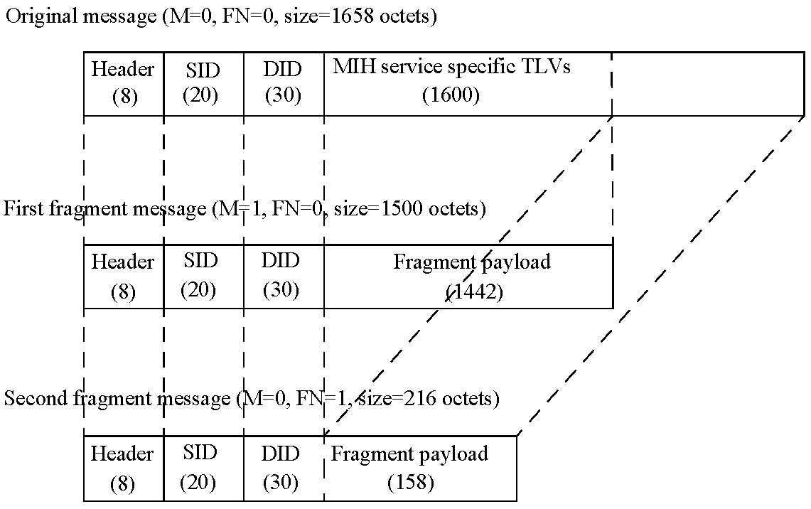
Figure K.2—MIH Fragmentation example for MTU of 1500 octets

(normative)
MIH protocol message code assignments
Table L.1 provides the action identifier (AID) assignment for MITT messages.
Table L.29—AID assignment
MIH messages | AID
MIH messages for Service Management
MITT_Capability_Discover | 1
MITT_Register | 2
MITT_DeRegister | 3
MITT_Event_Subscribe | 4
MITT_Event_Unsubscribe | 5
MIH messages for Event Service
MITT_Link_Detected | 1
MITT_Link_Up | 2
MITT_Link_Down | 3
MITT_Link_Parameters_Report | 5
MITT_Link_Going_Down | 6
MITT_Link_TTandover_Imminent | 7
MITT_Link_TTandover_Complete | 8
MIH messages for Command Service
MITT_Link_Get_Parameters | 1
MITT_Link_Configure_Thresholds | 2
MITT_Link_Actions | 3
MITT_Net_TTO_Candidate_Query | 4
MITT_MN_TTO_Candidate_Query | 5
MITT_N2N_TTO_Query_Resources | 6
MITT_MN_TTO_Commit | 7
MITT_Net_TTO_Commit | 8
MITT_N2N_TTO_Commit | 9
MITT_MN_TTO_Complete | 10
MITT_N2N_TTO_Complete | 11

Table L.1—AID assignment (continued)
MIH messages | AID
MIH messages for Information Service
MIH_Get_Information | 1
MIH_Push_Information | 2

Table L.2 provides the TLV type value assignment for MIH messages. The type value can be extracted from the binary encoding method of the corresponding data type. TLV type value 101–255 is reserved for experimental TLVs.
Table L.30—Type values for TLV encoding
TLV type name | TLV  type value | Data type
Source MIHF ID | 1 | MIHF_ID
Destination MIHF ID | 2 | MIHF_ID
Status | 3 | STATUS
Link type | 4 | LINK_TYPE
MIH event list | 5 | MIH_EVT_LIST
MIH command list | 6 | MIH_CMD_LIST
MIIS query type list | 7 | MIH_IQ_TYPE_LST
Transport option list | 8 | MIH_TRANS_LST
Link address list | 9 | LIST(NET_TYPE_ADDR)
MBB handover support | 10 | LIST(MBB_HO_SUPP)
Register request code | 11 | REG_REQUEST_CODE
Valid time interval | 12 | UNSIGNED_INT(4)
Link identifier | 13 | LINK_TUPLE_ID
New link identifier | 14 | LINK_TUPLE_ID
Old access router | 15 | LINK_ADDR
New access router | 16 | LINK_ADDR
IP renewal flag | 17 | IP_RENEWAL_FLAG
Mobility management support | 18 | IP_MOB_MGMT
IP address configuration methods | 19 | IP_CFG_MTHDS
Link down reason code | 20 | LINK_DN_REASON
Time interval | 21 | UNSIGNED_INT(2)
Link going down reason | 22 | LINK_GD_REASON
Link parameter report list | 23 | LIST(LINK_PARAM_RPT)

Table L.2—Type values for TLV encoding (continued)
TLV type name | TLV  type value | Data type
Device states request | 24 | DEV_STATES_REQ
Link identifier list | 25 | LIST(LINK_ID)
Device states response list | 26 | LIST(DEV_STATES_RSP)
Get status request set | 27 | LINK_STATUS_REQ
Get status response list | 28 | LIST( SEQUENCE(LINK_ID,LINK_STATUS_RSP) )
Configure request list | 29 | LIST(LINK_CFG_PARAM)
Configure response list | 30 | LIST(LINK_CFG_STATUS)
List of link PoA list | 31 | LIST(LINK_POA_LIST)
Preferred link list | 32 | LIST(RQ_RESULT)
Handover resource query list | 33 | QOS_LIST
Handover status | 34 | HO_STATUS
Access router address | 35 | IP_ADDR
DHCP server address | 36 | IP_ADDR
FA address | 37 | IP_ADDR
Link actions list | 38 | LIST(LINK_ACTION_REQ)
Link actions result list | 39 | LIST(LINK_ACTION_RSP)
Handover result | 40 | HO_RESULT
Resource status | 41 | LINK_RES_STATUS
Resource retention status | 42 | BOOLEAN
Info query binary data list | 43 | LIST(IQ_BIN_DATA)
Info query RDF data list | 44 | LIST(IQ_RDF_DATA)
Info query RDF schema URL | 45 | BOOLEAN
Info query RDF schema list | 46 | LIST(IQ_RDF_SCHM)
Max response size | 47 | UNSIGNED_INT(2)
Info response binary data list | 48 | LIST(IR_BIN_DATA)
Info response RDF data list | 49 | LIST(IR_RDF_DATA)
Info response RDF schema URL list | 50 | LIST(IR_SCHM_URL)
Info response RDF schema list | 51 | LIST(IR_RDF_SCHM)
Mobile node MIHF ID | 52 | MIHF_ID
Query resource report flag | 53 | BOOLEAN
Event configuration info list | 54 | LIST(EVT_CFG_INFO)

Table L.2—Type values for TLV encoding (continued)
TLV type name | TLV  type value | Data type
Target network info | 55 | TGT_NET_INFO
List of target network info | 56 | LIST(TGT_NET_INFO)
Assigned resource set | 57 | ASGN_RES_SET
Link detected info list | 58 | LIST(LINK_DET_INFO)
MN link ID | 59 | LINK_ID
PoA | 60 | LINK_ADDR
Unauthenticated information request | 61 | BOOLEAN
Network type | 62 | NETWORK_TYPE
Requested resource set | 63 | REQ_RES_SET
(Reserved) | 64–99 | (Reserved)
Vendor specific TLV | 100 | (Vendor specific)
(Reserved for experimental TLVs) | 10 1–255 | (Used for experimental purposes)

(normative)
Protocol implementation conformance statement (PICS) proforma

Introduction
To evaluate conformance of a particular implementation, it is necessary to have a statement of which capabilities and options have been implemented for a given IEEE 802 standard. Such a statement is called an Implementation Conformance Statement (ICS).

Scope
This annex provides the ICS proforma for IEEE Std 802.21 in compliance with the relevant requirements, and in accordance with the relevant guidance, given in ITU-T Recommendation X.290 (1995), OSI conformance testing methodology and framework for protocol Recommendations for ITU-T applications—General concept, and.ITU-T Recommendation X.296 (1995) OSI conformance testing methodology and framework for protocol Recommendations for ITU-T applications—Implementation conformance statements.

Conformance
If it is claimed to conform to IEEE Std 802.21, the actual PICS Proforma to be filled in by a supplier shall be technically equivalent to the text of the PICS Proforma in this annex, and shall preserve the number/naming and ordering of the PICS Proforma items.
A PICS that conforms to this IEEE Std 802.21 shall be a conforming PICS proforma completed in accordance with the instructions for completion given in M.4.

Instructions

Purpose and structure
The supplier of a protocol implementation that is claimed to conform to IEEE Std 802.21, shall complete the following protocol implementation conformance statement (PICS) proforma.
The PICS proforma expresses in compact form the static conformance requirements of this standard. It serves as a reference to the static conformance review. ITU-T Recommendation X.296, 6.7, provides examples of uses and users of proformas.
A completed PICS proforma is the PICS for the implementation in question. The PICS is a statement of which capabilities and options of the protocol have been implemented.
¹⁴Copyright release for PICS proformas: Users of this standard may freely reproduce the PICS proforma in this annex so that it can be used for its intended purpose and may further publish the completed PICS.

This PICS proforma has the following structure. Within this, the instructions subclause, are the purpose and scope; symbols, abbreviations, and terms; and explicit instructions for completing the implementation conformance statement. After the instructions are the subclauses for identifying the implementation, the protocol, and corrigenda (if any). The final subclause contains the questionnaire in tabular form. Within this final subclause a separate table is used to cover these categorizes: global statement of conformance, roles, major capabilities, protocol data units (PDUs), PDU parameters, and timers.
The structure of the individual tables varies. Except for the tables for the identification of the protocol and the identification of any corrigenda, at a minimum all tables have columns for item number, item description, status, and support. For most the status columns includes both a status and a predicate. Some tables have a column for a mnemonic, which makes for easier cross-referencing within the PICS proforma. Most tables contain a reference column. A few tables (e.g., PDU parameters and timers) contain a column for entering supported value(s).

Symbols, abbreviations, and terms
M mandatory
O optional
O.<n> optional, but support of at least one of the group of options labeled by the same numeral <n> is required
pred: conditional symbol, including predicate identification (mnemonic)
N/A not applicable
GBLx mnemonic for global statement of conformance, where x is an integer
MCx mnemonic for major capabilities, where x is an integer
PDUx mnemonic for protocol data unit, where x is an integer
RLx mnemonic for role, where x is an integer

Explicit instructions
The blank spaces in the identification of the implementation part is to be completed with the information necessary to identify fully both the implementation and supplier, as well as the name of a person to contact if there are any queries concerning the contents of the PICS.
For the identification of the protocol, indicate in the support column “Yes,” if this is the protocol being supported.
For the identification of corrigenda to the protocol, indicate if any corrigenda have been applied by entering the corrigenda information in the space provided. If none are applicable, then leave it blank.
The main part of the PICS proforma is a fixed questionnaire in tabular form, divided into subclauses, each containing a number of individual items. Answers to the questionnaire items are to be provided in the column labelled support, either by simply marking an answer to indicate a restricted choice (i.e., Yes or No) or by entering a value or a set or a range of values in the supported range column. (Note that there are some items where two or more choices from a set of possible answers may apply. All relevant choices are to be marked in these cases.)
Each item is identified by an item number, which is given in the first column. The second column (labelled item description) contains the question to be answered. The remaining columns may be labeled: references, status, support, allowed value(s), supported value(s), or mnemonic. The reference column contains the reference or references to the appropriate static conformance requirements or other clauses in IEEE Std 802.21. The status column contains the status value [mandatory, optional, not applicable, or conditional (see M.4.6)] of the item. The answer to the item is to be entered in the support column by either entering Yes or No in the space provided or, if present, mark the appropriate tick box beside the appropriate answer. For items that contain a supported value(s) column, in addition to answering the support column, enter the value or values supported for the item in the space provided.
A supplier may also provide further information, categorized as either Additional Information or Exception Information. When present, each kind of further information is to be provided in a further subclause of items labeled A<I> or X<I>, respectively, for cross-referencing purposes, where <I> is any unambiguous identification for the item (e.g., simply a numeral). There are no other restrictions on its format or presentation.
A completed PICS proforma, including any Additional Information and Exception Information, is the PICS for the implementation in question.
NOTE—Where an implementation is capable of being configured in more than one way, a single PICS may be able to describe all such configurations. However, the supplier has the choice of providing more than one PICS, each covering some subset of the implementation’s capabilities, if this makes for easier and clearer presentation of the information.

Additional information
Items of Additional Information allow a supplier to provide further information intended to assist in the interpretation of the PICS. It is not intended or expected that a large amount of information will be supplied, and a PICS can be considered complete without any such information. Examples of such Additional Information might be an outline of the ways in which an (single) implementation can be set up to operate in a variety of environments and configurations, or information about aspects of the implementation that are outside the scope of this standard but have a bearing upon the answers to some items.
References to items of Additional Information may be entered next to any answer in the questionnaire, and may be included in items of Exception Information.

Exception information
It may happen occasionally that a supplier will wish to answer an item with mandatory status (after any conditions have been applied) in a way that conflicts with the indicated requirement. No preprinted answer will be found in the Support column for this. Instead, the supplier shall write the missing answer into the Support column, together with an X<I> reference to an item of Exception Information, and shall provide the appropriate rationale in the Exception Information item itself.
An implementation for which an Exception Information item is required in this way does not conform to this standard.
NOTE—A possible reason for the situation described above is that a defect in this standard has been reported, a correction for which is expected to change the requirement not met by the implementation.

Conditional status
The PICS proforma contains a number of conditional items. These are items for which both the applicability of the item itself, and its status if it does apply, mandatory or optional, are dependent upon whether or not certain other items are supported.
In this PICS proforma conditional items are represented through the use of nesting item numbering and by using individual conditional items as indicated in the status column.
If the value of the predicate is true, the conditional item is applicable, and its status is given by S and the support column is to be completed in the usual way. Otherwise, the conditional item is not relevant and the N/A answer is to be marked.
A predicate is an mnemonic for an item in the PICS proforma. The value of the predicate is true if the item is marked as supported, and is false otherwise.
Each item referenced in a predicate is indicated by an asterisk in the item number column.

Identification of the implementation
In the space provided in the following subclauses, provide all information that will uniquely identify both the supplier (or client of the test laboratory) and the implementation and the system on which it resides. Also, provide a person as a point of contact for any queries concerning the contents of the PICS.

Implementation and the system

Supplier or client of the test laboratory
Name:
Address:
M.5.3 Contact
Name:
Address:

Identification of the protocol
Item  number | Identification of protocol specification | Support
M.6.1 | IEEE Std 802.21-2008

Identification of corrigenda to the protocol
Identification of corrigenda implemented
Specification | Corrigenda implemented
IEEE Std 802.21-2008

PICS proforma tables

Global statement of conformance
Item  number | Item description | Status | Support | Mnemonic
M.8. 1 | Have all mandatory capabilities been implemented? | M | Yes [ ] No [ ] | GBL1

Answering “No” to this question indicates non-conformance to the IEEE Std 802.21. Non-supported mandatory capabilities are to be identified in the implementation conformance statement, with an explanation of why the implementation is non-conforming.

Roles
Item  number | Item description | References | Status | Support | Mnemonic
M.8.2.1 | Is MIHF supported in a mobile node? | 5.4 | O.1 | Yes [ ] No [ ] | RL1
M.8.2.2 | Is MIHF supported in a network entity? | 5.4 | O.1 | Yes [ ] No [ ] | RL2

Major capabilities
Item  number | Item description | References | Status | Support | Mnemonic
*M.8.3.1 | Is the Event Service (ES) supported? | 6.3 | O.2 | Yes [ ] No [ ] | MC1
*M.8.3.2 | Is the Command Service (CS) supported? | 6.4 | O.2 | Yes [ ] No [ ] | MC2
*M.8.3.3 | Is the Information Service | 6.5 | O.2 | Yes [ ] No [ ] | MC3
 | (IS) supported?
M.8.3.3. | Is the TLV query method | 6.5.6.1, | MC3:O.3 | Yes [ ] No [ ] N/A [ ] | MC3.1
1 | supported? | 6.5.6.2
M.8.3.3. | Is the RDF query method | 6.5.6.1, | MC3:O.3 | Yes [ ] No [ ] N/A [ ] | MC3.2
2 | supported? | 6.5.6.3
M.8.3.3. | Is the push mode supported? | 5.3.4 | O | Yes [ ] No [ ] | MC3.3
3
*M.8.3.4 | Is capability discovery supported? | 6.2.3 | M | Yes [ ] No [ ] | MC4
M.8.3.4. | Is Unsolicited Capability | 8.2.4.3.3 | O | Yes [ ] No [ ] | MC4.1
1 | Discovery supported?
M.8.3.4. | Is Solicited Capability | 8.2.4.3.4 | M | Yes [ ] No [ ] | MC4.2
2 | Discovery supported?
*M.8.3.5 | Is the Registration Service supported? | 6.2.4 | MC2 OR MC3.3: M | Yes [ ] No [ ] | MC5
M.8.3.6 | Is Mobile Initiated Handover supported? | 6.4.3.2.3 | O.4 | Yes [ ] No [ ] | MC6
M.8.3.7 | Is Network Initiated | 6.4.3.2.4 | O.4 | Yes [ ] No [ ] | MC7
 | Handover supported?
M.8.3.8 | Is MIH Acknowledgement protocol supported? | 8.2.2 | O | Yes [ ] No [ ] | MC8
M.8.3.9 | Is MIH fragmentation supported? | 8.4.2 | M | Yes [ ] No [ ] | MC9

PDUs
Item  number | Item description | References | Status | Support | Mnemonic
M.8.4. 1 | MIH_Link_Detected indication? | 8.6.2.1 | MC1 :M | Yes [ ] No [ ] N/A[ ] | PDU1
M.8.4.2 | MIH_Link_Up indication? | 8.6.2.2 | MC1:M | Yes [ ] No [ ] N/A[ ] | PDU2
M.8.4.3 | MIH_Link_Down indication? | 8.6.2.3 | MC1 :M | Yes [ ] No [ ] N/A[ ] | PDU3
M.8.4.4 | MIH_Link_Going_Down indication? | 8.6.2.5 | MC1:M | Yes [ ] No [ ] N/A[ ] | PDU4

Item  number | Item description | References | Status | Support | Mnemonic
M.8.4.5 | MIH_Link_Parameters_Report indication? | 8.6.2.4 | MC1:M | Yes [ ] No [ ] N/A[ ] | PDU5
M.8.4.6 | MIH_Link_Handover_Imminent indication? | 8.6.2.6 | MC1:O | Yes [ ] No [ ] N/A[ ] | PDU6
M.8.4.7 | MIH_Link_Handover_Complete indication? | 8.6.2.7 | MC1 :O | Yes [ ] No [ ] N/A[ ] | PDU7
M.8.4.8 | MIH_Link_Get_Parameters | 5.3.3.1, | MC2:M | Yes [ ] No [ ] N/A[ ] | PDU8
 | request? | 8.6.3.1
M.8.4.9 | MIH_Link_Get_Parameters | 5.3.3.1, | MC2:M | Yes [ ] No [ ] N/A[ ] | PDU9
 | response? | 8.6.3.2
M.8.4.10 | MIH_Link_Configure_Threshold | 5.3.3.1, | MC2:M | Yes [ ] No [ ] N/A[ ] | PDU10
 | s request? | 8.6.3.3
M.8.4.11 | MIH_Link_Configure_Threshold | 5.3.3.1, | MC2:M | Yes [ ] No [ ] N/A[ ] | PDU11
 | s response? | 8.6.3.4
M.8.4.12 | MIH_Link_Action request? | 5.3.3.1, | MC2:M | Yes [ ] No [ ] N/A[ ] | PDU12
 |  | 8.6.3.5
M.8.4.13 | MIH_Link_Action response? | 5.3.3.1, | MC2:M | Yes [ ] No [ ] N/A[ ] | PDU13
 |  | 8.6.3.6
M.8.4.14 | MIH_Net_HO_Candidate_Query | 5.3.3.1, | MC2:M | Yes [ ] No [ ] N/A[ ] | PDU14
 | request? | 8.6.3.7
M.8.4.15 | MIH_Net_HO_Candidate_Query | 5.3.3.1, | MC2:M | Yes [ ] No [ ] N/A[ ] | PDU15
 | response? | 8.6.3.8
M.8.4.16 | MIH_MN_HO_Candidate_Query | 5.3.3.1, | MC2:M | Yes [ ] No [ ] N/A[ ] | PDU16
 | request? | 8.6.3.9
M.8.4.17 | MIH_MN_HO_Candidate_Query | 5.3.3.1, | MC2:M | Yes [ ] No [ ] N/A[ ] | PDU17
 | response? | 8.6.3.10
M.8.4.18 | MIH_N2N_HO_Query_Resource | 5.3.3.1, | MC2:M | Yes [ ] No [ ] N/A[ ] | PDU18
 | s request? | 8.6.3.11
M.8.4.19 | MIH_N2N_HO_Query_Resource | 5.3.3.1, | MC2:M | Yes [ ] No [ ] N/A[ ] | PDU19
 | s response? | 8.6.3.12
M.8.4.20 | MIH_MN_HO_Commit request? | 5.3.3.1, | MC2:M | Yes [ ] No [ ] N/A[ ] | PDU20
 |  | 8.6.3.13
M.8.4.21 | MIH_MN_HO_Commit | 5.3.3.1, | MC2:M | Yes [ ] No [ ] N/A[ ] | PDU21
 | response? | 8.6.3. 14
M.8.4.22 | MIH_Net_HO_Commit request? | 5.3.3.1, | MC2:M | Yes [ ] No [ ] N/A[ ] | PDU22
 | MIH_Net_HO_Commit request? | 8.6.3.15
M.8.4.23 | MIH_Net_HO_Commit | 5.3.3.1, | MC2:M | Yes [ ] No [ ] N/A[ ] | PDU23
 | response? | 8.6.3.16
M.8.4.24 | MIH_N2N_HO_Commit request? | 5.3.3.1, | MC2:M | Yes [ ] No [ ] N/A[ ] | PDU24
 |  | 8.6.3.17
M.8.4.25 | MIH_N2N_HO_Commit | 5.3.3.1, | MC2:M | Yes [ ] No [ ] N/A[ ] | PDU25
 | response? | 8.6.3.18
M.8.4.26 | MIH_MN_HO_Complete | 5.3.3.1, | MC2:M | Yes [ ] No [ ] N/A[ ] | PDU26
 | request? | 8.6.3.19

Item  number | Item description | References | Status | Support | Mnemonic
M.8.4.27 | MIH_MN_HO_Complete | 5.3.3.1, | MC2:M | Yes [ ] No [ ] N/A[ ] | PDU27
 | response? | 8.6.3.20
M.8.4.28 | MIH_N2N_HO_Complete | 5.3.3.1, | MC2:M | Yes [ ] No [ ] N/A[ ] | PDU28
 | request? | 8.6.3.21
M.8.4.29 | MIH_N2N_HO_Complete | 5.3.3.1, | MC2:M | Yes [ ] No [ ] N/A[ ] | PDU29
 | response? | 8.6.3.22
M.8.4.30 | MIH_Get_Information request? | 8.6.4.1 | MC3 :M | Yes [ ] No [ ] N/A[ ] | PDU30
*M.8.4.31 | MIH_Get_Information response? | 8.6.4.2 | MC3 :M | Yes [ ] No [ ] N/A[ ] | PDU3 1
M.8.4.32 | MIH_Push_Information indication | 8.6.4.3 | MC3:M | Yes [ ] No [ ] N/A[ ] | PDU32
M.8.4.33 | MIH_Capability_Discover request? | 8.6.1.1 | MC4:M | Yes [ ] No [ ] N/A[ ] | PDU33
M.8.4.34 | MIH_Capability_Discover response? | 8.6.1.2 | MC4:M | Yes [ ] No [ ] N/A[ ] | PDU34
M.8.4.35 | MIH_Register request? | 8.6.1.3 | MC5:M | Yes [ ] No [ ] N/A[ ] | PDU35
M.8.4.36 | MIH_Register response? | 8.6.1.4 | MC5:M | Yes [ ] No [ ] N/A[ ] | PDU36
M.8.4.37 | MIH_DeRegister request? | 8.6.1.5 | MC5:M | Yes [ ] No [ ] N/A[ ] | PDU37
M.8.4.38 | MIH_DeRegister response? | 8.6.1.6 | MC5:M | Yes [ ] No [ ] N/A[ ] | PDU38
M.8.4.39 | MIH_Event_Subscribe request? | 8.6.1.7 | M | Yes [ ] No [ ] | PDU39
M.8.4.40 | MIH_Event_Subscribe response? | 8.6.1.8 | M | Yes [ ] No [ ] | PDU40
M.8.4.41 | MIH_Event_Unsubscribe request? | 8.6.1.9 | M | Yes [ ] No [ ] | PDU41
M.8.4.42 | MIH_Event_Unsubscribe response? | 8.6.1.10 | M | Yes [ ] No [ ] | PDU42

PDU parameters
Item  number | Item description | References | Status | Support | Supported  value
M.8.5.1 | Maximum supported MIH_Get_Information response message size (in octets)? | 8.6.4.2 | PDU31: M | Yes [ ] No [ ] N/A [ ]

Timers
Item  number | Item description | References | Status | Support | Allowed  values | Supported  values
M.8.6.1 | TransactionLifeTime Timer | 8.2.3.5 | M | Yes [ ] No [ ] | 1–255
M.8.6.2 | RetransmissionInterval Timer | 8.2.3.8.2 | M | Yes [ ] No [ ] | 1–255
M.8.6.3 | ReassemblyTimer | 8.4.2.3 | M | Yes [ ] No [ ] | 1–255

•The Institute of Electrical and Electronics Engineers, Inc. 3 Park Avenue, New York, NY 10016-5997, USA Copyright © 2013 by The Institute of Electrical and Electronics Engineers, Inc. All rights reserved. Published varPublishedDate. Printed in the United States of America. IEEE is a registered trademark in the U.S. Patent & Trademark Office, owned by The Institute of Electrical and Electronics Engineers, Incorporated. PDF: ISBN varISBNpdf varStdIDpdf Print: ISBN varISBNprint varStdIDprint IEEE prohibits discrimination, harassment, and bullying. For more information, visit http://www.ieee.org/web/aboutus/whatis/policies/p9-26.html. No part of this publication may be reproduced in any form, in an electronic retrieval system or otherwise, without the prior written permission of the publisher.
Information on references can be found in Clause 2.
ANSI publications are available from the Sales Department, American National Standards Institute, 11 West 42nd Street, 13th Floor, New York, NY 10036, USA (http://www.ansi.org/).
IEEE publications are available from the Institute of Electrical and Electronics Engineers, 445 Hoes Lane, Piscataway, NJ 08854, USA (http://standards.ieee.org/).
The IEEE standards or products referred to in this clause are trademarks of the Institute of Electrical and Electronics Engineers, Inc.
Numbers preceded by P are IEEE authorized standards projects that were not approved by the IEEE-SA Standards Board at the time this publication went to press. For information about obtaining drafts, contact the IEEE.
IETF RFCs are available from the Internet Engineering Task Force website at http://www.ietf.org/rfc.html.
ISO publications are available from the ISO Central Secretariat, Case Postale 56, 1 rue de Varembé, CH-1211, Genève 20, Switzer¬land/Suisse (http://www.iso.ch/). ISO publications are also available in the United States from the Sales Department, American National Standards Institute, 11 West 42nd Street, 13th Floor, New York, NY 10036, USA (http://www.ansi.org/).
ITU-T publications are available from the International Telecommunications Union, Place des Nations, CH-121 1, Geneva 20, Switzer¬land/Suisse (http://www.itu.int/).
W3C recommendations are available from http://www.w3.org.
IEEE Standards Dictionary Online subscription is available at: http://www.ieee.org/portal/innovate/products/standard/standards_dictionary.html.
The mechanism that triggers and executes a link-layer handover/switch (also referred as an L2 handover) is specified within the corresponding media-specific standard and out of scope of this standard.
Notes in text, tables, and figures are given for information only and do not contain requirements needed to implement the standard.

