Project | IEEE 802.21.1  <https://mentor.ieee.org/802.21>
Title | Review on user authentication problem of handover between heterogeneous networks
DCN | IEEE 802.21-13-0198-00-0000
Date Submitted | November 9, 2013
Source(s) | Sangkwon Peter Jeong(IMRC), Junghun Kim(TTA), and Hyungbae Park(KWISA)
Re: | IEEE 802.21 Session #59 in Dallas, TX. USA
Abstract | This contribution is updated document of “Explaining that how to solve of the 'User Authentication in case of MIH'”(DCN: 21-13-0071-0000) that is discussed in Geneva in July 2013.
Purpose | Work Group Explain and Discussion
Notice | This document has been prepared to assist the IEEE 802.21 Working Group. It is offered as a basis for discussion and is not binding on the contributing individual(s) or organization(s). The material in this document is subject to change in form and content after further study. The contributor(s) reserve(s) the right to add, amend or withdraw material contained herein.
Release | The contributor grants a free, irrevocable license to the IEEE to incorporate material contained in this contribution, and any modifications thereof, in the creation of an IEEE Standards publication; to copyright in the IEEE’s name any IEEE Standards publication even though it may include portions of this contribution; and at the IEEE’s sole discretion to permit others to reproduce in whole or in part the resulting IEEE Standards publication. The contributor also acknowledges and accepts that IEEE 802.21 may make this contribution public.
Patent Policy | The contributor is familiar with IEEE patent policy, as stated in Section 6 of the IEEE-SA Standards Board bylaws <http://standards.ieee.org/guides/bylaws/sect6-7.html#6> and in Understanding Patent Issues During IEEE Standards Development http://standards.ieee.org/board/pat/faq.pdf

- Solution for user authentication problem of handover between heterogeneous networks
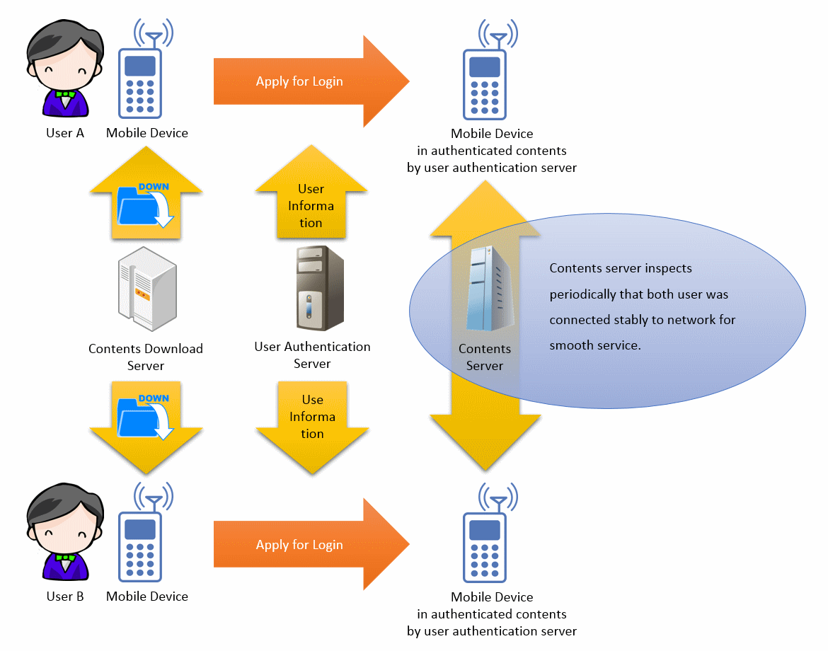
<Figure 1. User authentication by content server>

As shown in Fig. 1, the content servers periodically check whether users connect to networks or not for providing stable services of contents and applications. To authenticate users and check users’ connection to content server, content servers check users’ IP address for initial connection except for users’ identifiers (IDs) and passwords (PWs) because users’ IDs and PWs are easy to be disclosed.
However, if a mobile node performs handover in homogeneous networks or heterogeneous networks, IP address of the mobile node are changed, and thus the mobile node loses connection to its content server.

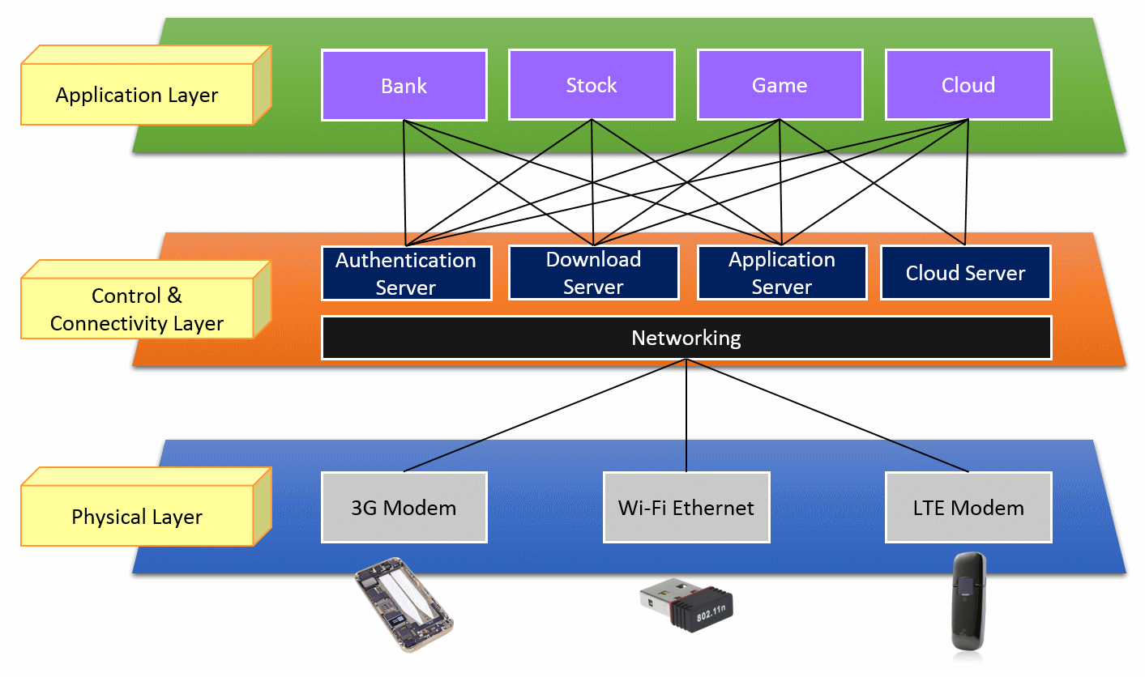
<Figure 2. User authentication check in each layers>

The content server treats users that change its IP address as unapproved users for protecting itself from hacking. Specially, authentication of users by using IP address should be considered very seriously in situation that monetary transaction with Mobile banking, mobile shopping or game item transaction is achieved. Authentication by using identifier of a mobile node can be an alternative of authentication by using IP address. Identifier of a mobile node is UDID (Unique Device Identifier) proposed in Geneva meeting of July.
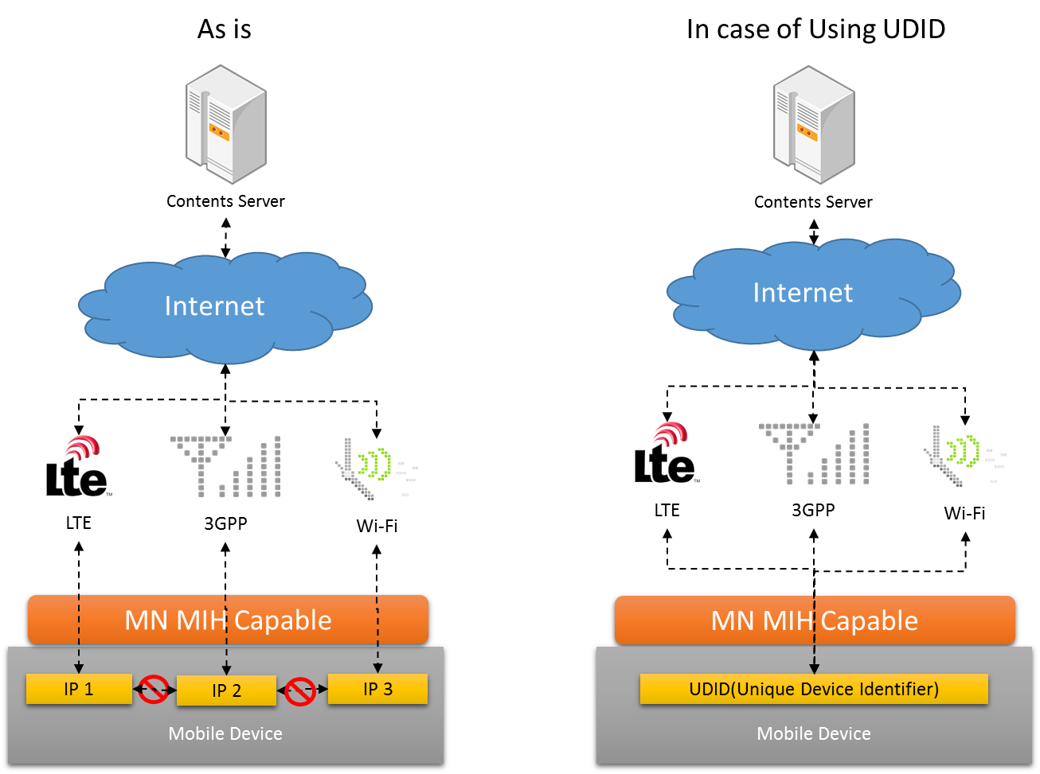
<Figure 3. IP check case & UDID check case>

“As Is” in Fig. 3 shows that a content server using authentication based on IP address does not allow change of a user’s access network. “In case of using UDID” in Fig. 3 shows that the content server using authentication based on UDID allows a user’s change of a user’s access network.
Standard of UDID has been discussed in IETF but is not finalized yet.

- Works for UDID in IEEE 802.21.1 task group
IEEE802.21 working group (WG) standardized media independent handover (MIH) to support handover between heterogeneous networks for heterogeneous networks and security optimization for MIH. IEEE 802.21 WG has lots of experts that can discuss security in handover between heterogeneous networks and thus is a good standard group to discuss authentication by using UDID in heterogeneous networks. In addition, IEEE 802.21.1 task group (TG) begins to standardize service for supporting interworking between heterogeneous networks.
Standard for procedure, primitives, and messages for authentication based on UDID should be discussed in IEEE 802.21.1 TG.

