Project | IEEE 802.21 MIHS  <http://www.ieee802.org/21/>
Title | Section 9.2.2 Update
DCN | 21-13-0040-00-0000
Date Submitted | March 7, 2013
Source(s) | Yoshihiro Ohba
Re: | IEEE 802.21 Session #55 in Orlando
Abstract | This document proposes an update for Section 9.2.2 of 802.21c/D02
Purpose | Comment resolution of 802.21 LB#6a
Notice | This document has been prepared to assist the IEEE 802.21 Working Group. It is offered as a basis for discussion and is not binding on the contributing individual(s) or organization(s). The material in this document is subject to change in form and content after further study. The contributor(s) reserve(s) the right to add, amend or withdraw material contained herein.
Release | The contributor grants a free, irrevocable license to the IEEE to incorporate material contained in this contribution, and any modifications thereof, in the creation of an IEEE Standards publication; to copyright in the IEEE’s name any IEEE Standards publication even though it may include portions of this contribution; and at the IEEE’s sole discretion to permit others to reproduce in whole or in part the resulting IEEE Standards publication. The contributor also acknowledges and accepts that IEEE 802.21 may make this contribution public.
Patent Policy | The contributor is familiar with IEEE patent policy, as stated in Section 6 of the IEEE-SA Standards Board bylaws <http://standards.ieee.org/guides/bylaws/sect6-7.html#6> and in Understanding Patent Issues During IEEE Standards Development http://standards.ieee.org/board/pat/faq.pdf

[1] Replace the first paragraph of subclause 9.2.2 in 802.21a with the following:
Upon a successful MIH service access authentication, the authenticator, (i.e., the serving PoS, perhaps OPoS) obtains a master session key (MSK), a re-authentication master session key (rMSK) via EAP or generates a root key K) to generate a root key K shared between the MN and the serving PoS. Alternatively, a root key K’ transferred from the OPoS may be used as K. In the latter case, the MIHF identifier of the MN, a nonce generated by the MN and a nonce generated by the OPoS are also transferred together with K’. The key transfer mechanism for K’ is specified in 10.3.1. For the purposes of deriving the key hierarchy in section 10, all three of these possibilities can be considered to be simply a string of bits long enough to satisfy randomness requirements of the algorithm below. The MSK or rMSK is generated via EAP.; K is distributed from the OPoS to TPoS and MN and thus established between a MN and a TPoS. A media independent session key (MISK) is subsequently established between a MN and a PoS or Target PoS (TPoS) and is derived from either MSK or rMSK or K as described below. K is produced by the OPoS, perhaps simply by invoking a pseudo-random number generator. The MISK The keys derived from K include a 128 bit authentication key (MIAK) used to generate a value AUTH, the session keys determined by the ciphersuite agreed upon between the MN and the originating serving PoS, and K’. The session keys used for MIH message protection consist of an encryption key (MIEK) only, an integrity key (MIIK) only, or both an encryption key (MIEK) and an integrity key (MIIK). The concatenation of MIAK, MIEK and MIIK is called media independent session key (MISK). The length, L, of the derived keying material, called media independent session key (MISK) is are specified in 9.2.3. Alternatively, K’ may be generated by the OPoS, perhaps simply by invoking a pseudo-random number generator.
MISK is distributed from the OPoS to TPoS and MN and thus established between a MN and a TPoS. A media independent session key (MISK) is subsequently established between a MN and a PoS or Target PoS (TPoS) and is derived from either MSK or rMSK or K as described below.
The MISK includes a 128 bit authentication key (MIAK) used to generate a value AUTH and the session keys determined by the ciphersuite agreed upon between the MN and the originating PoS. The session keys used for MIH message protection consist of an encryption key (MIEK) only, an integrity key (MIIK) only, or both an encryption key (MIEK) and an integrity key (MIIK). The length, L, of the derived keying material, MISK, is specified in 9.2.3.
K and the MIHF identifier of the MN are used as the symmetric key credentials for a symmetric key based method (e.g., EAP-GPSK) to perform MIH service access authentication between the MN and the target PoS without necessarily communicating with the authentication server located in the MN’s home network. The first option is described below. The second option is described in subclause 10.3.
Key distribution of K K’ from OPoS to TPoS may produce a security weakness, the so-called “domino effect” [IETF RFC 4962]. This weakness implies that the compromise of OPoS will also compromise the security association between the MN and TPoS, since an attacker can know and derive KK’ that is delivered to the target PoS. Reducing the latency of proactive authentication based on transferring KK’ is at the cost of taking such a risk.
All other keys are derived from K in the same manner as specified in subclause 10.2, illustrated in Figure 48.

[2] Replace the 2nd and subsequent paragraphs of subclause 9.2.2 in 802.21a with the following:
For the key derivation, the following notations and parameters are used.
- K - key derivation key. It is truncated from a master session key (MSK) or re-authentication MSK (rMSK). The length of K is determined by the pseudorandom function (PRF) used for key derivation. If HMAC-SHA-1 or HMAC-SHA-256 is used as a PRF, then the full MSK or rMSK is used as key derivation key, K. If CMAC-AES is used as a PRF, then the first 128 bits of MSK or rMSK are used as key derivation key, K.
- L - The binary length of derived keying material MISK. L is determined by the selected ciphersuite, which is specified in 9.2.3.
- L’ - The binary length of derived keying material K’. L’ is determined by the selected ciphersuite, which is specified in 9.2.3.
- h - The output binary length of PRF used in the key derivation. That is, h is the length of the block of the keying material derived by one PRF execution. Specifically, for HMAC-SHA-1, h = 160 bits; for HMAC-256, h =256 bits; for CMAC-AES, h = 128 bits.
- n - The number of iterations of PRF in order to generate L-bits keying material.
- n’ - The number of iterations of PRF in order to generate L’-bits keying material.
- Nonce-T and Nonce-N - The nonces exchanged during the execution of service access authentication.
- c - The ciphersuite code is a one octet string specified for each ciphersuite. The code is defined in 9.2.3.
- v - The length of the binary representation of the counter and the length of keying material L. The default value for v is 32.
- v’ - The length of the binary representation of the counter and the length of keying material L’. The default value for v’ is 32.
- MN_MIHF_ID – Mobile node’s MIHF identity.
- POS_MIHF_ID – PoS’s MIHF identity.
- “MISK” - 0x4D495354, ASCII code in hex for string “MISK.”
- “MIRK” - 0x4D49524B, i.e., the ASCII code in hex for string “MIRK”.
- [a]2 - Binary representation of integer a with a given length.
For a given PRF, the key derivation for MISK can be described in the following procedures:

Fixed input values: h and v.

Input: K, Nonce-T, Nonce-N, L and ciphersuite code.

Process:

a) n := ⌈L/h⌉; /* ⌈x⌉ is the ceiling function, returning the least integer n >= x */;
b) If n > 2^{v} -1, then indicate an error and stop.
c) Result (0) := empty string.
d) For i = 1 to n, do
i) K(i) := PRF(K, “MISK” || [i]2 || Nonce-T || Nonce-N || c || [L]2).
ii) Result(i) = Result (i-1) || K(i).
e) Return Result (n) and MISK is the leftmost L bits of Result (n).

Output: MISK.
The MISK is parsed in such a way that
MISK = MIAK || MIIK || MIEK. (1)

For a given PRF, the key derivation for MIRK can be described in the following procedures:

Fixed input values: h and v’.

Input: K, Nonce-T, Nonce-N, L’, MN_MIHF_ID, POS_MIHF_ID and ciphersuite code.

Process:
a) n’ := ⌈L’/h⌉; /* ⌈x⌉ is the ceiling function, returning the least integer n >= x */;
b) If n’ > 2^{v’} -1, then indicate an error and stop.
c) Result (0) := empty string.
d) For i = 1 to n’, do
i) K(i) := PRF(K, “MIRK” || [i]2 || Nonce-T || Nonce-N ||MN_MIHF_ID||POS_MIHF_ID|| c || [L’]2).
ii) Result(i) = Result (i-1) || K(i).
e) Return Result (n) and K’ is the leftmost L’ bits of Result (n).

Output: K’.

With the above procedure, a key hierarchy is derived as shown in Figure 36.
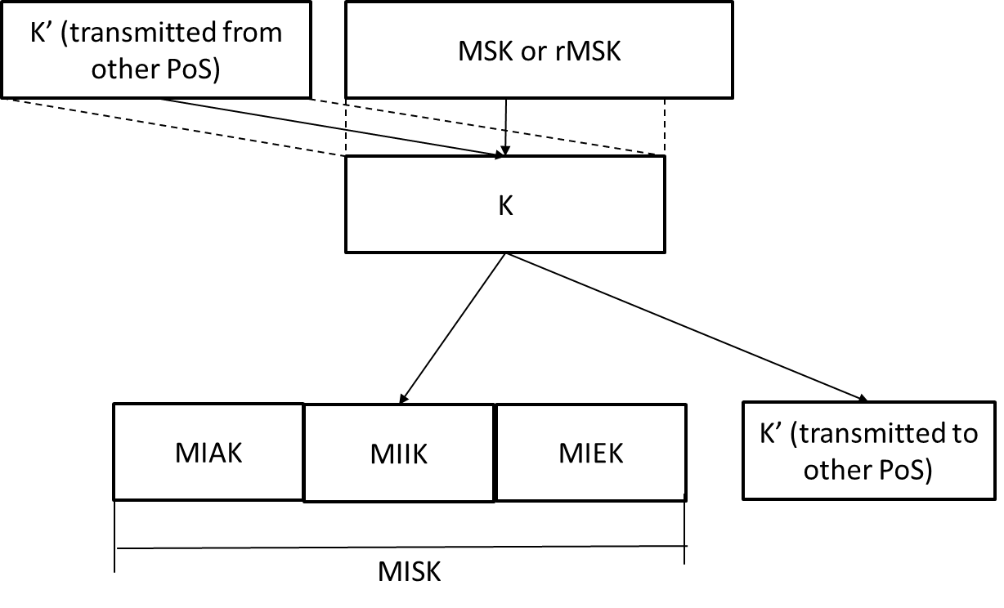
Figure36 MIH Key Hierarchy

