Project | IEEE 802.21 Media Independent Handover Services  <http://www.ieee802.org/21/>
Title | Comment Resolution on Gateway Service in Draft 802.21c
Date Submitted | January 17, 2013
Source(s) | Hyunho Park (ETRI), Hyeong-Ho Lee (ETRI), H Anthony Chan (Huawei), Yoshihiro Ohba (Toshiba), Antonio de la Oliva (UC3M), Charles Perkins (Huawei), Subir Das (ACS)
Re: | IEEE 802.21 Session #53 in San Antonio, TX and follow-up 802.21c teleconferences
Abstract | This document proposes to make major changes on Gateway Service in P802.21c to resolve comments number 79, 87, 107, 115, 130, 152, 154, 167, 179, 182, 219, 230, and 275.
Purpose | Task Group Discussion and Acceptance
Notice | This document has been prepared to assist the IEEE 802.21 Working Group. It is offered as a basis for discussion and is not binding on the contributing individual(s) or organization(s). The material in this document is subject to change in form and content after further study. The contributor(s) reserve(s) the right to add, amend or withdraw material contained herein.
Release | The contributor grants a free, irrevocable license to the IEEE to incorporate material contained in this contribution, and any modifications thereof, in the creation of an IEEE Standards publication; to copyright in the IEEE’s name any IEEE Standards publication even though it may include portions of this contribution; and at the IEEE’s sole discretion to permit others to reproduce in whole or in part the resulting IEEE Standards publication. The contributor also acknowledges and accepts that this contribution may be made public by IEEE 802.21.
Patent Policy | The contributor is familiar with IEEE patent policy, as outlined in Clause 6.3 of the IEEE-SA Standards Board Operations Manual <http://standards.ieee.org/guides/opman/sect6.html#6.3> and in Understanding Patent Issues During IEEE Standards Development <http://standards.ieee.org/board/pat/guide.html>.
- Overview
- Gateway Service was changed to Proxy Function. Thus, updated or newly inserted clauses are used to explain Proxy Function. The Proxy Function is implemented by Command Service.
- Firstly, clause 3 gives definition of Proxy Function.
- Subclauses 5.4.5 and 5.4.6 introduce Proxy Function.
- For supporting Proxy Function, subclause 7.4.33 introduces MIH_CTRL_Transfer primitive, and subclauses 8.6.3.30 and 8.6.3.31 introduces MIH_CTRL_Transfer messages as command service messages.
- Clause 12 explains Proxy Function in detail with protocol stack diagrams.
- Annex F and L cover parameters for Proxy Function.
- Lastly, Annex T that is separated as informative clause from clause 12 shows practical uses of proxy function.

- Comment Resolutions
Followings indicate resolutions of Gateway Service by using Proxy Function.
- Comments #79 and #87: Where is the text to introduce the new gateway service?
  - Resolution: Proxy Function as the substitute of Gateway Service is described in “3. Definitions,” and “12. Proxy Function,” and Annex T.
- Comment #107: In 802.21-2008, Clause 8.6.4 is MIH messages for information service, not MIH messages for Gateway service. You might be thinking about inserting a new clause 8.6.5. But I do not know since there is no editing instruction.
  - Resolution: Proxy Function is the substitute of Gateway Service and is implemented by using command service. Therefore, the messages for Proxy Function are shown in sub clause “8.6.3 MIH messages for command service.”
- Comment #115: What happens when AID is zero?
  - Resolution: After the change from Gateway Service to Proxy Function, AID value “zero” is not used anymore.
- Comments #130, #152, #154, #167, and #230
  - Comment # 130: There is no gateway service MIH message defined in clause table.
  - Comment #152 and #167: A need for a new service "gateway service" is not justified under the scope of this amendment which is about single radio handover.
  - Comment #154: The functionality realized by a new gateway service is beyond the scope of single radio handover. This amendment project is not chartered for defining a general interworking service.
  - Comment #230: Shouldn't the "Gateway Service" be explained as one of the main MIHF services in the 802.21 standard, in Section 6 "MIHF Services"
  - Resolution for comments #130, #152, #154, #167, and #230: In the revised draft, there is no Gateway Service. Proxy Function is a substitute of the Gateway Service and is implemented by command service.
- Comment #179: First of all, we need a section that describes briefly what this gateway service is. This description can go to the Section 5 of 802.21 base specification but for this document, we first need this and then I can understand the need for these messages. Is this a proxy MIHF?
  - Resolution: Proxy Function is introduced in “3. Definitions” and “5.4.5 General MIHF reference model and SAPs / Single Radio handover Control Function,” and discussed in “12. Proxy Function.”

- Comment #182: The definition says that Proxy Gateway is a virtual POA. If it is a POA, then one would assume that it is not running MIHF. On the other hand, a gateway service (SID=5) is defined. Is this gateway service provided by Proxy Gateway? Both the gateway definition and gateway service are very confusing
  - Resolution: Gateway and Gateway Service are changed to Proxy Function, and Proxy Function is defined in “3. Definitions.” Moreover, the SID 5 is not used now because Proxy Function uses command service (SID=3).
- Comment #219: The conversion service proposed cannot be specified in this way. It is not trivial at all the conversion between protocols, for example the IE exchanged in MIIS and ANQP are 100% compatible (information is not the same) hence, converting between both protocols is far from trivial. A specification cannot just say that this service is supported without specifying how to do it.
  - Resolution: In Annex T, we changed “media independent information server” to the “ANQP Proxy Server” and assumed that the ANQP Proxy Server support Proxy Function and ANQP. Through ANQP Proxy Server, ANQP message can be delivered by using the MIH_CTRL_Transfer message.
- Comment #275: There should be a new section with mapping guidelines for interworking with different control message protocols. For example, establishing minimal services, requirements, information exchanges, etc. Revise adding more information on Interworking protocol message conversion.
  - Resolution: The interworking protocol message conversion is separated to Annex T from clause 12. Annex T is informative clause. Thus, we do not need to consider technical guidelines for that kind of conversion.

- Extension of Figure 10b for the candidate network discovery
- (To Editor) Please insert the following figure to the Figure 10b.
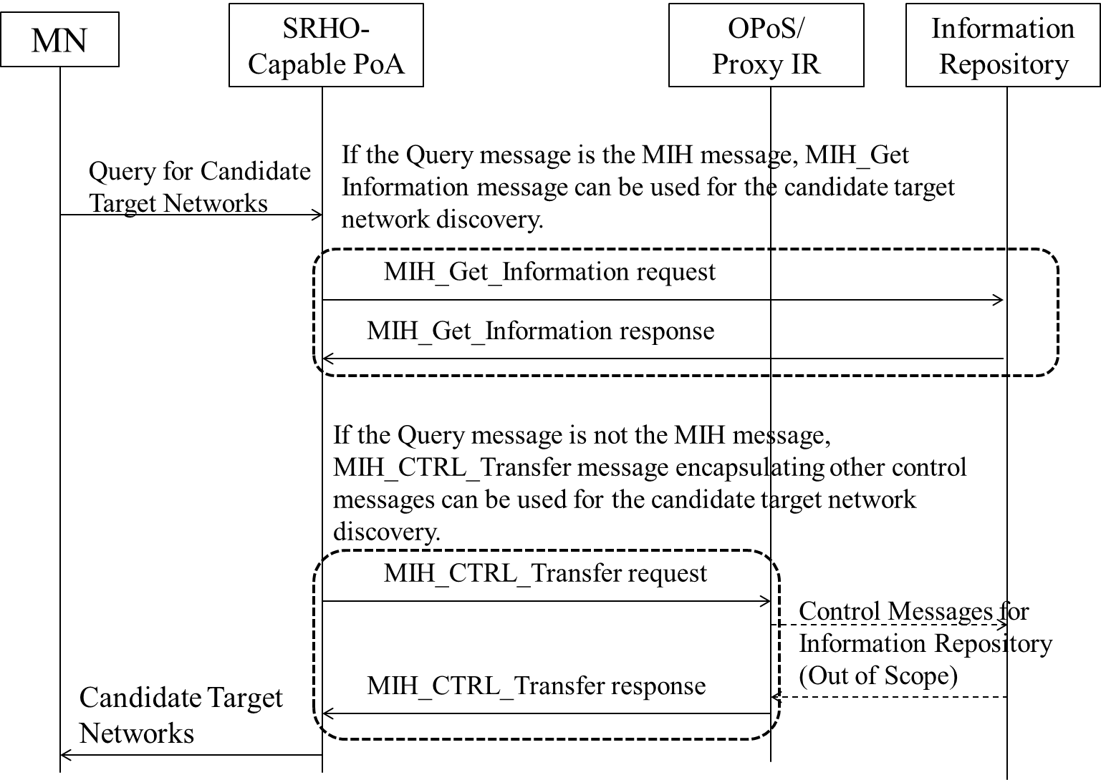
Upon receiving query message to discover candidate target from MN
1) If the Query message from the MN is the MIH message, the SRHO-Capable PoA communicates with Information Repository by using MIH_Get Information.
2) If the Query message from the MN is not the MIH message, the SRHO-Capable PoA communicates with the Proxy IR by using MIH_CTRL_Transfer message encapsulating other control messages can be used for the candidate target network discovery. The Proxy IR behaves like the Information Repository to the MN. The control messages between Proxy IR and Information Repository is out of scope.

- Clauses for Proxy Function
Followings are clauses to explain the Proxy Function.

3. Definitions
Proxy function: A function to bridge the mobility signaling between a mobile node and a target point of attachment via the source network. To the MN, the Proxy function acts like a virtual point of attachment (PoA) to the target network. It enables such functions as preregistration and proactive authentication of the MN.

5.4.5 General MIHF reference model and SAPs / Single Radio handover Control Function
To prepare for handover, the MN’s target radio exchanges link-layer network entry PDUs with the target PoA at the target network. These network entry PDUs can be the same PDUs that would be exchanged if the target link were active. There is no guarantee that the target link is available during a single radio handover. A proxy function is used here to enable the MN and the target PoA to exchange the network entry link-layer PDUs without depending on the existence of the target radio’s physical channel but with the help of the active source radio.
In figure 4 (above in this section 5.5.2) the Single Radio MIHF in a multiple interface node is implemented using the media independent control function (MIHF) in the control plane.
The SR-MIHF use MIH_SAP for communication via TCP/IP or UDP/IP. The SR-MIHF similarly interfaces with the link-layer (L2) MIH_LINK_SAP as before. During a single radio handover, an L2 frame of a deactivated link is encapsulated in an MIH message to constitute a SRC frame, which is then exchanged via an active link between the SR-MIHFs of a local and a remote node using MIH protocol over L3 transport (TCP or UDP).

5.4.6 SR-MIHF and Proxy function at Home Network, Source Network, and Target Network
Figure 3a An architecture of distributed mobility management.
This distributed mobility management architecture also works for single radio management. Because the logical functions for distributed mobility management must already reside in some physical network elements, new physical network elements are not necessarily needed with this single radio handover reference model.
    - MIH_CTRL_Transfer

7.4.33.1 MIH_CTRL_Transfer.request

7.4.33.1.1 Function
This primitive delivers control messages encapsulated by MIH header. The control messages are messages to control networks. Therefore, the control messages are not only network specific control messages but also messages, such as ANQP and ANDSF messages, for interworking heterogeneous networks.

7.4.33.1.2 Semantics of service primitive
MIH_CTRL_Transfer.request (
DestinationIdentifier,
CTRLInformation,
)
Parameters:
Name | Data type | Description
DestinationIdentifier | MIHF_ID | Identifies a remote MIHF as the destination of this request.
CTRLInformation | CTRL_PRTC_MSGS | Delivers control messages.

7.4.33.1.3 When generated
This primitive is generated by an MIH user to deliver control messages such as ANQP and ANDSF messages.

7.4.33.1.4 Effect on receipt
After reception of this primitive, the MIHF must generate a MIH_CTRL_Transfer request message towards the remote MIHF.

7.4.33.2 MIH_CTRL_Transfer.indication

7.4.33.2.1 Function
This primitive is used by the remote MIHF to notify the corresponding MIH user about the reception of a MIH_CTRL_Transfer request message.

7.4.33.2.2 Semantics of service primitive
MIH_CTRL_Transfer.indication (
SourceIdentifier,
CTRLInformation,
)
Parameters:
Name | Data type | Description
SourceIdentifier | MIHF_ID | Identifies the invoker, typically a remote MIHF.
CTRLInformation | CTRL_PRTC_MSGS | This delivers control messages.

7.4.33.2.3 When generated
This primitive is generated by a remote MIHF after receiving a MIH_CTRL_Transfer request message.

7.4.33.2.4 Effect on receipt
The MIH user must generate a MIH_CTRL_Transfer.response primitive.

7.4.33.3 MIH_CTRL_Transfer.response

7.4.33.3.1 Function
This primitive is used by an MIH user to provide control messages to the local MIHF.

7.4.33.3.2 Semantics of service primitive
MIH_CTRL_Transfer.response (
DestinationIdentifier,
CTRLInformation,
Status
)
Parameters:
Name | Data type | Description
DestinationIdentifier | MIHF_ID | This identifies a remote MIHF that will be the destination of this response.
CTRLInformation | CTRL_PRTC_MSGS | Delivers control messages.
Status | STATUS | Status of the operation. Code 3 (Authorization Failure) is not applicable.

7.4.33.3.3 When generated
This primitive is generated by the local MIHF after receiving a MIH_CTRL_Transfer.indication primitive.

7.4.33.3.4 Effect on receipt
The local MIHF may generate a MIH_CTRL_Transfer response message.

7.4.33.4 MIH_CTRL_Transfer.confirm

7.4.33.4.1 Function
This primitive is used to notify the corresponding MIH user about the reception of a MIH_CTRL_Transfer response message.

7.4.33.4.2 Semantics of service primitive
MIH_CTRL_Transfer.confirm (
SourceIdentifier,
CTRLInformation,
Status
)
Parameters:
Name | Data type | Description
SourceIdentifier | MIHF_ID | This identifies the invoker, which is a remote MIHF.
CTRLInformation | CTRL_PRTC_MSGS | Delivers control messages.
Status | STATUS | Status of the operation. Code 3 (Authorization Failure) is not applicable.

        - When generated
This primitive is generated by the local MIHF after receiving a MIH_CTRL_Transfer response message.

7.4.33.4.4 Effect on receipt
The MIH user on the MN may generate a MIH_CTRL_Transfer.request primitive.

8.6.3.30 MIH_CTRL_Transfer request
This message is used to deliver control messages such as ANQP and ANDSF message. The delivery of control messages is described in subclause 12.3. The corresponding MIH primitive of this message is defined in 7.4.33.1.
MIH Header Fields (SID=3, Opcode=1, AID=13)
Source Identifier = sending MIHF ID
(Source MIHF ID TLV)
Destination Identifier = receiving MIHF ID
(Destination MIHF ID TLV)
CTRLInformation
(Control Information TLV)

8.6.3.31 MIH_CTRL_Transfer response
This message is used to respond to MIH_CTRL_Transfer request message. Moreover, this message can deliver control messages such as ANQP and ANDSF message. The delivery of control messages is described in subclause 12.3. The corresponding MIH primitive of this message is defined in 7.4.33.3.
MIH Header Fields (SID=3, Opcode=2, AID=13)
Source Identifier = sending MIHF ID
(Source MIHF ID TLV)
Destination Identifier = receiving MIHF ID
(Destination MIHF ID TLV)
CTRLInformation
(Control Information TLV) (optional)

12. Proxy Function

12.1 Introduction
The proxy function bridges the signaling between the MN and the target network via the originating network. In single radio handover, the MN may signal to the proxy function as if signaling to the target point of attachment, and the target PoA may respond by signaling to the Proxy GW as if signaling to the MN.
The Proxy function may also behave like a virtual PoA to signal with the target PoA. The control frames from the MN tunneled via the source network to the target network are consumed at the Proxy function, which processes these control frames. Before replying to the control frames, the Proxy function may communicate with the appropriate network entities in the target network to enable conducting any needed functions requested in the control frame. This proxy in the control plane may therefore proxy any control functions in general, including but not limited to preregistration and proactive authentication of the MN.
Moreover, the Proxy Function may behave like a virtual IR to signal with the target IR. The control frames for IR from the MN tunneled via the OPoS to the IR that is not the MIH information server are consumed at the proxy function. It can be called as Proxy IR. If the MN requests target network discovery to Proxy IR, the Proxy IR signals with the IR and then responds to the MN’s request. Through the Proxy IR, even though the MN cannot communicate with the IR directly, the MN can discover target network by using Proxy IR.
The proxy functions may be located at gateway router of the network.
In a WiMAX network, the Proxy functions may be implemented in as an extension of the Signal Forwarding Function (SFF) [B5] and may reside at the ASN-GW.
In a 3GPP network, the Proxy functions may be implemented as an extension of the Mobility Management Entity (MME).
In a 3GPP2 network, the Proxy functions may be implemented in the HRPD-SFF and the existing functions of the Packet Control Function (PCF).
Control signals between the MN and the proxy function are implemented in a media independent manner using the functions of, respectively, the originating network PoS and target PoS and the signaling messages defined in this specification.
In a distributed mobility management design, each network has a mobility routing function. The mobility routing function enables a router to forward packets towards a mobile node according to the new location of a mobile node. The logical functions of mobility routing and of the Proxy may be co-located. The distributed mobility management architecture is then shown in Figure 10a in which the Information Repository contains the logical function of location management information only and the proxy contains the logical function of mobility routing only.
The Proxy GW works as a gateway to bridge the mobility signaling between a MN and a target network via the source network. The Proxy GW can transfer L2 messages to the target network via the source network, as shown in Figure 52 (b). Moreover, the Proxy GW can convert the L2 messages to other control messages for the target network as a proxy between the MN and the target PoA, as shown in Figure 53 (b).
If the control message for IR that are not the MIH information server may transfer control messages to Proxy IR, and then Proxy IR can exchange control messages with the IR such as in the example described in Annex T.

12.2 Communication between the MN and the target PoA
The MN needs to communicate eventually with the target PoA to prepare for handover by performing network access procedure with the target access network. The first part of this communication is the transport of TCP or UDP / IP packets to the proxy function. The second part of this communication depends on whether the target PoA supports MIHF in the 802-architecture or whether it is a legacy PoA lacking such support.
If the target PoA supports MIHF, the network entry L2 frame is encapsulated into an MIH frame to forward to the target radio. Figure 51 shows the transport of the target radio L2 control frame as a payload of a media independent control frame between the MN and the Proxy function via the source radio interface, in the absence of the target link.

Figure 51: Transport of L2 frame of target interface via MIH using the logical connection at the Target PoS to SRHO-capable target PoA, showing the resulting protocol stack.
Figure 52 shows the transport of the target radio L2 control frame as a payload of a media independent control frame between the MN and the Proxy GW via the source radio in the absence the target link. The GW communicates with the target PoA using other control messages in order to proxy between the MN and the target PoA.
Figure 52 Transport of L2 frame of target interface to the GW which proxies between the MN and the target PoA, showing the resulting protocol stack.

12.3 Proxy Function for Information Repository
As extension of L2 message transfer in Figure 51, Proxy Function for Information Repository that is not MIH information server, as shown in Figure 53, can be considered. If the SRHO-Capable PoA receives the control message for the Information Repository, the SRHO-Capable PoA can only encapsulate control messages with the MIHF header using MIH_CTRL_Transfer messages. The SRHO-Capable PoA uses the encapsulated messages to communicate with the Proxy IR. The SRHO-Capable PoA only encapsulates the control messages but does not need full function of the MIH. It means the implementation of the PoA for single radio handover can be simplified. Use cases and extension of the Proxy Function are included in Annex T.

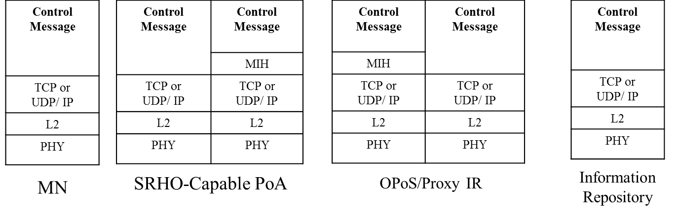

Figure 53. Proxy Function for Information Repository

Annex F

F.3.17 Data types for delivery of control messages
Insert Table F.25 as follows:
Table F.25- Data types for delivery of control messages
Data type name | Derived form | Definition
CTRL_PRTC_MSGS | SEQUENCE(  CTRL_TYPE,  CTRL_MSGS  ) | Represent which control messages are delivered. CTRL_TYPE represents a type of control messages. CTRL_MSGS represents control messages to be delivered.
CTRL_TYPE | UNSIGNED_INT(1) | A type to represent control messages.  0: ANQP  1~122: Reserved for other controls  123~255: Reserved for vendor specific uses
CTRL_MSGS | OCTET_STRING | Represents control messages to be delivered.

Annex L
(normative)
Insert the following rows to Table L.1
MIH messages | AID
MIH messages for Command Service
MIH_Prereg_Xfer | 13
MIH_N2N_Prereg_Xfer | 14
MIH_IF_PreReg_Ready | 15
MIH_CTRL_Transfer | 16

Annex T
(Informative)
Practical Uses of Proxy Function for Information Repository
When the MN wants to receive ANQP messages of access network information from the ANQP server, the WLAN AP (Access Point) can perform as a SRHO-Capable PoA as shown in Figure T.1 (a). As explained in Figure 53, if the MN transfer ANQP messages to the WLAN PoA, the the WLAN AP as the SRHO-Capable PoA can only encapsulate ANQP messages with the MIHF header using MIH_CTRL_Transfer messages. If the WLAN AP exchanges the MIH_CTRL_Transfer messages with the ANQP Proxy Server as the Proxy IR can.signal with ANQP server through control messages for the ANQP server. The WLAN AP only encapsulates ANQP messages of the MN into MIH_CTRL_Transfer messasges and decapsulates MIH_CTRL_Transfer message of ANQP Proxy Server, as shown in Figure T.1 (b).

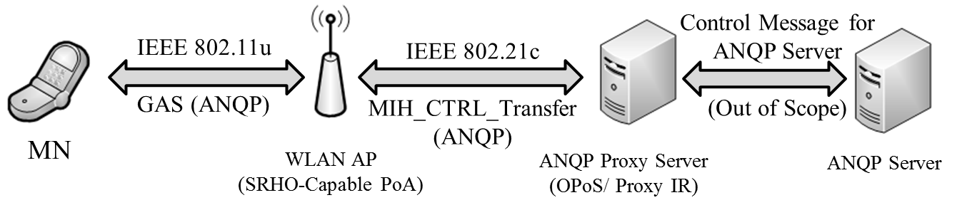
(a) ANQP Message Transfer using Proxy IR

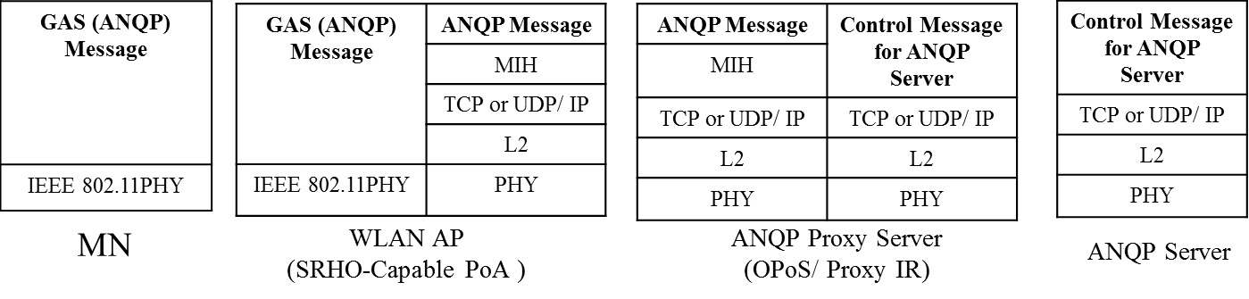

(b) Protocol Stacks for ANQP Transfer
Figure T. 1 Proxy IR for ANQP Transfer

If the Information Repositorydoes not supportcontrol messages that the MS can use, the Proxy IR converts the control message (Control Message A) into other control message (Control Message B) for the Information Repository. The Proxy IR operates as a proxy of the Information Repository that the MN can communicate with. To the Information Repsitory, the Proxy IR behaves like the MS that can communicate with the IR.

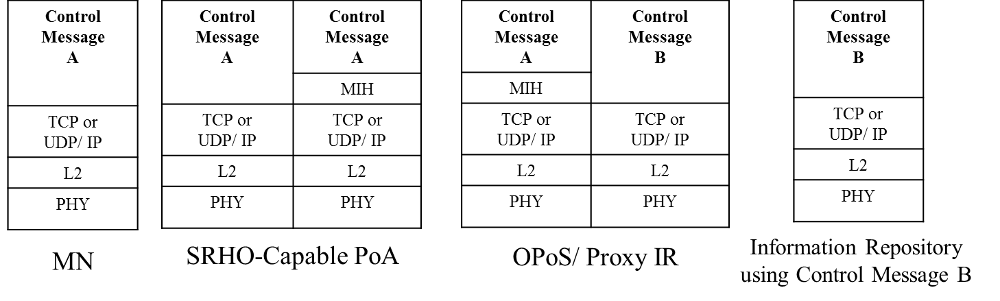
Figure T.2 Proxy Function for Control Message Conversion for Information Repository

If the MN uses ANQP messages but the Information Repository uses the other control messages such as ANDSF messages, the Proxy IR needs to convert ANQP messages to the other control messages. For this case, the WLAN AP as the SRHO-Capable PoA only encapsulates ANQP messages of the MN into MIH_CTRL_Transfer messasges and decapsulates MIH_CTRL_Transfer message of information server, as shown in Figure T.3 (a). Proxy IR converts the ANQP messages from the WLAN AP to the other control messages and vice versa. Hence, the MN can communicate with Information Repository by using the WLAN AP and the Proxy IR. To explain the ANQP conversion, the protocol stacks for MN, WLAN AP, Proxy, and information server are shown in Figure T.3 (b).

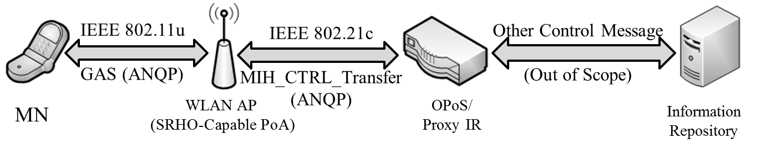
(a) ANQP Message Conversion using the Proxy IR

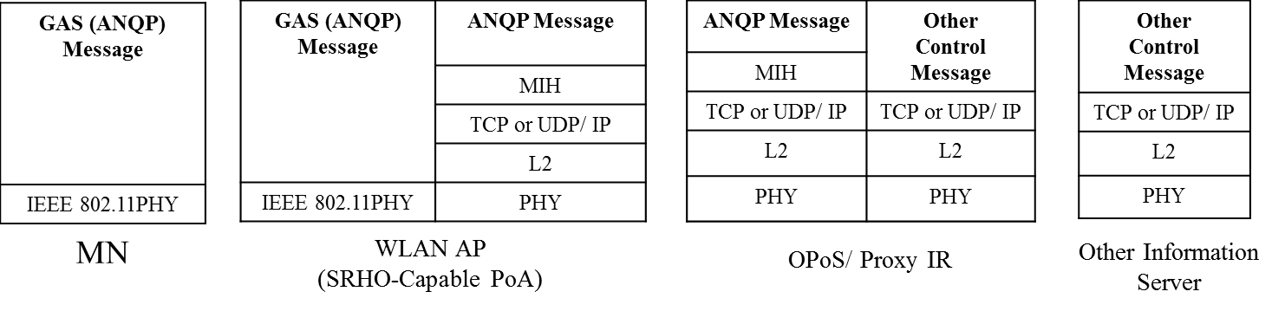
(b) Protocol Stacks for ANQP Conversion
Figure T.3 Proxy IR for ANQP Conversion

