Project | IEEE 802.21 Media Independent Handover Services  <http://www.ieee802.org/21/>
Title | User Authentication in case of MIH
Date Submitted | 30 October, 2012
Source(s) | Sangkwon P. Jeong(IMRC), Junghun Kim(TTA), Hyoungbae Park(KWISA), Seokkyu Kang(TTA), Hyunho Park (ETRI), Hyeong-Ho Lee (ETRI), Youn-Kwan Kim(High Gain Telecom).
Re: | IEEE 802.21 Session #53 in San Antonio, TX
Abstract | This document proposes to consider for new work item in the 802.21.
Purpose | Work Group Discussion and Acceptance
Notice | This document has been prepared to assist the IEEE 802.21 Working Group. It is offered as a basis for discussion and is not binding on the contributing individual(s) or organization(s). The material in this document is subject to change in form and content after further study. The contributor(s) reserve(s) the right to add, amend or withdraw material contained herein.
Release | The contributor grants a free, irrevocable license to the IEEE to incorporate material contained in this contribution, and any modifications thereof, in the creation of an IEEE Standards publication; to copyright in the IEEE’s name any IEEE Standards publication even though it may include portions of this contribution; and at the IEEE’s sole discretion to permit others to reproduce in whole or in part the resulting IEEE Standards publication. The contributor also acknowledges and accepts that this contribution may be made public by IEEE 802.21.
Patent Policy | The contributor is familiar with IEEE patent policy, as outlined in Clause 6.3 of the IEEE-SA Standards Board Operations Manual <http://standards.ieee.org/guides/opman/sect6.html#6.3> and in Understanding Patent Issues During IEEE Standards Development <http://standards.ieee.org/board/pat/guide.html>.
Issue case
Man A plays mobile game in 3GPP areas and walks.
The mobile game is a network game that is acting in client-server environment.
He connected to game server was authenticated to network continuously through phone number to have connected in 3GPP areas, to use ID and PW.
Game server checks phone number to confirm that user who is authenticated through ID and PW is coupled continuously to server.
As he plays a game, he is walking into Wi-Fi area.
Network authentication through phone number does not need at Wi-Fi area.
Game server checks IP to confirm that user who is authenticated through ID and PW is coupled continuously to server.
Because game server was designed to check IP regularly.
By the way, IP is changed as man A moves from 3GPP areas to Wi-Fi area.
Therefore, despite man A of game server is on-line state continuously, recognize that secede at network.
Man A can not play a game breaking in game regardless of own will.

Usecase
Man A plays mobile game in 3GPP areas and walks.
The mobile game is a network game that is acting in client-server environment.
He connected to game server was authenticated to network continuously through phone number to have connected in 3GPP areas, to use ID and PW.
And, game server is authentication UDID(Unique Device Identity) of his smartphone.
Game server checks phone number to confirm that user who is authenticated through ID and PW is coupled continuously to server.
As he plays a game, he is walking into Wi-Fi area.
Network authentication through phone number does not need at Wi-Fi area.
Game server checks UDID to confirm that user who is authenticated through ID and PW was coupled continuously to server.
Because game server was designed to check UDID regularly.
IP was authenticated without problem because UDID is fixing as man A moves from 3GPP areas to Wi-Fi area although changed.
Though man A plays a game continuously, there is no problem.
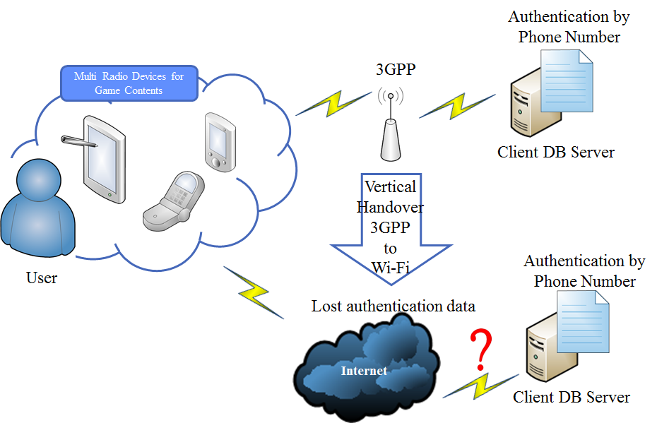
<Problem in case of user authentication for MIH>

Summary of Contribution
The contents used by most of smartphone users download or upload the data from server unilaterally and Handover occurred in this cases has not raised a problem to user.
However, in this general case, it is very important whether or not user exists in certifications server consistently because the continuous interaction is occurred on network between server and terminal or terminal and terminal.
If the Handover occurred between servers when the user does not want, there are many changes on the server regarding the user certification, for examples, unexpected situations such as changing the IP or disappearance of the column on certification DB caused CTN’s move from 3G to Wi-Fi network.
In these cases, the server fails to certify or identify the users, so they are regarded they leave the game themselves.
Most of games use ID and PW to identifyy the users, but the information identified through ID and PW is not available method for the game with enhanced security.
To correct these problems, this paper shall establish the standard using the Device ID of user’s terminal as a means of identification. Detailed Proposal

