Project | IEEE 802.21a  <https://mentor.ieee.org/802.21>
Title | Proactive pull key distribution through target PoS
DCN | 21-11-0157-00-0sec
Date Submitted | 19/09/2011
Source(s) | Yoshihiro Ohba, Rafa Marin, Fernando Bernal, Antonio de la Oliva
Re:
Abstract | This contribution addresses the required extensions to support proactive pull key distribution.
Purpose | Proposes changes in the current draft
Notice | This document has been prepared to assist the IEEE 802.21 Working Group. It is offered as a basis for discussion and is not binding on the contributing individual(s) or organization(s). The material in this document is subject to change in form and content after further study. The contributor(s) reserve(s) the right to add, amend or withdraw material contained herein.
Release | The contributor grants a free, irrevocable license to the IEEE to incorporate material contained in this contribution, and any modifications thereof, in the creation of an IEEE Standards publication; to copyright in the IEEE’s name any IEEE Standards publication even though it may include portions of this contribution; and at the IEEE’s sole discretion to permit others to reproduce in whole or in part the resulting IEEE Standards publication. The contributor also acknowledges and accepts that IEEE 802.21 may make this contribution public.
Patent Policy | The contributor is familiar with IEEE patent policy, as stated in Section 6 of the IEEE-SA Standards Board bylaws <http://standards.ieee.org/guides/bylaws/sect6-7.html#6> and in Understanding Patent Issues During IEEE Standards Development http://standards.ieee.org/board/pat/faq.pdf
Extension of MIH_LL_Auth to carry the MN’s NAI
7.4.29.2.4 Effect on receipt
The MIH user must generate an MIH_LL_Auth.response primitive or invoke an MIH_N2N_LL_Auth.request primitive to exchange MIH_N2N_LL_Auth messages with the MIHF on the target PoS before invoking the MIH_LL_Auth.response primitive.

7.4.29.3 MIH_LL_Auth.response
7.4.29.3.1 Function
This primitive is used by an MIH user to provide the link-layer frames to the local MIHF.
7.4.29.3.2 Semantics of service primitive
MIH_LL_Auth.response (
DestinationIdentifier,
LinkIdentifier,
LLInformation,
MNnetworkaccessid,
Status
)

Parameters:

Name | Data type | Description
DestinationIdentifier | MIHF_ID | This identifies a remote MIHF that will be the destination of this response.
LinkIdentifier | LINK_TUPLE_ID | This identifies a PoA which is also the authenticator.
LLInformation | LL_FRAMES | This carries link layer frames.
MNnetworkaccessid | NAI | (Optional) This carries the MN’s Network Access Identifier in the case optimized pull key distribution is used
Status | STATUS | Status of the authentication.
7.4.29.3.3 When generated
This primitive is generated after receiving an MIH_LL_Auth.indication primitive and possibly after the exchange of MIH_N2N_LL_Auth messages with the MIHF on the target PoS.
7.4.29.3.4 Effect on receipt
The local MIHF must generate an MIH_LL_Auth response message in order to provide the required infor mation until the authentication is finished.

7.4.29.4 MIH_LL_Auth.confirm
7.4.29.4.1 Function
This primitive is used to notify the corresponding MIH user about the reception of an MIH_LL_Auth response message.
7.4.29.4.2 Semantics of service primitive
MIH_LL_Auth.confirm (
SourceIdentifier,
LLInformation,
MNnetworkaccessid,
Status
)

Parameters:

Name | Data type | Description
SourceIdentifier | MIHF_ID | This identifies the invoker, which is a remote MIHF.
LLInformation | LL_FRAMES | This carries link layer frames.
MNnetworkaccessid | NAI | (Optional) This carries the MN’s Network Access Identifier in the case optimized pull key distribution is used
Status | STATUS | Status of the authentication.

7.4.29.4.3 When generated
This primitive is generated by the remote MIHF after receiving an MIH_LL_Auth response message.
7.4.29.4.4 Effect on receipt
The MIH user may generate an MIH_LL_Auth.request primitive unless the authentication is completed.

--------------------------------------------
ADD FOLLOWING DATA TYPE TO TABLE F.24

Data | Derived from | Definition
NAI | OCTET_STRING | Represents a Network Access Identifier as for IETF RFC 4282

8.6.1.19 MIH_LL_Auth response

This message is used for an MIHF to carry link layer frames to conduct an authentication. The correspond ing primitive is defined in Figure 7.4.29.3

MIH Header Fields (SID=1, Opcode=2, AID=9)
Source Identifier = sending MIHF ID (Source MIHF ID TLV)
Destination Identifier = receiving MIHF ID (Destination MIHF ID TLV)
LinkIdentifier (Link Identifier TLV)
LLInformation (Link Layer Information TLV)
MNnetworkaccessid (Network Access Identifier TLV)
Status (Status TLV)

Add to table L.2

TLV type Name | TLV type value | Data type
Network Access Identifier | 76 | NAI

Primitive MIH_N2N_LL_Auth
7.4.30 MIH_N2N_LL_Auth
The primitives defined are to carry out an optimized pull key distribution over MIH between the serving PoS and the target PoS using link layer frames. The authentication is conducted with the media specific authenticator that serves the target PoA.
7.4.30.1 MIH_N2N_LL_Auth.request
7.4.30.1.1 Function
This primitive is used to perform optimized pull key distribution using link-layer frames.
7.4.30.1.2 Semantics of Service Primitive
MIH_N2N_LL_Auth.request(
DestinationIdentifier,
LinkIdentifier,
LLInformation,
MNmirk
)

Parameters:

Name | Data type | Description
DestinationIdentifier | MIHF_ID | This identifies a remote MIHF that will be the destination of this request.
LinkIdentifier | LINK_TUPLE_ID | This identifies a PoA which is also the authenticator.
LLInformation | LL_FRAMES | This carries link layer frames.
MNmirk | KEY | (Optional) MN’s Media Independent Root Key to be transferred to the target PoS.

7.4.29.1.3 When generated
This primitive is generated by the serving PoS of a MN to execute an optimized pull key distribution to the target PoS when the serving PoS receives an MIH_LL_Auth request message.
7.4.29.1.4 Effect on receipt
The local MIHF shall generate an MIH_N2N_LL_Auth request message to the remote MIHF.
7.4.30.2 MIH_N2N_LL_Auth.indication
7.4.30.2.1 Function
This primitive is used by the remote MIHF to notify the corresponding MIH user about the reception of an MIH_N2N_LL_Auth request message.
7.4.30.2.2 Semantics of service primitive
MIH_N2N_LL_Auth.indication (
SourceIdentifier,
LinkIdentifier,
LLInformation,
MNmirk
)

Parameters:
Name | Data type | Description
SourceIdentifier | MIHF_ID | This identifies the invoker, which is a remote MIHF.
LinkIdentifier | LINK_TUPLE_ID | This identifies a PoA which is also the authenticator.
LLInformation | LL_FRAMES | This carries link layer frames.
MNmirk | KEY | (Optional) MN’s Media Independent Root Key to be transferred to the target PoS.

7.4.30.2.3 When generated
This primitive is generated by a remote MIHF after receiving an MIH_N2N_LL_Auth request message.
7.4.30.2.4 Effect on receipt
The MIH user must generate an MIH_N2N_LL_Auth.response primitive.
7.4.30.3 MIH_N2N_LL_Auth.response
7.4.30.3.1 Function
This primitive is used by an MIH user to provide the link-layer frames to the local MIHF.
7.4.30.3.2 Semantics of service primitive
MIH_N2N_LL_Auth.response (
DestinationIdentifier,
LinkIdentifier,
LLInformation,
MNnetworkaccessid,
Status
)

Parameters:

Name | Data type | Description
DestinationIdentifier | MIHF_ID | This identifies a remote MIHF that will be the destination of this response.
LinkIdentifier | LINK_TUPLE_ID | This identifies a PoA which is also the authenticator.
LLInformation | LL_FRAMES | This carries link layer frames.
MNnetworkaccessid | NAI | This carries the MN’s Network Access Identifier in the case optimized pull key distribution is used
Status | STATUS | Status of the authentication.
7.4.30.3.3 When generated
This primitive is generated after receiving an MIH_N2N_LL_Auth.indication primitive.
7.4.30.3.4 Effect on receipt
The local MIHF must generate an MIH_N2N_LL_Auth response message in order to provide the required information until the authentication is finished.
7.4.30.4 MIH_N2N_LL_Auth.confirm
7.4.30.4.1 Function
This primitive is used to notify the corresponding MIH user about the reception of an MIH_N2N_LL_Auth response message.
7.4.29.4.2 Semantics of service primitive
MIH_N2N_LL_Auth.confirm (
SourceIdentifier,
LLInformation,
MNnetworkaccessid,
Status
)

Parameters:

Name | Data type | Description
SourceIdentifier | MIHF_ID | This identifies the invoker, which is a remote MIHF.
LLInformation | LL_FRAMES | This carries link layer frames.
MNnetworkaccessid | NAI | This carries the MN’s Network Access Identifier in the case optimized pull key distribution is used
Status | STATUS | Status of the authentication.

7.4.30.4.3 When generated
This primitive is generated by the remote MIHF after receiving an MIH_N2N_LL_Auth response message.
7.4.30.4.4 Effect on receipt
The MIH user invokes an MIH_LL_Auth.response primitive with the information obtained from this primitive.

8.6.1.20 MIH_N2N_LL_Auth request
This message is used for an MIHF to carry link layer frames to conduct an authentication. The correspond ing primitive is defined in Figure (must be section) 7.4.30.1

MIH Header Fields (SID=1, Opcode=1, AID=9)
Source Identifier = sending MIHF ID (Source MIHF ID TLV)
Destination Identifier = receiving MIHF ID (Destination MIHF ID TLV)
LinkIdentifier (Link Identifier TLV)
LLInformation (Link Layer Information TLV)
MNmirk (Media Independent root key TLV)

8.6.1.21 MIH_N2N_LL_Auth response

This message is used for an MIHF to carry link layer frames to conduct an authentication. The correspond ing primitive is defined in Figure 7.4.30.3

MIH Header Fields (SID=1, Opcode=2, AID=9)
Source Identifier = sending MIHF ID (Source MIHF ID TLV)
Destination Identifier = receiving MIHF ID (Destination MIHF ID TLV)
LinkIdentifier (Link Identifier TLV)
LLInformation (Link Layer Information TLV)
MNnetworkaccessid (Network Access Identifier TLV)
Status (Status TLV)

Add to table L.2

TLV type Name | TLV type value | Data type
Media independent root key | 77 | KEY

Changes to section 9.2.2

9.2.2 Key derivation and key hierarchy
Upon a successful MIH service access authentication, the authenticator, PoS obtains a master session key (MSK) or a re-authentication master session key (rMSK). Alternatively upon an optimized pull key distribution process a Target PoS can obtain a MIRK from a Serving PoS (see clause 9.2.2.2).

9.2.2.1 Derivation of media independent session keys (MISKs)

From the MSK, rMSK or MIRK based on the ciphersuite agreed upon between an MN and a PoS, the session keys used for MIH message protection can consist of an encryption key (MIEK) only, an integrity key (MIIK) only, or both an encryption key (MIEK) and an integrity key (MIIK). The length, L, of the derived keying material, called media independent session key (MISK), depends on the ciphersuite, which are specified in Clause 9.2.3.

For the key derivation, the following notations and parameters are used.
— K - key derivation key. It is truncated from a master session key (MSK), re-authentication MSK
(rMSK) or media independent root key (MIRK). The length of K is determined by the pseudorandom function (PRF) used for key derivation. If HMAC-SHA-1 or HMAC-SHA-256 is used as a PRF, then the full MSK, rMSK or MIRK is used as key derivation key, K. If CMAC-AES is used as a PRF, then the first 128 bits of MSK or rMSK are used as key derivation key, K.

….

9.2.2.2 Derivation of media independent root keys (MIRKs)

During an optimized pull key distribution process that involves the MN, the Serving PoS and a target PoS, the serving PoS derives a Media Independent Root Key (MIRK) for a specific target PoS. For the master media independent root key (MIRK) derivation, the following notations and parameters are used:

— K - key derivation key. It is truncated from a master session key (MSK) or re-authentication MSK
(rMSK). The length of K is determined by the pseudorandom function (PRF) used for key derivation.
If HMAC-SHA-1 or HMAC-SHA-256 is used as a PRF, then the full MSK or rMSK is used as key
derivation key, K. If CMAC-AES is used as a PRF, then the first 128 bits of MSK or rMSK are used
as key derivation key, K.

— L - The binary length of derived keying material MIRK. L=64 bytes for the MIRK
— h - The output binary length of PRF used in the key derivation. That is, h is the length of the block of
the keying material derived by one PRF execution. Specifically, for HMAC-SHA-1, h = 160 bits; for
HMAC-256, h =256 bits; for CMAC-AES, h = 128 bits.
— n - The number of iterations of PRF in order to generate L-bits keying material.
— Nonce-T and Nonce-N - The nonces exchanged during the execution of service access authentication.
— c - The ciphersuite code is a one octet string specified for each ciphersuite. The code is defined in
9.2.3.
— v - The length of the binary representation of the counter and the length of keying material L. The
default value for v is 32.
— [a]2 - Binary representation of integer a with a given length.
— MN_MIHF_ID – Mobile node’s MIHF identity.
— PoS_MIHF_ID – Target PoS’s MIHF identity.
— “MIRK” - 0x4D49524B, ASCII code in hex for string “MIRK”.

Fixed input values: h and v.
Input: K, Nonce-T, Nonce-N, L=64, and ciphersuite code.
Process:
a) n := ;
b) If n > 2v -1, then indicate an error and stop.
c) Result (0) := empty string.
d) For i = 1 to n, do
i) K(i) := PRF(K, “MIRK” || [i]2 || Nonce-T || Nonce-N || MN_MIHF_ID || POS_MIHF_ID || c || [L]2).
ii) Result(i) = Result (i-1) || K(i).
e) Return Result (n) and MISK is the leftmost L bits of Result (n).
Output: MIRK

Add the following Annex

Annex P

(informative)

MN’s Network Access Identifier Format

An MNnetworkaccessid attribute (of type NAI), which is optionally contained in MIH_LL_Auth.response, MIH_LL_Auth.confirm, MIH_N2N_LL_Auth.response, and MIH_N2N_LL_Auth.confirm primitives, is assigned by the target PoS to the MN such that the MN can use the value of this attribute as the EAP peer identity for subsequent reactive pull key distribution or optimized pull key distribution from the target PoS. The username part of the NAI carried in this attribute may contain the identifier of the MSRK used between the MN and the target PoS, and the realm part of the NAI may contain a Fully Qualified Domain Name of the target PoS.

Subclause 10.1

Change Figure 43 as follows

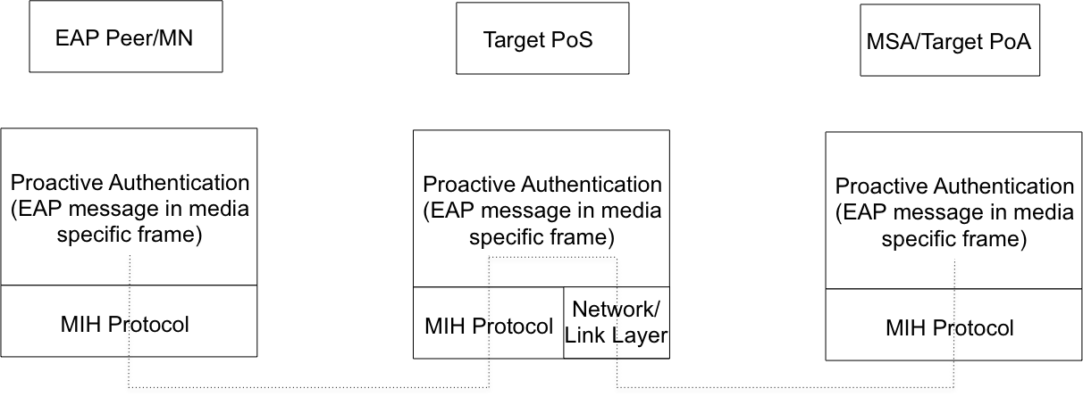
Fig 43

Add new figure as follows

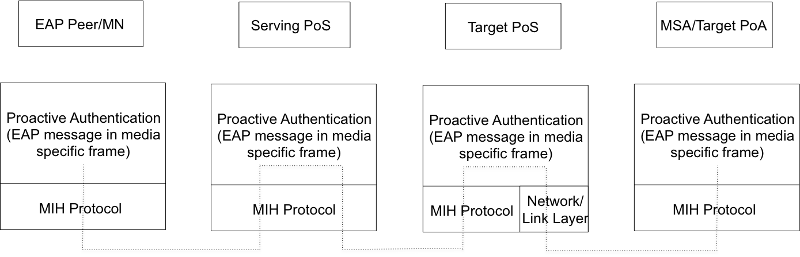

MODIFY TEXT ON PAGE 48 (SUBCLAUSE 10.1)

In a media access proactive authentication, a PoS passes authentication messages between the mobile node and a media specific authenticator (MSA). The protocol stacks in each interface are illustrated in Figure 43. In scenarios where MSA/Target PoA is reachable via same media as MN and PoS, EAP messages received at PoS are directly forwarded to the target PoA. In an optimized pull key distribution, a PoS passes authentication messages between the mobile node, the target PoS and a media specific authenticator (MSA). The protocol stacks in each interface are illustrated in Figure 44.

Annex N

In this first call flow how the identity bootstrap (from TPoS) and MNMSRK installation into the TPoS (AAA) are depicted.

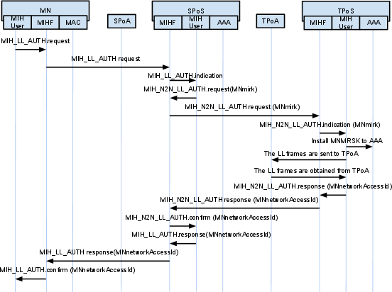

In the second one, the authentication between the MN and the TPoA is depicted.
