Project | IEEE 802.21 Media Independent Handover Services  IEEE 802.21c: Single Radio Handover  <http://www.ieee802.org/21/>
Title | IEEE 802.21c Proposal: Single Radio Handover Proposal
Date Submitted | April 26, 2011
Source(s) | Dapeng Liu (China Mobile), H Anthony Chan (Huawei), Hongseok Jeon (ETRI), Junghoon Jee (ETRI)
Re: | IEEE 802.21c draft
Abstract | This document specifies the specification of IEEE 802.21c Single Radio Handover Optimization.
Purpose | Task Group Discussion and Acceptance
Notice | This document has been prepared to assist the IEEE 802.21 Working Group. It is offered as a basis for discussion and is not binding on the contributing individual(s) or organization(s). The material in this document is subject to change in form and content after further study. The contributor(s) reserve(s) the right to add, amend or withdraw material contained herein.
Release | The contributor grants a free, irrevocable license to the IEEE to incorporate material contained in this contribution, and any modifications thereof, in the creation of an IEEE Standards publication; to copyright in the IEEE’s name any IEEE Standards publication even though it may include portions of this contribution; and at the IEEE’s sole discretion to permit others to reproduce in whole or in part the resulting IEEE Standards publication. The contributor also acknowledges and accepts that this contribution may be made public by IEEE 802.21.
Patent Policy | The contributor is familiar with IEEE patent policy, as outlined in Clause 6.3 of the IEEE-SA Standards Board Operations Manual <http://standards.ieee.org/guides/opman/sect6.html#6.3> and in Understanding Patent Issues During IEEE Standards Development <http://standards.ieee.org/board/pat/guide.html>.

IEEE Standard for
Local and metropolitan area networks—

Part 21: Media Independent Handover Services

Amendment: Optimized Single Radio Handovers

Abstract: This specifies the single radio handover optimizations to reduce the latency during handovers between heterogeneous access networks.

Keywords:

IEEE Standard for
Local and metropolitan area networks—

Part 21: Media Independent Handover
Services

Amendment: Optimized Single Radio Handovers

Overview

1.3 General

Normative references

Definitions
Control Plane Gateway: Gateway in the control plane to bridge the signaling between the MN and the target network via the source network. To the MN, it behaves like the target point of attachment (POA). It enables such functions as pre-registration and pre-authentication of MN to the target network.
Single radio handover: A handover among different radio access technologies during which a mobile node can transmit on only one radio at a time.

Abbreviations and acronyms
C-GW Control Plane Gateway
SFF Signal Forwarding Function
SRHO Single Radio Handover

General architecture

MIH Services

6.3 Media independent event service

6.4 Media independent command service

6.5 Media independent information service

Service access point (SAP) and primitives

Media independent handover protocols

Single Radio Handover

Introduction

Need for single radio handover
In a single radio handover, a mobile node can transmit on only one radio at a time. The needed peak transmission power capability for the mobile node is therefore smaller than if the mobile node may transmit on both the source radio and the target radio simultaneously. In addition, the design of signal filter at the radio receiver is simpler if one radio is not transmitting when another radio is receiving. The lower peak power transmission and the simpler filter design for the mobile device both contribute to lower cost for the mobile device.
Such a lower cost design is appealing especially to the consumer market which is experiencing the proliferation of multiple radio interface devices using different network technologies.

Relationship to other network standards
Network standards organizations such as WiMAX Forum and 3GPP had both been looking into single radio handover from/to their network. With different networks involved in a single radio handover, a media independent single radio handover standard can avoid duplicating the technology for the different networks and achieve higher volume production using the same technology. The resulting economy of scale can benefit both network service providers and vendors. This standard provides such a media independent single radio handover optimization and explains how the individual network standards may tailor it to the needs of their specific networks.

Single radio versus dual radio handover
A mobile device switches its link to the network in a handover process. The link is between a radio interface of the device and a point of attachment in a network. In the handover process, the radio interface may or may not change, whereas the point of attachment in the network also may or may not change to a different network technology.
If the radio interface remains the same, the handover is from one point of attachment to another point of attachment in the same network technology. This type of handover is a horizontal handover. While the source and target networks are of the same type of network technology, it is possible that the source and target points of attachment may belong to the same or different access networks, and different access networks may connect through the same or different networks to the Internet. An example of the handover involving only one radio interface is the handover with one WiMAX interface from one WiMAX base station to another WiMAX base station. A single interface device can only perform a single radio handover, whereas a multiple interface device has more options to perform handover.
A multiple-interface device connecting with one interface to a network may change the connection with another interface to another network of a different network technology. This type of handover is a heterogeneous network handover, with which the multiple-interface device is able to exploit the availability of the different networks to enjoy more opportunities and choices of network connectivity.
When the multiple-interface device performs handover from a source radio interface to a target radio interface, it is possible to perform a dual-radio handover which has an overlap period utilizing both radios simultaneously. Such a make-before-break handover, in which there is an overlap period during which both radios are fully on, has the advantage of avoiding handover delay and packet loss. Yet the device must then possess the functional capability for both radios to operate simultaneously during the dual-radio handover. The resulting requirements to the device are higher peak power consumption and more demanding filtering of receiver signals.
An alternative is to perform a single radio handover, in which the mobile device is allowed to transmit on only one radio at any time. Because the power consumption of the transmitter is high compared with that of the rest of the radio, limiting to only one radio transmission at a time will reduce the peak power consumption of the device.
Another requirement with the dual-radio handover is a sharper receiver signal filter. When a radio is transmitting, the receiver of the same radio may or may not be receiving signals. If the receiver is not receiving signal such as when time division duplex is used, there is no interference between the transmitter signal and the receiver signal. If the receiver is receiving signal such as when frequency division duplex is used, the frequency bands for transmission for reception in the same network technology will avoid being too close to each other. Yet with two different network technologies, there is generally no coordination to sufficiently separate the transmission frequency of one technology from the receiver frequency of another technology. A sharper signal filter is therefore needed to avoid interference when one radio is transmitting while another radio is receiving.
An additional requirement may therefore be imposed on single radio handover to disallow one radio from transmitting when another radio is receiving. This restriction will result in simpler filter design and therefore further reduction in the cost of the device.
Other than the above requirements, a single radio handover does not exclude both radios to be receiving simultaneously when no radio is transmitting.
With the restrictions on the single radio handover, certain operations that are possible in the dual-radio handover will not be possible here. New functions and therefore new functional requirements (Clause 9.2) are needed in single radio handover. The single radio handover therefore differs from the dual-radio handover in that the device follows a different signaling procedure (Clause 9.5 and 9.6) whereas the network provides the needed network support with the different network configuration (Clause 9.3) to optimize the handover performance.
As with a dual-radio handover, a single radio handover among different access technologies also includes a L2 handover and a L3 handover. To the network, a handover involves a change of the layer 2 network link. To the higher layer however, only the changes at the IP layer may be seen. This is seen as a L3 handover in which the IP layer reconfigures itself and involves changes such as in binding the IP address to the new L2 address of the new radio interface.
The L2 handover related signaling messages, which terminate at the L2 endpoints of the radio link, involve L2 interfaces in the different network technologies. It is also possible to use IP packets to deliver signaling messages, which are then independent of the network medium.

Media independent single radio handover
The concept of media independency applies to the single radio handover as it does to the dual-radio handover: Although the network technologies involving the two different L2 radio interfaces differ, it is possible to define generic signaling messages which are the same for different radio interfaces. These signaling messages are media independent messages. The single radio handover using these media independent messages is a media independent single radio handover. Therefore, a media independent handover may be accomplished in a media independent way utilizing L2 or L3 transport, keeping in mind that the signaling messages for a single radio handover differ from that for a dual-radio handover.
In a single radio handover using the media independent messages, these messages may be transported through either L2 or L3. The requirements for single radio handover are described next in Clause 9.2.

Requirements of Single Radio Handover
The following are the lists of requirements with regard to assist and facilitate the single radio handover among different radio access technology networks.
General Requirements;
- The defined mechanism shall be general so that it can be applied to the single radio mobile station whether it activates the dual receivers for both access networks or only single receiver for the current access network.
- The defined mechanisms shall be general enough so that they can be applicable to various interworking scenarios (e.g., WiMAX-3GPP, WiMAX-WiFi, 3GPP-WiFi, etc.)
- The impact on existing access network architectures (3GPP, 3GPP2, WiMAX, WiFi) shall be minimized
Functional Requirements;
- The mechanism shall define the way to deliver radio measurement configuration and report information within a media-independent container for single radio mobile station.
- The mechanism shall define the tunneling mechanism to deliver the pre-registration messages.
- The defined mechanism shall provide a way to control pre-registered states and deliver pre-registered contexts to enable single-radio operation.
- The mechanism shall assist the mobile station to detect the presence of single radio enabling entity at the network before attaching to the target access network.
- The mechanism shall assist the mobile station to select appropriate target network and the corresponding required information from the access network.
- The following capability shall be communicated between mobile station and single radio enabling entity at the network.
                - Supported RATs accesses on mobile station (3GPP, WiMAX, WiFi, 3GPP2, etc.)
                - Whether it supports single radio handover or dual radio handover
                - Applicable frequencies bands per access technology
                - Transmit Configuration (Single/Dual)
                - Receive Configuration (Sigle/Dual)
                - Measurement Gaps (UL/DL)
                - Whether the networks is allowing pre-registration

Assumptions of Single Radio Handover
The following assumptions apply during the single radio handover:
- While the source radio is transmitting, the target radio cannot transmit.
The mobile device can transmit on only one radio at a time. Prior to handover completion, the source radio link is used to support data transfer so that the priority to transmit is given to the source radio.
- If sufficiently sharp signal filtering is lacking, then while the source radio is receiving, the target radio shall not transmit at a frequency close to the frequency of the source radio receiver.
- If sufficiently sharp signal filtering is lacking, then while the source radio is transmitting, the target radio shall not receive at a frequency close to the frequency of the source radio transmitter.
- The MN and the target network may communicate with each other through the point of attachment at the source network.
It is possible that the source point of attachment and the target point of attachment may: (a) belong to the same access network, (b) belong to different access networks connecting to the same network, the communication, or (c) belong to different access networks connecting to different networks. In (a) and (b), the capability to communicate between the source radio and the target network usually does not need new internetwork interfaces. In (c), the two networks should be able to communicate with each other.

SRHO Reference Model
(Note: We need to describe 21c entities to support single radio handover operations and corresponding relationship among them. This should be general so that they can be applied to specific system interworking architecture.)
The reference model for single radio handover across different networks is shown in Figure 9.1.

Figure 9.1. Reference model for single radio handover across different networks.
Link configuration before handover:
- Between MN and source network: Source radio is connected to a point of attachment in an access network. This link can exchange both data and signal.
- Between MN and target network: Not specified.
Link configuration after handover:
- Between MN and source network: Not specified.
- Between MN and target network: Target radio is connected to a point of attachment in an access network. This link can exchange both data and signal.
Link configuration during handover:
- Between MN and source network: Source radio remains connected to a point of attachment in an access network. This link can exchange both data and signal.
The control function in MN and the control function in the source network may use this link to transport control plane messages between them.
- Between MN and target network: The link between MN and the target network is virtual and communication may happen meeting the constraints given in the assumptions Clause.
The control function in MN and the control function in the target network may use this link to transport control plane messages between them.
The Information Repository may reside in the source network or the target network, and is accessible from both networks. It contains network information needed to make handover decision, such as the availability of candidate target network etc. In particular, a media independent information server (IS) is used for information expressed in media independent format. The Information Repository may also be implemented in such a network information repository as part of the Access Network Discovery and Selection Function (ANDSF) defined in 3GPP.
The source network and the target network may communicate with each other. Examples of such communication are:
When the information server is in one network, the other network may push and pull information to the server through this communication mechanism.
Shortly after handover, packets delivered to the source network may be forwarded or tunneled to the target network.
The Control Plane Gateway (C-GW) bridges the control plane signaling between the MN and the target network via the source network. To the MN, it behaves like the target point of attachment (POA). It enables such functions as pre-registration and pre-authentication of MN to the target network.
A control signal should be provided in a media independent manner. It may be transported as a higher layer payload through an IP packet as shown in Figure 9.2. (need more discussions and details to show how it works, such as using the P802.1 control plane model)

Figure 9.2. Transport of SRHO message as a higher layer payload through an IP packet.
Examples of the C-GW implementation are the media independent point of service (POS) over the Signal Forwarding Function (SFF) defined in WiMAX Forum and that over the Mobility Management Entity (MME) defined in 3GPP.

Single radio handover overall procedures
A single radio handover following the above reference model may consists of different handover processes and involve different information elements (Clause 9.7) and messages (Clause 9.8). This Clause describes overall procedures of single radio handover, and examples of handover are described in Clause 9.6. Figure 9.3 shows the single radio handover procedures consisting of 6 phases.
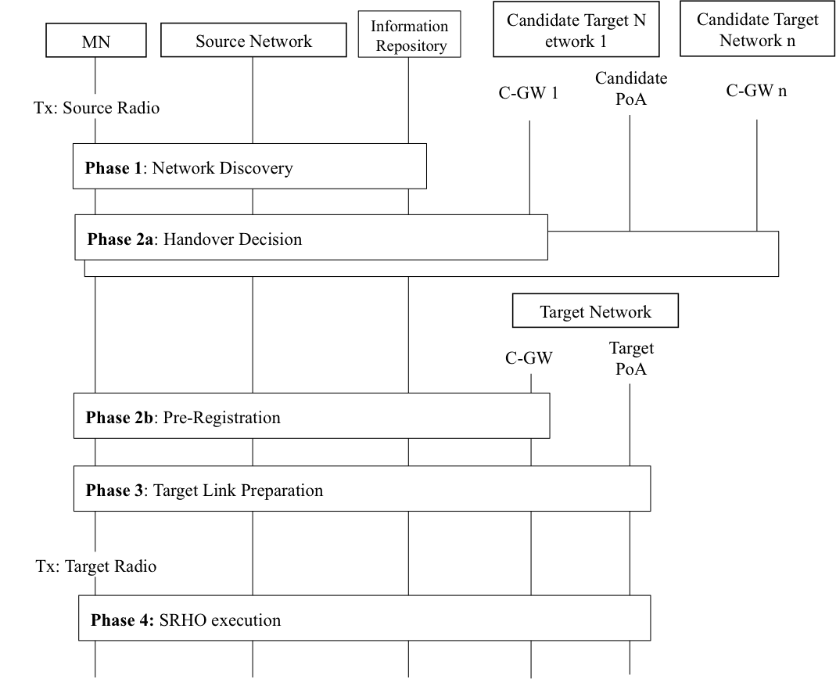
Figure 9.3 – Overall Single Radio Handover Procedures
Phase 1 is Network discovery to ascertain whether there is a candidate target network available to handover to? In this Phase, the MN queries the Information Repository to discover candidate networks. Information Repository provides the MN with information about available networks and handover policy. Such information includes whether candidate networks and MN support SRHO or not, and the presence of C-GW on the candidate network. This phase also allows the MN to acquire the corresponding system information blocks of candidate PoAs to perform the radio measurements.
Phase 2a is Handover Decision, which may involve the following (1) The handover may be triggered by a need. (2) A target network is selected. (3) A determination is made on whether there is benefit to handover? The decision can be taken by the MN or the network and may be based on the parameters such as signal strength, cost, and operator policy. Phase 2b is Pre-registration, which includes pro-active authentication and establishing context at the target network. In this Phase, the MN performs pre-registration to C-GW on the target network. With the help of C-GW, the MN can perform network entry procedures toward the target network while retaining its data connection with the source network. The pre-registration may include pre-authentication, establishing context (user identity, security, resource information) at the target network.
Optionally, 2b may occur before 2a.
Phase 3 is Target link preparation, in which the MN and target network prepare the establishment of the target link. This phase ensures whether the target network has enough resources to accommodate the new link and may include performing resource reservation or admission control. It also confirms the signal conditions are favorable enough to establish the target link. In addition, the target radio may perform limited signaling if it can do it within the constrainsts of peak power and sigaling interface defined for single radio handover in this standard.
Phase 4 is SRHO execution. In this Phase, the source link is disconnected, the target radio is activated, and the target link is established. The mobility management protocol used would perform binding update, and future incoming packets are then routed to the target radio. .

Examples of SRHO procedures

WiMAX – 3GPP single radio handover procedures (Note: Diagram is required. Entity, Call flows)
The general single radio handover requirements and configurations as described in Clauses 9.1 to 9.3 apply here.
The architecture of WiMax-3GPP E-UTRAN single radio handover is illustrated in Figure 9.4.
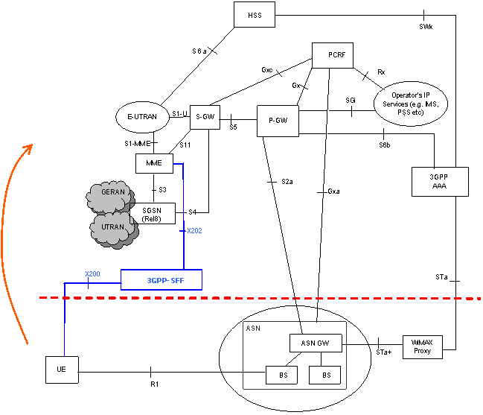
Figure 9.4 WiMax-3GPP single radio handover architecture.
Function element:
3GPP-SFF: 3GPP-SFF is the control function defined in 9.1. The 3GPP SFF facilitates pre-registration and authentication while the UE/MS is connected through the WiMAX Access Network prior to an active handover to the E-UTRAN and Pre-Release8 3GPP access networks.
For Single Radio Handover to Release 8 or later 3GPP networks, 3GPP SFF emulates functionality of eNodeB and connects to target MME (E-UTRAN HO) via the X202 Reference Point.
For Single Radio Handover to Pre-Release 8 3GPP access, the 3GPP SFF emulates the functionality of a RNC and connects to a target SGSN (GERAN/UTRAN HO) via the X201 reference point. 3GPP SFF may be co-located with SGSN and in this case X201 reference point is not exposed.
Reference Points:
X200: This reference point supports secure communication between the UE and the 3GPP SFF through the mobile WiMAX IP access. It is used for pre-registration and for requesting resource preparation in the target 3GPP access network.
X202: This reference point has the same functionality as the S1-MME (described in TS 23.401 Error: Reference source not found) and terminates at MME.
WiMAX to E-UTRAN Single Radio Handover procedure
UE
3GPP SFF
Target eNB
MME
S-GW
P-GW

- 3GPP SFF discovery and tunnel setup

2. Pre-registration to 3GPP SFF

3. Handover to E-UTRAN

Figure 9.5 WiMax-3GPP single radio handover procedure.

Step1: 3GPP SFF discovery and tunnel setup
The 3GPP SFF’s address could be discovered by DNS.
Step2:Pre-registration to 3GPP SFF
In this step, UE pre-registered to the 3GPP SFF. The pre-registration signaling is carried by media independent single radio handover messages (MIF SRHO messages).
Step3: Handover to E-UTRAN
The UE handover from WiMax to E-UTRAN.

WiMAX - WiFi single radio handover model and procedure

The general single radio handover requirements and configurations as described in Sections 9.1 to 9.3 apply here.
The architecture of WiMAX-WiFi single radio handover is illustrated in figure 9.6.

ASN
GW
WiFi
SFF
WiMAX
SFF
AAA
HA/LMA
BS

BS
UE

WIF
SFF

AP
AP

Figure 9.6 WiMAX-WiFi single radio handover architecture

Functional element:
The WiMAX-WiFi single radio handover model uses WiMAX SFF and WiFi SFF entity for single radio handover.
WiMAX SFF is used for UE’s handover from WiFi network to WiMAX network. It emulates WiMAX core network and enable UE to pre-register to WiMAX network though WiFi Access network.
WiFi SFF is used for UE’s handover from WiMAX network to WiFi network. It emulates WiFi network and enables UE to pre-register to WiFi network though WiMAX access network.
WIF: WiFi Interworking Function, used for MN connecting to the WiFi access network to access to the WiMAX CSN. WIF function includes authentication, accounting etc.

WiMAX to WiFi handover procedure:

UE
WiMAX
ASN
WiFi
SFF
WiFi
AN
HA/
AAA
Phase1
Phase2
Phase3

WiMAX to WiFi single radio handover

Phase1: WiFi network discovery and selection.
Pahse2: Authentication with WiFi network though WiFi SFF.
Pahse 3: Connect to WiFi access network and disconnect from WiMAX network.

WiFi to WiMAX handover procedure:
UE
WiFi
AN
WiMAX
SFF
Target
BS
HA/
AAA
HA/
AAA
PTarget
BS
hWiMAX
SFF
aWiFi
AN
sUE

Phase3

WiFi to WiMAX single radio handover
Phase1: WiMAX network discovery and selection.
Pahse2: Authentication with WiMAX network though WiMAX SFF.
Pahse 3: Connect to WiMAX network and disconnect from WiFi network.

SRHO Information Elements

SRHO Messages
The media independent signaling messages which are the same for different radio interfaces, are defined in this Clause.

SRHO message types
The media independent handover signaling messages have the following types:
- MIH Information Service message
These messages are for network discovery used in Phase 1 utilizing the MIH frame to deliver Inter-RAT information in a uniform manner. The details of these messages, which are also described in Clause 8.6.4, are reproduced here. (detail format need to be described)
(How about the radio ranging and signal strength measurements?)
- Pre-registration message
Media independent handover messages that used for pre-registration. (detail format need to be defined)
The message for pro-active authentication is MIH_LL_AUTH defined in P802.21a. The other pre-registration messages can be tunneled to the target network via the source network.
- Media independent handover message
Media independent handover messages that used for Inter-RATs radio link check and SRHO execution (detail format need to be defined)

SRHO Primitives
The following MIH command is defined for MIH SRHO messages:
MIH Commands | MIH Command type | Description
MIH_SRHO_RAT | Remote | MIH single radio handover inter-RAT information message
MIH_SRHO_PreRegistration | Remote | Carry MIH single radio handover pre-registration frames
MIH_SRHO_Handover | Remote | Carry single radio handover message
- MIH_SRHO_RAT:
General description: MIH_SRHO_RAT is used to carry single radio handover inter-RAT information.
MIH_SRHO_RAT.request
Function:
This primitive is used by the UE to request inter-RAT information.
Semantics of service primitive:
MIH_SRHO_RAT.request (
DestinationIdentifier,
SRHO_RAT_Messages
)
MIH_SRHO_RAT.indication
Function:
This primitive is used by the entity that indicates the reception of SRHO inter-RAT query messages.
Semantics of service primitive:
MIH_SRHO_RAT.indication (
DestinationIdentifier,
SRHO_RAT_Messages (cannot name this a message because it is from the primitive)
)
- MIH_SRHO_PreRegistration
General description: MIH_SRHO_PreRegistration is used to carry single radio handover pre-registration message.
MIH_SRHO_PreRegistration.request
Function:
This primitive is used by the UE and SFF control function to exchange single radio handover pre-registration control messages.
Semantics of service primitive:
MIH_SRHO_PreRegistration (
DestinationIdentifier,
SRHO_PreRegistration_Messages (cannot name this a message because it is from the primitive)
)
MIH_SRHO_ PreRegistration.indication
Function:
This primitive is used by the entity that indicates the reception of SRHO pre-registration request message.
Semantics of service primitive:
MIH_SRHO_ PreRegistration.indication (
DestinationIdentifier,
SRHO_ PreRegistration _Messages (cannot name this a message because it is from the primitive)
)
- MIH_SRHO_Handover
General description: MIH_SRHO_handover is used to carry single radio handover message.
MIH_SRHO_handover.request
Function:
This primitive is used by the UE and SFF control function to perform SRHO execution.
Semantics of service primitive:
MIH_SRHO_handover.request (
DestinationIdentifier,
SRHO_handover_Messages (cannot name this a message because it is from the primitive)
)
MIH_SRHO_handover.indication
Function:
This primitive is used by the entity that indicates the reception of SRHO handover message.
Semantics of service primitive:
MIH_SRHO_handover.indication (
DestinationIdentifier,
SRHO_handover_Messages (cannot name this a message because it is from the primitive)
)

