Project | IEEE 802.21 Media Independent Handover Services  IEEE 802.21c: Single Radio Handover  <http://www.ieee802.org/21/>
Title | IEEE 802.21c Proposal: Single Radio Handover Proposal
Date Submitted | November 1, 2010
Source(s) | Dapeng Liu (China Mobile), Anthony Chan (Huawei), Hongseok Jeon (ETRI), Junghoon Jee (ETRI), Kim Chang (Huawei)
Re: | IEEE 802.21 Session #41 in Dallas, Texas
Abstract | This document specifies the specification of IEEE 802.21c Single Radio Handover Optimization.
Purpose | Task Group Discussion and Acceptance
Notice | This document has been prepared to assist the IEEE 802.21 Working Group. It is offered as a basis for discussion and is not binding on the contributing individual(s) or organization(s). The material in this document is subject to change in form and content after further study. The contributor(s) reserve(s) the right to add, amend or withdraw material contained herein.
Release | The contributor grants a free, irrevocable license to the IEEE to incorporate material contained in this contribution, and any modifications thereof, in the creation of an IEEE Standards publication; to copyright in the IEEE’s name any IEEE Standards publication even though it may include portions of this contribution; and at the IEEE’s sole discretion to permit others to reproduce in whole or in part the resulting IEEE Standards publication. The contributor also acknowledges and accepts that this contribution may be made public by IEEE 802.21.
Patent Policy | The contributor is familiar with IEEE patent policy, as outlined in Section 6.3 of the IEEE-SA Standards Board Operations Manual <http://standards.ieee.org/guides/opman/sect6.html#6.3> and in Understanding Patent Issues During IEEE Standards Development <http://standards.ieee.org/board/pat/guide.html>.


IEEE Standard for
Local and metropolitan area networks—

Part 21: Media Independent Handover Services

Amendment: Optimized Single Radio Handovers

Abstract: This specifies the single radio handover optimizations to reduce the latency during handovers between heterogeneous access networks.

Keywords:

IEEE Standard for
Local and metropolitan area networks—

Part 21: Media Independent Handover
Services

Amendment: Optimized Single Radio Handovers

Overview

1.3 General

Normative references

Definitions
Single radio handover: A handover during which a mobile node can transmit on only one radio at a time.
single-radio operation: In this mode, a dual radio device can receive and transmit on only one radio at a time. This is usually the mode of operation when radio frequencies of the two radios are close to each other (e.g., in IMT 2000 bands).
Abbreviations and acronyms
SFF Signal Forwarding Function
SRHO Single Radio Handover

General architecture

MIH Services

6.3 Media independent event service

6.4 Media independent command service

6.5 Media independent information service

Service access point (SAP) and primitives

Media independent handover protocols

Single Radio Handover

Introduction

Need for single radio handover
In a single radio handover, a mobile node can transmit on only one radio at a time. The needed peak transmission power capability for the mobile node is therefore smaller than if the mobile node may transmit on both the source radio and the target radio simultaneously. In addition, the design of signal filter at the radio receiver is simpler if one radio is not transmitting when another radio is receiving. The lower peak power transmission and the simpler filter design for the mobile device both contribute to lower cost for the mobile device.
Such a lower cost design is appealing especially to the consumer market which is experiencing the proliferation of multiple radio interface devices using different network technologies.

Relationship to other network standards
Network standards organizations such as WiMAX Forum and 3GPP had both been looking into single radio handover from/to their network. With different networks involved in a single radio handover, a media independent single radio handover standard can avoid duplicating the technology for the different networks and achieve higher volume production using the same technology. The resulting economy of scale can benefit both network service providers and vendors. This standard provides such a media independent single radio handover optimization and explains how the individual network standards may tailor it to the needs of their specific networks.

Single radio versus dual radio handover
A mobile device switches its link to the network in a handover process. The link is between a radio interface of the device and a point of attachment in a network. In the handover process, the radio interface may or may not change, whereas the point of attachment in the network also may or may not change to a different network technology.
If the radio interface remains the same, the handover is from one point of attachment to another point of attachment in the same network technology. This type of handover is a homogeneous handover. In general, it is possible that the source and target points of attachment may belong to the same or different access networks, and different access networks may connect through the same or different networks to the Internet. An example is the handover involving only one radio interface is the handover with one WiMAX interface from one WiMAX base station to another WiMAX base station. A single interface device can only perform a single radio handover, whereas a multiple interface device has more options to perform handover.
If the radio interface changes from one radio technology to another, the handover also changes from one access network technology to another. This type of handover is a heterogeneous network handover, with which multiple-interface devices are able to exploit the availability of the different networks to enjoy more opportunities and choices of network connectivity.
When the multiple-interface device performs handover from a source radio interface to a target radio interface, it is possible to perform a dual-radio handover which has an overlap period utilizing both radios simultaneously. Such a make-before-break handover, in which there is an overlap period during which both radios are fully on, has the advantage of avoiding handover delay and packet loss. Yet the device must then possess the functional capability for both radios to operate simultaneously during the dual-radio handover. The resulting requirements to the device are higher peak power consumption and more demanding filtering of receiver signals.
An alternative is to perform a single radio handover, in which the mobile device is allowed to transmit on only one radio at any time. Because the power consumption of the transmitter is high compared with that of the rest of the radio, limiting to only one radio transmission at a time will reduce the peak power consumption of the device.
Another requirement with the dual-radio handover is a sharper receiver signal filter. When a radio is transmitting, the receiver of the same radio may or may not be receiving signals. If the receiver is not receiving signal such as when time division duplex is used, there is no interference between the transmitter signal and the receiver signal. If the receiver is receiving signal such as when frequency division duplex is used, the frequency bands for transmission for reception in the same network technology will avoid being too close to each other. Yet with two different network technologies, there is generally no coordination to sufficiently separate the transmission frequency of one technology from the receiver frequency of another technology. A sharper signal filter is therefore needed to avoid interference when one radio is transmitting while another radio is receiving.
An additional requirement may therefore be imposed on single radio handover to disallow one radio from transmitting when another radio is receiving. This restriction will result in simpler filter design and therefore further reduction in the cost of the device.
Other than the above requirements, a single radio handover does not exclude both radios to be receiving simultaneously when no radio is transmitting.
With the restrictions on the single radio handover, certain operations that are possible in the dual-radio handover will not be possible here. New functions and therefore new functional requirements (Section 9.2) are needed in single radio handover. The single radio handover therefore differs from the dual-radio handover in that the device follows a different signaling procedure (Section 9.4) whereas the network provides the needed network support with the different network configuration (Section 9.3) to optimize the handover performance.
As with a dual-radio handover, a single radio handover also includes a L2 handover and a L3 handover. To the network, a handover involves a change of the layer 2 network link. To the higher layer however, only the changes at the IP layer may be seen. This is seen as a L3 handover in which the IP layer reconfigures itself and involves changes such as in binding the IP address to the new L2 address of the new radio interface.
Also as with a dual radio handover, the handover procedure in a single radio handover may involve L2 messages and/or L3 messages.
L2 handover signaling messages, which terminate at the L2 endpoints of the radio link, involve L2 interfaces in the different network technologies. It is also possible to use IP packets for signaling messages, which are then independent of the network medium.

Media independent single radio handover
The concept of media independency applies to the single radio handover as it does to the dual-radio handover: Although the L2 radio interfaces differ between any two different networks, it is possible to define generic signaling messages which are the same for different radio interfaces. These signaling messages are media independent messages. The single radio handover using these media independent messages is a media independent single radio handover. Therefore, a media independent handover may be accomplished using media independent L2 handover messages or using L3 handover messages, keeping in mind that the signaling messages for a single radio handover differ from that for a dual-radio handover.
Again, as with a dual-radio handover, it is generally faster in a single radio handover to directly perform L2 signaling for the L2 handover than to use L3 signaling. A fairly extensive suite of media independent L2 messages is already defined in the earlier Sections of this document. Those media independent messages for single radio handover are given Section 9.5.
In a single radio handover using the media independent messages, these messages may be transported through either L2 or L3. The requirements for single radio handover are described next in Section 9.2.

Requirements of Single Radio Handover
The following are the lists of requirements with regard to assist and facilitate the single radio handover among different radio access technology networks.
The defined mechanism shall be general so that it can be applied to the single radio mobile station whether it activates the dual receivers for both access networks or only single receiver for the current access network.
The impact on existing access network architectures (3GPP, 3GPP2, WiMAX, WiFi) shall be minimized.
The defined mechanisms shall be general enough so that they can be applicable to various IWK scenarios (e.g., WiMAX-3GPP, WiMAX-WiFi, 3GPP-WiFi, etc.)The mechanism shall define the way to deliver radio measurement configuration and report information within a media-independent container for single radio mobile station.
The mechanism shall define the tunneling mechanism to deliver the pre-registration messages.
The defined mechanism shall provide a way to control pre-registered states and deliver pre-registered contexts to enable single-radio operation.
The mechanism shall assist the mobile station to detect the presence of single radio enabling entity at the network before attaching to the target access network.
The mechanism shall assist the mobile station to select appropriate target network and the corresponding required information from the access network.
- The following capability shall be communicated between mobile station and single radio
- enabling entity at the network.
      - . Supported RATs accesses on mobile station (3GPP, WiMAX, WiFi, 3GPP2, etc.)
      - . Whether it supports single radio handover or dual radio handover
      - . Applicable frequencies bands per access technology
        - . Transmit Configuration (Single/Dual)
        - . Receive Configuration (Sigle/Dual)
        - . Measurement Gaps (UL/DL)
        - . Whether the networks is allowing pre-registration

Assumptions of Single Radio Handover
The following assumptions apply during the single radio handover:
- While the source radio is transmitting, the target radio cannot transmit.
The mobile device can transmit on only one radio at a time. Prior to handover completion, the source radio link is used to support data transfer so that the priority to transmit is given to the source radio.
- If sufficiently sharp signal filtering is lacking, then while the source radio is receiving, the target radio shall not transmit at a frequency close to the frequency of the source radio receiver.
- If sufficiently sharp signal filtering is lacking, then while the source radio is transmitting, the target radio shall not receive at a frequency close to the frequency of the source radio transmitter.
- The MN and the target network may communicate with each other through the point of attachment at the source network.
It is possible that the source point of attachment and the target point of attachment may: (a) belong to the same access network, (b) belong to different access networks connecting to the same network, the communication, or (c) belong to different access networks connecting to different networks. In (a) and (b), the capability to communicate between the source radio and the target network usually does not need new internetwork interfaces. In (c), the two networks should be able to communicate with each other.

SRHO Reference Model
The reference model for single radio handover across different networks is shown in Figure 9.1.
Figure 9.1. Reference model for single radio handover across different networks.
Link configuration before handover:
- Between MN and source network: Source radio is connected to a point of attachment in an access network. This link can exchange both data and signal.
- Between MN and target network: Not specified.
Link configuration after handover:
- Between MN and source network: Not specified.
- Between MN and target network: Target radio is connected to a point of attachment in an access network. This link can exchange both data and signal.
Link configuration during handover:
- Between MN and source network: Source radio remains connected to a point of attachment in an access network. This link can exchange both data and signal.
The control function in MN and the control function in the source network may use this link to transport control plane messages between them.
- Between MN and target network: The link between MN and the target network is virtual and communication may happen meeting the constraints given in the assumptions section.
The control function in MN and the control function in the target network may use this link to transport control plane messages between them.
The information server may reside in the source network or the target network, and is accessible from both networks. It contains network information needed to make handover decision, such as the availability of candidate target network etc. In particular, a media independent information server is used for information expressed in media independent format.
The source network and the target network may communicate with each other. Examples of such communication are:
When the information server is in one network, the other network may push and pull information to the server through this communication mechanism.
Shortly after handover, packets delivered to the source network may be forwarded or tunneled to the target network.

SRHO Processes
A single radio handover following the above reference model may consists of different handover processes and involve different messages (Section 9.7). Example processes during handover, which are not necessarily in the order of occurrence, are in the following, and examples of handover are described in Section 9.6.
Questioning stage to the following questions: (1) Is handover needed? (2) Is a candidate target network available to handover to? (3) Is there benefit to handover to the target network?
Handover decision
Pre-registration
Preparation for connection to the target network, such as to pre-configure the target link
Disconnect source link
Connect target link

Single Radio Procedures
[Note]
- Overall Procedures in terms of 802.21c perspective

Single radio handover overall procedures
This section describes overall procedures of single radio handover. Figure x shows the single radio handover procedures consisting of 6 phases.
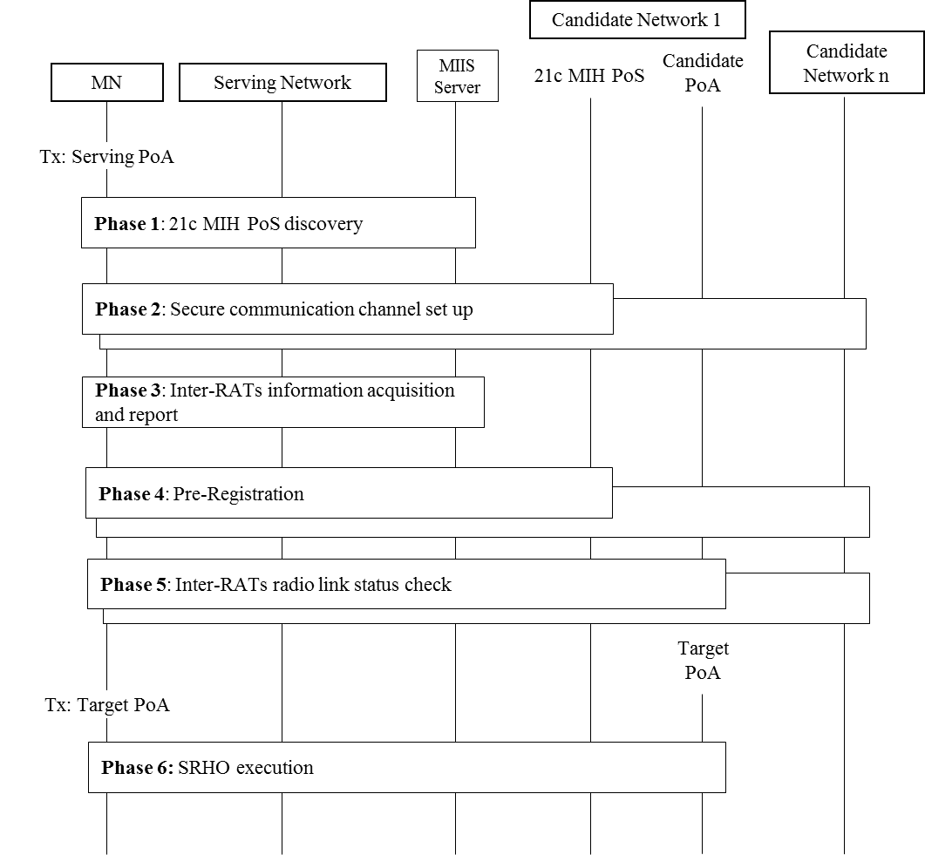
Figure x – Overall Single Radio Handover Procedures

Phase 1 is to discover 21c MIH PoSs on the candidate networks. The 21c MIH PoS is a network entity enabling SRHO services to a MN. In this phase, a MN recognizes if candidate networks supports SRHO or DRHO. If some candidate network supports SRHO, the MN tries to detect the presence of a 21c MIH PoS on the candidate network. MIIS provides information to discover the SRHO capability and detect the presence of the 21c MIH PoS.
Phase 2 is to set up a communication channel between the MN and discovered 21c MIH PoSs. Phase 2 ensures a secure communication channel to be used for pre-registration. MIIS provides information about secure protocols and mechanisms used for establishing the secure communication channels between MN and 21c MIH PoSs.
Phase 3 is the Inter-RATs information acquisition and report phase. In this phase, the MN acquires the information to find out the existence of candidate PoAs in the vicinity of its current location and corresponding SIBs of candidate PoAs to perform the radio measurements. Pull mode or push mode of MIIS can be used to convey such information.
Phase 4 is the Pre-Registration phase. Phase 4 allows the MN to perform a registration to 21c MIH PoSs on the candidate networks via the secure communication channels established in Phase 2. By helping of the 21c MIH PoSs, MN can perform network entry procedures toward the candidate networks while retaining its data connection with the serving network. MIH protocol encapsulates and delivers media specific messages that are exchanged for the network entry.
Phase 5 is to check Inter-RATs radio link status. In this phase, the MN checks link status of a serving PoA and all available candidate PoAs to see whether the handover toward the pre-registered candidate network is required at that point of time. With the result of checking link status, MN selects a Target PoA.
Phase 6 is the SRHO execution phase. In this phase, MN switches its transmission mode from serving PoA to the target PoA selected in Phase 5 and then tries to connect to the target PoA over the air. Context transfer could occur between the 21c MIH PoS and the target PoA to expedite the handover process.

WiMAX - WiFi single radio handover model and procedure
[Note]
- specialize the generalized model to WiMAX-WLAN model

WiMAX – 3GPP single radio handover requirements
The general single radio handover requirements and configurations as described in Sections 9.1 to 9.3 apply here. The following are specific requirements for the WiMAX – 3GPP single radio handover.
The communication between the WiMAX network and the 3GPP network is through the interface R9, which is defined in the WiMAX interworking document (add document name here) by WiMAX Forum. This interface is used to transport MIH messages.
The information for network availability resides in ANDSF, which is defined in 3GPP (add document number here)
The information needed to decide whether to handover from WiMAX network to 3GPP network is provided by the 3GPP network to the ANDSF, and the WiMAX network may access the information at this ANDSF via the R9 interface. [Note] This part needs to be checked.
The information needed to decide whether to handover from 3GPP network to WiMAX network is provided by the WiMAX network to the ANDSF, and the 3GPP network may access the information at this ANDSF via the R9 interface. . [Note] This part needs to be checked.
When performing handover from a WiMAX network to a 3GPP network, preauthentication by the 3GPP network may go through the R9 interface while the device is still connected to the WiMAX network. The 3GPP user profile and subscription information is stored in the HSS+, which contains the user information needed to authenticate the user. The usually authentication process when a mobile device attached to a 3GPP network applies, except that the messages are transported via the WiMAX interface and the R9 interface to the 3GPP network. Other desired handover preparation process may also proceed by exchanging messages through this interface.
When performing handover from a 3GPP network to a WiMAX network, preauthentication by the WiMAX network may go through the R9 interface while the device is still connected to the 3GPP network. Other desired handover preparation process may also proceed by exchanging messages through this interface.

SRHO Messages
Although the L2 radio interfaces differ between any two different networks, it is possible to define generic signaling messages which are the same for different radio interfaces. These signaling messages are media independent messages. Media independent handover may be accomplished using the media independent L2 handover messages or using L3 handover messages,
There are following types of the media independent handover signaling messages:
Media independent handover messages that utilize the MIH frame to deliver Inter-RAT information in an uniform manner. (detail format need to be defined)
Media independent handover messages that used for pre-registration. (detail format need to be defined)
Media independent handover messages that used for Inter-RATs radio link check (detail format need to be defined)
Media independent handover messages that used for SRHO execution (detail format need to be defined)

