Project | IEEE 802.21 Media Independent Handover Services  IEEE 802.21a: Security  <http://www.ieee802.org/21/>
Title | Text of the option A of work item I: Proactive Authentication Through EAP (MSA is the authenticator)
Date Submitted | July 28, 2010
Source(s) | Dapeng Liu (China Mobile)
Re: | IEEE 802.21a
Abstract | This document is used for down-selection discussion in July meeting for option A of work item I.
Purpose | Task Group Discussion
Notice | This document has been prepared to assist the IEEE 802.21 Working Group. It is offered as a basis for discussion and is not binding on the contributing individual(s) or organization(s). The material in this document is subject to change in form and content after further study. The contributor(s) reserve(s) the right to add, amend or withdraw material contained herein.
Release | The contributor grants a free, irrevocable license to the IEEE to incorporate material contained in this contribution, and any modifications thereof, in the creation of an IEEE Standards publication; to copyright in the IEEE’s name any IEEE Standards publication even though it may include portions of this contribution; and at the IEEE’s sole discretion to permit others to reproduce in whole or in part the resulting IEEE Standards publication. The contributor also acknowledges and accepts that this contribution may be made public by IEEE 802.21.
Patent Policy | The contributor is familiar with IEEE patent policy, as outlined in Section 6.3 of the IEEE-SA Standards Board Operations Manual <http://standards.ieee.org/guides/opman/sect6.html#6.3> and in Understanding Patent Issues During IEEE Standards Development <http://standards.ieee.org/board/pat/guide.html>.

Introduction

Scope:
The scope of this document is to give detail text description of the option A of work item I in the summary of the current proposals in IEEE802.21a (21-10-0049-03-0sec-proposal-summary). The purpose of this proposal is for down-selection in July meeting.

Purpose:
The purpose of this document is for the task group discussion regarding to the option A of work item I (Proactive authentication through EAP; MSA is the authenticator).

Terminologies
EAP: Extensible Authentication Protocol
ERP : EAP Re-Authentication Protocol
SA : Serving Authenticator
CA : Candidate Authenticator

Definitions
Authentication Process: The cryptographic operations and supporting data frames that perform the authentication
Proactive Authentication: An authentication process that is performed between MIA-KH and other entities attached to the other end of a link of a MSA-KH. This process occurs when the other entities intend to perform a handover to another link.
MIH Assisted Proactive Authentication: MIH (Media Independent Handover Service) could be used to assist proactive authentication. For example, MIH PoS may help to forward the proactive authentication message to the corresponding media specific authenticator. MIH could be used for candidate media specific authenticator discovery, etc. MIH Assisted Proactive Authentication means the procedure that using MIH service to assist the performance of proactive authentication.
Media Specific Authenticator and Key Holder (MSA-KH): Media specific authenticator and key holder is an entity that facilitates authentication of other entities attached to the other end a link specific to a media.

MIH Security Association (SA): An MIH SA is the security association between the peer MIH entities
Media AS: Authentication server of the specific media

References
[IEEE802.21] IEEE P802.21 Std-2008, IEEE Standard for Local and Metropolitan Area Networks- Part 21: Media Independent Handover Services.

Architecture overview

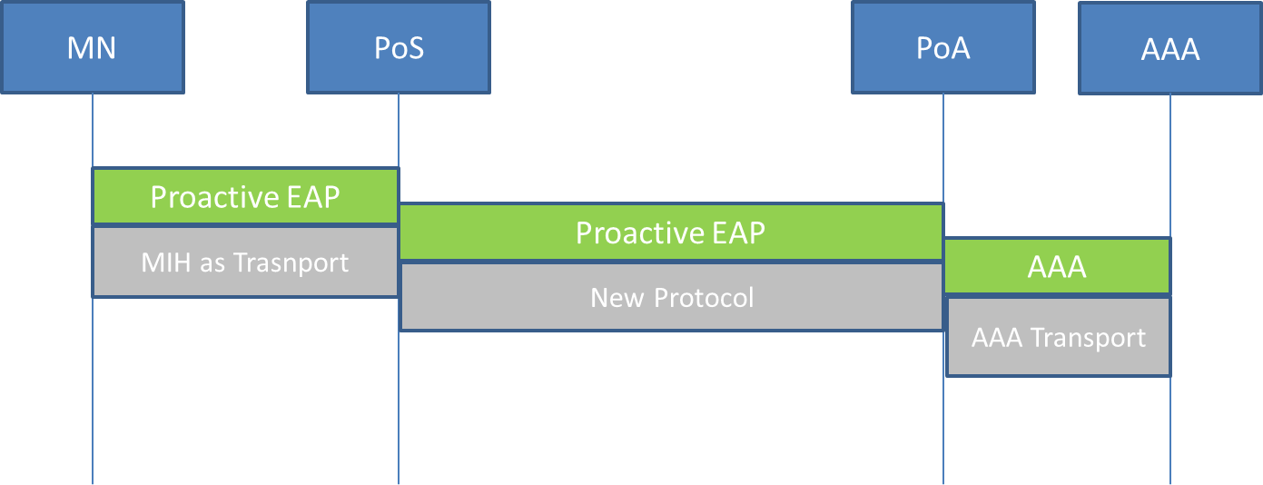

Figure 1 Architecture of MIH Assisted Proactive EAP Authentication

Figure 1 illustrates the architecture of MIH assisted proactive EAP authentication. There are mainly four entities in the architecture:
MN: The Mobile Node is assumed to have MIH function.
PoS: PoS is the IEEE 802.21 point of service which provides MIH function and service. This document intends to extend the current IEEE 802.21 base specification to provide assistant for proactive authentication during handover. The purpose of proactive authentication is to reduce the authentication delay during handover.
There are two classes of proactive authentication: proactive authentication and EAP re-authentication (ERP). There are two forms to preform proactive authentication: direct and indirect mode.
The PoS could provide assistants for the proactive authentication. Such as: deliver proactive authentication message to the media specific candidate authenticator; help to perform candidate media specific authenticator discovery etc.
PoA: this is the candidate media specific authenticator that the MN may handover to after handover execution.
AAA: this is the EAP authentication server.

Function description and procedures

MN function description
The MN is assumed having MIH function. The MIHF also need to be extended to support proactive authentication signaling. The proactive authentication signaling is carried using extended MIH protocol which is running between MN and enhanced PoS.
The MN need to support the function of candidate media specific authenticator discovery.

Enhanced PoS function description
The function of enhanced PoS is composed by the following:
- Receive MIH message which carries proactive EAP authentication frames from MN.
- Decapsulate the MIH message that carries the proactive authentication frames then forward the EAP frames to the candidate media specific authenticator. The protocol that used to carry EAP proactive authentication frames between PoS and media specific authenticator need to be further specified.

Procedures of MIH assisted proactive authentication
The procedure of MIH assistant proactive authentication is consisted of the following steps:
1. POS and Candidate Media Specific Authenticator Discovery
Before MN initiates MIH assisted proactive authentication, MN needs to know the PoS’s address and the candidate media specific authenticator’s MAC addresses. The discovery of PoS’s address has already been specified by IEEE 21 base specification. The discovery of corresponding media specific candidate authenticator’s address could be done by using extended IEEE802.21 information service.
- Perform of Proactive EAP authentication
The proactive EAP authentication or ERP message could be encapsulated in to the extended MIH messages as L2 frames. When the PoS receives the encapsulated MIH message, it decapsulates it, then forwards the EAP message to the media specific candidate authenticator. The EAP message could be encoded as OCTET_STRING, the PoS needs not to implement EAP protocol; It may simply forwards the EAP messages to the media specific authenticator.
After successful proactive EAP authentication, the MN and AS derives the related keying material and candidate media specific authenticator can get the keying material from the AS using AAA protocol. The packet format of the MIH assisted EAP proactive authentication is depicted in figure 3.
- Security association
When the MN decide to handover to the candidate network, the MN and candidate media specific authenticator perform security association based on the keying material derived by the proactive EAP authentication. For example, this could be 4-way handshake in 802.11i.
MN
PoS
PoA
AS
Information Server
- Candidate authenticator discovery
2. MN or network initiates proactive EAP authentication
3. Security association

Figure 2 Procedure of MIH assisted proactive EAP authentication

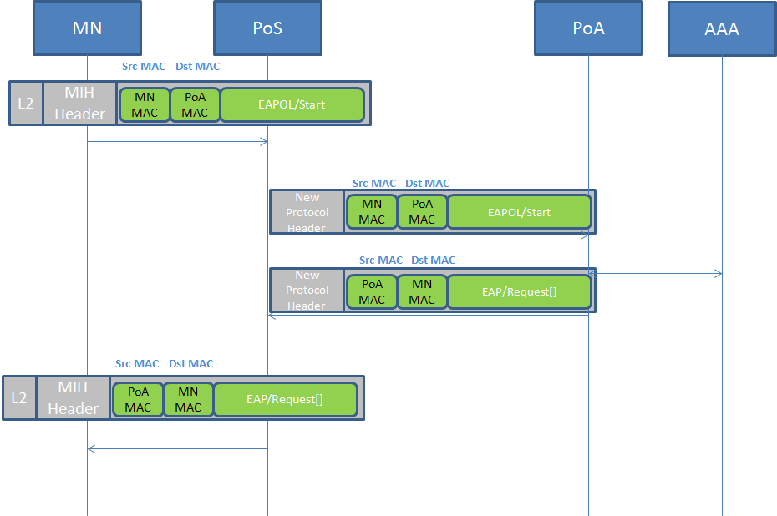
Figure 3 Proactive EAP authentication packet format

Extensions of IEEE802.21 Specification

4.1 Extension used for candidate media specific authenticator discovery
There are two possible ways proposed for media specific authenticator discovery:
- Extending Command Service

MIH_Net_HO_Candidate_Query and MIH_MN_HO_Candidate_Query command are extended for candidate media specific authenticator discover.

When the UE or network prepares for handover, it may use the MIH_Net_HO_Candidate_Query or MIH_MN_HO_Candidate_Query to get the candidate network information. This command is proposed to extend to return candidate media specific authenticator’s information, such as media specific candidate authenticator’s IP address and L2 address.

MIH command | (L)ocal,  (R)emote | Comments | Defined in
MIH_Net_HO_Candidate_Query | R | Network initiates handover and sends a list of suggested networks and associated points of attachment and also includes the media specific candidate authenticator information in the candidate networks. | 7.4.17
MIH_MN_HO_Candidate_Query | R | Command used by MN to query and obtain handover related information about possible candidate networks and the candidate media specific authenticators’ information in the candidate networks. | 7.4.18

1. Detail extension of MIH_MN_HO_Candidate_Query:

MIH_MN_HO_Candidate_Query.request

Function: (section 7.4.18.1)
This primitive is used by MIH users on an MN to inform MIHF to query candidates for possible handover initiation. The request includes queries on QoS resources and/or whether IP address configuration method of the ongoing data sessions can be supported in the candidate network. This primitive also includes the current IP configuration server address (e.g., DHCP server, foreign agent(FA) IP address, AR IP address) when the current IP configuration method is included. This primitive also include flag that indicates whether the MIH user is expecting the response message should include candidate authenticator’s address information.
Semantics of service primitive (section 7.4.18.1.2)

MIH_MN_HO_Candidate_Query.request(
DestinationIdentifier,
SourceLinkIdentifier,
CandidateLinkList,
QoSResourceRequirments,
IPConfigurationMethods,
FA Address,
AccessRouterAddress，
PreAuthenticationFlg
)

Parameters:
Name | Data type | Description
DestinationIdentifier, | MIHF_ID | This identifies a remote MIHF that will be the destination of this request
SourceLinkIdentifier | LINK_TUPLE_ID | This identifies the source link for handover
CandidateLinkList | LIST(LINK_POA_LIST)
QoSResourceRequirments, | QOS_LIST
IPConfigurationMethod | IP_CFG_METHDS
DHCPServerAddress | IP_ADDR
FAAddress | IP_ADDR
AccessRouterAddress | IP_ADDR
PreAuthenticationFlg | BOOLEAN | This flag indicates whether the MIH user expects the response message include candidate authenticator’s address information

When generated (section 7.4.18.1.3)

This primitive is generated by an MIH User in the MN that wants to query other candidate networks for a possible handover. MN uses the QueryResourceList parameter to notify the serving PoS of the minimal resource requirement at the candidate networks in order for the handover to be successful. An MIH User on MN generates this primitive when it wants to query IP address related information from the candidate networks before handover. An MIH user on MN may include PreAuthenticationFlg parameter when it wants to query the candidate authenticator’s address information.

Effect on receipt (section 7.4.18.1.4)

Upon receipt of this primitive, the local MIHF generates and sends an MIH_MN_HO_Candidate_Query request message to the remote MIHF identified by the Destination Identifier.

Detail extension of MIH_MN_HO_Candidate_Query.indication (section 7.4.18.2)
Function: (section 7.4.18.2.1)
This primitive is used by MIHF to indicate the receipt of MIH_MN_HO_Candidate_Query request message from an MN.

Semantics of service primitive (section 7.4.18.2.2)
MIH_MN_HO_Candidate_Query.indication(
DestinationIdentifier,
SourceLinkIdentifier,
CandidateLinkList,
QoSResourceRequirments,
IPConfigurationMethods,
FA Address,
AccessRouterAddress，
PreAuthenticationFlg
)

Name | Data type | Description
DestinationIdentifier, | MIHF_ID | This identifies a remote MIHF that will be the destination of this request
SourceLinkIdentifier | LINK_TUPLE_ID | This identifies the source link for handover
CandidateLinkList | LIST(LINK_POA_LIST)
QoSResourceRequirments, | QOS_LIST
IPConfigurationMethod | IP_CFG_METHDS
DHCPServerAddress | IP_ADDR
FAAddress | IP_ADDR
AccessRouterAddress | IP_ADDR
PreAuthenticationFlg | BOOLEAN | This flag indicates whether the MIH user expects the response message include candidate authenticator’s address information

When generated (section 7.4.18.2.3)
This primitive is generatged by MIHF on receiving MIH_MN_HO_Candidate_Query request message from a peer MIHF in an MN.

Effect on receipt (section 7.4.18.2.4)
The MIH User invokes MIH_N2N_HO_Query_Resoures.request primitive to exchange MIH_N2N_HO_Query_Resource messages with MIHF in one or more candidate networks under consideration before invoking the MIH_MN_HO_Candidate_Query.response primitive.

Detail extension of MIH_MN_HO_Candidate_Query.response (section 7.4.18.3)
Function: (section 7.4.18.3.1)
This primitive is used by MIH Users to inform MIHF of the result of the candidate query request.

Semantics of service primitive (section 7.4.18.3.2)

MIH_MN_HO_Candidate_Query.response(
DestinationIdentifier,
Status,
SourceLinkIdentifier,
PreferedCandidateLinkList,
PreferedCandidateAuthenticator
)

Name | Data type | Description
DestinationIdentifier | MIHF_ID
Status | STATUS
PreferredCandidateLinkList | LIST(RQ_RESULT)
PreferedCandidateAuthenticator | LINK_ADDR | Candidate authenticator’s link layer address

When generated (section 7.4.18.3.3)

The MIH User invokes this primitive in response to an MIH_MN_HO_Candidate_Query request message from a peer MIHF entity in MN and possibly after the exchange of MIH_N2N_HO_Query_Resources messages with the MIHF in the candidate networks.

Effect on receipt (section 7.4.18.3.4)

Upon receipt of this primitive MIHF sends a response message to the destination.

Detail extension of MIH_MN_HO_Candidate_Query.confirm (section 7.4.18.4)

Function (section 7.4.18.4.1)
This primitive is used by MIHF to inform MIH users of the receipt of candidate query and IP address related information response.

Semantics of Service primitive (section 7.4.18.4.2)

MIH_MN_HO_Candidate_Query.confirm(
SourceIdentifier,
Status,
SourceLinkIdentifier,
PreferedCandidateLinkList,
PreferedCandidateAuthenticator
)

Name | Data type | Description
DestinationIdentifier | MIHF_ID
Status | STATUS
PreferredCandidateLinkList | LIST(RQ_RESULT)
PreferedCandidateAuthenticator | LINK_ADDR | Candidate authenticator’s link layer address

When generated (section 7.4.18.4.3)

This primitive is generated by MIHF on receiving MIH_MN_HO_Candidate_Query response message from a peer MIHF in the network.

Effect on receipt (section 7.4.18.3.4)

On receiveing the primitive the MIH User entity that originally initiated the candidate query request can decide to choose the candidate network for handove or abort it based on the list of PoA, avilable resoures, and the IP address related information. The MIH User can also initiate pre-active authentication use the candidate authenticator’s address.Howerver, if Statues does not indicate ‘Success’, the recipient ignores any other returned values and, instead, performs appropriate error handling.

- Detail extension of MIH_Net_HO_Candidate_Query:

MIH_Net_HO_Candidate_Query.request

Function: (section 7.4.17.2.1)

The primitive is invoked by an MIH User on a network node to communicate to a peer MIH User about its intent of handover initiation.

Semantics of service primitive (7.4.17.2.2)

MIH_Net_Ho_Candidate_Query.request(
DestinationIdentifier,
SuggestedNewLinkList,
SuggestedNewLinkCandidateAuthenticatorList,
QueryResourceReportFlag
)

Parameters :
Name | Data type | Description
DestinationIdentifier | MIHF_ID
SuggestedNewLinkList | STATUS
SuggestedNewLinkCandidateAuthenticatorList, | LIST(LINK_ADDR) | Candidate authenticator’s address information
QueryResourceReportFlag | BOOLEAN

When generated (7.4.17.2.3)

This primitive is invoked by an MIH User to communicate with a remote MIH User about its intent of handover initiation. Serving PoS requests MN to provide information about resources required to initiate a handover by setting the QueryResourceReportFlag parameter.

Effect on receipt (7.4.17.2.4)

Upon receipt of this primitive, the local MIHF generates and sends an MIH_Net_HO_Candidate_Query request message to the remote MIHF identified by the Destination Identifier. The remote MIHF forwards the request as an indication to the MIH User.

Detail extension of MIH_Net_HO_Candidate_Query.indication:
Function (7.4.17.3.1)

This primitive is used by an MIHF to indicate to an MIH User that an MIH_Net_HO_Candidate_request message was received from a remote MIHF.
Semantics of service primitive (7.4.17.3.2)

MIH_Net_Ho_Candidate_Query.indication(
DestinationIdentifier,
SuggestedNewLinkList,
SuggestedNewLinkCandidateAuthenticatorList,
QueryResourceReportFlag
)

Parameters :
Name | Data type | Description
DestinationIdentifier | MIHF_ID
SuggestedNewLinkList | STATUS
SuggestedNewLinkCandidateAuthenticatorList, | LIST(LINK_ADDR) | Candidate authenticator’s address information
QueryResourceReportFlag | BOOLEAN

When generated (7.4.17.3.3)

This primitive is generated by an MIHF on receiving an MIH_Net_HO_Candidate_Query request message from a peer MIHF.

Effect on receipt (7.4.17.3.4)

An MIH User receiving this indication shall invoke an MIH_Net_HO_Candidate_Query.response primitive towards the remote MIHF indicated by the Source Identifier in the request message.

Detail extension of MIH_Net_HO_Candidate_Query.response:
Function (7.4.17.4.1)

This primitive is used by the MIHF on an MN to respond to an MIH_Net_HO_Candidate_Query request message from a remote MIHF in the network.

Semantics of service primitive (7.4.17.4.2)

MIH_Net_HO_Candidate_Query.reponse(
DestinationIdentifier,
Status,
SourceLinkIdentifier,
HandoverStatus,
PerferredLinkList,
PreferedCandidateAuthenticator,
)
Name | Data type | Description
DestinationIdentifier,
Status,
SourceLinkIdentifier,
HandoverStatus,
PerferredLinkList,
PreferedCandidateAuthenticator, | LINK_ADDR | Preferred candidate authenticator’s address

When generated (7.4.17.4.3)

The remote MIH User invokes this primitive in response to an MIH_Net_HO_Candidate_Query.indication from its MIHF.

Effect on receipt (7.4.17.4.4)

The MIHF sends an MIH_Net_HO_Candidate_Query response message to the peer MIHF as indicated in the Destination Identifier.

MIH_Net_HO_Candidate_Query.confirm (7.4.17.5)

Function (7.4.17.5.1)

This primitive is used by the MIHF to confirm that an MIH_Net_HO_Candidate_Query response message was received from a peer MIHF.

Semantics of service primitive (7.4.17.5.2)

MIH_Net_HO_Candidate_Query.confirm(
DestinationIdentifier,
Status,
SourceLinkIdentifier,
HandoverStatus,
PerferredLinkList,
PreferedCandidateAuthenticator,
)

Name | Data type | Description
DestinationIdentifier,
Status,
SourceLinkIdentifier,
HandoverStatus,
PerferredLinkList,
PreferedCandidateAuthenticator, | LINK_ADDR | Preferred candidate authenticator’s address

When generated (7.4.17.5.3)

This primitive is generated by the MIHF on receiving an MIH_Net_HO_Candidate_Query response message from a peer MIHF.

Effect on receipt (7.4.17.5.4)

On receiving the primitive the entity that originally initiated the handover request decides to carry out the handover or abort it based on the primitive. However, if Status does not indicate “Success”, the recipient ignores any other returned values and, instead, performs appropriate error handling.

- Extending Information Service

The candidate media specific authenticator information could be provided by MIH information service. The following extensions are proposed for the information service to provide candidate media specific authenticator discovery.

The following Information element is extended to provide candidate media specific authenticator information.

Name of information element | Description | Data type
Access network specific information elements
IE_SEC_OPEN_AUTH | Whether the security policy allows open authentication. | BOOLEAN
IE_SEC_PASSWORD | Whether the security policy allows password based authentication. | TBD
IE_SEC_CA | Certificate authority ID | TBD
PoA Specific Information Elements
IE_POA_AUTHENTICATOR_ADDR | The L2 address of the authenticator which serves the PoA. | LINK_ADDR
IE_POA_AUTHENTICATOR_METHOD_INFO | The supported proactive authentication method information of the authenticator which serves the PoA. | SYSTEM_INFO
IE_SEC_AUTH_PROTOCOL | Which authentication protocol is supported for access authentication | TBD
IE_SEC_EAP_REAUTH | Whether to support re-authentication | BOOLEAN
IE_SEC_EAP_PREAUTH | Whether to support pre-authentication | BOOLEAN
PoA Specific Higher Layer Service Information Elements
IE_POA_AUTHENTICATOR_IP_ADDR | The IP address of the authenticator which serves the PoA. | IP_ADDR
IE_PoA_PoS_IP_ADDR | PoS’s IP address; this PoS is the serving PoS of the PoA | IP_ADDR
IE_SEC_MOBIKE | Whether to support MOBIKE | BOOLEAN

4.2 Extensions used for carry EAP proactive authentication frames

4.2.1 MIH Command Extension

Following table describes the MIH commands.
MIH Commands | MIH Command type | Description
MIH_Pro_Auth_Start | Remote | Starting Proactive authentication
MIH_Pro_Auth _Request | Remote | Carry proactive EAP signaling as L2 frame
MIH_Pro_Auth _Response | Remote | Carry proactive EAP signaling as L2 frame

Definition of newly defined MIH primitives:

- MIH_Pro_Auth_Start

General description: MIH_Pro_Auth_Start is used to carry pro-active authentication EAP_Start message. MIH users in MN or PoS use this primitive encapsulate the EAP-Start message as layer 2 frames.

1.1 MIH_Pro_Auth_Start.request

Function
This primitive is used by an MIH User to encapsulate pro-active EAP_Start message.

Semantics of service primitive

MIH_Pro_Auth_Start.request (
DestinationIdentifier,
Pro_Auth_Start_Message
)

Parameters:

Name | Data type | Description
DestinationIdentifier | MIHF_ID | This identifies the local MIHF or a remote MIHF that will be the destination of this request.
Pro_Auth_Start_Message | OCTET_STRING | This parameter is used to encapsulate pro-active EAP_Start message.

When generated

The MIH user that wants to initiate practice EAP authentication uses this primitive to encapsulate the proactive EAP_Start message.

Effect on receipt

When the MIHF receives this message, it will de-capsulate it, get the EAP_Start message from this message for further processing.

1.2 MIH_Pro_Auth_Start.indication

Function

This primitive is used by an MIHF to indicate to an MIH User that an MIH_Pro_Auth_Start.request message was received from a remote MIHF.

Semantics of service primitive

MIH_Pro_Auth_Start.request (
SourceIdentifier,
Pro_Auth_Start_Message
)

Parameters:

Name | Data type | Description
SourceIdentifier, | MIHF_ID | This identifies the invoker of this primitive, which is  a remote MIHF.
Pro_Auth_Start_Message | OCTET_STRING | This parameter is used to encapsulate pro-active EAP_Start message.

When generated
This primitive is generated by an MIHF on receiving an MIH_Pro_Auth_Start.request message
from a peer MIHF.

Effect on receipt

An MIH User receiving this indication shall invoke an MIH_Pro_Auth_Request primitive towards the remote MIHF indicated by the Source Identifier in the request message.

- MIH_Pro_Auth_Request
General description: MIH_Pro_Auth_Request is used to carry pro-active authentication EAP-Request message. MIH users in MN or PoS use this primitive encapsulate the EAP-Request message as layer 2 frames.
2.1 MIH_Pro_Auth_Request.request

Function
This primitive is used by an MIH User to encapsulate pro-active EAP-Request message.

Semantics of service primitive

MIH_Pro_Auth_Request.request (
DestinationIdentifier,
Pro_Auth_Request_Message
)

Parameters:

Name | Data type | Description
DestinationIdentifier | MIHF_ID | This identifies the local MIHF or a remote MIHF that will be the destination of this request.
Pro_Auth_Request_Message | OCTET_STRING | This parameter is used to encapsulate pro-active EAP-Request message.

When generated

The MIH user that wants to send proactive EAP-Request message uses this primitive to encapsulate the proactive EAP-Request message.

Effect on receipt

When the MIHF receives this message, it will de-capsulate it, get the EAP-Request message from this message for further processing.

2.2 MIH_Pro_Auth_ Request.indication

Function

This primitive is used by an MIHF to indicate to an MIH User that an MIH_Pro_Request.request message was received from a remote MIHF.

Semantics of service primitive

MIH_Pro_Auth_Request.indication (
SourceIdentifier,
Pro_Auth_Request_Message
)

Parameters:

Name | Data type | Description
SourceIdentifier, | MIHF_ID | This identifies the invoker of this primitive, which is  a remote MIHF.
Pro_Auth_Request_Message | OCTET_STRING | This parameter is used to encapsulate pro-active EAP-Request message.

When generated
This primitive is generated by an MIHF on receiving an MIH_Pro_Auth_Request.request message from a peer MIHF.

Effect on receipt

An MIH User receiving this indication shall invoke an MIH_Pro_Auth_Response primitive towards the remote MIHF indicated by the Source Identifier in the request message.

- MIH_Pro_Auth_Response

General description: MIH_Pro_Auth_Response is used to carry pro-active authentication EAP-Response message. MIH users in MN or PoS use this primitive encapsulate the EAP-Response message as layer 2 frames.

3.1 MIH_Pro_Auth_Response.request

Function
This primitive is used by an MIH User to encapsulate pro-active EAP-Response message.

Semantics of service primitive

MIH_Pro_Auth_Response.request (
DestinationIdentifier,
Pro_Auth_Response_Message
)

Parameters:

Name | Data type | Description
DestinationIdentifier | MIHF_ID | This identifies the local MIHF or a remote MIHF that will be the destination of this request.
Pro_Auth_Response_Message | OCTET_STRING | This parameter is used to encapsulate pro-active EAP-Response message.

When generated

The MIH user that wants to send proactive EAP-Response message uses this primitive to encapsulate the proactive EAP-Response message.

Effect on receipt

When the MIHF receives this message, it will de-capsulate it, get the EAP-Response message from this message for further processing.

2.2 MIH_Pro_Auth_Response.indication

Function

This primitive is used by an MIHF to indicate to an MIH User that an MIH_Pro_Response.request message was received from a remote MIHF.

Semantics of service primitive

MIH_Pro_Auth_Response.indication (
SourceIdentifier,
Pro_Auth_Response_Message
)

Parameters:

Name | Data type | Description
SourceIdentifier, | MIHF_ID | This identifies the invoker of this primitive, which is  a remote MIHF.
Pro_Auth_Response_Message | OCTET_STRING | This parameter is used to encapsulate pro-active EAP-Response message.

When generated
This primitive is generated by an MIHF on receiving a MIH_Pro_Auth_Response.request message from a peer MIHF.

Effect on receipt

An MIH User receiving this indication was notified that a Pro_Auth_Response.request message was successfully received by the MIHF.

4.2.2 MIH Protocol Extension
- New MIH message is proposed to carry the EAP message over MIH.
MIH New Message Types
Message name | Action ID
MIH_Pro_Auth_Start | TBD
MIH_Pro_auth Request | TBD
MIH_Pro_auth Response | TBD

- MIH_Pro_Auth_Start
MIH Header Fields (SID=3, Opcode=3, AID-xx)
Source Identifier = sending MIHF ID
(Source MIHF ID TLV)
Destination Identifier = receiving MIHF ID
(Destination MIHF ID TLV)
Auth_Start TLV
- MIH_Pro_Auth Request
MIH Header Fields (SID=3, Opcode=1, AID-xx)
Source Identifier = sending MIHF ID
(Source MIHF ID TLV)
Destination Identifier = receiving MIHF ID
(Destination MIHF ID TLV)
Proactive EAP message Frame TLV
- MIH_Pro_Auth Response
MIH Header Fields (SID=3, Opcode=2, AID-xx)
Source Identifier = sending MIHF ID
(Source MIHF ID TLV)
Destination Identifier = receiving MIHF ID
(Destination MIHF ID TLV)
Proactive EAP message Frame TLV
- Encoding of proactive EAP message frame
The EAP message frame could be encoded as OCTET_STRING;

4.2.3 Protocol between PoS and PoA
New protocol need to be defined to carry EAP frame between PoS and PoA. Whether this protocol need to be specified in 21a’s scope and the details of this protocol need to be further studied.

