Project | IEEE 802.21 Media Independent Handover Services  IEEE 802.21a: Security  <http://www.ieee802.org/21/>
Title | Text of the option A of work item I: Proactive Authentication Through EAP (MSA is the authenticator)
Date Submitted | April 8, 2010
Source(s) | Dapeng Liu (China Mobile)
Re: | IEEE 802.21a
Abstract | This document describes the details of the option A of work item I of the proposal summary which discussed at IEEE802.21 2010 March meeting.
Purpose | Task Group Discussion
Notice | This document has been prepared to assist the IEEE 802.21 Working Group. It is offered as a basis for discussion and is not binding on the contributing individual(s) or organization(s). The material in this document is subject to change in form and content after further study. The contributor(s) reserve(s) the right to add, amend or withdraw material contained herein.
Release | The contributor grants a free, irrevocable license to the IEEE to incorporate material contained in this contribution, and any modifications thereof, in the creation of an IEEE Standards publication; to copyright in the IEEE’s name any IEEE Standards publication even though it may include portions of this contribution; and at the IEEE’s sole discretion to permit others to reproduce in whole or in part the resulting IEEE Standards publication. The contributor also acknowledges and accepts that this contribution may be made public by IEEE 802.21.
Patent Policy | The contributor is familiar with IEEE patent policy, as outlined in Section 6.3 of the IEEE-SA Standards Board Operations Manual <http://standards.ieee.org/guides/opman/sect6.html#6.3> and in Understanding Patent Issues During IEEE Standards Development <http://standards.ieee.org/board/pat/guide.html>.

Introduction

Scope:
The scope of this document is to give detail text description of the option A of work item I in the summary of the current proposals in IEEE802.21a (21-10-0049-03-0sec-proposal-summary).

Purpose:
The purpose of this document is for the task group discussion regarding to the option A of work item I (Proactive authentication through EAP; MSA is the authenticator).

Terminologies
EAP: Extensible Authentication Protocol
ERP : EAP Re-Authentication Protocol
SA : Serving Authenticator
CA : Candidate Authenticator

Definitions
Authentication Process : The cryptographic operations and supporting data frames that perform the authentication
Proactive Authentication : An authentication process that is performed between MIA-KH and other entities attached to the other end of a link of a MSA-KH. This process occurs when the other entities intend to perform a handover to another link.
Media Specific Authenticator and Key Holder (MSA-KH): Media specific authenticator and key holder is an entity that facilitates authentication of other entities attached to the other end a link specific to a media.

MIH Security Association (SA): An MIH SA is the security association between the peer MIH entities
Media AS: Authentication server of the specific media

References
[IEEE802.21] IEEE P802.21 Std-2008, IEEE Standard for Local and Metropolitan Area Networks- Part 21: Media Independent Handover Services.

Architecture overview

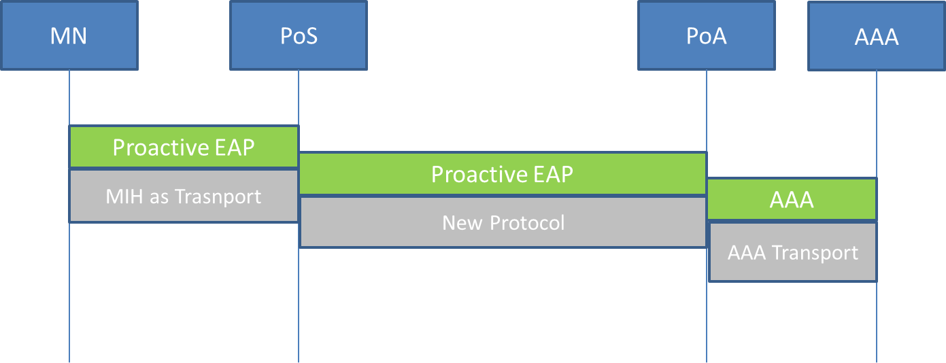

Figure 1 Architecture of Proactive EAP Authentication

Figure 1 illustrates the architecture of MIH assistant proactive EAP authentication. There are mainly four entities involved:
MN: The Mobile Node is assumed has MIH function.
PoS: PoS is the IEEE 802.21 point of service which provides MIH function. This document intends to extend the current IEEE 802.21 specification to provide assistant for proactive authentication during handover. The purpose of proactive authentication is to reduce the authentication delay during handover.
There are two classes of proactive authentication: proactive authentication and EAP re-authentication (ERP). There are two forms to preform proactive authentication: direct and indirect mode.
The PoS could provide assistant for the proactive authentication. Such as: deliver proactive authentication message to the candidate authenticator etc. PoS can also provide security protection of the proactive authentication signaling.
PoA: this is the candidate media specific authenticator that the MN may handover to later.
AAA: this is the EAP authentication server.

Function description and procedures

MN function description
The MN is assumed having MIH function. The MIHF also need to be extended to support proactive authentication signaling.
The proactive authentication signaling is carried using extended MIH protocol which is running between MN and enhanced PoS.

Enhanced PoS function description
The function of enhanced PoS is composed by the following:
- Receive MIH message which carries proactive EAP authentication frames from MN.
- Decapsulate the MIH message that carries the proactive authentication frames and forward the EAP frames to the candidate authenticator. The protocol that used to carry EAP proactive authentication frames is need further specified.

Procedures of MIH assistant proactive authentication
The procedure of MIH assistant proactive authentication is consisted of the following steps:
1. Candidate authenticator discovery
Before MN initiates proactive authentication, MN needs to know the candidate authenticator’s addresses. There could be done using extended IEEE802.21 information elements.
- Perform of Proactive EAP authentication
The proactive EAP authentication or ERP message could be encapsulated in to the extended MIH messages as L2 frames. When the PoS receives the encapsulated MIH message, it decapsulates it, then forwards the EAP message to the candidate authenticator. The EAP message could be encoded as OCTET_STRING, the PoS needs not to implement EAP protocol; it may simply forwards the EAP messages.
After successful proactive EAP authentication, the MN can AS derives the related keying material and candidate media specific authenticator can get the keying material from AS using AAA protocol. The packet format of EAP proactive authentication is depicted as figure 3.
- Security association
When the MN decide to handover to the candidate network, the MN and candidate media specific authenticator perform security association based on the keying material derived by the proactive EAP authentication. For example, this could be 4-way handshake in 802.11i.
MN
PoS
PoA
AS
Information Server
- Candidate authenticator discovery
2. MN or network initiates proactive EAP authentication
3. Security association

Figure 2 Procedure of proactive EAP authentication

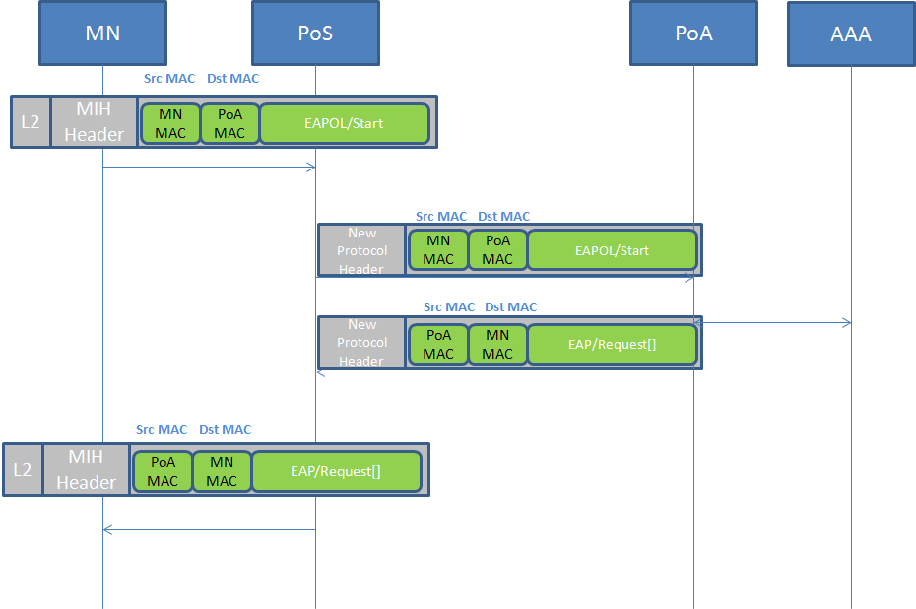
Figure 3 Proactive EAP authentication packet format

Extensions of IEEE802.21 Specification

4.1 Extension used for candidate authenticator discovery
The candidate authenticator information could be provided by MIH information server. The following extensions are needed of the information element to provide candidate authenticator information.

- Command extension for proactive EAP authentication
MIH_Net_HO_Candidate_Query and MIH_MN_HO_Candidate_Query command are extended for candidate authenticator discover. When the UE prepares for handover, it issues the MIH_Net_HO_Candidate_Query or MIH_MN_HO_Candidate_Query to get the candidate network information. These commands are extended to also return candidate authenticator’s information, such as candidate authenticator’s IP address and L2 address; supported authentication mode etc.

MIH command | (L)ocal,  (R)emote | Comments | Defined in
MIH_Net_HO_Candidate_Query | R | Network initiates handover and sends a list of suggested networks and associated points of attachment and also includes the candidate authenticator information in the candidate networks. | 7.4.17
MIH_MN_HO_Candidate_Query | R | Command used by MN to query and obtain handover related information about possible candidate networks and the candidate authenticators’ information in the candidate networks. | 7.4.18

- Information Element extension
The following Information element is extended to provide candidate authenticator information.

Name of information element | Description | Data type
Access network specific information elements
IE_SEC_OPEN_AUTH | Whether the security policy allows open authentication. | BOOLEAN
IE_SEC_PASSWORD | Whether the security policy allows password based authentication. | TBD
IE_SEC_CA | Certificate authority ID | TBD
PoA Specific Information Elements
IE_POA_AUTHENTICATOR_ADDR | The L2 address of the authenticator which serves the PoA. | LINK_ADDR
IE_POA_AUTHENTICATOR_METHOD_INFO | The supported proactive authentication method information of the authenticator which serves the PoA. | SYSTEM_INFO
IE_SEC_AUTH_PROTOCOL | Which authentication protocol is supported for access authentication | TBD
IE_SEC_EAP_REAUTH | Whether to support re-authentication | BOOLEAN
IE_SEC_EAP_PREAUTH | Whether to support pre-authentication | BOOLEAN
PoA Specific Higher Layer Service Information Elements
IE_POA_AUTHENTICATOR_IP_ADDR | The IP address of the authenticator which serves the PoA. | IP_ADDR
IE_SEC_MOBIKE | Whether to support MOBIKE | BOOLEAN

4.2 Extensions used for carry EAP proactive authentication frames

4.2.1 MIH Command Extension

Following table describes the MIH commands.
MIH Commands | MIH Command type | Description
MIH_Pro_Auth_Start | Remote | Starting Proactive authentication
MIH_Pro_Auth _Request | Remote | Carry proactive EAP signaling as L2 frame
MIH_Pro_Auth _Response | Remote | Carry proactive EAP signaling as L2 frame

4.2.2 MIH Protocol Extension
- New MIH message is proposed to carry the EAP message over MIH.
MIH New Message Types
Message name | Action ID
MIH_Pro_Auth_Start | TBD
MIH_Pro_auth Request | TBD
MIH_Pro_auth Response | TBD

- MIH_Pro_Auth_Start
MIH Header Fields (SID=3, Opcode=3, AID-xx)
Source Identifier = sending MIHF ID
(Source MIHF ID TLV)
Destination Identifier = receiving MIHF ID
(Destination MIHF ID TLV)
Auth_Start TLV
- MIH_Pro_Auth_Response
MIH Header Fields (SID=3, Opcode=1, AID-xx)
Source Identifier = sending MIHF ID
(Source MIHF ID TLV)
Destination Identifier = receiving MIHF ID
(Destination MIHF ID TLV)
Proactive EAP message Frame TLV
- MIH_Pro_Auth_Response
MIH Header Fields (SID=3, Opcode=2, AID-xx)
Source Identifier = sending MIHF ID
(Source MIHF ID TLV)
Destination Identifier = receiving MIHF ID
(Destination MIHF ID TLV)
Proactive EAP message Frame TLV
- Encoding of proactive EAP message frame
The EAP message frame could be encoded as OCTET_STRING

4.2.3 Protocol between PoS and PoA
New protocol need to be defined to carry EAP frame between PoS and PoA. Whether this protocol need to be specified in 21a’s scope and the details of this protocol need to be further studied.

