Project | IEEE 802.21a  <https://mentor.ieee.org/802.21>
Title | Option III: EAP to conduct service authentication and MIH packet protection
DCN | 21-10-0078-08-0sec
Date Submitted
Source(s) | Fernando Bernal-Hidalgo (University of Murcia), Rafael Marin-Lopez (University of Murcia)
Re:
Abstract | This document elaborates 21-10-0049-03-0Sec proposal: Proposal summary
Purpose | This document proposes a service authentication based on EAP and how this authentication could be used to protect the MIH protocol.
Notice | This document has been prepared to assist the IEEE 802.21 Working Group. It is offered as a basis for discussion and is not binding on the contributing individual(s) or organization(s). The material in this document is subject to change in form and content after further study. The contributor(s) reserve(s) the right to add, amend or withdraw material contained herein.
Release | The contributor grants a free, irrevocable license to the IEEE to incorporate material contained in this contribution, and any modifications thereof, in the creation of an IEEE Standards publication; to copyright in the IEEE’s name any IEEE Standards publication even though it may include portions of this contribution; and at the IEEE’s sole discretion to permit others to reproduce in whole or in part the resulting IEEE Standards publication. The contributor also acknowledges and accepts that IEEE 802.21 may make this contribution public.
Patent Policy | The contributor is familiar with IEEE patent policy, as stated in Section 6 of the IEEE-SA Standards Board bylaws <http://standards.ieee.org/guides/bylaws/sect6-7.html#6> and in Understanding Patent Issues During IEEE Standards Development http://standards.ieee.org/board/pat/faq.pdf

Introduction

Scope
The scope of this document is to describe the solution based on EAP proposed in 21-10-0049-03-0sec-proposal-summary. More concretely, working item #2 option III and bundle with working item #1.

Purpose
The purpose of this document is to describe the proposed approach for service authentication based on EAP and how this authentication could be used to protect the MIH protocol. Moreover, this proposal assists working item #1 in order to perform the key distribution mechanisms, the so-called bundle with working item #1. In particular, this document addresses the following functionalities:

Work Item # | Supported Functionality | Note
2 | Access Authentication | Yes
2 | MIH-Specific Authentication | Yes
2 | Key Hierarchy and Derivation | Yes
2 | MIH-Specific Protection | Yes
2 | Visited Domain Access | No*
Note*: Does not mention explicitly but the proposed approach may be applicable

Terminologies

EAP: Extensible Authentication Protocol
PoS: Point of Service
PoA: Point of Attachment
AS: Authentication Server
MN: Mobile Node
MIH PDU: MIH Packet Data Unit

Definitions

MIH Service Authentication : Authentication to enable MIH services provided by the PoS. It also allows to protect MIH signalling as a consequence of a successful authentication. In the context of 802.21a, the services provided by the PoS could be key distribution services for the bundle with working item #1.
PoS: acts as authenticator for the service authentication. Moreover, it is the entity that interacts with PoAs to facilitate key distribution services.
MIH Service AS: It is a backend authentication server for the MIH service authentication.
Candidate PoS: A PoS that is a potential target to the MN’s movement
Target PoS: A PoS that is the PoS selected for the MN’s movement
Serving PoS: A PoS that is the current PoS which provides access to the supported network services.
Candidate PoA: A PoA that is a potential target to the MN’s network attachment.
Target PoA: A PoA that is the PoA selected to perform a key distribution
Serving PoA: A PoA that is the current PoA where the MN is attached. Moreover, it provides network access to the MN.

References

[RFC 3748] H. Levkowetz, Ed. and et al, “Extensible Authentication Protocol (EAP)”
[RFC5247] B. Aboba, D. Simon and P. Enoren, “Extensible Authentication Protocol (EAP) Key Management Framework”
[RFC5246] T. Dierks and E. Rescorla, “The Transport Layer Security (TLS) Protocol Version 1.2”
[ProAuthMihSec] Subir Das, Ashutosh Dutta , Toshikazu Kodama, “Proactive Authentication and MIH security”, 21-09-0102-01-0Sec.
[RFC5191] D. Forsberg, Y. Ohba, B. Patil, H. Tschofenig and A. Yegin, “Protocol for Carrying Authentication for Network Access (PANA)”
[RFC5873] Y. Ohba, A. Yegin, “Pre-Authentication Support for the Protocol for Carrying Authentication for Network Access (PANA)”
[OPT2] Subir Das, Toshikazu Kodama, “Option II: use (D)TLS to protect MIH”, 21-09-0079-02-0Sec.
[IEEE802.21] IEEE Standard for local and metropolitan are networks. Part 21: Media Independent Handover Services.
[NIST-SP800-38C] Dworkin, M., "NIST Special Publication 800-38C: The CCM Mode for Authentication and Confidentiality", U.S. National Institute of Standards and Technology.

EAP for MIH Service Authentication (Option III)

The main aim of this section is to provide a description about how EAP can be used, in the scope of IEEE 802.21a work item #2, to allow the MN gains access to the MIH services provided by a PoS and protect the subsequent MIH messages. Two main objectives must be achieved. First one, to authenticate and authorize the MN against a MIH Service AS by using EAP. This allows to use the key material generated by the EAP authentication to protect the MIH signaling. Additionally, it is possible to securely access the available services provided by the PoS, such as key distribution services (bundle with work item #1). The Figure 1 shows the general process, where the MN acts as EAP peer, the PoS as EAP authenticator in pass-through mode and the MIH Service AS acts as EAP server.

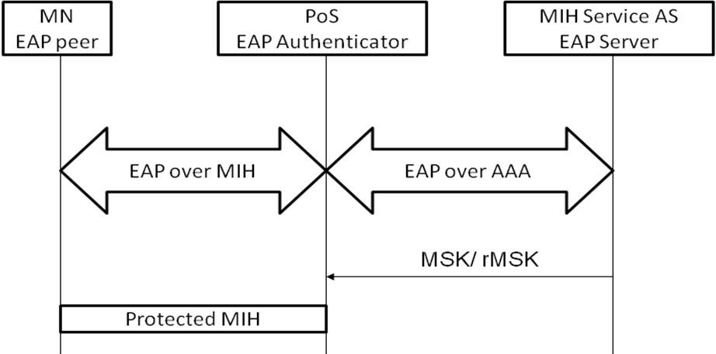
Figure 1 General process

Media Independent Authentication process

In this section we describe how the Media Independent Authentication by using EAP is performed. It is worth noting that MIH protocol is acting as a EAP lower layer so, EAP messages are going to be transported inside MIH messages. This extension is defined in this document.
Before providing any service to the MN, a media independent authentication must be performed in order to authenticate and authorize the credentials provided by the MN. Therefore, in order to achieve this objective, MN credentials and authentication servers (AS) are needed in the architecture. To clarify, Figure 2 depicts a general message flow needed to achieve a Media Independent Authentication based on EAP.
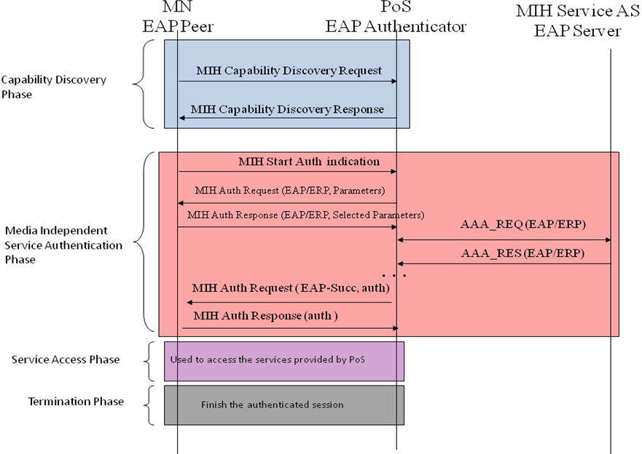
Figure 2 General message flow MN initiated
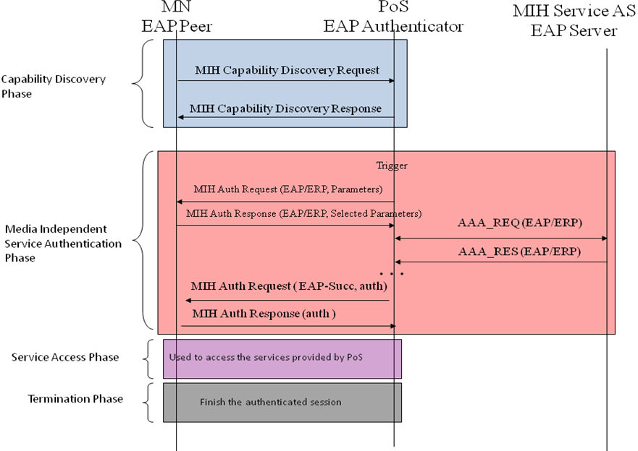
Figure 3 General message flow network initiated
We divide Media Independent Authentication in four phases, which are:
- Capability Discovery Phase. In this phase, both the MN and the PoS exchange unprotected MIH messages in order to obtain the services which can be selected by the MN. PoS provide a list of the available services and the MN is aware about the different capabilities provided by a certain PoS.
- Media Independent Service Authentication phase. Before to start the MN authentication, between the MN and the PoS a negotiation is performed in order to agree the ciphersuite to be used and others useful parameters. Once this negotiation is completed, the MN (acting as EAP peer) authenticates against a PoS (which is acting as EAP authenticator) using a MIH Service AS (acting as EAP server). To achieve this, EAP is transported by MIH protocol between the MN and the PoS which manages the MN authentication. In order to carry out the authentication, the PoS may need a backed authentication server (i.e. MIH Service AS such as an AAA server) to verify the MN’s credentials. It is assumed in this document, that the EAP method performed between the EAP peer and the EAP Server is able to export key material. Thus, after performing the authentication, key material (i.e. MSK) will be shared between the MN and the PoS. So, this key material is exported to both MN’s and PoS’ MIH lower-layer and it is available to protect the rest of the MIH signalling exchanged between the PoS and the MN (how to MIH is protected is explained in section 2.5). In order to protect the MIH signaling, the exported MSK is used as root key to derive new session keys which are use to protect the MIH packets. How this key hierarchy is derived is described in section 2.5. Note that, the authentication procedure could be based in ERP in order to perform a fast re-authentication procedure; in that case, an rMSK is used as root key to derive the key hierarchy and protect the MIH signaling.
- Service Access phase. At this point, the MN is authenticated and authorized to use the MIH services, agreed and provided by the PoS. The Media Independent Service Authentication phase is already completed and the MIH protocol is protected by using the key material obtained in the Media Independent Service Authentication Phase. This phase is related with section 2.4 for key derivation and section 2.5 for protecting MIH protocol.
- Termination phase. When the MN and the PoS desire to release resources and the MN’ state related with the provided services.

General architecture

In this section we describe the general architecture needed to use the key material generated by the EAP authentication by the MIH layer in order to provide MIH packet protection.
To be available to use the key material provided by EAP from a layer which wants protection, this layer must be act as EAP lower layer for the EAP protocol, as specified in RFC5247. Therefore, to be available to protect MIH packets, MIH acts as EAP lower-layer. So, we will refer to this as MIH lower-layer hereafter. In that sense, when the EAP authentication finishes, the key material (i.e. MSK) obtained through the EAP authentication is exported to the MIH lower layer and using this key material so that the MIH lower-layer can protect its packets.

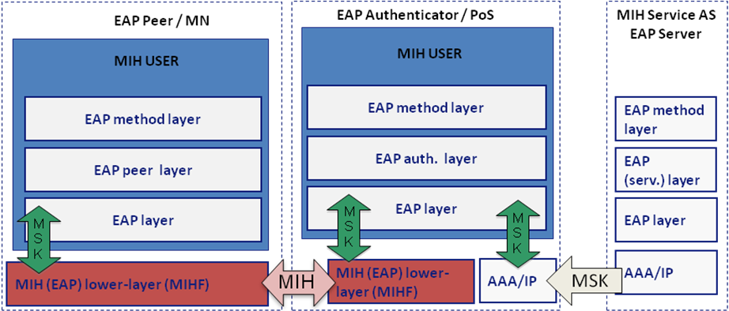
Figure 4 General architecture

CipherSuite

Confidentiality algorithms | Reference
ENCR_AES_CBC | NIST 800-38A
ENCR_NULL
Integrity algorithms | Reference
INTR_HMAC_SHA_96 | FIPS 180-1
INTR_CMAC_AES | NIST 800-38B
INTR_NULL
Confidentiality and Integrity algorithms | Reference
AUTH_ENC_AES_CCM | NIST 800-38C
KDF algorithms | Reference
PRF_CMAC_AES | NIST 800-108
PRF_HMAC_SHA1 | NIST 800-108

The ciphersuites are coded as follows:

Code | Integrity Algorithm | Encryption Algorithm | Length (bits)
00000000 | NULL | NULL | 0
00000001 | AES_CBC | NULL | 128
00000010 | AES_CBC | HMAC-SHA1-96 | 256
00000011 | AES_CBC | CMAC-AES | 256
00000100 | NULL | HMAC_SHA1-96 | 128
00000101 | NULL | CMAC_AES | 128
00000110 | AES_CCM |  | 128
A default cipher suite is needed in order to avoid mismatch between MN and PoS in terms of cipher suite.
AES_CCM needs counter generation function and a formatting function. Moreover, a NONCE generation is needed.These functions are defined in Appendix A of [NIST-SP800-38C] with the following parameters:
- The nonce length n is 12
- The tag length t is 16
- The value of q is 3

Information elements
The following information elements should be specified within the IE_CONTAINER_NETWORK within a new subcategory named PoS-specific information elements.
Name of information element | Description | Data type
IE_POS_KEY_DIST_INFO | Information about the key distribution mechanisms supported by the PoS | KEY_DIST_LIST
IE_POS_INTR_ALG_INFO | Information about the integrity algorithms supported by the PoS. | INT_ALG_LIST
IE_POS_ENCR_ALG_INFO | Information about the encryption algorithms supported by the PoS. | CIPH_ALG_LIST
IE_POS_KDF_INFO | Information about the key derivation functions supported by the PoS. | KDF_LIST

Key Hierarchy

To protect the MIH messages during Service Access Phase, a key hierarchy needs to be derived from the key material (i.e. MSK) exported during EAP/ERP authentication carried out during the Media Independent Service Authentication phase. The proposed hierarchy is showed in the Figure 4.
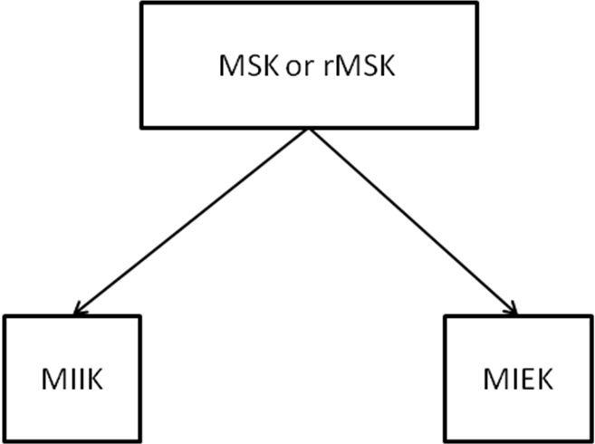
Figure 5 Key hierarchy proposed

Using the MSK or rMSK provided by the EAP authentication, as a root key, two keys are derived: MIIK (Media Independent Integrity Key), this key is used to provide integrity protection to the MIH protocol and MIEK (Media Independent Encryption Key), used to provide confidentiality to the MIH protocol. This key hierarchy has been based on the key hierarchy described in [ProAuthMihSec].
Note: it is assumed that the EAP method performed is available to export key material (MSK or rMSK).
How to generate the key hierarchy is described as follows:
Parameters:
- MSK or rMSK – master session key established through an EAP or EAP re-authentication. When the MSK or rMSK is 128 bits long, the PRF used for key derivation can be HMAC-SHA1, HMAC-SHA-256, or AES-CMAC. But if MSK is longer than 128 bits, then HMAC-SHA-1 or HMAC-SHA-256 shall be used as a PRF in key derivation.
- L – the length of keying material. L = |MIIK| + |MIEK|, that is, the sum of the binary length of MIIK and MIEK.
- h – The output length of the PRF used in key derivation.
  - For HMAC-SHA-1, h = 160
  - For HMAC-SHA-256, h = 256
  - For CMAC-AES, h = 128
- n = the number of iterations of PRF in order to generate L bit keying material

The key derivation for MIH session keys can be described by the following procedure:
Fixed values:
    - h - The length of the output of the PRF in bits, and
    - t - The length of the binary representation of the counter I and L. A default value of t is 32.
Input: K = MSK or rMSK, Nonce-P, Nonce-S, and L.
Process:
- n: = ⎡L/h⎤.
- If n > 2^{t}-1, then indicate an error and stop.
- result(0):= ∅
- For i = 1 to n, do
  - K(i) := PRF (K, “MISK” || [i]₂ || Nonce-P || Nonce-S || ciphersuite code || [L]₂)
  - result (i) := result(i-1) || K(i)
7. Return: MISK, i.e., the leftmost L bits of result(n).
Output: MISK.
The MISK is parsed in such a way that
MISK = MIIK || MIEK.

MIH Packet Protection

In this section we define how the MIH protocol messages are protected by using MIEK and MIIK. This is carried out in the Authenticated/Authorized Service Access Phase. Once Media Independent Service Authentication phase finishes with success, MIH lower-layer can access to key material, which is used to protect MIH messages. Specifically, using the MSK or rMSK as root key and using the key hierarchy defined in the previous section, the MIH protocol is protected by encrypting the MIH message using the MIEK and providing integrity protection uses MIIK. Whereas, encryption is optional, integrity protection is mandatory when MISK is available. Moreover, there are some algorithms which provide confidentiality and integrity (i.e. AUTH_ENC_AES_CCM); therefore, MIEK will be used as the key for performing these algorithms.
Four situations related with the protection of the MIH messages are possible in this document: Confidentiality and Integrity protection by using an encryption and an integrity algorithm, respectively; Confidentiality and Integrity protection by using a single algorithm which provides confidentiality and integrity; only integrity protection and no protection. Figure 5 summarizes these cases.
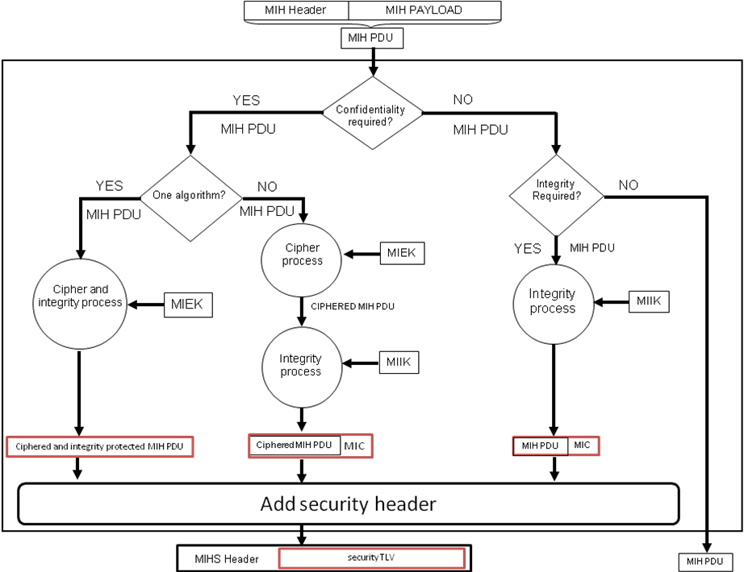
Figure 6 MIH packet protection procedure
MIH protocol is protected by means of the MIHF layer. A new MIHS (MIH Security) Header is needed to indicate that the payload after MIHS is a whole protected MIH message. This new header contains a new bit S used to indicate if the message is confidentiality protected or not, definition of this header is provided in [OPT2]. To merge both our proposal and [OPT2] we propose to define a Security TLV to transport the protected MIH PDU instead of the current defined TLS TLV.

State termination

A termination phase has been defined to provide a mechanism to allow the MN to release the resources kept by MN and PoS (such as keys, authorization lifetime, etc...) associated to the authentication. We provide two alternatives to proceed: define a termination message or/and session lifetime. In the following we explain the meaning of each alternative.
- Termination message: Allows the MN to finalize, explicitly, the current state. This could be useful when the MN changes to another PoS. Allows release resources from the serving PoS which the MN leaves it. This option is currently supported by MIH_Termination_Auth primitive and MIH_Termination_Auth MIH protocol message.
- State timeout: Provides a mechanism to finalize the established state after a certain period of time. This state timeout must be equal or lower than the EAP authentication timeout. Using this option it is guarantee that the state is always closed. This option is currently supported by the lifetime tlv included in MIH_AUTH request and MIH_AUTH response messages which will define in section 2.7.3.5.

Extensions to IEEE802.21 Specification

Extension to Service Management.

Primitives | Service Category | Description
MIH_Start_Auth | Command | Initiates the authentication process with a target PoS.
Extension: MIH_Capability_Discover | Service Management | To assist the negotiation process.
MIH_Auth | Service Management | To perform the authentication process.
MIH_Termination_Auth | Service Management | To finish the current established state.

MIH_Start_Auth.request

Function
This primitive is used by the MIHF (MN side) to initiate the authentication process with a candidate PoS.

Semantics of service primitive
MIH_Start_Auth.request (
DestinationIdentifier,
)
Name | Data type | Description
DestinationIdentifier | MIHF_ID | This identifies the remote MIHF that will be the destination of this request.

When generated
This primitive is generated by an MIH user (in MN side) in order to start the authentication process to authenticate with the candidate PoS.

Effect on receipt
The remote MIHF must generate a corresponding MIH_Start_Auth indication message to the remote MIHF.

MIH_Start_Auth.indication

Function
This primitive is used to notify an MIH User about the reception of a MIH_Start_Auth indication message.

Semantics of service primitive
MIH_Start_Auth.indication (
SourceIdentifier
)
Name | Data type | Description
SourceIdentifier | MIHF_ID | This identifies the invoker of this primitive, which is a remote MIHF.

When generated
This primitive is generated by the MIHF in the PoS upon receiving an MIH_Start_Auth indication message.

Effect on receipt
The MIH User must generate the corresponding MIH_Auth.request primitive after receiving this primitive.

Extension: MIH_Capability_Discover.request
The parameters defined here must be added to the existing in MIH_Capability_Discover.request on section 7.4.1.1 in [IEEE 802.21] .

Function
This primitive is extended to provide an MIH user to discover the ciphersuite capabilities and key distribution mechanisms available of a local or remote MIHF.

Semantics of service primitive
MIH_Capability_Discover.request (
KeyDistributionMechanismList,
IntegrityAlgorithmList,
CipherAlgorithmList,
KDFList
)
Name | Data type | Description
KeyDistributionMechanismList | KEY_DIST_LIST | It identifies the available key distribution mechanism.
IntegrityAlgorithmList | INT_ALG_LIST | It identifies the available integrity algorithms.
CipherAlgorithmList | CIPH_ALG_LIST | It identifies the available encryption algorithms.
KDFList | KDF _LIST | It identifies the available key derivation functions.

When generated
Same effect as defined in MIH standard for MIH_Capability_Discover.request.

Effect on receipt
Same effect as defined in MIH standard for MIH_Capability_Discover.request.

Extension: MIH_Capability_Discover.indication
The parameters defined must be added to the existing ones in MIH_Capability_Discover.indication on section 7.4.1.2 in [IEEE 802.21].

Function
Same function as defined in MIH standard for MIH_Capability_Discover.indication.

Semantics of service primitive
MIH_Capability_Discover.indication ( KeyDistributionMechanismList,
IntegrityAlgorithmList,
CipherAlgorithmList,
KDFList
)
Name | Data type | Description
KeyDistributionMechanismList | KEY_DIST_LIST | It identifies the available key distribution mechanism.
IntegrityAlgorithmList | INT_ALG_LIST | Identifies the available integrity algorithms.
CipherAlgorithmList | CIPH_ALG_LIST | Identifies the available encryption algorithms.
KDFList | KDF _LIST | Identifies the available key derivation functions.

When generated
Same effect as defined in MIH standard for MIH_Capability_Discover.indication

Effect on receipt
Same effect as defined in MIH standard for MIH_Capability_Discover.indication

Extension: MIH_Capability_Discover.response
The parameters defined must be added to the existing ones in MIH_Capability_Discover.response on section 7.4.1.3 in [IEEE 802.21].

Function
Same function as defined in MIH standard for MIH_Capability_Discover.response.

Semantics of service primitive
MIH_Capability_Discover.response (
KeyDistributionMechanismList,
IntegrityAlgorithmList,
CipherAlgorithmList,
KDFList
)
Name | Data type | Description
KeyDistributionMechanismList | KEY_DIST_LIST | Identifies the available key distribution mechanism.
IntegrityAlgorithmList | INT_ALG_LIST | Identifies the available integrity algorithms.
CipherAlgorithmList | CIPH_ALG_LIST | Identifies the available encryption algorithms.
KDFList | KDF _LIST | Identifies the available key derivation functions.

When generated
Same effect as defined in MIH standard for MIH_Capability_Discover.response.

Effect on receipt
Same effect as defined in MIH standard for MIH_Capability_Discover.response.

Extension: MIH_Capability_Discover.confirm
The new defined parameters must be added to the existing ones in MIH_Capability_Discover.confirm on section 7.4.1.4 in [IEEE 802.21].

Function
Same function as defined in MIH standard for MIH_Capability_Discover.confirm.

Semantics of service primitive
MIH_Capability_Discover.confirm (
KeyDistributionMechanismList,
IntegrityAlgorithmList,
CipherAlgorithmList,
KDFList
)
Name | Data type | Description
KeyDistributionMechanismList | KEY_DIST_LIST | Identifies the available key distribution mechanism.
IntegrityAlgorithmList | INT_ALG_LIST | Identifies the available integrity algorithms.
CipherAlgorithmList | CIPH_ALG_LIST | Identifies the available encryption algorithms.
KDFList | KDF _LIST | Identifies the available key derivation functions.

When generated
Same effect as defined in MIH standard for MIH_Capability_Discover.confirm.

Effect on receipt
Same effect as defined in MIH standard for MIH_Capability_Discover.confirm.

MIH_Auth.request

Function
This primitive is generated by the MIH user and used to perform the authentication process.

Semantics of service primitive
MIH_Auth.request (
DestinationIdentifier,
AuthenticationInformation,
Status
)

Name | Data type | Description
DestinationIdentifier | MIHF_ID | This identifies the remote MIHF that will be the destination of this request.
AuthenticationInformation | AUTH_INFO_VALUE | This transport the EAP or ERP packet.
Status | STATUS(*) | Status of the authentication
*see section 4.

When generated
This primitive is generated after receiving an MIH_Start_Auth indication or an MIH_Auth.confirm. Also in network initiated authentication this primitive could be generated by a trigger (e.g. radio link variations, resource management reasons, etc).

Effect on receipt
The local MIHF shall generate a corresponding MIH_Auth request message which will be sent to the remote MIHF.

MIH_Auth.indication

Function
This primitive is used by an MIHF to indicate to a MIH User that a MIH_Auth request message was received from a remote MIHF.

Semantics of service primitive
MIH_Auth.indication (
SourceIdentifier,
AuthenticationInformation
)
Name | Data type | Description
SourceIdentifier | MIHF_ID | This identifies the invoker of this primitive.
AuthenticationInformation | AUTH_INFO_VALUE | This transport the EAP or ERP packet.

When generated
This primitive is generated after receive a MIH_Auth request message.

Effect on receipt
An MIH User receiving this indication must generate a MIH_Auth.response primitive.

MIH_Auth.response

Function
This primitive is used to perform the authentication process.

Semantics of service primitive
MIH_Auth.response (
DestinationIdentifier,
AuthenticationInformation
)
Name | Data type | Description
DestinationIdentifier | MIHF_ID | This identifies a remote MIHF that will be the destination of this request.
AuthenticationInformation | AUTH_INFO_VALUE | This represents the authentication information used to authenticate a MN.
*Only included in the first MIH_Auth.response sent.
**Only included in the first MIH_Auth.response messages and in the last one.

When generated
This primitive is generated after receiving a MIH_Auth.indication.

Effect on receipt
The local MIHF must generate a MIH_Auth response message.

MIH_Auth.confirm

Function
This primitive is used by an MIHF to indicate to an MIH User that a MIH_Auth response was received.

Semantics of service primitive
MIH_Auth.confirm (
SourceIdentifier,
AuthenticationInformation
)
Name | Data type | Description
SourceIdentifier | MIHF_ID | This identifies the invoker of this primitive.
AuthenticationInformation | AUTH_INFO_VALUE | This represents the authentication information used to authenticate a MN.

When generated
This primitive is generated after receiving a MIH_Auth response message.

Effect on receipt
A MIH User receiving this primitive must generate a MIH_Auth.request primitive.

MIH_Termination_Auth.request

Function
This primitive is used to request the termination of the established state.

Semantics of service primitive
MIH_Termination_Auth.request (
DestinationIdentifier
)
Name | Data type | Description
DestinationIdentifier | MIHF_ID | This identifies a remote MIHF that will be the destination of this request.

When generated
This primitive is generated by a MIH user to terminate the current state.

Effect on receipt
The MIHF must generate a MIH_Termination_Auth.response primitive in order to confirm the state finalization.

MIH_Termination_Auth.response

Function
This primitive is used to confirm from the remote MIHF that the state has been closed.

Semantics of service primitive
MIH_Termination_Auth.response (
DestinationIdentifier
)
Name | Data type | Description
DestinationIdentifier | MIHF_ID | This identifies a remote MIHF that will be the destination of this request.

When generated
This primitive is generated by a remote MIHF after receiving a MIH_Termination_Auth.indication primitive.

Effect on receipt
The MIHF must generate a MIH_Termination_Auth.confirm primitive in order to finalize the state.

MIH_Termination_Auth.indication

Function
This primitive is used to notify to the corresponding MIH User about the termination of the established state.

Semantics of service primitive
MIH_Termination_Auth.indication (
SourceIdentifier,
)
Name | Data type | Description
SourceIdentifier | MIHF_ID | This identifies the invoker, which is a remote MIHF.

When generated
This primitive is generated by a MIHF to terminate the current state after receiving a MIH_Termination_Auth request message.

Effect on receipt
The established state terminates.

MIH_Termination_Auth.confirm

Function
This primitive is used to notify to the corresponding MIH User about the termination of the established state.

Semantics of service primitive
MIH_Termination_Auth.confirm (
SourceIdentifier
)
Name | Data type | Description
SourceIdentifier | MIHF_ID | This identifies the invoker, which is a remote MIHF.

When generated
This primitive is generated by a MIHF to terminate the current state after receiving a MIH_Termination_Auth response message.

Effect on receipt
The established state terminates.

MIH Protocol Extensions

MIH_Start_Auth indication

MIH Header Fields (SID = 1, Opcode = 3, AID = 6)
Source Identifier = sending MIHF ID
(Source MIHF ID TLV)
Destination Identifier = receiving MIHF ID
(Destination MIHF ID TLV)

Extension: MIH_Capability_Discover request

MIH Header Fields (SID = 1, Opcode = 1, AID = 1)
KeyDistributionMechanismList(optional)
(Key Distribution Mechanism List TLV)
IntegrityAlgorithmList (optional)
(Integrity Protection List TLV)
CipherAlgorithmList (optional)
(Encryption Algorithm List TLV)
KDFList (optional)
(KDF List TLV)

Extension: MIH_Capability_Discover response

MIH Header Fields (SID = 1, Opcode = 2, AID = 1)
KeyDistributionMechanismList (optional)
(Key Distribution Mechanism List TLV)
IntegrityAlgorithmList (optional)
(Integrity Protection List TLV)
CipherAlgorithmList (optional)
(Encryption Algorithm List TLV)
KDFList (optional)
(KDF List TLV)

MIH_Auth request

MIH Header Fields (SID = 1, Opcode = 1, AID =7)
Destination Identifier = receiving MIHF ID
(Destination MIHF ID TLV)
Source Identifier = sending MIHF ID
(Source MIHF ID TLV)
Nonce (optional)
(Nonce TLV)
AuthenticationInformation (optional)
(Authentication TLV)
Lifetime (optional)
(Lifetime TLV)
Status (optional)
(STATUS TLV)
KeyDistributionMechanismList (optional)
(Key Distribution Mechanism List TLV)
IntegrityAlgorithmList (optional)
(Integrity Protection List TLV)
CipherAlgorithmList (optional)
(Encryption Algorithm List TLV)
KDF-List (optional)
(KDF List TLV)
IdentityOpt (optional)
(Identity TLV)
AUTH (optional)
(AUTH TLV)

MIH_Auth response

MIH Header Fields (SID = 1, Opcode = 2, AID = 7)
Destination Identifier = receiving MIHF ID
(Destination MIHF ID TLV)
Source Identifier = sending MIHF ID
(Source MIHF ID TLV)
Nonce (optional)
(Nonce TLV)
AuthenticationInformation (optional)
(Authentication TLV)
KeyDistributionMechanismList (optional)
(Key Distribution Mechanism List TLV)
IntegrityAlgorithmList (optional)
(Integrity Protection List TLV)
CipherAlgorithmList (optional)
(Encryption Algorithm List TLV)
KDFList (optional)
(KDF List TLV)
AUTH (optional)
(AUTH TLV)

MIH_Termination_Auth request

MIH Header Fields (SID = 1, Opcode = 1, AID = 8)
Destination Identifier = receiving MIHF ID
(Destination MIHF ID TLV)
Source Identifier = sending MIHF ID
(Source MIHF ID TLV)
AUTH (optional)
(AUTH TLV)

MIH_Termination_Auth response

MIH Header Fields (SID = 1, Opcode = 2, AID = 8)
Destination Identifier = receiving MIHF ID
(Destination MIHF ID TLV)
Source Identifier = sending MIHF ID
(Source MIHF ID TLV)
AUTH (optional)
(AUTH TLV)

Message flows
This section shows the message flow of the different phases explained using the MIH commands defined before.

Capability Discovery Phase
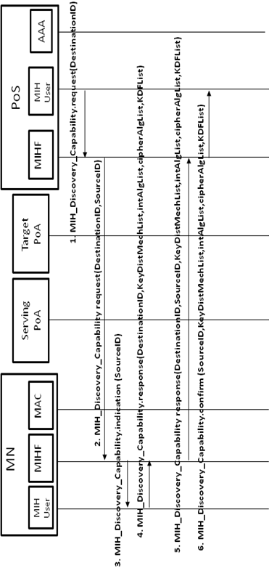
Figure 7 Capability Discovery phase messages (PoS initiated)

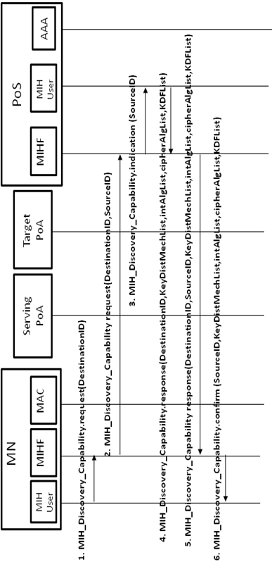
Figure 8 Capability Discovery phase messages (MN initiated)

Media Independent Service Authentication phase

Media independent Service Authentication MN initiated
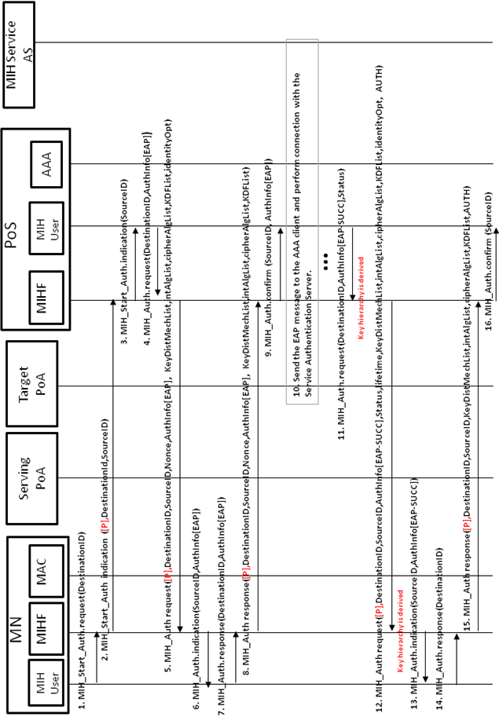
Figure 9 Media Independent Service Authentication MN initiated messages
Some aspects which need further consideration:
- Negotiation phase to negotiate the cipher suite to be used is performed in the firsts two MIH_AUTH messages (request/response).
- The authentication process is based in EAP.
- KeyDistMechList identifies the Key Distribution Mechanism List TLV. This is used to select a key distribution mechanism (Push, Reactive Pull, Proactive Pull, or Optimized Proactive Pull). If this TLV is present, it is signaling that the bundle option is active and the key distribution mechanism selected by this TLV is going to be used to perform the bundle.
- Flag P is used to indicate that the MN is trying to authenticate with a PoS in a different domain. This flag is in MIH Header on bit 0 in RESERVED2 field.
- Status is used to indicate the state of the authentication, if it has been successful or not.
- The last two messages have an AUTH TLV and they include the ciphersuite and the other related parameters negotiated before, in order to securely confirm that these parameters (cipher suite, key distribution mechanism, etc) have been those exchanged during the first MIH_Auth exchange. This AUTH TLV is checked both the MN and the PoS.

Media independent Service Authentication Network initiated
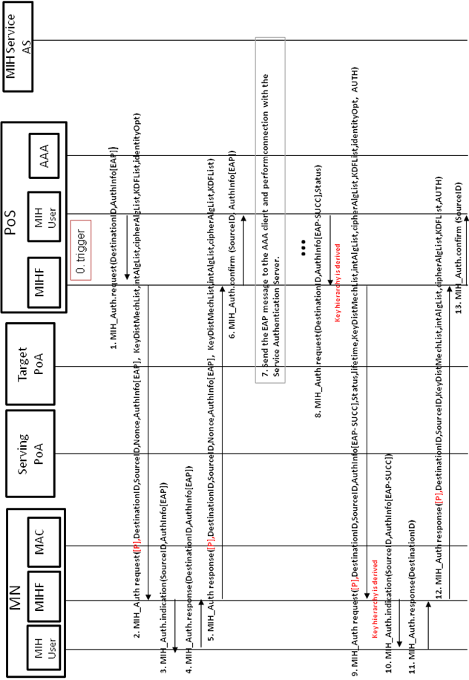
Figure 10 Media Independent Service Authentication Network initiated messages

Some aspects to be consider:
- The same aspects listed before.
- To initiate the Media independent Authentication by the network a trigger is needed.

Media Independent Service Authentication MN initiated based on ERP

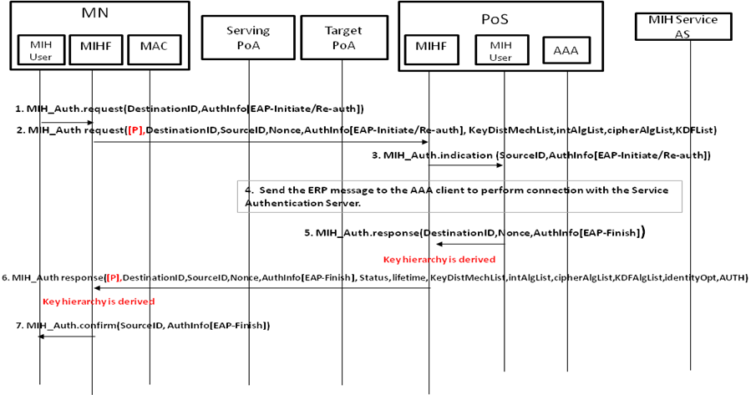
Figure 11 Media Independent Service Authentication MN initiated based on ERP
Some aspects to be considered:
- The authentication process is based on ERP.
- In the MN initiated scenario, the negotiation phase performed in the firsts two messages is in a different way. In this case, the MN proposes its supported parameters (cipher suite, key distribution mechanism, etc) and the PoS chooses which ones are going to be used, unlike the EAP authentication case where the PoS proposes and the MN chooses.
- To check the negotiated parameters, in the last message the PoS sends the proposed parameters by the MN and its own selection. This message is integrity protected. At the MN side, the parameters can be checked due to the MN has its proposal and the selection made by the PoS is integrity protected.

Media Independent Service Authentication Network initiated based on ERP
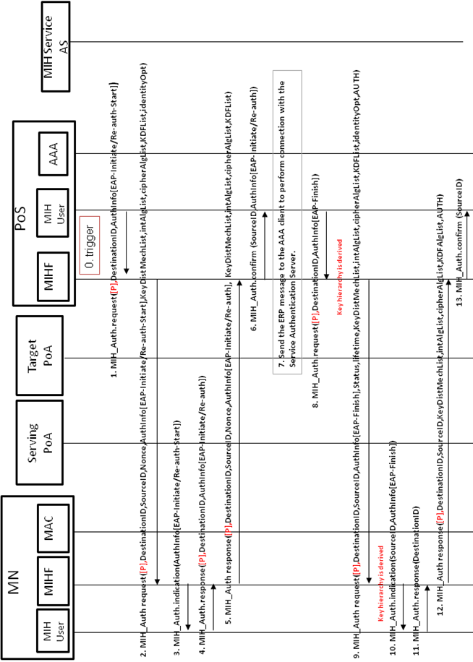
Figure 12 Media Independent Service Authentication Network initiated based on ERP
Some aspects to consider:
- The authentication process is based on ERP.
- Negotiation phase to negotiate the cipher suite to be used is performed in the firsts two MIH_AUTH messages (request/response).
- KeyDistMechList identifies the Key Distribution Mechanism List TLV. This is used to select a key distribution mechanism (Push, Reactive Pull, Proactive Pull, or Optimized Proactive Pull). If this TLV is present, it is signaling that the bundle option is active and the key distribution mechanism selected by this TLV is going to be used to perform the bundle.
- Flag P is used to indicate that the MN is trying to authenticate with a PoS in a different domain. This flag is in MIH Header on bit 0 in RESERVED2 field.
- Status is used to indicate the state of the authentication, if it has been successful or not.
- The last two messages have an AUTH TLV and they include the ciphersuite and the other related parameters negotiated before, in order to securely confirm that these parameters (cipher suite, key distribution mechanism, etc) have been those exchanged during the first MIH_Auth exchange. This AUTH TLV is checked both the MN and the PoS.
- To initiate the Media independent Authentication by the network a trigger is needed.

Termination phase

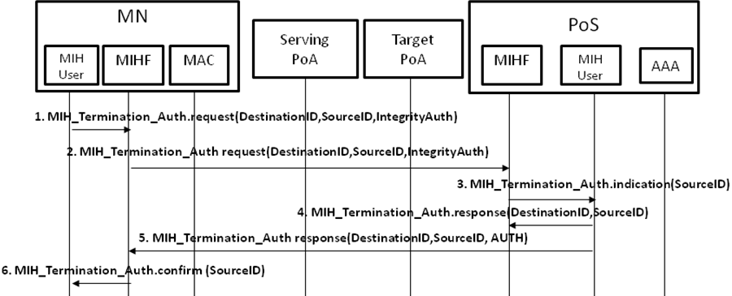
Figure 13 Finalization phase messages

Flags
We need to provide a flag P to indicate if the MN is performing an authentication to a different domain that it is currently connected. Moreover, another flag F may be needed to indicate that the authentication has finished and parameters binding process can be carried out.
To implement these flags there are two alternatives. First one, use the field reserved2 in IEEE 802.21 header and use two bits, one for each flag. The other alternative, is define a specific FLAG TLV and add it to the corresponding MIH messages.
Use the FLAG TLV provides a point of extension for future updates. Moreover, we do not need to modify the MIH header.
Name | Data type | Description
Flag | FLAG_DATA | Used to codify information which could be represented with one bit.

Data type definition
Data Type Name | Derived from | Definition
FLAG_DATA | BITMAP(8) | Bitmap values:  Bit 0: P  Bit 1: F  Bit 2-7 : (Reserved)

TLVs included by MIHF in MIH Messages

Name | Data type | Description
Lifetime | LIFETIME | This TLV represent the period of time that a key is valid for being used.
AUTH | AUTH_VALUE | Integrity data to verify that a message has not been modified.

Bundle option with WI#1 option B

Services: Key Distribution Mechanisms

The described solution in this document as well as provide key material to protect the MIH protocol, the new key hierarchy generated could be use to assist the key distribution to operate in the context of IEEE 802.21a working item #1 to reduce the media-specific network access time after a handoff. In that sense, this solution can assist the following key distribution mechanisms:
- Push key distribution. Its objective is to push a key into the target PoA by the PoS which controls that PoA. The key to be pushed is derived from key hierarchy (see section 3.2) since the PoS and the MN already have the necessary key material (i.e. MSK or rMSK). To perform this mechanism the MN uses the MIH protocol, which at this point could be protected (see section 2.4), to notify the PoS to start the key installation to the target PoA.
- Reactive pull key distribution. It is performed after the MN moves to the target PoA. It assumes that both the MN and the PoS shares a symmetric key. In particular a specific derived MS-PMK for this purpose. The reactive key distribution implies the execution of a media-specific EAP/ERP authentication between the MN and the target PoA. In this media-specific EAP/ERP authentication, the EAP/ERP peer is the MN, the EAP/ERP authenticator is the target PoA and the PoS acts as AAA/EAP server. The EAP authentication is performed by using the MS-PMK shared between the MN and the PoS. Since an EAP method based on symmetric keys or ERP must be used for this reactive media-specific EAP authentication, which does not involve any MIH signaling. In order to optimize the mechanism a new identity, provided during the negotiation carried out in the media independent service authentication phase (see section 2.1), is used to contact with the PoS (acting as AAA/EAP).
- Proactive pull key distribution. This mechanism allows the MN to perform a proactively media-specific authentication with the target PoA without being directly connected to the wireless link of the target PoA by means sending link-layer frames through the PoS to the target PoA.
- Optimized pull key distribution. This mechanism function is the same as Proactive pull key distribution, but it provides an optimization. In this optimization, the key hierarchy shared between the MN and the PoS could be used in order to derive a shared key to be used in the key distribution process, where the PoS will be acting as a local AAA and using the identity provided during the Media Independent Service Authentication phase the PoS could be contacted to perform the key distribution mechanism.

Key Hierarchy extension

Regarding the key hierarchy proposed for Media Independent Service Authentication phase in section 2.4, for the bundle option with WI#1 option B we propose to extend the existing hierarchy to derive different Media Specific Pairwise Master Keys (MS-PMKs). Using the MSK/rMSK exported from the EAP/ERP authentication, a new key called MS-ROOT is derived. A set of MS-PMKs can be derived from the MS-ROOT key, acting as root key. An MS-PMK can be used as shared secret between the PoS and the MN to carry out a media-specific EAP authentication in the reactive pull key distribution mechanisms or optimized proactive pull key distribution. Alternatively, they can be used directly by the target PoA and the MN to perform a security association protocol which allows to protect the data link.
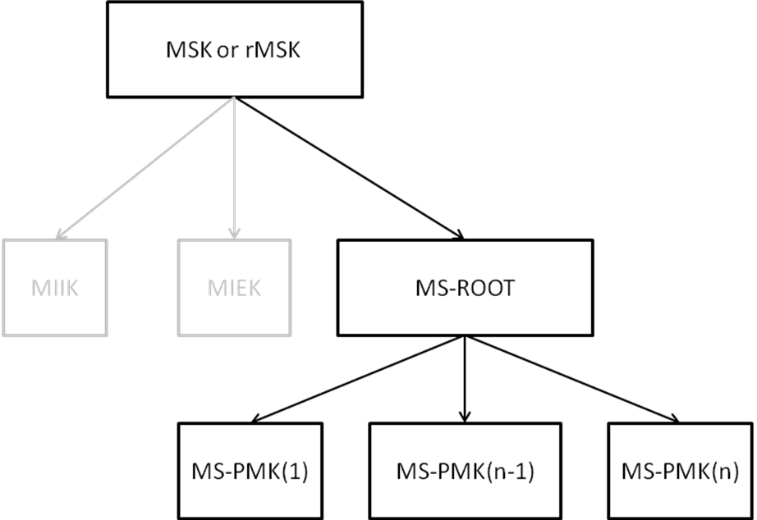
Figure 14 Key hierarchy proposed

Note: If a Key Distribution Mechanism is not selected, MS-ROOT and MS-PMK do not need to be derived.
The MS-ROOT key can be derived by the following procedure.
Input: K (= MSK or rMSK), Nonce-P, Nonce-S, and L.
Process:
- MS-RK := PRF (K, “MSROOTKEY” || Nonce-P || Nonce-S )
- Return: MS-RK.
Output: MS-RK.
MS-RK can be 128 bits, 160 bits or 256 bits depending on the PRF used.
Multiple MS-PMK can be derived from MS-ROOT key (MS-RK) for different PoAs. Each PoA is defined by its link-layer address.
It is assumed that the same PRF is used for both MIH session keys and for MS root key. When the MSK or rMSK is 128 bits long, the PRF used for key derivation can be HMAC-SHA1, HMAC-SHA-256, or AES-CMAC. But if MSK is longer than 128 bits, then HMAC-SHA-1 or HMAC-SHA-256 shall be used as a PRF in key derivation.
The MS-PMK can be derived by the following procedure.
Input: MS-RK, MN_LINK_ID, POA_LINK_ID.
Process:
- MS-PMK := PRF (MS-RK, “MS-PMK” || MN_LINK_ID || POS_LINK_ID )
- Return: MS-PMK.
Output: MS-PMK.
MS-PMK can be 128 bits, 160 bits or 256 bits depending on the PRF used in the above. The MS-PMK will be distributed to the PoA identified by POA_LINK_ID. It will be used by the PoA to derive media specific session keys. The key derivation for media specific session keys is out of the scope of this standard.

Bundle option: Extensions of IEEE802.21 Specification

New commands

Primitives | Service Category | Description
MIH_Push_Key | Command | To perform the push key distribution mechanism
MIH_Proact_Pull_key | Command | To perform the (optimized) proactive pull key distribution mechanism.

Key Distribution Mechanism primitives

MIH_Push_Key.request

Function
This primitive is used to request to a remote MIHF (PoS) to install a specific MS-PMK in a target PoA.

Semantics of service primitive
MIH_Push_Key.request (
DestinationIdentifier,
PoAIndentifier,
LinkId
)
Name | Data type | Description
DestinationIdentifier | MIHF_ID | This identifies a remote MIHF that will be the destination of this request.
PoAIdentifier | PoA_ID | This identifies the link address of the PoA.
LinkId | Link_Addr | This contains the MAC address of the MN’s target interface.

When generated
This primitive is generated by a MIH user in the MN to request a remote MIHF (i.e. serving PoS), to install a MS-PMK in a target PoA.

Effect on receipt
The local MIHF shall generate an MIH_Push_Key request message to the remote MIHF.

MIH_Push_Key.indication

Function
This primitive is used to send a MS-PMK to the corresponding MIH User on PoS.

Semantics of service primitive
MIH_Push_Key.indication (
MSPMK,
PoAIdentifier,
LinkId
)
Name | Data type | Description
MSPMK | KEY | It is the MS-PMK to be pushed.
PoAIdentifier | PoA_ID | This identifies a PoA.
LinkId | Link_Addr | This contains the MAC address of the MN’s active interface.
lifetime | LIFETIME | Indicates the period of time that a key tansported in MSPMK is valid for being used.

When generated
This primitive is generated the local MIHF after receiving an MIH_Push_Key request message from the remote MIHF.

Effect on receipt
A media specific key is delivered to the corresponding MIH User.

MIH_Push_Key.response

Function
This primitive is used to confirm that the key installation has been carried out.

Semantics of service primitive
MIH_Push_Key.response (
DestinationIdentifier,
PoAIndentifier,
Status
)
Name | Data type | Description
DestinationIdentifier | MIHF_ID | This identifies a remote MIHF that will be the destination of this request.
PoAIdentifier | PoA_ID | This identifies a PoA.
Status | STATUS | Represent the operation result.

When generated
This primitive is generated by a MIH user after receiving a MIH_Push_Key.indication primitive.

Effect on receipt
The local MIHF shall generate a MIH_Push_Key response message to the remote MIHF.

MIH_Push_Key.confirm

Function
This primitive is used to notify the MIH user (in MN side) about the status of the requested operation.

Semantics of service primitive
MIH_Push_Key.confirm (
PoAIdentifier,
Status
)
Name |  | Data type | Description
PoAIdentifier | PoA_ID |  | This identifies a PoA.
Status | STATUS |  | Represent the operation state.

When generated
This primitive is generated after receiving a MIH_Push_Key message.

Effect on receipt
A media specific key must be installed in the MAC layer.

MIH_Proact_Pull_key.request

Function
This primitive is used by the MN to request a key installation in a target PoA using link-layer frames to be authenticated. The authentication is performed proactively.

Semantics of service primitive
MIH_Proact_Pull_key.request (
DestinationIdentifier,
PoAIndentifier,
ProactivePullInformation,
)
Name | Data type | Description
DestinationIdentifier | MIHF_ID | This identifies a remote MIHF that will be the destination of this request.
PoAIdentifier | PoA_ID | This identifies a PoA.
ProactivePullInformation | PROACT_PULL_LL_FRAMES | This contains link-layer frames

When generated
This primitive is generated by a MIH user in the MN to perform a key installation using the proactive pull key distribution method.

Effect on receipt
The MN shall generate a MIH_Proact_Pull_key request message to the remote MIHF.

MIH_Proact_Pull_key.indication

Function
This primitive is used by the PoS MIHF to notify the corresponding MIH user about the reception of a MIH_Proact_Pull_key request message.

Semantics of service primitive
MIH_Proact_Pull_key.indication (
SourceIdentifier,
PoAIndentifier,
ProactivePullInformation,
)
Name | Data type | Description
SourceIdentifier | MIHF_ID | This identifies the invoker, which is a remote MIHF.
PoAIdentifier | PoA_ID | This identifies a PoA.
ProactivePullInformation | PROACT_PULL_LL_FRAMES | This contains link-layer frames.

When generated
This primitive is generated by the MIHF in PoS after receiving a MIH_Proact_Pull_key request message.

Effect on receipt
The MIH user must generate a MIH_Proact_Pull_key.response primitive.

MIH_Proact_Pull_key.response

Function
This primitive is used by the MIH user in PoS to carry out the key distribution.

Semantics of service primitive
MIH_Proact_Pull_key.response (
DestinationIdentifier,
PoAIndentifier,
ProactivePullInformation,
Status
)
Name | Data type | Description
DestinationIdentifier | MIHF_ID | This identifies a remote MIHF that will be the destination of this request.
PoAIdentifier | PoA_ID | This identifies a PoA.
ProactivePullInformation | PROACT_PULL_LL_FRAMES | This contains link-layer frames both the MN and the PoA in other to perform a proactive authentication.
Status | STATUS | Status of the authentication

When generated
This primitive is generated after receiving a MIH_Proact_Pull_key.indication primitive.

Effect on receipt
The MIHF in the MN must generate a MIH_Proact_Pull response in order to provide the required information until the key distribution is finished.

MIH_Proact_Pull_key.confirm

Function
This primitive is used to notify the corresponding MIH user about the reception of a MIH_Proact_Pull response.

Semantics of service primitive
MIH_Proact_Pull_key.confirm (
ProactivePullInformation,
Status
)
Name | Data type | Description
ProactivePullInformation | PROACT_PULL_LL_FRAMES | This contains link-layer frames both the MN and the PoA in other to perform a proactive authentication.
Status | STATUS | Status of the authentication

When generated
This primitive is generated by the MIHF in PoS after receiving a MIH_Proact_Pull_key response message.

Effect on receipt
The MIH user must generate a MIH_Proact_Pull_key.request primitive until the key distribution is completed.

Bundle option: MIH Protocol Extensions

MIH_Push_Key request

MIH Header Fields (SID = 1, Opcode = 1, AID = 9)
Destination Identifier = receiving MIHF ID
(Destination MIHF ID TLV)
Source Identifier = sending MIHF ID
(Source MIHF ID TLV)
PoAIdentifier
(PoA Identifier TLV)
LinkId
(Link ID TLV)
AUTH (optional)
(AUTH TLV)

MIH_Push_Key response

MIH Header Fields (SID = 1, Opcode = 2, AID = 9)
Destination Identifier = receiving MIHF ID
(Destination MIHF ID TLV)
Source Identifier = sending MIHF ID
(Source MIHF ID TLV)
PoAIdentifier
(PoA Identifier TLV)
Status
(Status TLV)
AUTH (optional)
(AUTH TLV)

MIH_Proact_Pull_key request

MIH Header Fields (SID = 1, Opcode = 1, AID = 10)
Destination Identifier = receiving MIHF ID
(Destination MIHF ID TLV)
Source Identifier = sending MIHF ID
(Source MIHF ID TLV)
PoAIdentifier
(PoA Identifier TLV)
ProactivePullInformation
(Pull Information TLV)
AUTH (optional)
(AUTH TLV)

MIH_Proact_Pull_key response

MIH Header Fields (SID = 1, Opcode = 2, AID = 10)
Destination Identifier = receiving MIHF ID
(Destination MIHF ID TLV)
Source Identifier = sending MIHF ID
(Source MIHF ID TLV)
PoAIdentifier
(PoA Identifier TLV)
ProactivePullInformation
(Pull Information TLV)
Status (optional)
(Status TLV)
AUTH (optional)
(AUTH TLV)

Bundle option: Message flow

Push key distribution

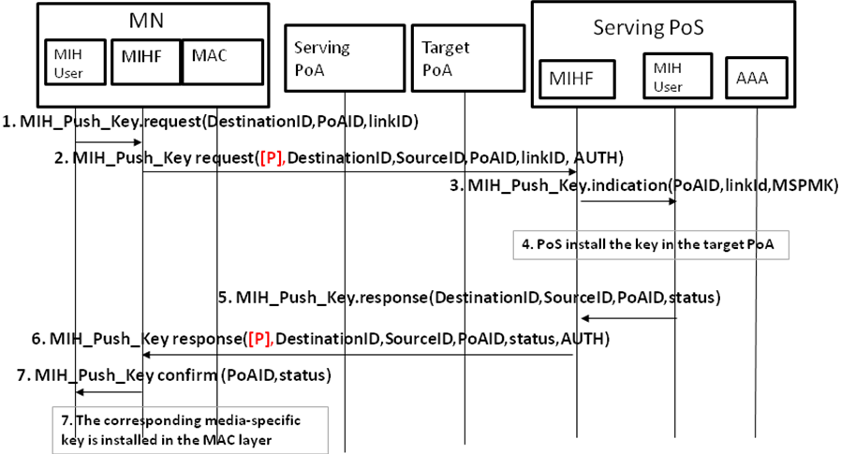
Figure 15 Push key distribution messages

Proactive Pull key distribution

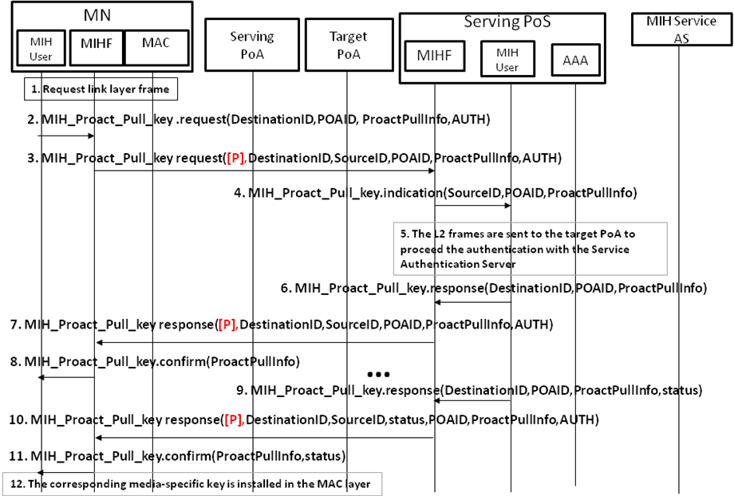
Figure 16 Proactive pull key distribution messages

Optimized pull key distribution
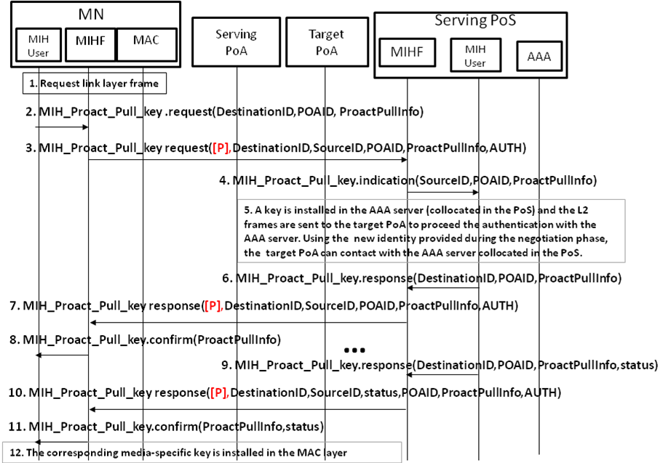
Figure 17 Optimized proactive pull key distribution messages

Reactive pull key distribution

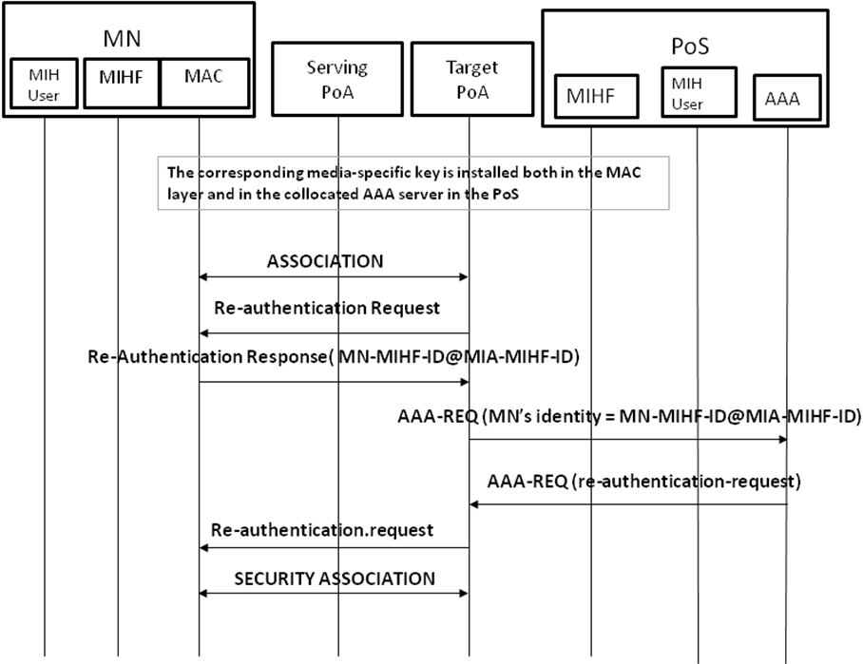
Figure 18 Reactive pull key distribution messages
Note: to perform this key distribution mechanism there is no need of use MIH protocol. It is a media-specific authentication which could be optimized by acting the PoS like a AAA server.

New data types definition

Data Type Name | Derived from | Definition
KEY_DIST_LIST | BITMAP(8) | A list of key distribution methods available.  Bitmap values:  Bit 0: Push Key distribution.  Bit 1: Proactive Pull Key Distribution.  Bit 2: Optimized Proactive Pull Key Distribution.  Bit 3: Reactive Pull Key Distribution.  Bit 4-7: (Reserved)
INT_ALG_LIST | BITMAP(8) | A list of integrity algorithms available.  Bitmap values:  Bit 0: INTR_HMAC_SHA_96  Bit 1: INTR_CMAC_AES  Bit 2: INTR_NULL  Bit 3-7: (Reserved)
CIPH_ALG_LIST | BITMAP(8) | A list of encryption algorithms available.  Bitmap values:  Bit 0: ENCR_AES_CBC  Bit 1: AUTH_ENC_AES_CCM  Bit 2 : ENCR_NULL  Bit 3-7: (Reserved)
KDF-List | BITMAP(8) | A list of Key Derivation Functions available.  Bitmap values:  Bit 0: PRF_CMAC_AES  Bit 1: PRF_HMAC_SHA1  Bit 2-7: (Reserved)
ID_OPT | OCTET_STRING | Represents a new identity provided for optimization purposes.
NONCE_VALUE | UNSIGNED_INT(2) | Represents a random value.
AUTH_INFO_VALUE | OCTET_STRING | Represents the authentication information used to authenticate.
AUTH_VALUE | OCTET_STRING | Represent an integrity string to verify data integrity.
INTEGRITY_DATA | OCTET_STRING | Represents the integrity data of a message.
KEY | OCTET_STRING | Represents a key
PROACT_PULL_LL_FRAMES | OCTET_STRING | Represents the information needed to carry out a key installation.
STATUS | ENUMERATED | This is an extension of STATUS TLV defined in IEEE 802.21, it must be updated to support:  5: Authentication Failure
LIFETIME | UNSIGNED_INT(2) | Represents the period of time that a key is valid for being used.
POA_ID | LINK_ADDR | A data type to represent an address of any link layer

Alternatives to transport EAP

In this section we analyze PANA (RFC 5191) as an alternative to transport EAP between the MN and the PoS in order to authenticate the MN. Using PANA as protocol the current architecture would be updated as follows: MN would be acting as PaC (PANA Client) and PoS as PAA (PANA Authentication Agent) and PoA as EP (Enforcement Point).
PANA is a protocol (RFC 5191) defined under the IETF and defines a network-layer transport for EAP. Moreover, it is a secure protocol where a security association is created after successfully completion of the EAP authentication creating a MSK. Using this cryptographic material protocol messages could be protected. Furthermore, PANA provides pre-authentication supports (RFC 5873) which allows a MN to establish a PANA session with a target PoS/PAA before to perform the movement. Therefore, PANA protocol provides all the necessary mechanisms to perform a secure seamless handover between the MN and its serving PoS (PAA).
Thus, PANA achieves the same objectives as MIH protocol (protocol security and seamless handover). But PANA has some lacks which are inherent to its definition which provokes that it could not be used instead of MIH protocol. We have identified a main issue, this is, PANA is a network-layer protocol (it works under UDP). PANA assumes that the MN has IP connectivity. Therefore, to use PANA, the MN always needs IP connectivity to perform the PANA procedure to get network access. To solve this issue PANA pre-authentication could be used (performing an authentication with the target PoS (PAA)). In this way, when the MN arrives to the target network, it only needs to perform the security association with the target PoA. If the MN is moving quickly and the pre-authentication procedure takes long time (for example, an EAP-TLS authentication), the MN could lose its connectivity with the Serving PoA before complete the pre-authentication procedure. Then, if the MN moves finally to the target PoA the pre-authentication procedure cannot be completed therefore, there is neither IP connectivity nor key material. In that case, to gain network access the MN must perform a full EAP authentication where the delay can be very high. Therefore, the use of pre-authentication it is not a valid solution in all cases.
On the other hand, if we are using MIH protocol, which could be carried over any technology, the same problem is present (if the MN moves quickly connectivity could be lost) but, MIH protocol allows, if the connectivity has been lost, to resume the unfinished pre-authentication through the target PoA without the need of re-start the (pre-)authentication. All the progress carried out before losing connection is valid and the authentication can continue in the same point before the lost of connectivity. This advantage cannot be carried out in PANA, due to its IP connectivity requirement. In fact, PANA may not continue since a complete media-specific EAP authentication may be required with the target PoA to send IP traffic, which basically spoils the benefits of having a PANA pre-authentication mechanism..
In the following, we explain a scenario where this issue is represented.
, the MN is attached to a Serving WiFi PoA and it has been authenticated with the PoS (the PoA could be collocated with the PoS) in a domain A and it has IP connectivity (number 1 in the figure). Moreover, the MN is moving quickly (number 2) and through the IEEE 802.21 information server knows that, in that area, there are a WiFi PoA and WiMAX PoA, which belongs to another domain (domain B) . The MN realizes that the connectivity with the Serving WiFi PoA is going down. At this point, there are two options: either using PANA or using MIH protocol in order to perform an authentication with the discovered PoS which manage WiFi PoA and WiMAX PoA .
If PANA is used, the MN starts a pre-authentication procedure against the candidate PoS (target PoS, due to it has been selected to perform the authentication) through the Serving WiFi PoA. Once the process has started, due to the MN is moving, the connectivity with the Serving WiFi PoA is lost before the pre-authentication process could have been completed. Therefore, when the MN enters in the WiMAX PoA range a full media-specific EAP authentication process needs to be performed from the beginning since PANA cannot continue since it needs IP connectivity to be used.
If MIH protocol is used, also, the connectivity would have been lost but, MIH has an advantage, since it can be directly carried over link-layer frames. Thus, when the MN enters in the WiMAX PoA range, it can resume the (pre-)authentication process in the point before the MN lost the network connectivity and to finish the authentication process initiated in Domain A. Thus, there is no need to start a new authentication process. So that, for example, if the network connectivity is lost when only one message remains, MIH protocol can finish the authentication sending the last message over WiMAX link-layer and PANA needs to start a new authentication process.
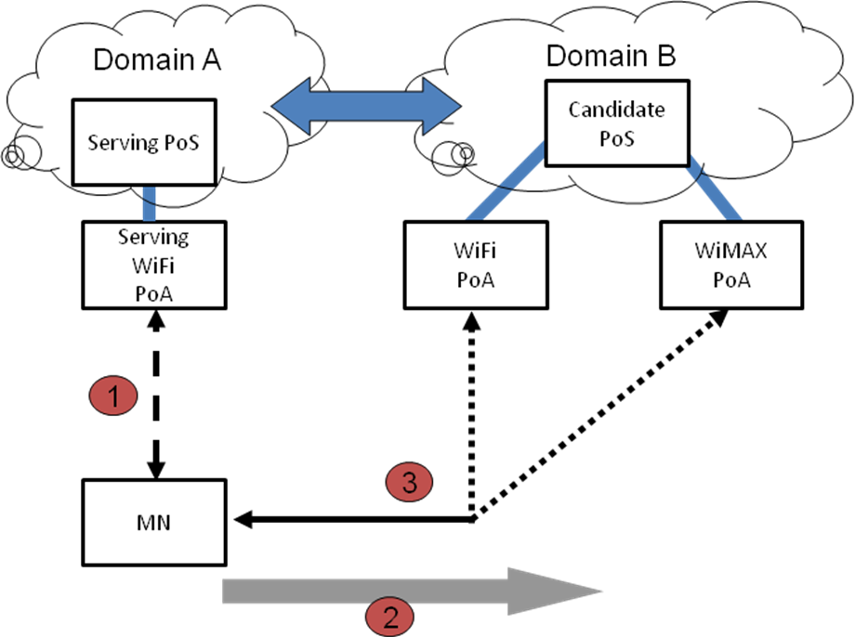
Figure 19 scenario using a PoA as a bridge
Another issue (if we consider to co-locate the PoS with the PoA), even though this is not a limitation, we believe that in terms of deployment is easier to convince a technical IEEE vendor to implement, in its products (i.e. antennas, access points, etc), an IEEE technology like IEEE 802.21 rather than implement a PANA agent, which is an IP layer protocol.

Conclusions

This proposal describes how to carry out a service authentication to access to a set of services. EAP is used to achieve the aim of authenticating the MN to satisfy the requirements of IEEE 802.21a work item #2. Moreover, once the authentication is performed the key material obtained after the service authentication is used to protect the MIH layer. Therefore, EAP provides the flexibility to avoid the need of performing subsequence authentication while the key material exported is still valid.
In summary, using EAP and a new key hierarchy, derived from the key material provided by EAP, this proposal could protect the MIH protocol on MIH layer without other dependencies.
According to this proposal, we have analyzed the use of PANA instead of MIH as protocol between MN and PoS. Summarizing, PANA does not provide a completely solution to inter-technology handovers due to IP connectivity is needed beforehand, PANA may not perform successfully in scenarios where IP is not available. In other hand, MIH is a protocol more general allowing handovers between different distribution systems and it could be used to perform inter-technology handovers.

