Project | IEEE 802.21a  <https://mentor.ieee.org/802.21>
Title | Option III: EAP to conduct service authentication and MIH packet protection
DCN | 21-10-0078-04-0sec
Date Submitted
Source(s) | Fernando Bernal-Hidalgo (University of Murcia), Rafael Marin-Lopez (University of Murcia)
Re:
Abstract | This document elaborates 21-10-0049-03-0Sec proposal: Proposal summary
Purpose | This document proposes a service authentication based on EAP and how this authentication could be used to protect the MIH protocol.
Notice | This document has been prepared to assist the IEEE 802.21 Working Group. It is offered as a basis for discussion and is not binding on the contributing individual(s) or organization(s). The material in this document is subject to change in form and content after further study. The contributor(s) reserve(s) the right to add, amend or withdraw material contained herein.
Release | The contributor grants a free, irrevocable license to the IEEE to incorporate material contained in this contribution, and any modifications thereof, in the creation of an IEEE Standards publication; to copyright in the IEEE’s name any IEEE Standards publication even though it may include portions of this contribution; and at the IEEE’s sole discretion to permit others to reproduce in whole or in part the resulting IEEE Standards publication. The contributor also acknowledges and accepts that IEEE 802.21 may make this contribution public.
Patent Policy | The contributor is familiar with IEEE patent policy, as stated in Section 6 of the IEEE-SA Standards Board bylaws <http://standards.ieee.org/guides/bylaws/sect6-7.html#6> and in Understanding Patent Issues During IEEE Standards Development http://standards.ieee.org/board/pat/faq.pdf

Introduction

Scope
The scope of this document is to describe the solution based on EAP proposed in 21-10-0049-03-0sec-proposal-summary. More concretely, working item #2 option III.

Purpose
The purpose of this document is to describe the proposed approach for service authentication based on EAP and how this could be used to protect the MIH protocol. Moreover, this proposal assist working item #1 in order to perform the key distribution mechanisms. In particular, this document addresses the following functionalities:

Work Item # | Supported Functionality | Note
2 | Access Authentication | Yes
2 | MIH-Specific Authentication | Yes
2 | Key Hierarchy and Derivation | Yes
2 | MIH-Specific Protection | Yes
2 | Visited Domain Access | No*
Note*: Does not mention explicitly but the proposed approach may be applicable

Terminologies

EAP: Extensible Authentication Protocol
PoS: Point of Service
PoA: Point of Attachment
AS: Authentication Server
MN: Mobile Node

Definitions

MIH Service Authentication : Authentication to enable MIH services provided by PoS. In the context of 802.21a they could be key distribution services for working item #1. It also allows to protect MIH signalling as a consequence of a successful authentication.
PoS: is an entity that interacts with PoAs and facilitates service authentication of other entities attached to the other end of a link of a PoA.
MIH Service AS: It is a backend authentication server for the MIH service authentication.

References

[RFC 3748] H. Levkowetz, Ed. and et al, “Extensible Authentication Protocol (EAP)”
[RFC5247] B. Aboba, D. Simon and P. Enoren, “Extensible Authentication Protocol (EAP) Key Management Framework”
[RFC5246] T. Dierks and E. Rescorla, “The Transport Layer Security (TLS) Protocol Version 1.2”
[IEEE802.21a] Subir Das, Ashutosh Dutta , Toshikazu Kodama, “Proactive Authentication and MIH security”, 21-09-0102-01-0Sec.
[RFC5191] D. Forsberg, Y. Ohba, B. Patil, H. Tschofenig and A. Yegin, “Protocol for Carrying Authentication for Network Access (PANA)”
[RFC5873] Y. Ohba, A. Yegin, “Pre-Authentication Support for the Protocol for Carrying Authentication for Network Access (PANA)”

EAP for MIH Service Authentication (Option III)

The main aim of this section is to provide a description about how EAP could be used, in the scope of IEEE 802.21a work item #2, to allow the MN gains MIH service from a PoS and protect the subsequent MIH messages specified in IEEE 802.21a work item #1. Two main objectives must be achieved. First one, to authenticate and authorize the MN, against a Service AS, to use the available services provided by the PoS; and the second one, to use the key material generated by the EAP authentication to protect the MIH signaling. The next figure shows the general process.

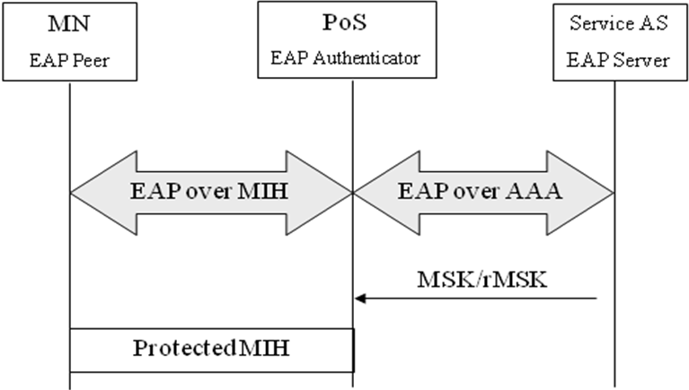
Figure 1 General process

Media Independent Authentication process

In this section we describe how the Media Independent Authentication using EAP is performed. Is worth noting that MIH is acting as a EAP lower layer so, EAP messages are going to be transported inside MIH messages (this extension must be added to the MIH protocol, if it is not available).
Before providing any service to the MN, a media independent authentication must be performed in order to authenticate and authorize the credentials provided by the MN. Therefore, in order to achieve this objective, MN credentials and authentication servers (AS) are needed in the architecture. To clarify, the next figure depicts a general message flow needed to achieve a Media independent authentication based on EAP.
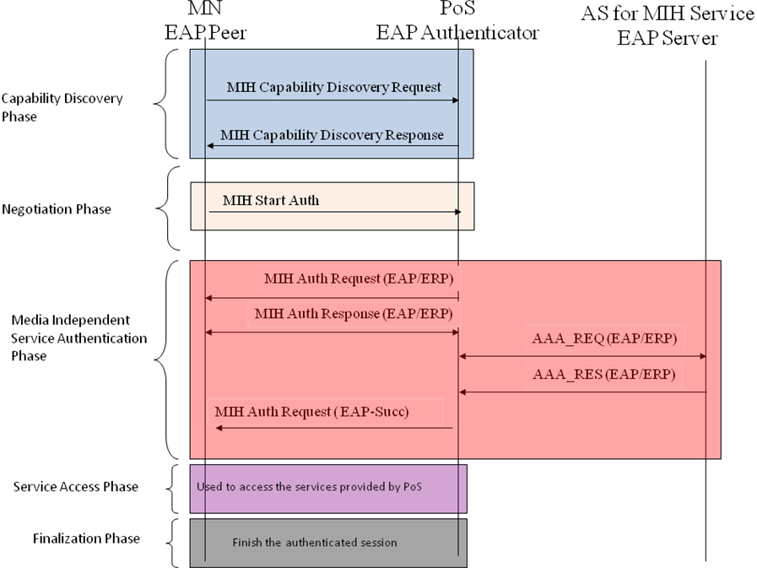
Figure 2 General message flow MN initiated

We divide Media Independent Authentication in four phases, which are:
- Capability Discovery Phase. In this phase, both the MN and the PoS exchange unprotected MIH messages in order to obtain the services which can be selected by the MN. PoS provide a list of the available services and the MN is aware about the different capabilities provided by a certain PoS.
- Negotiation Phase. In this phase the MN selects the different parameters, which have been discovered in the previous phase (Capability Discovery Phase), to be used in the Media Independent Service Authentication phase.
- Media Independent Service Authentication phase. The MN authenticates against a PoS (is acting as EAP authenticator) using a Service AS. To achieve this, EAP is transported by MIH protocol to the current PoS which manage the MN’s communications. In order to carry out the authentication the PoS may need a backed authentication server (Service AS, e.g. AAA server) to verify the MN’s credentials. After performing the authentication key material will be shared between the MN and the PoS. So, both at MN’s and PoS’ MIH layer key material is exported and it could be used to protect the rest of the communication (how to MIH is protected is explained in section 2.3). In order to preserve the security of the exported key material, the exported MSK is used as root key to derive new session keys which are use to protect the MIH packets. How this key hierarchy is carried out is described in section 2.3.
- Service Access phase. At this point, the MN is authenticated and authorized to use the MIH services, agreed and provided by the PoS. The authentication session is already established and the MIH protocol is protected by using the key material obtained in the Media Independent Service Authentication Phase. This phase is related with section 2.3 for key derivation and section 2.4 for protecting MIH protocol.
- Finalization phase. When the MN and the PoS desire to finish the authentication session in order to release resources and the MN’ state related with the provided services.

Internal architecture

In this section we describe the architecture needed to use the key material generated by the EAP authentication by the MIH layer in order to provide MIH packet protection.
To be available to use the key material provided by EAP from a layer which wants protection, this layer must be a lower layer of the EAP protocol, as specified in RFC5247. Therefore, to be available to protect MIH packets, MIH must act as EAP lower layer. In that sense, when the EAP authentication finish the key material (MSK) obtained throw the EAP authentication is exported to the MIH lower layer and using this key material the MIH layer could protect its packets.

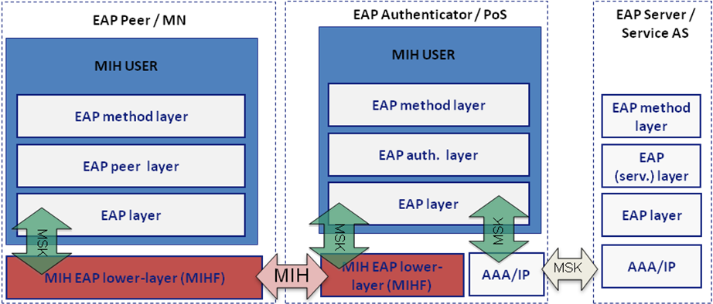
Figure 3 General architecture

Key Hierarchy

As we commented in the previous section, in Media Independent Authentication phase, a key hierarchy is needed in order to preserve MSK security. The proposed hierarchy is showed in the next figure.
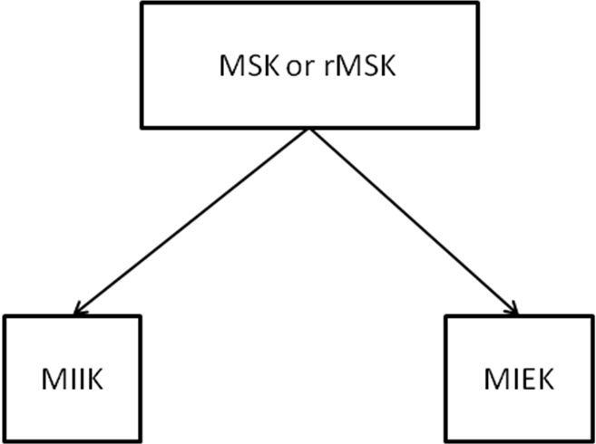
Figure 4 Key hierarchy proposed

Using the MSK or rMSK provided by the EAP authentication, as a root key, two keys are derived: MIIK (Media Independent Integrity Key), this key is used to provide integrity protection to the MIH protocol and MIEK (Media Independent Encryption Key), used to provide confidentiality to the MIH protocol. This key hierarchy has been based on the key hierarchy described in [IEEE802.21a].
The key generation algorithm is based on the following functions:
KDF : Key derivation function specified in RFC5246. The default KDF (i.e., IKEv2 PRF+ with based on HMAC-SHA-256 ) is used unless explicitly negotiated between MN and PoS.
The key hierarchy key hierarchy is derived in the following way:
- MIIK = KDF(MSK, “integrity key” | NONCE_P | NONCE_S | length)
  - Length of MIIK depends on the KDF used
  - NONCE_P: A random number generated by peer
  - NONCE_S: A random number generated by authenticator
- MIEK = KDF(MSK, “encryption key” | NONCE_P | NONCE_S | length)
  - Length of MIEK depends on the KDF used
  - NONCE_P: A random number generated by peer
  - NONCE_S: A random number generated by authenticator

CipherSuite

Confidentiality algorithms | Reference
ENCR_AES_CBC | NIST 800-38A
ENCR_NULL
Integrity algorithms | Reference
INTR_HMAC_SHA_96 | FIPS 180-1
INTR_CMAC_AES | NIST 800-38B
INTR_NULL
Confidentiality and Integrity algorithms | Reference
AUTH_ENC_AES_CCM | NIST 800-38C
KDF algorithms | Reference
PRF_CMAC_AES | NIST 800-108
PRF_HMAC_SHA1 | NIST 800-108

MIH Packet Protection

In this section we propose the MIH protocol message security. As we commented before, this is carried out in the Authenticated/Authorized phase. Once authentication process is finish, MIH layer has key material which could be used to protect MIH messages. To perform this, using the MSK as root key and using the mechanisms described in the previous section, the MIH protocol could be protected, by means of encrypting the MIH data using MIEK and providing integrity protection using MIIK. Moreover, there are some algorithms which provide confidentiality and integrity (i.e. encr_intr_aes_ccm) therefore, MIEK will be used as the key for performing these algorithms.
The protection provided to the MIH message can be in three ways: Confidentiality and Integrity protected, integrity protected or no protection. In the following, we describe how perform these three mechanism.
Next figure depicts the procedure to protect the MIH protocol. This procedure allows four types mechanisms to carry out the protection: No protection, use an integrity algorithm, use two algorithms one for confidentiality and another for integrity protection and the use of only one algorithm which provides confidentiality and integrity by itself. Note that integrity is always required when some type of protection is used, in others words, confidentiality cannot be provided without integrity.
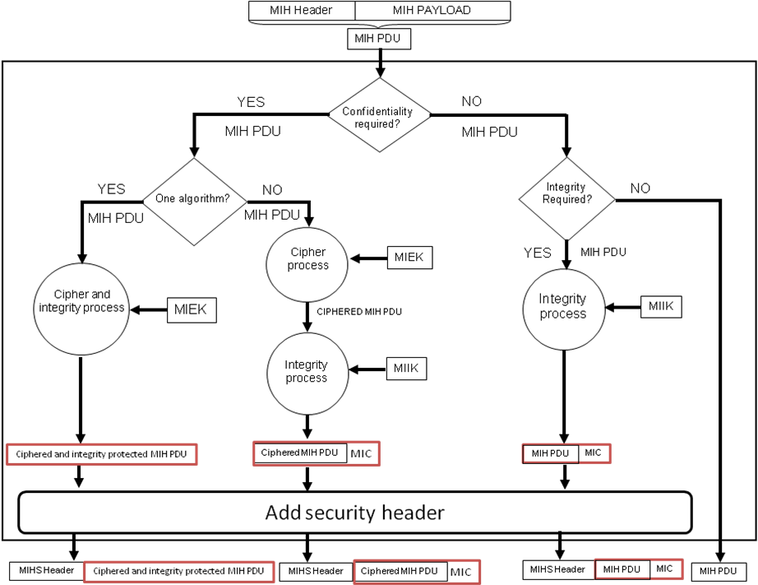
Figure 5 MIH packet protection procedure
MIH protocol is protected by the MIH layer itself. Therefore, MIH protocol security does not depend on others layers or mechanisms to be protected. Moreover, a new MIHS (MIH Security) Header is needed in order to be capable to provide integrity and confidentiality to the whole MIH message. This new header could provide useful information as if the message is confidentiality protected or not.

Extensions of IEEE802.21 Specification

New Commands

Primitives | Service Category | Description
MIH_Start_Auth | Command | Initiates the authentication process with a target PoS.
Extension: MIH_Capability_Discover | Command | To carry out the negotiation process.
MIH_Auth | Command | To perform the authentication process.
MIH_Finish_Auth | Command | For finishing the current secured session.

MIH_Start_Auth.request

Function
This primitive is used by the MIHF (MN side) to initiate the authentication process with a candidate PoS.

Semantics of service primitive
MIH_Start_Auth.request (
DestinationIdentifier,
SourceIdentifier,
KeyDistributionMechanism,
Integrity-Algorithm,
Cipher-Algorithm,
KDF-Algorithm,
Cipher-Required,
Identity-opt
)
Name | Data type | Description
DestinationIdentifier | MIHF_ID | This identifies the local MIHF or a remote MIHF that will be the destination of this request.
SourceIdentifier | MIHF_ID | This identifies the invoker of this primitive.
KeyDistributionMechanism | KEY_DIST | Identifies the selected key distribution mechanism.
Integrity-Algorithm | INT_ALG | Identifies the selected integrity algorithm.
Cipher-Algorithm | CIPH_ALG | Identifies the selected encryption algorithm.
KDF-Algorithm | KDF_ALG | Identifies the selected KDF algorithm.
Cipher-Required | BOOL | Use to indicate if cipher is going to be used
Identity-opt | ID_OPT | Provides a new identity to be used for optimization purposes.

When generated
This primitive is generated by the MN in order to start the authentication process to authenticate with the candidate PoS. This primitive is received by a remote MIHF.

Effect on receipt
The remote MIHF must generate a corresponding MIH_Auth request message which starts the service authentication process.

MIH_Start_Auth.indication

Function
This primitive is used to notify an MIH User about the reception of a MIH_Start_Auth request message.

Semantics of service primitive
MIH_Start_Auth.indication (
)

When generated
This primitive is generated by the PoS MIHF just receiving a MIH_start_Auth request message.

Effect on receipt
The MIH User must generate the corresponding MIH_Auth.request message providing to the MIHF the required information.

Extension: MIH_Capability_Discover.request
The parameters defined must be added to the existing ones in IEEE 802.21 MIH_Capability_Discover.request.

Function
This primitive is extended to carry out the crypto suite negotiation between the MN and the candidate PoS. This primitive is used by a Candidate PoS to show its current security capabilities.

Semantics of service primitive
MIH_Capability_Discover.request (
SourceIdentifier,
Session,
KeyDistributionMechanism,
Integrity-Algorithm,
Cipher-Algorithm,
KDF-Algorithm,
Cipher-Required,
Identity-opt
)
Name | Data type | Description
SourceIdentifier | MIHF_ID | This identifies the invoker of this primitive.
Session | SESSION_ID | This identifies a security session.
KeyDistributionMechanismList | KEY_DIST_LIST | Identifies the available key distribution mechanism.
Integrity-Algorithm-List | INT_ALG_LIST | Identifies the different integrity algorithms available.
Cipher-Algorithm-List | CIPH_ALG_LIST | Identifies the different encryption algorithms available.
KDF-Algorithm-List | KDF_ALG_LIST | Identifies the different KDF algorithm available.
Cipher-Required | BOOL | Use to indicate if cipher is going to be used
Identity-opt | ID_OPT | Provides a new identity to be used for optimization purposes.

When generated
Same effect as defined in MIH standard for MIH_Capability_Discover.request.

Effect on receipt
Same effect as defined in MIH standard for MIH_Capability_Discover.request.

Extension: MIH_Capability_Discover.indication
The parameters defined must be added to the existing ones in IEEE 802.21 MIH_Capability_Discover.indication.

Function
Same function as defined in MIH standard for MIH_Capability_Discover.indication.

Semantics of service primitive
MIH_Capability_Discover.indication (
SourceIdentifier,
Session,
KeyDistributionMechanism,
Integrity-Algorithm,
Cipher-Algorithm,
KDF-Algorithm,
Cipher-Required,
Identity-opt
)
Name | Data type | Description
SourceIdentifier | MIHF_ID | This identifies the invoker, which is a remote MIHF.
Session | SESSION_ID | This identifies a security session.
KeyDistributionMechanismList | KEY_DIST_LIST | Identifies the available key distribution mechanism.
Integrity-Algorithm-List | INT_ALG_LIST | Identifies the different integrity algorithms available.
Cipher-Algorithm-List | CIPH_ALG_LIST | Identifies the different encryption algorithms available.
KDF-Algorithm-List | KDF_ALG_LIST | Identifies the different KDF algorithm available.
Cipher-Required | BOOL | Use to indicate if cipher is going to be used
Identity-opt | ID_OPT | Provides a new identity to be used for optimization purposes.

When generated
Same effect as defined in MIH standard for MIH_Capability_Discover.indication

Effect on receipt
Same effect as defined in MIH standard for MIH_Capability_Discover.indication

Extension: MIH_Capability_Discover.response
The parameters defined must be added to the existing ones in IEEE 802.21 MIH_Capability_Discover.response.

Function
Same function as defined in MIH standard for MIH_Capability_Discover.response.

Semantics of service primitive
MIH_Capability_Discover.response (
SourceIdentifier,
Session,
KeyDistributionMechanism,
Integrity-Algorithm,
Cipher-Algorithm,
KDF-Algorithm,
Cipher-Required,
Identity-opt
)
Name | Data type | Description
SourceIdentifier | MIHF_ID | This identifies the invoker of this primitive.
Session | SESSION_ID | This identifies a security session.
KeyDistributionMechanism | KEY_DIST | Identifies the selected key distribution mechanism.
Integrity-Algorithm | INT_ALG | Identifies the selected integrity algorithm.
Cipher-Algorithm | CIPH_ALG | Identifies the selected encryption algorithm.
KDF-Algorithm | KDF_ALG | Identifies the selected KDF algorithm.
Cipher-Required | BOOL | Use to indicate if cipher is going to be used
Identity-opt | ID_OPT | Provides a new identity to be used for optimization purposes.

When generated
Same effect as defined in MIH standard for MIH_Capability_Discover.response.

Effect on receipt
Same effect as defined in MIH standard for MIH_Capability_Discover.response.

Extension: MIH_Capability_Discover.confirm
The parameters defined must be added to the existing ones in IEEE 802.21 MIH_Capability_Discover.confirm.

Function
Same function as defined in MIH standard for MIH_Capability_Discover.confirm.

Semantics of service primitive
MIH_Capability_Discover.confirm (
SourceIdentifier,
Session,
KeyDistributionMechanism,
Integrity-Algorithm,
Cipher-Algorithm,
KDF-Algorithm,
Cipher-Required,
Identity-opt
)
Name | Data type | Description
SourceIdentifier | MIHF_ID | This identifies the invoker, which is a remote MIHF.
Session | SESSION_ID | This identifies a security session.
KeyDistributionMechanism | KEY_DIST | Identifies the selected key distribution mechanism.
Integrity-Algorithm | INT_ALG | Identifies the selected integrity algorithm.
Cipher-Algorithm | CIPH_ALG | Identifies the selected encryption algorithm.
KDF-Algorithm | KDF_ALG | Identifies the selected KDF algorithm.
Cipher-Required | BOOL | Use to indicate if cipher is going to be used
Identity-opt | ID_OPT | Provides a new identity to be used for optimization purposes.

When generated
Same effect as defined in MIH standard for MIH_Capability_Discover.confirm.

Effect on receipt
Same effect as defined in MIH standard for MIH_Capability_Discover.confirm.

MIH_Auth.request

Function
This primitive is used to perform the authentication process.

Semantics of service primitive
MIH_Auth.request (
DestinationIdentifier,
SourceIdentifier,
Session,
Nonce,
AuthenticationInformation,
AUTH
)
Name | Data type | Description
DestinationIdentifier | MIHF_ID | This identifies the local MIHF or a remote MIHF that will be the destination of this request.
SourceIdentifier | MIHF_ID | This identifies the invoker of this primitive.
Session | SESSION_ID | This identifies a security session.
*Nonce | NONCE_VALUE | Represent a random value.
AuthenticationInformation | AUTH_INF_VALUE | The authentication information used to authenticate a MN.
AUTH | AUTH_VALUE | To bind the algorithms and parameters to the authentication.
*Only included the first time MIH_Auth.request is sent.

When generated
This primitive is generated after receive a MIH_Start_Auth request. This primitive requests the required information to authenticate a MN.

Effect on receipt
The MN must generate a MIH_Auth response in order to provide the required information if it is required.

MIH_Auth.indication

Function
This primitive is used by an MIHF to indicate to an MIH User that an MIH_Auth request or a MIH_Auth response was received from a remote MIHF.

Semantics of service primitive
MIH_Auth.indication (
AuthenticationInformation
)
Name | Data type | Description
AuthenticationInformation | AUTH_INF_VALUE | The authentication information used to authenticate a MN.

When generated
This primitive is generated after receive a MIH_Auth request/response.

Effect on receipt
An MIH User receiving this indication must provide the authentication information.

MIH_Auth.response

Function
This primitive is used to perform the authentication process.

Semantics of service primitive
MIH_Auth.response (
DestinationIdentifier,
SourceIdentifier,
Session,
Nonce,
AuthenticationInformation,
AUTH
)
Name | Data type | Description
DestinationIdentifier | MIHF_ID | This identifies a remote MIHF that will be the destination of this request.
SourceIdentifier | MIHF_ID | This identifies the invoker of this primitive.
Session | SESSION_ID | This identifies a security session.
*Nonce | NONCE_VALUE | Represent a random value.
AuthenticationInformation | AUTH_INF_VALUE | The authentication information used to authenticate a MN.
AUTH | AUTH_VALUE | To bind the algorithms and parameters to the authentication.
*Only included the first time MIH_Auth.response is sent.

When generated
This primitive is generated after receive a MIH_Auth indication. This primitive provide the required information to authenticate a MN.

Effect on receipt
The MN must generate a MIH_Auth request in order to request required information.

MIH_Finish_Auth.request

Function
This primitive is used to request the finalization of the established security session.

Semantics of service primitive
MIH_Finish_Auth.request (
DestinationIdentifier,
SourceIdentifier,
Session,
IntegrityAuth
)
Name | Data type | Description
DestinationIdentifier | MIHF_ID | This identifies a remote MIHF that will be the destination of this request.
SourceIdentifier | MIHF_ID | This identifies the invoker of this primitive.
Session | SESSION_ID | This identifies a security session.
IntegrityAuth | INTREGRITY_DATA | This contains the message integrity data.

When generated
This primitive is generated by a MIHF to finalize the current security session.

Effect on receipt
The MIHF must generate a MIH_Finish_Auth response in order to confirm the session finalization.

MIH_Finish_Auth.response

Function
This primitive is used to confirm from the remote MIHF that the authentication session has been closed.

Semantics of service primitive
MIH_Finish_Auth.response (
DestinationIdentifier,
SourceIdentifier,
Session,
IntegrityAuth
)
Name | Data type | Description
DestinationIdentifier | MIHF_ID | This identifies a remote MIHF that will be the destination of this request.
SourceIdentifier | MIHF_ID | This identifies the invoker of this primitive.
Session | SESSION_ID | This identifies a security session.
IntegrityAuth | INTREGRITY_DATA | This contains the message integrity data.

When generated
This primitive is generated by a remote MIHF after receiving a MIH_Finish_Auth request.

Effect on receipt
The MIHF must generate a MIH_Finish_Auth.indication in order to finalize the session finalization.

MIH_Finish_Auth.indication

Function
This primitive is used to notify to the corresponding MIH User about finalize the security session.

Semantics of service primitive
MIH_Finish_Auth.indication (
SourceIdentifier,
Session
)
Name | Data type | Description
SourceIdentifier | MIHF_ID | This identifies the invoker, which is a remote MIHF.
Session | SESSION_ID | This identifies a security session.

When generated
This primitive is generated by a MIHF to finalize the current security session after receiving a MIH_Finish_Auth request/response message.

Effect on receipt
The security session finish.

MIH Protocol Extensions

MIH_Start_Auth request

MIH Header Fields (SID = 2, Opcode = 1, AID = XX-1)
Destination Identifier = receiving MIHF ID
(Destination MIHF ID TLV)
Source Identifier = sending MIHF ID
(Source MIHF ID TLV)
KeyDistributionMechanism
(Key Distribution Mechanism TLV)
Integrity-Algorithm
(Integrity Algorithm TLV)
Cipher-Algorithm
(Cipher Algorithm TLV)
KDF-Algorithm
(KDF Algorithm TLV)
Cipher-Required
(Cipher Required TLV)
Identity-opt
(Identity Opt TLV)

Extension: MIH_Capability_Discover request

MIH Header Fields (SID = 2, Opcode = 1, AID = XX-1)
Source Identifier = sending MIHF ID
(Source MIHF ID TLV)
Session
(Session TLV)
KeyDistributionMechanismList
(Key Distribution Mechanism List TLV)
Integrity-Algorithm-List
(Integrity Algorithm List TLV)
Cipher-Algorithm-List
(Cipher Algorithm List TLV)
KDF-Algorithm-List
(KDF Algorithm List TLV)
Cipher-Required
(Cipher Required TLV)
Identity-opt
(Identity Opt TLV)

Extension: MIH_Capability_Discover response

MIH Header Fields (SID = 2, Opcode = 1, AID = XX-1)
Source Identifier = sending MIHF ID
(Source MIHF ID TLV)
Session
(Session TLV)
KeyDistributionMechanism
(Key Distribution Mechanism TLV)
Integrity-Algorithm
(Integrity Algorithm TLV)
Cipher-Algorithm
(Cipher Algorithm TLV)
KDF-Algorithm
(KDF Algorithm TLV)
Cipher-Required
(Cipher Required TLV)
Identity-opt
(Identity Opt TLV)

MIH_Auth request

MIH Header Fields (SID = 2, Opcode = 1, AID = XX-1)
Destination Identifier = receiving MIHF ID
(Destination MIHF ID TLV)
Source Identifier = sending MIHF ID
(Source MIHF ID TLV)
Session
(Session TLV)
Nonce
(Nonce TLV)
AuthenticationInformation
(Authentication Information TLV)
AUTH
(AUTH TLV)

MIH_Auth response

MIH Header Fields (SID = 2, Opcode = 3, AID = XX-3)
Destination Identifier = receiving MIHF ID
(Destination MIHF ID TLV)
Source Identifier = sending MIHF ID
(Source MIHF ID TLV)
Session
(Session TLV)
Nonce
(Nonce TLV)
AuthenticationInformation
(Authentication Information TLV)
AUTH
(AUTH TLV)

MIH_Finish_Auth request

MIH Header Fields (SID = 2, Opcode = 1, AID = XX-1)
Destination Identifier = receiving MIHF ID
(Destination MIHF ID TLV)
Source Identifier = sending MIHF ID
(Source MIHF ID TLV)
Session
(Session TLV)
IntegrityAuth
(Integrity Auth TLV)

MIH_Finish_Auth response

MIH Header Fields (SID = 2, Opcode = 2, AID = XX-2)
Destination Identifier = receiving MIHF ID
(Destination MIHF ID TLV)
Source Identifier = sending MIHF ID
(Source MIHF ID TLV)
Session
(Session TLV)
IntegrityAuth
(Integrity Auth TLV)

Message flows
This section shows the message flow of the different phases explained using the MIH commands defined before.

Capability Discovery Phase

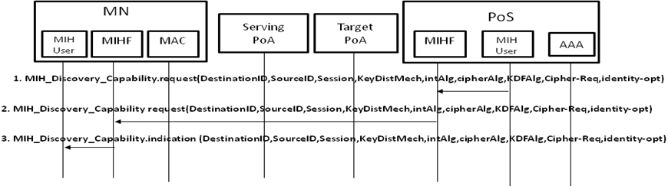
Figure 6 Capability Discovery phase messages (PoS initiated)

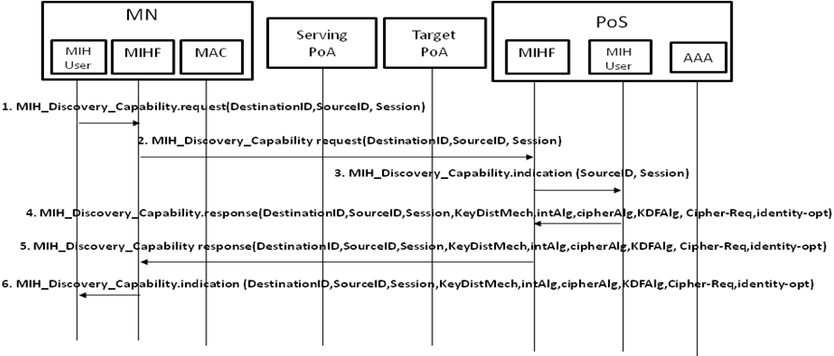
Figure 7 Capability Discovery phase messages (MN initiated)

Negotiation Phase
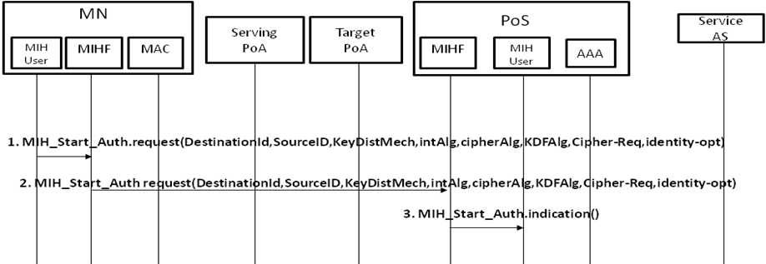
Figure 8 Negotiation Phase messages

Media Independent Service Authentication phase
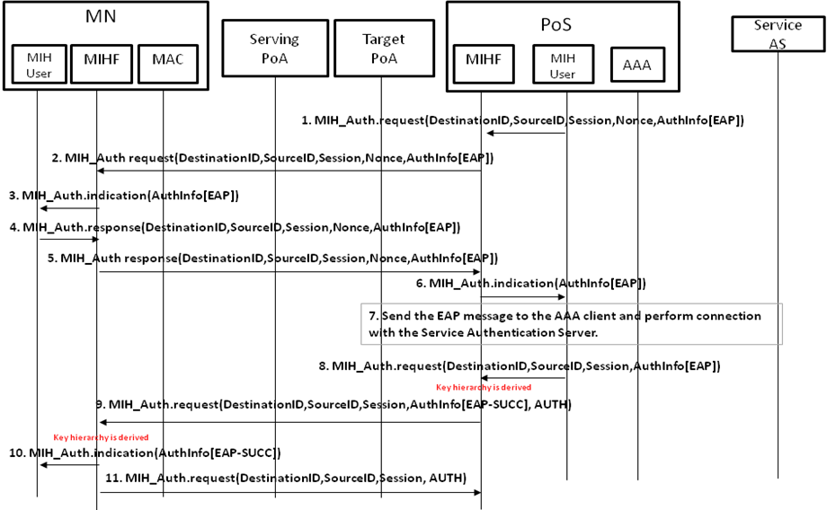
Figure 9 Media Independent Service Authentication Phase messages
In this figure is shown the media independent service authentication phase. The last messages 10 and 11 have an AUTH TLV in order to perform a binding for checking, if the different algorithms and parameters used in the authentication procedure were feasible. The algorithms and parameters are known during the capability discovery phase by the MN from the PoS and they are selected during the negotiation phase. If there is any problem checking the AUTH TLV, the authentication is aborted. Moreover, in order to carry out the binding a new flag is needed to indicate that the messages number 10 and 11 are the last ones.
Note that this phase is carried out due to the negotiation phase has been performed and the required parameters have been selected.

Finalization phase

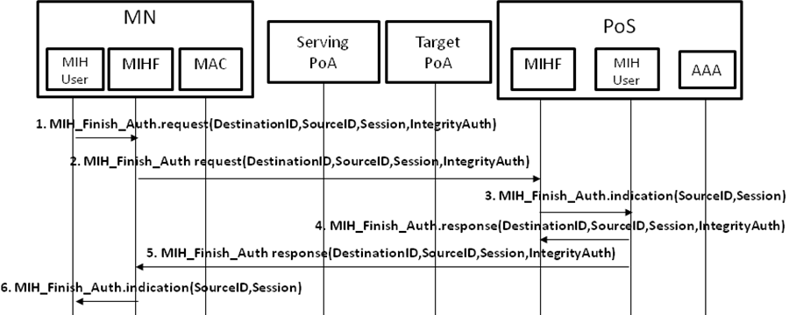
Figure 10 Finalization phase messages

Bundle option with WI#1 option B

Key Hierarchy extension

Regarding the key hierarchy proposed for Media Independent Authentication phase, needed in order to preserve MSK security, for the bundle option in WI#1 option B we propose to extend the existing hierarchy to provide a MS-PMK. Using the MSK or rMSK exported from the EAP authentication a new key called MS-ROOT is derived. A set of MS-PMK can be derived from the MS-ROOT key, acting as root key, to be used to protect the communication channel.
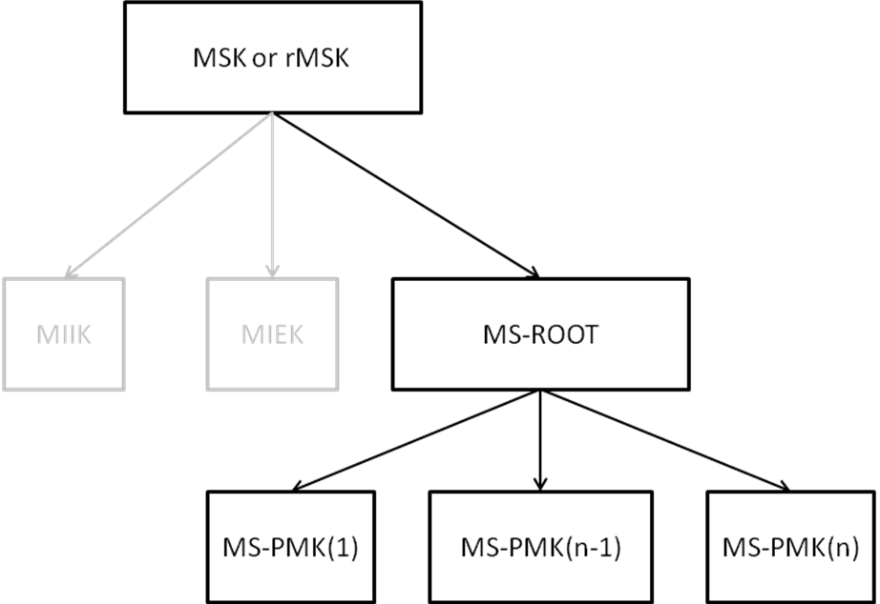
Figure 11 Key hierarchy proposed

This MS-PMK is used as media-specific pre-shared key to assist the key distribution methods in working item #1. This key hierarchy has been based on the key hierarchy described in [IEEE802.21a].
Following the same aspects as in the previous section, the MS-PMK will be derived as follows:
MS-PMK =KDF(MS-ROOT, “MS-PMK” | MN_LINK_ID | POA_LINK_ID | length)
- Length of MS-PMK depends on the KDF used.
- MN_LINK_ID: Link identifier of MN, encoded as LINK_ID data type
- POA_LINK_ID: Link identifier of media-specific authenticator, encoded as LINK_ID data type

Services: Key Distribution Mechanisms

The described solution in this document as well as provide key material to protect the MIH protocol, the new key hierarchy generated could be use to assist the key distribution to operated in the context of IEEE 802.21a working item #1 to reduce the media-specific network access time after a handoff. In that sense, this solution can assist the following key distribution mechanisms:
- Push key distribution. Its objective is to push a key into the target PoA by the PoS which controls that PoA. The key to be pushed could be derived from key hierarchy (see section 2.3) since the PoS and the MN have the necessary key material. To perform the installation the MN uses the MIH protocol, which at this point could be protected (see section 2.4), to notify the PoS to start the key installation.
- Reactive pull key distribution. It is performed after the MN moves to the target PoA. It assumes that both the MN and the PoS shares a symmetric key, in that way, the symmetric key is derived from the key hierarchy shared between the MN and the PoS, section 3.1. Therefore, the key distribution to the target PoA could be performed, for example, executing an EAP authentication where the PoS act as a local AAA server. The general message flow is depicted in the next figure.
- Proactive pull key distribution. This mechanism allows the MN to perform a pro-actively media specific authentication with the target PoA without being directly connected to the wireless link of the target PoA by means sending level two frames throw the PoS to the target PoA. As in reactive pull key distribution, the key hierarchy shared between the MN and the PoS could be used in order to derive a shared key to be used in the authentication process, where the PoS will be acting as a local AAA.

Bundle option: Extensions of IEEE802.21 Specification

New commands

Primitives | Service Category | Description
MIH_Push_Key | Command | To perform the push key distribution mechanism
MIH_Proact_Pull_key | Command | To perform the proactive pull key distribution mechanism.

MIH_Push_Key.request

Function
This primitive is used to request to a remote MIHF (PoS) to install a key in a target PoA.

Semantics of service primitive
MIH_Push_Key.request (
DestinationIdentifier,
SourceIdentifier,
Session,
PoAIndentifier,
Link_id,
IntegrityAuth
)
Name | Data type | Description
DestinationIdentifier | MIHF_ID | This identifies a remote MIHF that will be the destination of this request.
SourceIdentifier | MIHF_ID | This identifies the invoker of this primitive.
Session | SESSION_ID | This identifies a security session.
PoAIdentifier | PoA_ID | This identifies a PoA.
Link_id | Link_Addr | This contains the MAC address of the MN’s active interface.
IntegrityAuth | INTREGRITY_DATA | This contains the message integrity data.

When generated
This primitive is generated by an MIHF from the MN to request a remote MIHF, the Serving PoS, to install a key in a target PoA.

Effect on receipt
The remote MIHF must generate a MIH_Push_Key response in order to confirm that the key has been installed successful.

MIH_Push_Key.indication

Function
This primitive is used to send a key to the corresponding MIH User by a remote MIHF (PoS side).

Semantics of service primitive
MIH_Push_Key.indication (
MS-Key
)
Name | Data type | Description
MS-Key | KEY | Identifies a media specific key

When generated
This primitive is generated by a remote MIHF after receiving a MIH_Push_Key response to send a key to the corresponding MIH User.

Effect on receipt
A media specific key is delivered to the corresponding MIH User.

MIH_Push_Key.response

Function
This primitive is used to confirm that the key installation has been carried out.

Semantics of service primitive
MIH_Push_Key.response (
DestinationIdentifier,
SourceIdentifier,
Session,
PoAIndentifier,
IntegrityAuth
)
Name | Data type | Description
DestinationIdentifier | MIHF_ID | This identifies a remote MIHF that will be the destination of this request.
SourceIdentifier | MIHF_ID | This identifies the invoker of this primitive.
Session | SESSION_ID | This identifies a security session.
IntegrityAuth | INTREGRITY_DATA | This contains the message integrity data.

When generated
This primitive is generated by a remote MIHF after receiving a MIH_Push_Key request to confirm that a key installation has been performed.

Effect on receipt
The remote MIHF must generate a MIH_Push_Key confirm in order to confirm that the key has been installed successful.

MIH_Proact_Pull_key.request

Function
This primitive is used by the MN in order to request a key installation in a target PoA.

Semantics of service primitive
MIH_Proact_Pull_key.request (
DestinationIdentifier,
SourceIdentifier,
Session,
PoAIndentifier,
ProactivePullInformation,
IntegrityAuth
)
Name | Data type | Description
DestinationIdentifier | MIHF_ID | This identifies a remote MIHF that will be the destination of this request.
SourceIdentifier | MIHF_ID | This identifies the invoker of this primitive.
Session | SESSION_ID | This identifies a security session.
PoAIdentifier | PoA_ID | This identifies a PoA.
ProactivePullInformation | PROACT_PULL_INF | This contains specific data to carry out the key installation.
IntegrityAuth | INTREGRITY_DATA | This contains the message integrity data.

When generated
This primitive is generated by the MN in order to perform a key installation in a target PoA through the Serving PoS.

Effect on receipt
The MN must generate a MIH_Proact_Pull response in order to provide the required information.

MIH_Proact_Pull_key.indication

Function
This primitive is used by the remote MIHF in order to notify the corresponding MIH user about the reception of a MIH_Proact_Pull request.

Semantics of service primitive
MIH_Proact_Pull_key.indication (
PoAIndentifier,
ProactivePullInformation,
)
Name | Data type | Description
PoAIdentifier | PoA_ID | This identifies a PoA.
ProactivePullInformation | PROACT_PULL_INF | This contains specific data to carry out the key installation.

When generated
This primitive is generated by the MN in order to perform a key installation in a target PoA through the Serving PoS.

Effect on receipt
The MN must generate a MIH_Proact_Pull response in order to provide the required information to perform the key distribution.

MIH_Proact_Pull_key.response

Function
This primitive is used by the Serving PoS in order to carry out the key distribution.

Semantics of service primitive
MIH_Proact_Pull_key.response (
DestinationIdentifier,
SourceIdentifier,
Session,
PoAIndentifier,
ProactivePullInformation,
IntegrityAuth
)
Name | Data type | Description
DestinationIdentifier | MIHF_ID | This identifies a remote MIHF that will be the destination of this request.
SourceIdentifier | MIHF_ID | This identifies the invoker of this primitive.
Session | SESSION_ID | This identifies a security session.
ProactivePullInformation | PROACT_PULL_INF | This contains specific data to carry out the key installation.
IntegrityAuth | INTREGRITY_DATA | This contains the message integrity data.

When generated
This primitive is generated after receive a MIH_Proact_Pull indication. This primitive provide the required information to perform the key distribution.

Effect on receipt
The MN must generate a MIH_Proact_Pull request in order to provide the required information until the key distribution is completed.

Bundle option: MIH Protocol Extensions

MIH_Push_Key request

MIH Header Fields (SID = 2, Opcode = 1, AID = XX-1)
Destination Identifier = receiving MIHF ID
(Destination MIHF ID TLV)
Source Identifier = sending MIHF ID
(Source MIHF ID TLV)
Session
(Session TLV)
PoAIdentifier
(PoA Identifier TLV)
IntegrityAuth
(Integrity Auth TLV)

MIH_Push_Key response

MIH Header Fields (SID = 2, Opcode = 2, AID = XX-3)
Destination Identifier = receiving MIHF ID
(Destination MIHF ID TLV)
Source Identifier = sending MIHF ID
(Source MIHF ID TLV)
Session
(Session TLV)
IntegrityAuth
(Integrity Auth TLV)

MIH_Proact_Pull_key request

MIH Header Fields (SID = 2, Opcode = 1, AID = XX-1)
Destination Identifier = receiving MIHF ID
(Destination MIHF ID TLV)
Source Identifier = sending MIHF ID
(Source MIHF ID TLV)
Session
(Session TLV)
PoAIdentifier
(PoA Identifier TLV)
ProactivePullInformation
(Proactive Pull Information TLV)
IntegrityAuth
(Integrity Auth TLV)

MIH_Proact_Pull_key response

MIH Header Fields (SID = 2, Opcode = 2, AID = XX-1)
Destination Identifier = receiving MIHF ID
(Destination MIHF ID TLV)
Source Identifier = sending MIHF ID
(Source MIHF ID TLV)
Session
(Session TLV)
ProactivePullInformation
(Proactive Pull Information TLV)
IntegrityAuth
(Integrity Auth TLV)

Bundle option: Message flow

Push key distribution

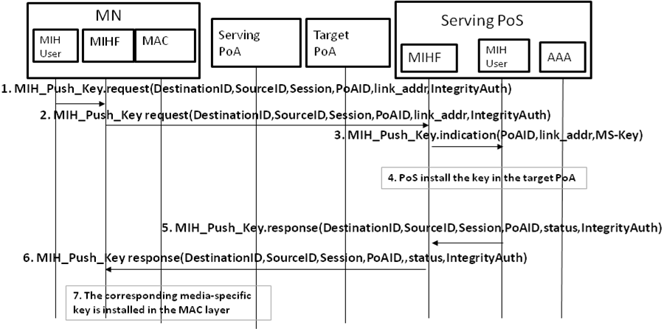
Figure 12 Push key distribution message

Proactive Pull key distribution

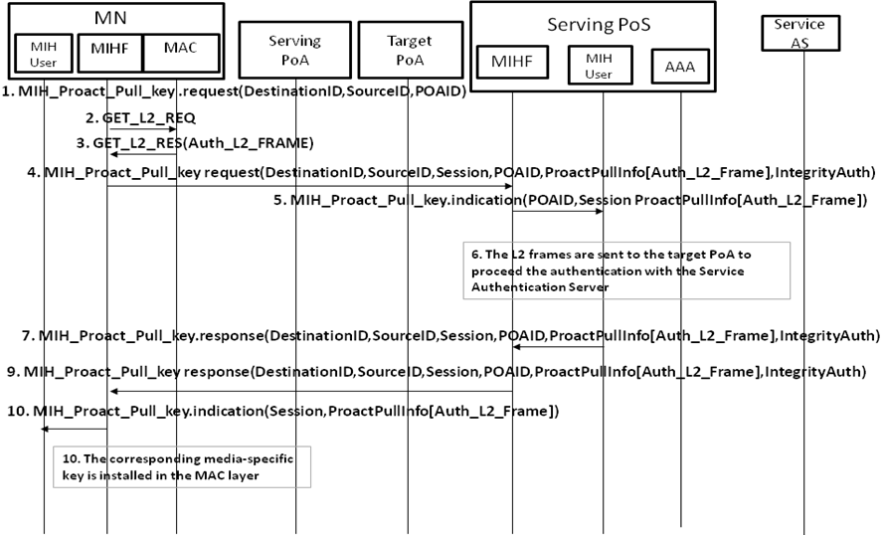
Figure 13 Proactive pull key distribution messages

Optimized pull key distribution

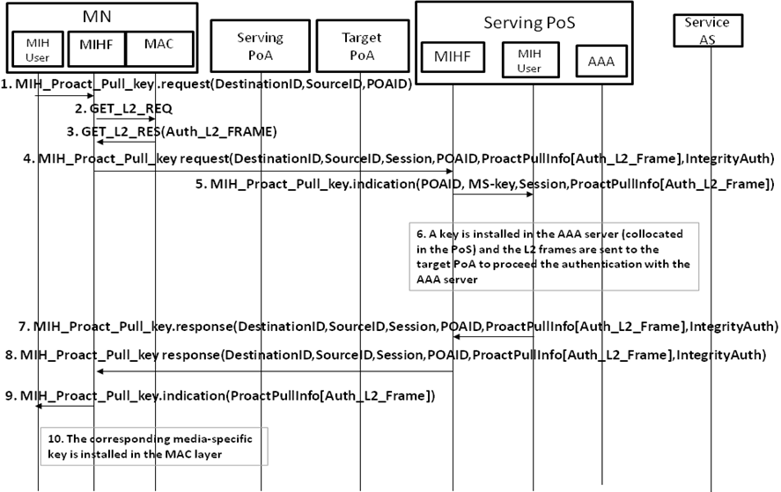
Figure 14 Optimized proactive pull key distribution messages

Reactive pull key distribution

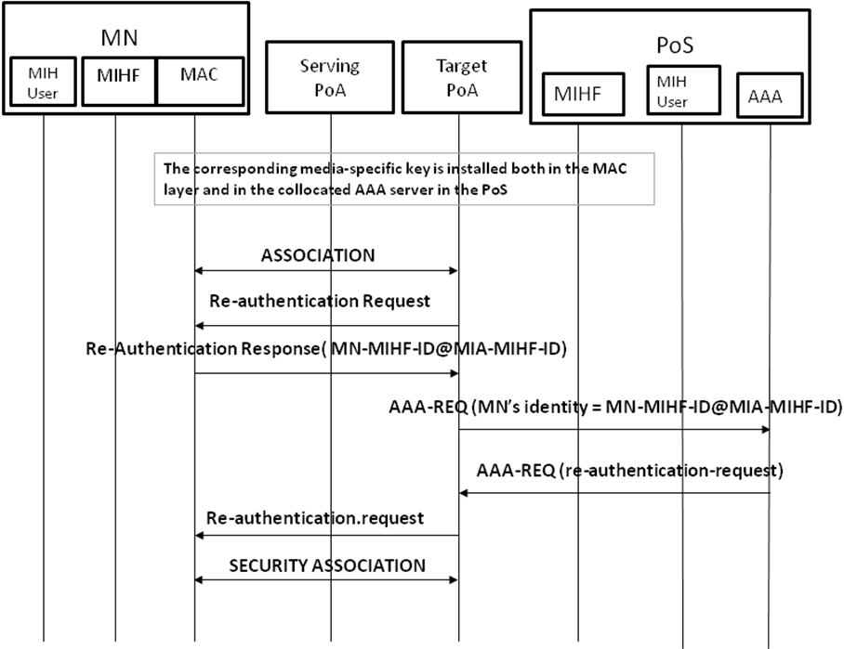
Figure 15 Reactive pull key distribution messages

Alternatives to transport EAP

In this section we analyze PANA (RFC 5191) as alternative to transport EAP between the MN and the PoA in order to authenticate the MN. Using PANA as protocol the actual architecture would be updated as follows: MN would be acting as PaC (PANA Client) and PoS as PAA (PANA Authentication Agent) and PoA as EP (Enforcement Point).
PANA is a protocol (RFC 5191) defined under the IETF and defines a network-layer transport for EAP. Moreover, it is a secure protocol where a security association is created after successfully completion of the EAP authentication creating a MSK. Using this cryptographic material protocol messages could be protected. Furthermore, PANA provides pre-authentication supports (RFC 5873) which allows a MN to establish a PANA session with a target PoS/PAA before to perform the movement. Therefore, PANA protocol provides all the mechanisms necessary to perform a secured seamless handover by the MN once a PANA session is established between the MN and its serving PoS (PAA).
As we explained in the previous sections, PANA achieves the same objectives as MIH protocol (protocol security and seamless handover). But PANA has some lacks which are inherent to its definition which provokes that it could not be used instead of MIH protocol. We have identified a main issue, this is, PANA is a network-layer protocol (it works under UDP) so, PANA assume that the MN has IP connectivity.
We can explain a scenario that must be taken into account shown in Figure 16. The MN is attached to a serving WiFi PoA in a domain. The MN is moving quickly and through the information server knows that there are a WiFi PoA and WiMAX PoA, which belongs to another domain. The WiFi PoA is reachable before the WiMAX PoA, but for network selection reasons (e.g. MN is moving quickly), a pre-authentication with the WiMAX PoA must be performed due to WiMAX provide a better wideband. So, the WiFi PoA could be use as a bridge to deliver the WiMAX link-layer frames to the WiMAX PoA. This can be performed using MIH protocol transported at link layer level; due to the MN has not IP connectivity with the (bridge) WiFi PoA.

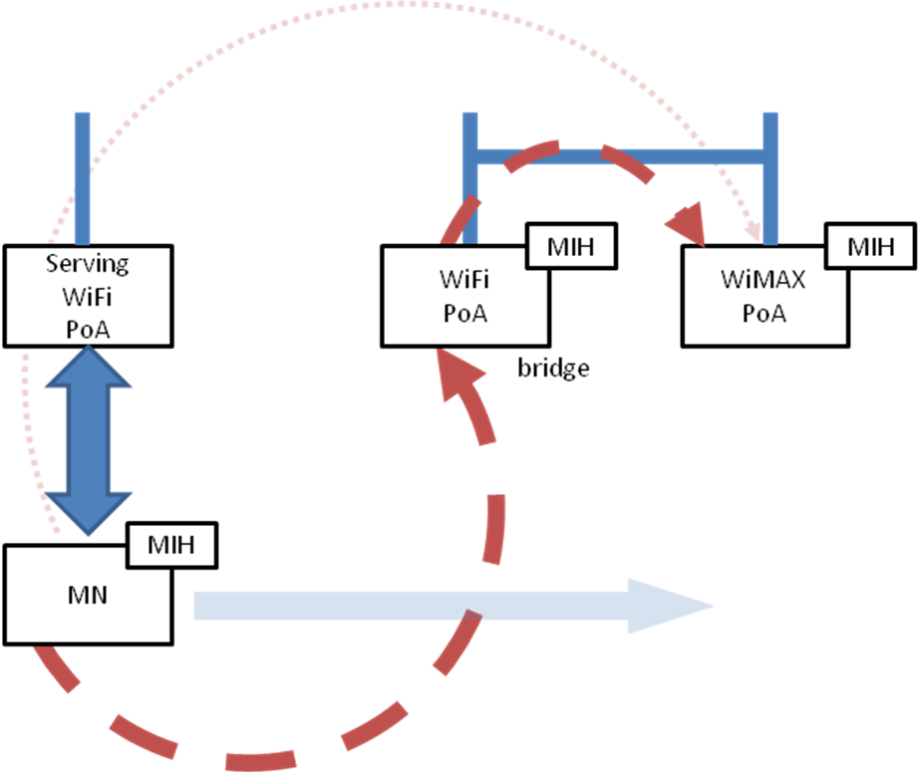
Figure 16 scenario using a PoA as a bridge

Another issue, even though this is not a limitation, we can anticipate that in terms of deployment is easier to convince a vendor to implement IEEE technologies than new IP layer protocols.

Conclusions

This proposal describes how to carry out a service authentication to access to a set of services. EAP is used to achieve the aim of authenticate the MN to satisfy the requirements of IEEE 802.21a work item #2. Moreover, once the authentication is performed the key material obtained after the service authentication is used to protect the MIH layer. Therefore, EAP provides the flexibility to avoid the need of performing subsequence authentication while the key material exported still valid.
In summary, using EAP and a new key hierarchy derived from the key material provided by EAP (to preserve MSK security) this proposal could protect the MIH protocol on MIH layer without other dependencies.
According to this proposal, we have analyzed the use of PANA instead of MIH as protocol between MN and PoS. Summarizing, PANA does not provide a completely solution to inter-technology handovers due to IP connectivity is needed beforehand, PANA lacks in scenarios where perform a handover using a link-layers protocol is useful. In other hand, MIH is a protocol more general allowing handovers between different distribution systems and it could be used to perform handover inter-technology at link layer level.

