Project | IEEE 802.21a  <https://mentor.ieee.org/802.21>
Title | Option III: EAP to conduct MIH service authentication and MIH packet protection
DCN | 21-10-0078-00-0sec
Date Submitted
Source(s) | Fernando Bernal-Hidalgo (University of Murcia), Rafael Marin-Lopez (University of Murcia).
Re:
Abstract | This document elaborates 21-10-0049-03-0Sec proposal: Proposal summary
Purpose | This document proposes a service authentication based on EAP and how this authentication could be used to protect the MIH protocol.
Notice | This document has been prepared to assist the IEEE 802.21 Working Group. It is offered as a basis for discussion and is not binding on the contributing individual(s) or organization(s). The material in this document is subject to change in form and content after further study. The contributor(s) reserve(s) the right to add, amend or withdraw material contained herein.
Release | The contributor grants a free, irrevocable license to the IEEE to incorporate material contained in this contribution, and any modifications thereof, in the creation of an IEEE Standards publication; to copyright in the IEEE’s name any IEEE Standards publication even though it may include portions of this contribution; and at the IEEE’s sole discretion to permit others to reproduce in whole or in part the resulting IEEE Standards publication. The contributor also acknowledges and accepts that IEEE 802.21 may make this contribution public.
Patent Policy | The contributor is familiar with IEEE patent policy, as stated in Section 6 of the IEEE-SA Standards Board bylaws <http://standards.ieee.org/guides/bylaws/sect6-7.html#6> and in Understanding Patent Issues During IEEE Standards Development http://standards.ieee.org/board/pat/faq.pdf

Introduction

Scope
The scope of this document is to describe the solution based on EAP proposed in 21-10-0049-03-0sec-proposal-summary. More concretely, working item #2 option III.

Purpose
The purpose of this document is to describe the proposed approach for service authentication based on EAP and how this could be used to protect the MIH protocol. Moreover, this proposal assist working item #1 in order to perform the key distribution mechanisms. In particular, this document addresses the following functionalities:

Work Item #2 | Supported Functionality | Note
2 | Access Authentication | Yes
2 | MIH-Specific Authentication | Yes
2 | Key Hierarchy and Derivation | Yes
2 | MIH-Specific Protection | Yes
2 | Visited Domain Access | No*
Note*: Does not mention explicitly but the proposed approach may be applicable

Terminologies

EAP: Extensible Authentication Protocol
PoS: Point of Service
PoA: Point of Attachment
AS: Authentication Server
MN: Mobile Node

Definitions

MIH Service Authentication : Authentication to enable MIH services provided by PoS. In the context of 802.21a they could be key distribution services for working item #1. It also allows to protect MIH signalling as a consequence of a successful authentication.
PoS: is an entity that interacts with PoAs and facilitates service authentication of other entities attached to the other end of a link of a PoA.
MIH Service AS: It is an backend authentication server for the MIH service authentication.

References

[RFC 3748] H. Levkowetz, Ed. and et al, “Extensible Authentication Protocol (EAP)”
[RFC5247] B. Aboba, D. Simon and P. Enoren, “Extensible Authentication Protocol (EAP) Key Management Framework”
[RFC5246] T. Dierks and E. Rescorla, “The Transport Layer Security (TLS) Protocol Version 1.2”
[proauth] Subir Das, Ashutosh Dutta , Toshikazu Kodama, “Proactive Authentication and MIH security”, 21-09-0102-01-0Sec.
[RFC5191] D. Forsberg, Y. Ohba, B. Patil, H. Tschofenig and A. Yegin, “Protocol for Carrying Authentication for Network Access (PANA)”

EAP for MIH Service Authentication (Option III)

The main aim of this section is to provide a description about how EAP could be used, in the scope of IEEE 802.21a work item #2, to allow the MN gains MIH service from a PoS and protect the subsequent MIH messages specified in IEEE 802.21a work item #1. Two main objectives must be achieved. First one, to authenticate and authorize the MN, against a Service AS, to use the available services provided by the PoS; and the second one, to use the key material generated by the EAP authentication to protect the MIH signaling. The next figure shows the general process.

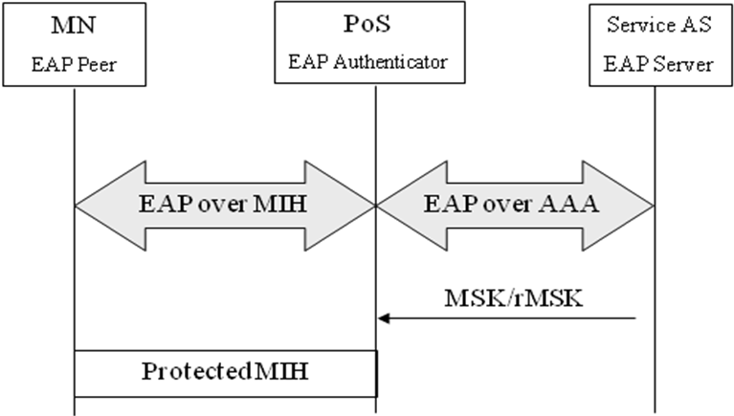
Figure 1 General process

Media Independent Authentication process

In this section we describe how the Media Independent Authentication using EAP is performed. Is worth noting that MIH is acting as a EAP lower layer so, EAP messages are going to be transported inside MIH messages (this functionality must be added to the MIH protocol, if it is not available).
Before providing any service to the MN, a media independent authentication must be performed in order to authenticate and authorize the credentials provided by the MN. Therefore, in order to achieve this objective, MN credentials and authentication servers (AS) are needed in the architecture. To clarify, the next figure depicts a general message flow needed to achieve a Media independent authentication based on EAP.
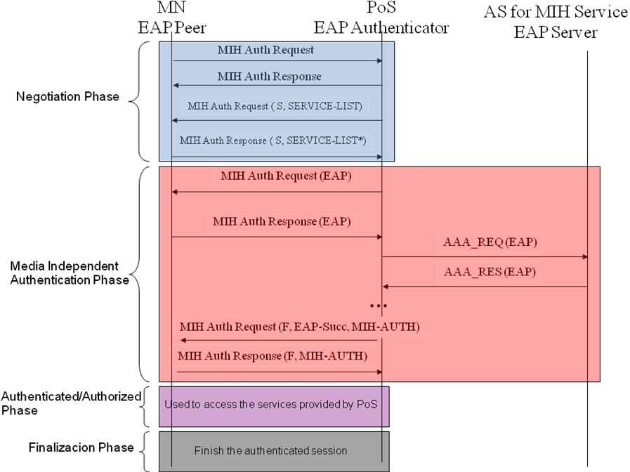
Figure 2 General Message Flow

We divide Media Independent Authentication in four phases, which are:
- Negotiation Phase. In this phase, both the MN and the PoS exchange unprotected MIH messages in order to agree on the services which want to be accessed by the MN. PoS provide a list of the available services and the MN chooses, for example, by priority the service or services that it supports.
- Media Independent Authentication phase. The MN authenticates against a PoS (is acting as EAP authenticator) using a service AS. To achieve this, EAP is transported by MIH protocol to the current PoS which manages the MN’s communications. In order to carry out the authentication, the PoS may need a backed authentication server (Service AS, e.g. AAA server) to verify the MN’s credentials. After performing the authentication, key material (e.g. MSK) will be shared between the MN and the PoS. So, both at MN’s and PoS’ MIH layer key material is exported and it could be used to protect the rest of the MIH signalling (how to MIH is protected is explained in section 2.3). In order to preserve the security of the exported key material, the exported MSK is used as root key to derive new session keys which are use to protect the MIH packets. How this key hierarchy is carried out is described in section 2.3.
- Authenticated/Authorized phase. At this point, the MN is authenticated and authorized to use the MIH services, agreed and provided by the PoS. The authentication session is already established and the MIH protocol is protected by using the key material obtained in the Media Independent Authentication. This phase is related with section 2.3 for key derivation and section 2.4 for protecting MIH protocol.
- Finalization phase. When the MN and the PoS desire to finish the authentication session in order to release resources and the MN’ state related with the provided services.

Internal architecture

In this section we describe the general internal architecture needed to use the key material generated by the EAP authentication by the MIH protocol acting as EAP lower layer in order to provide MIH packet protection.
To be available to use the key material provided by EAP from a layer which wants protection, this layer must be a lower layer of the EAP protocol, as specified in RFC5247. Therefore, to be available to protect MIH packets, MIH must act as EAP lower layer. In that sense, when the EAP authentication finishes, the key material (MSK) obtained through the EAP authentication is exported to the MIH lower layer which uses this key material to protect MIH protocol packets.

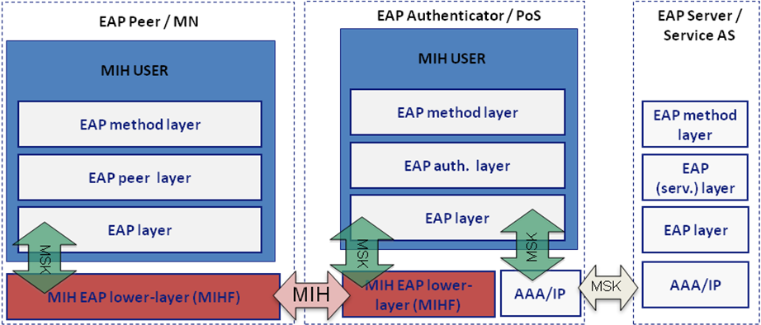
Figure 3 Internal architecture

Key Hierarchy

As we commented in the previous section, in Media Independent Authentication phase, a key hierarchy is needed in order to preserve MSK security. The proposed hierarchy is showed in the next figure.
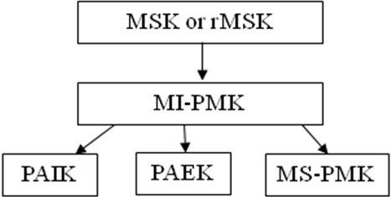
Figure 4 Key hierarchy proposed

Using the MSK (or rMSK if ERP is used instead of EAP) provided by the EAP authentication, a MI-PMK is derived in order to preserve the key material security. Using this MI-PMK as root key, other session keys are derived: PAIK, this key is used to provide integrity protection to the MIH protocol. PAEK is used to provide confidentiality to the MIH protocol by encrypting MIH data. MS-PMK used as media-specific pre-shared key to assist the key distribution methods in working item #1.This key hierarchy has been based on the key hierarchy described in [proauth].
The key generation algorithm is based on the following functions [proauth]:
KDF : Key derivation function specified in RFC5246. The default KDF (i.e., IKEv2 PRF+ with based on HMAC-SHA-256 ) is used unless explicitly negotiated between MN and PoS. PRF+ is defined in RFC4306 and it is calculated as follows:
PRF+ (K,S) = T1 | T2 | T3 | T4 | ...
Where:
‘|’ means concatenation
T1 = PRF (K, S | 0x01)
T2 = PRF (K, T1 | S | 0x02)
T3 = PRF (K, T2 | S | 0x03)
T4 = PRF (K, T3 | S | 0x04)
…
The key hierarchy key hierarchy is derived in the following way:
- MI-PMK = KDF(MK, “MI-PMK” | RAND_P | RAND_A | length)
  - Length of MI-PMK is 64 octets
  - MK (Master Key): MSK or rMSK
  - RAND_P: A random number generated by peer
  - RAND_A: A random number generated by authenticator
- MS-PMK =KDF(MI-PMK, “MS-PMK” | MN_LINK_ID | POA_LINK_ID | length)
  - Length of MS_PMK depends on each media. In the case of 802.11, Length=32.
  - MN_LINK_ID: Link identifier of MN, encoded as LINK_ID data type
  - POA_LINK_ID: Link identifier of media-specific authenticator, encoded as LINK_ID data type
- PAIK = KDF(MI-PMK, “integrity key” | RAND_P | RAND_A | length)
  - Length of PAIK is 64 octets
  - MI-PMK (Master Key)
  - RAND_P: A random number generated by peer
  - RAND_A: A random number generated by authenticator
- PAEK = KDF(MI-PMK, “encryption key” | RAND_P | RAND_A | length)
  - Length of PAEK is 64 octets
  - MI-PMK (Master Key)
  - RAND_P: A random number generated by peer
  - RAND_A: A random number generated by authenticator

MIH Packet Protection

In this section we show the MIH protocol message protection. As we commented before, this is carried out in the Authenticated/Authorized phase. Once authentication process is finished, MIH protocol owns key material (e.g MSK) which is used to protect MIH messages. To perform this, using the MSK as root key and using the mechanisms described in the previous section, the MIH protocol could be protected, by means of encrypting the MIH data using PAEK and providing integrity protection using PAIK. Next figure depicts how to protect the MIH protocol. MIC represents Message Integrity Code needed to provide integrity protection.

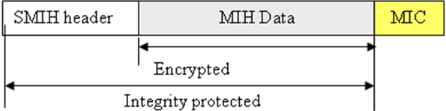
Figure 5 MIH packet protection

Key Distribution Mechanisms

The new key hierarchy generated could be used to assist the key distribution to operate in the context of IEEE 802.21a working item #1 to reduce the latency of media-specific network access process after a handoff. In that sense, this solution can assist the following key distribution mechanisms:
- Push key distribution. Its objective is pushes a key into the target PoA by the PoS which controls that PoA. The key to be pushed could be derived from key hierarchy (see section 2.3) due to both the PoS and the MN have the necessary shared key hierarchy. To perform the installation the MN uses the MIH protocol, which at this point could be protected (see section 2.4), to notify the PoS to start the key installation. The next figure depicts the push key mechanism message flow.
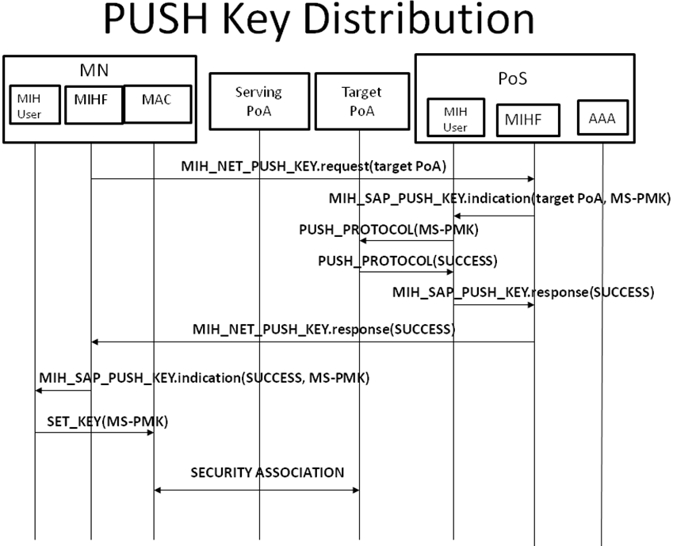
Figure 6 Push Key Distribution
- Reactive pull key distribution. It is performed after the MN moves to the target PoA. It assumes that both the MN and the PoS shares a symmetric key (MS-PMK) derived from the key hierarchy shared between the MN and the PoS, section 2.3. To perform key distribution, a media-specific EAP authentication based on an symmetric-key EAP authentication mechanism is carried out with the target PoA and where the PoS acts as a local AAA/EAP server. The general message flow is depicted in the next figure.
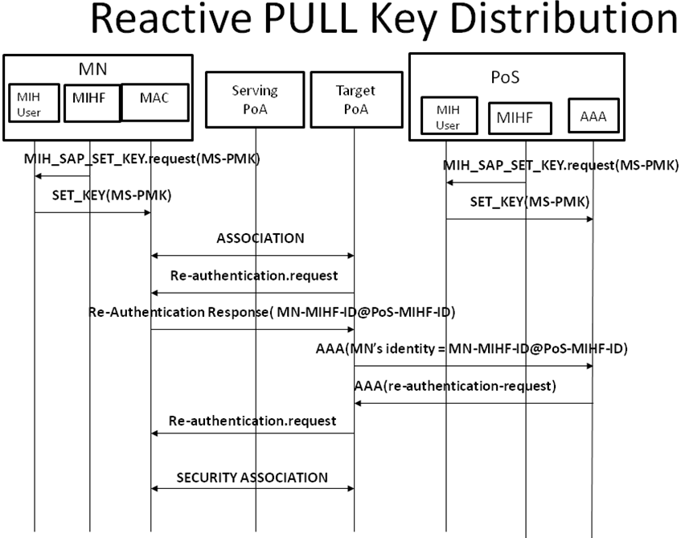
Figure 7 Reactive Pull Key Distribution
- Proactive pull key distribution. This mechanism allows the MN to perform a pro-actively media specific authentication with the target PoA without being directly connected to the wireless link of the target PoA by means sending link-layer frames to the target PoA through the PoS . As in reactive pull key distribution, the key hierarchy shared between the MN and the PoS could be used in order to derive a shared key to be used in the authentication process, where the PoS will be acting as a AAA server for the media-specific authentication.

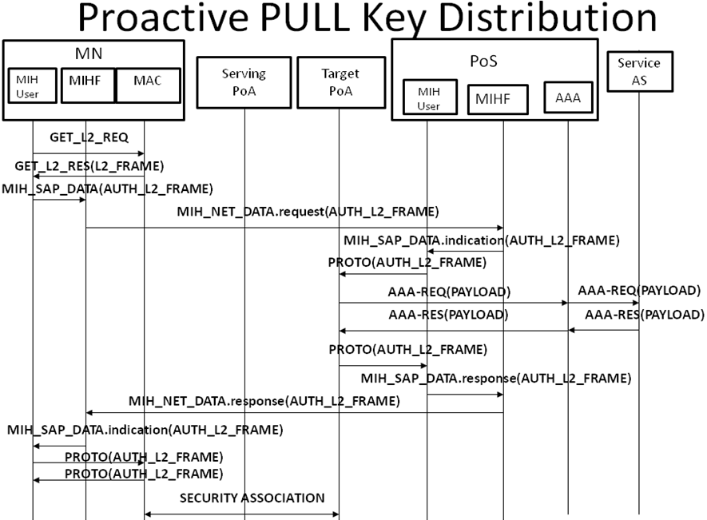
Figure 8 Proactive Key Distribution

Some clarifications about the key distribution message flows showed before.
- MIH_NET_DATA: represents a general communication message between two remote MIH entities. More concretely, represents a MIHF communication.
- MIH_SAP_DATA: It is a general message which is exchanged between MIH user and MIHF inside the same entity.
- PUSH_PROTOCOL: it represents the protocol used in push key distribution mechanism to install the key in the target PoA by the PoS (e.g. SNMP).
- PROTO: it represents the protocol needed between the PoS and the PoA, in the proactive pull key distribution mechanism, to send wireless link-layer frames over a wired environment.

Conclusions

This proposal describes how to carry out a service authentication to access to a set of services. EAP is used to achieve the aim of authenticating the MN to satisfy the requirements of IEEE 802.21a work item #2. Moreover, once the authentication is performed, the key material obtained after the service authentication is used to protect the MIH protocol. To achieve this goal a new key hierarchy is derived from the key material provided by EAP.
Note that the key hierarchy can be used to derive further key material to define a set of key distribution mechanisms that allows to reduce the latency of media-specific authentication during MN handoff. Thus, it is possible to assist also the working item #1.
As alternative to this proposal, we are considering to use PANA (RFC 5191) instead of MIH as protocol between MN and PoS in order to transport EAP messages to perform the MN authentication. In that sense, MN would be acting as PaC (PANA Client) and the PAA (PANA Authentication Agent) would reside at the PoS which would act as EP (Enforcement Point). Further analysis is still required though.

