Project | IEEE 802.21 TGa
Title | Security Solution Proposal for IEEE 802.21 TGa
Date Submitted | 05th July, 2009
Source(s) | Anirudh Bhatt (Samsung), Shubhranshu Singh (Samsung)
Abstract | - This document is detailed text proposal, subsequent to our earlier contribution with DCN number 21-09-0062-00-0sec. The proposal is in response to the IEEE 802.21 TGacall for proposals.
DCN | 21-09-0105-00-0sec

IEEE 802.21 Security TGa
Solution Proposal

1 Introduction 3
1.1 Scope 3
1.2 References 3
1.3 Definitions and abbreviations 4
1.3.1 Definitions 4
1.3.2 Abbreviations 4
2 Security Signaling Optimization during Handovers 5
2.1 Assumptions 5
2.2 Requirements 5
2.3 ERP based approach 6
2.4 MIH Primitive modifications 7
3 MIH Protocol Security 8
3.1 Basic Concept 8
3.2 Terminologies 9
3.3 MIH SAP Reference Model 9
3.3.1 Security functionalities of the MIH User 10
3.3.2 MIH_SAP enhancements 11
3.3.2.1 New primitives 11
3.3.2.2 Modified Primitives 16
3.3.3 New parameters/Data types 23
3.3.3.1 Parameters 23
3.3.3.2 New TLV 24
3.3.4 Authentication 25
3.3.4.1 Secondary Key Distribution 27
3.3.5 Security 29
3.3.5.1 Protected PDU 31
3.3.5.2 Integrity protection 32

Introduction

The IEEE 802.21-2008 specification [1] provides a media independent solution for handovers but does not address the security signaling required between heterogeneous networks. To perform a secure handover, the authorization and authentication between the MN and the target network needs to be addressed. However, security-related signaling can add significant delays to handover efforts. In many cases, service continuity can no longer be met, which affects time sensitive applications in particular, and ultimately impacts the user experience.
The other aspect is that the IEEE 802.21 draft does not address security at the MIH level. Because 802.21 provides services that affect network resources, cost and user experience, MIH level security will be an important factor to network providers that want to deploy these MIH services in their network. MIH level security may comprise of the following aspects: mutual or unilateral authentication of MIH peer nodes, authentication-based access control to MIH services, MIH protocol messages confidentiality, integrity and replay protection.
This solution proposal addresses several of the requirements detailed in [2]. The underlying concept and philosophy being to use the MIH protocol to transmit required information and signaling to initiate/facilitate requisite security transactions.

Scope

The scope of this document is to describe a solution to the high-level approaches for the following two identified work items in the 802.21 TGa CFP [3]
  - Security signaling optimization during handovers
  - MIH-level security

References

The following documents contain provisions which, through reference in this text, constitute provisions of the present document.

[1] IEEE Standard 802.21: "Media Independent Handover Services"
[2] 21-09-0014-00-0sec-security-tr
[3] 21-09-0017-03-0sec-security-tg-draft-call-for-proposals

[4] RFC 5295 - Specification for the Derivation of Root Keys from an Extended Master Session Key (EMSK)
[5] RFC 5296 – EAP extensions for EAP Re-authentication Protocol (ERP)

Definitions and abbreviations

Definitions

AAA domain: See RFC2903

Authenticator: EAP Authenticator
Candidate Authenticator: The authenticator on a candidate Point of Attachment (PoA) with respect to the mobile node.

EAP Pre-authentication: The utilization of EAP to pre-establish EAP keying material on an authenticator prior to attaching the peer to the access network managed by that authenticator.

Peer: EAP Peer
Serving Authenticator: The authenticator on the serving PoA/PoS

Target Authenticator: The authenticator on the target PoA/PoS

Abbreviations
In addition to the abbreviations that are defined in the 802.21 draft specification, the following abbreviations are defined:
.
BS Base station in 802.16 networks
CA Candidate Authenticator
CS Command service of the media independent handover services
ERS EAP Re-authentication Server
ES Event service of the media independent handover services
IAB Internet architecture board
IS Information service of the media independent handover services
FQDN Fully qualified domain name
MIH Media independent handover services
MIHF Media independent handover services function
MN Mobile node
MoS Mobility services (as defined in [10]) - includes the MIH IS, CS and ES)
MoSh Mobility service in home network
MoS3 Mobility service in third party network
MoSv Mobility service in visited network
MS Mobile station in 802.16 networks
MSTP Mobility services transport protocol
ND&S Network detection and selection
PFS Perfect forward secrecy
PoA Point of attachment
PoS Point of service
SA Serving Authenticator
TA Target Authenticator
MIHID MIH Identifier e.g. FQDN
NN Network Node

Security Signaling Optimization during Handovers

This section, Mobile Node is assumed to have multiple radios to access 802-based networks. Devices with multiple radios which cannot operate concurrently have certainly more stringent requirements on security signalling delays during handovers, compared to devices that have multiple radios available that can operate in an overlapping fashion during the handovers.
Each access network may have its own authentication scheme and key hierarchy. This report specifically addresses a security transition scheme between 802-based networks that are based on EAP authentication mechanisms.

Assumptions

Below assumptions are in particular relevant to this section on “handover security signaling Optimization”

- For the simplicity reason, below subsection text assumes that PoS and authenticator are logically co-located. In those deployment scenarios where these are two separate entities, it would be needed to define any interaction between these entities however, the proposed solution is expected to work as discussed here.
- Proposed solution is applicable in particular for inter-technology handover scenarios where EAP is used as access authentication protocol
- Proposed solution is applicable to single radio scenario although it would work for dual radio as well.
- Proposed solution is applicable to network initiated as well as mobile initiated scenarios
- Key hierarchy as defined in the RFC5295 is supported

Requirements

All the requirements as listed in the IEEE 802.21 TGa TR document are applicable for this proposal. Some important requirements relevant to this proposal are highlighted below:

  - Any key transport should ensure the key confidentiality and integrity protection.
  - The derived keys from the root keys must be cryptographically separate
  - A key Distribution Exchange mechanism may be used to distribute the keys to the appropriate MIH PoS entity

ERP based approach

The ERP based approach for the optimized media independent handover is based on and is compatible with RFC 5296 “EAP Extensions for EAP Re-authentication Protocol (ERP)”. However, if RFC 5296 is not supported by any of the involved entities then the required messages, e.g. between PoS and AAA would be carried as a newly defined attribute over AAA protocol. The steps involved are as below:

- Mobile Node, while on the serving network decides to handover to the serving network. This could be either mobile initiated or network initiated handover, as defined in the IEEE 802.21 Std-2008
- MN sends EAP-initiate/re-authentication message to the Authentication server via the authenticator.
- Authentication server derives the required key and also delivers the authentication root key to the authenticator.
- MN moves to the target network and gets authenticated using the key already established.

An example flow sequence for the ERP based approach is shown in the below figures 1 & 2. This assumes that the MN, authenticators and the authentication server support RFC 5296.

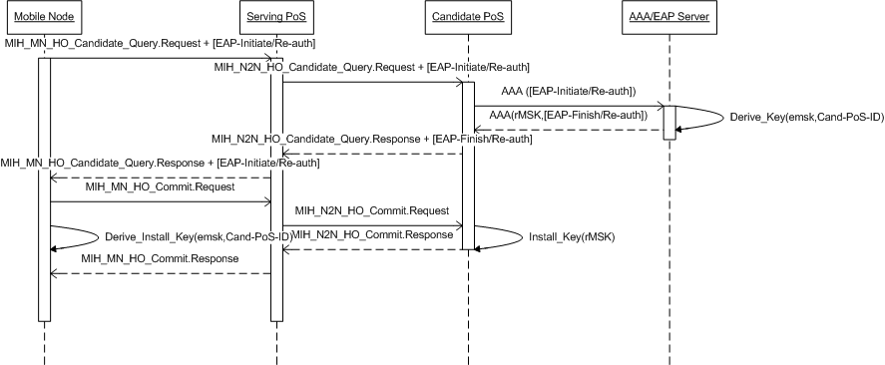
Figure 1Mobile Initiated ERP Based Approach

After handover decision is made, MN sends “EAP-Initiate/Re-auth” message to the authentication server via candidate PoS. In case of Mobile initiate handover, the message is carried from MN to serving PoS in the MN_HO_Candidate_Query.Request and from serving PoS/authenticator to candidate PoS/authenticator in the N2N_HO_Candidate_Query.Request. Corresponding message would be used for the network initiated handover. The trigger message from candidate PoS to the authenticator server is “AAA[EAP-Initiate/Re-auth], which is carried over the AAA protocol.

The AAA server verifies that the MN has previously authenticated successfully by verifying the possession of a common EMSK, derived from EAP method execution. AAA then derives rMSK and transports it to candidate PoS over AAA protocol along with confirm message “AAA (rMSK, EAP-Finish /Re-auth)” as shown in the above figure 1. On receiving this message, candidate PoS sends N2N_HO_Candidate_Query.Response to the serving PoS which carries “EAP-Finish/Re-auth”. Serving PoS in turn sends this message to the MN.

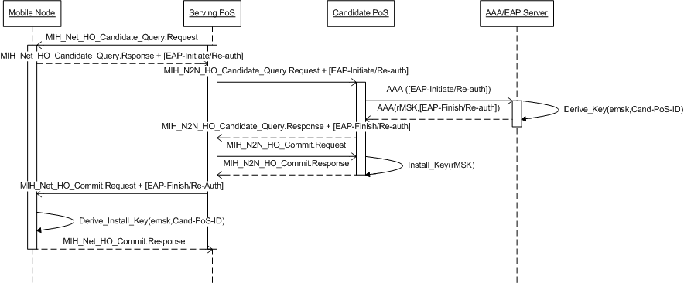
Figure 2. Network Initiated ERP Based Approach

MIH Primitive modifications

To facilitate transport of opaque ERP messages over the MIH primitives, especially those used for handover indications, the following changes are proposed:

Primitive Name | New Parameter | Type | Descripton
MIH_MN_HO_Candidate_Query.Request | OpaqueEAPData | OCTET_STRING | To carry the ERP packet through to and fro the candidate authenticator
MIH_MN_HO_Candidate_Query.Response | OpaqueEAPData | OCTET_STRING
MIH_N2N_HO_Candidate_Query.Request | OpaqueEAPData | OCTET_STRING
MIH_N2N_HO_Candidate_Query.Response | OpaqueEAPData | OCTET_STRING
MIH_Net_HO_Candidate_Query.Response | OpaqueEAPData | OCTET_STRING
MIH_MN_HO_Commit.Request | OpaqueEAPData | OCTET_STRING

MIH Protocol Security

This section discusses and proposes a solution space for providing security to the MIH protocol signaling.

Basic Concept
The proposed solution can be outlined as follows:
- The MIH security and authentication functions shall be performed by the MIH User.
- MIH User will use defined primitives to protect/decrypt protected PDU received. Such primitives will be used to request the MIH user to perform the needed security processes
- The functioning of the MIH function will be oblivious to the exact authentication and security mechanisms used. Only information the MIH function shall need to store will be the mapping from MIHF ID to the security implemented for the peer [no security, MIH specific protection or transport protocol protection].
- MIH User will use primitives like MIH_Capability_Discovery and MIH_Register to advertise authentication and security capabilities.
- Such messages will help the MIH User to initiate authentication process. Such authentication shall run between the peer MIH Users.
- Network access key hierarchy and/or alternate key distribution mechanism shall also be used to facilitate security establishment between peer MIH entities.

Terminologies

MIH Access control - To limit MIH service access to the subscribers of MIH services.

AAA server – A server that provides AAA services.

Transport protocol for MIH services - The protocol which transports MIH messages.

MIH specific protection - To provide authenticity/integrity and confidentiality for MIH messages so that the protection is independent of the transport protocols for MIH messages. MIH specific protection is applied end-to-end between two MIHFs.

MIH SAP Reference Model

Following is the MIH SAP reference model diagram depicting proposed changes relevant to the security solution:
MIH USER
TRANSPORT SERVICE
PROVIDER
MEDIA SPECIFIC
SAP
MIH_SAP

MIH FUNCTION
MIH_LINK_SAP
MIH_NET_SAP
To be augmented with security function/module
MIH_SAP modification/addition needed to use security features

The above MIH SAP reference model separates media independent and media dependent functionalities of the MIH ecosystem. While the MIH function undertakes the management and transmission of the MIH messages, the MIH User is responsible to analyze and consume the MIH messages.
Keeping in line with the same architecture, it is proposed to have the MIH security functionalities to be implemented at the MIH User. The MIH function shall get the security services from the MIH User using the MIH_SAP for communication.

Security functionalities of the MIH User
The MIH User may provide implementations for facilitating authentication and protection. This allows a collection of authentication mechanisms and protection algorithms to be used / implemented. In brief, the MIH function will provide facility to signal the initiation of the authentication mechanism, which shall then be carried out by the peer MIH User. The authentication process may establish keying material and/or SA to facilitate protection. Such a protection may happen at the MIH protocol or may be done at the transport protocol layer. As per the implementation, the MIH User triggers the protection at the transport later.
To enable the peer MIH users to learn and decide authentication mechanism, MIH messages may broker security to be used as well as enable MIH User to initiate the authentication process. Such a brokering process can be merged in the regular MIH discovery process, that is, use the MIH capability discovery process to learn about the security and authentication capabilities of the MIH peer.

Hence the security functionalities of the MIH user can be listed as:

- Contains the security functionalities for necessary peer authentication
- Contains the security functionalities for providing MIH specific protection to MIH payloads
- Contains the security functionalities for interfacing with transport service provider to facilitate transport layer security.

MIH_SAP enhancements

MIH_SAP is the media-independent SAP providing interface between the MIH function and the MIH user. For providing additional security functionalities, the following MIH_SAP changes are proposed

New primitives

MIH_Decrypt_Message

This primitive shall be used by the MIH function to request the MIH User to request for the decryption/verification of a MIH PDU received from the MIH_NET_SAP.

MIH_Decrypt_Message.Request

From: MIH function
To: MIH User

This message shall indicate the availability of an encrypted MIH PDU to the MIH User. This will be generated in the MIH Function on receiving a new PDU through the MIH_TP_Indication primitive.

On receiving this message, the MIH User shall check the associated security policy and decrypt the message accordingly.

Semantics

MIH_Decrypt_Message.Request(
SourceAddress
DestinationAddress
MIHProtocolPDU
)

Name | Data Type | Description
SourceAddress | MIH_SEC_TRANSPORT_ID | The source L2/L3 identity of the peer MIH
DestinationAddress | MIH_SEC_TRANSPORT_ID | The destination L2/L3 identity of the MIH
MIHProtocolPDU | OCTET_STRING | MIH Protocol PDU received/reassembled

MIH_Decrypt_Message.Response

From: MIH User
To: MIH Function

This message is generated in response to a successful decryption/verification of a MIHProtocolPDU received in a MIH_Decrypt.Request message

On receiving this message, the MIH function shall utilize the received MIHProtocolPDU as per the normal MIH functioning.

Semantics

MIH_Decrypt_Message.Response(
ProtectionIndication
MIHProtocolPDU
)

Name | Data Type | Description
ProtectionIndication | PROTOCOL_INDICATION_OUTCOME | The outcome of the decryption/encryption
ProcessedMIHProtocolPDU | OCTET_STRING | Processed MIH message

If the ProtectionIndication indicates an unsuccessful decryption or a non-matching integrity check, the MIH function shall silently discard the MIH PDU.

MIH_Encrypt_Message

This primitive shall be used by the MIH function to request the MIH User to request for the encryption/integrity protection of a MIH PDU prepared to be transported to a peer MIH through the MIH_NET_SAP.

MIH_Encrypt_Message.Request

From: MIH function
To: MIH User

This message shall indicate the availability of an unprotected MIH PDU to the MIH User. This will be generated in the MIH Function before the MIH PDU is ready to be sent to the peer MIH through the transport layer.

On receiving this message, the MIH User shall check the associated security policy and protect the message accordingly.

Semantics

MIH_Encrypt_Message.Request(
SourceAddress
DestinationAddress
MIHProtocolPDU
)

Name | Data Type | Description
SourceAddress | MIHF_ID | MIHF ID of the source MIH Peer
DestinationAddress | MIHF_ID | MIHF ID of the destination MIH Peer
MIHProtocolPDU | OCTET_STRING | MIH Protocol PDU to be protected

MIH_Encrypt_Message.Response

From: MIH User
To: MIH Function

This message is generated in response to a successful encryption/integrity protection of a MIHProtocolPDU received in a MIH_Encrypt.Request message

On receiving this message, basedo n the success of the protection, the MIH function shall proceed with sending the MIHProtocolPDU to the peer MIH using the MIH_TP_Data.Request primitive.

Semantics

MIH_Encrypt_Message.Response(
ProtectionIndication
MIHProtocolPDU
)

Name | Data Type | Description
ProtectionIndication | PROTOCOL_INDICATION_OUTCOME | The outcome of the decryption/encryption
ProcessedMIHProtocolPDU | OCTET_STRING | Processed MIH message
SourceAddress | MIHF_ID | MIHF ID of the source MIH Peer
DestinationAddress | MIHF_ID | MIHF ID of the destination MIH Peer

If the ProtectionIndication indicates an unsuccessful decryption or a non-matching integrity check, the MIH function should not send the MIH PDU as protection could not be provided by the MIH User.

MIH_Security

This primitive shall be used by the MIH user to request the MIH function to indicate the beginning of a protected communication with a peer entity. On receiving this request, the MIH function shall assume PDU’s received from the indicated host to be protected.

MIH_Security.Request

From: MIH User
To: MIH Function

This message shall request the MIH function to assume the PDU’s coming from the indicated peer MIH to be protected and request the MIH user for verification/decryption.

On receiving this message the MIH function may update the security context for the specified host.

Semantics

MIH_Security.Request(
DestinationAddress
ProtectionStatus
)

Name | Data Type | Description
DestinationAddress | MIHF_ID | MIHF ID of MIH Peer
ProtectionStatus | MIHF_SECURITY_STATUS | The status of the security being implemented

MIH_Security.Confirm

From: MIH Function
To: MIH User

This message shall confirm that MIH user than MIH function is ready to receive protected MIH messages from the peer.

On receiving this message the MIH user may initiate further communication with the peer MIH assuming that MIH function will respond for protection of the final PDU to be sent.

Semantics

MIH_Security.Request(
DestinationAddress
ProtectionOutcome
)

Name | Data Type | Description
DestinationAddress | MIHF_ID | MIHF ID of MIH Peer
ProtectionStatus | BOOLEAN | Indicates whether the MIHF has been able to successfully note the establishment of SA/authentication between the peer MIH

Modified Primitives

The following primitives shall be modified to facilitate implementation of an MIH security mechanism.

MIH_Capability_Discover

This primitive shall be enhanced to carry additional parameters that shall help the peer MIH to learn of the supported authentication and security mechanisms, along with the other MIH capabilities.

MIH_Capability_Discover.Request

Semantics

MIH_Capability_Discover.request (
DestinationIdentifier,
LinkAddressList,
SupportedMihEventList,
SupportedMihCommandList,
SupportedIsQueryTypeList,
SupportedTransportList,
MBBHandoverSupport,
SupportedAuthMechanismList
)

New Parameters

Name | Data Type | Description
SupportedAuthMechanismList | LIST(MIH_SEC_AUTH_MECHANISM) | List of the supported MIH authentication mechanisms

The usage of the MIH_Capability_Discover.Request message shall remain the same as described in [1]. The additional parameters shall be used by the peer MIH Users to discover the agreeable authentication and security mechanisms.

MIH_Capability_Discover.Indication

Semantics

MIH_Capability_Discover.indication (
SourceIdentifier,
LinkAddressList,
SupportedMihEventList,
SupportedMihCommandList,
SupportedIsQueryTypeList,
SupportedTransportList,
MBBHandoverSupport,
SupportedAuthMechanismList
)

New Parameters

Name | Data Type | Description
SupportedAuthMechanismList | LIST(MIH_SEC_AUTH_MECHANISM) | List of the supported MIH authentication mechanisms

The usage of MIH_Capability_Discover.indication shall remain as is, to indicate the MIH User of reception of a MIH_Capability_Discover.Request message from a peer MIH.

MIH_Capability_Discover.Response

Semantics

MIH_Capability_Discover.response(
DestinationIdentifier,
Status,
LinkAddressList,
SupportedMihEventList,
SupportedMihCommandList,
SupportedIsQueryTypeList,
SupportedTransportList,
MBBHandoverSupport,
SupportedAuthMechanismList
)

New Parameters

Name | Data Type | Description
SupportedAuthMechanismList | LIST(MIH_SEC_AUTH_MECHANISM) | List of the supported MIH authentication mechanisms

The usage of the MIH_Capability_Discover.Response message shall remain the same as described in [1]. The additional parameters shall be used by the peer MIH User to discover the agreeable authentication and security mechanisms.

MIH_Capability_Discover.Confirm

Semantics

MIH_Capability_Discover.confirm (
SourceIdentifier,
Status,
LinkAddressList,
SupportedMihEventList,
SupportedMihCommandList,
SupportedIsQueryTypeList,
SupportedTransportList,
MBBHandoverSupport,
SupportedAuthMechanismList
)

New Parameters

Name | Data Type | Description
SupportedAuthMechanismList | LIST(MIH_SEC_AUTH_MECHANISM) | List of the supported MIH authentication mechanisms

The usage of the MIH_Capability_Discover.Confirm message shall remain the same as described in [1]. The additional parameters shall be used by the peer MIH User to indicate the list of agreeable authentication and security mechanisms.

MIH_Register

The MIH Register messages shall be used to indicate the acceptable authentication and security mechanisms. After exchange of capability discovery, an MIH peer may send a MIH_Register.Request with one or less authentication mechanisms and one or less security mechanism. If the request mechanisms are agreeable, the MIH User triggers an authentication and SA establishment procedure. Such an authentication happens between the MIH peers and MIH function shall have no role to play in it. On a successful authentication and/or SA establishment, the MIH User shall then transfer a MIH_Register.Response message.

MIH_Register.Request

Semantics

MIH_Register.request (
DestinationIdentifier,
LinkIdentifierList,
RequestCode,
SupportedAuthMechanism,
primaryPoS
)

New Parameters

Name | Data Type | Description
SupportedAuthMechanism | MIH_SEC_AUTH_MECHANISM | The proposed MIH authentication mechanism
primaryPoS | MIHF_ID | (Optional)MIHF ID of the primary PoS. To be used in case distributed keys are used as authentication

The MIH_Register.Request shall be used to request a peer MIH entity for registration and subsequent authentication and/or protection using the supplied authentication and security mechanism. This message shall essentially be sent in plaintext.

MIH_Register.Indication

Semantics

MIH_Register.indication (
SourceIdentifier,
LinkIdentifierList,
RequestCode,
SupportedAuthMechanism,
primaryPoS

)

New Parameters

Name | Data Type | Description
SupportedAuthMechanism | MIH_SEC_AUTH_MECHANISM | The proposed MIH authentication mechanism
primaryPoS | MIHF_ID | (Optional)MIHF ID of the primary PoS. To be used in case distributed keys are used as authentication

The MIH_Register.Indication delivers a request received from a peer MIH entity to the MIH user. The MIH User is then supposed to initiate a MIH-peer to MIH-peer authentication mechanism [as per SupportedAuthMechanism].

MIH_Register.Response

Semantics

MIH_Register.response (
DestinationIdentifier,
Status,
ValidTimeInterval,
SecondaryKeyList
)

New Parameters

Name | Data Type | Description
SecondaryKeyList | LIST(MIH_SEC_KEY_DATA) | List of secondary keys that peer MIH can use to protect communication with peer entities

The MIH_Register.Response is used to indicate a peer MIH entity the outcome of a registration request. This response packet may or may not be protected. The MIH function might be intimated of the security initiation using the MIH_Security.Indication primitive. The MIH function can then appropriately arrange for the PDU protection, if needed. If the message contains SecondaryKeyList, protecting the MIH_Register.Response should be mandatory, unless the MIH User protect the particular parameter using a peer specific protection. The SecondaryKeyList contains a list of secondary peers and their associated keys that the MIH entity being responded to can use for protection, circumventing the need for full authentication.

MIH_Register.Confirm

Semantics

MIH_Register.response (
SourceIdentifier,
Status,
ValidTimeInterval,
SecondaryKeyList
)

New Parameters

Name | Data Type | Description
SecondaryKeyList | LIST(MIH_SEC_KEY_DATA) | List of secondary keys that MIH user can use to protect communication with peer entities

The MIH_Register.Confirm is used by the MIH function on reception of a MIH_Register.Indication. This response packet may or may not be protected, an unsuccessful registration will generate a failure, and the packet will not be protected. However, if the PDU indicates protection, the MIH function shall use MIH_Decrypt_Message to request decryption. The SecondaryKeyList will be used by the MIH User, who shall decide on how to use the keys in lieu of authentication.

New parameters/Data types

Parameters

Datatype | Derived From | Description
MIH_SEC_AUTH_TYPE | ENUMERATED | Type of authentication:  0 : EAP over PANA  1 : IKEv2  2 : Network Access Derived Key  3 : PoS Distributed Key  4 : Kerberosv4  5 : Kerberosv5  255 : No Authentication  TBD  Scope for vendor specific definitions to be considered as well
MIH_SEC_SECURITY_TYPE | ENUMERATED | Types of security algorithms  0: Transport Layer  1: AES-128  2: 3DES  128: HMAC-SHA1-96  129: HMAC-MD5  255 : No Security  0-127 represents confidentiality algorithms, and 128-TBD represents integrity algorithms.  TBD:  Scope for vendor specific definitions to be considered as well
MIH_SEC_AUTH_MECHANISM | SEQUENCE(  MIS_SEC_AUTH_TYPE, LIST(MIS_SEC_SECURITY_TYPE)  ) | Authentication mechanism and a list of security algorithms supported as part of the security profile
KEY_LIFETIME | UNSIGNED_INT(4) | Timestamp to indicate the lifetime of the key
MIH_SEC_KEY_DATA | SEQUENCE(  OCTET_STRING,  KEY_LIFETIME,  MIHF_ID  ) | Represents the keying information for a distributed key from a secondary PoS
MIH_SEC_TRANSPORT_ID | CHOICE(  IP_ADDR,  MAC_ADDR  ) | Represents the current transport identity of a MIH entity
MIHF_SECURITY_STATUS | BITMAP[8] | Status of the security being implemented  0 : No Security  1 : MIH User Confidentiality  2 : MIH User Integrity  3 :MIH User Mixed Mode  4 : Transport Layer protection  5-7 : Reserved
PROTOCOL_INDICATION_OUTCOME | BOOLEAN | Represents the outcome of the requests encryption/decryption

New TLV

TLV Type Name | TLV Type Value | Data Type
Integrity Hash | 64 | OCTET_STRING

Authentication

The MIH peer entities need to be authenticated first. The authentication can be either based on access control, using a AAA Server, or by mutual authentication which may employ use of a 3rd party certifying authority (CA). Moreover, in cases where the PoS and PoA are co-located, the network access authentication may be used to derive a key/SA for MIH protection.
Thus the basic requirements for an MIH security authentication can be listed as:
- Need for the peers to know the authentication and security capabilities of each other
- Need for the MIH protocol to be able to trigger the authentication mechanism
- Alternately, need for the MIH peer to know availability of derived keying material at the other peer.
- Need for the MIH function to be able to know state of successful/unsuccessful authentication
The MIH_Capability_Discovery can be used to advertise authentication and security mechanisms supported by the MIH peer. This information can be used by a receiving peer entity, who in turn, may advertise with a common subset of the supported authentication/security mechanisms.
This is followed by a MIH_Register request, with a single authentication/security mechanism as part of its parameter. This enables the peer MIH entity to learn of the authentication and security mechanism that has been agreed to.
The peer entities can then initiate the agreed authentication mechanism, with the entity receiving the MIH_Register.Request to initiate the procedure [typically the request shall be sent to a PoS ].
On a successful authentication/SA establishment, the MIH User on the peers shall inform the MIH function of a successful authentication using the MIH_Security.Request message, after the completion of which, the response to the MIH_Register message shall be sent.
This message shall be sent as a protected message, and marks the start of the MIH security session between the two MIH peers.

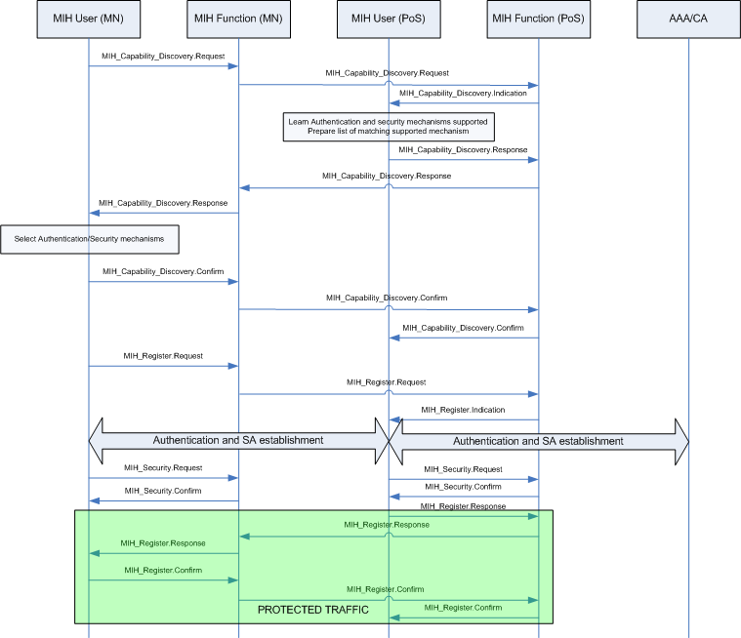
Figure 3. MIH Authentication Flow

Notes:

- The network access keying material can be used to derive keying material for MIH service ass as well. This is a viable scenario in the case when PoS and PoA may be co-located. In such a case, the peer MN shall advertise the appropriate authentication mechanism [use of derived keys].
- Transport layer protection shall be applied as per the authentication/security policy. In that case the MIH_Security messages will notify the presence of a transport level protection to the MIH function.

Secondary Key Distribution

PoS’s can be utilized as single points of authentication, whereby, on a successful authentication, post a registration request, the PoS may distribute context derived keys for several other PoS to the authentication MN. These keys may be utilized for protected communication without the need of doing any further authentication. This mechanism will essentially work by introducing a context bound key hierarchy and distribution mechanism.The PoS to which the MN shall authenticate is called the primary PoS while the PoS for which the key/key context shall be distributed to the MN is called secondary PoS. The steps of which are described below:

- The primary and secondary PoS establish a trust relationship between themselves. This may be out of scope of MIH and MIH security([2])
- The secondary PoS uses a non-transferable root key to generate a key hierarchy using a KDF as defined in RFC 5295.
- On establishment of a trust relationship, the secondary PoS may transfer an intermediate key to the primary PoS. This intermediate key is derived using a KDF which takes the primary PoS’ MIH identity as an input.
- After authentication with the primary PoS, the MN shall be transferred a collection of secondary keys. These keys correspond to each secondary PoS. They are derived using the same KDF as for deriving the intermediate key, with the MIH identity of the MN being one of the inputs to the KDF.
- The MN sends a MIH_Register request to the secondary PoS, with the authentication mechanism set as ‘Delivered Key’. Additionally, the primaryPoS value will be set to that of the primary PoS MIHF ID.
- The secondary PoS may then derive the transmitted key using the MN identity, referring to the primary PoS MIHF identity.
- Protection may be provided using the derived key. However, if additional steps are needed, the MIH peers communicates with each other as required.
- The secondary PoS sends the MIH_Register response to MN on successful protection establishment.

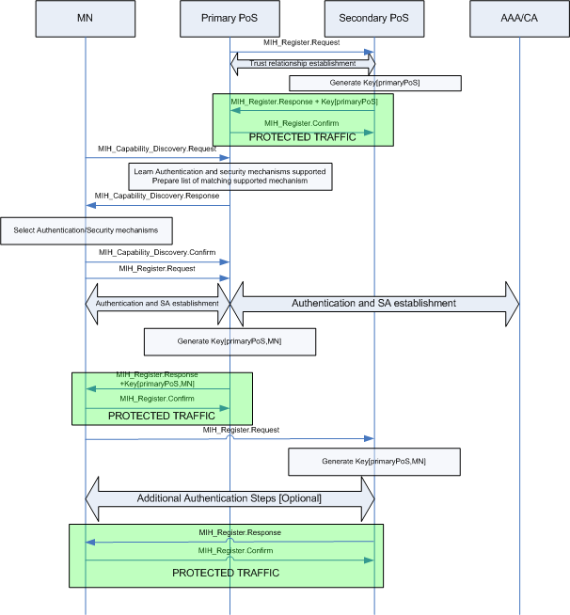
Figure 4. Secondary Key Distribution

Key Hierarchy
For such a key distribution, a context-bound key hierarchy is proposed. RFC 5295 proposes a KDF which makes it computationally infeasible to:
- derive a parent key from a child key
- derive a sibling key
This prevents a rogue PoS or a rogue MN to be able to derive keying material used to authenticate with a secondary PoS, only on the exposure of a related key.

Root key (Key [root]): An appropriate sized pseudo-random value may be used. This root key shall always reside at the secondary PoS.

Key[primaryPoS] : this key shall be generated by the secondary PoS after establishment of a trust relationship with the primary PoS. The key is derived such that:
Key[primaryPoS]=KDF(Key[root],primaryPoS-MIHF-ID,…)

Herein, the MIHF ID of the primary PoS is the essential input to the KDF. Moreover, the KDF should not be able to generate the same key for two different values of primaryPoS-MIHF-ID [or the computational probability should be extremely low].

Key[primaryPoS,MN] : this key shall be generated at the primary PoS after MN registers with the PoS. The key is derived such that:
Key[primaryPoS,MN]=KDF(Key[primaryPoS],MN-MIHF-ID,…)

Herein, the MIHF ID of the MN is the essential input to the KDF. Moreover, the KDF should not be able to generate the same key for two different values of MN-MIHF-ID [or the computational probability should be extremely low].

An assumption should be made that the entities involved in key generation [primary and secondary PoS] have the prior knowledge of the KDF, and the KDF used for key derivation shall always be the same for same pair of primary and secondary PoS’s.

Security

The proposal segregates the role of the MIH function and MIH user in implementing security in the following way:

- After a successful authentication, MIH function shall be intimated of the applied security. The security/protection may be applied either at the MIH level, or at the transport layer. The MIH function needs the information to know what to do with a received PDU. Additionally, it is important from the perspective of its ability to analyze the MIH PDU. It shall be assumed that the transport layer will de-protect the packet and deliver it to the MIH through the MIH_NET_SAP.
- If the security is implemented at the MIH ‘layer’, MIH shall use the primitives proposed in 3.2.1 to de-protect the MIH PDU received from the peer MIH.
- Similarly, after preparation of a MIH PDU, the MIH function shall use the primitives proposed in 3.2.1 to protect the MIH PDU before sending to a peer MIH.
- The MIH user shall protect the received PDU as an opaque stream of octets, and respond to the MIH function using primitives as described in 3.2.1.

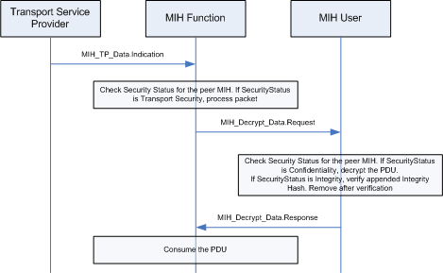
Figure 5. MIH PDU Decryption

For decryption, MIH function shall use the MIH_Decrypt_Data.Request packet. The MIH User shall respond after decryption or verification as the case may be. Both MIH function and MIH User need to maintain the security context of each of the peer MIH entities using protected communication.

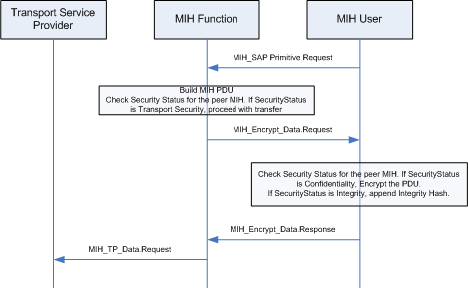
Figure 6. MIH PDU Encryption
For encryption/integrity protection, MIH function shall use the MIH_Encrypt_Data.Request packet. The MIH User shall respond after encryption or after appending a integrity TLV. Both MIH function and MIH User need to maintain the security context of each of the peer MIH entities using protected communication.

Protected PDU

When MIH level security is used, it is impossible for the MIH function to know the content of the packet. Since the security negotiation is done per-peer pair basis, knowledge of the source MIHF ID becomes important. Two distinct approaches can be employed to achieve this:

- Use the L2 or L3 identity of the received PDU to map to the MIHF ID. The MIHF ID information shall be conveyed to the MIH User using the appropriate decryption request primitives.

PROTECTED
Figure 7. Full PDU protection

- Alternately, the MIHF frame can be transmitted with the MIH Header unprotected, fully or partially.
UNPROTECTED
PROTECTED
Figure 8. PDU payload protection

The above mechanism is useful for collecting the fragmented frames before they are to be decrypted. The MIH shall rebuild the fragmented frame and use it as a PDU to be decrypted.

Integrity protection

Classically, integrity protection hash is either pre-pended or post-pended to the payload to be protected. In case of PDU protection, the integrity hash shall be placed before the MIH protocol header as a TLV. This TLV shall be introduced just before the MIH PDU is sent. For the MIHF, this TLV shall not be considered part of the MIH protocol frame.

An appropriate TLV Type identifier shall be used to identify the integrity TLV. This value may be from the reserved range of TLV type value [64-99] as defined in [1] Table L.2.
MIH Protocol Header (8 octets)
Source MIHF identifier TLV
Destination MIHF identifier TLV
MIH service specific TLV
Integrity Hash
(Type=64)

Figure 9. Integrity Protection TLV

The MIH User after a successful verification shall remove the Integrity Hash TLV from the PDU and transfer the remaining MIH PDU to the MIH Function.

