Project | IEEE 802.21a <http://www.ieee802.org/21/>
Title | EAP-FRM Architecture for Proactive EAP re-authentication
DCN | 21-09-0104-00-0sec
Date Submitted | July 05, 2009
Source(s) | Rafa Marin-Lopez, Fernando Pereniguez-Garcia, Fernando Bernal-Hidalgo,  Antonio F. Gomez Skarmeta
Re: | IEEE 802.21 Session #33 in San Francisco, USA
Abstract | Architecture for Proactive EAP Re-authentication aimed for reducing the latency of network access authentication based on EAP. It is based on the design of a new EAP method (EAP-FRM).
Purpose | Describe an architecture for proactive EAP re-authentication based on an EAP method named EAP-FRM that tries to simplify the mechanisms for EAP pre-authentication and proactive EAP re-authentication within IEEE 802.21a and to facilitate its deployment.
Notice | This document has been prepared to assist the IEEE 802.21 Working Group. It is offered as a basis for discussion and is not binding on the contributing individual(s) or organization(s). The material in this document is subject to change in form and content after further study. The contributor(s) reserve(s) the right to add, amend or withdraw material contained herein.
Release | The contributor grants a free, irrevocable license to the IEEE to incorporate material contained in this contribution, and any modifications thereof, in the creation of an IEEE Standards publication; to copyright in the IEEE’s name any IEEE Standards publication even though it may include portions of this contribution; and at the IEEE’s sole discretion to permit others to reproduce in whole or in part the resulting IEEE Standards publication. The contributor also acknowledges and accepts that this contribution may be made public by IEEE 802.21.
Patent Policy | The contributor is familiar with IEEE patent policy, as outlined in Section 6.3 of the IEEE-SA Standards Board Operations Manual <http://standards.ieee.org/guides/opman/sect6.html#6.3> and in Understanding Patent Issues During IEEE Standards Development <http://standards.ieee.org/board/pat/guide.html>.

Introduction

This document* explains an architecture for proactive EAP Re-authentication aimed for reducing the latency of network access authentication based on EAP. It is based on the design of a new EAP method (EAP-FRM).

References

- RFC 3748: “Extensible Authentication Protocol (EAP)”.
- RFC 5169: Handover Key Management and Re-Authentication Problem Statement.
- "Architecture for Fast EAP Re-authentication based on a new EAP method (EAP-FRM) working on standalone mode", draft-marin-eap-frm-fastreauth-v00.
- RFC 5296: EAP extensions for EAP Re-authentication Protocol (ERP).
- RFC 5295: Specification for the Derivation of Root Keys from an Extended Master Session Key (EMSK).
- Internet Key Exchange (IKEv2) protocol.

Motivation

The Extensible Authentication Protocol (EAP) [1] has been designed to permit different types of authentication mechanisms through the so-called EAP methods. These are performed between an EAP peer and an EAP server, through an EAP authenticator. Whereas the EAP peer is located with the mobile and the EAP authenticator is commonly placed on the Network Access Server (NAS) (e.g. an access point or an access router), the EAP server can be placed either with a backend AAA server (pass-through configuration) or co-located with the EAP authenticator (standalone configuration).

In order to deliver EAP packets between the EAP peer and the EAP authenticator, an EAP lower-layer is used. In case of pass-through configuration, an AAA protocol such as RADIUS or Diameter is used for the same purpose between the EAP authenticator and the EAP server.

Taking into account mobile environments, EAP has shown some drawbacks where a reduced handover latency, including the latency in network access authentication and key establishment, is required [2]. Indeed, a complete EAP authentication with use of long-term authentication credentials requires a considerable amount of time and number of message exchanges. The latency of the complete EAP authentication can be even longer when the EAP peer and EAP server are geographically far apart. For instance, the EAP server may be located in the home AAA domain of the subscriber, whereas the subscriber is currently located in a visited AAA domain, residing the home and visited AAA domains in different geographical areas (e.g., different countries or different states in the same country). In the worst case, a full EAP authentication can happen each time the peer changes its point of attachment.

*Part of the content of this document has been submitted as an IETF I-D [3].
To solve these problems, the ERP (EAP Extensions for EAP Re- authentication Protocol) [RFC5296] protocol has been standardized in HOKEY WG. Moreover, the ERP protocol can be used during a pro-active EAP re-authentication process as Figure 1. describes.

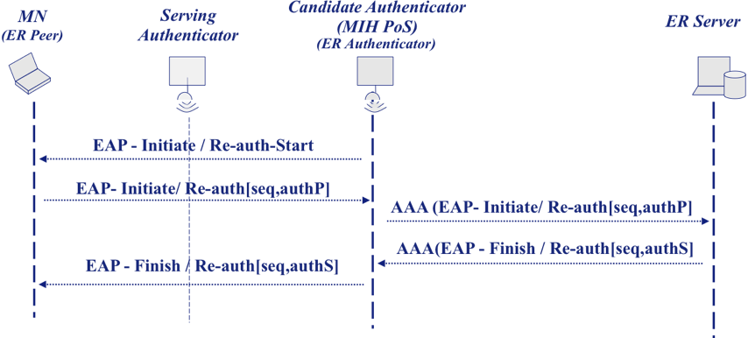
Figure 1. Proactive EAP Re-authentication based on ERP

Nevertheless, ERP has the following drawbacks:

- It requires modifications in current EAP peers, EAP authenticators and EAP/AAA servers.

- It modifies the standard EAP state machines.

- Current EAP lower-layers require modifications. Standard wireless technologies and protocols that currently use EAP need to be updated.

The result is that a mechanism of proactive EAP re-authentication based on ERP will inherit these drawbacks. Then it may provoke a harder deployment of the solution.

In order to alleviate the impact of these potential problems and keeping a reduced latency for network access authentication, we propose an architecture for fast EAP re-authentication based on the design of a new EAP method named EAP-FRM. These EAP method works on standalone EAP authenticators but the method itself can contact a backend authentication server. The EAP-FRM can transport the payload of any fast re-authentication protocol (hereafter FRP). This new architecture allows:

- No modification to EAP is required because EAP is designed to carry any EAP method.

- No modification to lower-layer specifications is required because EAP has media independence property.

- Minimum extension to AAA protocols is needed. When an AAA protocol is used between the authenticator and a backend authentication server, a new AAA attribute needs to be defined to carry the authentication information between an authenticator and the backend authentication server.

- Assuming a well designed FRP, only one roundtrip beyond access network is needed at the most.

Due to these features and taking into account the media independence property in EAP, we may achieve an important advantage in the context of 802.21a:

- There is no need to define a MIH protocol acting as EAP lower-layer that supports both ERP (proactive EAP re-authentication) or EAP pre-authentication. In particular, a MIH protocol designed for EAP pre-authentication is also valid for proactive EAP re-authentication with the use of EAP-FRM.

Proactive EAP Re-Authentication based on EAP-FRM

The proposed architecture for fast re-authentication uses a new EAP method named EAP-FRM that operates in the standalone authenticator mode (see figure 2). Unlike other EAP methods working on standalone mode, EAP-FRM itself may communicate with a backend authentication server (e.g., an AAA server), using a protocol for verification of the authentication information originated by the EAP peer and sent to the EAP server encapsulated in EAP-FRM messages. A PDU of any FRP can be encapsulated in EAP-FRM. Nevertheless, it does not change the standard model of EAP operation.

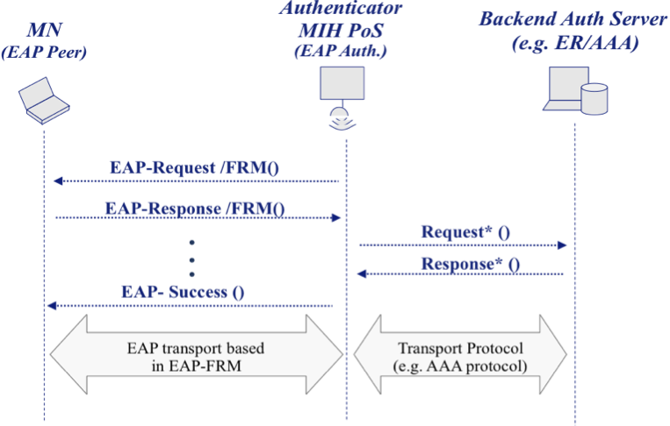
Figure 2. General EAP-FRM architecture

In case the backend authentication server is contacted to process the FRP, upon successful authentication, the backend authentication server sends key material and other information associated with the key material back to the authenticator. The protocol used for conveying the FRP messages between the authenticator and the backend authentication server is an AAA protocol.

Figure 3 shows how the proactive EAP re-authentication based on EAP-FRM works. In this general example, let us assume a fast re-authentication protocol named FRP* with two messages FRP*_1 FRP*_2 . FRP*_1 message can be only processed by the backend authenticator server.

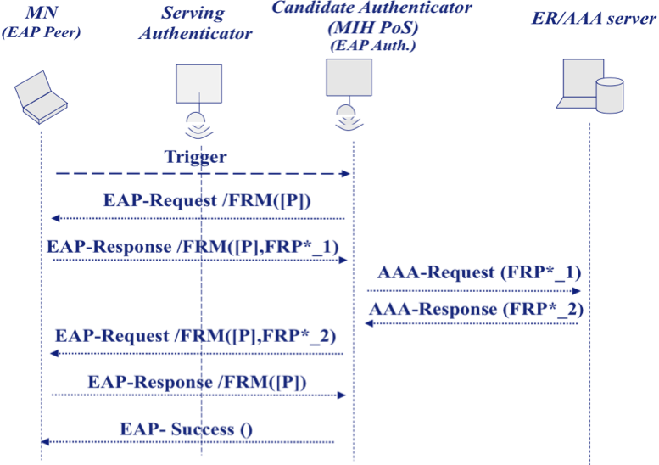
Figure 3. Example of proactive EAP Re-authentication with EAP-FRM

The candidate MIH PoS must be configured to start EAP-FRM, in such a way that it sends automatically an EAP-Request/FRM message instead of EAP Request/Id. In this example, the candidate MIH PoS set the FRP-Type to FRP*. Then, the MN answers EAP-Response/FRM containing the first message of the fast re-authentication protocol (FRP*_1) FRP_1. The candidate MIH PoS extracts this information from the EAP-Response/FRM and either processes it to provide access or forwards it (e.g. through an AAA protocol) for verification to the backend authentication server. In this case, the authenticator forwards FRP*_1 to the backend authentication server.

If the backend authenticator server verifies correctly FRP*_1 it answers to the authenticator with the response obtained as a consequence of processing the fast re-authentication protocol (FRP*_2). Then, the message FRP*_2 is forwarded to the MN through an EAP-Response/FRM. The last two messages in the flow are required to maintain compatibility with the current EAP specification. As observed, every message contains a bit P to indicate that EAP-FRM is performed proactively. The details of this bit P are explained in next section.

Note that only one FRP protocol can be executed in an execution of EAP-FRM. Once the specific FRP has finished the authenticator sends the EAP success.

EAP-FRM Format and AAA Protocol Extensions

Figure 4 shows the EAP-FRM packet format. The packet format for the EAP-FRM messages follows the EAP packet format defined in [RFC3748].

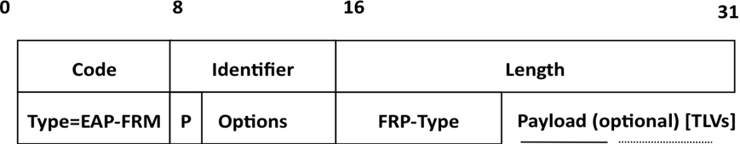
Figure 4. EAP-FRM packet format

- Code, Identifier, Length: Common fields to all EAP messages (see [RFC3748])

- Type: This field (1-octet) contains the value of the EAP method type corresponding to EAP-FRM (TBD).

- Flags: A 1-octet options field reserved for flags. In the context of 802.21a we have defined next flag:
  - P flag (1 bit): Proactive mode. This flag indicates that EAP-FRM is performed proactively.
- FRP-Type: The FRP-Type is a 1-octet field which identifies the transported fast re-authentication protocol (TBD).

- Reserved
- ERP*
- Kerberos
- ...

- Payload TLVs: the rest of the EAP-FRM packet is optionally composed of a set of TLVs. In a TLV payload there is a 1-octet type field, two octet length field and data field. The length field indicates the length of the data field in number of octets. These are the TLVs considered in the context of 802.21a:

- FRP-Payload TLV. It contains the specific payload of the FRP.
- User-Id TLV. It contains the user's NAI.
- Context-Binding TLV. This TLV transports information related with context binding. This information tells the candidate EAP authenticator about the media specific security context.
- Auth TLV. This TLV contains integrity data used for protecting EAP-FRM messages.

Although, in principle, any transport protocol could be considered for communicating the authenticator and the backend authentication server, we consider that an AAA protocol seems the most common choice. Therefore, extensions for RADIUS and Diameter are required. These extensions are defined in the following.

For RADIUS, it is required (at least) three new attribute RADIUS:

- RADIUS FRM-Flags. One octet with the content of the flag field in EAP-FRM packet.
- RADIUS FRP-Id. It contains the fast re-authentication protocol type (ERP*, Kerberos, ...) attribute that allows the backend authentication server to determine which specific FRP is contained in the attribute FRP-Payload-Attr.
- RADIUS FRP-Payload-Attr. It carries the payload of the fast re-authentication protocol.

For Diameter, it is not only required three new Diameter AVPs but also a new Diameter application may be required. We have called this application as Diameter-FR (Fast Re-authentication) application. Nevertherless, extensions to the existing Diameter NASREQ application could be considered.

The Diameter-FR-Application will be composed by two messages:

- Diameter-FR-Request: to carry an EAP-FRM payload from the authenticator to the AAA server.
- Diameter-FR-Response: for the same purpose in the opposite direction.

Both messages include three new Diameter AVPs, with the same meaning as those defined for RADIUS:

FRM-Flags

FRP-Id

FRP-Payload-Attr

Note that thanks to FRM-Flags AVP (FRM-Flags attribute) the AAA server can know whether the EAP authentication is a performed proactively or not (bit P is enabled or not).

An Example: ERP-based Fast Re-authentication Protocol with EAP-FRM

In the following we describe a more specific example where the fast re-authentication protocol carried by EAP-FRM is derived from the ERP protocol described in [4]. In particular, EAP-FRM will carry the payload of the ERP messages from the Type field to the end of the messages. More precisely, this ERP-based fast re-authentication protocol has three different payloads:

- IRS: It corresponds to the fields from Type field to the end of the EAP-Initiate/Re-auth-Start

- IR: It corresponds to the fields from Type field to the end of the EAP-Initiate/Re-auth

- FR: It corresponds to the fields from Type field to the end of the EAP-Finish/Re-auth

Figure 5 shows the protocol exchange that takes place when a MN performs a proactive EAP re-authentication based on EAP-FRM with the candidate MIH PoS under the control of an ER server. The process starts when the authenticator sends an EAP-Req./FRM (with the FRP-Type field set to ERP code) to the peer. A FRP-Payload TLV is included to contain the IRS* payload.

Then, the peer sends an EAP-Response/FRM containing the IR* payload. The message includes an User-Id TLV that has the value of the keyName-NAI (e.g. EMSKname@local). On the reception, the authenticator creates a RADIUS Access-Request that includes the User-Name attribute carrying the content of the User-Id TLV; the FRP-Id attribute indicating the ERP-based protocol as the fast re-authentication protocol; and the FRP-Payload-Attr containing the ERP payload (IR*). Note that, in this case, the authenticator is not required to understand the data contained in the FRP payload.

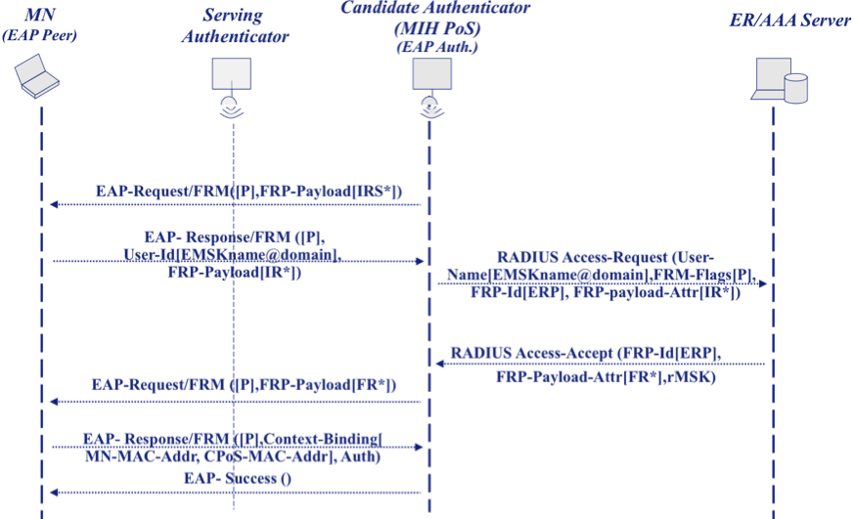
Figure 5. ERP-based fast re-authentication protocol and EAP-FRM

When the ER server performs a successful re-authentication based on the information contained in the FRP-Payload-Attr, it generates the associated RADIUS Access-Accept. This message includes: the FRP-Id attribute (indicating ERP as FRP); the FRP response message (FR*) that is included in a FRP-Payload-Attr attribute; and the rMSK. The rMSK will reach the EAP-FRM method in the authenticator, and EAP-FRM method will exports the rMSK to the lower-layer. Additionally, the authenticator forwards the content of the FRP response message (FR*) to the peer through an EAP-Request/FRM message. When the peer processes the FR* payload contained in the received FRP-Payload TLV, the execution of the FRP (in this case an ERP-based protocol) ends. As a consequence of a successful ERP-based FRP execution, the EAP-FRM method in the peer will obtain the same rMSK that the one received in the authenticator and will export it to the lower-layer. The EAP-FRM method concludes through an additional EAP-Resp./FRM and EAP-Success messages to maintain backward compatibility with current EAP specification.

Key Derivation and Context Binding

As observed in the previous example, the last EAP-Response/FRM sent to the authenticator includes a Context-Binding TLV. This TLV contains all the information necessary to bind the EAP keying material generated as result of the EAP re-authentication and the specific link layer security context where will be applied. Additionally, an Auth TLV is included in order to integrity protect the message and the context binding information.

Assuming the execution of a given fast re-authentication protocol generates key MSK’ (such as ERP-based fast re-authentication protocol where the MSK' will be the rMSK) two keys are derived. On one hand, an IK (Integrity Key) is generated in order protect EAP-FRM messages through the Auth TLV. On the other hand, the MSK which is generated by EAP-FRM is exported to the lower layer. These keys are derived by using the PRF+ defined in [RFC4306], being PRF_HMAC_SHA2_256 the hash algorithm for PRF+.

- IK = PRF+(MSK’, “EAP-FRM-Integrity-Key” | “\0” | length)
- MSK =PRF+(MSK’, “EAP-FRM-Master-Session-Key” | “\0” | length)

The Auth TLV field contains an integrity checksum computed over the EAP-FRM packet, from the Flags field.

IEEE 802.21 Information service requirements

The IEEE 802.21 information service should provide a MN about next information:

- Whether the PoS supports EAP-FRM.
- The type of fast re-authentication protocol supported by the candidate MIH PoS.
- The specific backend authentication server that controls the candiate MIH PoS.

