Project | IEEE 802.21 MIHS  <http://www.ieee802.org/21/>
Title | MIH link layer transport
DCN | 21-08-01xx-00-0000
Date Submitted | May, 2008
Source(s) | H Anthony Chan, Huawei Technologies  Yoshihiro Ohba, Toshiba  Vivek Gupta, Intel
Re: | DCN 21-08-0086-00-0000 follow-up
Abstract | Explain link-layer transport of MIH messages as proposed amendment to Chapter 5. These changes are intended to resolve Comment #2142 from Tony Jeffree and are follow-up to the proposal in DCN 21-08-0086-00-0000 from David Johnston.
Purpose | Define link layer transport for MIH with EtherType and port access security in section-5
Notice | This document has been prepared to assist the IEEE 802.21 Working Group. It is offered as a basis for discussion and is not binding on the contributing individual(s) or organization(s). The material in this document is subject to change in form and content after further study. The contributor(s) reserve(s) the right to add, amend or withdraw material contained herein.
Release | The contributor grants a free, irrevocable license to the IEEE to incorporate material contained in this contribution, and any modifications thereof, in the creation of an IEEE Standards publication; to copyright in the IEEE’s name any IEEE Standards publication even though it may include portions of this contribution; and at the IEEE’s sole discretion to permit others to reproduce in whole or in part the resulting IEEE Standards publication. The contributor also acknowledges and accepts that IEEE 802.21 may make this contribution public.
Patent Policy | The contributor is familiar with IEEE patent policy, as stated in Section 6 of the IEEE-SA Standards Board bylaws <http://standards.ieee.org/guides/bylaws/sect6-7.html#6> and in Understanding Patent Issues During IEEE Standards Development http://standards.ieee.org/board/pat/faq.pdf
- MIHF reference models for link-layer technologies
The MIHF provides asynchronous and synchronous services through well-defined Service Access Points for MIH Users. The following subclauses describe the reference models for various link-layer technologies with MIH functionality.
- IEEE 802 Architectural considerations
The MIH reference models for different IEEE 802 technologies and the general MIH framework is designed to be consistent with the IEEE 802 Architecture for different link layer technologies. The MIH Function is a management entity that obtains link layer information from lower layers of different protocol stacks and also from other remote nodes. The MIH Function co-ordinates handover decision making with other peer MIH Functions in the network.
The MIH Protocol provides the capability for transferring MIH messages between peer MIH Function entities at L2 or at L3. These messages transfer information about different available networks and also provide network switching and handover capability across different networks. The MIH protocol encompasses IEEE 802 technologies such as IEEE 802.11 and IEEE 802.16 and also other non IEEE 802 technologies such as those specified by 3GPP and 3GPP2 standards. In this sense the MIH Protocol has different scope and functionality than the Link layer Discovery Protocol (LLDP) as specified by the IEEE 802.1AB standard.
- General MIHF reference model and SAPs
General MIHF reference model and SAPs illustrates the position of the MIHF in a protocol stack and the interaction of the MIHF with other elements of the system. All exchanges between the MIHF and other functional entities occur through service primitives, grouped in Service Access Points (SAPs).
- General MIHF reference model and SAPs
The media agnostic General MIH Reference Model includes the following SAPs:
- MIH_SAP: Media independent interface of MIHF with the upper layers of the protocol stack.
- MIH_LINK_SAP: Abstract media dependent interface of MIHF with the lower layers of the media-specific protocol stacks.
- MIH_NET_SAP: Abstract media dependent interface of MIHF that provides transport services over the data plane on the local node, supporting the exchange of MIH information and messages with the remote MIHF. For all transport services over L2, the MIH_NET_SAP uses the primitives specified by the MIH_LINK_SAP.
In the media-specific reference models, the media independent SAP (MIH_SAP) always maintains the same name and same set of primitives. The media dependent SAP (which is a technology specific instantiation of the MIH_LINK_SAP), assumes media-specific names and sets of primitives, often reusing names and primitives that already exist in the respective media-specific existing lower-layer SAPs. Primitives defined in MIH_LINK_SAP result in amendments to media-specific SAPs due to additional functionality defined for interfacing with the MIHF. All communications of the MIHF with the lower layers of media-specific protocol stacks take place through media-specific instantiations of MIH_LINK_SAP.
The message exchanges between peer MIHF instances, in particular the type of transport that they use, are sensitive to several factors, such as the nature of the network nodes that contain the peer MIHF instances (whether or not one of the two is an MN or a PoA), the nature of the access network (whether IEEE 802 or 3G cellular), and the availability of MIH capabilities at the PoA.
Types of MIHF relationship presents a summary of the types of relationships that can exist between the MIHF and other functional components in the same network node.
- Types of MIHF relationship
(****MIH local Interface between MIHF and 802 network is missing in Figure 5. Need to add them.****)
The general MIH reference model in General MIHF reference model and SAPs enables a simple representation of the broad variety of MIHF relationships shown in Types of MIHF relationship. In the model, a mobility-management protocol stack is logically identified within each network node that includes an MIHF instance. The abstraction provided makes it easy to isolate and represent the MIH relationships with all pre-existing functional entities within the same network node. Such relationships are both internal (with functional entities that, just like the MIHF, share the logical inclusion in the mobility-management protocol) and external (with functional entities that belong to other planes).
Types of MIHF relationship shows how an MIH-enabled MN communicates with an MIH-enabled network. The gray arrows show the MIH signaling over the network, whereas the black arrows show local interactions between the MIHF and lower and higher layers. For a more detailed view of local interactions, please refer to technology-specific reference models and Service Access Point in the following subclauses.
When connected to an IEEE 802 network, an MN directly uses L2 for exchanging MIH signaling, as the peer MIHF can be embedded in a PoA. The MN does this for certain IEEE 802 networks even before being authenticated with the network. However, the MN can also use L3 for exchanging MIH signaling, for example in cases where the peer MIHF is not located in the PoA, but deeper in the network.
When connected to a 3GPP or 3GPP2 network, an MN uses L3 transport to conduct MIH signaling.
- MIHF reference model for IEEE 802MAC service
The MIHF reference model for IEEE 802.3 is illustrated in MIH reference model for IEEE 802.3. The transport of MIHF services is supported over the data plane by use of existing primitives defined by the LSAP. There are no amendments specified in IEEE 802.3 to support any link services defined over the MIH_LINK_SAP in this specification.
- MIH reference model for IEEE 802.3
Replace Figure 6 and figure caption with following

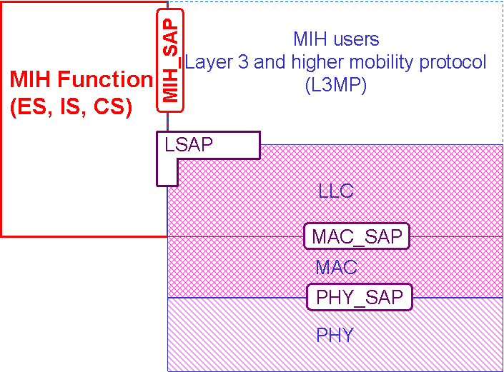

Figure 6 – MIH reference model for IEEE 802 MAC service

- MIHF reference model for IEEE 802.11
MIH reference model for IEEE 802.11 shows the MIHF reference model for IEEE 802.11 stations and network PoAs. The payload of MIHF services over IEEE 802.11 is carried either in the data frames by using existing primitives defined by the LSAP or by using primitives defined in the MLME_SAP.
It should be noted that sending MIHF payload over the LSAP is allowed only after successful authentication and association of the station to the AP. Moreover, before the station has authenticated and associated with the AP, only MIH Information Service and MIH Capability Discovery messages can be transported over the MLME_SAP.
The MIH_SAP specifies the interface of the MIHF with MIH Users.
- MIH reference model for IEEE 802.11
- MIHF reference model for IEEE 802.16
MIH reference model for IEEE 802.16 shows the MIHF for IEEE 802.16 based systems. The Management SAP (M_SAP) and Control SAP (C_SAP) are common between the MIHF and Network Control and Management System (NCMS).
The M_SAP specifies the interface between the MIHF and the management plane and allows MIHF payload to be encapsulated in management messages (such as MOB_MIH-MSG defined in [B21]). The primitives specified by M_SAP are used by an MN to transfer packets to a base station (BS), both before and after it has completed the network entry procedures. The C_SAP specifies the interface between the MIHF and control plane. M_SAP and C_SAP also transport MIH messages to peer MIHF entities. The Convergence Sublayer SAP (CS_SAP) is used to transfer packets from higher layer protocol entities after appropriate connections have been established with the network.
The MIH_SAP specifies the interface of the MIHF with other higher layer entities such as transport layer, handover policy engine, and layer 3 mobility protocol.
- MIH reference model for IEEE 802.16
****the dotted line in Fig. 8 should be intended to show the CS_SAP between CS and MIHF. Llower the end of the horizontal part of this dotted line to end at MIHF (and not at MIH_SAP) as is shown in following****
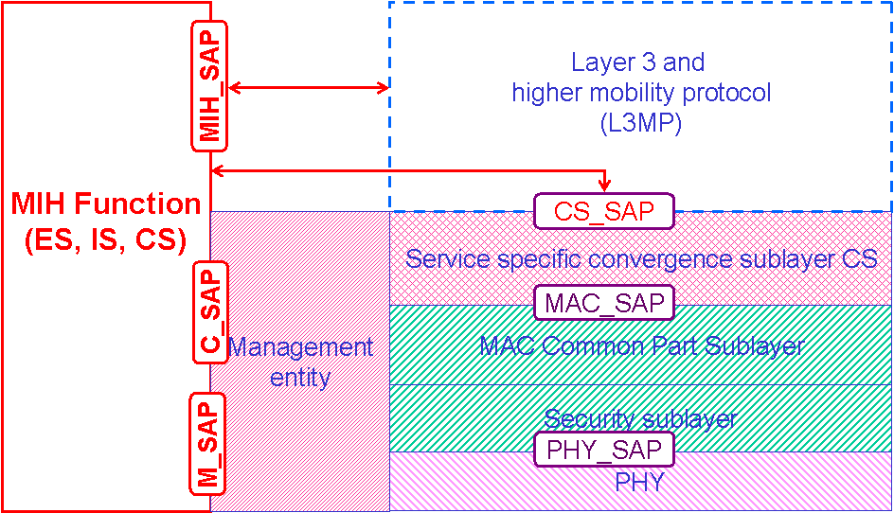

In the above model, C_SAP and M_SAP provide link services defined by MIH_LINK_SAP, C_SAP provides services before network entry, while CS_SAP provides services over the data plane after network entry.
- MIHF reference model for 3GPP
MIH reference model for 3GPP systems illustrates the interaction between the MIHF and the 3GPP based systems. The MIHF services are specified by the MIH_3GLINK_SAP. However no new primitives or protocols need to be defined in the 3GPP specification for accessing these services. The MIHF services are mapped to existing 3GPP signaling functions (see Table J-3). The architectural placement of the MIHF is also decided by the 3GPP standard. MIH reference model for 3GPP systems is for illustrative purposes only and should not constrain implementations.
- MIH reference model for 3GPP systems
- MIHF reference model for 3GPP2
MIH reference model for 3GPP2 systems illustrates the interaction between IEEE 802.21 services and 3GPP2 based systems. IEEE 802.21 services are accessed through the MIH_3GLINK_SAP. Note however that no new primitives or protocols need to be defined within the 3GPP2 specification. Instead, a mapping between IEEE 802.21 Link Layer primitives and 3GPP2 primitives as defined in IETF RFC 1661 and 3GPP2 C.S0004-D is already established. Primitive information available from Upper Layer Signaling and Point-to-Point Protocol (PPP) can be directly used by mapping LAC SAP and PPP SAP primitives to IEEE 802.21 service primitives in order to generate an event.
- MIH reference model for 3GPP2 systems
This mapping is illustrated in Table J-3, which provides an example of how 3GPP and 3GPP2 primitives can be mapped to IEEE 802.21 primitives. For example, events received from the Upper Layer Signaling through the LAC layer SAP such as “L2.Condition.Notification” can be mapped and generated through the MIH_3GLINK_SAP as a Link_Up, Link_Down, or Link_Going_Down. Likewise, events generated at the PPP SAP within the PPP layer, such as LCP-Link-Up or IPCP_LINK_OPEN, could be mapped and generated through the MIH_3GLINK_SAP as a Link_Up event.
It is noteworthy that there will be no direct communication between the 3GPP2 PHY and MAC layers with the MIHF. The architectural placement of any MIHF is left to 3GPP2. MIH reference model for 3GPP2 systems is for illustrative purposes only and should not constrain implementations.
- Service access points (SAPs)
- General
The MIHF interfaces with other layers and functional planes using Service Access Points (SAPs). Each SAP consists of a set of service primitives that specify the interactions between the service user and provider.
The specification of the MIHF includes the definition of SAPs that are media independent and recommendations to define or extend other SAPs that are media dependent. Media independent SAPs allow the MIHF to provide services to the upper layers of the mobility-management protocol stack, the network management plane, and the data bearer plane. The MIH_SAP and associated primitives provide the interface from MIHF to the upper layers of the mobility-management protocol stack. Upper layers need to subscribe with the MIHF as users to receive MIHF generated events and also for link layer events that originate at layers below the MIHF but are passed on to MIH Users through the MIHF. MIH Users directly send commands to the local MIHF using the service primitives of the MIH_SAP. Communication between two MIHFs relies on MIH protocol messages.
Media dependent SAPs allow the MIHF to use services from the lower layers of the mobility management protocol stack and their management planes. All inputs (including the events) from the lower layers of the mobility-management protocol stack into the MIHF are provided through existing media-specific SAPs such as MAC SAPs, PHY SAPs, and logical link control (LLC) SAPs. Link Commands generated by the MIHF to control the PHY and MAC layers during the handover are part of the media-specific MAC/PHY SAPs and are already defined elsewhere.
- Relationship between different MIHF SAPs
Relationship between different MIHF SAPs shows the key MIHF-related SAPs for different networks:
- The MIH_SAP specifies a media independent interface between the MIHF and upper layers of the mobility management protocol stack. The upper layers need to subscribe with the MIHF as users to receive MIHF-generated events and also for link layer events that originate at layers below the MIHF but are passed on to MIHF users through the MIHF. MIHF users directly send commands to the local MIHF using the service primitives of the MIH_SAP;
- The MIH_LINK_SAP specifies an abstract media dependent interface between the MIHF and lower layers media-specific protocol stacks of technologies such as IEEE 802.3, IEEE 802.11, IEEE 802.16, 3GPP, and 3GPP2. For different link layer technologies media-specific SAPs provide the functionality of MIH_LINK_SAP. Amendments are suggested to the respective media-specific SAPs to provide all the functionality as described by MIH_LINK_SAP;
- The MIH_NET_SAP specifies an abstract media dependent interface of the MIHF that provides transport services over the data plane on the local node, supporting the exchange of MIH information and messages with remote MIHFs.
- Media dependent SAPs
- General
Each link layer technology specifies its own technology-dependent SAPs. For each link layer technology, the MIH_LINK_SAP maps to the technology-specific SAPs.
- MIH_LINK_SAP
This SAP defines the abstract media dependent interface between MIHF and different link layer technologies. Amendments are suggested for different layer technology-specific SAPs based on the definition of this particular SAP.
- MIH_NET_SAP
MIH_NET_SAP defines the abstract media dependent interface of the MIHF that provides transport services over the data plane on the local node, supporting the exchange of MIH information and messages with remote MIHFs. For L2 this SAP uses the primitives provided by MIH_LINK_SAP.
- MLME_SAP
This SAP defines the interface between the MIHF and the management plane of an IEEE 802.11 network. This SAP is used for sending MIH messages between the MIHF and local link layer entities, as well as between peer MIHF entities.
- C_SAP
The C_SAP, defined in the IEEE 802.16 standard, provides the interface between the MIHF and the IEEE 802.16 control plane. This SAP is used for MIH exchanges between the MIHF and the lower layers of the management plane (as part of the IEEE 802.16 instantiation of the MIH_LINK_SAP).
- M_SAP
The M_SAP, defined in the IEEE 802.16, provides the interface between the MIHF and the IEEE 802.16 management plane functions.
- MSGCF_SAP
This SAP, defined in the IEEE 802.11, provides services to MIHF based on the IEEE 802.11 MAC state machines and interactions between the IEEE 802.11 sublayers.
- MIH_3GLINK_SAP
This SAP works as an umbrella that defines the interface between the MIHF and the different protocol elements of the cellular systems. The existing service primitives or media-specific SAPs as defined in 3GPP and 3GPP2 specifications are directly mapped to MIHF services, and hence no new primitives need to be defined in these specifications. Table J-3 lists this mapping.
- LSAP
The LLC SAP (LSAP), defined in the IEEE 802.2 standard, provides the interface between the MIHF and the Logical Link Control sublayer in IEEE 802.3 and IEEE 802.11 networks. This SAP is used for local MIH exchanges between the MIHF and the lower layers of the IEEE 802.3 interface (as the IEEE 802.3 instantiation of the MIH_LINK_SAP) and for the L2 transport of MIH messages across IEEE 802.3 and IEEE 802.11access links.
- CS_SAP
The CS_SAP, defined in the IEEE 802.16 standard, provides the interface between the MIHF and the service-specific Convergence Sublayer in IEEE 802.16 networks. This SAP is used for the L2 transport of MIH messages across IEEE 802.16 access links.
- Media independent SAPs
- MIH_SAP
This SAP defines the media independent interface between the MIHF and MIH Users such as an upper layer mobility protocol or a handover function that might reside at higher layers or a higher layer transport entity as well. The definition of this SAP is required to define the scope and functionality of the MIHF.
- MIH protocol

- General
MIH Protocol defines the format of messages (i.e., MIHF packet with header and payload) that are exchanged between remote MIHF entities and the media independent mechanisms that support the delivery of these messages.
- Transport Considerations

Transport with MIH_NET_SAP is supported at both L2 or L3. After authentication and association for secured network, L3 transport is supported using IP whereas L2 transport uses LSAP with EtherType set to that for MIH protocol. In unassociated or unauthenticated state, L2 transport via management plane is provided in IEEE 802.11 and IEEE 802.16 networks only.In addition, IEEE802 networks except 802.16 provides L2 transport using LSAP over EAPOL through uncontrolled port.
Table ****Number****. L2 or L3 transport of MIH protocol
Connection state | Transport | 802.11 | 802.16 | 802.3 and other 802 networks
After authentication and association | using IP | √ | √ | √  (shall)
 | using LSAP with MIHF EtherType and Size limit | optional, through controlled port | optional | optional, through controlled port
before and during authentication | via management plane bypassing security but with filtering | √ | √ | No  (shall not)
 | using LSAP over EAPOL through uncontrolled port with size limit and filtering | optional | N/A | optional  (may)

    - The generic MAC service with 802.1X
The generic MAC service in all IEEE 802 except 802.16 networks, which use 802.1X REV port-based network access control, goes through the controlled port after authentication and association and through the uncontrolled port otherwise. The uncontrolled port is in open access mode to allow exchange of messages to perform authentication and secure connection association, whereas the controlled port is closed until authentication and association are successful.
The MIH messages through the LSAP are distinguished from that of other protocols with an EtherType value of ****value**** in the LLC header. The EtherType and subtype for MIH protocol are described in Annex ****.

      - Port open state: LSAP transport
After successful authentication and association, the controlled port is open to the transport of authenticated messages. The MIH messages are then encapsulated into LLC protocol with EtherType (****value****) to pass through the controlled port. When LSAP receives MAC frames from the LLC layer, it checks the EtherType of each frame to determine whether to send the frame to MIHF protocol or to other protocols.

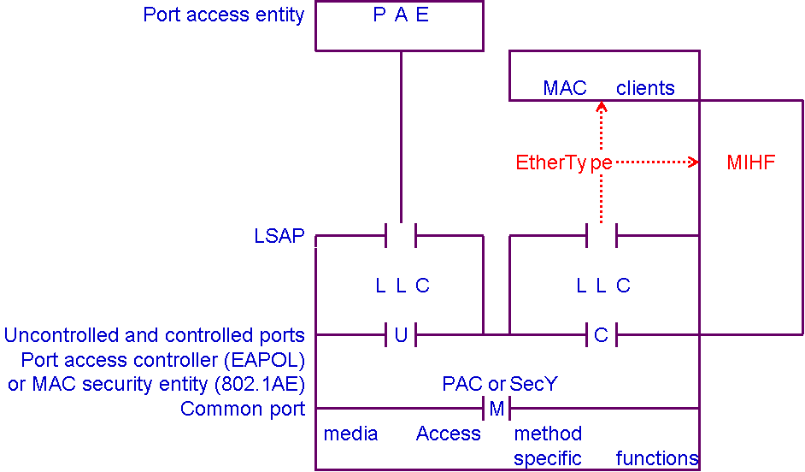
Note: The security sublayer is PAC for 802.11 network and is MAC security entity (SecY) for all other networks using 802.1AE.
Figure ***Number***. Transport through controlled port using LSAP for all IEEE 802 except 802.16 networks.

      - Port closed state: LSAP over EAPOL
Following IEEE P802.1X REV, the controlled port is in closed state until authentication has been completed. At this time, the MIH messages cannot go through the controlled port, and the message transport for authentication and key management (AKM) uses the uncontrolled port.
To provide the needed MIHF IS, transport could be supported by LSAP over EAPOL.

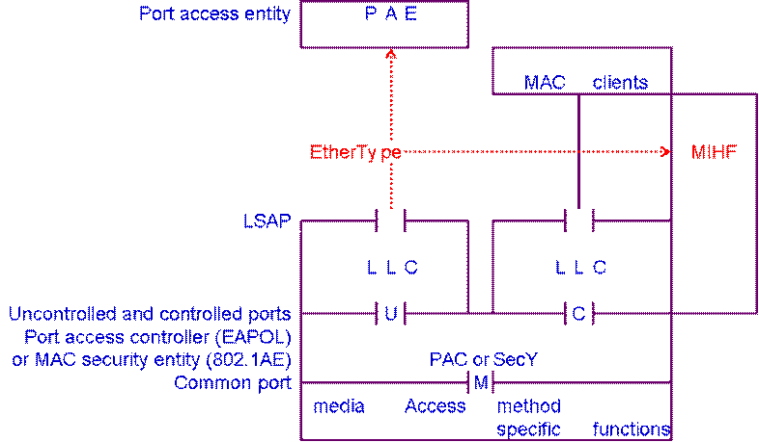
Note: The security sublayer is PAC for 802.11 network and is MAC security entity (SecY) for all other networks using 802.1AE.
Figure ***Number***. Transport through uncontrolled port using LSAP over EAPOL for all IEEE 802 except 802.16 networks.

    - 802.11
802.11 networks support robust security network association (RSNA) but also supports legacy WEP security only for backward compatibility. Before authentication and association, only MIH Information Service and MIH Capability Discovery messages can be transported over the MLME_SAP.
      - RSNA network
L2 transport with RSNA network is described in Section 5.7.3 above.
      - WEP network
WEP is supported in IEEE Std 802.11-2007 only when backward compatibility is needed. With WEP network, shared key authentication is used to transport the authentication exchange. After successful authentication and association of an STA with AP, data plane transport is allowed between them so that MIH messages may go through LSAP to use the MAC transport service in the data plane.
    - 802.16 using PKMv2 and negotiated cipher suite
In IEEE 802.16 network using PKMv2 and negotiated cipher suite, message exchange between peer MIHF may be supported by MAC service through CS_SAP in addition to IP transport.
Before authentication and association, only MIH Information Service and MIH Capability Discovery messages can be transported using M_SAP via the management plane.

