Project | IEEE 802.21 MIHS  <http://www.ieee802.org/21/>
Title | Support for Centrally Coordinated Network Initiated Handovers
DCN | 21-06-0783-00-0000-centralized_NIHO.doc
Date Submitted | 17th October 2006
Source(s) | Albert Vidal (albert.vidal@netlab.nec.de)  Telemaco Melia (telemaco.melia@netlab.nec.de)  Albert Banchs (banchs@it.uc3m.es)
Re: | IEEE 802.21 Session #NN in November 2006
Abstract | This document presents a proposal for supporting centrally coordinated network initiated handovers. This allows a central entity of the access network to reorganize the existing connections in order to improve the overall network performance.
Purpose | Discussion and modification of the current draft to support centrally coordinated network initiated handovers.
Notice | This document has been prepared to assist the IEEE 802.21 Working Group. It is offered as a basis for discussion and is not binding on the contributing individual(s) or organization(s). The material in this document is subject to change in form and content after further study. The contributor(s) reserve(s) the right to add, amend or withdraw material contained herein.
Release | The contributor grants a free, irrevocable license to the IEEE to incorporate material contained in this contribution, and any modifications thereof, in the creation of an IEEE Standards publication; to copyright in the IEEE’s name any IEEE Standards publication even though it may include portions of this contribution; and at the IEEE’s sole discretion to permit others to reproduce in whole or in part the resulting IEEE Standards publication. The contributor also acknowledges and accepts that IEEE 802.2 may make this contribution public.
Patent Policy | The contributor is familiar with IEEE patent policy, as outlined in Section 6.3 of the IEEE-SA Standards Board Operations Manual <http://standards.ieee.org/guides/opman/sect6.html#6.3> and in Understanding Patent Issues During IEEE Standards Development <http://standards.ieee.org/board/pat/guide.html>.

Introduction

The need for centrally coordinated network initiated handovers is currently being discussed at the IETF [1]. This function requires support from the lower layers that 802.21 could provide with minor modifications to the existing draft. This contribution proposes some modifications to the draft in order to allow for centrally coordinated network initiated handovers. We do this by:

- Motivating the advantage of having centrally coordinated network initiated handovers.
- Propose some modifications to the current version of the draft in order to allow for network initiated handovers
- Give an example for the operation of centrally coordinated network initiated handovers based on the proposed modifications.
- Present some simulation results that confirm the performance improvement obtained with this approach.

Motivation for centrally coordinated network initiated handovers

In this document we address a type of handovers in which a central point in the network reorganizes the connections of some mobile terminals in order to optimize network performance.

A typical application for this is load balancing: if one PoA is overloaded while another nearby PoA is lightly loaded, it would clearly be desirable to move some mobile terminals from the first PoA to the second one. Another application is the reorganization of all the connections in order to ensure that the QoS requirements of all the mobile terminals are met.

In order to perform the above, the following information needs to be conveyed to the central network entity: 1) the possible PoAs for all the mobile terminals located in the region controlled by the centralized entity, 2) the available throughput in all the PoAs of the region.

While with the current draft allows it is possible to convey the information on the candidate PoAs for a mobile terminal to the central entity, it does not allow for conveying the information on available throughput.

Comments to the current draft (P802.21/D02.00)

To convey the information about the available throughput of a PoA to a centralized network entity, which is necessary to realize the functionality described in the previous section, we propose the following two modifications to the current standard draft:

- In order to allow a central network entity to poll a PoA to inquire their available throughput we propose to modify the MIH_Get_Status command as follows:
  - Define this command in page 45 not only as a Network → Client primitive, but also as Network → Network and Client → Network, in order to allow communication between two network entities (namely, the centralized entity and a PoA in our scenario).

- In order to allow the central network entity to detect when a PoA becomes overloaded by setting thresholds that will trigger an event, we propose to modify the MIH_Configure command as follows:
  - Define this command in page 45 as Network → Network and Client → Network in addition to Network → Client.

- Both primitives MIH_Get_Status and MIH_Configure make use of the Link_QoS_Parameter_List. This list (defined in Table 21 in page 108) contains the parameter ‘Throughput’ described as “the maximum information transfer rate achievable. This value is determined by the physical characteristics of the link . It is measured in kbps.”
The current definition of ‘Throughput’ seems to be defined without taking into account the already in use bandwidth by other users. Therefore, we would suggest to add another parameter called ‘CoS Available Throughput’ which refers to the maximum data throughput that a user can use, given the data throughput already used by other users and the data throughput the PoA reserves for other potential users, according to its own policies. We also consider this available throughput needs to be specified for every class of service as PoA policies may be class of service dependent.

Ammendments to the current draft (P802.21/D02.00)

Therefore, the following changes to the draft are proposed.

Table 4 in page 45, as follows:

- MIH Commands
No | MIH Command | (L) ocal,  (R) emote | Remote Direction | Comments
1 | MIH Get Status | L, R | Network -> Client  Client -> Network  Network -> Network | Get the status of links
2 | MIH Switch | L, R | Network -> Client | Switch the links as specified
3 | MIH Configure | L,R | Network-> Client  Client -> Network  Network -> Network | Configure a link
4 | MIH Scan | L, R | Network -> Client | Scan a link
5 | MIH Handover Initiate | L, R | Client -> Network  Network -> Client | Network or client may initiate handover and send a list of suggested networks and associated Points of Attachment
6 | MIH Handover Prepare | L, R | Network -> Network | This command is sent by the serving MIHF entity to the target MIHF entity to allow for resource query, context transfer (if applicable), and handover preparation.
7 | MIH Handover Commit | L, R | Client -> Network,  Network -> Client | In this case the client or network commits to do the handover and sends the choice of selected network and associated PoA.
8 | MIH Handover Complete | L, R | Client -> Network,  Network -> Network | Notification from new serving MIHF to previous serving MIHF indicating handover completion, and any pending packets may now be forwarded to the new MIHF.
9 | MIH Network Address Information | L, R | Client -> Network,  Network -> Client | Sent from MIHF entity of Moble Node to either current MIHF entity or target MIHF entity to obtain IP configuration related information.

Table 21 in page 108, as follows:

- LinkQoSParameterType values
Value |  | Name | Value Size (octets) | Valid Range | Description
0 |  | Throughput | 4 | 0-(232-1) | The maximum information transfer rate achievable. This value is determined by the physical characteristics of the link . It is measured in kbps
1 |  | Link Packet Error Rate | 2 | 0-65535 | A value equal to integer part of the result of multiplying -100 times the log10 of the ratio between the number of packets received in error and the total number of packets transmitted in a link population of interest.
2 |  | Supported number of COS | 2 | 0-65535 | The maximum number of differentiable classes of service supported by this link
3 |  | CoS Minimum Packet Transfer Delay | 4 | 0-2^32 | This is an encoded value which contains the class of service identifier in the 2 most significant octets and the minimum packet transfer delay for the class in ms in the two least significant octets. Valid range for minimum packet transfer delay: [0..65535] ms
4 |  | CoS Average Packet Transfer Delay | 4 | 0-2^32 | This is an encoded value which contains the class of service identifier in the 2 most significant octets and the average packet transfer delay for the class in ms in the two least significant octets. Valid range for average packet transfer delay: [0..65535] ms
5 |  | CoS Maximum Packet Transfer Delay | 4 | 0-2^32 | This is an encoded value which contains the class of service identifier in the 2 most significant octets and the maximum packet transfer delay for the class in ms in the two least significant octets. Valid range for maximum packet transfer delay: [0..65535] ms
6 |  | CoS Packet Transfer Delay Jitter | 4 | 0-2^32 | This is an encoded value which contains the class of service identifier in the 2 most significant octets and the packet transfer delay jitter for the class in ms in the two least significant octets. Valid range for packet transfer delay jitter: [0..65535] ms
7 |  | CoS Packet Loss rate | 4 | 0-2^32 | This is an encoded value which contains the class of service identifier in the 2 most significant octets and a value equal to integer part of the result of multiplying -100 times the log10 of the ratio between the number of packets lost and the total number of packets transmitted in the class population of interest
8 | CoS Available Throughput |  | 4 | 0-(2^32-1) | The maximum information transfer rate achievable by certain client of certain class of service. This value is determined by the physical characteristics of the link, the amount of throughput already in use and PoA’s own policies. It is measured in kbps.
9-255 |  | Reserved | N/A | N/A | Reserved for future use.

Operation of centrally coordinated Network Initiated Handovers

In the following MSC we illustrate the operation of centrally coordinated network initiated handovers. Note that primitives 2, 5, 8, 11, 29 and 32 (in red) are not allowed in the current version of the draft.

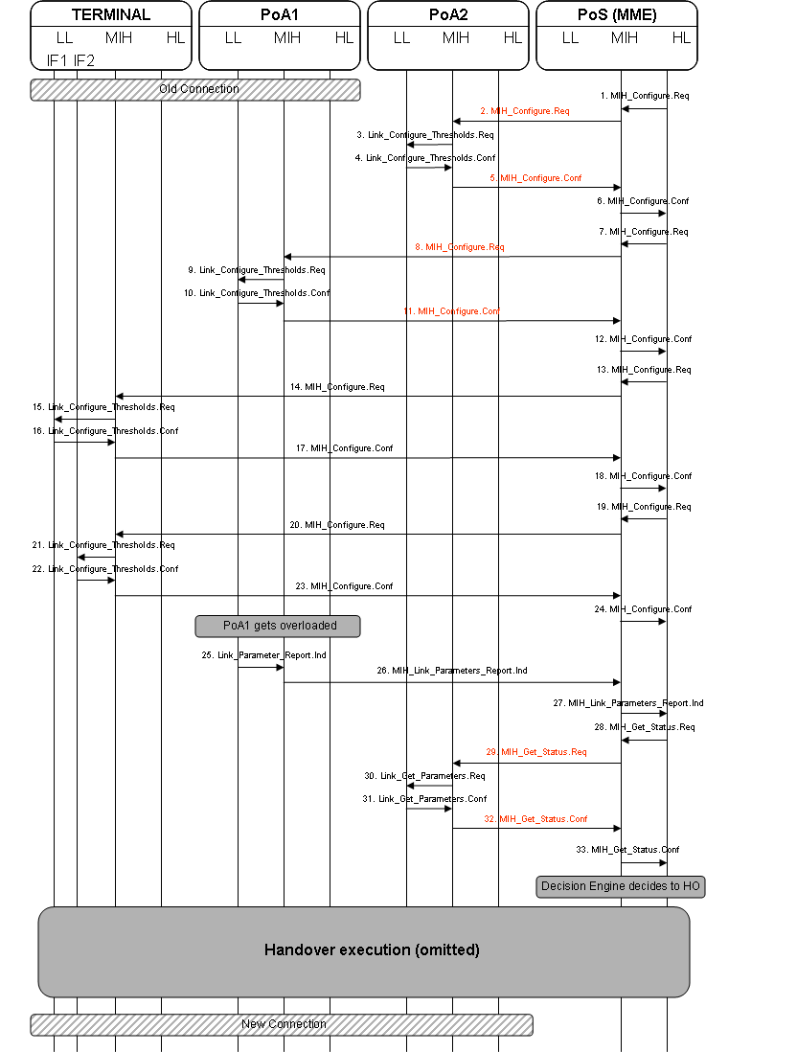
Description:

1-6) The Mobility Management Entity (MME) is the centralized entity that controls and optimizes the connections of a region. This entity issues a MIH_Configure request to configure all the PoA with thresholds for the ‘CoS Available Throughput’ of their links and it also issues MIH_Configure requests to all interfaces of the mobile terminal to configure its QoS parameters thresholds (signal strength, error rate, etc). In messages 1 to 6 it configures the thresholds for load in PoA2. Based on this threshold, if PoA2 becomes overloaded it will send an event indicator to the MME.

7-12) In messages 7 to 12 the MME configures the thresholds for ‘CoS Available Throughput’ in PoA1.

13-24) In messages 13 to 24 the MME configures the QoS parameters thresholds in all interfaces of every mobile terminal. Based on this information, the MME is aware of all potential candidate PoAs for each mobile terminal. Note that this information is required in order to take appropriate handover decisions.

25-27) In messages 25 to 27 PoA1 becomes overloaded and based on the previous threshold configuration it notifies of this event to the MME.

28-33) In messages 28 to 33 the MME retrieves the information on the ‘CoS Available Throughput’ of the other PoAs for a certain Class of Service by using the MIH_Get_Status command. The ‘CoS Available Throughput’ indicates the maximum data throughput that a user can use, given the data throughput already used by other users and the data throughput the PoA reserves for other potential users, according to its own policies. With this information, the MME can ensure that a new terminal connecting to that PoA will have the available resources demanded by its Class of Service. Based on this information and the QoS information from the terminals, the MME has enough information in order to take optimal handover decisions to optimize the overall network performance of its region. The execution of the handover is therefore triggered by the MME. The execution part has been omitted here for convenience.

Performance Evaluation

The feasibility and performance of centrally coordinated network initiated handovers has been thoroughly analyzed via an extensive set of simulations [2, 3, 4]. In this section we present some simulations results, just to briefly illustrate the performance improvement that can be achieved with the proposed centralized network initiated handover strategy. For the more detailed analysis the reader is referred to the given references which are available from the authors upon request.

In order to gain insight into the performance improvement achieved with the proposed strategy, we performed the following simulation. We had a number of MTs moving around at a speed uniformly distributed between 0 and 10 m/s in an area covered by 25 APs separated 250 m from each other. Their QoS requirements were such that at most 10 MTs could be admitted at one AP. In this scenario, we measured the improvement in terms of the number of communications interrupted due to moving into an area with all APs fully loaded when using the proposed strategy and when not using it.
Results, as a function of the number of MTs, are given the figure above. Taking into account that the point of saturation is when there are 250 terminals in the scenario, for non congested cases the improvement in the number of interruptions suffered by users is close to four times better when utilizing NIHO schemes than utilizing MIHO schemes. As we approach to the saturation point in number of terminals, the improvement decreases. Nevertheless, these results show that a substantial improvement in performance is achieved with the proposed technique.

Acknowledgments

The presented contribution has been studied in the framework of the IST collaborative project Daidalos (www.ist-daidalos.org), project founded by the European commission.

References

- “draft-melia-mipshop-mobility-services-ps-00”, Internet draft on problem statement for mobility services, work in progress.
- R. Aguiar, S. Sargento, A. Banchs, C. Bernardos, M. Calderon, I. Soto, M. Liebsch, T. Melia, P. Pacyna, “Scalable QoS-Aware Mobility for Future Mobile Operators”, IEEE Communications Magazine, Special issue on scaling the Mobile Internet, June 2006.
- T. Melia et al., “Network Controlled Handovers: challenges and possibilities”, under revision on Personal Wireless Communications.
- T. Melia, A. Vidal et al., “Towards IP Converged Heterogeneous Mobility: A Network Controlled Approach”, under revision on IEEE Infocom 07.

Note that, in order to obtain the information required for this command, a technology specific primitive needs to be executed to obtain the available bandwidth information. For example, with 802.11e this information can be obtained by means of the MLME-SCAN command – this command contains the QBSS Load element which corresponds precisely to the maximum available throughput parameter.

