Project | IEEE 802.21 MIHS  <http://www.ieee802.org/21/>
Title | Logical Network Reference Model text
DCN | 21-06-0708-00-0000
Date Submitted | July 19, 2006
Source(s) | Michael G. Williams, Nokia
Re: | IEEE 802.21 Session #15 in San Diego
Abstract | The section 5.3.2 Logical Network Reference Model text needs modifications to go along with the revised drawing and accepted comments. The revised text is more abstract and makes fewer assumptions about particular topologies or scenarios.
Purpose | To resolve LB#1 comments 130, 136, 137, 138, 140
Notice | This document has been prepared to assist the IEEE 802.21 Working Group. It is offered as a basis for discussion and is not binding on the contributing individual(s) or organization(s). The material in this document is subject to change in form and content after further study. The contributor(s) reserve(s) the right to add, amend or withdraw material contained herein.
Release | The contributor grants a free, irrevocable license to the IEEE to incorporate material contained in this contribution, and any modifications thereof, in the creation of an IEEE Standards publication; to copyright in the IEEE’s name any IEEE Standards publication even though it may include portions of this contribution; and at the IEEE’s sole discretion to permit others to reproduce in whole or in part the resulting IEEE Standards publication. The contributor also acknowledges and accepts that IEEE 802.2 may make this contribution public.
Patent Policy | The contributor is familiar with IEEE patent policy, as outlined in Section 6.3 of the IEEE-SA Standards Board Operations Manual <http://standards.ieee.org/guides/opman/sect6.html#6.3> and in Understanding Patent Issues During IEEE Standards Development <http://standards.ieee.org/board/pat/guide.html>.

Proposal: Replaces section 5.3.2 with the following picture and text:

5.3.2 Illustration of the MIH Communication Model

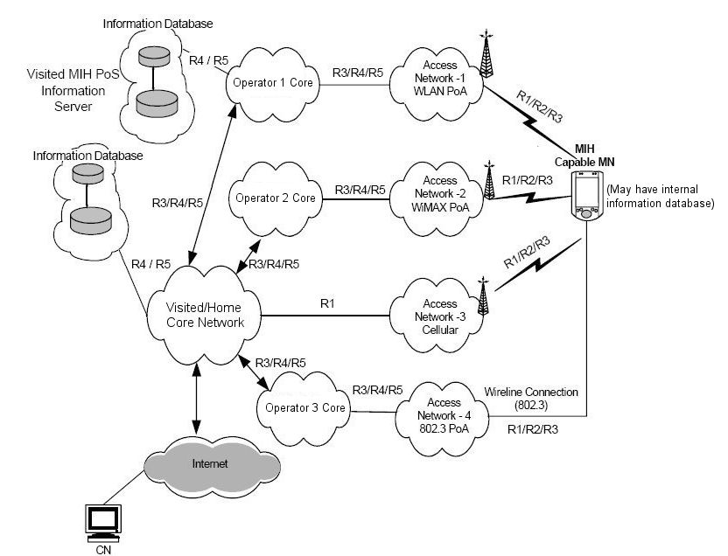

A network model including MIH services is shown in Figure 3 for greater illustration of the MIH Communication Reference Points. Moving from right to left, the model includes an MIH-capable mobile node (MN, far right) that supports multiple wired and wireless access technology options. The MN has an MIHF implemented. The MN may have the information service partially implemented internally.

The model illustrates access networks that are connected in some loose, serial way to a core network (Operator 1-3 Core). Also depicted is an access network that is more tightly interworked or coupled (Access Network-3) The Operator 1-3 Core each might represent a service provider or corporate intranet provider. This model illustrates the provisioning provider is operating Access Network-3 coupled via R1 to a core (labeled Visited/Home Core Network) The terms Visited and Home are used to indicate the provisioning service provider or enterprise. Any of the illustrated networks could be both a visited or home network depending on the relation of the operator to the provisioner of the MN.

Network providers offer MIH services in their access networks (Access Network-1 to 4) to facilitate handover into their networks. Each access technology either advertises its MIH capability or responds to MIH service discovery. Each service provider for the access network allows access to one or more MIH Points of Service (PoS, compare with Communication Model) These PoS may provide some or all of the MIH services as determined during MIH capabilities discovery. The location or node of an MIH PoS is not fixed by the standard. The PoS location may vary based on operator deployment scenario and the technology-specific MIH architecture.

An MIH PoS may reside next to or be co-located with the point of attachment (PoA) in the access network Access Network 1,2,4 are typical). Alternatively the PoS may reside deeper inside the access or core networks (Access Network 3 is typical). As shown in Figure 3, the MIH entity in the MN communicates with MIH network entities either by R1, R2 or R3 over any access network. When the PoA in the serving access network has a co-located MIH function, then an R1 reference connection terminates at the PoA which is also the PoS (MN to Access Network 1,2,4 of the model could all be R1 ) In that case an R3 reference connection would be terminated at any non-PoA (also illustrated by MN to Access Networks 1,2,4). MIH events may originate at both sides of an active R1 link. The MN is typically the first node to react to these events.

The interaction of visited and home network could be either for control and management purposes or
for data transport purposes. It is also possible that due to roaming or SLA agreements, the home network
may allow the MN to access the public Internet directly through a visited network. As illustrated, two MIH network entities may communicate with each other via R4 or R5 reference connections.
The MIH capable PoA may also communicate with other MIH network entities via R3 and R4 reference points. The MIH capable MN could have a MIH communication with other PoA in the candidate access networks via R2 reference point to obtain information services about the candidate network.

With regard to the MIH Information Service (MIIS) the providers offer access to their information server located in a MIH PoS node (upper far left). The operator provides the MIIS to mobile nodes so they can obtain pertinent information including but not limited to new roaming lists, costs, provider identification information, provider services, priorities and any other information that would enable to select and utilize services. As illustrated, it is possible for the mobile node to be pre-provisioned with MIIS data by its provider. Also possible is for the mobile node to obtain MIH information services from any access network of its provider. MIIS could also be available from another overlapping or nearby network, using that network’s MIIS point of service. A provisioner’s network (depicted here as coupled with Access Network 3) may utilize R3 and R4 interfaces to access other MIH entities like the provisioner’s or visited network’s MIH information server.

With regard to the MIH Command Service (MICS) the Information Database (far left, mid-way down) depicts a command service PoS. The MN MIHF typically communicates with this server using a layer three transport.

