Project | IEEE 802.21 Media Independent Handover Services  <http://www.ieee802.org/21/>
Title | Amendment of the MIH Handover Procedure: LB Issue-# 18 : Comment 495, 915
Date Submitted | July 13th, 2006
Source(s) | Junghoon Jee, Eunah Kim, Hongseok Jeon  ETRI  161 Gajeong-Dong, Yuseong-Gu  Daejeon, 305-700, KOREA | Voice: +82-42-860-4820  Fax: +82-42-861-5404  {jhjee, eakim, jeonhs}@etri.re.kr
Re: | IEEE 802.21 Session #NN in Hyatt Regency, Vancouver
Abstract | This contribution proposes an amendment of the handover procedure of Media Independent Handover which is defined in IEEE P802.21/D01.00.
Purpose | Discussion and Adoption
Notice | This document has been prepared to assist the IEEE 802.21 Working Group. It is offered as a basis for discussion and is not binding on the contributing individual(s) or organization(s). The material in this document is subject to change in form and content after further study. The contributor(s) reserve(s) the right to add, amend or withdraw material contained herein.
Release | The contributor grants a free, irrevocable license to the IEEE to incorporate material contained in this contribution, and any modifications thereof, in the creation of an IEEE Standards publication; to copyright in the IEEE’s name any IEEE Standards publication even though it may include portions of this contribution; and at the IEEE’s sole discretion to permit others to reproduce in whole or in part the resulting IEEE Standards publication. The contributor also acknowledges and accepts that this contribution may be made public by IEEE 802.21.
Patent Policy | The contributor is familiar with IEEE patent policy, as outlined in Section 6.3 of the IEEE-SA Standards Board Operations Manual <http://standards.ieee.org/guides/opman/sect6.html#6.3> and in Understanding Patent Issues During IEEE Standards Development <http://standards.ieee.org/board/pat/guide.html>.

Amendment of MIH Handover Procedures in the Annex A-1
Proposal #1
We propose to add the following section to the Annex A-1 and reorganize the section like below.
Annex A-1
(informative)
A-1.1 Mobile-initiated MIH Handover Procedure
A-1.2 Network-initiated MIH Handover Procedure
A-1.3 MIH Handover Procedure between 802.11 and 3GPP2
[Please refer the texts from the current Annex A-1 of D01.]
A-1.4 MIH Handover Procedure between 802.11 and 802.16

Proposal #2
We also propose to adopt the following general handover procedures as the baseline of the section A-1.1 and A-1.2.
A-1.1 Mobile-initiated MIH Handover Procedure
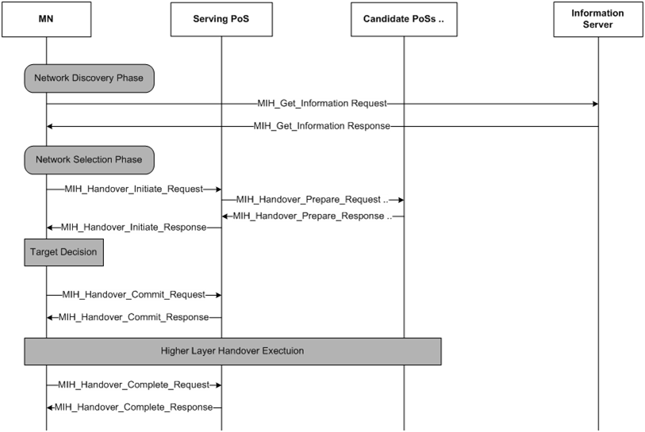

The Mobile-initiated MIH Handover Procedure is as follows,
- The MN queries the neighboring network information by sending the MIH_Get_Information Request message to the Information Server. This information query needs to be done as soon as a MN is first attached to a new serving network. Also, a MN can query the neighboring information to the Information Server to get the fresh neighboring network information. [Note: There is no functional entity in our communication model. Is there any other way to express that?]
- The Information Server responds by using the MIH_Get_Information Response message.
- The MN initiates a mobile-initiated media independent handover by sending the MIH_Handover_Initiate_Request message to the Serving PoS.
- The Serving PoS sends the MIH_Handover_Prepare_Request messages to more than one Candidate PoSs to query the availability of the resource at the candidate network.
- The Candidate PoS responds by using the MIH_Handover_Prepare Response message.
- The Serving PoS notifies MN of the handover initiation result by the MIH_Handover_Initiate Response message.
- The MN decides the target of the media independent handover. This target decision is based on the information of the availability of resource at the target which was received through the MIH_Handover_Initiate Response message.
- The MN commits a handover by sending the MIH_Handover_Commit Request message to the serving PoS. [Note: Questions arises…Relationship with the MIH_Switch command or message? L2 handover execution command? Relationship with the higher layer handover execution?]
- The Serving PoS notifies the result of the handover using the MIH_Handover_Commit Response message.
- After the higher layer handover execution, MN sends the MIH_Handover_Complete Request message to the Serving PoS.
- The Serving PoS responds by sending the MIH_Handover_Complete Response message to the MN.

A-1.2 Network-initiated MIH Handover Procedure

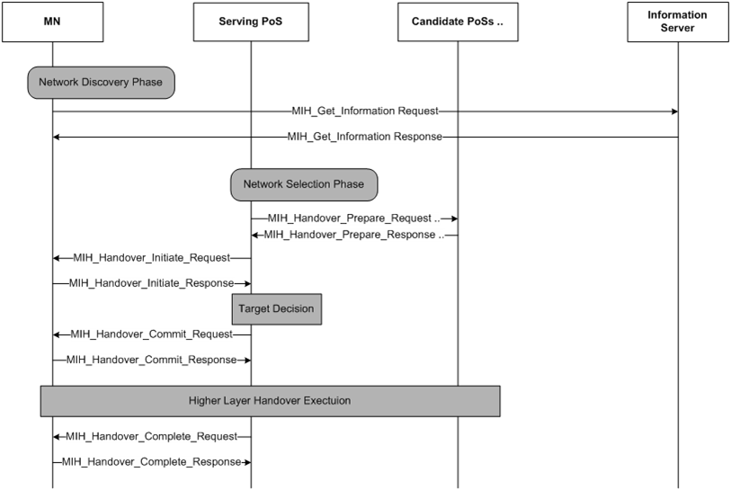

The Network-initiated MIH Handover Procedure is as follows,
- The MN queries the neighboring network information by sending the MIH_Get_Information Request message to the Information Server. [Note: There is no functional entity in our communication model. Is there any other way to express that?]
- The Information Server responds using the MIH_Get_Information Response message.
- When the need of media independent handover is found, the Serving PoS sends the MIH_Handover_Prepare_Request messages to more than one Candidate PoSs to query the availability of the resource at the candidate network.
- The Candidate PoS responds by the MIH_Handover_Prepare Response message.
- The Serving PoS initiates a media independent handover by sending the MIH_Handover_Initiate Request to the MN.
- The MN responds through the MIH_Handover_Initiate Response.
- The Serving PoS decides the target of the media independent handover.
- The Serving PoS commits a handover by sending the MIH_Handover_Commit Request.
- The MN replies the result through the MIH_Handover_Commit Response.
- After the higher layer handover execution, the Serving PoS sends the MIH_Handover_Complete Request to the MN.
- The MN responds by sending the MIH_Handover_Complete Response message to the Serving PoS.

