
IEEE P802
Media Independent Handover Services
Tentative Minutes of the IEEE P802.21 Working Group
May 11, 2004
Hyatt Regency, Los Angeles, CA, USA
Chair: Ajay Rajkumar
Vice Chair: Michael Glenn Williams
Secretary: Xiaoyu Liu

First Day Meetings: Terrace CD; Tuesday, May 11, 2004

Meeting opening

Opening Notes (21-04-0053-00-0000-session2_opening_notes.ppt)

Meeting called to order by Ajay Rajkumar at 9:00AM

Xiaoyu Liu appointed the secretary

IEEE 802 rules of order presented

Roberts Rules of Order will be used

Patent policy slides presented – No responses

Slide on discussions which are inappropriate also presented

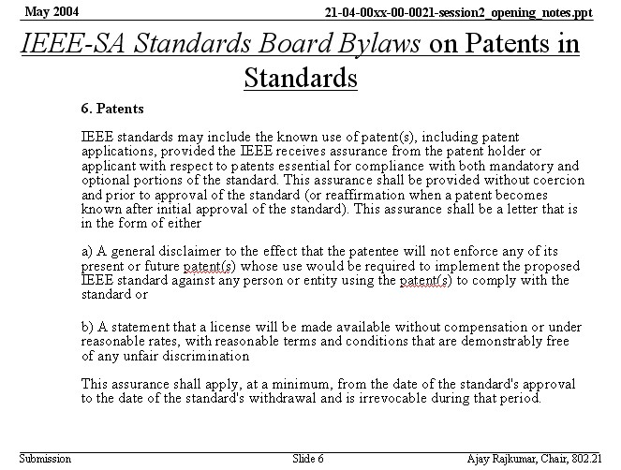

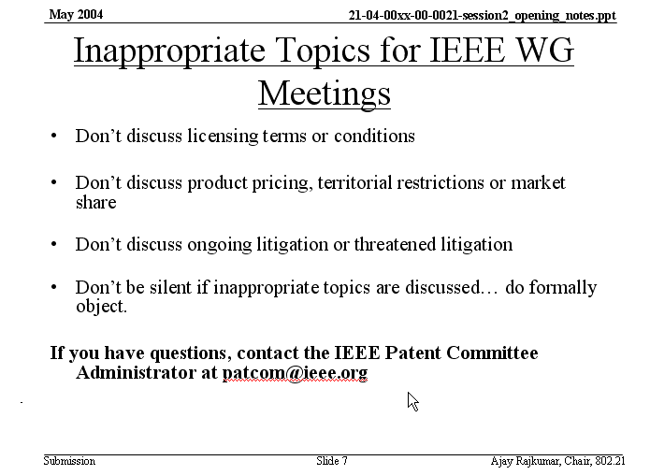

Meeting Server Details (21-04-0055-00-0000-meeting_server_details.ppt)

External website: http://www.ieee802.org/21

Meeting website: http://10.0.1.21

Alternate website name: http://handover/

Agenda

Meetings Tuesday-Thursday 9AM-5PM

Moving forward to technical requirements and user scenarios

The agenda is approved with unanimous consent

Approval of March Meeting Minutes

Approved with unanimous consent

Contribution Cover Sheet (21-04-0036-00-0000-cover_sheet.doc)

Document contribution, place title, date submitted, source, abstract, purpose

No objections

Document Control Number Scheme (21-04-0037-01-0000-naming_convention.ppt)

Generic filename: gg-yy-ssss-rr-GGGG-brief_topic_name.ext

Q: Is this compatible with .11 or .16 document uploading system? A: Yes, but the leading 21 helps sorting

Q: Could a template be provided with cover sheet, etc.? A: Yes.

DCN applied to documents of March and May meeting

Temporarily sequence numbers are manually assigned by the chair.

DCN Scheme adopted with unanimous consent

Voting Membership Rules (21-04-0038-01-0000-voting_member_process.ppt)

Starting from plenary meeting, voting membership at the end of second plenary meeting

Starting from an interim, voting membership at the end of the second plenary meeting

Attendance sheet is being circulated. Be sure to sign. We use manual right now. Include your email contact.

Q: Cross voting last time was with .16? A: Yes if you’re a member of .16 and you attend .21, you can count towards maintaining voting rights. Remember this is for maintaining rights only.

Do sessions count across meetings, or do you have to do them all at one meeting when trying to earn voting rights? A: They can count across meetings but must be within .21 to earn voting rights in .21.

Q: Is there the same agreement as .16 with .20 as well? A: Yes. We are trying to work with other groups as well.

Technical presentations

Michael G. Williams assumes the Secretary, Xiaoyu Liu Presents

Technical Presentation: Considerations regarding L2&L3 Schemes in 802.3/802.11 Handover (21-04-0052-00-0000-wired_wireless_LAN_handover.ppt) (Contributor: Xiaoyu Liu, Youn-Hee Han, SAMSUNG AIT. Presented by Xiaoyu Liu)

Q: Comment that use doesn’t have much choice today in handover between .3 and .11. The O/S makes the decision, but uses routing metrics or something.

Comment that having two data flows at the same time isn’t typical now because there are two IP address on the different interfaces and the application can’t use it. Comment that it isn’t clear if this group will address L3 or not.

Comment that security and QoS differ on “flows” between .3 and .11.

Q: Is mobile IP or other mobility agent with its own IP address, or L2 tunneling only included in the scope? A: Some of the scope is defined by the group as being within 802. However handovers between domains or technologies rely on L3 as well like mobile IP. We will interact with IETF too.

Q: What is the identity, IP address or MAC address? A: Within the 802 it is the MAC address.

Comment that mobile IP-like mechanisms could be applied to MAC addresses.

Comment that we have presentations already demonstrating L2 mobility.

Comment that we can address L3 by doing joint work items with IETF.

Comment that assuming L2 triggers & hints must have a way of reaching L3.

Comment that this presentation describes user’s behaviors more than the possibilities. For example .11 to .3 could be sudden.

Q: Are there any measurements taken to back up the binding update? A: Yes see earlier slide. Comment it depends on where the HA is.

Comment that IETF has explicitly asked for help with distributing router advertisements to facilitate handover. Comment that embedding such info in beacons greatly reduces handover time. RA caching would help also.

Comment that PPP is a layer 2 mechanism.

Review draft text for above presentation: Considerations Regarding L2&L3 schemes (21-04-0051-00-0000-input_to_technical_requirements.doc) (Contributor: Dong-Jye Shyy, MITRE; Xiaoyu Liu, Soohong Park, SAMSUNG. Presented by Xiaoyu Liu)

Q: Is there something specific to .11 in this presentation or could it be any wireless? A: I think there are different scenarios for other wireless. These requirements are only for .11.

Comment that these requirements seem to go beyond the scope, e.g. 4.1.1.2.3. It seems to say we require STA to have IPv4 and v6.

Comment that our scope should permit any L3 client.

Q: Are you looking at each specific pairing within 802, or is there a generic model behind this? Especially why assume that 802.3 won’t move too much. A: The technical requirements have a structure and conformance to the section called “reference model”. The scenarios or use cases give specific pairings.

Comment that there are common elements on requirements in the submissions from different authors. Perhaps those who have submitted can work offline to get something that has the merge or consensus of them.

ACTION (.002) Have ad hoc to work on the 1.6.5 topic.

Has there been any interest in L3 of knowing specifically what MAC address is or has changed to? A: Outlook seems to want to be addressed independent and might rely on MAC address.

EUI should be used by all 802 standards.

Comment that by knowing the MAC address of an AP, a STA might be able to get the IP of it and decide if there would be a subnet change by moving there.

Comment that we should study what uses of the MAC address is made by different L3 clients.

The requirements and models and use cases might break out into separate docs later. The requirement document has a roughly outlined agreement to last time.

Normative draft text has not been called for yet.

Xiaoyu Liu resumes the Secretary

Technical Presentation: Steps in Handoffs and Use Cases (21-04-0057-00-0000-Handoffs_Steps_UseCases.ppt) (Contributor: Vivek Gupta, Intel Corporation. Presented by Vivek Gupta)

Comment: 802.11a/b/g/ share the similar MAC. .11n in the charter has the ability to modify the MAC as well as PHY, but unclear this time. .11n could not be talked about at this time. .11a/b/g are concerned because they are consistent.

Comment: Intra administrative domain, in case of .11, really means between ESS. Subnet switch may or may not be involved.

Q: Do you suggest something like 802.15, i.e. handoff between Zigbee and Bluetooth? An example is a gateway from internet IP world to body transaction. A: Do not have good answer.

Q: Do we see WLAN/WPAN handoff within our scope? A: Yes, .xx to .xx is within our scope. But not know exactly how it works.

(Discussions about ESS)

Comment: Intra ESS is within our scope, not inter ESS. In case of 802.11 two .11 interfaces are connected to two different ESS, this may be within the scope. It would be called intra 802.xx instead of inter ESS. C: One AP may service multiple ESS. Response: Complicate use case. C: TGr finds work inside ESS. We are working inter-ESS.

C: ESS’s aren’t well defined by the .11 standard. Two ESSs with the same name but joined by the internet are technically part of the same ESS. Within .11r it isn’t clear either what an ESS is.

C: .11r isn’t thinking of handling IP address change at this point. If there are subnet changes within a BSS, it isn’t clear how that will be accelerated

Q: Who makes the network selection decision? How to deliver such selection into to STA? A: Could be mobile initiated handoff. STA with multiple interfaces makes decision and could use the primitive defined in .21 to facilitate such selection. Policy decision function depends on customers.

Q: Why do you distinct voice from data applications? Voice may run over data. A: During study phase group, we agreed handover is of IP connection, not a CS call for example.

Q: Is voice over cellular L1 handover to voice L3 on another bearer in scope? A: No. Specifically is a VoIP over 802.11 handed over to GSM CS call is not in scope but could be helped anyway by this work.

Q: So are bearers that can’t support IP in scope? A: Yes the intention was to give examples only. C: .17 have explicitly said they have no interest in .21

Q: The only considered technology is mobile IP? A: No. The scope is “Layer 3”, such as mobile IP.

Meeting called to order by Ajay Rajkumar at 2:00PM after break for lunch. Vivek’s Presentation continued.

Q: What particular info service providers give through L2 connection, and how? The information may not be there when you just have L2 connection. A: Another presentation to address this issue, global network neighborhood. Current radio may get the information for selection of other radios. You may not need regular MAC scan or switching to another radio.

Comment: .11k introduces site report, some similar mechanisms available. Response: I am not say about site report. Site report from beacon still provides L2 connection info. You may need all the info, such as security mechanism, different service providers, etc.

Comment: W may need a report to describe interactions between 802.11 all that are .11 specific suite, e.g. BSSID, channel. .21 should combine of that of .11. A: The 802.21 would define a generic model and apply to specific technologies. Comment: Generic solution for all the different groups could be difficult.

D.J.: There are various solutions to do media specific things. .21 intended to provide a model to allow other groups to share their specific own info.

Ajay: It could be a framework, but not only framework. It could be certain generic and certain specific defined by .21. Mechanisms to carry that information may be implementation specific things. That’s the model in my mind.

Comment: Scope of this WG includes 11/16/15/3G and maybe different service providers, etc. Problems become bigger and bigger, how to solve this problem? Response: Focus on only certain interested technologies.

Comment: Figure out problems of .21 and external standard groups, e.g. IETF DNA WG, MOBOPTS, etc. Define, extend and solve the problems. General architecture is not the work of standard organization. I am also not sure of the timeline. Response: More generic triggers would benefit this group, rather than progressing or extending older issue in 802 or 3G like 3G/WLAN handover.

Comment might need to clarify what is done by 11 and what by 21. Detection of link is defined by the MAC / technology. 21 could create a trigger like “identified access point”

Comment that SNMP addressed a huge amount of info into abstracts such as mib1, mib2, etc. We could do something such as that. Response that yes that has a lot of consensus here.

Q: Transitions between wired/wireless is through software? We specify availability of certain trigger and supplementary service in the MAC. A lot of MAC services are hardware implementation. A: It is not necessarily across the link. It could go across the link or just be OS function.

Comment: Regarding “NOT to do in 802.21”, I would refrain of that. We may go forward.

Comment: E.g. the link-cross trigger, threshold is not a trigger. Some entity above L2 has knowledge not in MAC/PHY to set the threshold, and then MAC/PHY can generate that trigger. The decision making engine may reside in OS. But some functionality of policy decision is there, if .21 does not do that, who does?

Comment that policy can determine where the L2 signaling mechanism resides (e.g. in the mobile device, or in the base station or both.)

Comment that 802.21 is about internetworking and media independent handover. It might be that eventually other groups might do some of the things that are out of scope for the first standard.

Comment that link quality maybe it should be in the triggers list. Response: I agree with you. There was consensus in the room. Comment that a threshold isn’t inherent in the MAC & PHY.

Comment on the discussions that have been surrounding L2.5. 3GPP call it convergence layer. It seems to be below IP and above the MAC.

Comment it will be difficult for .21 to abstract things from all MACs. 21 might make a strawman but it would get shot down once presented to the other SDO.

Comment that the chair of a particular WG doesn’t commit the WG. Response: 21 will rely heavily on liaisons. Q: Would the 11 group ballot on the 21 information? A: Yes we think so.

Comment that .11 could just pass info through the .21 conduit. In that way 21 wouldn’t require something from .11. Comment that WMN and WIEN all will have input / interaction with 21 too. Comment that 14 people are currently registered as 21 for their primary group. 47 registered as their 2nd interest.

Comment that if we define things that are implemented in h/w we meet this presentation’s definition of success.

Technical Presentation: Architecture of a Dynamic Heterogeneous Network System (21-04-0043-00-0000-Seesta.pdf) (Contributor: Reijo Salminen, Seesta. Presented by Reijo Salminen)

Q: Something in the diagram network indicates the movement from one cell to other cells? Is there any report or monitoring function here? A: When mobile moves from one cell to another, there is an event that needs to transfer. TOM is complex.

Comment: What is the complexity of vertical handover? One level of abstraction, communication goes back and forth. Different networks deal with different complexity metrics. Response: What’s shown is only core network side.

Discussion about cellular architectures and functions

Comment that 21 isn’t using MAP type core GSM/WCDMA protocols. We are using MIP or SIP or other IP based mobility

Q: Could the cellular experts here think they could write a convergence layer between the GSM RR CS, and say 802? A: Doesn’t appear in scope. But you need another function below mIP that handles the mobility at the MAP layer. There is the control plane and user plane, where the control is parallel to the data, not layered like an 802 MAC with IP payload. But cellular can do handover between WCDMA and GSM today which is inter-technology handover.

Comment: 3GPP 25/45 address nothing about WLAN.

Comment: In 802 the link does QoS. We have MAC definition in .11 and .16 for QoS. One of the features we would do is to join the gap between 802 QoS requirements, QoS facilities. Response: Natures of QoS parameters are different. End-to-end QoS or link level QoS? Comment: Basically local link QoS. QoS parameter set.

Comment that network initiated handover such as a signal over the .3 saying stop using your .11 could be useful. Should it be in scope? A: Yes it shouldn’t mater which end initiates the handover. Cellular calls that directed handover, e.g. to get all MN’s off of a cell and onto another cell. Comment: All handover in cellular are Network initiated.

Comment that 3GPP has scenario 4 with the first mobility of session continuity. This presentation is potentially solving 3GPP scenarios 5,6

Comment that the cellular environment is based on centralized control. It has to do with management.

Comment: Mobile host is key here. In cellular, mobile takes a bigger role. Mobile can be fully capable and has more intelligence.

Technical Presentation: IEEE 802.11 Wireless Interworking with External Networks (WIEN) Study Group (21-04-0058-00-0000-IEEE802_11_WIEN_SG_scope.ppt) (Contributor: Stephen McCann, Siemens. Presented by Stephen McCann)

Q: Cooperate of the WG? A: An informational group in .11 could come up with a generic internetworking architecture. Main 3G groups may require 802’ work.

Examples of service would be SMS, other cellular services through the .11 network.

Q: Work complementing 3GPP/PP2 or developing signaling? A: PP/PP2 has solutions to .11 community. They need to address more important work, standardized work. We may need to double check the premises.

OMA, GMSA, 3GPP and 3GPP2 are SDO’s to be contacted / work with

Comment that the Motion should be in Sept to avoid a two meeting delay

Comment that .11 might accept MAC or other changes based on input from 21 requirements

Q: Grey box in the scope slide is in the STA? A: Yes. Q: Resource management mentioned in the scope may be end-to-end. You’ll define end-to-end protocols? A: We just define the interface, the API. We’ll not go to network side. Comment: Resource management may across the link.

Q: What is that external network, the network outside of the STA+AP combination? Are the Auth. & Auth. Boxes shorthand for a AAA infrastructure? A: AAA structure is typically outside the realm of the work here. We are not going to define internetworking architecture.

Q: You use 3G cellular networks as external networks, .16 not mentioned. Are you considering that be solved? A: We have to define the scope and choose the external networks. Not sure about .16 networks.

Are DSL, ISDN and cable included in external networks? A: Yes. Standardizing those is important to hotspots.

Comment: I think the white box more where STA communicates with AP, more generally, should be ESS. DS may be empty. Response: Then we go back to the problem of what is ESS.

Q: In the scope diagram, resource management e.g. 11k as well as 11e in one box? A: Not sure. One thing we got to go is to go to .11i/e/k to look and see what’s done. C: .11r also.

Comment that 11r and mobility doesn’t appear. Response: Yes that’s on purpose. The leaning at this point is that mobility is out of scope for us.

WIEN will meet at 4PM on Thursday.

Recess until tomorrow

Second day meetings on Wednesday, 9:00AM

Attendees

Attendees (1 or 2 credits towards voting rights today)

Takashi Aramaki 2
Sanjeev Athalye 2
Raymond Aubun 2
Yogesh Bhatt 2
Alistair Buttar 2
Alan Carlton 2
Ron Chang 1
Hong Cheng 2
Byungho Chung 2
Gopal Dommety 2
Jon Edney 1
Stefano Faccin 2
Peretz Feder 2
Helena Flygare 2
Yuri Goldstein 2
Vivek Gupta 2
James Han 2
Thomas Haslestad 1
Haixiang He 1
SuJin Heo 2
Eleanor Hepworth 2
Dave Hetherington 2
John Humber 1
David Hunter 2
Shinkichi Ikeda 2
David Johnston 2
Tyan-Shu Jou 1
Naveen Kakani 2
Beomjoon Kim 2
Wong Kue 1
Masahiro Kuroda 2
Yoko Kurosawa 2
Paul Lambert 1
Sungjin Lee 2
Jun Li 1
Jiaru Li 2
Jie Liang 2
Xiaoyu Liu 2
Rober Love 1
De Mai 1
Rahul Malik 2
Mahalingam Mani 1
Stephen McCann 2
Mike Moreton 2
Chiu Ngo 1
Eric Njedjou 2
Fran O’Brien 1
Ajay Rajkumar 2
Yousuf Saifullah 2
Takashi Sakakura 2
Reijo Salminen 2
Heather Sze 2
Lai-Ling (Anna) Tee 1
Sandy Turner 2
Jim Wendt 1
Henning Wieman 2
Michael Williams 2
Lily Yang 1
Tan Pek Yew 2
Petros Zerfos 1

