
IEEE P802
Media Independent Handover Services
Tentative Minutes of the IEEE P802.21 Working Group
May 11, 2004
Hyatt Regency, Los Angeles, CA, USA
Chair: Ajay Rajkumar
Vice Chair: Michael Glenn Williams
Secretary: Xiaoyu Liu

First Day Meetings: Terrace CD; Tuesday, May 11, 2004

Meeting opening

Opening Notes (21-04-00xx-00-0021-session2_opening_notes.ppt)

Meeting called to order by Ajay Rajkumar at 9:00AM

Xiaoyu Liu appointed to take the Secretary position

IEEE 802 rules of order presented

Roberts Rules of Order will be used

Patent policy slides presented – No responses

Slide on discussions which are inappropriate also presented

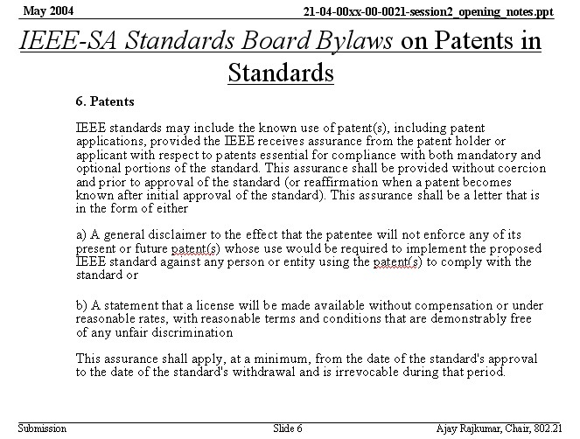

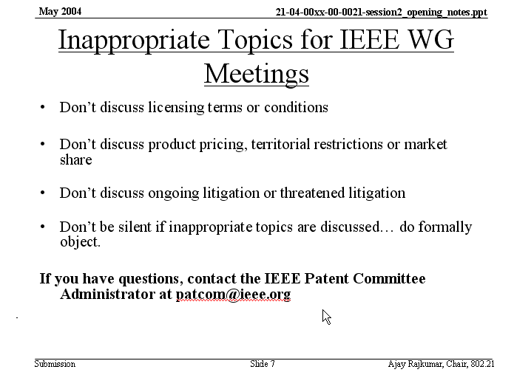

Meeting Server Details (21-04-00xx-00-0021-meeting_server_details.ppt)

External website: http://www.ieee802.org/21

Meeting website: http://10.0.1.21

Alternate website name: http://handover/

Agenda

Meetings Tuesday-Thursday 9AM-5PM

Moving forward to technical requirements and user scenarios

The agenda is approved with unanimous consent

Approval of March Meeting Minutes

Approved with unanimous consent

Contribution Cover Sheet (21-04-00xx-00-0021-cover_sheet.doc)

Document contribution, place title, date submitted, source, abstract, purpose

No objections

Document Control Number Scheme (21-04-00xx-00-0021-naming_convention.ppt)

Generic filename: gg-yy-ssss-rr-GGGG-brief_topic_name.ext

DCN Scheme adopted with unanimous consent

DCN applied to documents of March and May meeting

Voting Membership Rules (21-04-00xx-00-0021-voting_member_process.ppt)

Starting from plenary meeting, voting membership at the end of second plenary meeting

Starting from an interim, voting membership at the end of the second plenary meeting

Technical presentations

Michael G. Williams took the Secretary, Xiaoyu Liu Presents

Technical Presentation: Considerations regarding L2&L3 Schemes in 802.3/802.11 Handover (21-04-00xx-00-0021-wired_wireless_LAN_handover.ppt) (Xiaoyu Liu, SAMSUNG AIT)
Presentation of Xiaoyu Liu; Comments and discussions

Xiaoyu Liu back to the Secretary

Technical Presentation: Steps in Handoffs and Use Cases (21-04-00xx-00-0021-Handoffs_Steps_UseCases.ppt) (Vivek Gupta, Intel Corporation)

Comment: 802.11a/b/g/ share the similar MAC. .11n in the charter has the ability to modify the MAC as well as PHY, but unclear this time. .11n could not be talked about at this time. .11a/b/g are concerned because they are consistent.

Comment: Intra administrative domain, in case of .11, really means between ESS. .11 has defined the procedures for handoff within ESS.

Q: Do you suggest something like 802.15, i.e. handoff between Zigbee and Bluetooth? An example is a gateway from internet IP world to body transaction. A: Do not have good answer.

Q: Do we see WLAN/WPAN handoff within our scope? A: Yes, .xx to .xx is within our scope. But not know exactly how it works.

(Discussions about ESS)

Comment: Intra ESS is within our scope, not inter ESS. In case of 802.11 two .11 interfaces are connected to two different ESS, this may be within the scope. It would be called intra 802.xx instead of inter ESS. C: One AP may service multiple ESS. Response: Complicate use case. C: TGr finds work inside ESS. We are working inter-ESS. C: TRr handles mobility issue within ESS. C: APs have the same ESS ID, but in different subnet. Gateway does tunneling. Response: In this presentation, loose coupling is assumed to be the internetworking architecture. Most handoffs are L3 handoffs.

Q: Who makes the network selection decision? How to deliver such selection into to STA? A: Could be mobile initiated handoff. STA with multiple interfaces makes decision and could use the primitive defined in .21 to facilitate such selection. Policy decision function depends on customers.

Q: Why do you distinct voice from data applications? Voice may run over data. A: Distinguish between voice and data because of latency. How voice is implemented, over IP or in cellular network, depends on particular network environment. All the cases are within the scope of handoff.

Q: The only considered technology is mobile IP? A: No. The scope is “Layer 3”, such as mobile IP.

Meeting called to order by Ajay Rajkumar at 2:00PM after break for lunch. Vivek’s Presentation continued.

Q: What particular info service providers give through L2 connection, and how? The information may not be there when you just have L2 connection. A: Another presentation to address this issue, global network neighborhood. Current radio may get the information for selection of other radios. You may not need regular MAC scan or switching to another radio.

Comment: .11k introduces site report, some similar mechanisms available. Response: I am not say about site report. Site report from beacon still provides L2 connection info. You may need all the info, such as security mechanism, different service providers, etc.

Comment: W may need a report to describe interactions between 802.11 all that are .11 specific suite, e.g. BSSID, channel. .21 should combine of that of .11. A: The 802.21 would define a generic model and apply to specific technologies. Comment: Generic solution for all the different groups could be difficult.

D.J.: There are various solutions to do media specific things. .21 intended to provide a model to allow other groups to share their specific own info.

Ajay: It could be a framework, but not only framework. It could be certain generic and certain specific defined by .21. Mechanisms to carry that information may be implementation specific things. That’s the model in my mind.

Comment: Scope of this WG includes 11/16/15/3G and maybe different service providers, etc. Problems become bigger and bigger, how to solve this problem? Response: Focus on only certain interested technologies.

Comment: Figure out problems of .21 and external standard groups, e.g. IETF DNA WG, MOBOPTS, etc. Define, extend and solve the problems. General architecture is not the work of standard organization. I am also not sure of the timeline. Response: More generic triggers would benefit this group, rather than progressing or extending older issue in 802 or 3G like 3G/WLAN handover.

Comment: The problem similar to SNMP that is extremely diverse in different equipment. Some set is common and sub-set carries info for specific types of equipment. Some numbering scheme may happen.

Q: Transitions between wired/wireless is through software? We specify availability of certain trigger and supplementary service in the MAC. A lot of MAC services are hardware implementation. A: It is not necessarily across the link. It could go across the link or just be OS function.

Comment: Regarding “NOT to do in 802.21”, I would refrain of that. We may go forward.

Comment: E.g. the link-cross trigger, threshold is not a trigger. Some entity above L2 has knowledge not in MAC/PHY to set the threshold, and then MAC/PHY can generate that trigger. The decision making engine may reside in OS. But some functionality of policy decision is there, if .21 does not do that, who does?.

Technical Presentation: Architecture of a Dynamic Heterogeneous Network System (Anaheim Slides - Seesta.pdf) (Reijo Salminen, Seesta)

Q: Something in the diagram network indicates the movement from one cell to other cells? Is there any report or monitoring function here? A: When mobile moves from one cell to another, there is an event that needs to transfer. TOM is complex.

Comment: What is the complexity of vertical handover? One level of abstraction, communication goes back and forth. Different networks deal with different complexity metrics. Response: What’s shown is only core network side.

Discussion about cellular architectures and functions

Comment: 3GPP 25/45 address nothing about WLAN.

Comment: In 802 the link does QoS. We have MAC definition in .11 and .16 for QoS. One of the features we would do is to join the gap between 802 QoS requirements, QoS facilities. Response: Natures of QoS parameters are different. End-to-end QoS or link level QoS? Comment: Basically local link QoS. QoS parameter set.

Comment: Not sure of the network initiated session establishment. You are on wireless interface, something over .3 wired. Something like that. Response: Some tech has priority over the others. Comment: All handover in cellular are Network initiated.

Comment: Mobile host is key here. In cellular, mobile takes a bigger role. Mobile can be fully capable and has more intelligence.

Technical Presentation: IEEE 802.11 Wireless Interworking with External Networks (WIEN) Study Group (21-04-00xx-00-0021-IEEE 802_11_WIEN_SG_scope.ppt) (Stephen McCann, Siemens)

Q: Cooperate of the WG? A: An informational group in .11 could come up with a generic internetworking architecture. Main 3G groups may require 802’ work.

Q: Work complementing 3GPP/PP2 or developing signaling? A: PP/PP2 has solutions to .11 community. They need to address more important work, standardized work. We may need to double check the premises.

Q: Grey box in the scope slide is in the STA? A: Yes. Q: Resource management mentioned in the scope may be end-to-end. You’ll define end-to-end protocols? A: We just define the interface, the API. We’ll not go to network side. Comment: Resource management may across the link.

Q: What is that external network? Are you just talking about AAA structure in the box? A: AAA structure is typically outside. We are not going to define internetworking architecture.

Q: You use 3G cellular networks as external networks, .16 not mentioned. Are you considering that be solved? A: We have to define the scope and choose the external networks. Not sure about .16 networks.

Comment: I think the white box more where STA communicates with AP, more generally, should be ESS. DS may be empty. Response: Then we go back to the problem of what is ESS.

Q: In the scope diagram, resource management e.g. 11k as well as 11e in one box? A: Not sure. One thing we got to go is to go to .11i/e/k to look and see what’s done. C: .11r also.

Recess until tomorrow

Second day meetings on Wednesday, 9:00AM

Attendees

Attendees (0, 1 or 2 credits towards voting rights today)

Asher Altman 0
Keith Amann 0
Takashi Aramaki 2
Sanjeev Athalye 2
Raymond Aubun 2
Yogesh Bhatt 2
Harry Bims 0
Alistair Buttar 2
Alan Carlton 2
Yong Chang 0
Ron Chang 1
Hong Cheng 2
Aik Chindapol 0
Byungho Chung 2
Steven Crowley 0
Gopal Dommety 2
Jon Edney 1
Stefano Faccin 2
Lars Falk 0
Peretz Feder 2
Helena Flygare 2
Ruben Formoso 0
Yuri Goldstein 2
Qiang Guo 0
Vivek Gupta 2
James Han 2
Younhee Han 0
Thomas Haslestad 1
Takanari Hayama 0
Haixiang He 1
SuJin Heo 2
Eleanor Hepworth 2
Dave Hetherington 2
Michael HogHooghi 0
John Humber 1
David Hunter 2
David Huo 0
Shinkichi Ikeda 2
Prakash Iyer 0
Yeong Min Jang 0
Ho-in Jeon 0
David Johnston 2
Tyan-Shu Jou 1
Naveen Kakani 2
Allen Kasey 0
Toyoyuki Kato 0
Farrokh Khatibi 0
Byoung-Jo Kim 0
Beomjoon Kim 2
Wong Kue 1
Ted Kuo 0
Masahiro Kuroda 2
Yoko Kurosawa 2
Ming Lai 0
Paul Lamber 1
Jie Lang 0
B.J. Lee 0
Insun Lee 0
Sungjin Lee 2
Jun Li 1
Jiaru Li 2
Jie Liang 2
Wei Lih Lim 0
Xiaoyu Liu 2
Rober Love 1
De Mai 1
Rahul Malik 2
Mahalingam Mani 1
Taisuke Matsumoto 0
Stephen McCann 2
David McGinniss 0
Max Miyazono 0
Mike Moreton 2
Patrick Mourot 0
Mickey Mouse 0
Mullaguru Naidu 0
Chiu Ngo 1
Eric Njedjou 2
Fran O’Brien 1
Akira Okubo 0
Soohong Park 0
Vincent D. Park 0
Jani Preetida 0
Ajay Rajkumar 2
Maximilliam Riegel 0
Stefan Rommer 0
Yousuf Saifullah 2
Takashi Sakakura 2
Reijo Salminen 2
Maria Sanchez 0
Mike Sanderson 0
Emek Sadot 0
Chris Seagren 0
Ian Sherlock 0
Dong-Jye Shyy 0
Floyd Simpson 0
Tricci So 0
Heather Sze 2
Lai-Ling (Anna) Tee 1
SK Sung 0
Sandy Turner 2
Stephen Wang 0
Jim Wendt 1
AI Wieczorek 0
Henning Wieman 2
Michael Williams 2
Lily Yang 1
Tan Pek Yew 2
Petros Zerfos 1

