IEEE P802.21
Media Independent Handover Service
Draft Technical Requirements
Date:
May 9, 2004
Authors:

Peretz Feder
Ajay Rajkumar
Lucent Technologies

3. Architectures

IEEE 802 standards define only the PHY and MAC layers of a given interface. For end-to-end services and its architectural view of the network, other core network elements have to be defined.
Seamless Interworking between heterogeneous networks has traditionally been defined based on the degree of integration of the two networks. At one extreme is a tightly coupled architecture where the two networks share the same core network elements. At the other extreme is a loosely coupled network where the two networks may not share any network element in the core network. Any discussion on seamless interworking of a combination of different 802.xx wire-line and wireless networks as well as different cellular networks can lead to several network architectural scenarios. We broadly classify them as follows:

- Tight coupling of 802.xx networks
- Tight coupling of cellular networks
- Tight coupling of 802.xx and cellular networks
- Loose coupling of any combination of the above networks.

The following defines tight and loose coupling of 802.xx based wireless networks and Cellular networks.

3.3 Tight coupling of 802.xx and Cellular networks

In a tightly coupled approach an 802.xx wireless network is connected to the cellular core network in the same manner as the radio access elements, as shown in Figure 1. Session handover in tightly coupled networks is performed according to the cellular mobility scheme. The 802.xx networks emulate functions natively available in the cellular access networks. In this architecture, the 802.xx interworking gateway element appears to cellular networks such as UMTS and CDMA2000 core network as an SGSN or a PDSN router element respectively. In tight architecture, the inter-working gateway hides the working details of the 802.xx network from the cellular core network and instantiates the 802.xx radio elements as native cellular component. Mobile Nodes (MNs) must run the corresponding cellular protocol stack on top of their standard 802.xx network interface cards and handover from one physical layer to the other as needed. The 802.xx traffic is injected using cellular protocols into the core network. Both networks share the same authentication, signaling, transport, and billing infrastructures.

The tight approach presents several disadvantages. First, exposing the cellular RAN interface, which is inherently private to the cellular network, can imply security threats. Second, injecting high bandwidth 802.xx traffic directly into the cellular core network can significantly modify the provisioning of cellular core network elements, in effect re-provisioning all the core network elements.

Client device configuration also presents issues. First, there is the need to implement the cellular protocol stack on both interfaces. Second, for 3GPP networks Universal Subscriber Identity Module (USIM) authentication mechanism ETSI (1) most likely will be used for authentication, implying the use of USIM algorithms to gain access through the IEEE 802.xx interface. Also, the cellular authentication mechanism will force the 802.xx operators to interconnect and comply with the SS7 cellular network.

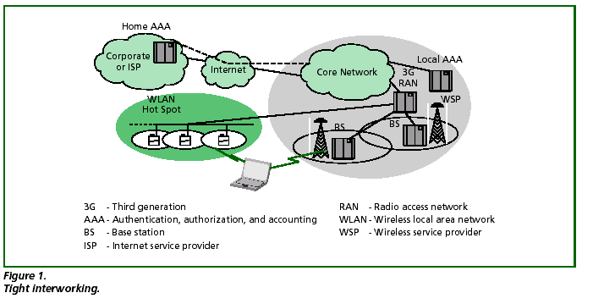

References

1. ETSI, 2002, “General Packet Radio Service (GPRS) Service Description, (Stage 2), (Release 99)”, 3GPP TS 23.060 v3.14.0 (2002-12) 122 060

