IEEE P802.19.1a
Wireless Coexistence
A coexistence decision algorithm for GCOs operating over overlapped service coverage area
Date: 2016-11-08
Author(s):
Name | Company | Address | Phone | Email
Hyunduk Kang | ETRI | 138 Gajeong-Ro, Yuseong-Gu, Daejeon, 305-700, South Korea |  | henry@etri.re.kr
Ae-Soon Park | ETRI
Seung Chan Bang | ETRI
Abstract

This document provides a coexistence decision algorithm for GCOs operating over overlapped service coverage area in order to resolve CID 166 in 1st TG review.

Proposal
The text below is proposed for a coexistence decision algorithm for GCOs operating over overlapped service coverage area.

      - Algorithm for GCOs operating over overlapped service coverage area
GCOs operating over overlapped service area may cause heavy co-channel interference. This algorithm provides a method for avoiding interference among GCOs operating over overlapped service coverage area according to a distribution state of GCOs(i.e, APs) and client of GCOs(i.e., STAs) in a GCO constituting an overlapping service coverage area , i.e., overlapping basic service set (OBSS).
Accordingly, a method of avoiding interference between adjacent BSSs shall minimize interference between STAs in an overlapping zone by adjusting the number of AP to be associated with STAs in an overlapping zone between BSSs causing interference when there is an overlapping zone between BSSs by taking into consideration various distribution states of an AP and an STA causing the interference between the BSSs. In order to reduce the number of APs associating with STAs located in an overlapping zone between BSSs, a process of re-associating a specific STA associated with a specific AP with another AP refers to station association filtering (SAF).

We assume that one CM and on CE are embeded in each AP which is a GCO. A coexisetence decision algorithm shall include the following steps as depcited Figure 1:
- Each AP collects information on STA scanning at least one AP
- Each AP obtains list of STAs scanning all of the AP and an adjacent AP by exchanging information with the adjacent AP
- Each AP compares the number of STAs associated with the AP and the adjacent AP by exchanging information with the adjacent AP
- Each AP determines AP to be associated with STAs located in overlapping zone through negotiation with the adjacent AP
- Each AP transmits reassociation request message to STA to be reassociate with the adjacent AP
- STAs receving reassociation request message transmit disassociation request message to serving AP, and transmit reassociation request message to the adjacent AP

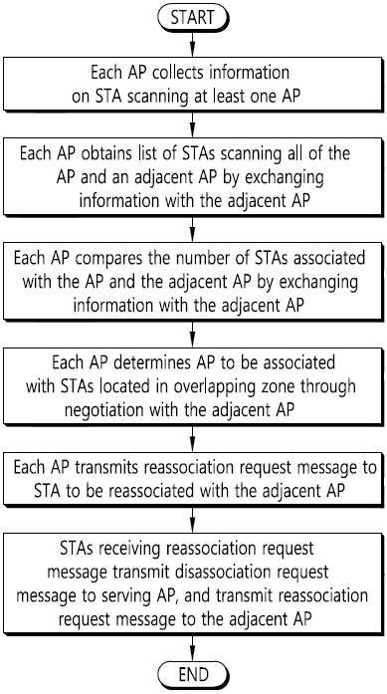
Figure 1 Flow chart of a coexistence decision algorithgm for avoiding interference among GCOs operating over overlapped service coverage area

Figure 2 depicts AP operation for hidden AP discovery.
Each AP scans a wireless channel and selects an operation channel to be operated. In this case, when receiving an association request message Association_Request from a specific STA, each AP transmits an association response message Association_Response to the STA to associate with the STA. Next, each AP collects channel scan results of STAs associated with the AP.
When it is determined that there is a hidden AP based on the collected channel scan results , each AP shall performs hidden AP discovery to detect a hidden AP. In this case, the hidden AP means an AP which configures an OBSS but a presence thereof is not detected because the AP cannot directly receive a beacon signal from an adjacent AP. The process of detecting the hidden AP may be performed with respect to channel scan results of all STAs associated with each AP.
After that, each AP shall performs connection setup of adjacent APs constituting the OBSS(overlapped basic servce set). Each AP shall selects an STA to be associated with the adjacent AP among STAs associated with the AP and an STA to be reassociated with the AP among STAs associated with the adjacent AP to perform SAF negotiation with the adjacent APs.
When the negotiation with the adjacent APs constituting the OBSS fails, each AP shall retry the SAF negotiation according to whether to retry the SAF negotiation. When the negotiation with the adjacent APs constituting the OBSS succeeds, each AP shall transmit a message APReassociation_Request to request reassociation request to the adjacent AP to an STA associated with the AP. This step shall be repeatedly performed until the review for all adjacent APs is completed.
Meanwhile, when channel scan results of the STA are updated, each AP shall perform the above hidden AP discovery process based on the updated channel scan results. When there is an SAF negotiation request from the adjacent AP, each AP hall perform the SAF negotiation in response thereto.
For example, although figure 2 illustrates a process of avoiding interference between BSSs through the negotiation between APs in a distributed topology scheme, an AP controller to manage APs may adjust the number of APs to be associated with STAs in an overlapping zone between BSSs and may indicate a command therefore to a corresponding AP by directly determining a certain AP to be associated with a certain STA in a centralized topology scheme. In addition, in a standalone topology scheme, since the negotiation between APs with respect to STAs located in an overlapping zone is impossible, each AP may transmit a message to request reassociation with an adjacent AP to STAs associated with the AP according to a creative determination.

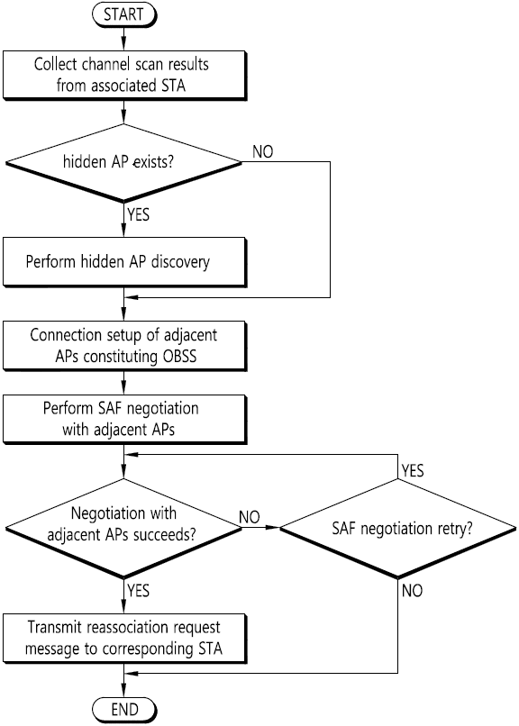
Figure 2 Flow chart of AP operation for a method for avoiding interference among GCOs operating over overlapped service coverage area

Figure 3 depicts STA operation for hidden AP discovery
The STA shall perform channel scan. If at least associatable AP is detected, the STA shall select an AP to be associated with among the detected APs. Next, the STA shall perform AP association by transmitting an association request message Association_Request to the AP to be associated and by receiving an association response message Association_Response from a corresponding AP. Next, the STA shall transmit channel scan results (list of APs detected through the channel scan) to the associated AP (serving AP), and is operated to use an operation channel of a corresponding AP. In this case, the STA shall periodically scan the channel. When the channel scan results are updated, the STA shall transmit the updated channel scan results to the associated AP.
When the message APReassociation_Request to request reassociation with another AP is received from the serving AP because the negotiation between the serving AP and the adjacent AP succeeds, the STA shall transmit a disassociation request message Disassociation_Request to the serving AP to select a new AP (AP adjacent to the serving AP). Next, the STA shall transmit the reassociation request message Reassociation_Request to the new AP and receives a reassociation response message from a corresponding AP. This step shall be performed until the STA stops the operation. In this case, the message APReassociation_Request to request reassociation to another AP shall include information (for example, identifier) on an AP to be associated with the STA. In this case, the negotiation between the serving AP and the adjacent AP shall be performed by transmitting a negotiation request message including at least one of an identifier of an STA associated with the serving AP, information on whether to reassociate the STA with another AP, and information on presence of a STA to be reassociated with the serving AP among STAs associated with the another AP to another AP by the serving AP, and by receiving an negotiation response message including an identifier of an STA associated with the another AP, information on whether to reassociate the STA associated with another AP with the serving AP, information on whether to accept reassociaiton with an STA reassociation-requested from the serving AP, and information on whether to succeed the negotiation from the another AP from the another AP.
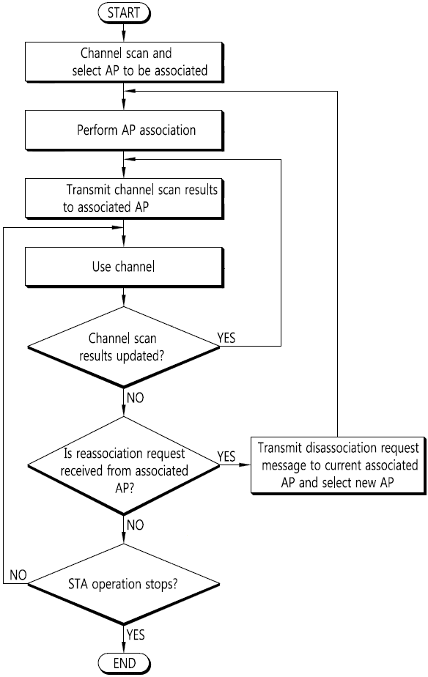
Figure 3 Flow chart of STA operation for a method for avoiding interference among GCOs operating over overlapped service coverage area

Figure 4 depicts An example of re-associating an STA located in an overlapping zone between BSSs to an adjacent AP. This is the case where an STA14 becomes an STA24 by reassociating the STA14 associated with an AP1 with an AP2 in an overlapping zone between BSSs by using a method for avoiding interference according to an embodiment of the present invention. To this end, the AP1 shall transmit a message APReassociation_Request to request reassociation with another AP (AP2) to the STA14 through the negotiation with the AP2. When receiving the message APReassociation_Request to request association with another AP from the AP1, the STA14 shall transmit a disassociation message Disassociation_Request to the AP1. Next, the STA14 shall transmit a reassociaton request message Reassociation_Request to the AP2, and shall receive a reassociation response message Reassociation_Response from the AP2 to become an STA24. Since only the STA21 and the STA24 associated with the AP2 are located in an overlapping zone between BSS coverage (BSS1) of the AP1 and BSS coverage (BSS2) of the AP2, the interference between BSSs shall be efficiently avoided through the above process.

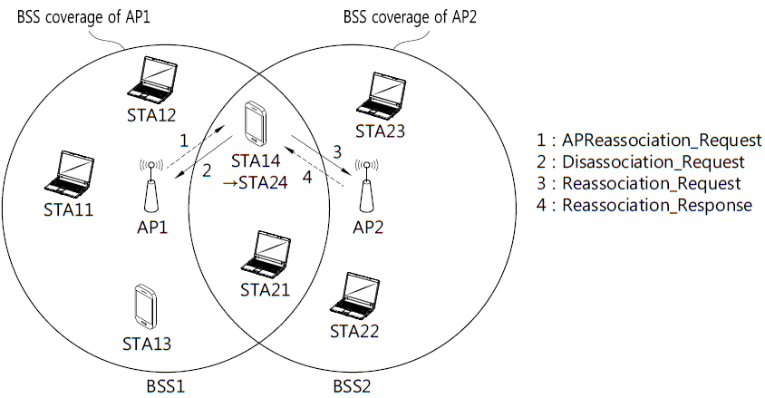
Figure 4 An example of re-associating an STA located in an overlapping zone between BSSs to an adjacent AP

Figure 5 depicts message exchange among APs and STAs for re-associating an STA located in an overlapping zone between BSSs to an adjacent AP.

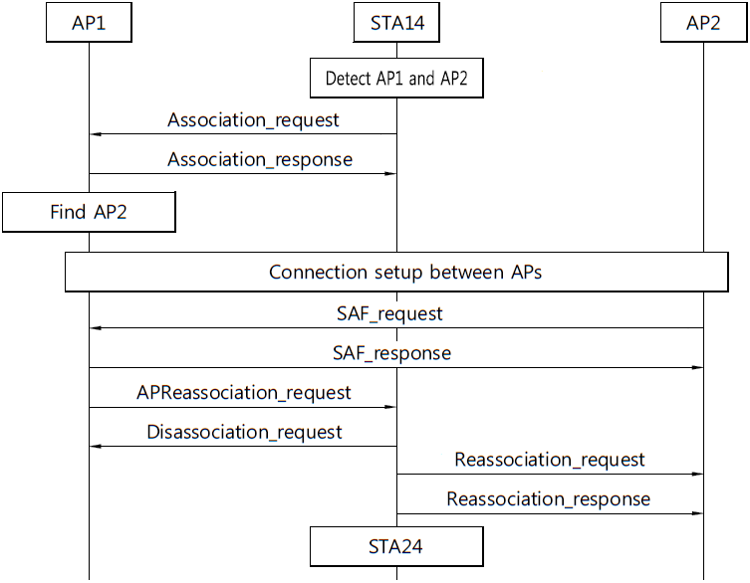
Figure 5 Message exchange among APs and STAs for re-associating an STA located in an overlapping zone between BSSs to an adjacent AP

