IEEE P802.19.1a
Wireless Coexistence
A coexistence discovery algorithm for multi-band operating GCOs under inaccurate geo-location information
Date: 2016-11-08
Author(s):
Name | Company | Address | Phone | Email
Hyunduk Kang | ETRI | 138 Gajeong-Ro, Yuseong-Gu, Daejeon, 305-700, South Korea |  | henry@etri.re.kr
Ae-Soon Park | ETRI
Seung Chan Bang | ETRI
Abstract

This document provides a coexistence discovery algorithm for multi-band operating GCOs under inaccurate geo-location information in order to resolve CID 165 in 1st TG review.

Proposal
The text below is proposed for a coexistence discovery algorithm for multi-band operating GCOs under inaccurate geo-location information.

      - Algorithm for multi-band operating GCOs under inaccurate geo-location information
This algorithm provides a method for a hidden AP(GCO) discovery among APs using multi-bands. It is preferentially executed in a channel in which a sub channel exists based on a channel width extension scheme by channel (width) information and a GCO like AP in WLAN included in a primary channel when the multi-bands are used in each AP and STA to enable an inter-adjacent AP discovery using the multi-bands to be effectively performed. In addition, this algorithm provides a method in which when the APs using the multi-bands discover each other through direct discovery using a beacon signal or channel detection using an STA positioned in an overlapping area in one band, a discovery of another band is not separately performed and the discovery of another band is performed based on information obtained in one band to minimize overhead of a channel detection time required for a discovery in the multi-bands.

The adjacent APs shall classified into the following four types and when an interference situation occurs, a priority of a target to be preferentially avoided shall be determined.
- Single-band single-channel adjacent AP (e.g., priority 4)
- Single-band multi-channel adjacent AP (e.g., priority 3
- Multi-band single-channel adjacent AP (e.g., priority 2)
- Multi-band multi-channel adjacent AP (e.g., priority 1)
Intuitionally, the adjacent AP using the multi-bands and the multi-channels shall have the highest priority in the interference avoidance and the adjacent AP using the single-band and the single-channel shall have the lowest priority.

We assume that one CM and on CE are embeded in each AP which is a GCO. A coexisetence discovery algorithm shall include the following steps as depcited Figure 1:
- Each AP and STA perform multi-band multi channel scanning
- Each STA performs AP assocition
- Each AP collects scanning result from associated STA
- Until all its associated STAs take into consideration, each AP compares scanning results thereof and scanning result of associated STA to perform hidden AP discovery and generte/update neighbor AP list
- If hidden APs are exist,
- AP selects STA that will transmit APDiscovery_indication message among STAs associated therewith
- AP transmits APDiscovery_indication message to selected STA among associated STAs
- Selected STA broadcasts APDiscovery_indication message received from associated AP so that adjacent AP receives APDiscovery_indication message
- Cooresponding AP that receives APDiscovery_indication message updates neighbor AP list
- If hidded APs are not exist,
- Cooresponding AP that receives APDiscovery_indication message updates neighbor AP list

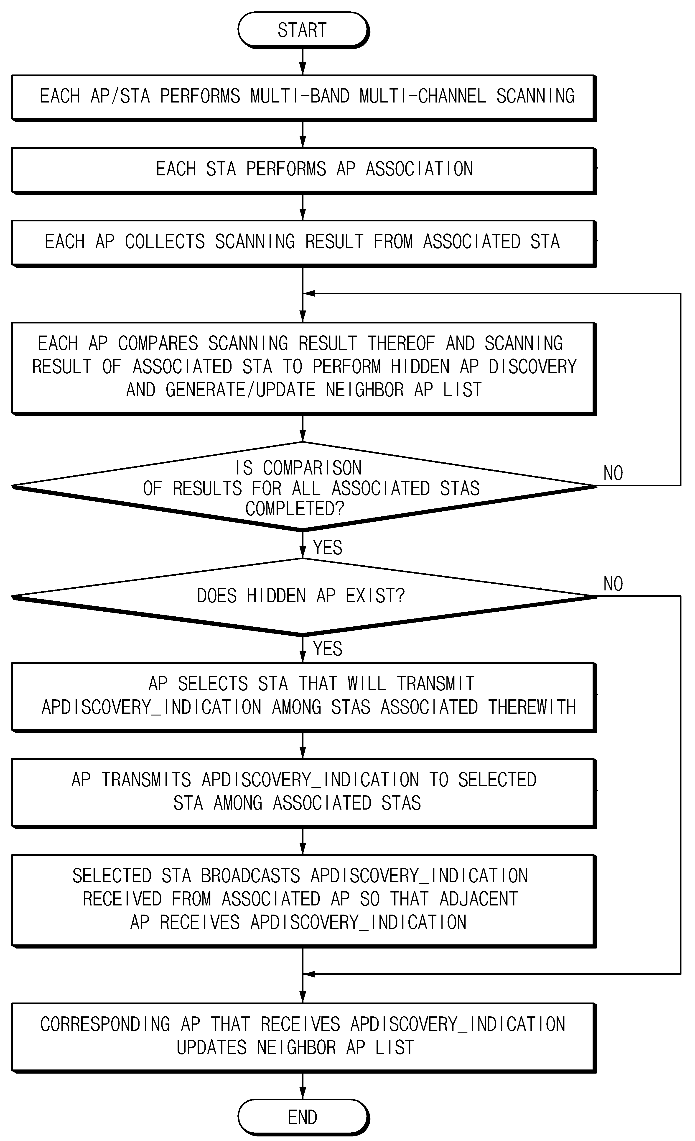
Figure 1 Flow chart of hidden AP(GCO) disocovery for multi-band operating GCOs

Figure 2 depicts AP operation for hidden AP discovery. Each AP shall search the channel in the band of A (i.e., 2.4 GHz, and the like) or B (i.e., 5 GHz, and the like) with respect to the adjacent AP based on the beacon signals from one or more adjacent APs and when an operating channel is detected, it shall be determined whether the detected operating channel is the primary channel.
If it is the primary channel, each AP shall acquire channel information regarding the primary channel, and shall verify whether the AP operating channel exists in the sub channel corresponding to the primary channel according to channel arrangement information based on the acquired channel information, and shall acquire information on the corresponding operating channel which exists in the sub channel of the corresponding adjacent AP to store and manage the operating channel information including the acquired primary channel and sub channel information.
Channel detection between adjacent APs shall be preferentially executed in a channel in which the sub channel exists as compared with a channel in which the sub channel does not exist according to a channel arrangement scheme based on information included in the primary channel to more rapidly recognize the interference between the adjacent APs depending on use of the multi-bands and the multi-channels and reflect the recognized interference to the determination of the interference avoidance in real time whenever the interference is recognized.
The operating channel detecting process for the adjacent AP is repeated until the operating channel information is acquired with respect to all bands and all channels of the adjacent AP.
When acquiring the operating channel information (primary channel and sub channel information) for all bands of the adjacent AP which is detected, is completed, each AP shall divide the adjacent APs into four adjacent AP types of a single-band single-channel adjacent AP, a single-band multi-channel adjacent AP, a multi-band single-channel adjacent AP, and a multi-band multi-channel adjacent AP according to whether multi-channels overlap with the adjacent AP and whether multi-channels overlap with the adjacent AP to store and manage the four adjacent AP types.
When a channel scanning process for the adjacent AP is completed as described above, the channel scanning process shall be repeated with respect to all other adjacent APs which are detectable to acquire channel scanning information.

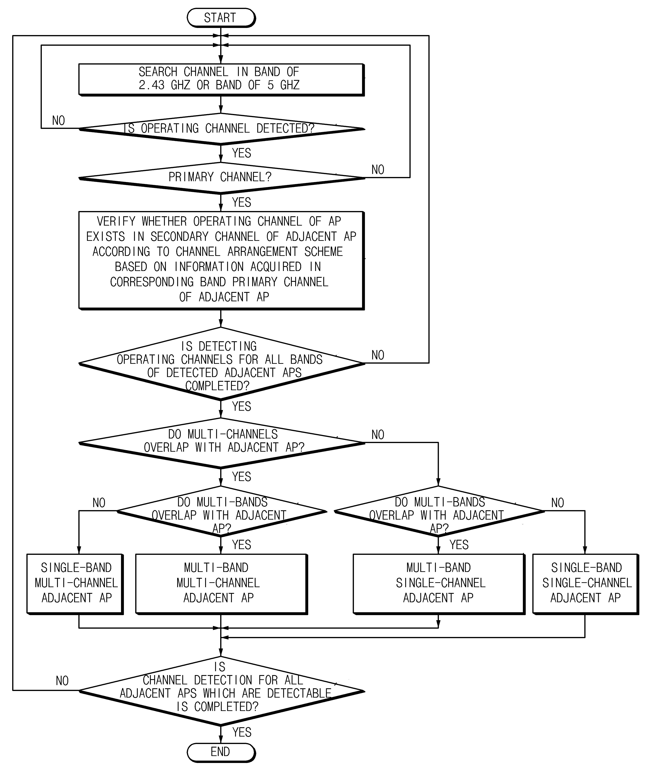
Figure 2 Flow chart of AP operation for multi-band operating GCOs

Figure 3 depicts STA operation for hidden AP discovery for multi-band operating GCOs. Each SAT shall search the channel in the band of A (i.e., 2.4 GHz, and the like) or B (i.e., 5 GHz, and the like) with respect to the adjacent AP based on the beacon signals from one or more adjacent APs and when the operating channel is detected, it shall be determined whether the detected operating channel is the primary channel.
If it is the primary channel, each STA shall acquire channel information regarding the primary channel, and shall verify whether the AP operating channel exists in the sub channel corresponding to the primary channel according to channel arrangement information based on the acquired channel information, and shall acquire information on the corresponding operating channel which exists in the sub channel to store and manage the operating channel information including the primary channel and sub channel information acquired with respect to the corresponding adjacent AP.
The operating channel detecting process for the adjacent AP shall be repeated until the operating channel information is acquired with respect to all bands and all channels of the adjacent AP.
When a channel scanning process for the adjacent AP is completed as described above, the channel scanning process shall be repeated with respect to all other adjacent APs which are detectable to acquire the channel scanning information.

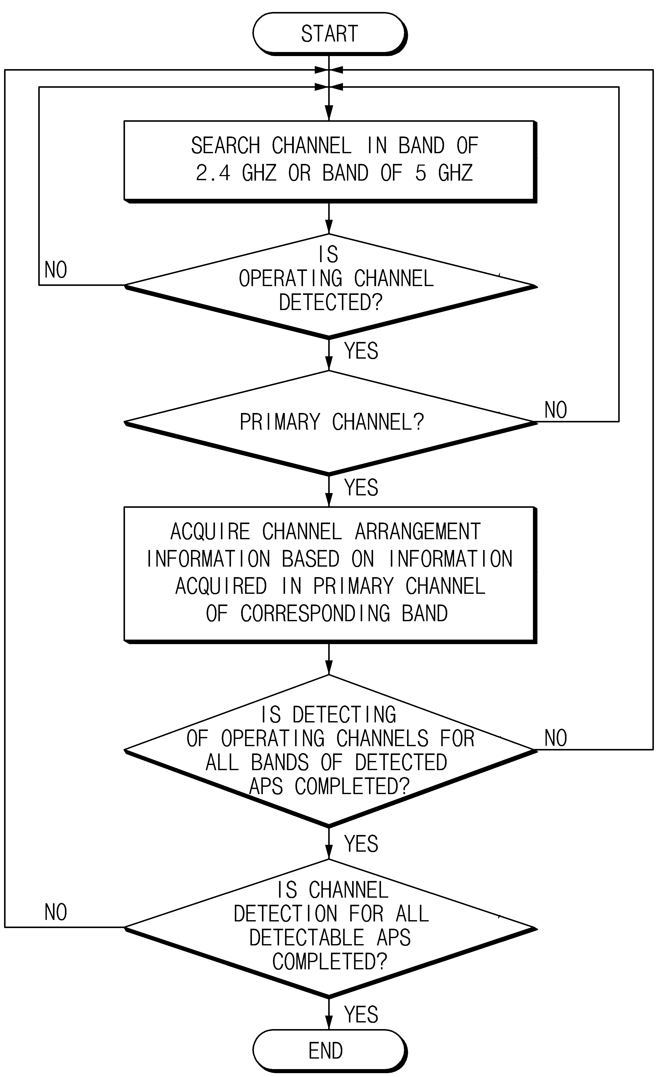
Figure 3 Flow chart of STA operation for multi-band operating GCOs
Figure 4 depicts an example of hidden APs (GCOs) situation for multi-band operating GCOs. In this case, AP1 (GCO1) has hidden neighbors, AP2 (GCO2) and AP3 (GCO3). AP2 has a hidden neighbor, AP1. AP3 has a hidden neighbor, AP1. After the algorithm is processed, each AP shall discover the followings;
- AP1 detects AP2 as an single band multi-channel adjacent AP
- AP1 also detects AP3 as an multi-band multi channel adjacent AP
- AP2 detects AP1 as an single band mult-channel adjacent AP
- AP2 also detects AP3 as an multi-band single channel adjacent AP
- AP3 detects AP1 as an multi-band multi-channel adjacent AP
- AP3 also detects AP2 as an multi-band single channel adjacent AP

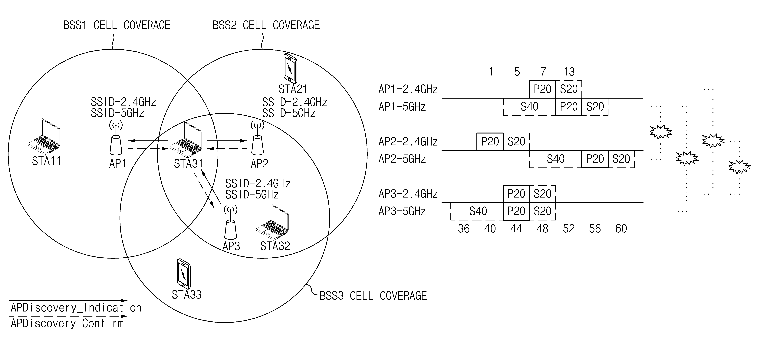
Figure 4 An example of hidden AP(GCO) situation for multi-band operating GCOs
Figure 5 depicts message exchange among APs and STAs.

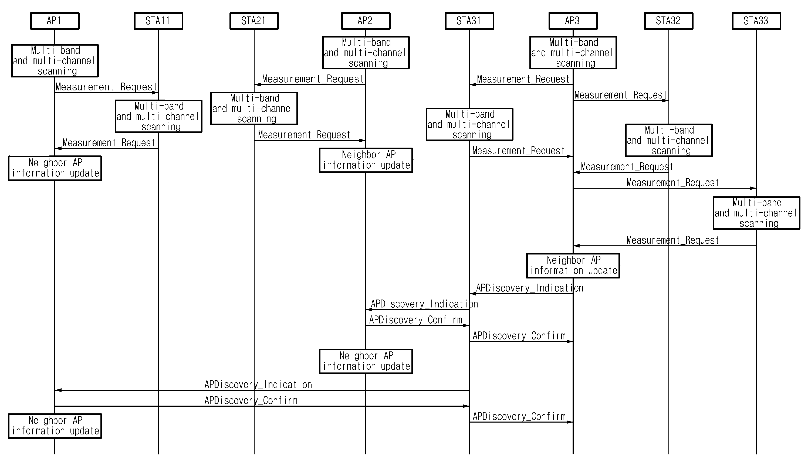
Figure 5 Message exchange among APs and STAs for multi-band operating GCOs

