IEEE 802 |  |  |  | Paul Nikolich
Local and Metropolitan Area Network Standards Committee |  |  |  | Chair, IEEE 802 LMSC
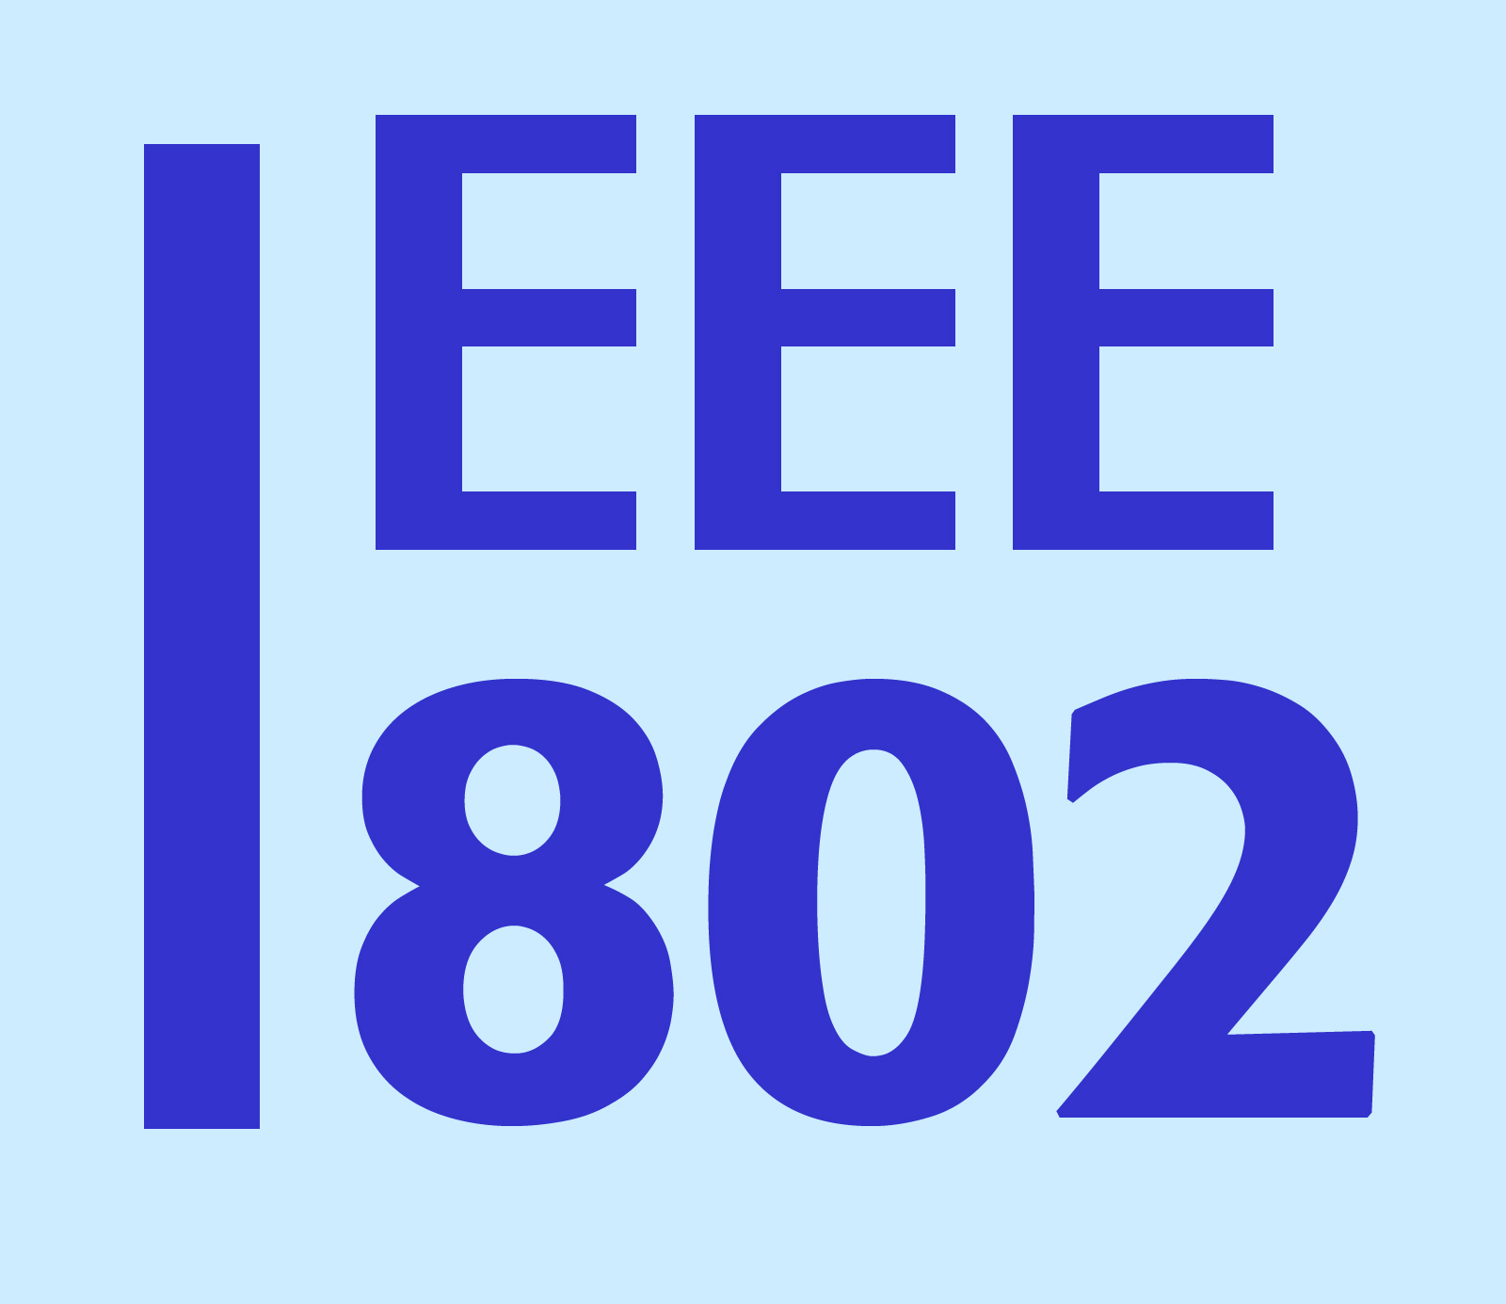 |  |  |  | 3 Barberry Way
 |  |  |  | Essex Fells, NJ 07021
 |  |  |  | cell: 857.205.0050
To: | Edgar Figueroa, CEO/President Wi-Fi Alliance |  | CC: 3GPP, RAN Chair; RAN4 WG Chair  CableLabs, Rob Aldefer  NIST, William F. Young  CTIA, Tom Sawanobori <TSawanobori@ctia.org>.  GCF
Subject: | Coexistence Testing liaison response
Date: | 19 January 2016

Dear Mr. Figueroa

Thank you for your 15 January 2016 liaison communication on the Wi-Fi Alliance (WFA) coexistence testing for LTE in unlicensed spectrum. The 802.19 Working Group on Coexistence considered the liaison at their January 2016 interim session and wish to recommend a potential way forward to efficiently utilize the coexistence testing work done in the WFA as well as other organizations such as 3GPP, CableLabs, NIST, CTIA, and GCF.

The 802.19 Working Group participants are interested in receiving inputs from the aforementioned groups that can be publicly shared among the 802 participants with the objective of producing a generalized inter-device/system coexistence test methodology using the IEEE 802 open standards development process. We feel using the 802 process provides an open, fair and balanced mechanism for the development of such a standard that would be generally useful to the users of unlicensed spectrum. As such, we actively seek input from the WFA and aforementioned groups as to whether or not they would be interested in participating in such a process.

If the WFA is interested in pursuing this path, please let us know when WFA test documents might be ready for submission to IEEE 802.19 for consideration. Thank you.

Regards,

/s/ Paul Nikolich

Paul Nikolich
Chair, IEEE 802 LAN/MAN Standards Committee
p.nikolich@ieee.org

