IEEE P802.19  
Wireless Coexistence

|  |  |  |  |  |
| --- | --- | --- | --- | --- |
| Basic principles of coexistence discovery | | | | |
| Date: 2013-03-19 | | | | |
| Author(s): | | | | |
| Name | Company | Address | Phone | email |
| Jari Junell | Nokia |  |  | jari.junell@nokia.com |
| Mika Kasslin | Nokia |  |  | mika.kasslin@nokia.com |

Abstract

This document is a submission to IEEE 802.19 TG1 that contains a relatively high level description of coexistence discovery scheme that is proposed for 802.19.1 draft. The proposed scheme builds upon the one currently in the draft but complements it by filling in the holes in the current description.

**Notice:** This document has been prepared to assist IEEE 802.19. It is offered as a basis for discussion and is not binding on the contributing individual(s) or organization(s). The material in this document is subject to change in form and content after further study. The contributor(s) reserve(s) the right to add, amend or withdraw material contained herein.

# Introduction

Coexistence discovery is functionality with which the IEEE 802.19.1 compliant coexistence system finds out those WSOs that may interfere with each other. The following clauses explain the phases of coexistence discovery and responsibilities of each related entity. Figure 1 provides an overview of the entity interactions that relate somehow to coexistence discovery.

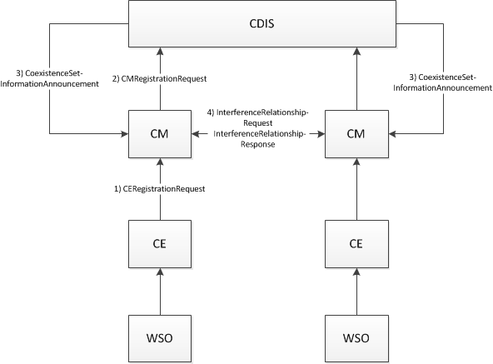

Figure 1: Steps within the coexistence discovery functionality

## Design principles

One of the main design principles of the coexistence discovery mechanism proposed in this submission is that the coexistence discovery is done on WSO level. In practice this means that in the coexistence discovery one analyzes whether WSOs may interfere with each other.

As per the current WSO definition, a WSO is either a device or a network of devices. Further, in the current design each WSO is given just one location. In case of a WSO being a device, the location is the device’s location and in case of a WSO being a network of devices, the location is location of the master device of the network. In fact, the objective of the coexistence discovery is to find out those devices that may interfere with each other with their radio transmissions. In case of a network we don’t, however, know all the device locations and thus coexistence discovery is based on device location estimates when a WSO is a network. This method should be limited to cases in which devices’ maximum transmission power is below a pre-defined threshold. All those devices that have maximum transmission power above the pre-defined threshold would be represented as a WSO. With this basic rule we can assure that the coexistence discovery mechanism has a reasonable performance in finding out those WSOs that may interfere each other.

All the above means that the 802.19.1 specification would have a rule for WSOs that would disallow WSOs of network type when the maximum EIRP of any of the devices of the network is above a certain threshold. The EIRP threshold should be frequency band specific to accommodate different propagations conditions in different bands.

Other design principles are as follows:

1. CDIS is the main entity that is responsible for the coexistence discovery
2. CM may perform coexistence discovery for those WSOs that are registered to it (i.e. those WSOs that are represented by those CEs that the CM serves)

# Initialization of the coexistence discovery

The coexistence discovery shall be initiated by a CM. A CM shall initiate the coexistence discovery by sending the following information to the CDIS:

1. Entity identification information
   * CE identifier
   * WSO identifier
2. Interference level estimation information
   * WSO type (device or network)
   * WSO location
   * WSO antenna location type (indoor, outdoor, unknown)
   * WSO Tx frequency range
   * WSO Rx frequency range
   * WSO Tx signal bandwidth
   * WSO Tx antenna properties
   * WSO Rx antenna properties
   * WSO Max Tx power per Hz
   * WSO Rx tolerable interference level per Hz
   * WSO Rx sensitivity level per Hz

The CM gets all the WSO related information from the CE in a CERegistrationRequest message.

The CM shall initiate the coexistence discovery by sending a CMRegistrationRequest message to the CDIS. The CM shall send a CMRegistrationRequest message when any of the following events happen:

1. Upon receiving request for a new registration for a WSO from the CE
2. Upon receiving request for an update of a WSO registration from the CE where the update request contains at least one of the interference level estimation information

# CDIS actions on coexistence discovery

Upon receiving a CMRegistrationRequest message from a CM the CDIS shall invoke a coexistence discovery algorithm to find out coexistence set for the WSO to which the CMRegistrationRequest applies. Algorithm is implementation dependent but each coexistence discovery algorithm uses the WSO interference level estimation information it has received from the CMs and propagation model relevant for the frequency band in consideration. Basis of each algorithm shall be also as described in the following.

In case interference to devices of a network is considered, one estimates interference level to the master device and the highest interference level to all possible locations of slave devices. If the devices of a network are considered to be interference victims, the CDIS reports power spectral density with direction of arrival for two locations of the network: 1) location of the master device (Mode II device), and 2) location of the highest interference.

If devices of a network are considered to cause interference to a device or to a network of devices, the interference caused by its devices is estimated from two different locations: 1) master device (Mode II device), and 2) location in which a device of the network would cause the highest interference power spectral density to another device.

The algorithm results in both those WSOs that may cause potentially harmful interference to the WSO and those WSOs may be harmfully interfered by the WSO. The CDIS shall transmit a CoexistenceSetInformationAnnouncement message to a CM to indicate either

1. All those other WSOs that may cause interference to receiver(s) of a WSO that the CM serves, or
2. Change in the list of WSOs that may cause interference to receiver(s) of a WSO that the CM serves

The former approach should be used only when really needed, e.g. when establishing the list of interfering WSOs for the CM. The latter approach should be the default case. A CDIS should use it whenever there is a need to add or retrieve one or more WSOs from the list of interferers.

The minimum information about the potential interferer and interference to a CM serving a possibly interfered WSO includes

* Interferer identification information
  + CE identifier
  + WSO identifier
  + Identifier and host name of the CM
* Interference power spectral density and direction of arrival
  + When the WSO is of a device type, this information is given for the location of the device
  + When the WSO is of a network type, this information is given for at least two locations
    - Location of the master device of the network
    - Location of a possible slave device in which the interference is estimated to be highest
  + The power spectral density shall be indicated in at least one frequency in which it was estimated and the frequency/frequencies shall be indicated as well
  + Interference signal bandwidth

An example of four scenarios is shown in Figure 2: device-device, device-network, network-device and network-network.

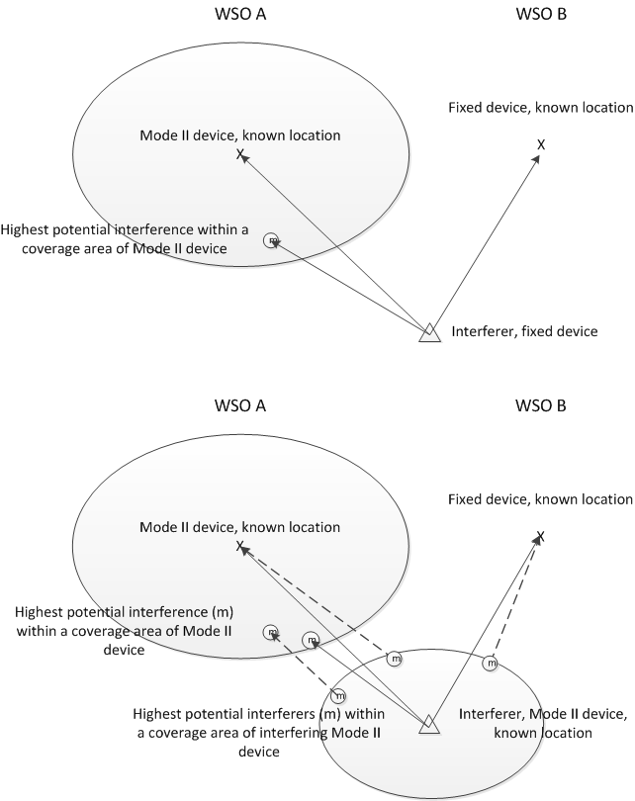

Figure 2: An example of interference spectrum density estimation to a network (WSO A) and a device (WSO B), when interferer is either the device or the network formed by a master (Mode II) device

# Interaction between CMs

Once a CM has received information from the CDIS about potential interferers of a WSO represented by a CE it serves, the CM shall analyze whether the potential interferers are really capable of interfering the WSO.

In the analysis the CM uses information about the receiver of the potentially interfered WSO to check whether the interference levels indicated by the CDIS from the potential interferers are such that they really may interfere with the WSO. The CM takes into account the WSO receive antenna configurations, the WSO receiver interference tolerance level and all the received information about the potential interference signal when deciding whether the interference signal levels exceed interference threshold level. If they do so, the potential interferer that the CDIS reported is considered by the CM as true interferer.

If the true interferer is served by another CM, the CM shall report the interference relationship to the other CM. The CM shall generate an InterferenceRelationshipRequest message and send it to the other CM indicating that there is an interference relationship between the two WSOs.

The reporting message includes at least the following information:

* Entity identification information related to both interfering and interfered WSO
  + CE identifier
  + WSO identifier